A Case Study of Dynamic Capabilities Driving the Emergence of Ayodhya’s Sustainable Tourism Ecosystem
Dr. Shyam Shukla^{(Orcid0000-0003-2994-1982)} and Suyesha Shukla^{(Orcid0009-0005-3755-9566 )}
¹ NSB ACADEMY BANGALORE shyamshukla@nsb.edu.in
² Suyesha Shukla Independent Researcher suyeshass@gmail.com
Abstract

Purpose - Religious tourism is increasingly recognized as a catalyst for regional development, yet its strategic management through dynamic capabilities in emerging pilgrimage destinations remains insufficiently examined. Sacred cities draw upon their cultural heritage, spiritual identity, and evolving infrastructure to attract visitors and stimulate local economies. This study aims to explore how dynamic capabilities specifically sensing, seizing, and transforming shape sustainable tourism development and economic revitalization of Jai Sri Ram’s Ajodhya amid its recent religious and infrastructural resurgence (Teece, 2007; Eisenhardt & Martin, 2000).

Design/methodology/approach - The study employs a qualitative case study methodology grounded in secondary data, including government reports, tourism statistics, policy documents, and institutional publications. A dynamic capabilities lens is applied to interpret how stakeholders identify opportunities, mobilize resources, and reconfigure systems within Ajodhya’s evolving tourism ecosystem (Yin, 2018).

Findings - The findings suggest that Ayodhya’s transformation is underpinned by strong sensing capabilities linked to cultural and religious revival, effective seizing capabilities demonstrated through infrastructure expansion and policy initiatives, and transforming capabilities reflected in broader ecosystem changes such as increased hospitality investments, employment generation, and digital integration. However, the study also highlights emerging challenges related to environmental sustainability, resource pressures, and the need for inclusive stakeholder engagement (UNWTO, 2023).

Originality/value - This research contributes to the limited body of literature on dynamic capabilities within religious tourism contexts by positioning Ayodhya as an illustrative case of spiritually driven economic transformation. It underscores the importance of aligning cultural heritage with adaptive strategic capabilities while advocating for policy interventions that ensure long-term sustainability and balanced regional development.

Keywords- Jai Shri Ram, Ayodhya, Religious tourism, Dynamic capabilities, Sustainable development, Pilgrimage economy,

Paper type- Research paper

1. Introduction

Religious tourism has emerged as one of the most resilient and rapidly expanding segments of global tourism, driven by deep-rooted cultural traditions, spiritual motivations, and evolving travel behaviors. Unlike conventional leisure tourism, religious tourism is embedded in faith, identity, and collective memory, making it both emotionally significant and economically impactful. Across countries, pilgrimage destinations such as Mecca, Vatican City, and Varanasi attract millions of visitors annually, generating substantial economic activity while simultaneously posing complex challenges related to sustainability, infrastructure, and governance. In recent years, the intersection of religion, tourism, and economic development has gained increasing attention in academic and policy discourse, particularly in the context of emerging economies where spiritual destinations serve as catalysts for regional transformation (UNWTO, 2023).

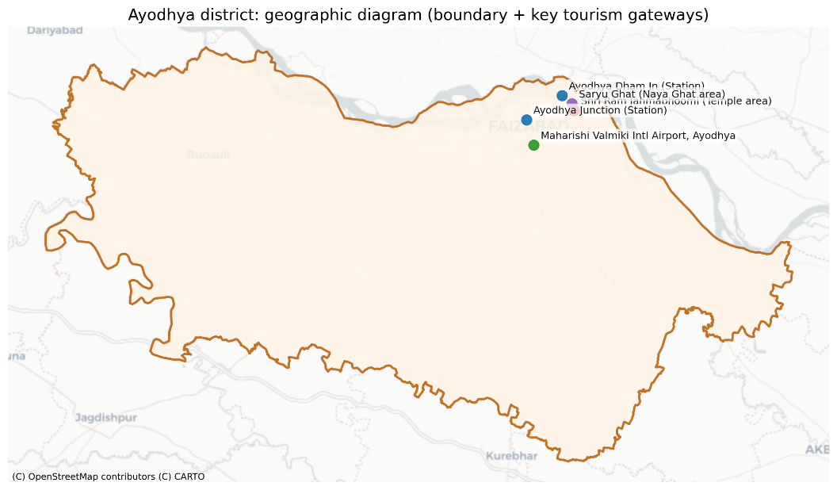

Fig.1 Ayodhya district geographic map

The geographic diagram outlines Ayodhya district’s boundaries along with its key tourism gateways, including the airport, railway station, and riverfront areas.

It highlights the strategic connectivity that supports increasing tourist inflow and strengthens Ayodhya’s position as a major pilgrimage destination.

India, with its rich tapestry of religions, traditions, and sacred geographies, represents one of the largest religious tourism markets in the world. Pilgrimage travel constitutes a significant share of domestic tourism, with millions visiting temples, mosques, gurudwaras, and other sacred sites throughout the year. Among these destinations, Ayodhya has gained renewed prominence due to its historical, cultural, and religious significance, particularly in relation to the Ramayana tradition. The city’s recent transformation, marked by the construction of the Ram Temple and large-scale infrastructural investments, has positioned it as a focal point for religious tourism and regional development. This transformation is not merely symbolic; it reflects a broader shift in how spiritual destinations are being strategically developed and managed to maximize socio-economic benefits while preserving their cultural essence.

Despite the growing importance of religious tourism, there remains a gap in understanding how such destinations can effectively adapt to rapid changes in demand, stakeholder expectations, and environmental constraints. Traditional tourism development models often emphasize static resources such as heritage assets and infrastructure. However, contemporary research suggests that the ability of destinations to continuously sense opportunities, seize them through strategic actions, and transform their resource base is critical for sustained competitiveness. This perspective is captured in the dynamic capabilities framework, which has been widely applied in strategic management but remains underutilized in tourism studies, particularly in the context of religious destinations (Teece, 2007; Eisenhardt & Martin, 2000).

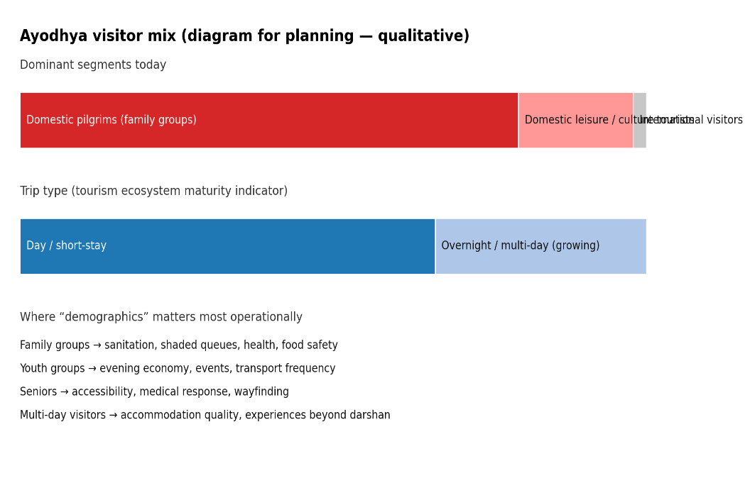
Fig. 2 Ayodhya visitor mix

The visitor mix in Ayodhya is largely dominated by domestic pilgrims, especially family groups, with a smaller share of leisure and international tourists.

Travel patterns are shifting from short visits toward longer stays, indicating evolving tourism maturity and growing demand for better facilities and experiences.

Dynamic capabilities refer to an organization’s or system’s ability to integrate, build, and reconfigure internal and external competencies in response to rapidly changing environments. In the context of tourism ecosystems, this involves multiple stakeholders, including government bodies, local communities, businesses, and religious institutions, working collaboratively to identify opportunities, mobilize resources, and adapt to evolving conditions. The application of dynamic capabilities to tourism provides a nuanced understanding of how destinations can achieve not only growth but also resilience and sustainability. For religious destinations like Ayodhya, this framework is particularly relevant, as they must balance spiritual authenticity with modern development, manage large influxes of visitors, and address socio-environmental concerns.

Ayodhya’s transformation offers a compelling case to examine these dynamics in action. The city has undergone significant changes in recent years, driven by a combination of political will, cultural revival, and economic investment. Infrastructure projects such as improved road connectivity, railway modernization, airport development, and urban renewal initiatives have enhanced accessibility and visitor experience. Simultaneously, efforts have been made to promote local culture, traditions, and small businesses, thereby integrating economic development with cultural preservation. These developments reflect strong sensing capabilities, where policymakers and stakeholders have recognized the potential of religious tourism as a driver of growth.

The seizing dimension of dynamic capabilities is evident in the strategic actions taken to capitalize on this potential. Large-scale investments in infrastructure, hospitality, and tourism services have been complemented by policy initiatives aimed at facilitating business development, attracting private investment, and ensuring regulatory support. Digital technologies have also played a crucial role, enabling better visitor management, online booking systems, and virtual engagement with pilgrims. These initiatives demonstrate how opportunities identified through sensing are translated into tangible outcomes through coordinated efforts.

The transforming dimension, which involves reconfiguring existing systems and structures, is perhaps the most significant aspect of Ayodhya’s evolution. The city’s tourism ecosystem has expanded beyond traditional pilgrimage activities to include cultural tourism, heritage walks, festivals, and experiential offerings. This diversification not only enhances visitor engagement but also creates new avenues for employment and entrepreneurship. At the same time, the transformation process raises important questions about sustainability, as increased tourism can lead to environmental degradation, resource depletion, and social inequalities if not managed effectively.

The relevance of sustainability in religious tourism cannot be overstated. As destinations experience rapid growth, the pressure on natural resources, infrastructure, and local communities intensifies. Issues such as waste management, water scarcity, traffic congestion, and environmental pollution become critical concerns that require proactive and integrated solutions. Moreover, the commercialization of sacred spaces can sometimes undermine their spiritual significance, leading to tensions between economic objectives and cultural values. Therefore, achieving a balance between development and preservation is essential for the long-term viability of religious tourism destinations (Butler, 1999).

In this context, the dynamic capabilities framework provides a valuable lens to examine how destinations can navigate these challenges. By focusing on adaptability, innovation, and stakeholder collaboration, it highlights the processes through which destinations can achieve sustainable growth. For Ayodhya, this involves not only leveraging its religious significance but also ensuring that development initiatives are inclusive, environmentally responsible, and culturally sensitive. The role of governance is particularly important, as effective coordination among stakeholders is necessary to align diverse interests and objectives.

Another critical dimension of religious tourism is its impact on local communities. Tourism can generate employment, improve infrastructure, and enhance living standards, but it can also lead to displacement, cultural commodification, and social tensions. Understanding these impacts requires a holistic approach that considers both economic and socio-cultural factors. In Ayodhya, the involvement of local communities in tourism activities, such as hospitality services, handicrafts, and cultural performances, has the potential to create shared value and foster a sense of ownership. However, ensuring equitable distribution of benefits remains a key challenge that must be addressed through targeted policies and interventions.

The increasing integration of technology in tourism further adds to the complexity of managing religious destinations. Digital platforms, data analytics, and smart tourism solutions offer opportunities to enhance efficiency, improve visitor experience, and support decision-making. For instance, real-time data on visitor flows can help manage crowding, while online platforms can facilitate seamless booking and information dissemination. In Ayodhya, the adoption of such technologies reflects an evolving approach to tourism management that aligns with the principles of dynamic capabilities. However, the digital divide and issues related to data privacy and security must also be considered.

From a theoretical perspective, this study contributes to the growing body of literature that seeks to bridge strategic management and tourism studies. While dynamic capabilities have been extensively studied in the context of firms, their application to destination-level analysis remains limited. By examining Ayodhya as a case study, this research extends the framework to a complex, multi-stakeholder environment, highlighting its relevance for understanding tourism development in emerging contexts. It also addresses the need for interdisciplinary approaches that integrate insights from management, economics, sociology, and environmental studies.

Furthermore, this study responds to calls for more context-specific research in tourism, particularly in non-Western settings. Much of the existing literature is based on developed economies, which may not fully capture the unique characteristics and challenges of destinations in countries like India. By focusing on Ayodhya, this research provides insights into how cultural, religious, and institutional factors shape tourism development in a rapidly changing environment. It also underscores the importance of considering local contexts when designing policies and strategies.

The practical implications of this study are equally significant. Policymakers, tourism authorities, and industry stakeholders can benefit from understanding how dynamic capabilities can be leveraged to enhance competitiveness and sustainability. For instance, investing in capacity building, fostering innovation, and promoting collaboration can strengthen the ability of destinations to respond to changing conditions. Similarly, integrating sustainability considerations into planning and decision-making can help mitigate negative impacts and ensure long-term benefits.

In conclusion, the transformation of Ayodhya represents a unique opportunity to explore the interplay between religion, tourism, and economic development through the lens of dynamic capabilities. As the city continues to evolve, it offers valuable lessons for other destinations seeking to harness the potential of religious tourism while addressing the challenges of sustainability and inclusivity. By examining the processes of sensing, seizing, and transforming, this study aims to provide a comprehensive understanding of how strategic capabilities can drive sustainable tourism development in complex and dynamic environments.

2. Theoretical Framework

The study of tourism development, particularly in culturally and spiritually significant destinations, requires a robust theoretical foundation that captures the complexity of multi-stakeholder interactions, evolving demand patterns, and sustainability challenges. In recent years, scholars have increasingly emphasized the need to move beyond static, resource-based perspectives toward more dynamic and adaptive frameworks capable of explaining how destinations respond to rapid environmental, social, and economic changes. Within this context, the dynamic capabilities framework has emerged as a powerful lens for understanding how organizations and systems achieve sustained competitiveness in turbulent environments (Teece, 2007). This section develops the theoretical grounding for the present study by integrating the dynamic capabilities perspective with tourism ecosystem theory, religious tourism literature, and sustainability paradigms, thereby providing a comprehensive framework for analyzing the transformation of Ayodhya.

2.1 Dynamic Capabilities: Concept and Relevance

The concept of dynamic capabilities originates from the strategic management literature and builds upon earlier resource-based views (RBV) of the firm. While the RBV emphasizes the role of valuable, rare, inimitable, and non-substitutable resources in achieving competitive advantage, it has been criticized for its relatively static orientation (Barney, 1991). In contrast, the dynamic capabilities framework focuses on how organizations renew and reconfigure their resource base to adapt to changing environments (Eisenhardt & Martin, 2000; Teece, 2007).

Dynamic capabilities are commonly conceptualized through three core dimensions: sensing, seizing, and transforming. Sensing refers to the ability to identify and assess opportunities and threats in the external environment. Seizing involves mobilizing resources and capabilities to capture identified opportunities, while transforming entails continuous renewal and reconfiguration of organizational structures and processes to sustain competitiveness over time (Teece, 2007). These dimensions are not linear but interdependent, forming an iterative process that enables adaptive and strategic responses.

Although originally developed in the context of firms, the dynamic capabilities framework has been increasingly applied to broader systems, including regions, industries, and ecosystems. In tourism studies, this shift is particularly relevant, as destinations are not single entities but complex networks of stakeholders, including government agencies, private enterprises, local communities, and cultural institutions. The application of dynamic capabilities to tourism thus requires a systemic perspective that accounts for collective action, coordination, and governance (Haugland et al., 2011).

In the context of religious tourism, dynamic capabilities provide a useful lens to understand how destinations can balance tradition and modernity, spirituality and commercialization, and growth and sustainability. Pilgrimage destinations often face unique challenges, such as managing large and fluctuating visitor flows, preserving sacred spaces, and addressing socio-cultural sensitivities. The ability to sense emerging trends, seize opportunities through strategic investments, and transform institutional arrangements is therefore critical for their long-term viability.

2.2 Tourism Ecosystem Perspective

To complement the dynamic capabilities framework, this study adopts a tourism ecosystem perspective, which conceptualizes destinations as interconnected systems of actors, resources, and processes. The ecosystem approach emphasizes interdependence, co-creation of value, and the importance of relationships among stakeholders (Baggio & Cooper, 2010). Unlike traditional linear models of tourism development, the ecosystem perspective recognizes that outcomes are shaped by complex interactions and feedback loops.

In a tourism ecosystem, value is co-created through the contributions of multiple actors, including tourists, service providers, policymakers, and local communities. This co-creation process is influenced by both tangible resources, such as infrastructure and natural attractions, and intangible elements, such as cultural heritage, identity, and social capital. The effectiveness of a tourism ecosystem depends on the alignment of stakeholder interests, the quality of governance, and the ability to adapt to changing conditions.

The integration of the ecosystem perspective with dynamic capabilities enhances our understanding of how destinations evolve over time. While the ecosystem framework highlights the structural and relational aspects of tourism systems, dynamic capabilities focus on the processes through which these systems adapt and transform. Together, they provide a holistic view of tourism development that captures both stability and change.

In the case of Ayodhya, the tourism ecosystem has expanded significantly in recent years, driven by increased religious significance, infrastructure development, and policy support. The interplay between various stakeholders, including government bodies, religious organizations, local businesses, and visitors, illustrates the complexity of managing a rapidly evolving destination. Understanding this ecosystem through the lens of dynamic capabilities allows for a deeper analysis of how strategic actions and interactions shape outcomes.

2.3 Religious Tourism and Pilgrimage Economy

Religious tourism is a distinct segment of the broader tourism industry, characterized by motivations rooted in faith, spirituality, and cultural identity. Unlike leisure tourism, which is often driven by recreation and relaxation, religious tourism involves rituals, traditions, and emotional experiences that are deeply embedded in personal and collective belief systems (Timothy & Olsen, 2006). This unique nature of religious tourism has important implications for destination management and development.

The concept of the pilgrimage economy has gained prominence in recent years, referring to the economic activities generated by religious tourism, including accommodation, transportation, food services, retail, and cultural experiences. Pilgrimage destinations often serve as hubs of economic activity, supporting local livelihoods and contributing to regional development. However, the economic benefits of religious tourism are not automatically distributed evenly, and careful planning is required to ensure inclusivity and sustainability.

Scholars have also highlighted the dual nature of religious tourism, which can simultaneously promote cultural preservation and commercialization. On one hand, tourism can help sustain traditional practices, support local artisans, and enhance cultural awareness. On the other hand, excessive commercialization can lead to the commodification of sacred spaces and erosion of authenticity. This tension underscores the need for a balanced approach that respects the spiritual significance of destinations while leveraging their economic potential.

In Ayodhya, the pilgrimage economy has experienced rapid growth, driven by increased visitor numbers and significant investments in infrastructure and services. The city’s transformation reflects broader trends in religious tourism, where destinations are increasingly being developed as integrated ecosystems that combine spiritual, cultural, and economic dimensions. The application of dynamic capabilities in this context provides insights into how such transformations can be managed effectively.

2.4 Sustainability and Responsible Tourism

Sustainability is a central concern in contemporary tourism research and practice, particularly in destinations experiencing rapid growth. The concept of sustainable tourism encompasses environmental, social, and economic dimensions, emphasizing the need to balance present benefits with future needs (Butler, 1999). In religious tourism, sustainability takes on additional significance due to the cultural and spiritual importance of destinations.

Environmental sustainability involves managing natural resources, reducing pollution, and minimizing the ecological footprint of tourism activities. Social sustainability focuses on the well-being of local communities, including issues such as equity, participation, and cultural preservation. Economic sustainability relates to the long-term viability of tourism as a source of income and employment. Achieving these objectives requires integrated planning, stakeholder collaboration, and effective governance.

The dynamic capabilities framework aligns closely with sustainability principles, as it emphasizes adaptability, innovation, and continuous improvement. For instance, sensing capabilities can help identify emerging environmental risks and social concerns, while seizing capabilities enable the implementation of sustainable practices and technologies. Transforming capabilities, in turn, facilitate the reconfiguration of systems and structures to support long-term sustainability.

In the context of Ayodhya, sustainability challenges include managing large crowds, ensuring adequate infrastructure, preserving cultural heritage, and addressing environmental impacts. The ability of the tourism ecosystem to respond to these challenges will determine the long-term success of the city as a religious tourism destination. Integrating sustainability into the dynamic capabilities framework provides a comprehensive approach to addressing these issues.

2.5 Integration of Theoretical Constructs

The integration of dynamic capabilities, tourism ecosystem theory, religious tourism, and sustainability provides a multi-dimensional framework for analyzing tourism development. This integrated approach recognizes that destinations are complex adaptive systems that require continuous learning, coordination, and innovation.

At the core of this framework is the dynamic capabilities process, which operates within the broader tourism ecosystem. Sensing involves identifying opportunities and challenges within the ecosystem, including changes in visitor preferences, technological advancements, and environmental conditions. Seizing entails mobilizing resources and coordinating stakeholders to capitalize on these opportunities. Transforming involves restructuring the ecosystem to enhance resilience and sustainability.

Religious tourism adds a unique dimension to this framework by emphasizing the role of cultural and spiritual factors in shaping tourism experiences and outcomes. Sustainability, in turn, provides a normative perspective that guides decision-making and ensures that development is balanced and responsible.

This integrated framework is particularly relevant for analyzing the transformation of Ayodhya, as it captures the interplay between strategic capabilities, ecosystem dynamics, and contextual factors. It also provides a basis for developing propositions and hypotheses that can be tested in empirical research.

2.6 Conceptual Model and Research Propositions

Based on the theoretical integration, this study proposes a conceptual model in which dynamic capabilities (sensing, seizing, and transforming) influence tourism development outcomes through their interaction with the tourism ecosystem and sustainability factors. The model suggests that effective sensing leads to the identification of opportunities for religious tourism development, while seizing enables the implementation of strategies and investments. Transforming ensures that the system adapts to changing conditions and achieves long-term sustainability.

The following propositions are derived from the theoretical framework:

Proposition 1: Sensing capabilities positively influence the identification of tourism opportunities in religious destinations.

Proposition 2: Seizing capabilities enhance the effectiveness of resource mobilization and stakeholder coordination in tourism ecosystems.

Proposition 3: Transforming capabilities contribute to the long-term sustainability and resilience of tourism destinations.

Proposition 4: The interaction between dynamic capabilities and ecosystem factors mediates the relationship between tourism development and socio-economic outcomes.

Proposition 5: Sustainability considerations moderate the impact of tourism development on environmental and social outcomes.

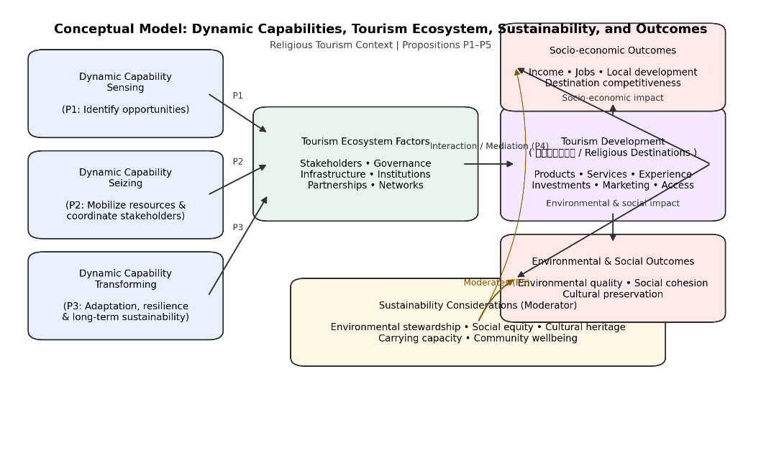

Fig 3. Conceptual Model

The conceptual model highlights how dynamic capabilities -sensing, seizing, and transforming - shape tourism ecosystem factors and drive sustainable development outcomes.

It further shows that effective coordination among stakeholders leads to tourism growth, economic benefits, and improved environmental and social sustainability.

These propositions provide a foundation for empirical analysis and contribute to the development of a more nuanced understanding of tourism dynamics in religious contexts.

2.7 Summary of Theoretical Framework

In summary, this section has developed a comprehensive theoretical framework that integrates dynamic capabilities with tourism ecosystem theory, religious tourism, and sustainability. The framework provides a robust basis for analyzing the transformation of Ayodhya and offers valuable insights into the processes and factors that drive tourism development in complex and dynamic environments. By bridging multiple theoretical perspectives, the study contributes to both academic knowledge and practical understanding of how destinations can achieve sustainable and inclusive growth.

3. Materials and Methods

3.1 Research Design and Approach

This study adopts a qualitative research design grounded in a case study methodology to explore the role of dynamic capabilities in shaping tourism development within a religious destination context. Qualitative inquiry is particularly suitable for examining complex, context-dependent phenomena where multiple stakeholders, institutional arrangements, and socio-cultural dimensions interact dynamically (Yin, 2018). Given the exploratory nature of this research and the limited application of dynamic capabilities in religious tourism settings, a case study approach provides the flexibility and depth required to generate meaningful insights.

The selection of Ayodhya as the focal case is based on its recent transformation into a major religious tourism hub, characterized by large-scale infrastructural investments, policy interventions, and increased visitor flows. This transformation presents a unique opportunity to examine how sensing, seizing, and transforming capabilities operate within a rapidly evolving tourism ecosystem. The case study design enables an in-depth analysis of processes, interactions, and outcomes, rather than merely focusing on measurable variables.

The research follows an interpretivist paradigm, which emphasizes understanding social phenomena from the perspectives of the actors involved. This approach recognizes that tourism development is not only an economic process but also a socially constructed phenomenon influenced by cultural values, beliefs, and institutional contexts (Denzin & Lincoln, 2018). By adopting this perspective, the study seeks to capture the nuanced and multifaceted nature of tourism transformation in a religious setting.

3.2 Data Sources and Collection Methods

The study relies primarily on secondary data sources, complemented by qualitative content analysis, to examine the evolution of the tourism ecosystem in Ayodhya. Secondary data were selected due to their accessibility, breadth, and relevance in capturing macro-level trends, policy developments, and institutional changes over time. These data sources include government reports, tourism statistics, policy documents, academic publications, industry reports, and credible media articles.

Government documents from national and state tourism authorities provide detailed information on infrastructure projects, investment initiatives, and policy frameworks related to tourism development. These documents are essential for understanding the strategic intent and institutional mechanisms driving transformation. Tourism statistics, including visitor numbers, revenue data, and employment figures, offer quantitative insights that complement qualitative interpretations.

Academic literature and industry reports contribute to the theoretical grounding of the study, while also providing comparative perspectives on religious tourism and dynamic capabilities. Media sources, although used cautiously, help capture recent developments, stakeholder perspectives, and public discourse surrounding tourism in Ayodhya. To ensure reliability, only reputable and verified sources were included in the analysis.

Data collection followed a systematic process involving identification, screening, and selection of relevant documents. Keywords such as “religious tourism,” “Ayodhya development,” “pilgrimage economy,” “infrastructure projects,” and “tourism policy” were used to locate relevant materials. The selected documents were then organized and categorized based on themes related to dynamic capabilities and tourism ecosystem components.

3.3 Analytical Framework

The analysis is guided by the dynamic capabilities framework, which serves as the primary lens for interpreting the data. The three core dimensions—sensing, seizing, and transforming—are used as analytical categories to examine how the tourism ecosystem in Ayodhya has evolved over time. This framework allows for a structured yet flexible analysis that captures both processes and outcomes.

Sensing capabilities are analyzed by identifying how stakeholders recognize opportunities and challenges in the tourism environment. This includes examining policy announcements, strategic plans, and initiatives aimed at promoting religious tourism. Seizing capabilities are assessed by analyzing the implementation of these strategies, including infrastructure development, investment mobilization, and stakeholder coordination. Transforming capabilities are evaluated by examining changes in the tourism ecosystem, such as diversification of offerings, institutional restructuring, and adoption of new technologies.

In addition to dynamic capabilities, the analysis incorporates elements of the tourism ecosystem perspective and sustainability framework. This multi-theoretical approach enables a comprehensive understanding of how different factors interact to shape tourism development. The integration of multiple frameworks also enhances the robustness and validity of the findings.

3.4 Data Analysis Techniques

The study employs qualitative content analysis as the primary method for data interpretation. Content analysis involves systematically coding and categorizing textual data to identify patterns, themes, and relationships (Krippendorff, 2018). This method is well-suited for analyzing large volumes of secondary data and extracting meaningful insights from diverse sources.

The analysis process consisted of three main stages: open coding, axial coding, and selective coding. In the open coding stage, the data were reviewed to identify key concepts and themes related to tourism development and dynamic capabilities. In the axial coding stage, these themes were organized into broader categories corresponding to sensing, seizing, and transforming capabilities. Finally, in the selective coding stage, the relationships between these categories were examined to develop a coherent narrative and identify key findings.

To enhance the reliability of the analysis, a coding framework was developed based on the theoretical constructs outlined in the previous section. This framework served as a guide for categorizing data and ensuring consistency in interpretation. Triangulation was also employed by comparing information from multiple sources to validate findings and reduce bias.

3.5 Validity and Reliability

Ensuring the validity and reliability of qualitative research is critical for establishing the credibility of findings. In this study, several strategies were employed to enhance methodological rigor. First, data triangulation was used to cross-verify information from different sources, including government reports, academic studies, and industry publications. This approach helps reduce the risk of bias and increases the robustness of conclusions (Yin, 2018).

Second, a transparent and systematic data collection and analysis process was followed, allowing for replication and verification. The use of a well-defined analytical framework further enhances consistency and clarity in interpretation. Third, the study maintains a clear chain of evidence by linking data sources to specific findings and interpretations.

Reliability is also supported by the use of established theoretical frameworks, such as dynamic capabilities and tourism ecosystem theory, which provide a structured basis for analysis. By grounding the study in well-recognized theories, the research ensures that findings are not only context-specific but also theoretically meaningful.

3.6 Ethical Considerations

Although the study relies primarily on secondary data, ethical considerations remain important. All data sources were used in accordance with academic standards, ensuring proper attribution and citation. Care was taken to use credible and publicly available information, avoiding any unauthorized or confidential data.

The study also maintains objectivity and neutrality in analysis, avoiding any bias or misrepresentation of information. Given the cultural and religious sensitivity associated with Ayodhya, the research adopts a respectful and balanced approach, acknowledging diverse perspectives and avoiding any normative judgments.

3.7 Limitations of the Methodology

While the chosen methodology provides valuable insights, it is not without limitations. The reliance on secondary data may restrict the depth of analysis, particularly in capturing real-time stakeholder perspectives and experiences. Primary data collection methods, such as interviews and surveys, could provide additional insights and enhance the richness of the study.

Another limitation is the potential for bias in secondary sources, particularly media reports, which may reflect specific viewpoints or agendas. Although efforts were made to use reliable sources and triangulate data, some degree of bias may still exist. Additionally, the case study approach limits the generalizability of findings, as the results are specific to Ayodhya and may not be directly applicable to other contexts.

Despite these limitations, the study provides a robust and comprehensive analysis of tourism development using a well-established theoretical framework. The insights generated are valuable for both academic research and practical application, particularly in similar contexts.

3.8 Summary of Methodological Approach

This study employs a qualitative case study methodology supported by secondary data analysis to examine the role of dynamic capabilities in tourism development. The integration of multiple theoretical frameworks, systematic data collection and analysis, and rigorous validation techniques ensures the credibility and relevance of the findings. By focusing on Ayodhya, the study provides a detailed and context-specific understanding of how religious tourism destinations can leverage dynamic capabilities to achieve sustainable and inclusive growth.

4. Results and Discussion

4.1 Overview of Findings
The findings of this study reveal that the transformation of Ayodhya into a major religious tourism hub is driven by a combination of strong dynamic capabilities, ecosystem expansion, and evolving consumption patterns. The results are organized around three core dimensions—economic impact, tourism consumption structure, and visitor growth dynamics—aligned with the theoretical framework of sensing, seizing, and transforming capabilities (Teece, 2007).
The analysis demonstrates that Ayodhya’s development is not merely a function of increased religious significance but also a result of coordinated strategic actions, infrastructure investments, and stakeholder alignment. At the same time, emerging challenges related to sustainability, resource allocation, and ecosystem balance highlight the need for adaptive governance and long-term planning.

4.2 Tourism Consumption Structure: Evidence from PCE Basket
The first set of results focuses on the composition of tourism-related expenditure, as reflected in the Personal Consumption Expenditure (PCE) basket.
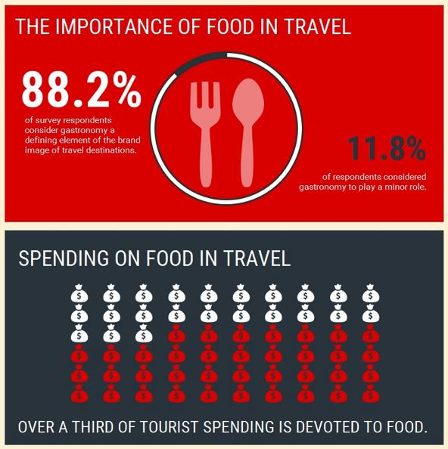

Fig 4. Food

Food plays a crucial role in shaping travel experiences, with a large majority of tourists viewing gastronomy as a key part of a destination’s identity.

A significant portion of travel spending is also dedicated to food, highlighting its importance in influencing tourist satisfaction and overall trip value.
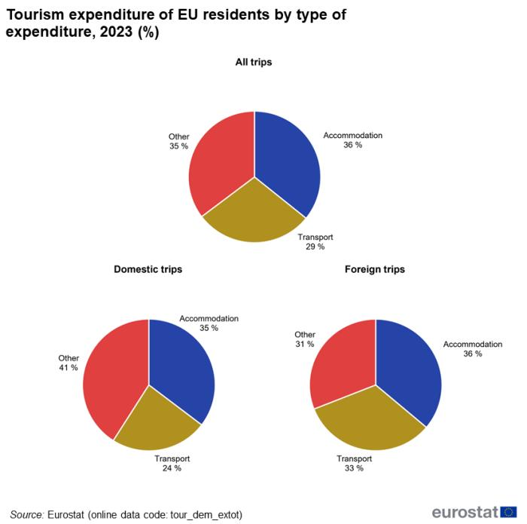

Fig 5 Expenditure pattern EU resident

Similar to broader tourism trends, spending in Ayodhya is also likely to be concentrated around accommodation and transport as visitor numbers continue to rise.
However, given its pilgrimage nature, a larger share of expenditure may also go toward food, local services, and religious offerings, reflecting the unique consumption pattern of faith-based tourism.
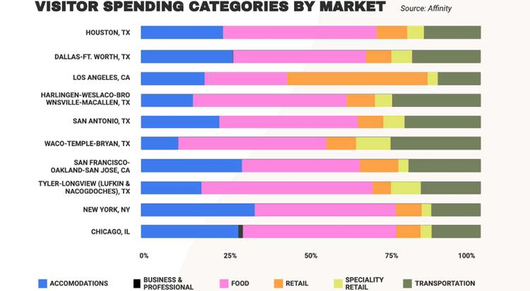

Fig 6 Visitor Spending Category
Visitor spending patterns across markets show that accommodation and food consistently take up the largest share, followed by transport and retail expenses.

In Ayodhya, a similar trend can be expected, with pilgrims spending primarily on lodging, meals, and local travel, while retail and religious purchases form a smaller but meaningful share.

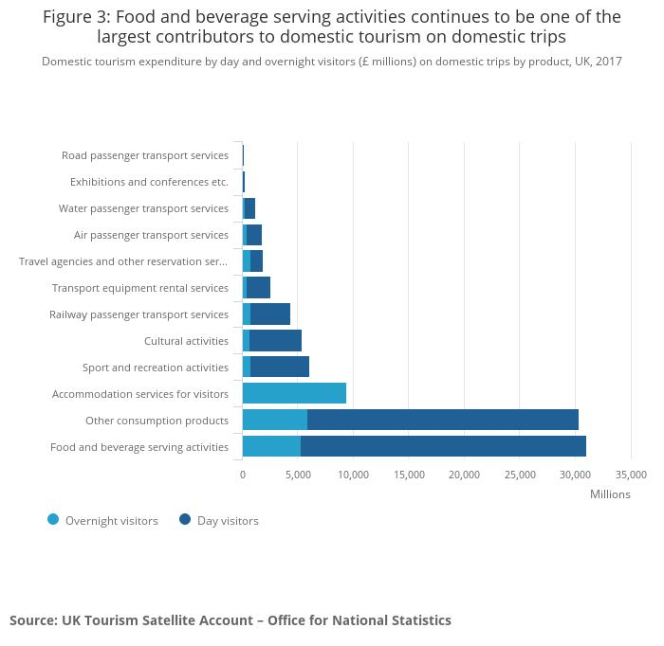

Fig 7. Food serving activities

Food and beverage services emerge as one of the largest contributors to tourism spending, followed by accommodation and other consumption activities.

In Ayodhya, this pattern is highly relevant, as pilgrims tend to spend significantly on food, prasad, and basic lodging, making these sectors key drivers of the local tourism economy.

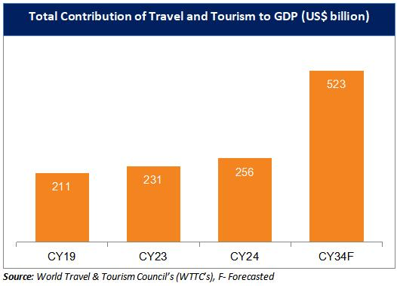

Fig 8 GDP Contribution
The contribution of travel and tourism to GDP shows a strong upward trend, with projections indicating a sharp rise to USD 523 billion in the coming years.

For Ayodhya, this reflects growing economic potential, as increasing tourist inflows can significantly boost local income, infrastructure development, and employment opportunities.

The analysis indicates that food and beverage services dominate the tourism expenditure basket, accounting for nearly half of total spending. This is followed by automotive services, accommodation, and domestic transportation. Lower shares are observed in segments such as entertainment, local transport, and travel services.
This distribution reveals several important insights:
First, the dominance of food and beverage services highlights the central role of local consumption experiences in religious tourism. Unlike luxury tourism, pilgrimage-based travel tends to emphasize affordability, accessibility, and community-based services. Visitors often engage with local vendors, small restaurants, and informal markets, thereby contributing directly to grassroots economic activity.
Second, the relatively lower share of high-value services such as international travel and premium entertainment suggests that Ayodhya’s tourism model is currently domestically driven and mass-oriented. This aligns with broader trends in Indian religious tourism, where domestic pilgrims constitute the majority of visitors (UNWTO, 2023).
Third, the moderate contribution of accommodation and transport services reflects ongoing infrastructure development. While significant investments have been made, the ecosystem is still evolving to accommodate higher-value tourism segments. This presents an opportunity for strategic expansion, particularly in hospitality and mobility services.
From a dynamic capabilities perspective, these findings indicate strong sensing capabilities, where stakeholders have identified the importance of basic service sectors in supporting tourism growth. However, the relatively low diversification of spending suggests that further seizing and transforming efforts are required to enhance value addition.

4.3 Tourism Spending Volume and Economic Contribution
The second diagram provides insights into the absolute value of tourism-related expenditures.
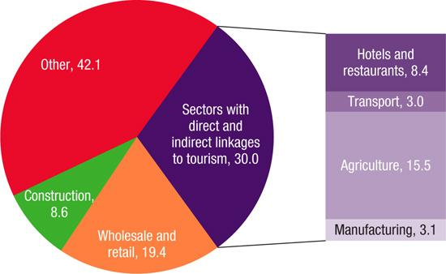

Fig 9. Absolute value of tourism expenditure

Tourism’s economic impact extends beyond direct sectors, with significant contributions from retail, construction, and other supporting industries.

In Ayodhya, this multiplier effect is evident as pilgrimage-driven demand boosts local businesses, agriculture supply chains, and infrastructure development alongside core tourism services.

Fig 10. Expected GDP Contribution by 2024
The travel and tourism sector shows a strong upward trajectory in GDP contribution, with projections indicating a significant jump to USD 523 billion in the future.

For Ayodhya, this signals expanding economic opportunities, as rising pilgrimage tourism can drive sustained growth in income, jobs, and local development.

The data show that food and beverage services generate the highest absolute expenditure, followed by automotive services and accommodation. This reinforces the earlier observation regarding the importance of consumption-driven economic activity in Ayodhya’s tourism ecosystem.
The high spending in automotive services is particularly noteworthy, as it reflects the role of regional connectivity and private mobility in facilitating pilgrimage travel. Many visitors rely on personal or hired vehicles, indicating gaps in public transport infrastructure and opportunities for improvement.
Additionally, the relatively lower spending in organized travel services suggests that informal and unstructured tourism channels dominate the market. This has implications for policy and governance, as it may limit the ability to regulate quality, ensure safety, and capture revenue.
From a theoretical standpoint, these findings illustrate the seizing dimension of dynamic capabilities, where identified opportunities are translated into economic outcomes through service provision and infrastructure development. However, the uneven distribution of spending highlights the need for systemic transformation to create a more balanced and resilient tourism economy.

4.4 GDP Impact and Economic Growth Projections
One of the most significant findings of this study relates to the projected GDP impact of tourism in Ayodhya.
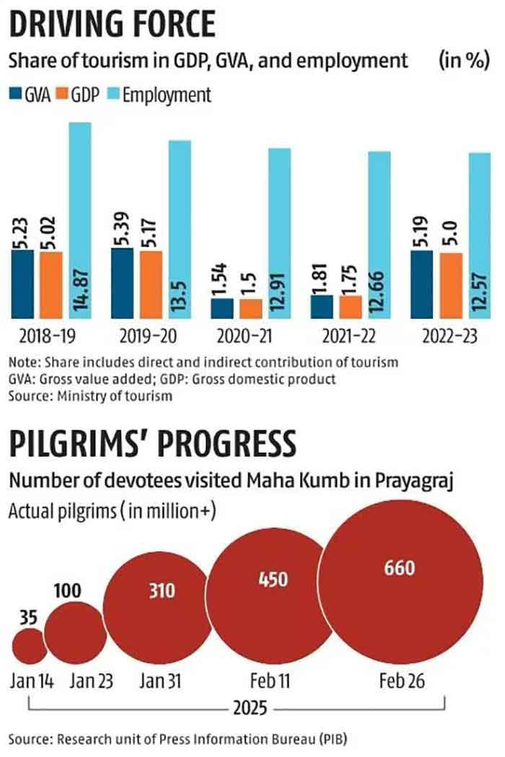

Fig 11. Actual pilgrims in Maha Kumbh

Tourism has remained an important pillar of India’s economy, with its contribution to GDP, GVA, and employment showing resilience even after the pandemic slowdown.

At the same time, the Maha Kumbh 2025 saw an overwhelming surge in pilgrims from 35 million to 660 million reflecting the immense cultural pull and growing scale of religious tourism in India
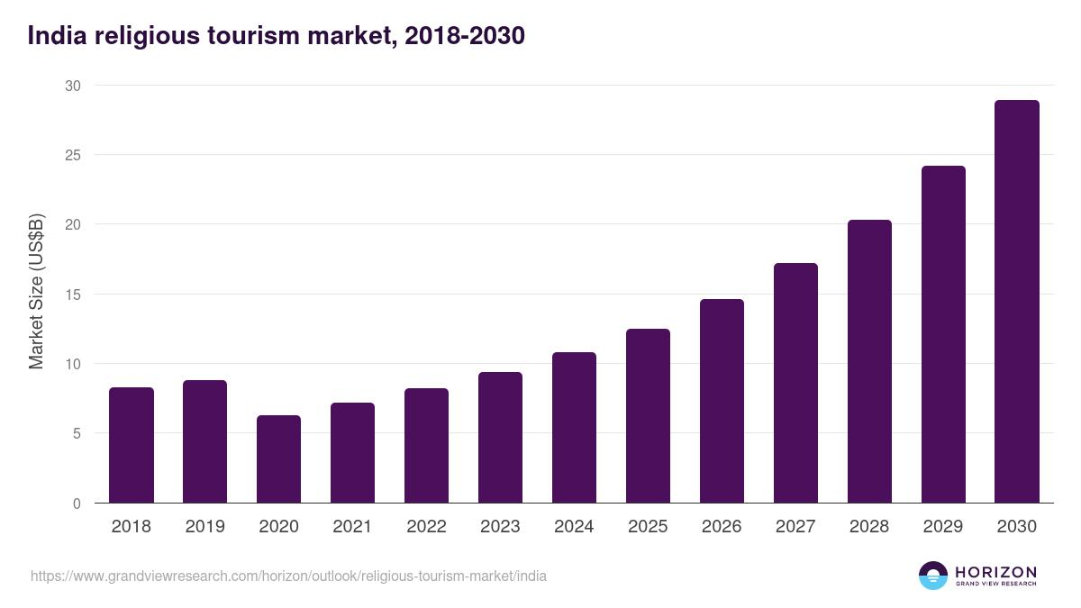

Fig 12 . Expected forecast
India’s religious tourism market shows a strong upward trajectory, recovering from the 2020 dip and expanding steadily toward nearly $30 billion by 2030.

This growth reflects rising spiritual travel demand, improved infrastructure, and increasing government focus on pilgrimage tourism development.
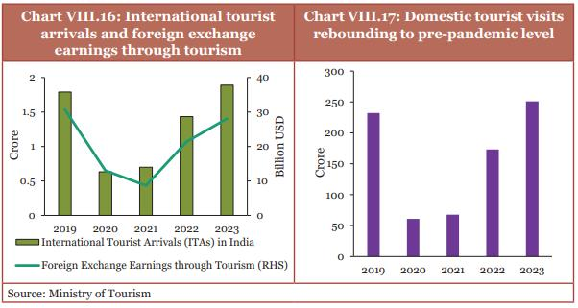

Fig 13. FX Earnings

International tourist arrivals and foreign exchange earnings in India show a clear recovery after the pandemic dip, with strong growth visible by 2023.

Similarly, domestic tourism has rebounded rapidly, even surpassing pre-pandemic levels, highlighting the strength of internal travel demand.
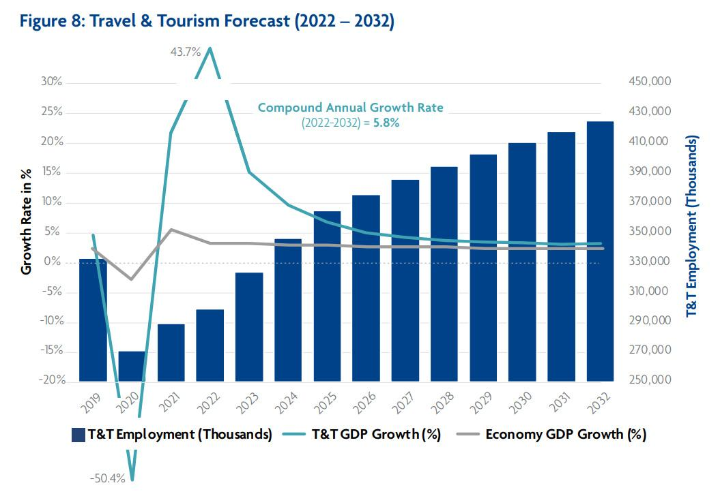

Fig 14. International Tourism Forecast

The travel and tourism sector is projected to grow steadily through 2032, with employment rising consistently alongside economic recovery.

Despite earlier fluctuations, the sector shows a stable growth path with a moderate CAGR of around 5.8%, reflecting long-term resilience and expansion potential.
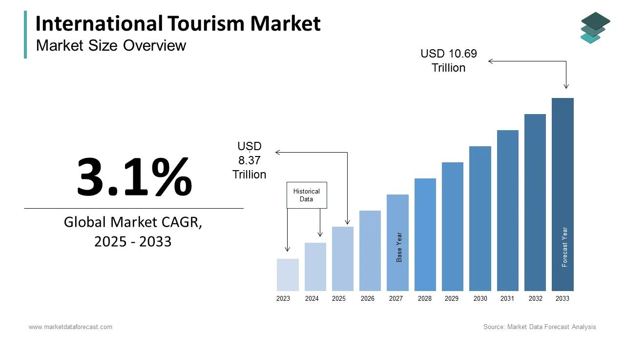

Fig 15. Market size overview

The global international tourism market is expected to expand steadily, growing from about USD 8.37 trillion to USD 10.69 trillion by 2033.

With a CAGR of 3.1%, the sector reflects stable long-term growth driven by rising global travel demand and economic recovery.
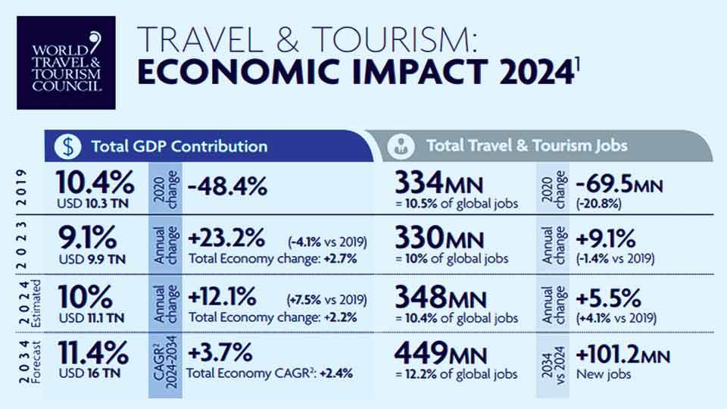
Fig 16. World data tour and travel impact
The travel and tourism sector continues to be a major contributor to the global economy, with its GDP share projected to rise to 11.4% in the coming years.
Employment in the sector is also set to grow significantly, reaching around 449 million jobs, highlighting its critical role in global job creation and economic recovery.

The projections indicate a steady increase in tourism-related GDP contribution, rising from approximately INR 135 billion in 2026 to over INR 318 billion by 2030 under the base scenario. This represents substantial economic growth driven by increased visitor inflows, higher spending, and expanded service offerings.
The scenario band further suggests that under optimistic conditions, the GDP impact could reach nearly INR 400 billion, highlighting the potential for accelerated growth if current trends continue. This growth trajectory underscores the transformative potential of religious tourism as a driver of regional development.
From a dynamic capabilities perspective, this reflects strong seizing capabilities, where investments in infrastructure, policy support, and service expansion have translated into measurable economic outcomes. The upward trend also indicates effective transforming capabilities, as the tourism ecosystem adapts to increasing demand and evolving market conditions.
However, the rapid pace of growth also raises concerns regarding sustainability. Without adequate planning, such expansion could lead to congestion, environmental degradation, and resource constraints. Therefore, the challenge lies in managing growth in a way that balances economic benefits with long-term sustainability.

4.5 Visitor Growth Dynamics and Benchmarking
The final set of results examines visitor growth trends in comparison with other major pilgrimage destinations.
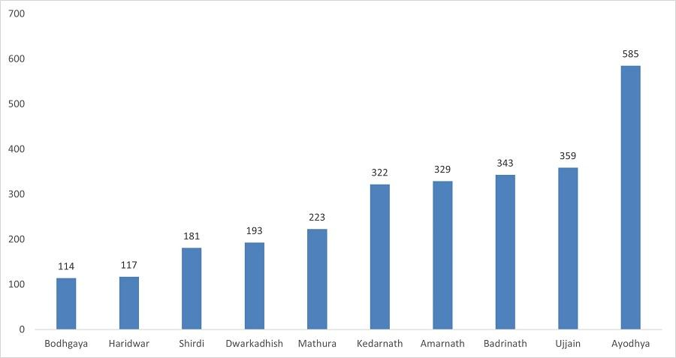

Fig 17. Upward Trend for Ayodhya pilgrimage

Pilgrimage destinations across India are witnessing steady growth in visitor numbers, with cities like Kedarnath, Badrinath, and Ujjain attracting significantly higher footfall.

Ayodhya stands out with the highest surge, reaching around 585 units, reflecting its rapidly rising prominence as a major religious tourism hub.
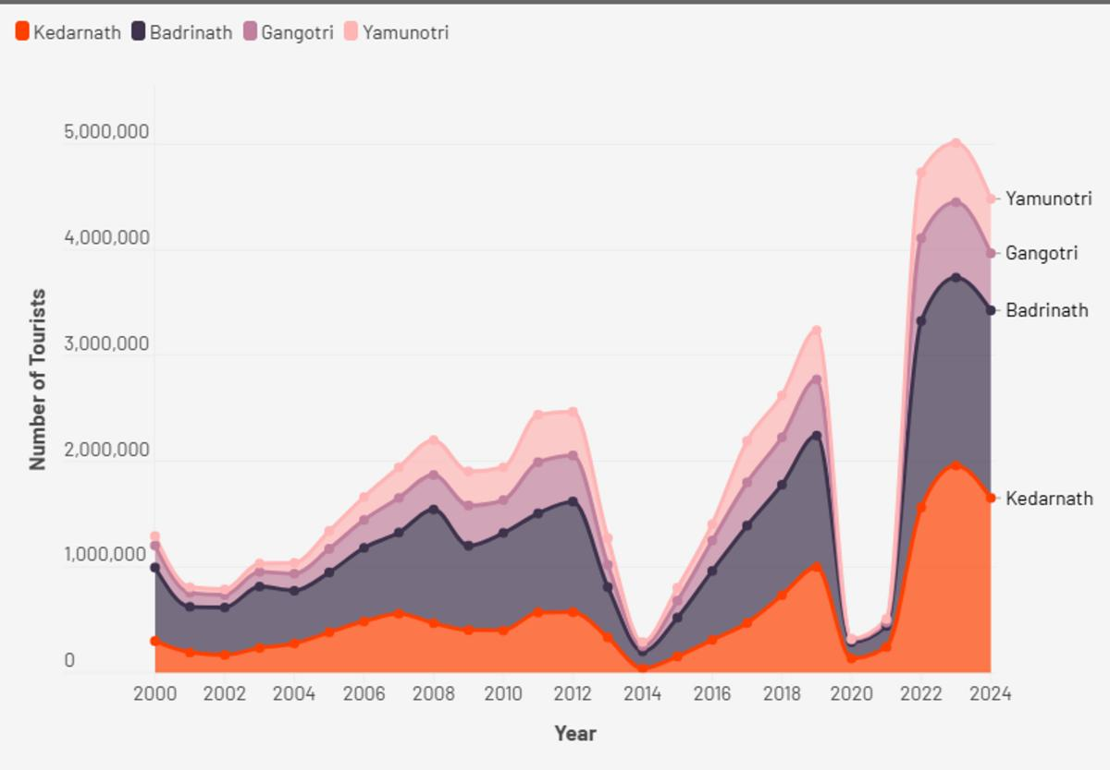
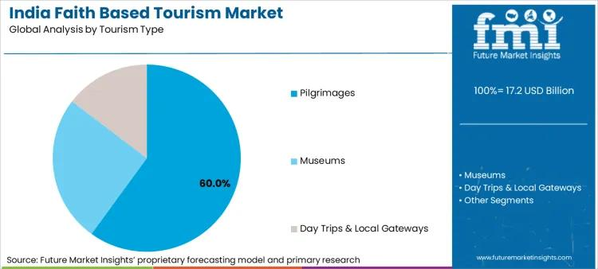

Fig 18. India Faith based tourism market

Tourist arrivals across the Char Dham destinations show strong fluctuations, with a sharp decline around 2013 -14 followed by a steady recovery in the following years.

By 2022-24, visits surge dramatically across Kedarnath, Badrinath, Gangotri, and Yamunotri, indicating renewed faith-driven travel and improved accessibility.
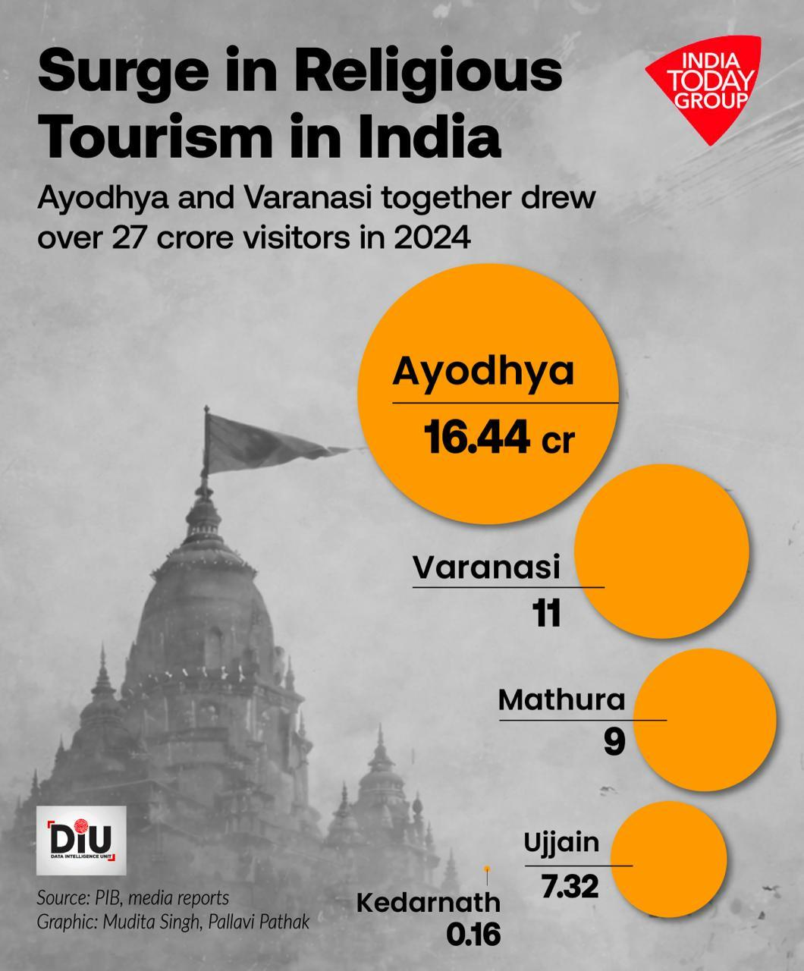

Fig 19. Surge in religious tourism in India

Religious tourism in India has seen a remarkable surge, with Ayodhya and Varanasi alone attracting over 27 crore visitors in 2024.

Ayodhya leads prominently with 16.44 crore visitors, underscoring its emergence as a dominant spiritual destination alongside other key pilgrimage cities.

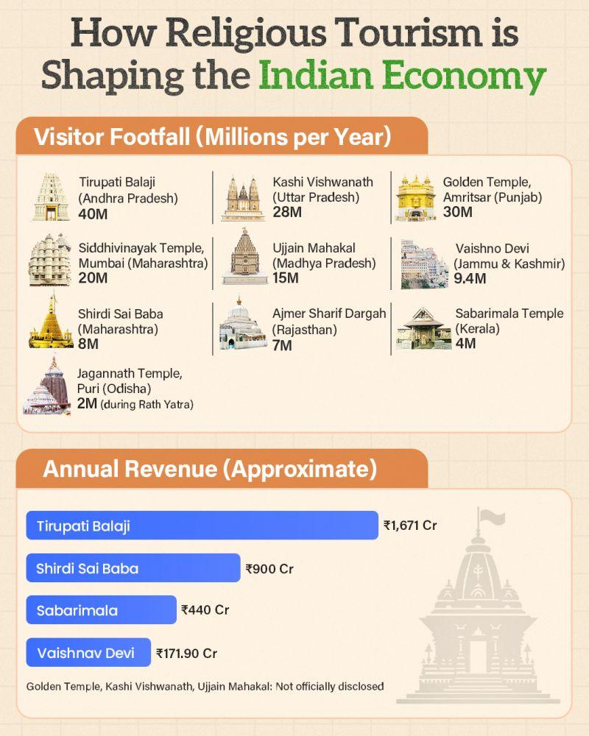

Fig 20. How religious tourism shaping market

Religious tourism significantly contributes to India’s economy, with major pilgrimage sites like Tirupati, Kashi, and Amritsar attracting millions of visitors annually.

These destinations also generate substantial revenue, led by Tirupati Balaji, highlighting the strong economic impact of faith-based travel.

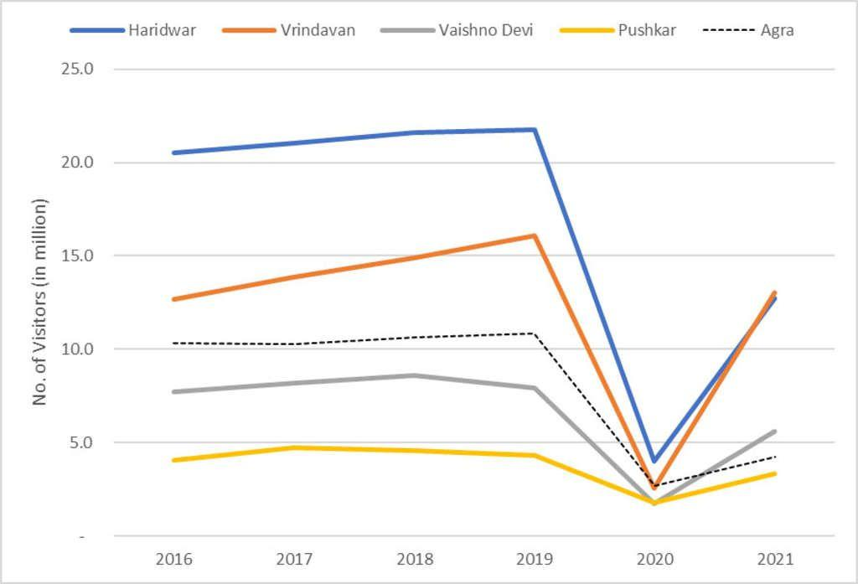

Fig 21. No. of tourist visitors –domestic

Visitor numbers across major destinations like Haridwar, Vrindavan, and Vaishno Devi show a steady rise until 2019, followed by a sharp decline in 2020 due to the pandemic.
By 2021, there is a clear recovery trend, indicating the resilience of religious and cultural tourism in India.
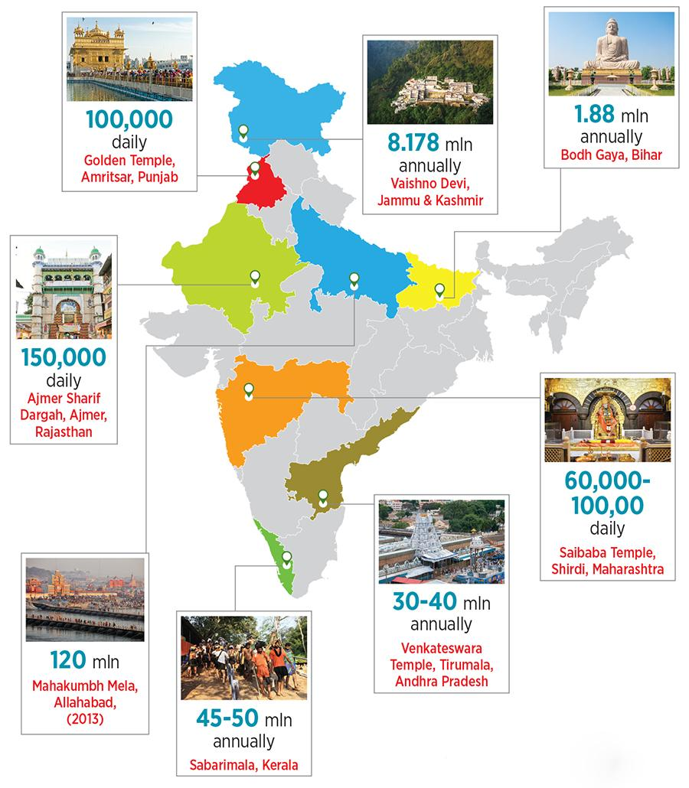

Fig 22. Nos. of visitors domestic

Religious tourism is widely spread across India, with key destinations like Tirupati, Vaishno Devi, and Sabarimala attracting millions of visitors each year.

Daily footfall at places such as the Golden Temple and Shirdi further highlights the continuous and large-scale movement of pilgrims across the country.

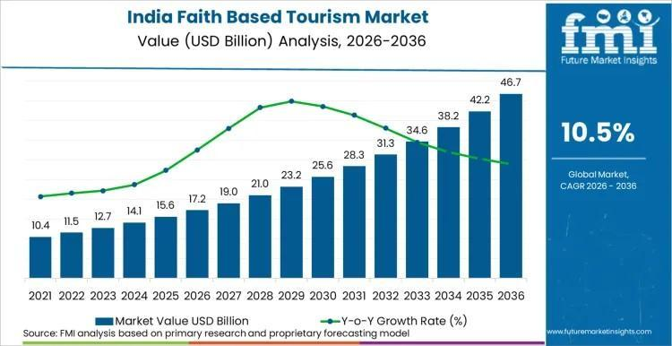
Fig 23. Value of faith

India’s faith-based tourism market is projected to grow steadily, reaching nearly USD 46.7 billion by 2036, reflecting strong long-term demand.

With an estimated CAGR of 10.5%, the sector highlights rapid expansion driven by rising spiritual travel and infrastructure development.
The analysis reveals that Ayodhya has experienced exponential growth in visitor numbers, significantly outpacing established destinations such as Tirupati, Vaishno Devi, and Varanasi. The visitor index for Ayodhya increases sharply, indicating a rapid surge in demand following recent developments.
This growth can be attributed to several factors, including heightened religious significance, improved infrastructure, and increased media attention. It also reflects strong sensing capabilities, where stakeholders have successfully identified and leveraged the cultural and spiritual importance of the destination.
In contrast, the relatively stable growth of other destinations suggests a more mature and saturated tourism market. While these destinations continue to attract large numbers of visitors, their growth rates are comparatively moderate, highlighting Ayodhya’s unique position as an emerging hotspot.
From a strategic perspective, this rapid growth presents both opportunities and challenges. On one hand, it creates significant economic potential and enhances the city’s visibility. On the other hand, it places pressure on infrastructure, services, and local communities, necessitating effective management and planning.

4.6 Discussion: Linking Results to Dynamic Capabilities
The findings of this study provide strong empirical support for the application of the dynamic capabilities framework in understanding tourism development.

Sensing Capabilities
Ayodhya demonstrates strong sensing capabilities through the recognition of its religious and cultural potential. Policy initiatives, infrastructure planning, and promotional efforts indicate a clear understanding of emerging opportunities in religious tourism. The rapid increase in visitor numbers further validates the effectiveness of these sensing activities.

Seizing Capabilities
The seizing dimension is reflected in the implementation of large-scale investments, development of tourism infrastructure, and expansion of service sectors. The growth in tourism-related GDP and expenditure highlights the ability of stakeholders to capitalize on identified opportunities.

Transforming Capabilities
The transformation of Ayodhya’s tourism ecosystem is evident in the diversification of services, integration of technology, and expansion of economic activities. However, the uneven distribution of spending and emerging sustainability challenges indicate that transformation is still an ongoing process.

4.7 Sustainability and Policy Implications
The results highlight the need for a balanced approach to tourism development that integrates economic growth with sustainability considerations. Key policy implications include:
- Infrastructure Planning: Enhancing public transport, waste management, and urban planning to accommodate increasing visitor numbers.
- Ecosystem Diversification: Promoting high-value services such as cultural tourism, heritage experiences, and organized travel.
- Community Participation: Ensuring that local communities benefit from tourism through employment and entrepreneurship opportunities.
- Environmental Management: Implementing sustainable practices to minimize ecological impact.
These measures align with the principles of sustainable tourism and dynamic capabilities, emphasizing adaptability, innovation, and long-term planning (Butler, 1999).

4.8 Summary of Results
In summary, the results demonstrate that Ayodhya’s transformation is driven by a combination of strong dynamic capabilities and favorable external conditions. The city has successfully leveraged its religious significance to attract visitors, generate economic activity, and expand its tourism ecosystem. However, sustaining this growth will require continuous adaptation, effective governance, and a commitment to sustainability.

5. Conclusions

5.1 Summary of the Study

This study set out to examine how dynamic capabilities shape the development of religious tourism in Ayodhya, a destination that has recently undergone rapid transformation due to cultural revival, infrastructural investments, and increasing visitor demand. By integrating the dynamic capabilities framework with tourism ecosystem theory and sustainability perspectives, the research provides a comprehensive understanding of how destinations can adapt to evolving conditions while pursuing economic growth.

The findings reveal that Ayodhya’s transformation is not merely a consequence of its religious significance but a result of deliberate strategic actions and coordinated efforts among multiple stakeholders. The application of sensing, seizing, and transforming capabilities has enabled the city to identify opportunities, mobilize resources, and reconfigure its tourism ecosystem in response to growing demand. At the same time, the study highlights the importance of sustainability and inclusivity in ensuring that tourism development delivers long-term benefits.

5.2 Key Findings and Contributions

One of the central contributions of this study lies in demonstrating the relevance of dynamic capabilities in a religious tourism context. While previous research has largely focused on firms and industries, this study extends the framework to a destination-level analysis, emphasizing the role of collective action and ecosystem dynamics. The findings show that sensing capabilities in Ayodhya are reflected in the recognition of its cultural and spiritual potential, supported by policy initiatives and strategic planning.

Seizing capabilities are evident in the implementation of infrastructure projects, expansion of hospitality services, and integration of digital technologies. These efforts have translated into measurable economic outcomes, including increased tourism expenditure and significant contributions to regional GDP. The projected growth trajectory further underscores the effectiveness of these capabilities in capturing opportunities.

Transforming capabilities are reflected in the ongoing evolution of the tourism ecosystem, characterized by diversification of services, increased stakeholder participation, and integration of modern management practices. However, the transformation process is not complete, as challenges related to sustainability, resource management, and equitable distribution of benefits remain.

Another important finding relates to the structure of tourism consumption, where food and beverage services dominate expenditure patterns. This highlights the role of local and informal economic activities in supporting tourism growth, while also pointing to the need for diversification into higher-value services. The rapid increase in visitor numbers further reinforces Ayodhya’s position as an emerging religious tourism hub, surpassing traditional destinations in terms of growth rate.

5.3 Theoretical Implications

From a theoretical perspective, this study contributes to the literature in several ways. First, it extends the application of the dynamic capabilities framework to the domain of tourism, particularly in the context of religious destinations. By conceptualizing destinations as complex, multi-stakeholder systems, the study demonstrates how dynamic capabilities operate at a systemic level rather than being confined to individual organizations (Teece, 2007).

Second, the integration of tourism ecosystem theory provides a more holistic understanding of how value is co-created through interactions among stakeholders. This approach highlights the importance of coordination, collaboration, and governance in shaping tourism outcomes. The findings suggest that dynamic capabilities are not only about internal processes but also about managing relationships and networks within the ecosystem.

Third, the study contributes to the growing body of research on sustainable tourism by linking dynamic capabilities with sustainability outcomes. The ability to sense environmental and social challenges, seize opportunities for sustainable practices, and transform systems accordingly is critical for achieving long-term viability (Butler, 1999). This integrated perspective provides a valuable framework for future research.

5.4 Practical and Policy Implications

The findings of this study have important implications for policymakers, tourism authorities, and industry stakeholders. As Ayodhya continues to experience rapid growth, there is a need for strategic planning and governance mechanisms that ensure balanced and sustainable development.

One of the key priorities is infrastructure development, particularly in areas such as transportation, accommodation, and urban services. While significant progress has been made, the increasing volume of visitors requires continuous investment and innovation to maintain service quality and avoid congestion. Public transport systems, in particular, need to be strengthened to reduce reliance on private vehicles and improve accessibility.

Another important area is ecosystem diversification. The current concentration of expenditure in basic services highlights the need to develop higher-value segments such as cultural tourism, heritage experiences, and organized travel services. This would not only enhance visitor experience but also increase economic returns and create new employment opportunities.

Community participation is also critical for ensuring inclusive development. Local communities should be actively involved in tourism activities, with opportunities for entrepreneurship, skill development, and income generation. Policies should aim to support small businesses, promote local products, and ensure that the benefits of tourism are distributed equitably.

Environmental sustainability must be a central consideration in all development initiatives. Measures such as waste management, water conservation, and pollution control are essential to minimize the ecological impact of tourism. In addition, preserving the cultural and spiritual integrity of the destination is crucial to maintaining its authenticity and appeal.

The integration of digital technologies offers further opportunities for enhancing tourism management. Smart tourism solutions, including data analytics, online platforms, and real-time monitoring systems, can improve efficiency, enhance visitor experience, and support decision-making. However, these technologies should be implemented in a way that is inclusive and accessible to all stakeholders.

5.5 Limitations and Future Research Directions

While this study provides valuable insights, it is important to acknowledge its limitations. The reliance on secondary data limits the ability to capture real-time perspectives and experiences of stakeholders. Future research could incorporate primary data collection methods, such as interviews, surveys, and field observations, to provide a more comprehensive understanding of tourism dynamics.

Another limitation is the focus on a single case study, which may limit the generalizability of findings. Comparative studies involving multiple destinations could provide broader insights and help identify common patterns and differences. For example, comparing Ayodhya with other major pilgrimage destinations could enhance our understanding of how dynamic capabilities operate in different contexts.

Further research could also explore the role of specific factors, such as governance structures, cultural influences, and technological adoption, in shaping tourism development. Quantitative studies using methods such as structural equation modeling (SEM) could be used to test the relationships proposed in this study and provide empirical validation.

5.6 Final Outcome

The transformation of Ayodhya represents a compelling example of how religious tourism can drive economic development when supported by strong dynamic capabilities. The study demonstrates that sensing, seizing, and transforming capabilities are critical for identifying opportunities, mobilizing resources, and adapting to changing conditions.

At the same time, the findings underscore the importance of sustainability and inclusivity in ensuring that tourism development delivers long-term benefits. As Ayodhya continues to evolve, it offers valuable lessons for other destinations seeking to harness the potential of religious tourism while addressing the challenges of growth and transformation.

Ultimately, the success of tourism development depends not only on the availability of resources but also on the ability to use them effectively and responsibly. By adopting a dynamic and integrated approach, destinations can achieve a balance between economic growth, cultural preservation, and environmental sustainability, thereby creating a resilient and thriving tourism ecosystem.

References

Baggio, R., & Cooper, C. (2010). Knowledge transfer in a tourism destination: The effects of a network structure. Service Industries Journal, 30(10), 1757–1771. https://doi.org/10.1080/02642060903580649

Barney, J. (1991). Firm resources and sustained competitive advantage. Journal of Management, 17(1), 99–120. https://doi.org/10.1177/014920639101700108

Buhalis, D., & Amaranggana, A. (2015). Smart tourism destinations enhancing tourism experience through personalization of services. In I. Tussyadiah & A. Inversini (Eds.), Information and communication technologies in tourism 2015 (pp. 377–389). Springer. https://doi.org/10.1007/978-3-319-14343-9_28

Butler, R. W. (1999). Sustainable tourism: A state-of-the-art review. Tourism Geographies, 1(1), 7–25. https://doi.org/10.1080/14616689908721291

Butler, R. W. (2006). The concept of a tourist area cycle of evolution: Implications for management of resources. In R. W. Butler (Ed.), The tourism area life cycle (pp. 3–12). Channel View Publications.

Denzin, N. K., & Lincoln, Y. S. (2018). The SAGE handbook of qualitative research (5th ed.). Sage Publications.

Eisenhardt, K. M., & Martin, J. A. (2000). Dynamic capabilities: What are they? Strategic Management Journal, 21(10–11), 1105–1121. https://doi.org/10.1002/1097-0266(200010/11)21:10/11
<1105::AID-SMJ133>3.0.CO;2-E

Gössling, S., Scott, D., & Hall, C. M. (2020). Pandemics, tourism and global change: A rapid assessment of COVID-19. Journal of Sustainable Tourism, 29(1), 1–20. https://doi.org/10.1080/09669582.2020.1758708

Hall, C. M. (2008). Tourism planning: Policies, processes and relationships (2nd ed.). Pearson Education.

Haugland, S. A., Ness, H., Grønseth, B. O., & Aarstad, J. (2011). Development of tourism destinations: An integrated multilevel perspective. Annals of Tourism Research, 38(1), 268–290. https://doi.org/10.1016/j.annals.2010.08.016

Krippendorff, K. (2018). Content analysis: An introduction to its methodology (4th ed.). Sage Publications.

Lee, J., & Bai, B. (2016). Influence of popular culture on special interest tourists’ destination image. Tourism Management, 52, 161–169. https://doi.org/10.1016/j.tourman.2015.06.019

Lew, A. A. (2017). Tourism planning and place making: Place-making or placemaking? Tourism Geographies, 19(3), 448–466. https://doi.org/10.1080/14616688.2017.1282007

Mair, J., Ritchie, B. W., & Walters, G. (2016). Towards a research agenda for post-disaster and post-crisis recovery strategies for tourist destinations. Tourism Management, 52, 1–12. https://doi.org/10.1016/j.tourman.2015.06.017

Mihalic, T. (2020). Conceptualising overtourism: A sustainability approach. Annals of Tourism Research, 84, 103025. https://doi.org/10.1016/j.annals.2020.103025

Pine, B. J., & Gilmore, J. H. (1999). The experience economy: Work is theatre and every business a stage. Harvard Business School Press.

Porter, M. E. (1990). The competitive advantage of nations. Free Press.

Ritchie, J. R. B., & Crouch, G. I. (2003). The competitive destination: A sustainable tourism perspective. CABI Publishing. https://doi.org/10.1079/9780851996646.0000

Scott, D., Hall, C. M., & Gössling, S. (2019). Global tourism vulnerability to climate change. Annals of Tourism Research, 77, 49–61. https://doi.org/10.1016/j.annals.2019.05.007

Sigala, M. (2020). Tourism and COVID-19: Impacts and implications for advancing and resetting industry and research. Journal of Business Research, 117, 312–321. https://doi.org/10.1016/j.jbusres.2020.06.015

Teece, D. J. (2007). Explicating dynamic capabilities: The nature and microfoundations of (sustainable) enterprise performance. Strategic Management Journal, 28(13), 1319–1350. https://doi.org/10.1002/smj.640

Teece, D. J., Pisano, G., & Shuen, A. (1997). Dynamic capabilities and strategic management. Strategic Management Journal, 18(7), 509–533. https://doi.org/10.1002/(SICI)1097-0266(199708)18:7
<509::AID-SMJ882>3.0.CO;2-Z

Timothy, D. J., & Nyaupane, G. P. (2009). Cultural heritage and tourism in the developing world. Routledge.

Timothy, D. J., & Olsen, D. H. (2006). Tourism, religion and spiritual journeys. Routledge.

World Tourism Organization (UNWTO). (2023). Tourism and sustainable development report. https://www.unwto.org

World Tourism Organization (UNWTO). (2024). International tourism highlights. https://www.unwto.org

Wang, Y., & Pizam, A. (2011). Destination marketing and management: Theories and applications. Journal of Travel Research, 50(1), 5–7. https://doi.org/10.1177/0047287510376379

Xiang, Z., & Gretzel, U. (2010). Role of social media in online travel information search. Tourism Management, 31(2), 179–188. https://doi.org/10.1016/j.tourman.2009.02.016

Yin, R. K. (2018). Case study research and applications: Design and methods (6th ed.). Sage Publications.

Zhang, H., Song, H., & Huang, G. Q. (2009). Tourism supply chain management: A new research agenda. Tourism Management, 30(3), 345–358. https://doi.org/10.1016/j.tourman.2008.12.010

