KARPA KIRANTHI ENNAI IN UTERINE DISORDER- A CLINICAL INSIGHT
Sowmya.M ¹, Anusiya Devi.J ², Lakshmi Priya.M.A ³, Janani.A.M ⁴
1,2,3 UG Scholar, B.S.M.S, Nandha Siddha Medical College and Hospital, Erode-52
4 Guide, Assistant Professor, Department of Gunapadam-Marunthakkaviyal, Nandha Siddha Medical College and Hospital, Erode-52
Corresponding author email ID: anusiya9901@gmail.com

ABSTRACT:
Female uterine disorder, including dysmenorrhea, menorrhagia and infertility are increasingly prevalent in reason years, significantly affecting women’s quality of life & reproductive health. Karpa kiranthi ennai – a traditional Siddha medicine is recognised for its beneficial effects on uterine wellness. This herbal- mineral oil is formulated using sesame oil (ellu ennai), garlic (poondu) & purified sulphur (gandhagam), each contributing unique pharmacological properties. The formulation is believed to enhance udal thee (digestive & metabolic fire), improve circulation and regulate reproductive function. This article presents a comprehensive literature review on the formulation, traditional indication and ovulating classical concepts with contemporary perspectives on reproductive health.
Keywords: Infertility, Karpa kiranthi ennai/oil, Reproductive health, Udal thee, Uterine disorder.
INTRODUCTION:
Female uterine disorder such as dysmenorrhea, menorrhagia & infertility represent a growing public health concern worldwide, with rising incidence attributed to lifestyle modification, chromosomal imbalance, metabolic dysfunction and chronic inflammatory state⁷. These condition significantly affect the women’s reproductive health, quality of life and psychological will being. Conventional therapeutic approaches largely emphasize symptomatic management, often associated with adverse effects and limited long term efficiency, underscoring the need for safe, holistic and is sustainable treatment options⁷.

REVIEW OF LITERATURE:
KARPAKIRANTHI ENNAI
Serial number | Ingredients | Bioactive compound | Action
1. | Gandhagam (purified sulphur) |  | Antimicrobial  Body rejuvenating | 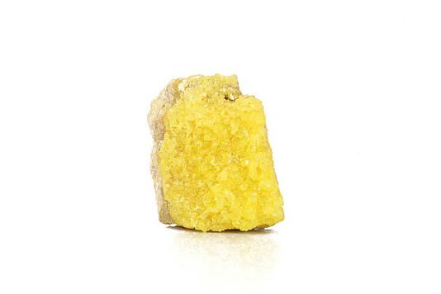
2. | Garlic (Allium sativum) | Allium (diallyl thiosulfinate) | Strong antimicrobial antioxidant | 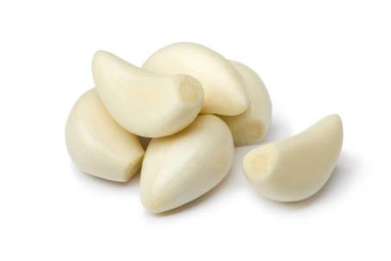
 |  | Ajoene (E/Z ajoene) | Antithrombotic (prevent blood clot)  Anticancer property
 |  | DAS  DADS  DATS (Sulphur containing compound) | Associated with anticancer &  anti inflammatory
3. | Sesame oil (Sesamum indicum) | Flavonoids | Activate enzyme known as aromatase: enhance folliculogenesis  Reduce inflammation | 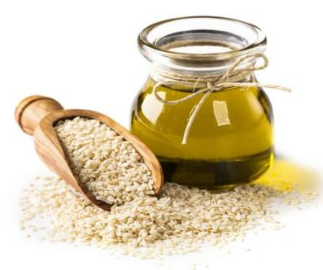
 |  | Sesamin | Restore Estradiol/progesterone
 |  | Sesamol | Antioxidant
Table No:1- Based on ingredients and their action^{1,2,3,4,5}

METHODS:
Ingredient required:
1. Purified sulphur (suthiththa gandhagam) - 10g
2. Poondu (Allium sativum) -1 no
3. Sesamum oil (Sesamum indicum)- 1L
Procedure:
- Peel the garlic and grind it with purified Sulphur (gandhagam) in mortar and pestle.
- Make it as a paste.
- Coat this paste inside of an iron pan.
- add sesame oil and heated on low flame.
- When it turns red, filter it & seal it in a glass bottle.
Usage:
- Begin taking this karpa kiranthi ennai 2 days before the onset of menstruation and continue for 10 days.
- Half cooked egg (when the yolk is still soft) add 10 drops of this Karpa kiranthi ennai. Once the yolk is observe the oil & then consume it.
- Alternatively, 10 to 20 drops of Karpa kiranthi oil can be mixed with powdered white sugar and given.
Dietary restrictions:
- Avoid meat and fish
- Don’t add spices
- (Include milk, buttermilk, curd, ghee)
Indications:
- Infertility
- Excessive menstrual bleeding
- Menstrual cramps⁶
RESULT:
The review of classical siddha text and contemporary scientific literature revealed consistent therapeutic indication of Karpa kiranthi ennai in the management of female uterine disorders, particularly dysmenorrhea, menorrhagia, female infertility⁶. Classical sources describe the formulation as udal thee- enhancing, vatha-kapha balancing, garbhasaya (uterine) strengthening³.Pharmacological evidence from modern studies indicate studies that sesame oil act as an effective liquid carries, improving absorption and tissue penetration of bioactive constituents². Garlic (Allium sativum) was found to contain allicin, DAS,DADS and micronutrients exhibiting anti-inflammatory, antioxidant, antimicrobial, antispasmodic and hormone modulating properties⁴. Purified sulphur demonstrated detoxifying, catalytic & tissue rejuvenating actions, contributing to metabolic regulation and cellular repair⁵.The synergistic interaction of these components support improved uterine circulation, regulation of menstrual flow, reduction of inflammatory mediators, modulation of endocrine function and enhancement of reproductive tissue health collectively, the literature support the traditional claims of Karpa kiranthi ennai in addressing functional and metabolic aspect of uterine disorders⁶.
DISCUSSION:
Uterine disorders are multifactorial in origin, involving hormonal imbalance, inflammatory pathways, oxidative stress and impaired metabolic activity⁷. Siddha medicine attributes these condition primarily to derangement of udal thee, leading to improper tissue nourishment and reproductive dysfunction³. They finding of their review demonstrate that Karpa kiranthi ennai aligns with this conceptual framework though it metabolic enhancing under tissue restorative actions. Garlic bioactive sulphur components are known for inhibit prostaglandin synthesis, reduce uterine spasm, and modulate oestrogenic activity, which may explain its effectiveness in dysmenorrhea & menorrhagia⁴.It’s antioxidant and anti-inflammatory properties further contribute to endometrial stability and improved pelvic circulation¹. Sesame oil, rich in polyunsaturated fatty acids and antioxidants, support hormonal balance and acts as a potent drug delivery medium².Purified sulphur enhance cellular metabolism and detoxification, which may aid follicular maturation and implantation³.The synergistic formulation addresses both symptomatic relief and underlying pathology, offering a holistic approach distinct from conventional symptomatic therapies. While classical and pharmacological evidence is supportive, the absence of largescale clinical trials reminds a limitation, emphasising the need for further experimental and clinical validation.
CONCLUSION:
This literature review highlights therapeutic relevance of Karpa kiranthi ennai in the management of female uterine disorder such as dysmenorrhea, menorrhagia, infertility⁶.The formulations traditional Siddha indication are substantiate by modern pharmacological evidence demonstrating anti- inflammatory, antioxidant, hormone modulating and metabolic enhancing properties of its ingredients. The synergistic action of sesame oil, garlic and purified sulphur support uterine health by improving circulation, regulation of menstrual function and enhancing reproductive tissue vitality. Karpa kiranthi ennai thus emerges as a promising traditional formulation with potential application in integrative gynaecological care⁶. Further clinical and experimental studies are warranted to establish its efficacy, safety profile, mechanism of action in contemporary healthcare settings.

ACKNOWLEDGEMENT:
The authors gracefully acknowledge Nandha Siddha Medical College And Hospital for providing a supportive environment and necessary facilities for the successful completion of this study. We are thankful to all individuals who directly or indirectly contributed to the completion of this study.
REFERENCE:
- Murugesa Mudaliyar KS. Gunapadam: Mooligai Vaguppu (Siddha Materia Medica). Chennai: Directorate of Indian Medicine and Homoeopathy; 2022.
- Al-Kadhi NA, Abass KS, Jaafar SE. Enhancement effect of sesame seeds oil on some physiological parameters in the serum of female mice treated with tamoxifen. EurAsian J Biosci. 2020;14(2):3669-3681. ISSN 1307-9867.
- Mithurendran B. Sulphur (Kanthakam) in Siddha medicine: its toxicological, medicinal and modern aspects. Int J Reverse Pharmacol Health Res. 2023;6(3):295-304. doi:10.1211/ijrphr/06.0302.295.
- Jafari F, Khalilzadeh S, Nejatbakhsh F. Therapeutic effects of garlic (Allium sativum) on female reproductive system: a systematic review. Heliyon. 2023;9:e22555. doi:10.1016/j.heliyon.2023.e22555.
- Thiyagarajan IR. Gunapadam: Thathu Vaguppu. C+hennai: Department of Indian Medicine and Homoeopathy; 2019.
- Balaramayya V. Anubava Siddha Vaithiya Muraigal. Chennai: Aruljothi Pathippagam; 1989.
- Daftary SN, Padubidri VG. Uterine disorders. In: Padubidri VG, Daftary SN, editors. Shaw's Textbook of Gynaecology. 13th ed. New Delhi: Elsevier India; 2004.

