Entrepreneurial Management in Digital Freelance Work: A Systematic Literature Review of Competencies, Barriers, Opportunities, and Performance Outcomes

James Rey M. Aponte, DBA
Instructor 1/Marikina Polytechnic College
Commission on Higher Education
Author e-mail: aponte.jrm@mpc.edu.ph

Eldon S. Aquino, Ph.D.
Division of Pasig City
Department of Education
Author email: eldon.aquino@deped.gov.ph

Abstract

This study examined the digital freelancing work has become a fast-facing form of entrepreneurship in the global digital economy. Information and Communication Technologies (ICT), digital platforms, and exterior work systems involved individuals to provide independent freelance work and renders focus services although out international markets. While digital freelance work grows, entrepreneurial management had become important for business sustainability, client acquisition, financial growth, and competencies. Despite increasing interest, studies remain underexamined across disciplines, making limited understanding of the competencies, barriers, opportunities, and performance outcomes among developing digital freelance workers. This systematic study reviews updated evidence on entrepreneurial management skills in digital freelance work. It evaluates core competencies requisites for entrepreneurial skills that ascertain barriers faced by digital freelancers. It was explored the opportunities in the digital economy and examined performance outcomes which associates to effective entrepreneurial management. The study follows the PRISMA 2020 following guideline to support transparency, rigor, and reproducibility. Connected studies were evaluated through organized searches of major academic databases screening predefined search keyword terms of the inclusion and exclusion criteria. These verified studies underwent screening, data extraction, standard assessment, and thematic synthesis. The results implied that the entrepreneurial management advance beyond technical expertise. It provides organized planning, digital marketing, financial management, client relationship management, innovation capability, adaptability, continuous learning, and digital competency. Meanwhile, the major barriers influence intense competition, finance instability, platform algorithm dependence, limited social protection, client acquisition difficulties, and work-life imbalance. This study concluded that as opportunities improved from digital platforms, artificial intelligence, technological innovation, and globalization in the international market access the performance outcomes also improved based on business sustainability, client retention, innovation, financial performance, and long-term entrepreneurial success.

Keywords: Digital Freelance Work; Entrepreneurship Management; Performance Outcomes; PRISMA 2020; Systematic Literature Review

1.0 Introduction
One way that digital transformation has changed entrepreneurship is by making work arrangement that breaks through the boundaries of how you used to limit yourself to your own organization. Technologies such as cloud computing, digital labor platforms, digital communication systems and remote work technologies have allowed professionals to become independent (digital) freelancers. Online Freelancing: Independent contracting in which workers offer their services via online labor platforms; managing one own clients, projects, pricing, and reputation as a professional. This change builds a entrepreneurial management critical to sustain freelance businesses in competitive digital markets (Kim et al., 2023; Gussek et al, 2024).
Digital freelancing has developed from short-term contract job into a form of online platform-based entrepreneurship. Freelancers are often self-employed individuals who work for many clients, pay their own taxes, manage projects, and operate remotely (Huđek, 2020). Updated studies also revealed that freelancers develop careers through portfolio development, continuous learning, skill diversification, and strategic positioning in online markets. These parameters position digital freelancers as micro-entrepreneurs rather than ordinary workers (Baitenizov et al., 2025).
Correspondingly, the entrepreneurial management in digital freelance work includes opportunity recognition, planning, financial management, digital branding, client acquisition, innovation, and adaptation to technological adjustment. Empirical evidence indicates that entrepreneurial skills training enhance online freelancing performance, such as profile creation, proposal submission, job offers, and contracts (Baptista et al., 2023; Fazio et al., 2025). Competency-based research also determine strategic thinking, innovation, financial management, and market orientation as success indicators profiles among digital freelancers (Segundo et al., 2025).
Similarly, the digital labor platforms have develop entrepreneurial opportunities by associating freelancers with international clients. These platforms provide services namely virtual assistance, software development, digital marketing, graphic design, content creation, accounting, consulting, and project supervision. The OECD declared that online freelance platforms create entrepreneurial opportunities, particularly through access to global markets, flexible work, and digital business models. This development strengthens the role of freelancing as a career pathway within the digital economy (Muszyński et al., 2023).
Despite these opportunities, entrepreneurial success in digital freelancing remains uneven. Studies report barriers such as intense competition, unstable income, client dependency, platform control, algorithmic visibility, limited social protection, and weak bargaining power (Gussek et al., 2023; Muszyński et al., 2023). Research on digital labor platforms also shows that freelancers face challenges in self-presentation, flexibility, skill development, and long-term work sustainability. These barriers affect business survival even when freelancers possess strong technical skills . However, the study on digital freelancing has increased, the literature remains dispersed across entrepreneurship, information systems, digital business, innovation, labor economics, and management. Existing studies often focus on separate issues such as platform work, digital skills, entrepreneurial identity, career sustainability, or freelancer performance. This fragmentation limits a complete understanding of how competencies, barriers, opportunities, and performance outcomes interact in digital freelance work (Kim et al., 2023).
The PRISMA 2020 framework provides a rigorous method for reviewing and synthesizing this body of evidence. PRISMA offers latest guidance for identifying, selecting, appraising, and synthesizing studies in systematic reviews. Utilizing his framework supports transparency, reproducibility, and consistency in examining multidisciplinary literature on entrepreneurial management in digital freelance work (Page et al., 2021).
Accordingly, this systematic literature review synthesizes current evidence on entrepreneurial management in digital freelance work. This study objectives identify the entrepreneurial management competencies, barriers, opportunities, and performance outcomes reported in the existing literature on digital freelance work. It also sought to synthesize an evidence-based entrepreneurial management framework that provides entrepreneurial success and sustainability among digital freelancers.

2.0 Methodology
2.1 Research Design
This study adopted a systematic literature review utilizing the Preferred Reporting Items for Systematic Reviews and Meta-Analyses (PRISMA 2020), reporting guideline. The systematic review method was selected since it provides a rigorous, transparent, and reproducible approach for identifying, evaluating, and synthesizing published articles related evidences to entrepreneurial management in digital freelance work. Systematic reviews are generally used in management and business research which reduce bias through explicit search procedures, inclusion criteria, and organized structured synthesis methods (Tranfield et al., 2003; Snyder, 2019).
On the other hand, systematic reviews follow a predetermined review protocol that increased the credibility and reproducibility of the results compared to traditional narrative reviews. PRISMA 2020 provides updated guidance for reporting systematic reviews particularly in identifying, screening, assessing the eligibility of and including studies. The frameworks facilitate methodological transparency and allow readers to evaluate the process by which studies were selected and synthesized (Page et al., 2021).
The study conducted a systematic review synthesizing empirical evidence on entrepreneurial management competencies, barriers, opportunities and performance outcomes among digital freelancers. An iterative thematic synthesis method was applied for engaging substantive findings across studies and synthesizing an interpretation of entrepreneurial management in the digital freelance economy. Thematic synthesis specifically addresses the requirements of systematic reviews by helping researchers’ structure recurrent themes, facilitate cross-study comparisons and develop analytical themes from heterogeneous evidence (Thomas & Harden, 2008).
Furthermore, prior to initiating the literature search, we created a protocol for reviewing literature that ensures methodological consistency across studies. The research objectives, review questions, eligibility criteria, information sources, search strategy, screening process, quality appraisal and data extraction procedures were outlined in the protocol followed by thematic synthesis. The protocol is guided by the PRISMA 2020 indicating the structure of four key phases: identification, screening, eligibility and inclusion. These phases facilitated a systematic workflow for filtering the relevant studies, documenting the decisions taken in each round of the review cycle.
2.2. Search Strategy
The search strategy for the review study aimed to identify studies related to entrepreneurial management about digital freelance jobs. We performed an extensive search of the academic literature in a range of reputable sources as represented by Scopus, Web of Science, Google Scholar, ScienceDirect, SpringerLink, Taylor & Francis Online, Emerald Insight and SAGE Journals. We selected these sources based on their access to peer-reviewed literature in entrepreneurship, management, digital business, innovation, labor studies and information systems.
The search was conducted using keywords associated with main concepts of the study, such as digital freelancing, online freelancing, platform work, gig work, digital entrepreneurship; entrepreneurial management; entrepreneurial competencies; barriers/struggles/challenges to access and opportunities/benefits from digital-work platforms and performance/productivity outcomes. The search terms were combine using some Boolean operators to further enhance the relevancy of our studies extracted from one another for example AND OR.
2.3. Search Keywords
An appropriately structured search strategy using keywords and Boolean operators (AND, OR) was designed to maximize identification of relevant studies. Search terms were informed from the central themes of the review, which include digital freelancing and entrepreneurship management. Synonyms were united by the Boolean operator OR, while related concepts were concatenated using AND to both broaden and narrow search results. The main search strategy formulated in the databases was
((“digital freelancing” OR “online freelancing” OR “freelance work” OR “digital freelancer” OR “online freelancer”) AND (“platform work ”OR performance digital work) OR gig economy OR digital entrepreneurship/Capacity (as a part of a version /name or abbreviation as published by a journal, please refer to searched for their entire terms in page 184 table S35)) AND younger than one year. Each of the new searches kept the same basic concepts, but altered the syntax as needed to match how each database indexed content. Reference searches of relevant articles within the manual of lists searches were performed to identify potentially eligible publications not captured during the database search process.
2.2 Inclusion Criteria
The studies included in the systematic review were the published journal articles, conference papers, or scholarly book chapters related to digital freelancing, online freelancing, platform work, gig work, or digital entrepreneurship. The studies similarly had to examine entrepreneurial management, entrepreneurial competencies, barriers, opportunities, or performance outcomes among digital freelancers. Empirical, conceptual, and review-based studies were included eligible when the papers directly aligned with the objectives of the review. Only studies written in English, available in full text, and indexed in reputable databases such as Scopus, Web of Science, Google Scholar, ScienceDirect, SpringerLink, Taylor & Francis, Emerald Publishing, or SAGE Publishing were included.
2.3. Exclusion Criteria
The studies excluded in the reviews those terms were not related to digital freelancing, online platform work, gig work, or digital entrepreneurship. The traditional employment, offline self-employment, or general entrepreneurship without a digital freelance context were also excluded. Similarly, the studies were removed when they did not discuss entrepreneurial management, competencies, barriers, opportunities, or performance outcomes. The articles, editorials, news reports, blogs, unpublished manuscripts, non-scholarly sources, non-English publications, inaccessible full-text records, and duplicate entries which are opinionated were excluded during the screening process.
2.4. Screening Process
The study was adopted in accordance with PRISMA 2020 screening process to identify, evaluate, and select relevant studies for inclusion in the systematic literature review. The total of 512 records were retrieved from eight electronic databases namely: Scopus, Web of Science, Google Scholar, ScienceDirect, SpringerLink, Taylor & Francis Online, Emerald Insight, and SAGE Journals. After discarding 112 duplicate records, 400 unique studies remained for title and abstract screening.
During the first screening, the 295 studies were excluded because they were not related to the research topic, did not examine entrepreneurial management in digital freelance work, were non-scholarly publications, or were written in languages other than English. The identified 105 studies underwent full-text assessment for eligibility. After the application of the inclusion and exclusion criteria, 85 articles were excluded due to irrelevance to the research objectives, insufficient data, unavailable full texts, duplicate publications, conference abstracts without complete papers, or low methodological quality. The last review of this study consisted of twenty (20) studies that were reviewed and got synthesized in the qualitative analysis.
2.5. Quality Appraisal
The quality appraisal was performed to assess the credibility, relevance, and methodological rigor of the studies included in the review. Each study was determine based on the clarity of its research objectives, appropriateness of the research design, transparency of methods, adequacy of data analysis, relevance of findings, and contribution to the review objectives. The studies were classified using three categories such as: High quality, moderate quality, and low quality. High-quality studies exhibit clear objectives, strong methodology, reliable analysis, and direct relevance to entrepreneurial management in digital freelance work. Moderate-quality studies met most criteria but had minor limitations in scope, method, or reporting. Low-quality studies had weak methodology, limited data, unclear procedures, or insufficient relevance to the review topic. Only studies rated as high or moderate quality were involve in the final synthesis. Low-quality studies were excluded to strengthen the reliability and validity of the systematic literature review.
2.6. Data Extraction
The data extraction of the review was carried out to categorized the key information from the studies included in the systematic literature review. A standardized data extraction matrix was used to guarantee consistency in recording and comparing relevant information across the selected studies. The following data were extracted from each study including: Author, year of publication, country or research setting, research method, major findings, entrepreneurial competencies, barriers, opportunities, and performance outcomes. These categories were selected because they directly corresponds with the objectives of the review and supported the thematic synthesis of evidence on entrepreneurial management in digital freelance work. The extracted data support identify recurring patterns, similarities, differences, and research gaps across the included studies. This process also support the basis for developing the major themes discussed in the results and synthesis section.
2.7. Data synthesis
The synthesis of the extracted data was performed using Thematic Synthesis The same method was used to identify, ordinate and interpret the recurring patterns across studies selected Results were analyzed and classified according to the main objectives of the review (entrepreneurial competencies, barriers, opportunities, performance outcomes in digital freelance work. Synthesis process: Comparing extracted findings, identifying patterns and relationships between studies? We aggregated them in groups by similar findings and for opposite results gave a more comprehensive view of entrepreneurial management in digital freelancing. Main themes given as the basis for data presentation and development of an integrated framework on entrepreneurial management in digital freelance work
3.0 Results and Discussion
3.1 Data Screening and Preliminary Assessment
The data screening and preliminary assessment were performed according to the preferred reporting items for systematic reviews and meta-analyses (PRISMA 2020, Figure 1) framework, which is an evidence-based minimum set of items recommended for reporting in scientific journals for a transparent, systematic, and rigorous selection of studies. For the identification phase, a total of 756 records were retrieved from eight electronic databases: Scopus (n = 210), Google Scholar (n = 198), Web of Science (n = 128), ScienceDirect (n =86). SpringerLink (n=45); Taylor & Francis Online (n=42); Emerald Insight (n=29); SAGE Publications(n=18). Prior to screening, 156 duplicate records were removed, resulting in a total of 600 unique records for potential inclusion.
However, the remaining 600 records underwent title and abstract screening to examine their relevance to the objectives of the review. At this phased, 428 records were excluded based on the predefined inclusion and exclusion criteria. In particular, 203 studies were excluded since they were unrelated to digital freelancing or platform-based work, 146 did not review on entrepreneurial management, entrepreneurial competencies, barriers, opportunities, or performance outcomes, forty-seen (47) were identified as non-scholarly publications, and thirty-two (32) were excluded since they were not written in English.
Corresponding to the initial screening phase, 172 reports were sought for full-text retrieval. However, twenty-seven (27) reports were not achieved because 24 full-text articles were unavailable and three (3) could not be accessed. Consequently, 145 full-text articles proceeded to the eligibility assessment.
Each full-text article was systematically examined utilizing the predetermined eligibility criteria. A total of 125 studies were excluded during this phase for various reasons. Thirty-eight (38) studies did not answers entrepreneurial management or entrepreneurial competencies, thirty-one (31) failed to report barriers, opportunities, or performance outcomes, 21 include populations or settings that were not related to the review, fifteen (15) were conceptual papers without direct related to the research objectives, twelve (12) were excluded since of poor methodological quality or insufficient data, and eight (8) were determined as duplicate publications.
The screening and eligibility assessment resulted in twenty (20) studies which fulfilled all of the inclusion criteria, comprising the final qualitative synthesis. These studies introduced the evidence base on exploring entrepreneurial management in digital freelance work, particularly regarding entrepreneurial competencies, barriers, opportunities and performance outcomes. In conclusion, the mentioned systematic screening and preliminary assessment substantiated the transparency, credibility and methodological rigor of the current high quality review by ensuring that only relevant and good studies at provide were included in the final analysis.
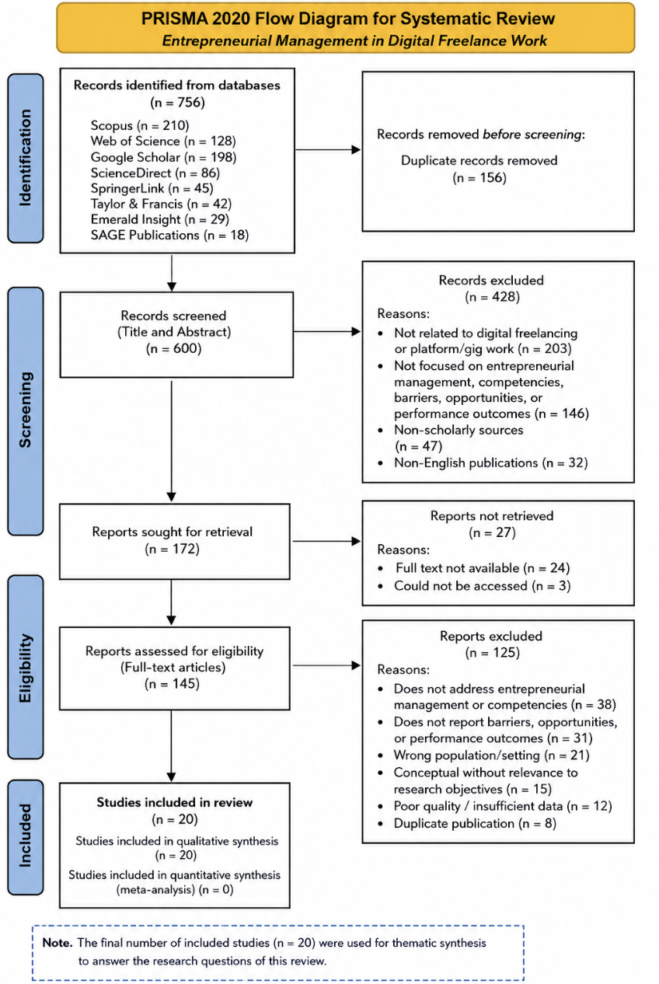

Figure 1. PRISMA 2020 Systematic Flow Diagram of the Study.

3.2. Characteristics of included studies, Author, year, country, method, database, focus.
Table 1 shows the twenty (20) studies included in the systematic literature review. The studies included online freelancing, digital labor platforms, platform-based entrepreneurship, freelancer competencies, work challenges, client acquisition, reputation systems, self-branding, and performance outcomes. Most studies utilized qualitative, quantitative, experimental, and review-based approach, which provided a general evidence base for interpreting entrepreneurial management in digital freelance work.
These studies were collected from reputable scholarly sources including ScienceDirect, SpringerLink, Taylor & Francis, SAGE Journals, ACM Digital Library, Wiley, Oxford Academic, OECD, and Google Scholar. The dissemination of sources provides the credibility of the review and reflects the multidisciplinary nature of digital freelance research.
Table 1. Characteristics of the Included Studies (N = 20)
No. | Author(s) | Year | Country / Context | Method | Database / Source | Focus of the Study
1 | Fazio, Freund, & Novella | 2025 | El Salvador | Randomized experiment | ScienceDirect / Journal of Developmental Economics | Entrepreneurial skills training and online digital freelancing outcomes
2 | Baptista, Freund, & Novella | 2023 | Haiti | Randomized pilot experiment | ScienceDirect / Economics Letters | Entrepreneurial skills training for initial entry into online freelance markets
3 | Segundo et al. | 2025 | Digital freelancers | Configurational study | ScienceDirect / Technology in Society | Success demographic profiles and EntreComp-based entrepreneurial competencies
4 | Gussek, Grabbe, & Wiesche | 2023 | IT freelancers on digital labor platforms | Topic modeling and qualitative analysis | SpringerLink / Electronic Markets | Challenges faced by IT freelancers on digital labor platforms
5 | Gussek & Wiesche | 2024 | Digital labor platforms, IT work | Exploratory qualitative study | Wiley / Information Systems Journal | Career development and career dynamics program of freelancers
6 | Kim, Cheon, & Sawyer | 2023 | Online freelancing literature | Scoping review | ACM Digital Library | Research topics, conceptual framing, and approach in online freelancing
7 | Baitenizov et al. | 2025 | Global literature | Systematic literature review | SpringerLink / Journal of Innovation and Entrepreneurship | Freelancing as an innovation-driven business model approach
8 | Seifried et al. | 2024 | Online labor markets | Mixed-method / project-level study | Taylor & Francis / Industry and Innovation | Factors affecting project success indicator in online labor markets
9 | Blyth, Jarrahi, Lutz, & Newlands | 2024 | Upwork | Qualitative interviews | SAGE / New Media & Society | Self-branding strategies of online freelancers’ innovation
10 | Fiers | 2024 | Online freelancers | Qualitative interviews | Oxford Academic / Journal of Computer-Mediated Communication | Digital skills and resilience in online freelancing works
11 | Sutherland, Jarrahi, Dunn, & Nelson | 2020 | Upwork and online freelancers | Qualitative interviews and platform walkthrough | SAGE / Work, Employment and Society | Precarity and gig literacies in online freelancing works
12 | Lukac & Grow | 2021 | Online labor markets | Agent-based modeling | SpringerLink / Journal of Computational Social Science | Reputation systems and freelancer recruitment systems
13 | Chan & Wang | 2018 | Online labor markets | Field experiment and observational analysis | INFORMS / Management Science | Hiring preferences and bias in online labor markets approach
14 | Ren | 2023 | Online labor platforms | Quantitative analysis | MDPI / Economies | Influential factors in hiring freelancers works
15 | Tran Nhat et al. | 2024 | Online labor platforms | Online experiment | SpringerLink / Electronic Markets | Reputation portability and demand effects of imported ratings system
16 | Liang, Hong, & Gu | 2024 | Online labor platform | Difference-in-differences analysis | INFORMS / Information Systems Research | Monitoring systems and home bias in global hiring freelancers
17 | Benson, Sojourner, & Umyarov | 2020 | Online labor market | Experiment and natural experiment | INFORMS / Management Science | Reputation discipline and market performance in gig work system
18 | Tóth et al. | 2022 | Professional sharing economy platforms | Qualitative interviews | ScienceDirect / Journal of Business Research | Social capital creation among freelance designers and platform clients relationships
19 | Alvarez de la Vega, Cecchinato, & Rooksby | 2022 | Online freelancing platforms | Design fiction and qualitative evaluation | ACM Digital Library | Worker-centered design opportunities for freelancing platforms system
20 | Troncoso & Luo | 2023 | Online labor marketplaces | Observational and experimental study | INFORMS / Marketing Science | Profile pictures, matching outcomes, and hiring decisions system

3.3. Entrepreneurial Competencies
The data revealed in table 1 were five themes affirming the entrepreneurial competencies are essential in digital freelance work. These five sub-themes show that freelancers need entrepreneurial skills training, strategic and financial competencies, self-branding, digital skills and resilience, and platform and client management skills. These findings imply that successful digital freelancers operate not only as service providers but also as entrepreneurs who must continuously develop business, marketing, financial, and relationship management capabilities.
Table 2. Themes on Entrepreneurial Competencies
Author(s) | Themes | Axiological Meaning
Fazio, Freund, & Novella (2025) | - Entrepreneurial Skills Training | Training enhances business readiness, writing proposals and online freelance participation.
Segundo et al. (2025) | - Strategic and Financial Competencies | Successful entrepreneurs are strategic thinkers with business acumen and an eye for opportunity
Blyth et al. (2024) | - Self-Branding Competency | A strong professional identity helps freelancers attract clients and establish trust.
Fiers (2024) | - Digital Skills and Resilience | Digital competence and resilience enable freelancers to adapt to changing market demands.
Sutherland, Jarrahi, Dunn, & Nelson (2020) | - Platform and Client Management Skills | Knowledge of digital platforms, effective client communication, and adaptive work practices strengthen freelance performance.

3.4. Barriers to Entrepreneurial Management in Digital Freelance Work
Table Theme 2 emphasized the five major barriers faced by digital freelancers in managing and sustaining their businesses. The reviewed studies systematically examined challenges related to platform challenges, career sustainability, market platform constraints, client acquisition challenges, and work precarity and social protection. These barriers affect freelancers' ability to secure clients, sustain stable income, and achieve long-term entrepreneurial success.
The reviewed studies suggest that entrepreneurial success rely not only on diversified competencies but also on overcoming structural barriers within digital labour platforms. Entrepreneurship education, platform guidelines, and institutional support should improve career sustainability, strengthen access to clients, enhance digital labour protections, and promote fair working conditions for digital freelancers.
Table 3. Barriers to Entrepreneurial Management in Digital Freelance Work
Author(s) | Themes | Axiological Meaning
Gussek, Grabbe, & Wiesche (2023) | - Platform Challenges | IT freelancers experienced algorithmic control, rigid competition, and dependence on digital labour system.
Gussek & Wiesche (2024) | - Career Sustainability | Freelancers face career uncertainty, continuous skill demands, and difficulties sustaining long-term careers.
Kim, Cheon, & Sawyer (2023) | - Market and Platform Constraints | Platform organizations, market saturation, and uneven access to opportunities affect freelancer success.
Chan & Wang (2018) | - Client Acquisition Challenges | Hiring decisions aspect in online labor markets make barriers for new and less-established freelancers seeking contracts.
Sutherland, Jarrahi, Dunn, & Nelson (2020) | - Work Precarity and Social Protection | Freelancers encountered unstable income, limited employment protection, and work-life imbalance within the partime gig economy.

3.5. Opportunities of Entrepreneurial Management in Digital Freelance Work
Theme 3 shows the entrepreneurial opportunities distinguished in the reviewed studies. The literature presents that digital technologies and online labour platforms have been expanded access to global markets, enabled flexible work arrangements, provided innovation, and open new business opportunities for digital freelancers.
Digital freelancing can represent important ways of entrepreneurship and unpaid work outside of traditional employment, according to the studies reviewed. Thanks to digital platforms, innovation, access to international markets, remote work and continuous capability development freelancers can build their business and stay competitive. These findings demonstrate that entrepreneurship education and workforce development programs should focus on enhancing digital competencies, innovation and international market readiness in order to leverage the opportunities offered by the digital economy.
Table 4. Opportunities Entrepreneurial Management in Digital Freelance Work
Author(s) | Themes | Axiological Meaning
Baitenizov et al. (2025) | - Innovation-Driven Entrepreneurship | Digital freelancing has been evolved into an innovation-oriented business model that makes new entrepreneurial opportunities.
Kim, Cheon, & Sawyer (2023) | - Digital Labor Platforms | Online labor platforms link freelancers with clients worldwide and growth access to diverse work opportunities.
Muszyński et al. (2023) | - Global Market Access | Platform work enabling self-employed freelancers to achieved international clients and participate in the global digital economy.
Fiers (2024) | - Digital Capability Development | Continuous development of digital skills improves freelancers' skills to adapt to technological change and emerging markets.
Alvarez de la Vega et al. (2022) | - Remote Work and Platform Flexibility | Digital platforms provide flexible work arrangements, letting freelancers to supervise projects across geographical boundaries.

3.6. Performance Outcomes of Entrepreneurial Management in Digital Freelance Work
Theme 4 synthesize the performance outcomes related to effective entrepreneurial supervision in digital freelance work. The reviewed studies suggest that entrepreneurial competencies provided to improved business performance through successful client acquisition, stronger reputation, sustainable careers, higher earnings, innovation, and long-term competitiveness.
The findings indicates that entrepreneurial management positively affects the long-term performance of digital freelancers. Developing entrepreneurial competencies improved business sustainability, enhanced employability, strengthens client relationships, enhances reputation, and strengthen competitiveness in digital labor markets. These outcomes pointed out the importance of integrating entrepreneurial capability development into education, training, and workforce development initiatives.
Table 5. Performance Outcomes of Entrepreneurial Management in Digital Freelance Work
Author(s) | Themes | Formulated Meaning
Fazio, Freund, & Novella (2025) | - Business Performance | Entrepreneurial skills training enhances online contracts, job offers, and overall freelancing performance.
Seifried et al. (2024) | - Project Success and Client Satisfaction | Successful corroboration between freelancers and clients enhanced project outcomes and professional relationships.
Ren (2023) | - Freelancer Employability | Freelancer characteristics and platform open increased hiring opportunities and work performance.
Lukac & Grow (2021) | - Reputation-Based Performance | Strong reputation systems improve visibility, trust, and opportunities for repeat engagements.
Baitenizov et al. (2025) | - Business Sustainability and Competitiveness | Innovation and entrepreneurial skills strengthened long-term business sustainability and competitiveness.

3.7. Synthesized Framework of Entrepreneurial Management in Digital Freelance Works
Figure 2 showed the synthesized framework of entrepreneurial management in digital freelance work derived from the systematic literature reviews. The framework display that entrepreneurial competencies serve as the basis for the foundation of entrepreneurial success by equipping digital freelancers with essential business, strategic, financial, digital, and client management skills. These competencies enabling freelancers to face entrepreneurial barriers, involving platform challenges, career sustainability issues, market constraints, client acquisition challenges, and work precarity.
As a digital freelance work overcome these barriers, they become better positioned to use on entrepreneurial opportunities provided by digital labor platforms, innovation, global market access, digital capability development, and exterior work flexibility. Maximizing these opportunities strenghtens to improved performance outcomes, involving stronger business performance, project success, employability, reputation, business sustainability, and competitiveness. The feedback loop further suggest that positive performance outcomes support entrepreneurial competencies through continuous learning, experience, and capability development, creating an ongoing cycle of entrepreneurial growth and sustainable success in digital freelance work.

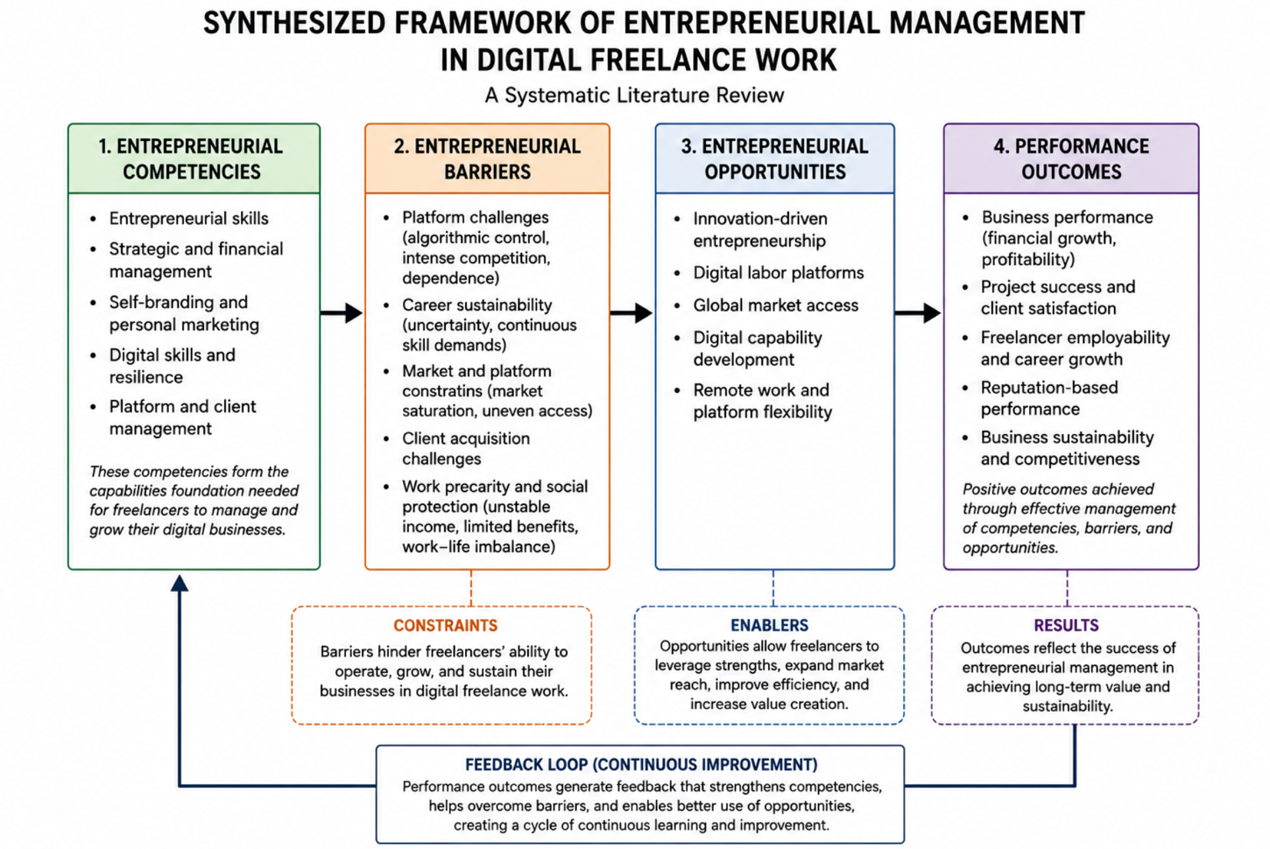

Figure 2. Synthesized Framework of Entrepreneurial Management in Digital Freelance Works

4.0 Conclusion
- The PRISMA screening and preliminary evaluation produced twenty (20) eligible studies from the initial obtained records of 756 published studies. This indicates that the study followed a systematic and rigorous selection procedure, allowing only related and quality studies on entrepreneurial management in digital freelance work to be include in the final synthesis.
- The criteria and characteristics of the included studies indicated that digital freelance work is a multidisciplinary research area. The reviewed studies scope online freelancing, digital labor platforms, platform-based entrepreneurship, freelancer competencies, client acquisition, reputation systems, self-branding, and performance outcomes.
- The results of the study showed that entrepreneurial competencies are important for digital freelancers. These competencies involved entrepreneurial skills training, strategic and financial competencies, self-branding, digital skills and resilience, and platform and client management skills. This signifies that freelancers need business, marketing, financial, and relationship management capabilities to succeed.
- Similarly, the major barriers revealed in the study that entrepreneurial management in digital freelance work include platform challenges, career sustainability issues, market and platform constraints, client acquisition challenges, and work precarity. These barriers influence freelancers’ ability to secure clients, maintain stable income, and sustain long-term careers.
- The review further indicated that digital freelance work supports entrepreneurial opportunities through innovation-driven entrepreneurship, digital labor platforms, global market access, digital capability skills and development, and remote work flexibility. These opportunities allowed freelancers to enhanced services, achieved international clients, and compete in the digital economy.
- Furthermore, the performance outcomes of entrepreneurial management involve business performance, project success, client satisfaction, employability, reputation-based performance, business sustainability, and competitiveness. These findings implies that effective entrepreneurial management strengthen both short-term work outcomes and long-term freelance sustainability.
- Conclusively, the study affirms that entrepreneurial management in digital freelance work depends on the association among competencies, barriers, opportunities, and performance outcomes. Digital freelancers set clear stronger findings when they develop entrepreneurial competencies, manage platform-related challenges, maximize digital opportunities, and build sustainable professional performance.
5.0 Contributions of Authors
There are two authors for this research.

6.0 Funding
This work received no specific grant from any funding agency.

7.0 Conflict of Interests
The author declares that there is no conflict of interest related to this research.

8.0 Acknowledgment
The author express sincere gratitude to the participating digital freelancers, entrepreneurship educators, expert validators, and all individuals who contributed to the completion of this study at Marikina Polytechnic College.

9.0 References
Alvarez de la Vega, J. C., Cecchinato, M. E., & Rooksby, J. (2022). Design opportunities for freelancing platforms: Online freelancers’ views on a worker-centred design fiction. Proceedings of the ACM Designing Interactive Systems Conference. https://doi.org/10.1145/3533406.3533410
Baitenizov, D., et al. (2025). The evolution of freelance as a new innovation business mode in the modern economy: A literature review. Journal of Innovation and Entrepreneurship, 14. https://doi.org/10.1186/s13731-025-00596-4
Baptista, D., Freund, R., & Novella, R. (2023). Entrepreneurial skills training for online freelancing: Experimental evidence from Haiti. Economics Letters, 232, 111371. https://doi.org/10.1016/j.econlet.2023.111371
Benson, A., Sojourner, A., & Umyarov, A. (2020). Can reputation discipline the gig economy? Experimental evidence from an online labor market. Management Science, 66(5), 1802–1825. https://doi.org/10.1287/mnsc.2019.3303
Blyth, D. L., Jarrahi, M. H., Lutz, C., & Newlands, G. (2024). Self-branding strategies of online freelancers on Upwork. New Media & Society. https://doi.org/10.1177/14614448221108960
Chan, J., & Wang, J. (2018). Hiring preferences in online labor markets: Evidence of a female hiring bias. Management Science, 64(7), 2973–2994. https://doi.org/10.1287/mnsc.2017.2756
Fazio, M. V., Freund, R., & Novella, R. (2025). Do entrepreneurial skills unlock opportunities for online freelancing? Experimental evidence from El Salvador. Journal of Development Economics, 172, 103363. https://doi.org/10.1016/j.jdeveco.2024.103363
Fiers, F. (2024). Resilience in the gig economy: Digital skills in online freelancing. Journal of Computer-Mediated Communication, 29(5), zmae014. https://doi.org/10.1093/jcmc/zmae014
Gussek, L., Grabbe, A., & Wiesche, M. (2023). Challenges of IT freelancers on digital labor platforms: A topic model approach. Electronic Markets, 33, 55. https://doi.org/10.1007/s12525-023-00675-y
Gussek, L., & Wiesche, M. (2024). Understanding the careers of freelancers on digital labor platforms: The case of IT work. Information Systems Journal, 34(5), 1664–1702. https://doi.org/10.1111/isj.12509
Huđek, I. (2020). Entrepreneurship vs. freelancing: What’s the difference? Naše gospodarstvo/Our Economy, 66(3), 56–62. https://doi.org/10.2478/ngoe-2020-0018
Kim, P., Cheon, E., & Sawyer, S. (2023). Online freelancing on digital labor platforms: A scoping review. Proceedings of the ACM. https://doi.org/10.1145/3584931.3607011
Liang, C., Hong, Y., & Gu, B. (2025). Monitoring and home bias in global hiring: Evidence from an online labor platform. Information Systems Research, 36(2), 736–760. https://doi.org/10.1287/isre.2021.0526
Lukac, M., & Grow, A. (2021). Reputation systems and recruitment in online labor markets. Journal of Computational Social Science, 4, 549–571. https://doi.org/10.1007/s42001-020-00072-x
Muszyński, K., Pulignano, V., Domecka, M., Potter, J., & Halabisky, D. (2023). Entrepreneurial opportunities and working conditions of self-employed online freelancers in the platform economy: Lessons from the COVID-19 pandemic. OECD SME and Entrepreneurship Papers, 45. https://doi.org/10.1787/ebc310de-en
Page, M. J., et al. (2021). The PRISMA 2020 statement: An updated guideline for reporting systematic reviews. BMJ, 372, n71. https://doi.org/10.1136/bmj.n71
Ren, J. (2023). Exploring influential factors in hiring freelancers in online labor platforms: An empirical study. Economies, 11(3), 80. https://doi.org/10.3390/economies11030080
Segundo, J., Florez, R., Velez, M., & Sanchez, J. M. (2025). Mapping success profiles for digital freelancers: A configurational approach using EntreComp competencies. Technology in Society, 83, 103025. https://doi.org/10.1016/j.techsoc.2025.103025
Seifried, M., Kretschmer, T., Khashabi, P., & Claussen, J. (2024). What drives project success in online labour markets? A bilateral perspective on freelancers and clients. Industry and Innovation. https://doi.org/10.1080/13662716.2023.2243243
Snyder, H. (2019). Literature review as a research methodology: An overview and guidelines. Journal of Business Research, 104, 333–339. https://doi.org/10.1016/j.jbusres.2019.07.039
Sutherland, W., Jarrahi, M. H., Dunn, M., & Nelson, S. B. (2020). Work precarity and gig literacies in online freelancing. Work, Employment and Society, 34(3), 457–475. https://doi.org/10.1177/0950017019886511
Thomas, J., & Harden, A. (2008). Methods for the thematic synthesis of qualitative research in systematic reviews. BMC Medical Research Methodology, 8, 45. https://doi.org/10.1186/1471-2288-8-45
Tóth, Z., Nemkova, E., Hizsák, G., & Naudé, P. (2022). Social capital creation on professional sharing economy platforms: The problems of rating dependency and the non-transferability of social capital. Journal of Business Research, 144, 450–460. https://doi.org/10.1016/j.jbusres.2022.01.090
Tranfield, D., Denyer, D., & Smart, P. (2003). Towards a methodology for developing evidence-informed management knowledge by means of systematic review. British Journal of Management, 14(3), 207–222. https://doi.org/10.1111/1467-8551.00375
Tran Nhat, D., Thäter, L., & Teubner, T. (2024). The duality of reputation portability: Investigating the demand effect of imported ratings across online labor markets. Electronic Markets, 34, 21. https://doi.org/10.1007/s12525-024-00706-2
Troncoso, I., & Luo, L. (2023). Look the part? The role of profile pictures in online labor markets. Marketing Science, 42(6), 1080–1100. https://doi.org/10.1287/mksc.2022.1425

