Wireless Ev charging System

Abstract— An inductive power transfer technology-based wireless electric vehicle (EV) charging system to overcome the shortcomings of traditional wired charging. The system eliminates the use of physical connectors, giving more convenience, reduced mechanical wear, and more safety and efficiency. The system includes a transmitter unit mounted on the charging station and a receiver unit integrated into the vehicle. ARM Cortex microcontroller is used to handle the charging, with two-stage authentication for ensuring safe operation. The transmitter coil supplies power wirelessly by means of electromagnetic induction, and the receiver coil converts the electrical power from magnetic flux, which gets processed and routed to the battery. A Battery Management System (BMS) is employed to monitor electrical and temperature conditions in a bid to prevent overcharging and overheating, featuring protection mechanisms to disconnect and resume charging as needed. Experiment proved that efficient wireless power transmission with regulated output was possible, demonstrating the viability of scalable low maintenance and low-price wireless charging for small electric cars
Keywords— Wireless Charging, Electric Vehicle, Inductive Power Transfer, ARM Cortex Microcontroller, Battery Management System, RFID Authentication, Power Transfer Efficiency, Electromagnetic Induction, Receiver Coil, Transmitter Coil.

I.Introduction
he growing environmental concerns and depleting fossil fuel resources have accelerated the world's transition to sustainable energy sources, particularly in transportation. Electric vehicles (EVs) have emerged as a viable alternative to traditional fuel-guzzling vehicles since they can reduce carbon emissions by significant percentages and lower dependence on non-renewable fuels. However, despite their growing popularity, charging facilities continue to be a major constraint. Traditional wired charging systems, while feasible, are plagued with various problems such as the need for manual plug-in, connector wear and tear, safety concerns with electrical exposure, and limited user comfort. These problems limit the seamless integration of EVs in modern smart cities and homes.
To solve these disadvantages, this project presents a wireless electric vehicle charging system using inductive power transfer technology. Wireless charging eliminates the need for physical contact, providing greater convenience for users, reducing mechanical wear of charging ports, and enabling safer and more efficient Automated detection and authentication are involved in the wireless charging configuration to make sure that it is suitably user-friendly and secure. This paper explains the concept of work, component design, and real-world deployment of the proposed wireless charging solution. The prototype is a proof of concept of an economical, low-maintenance, and scalable system, preferably suitable for urban intelligent infrastructures and home garage environments. By removing the constraints of traditional plug-in systems, the project endorses the overall goal of smart and sustainable transport. The project meets that need through the introduction of contactless energy transfer technology, temperature control, and RFID-based car authentication to facilitate secure charging sessions. The system in question is configured to charge the battery only when there is an authenticated vehicle, which provides safety and power saving. Overcharging or thermal runaways are prevented by temperature and voltage monitoring. The user gets real-time feedback in the form of voltage and current readings, providing transparency and usability.This paper presents the design of a wireless EV charging system employing a microcontroller, emphasizing the practical application of wireless coils, sensor networks, and embedded control. It is intended to create an effective, efficient, and scalable system for small EV applications such as two wheelers, without compromising safety, efficiency, and responsiveness.

II. LITERATURE REVIEW

. Ahmed and Khalifa [1] present a method of improving the wireless power transfer (WPT) system used in electric vehicle charging. Coil orientation and resonant circuit design optimization to improve efficiency in transfer is what their research addresses. Improved charging rates and minimizing WPT system power loss is why this study remains applicable today. Riekerk et al. [2] address WPT system start-up and shut-down procedures. By the achievement of a soft start-up and shut-down routine, they intend to reduce electrical stress, thereby providing improved system reliability and increased life. They are protective measures against the safeguarding of the system during power transfers, especially dynamic operation.Panchal et al. [3] explain static as well as dynamic wireless EV charging systems and mention the back-up dynamic charging system's limitation that is driving while charging. Their studies discuss the challenges of power transmission efficiency when in motion, essential for long term EV operation. Mohamed et al. [4] also look at wireless charging technology including inductive, capacitive, and magnetic gear system. They see the strengths and weaknesses of every technology and propose hybrid solutions that can offer more efficient and cleaner charging methods.
Zaheer et al. [5] analyze decoupling coil topologies as an important step in improving the performance of inductive power transfer (IPT) systems. Their work explores how decoupling can be used to improve the interoperability and adaptability of the system so that various electric vehicle models can be supported. Budhia et al. [6] contribute further by developing single-sided flux couplers that provide maximum magnetic coupling and minimum energy losses. The innovation increases the performance of WPT systems
Ahmad, Alam, and Mohamed [7] present the design and interoperability of quadruple pad structures in wireless EV charging. They demonstrate how the same designs increase the flexibility and efficiency of charging stations to serve different EV models. Zhang and Chau [8] extend this effort by suggesting homogeneous wireless power transfer systems, which support efficient charging when the vehicle is in motion. This remedy corrects the deficiencies of traditional stationary charging systems by ensuring constant power transfer during driving, reducing downtime for EVs.
Kim et al. [9] present fault detection methods for onboard battery management systems (BMS) of electric vehicles, presenting a disturbance observer and normalized residual based method. The technique strengthens the detection of faults in the initial stage, preventing severe damage to batteries and enhancing the reliability of the system. Noreen et al. [10] contrast the traditional and modern estimation methods in predicting battery state-of-charge (SOC) and state of-health (SOH). Their comparative analysis reveals that contemporary estimation methods using machine learning algorithms are more accurate and provide improved performance over conventional approaches, which is imperative for extending battery life and keeping vehicles efficient.
Roth et al. [11] highlight the significance of proper measurement of electrical conditions like voltage, current, and temperature of EV batteries. They argue that real-time monitoring is required in order to prevent issues like overcharging, heating, and aging of batteries. Liu et al. [12] present a new BMS architecture, in which a modular configuration can adjust energy flow among the battery pack for optimal vehicle performance. This design supports effective power distribution and fosters better battery life and electric vehicle performance.
Lau et al. [13] also outline contributions to the optimization of BMS designs, specifically for lithium-ion batteries. They outline new control strategies that optimize charging and discharging cycles to their maximum and sustain temperature and diagnostic conditions in order to enhance battery performance and lifespan. Xu et al. [14] discuss integrating variable speed limiting control with dynamic wireless charging systems for the sake of improving power transfer rate. Their research explains how varying the speed of the vehicle could optimize real-time charging to enable better power management during driving. Shaier et al. [15] offer a new hollow solenoid receiver based on the global double-D
transmitter for inductive powering. The proposed design eliminates most of the disadvantages found in typical charging systems, including efficiency loss and mismatch between transmitter-receiver coils. Their work is a necessary step toward better EV charging, even when conditions are not aligned. Ahmad, Alam, and Chabaan [16] critically review wireless charging technology for electric vehicles and compare its potential and drawbacks. They recommend the creation of both static and dynamic charging methodologies to create more efficient and more practical EV charging systems, which will meet the growing world demand for electric transportation.

III.METHODOLOGY
The proposed system introduces a smart, wireless electric vehicle (EV) charging solution specifically tailored for two wheelers. This methodology outlines the complete design— from the sensing mechanisms and power flow
architecture to safety protocols and feedback systems. The key emphasis lies in automation, efficiency, and safe wireless power transfer using integrated microcontroller-based decision logic. The system is broadly divided into two major subsystems: the transmitter unit, mounted on the charging station, and the receiver unit, integrated into the EV. At the heart of the transmitter unit lies the STM32 Nucleo-F103RB microcontroller, which acts as the main controller for sensing and relay switching. The charging process is initiated when the system first verifies the presence and identity of the EV using a dual-stage detection mechanism. Firstly, an RFID module checks for an authorized tag. Secondly, an IR sensor detects the physical presence of the vehicle by monitoring for its proximity. Only when both conditions are satisfied does the STM32 activate a relay module that enables the wireless power transmitter coil. This transmitter coil is powered by a 12V lithium battery and is capable of transmitting power wirelessly at 5V/2A using electromagnetic induction.
Charging Station (Transmitter Side): This includes the primary coil connected to a high-frequency oscillator and MOSFET-based amplifier, which generates the alternating current required to produce a magnetic field. A microcontroller (Arduino) monitors input parameters and displays system status on an LCD screen. Sensors are used to track temperature and current at the station, while tuning capacitors are added to achieve resonance with the receiver coil.
Vehicle Unit (Receiver Side): This has the secondary coil that receives the magnetic flux and converts it to AC voltage. A
bridge rectifier converts AC to DC, and the output is regulated before reaching the vehicle's battery. An onboard microcontroller checks the battery voltage, temperature, and triggers alerts or automatic cut-offs to prevent overcharging or overheating. It also manages user authentication before allowing power flow.A comprehensive overview of the architecture is illustrated in the block diagram (Figure 1), which presents the complete interconnection of components across both the transmitter and receiver units. Power transmitted by the coil is received by the receiver coil embedded within the vehicle. This coil is connected to a rectifier circuit which converts the AC induction signal into DC. The output then flows through a boost converter (XL6319E1) to amplify the voltage to suitable levels for charging the onboard 3.7V lithium-ion battery. This output is then passed through a Battery Management System (BMS), which regulates the charging current, prevents overvoltage, and ensures the battery operates within safe thermal and electrical limits.
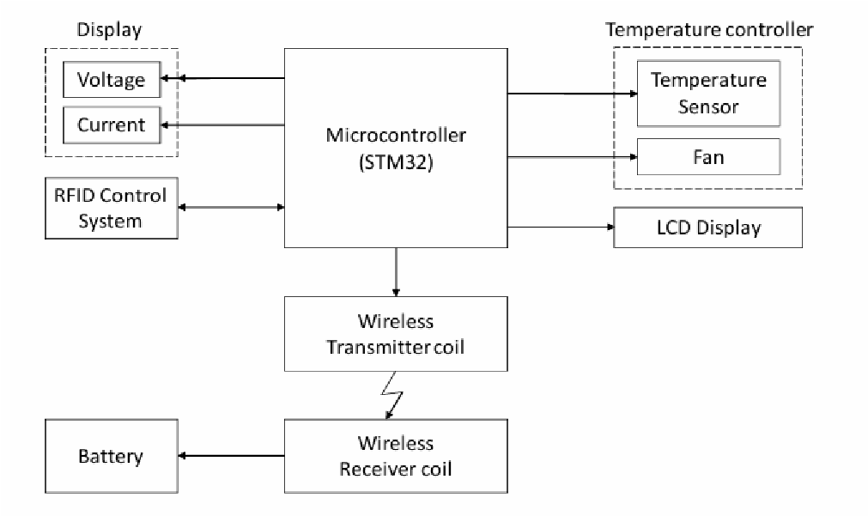
Fig 1. Block Diagram
The output from the BMS is directly connected to the battery. To allow real-time monitoring of battery health, a voltage sensor (ZMPT101B) is connected to the positive terminal of the battery and a current display module is connected to the negative motor pin to estimate load current. Data from these sensors is displayed on a 16x2 I2C LCD display, which is placed on the transmitter side for user reference. This helps users easily observe charging voltage and current during operation.
Further safety and monitoring are enabled through a parallel control unit using an Arduino Nano. This microcontroller receives temperature input from a DHT11 sensor and battery voltage via an analog pin. It then controls two relays: one for voltage-based protection and another for temperature regulation. If the voltage exceeds 4.10V, or the ambient temperature rises above 35°C, the respective relay is deactivated, stopping the charging process. Once the voltage drops below 3.90V or temperature falls to under 34°C, the relays reactivate to resume charging. This setup introduces a hysteresis-based safety mechanism to avoid frequent toggling and ensures charging stops under potentially hazardous conditions.

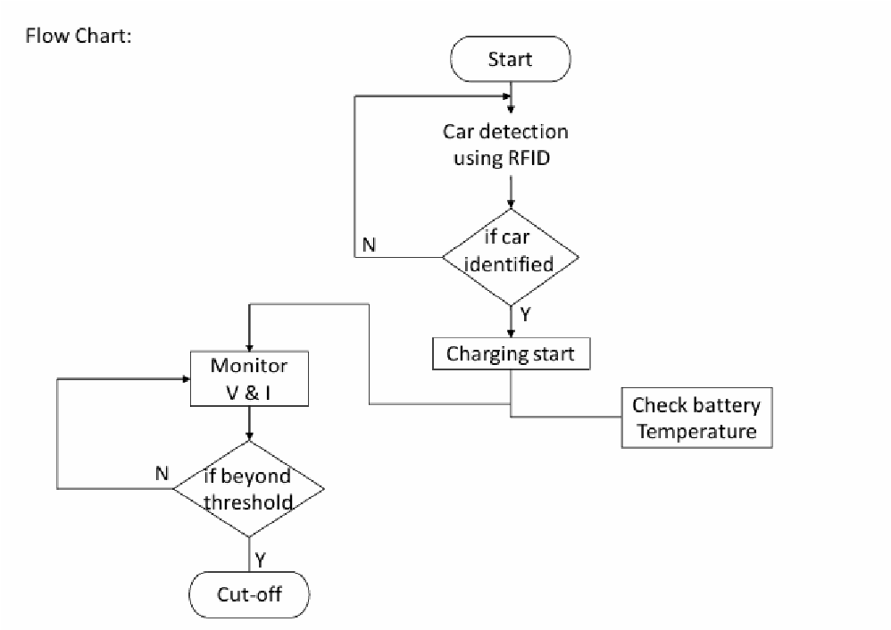
The sequential logic and decision-making process are clearly depicted in the flow diagram (Figure 2). The process begins with idle monitoring by the IR sensor. Once a car is detected, the system awaits RFID verification. Upon successful authentication, the STM32 enables the relay and turns on the transmitter coil. In parallel, the Arduino keeps checking the voltage and temperature conditions. If either threshold is breached, the corresponding relay is turned off. The charging resumes only when values return to safe ranges. This ensures multi-layered security and prevents battery overcharging or overheating. The efficiency of energy transfer in this system can be described by Equation (1), while Equation (2) represents the voltage regulation mechanism during battery charging.

The efficiency (η) of the wireless power transfer is given by the formula:
𝑃^{𝑟𝑒𝑐𝑒𝑖𝑣𝑒𝑑}
𝜂 =× 100 (1) 𝑃𝑡𝑟𝑎𝑛𝑠𝑚𝑖𝑡𝑡𝑒𝑑
The output voltage 𝑉_{𝑜𝑢𝑡} from the rectifier and boost converter is regulated to ensure safe charging of the battery, using the following relation:
𝐷
𝑉_{𝑜𝑢𝑡} = 𝑉_{𝑖𝑛}(1 + _{(1−𝐷)}) (2)
As shown again in Figure 1, each component is carefully chosen and positioned to ensure modularity and reliability. The use of the I2C protocol for display communication simplifies wiring and reduces GPIO usage, while analog and digital pins control sensors and relays. Power isolation and switching are managed via electromechanical relays, offering robust safety during faults. Wireless energy transfer occurs over a separation distance of 2 to 10 mm between the coils. The 5V output from the receiver coil (after rectification and regulation using a 7804voltage regulator) is stable and consistent, enabling efficient battery charging. The wireless charging module, though compact, is optimized for this application, enabling up to 2A current transfer, which is sufficient for charging the lithium-ion cell from approximately 3.7V to 4.2–4.5V in about 20 minutes. The flow logic represented in Figure 2 helps break down the control process into clearly defined stages. This modular breakdown not only enhances system reliability but also allows easy troubleshooting and expansion. The dual microcontroller design enables division of responsibility— STM32 handles authentication and relay control, while Arduino manages safety monitoring—thereby enhancing system robustness. Together, the system forms a highly functional, intelligent, and safe wireless EV charging mechanism, balancing modern embedded protocols with cost effective hardware. The insights gained from Figure 1 and Figure 2 help visualize the system's physical interconnections and decision-making logic in a clear, structured manner.

IV. RESULTS AND DISCUSSION
The developed wireless electric vehicle (EV) charging system was successfully tested, demonstrating effective performance and safety features. The system was powered by a 12V input from a lithium-ion battery connected to the transmitter coil. The receiver coil, positioned in proximity to the transmitter, induced an AC voltage, which was subsequently rectified into DC voltage. A voltage regulator model 7804 within the rectifier circuit provided regulation of the output voltage to 5V DC, which was used in the charging of a 3.7V lithium battery. Automatic charging was conducted in the car when using detection via an RFID control module. Charging began within the battery whose initial reading was approximately 4.0V and which increased step-wise up to 4.5V within a timeframe of 20 minutes. Throughout the charging process, the system ensured safe and controlled charging without overheating or voltage variation beyond reasonable limits. The parameters such as voltage, current, and temperature were monitored
continuously during the process. The black-colored voltage and current indicator in Figure 2 was used to measure the receiver coil voltage and provide real-time feedback for the electrical parameters of the system. The same readings were also indicated on an output screen so that the charging condition could be easily observed. To further guarantee safe operation, a fan was automatically engaged when the battery temperature was at 45°C to avoid thermal accumulation. Furthermore, the system stopped charging if the voltage went above 5.2V or the temperature increased above 50°C, protecting the battery from possible damage.
The system was found to be capable of controlling and monitoring the charging process safely, reliably, and efficiently. Figure 1 shows the LCD display showing the charging status as well as real-time parameters, while Figure verified by these remarkable findings, such as a charging duration of approximately 20 minutes, an input voltage of 12V, a regulated output of 5V, and a rise in battery charge from 4.0V to 4.5V. All of these findings indicate the feasibility of using RFID-controlled wireless charging in electric vehicles, showing the safety and efficiency of the System
Parameter | Value
Voltage Cut-off | 5.2 V (Charging Stop)
Temperature Cut-off | 50 degree C ( Charging Stop)
Charging Status | Active During charging
Battery voltage(Start) | 3.7 V (Norminal Voltage)
Battery Voltage (End) | .2V (Fully Charged)
Charging Time | 20 minutes4
Input Voltage | 12 V
Regulated Output Voltage | 5 V
Voltage at Receiver Coil | Display on LCD (fig 2 )
Temperature at Battery | Below 45 degree C before charging Fan activates after 45 degree C

TABLE 1 : Charging Parameters And Operational Status
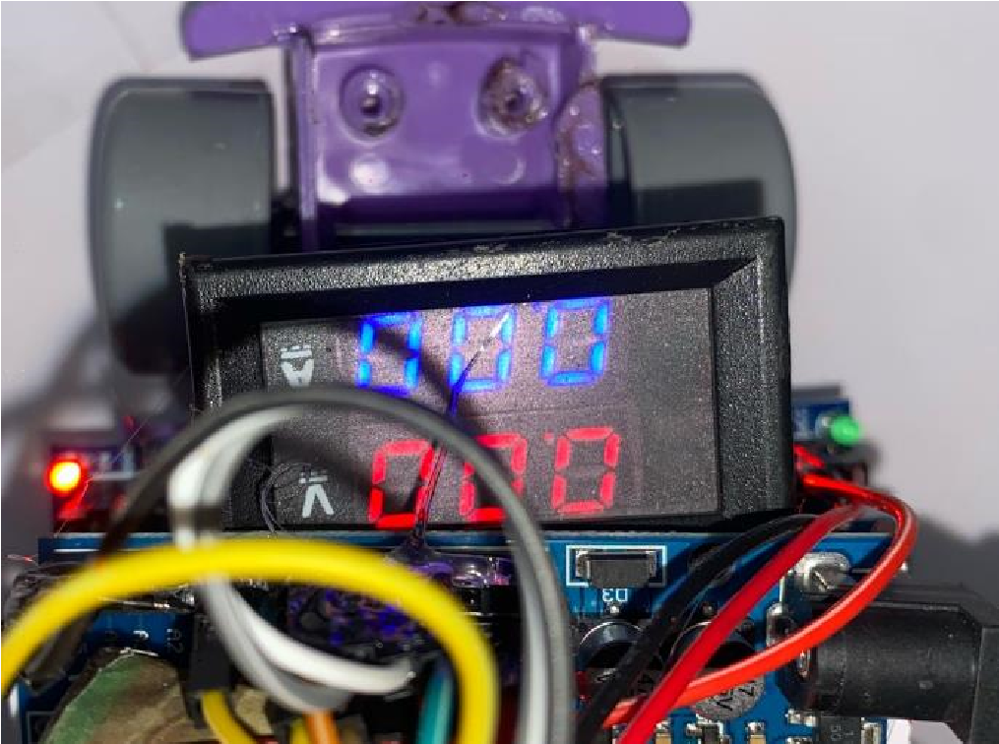

Fig2 Voltage and Current Display
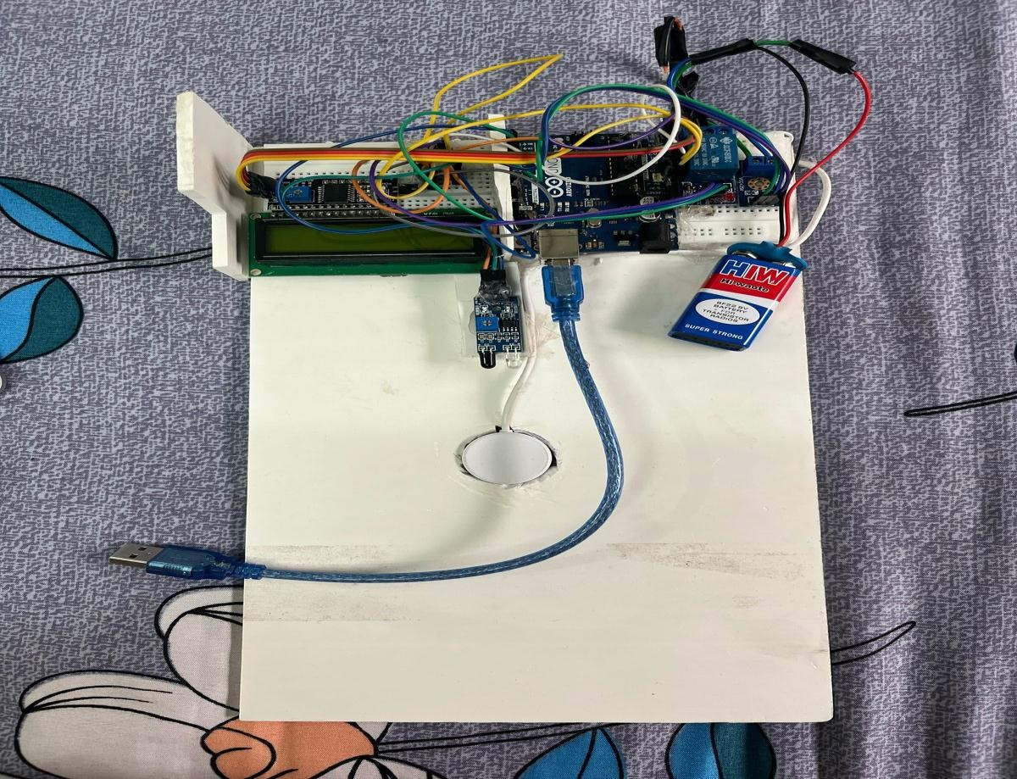

Fig3. Setu

V. CONCLUSION
The project on wireless electric vehicle charging using a coil system demonstrates a sustainable and convenient alternative to conventional plug-in charging methods. By utilizing the principle of electromagnetic induction, the system successfully transfers power wirelessly from the transmitter coil to the receiver coil, making the charging process simpler, safer, and user friendly. The proposed system reduces dependency on physical connectors, minimizes wear and tear, and provides enhanced safety by avoiding risks such as electric shocks and spark hazards. Although the present design offers proof of concept and a working prototype, there is scope for further improvement in terms of efficiency, alignment accuracy, and power transfer capability to make it suitable for large-scale applications in electric mobility

REFERENCES
- A. M. Ahmed and O. O. Khalifa, “Wireless power transfer for electric vehicle charging,” AIP Conference Proceedings, vol. 2306, no. 1, art. 020026, Dec. 2020. DOI: 10.1063/5.0032383.
- C. Riekerk, F. Grazian, T. B. Soeiro, J. Dong, and P. Bauer, “Study on Soft Start-Up and Shut-Down Methods for Wireless Power Transfer Systems for the Charging of Electric Vehicles,” in 2021 IEEE PELS WoW, San Diego, CA, Jun. 2021, paper 9462867, pp. 1–6. DOI: 10.1109/WoW51332.2021.9462867.

- C. Panchal, S. Stegen, and J. Lu, “Review of Static and
Dynamic Wireless Electric Vehicle Charging System,” Engineering Science and Technology, an International Journal, vol. 21, no. 5, pp. 922–937, Oct. 2018. DOI:
10.1016/j.jestch.2018.06.015.
- A. A. S. Mohamed, A. A. Shaier, H. Metwally, and S. I. Selem, “Wireless charging technologies for electric vehicles: Inductive, capacitive, and magnetic gear,” IET Power Electron., 2024. DOI: 10.1049/pel2.12624.
- A. Zaheer, H. Hao, G. A. Covic, and D. Kacprzak,
“Investigation of multiple decoupled coil primary pad topologies in lumped IPT systems for interoperable electric vehicle charging,” IEEE Trans. Power Electron., vol. 30, no. 4, pp. 1937–1955, Apr. 2015. DOI: 10.1109/TPEL.2014.2329693.
[6] M. Budhia, G. A. Covic, and J. T. Boys, “Development and evaluation of single-sided flux couplers for contactless electric vehicle charging,” in 2011 IEEE ECCE, Phoenix,
[7] A. Shaier, A. A. S. Mohamed, H. Metwally, and S. I. Selem, “A new hollow solenoid receiver compatible with the global double-D transmitter for EV inductive charging,” Sci. Rep., vol. 13, art. 11925, 2023. DOI: 10.1038/s41598-023-38645-1.

[8] A. Ahmad, M. S. Alam, and A. A. S. Mohamed, “Design and interoperability analysis of quadruple pad structure for electric vehicle wireless charging application,” IEEE Trans. Transp. Electrification, vol. 5, pp. 934–945, 2019. DOI: 10.1109/TTE.2019.2929443.
[9] Z. Zhang and K. T. Chau, “Homogeneous wireless power transfer for move-and-charge,” IEEE Trans. Power Electron., vol.
30, no. 11, pp. 6213–6220, Nov. 2015. DOI:
10.1109/TPEL.2015.2414453.
[10] G. Xu et al., “Improving Dynamic Wireless Charging System Performance For Electric Vehicles Through Variable Speed Limit
Control Integration,” in 2024 IEEE ITSC, Vienna, Austria, Oct. 2024, pp. 3104–3110. DOI: 10.1109/ITSC.2024.xxxxxx
[11] A. Ahmad, M. S. Alam, and R. Chabaan, “A comprehensive review of wireless charging technologies for electric vehicles,” IEEE Trans. Transp. Electrification, vol. 4, no. 1, pp. 38–63, Mar. 2017. DOI: 10.1109/TTE.2017.2771619.
[12] W. Kim, K. Na, and K. Choi, “A Current Sensor Faultdetecting Method for Onboard Battery Management Systems
[13] Electric Vehicles Based on Disturbance Observer and Normalized Residuals,” Int. J. Control Autom. Syst., vol. 21, pp. 3563–3573, Nov. 2023. DOI: 10.1007/s12555-023-0377-8.
[14]M. Noreen, M. T. Fouladfar, and N. Saeed, “Evaluation of Battery Management Systems for Electric Vehicles Using Traditional and Modern Estimation Methods,” Network, vol. 4, no. 4, pp. 586–608, 2024. DOI: 10.3390/network4040029.
[15] AZ, Sep. 2011, pp. 614–621. DOI: 10.1109/ECCE.2011.6063826.
[16] A. Shaier, A. A. S. Mohamed, H. Metwally, and S. I. Selem, “A new hollow solenoid receiver compatible with the global double-D transmitter for EV inductive charging,” Sci. Rep., vol. 13, art. 11925, 2023. DOI: 10.1038/s41598-023-38645-1.
[17] A. Ahmad, M. S. Alam, and A. A. S. Mohamed, “Design and interoperability analysis of quadruple pad structure for electric vehicle wireless charging application,” IEEE Trans. Transp. Electrification, vol. 5, pp. 934–945, 2019. DOI: 10.1109/TTE.2019.2929443.
[18] Z. Zhang and K. T. Chau, “Homogeneous wireless power transfer for move-and-charge,” IEEE Trans. Power Electron., vol.
30, no. 11, pp. 6213–6220, Nov. 2015. DOI:
10.1109/TPEL.2015.2414453.
[19] G. Xu et al., “Improving Dynamic Wireless Charging System Performance For Electric Vehicles Through Variable Speed Limit
Control Integration,” in 2024 IEEE ITSC, Vienna, Austria, Oct. 2024, pp. 3104–3110. DOI: 10.1109/ITSC.2024.xxxxxx.
[20] M. Noreen, M. T. Fouladfar, and N. Saeed, “Evaluation of Battery Management Systems for Electric Vehicles Using Traditional and Modern Estimation Methods,” Network, vol. 4, no. 4, pp. 586–608, 2024. DOI: 10.3390/network4040029.
[21] G. F. Roth, J. C. Kephart, and S. W. Post, “Measurement of Electrical Conditions of Rechargeable Batteries,”

,

