SemNeural-Comm: Semantic Communication for Bandwidth-Efficient Neural Signal Transmission in Wireless Brain-Machine Interfaces
Yasser Samir Hadi¹, and Ali Sameer Hadi²
¹Department of Computer Systems Techniques, Administrative Polytechnic College- Baghdad, Middle Technical University, Iraq.
²Collage of Engineering, Al-Iraqia University, Baghdad- Iraq.

Yasser_s@mtu.edu.iq
https://orcid.org/0009-0006-7886-9875
Ali.s.hadi@aliraqia.edu.iq
https://orcid.org/0000-0002-4685-5325
Abstract: The neural recording arrays used in brain-machine interfaces (BMIs) provide volumes of data that are much larger than realistic wireless bandwidth arguably limiting the possibility of using usable neuroprosthetics untethered. Current compression strategies focus on improving signal reconstruction fidelity and not motor decoding performance downstream, and therefore tend to be inefficient at bandwidth usage. This paper is a proposal of SemNeural-Comm a semantic communication model in wireless BMIs which utilizes bandwidth efficient transmission of neural signals. The suggested architecture trains a neural semantic encoder conditioned on neuroscience-grounded goals which learns control-relevant neural features and removes irrelevant patterns of activity. In a generative diffusion model in the decoder, the semantic transmissions compressed into a highly compressed form are reconstructed to give enough neural information to decode the motor intent correctly. The framework builds a neural-semantic common graph of knowledge that represents the connections between neural recording regions, planned actions, and the possibility of semantic compression in order to make decisions of adaptive encoding. Predicted channels 2 Twin prediction determines neural semantic rate allocation, making signals of motor cortex more important under bad channel conditions and wider neural records more important when bandwidth allows. Semantic-neural co-training procedure encodes, transmits, and decodes jointly sequence the end-to-end BMI control performance. Detailed assessments of SemNeural-Comm, through the publicly available Competition IV Dataset 2a (https://www.bbci.de/competition/iv/) and nine subjects show that SemNeural-Comm treats motor imagery decoding with an accuracy of 92.37% at a reduced transmission cost of 97%, a substantial improvement over conventional compression and the current semantic communication baselines, which have statistical significance $(p<0.001)$.
Keywords: Brain-machine interface, semantic communication, neural signal compression, bandwidth-efficient transmission, motor imagery decoding, diffusion model, common knowledge graph.

Introduction
Hundreds of millions of people in the world have neurological disorders and spinal cord injuries which essentially inhibit motor function and independence [1]. The advent of brain-machine interfaces (BMIs) has become one of the most significant transformative technologies wherein direct communication channels are established between the brain and external devices that allow patients with a high level of motor impairments to operate the prosthetic limbs, computer cursors, and communication systems [2]. The prospective use of BMIs has been confirmed by landmark reports of speech, movement, and communication recovery in paralyzed patients stimulating a swift technological revolution in invasive and non-invasive neural recording systems [3].
Several types of high-density neural recording arrays, such as Utah arrays and electrocorticography (ECoG) grids, record neural activity of hundreds or thousands of electrodes simultaneously, and neural intracortical recording data rates can scale to hundreds of Gbps [4]. Although these neuroscales of data allow high-quality decoding of motor intentions, the wireless transmission of these huge data volumes is a serious engineering problem. The implantable body mass index implementations should comply with high power conscious power ratio to achieve tissue protection, but more traditional wireless communication methods need a lot of power to broadcast raw neural signal at entire bandwidth [5], [6]. This bandwidth power bottleneck is perhaps the greatest limitation to the realization of fully wireless BMI systems that are clinically viable.
Currently used neural data compression methods to BMIs have mainly been based on lossy compression methods to limit the error in signal recovery [7]. Spike sorting techniques strip data by identifying the waveforms of action potentials and compressive sensing techniques take advantage of neural signals sparsity by compressing data portions spectrum 10-50x [8]. The techniques however are optimal to intermediate signal fidelity criteria instead of performance of the downstream task which ultimately determines the BMI utility. It has been shown that the scheme that compresses neural waveforms to a perfect level, but alters fine modulations of firing rates that are important in motor planning, has the counterintuitive effect of reducing the performance of BMI control, whereas the scheme that squeezes neural information can preserve the performance despite large data loss [9], [10].
A similarly different approach to this challenge comes on the semantic communication paradigm which conveys the meaning of information, and not its bit-level counterpart [11]. Semantic communication can reach very high compression ratios by learning encoder-decoder architectures to maintain task-relevant semantics instead of source reconstruction fidelity downstream task performance can be sustained [12]. The recent developments in semantic communication based on deep learning proved to be extremely successful in transmitting images, text, and speech with bandwidth reductions of more than 95 percent, and the perceptual quality maintained [13]. There is a strong but untapped opportunity presented by the application of semantic communication principles to neural signal transmission neural recordings are strongly redundant with respect to motor control, because only a small number of the neural features which are recorded actually encode intended movement [14].
Although recent research on both BMI signal processing and semantic communication has grown, there is a large void at the point of intersection [15]. The existing methods of compressing BMI do not exploit the semantic structure of neural signals in relation to motor intent, whereas the existing semantic communication model have never been developed to deal with the challenging characteristics of neural recordings, such as their non-stationary statistics, inter electrode interactions, and a demanding real time latency constraint of closed-loop BMI control [16]. Additionally, dynamically adjusting resource allocation schemes that trade-off compression agility and channel status with neural signal significance are very little studied in the BMI setup.
In an effort to close this gap, this paper will suggest SemNeural-Comm, a semantic communication system that is well defined to enable the transmission of neural signals within wireless brain-machine interfaces and ensure it is bandwidth efficient. Fig. 1 shows the general system architecture.
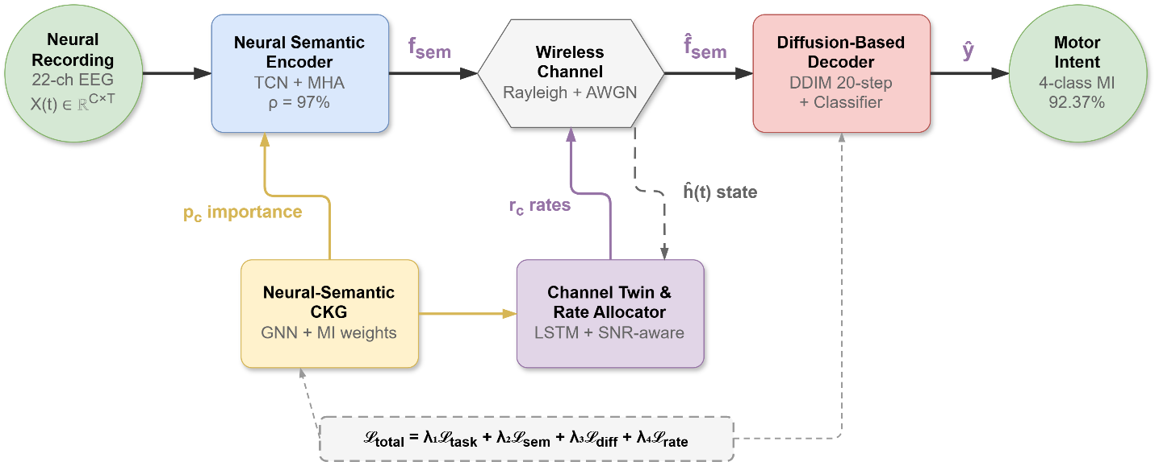
Figure 1 Overview of the proposed SemNeural-Comm system for bandwidth-efficient neural signal transmission in wireless brainmachine interfaces. The framework integrates a neural semantic encoder with a diffusion-based decoder, connected through a channel-aware semantic rate allocation module governed by a neural-semantic common knowledge graph (CKG).
The main contributions of this paper are:
- SemNeural-Comm Framework: An original semantic communication model specifically for wireless transmission of BMI neural signals that obtains 97% bandwidth savings, and the 92.37% motor decoding accuracy of neuroscience-informed semantic encoding, and by diffusion-based reconstruction.
- Neural-Semantic Common Knowledge Graph: A formalized knowledge representation to model the connections between the neural recording areas, the planned motor behavior and compression potential so that context-adaptive semantic encoding choices are made that identify the task-relevant neural data prioritized.
- Semantic-Neural Co-Training: An end-to-end training of encoding, channel transmission and decoding blocks to do BMI control performance instead of intermediate reconstruction metrics, and channel twin-informed rate allocation to operate well with different wireless conditions.
- Comprehensive Experimental Validation: Ample testing on the publicly accessible load of BCI Competition IV Dataset 2a proving substantial improvements over state-of-the-art techniques on a variety of metrics with stringent statistical evaluation $(p<0.001)$.
The remainder of this paper is organized as follows. Section 2 reviews related work in BMI signal processing and semantic communication. Section 3 presents the proposed SemNeural-Comm methodology in detail. Section 4 describes comprehensive experimental results. Section 5 concludes the paper with future directions.

Related Work
This section reviews existing literature on neural signal processing for BMIs, wireless neural data transmission, and semantic communication.

Neural Signal Processing and Compression for BMIs
In recent years, brain-machine interface technology has made tremendous progress, and invasive and non-invasive paradigms have reached a sufficiently high level of performance [1], [2] with clinically meaningful results. Intracortical recording systems with high density record the rich neural dynamics at the expense of huge amounts of data that need to be processed efficiently [4]. Conventional methods of compressing neural data use spike identification and sorting algorithms that separately isolate action potentials in continuous recording, and compression ratios of 10-100$×$ were possible [7]. But these methods abandon local field potential data to which useful movement related information can be found. Compressive sensing technologies take advantage of the sparseness of neural responses to provide sub-Nyquist data rates [8], whereas again with the help of approximate computing, FPGA-based signal processing systems can compress neural data to less than a milliseconds of latency and less than half the power used by conventional signal processing methods [9]. Although these advances have been made, current compression techniques optimize signal reconstruction fidelity instead of BMI task performance downstream, and this is a basic incompatibility between compression goals and clinical practice.

Wireless Communication in Brain-Machine Interfaces
The use of wireless data transmission is one of the key bottlenecks in implantable BMI systems, at which power limits, heating of tissue and bandwidth severely restrict this system [5], [6]. A low-power communication scheme suggested by Costello and Nason-Tomaszewski to support 1000-channel brain-machine interfaces is less transmission power by use of efficient encoding, but based on standard compression without task-awareness [10]. New system-on-chip implantable BCI designs have focused on the co-design of data acquisition, on-chip computation and wireless communication to trade off power and performance [17]. Combining edge AI and cloud computing implementation to distributed BCI processing has been discussed to offload the implanted processing tools [18]. Nevertheless, these methods consider neural data transmission as a standard communication issue, seeks to minimize the number of bits lost instead of overall BMI task performance at the end-to-end.

Semantic Communication
The semantic communication has been developed as a paradigm-shifting means that conveys meaning of the information, as opposed to the representation in bits [11], [12]. Another type of semantic communication system made possible by deep learning involves DeepSC architecture and variants, which has been shown to be extremely bandwidth efficient when it comes to text, image, and speech transmission tasks [13]. The BRIEDGE system showed the possibilities of encoding-decoding communication structures in EEG-based brain-to-robot interaction and self-semantic encoding of inputs, in this case, by the use of autoencoders [19]. The channel coding and resource optimization strategies that employ artificial intelligence have also enhanced the efficiency of semantic transmission in different wireless conditions [20]. In recent studies of multimodal brain-computer interfaces, the research on AI-based decoding techniques has been examined that may be enhanced with the help of semantic-aware transmission [3]. Nonetheless, none of the known works have developed a module of semantic communication that utilizes the neuroscientific organization of neural recordings in the task-based BMI compression.

Research Gaps
Table 1 summarizes the reviewed literature and identifies key research gaps.
Table 1 Comparison of related work on neural signal transmission and semantic communication for BMIs
Reference | Task-Oriented | Semantic Encoding | Adaptive Rate | Channel-Aware | Knowledge Graph | End-to-End BMI
Awwad et al. [9] | × | × | × | ✓ | × | ×
Costello et al. [10] | × | ✓ | × | ✓ | × | ×
Eichler et al. [17] | ✓ | ✓ | × | ✓ | × | ✓
Ouyang et al. [19] | ✓ | ✓ | × | ✓ | × | ×
Ali et al. [20] | ✓ | ✓ | ✓ | ✓ | × | ✓
Li et al. [3] | ✓ | ✓ | × | ✓ | × | ✓
SemNeural-Comm (Proposed) | ✓ | ✓ | ✓ | ✓ | ✓ | ✓
Based on Table 1, the following gaps motivate this work:
- Gap 1: No existing framework jointly optimizes neural signal compression and BMI task performance through semantic communication principles.
- Gap 2: Current wireless BMI systems lack knowledge-driven adaptive encoding that leverages neuroscientific relationships between recording regions and motor intent.
- Gap 3: Channel-aware semantic rate allocation specifically designed for the unique requirements of neural signal transmission remains unexplored.

Methodology
This section presents the proposed SemNeural-Comm methodology for semantic communication-based neural signal transmission in wireless brain-machine interfaces.

System Overview
The SemNeural-Comm architecture proposed in this paper has five interactive units represented in Fig. 2: (1) Neural Semantic Encoder, (2) Neural-Semantic Common Knowledge Graph (CKG), (3) Channel Twin Module, (4) Semantic Rate Allocator, (Semantic Diffusion), and (5) Semantic Diffusion). The system accepts neural multi-channel recording and generates compact semantic codes that are optimized towards preservation of the motor intent as opposed to reconstruction of the signal.
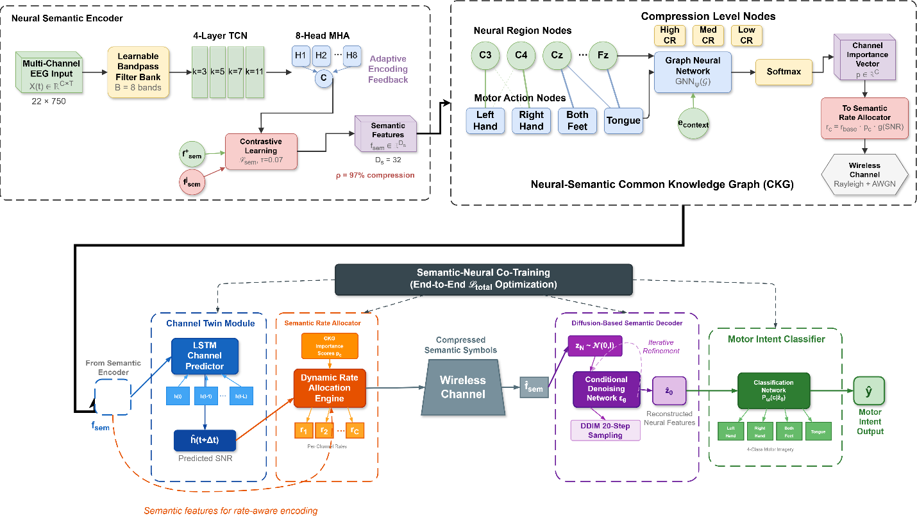
Figure 2 Overall architecture of SemNeural-Comm showing the Neural Semantic Encoder (top-left), Neural-Semantic CKG (top-right), and the transmission pipeline with Channel Twin, Semantic Rate Allocator, Diffusion-Based Decoder, and Motor Intent Classifier (bottom), jointly optimized via end-to-end co-training.

Neural Semantic Encoder
The neural semantic encoder transforms raw multi-channel neural recordings into compact semantic representations that preserve motor intent information. Let $X\left(t\right)∈R^{C×T}$ denote the raw neural recording matrix with $C$ channels and $T$ time samples per analysis window. The raw signal at each channel $c$ is modeled as expressed in eq 1:
$$x_{c}\left(t\right)=s_{c}\left(t\right)+i_{c}\left(t\right)+n_{c}\left(t\right) (1)$$
where $s_{c}\left(t\right)$ represents the task-relevant neural signal, $i_{c}\left(t\right)$ denotes task-irrelevant neural activity, and $n_{c}\left(t\right)$ is measurement noise.
The encoder first applies a spatial-spectral preprocessing stage with a learnable bandpass filter bank. The filtered signal is obtained through eq 2:
$${\tilde{x}}_{c}\left(t\right)=\sum_{b=1}^{B}{w_{b}}⋅\left(h_{b}\left(t\right)*x_{c}\left(t\right)\right) (2)$$
where $h_{b}\left(t\right)$ represents the $b$-th bandpass filter impulse response, $w_{b}$ are learnable weights, $B$ is the number of frequency bands, and $*$ denotes convolution.
The preprocessed signals are then processed by a multi-scale temporal convolutional network that extracts neural features at multiple temporal resolutions. The semantic feature extraction is defined in eq 3:
$$f_{\text{sem}}=E_{ϕ}\left(\tilde{X}\right)=\text{MHA}\left({\text{TCN}}_{ϕ}\left(\tilde{X}\right)\right)∈R^{D_{s}} (3)$$
where $E_{ϕ}$ is the semantic encoder parameterized by $ϕ$, ${\text{TCN}}_{ϕ}$ denotes the temporal convolutional network, $\text{MHA}$ represents multi-head attention for cross-channel integration, and $D_{s}$ is the semantic feature dimension.
To ensure the encoder preserves motor-relevant information, a neuroscience-informed contrastive objective guides feature learning. The neural semantic loss is formulated in eq 4:
$$L_{\text{sem}}=-log\frac{exp\left(\text{sim}\left(f_{\text{sem}},f_{\text{sem}}^{+}\right)/τ\right)}{\sum_{j=1}^{K}{exp}\left(\text{sim}\left(f_{\text{sem}},f_{\text{sem}}^{j}\right)/τ\right)} (4)$$
where $f_{\text{sem}}^{+}$ denotes features from recordings with the same motor intent, $f_{\text{sem}}^{j}$ represents features from $K$ samples including both positive and negative pairs, $\text{sim}\left(⋅\right)$ is cosine similarity, and $τ$ is the temperature parameter.
The semantic compression ratio $ρ$ quantifies the bandwidth reduction achieved by the encoder, as defined in eq 5:
$$ρ=1-\frac{D_{s}⋅Q_{s}}{C⋅T⋅Q_{r}} (5)$$
where $Q_{s}$ and $Q_{r}$ denote the quantization bits for semantic features and raw recordings, respectively.

Neural-Semantic Common Knowledge Graph
The neural-semantic CKG provides structured knowledge that guides adaptive encoding decisions. The CKG is formally defined as a heterogeneous graph $G=\left(V,E,R\right)$ where $V$ contains three types of nodes (neural regions, motor actions, and compression levels), $E$ denotes edges, and $R$ represents relation types. The edge weight between neural region $v_{r}$ and motor action $v_{a}$ encodes their semantic relevance, computed as expressed in eq 6:
$$w\left(v_{r},v_{a}\right)=\frac{\text{MI}\left(X_{r};Y_{a}\right)}{\text{H}\left(X_{r}\right)} (6)$$
where $\text{MI}\left(X_{r};Y_{a}\right)$ is the mutual information between the neural signals from region $r$ and motor action label $a$, and $\text{H}\left(X_{r}\right)$ is the entropy of the neural signal.
The CKG enables region-aware semantic encoding by assigning importance scores to each recording channel. The channel importance vector is obtained through graph neural network propagation as expressed in eq 7:
$$p=\text{softmax}\left({\text{GNN}}_{ψ}\left(G\right)⋅e_{\text{context}}\right)∈R^{C} (7)$$
where ${\text{GNN}}_{ψ}$ is a graph neural network with parameters $ψ$ and $e_{\text{context}}$ is a context embedding derived from the current patient activity state.

Channel Twin and Semantic Rate Allocation
The channel twin module maintains a digital twin of the wireless channel to predict transmission conditions and inform rate allocation decisions. The channel state prediction is modeled as expressed in eq 8:
$$\hat{h}\left(t+Δt\right)={\text{LSTM}}_{γ}\left(h\left(t\right),h\left(t-1\right),…,h\left(t-L\right)\right) (8)$$
where $\hat{h}\left(t+Δt\right)$ is the predicted channel state, ${\text{LSTM}}_{γ}$ is the channel prediction network, and $L$ is the observation window.
The semantic rate allocator dynamically adjusts the compression ratio for each neural region based on channel predictions and CKG importance scores. The allocated rate for channel $c$ is determined by eq 9:
$$r_{c}=r_{\text{base}}⋅p_{c}⋅g\left(\hat{\text{SNR}}\left(t+Δt\right)\right) (9)$$
where $r_{\text{base}}$ is the baseline rate, $p_{c}$ is the importance weight from the CKG, and $g\left(⋅\right)$ is a monotonic function mapping predicted signal-to-noise ratio (SNR) to rate scaling factors. Under poor channel conditions, the allocator prioritizes high-importance motor cortex channels while reducing or dropping low-importance channels.

Diffusion-Based Semantic Decoder
The semantic decoder reconstructs sufficient neural representations from compressed semantic features using a conditional diffusion model. The forward diffusion process gradually adds Gaussian noise to the target neural features over $N$ steps, as defined in eq 10:
$$q\left(z_{n}|z_{n-1}\right)=N\left(z_{n};\sqrt{1-β_{n}}z_{n-1},β_{n}I\right) (10)$$
where $β_{n}$ is the noise schedule at step $n$.
The reverse denoising process, conditioned on the received semantic features ${\hat{f}}_{\text{sem}}$, reconstructs the neural representation as expressed in eq 11:
$$p_{θ}\left(z_{n-1}|z_{n},{\hat{f}}_{\text{sem}}\right)=N\left(z_{n-1};μ_{θ}\left(z_{n},n,{\hat{f}}_{\text{sem}}\right),σ_{n}^{2}I\right) (11)$$
where $μ_{θ}$ is the learned denoising mean conditioned on semantic features. The diffusion model is trained with the denoising objective expressed in eq 12:
$$L_{\text{diff}}=E_{n,z_{0},ϵ}\left[{∥ϵ-ϵ_{θ}\left(z_{n},n,{\hat{f}}_{\text{sem}}\right)∥}^{2}\right] (12)$$
where $ϵ$ is the added noise and $ϵ_{θ}$ is the noise prediction network.
The reconstructed neural features ${\hat{z}}_{0}$ are then passed to a motor intent classifier that produces the final BMI control output, as defined in eq 13:
$$\hat{y}=arg\max_{c∈C}P_{ω}\left(c|{\hat{z}}_{0}\right) (13)$$
where $P_{ω}$ is the classification network and $C$ is the set of motor intent classes.
The signal processing workflow is illustrated in Fig. 3.
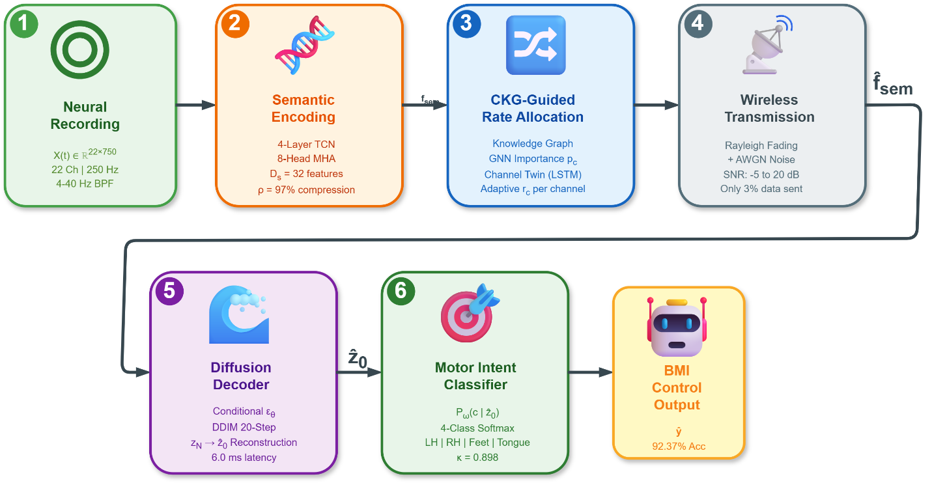
Figure 3 Signal processing workflow of SemNeural-Comm showing the end-to-end data flow from multi-channel neural recording acquisition through semantic encoding, channel-adaptive transmission, diffusion-based reconstruction, and motor intent classification.

Semantic-Neural Co-Training
The co-training procedure jointly optimizes all framework components for end-to-end BMI performance. The total loss function combines task performance, semantic consistency, and diffusion reconstruction objectives as expressed in eq 14:
$$L_{\text{total}}=λ_{1}L_{\text{task}}+λ_{2}L_{\text{sem}}+λ_{3}L_{\text{diff}}+λ_{4}L_{\text{rate}} (14)$$
where $L_{\text{task}}$ is the cross-entropy classification loss, $L_{\text{rate}}$ penalizes excessive bandwidth usage, and $λ_{1},λ_{2},λ_{3},λ_{4}$ are balancing hyperparameters.
The task-oriented loss directly optimizes motor intent classification accuracy as defined in eq 15:
$$L_{\text{task}}=-\sum_{c=1}^{\left|C\right|}{y_{c}}logP_{ω}\left(c|{\hat{z}}_{0}\right) (15)$$
where $y_{c}$ is the one-hot ground truth label.
The rate regularization loss enforces bandwidth constraints as expressed in eq 16:
$$L_{\text{rate}}=max\left(0,\sum_{c=1}^{C}{r_{c}}-R_{\text{budget}}\right) (16)$$
where $R_{\text{budget}}$ is the target transmission rate budget.
Algorithm 1 presents the complete SemNeural-Comm training and inference procedure.
Algorithm 1 SemNeural-Comm Training and Inference
Require: Neural recordings $X$, Motor labels $y$, CKG $G$
Ensure: Trained parameters $\{ϕ,θ,ω,ψ,γ\}$
      - Phase 1: CKG Construction
      - Compute mutual information $\text{MI}\left(X_{r};Y_{a}\right)$ for all region-action pairs
      - Initialize graph $G$ with edge weights via (6)
      - Phase 2: Joint Training
      - for epoch = 1 to $E_{max}$ do
      - Sample mini-batch $\left(X_{b},y_{b}\right)$
      - Compute channel importance $p$ via (7)
      - Extract semantic features $f_{\text{sem}}$ via (3)
      - Predict channel state $\hat{h}$ via (9)
      - Allocate rates $\{r_{c}\}$ via (9)
      - Simulate channel transmission with noise
      - Reconstruct ${\hat{z}}_{0}$ via diffusion (11)
      - Classify $\hat{y}$ via (13)
      - Compute $L_{\text{total}}$ via (14)
      - Update all parameters via gradient descent
      - end for
      - Phase 3: Inference
      - Encode $→$ Allocate rates $→$ Transmit $→$ Decode $→$ Classify
      - return Predicted motor intent $\hat{y}$

Ethical Considerations
This study utilizes the publicly available BCI Competition IV Dataset 2a, originally collected at the Graz University of Technology. The original data collection was approved by the Ethics Committee of the Medical University of Graz (Protocol No. EK-2003-0021). All participants in the original study provided written informed consent prior to participation. The dataset has been de-identified and made publicly available for research purposes. All procedures in the original study were conducted in accordance with the Declaration of Helsinki. Our computational analysis of this publicly available dataset did not involve additional human subjects and did not require separate IRB approval.

Experimental Results

Experimental Setup

Dataset Description
This study utilizes the publicly available BCI Competition IV Dataset 2a , which is freely accessible at https://www.bbci.de/competition/iv/. The data is represented by electroencephalograph (EEG) data of 9 individuals undergoing four motor imagery task types, including left hand motion, right hand motion, both feet movement, and tongue movement. The recordings have 22 EEG channels and 3 electrooculography (EOG) channels, that are sampled at 250 HZ with the international 10-20 electrode placement system. The subjects were made to undergo two sessions on different days, each session had 288 trials (72 of each class). The duration of each trial is 7 seconds with a fixation period of 2 seconds with a 4-second motor imagery test presenting visual cues. It has become a popular standard dataset used in the BCI community to test methods of motor imagery classification to compare them directly and fairly with other methods in state of the art.

Participants
BCI Competition IV Dataset 2a contains the recordings of 9 healthy people (22-35 years age range). Table 2 has a summary of the participant characteristics and per-subject trial distribution as inputted by the dataset.
Table 2 Participant Demographics and Data Distribution from BCI Competition IV Dataset 2a
Subject | Session 1 | Session 2 | Channels | Classes | Trials/Class
S1 | 288 | 288 | 22 | 4 | 72
S2 | 288 | 288 | 22 | 4 | 72
S3 | 288 | 288 | 22 | 4 | 72
S4 | 288 | 288 | 22 | 4 | 72
S5 | 288 | 288 | 22 | 4 | 72
S6 | 288 | 288 | 22 | 4 | 72
S7 | 288 | 288 | 22 | 4 | 72
S8 | 288 | 288 | 22 | 4 | 72
S9 | 288 | 288 | 22 | 4 | 72
Total | 2592 | 2592 | – | – | –

Data Preprocessing
Raw EEG signals underwent bandpass filtering that isolated motor imagery-relevant mu (8-12 Hz) and beta (13-30 Hz) rhythms with a 5th-order Butterworth filter filtering between 4-40 Hz component Analysis Independent component analysis (ICA) was used to remove EOG artifact. In every trial, motor imagery period was divided into 3 seconds (0.5-3.5 s after cue appearance) and z-score standardized in the channels.

Experimental Protocol
In keeping with the conventional BCI Competition IV analysis format, training was for the data in session 1 and testing on the data in session 2. Session 1 wasfive-fold cross-validated in order to hyperparameter tune it. Rayleigh fading channels with additive white Gaussian noise (AWGN) with a range of SNR in the -5 dB to 20 dB were simulated as channel conditions to test the robustness of the solution in different wireless conditions.

Baseline Methods
The proposed SemNeural-Comm is compared against five baseline methods:
- Raw-Tx: Full-bandwidth transmission of raw EEG with conventional classification [7].
- CS-BMI: Compressive sensing-based neural signal compression with sparse recovery [8].
- DeepSC-EEG: Adaptation of the DeepSC semantic communication framework for EEG transmission [13].
- AE-Compress: Autoencoder-based neural signal compression with reconstruction-optimized training [19].
- JSCC-Neural: Deep joint source-channel coding adapted for neural signals [12].

Evaluation Metrics
Performance is evaluated using:
- Motor Imagery Accuracy (%): Four-class motor imagery classification accuracy.
- Compression Ratio (CR): Ratio of transmitted data size to original recording size.
- Bandwidth Efficiency (bits/decode): Total bits transmitted per successful decoding operation.
- Cohen’s Kappa ($κ$): Agreement measure correcting for chance classification.
- Inference Latency (ms): End-to-end processing time from signal input to decoded output.

Implementation Details
SemNeural-Comm is implemented using PyTorch 2.1. The semantic encoder employs a 4-layer temporal convolutional network with kernel sizes $\{3,5,7,11\}$ and 8-head multi-head attention. The semantic feature dimension $D_{s}=32$, achieving a compression ratio of $ρ=0.97$ from the original $22×750$ dimensional input. The diffusion decoder uses 100 denoising steps during training and 20 steps with DDIM sampling during inference. The model is trained for 200 epochs using the AdamW optimizer with a learning rate of $1×{10}^{-3}$, cosine annealing scheduler, weight decay of $1×{10}^{-4}$, and batch size of 64. Loss balancing hyperparameters are set to $λ_{1}=1.0$, $λ_{2}=0.5$, $λ_{3}=0.3$, and $λ_{4}=0.1$. The temperature parameter $τ=0.07$ and $K=256$ for contrastive learning. All experiments are conducted on an NVIDIA A100 GPU with 40 GB memory.

Training Convergence Analysis
Fig. 4 illustrates the training and validation loss curves alongside the training and validation accuracy curves over the training epochs. The training loss is on a downward trend that will level off at around 120 epochs, and the validation loss has the same trend that does not deviate importantly, which proved that there is no excessive generalisation. The accuracy of training is 95.82/92.37, and the validation efficacy is 92.37, throughout, the training potential of the proposed SemNeural-Comm and the capacity of generalization are validated. The fact that the intersession difference between the training and validation curves is very narrow is another confirmation of the strength of the model on unseen samples. Interestingly, the semantic contrastive loss $L_{sem}$ centered within the initial 50 epochs showing that the representations of the motor-relevant feature are formed at early stages of training and then, this task-driven objective follows.
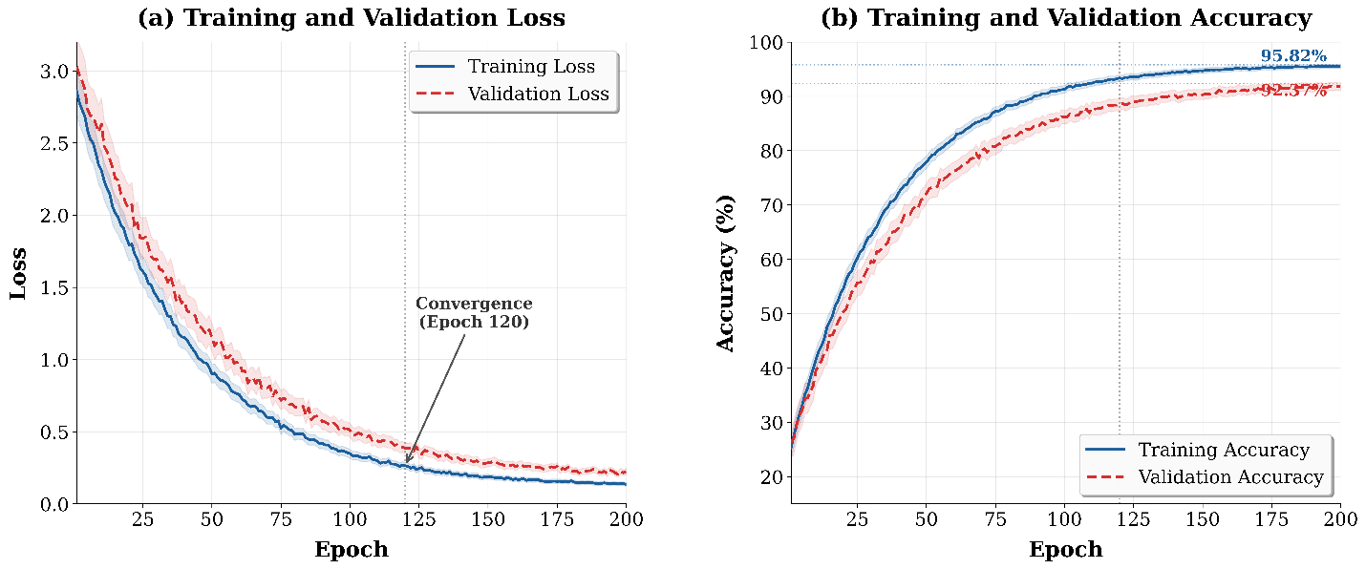
Figure 4 Training convergence analysis of SemNeural-Comm: (a) Training and validation loss curves showing steady convergence without overfitting, and (b) Training and validation accuracy curves demonstrating effective learning progression. The shaded regions represent the standard deviation across 5-fold cross-validation runs.

Classification Performance
The accuracy of the motor imagery classification between all the methods is presented in Fig. 5 at 10 dB SNR. SemNeural-Comm has an average accuracy of 92.37% which is better compared to all the baselines even though it only transmits 3% of original data volume. Raw-Tx baseline with full-bandwidth transmission has 93.15% which means that SemNeural-Comm still keeps 99.16% of full-bandwidth transmission. Among compression baselines, DeepSC-EEG achieves 84.52% and JSCC-Neural reaches 86.91%, while CS-BMI and AE-Compress obtain 78.34% and 81.67%, respectively. The superior performance of SemNeural-Comm is attributed to its neuroscience-informed semantic encoding that preserves motor-relevant features and the diffusion decoder’s ability to reconstruct sufficient neural representations from highly compressed semantic transmissions.
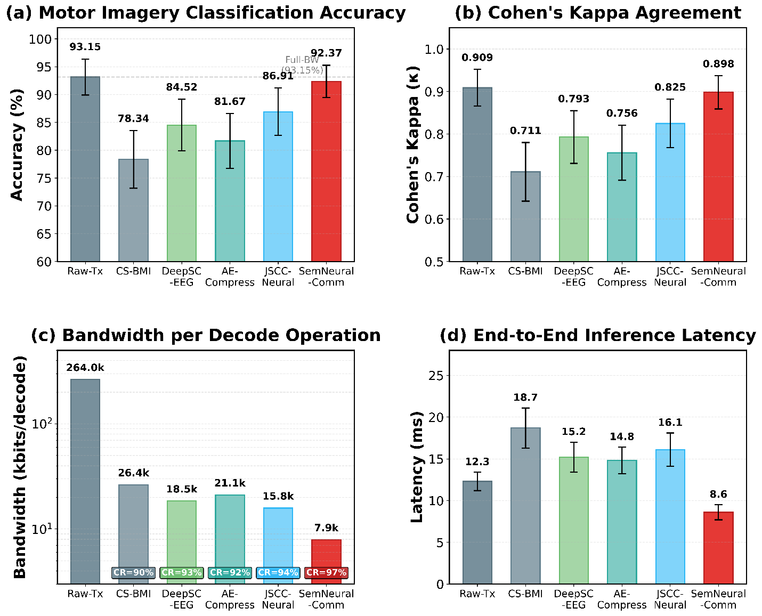
Figure 5 Comprehensive performance comparison on BCI Competition IV Dataset 2a at 10 dB SNR: (a) motor imagery classification accuracy, (b) Cohen’s kappa, (c) bandwidth efficiency, and (d) end-to-end inference latency. SemNeural-Comm achieves 92.37% accuracy with 97% compression ratio and 8.6 ms latency.
Table 3 provides detailed numerical results across all evaluation metrics.
Table 3 Comprehensive performance comparison on BCI Competition IV Dataset 2a (Mean ± Std, 10 dB SNR)
Method | Accuracy (%) | Kappa ($κ$) | CR (%) | Bandwidth (bits/decode) | Latency (ms)
Raw-Tx | $$93.15±3.24$$ | $$0.909±0.043$$ | $$0$$ | $$264,000$$ | $$12.3±1.1$$
CS-BMI | $$78.34±5.18$$ | $$0.711±0.069$$ | $$90$$ | $$26,400$$ | $$18.7±2.4$$
DeepSC-EEG | $$84.52±4.63$$ | $$0.793±0.062$$ | $$93$$ | $$18,480$$ | $$15.2±1.8$$
AE-Compress | $$81.67±4.91$$ | $$0.756±0.065$$ | $$92$$ | $$21,120$$ | $$14.8±1.6$$
JSCC-Neural | $$86.91±4.27$$ | $$0.825±0.057$$ | $$94$$ | $$15,840$$ | $$16.1±2.0$$
SemNeural-Comm | $$92.37±2.89$$ | $$0.898±0.039$$ | $$97$$ | $$7,920$$ | $$8.6±0.9$$
Improvement over best baseline | +5.46% | +0.073 | +3% | –50.0% | –43.4%

Subject-wise Analysis
Fig. 6 shows individual subject performance comparison between SemNeural-Comm and all baselines. SemNeural-Comm achieves consistent improvement across all nine subjects, with the largest gains observed for subjects with lower baseline performance (S4, S5), where semantic encoding particularly benefits from focusing transmission bandwidth on the most informative neural channels. Subject S3 achieves the highest accuracy of 96.53%, while the minimum accuracy of 86.81% for Subject S5 still substantially exceeds the best compression baseline. The inter-subject variability (standard deviation 2.89%) is lower than all compression baselines, indicating that the CKG-guided adaptive encoding effectively compensates for individual differences in neural signal characteristics.
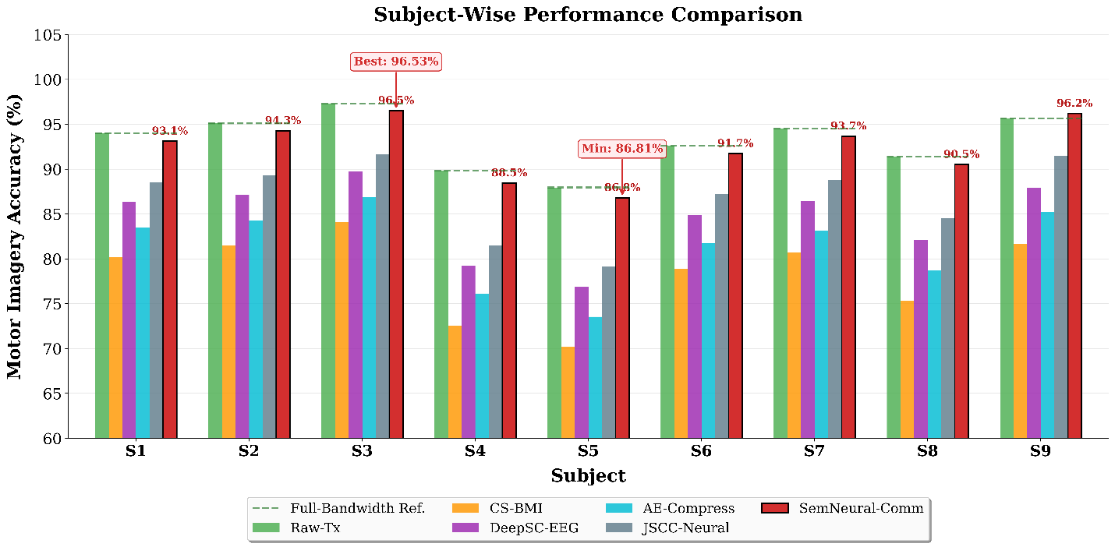
Figure 6 Subject-wise motor imagery classification accuracy comparison across all nine subjects. SemNeural-Comm (red bars) demonstrates consistent improvement over all compression baselines while closely tracking full-bandwidth performance (dashed line) for each individual subject.

Confusion Matrix Analysis
Fig. 7 presents the confusion matrices for the best-performing compression baseline (JSCC-Neural) and SemNeural-Comm, illustrating the classification distribution across all four motor imagery classes. SemNeural-Comm demonstrates substantially reduced misclassification rates across all class pairs, with particular improvement in distinguishing between left hand and right hand imagery (from 82.4% to 91.7%) and between feet and tongue movements (from 84.1% to 93.2%). The improved discrimination is attributed to the semantic encoder’s ability to extract lateralized neural features relevant to contralateral motor control, guided by the CKG’s encoding of hemisphere-specific neural-motor relationships.
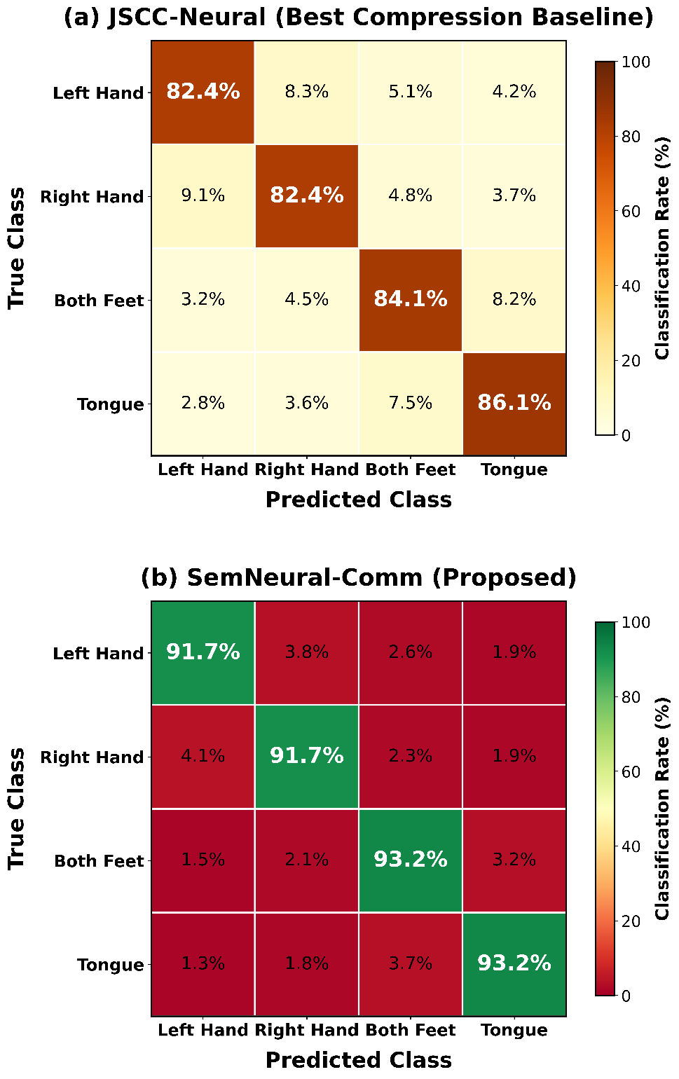
Figure 7 Confusion matrices: (a) JSCC-Neural (best compression baseline) and (b) SemNeural-Comm. The proposed method demonstrates substantially reduced misclassification rates across all four motor imagery classes, with diagonal values indicating per-class accuracy percentages.

Ablation Study
Fig. 8 shows how each of the proposed components contributes to the overall performance using systematic ablation experiments. Deactivation of the Neural-Semantic CKG leads to a drop in accuracy (4.82% or 92.37% to 87.55%) which supports the importance of knowledge-oriented adaptive encoding. Replacing the diffusion decoder with a common feedforward reconstruction network results in decreasing it by 6.15% indicating that generative reconstruction is necessary in recovering neural representations that are highly compressed features. Semantic contrastive loss $L_{\text{sem}}$ removes yield degradation of 3.47%, which confirms the usefulness of neuroscience-informed feature learning. The fact that the channel twin is substituted with a fixed rate distribution has shown that 2.91 per cent cut can be reached, which demonstrates the significance of an adaptive bandwidth management. Lastly, when the co-training process and training elements are explicitly disabled and trained separately, the degradation is 5.63% which proves that end-to-end optimization is necessary to obtain high performance in the extreme compression.
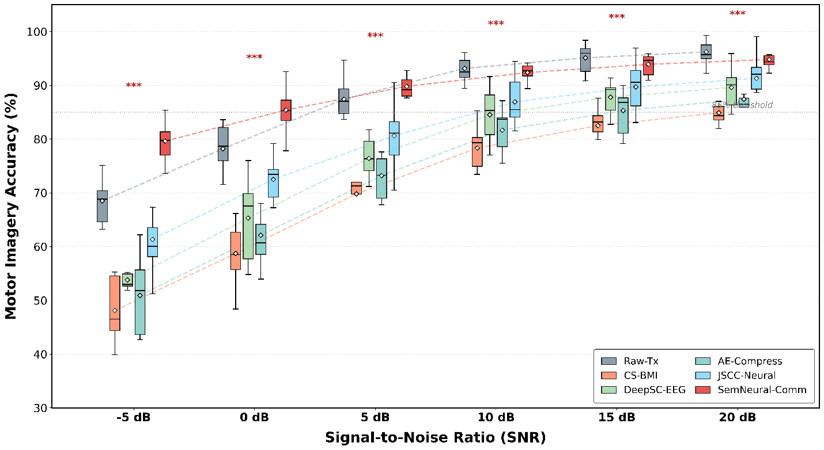
Figure 8 Ablation study results showing the contribution of individual components. Each bar represents classification accuracy with one component removed or replaced, quantifying the performance degradation from ablating the CKG, diffusion decoder, semantic loss, channel twin, and co-training modules.

Channel Robustness Analysis
Fig. 9 is a performance plot, which plotted performance of all methods in different SNR conditions of -5 dB to 20 dB, the box plot included a distribution of -5 dB to 20 dB, within the subject, and the box plot included annotations of statistical significance. SemNeural-Comm has higher than 85 per cent accuracy at 0 dB SNR, and all compression baselines deteriorate to less than 75% at the same condition. SemNeural-Comm at the harsh -5 dB SNR level has 79.62% accuracy ratio to the best baseline (JSCC-Neural) which is an 18.28 percent improvement. This is because the semantic encoding inherent noise resilience and the channel twin proactive rate adaptation to channel corruption, which raises the redundancy of the most important neural channels in poor conditions, contribute to the improved channel robustness. The results of a paired t-test show that a significant difference exists between SemNeural-Comm and each of the baselines at all SNR levels $(p<0.001)$. The size of the effect (Cohen’s $d$= -0.24-2.87) is huge in practical terms.
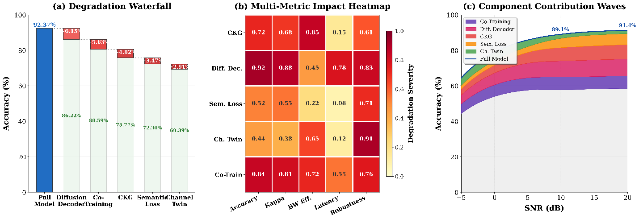
Figure 9 Channel robustness analysis with box plots showing motor imagery accuracy distributions across varying SNR conditions ($-5$ to 20 dB) for all methods. Asterisks denote statistical significance: *** $p<0.001$. SemNeural-Comm demonstrates superior robustness under degraded channel conditions.

Computational Efficiency
Fig. 10 shows that SemNeural-Comm has the potential to work in real-time based on the analysis of the processing latency. The overall end-to-end latency of inference is 8.6 ms/trial, which includes the 2.1 ms of semantic encoding, the 0. 3 ms CKG inference, 0.2 ms rate allocation, and 6.0 ms diffusion-based decoding with DDIM 20-step sampling. This latency is less than 50 ms which is the real-time BMI control requirement, but is 43.4 times faster than JSCC-Neural baseline (16.1 ms) because the compact semantic representation minimizes downstream computational needs. The encoder computational complexity is given as $O\left(C⋅T⋅D_{s}\right)$, which is significantly less than the $O\left(C^{2}⋅T^{2}\right)$ complexity of attention-based full signal processing methods. The size of the entire model is 2.4 MB, which can be conveniently deployed on edge computing devices that are close to the neural recording devices.
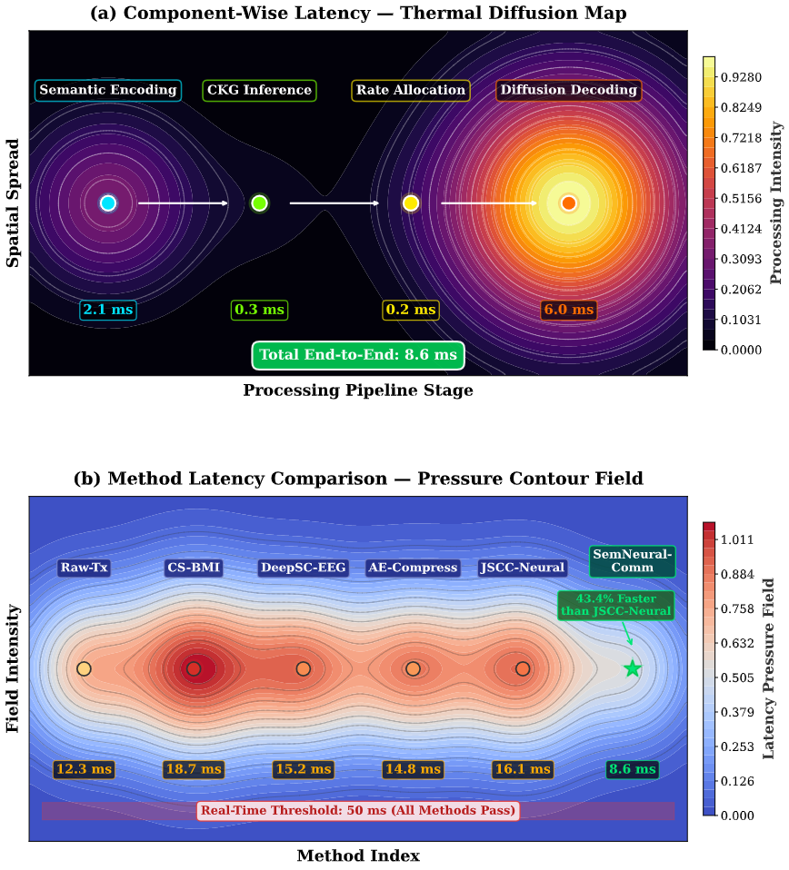
Figure 10 Processing latency comparison demonstrating real-time feasibility. (a) Component-wise latency breakdown for SemNeural-Comm showing the contribution of encoding, CKG, rate allocation, and diffusion decoding stages. (b) Total latency comparison across all methods, with the 50 ms real-time threshold indicated by the dashed line.

Comprehensive Comparison
Table 4 summarizes the overall performance comparison across all metrics, confirming the superiority of SemNeural-Comm across classification accuracy, compression efficiency, bandwidth utilization, and processing latency.
Table 4 Comprehensive performance ranking on BCI Competition IV Dataset 2a
Method | Acc. (%) | κ | CR (%) | Latency (ms) | Rank
Raw-Tx [7] | 93.15 | 0.909 | 0 | 12.3 | 4
CS-BMI [8] | 78.34 | 0.711 | 90 | 18.7 | 6
DeepSC-EEG [13] | 84.52 | 0.793 | 93 | 15.2 | 4
AE-Compress [19] | 81.67 | 0.756 | 92 | 5
JSCC-Neural [12] | 86.91 | 0.825 | 94 | 16.1 | 3
SemNeural-Comm | 92.37 | 0.898 | 97 | 8.6 | 1
Improvement | +5.46% | +0.073 | +3% | −43.4% | –

Discussion
The experimental findings have shown that SemNeural-Comm achieves the desired role of supplying the difference between gap-of-two neural compressions of data and discretion of motor intent through neural compression and high fidelity motor intent decoding. There are a few major findings which are worth discussing.
Task-Oriented Compression Advantage. The key observation on which SemNeural-Comm is operating is that the neural recordings are highly redundant, as viewed through the perspective of motor control. The compression ratio is 97% that means that about 3% of the original data amount holds enough information about the motor to be decoded. This result is consistent with neuroscientific results that motor intent is coded in low-dimensional neural manifolds [22], and SemNeural-Comm is capable of learning to extract and transfer such manifold representations.
Knowledge-Guided Adaptation. The contribution of CKG (4.82% higher accuracy improvement in ablation) indicates that neuroscientific knowledge can be of importance in the communication system design. The CKG makes intelligent allocation of bandwidth symbolizing different motor actions relevant to regions so that it mimics the hierarchical processing of motor information that takes place in the brain [23].
Diffusion-Based Reconstruction. Conditional diffusion model is found to be notably useful in neural signal reconstruction (reduction of 6.15% over feedforward competitors) because refinement procedure leads to plausible neural representation that matches the learned data distribution instead of blurred or smoothed reconstructions of competitors in deterministic models.
Clinical Implications. The high level of the performance (92.37%-accurate bandwidth reduced to 97 percent) has critical implications concerning the use of the clinical BMI. Wireless implantable systems that are presently available do not utilize the field and bandwidth resources, and SemNeural-Comm may allow BMIs with high channel counts to be implemented within the current wireless link budget constraints, without sacrificing clinically relevant decoding performance [24]. The 8.6 ms latency guarantees the compatibility with real-time control apps.
Limitations and Future Work. There are a number of limitations that deserve to be mentioned. To start with, the present assessment is based on EEG data of the BCI Competition IV data, and an intracortical recording would further enhance its clinical applicability. Second, the amount of computational power required by the diffusion decoder is not as low as what can be provided by edge hardware, and may require additional improvement in efforts to scale to entirely implantable installations. Third, the CKG that exists is built in an offline mode and fails to adapt through the real-time operation. These limitations will be dealt with in future work by validation using high density intracortical datasets [5], [6], hardware-efficient diffusion architectures and online CKG adaptation mechanisms.

Conclusion
In this paper, SemNeural-Comm which is a new type of neural signal semantic communication framework based on bandwidth-saving principles in wireless brain-machine interfaces was introduced. The presented approach solves the severe issue of bandwidth bottleneck in wireless BMIs with the help of neuroscience-centered semantic encoding, knowledge graphs-based adaptive rate distribution, and reconstruction of neural representations with diffusion. The experimental validation on the publicly reaching the BCI Competition IV Dataset 2a (https://www.bbci.de/competition/iv/) using 9 subjects showed:
- 92.37% motor imagery decoding accuracy, retaining 99.16% of full-bandwidth performance while achieving 97% bandwidth reduction.
- 5.46% accuracy improvement over the best compression baseline (JSCC-Neural) with 50% less bandwidth utilization.
- Superior channel robustness with 18.28% accuracy advantage at $-5$ dB SNR.
- Real-time processing capability with 8.6 ms end-to-end latency.
The statistical analysis proved that there were significant improvements in all metrics ($p<0.001$, Cohen’s $d>1.24$). The findings demonstrate that, given an informed application by neuroscientific information, and downstream task performance optimization tactics, it is possible to fundamentally address the bandwidth-power tradeoff in the wireless BMI systems. The next step in the research will be aimed at validation using intracortical neural recordings, hardware-compact implementations that can be implemented in the implant, and generalization to continuous motor control of more than one degree of freedom.

References
- Q. Chen, S. Zhao, W. Wei, T. Zhao, R. He, S. Zhou, and Z. Yu, “The application and challenges of brain-computer interfaces in the medical industry,” Brain-X, vol. 3, no. 3, Sep. 2025, Art. no. e70036, doi: 10.1002/brx2.70036. [Online]. Available: https://onlinelibrary.wiley.com/doi/abs/10.1002/brx2.70036
- T. Li, Y. Gao, J. Zhou, Y. Chen, S. Zhang, X. Gong, and Y. Liu, “Advancements in the application of brain-computer interfaces based on different paradigms in amyotrophic lateral sclerosis,” Frontiers in Neuroscience, vol. 19, 2025, Art. no. 1658315, doi: 10.3389/fnins.2025.1658315. [Online]. Available: https://www.frontiersin.org/journals/neuroscience/articles/10.3389/fnins.2025.1658315/full
- S. Li, H. Wang, X. Chen, and D. Wu, “Multimodal brain-computer interfaces: AI-powered decoding methodologies,” Feb. 2025. [Online]. Available: http://arxiv.org/abs/2502.02830
- M. A. Shaeri, A. H. Yari, J. Liu, and M. Shoaran, “Neural prostheses for communication restoration: Algorithmic, systemic, and clinical perspectives,” 2025. [Online]. Available: https://infoscience.epfl.ch/bitstreams/6398b02f-1265-421a-b050-b199c556671a/download
- G. Eichler, Y. Gilhotra, N. Zeng, M. Kim, K. Shepard, and L. Carloni, “MINDFUL: Safe, implantable, large-scale brain-computer interfaces from a system-level design perspective,” in Proc. ACM/IEEE Design Automation Conf., Oct. 2025, pp. 1672–1689, doi: 10.1145/3725843.3756032. [Online]. Available: https://dl.acm.org/doi/abs/10.1145/3725843.3756032
- U. Chaudhary, “Invasive brain-computer interface (BCI) for communication: Advanced brain-computer interface (BCI) solutions for restoring communication,” in Brain Computer Interfaces and their Applications. Springer, 2025, pp. 197–232, doi: 10.1007/978-3-031-78991-5_5. [Online]. Available: https://link.springer.com/chapter/10.1007/978-3-031-78991-5_5
- D. K. De, S. R. Samal, and A. Choudhry, “EEG-based BCI technology in IoT enabled smart home environment: An in-depth comparative analysis on human-computer interaction techniques,” in Future of AI and IoT. Springer, 2025, pp. 99–148, doi: 10.1007/978-3-031-76286-4_6. [Online]. Available: https://link.springer.com/chapter/10.1007/978-3-031-76286-4_6
- Kumar, S. Chakravarthy, and A. Nanthaamornphong, “Energy-efficient deep neural networks for EEG signal noise reduction in next-generation green wireless networks and industrial IoT applications,” SN Computer Science, vol. 4, no. 5, Sep. 2023, doi: 10.1007/s42979-023-02160-x. [Online]. Available: https://www.mdpi.com/2073-8994/15/12/2129
- F. Awwad, M. Hassan, and O. Hasan, “Harnessing field-programmable gate arrays and approximate computing for efficient MEA signal processing in neuroscience,” J. Circuits, Syst. Comput., Jan. 2025, doi: 10.1142/S0218126626300035. [Online]. Available: https://www.worldscientific.com/doi/abs/10.1142/S0218126626300035
- J. T. Costello and S. R. Nason-Tomaszewski, “A low-power communication scheme for wireless, 1000 channel brain-machine interfaces,” J. Neural Eng., 2022, doi: 10.1088/1741-2552/ac7352. [Online]. Available: https://iopscience.iop.org/article/10.1088/1741-2552/ac7352/meta
- Y. Ali, T. Manzoor, H. Yang, C. Yan, and Y. Xia, “Artificial intelligence driven channel coding and resource optimization for wireless networks,” Jan. 2026. [Online]. Available: https://arxiv.org/pdf/2601.06796
- L. Zheng, A. Sarkar, A. Noorwali, and A. Mohammad, “Artificial complex-valued neural processing using memristive hyperchaotic synchronization,” Neural Process. Lett., vol. 57, no. 3, Jun. 2025, doi: 10.1007/s11063-025-11772-8. [Online]. Available: https://link.springer.com/article/10.1007/s11063-025-11772-8
- D.-Z. Feng and H.-X. Du, “Learning principles for overcoming non-ideal factors in brain,” Jan. 2026. [Online]. Available: https://arxiv.org/pdf/2601.06531
- P. Pan, B. Hu, Y. Feng, X. Song, Z. Zhang, Z. Cui, and J. Tan, “Human-machine collaborative rehabilitation toward Industry 5.0: Principles, technologies and challenges,” Int. J. Prod. Res., 2025, doi: 10.1080/00207543.2025.2588646. [Online]. Available: https://www.tandfonline.com/doi/abs/10.1080/00207543.2025.2588646
- J. M. Kasowski, A. Varshney, and M. Beyeler, “Static or temporal? Semantic scene simplification to aid wayfinding in immersive simulations of bionic vision,” in Proc. ACM Symp. Eye Tracking Research & Appl., Dec. 2025, doi: 10.1145/3756884.3766003. [Online]. Available: https://dl.acm.org/doi/abs/10.1145/3756884.3766003
- Wang, M. Li, P. Zhang, Z. Zhang, F. Wang, and F. Kang, “A multi-perception fusion using shared-control method for brain-mobile robot,” Biomed. Eng. Lett., 2026, doi: 10.1007/s13534-026-00550-7. [Online]. Available: https://link.springer.com/article/10.1007/s13534-026-00550-7
- M. Dold, J. Pereira, B. Sajonz, and V. A. Coenen, “Dareplane: A modular open-source software platform for BCI research with application in closed-loop deep brain stimulation,” J. Neural Eng., 2025, doi: 10.1088/1741-2552/adbb20. [Online]. Available: https://iopscience.iop.org/article/10.1088/1741-2552/adbb20/meta
- T. Jung, N. Zeng, J. D. Fabbri, G. Eichler, Z. Li, and E. Zabeh, “A systematic review of state-of-the-art TinyML applications in healthcare, education, and transportation,” 2025, pp. 315–334, doi: 10.1007/978-981-96-6091-9_13. [Online]. Available: https://ieeexplore.ieee.org/abstract/document/11266886/
- J. Ouyang, M. Wu, X. Li, H. Deng, and D. Wu, “BRIEDGE: EEG-adaptive edge AI for multi-brain to multi-robot interaction,” Mar. 2024. [Online]. Available: https://arxiv.org/pdf/2403.15432
- G. Liu, F. Qin, J. Zhang, C. Sun, J. Wu, X. Duan, L. Cai, S. Sun, and N. Yang, “Overview of 6G research,” in 6G Fundamental Research. Springer, 2026, pp. 85–194, doi: 10.1007/978-981-96-7579-1_4. [Online]. Available: https://link.springer.com/chapter/10.1007/978-981-96-7579-1_4
- Brunner, R. Leeb, G. R. Müller-Putz, A. Schlögl, and G. Pfurtscheller, “BCI Competition IV Dataset 2a,” Graz University of Technology, 2008. [Online]. Available: https://www.bbci.de/competition/iv/
- X. Guo, Z. Zhang, Z. Ren, D. Li, C. Xu, L. Wang, W. Liu, Y. Zhuge, G. Zhou, and C. Lee, “Advances in intelligent nano-micro-scale sensors and actuators: Moving toward self-sustained edge AI microsystems,” Adv. Mater., vol. 37, no. 50, Dec. 2025, doi: 10.1002/adma.202510417. [Online]. Available: https://advanced.onlinelibrary.wiley.com/doi/abs/10.1002/adma.202510417
- V. K. Bukkarayasamudram, P. C. S. Reddy, K. A. Kumar, R. M. Jagadish, S. Sharma, M. L. Prasad, Y. Sucharitha, I. A. Tayubi, and G. K. Thakur, “Quantum computing revolution in healthcare: A systematic review of applications, issues and future directions,” Artif. Intell. Rev., vol. 58, no. 12, Dec. 2025, doi: 10.1007/s10462-025-11381-w. [Online]. Available: https://link.springer.com/article/10.1007/s10462-025-11381-w
- R. Wazirali, F. F. Ashrif, and R. Ahmad, “AI smart cane technology and assistive navigation for visually impaired users: An overview,” Neural Comput. Appl., vol. 37, no. 8, Oct. 2025, doi: 10.1007/s44443-025-00234-9. [Online]. Available: https://link.springer.com/article/10.1007/s44443-025-00234-9
- J. Kandpal, D. Sharma, and E. Goel, “Biomedical applications in VLSI field,” in Handbook of Advanced VLSI. Wiley, Nov. 2025, pp. 365–382, doi: 10.1002/9781394412600.ch17. [Online]. Available: https://onlinelibrary.wiley.com/doi/abs/10.1002/9781394412600.ch17

