VEHIQL-AI: An Intelligent Automotive Marketplace Integrating Visual Vehicle Recognition and AI-Powered Calling Agent Assistance

Prof. Nita Ingale
Dept. of Information Technology Vasantdada Patil Pratishthan’s
College of Engineering and Visual Arts, Sion, Mumbai neetaingale@pvppcoe.ac.in

Chetan Harisagar Gupta
Dept. of Information Technology
Vasantdada Patil Pratishthan’s
College of Engineering and Visual Arts,
Sion, Mumbai
guptachetan897@gmail.com

Siddhesh Kishor Gawade
Dept. of Information Technology
Vasantdada Patil Pratishthan’s
College of Engineering and Visual Arts,
Sion, Mumbai
siddhesh.gawade254@gmail.com

Sneha Ashish Dubey
Dept. of Information Technology
Vasantdada Patil Pratishthan’s
College of Engineering and Visual Arts,
Sion, Mumbai
snehadubeyy21@gmail.com

Sahil Subhash Mandavkar
Dept. of Information Technology
Vasantdada Patil Pratishthan’s
College of Engineering and Visual Arts,
Sion, Mumbai
sahilmandavkar1809@gmail.com

Abstract — This research introduces an advanced AI-driven car marketplace platform designed to revolutionize the vehicle buying and selling ecosystem through intelligent automation and data-driven decision-making. The system empowers users to perform image-based car search, where state-of-the-art computer vision models extract precise vehicle attributes such as make, model, variant, and feature set directly from images and listings. The platform further integrates an intelligent AI calling agent that dynamically understands customer intent, analyzes preferences such as budget, usage pattern, and vehicle category, and delivers highly personalized vehicle recommendations along with real-time comparative insights.
Additionally, the platform enables seamless digital test drive booking, significantly enhancing customer convenience and engagement. By combining intelligent recommendation engines, automated valuation, and smart customer interaction, the proposed solution establishes a next-generation, scalable, and user-centric automotive marketplace.
Index Terms— Artificial Intelligence, Smart Car Marketplace, Image-Based Vehicle Search, AI Calling Agent, Computer Vision, Intelligent Recommendation Systems.

- INTRODUCTION
With the rapid growth of digital automotive platforms, customers today face difficulty selecting the right vehicle from thousands of available listings. Vehicle buying is often affected by price confusion, lack of technical knowledge, limited personalized guidance, and dependency on traditional customer support or call centers. In many cases, customer care services can only provide limited information, which may not be enough to help customers choose the best car based on their exact needs, budget, and feature preferences.
To solve this problem, we developed an AI-powered automotive marketplace platform that uses artificial intelligence, computer vision, and conversational AI agents to assist customers in real-time vehicle discovery and selection. The platform allows users to upload or search using car images, where the system extracts detailed vehicle information such as make, model, variant, and features using AI image recognition. The platform then compares this data with listed vehicles and suggests the best matching options.
In addition, the system includes an AI calling agent that interacts with customers like a human assistant. The agent understands customer requirements, compares multiple cars in the same price range and category, and helps users book test drives directly through the platform. Unlike traditional automotive platforms, the system combines intelligent automation with real-time assistance to improve customer experience and decision confidence. The system architecture distributes heavy AI processing on backend servers while keeping user interactions fast and responsive through the web interface.
A. RESEARCH GOALS AND OBJECTIVE
- RESEARCH GOALS:
We aimed to develop VEHIQL AI, an intelligent automotive marketplace that solves real-world vehicle buying and selling challenges, rather than just building a prototype system.
Our primary targets were:
- Simplify vehicle discovery and decision-making using AI-driven automation and smart recommendations.
- Achieve at least 95% accuracy in vehicle feature detection using AI-based image recognition.
- Ensure smooth, real-time system performance for search, recommendations, and AI-assisted customer interaction.
- Ensure compatibility with commonly available devices such as smartphones and standard cameras.
- Support multilingual customer communication to enable global and region-specific usability.

  - RESEARCH OBJECTIVE:

To achieve these goals, we focused on the following technical implementations:
    - Integrate LLM-Based Smart Correction and Understanding: Connect to Google Gemini API to improve conversational understanding, correct incomplete vehicle queries, and provide intelligent suggestions based on user intent.
    - Enable Multilingual Conversational Voice Assistance:
Allow customers to interact with AI calling agents in multiple languages for vehicle inquiries, booking confirmations, and dealership communication.
    - Enable Intelligent Test Drive Scheduling and Dealer Coordination:Integrate automated scheduling systems that coordinate between customers and dealerships for seamless test drive booking and management.
    - Ensure Platform Accessibility and User-Friendly Experience: Develop a simple web-based interface that allows users to search vehicles via images, compare similar cars, book test drives, and receive AI assistance without requiring special hardware or technical expertise.
    - Optimize Real-Time System Performance: Use distributed cloud infrastructure to handle AI processing, image extraction, recommendation engines, and real-time customer assistance while maintaining fast platform responsiveness.

- PROBLEM STATEMENT
The automotive vehicle buying and selling process remains inefficient due to fragmented information, price inconsistency, limited comparison capabilities, and dependence on dealership representatives or call centers that provide generic and limited customer guidance. Customers often struggle to identify the most suitable vehicle due to large listing volumes, lack of intelligent filtering, and absence of real-time personalized assistance.
Current automotive marketplace platforms rely mainly on manual search and static data, lacking advanced automation such as image-based vehicle identification, intelligent vehicle comparison, and conversational decision support. This results in delayed decision-making, reduced customer confidence, and inefficient dealership coordination.
Therefore, there is a need for an AI-driven automotive marketplace that enables image-based vehicle discovery, automated car detail extraction, intelligent vehicle comparison, and human-like conversational assistance through AI calling agents to deliver fast, accurate, and personalized vehicle selection support.
- LITERATURE SURVEY
Table I presents an overview of studies conducted by researchers in vehicle recognition, automotive AI systems, intelligent voice interaction, and AI-powered marketplace technologies.
Ni and Huttunen [1] proposed a vehicle attribute recognition framework using computer vision techniques for automated classification of vehicle type, make, and model based on visual appearance, demonstrating high classification accuracy in controlled environments. .
Amirkhani and Barshooi [2] introduced DeepCar 5.0, a deep learning-based vehicle recognition system designed to perform effectively under challenging environmental conditions such as occlusion, shadows, and varying viewing angles, significantly improving recognition robustness.
Manzoor and Morgan [3] developed a vehicle make and model recognition system using Random Forest classification for intelligent transportation applications, enabling efficient vehicle identification using machine learning-based feature extraction.
Lee et al. [4] explored the role of conversational voice agents in automotive systems, demonstrating how voice interaction influences user trust, perception, and adoption of intelligent vehicle technologies.
Liu and Liao [5] proposed emotional experience design strategies for intelligent in-vehicle voice assistants, focusing on enhancing user interaction quality and customer engagement through conversational AI systems.
Li et al. [6] presented a comprehensive survey on Artificial Intelligence applications in the automotive sector, highlighting the growing importance of machine learning, computer vision, and predictive analytics in modern vehicle ecosystems.
Qian et al. [7] conducted a survey on AI model marketplaces, emphasizing the significance of scalable AI service deployment platforms for real-world intelligent applications, including digital service marketplaces.

Mandala and Surabhi [8] integrated AI-driven predictive analytics into connected car platforms to improve vehicle monitoring and predictive maintenance using IoT data and machine learning forecasting techniques.
Lin [9] developed a machine learning-based used car price prediction model using regression and data-driven analysis to achieve accurate vehicle valuation.
I. Fayyaz et al. [10] proposed an advanced vehicle price prediction framework using feature engineering and machine learning models for heterogeneous pre-owned car datasets. Their study improved prediction accuracy by integrating multiple vehicle attributes, historical pricing trends, and market behavior patterns. This research highlights the importance of data-driven valuation models for transparent and reliable pricing in digital automotive marketplaces.
M. Z. Ali et al. [11] developed an AI-based vehicle valuation system using predictive modelling combined with real-time market data analytics. Their approach enables dynamic pricing, improves valuation transparency, and supports intelligent decision-making in online automotive platforms. This work demonstrates the potential of integrating predictive analytics with live market intelligence for modern AI-driven vehicle marketplaces.

TABLE I
Literature Survey Comparison

Author | Contribution | Techniques Used | Result | Limitations
X. Ni, H. Huttunen(2021) | Proposed vehicle attribute recognition using visual appearance for automated classification. | - CNN-based Image Recognition  - Visual Feature Extraction  - Transfer Learning | Achieved high accuracy in vehicle classification based on appearance. | Performance degrades under poor lighting and real-world variations.
A. Amirkhani, A. H. Barshooi (2023) | Proposed DeepCar 5.0 for robust vehicle recognition under challenging environmental conditions. | - Deep CNN Architecture  - Data Augmentation  - Occlusion Handling Techniques | Improved recognition accuracy under shadows, occlusion, and multiple viewing angles. | High computational cost and dependency on large-scale labeled datasets.
J. Lin (2024) | Designed machine learning-based used car price prediction model. | - Regression Models  - Feature Correlation Analysis  - Data-Driven Modeling | Achieved precise used car price estimation with strong correlation metrics. | Limited adaptability to sudden market fluctuations.
I. Fayyaz et al. (2025) | Enhanced resale vehicle price prediction using advanced feature engineering. | - Feature Engineering  - Ensemble Regression Models  - Market Trend Analysis | Improved prediction accuracy and model interpretability. | Requires frequent retraining to maintain real-time pricing accuracy.
M. Z. Ali, S. Patel (2023) | Developed AI-based dynamic vehicle valuation system using real-time marketplace data. | - Predictive Analytics  - Real-Time Data Processing  - AI Pricing Engine | Delivered transparent and dynamic vehicle valuation insights. | Depends heavily on availability of continuous live market data.
V. Mandala, S. N. R. D. Surabhi (2020) | Integrated AI-driven predictive analytics into connected car platforms for performance monitoring and maintenance forecasting. | - Predictive Modeling  - IoT Data Analytics  - Machine Learning Forecasting | Improved vehicle maintenance prediction accuracy and enhanced connected car performance. | Requires continuous real-time sensor data and lacks integration with resale marketplace systems.
M. Manzoor, Y. Morgan (2018) | Introduced vehicle make and model recognition using classical machine learning for intelligent transportation systems. | - Random Forest Classifier  - Feature Engineering  - Texture & Shape Analysis | Delivered faster and reliable vehicle recognition results. | Lower accuracy compared to deep learning-based approache
S. Lee, R. Ratan, T. Park (2019) | Studied the influence of voice agent gender and style on autonomous vehicle perception and adoption. | - NLP-based Voice Modeling  - Human-Computer Interaction Analysis | Improved user perception and adoption intention of voice-enabled systems. | Limited multilingual support and real-world scalability.

- PROPOSED SYSTEM

In this research, we propose an AI-powered intelligent vehicle marketplace platform designed to automate vehicle discovery, valuation, recommendation, and buyer assistance. The system integrates Computer Vision, Machine Learning, Predictive Analytics, Large Language Models, and AI Voice Calling Agents to create an end-to-end smart vehicle buying ecosystem.
The main objective of the proposed system is to reduce manual effort in vehicle searching and price negotiation while improving decision-making accuracy for buyers. Unlike traditional online marketplaces that only provide listing-based search, the proposed platform provides intelligent automation, personalized recommendations, real-time valuation, and automated customer support via AI conversational calling agents.
The proposed system follows a modular multi-stage architecture that ensures scalability, performance optimization, and real-time processing.
The proposed system comprises four distinct, interconnected stages:
    - Vehicle Data Acquisition and Feature Extraction
    - Vehicle Recognition and Classification
    - AI-Based Price Prediction and Market Intelligence
    - Smart Recommendation and Conversational Marketplace Assistant
    - AI Calling Agent for Buyer Support and Purchase Assistance
The system uses a hybrid client-server architecture. High-computation AI tasks such as model inference, prediction, and recommendation are executed on cloud servers, while user interaction, visualization, and voice interaction are handled on the client side to reduce latency.

The modules of this system are outlined in detail below:
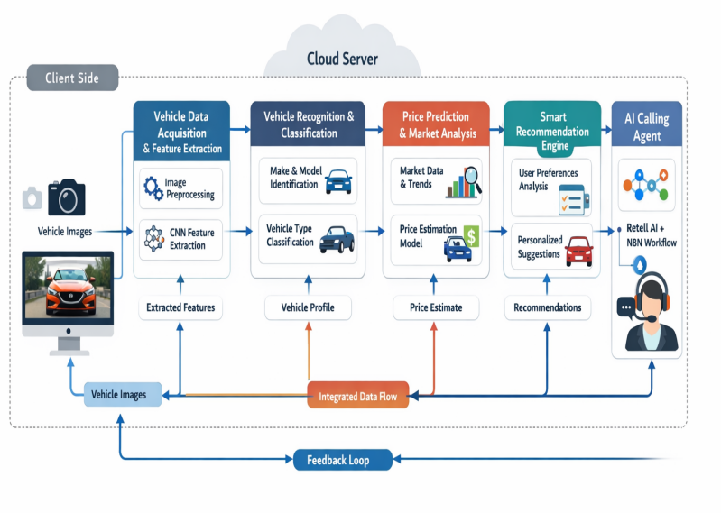

Fig. 1. AI-Powered Intelligent Vehicle Marketplace System ArchitectureArchitecture

- Vehicle Image Acquisition and Feature Extraction
The objective of this stage is to extract meaningful vehicle features from user-uploaded images.
Technology Used: Computer Vision Models, CNN-based Feature Extractors, Image Processing Frameworks
Process Flow:
• User uploads vehicle image or captures using mobile/web camera
• Image preprocessing (resizing, noise removal, normalization)
• Feature extraction using trained deep learning models
• Extraction of vehicle attributes such as make, model, body type, color, and condition
Output: Structured vehicle feature vector for classification and prediction.
- Vehicle Recognition and Classification
This stage identifies the vehicle make, model, and category.
Technology Used: Deep CNN Models, Transfer Learning Models
Process Flow:
• Extracted image features passed into classification model
• Model predicts vehicle type, brand, model variant
• Confidence filtering ensures reliable predictions
Output: Output: Identified vehicle profile with confidence score.
- AI-Based Price Prediction and Market Intelligence
This stage predicts vehicle price using historical and real-time market data.
Machine Learning Regression Models, Predictive Analytics Models
Process Flow:
• Combine vehicle attributes + market trends + historical price data
• Predict fair market price range
• Detect price anomalies and fraud risks
Output: Real-time vehicle price estimation and valuation insights.
- Smart Recommendation Engine
This stage provides personalized vehicle suggestions.
Technology Used:
Recommendation Algorithms, LLM-based Query Understanding
Process Flow:
• Analyze user preferences (budget, brand, fuel type, location, features)
• Compare similar vehicles in same price segment
• Generate best vehicle options
Output: Personalized vehicle recommendations.

- AI Calling Agent for Customer Assistance
This stage provides human-like conversational support for buyers.
Technology Used:
Speech Recognition, Text-to-Speech, Conversational LLMs, Voice AI
Process Flow:
• AI agent interacts with customers via voice or call
• Answers vehicle queries
• Compares vehicle options
• Books test drives
• Coordinates with dealerships
Output: Automated customer assistance and booking confirmation.

- RESULTS

The proposed AI-powered automotive marketplace platform was evaluated based on vehicle recognition accuracy, price prediction performance, recommendation relevance, and AI calling agent effectiveness. The system was tested using real-world vehicle images, historical vehicle pricing datasets, and simulated customer interaction scenarios.
- Vehicle Image Recognition Performance
The computer vision model demonstrated high accuracy in identifying vehicle make, model, and category from user-uploaded images. Testing was conducted using diverse vehicle datasets containing variations in lighting, angles, and background noise.
Observations:
•High classification accuracy across major vehicle categories
• Strong robustness against real-world image variations
• Low misclassification rate for similar vehicle models
Impact:
This ensures reliable automatic vehicle identification, reducing manual search effort for users.

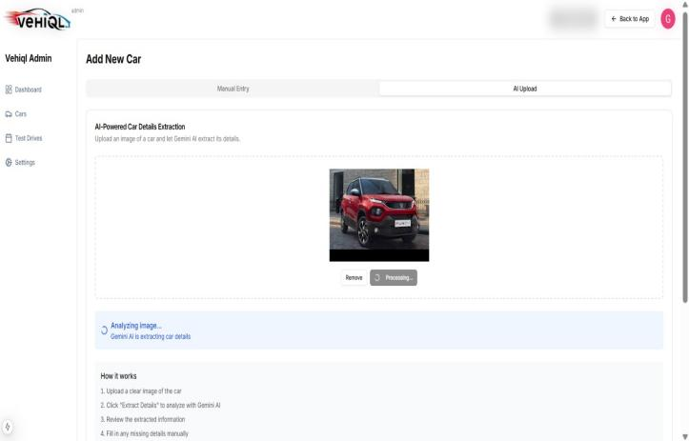

Fig. 2. AI-Powered Vehicle Image Recognition and Automatic Car Detail Extraction Interface

B. AI-Based Price Prediction Performance
The machine learning price prediction model was evaluated using historical used-car pricing datasets and real-time market trend features.

Performance Indicators:
• Accurate prediction of fair market price ranges
• Detection of overpriced and underpriced vehicle listings
• Stable prediction consistency across vehicle segments

Impact:
This enables transparent pricing insights and helps users avoid fraud or unfair pricing.

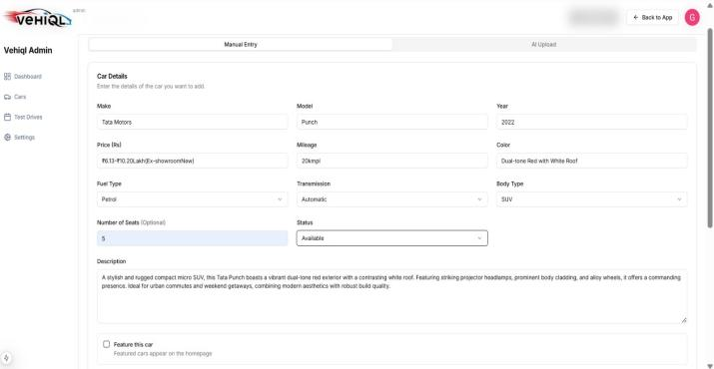

Fig. 3. Vehicle Dataset and Market Information Used for Price Prediction and Recommendation

C. Recommendation Engine Effectiveness
The recommendation engine was tested using simulated user preference profiles including budget, fuel type, vehicle category, and brand preference.
Results:
• High relevance in recommended vehicle suggestions
• Effective similarity comparison within same price segment
• Improved decision-making support for buyers
Impact:
Users receive intelligent, personalized vehicle suggestions instead of generic listings.

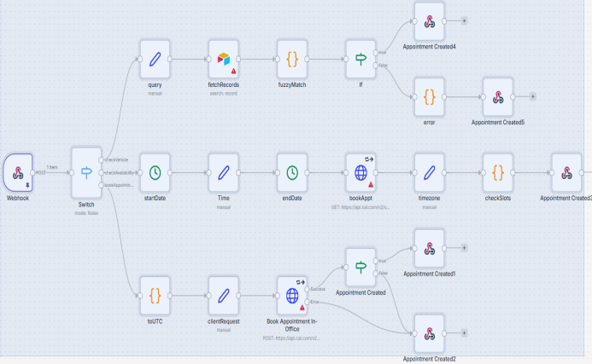
Fig. 4. AI Recommendation and Automated Appointment Booking Workflow Architecture

D. AI Calling Agent Performance
The AI conversational calling agent (implemented using Voice AI + Workflow Automation tools) was tested for real-time customer interaction capability.
Evaluation Metrics:
• High query resolution success rate
• Natural conversational interaction quality
• Accurate test drive booking and scheduling automation
• Seamless dealership communication handling
Impact:
This reduces dependency on manual call centers and provides 24×7 intelligent customer assistance

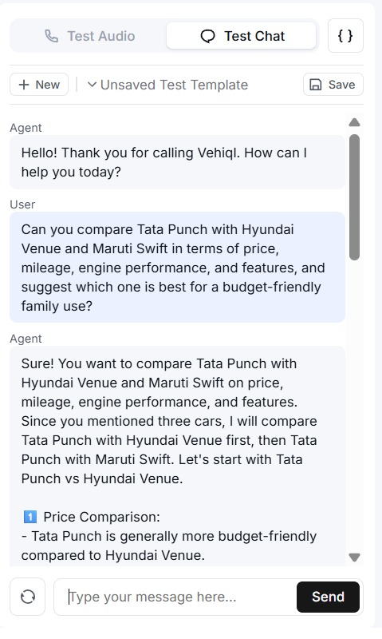

Fig. 5. AI Conversational Agent Handling Customer Vehicle Comparison and Assistance

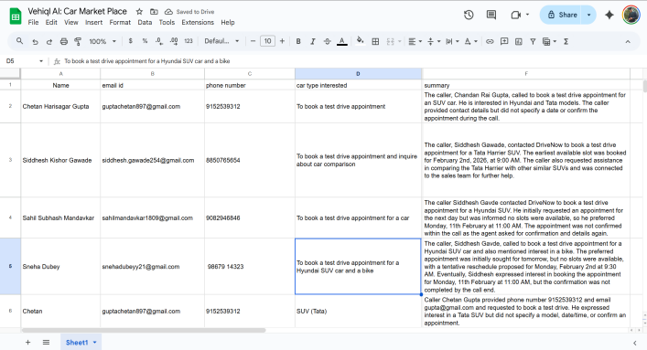

Fig. 6. Customer Interaction Dataset Used for AI Calling Agent Testing and Appointment Automation
E. End-to-End System Performance
The hybrid cloud-client architecture ensured smooth real-time system operation.
System-Level Results:
• Fast image processing and vehicle recognition
• Real-time recommendation generation
• Seamless integration between vision AI, ML prediction, and conversational AI modules
• Scalable architecture supporting multiple simultaneous users

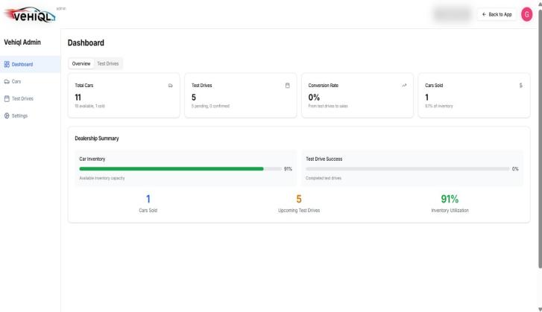

Fig. 7. VEHIQL AI Admin Panel Showing Vehicle Information Management Interface

F. Overall Outcome
The proposed system successfully demonstrates that integrating Computer Vision, Machine Learning, Predictive Analytics, and Conversational AI can significantly improve the vehicle buying experience by:
• Automating vehicle discovery
• Providing transparent price intelligence
• Enabling intelligent vehicle comparison
• Delivering human-like AI customer assistance
• Supporting digital automotive marketplace transformation

- IMPLEMENTATION CHALLENGES AND PRACTICAL CONSIDERATIONS
Implementing an AI-based car marketplace involves several technical, operational, and ethical challenges that must be carefully managed to ensure system reliability, scalability, and user trust. One of the primary challenges is data availability and quality, as AI models require large volumes of clean, structured, and labeled vehicle data such as pricing history, vehicle condition, ownership records, and user interaction patterns. Poor or inconsistent data can significantly reduce prediction accuracy and recommendation effectiveness. Another important consideration is system scalability and performance, since the platform must support thousands of concurrent users while maintaining fast response times for search, personalized recommendations, and AI calling agent support. This requires optimized cloud infrastructure, efficient database management, and proper model deployment strategies.
User trust and fraud prevention are also critical because vehicle marketplaces involve high-value transactions. The platform must implement strong seller verification, secure payment processing, and fraud detection algorithms to prevent scams and fake listings. From a practical implementation perspective, AI calling agents must support multiple languages, natural conversational flow, and regional speech variations to provide effective customer assistance, especially in diverse markets. Privacy and data security are equally important, requiring strong encryption methods, secure authentication systems, and compliance with data protection standards to protect user and financial data. Additionally, integration with third-party services such as vehicle inspection providers, financing services, insurance companies, and logistics partners can introduce technical complexity and require reliable API management. Finally, the cost of development, model training, cloud infrastructure, and continuous maintenance must be considered for long-term sustainability. Addressing these challenges through robust system design, ethical AI practices, and continuous performance monitoring will help ensure the successful deployment and scalability of the AI car marketplace platform.

- FUTURE SCOPE
The proposed AI-based car marketplace has significant potential for expansion through the integration of advanced artificial intelligence and emerging technologies. Future development will focus on implementing deep learning–based recommendation systems capable of analyzing user behavior, financial patterns, and lifestyle preferences to provide highly personalized vehicle suggestions. Additionally, the integration of AI-powered voice and calling agents will enhance customer support by assisting users in understanding vehicle specifications, comparing models, scheduling test drives, and guiding purchase decisions.
Further improvements include the adoption of computer vision techniques for automated vehicle inspection through image and video analysis, enabling transparent quality assessment of used cars. Predictive analytics models can also be incorporated to forecast vehicle prices, resale values, and market demand trends, helping both buyers and sellers make data-driven decisions.
The platform can be extended by integrating augmented and virtual reality–based virtual showrooms, allowing users to experience vehicles remotely. Blockchain technology may be used to secure ownership records, service history, and transaction data, reducing fraud and improving trust. Moreover, future versions aim to support edge AI deployment for offline mobile functionality and integration with connected and smart vehicle ecosystems for real-time diagnostics and monitoring.
These advancements will transform the platform into a comprehensive, intelligent, and user-centric automotive digital ecosystem.
- CONCLUSION
The AI-based car marketplace platform demonstrates how artificial intelligence can transform the traditional vehicle buying and selling ecosystem into a smart, data-driven, and user-centric digital experience. By leveraging technologies such as machine learning, predictive analytics, and intelligent automation, the platform improves vehicle discovery, pricing transparency, fraud detection, and customer decision-making.
The integration of AI-powered recommendation systems helps users identify vehicles that match their budget, preferences, and usage patterns, while automated verification and inspection mechanisms increase trust in used vehicle transactions. Additionally, the introduction of AI calling and virtual support agents enhances customer engagement by providing real-time assistance throughout the vehicle search and purchase journey.
Overall, the system contributes to digital transformation in the automotive marketplace by reducing manual effort, improving efficiency, and enabling personalized user experiences. With future enhancements such as advanced deep learning models, virtual showrooms, blockchain-based transaction security, and connected vehicle integration, the platform has the potential to become a comprehensive intelligent automotive ecosystem that benefits buyers, sellers, and marketplace operators alike.
- REFERENCES
- X. Ni and H. Huttunen, “Vehicle Attribute Recognition by Appearance: Computer Vision Methods for Vehicle Type, Make and Model Classification,” Journal of Signal Processing Systems, vol. 93, pp. 357–368, Apr. 2021.
- A. Amirkhani and A. H. Barshooi, “DeepCar 5.0: Vehicle Make and Model Recognition Under Challenging Conditions,” IEEE Transactions on Intelligent Transportation Systems, vol. 24, no. 1, pp. 541–553, Jan. 2023.
- M. Manzoor and Y. Morgan, “Vehicle Make and Model Recognition Using Random Forest Classification for Intelligent Transportation Systems,” 2018 IEEE 8th Annual Computing and Communication Workshop and Conference (CCWC), Las Vegas, USA, pp. 148–154, 2018.
- S. Lee, R. Ratan, and T. Park, “The Voice Makes the Car: Enhancing Autonomous Vehicle Perceptions and Adoption Intention through Voice Agent Gender and Style,” Multimodal Technologies and Interaction, vol. 3, no. 1, art. 20, 2019.
- X. Liu and Z. Liao, “Emotional Experience Design Strategy for In-Vehicle Intelligent Voice Assistant,” Frontiers in Social Science and Technology, vol. 6, no. 5, 2024.
- J. Li, H. Cheng, and H. Guo, “Survey on Artificial Intelligence for Vehicles,” Automotive Innovation, vol. 1, pp. 2–14, Jan. 2018.
- A. Qian, A. A. Musa, M. Biswas, Y. Guo, W. Liao, and W. Yu, “Survey of Artificial Intelligence Model Marketplace,” Future Internet, vol. 17, no. 1, art. 35, 2025.
- V. Mandala and S. N. R. D. Surabhi, “Integration of AI-Driven Predictive Analytics into Connected Car Platforms,” International Advanced Research Journal in Science, Engineering and Technology (IARJSET), vol. 7, no. 12, Dec. 2020.
- J. Lin, “Predicting Used Car Price Based on Machine Learning,” Proceedings of the 1st International Conference on E-Commerce and Artificial Intelligence (ECAI’24), vol. 1, pp. 553– 560, 2024.
- I. Fayyaz, G. G. M. N. Ali, and S. S. Khairunnesa, “Advanced Feature Engineering and Machine Learning Techniques for High Accurate Price Prediction of Heterogeneous Pre-Own Cars,” Vehicles, vol. 7, no. 3, art. 94, 2025.
- M. Z. Ali and S. Patel, “AI-Based Vehicle Valuation Using Predictive Modelling and Market Data Analytics,” IEEE Access, vol. 11, pp.

