Feasibility of Aero-Hydro Generator

Jane Antoneth D. Palma, Divine Mae P. Añasco, Joselito Y. Bulabos, Scarlett Claire A. Buscato, Brent Lee C. Delfino, John Carlo C. Divinagracia,Jeian B. Doblado, Baby Faith S. Juson, Junel Benedict F. Niñeza
Researchers, San Agustin National High School, Philippines

Abstract
This study investigated the feasibility of Aero-Hydro Generator as a dual system for atmospheric water harvesting and small scale renewable energy generation. Using a research and Development (R&D) approach guided by Engineering Development Model (EDM), a prototype combining mist collection, micro-hydrogenerator, and Arduino -based automation was designed , constructed, and tested in San Agustin, Sagbayan, Bohol. Descriptive statistics (mean and standard deviation) were used to assess performance in water efficiency and power output. Based on the results, the prototype achieved acceptable water efficiency but produced power output was low. Although the prototype has power generation limitations, the results demonstrate functional stability and potential to be a water harvesting system and alternative renewable energy source for rural communities.
Keywords: Aero-Hydro Generator, atmospheric water harvesting, renewable energy, micro-hydropower, feasibility study

INTRODUCTION
The requirement of electricity and clean water is a basic need for human beings. Millions of people are still struggling on a daily basis to meet their basic needs. Both of these factors are interlinked, as water is required to produce electricity, and electricity is also required to pump and treat water. Without the availability of both factors, the constraints for human beings in terms of health, education, livelihood, and development will be harsh.
Globally, the International Energy Agency, around 675 million people are still living without electricity (IEA, 2023). On the other hand, the United Nations state that 2.2 billion people are living without access to safely managed drinking water services (UN, 2023). Climate change, population increase, and environmental deterioration are further increasing these difficulties, and therefore, sustainable and renewable energy sources are more important than ever before.
In the Philippines, energy security remains a concern for many provinces, Especially during times of natural calamities and in remote areas not Connected to the main power grid, and water scarcity are still pressing Concerns. The Department of Energy verifies that many remote areas are still using diesel-fueled generators and are frequently experiencing brownouts (2022). On the other hand, the National Water Resources Board states that many rural areas are experiencing irregular water supply because of old infrastructure, lack of funding, and the fact that water services rely on electricity (2022). Even after the passage of the Renewable Energy Act of 2008, the application of alternative energy solutions still has challenges regarding logistics, maintenance, and adaptability.
In Bohol, there is potential as well as limitations of renewable energy in meeting the power challenges. According to an analysis by Pojadas and Abundo (2021), a mix of solar, wind, biomass, and hydropower energy can help the province reach a 35% or higher share of renewable energy, except for hydropower. This emphasizes the importance of a mix strategy to diversify energy resources to ensure a stable supply.
However, despite the growing use of renewable energy resources, most of the current systems are designed for conventional energy resources and are suited for areas that are resource-rich or have high fog content. There have been very few studies on the concept of harvesting atmospheric moisture as a way of generating electricity and water, particularly in areas that are of low elevation and resource-poor. The lack of suitable technologies for such regions highlights the need for alternative energy systems that can function even in adverse environmental conditions.
To address the need for sustainable energy solutions for rural communities, the development and performance evaluation of an Aero-Hydro Generator, a mist-capturing system integrated with a micro-hydrogenerator. Contrary to most studies that concentrated on high-altitude foggy areas, this study was conducted in San Agustin, Sagbayan, Bohol, which has an elevation of around 265.6 meters above sea level (PhilAtlas,2025).
The research aimed at creating the specifications, circuit, and logical flow of the device to ensure efficiency and functionality. The project also sought to produce an electric current by utilizing the atmospheric moisture. Although regions prone to fog have readily available moisture, there are limited global initiatives that have investigated the use of energy systems that utilize atmospheric moisture as an alternative source of power (Heng et al., 2021). Through the development of a framework that can be applied to rural areas, the research study sought to provide a model for alternative energy that can be applied to provide electricity and water. The study highlighted the need to apply environmental awareness and engineering skills to approach real-world problems.

Research Question
This study aimed to develop and assess the effectiveness of an Aero-Hydro
Generator, a mist capturing device with a micro-hydrogenerator system in Barangay San Agustin, Sagbayan, Bohol for the school year 2025-2026.
Specifically, this study sought to answer the following questions:
1.What is the technical specification of the device in terms of:
1.1circuit design;
1.2 physical and Mechanical specification;
1.3 logical flow?
2. How does the machine perform in terms of:
2.1. water efficiency;
2.2. power output?
3.What recommendations can be drawn from this study?

Hypothesis
The Aero-Hydro Generator does not perform well.

Review of Literature
One of the most researched areas of solution for electrification, particularly for remote and off-grid regions, is renewable energy. Hydropower is one of the most prevalent forms of renewable energy. Hydropower utilizes turbines and generators to convert flowing water into hydropower (U.S. Department of Energy, 2017; Union of Concerned Scientists, 2021). Research has shown that, with the proper design, even small quantities of flowing water can yield sufficient power (Sahay & Rachna, 2024). Micro-hydropower systems are considered to be practical options as they are straightforward and fit well with resource-poor settings. On the other hand, most studies on hydropower focus on the use of rivers and streams for water.
Studies have also considered the potential of atmospheric water harvesting to help with water scarcity. Mukhopadhyay, Singh and Patel (2024) found that condensation efficiency varies depending on the mesh material, surface texture and its orientation. Kennedy and Boreyko (2024) showed that bio-inspired mesh designs enhance fog and mist collection and avoid clogging. Li et al. (2025) demonstrated that water can be harvested by advanced fog collection, even at low humidity.
Automation plays an important role in improving renewable energy systems. Supardi and Abdulah (2024) developed an Arduino-based monitoring system for pico-hydropower and showed that automation improves reliability and reduces the need for constant supervision. Tang et al. (2023) demonstrated that micro water generators can power self-sustaining monitoring devices. These studies prove that automated control systems help renewable energy devices operate more efficiently. Automation is especially useful for remote and rural locations.
Despite these advancements, a research gap still exists in combining atmospheric water harvesting and micro-hydropower into one system. Most previous studies focus only on mist collection for water supply or hydropower generation using traditional water sources. Very few studies have examined hybrid systems that use collected mist to generate electricity, especially in low-elevation rural areas. In addition, limited research has tested such systems using locally available materials under real environmental conditions. Because of this gap, the Aero-Hydro Generator study aims to evaluate a combined, automated system that can collect mist and produce electricity at the same time.

METHODOLOGY
This study aimed to assess the performance of Aero-Hydro Generator in terms of water collection efficiency and power generation. The focus was on examining the performance of the constructed device in natural environmental condition. The data collected during the testing process were evaluated for analyzing the performance of the Aero-Hydro Generator.

Materials and Methods:
- Breadboard
- Arduino Uno
- Micro Servo
- Water Sensor
- LCD
- Jumper wires
- Battery
- DC Motor
- Wheel Rim
- Sprockets
- Bearings
- Inverter ( AC to DC)
- Nylon
- PVC
- Synthetic Leather
- Mosquito Net
- Data recording sheets

1. Development of Innovation
The study used a Research and Development (R&D) and Engineering Development Model (EDM) design to develop and test the Aero-Hydro Generator. This design focused on constructing the device and evaluating its performance based on water collection efficiency and power output. The Aero-Hydro Generator was developed to collect atmospheric moisture and convert the collected water into electrical energy. The device was constructed using a mist collection system, a water collection container, and a turbine-generator mechanism. The components were assembled to allow the collected water to flow through the turbine for power generation.
2. Testing and Set-up
The testing of the Aero-Hydro Generator was conducted in San Agustin, Sagbayan, Bohol. The device was placed in an open area exposed to natural airflow and atmospheric moisture. The setup remained the same throughout the testing period to ensure consistency of results.

3. Performance Evaluation
The performance of the Aero-Hydro Generator was evaluated based on its water collection efficiency and power output. Water efficiency was measured by recording the time required to collect a specific amount of water. Power output was observed during the operation of the device.

4. Data Gathering Procedure
Data were collected during several trial runs of the Aero-Hydro Generator. For each trial, the amount of water collected and the observed power output were recorded using researcher-made data sheets. The same procedure was followed for all trials to ensure uniformity in data gathering.

5. Data Analysis and Ethical Considerations:
The collected data were analyzed using descriptive statistical tools such as mean and standard deviation. These were used to summarize the performance of the Aero-Hydro Generator. The study did not involve human participants or animals; therefore, no ethical issues were encountered. Safety precautions were observed during testing to avoid damage to the device and the surroundings.

RESULTS
The final circuit design of the Aero-Hydro Generator successfully utilized the Arduino Uno, water level sensor, servo motor, and LCD display into a unified control system. The experiment enables controlled operation and coordination of sensors, controls, and monitoring components. Water level detection allows the system to release water effectively to generate electricity. Display of operational conditions supports monitoring and troubleshooting during operation. Overall, the circuit configuration contributes to stable, dependable, and continuous system performance.
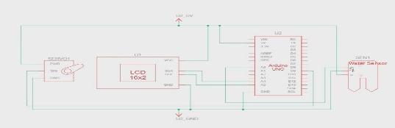

Figure 1. Circuit Design

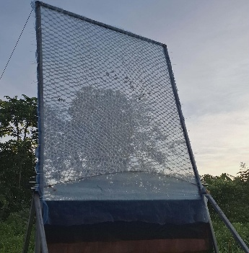
The physical and mechanical specifications of the Aero-Hydro Generator provided a stable and compact structure for mist collection and energy conversion. The three-layer mist harvesting enhances moisture capture efficiency as each layers are built to ensure moist collection capability. This collection system ensures continuous water flow toward the storage and turbine system. Mechanical integration of the turbine, DC motor and stabilizers enables smooth flow of the testing. This supports the safety of operation and reliable mechanical performance.
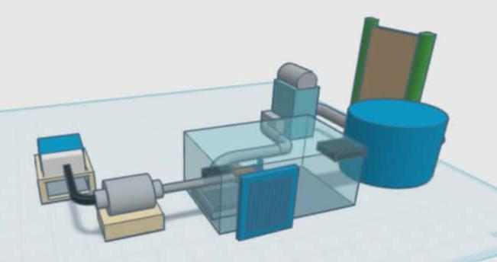

Figure 2. Physical and Mechanical Specification

The logical flow of the Aero-Hydro Generator followed the clear sequence given from water collection to power generation. The programmed control logic activates the system only if the required two-liter water volume is reached. Once activated, the servo-controlled valve releases water to drive the turbine in a controlled manner. The coordinated operation of the turbine, DC motor, battery, and inverter ensures stable energy conversion. This structured sequence improves reliability and prevents unnecessary system operation.
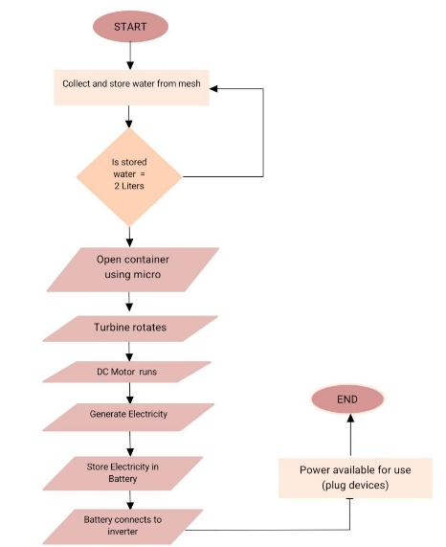

Figure 3. Logical Flow

Table 1: Performance of Aero-Hydro Generator
Performance Indicator | Mean | Standard Deviation | Descriptive Ratio
Water Efficiency | 2 | 0 | Acceptable
Power Output | 1 | 0 | Poor
Overall Performance | 1.5 | 0 | Acceptable

In terms of water efficiency, the Aero-Hydro Generator obtained a mean score of 2 with a standard deviation of 0, corresponding to the Acceptable rating. This result shows that the system collected the required water volume within the expected period of three to six days. The standard deviation shows that performance remained uniform across all test trials, this shows the reliability of the mist collection structure and mechanical design. Overall, the findings confirm that the system performs adequately in water harvesting.
For power output, the Aero-Hydro Generator recorded a mean score of 1 with a standard deviation of 0, which corresponds to a Poor rating. The result showed that the electrical energy produced during testing was inconsistent, which led to a low performance. The lack of variation across trials indicates a persistent limitation rather than operational inconsistency. The turbine and generator appears to be the primary factor affecting this result, improvements in these components are necessary to increase electrical output.
To summarize, the Aero-Hydro Generator resulted a mean score of 1.5, showing that the water collection system was acceptable and energy generation as consistent. This suggests that the concept of device is effective but needs further improvements. With further refinement, the Aero-Hydro Generator has the capability to become a more effective renewable source of electricity.

DISCUSSION
The water efficiency result of the Aero-Hydro Generator was rated properly because the device successfully collected the required 2 liters of water within the expected time period of 3–6 days. This shows that the mist collection work properly under environment conditions. The layered mesh design helped capture atmospheric moisture constantly. The results across trials show that the water collection process was consistent. And the system proved effective in capturing water.
In contrast, the power output of the Aero-Hydro Generator was rated poor due to very low electrical energy production. This might be because of insufficient water flow and pressure reaching the turbine. The turbine’s design and DC motor efficiency may not be appropriate for low-volume water input. The energy losses in mechanical transmission and electrical components might potentially have influenced the output. These factors led to the poor power generating output.
When compared to the related studies, the small-scale of mist harvesting and the micro-hydro systems showed a similar results. The previous study shown that, while the mist harvesting is successful for water collection, the power generation stays low but the turbine designs are modified. The other experiments increased power generation by enhancing the turbine and the water efficiency . This comparison supports up the findings of the current study. It demonstrates that the findings are in line with previous study.
This findings of the study have important significant for rural areas, but they also show limitations. The device can be useful as an alternative water-harvesting system in areas with limited access to clean water, but its power output is currently insufficient to meet regular energy needs. Testing the device was done at only one location under certain meteorological conditions. Also the turbine and generator designs had limited energy production. These limitations emphasize the need for more testing and system enhancements. This study’s findings are significant for rural areas, but they also had a limitations.

Conclusion and Recommendations
Based on the findings, the Aero-Hydro Generator is a feasible hybrid system for mist gathering and small-scale energy generation. During testing, the water efficiency showed enough and remained. This shows that the atmospheric mist collected with low-cost materials and designs. The system showed responsible and automated operation. Therefore, it is recommended for the future researchers improve the turbine and generator design to increase power output, enhance the mist collection design, and conduct further testing under different environmental condition to improve overall performance.

REFERENCES
Department of Energy. (2022). Energy situationer: Remote and off-grid areas in the Philippines. https://www.doe.gov.ph
Heng, C., Tan, A., & Lim, B. (2021). Atmospheric moisture harvesting for sustainable energy production: A review. Renewable and Sustainable Energy Reviews, 137, 110625. https://doi.org/10.1016/j.rser.2020.110625
International Energy Agency. (2023). World energy outlook 2023. International Energy Agency. https://www.iea.org/reports/world-energy-outlook-2023
Kennedy, A., & Boreyko, J. (2024). Bio-inspired fog harvesting meshes: A review. Advanced Functional Materials, 34, Article 2306162. https://doi.org/10.1002/adfm.202306162
Li, X., Chen, Y., & Zhang, H. (2025). Electrostatic fog collection for enhanced atmospheric water harvesting in low-humidity environments. Applied Energy.
National Water Resources Board. (2022). Water supply and infrastructure challenges in rural areas. https://www.nwrb.gov.ph
Mukhopadhyay, A., Singh, R., & Patel, K. (2024). Optimization of condensation surfaces for atmospheric water harvesting. Applied Thermal Engineering, 230, 121501. https://doi.org/10.1016/j.applthermaleng.2023.121501
PhilAtlas. (2025). San Agustin, Sagbayan, Bohol. https://www.philatlas.com
Pojadas, R., & Abundo, R. (2021). Renewable energy potential in Bohol: A mixed resource approach. Journal of Philippine Energy Studies, 12(3), 45–59.
Sahay, A., & Rachna. (2024). Performance analysis of low-head micro-hydropower systems for rural electrification. Renewable Energy Systems.
Supardi, S., & Abdulah, A. (2024). Design of an Arduino-based monitoring system for pico-hydro power plants. In 2024 International Conference on Green Energy, Computing and Sustainable Technology (GECOST) (pp. 1–5). IEEE. https://doi.org/10.1109/GECOST58504.2024.10346624
Tang, Y., Li, J., Wang, Z., & Chen, L. (2023). Self-powered water monitoring system using micro water generators. Sensors and Actuators A: Physical, 350, 114132.
Union of Concerned Scientists. (2021). How hydroelectric energy works. https://www.ucsusa.org/resources/how-hydroelectric-energy-works
United Nations. (2023). Water scarcity: Facts and figures.
https://www.un.org/waterforlifedecade/scarcity.shtml
U.S. Department of Energy. (2017). Hydropower basics. https://www.energy.gov/eere/water/hydropower-basics

Appendices
Appendix A: Raw Data

Day | Water Collected (ML) | Cumulative Water (ML) | Generator Run (2 L )
1 | 428 mL | 428 mL | No
2 | 347 mL | 775 mL | No
3 | 382 mL | 1,157 mL | No
4 | 412 mL | 1,569 mL | No
5 | 486 mL | 2,055 mL | Yes ( 1st Run)
6 | 439 mL | 439 mL | No(Reset)
7 | 457 mL | 896 mL | No
8 | 482 mL | 1,378 mL | No
9 | 384 mL | 1,762 mL | No
10 | 458 mL | 2,220 mL | Yes(2nd Run)
11 | 476mL | 476 mL | No(Reset)
12 | 394mL | 870 mL | No
13 | 418 mL | 1,288 mL | No
14 | 465 mL | 1,753 mL | No
15 | 485 mL | 2,238 mL | Yes(3rd Run)
16 | 493 mL | 493 mL | No(Reset)
17 | 463 mL | 956 mL | No
18 | 452 mL | 1,408 mL | No
19 | 396 mL | 1,804 mL | Yes(Last Trial)
Number of Generator Runs |  |  | 4

Trial | Voltage(V) | Current(A) | Power(V x A) | Score
1 | 0.28V | 0.00112A | 0.0003136W | 1
2 | 0.15V | 0.0006A | 0.00009W | 1
3 | 0.17V | 0.00068A | 0.0001156W | 1
4 | 0.25V | 0.001A | 0.00025W | 1
Mean |  |  |  | 1

Trial | Day Interval | Score
1 | 5 | 2
2 | 4 | 2
3 | 5 | 2
4 | 5 | 2
Average Time per Run | 4.75 | 2

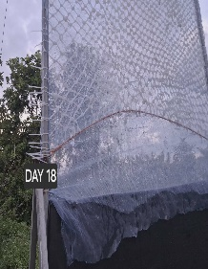

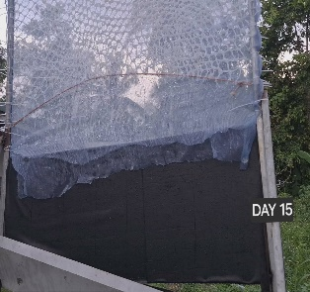
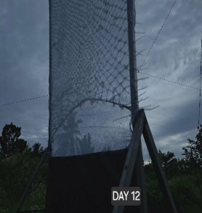
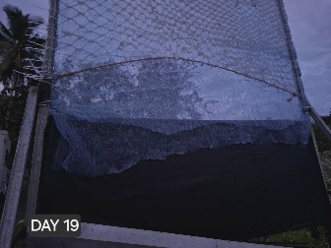
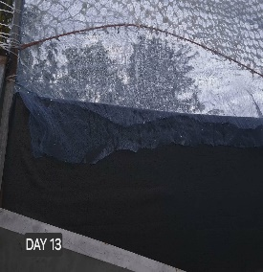
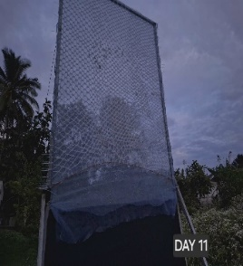
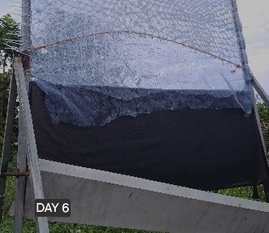
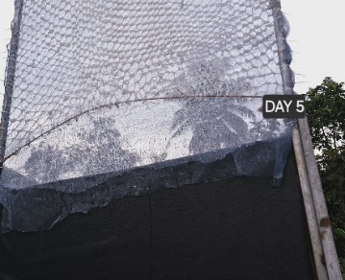
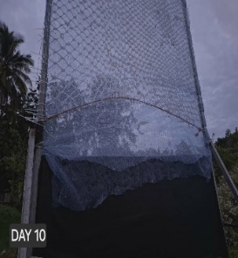
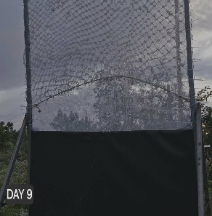
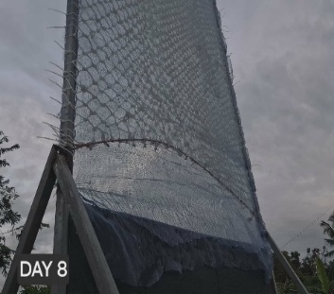

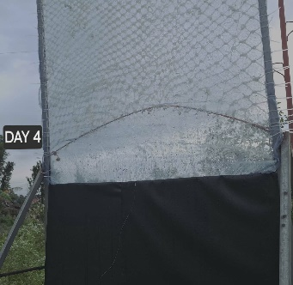
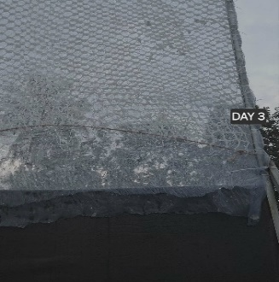
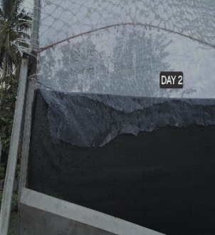
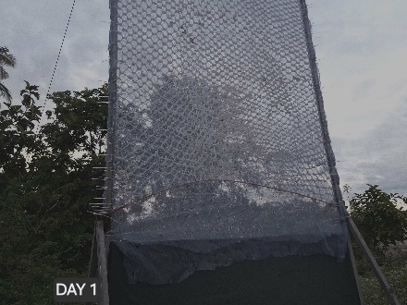
Appendix B: Photograph of the 19-days testing of the device
