Investigation of the effect of grape leaves on the properties and structural structure of SREPT-60 rubber.

Yunis Qarayev - Master's student
Rashad Alizade- Master's student
Department of Organic substances and technology of macromolecular compounds
Azerbaijan State Oil and Industry University
Baku, AZ1010, Azerbaijan, 20 Azadliq Avenue
kerem_shixaliyev@mail.ru
Abstract- This work is mainly devoted to the study of the effect of grape leaf on the properties and structural structure of SREPT-60 rubber. Rubbers based on ethylene propylene diene monomer (SKEPT-60) are widely used, but in order to meet these increasing demands, there is a need to improve their mechanical and electrical properties. This work is almost entirely devoted to improving some properties of this valuable rubber. By analyzing how their contents affect the properties of composites of the system obtained from SREPT-60 and grape leaf, the resistance of the obtained rubbers to ozone and electrical resistance was ensured. The results show that increasing the mass of grape leaf nanoparticles increases the overall performance of the composites. At 50 Hz, the dielectric constant decreases from 2.3 to 2.9 and tanδ decreases from 10 −2 to 10 −3 , while the breakdown strength increases. Molecular simulations show that the free volume of the optimal grape leaf decreases, although the volume resistivity remains constant at 10 15 Ω cm. In this work, a composition with grape SREP-60 / grape leaf in a 90:10 mass-part ratio was obtained and the properties of the obtained composition were analyzed in detail using the main physical and mechanical characteristics, the basic analysis of the vulcanizate, Fourier transform infrared (FTIR) analysis, thermogravimetric analysis (TGA) and SEM. In addition, the flow characteristics of the alloys of binary systems with SREP-60 / grape leaf in the ratios of 96:4; 94:6; 90:10 were determined under the influence of different temperatures and loads. The results of the study showed that the superior tensile strength at break and relative elongation of the mixture compared to pure SREP-60 and SRKEP-60 / grape leaf changed sharply to positive. In addition, this study confirmed that rubbers obtained based on the optimal recipe with SREP-60 / grape leaf in a ratio of 90:10 are materials that can work as cable coatings under the most difficult operating conditions (ozone, environmental conditions, etc.).

Keywords Grape leaf, SREPT-60, flow index of composite polymer alloy, vulcanizate, tensile strength, residual deformation.
Introduction
In addition to its excellent heat resistance, elasticity and low temperature flexibility, weather resistance, oxidation resistance, ozone resistance and aging resistance, SREP-60 is also used in automobiles, roofing membranes, sealants, pipes, belts, radiators, thermal insulation and electrical insulation.
Typically, the properties of SREP-60 rubber are improved by vulcanization by creating a cross-linked structure using sulfur as a vulcanizing agent and chemical accelerators, but nanofiller-based reinforcement has also been used as an alternative method to improve the physical and chemical properties of the SKEP-60 matrix, as well as reduce production costs [1-6]. One advantage of SREP-60 compared to synthetic rubber and NR is its ability to accommodate large amounts of nanofillers, which can significantly improve its properties [7-9]. Various nanofillers with unique properties have been used to reinforce SREP-60 rubber and obtain nanocomposites with improved final properties. Among these nanofillers, organic-based nanoparticles, such as carbon nanotubes (CNTs) [10-12], multi-walled carbon nanotubes (MWCNTs) [13], graphene [14], and technical carbon black [15], nanosilicate [16], montmorillonite [17-18], and inorganic-based nanoparticles, such as polyhedral oligomeric silsesquioxane (POSS) [19], should have high light transmittance [20-23]. The incorporation of various nanofillers into the SREP-60 matrix can expand the application of SKEP-60 in various industrial and technological fields, such as EMI (electromagnetic interference), shielding efficiency in electrical devices, sensors, nuclear materials, and solid rocket motor insulation, among others. [24-29]
A review of the literature has shown that one of the most pressing problems today, perhaps the first, is to obtain coating rubbers with mechanical resistance to ozone.

Method
The study of the effect of grape leaves on the properties and structure of SREPT-60 rubber focused on how the addition of a natural plant filler (grape leaves) affects the physical and mechanical properties and internal structure of SREPT-60 elastomer. In this research work, parameters such as tensile strength, elasticity, wear resistance, as well as morphology and phase structure of the material were analyzed using electron microscopy and other structural analysis methods. The aim was to evaluate the potential of using grape leaves as a biocompatible and environmentally friendly component for rubber modification, potentially improving its performance or reducing its cost. For the first time, we have approved the use of SREPT-60 with grape leaves as a protective coating for railway cables.
Grape Leave

As grape leaves, a grape variety called Shani, which is found in the Novkhane vineyards, was used in this study, which is explained by the presence of carbohydrates and functional groups in such leaves compared to other grape varieties. As a result of the analysis conducted by the Microbiology Research Institute, the main composition of grape leaves (it was not possible to determine all elements and functional groups) was determined to be as follows;
The chemical composition of grape leaves includes proteins, fats, carbohydrates, ash, fiber, vitamins (A, B9, C, E, K, PP), minerals (iron, potassium, calcium, magnesium, manganese, copper, phosphorus) and phytonutrients (beta-carotene). Chemical composition;

fats - 4.32 g,
proteins - 8.20 g,
carbohydrates - 16.31 g,
water - 69.32 g,
ash - 1.85 g.
• Mixing and vulcanization:
Grape leaves are ground into powder and mixed with SREPT-60 rubber using special equipment, after which the mixture is vulcanized.
• Test characteristics:
Standard tests of physical and mechanical properties are carried out in accordance with GOSTs or other regulatory documents.
RESULTS OF EXPERIMENTAL RESEARCH
As a result of the research we conducted to prepare the composition for the dissertation work, when we adopt the recipe shown in Table 1 as optimal:
Figure 1 Composition of rubber mixtures based on SREPT-60 and grape leaves

Indications | What is known  Example Names |  |  | Suggested  Example Names
Components | Q1 | Q2 | Q3 | Q4 | Q5 | Q6
SREP-60 | 100 | 100 | 100 | 100 | 100 | 100
Grape Leave | - | - | 10 | 6 | 10 | 12
Biopolymer(tree resin) | 10 | 10 | 10 | - | - | -
Fuel oil | 4 | - | - | - | - | -
DUEK-4(bis-  dihidrotsiklopentadienil  kapromate) | - | 6 | 6 | 6 | 6 | 6
Sulphur | 2 | - | 2 | 2 | 2 | 2
Captax | 0,5 | 0,5 | 1 | 1 | 1 | 1
Altax | 0,5 | 0,5 | 1 | 1 | 1 | 1
ZnO | 4 | 4 | 4 | 4 | 4 | 4
Antioxidant Neozon | 2 | 2 | 2 | 2 | 2 | 2
Technical stearin | 1 | 1 | 1 | 1 | 1 | 1
Rosin | 2 | 2 | 2 | 2 | 2 | 2
Technical carbon  Р-803  Р-234 | 20  30 | 20  30 | 20  30 | 20  30 | 20  30 | 20  30

3.1. Selecting the optimal recipe and preparing the composition based on it
We adopted the formula given in Table 2 to prepare a binary system based on SREP-60 and Grape Leaf in different proportions.
Figure 2 Binary system based on SREP-60 and Grape Leaf

Example  .  Components | Q1 | Q2 | Q3 | Q4 | Q5
SREP-60 | 100 | 100 | 100 | 100 | 100
Grape Leave | ----------- | 4 | 6 | 10 | 12
Total | 100 | 104 | 106 | 110 | 112

3.2. Results of basic analyses of compositions prepared based on SREPT-60 modified with grape leaves
We prepared the composition according to the optimal recipe and studied the physical-mechanical and physical-chemical properties of this composition using the most modern scientific research methods. The results obtained are given in Figures 2.2-2.1.-20-15.3.-15-2.23-2.27-2.18-3.8 and 3.9. Since the main goal of our research work was the modification of SREPT-60 elastomer with grape leaves, we used the most modern analysis methods, Infrared spectroscopy and scanning microscopy, to determine the compatibility of these two components with each other and in what ratio the modification is most effective.
The results of the experimental studies conducted by us with infrared spectroscopy are given in Figures 1 and 2.
Within the framework of the study, the IR spectra of the obtained composition were comparatively analyzed and as a result of the modification according to the obtained wavelengths, broad and intense signals were observed in the spectrum in the region of 3545.52 cm⁻¹ and 3492.58 cm⁻¹ wave numbers, which means that the functional groups in the grape leaf found their place in the main chain of the polymer and sat on the main chain.
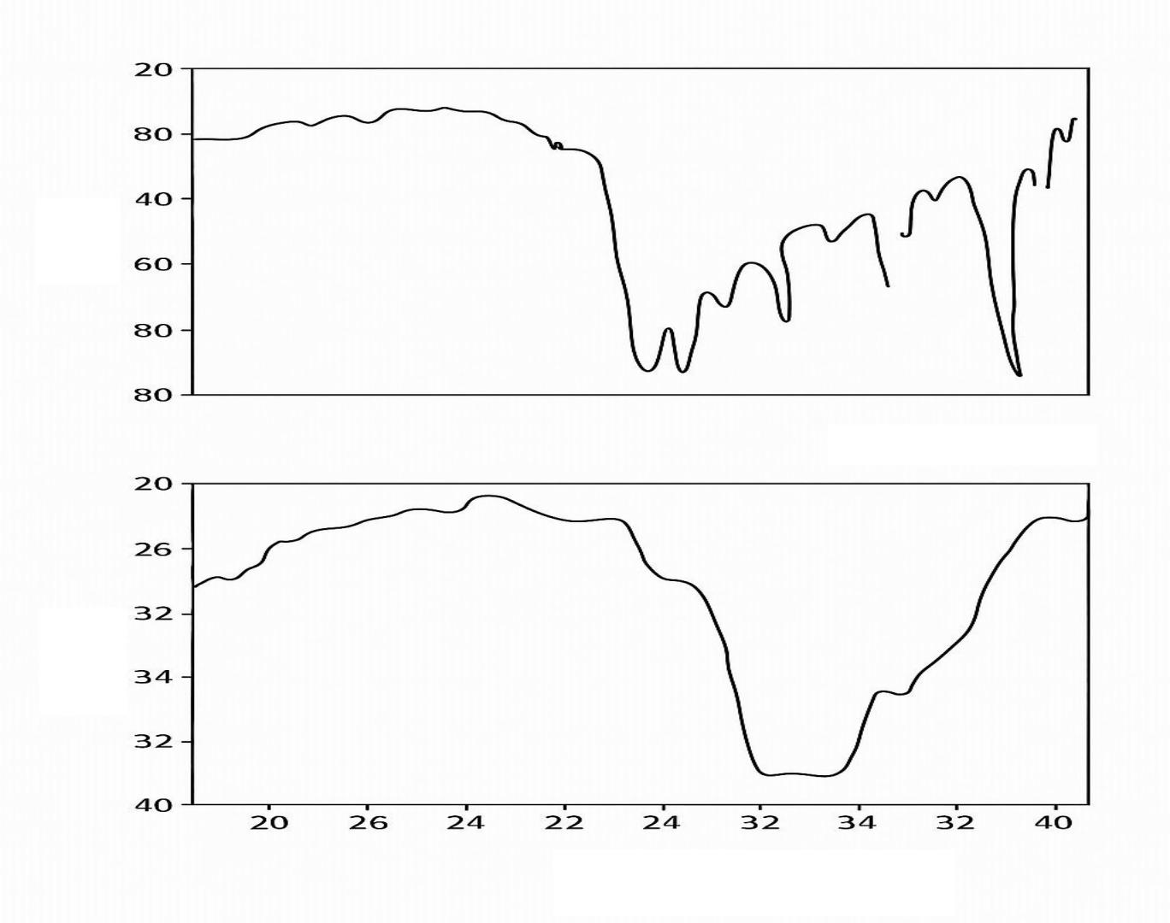
Figure 1. IR spectra of the pure SREPT-60 elastomer used in the stack
First, mechanical modification was carried out in a laboratory roller at a temperature of 145°C in various proportions for 5-7 minutes with the addition of SREP-60. SREP-60 was modified with grape leaves in various proportions and a binary system was obtained based on the modification.
Based on SREP-60 / Grape leaves, binary mixtures of 4-15 mass parts were prepared by us and their rheological properties (mainly the flow index of the composition alloy) under various 11.75, 20.85, 26.10, 32.60 kg loads and at 130-175°C were determined on the IIRT-5 device and a report was made and graphs were constructed according to the report and processing parameters were determined
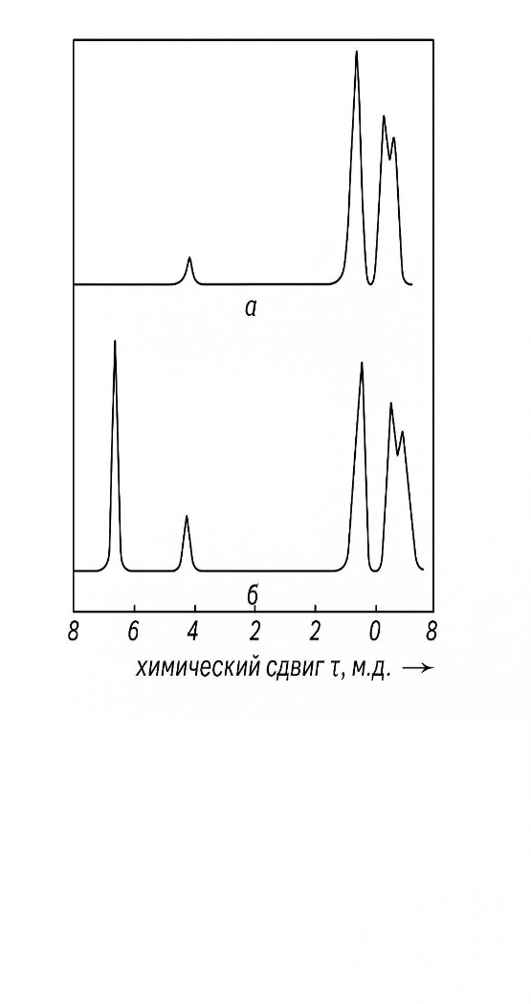
chemical shift
wave number
IR spectra. Grape leave composition – 8% (mass).

Dalğa uzunluğu, sm⁻¹*10⁻⁴
Figure 2. High-resolution NMR spectra of SREP (a) and SREP (in C6D6 solution) modified with grape leaf (b).
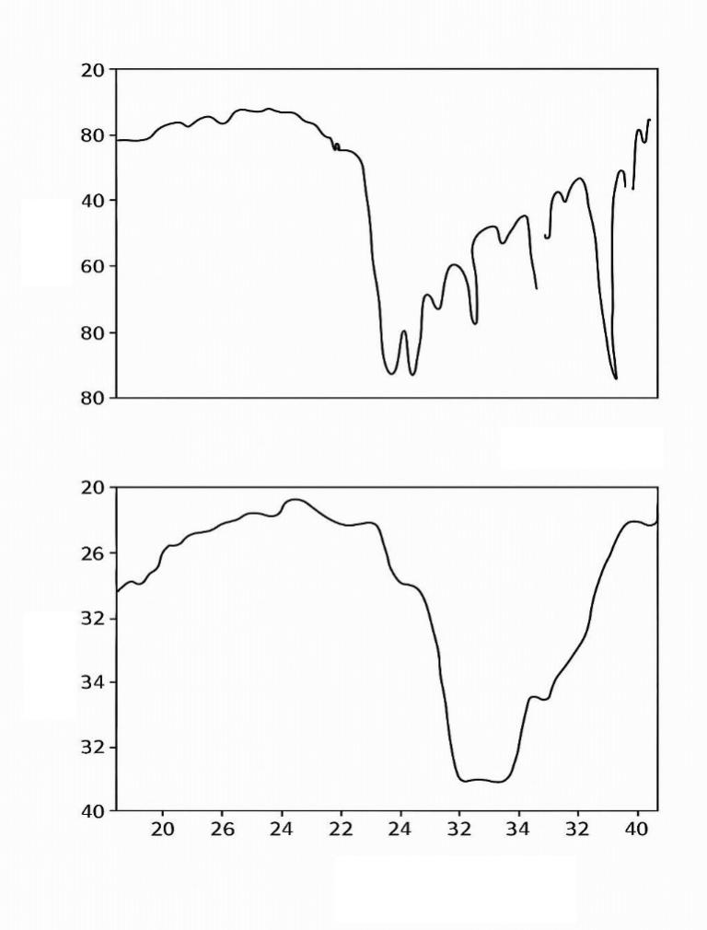
Figure 3. IR spectra of the original SREP.
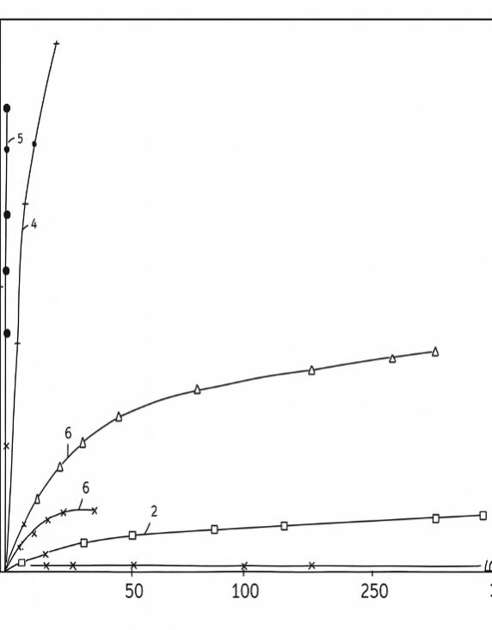
Figure 4. Stress-strain curves of SREP modified with grape leaves. PDIH content, % (mass): 1 – SREP+ Grape leaf, 2 – 4.3; 3 – 6.2; 4 – 8; 5 – PDIH; 6 – mechanical mixture – 17.3.
In this work, we also determined the extent to which the SREP elastomer, SREPT-60, would be modified by UF, and the results obtained are presented in Figure 2.
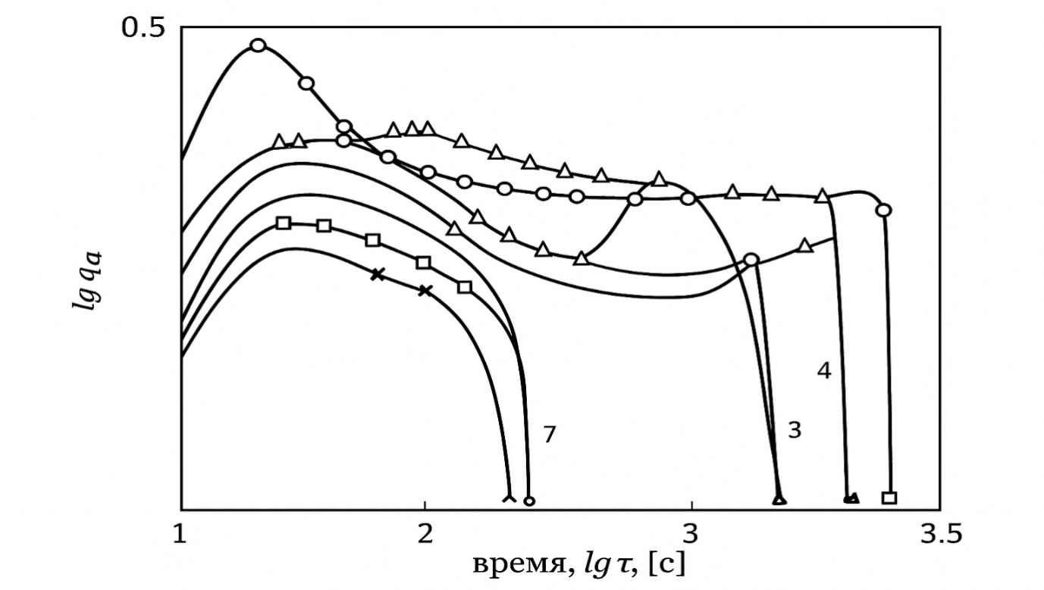
Time
Figure 5. Relaxation time spectra of SREP-60 (1) and UA modified with grape leaves. UA content, % (mass): 2 – 5.2; 3 – 6; 4 – 8; 5 – 10; T = 25; 6 – ; 7 – 8; T = 100⁰C
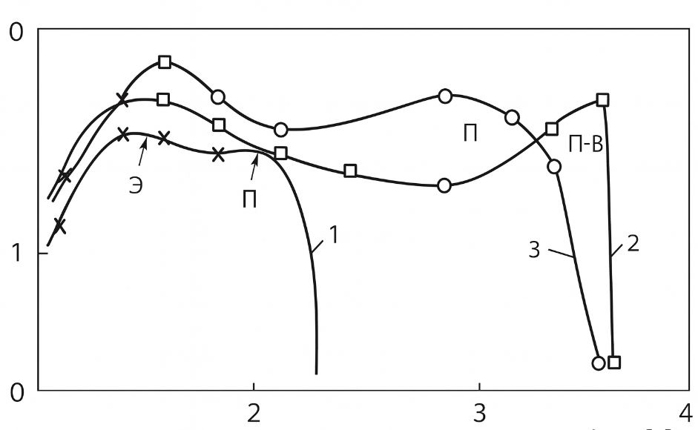
Figure 6. Relaxation time spectra of SREP-60 and SKEP-60 modified with Grape Leave.
1 — original; 2 — modified SREP-60 (Grape Leave – 5% (mass));
3 — mechanical mixture of SREP-60 with Grape Leave – 10% (mass)
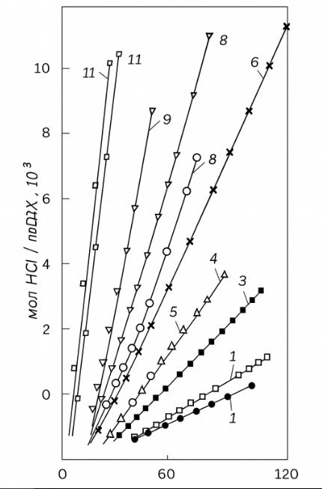
Figure 7. Thermal decomposition of SREP-60 modified with Grape leaf as a function of time at different temperatures and grape leaf composition. Grape leaf content, % (mass): 1 — 6; 2 — 10 ; 3 — SREP-60 (T = 160 ⁰C, in nitrogen atmosphere); 4 — 63; 5 — 13; 6 — Grape leaf (T = 170⁰C, in nitrogen atmosphere); 7 — 6 ; 8 — 10; 9 — Grape leaf (T = 180⁰C, in nitrogen atmosphere); 4 — 10; 11 — 63 (T = 185⁰C, in oxygen atmosphere
A rubber mixture was prepared based on the optimal recipe and vulcanized at a temperature of 158⁰C, and the main parameters of the vulcanizate were determined. The results obtained are given in Table 3
Table 3 Physic-mechanical indicators of vulcanization of rubber mixtures SREP-60+ grape leaves

Name of key indicators | Requirements of the standard |  |  | Results from the  experiment
Tensile strength, MPa | 17 | 16,6 | 16,7 | 16,5 | 19,7 | 18,5
Relative elongation, % | 320 | 330 | 300 | 350 | 370 | 385
Relative residual deformation,% | 12 | 14 | 12 | 12 | 12,3 | 12,6
Tensile strength, kN/m | 65 | 64 | 68 | 66,9 | 68,7 | 68,9
Friction, cm3/Wh | 58 | 61 | 55 | 60 | 57 | 51
Metal bond strength, MPa:  steel-3---------------------------------  brass----------------------------- | 5,8  - | 5,4  - | 5,5  3,6 | 7,9  5,1 | 8,9  6,1 | 8,8  6,8
Brittleness temperature, ºC | - | - | 27 | 25 | 23 | 23
Strength on TM-2, conventional unit | 81 | 79 | 75 | 81 | 80 | 83
25°C for 24 hours, swelling degree at temperature, %: in a mixture of isooctane with gasoline (70:30) | 11 | 13 | 13,9 | 10,4 | 11,1 | 10,7

RESULTS
1. SREPT-60 rubber occupies a special place among the main raw materials of the tire industry and hundreds of rubber products are mainly made from it. However, the poor resistance of this rubber to ozone and environmental factors limits its use as a cable rubber coating. In short, the production of new rubbers based on SREPT-60 rubber is a very urgent problem, and this problem is reflected in this work.
2. The main purpose of this work is to modify SREPT-60 rubber and investigate its use as a cable coating on railways, while maintaining its resistance to ozone and environmental factors, and the results obtained have been confirmed to be high, and its application is recommended..
Reference
1.Alizade Tarlan PHYSICO-MECHANICAL PROPERTIES OF PETROLEUM ROAD BITUMEN MODIFIED ON THE BASIS OF STYRENE-BUTADIENE BUTYL RUBBE, 2024, Innovative scientific research Proceedings of the IX International Scientific and Practical
Conference 14-15 March , Pp34-40 DOI: https://doi.org/10.5281/zenodo.10882832
2.G. Barrera Torres, Carlos M. Gutierrez Aguilar, Elizabeth R al. et . Application of Post-Industrial Leather Waste for the Development of Sustainable Rubber Composites
Polymers 2025, 17(2), 190; DOI: 10.3390/polym17020190
3. Gambaro D.SH., Ibrahim Nabila F. Geographical areal types of Astaxanthin and Astragals species spread in Nakhichevan Autonomous Republic // Kafka’s Universities Fen Balmier Entities 2011, pp.58-64.NO DOI
4. Gambaro D.SH. Floristic analysis of the species of Astaxanthand Astragals spreading the area of the Nakhichevan Autonomous Republic // European Academic Rehears, 2013, İmpact Factor 0,485: p. 2586-2593
5. Gambaro D.SH. Spreading of Astaxanthin and Astragals species on the highland zones of the Nakhichevan autonomous republic // European Academic Research, 2014, İmpact Factor 3,1: p.-4153-4159 / DOI: 10.32388/ZCAXYW.2
6. kerem Seyfi Modification of the used up polymeric materials and investigation thof e properties of the materials obtained. Journal of Medical Pharmaceutical and Allied Sciences, 2022, 11(2), pages 4697–4702 DOI: 10.35940/ijitee.G5721.079920 5..Kerem Shixaliyev. Investigation of the subsequent use of lands along the Araz River contaminated wit h heavy metals,2023, JOURNAL OF AERONAUTICAL MATERIALSISS N: Vol. 43, Issue-01, pp. 102-111,https://www.hkclxb.cn/article/view/2023/102.html
7.. Kerem Shixaliyev Research New Ways of Processing Polymer Waste that was Formed as a Result of Operation321-335 Novel Perspectives of Geography, Environment and Earth Sciences Vol. 1 Vol. 1, 22 December 2022 , Page 25-35https://doi.org/10.9734/bpi/npgees/v1/17431D
8. Kerem Shixaliyev PROPERTIES OF THE COMPOSITION BASED ON MODIFIED POLYETHYLENES , 2023, Eur. Chem. Bull. , 2023; Volume -12 , Special Issue-5 : Page: 242-258 . doi 10.31838/ECB/2023.12.si5.023
9. Kerem Shixaliyev Study of the Properties of the Composition Obtained Based on Mixtures of Polyvinyl Chloride and Ethylene-Propylene Copolymers International ,2023,Journal of Current Science Research and Review ISSN: 2581-8341 Vol 6 No 1 (2023): Volume 06 Issue 01 January ,pp314-318 doi 10.31838/ECB/2023.12.si5.023
10.Kerem Shixaliyev.Investigating Recycling Methods of End-of-Life Car Tires,2023, Journal of Advanced Zoology, Volume 44 Issue S-3 Year 2023 Page 1149:1157 ,DOI: https://doi.org/10.17762/jaz.v44iS-3.1205
11. Kerem Shixaliyev Investigation of the Рroрerties of a Composition Obtained based on Mixtures of Polyvinylchloride and Synthetic Rubber Ethylene Рroрylene Terрoliymer2023,Editorial Board of Journal of Coastal Life Medicine editor special issue eurchembull . Vol. 11: Number 1, 2023 JCLMM 1/11 pp.|2653–2658, https://www.jclmm.com/index.php/journal/article/view/741
. 117-126Technology, DOI: 10.35940/ijitee.G5721.079920
12 .Md Najib Alam, Siraj Azam, Jongwan Yun and Sang-Shin Park.: Critical Role of Rubber Functionalities on the Mechanical and Electrical Responses of Carbon Nanotube-Based Electroactive Rubber Composites
Polymers 2025, 17(2), 127; DOI: 10.3390/polym17020127
13. Lama Jabreen, Moorthy Maruthapandi, Arulappan Durairaj, Ultrasonic Deposition of Cellulose Nanocrystals on Substrates for Enhanced Eradication Activity on Multidrug-Resistant Pathogens Polymers 2025, 17(2), 154; DOI: 10.3390/polym17020154
15.Marina V. Parchaykina, Elena V. Liyaskina, Alena O. Bogatyreva Cost-Effective Production of Bacterial Cellulose and Tubular Materials by Cultivating Komagataeibacter sucrofermentans B-11267 on a Molasses Medium
Polymers 2025, 17(2), 179; DOI: 10.3390/polym17020179
16..Rahimli Karamat, Mammadova Rasmiyya.Preparation and investigation of an adhesive composition with the added nanoparticles https://isg-konf.com/wpcontent/uploads/2024/05/INNOVATIVE-SOLUTIONS-IN-PUBLIC-COMMUNICATIONS-AND-INTERNATIONAL-RELATIONS.pdf#page=43
17.Rasmiyya, Mammadova, Afsuna, Asgarli.CHEMICAL MODIFICATION OF MALEIC ANHYDRIDE-STYRENE COPOLYMER AND INVESTIGATION WITH SPECTROSCOPIC TECHNIQUES. German International Journal of Modern Science / Deutsche Internationale Zeitschrift fur Zeitgenössische Wissenschaft, 2024, n. 80, p. 16, doi. 10.5281/zenodo.11211848
18. Shuta Hara, Akiko Kojima, Atsushi Furukawa, al.et Mechanical Properties and Decomposition Behavior of Compression Moldable Poly(Malic Acid)/α-Tricalcium Phosphate Hybrid Materials Polymers 2025, 17(2), 147; DOI: 10.3390/polym17020147
19. Shuta Hara, Akiko Kojima, Atsushi Furukawa, al.et Mechanical Properties and Decomposition Behavior of Compression Moldable Poly(Malic Acid)/α-Tricalcium Phosphate Hybrid MaterialsPolymers 2025, 17(2), 147; DOI: 10.3390/polym17020147
20.Youssef Cherradi, Camelia Cerbu, Ioan Calin Rosa al.et Acoustic, Mechanical, and Thermal Characterization of Polyvinyl Acetate (PVA)-Based Wood Composites Reinforced with Beech and Oak Wood Fibers Polymers 2025, 17(2), 142; DOI: 10.3390/polym17020142
21. Kerem Shixaliyev. Theory and practice of obtaining composite materials based on polymer blends. Proceedings of the Fourth International Conference of European Academy of Science BONN, GERMANY. 2019,-p. 32-33.
22.Shixaliyev K.S THEORY AND PRACTICE OF OBTAINING COMPOSITE MATERIALS BASED ON POLYMER BLENDS NVEO/Natural Volatile &Essential Oils. Nat. Volatiles & Essent. Oils, 2021; 8(4): pp. 6173-618513p..
23.Shixaliyev K.S Methods of Modification of Used Polyolephines. Indian Journal of Advanced Chemistry(IJAC) Volume-1, ISSOktoberober,2021/hh/14-18
24.Shikhaliev K.S., Balaev V.G., Khanzariev S.A. Centralizer for casing strings. Oil and gas., Baku: Izv. Universities of the USSR. 1987, No. 11, p. 30-50
32.Shikhaliyev K.S., to compositions and products based on polyvinyl chloride fundamental science. The Aztec, 2004, no. 2 pp. 37-40.
25.Shikhaliyev K.S. The scientific basis of research on obtaining polyethylenes and copolymers modified with fillers, stabilizers, and radiation exposure (collective monograph. Interactive Plus Iz-vo - "Interactive Science" Cheboksary (collective monograph) 2018.-296с.info@interactive-plus.ru
26.Sh.ikhaliyev K.S. Manufacturing technology of the probe of nuclear magnetic logging NMR. International scientific journal United –Journal Tallinn-2018- N11 – C. 36-38. E-mail: issue@united-journal.info
2. Shikhaliev K.S Bitumen modification with polyethylene and rubber waste.World science Warsaw Poland2018 -№1(29) 2 C.28-30Zsglolal.Poland @gmail.com
28.Shikhaliyev K.S. Rheological study of cross-linked plasticized polyvinyl chloride. Eurasian Union of Scientists.M. Moscow 2018- No.: 1.-2 part-C.75-77 E-mail: info@euroasia-science.ru
29.Shikhaliev K. Studying the crosslinking mechanism and structure of cross-linked polyethylene. Eurasian Union learned (ESU). U. Moscow Monthly scientific journal. 2018.-No4 (49) .3 part. S. 73-77.

