advances and emerging challenges of digital Modulation RECOGNITION For wireless signals using Artificial Intelligence Techniques

Abstract:
This paper discusses a statistical review of various artificial intelligence techniques used in wireless communication for the implementation of automatic modulation recognition of digital modulated signals. Automatic recognition of modulation types from received signals in communication systems reduces complexity and cost of circuit design of the demodulators used at receiver. It helps to design an adaptive universal communication receiver in a noisy medium, where the behavior of a modulated signal keeps on changing continuously with noise. For the effective usage of RF (radio frequency) spectrum, determination of modulation types in spectrum sensing and software defined radios (SDRs) is considered to be crucial. Demodulation and recognition of signal types using hybrid machine learning algorithms at receiving end plays very significant role in various applications of cognitive radios, satellite communication systems, and military intelligence and in underwater surveillance systems too. Implementation methodologies of these applications for automatic recognition of modulation types are discussed using various AI techniques. Various spectral and statistical parameters like time-frequency features, higher order cumulants, constellation images and cyclic frequency domain features extracted from received signals for classifying modulation types are summarized. Different algorithms developed to extract features, classification algorithms and the validation metrics used in the models are outlined. Methodologies used to distinguish the type of digital modulated signals like ASK, PSK, FSK and QAM signals with its inferences and analysis from datasets are discussed.
Index terms
Artificial Intelligence(AI), Machine Learning(ML), Automatic Modulation Recognition (AMR), Transfer learning (TL), Self Learning (SL), Amplitude Shift keying (ASK), Frequency Shift Keying (FSK), Quadrature Phase Shift Keying (QPSK), Quadrature Amplitude Modulation (QAM), Stochastic Gradient Descent(SGD), CNNs(Convolution Neural Networks), DAEs (Denoising autoencoders), Deep Neural Networks (DNNs), Higher order cumulants( HOCs)

- Introduction
With introduction of AI in wireless communications, ML and DL algorithms for automatic modulation recognition (AMR) plays an important role in processing digital signals at the receiving end of communication system. Classification of modulation signal types at receiver m plays a very important for both covert and overt applications [1] of radio sensing applications in defense and civilian communications, cognitive radios, under water surveillance of signals, remote sensing applications of space and many others. At receiver, AMR acts as an intermediate step in the detection of digital signals and demodulation process that helps to detect ASK, FSK, PSK, QPSK, QAM and many other digital signals. Digital signals using DL and ML learning architectures can be detected by extracting spectral features [2] or any other mixed features converted into time to frequency (T-F) transformation [3] of received signals are applied as inputs to reduce the complexity [4]. As data is huge, processing of signals to detect modulation types should be fast and reliable for an effective communication between transmitter and receiver. Due to high flooded rate of RF data in space, efficiency of modems may decrease due to the traditional methods of detection of signals .Hence the usage of artificial intelligence in signal processing for automatic classification of signals will increase the efficiency of receiver for a communication system.
In defense and military applications, an intelligent communication system is very crucial for electronic war fare applications [6]; the ability to decode the information from an intelligent receiver to search for a specific signal is very essential. Thus, a communication systems in military applications, requires the extraction of radar signals [5] features and modulation type detection in complex electromagnetic environment automatically, helps to generate energy efficient jamming signals. Radar scanning, acquisition of signals and its processing, range of the radar and its tracking features are all trained [10] into the technology of machine learning to recognize the radar signals efficiently.
In cognitive radio [7], automatic modulation recognition (AMR) helps to accurately label and analyze the radio spectrum with the ability to monitor interference in the spectrum, any fault detections over radio, dynamic access to the spectrum and opportunistic mesh networking of wireless communications. As the bandwidth of RF spectrum is limited, automatic modulation classification also finds useful in real time environments for dynamic spectrum management, identification of interferences at the receiver and the type of modulated signals at intelligent modems of the digital video broadcasting (DVB) of satellite standard [9] applications.
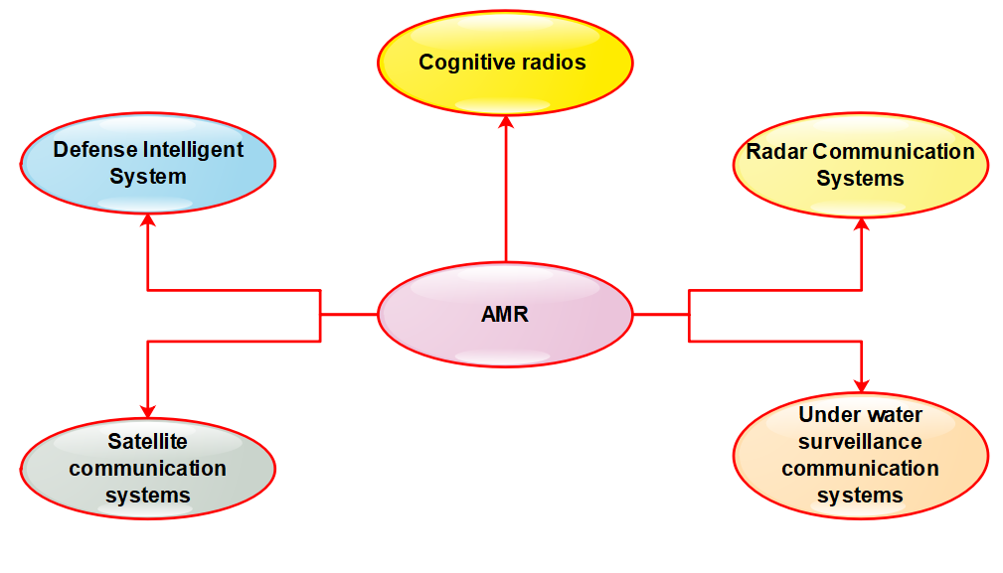
Fig 1: Applications of AMR
Automatic processing of signals is considered as one of the challenging issue in under water surveillance of acoustic wireless communication systems [8].Due to narrow bandwidth, prolonged time of signal communication, high inter symbol interference characteristics of underwater acoustic channel effects the stability of a communication system. Hence AMR system should be capable to identify and classify the received signal modulation types from the receiver in the complex environments of noise, interferences, fading and disturbances.
Further more efficient modulation recognition algorithms are required to be developed using hybrid ML /DL algorithms for both cooperative and non-cooperative communication systems. Figure 1 shows the applications of AMR in various technologies of communication systems. Digital modulated signals are more immune to interference than analog signals, the impact of accurate recognition rate due to effects of propagation, size/depth of the model and window size of neural nets, data sets, and the required modulation types should also be considered while implementing the algorithms.

In this comprehensive study, an in-depth analysis on various AI algorithms proposed for automatic modulation on various feature based techniques is discussed. Section 1 presents an AMR signaling system model with an overview of different digital signals, section 3 provides the importance of AI in wireless communication systems, section 4 discusses the different approaches used for to achieve automation using ML/DL algorithms, section 5 presents the existing methodologies used to implement AMR, section 6 discussed about the gap in research, where novel AMR algorithms are need to be improve the existing models, section 7 provides a comprehensive analysis signal recognition rate with datasets and last section concludes about the need and necessity to do further research in AMR in real time environment for both cooperative and non-cooperative applications.

- AMR Signaling System Model
An AMR signaling system model consists of transmitter, receiver and channel as a medium where noise gets introduced as shown in figure 2. Modulation recognition is considered as intermediate process between the signal processing stage and demodulator of the receiver. In digital transmission, baseband signal along with carrier signal is shifted to a high frequency band limited signal and is transmitted through a wireless channel.
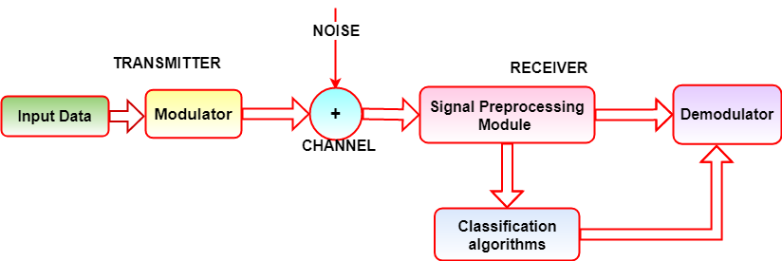
Figure 2: A digital communication system model

The expressions for basic modulations of digital signals [46] is explained in table 1. ASK, FSK and PSK signals are represented as shown in figure 3 for the modulation sequence 10110100 . For logic 1 and 0, ASK is denoted with different amplitudes A₁ and A₂, FSK with different carrier frequencies ω_{c1} and ω_{c2} and with a phase difference of φ in PSK are used as shown in table 1.
Modulation types | Bit 0 | Bit 1 | Significance
ASK | $$X_{ASK}= A_{1}Cosω_{c}t-Logic 0$$ | $$X_{ASK}= A_{2}Cosω_{c}t-Logic 1$$ | A₁ and A₂ of different amplitudes
FSK | $$X_{FSK}=ACosω_{c1}t-Logic 0$$ | $$X_{FSK}= ACosω_{c2}t-Logic 1$$ | ω_{c1} and ω_{c2} of different frequencies
PSK | $$X_{PSK}=ACosω_{c}t-Logic 0$$ | $$X_{PSK}= ACos{(ω}_{c}t+φ)-Logic 1$$ | Carrier signal with a phase difference of φ

Table 1 : Modulation equations
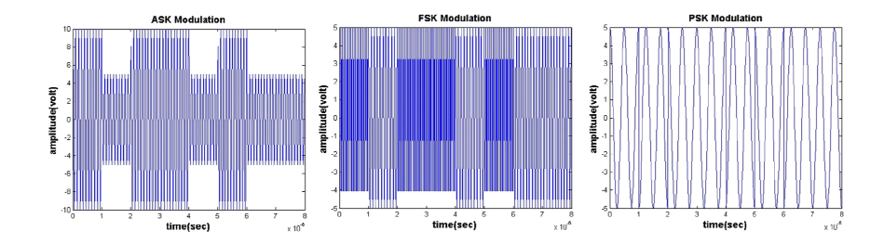Fig 3: ASK ,FSK,PSK for data sequence 1011010 [46]
Quadrature modulations equations for QASK, QFSK, QPSK [46] and its modulation sequence for different combinations of logic 0 and 1 are summarized in table 2 and represented in fig. 4 for data sequence of 10110100:
Logic 11 | Logic 01 | Logic 00 | Logic 10
$$X_{QASK}= A_{1}Cosω_{c}t$$ | $$X_{QASK}= A_{2}Cosω_{c}t$$ | $$X_{QASK}= A_{3}Cosω_{c}t$$ | $$X_{QASK}= A_{4}Cosω_{c}t$$
$$X_{QFSK}=ACos 2πf_{c1}t$$ | $$X_{QFSK}=ACos 2πf_{c2}t$$ | $$X_{QFSK}=ACos 2πf_{c3}t$$ | $$X_{QFSK}=ACos 2πf_{c4}t$$
$$X_{QPSK}=ACos(ω_{c}t+ \frac{π}{4})$$ | $$X_{QPSK}=ACos(ω_{c}t+ \frac{3π}{4})$$ | $$X_{QPSK}=ACos(ω_{c}t- \frac{3π}{4})$$ | $$X_{QPSK}=ACos(ω_{c}t- \frac{π}{4})$$
Table 2 : Quadrature modulation equations
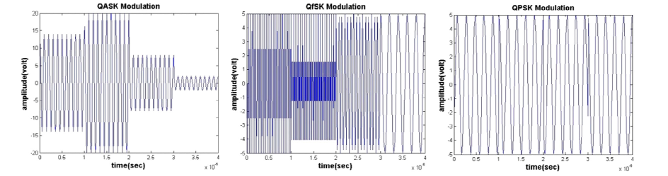Fig. 4:QASK, QFSK and QPSK signals for data sequence 10110100 [46]
At the receiver of a communication system, signal received r(t) is expressed as:
$r\left(t\right)=s\left(t\right).c\left(t\right)+n\left(t\right)$ (1)
where base band modulated signal, s(t) is multiplied with a high frequency carrier signal,c(t) added with Gaussian white noise, n(t). Initially the received signal is preprocessed by estimating received signal strength and synchronization parameters like frequency offset, recovery time. Interferences and noise are eliminated at this stage and then applied to the ML classification algorithms for further obtaining the base band signal.
Further, r(t) can be expressed as:
$r\left(t\right)=s\left(t\right)e^{-j\left(2πf_{c}t+φ_{c}\right)}+ n(t)$ (2)
where f_{c} is the carrier signal frequency with a phase of φ_{c} . s(t) can be expressed (Hassanpour,S et al; 2016) as
$s\left(t\right)=a_{k }E e^{-j\left(2πf_{m}t\right)+φ(t)]}x(t-kT_{s})$ (3)
Bit sequence, a_{k}
M-ASK | $a_{k}ϵ \left\{\left(2m-1-M\right)d,m=1,2,..,M\right\} d=$ $\sqrt{\frac{3E}{M^{2}-1}}$
M-PSK | $$a_{k}ϵ \left\{e^{j2π(m-1)/M},m=1,2,….…M\right\}$$
M-FSK | $a_{k }=e^{j2πtf_{k }}$ , $f_{k}ϵ \left\{\left(2m-1-M\right)∆f/2π,m=1,2,..,M\right\}$
M-QAM | $a_{k }= p_{k}+{jq}_{k}=e^{jφ_{k}}\sqrt{{p^{2}}_{k}+{{q^{2}}_{k}}_{ }}$ , $φ_{k}=\tan^{-1}\left(\frac{q_{k}}{p_{k}}\right)$  ${p_{k},q}_{k}ϵ \left\{\left(2m-1-\sqrt{M}\right)d,m=1,2,..,M\right\}$, $d=$ $\sqrt{\frac{3E}{2\left(M-1\right)}}$

Table 3: Bit sequence for digital signals
where x(t) is the base band signal with a pulse width of T_{s} for a_{k} digital sequence , having a signal strength of E. The bit sequence , a_{k} of M-array digital signals are explained in Table 3 for M-ASK, M-PSK, M-FSK and M-QAM.
The key factors that reduces the standards of signal strength in a communication channel are mainly due to the frequency variations in carrier frequency, delay spread in multipath fading environment due to the lag in signal reflection and refractions ; thermal noise also referred as as additive white Gaussian noise(AWGN) acquired from physical devices of the reciever.
- Role of Artificial Intelligence in Communication Systems
With the usage of advanced algorithms with high computing capabilities and accessibility to huge volumes of data, artificial intelligence in the field of communication systems has created a new technical revolution in the field of wireless communication. Artificial intelligence focuses on creating algorithms to solve problems nearer to a human approach of solving. AI and ML technologies have proved with the potential to solve complex problems in the fields of speech processing, image processing and video processing applications. Machine learning is a field of study that gives computers the ability to learn without being explicitly programmed [48]. ML is a well posed learning algorithm where a computer is said to acquire knowledge for a task T from the experience of programs E with a performance measure P, where performance measure on the task should improve with experience [49]. However, higher success rate has been achieved with deep learning (DL) algorithms where the learning process are inspired by the human brain structure of neurons. Deep learning is a group of ML algorithms that uses multiple layers to continuously extract discriminative features from the raw input data. Each level of layers contains set of neurons that learns and transforms raw input data into a fused representation knowledge. Due to its higher computational facilities, the number of layers can be increased to create a powerful neural network.
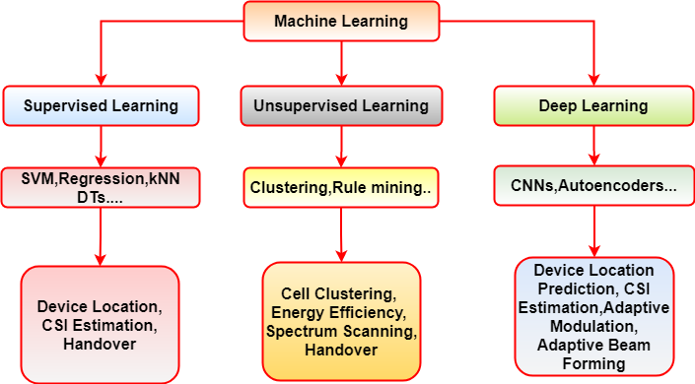
Fig 5: Classification and Applications of AI in Wireless Communication

ML technologies are grouped into supervised, unsupervised and reinforcement learning methods. In supervised learning, model learns from the labeled data of dataset and gets the desired output when an unknown input is applied to the model. In wireless communication systems, these algorithms can be applied to find the location of the device, estimating CSI and where the handover of the signal takes place. SVMs, KNNs, Linear and non- linear Regressions, Decision trees are the examples of supervised learning algorithms. In unsupervised learning, the model learns to extract common patterns from the training samples of datasets and predicts the new sets of labels. k means Clustering, Agglomerative and association rule mining are some of the examples of unsupervised learning. These algorithms can be applied to scan spectrum in real time and to check cell clustering in wireless communications. If the volume of data is big, DL algorithms can be applied to predict the location of device and to provide adaptive modulation and beam forming techniques.
With the introduction of AI in wireless communication, the mathematical models of physical layers can be replaced with ML models, which enables automation in dynamic resource allocation and enabling of intelligent internet of things (IOT).
- AI approaches for Modulation Recognition

In recent decades, the basic approach developed for modulation recognition and radio signal classification using machine learning and deep learning algorithms are classified mainly into decision based maximum likelihood and feature based pattern recognition [11,12] methods. Decision based approaches [13] use hypothesis testing and probability values to formulate that involves high complex computation, while in statistical approach of pattern recognition method extracts the features from received signals/raw data that used to classify the decision of recognition using classification algorithms. These algorithms perform automatic classification of digital signals by extracting time-frequency features [1], higher order cumulant features [13], constellation features [14] and cyclic frequency domain features [15] of the received signals. Usually, any one or mixture of these features is helpful for automatic classification of signals. However, it is difficult to compare the performance of extracted features obtained using different machine learning algorithms [16], as different modulation datasets are built on various assumptions like channel fading effects, carrier frequency and phase offsets. However, using deep learning methods, these features can be extracted automatically [17] from the signal data used for the classification of modulation types of signals. A deep neural network proves to be an advantageous to extract the signal from noise if SNR of received signals is low and also for large volumes of data.

- Baseline Classification Approach using ML algorithms

The baseline approach [17] is a feature-based method that consists of two steps: identification of statistical features and the application of classifiers to classify the digital signals.

- Statistical Features

AI techniques use spectral features like higher order statistics (HOS) and cyclo-stationary moments in statistical methods to detect signals with strong principal components carrier structure, timing symbols and symbolic structure of various modulations. Based on these structures with peak expected amplitudes in auto-correlation function (ACF) and spectral correlation function (SCF) of these features help for classification for any unknown input signal. Compressed HOSs are obtained from higher order moments (HOMs) that help to calculate higher order cumulants (HOCs). HOSs and instantaneous spectral features acts as effective discriminators to obtain modulation types [18 ] of received signals. Additionally, time-frequency features like mean, standard deviation were also used as discriminative features in recognition algorithms [19] for the recognition of digital signals. Probability distribution curves of these statistical, cumulant and spectral instantaneous features helps to obtain the modulation types of the received signals.

Spectral Features | Mathematical Expression | Significance
Power Spectral Density(PSD), $γ_{max}$  $A_{cn}$,normalized instantaneous amplitude of i^{th} sample  $A\left(i\right),$Instantaneous amplitude of i^{th} sample  $N_{s}$,Number of samples  $μ_{A},$Mean of instantaneous amplitudes | $$γ_{max}= \frac{{max⁡\left|DFT\left[A_{cn}\left(i\right)\right]\right|}^{2}}{N_{s}}$$  $A_{cn}=A_{n}\left(i\right)-1$ , $A_{n}\left(i\right)=\frac{A(i)}{μ_{A}}$ | Power Spectra density of the received signal helps to discriminate and recognize M-ASK, FSK, PSK and M-QAM.
Standard Deviation of amplitude,$σ_{aa }$  $N_{s}$ , Number of samples | $$σ_{aa }= \sqrt{\frac{1}{N_{s}}\left(\sum_{i=1}^{N}{{A_{cn}}^{2}} \left(i\right)\right)-\frac{1}{N_{s}}{\left(\sum_{i=1}^{N}{{{|A}_{cn}}^{2}} \left(i\right)|\right)}^{2}}$$ | Standard deviation of normalized instantaneous signal amplitude over non weak segments of received signal helps to classify the order of ASK.
Standard Deviation of phase,${ σ}_{ap}$  $N_{c}$ , Number of samples in $\left\{φ_{NL}\right\}$  $A_{t}$, is the minimum threshold amplitude of $A_{n}\left(i\right)$ obtained from filter due to high noise sensitivity  $φ_{NL}(i)$, Nonlinear component of i^{th} sample | $$σ_{ap }= \sqrt{\frac{1}{N_{c}}\left(\sum_{A_{n}\left(i\right)>A_{t}}{φ_{NL}^{2}\left(i\right)}\right)-\frac{1}{N_{c}}{\left(\sum_{A_{n}\left(i\right)>A_{t}}{\left|φ_{NL}\left(i\right)\right|}\right)}^{2}}$$ | Standard deviation of instantaneous phase over the non weak segments of received signal helps to classify the order PSK.
Standard Deviation of frequency,${ σ}_{af}$  $r_{b}$, bit rate  $A_{n}\left(i\right)$, normalized instantaneous amplitude of i^{th} sample  $f\left(i\right),$Instantaneous frequency of i^{th} sample  $N_{s}$, Number of samples  $μ_{f},$Mean of instantaneous frequencies | $$σ_{af }= \sqrt{\frac{1}{N_{s}}\left(\sum_{A_{n}\left(i\right)>A_{t}}{f_{N}^{2}\left(i\right)}\right)-\frac{1}{N_{s}}{\left(\sum_{A_{n}\left(i\right)>A_{t}}{\left|f_{N}\left(i\right)\right|}\right)}^{2} }$$  $f_{N}\left(i\right)= \frac{f_{c}\left(i\right)}{r_{b}},$ $f_{c}\left(i\right)=f\left(i\right)-μ_{f}$ | Standard deviation of instantaneous frequency is over the non weak segments received signal, helps to classify the order of ASK and FSK.
Table 4 : Spectral features for recognition of modulation types[47]

- Decision criterion

Statistical features obtained are then mapped to a modulation type class label using ML algorithms like decision trees (DTs), support vector machines(SVMs) and ensemble methods like Boosting, Bagging [17], and Gradient tree boosting were proved to be more effective in data science competitions. However, DL algorithms uses neural nets to extract instantaneous, spectral or statistical features for the recognition of digital signals.

Statistical Features | Mathematical Expression | Significance
Kurtosis of instantaneous amplitude ,K_{a}  $A_{cn}$,normalized centered instantaneous amplitude of n^{th} sample  $E\left(.\right),$ mathematical expectation | $$K_{a}= \frac{E\left[A_{cn}^{4}\left(n\right)\right]}{{\{E\left[A_{cn}^{4}\left(n\right)\right]\}}^{2}}$$ | Used to obtain amplitude distribution of intercepted signal, that helps to separate FSK/PSK from ASK/QAM.[50,51]
Kurtosis of instantaneous frequency, K_{f}  $f_{N}$,normalized centered us amplitude of n^{th} sample  $E\left(.\right),$is the mathematical expectation | $$K_{f}= \frac{E\left[f_{N}^{4}\left(n\right)\right]}{{\{E\left[f_{N}^{4}\left(n\right)\right]\}}^{2}}$$ | Used to obtain frequency distribution of intercepted signal, that helps to separate FSK/PSK from ASK/QAM.[50,51]
Moment generating function, $M_{pq}$  $y\left(n\right)$, complex received sample of zero-force estimation  $E\left(.\right),$mathematical expectation | $$M_{pq}=E\left({y\left(n\right)}^{p-q}{y\left(n\right)}^{q}\right)$$ | Helps to quantitatively estimate the shape of a function [52] to classify modulation types.
Higher order Cumulants(HOC),  $M_{Xy}$ , is moment function | $${∁_{40}=M}_{40}- 3M_{20}^{2}$$  $${∁_{41}=M}_{41}- 3M_{20}M_{21}$$  $${∁_{42}=M}_{40}-{\left|M_{20}\right|}^{2}-2 M_{21}^{2}$$ | These higher order moments (HoMs) helps to differentiate the order and types of digital modulation signals.[52]
Table 5: Statistical features for recognition of modulation types[47]

- Radio Channel Models using ML algorithms

Based on the stochastic models [ 20] of radio channel where the offset propagation features of carrier frequency, symbol rate and thermal noise are considered as discriminative features in a wireless medium for the detection of digital signals. CFO (carrier frequency offset) occurs due to phase and frequency offset obtained by separate local oscillators (LOs) at the transmitting and receiving end, SRO(Symbolic rate offset) occurs due to symbol clock offset and time dilation due to disparate clock sources and motion, impulsive delay spread due to the delayed reﬂection, diffraction and diffusion of emissions on multiple paths .
- Deep Learning Algorithms
Deep learning (DL) approach allows extracting complex features from set of input values, where the mathematical function obtained is a composition of many simple functions formed by mapping some set of input values. For optimizing large parametric networks DL uses SGD with back propagation algorithms, since Alexnet [21] performs effective training due more architectural advances hence provides significant performance improvements. Overfitting of training data can be reduced by regularizing convolution layers and batch normalization of Alpha Dropout [22] connected layers . A loss function is calculated between class labels and its predicted class for computing error gradients, until the model converges. CNNs provide less complexity with translational invariance, where the network activates neurons to generate output, the output value is then compared with true value to generate the error, which is then propagated backwards to converge. Adaptation of these deep learning and machine vision algorithms using CNNs, are also used to categorize the extra terrestrial signals [23] like squiggle, square pulsed and squiggle pulsed narrow band signals. To improve the performance and generalize the representations, transfer learning approaches were also developed where the weights of one process is shared by the other. For better results at low SNRs of the received signal, an autoencoder is trained to obtain the differential high level features from intercepted signals. For improving the recognition ability of radar signals [24], the signals can be preprocessed using image fusion algorithms and the features are extracted using neural networks and then classified using SVMs.
- Existing Implementation methodologies for AMR
X.-R. Jiang et al.[24] proposed a recognition model that uses mixed features for the recognition of 13 signals(ASK-2,4,8;FSK-2,4,8;PSK-2,4,8;QAM-8,16,32,64) where instantaneous spectral features: spectral power density (γ_{max}) , amplitude standard deviation of (σ_{aa}) , phase standard deviation(σ_{ap}) and frequency standard deviation(σ_{af}) of intercepted signals and high order cumulant features for second, fourth and sixth order are calculated to differentiate the type of modulation of intercepted signals. Since HOCs of each digital signal is distinct and HOC of Gaussian noise is zero, modulation type of signals were distinguished based on the threshold value, which is determined from the measured values of cumulants. FSK signals cannot be recognized from other signals, if only HOCs features were used; but the combination of instantaneous and HOCs recognizes all modulation types of received signals. These features are normalized and applied to a back propagation neural network for the classification of signals.
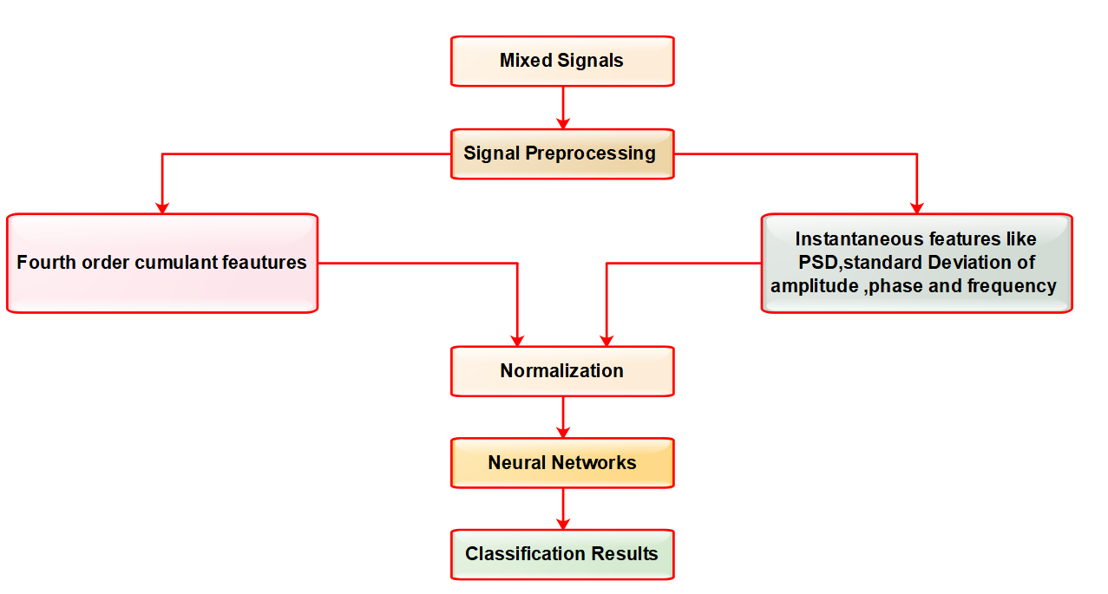
Figure 6: Block diagram of a mixed feature model used for modulation classification

Xu, Yu, et al. [25] analyzed modulation recognition model using denoising auto encoders and decoder, a deep learning framework for recognizing modulation types using adaptive model architecture CNNs with random initialization, transfer learning(TL) and denoising sparse autoencoders to compare its performance accuracy using real signal datasets . These methods could recognize 2ASK, BPSK, QPSK, 8PSK and 16QAM signals from real time signaling dataset. Convolution Neural Networks with stochastic gradient descent (SGD) algorithm [26],is used for a better optimization and learning process. Dataset generated from the instrument vector signal generator, have same carrier frequency of 100MHz with a bandwidth of 25MHz in a White Gaussian channel. It included 25000 samples with 5000 samples for each digital modulation technique for an amplitude of 2V after preprocessing, at a sampling rate of 1GHz. For this real signaling dataset adaptive CNNs with random initialization achieved a better accuracy when compared to RESNETs(Residual Nets) of ALEXNET as shown in table 6. As CNNs are less robust to noise [26], the training data assumed with signals having same SNRs (SNR=0dB) but the CNNs are tested for signals having different SNRs is assumed. Activation function used for CNNs is rectified linear unit (ReLU) with its output function as softmax. Due to over fitting problems of CNNs of random initialization, CNNs of transfer learning methods improved the accuracy for different SNRs but provided better results only for low noise i.e low SNRs. CNNs with DAEs [27] improved the performance at high SNRs , where DAEs processes the input raw corrupted data to obtain an original uncorrupted data and further processed by CNNs to predict the modulation types. This hybrid approach of transfer learning using CNNs with DAEs provided the intelligence to combat against the disturbances at the input has improved the recognition accuracy and performance signiﬁcantly than using the CNNS alone.

O’SHEA et al. [29] used a deep learning frame work for classifying communication signals over the air(OTA) where the performance of the model is analyzed using channel impairments and the configurations using feature based classifiers of baseline method with higher order moments and strong booster gradient tree classification algorithms. An extensive dataset having additional radio signal types built under real time propagation effects is generated using 24 analog and digital modulators over single carrier that included both higher order modulations like QAM 256 and APSK256 used in real time with high SNRs and also impulsive signals in low fading environment like the signals from satellite like DVB-S2X are considered. Signals of this simulated dataset is available on radio ML website, where the signals are shaped using square root of cosine ﬁlter with the range of roll-off values (α) [30] using signal shaping module, in figure 7 with 1024 samples for each modulation type . In base line method, high order moments and statistics for 1024 samples of each modulation type are calculated and translated them into a real set of values then represented on feature space. This representation reduces the dimension of samples and simplifies the classification of modulation types. For signal classification models, gradient boosted trees (XGBoost) algorithm performed better than SVMs and decision trees. CNNs of Visual Geometry(VG) group at Oxford University is a one dimensional CNNs with 2x2 as minimum filter size having smallest pooling operations of 3x3 ,where the raw I/Q samples that has been normalized to unity variance . Preprocessing and feature extraction on real I/Q samples is performed by the Neural networks itself on high dimensionality data and detected the modulation type of digital signal.
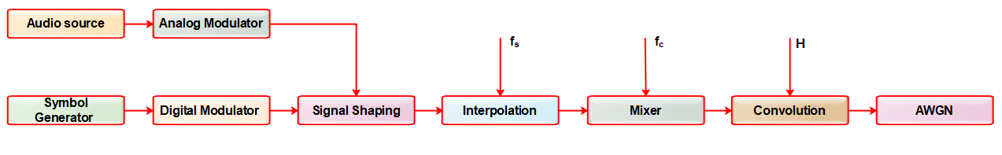 Fig 7: Modeling of synthetic dataset generation system with channel impairments
Residual Neural Networks(RNNs) were also employed to obtain modulation recognition for less epochs but achieved less improvements in terms of accuracy when compared to CNNs. However self normalizing neural networks [31] with SELU(scaled exponential linear unit) as activation function along with mean-response scaled initialization (MRSA) [32] and Alpha Dropout [33] improved the recognition accuracy compared to conventional ReLU activation and dropouts used. Also, RNNs requires less trainable parameters than CNNs; for 1024 samples of length 5, RNNs uses 236,344 trainable parameters while a CNN/VGG network required 257,099 trainable parameters. For lower order modulations, the performance with RNNs, VGG-CNNs, Baseline method was almost same for 1024 samples with low SNR, but RNNs proved better even at high SNRs. The classification performance was checked individually under AWGN Conditions, various impairments, against the model size of dataset and training size requirements where RNNs proved better with higher accuracy.
Hashim IA, et al.[35] proposed a pattern recognition model to classify Quadrature amplitude Modulation(QAM) types for QAM16, QAM32, QAM64, QAM128, and QAM256 for low SNR for 4096 samples using a pattern recognition classifier models with combined threshold algorithm. Comparison of HOCs and thresholds of low SNR signals is used as the working principle for the classification of QAM types. This model is simulated using MATLAB 2013a and achieved a highest accuracy rate with minimum effort of programming for the synthetic dataset having only QAM signals. Relationship between the cumulants and classifiers were used to identify the QAM modulation types, where each classifier is compared with output of other classifiers to find the highest priority classifier, based on the variation of a cumulant against input signals having for different SNRs.

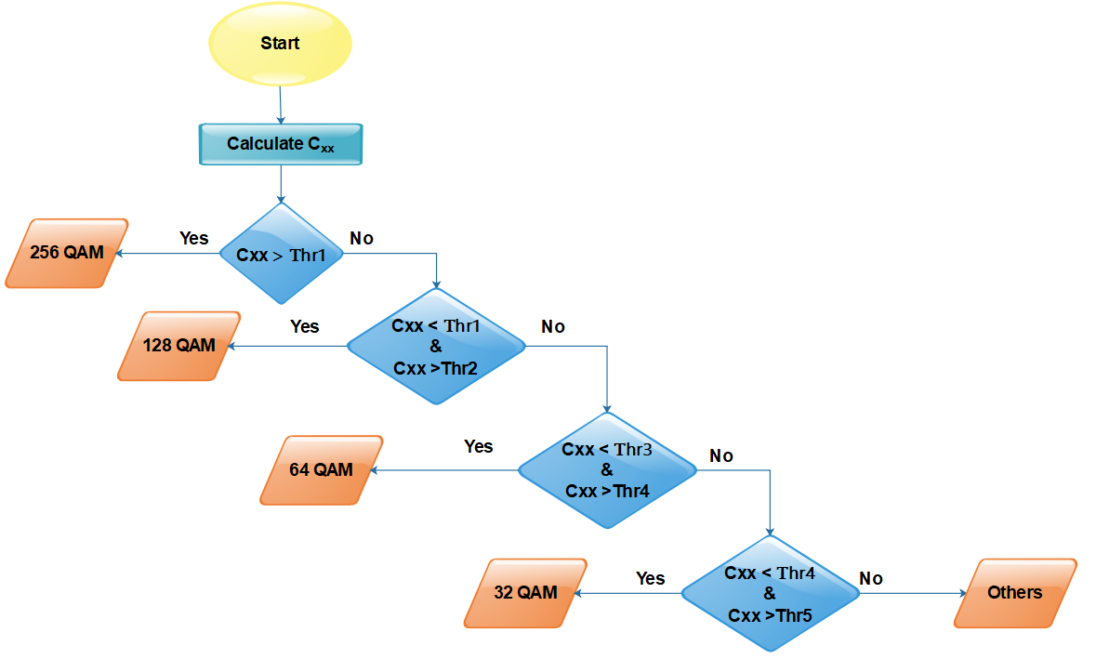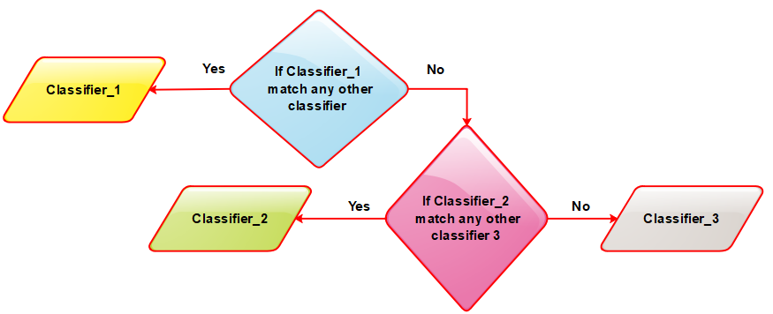
Fig 8: (a) Classification of Quadrature modulations according to thresholds (b) Operation of classifiers
Yang Wang[36] simulated the process of modulation recognition using deep learning methods for under water communication applications, where the channel models is verified with actual experiment conducted in the shallow sea [37]for acoustic channels. The parameters considered in shallow sea for modulation recognition are : wind speed of 20 knots, distance of 5000m between transmitter and receiver under the depth of 10m water having a channel bandwidth of 2kHz, with a carrier frequency of 10kHz , for a data rate of 1000bits/second having SNR range from -20dB to +20dB under Additive White Gaussian Noise(AWGN). In under water communications, validation of the model is verified for BPSK, QPSK, 8PSK, 16QAM [38] and 64QAM signals to recognize the modulation types. For different batch sizes of 32,64,128,256,1024 classifications accuracy is obtained against SNR from -20dB to +20dB. If the processing time of passing a complete dataset through a neural network(called epoch) is too long, then dataset is broken into multiple batches and its training performance is calculated between Loss ratio and Epoch to obtain training and validation errors.

Authors Name | Learning Algorithms | Assumptions/input features used | Advantages/ Disadvantages | Datasets | Validation Metrics:  Accuracy
X.-R. Jiang et al.[24] | Back propagation neural network(BPNN) | Instantaneous features of spectral density and standard deviation with HOCs, S/N>1dB | Improved recognition rate for distinct signals | 13 modulation signaling dataset | 90%
Xu, Yu, et al. [25] | Adaptive CNNs with random initialization | I/Q samples with S/N=0dB Constant | Over fitting problems, experiment conducted under ideal conditions | 7 modulation signaling dataset | 100%
Xu, Yu, et al. [25] | RESNETS (of ALEXNET) | I/Q samples with S/N=0dB Constant | Less accurate | 7 modulation signaling dataset | 86.7%
Xu, Yu, et al. [25] | CNNs with Transfer learning method | I/Q samples for S/N=1dB,2 dB, 3dB | Better performance for less SNRs | 7 modulation signaling dataset | 99.50%, 94.45%, 94.45%
Xu, Yu, et al. [25] | DAEs for preprocessing | I/Q samples with S/R ratio= high | Achieved better performance for high SNRs | 7 modulation signaling dataset
O’SHEA et al[28] | Baseline method with XGBoost | HOMs & HOCs | Outperformed well than SVMs | 11 modulation signaling dataset | 94.6%
O’SHEA et al[28] | CNNs (of VGG) | I/Q samples, ReLU as activation,  Softmax as output | Requires more epochs to obtain the results due to more trainable parameters but better than baseline method | 11 modulation signaling dataset | 98.3%
O’SHEA et al[29] | RESNETS (of VGG) | HOCs, HOMs  I/Q samples, SeLU as activation , Dropout approach at output | Less accurate than CNNs, Modulation recognition is achieved in few epochs due to less trainable parameters compared to CNNs | 24 modulation signaling OTA dataset | 59%(worst case)-87%(best case)
Hashim IA, et al.[35] | Pattern recognition classifiers of HOCs with combined threshold algorithm | HOCs to estimate modulation parameters by comparing with its thresholds | Simple and efficient | Synthetic dataset of QAM16, QAM32, QAM64, QAM128, QAM256 | 86.905% -98.665% SNR = +5 to -3dB
L. Gao et al.[41] | Non-multi-scale decomposition Fusion image algorithm with SVM classifier | Each signal is fused into images and then classified using SVMs | Superior and robust | Synthetic datasets | 95.5% at SNR of -6dB
Table 6: Comparison performance of AI Algorithms for modulation recognition of digital signals

L. Gao et al.[41] proposed a frame work in radar applications for modulation recognition using an image fusing and multi featured fusion algorithms under low SNR for detecting 12 different modulation signals that includes Costas, LFM(linear frequency modulated), NLFM(narrow linear frequency modulated), BPSK(binary phase shift keying), polyphase codes of P1,P2,P3,P4, and polytime codes of T1,T2,T3,T4 codes. This model uses DL algorithms for extracting features and ML algorithms for classifying the modulation types. Image fusion process uses non-multiscale decomposition algorithm that fuses images of each signal into time to frequency (T-F) images. TL based CNNs (ALEXNET) and SL based stacked auto encoder (SAE) extracted attributes from fused images for the recognition of 12 different modulation signals. These features are fused using image fusion algorithms that compress the redundant information of image and improved computational efficiency. Later, SVM is used to classify the modulation types with an average recognition accuracy of 95.5% for SNR=-6dB. Wigner-Ville distribution (WVD) image fusion algorithm provided better T-F aggregation, but its distribution was more sensitive[42] to cross talk interferences. These cross interference is a part of Cohen’s distribution, also known as RID (reduced interference distribution) can be filtered out [43] with enhanced resolution of time to frequency images by adding different kernel functions as window functions[44]. The proposed model uses image fusion[45] algorithm to combine the attributes of T-F images of radar signals to obtain discriminative features of fused images. Radar signal modulation recognition of fig 10 processes intercepted signals to convert into T-F images using RID for different kernel functions to minimize the cross interferences. The images are then fused using image fusion algorithms and PCA (principal component analysis) to obtain weights from which the discriminative features are obtained. PCA is a dimensionality reduction algorithm, used to remove the redundant features and ALEXNET based transfer learning with SAEs are applied to extract these discriminative features from fused images using serial fusion algorithm. Further, SVM(support vector machine) classifier is used to classify the modulation types of different radar signals.
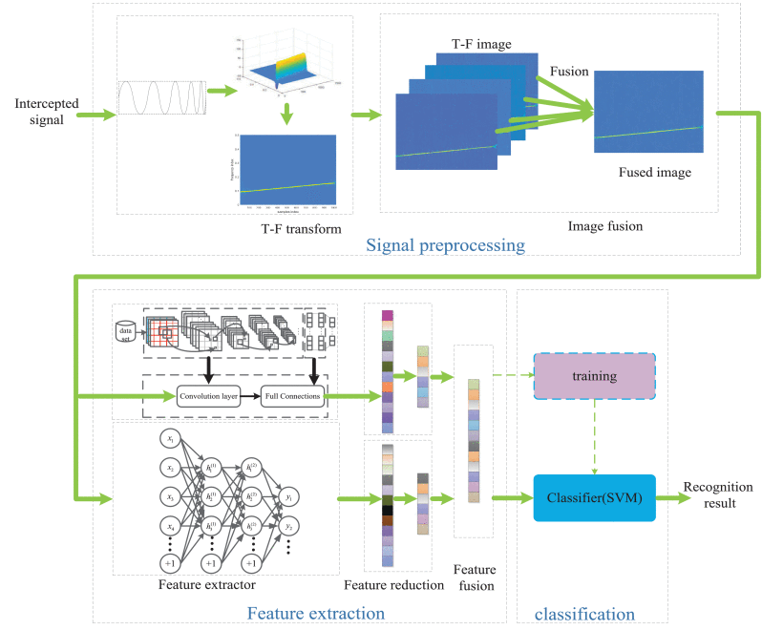
Fig 10: Radar signal modulation recognition system proposed by L. Gao et al.[41]
- DISCUSSIONS
- Based on datasets of real signals, researchers should identify whether machine learning algorithms / deep learning algorithms will fetch accurate results for identification of modulation types of digital signals. Instead of using deep learning methods directly, exploring a combination transfer learning methods with auto encoders or neural networks should achieve better recognition of signals with less complexity.
- For a heavy traffic with complex data, identification of precise modulation types plays a very important role for the detection of signal interferences of spectrum, detection of faults, dynamic access of spectrum and for sensing opportunistic mesh network in wireless communications, these factors will also provide impact on signal recognition rate. Hybrid cross learning algorithms with improved system parameters should cater the needs by considering these parameters.
- Exploring different propagation effects like CFO (Carrier frequency offset), thermal noise, SRO and impairments need to be considered over radio channels while modeling new algorithms for classification. Novel discriminative features should be identified to precisely achieve the desired recognition accuracy by considering model size/depth, data set sizes and observation windows of neural nets.
- CNNs used for modeling classification of modulation types used real valued I/Q samples, to identify and obtain much accurate results different samples should be experimented with both complex and real valued I/Q samples of the inputs in real time environment.
- Traditional methods of feature extraction will remain ineffective because modern radar signals are complex in nature; that involves the process of converting signals into time and frequency domain and is less effective. This led to the development of time-frequency (T-F) image features of signals. As the images are more vulnerable to cross term interference, hence sharp filters should be designed which shall reduce the distribution of interferences.
- At the receiving end of the communication receiver, detection of modulation type is considered as very crucial from which the information about frequency and bandwidth is estimated that helps to demodulate and decode the received signals in the presence of complex wireless electromagnetic signaling space. More the amount of information transmitted, signal changes rapidly, hence it is necessary to implement a universal communication receiver which uses hybrid cross machine/deep algorithms and recognizes modulation types of digital signals.
7. Comparative analysis and Inferences
The comparative analysis of various AMR models helps to understand at what extent the various ML and DL techniques of AI, provided automation in signal recognition and classification of received digital signals using different synthetic datasets. Datasets used analyze the algorithms should be accurate, legitimate, relevant and complete but if the datasets are not validated properly then the algorithms modeled cannot recognize the modulation types under real time environments. OTA dataset generated [53] consists of 12 different modulations is built upon GNU Radio, a software development tool kit [54]and on universal software radio peripheral(USRP) [55]B210 SDRs. Signals obtained on SDR and GNU are more real when compared to in-built datasets. Recognition rate using modulated auto correlation convolution networks (MACNs) with this dataset is shown in figure 11, are obtained by capturing the periodic local features[53].
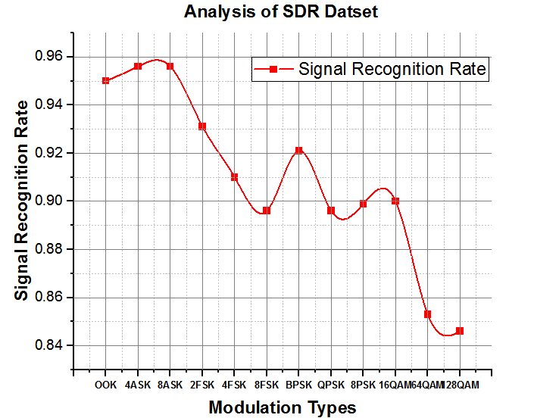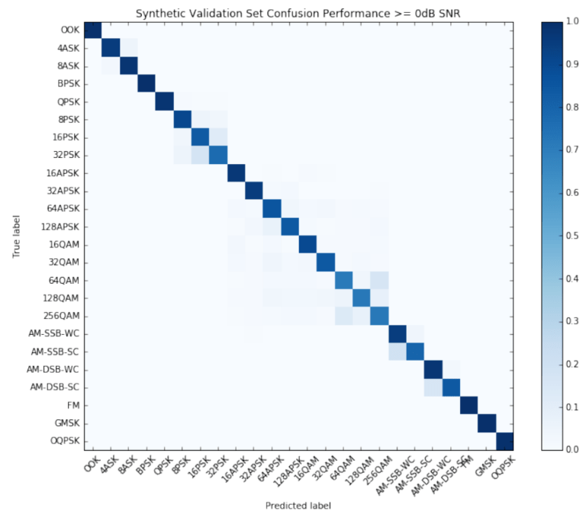
Fig 11: Recognition rate using SDR dataset Fig 12: Confusion Matrix for OTA recordings[29]
CCNNs(cyclic convolution neural network) are used to extract spatial features , bidirectional neural network (BRNN) to extract temporal features and ACGAN ( auxiliary classification of generative adversarial network)is used for classifying the signals. This model provided an accuracy of 94% on RML 2016.10a[56] dataset, an older version of synthetic dataset generated [28] by O’ SHEA under ideal conditions. An improved version of RML 2016.10a dataset is RML 2018.01a [29] has the signals recordings generated over the air (OTA) for 24 different single carrier modulation schemes in real time environment. Deep learning algorithms applied on RML 2018.01a [29] achieved a recognition accuracy of 87% on OTA recordings when compared to 94% of synthetic datasets as shown in figure 13. In OTA recordings, 1.44 million samples for 24 modulation schemes were considered using USRP setup. The accuracy of synthetic datasets decreases as SNR is increased negatively and could achieve a 100 percent signal recognition rate for simulated datasets at higher SNRs. DL approach proved to be better than ML approach in terms of time complexity for large datasets. A comparative analysis of the extracted features with classifiers is summarized in table. 10 is represented graphically fig.14, to recognize the modulation types using AI techniques. This summary of comparative inferences of discriminative features, algorithms, classifiers may help the researchers to further improve the recognition accuracy from these existing signal recognition algorithms.

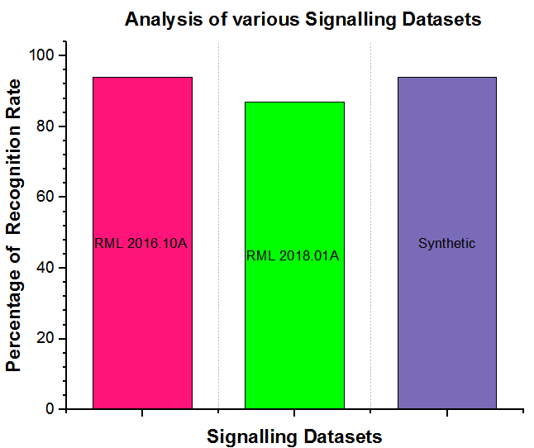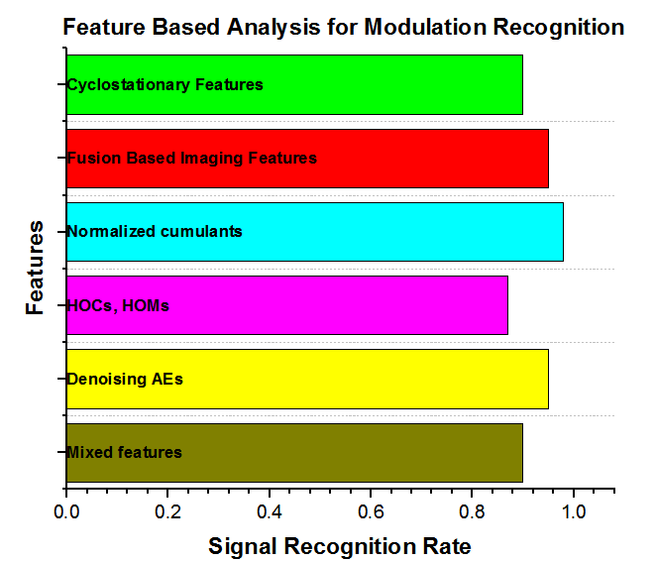 Fig 13 : Comparative analysis of signalling datasets Fig 14: Comparison of extracted features using AI algorithms
- CONCLUSION
This paper summarizes a variety of techniques, approaches and introduces different areas of applications which are useful and considered as important in the field of wireless communication systems. As automatic modulation recognition and its modulation classification type plays very crucial role in wireless communication for both cooperative and non-cooperative applications like dynamic spectrum management, intelligent modems, cognitive radio and interference identification in the received signals. However, new models should be proposed by identifying the discriminative features statistically or automatically through hybrid machine or deep learning techniques to take decisions in order to obtain the signal identification and its classification under the presence of noise, fading or any other disturbances in the channel. Further, highly efficient algorithms should be proposed to obtain modulation recognition by improving the sensitivity at the receiver and simulation methods proposed should be able match the gap between built-in or simulated datasets and real world data distributions of signals. In future, these algorithms should be implemented to develop a universal receiver that should able to recognize ASK, FSK, QPSK and QAM signals under the presence of high or low SNR to cater the need of defense and military applications, civilian applications , underwater surveillance applications, cognitive radio and in many wireless and satellite communication applications with less time complexity.
REFERENCES
- Azzouz, E. E., & Nandi, A. K. (1995). Automatic identification of digital modulation types. Signal Processing, 47(1), 55-69.
- Ma, H., Xu, G., Meng, H., Wang, M., Yang, S., Wu, R., & Wang, W. (2020). Cross Model Deep Learning Scheme for Automatic Modulation Classification. IEEE Access, 8, 78923-78931.
- Daldal, N., Cömert, Z., & Polat, K. (2020). Automatic determination of digital modulation types with different noises using Convolutional Neural Network based on time–frequency information. Applied Soft Computing, 86, 105834.
- Shah, M. H., & Dang, X. (2020). Low-complexity deep learning and RBFN architectures for modulation classification of space-time block-code (STBC)-MIMO systems. Digital Signal Processing, 99, 102656.
- Iglesias, V., Grajal, J., & Yeste-Ojeda, O. (2011, August). Automatic modulation classifier for military applications. In 2011 19th European Signal Processing Conference (pp. 1814-1818). IEEE.
- Xue, Y., Jin, Y., Chen, S., Du, H., & Shen, G. (2024). Modulation signal automatic recognition technology combining truncated migration processing and CNN. IEEE Access, vol. 12, pp. 120414-120428, 2024, https://doi.org/10.1109/ACCESS.2024.3448397.
- Ramkumar, B. (2011). Automatic Modulation Classication and Blind Equalization for Cognitive Radios (Doctoral dissertation, Virginia Tech).
- Singer, A. C., Nelson, J. K., & Kozat, S. S. (2009). Signal processing for underwater acoustic communications. IEEE Communications Magazine, 47(1), 90-96.
- Ali, A. K., & Erçelebi, E. (2020). Automatic modulation recognition of DVB-S2X standard-specific with an APSK-based neural network classifier. Measurement, 151, 107257.
- Li, P. (2019). Research on radar signal recognition based on automatic machine learning. Neural Computing and Applications, 1-11.
- Soliman, S. S., & Hsue, S. Z. (1992). Signal classification using statistical moments. IEEE Transactions on Communications, 40(5), 908-916.
- Rosti, A. V. (1998). Statistical methods in modulation classification. Master of Science Thesis, Tampere University of Technology, Finland June
- Su, W. (2013). Feature space analysis of modulation classification using very high-order statistics. IEEE Communications Letters, 17(9), 1688-1691.
- Yan, X., Zhang, G., & Wu, H. C. (2018). A Novel Automatic Modulation Classifier Using Graph-Based Constellation Analysis for ${M} $-ary QAM. IEEE Communications Letters, 23(2), 298-301.
- Spooner, C. M., Mody, A. N., Chuang, J., & Petersen, J. (2017, March). Modulation recognition using second-and higher-order cyclostationarity. In 2017 IEEE International Symposium on Dynamic Spectrum Access Networks (DySPAN) (pp. 1-3). IEEE.
- Jiang, X. R., Chen, H., Zhao, Y. D., & Wang, W. Q. (2020). Automatic modulation recognition based on mixed-type features. International Journal of Electronics, 1-10.
- West, N. E., & O'Shea, T. (2017, March). Deep architectures for modulation recognition. In 2017 IEEE International Symposium on Dynamic Spectrum Access Networks (DySPAN) (pp. 1-6). IEEE.
- Abdelmutalab, A., Assaleh, K., & El-Tarhuni, M. (2016). Automatic modulation classification based on high order cumulants and hierarchical polynomial classifiers. Physical Communication, 21, 10-18.
- Nandi, A. K., & Azzouz, E. E. (1998). Algorithms for automatic modulation recognition of communication signals. IEEE Transactions on communications, 46(4), 431-436.
- Goldsmith, A. (2005). Wireless communications. Cambridge university press.
- Krizhevsky, A., Sutskever, I., & Hinton, G. E. (2012). Imagenet classification with deep convolutional neural networks. In Advances in neural information processing systems (pp. 1097-1105)
- Klambauer, G., Unterthiner, T., Mayr, A., & Hochreiter, S. (2017). Self-normalizing neural networks. In Advances in neural information processing systems (pp. 971-980).
- Harp, G. R., Richards, J., Tarter, S. S. J. C., Mackintosh, G., Scargle, J. D., Henze, C., ... & Voien, J. (2019). Machine Vision and Deep Learning for Classification of Radio SETI Signals. arXiv preprint arXiv:1902.02426.
- Gao, L., Zhang, X., Gao, J., & You, S. (2019). Fusion image based radar signal feature extraction and modulation recognition. IEEE Access, 7, 13135-13148
- Xu, Y., Li, D., Wang, Z., Guo, Q., & Xiang, W. (2019). A deep learning method based on worsignals. Wireless Networks, 25(7), 3735-3746.
- Yazan, E., & Talu, M. F. (2017, September). Comparison of the stochastic gradient descent based optimization techniques. In 2017 International Artificial Intelligence and Data Processing Symposium (IDAP) (pp. 1-5). IEEE.
- Zhu, X., & Fujii, T. (2017, January). A modulation classification method in cognitive radios system using stacked denoising sparse autoencoder. In 2017 IEEE Radio and Wireless Symposium (RWS) (pp. 218-220). IEEE.
- O’Shea, T. J., Corgan, J., & Clancy, T. C. (2016, September). Convolutional radio modulation recognition networks. In International conference on engineering applications of neural networks (pp. 213-226). Springer, Cham.
- O’Shea, T. J., Roy, T., & Clancy, T. C. (2018). Over-the-air deep learning based radio signal classification. IEEE Journal of Selected Topics in Signal Processing, 12(1), 168-179.
- JG, P. (2001). Digital communications. Me Graw-Hill, 777-778.
- Klambauer, G., Unterthiner, T., Mayr, A., & Hochreiter, S. (2017). Self-normalizing neural networks. In Advances in neural information processing systems (pp. 971-980).
- He, K., Zhang, X., Ren, S., & Sun, J. (2015). Delving deep into rectifiers: Surpassing human-level performance on imagenet classification. In Proceedings of the IEEE international conference on computer vision (pp. 1026-1034).
- Klambauer, G., Unterthiner, T., Mayr, A., & Hochreiter, S. (2017). Self-normalizing neural networks. In Advances in neural information processing systems (pp. 971-980).
- Su, W. (2013). Feature space analysis of modulation classification using very high-order statistics. IEEE Communications Letters, 17(9), 1688-1691.
- Hashim, I. A., Abdul Sadah, J. W., Saeed, T. R., & Ali, J. K. (2015). Recognition of QAM signals with low SNR using a combined threshold algorithm. IETE Journal of Research, 61(1), 65-71.
- Wang, Y., Zhang, H., Sang, Z., Xu, L., Cao, C., & Gulliver, T. A. (2019). Modulation classification of underwater communication with deep learning network. Computational intelligence and neuroscience, 2019.
- Hoang, D. A., Nguyen, H., & Le, T. N. (2025). Performance analysis of superposition M-ary QAM modulation in coded protograph LDPC MIMO communication systems with low-resolution ADCs. IEEE Access, vol. 13, pp. 107410-107428, 2025, https://doi.org/10.1109/ACCESS.2025.3581775
- Chen, Z., Wang, J., & Zheng, Y. R. (2016). Frequency-domain turbo equalization with iterative channel estimation for MIMO underwater acoustic communications. IEEE Journal of Oceanic Engineering, 42(3), 711-721.
- Ye, H., Li, G. Y., & Juang, B. H. (2017). Power of deep learning for channel estimation and signal detection in OFDM systems. IEEE Wireless Communications Letters, 7(1), 114-117.
- Xu, Y., Li, D., Wang, Z., Guo, Q., & Xiang, W. (2019). A deep learning method based on convolutional neural network for automatic modulation classification of wireless signals. Wireless Networks, 25(7), 3735-3746.
- Gao, L., Zhang, X., Gao, J., & You, S. (2019). Fusion image based radar signal feature extraction and modulation recognition. IEEE Access, 7, 13135-13148.
- Zuo, L., Li, M., & Xia, X. G. (2016). New smoothed time-frequency rate representations for suppressing cross terms. IEEE Transactions on Signal Processing, 65(3), 733-747.
- Choi, H. I., & Williams, W. J. (1989). Improved time-frequency representation of multicomponent signals using exponential kernels. IEEE Transactions on Acoustics, Speech, and Signal Processing, 37(6), 862-871.
- Stankovic, L. (1995). A method for improved distribution concentration in the time-frequency analysis of multicomponent signals using the L-Wigner distribution. IEEE Transactions on Signal Processing, 43(5), 1262-1268.
- Zhang, X., Li, X., & Feng, Y. (2016). A new multifocus image fusion based on spectrum comparison. Signal Processing, 123, 127-142.
- Daldal, N., Cömert, Z., & Polat, K. (2020). Automatic determination of digital modulation types with different noises using Convolutional Neural Network based on time–frequency information. Applied Soft Computing, 86, 105834.
- Zhu, Z., & Nandi, A. K. (2015). Automatic modulation classification: principles, algorithms and applications. John Wiley & Sons.
- Samuel, A. L. (1959). Some studies in machine learning using the game of checkers. IBM Journal of research and development, 3(3), 210-229.
- Blum, A., & Mitchell, T. (1998, July). Combining labeled and unlabeled data with co-training. In Proceedings of the eleventh annual conference on Computational learning theory (pp. 92-100).
- Uys, L. Y., Gouws, M., Strydom, J. J., & Helberg, A. S. (2017, September). The performance of feature-based classification of digital modulations under varying SNR and fading channel conditions. In 2017 IEEE AFRICON (pp. 198-203). IEEE.
- Liu, Y., Liang, G., Xu, X., & Li, X. (2008, October). The methods of recognition for common used M-ary digital modulations. In 2008 4th International Conference on Wireless Communications, Networking and Mobile Computing (pp. 1-4). IEEE.
- Al-Nuaimi, D. H., Hashim, I. A., Zainal Abidin, I. S., Salman, L. B., & Mat Isa, N. A. (2019). Performance of feature-based techniques for automatic digital modulation recognition and classification—A review. Electronics, 8(12), 1407.
- Zhang, D., Ding, W., Liu, C., Wang, H., & Zhang, B. (2020). Modulated Autocorrelation Convolution Networks for Automatic Modulation Classification Based on Small Sample Set. IEEE Access, 8, 27097-27105.
- Blossom, E. (2004). GNU radio: tools for exploring the radio frequency spectrum. Linux journal, 2004(122), 4.
- Holland, O., Bogucka, H., & Medeisis, A. (2015). Opportunistic spectrum sharing and white space access: The practical reality. John Wiley & Sons.
- Chen, S., Zhang, Y., He, Z., Nie, J., & Zhang, W. (2020). A novel attention cooperative framework for automatic modulation recognition. IEEE Access, 8, 15673-15686.

