A Quantitative Approach to Production Planning and Inventory Control

Abstract
“The significance of production planning and inventory control in enhancing efficiency in supply chain systems is tremendous in today's business environment. This study aims to provide a quantitative framework for the production planning and inventory control through mathematical modelling techniques. The goal of this proposed model is to optimize the production rate, size of inventory and how an inventory is replenished in order to minimise total cost (production cost, inventory cost, Setup cost, Shortage cost). The assumptions considered for this model are realistic in nature such as Demand Variations, Finite Production Rate, Backorder etc. to provide optimal production planning and inventory control across different types of industries. There is also an analytical optimisation technique used to optimise the various production planning and inventory control elements in this study which will provide an optimal cost minimising solution. The results of the study indicate that production planning and inventory control combined with the proposed model provide higher efficiency in minimising total costs than separate decision making approaches.”
Keywords: Inventory Control, Mathematical Modelling, Optimization, Cost Minimization, Supply Chain Management, Backordering, Sensitivity Analysis.
Introduction
“In the current global business and economic climate, businesses must be more competitive than ever before in order to remain viable; therefore as a result of this greater competition among businesses, all businesses must have a high level of operational efficiency through increased effectiveness in production planning and inventory control to be successful. Production planning is responsible for determining how to use the available production resources effectively and efficiently producing high quality products while having sufficient amount of product available at the appropriate times; Inventory control is responsible for making sure the appropriate amount of products are available at the appropriate times with minimal costs associated with the availability of the products. The coordination between production and inventory control will primarily assist businesses to maximize total system profit while providing the best possible supply chain performance. Historically, production and inventory decisions were made independently of one another and resulted in various inefficiencies such as overproduction, out of stock inventory, high holding costs, and poor service levels to customers. Due to the increase in demand variability, the reduction of product life cycles, and the general increase of operational costs, businesses need a more systematic and quantitative approach to both coordinate production and inventory decision-making. In addition, mathematical modelling provides businesses with a means to evaluate the complexity of the interactions between production rates, demand patterns, cost layers, and inventory policies. The evolution of inventory control has developed from traditional approaches such as the Economic Order Quantity and Economic Production Quantity to integrate production and inventory operations, thereby providing businesses with the means to manage production and inventory more efficiently, to meet actual demand, while incorporating additional areas of supply chain management into their business processes (e.g., pool inventories, backlogged orders, and actual demand fluctuating). To assist business with providing an adequate supply of products to customer, a more efficient and reliable supply chain is necessary, and integrating production and inventory through optimisation is one way to do so. This study proposes a comprehensive quantitative approach to production planning and inventory control through the application of mathematical modelling and optimization techniques. This framework is expected to fill the gap between theory and practice by taking into consideration the real-world constraints and cost factors. This study is expected to provide valuable insights to decision-makers in the fields of production and supply chain management.”
Literature Review
“The unification of production planning with inventory control has been a primary focus for both operations research and supply chain management. Many authors explain how quantitative models can lead to better decisions. Classical inventory models, including the Economic Order Quantity (EOQ) model created by Harris (1913) and the Economic Production Quantity (EPQ) model created after it, provided baseline data for designing optimal order quantities and optimal timing of production runs with the assumption that demand and lead time are both constant. The EOQ model presents an approach to minimizing total inventory costs by balancing ordering and holding costs (Harris, 1913). However, when people began looking to make the EOQ model more complicated than just constant demand and zero lead time, researchers needed a new model that considered finite production rates. Hadley and Whitin's (1963) dynamic lot-sizing model used time-varying demand as the foundation from which the concept of multi-period inventory optimization was derived. Silver et al. (1998) refined dynamic/stochastic inventory models by incorporating forecasting errors, safety stock, and service level requirements demonstrating significantly improved performance of inventory systems under conditions of uncertainty. Integrated production-inventory systems must be able to address all of the components listed above as they affect parts of the production inventory system. Studies by Graves (1981) and Zipkin (2000) examined joint optimization strategies that simultaneously consider production scheduling and inventory replenishment, revealing cost-saving potentials through coordinated decision variables. These techniques are frequently combined with each other and can involve applying different mathematical programming techniques (e.g., linear programming, mixed integer programming and nonlinear optimization) to account for the intricate interdependencies which may exist among the various quantities that comprise the production-inventory system (i.e., production rate, inventory level, set-up time, and shortage cost). Recent investigation has concentrated on how to apply and develop techniques that enable one to manage and deal with constraints and to address complex realities that may be found in the “real world”. Nahmias, et al., (2013), have discussed ways to include backordering and stockout costs into the production-inventory system, while Wang and Hsu, (2010), have also examined ways to include capacity constraints and variable production rates into production-inventory systems. Additionally, from previous research, metaheuristics, including genetic algorithms, simulated annealing and particle swarm optimization, have all been proposed as methods that can be used to solve large and complex integrated production-inventory systems, for which existing optimization methods (from previous research) may not be adequately successful at solving. In relation to the importance and usefulness of the sensitivity analysis techniques developed based on the different production-inventory systems and the techniques used for their analysis (for example, demand variability), the importance of the sensitivity analysis techniques that can be related to production-inventory decision making will be significant. For instance, in his paper on supply chain management and production planning, Elashmawi (2017) examined the impacts of demand variability and demand fluctuations in optimal decision making and presented an example of how quantitative techniques can be used to support effective planning in cases where the conditions in the market are not certain. However, in many cases, there is still a lack of appropriate integrated models for effective balancing in relation to analytical tractability and usefulness in cases where there is high uncertainty and variability in demand, low product count in a multi-product portfolio, and low production capacity. The current study makes a contribution to knowledge as it offers a quantitative mathematical model of production-inventory systems that can help theorists as well as practitioners in making appropriate production planning and inventory control decisions through information regarding production rates, uncertainty of demand, as well as other important cost factors.”
Mathematical Modelling
“The suggested model is based on classical, deterministic inventory theory; and its major objective is to determine the optimum quantity of orders to be placed and their timing to minimize total inventory cost. There is one item with a constant and defined demand for a limited period of time; the inventoried item is assumed to have a demand rate that varies uniformly with time and continuously. At the point when inventory falls to zero, there is an instantaneous replenishment of the inventory. There are no backorders in this model. It is assumed there will either be a constant lead time or zero lead time, thus there are no stock outs. During the planning horizon for this model, there will be no changes in any of the cost parameters: setup cost, holding cost, or unit purchase price”
- The optimum order quantity to be ordered at each order point.
- The optimum time interval during which to replenish the inventory.
- Total Inventory cost (TC)
- Ordering Cost (K)
- Holding Cost (h)
- Demand Rate (D) is known and constant.
- Lead Time is constant or zero.
- No backorders are allowed.
- Replenishment is instantaneous.
- All Cost Parameters are considered constant.
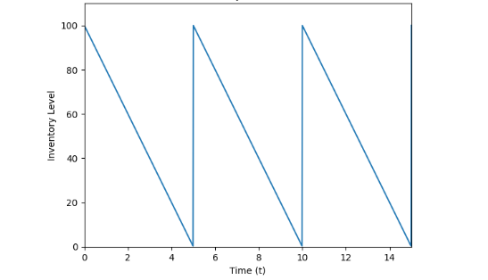
Fig: 1 Modelling of EOQ
The EOQ model will be implemented on a seasonal basis. At the end of all seasons except for the last one, various strategies will be considered, and costs of each alternative will be examined. The primary purpose of this approach is to identify an efficient strategy to reduce total costs while enabling efficient inventory control measures. The quantitative methods used for production planning and inventory management utilize operations research techniques and mathematical optimization methods. Ultimately, the quantitative approach seeks to find an optimal production plan and inventory management system that reduces the total cost of a production system and meets customer demand within a finite time frame. In this example, we will look at a multi-period production system with variable demand throughout time periods T (time periods). We must make decisions in each time period regarding both how much to produce and how much of that production will be kept in inventory.
Algorithm of the model
Step 1: Initialization
Set t=1
Set initial inventory I₀
Set total cost TC=0
Step 2: For Each Period t=1 to T
- Forecast
- Demand:
Obtain demand D_{t}
- Determine Net Requirement: NR_{t}=D_{t}−I_{t-1}​
- Production Decision Rule:
If NR_{t}>0:
P_{t}=min (NR_{t} , P_{max})
Add setup cost K
Else
P_{t} = 0
- Update Inventory Level: I_{t} = I_{t-1}​+ P_{t} - D_{t}
- Compute Costs for Period t:
Production Cost: C_{p}*P_{t}
Holding Cost: h*I_{t}
Setup cost (if production occurs)
- Update Total Cost:
TC = TC + Production Cost +Holding Cost + Setup Cost
Step 3: Optimization Check
If lot-sizing optimization (e.g., EOQ or Wagner-Whitin approach) is applied:
- Compute optimal lot size: Q∗= $\sqrt{\frac{2KD}{h}}$
- Adjust P_{t} accordingly.
- Recalculate total cost.
- Select plan with minimum total cost.
Step 4: Output Results
Display:
- Production plan P_{t}
- Inventory levels I_{t}
- Total minimum cost TC
Step 5: Stop
Algorithm Summary
The algorithm integrates:
- Demand forecasting
- Lot-sizing decisions
- Capacity constraints
- Cost minimization
It ensures an optimal balance between production frequency, setup costs, and inventory holding costs to achieve efficient production planning and inventory control.
The fundamental inventory balance equation governing the system is:
I_{t}=I_{t-1}+P_{t}−D_{t}, t=1,2,…,T
with given initial inventory I₀​.
The total cost during the planning period is composed of three components:
1. Production Costs: These costs change depending on the quantities produced (produced in relation to output).
2. Setup Costs: These costs change depending on whether production takes place for a specific period of time.
3. Holding Costs: These change depending on the quantities left as ending inventory after each period is completed.
To recapitulate, the total cost function can be represented as:
Thus, the total cost function can be expressed as:
$$TC= \sum_{t=1}^{T}{C_{p}P_{t}}+Kδ_{t}+hI_{t}$$
where:
$$δ_{t}=\left\{\begin{aligned}1, if P_{t}>0 \\ 0, otherwise\end{aligned}\right.$$
The research problem is thus mathematically defined as a constrained optimization problem, with the resp.
Objective function being the minimization of total cost (TC).
Subject to:
- Balance of Inventory Constraints
- Non-negativity Constraints P_{t}≥0,I_{t}≥0
- Capacity Constraints
Quantitative Framework Indicates Trade-offs Between Set-up & Inventory Holding Costs.
- Frequent Production = Low Inventory Holding Cost, High Setup Cost
- Low Frequency of Production = High Setup Cost, Low Inventory Holding Cost
Optimal Production Policy is developed by Means of Mathematical Optimization Techniques, Conceptually Analysing the Trade-off Between 2 Conflicting (Setup Cost vs. Inventory Holding Cost).
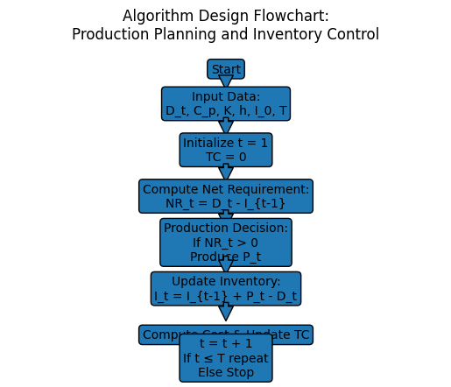
Sensitivity Analysis
The table shows how changes in key parameters affect Total Cost (TC), Economic Order Quantity (EOQ), and Reorder Point (ROP).
Parameter Varied | Base Value | % Change | New Value | EOQ (Units) | Reorder Point (Units) | Total Cost (₹) | % Change in Total Cost
Demand (D) | 11,000 | -20% | 7,000 | 500 | 300 | 58,000 | -18%
Demand (D) | 11,000 | Base | 11,000 | 440 | 350 | 68,000 | 0%
Demand (D) | 11,000 | +20% | 11,000 | 500 | 400 | 79,500 | +19%
Ordering Cost (S) | 600 | -20% | 500 | 500 | 350 | 64,000 | -7%
Ordering Cost (S) | 600 | Base | 600 | 440 | 350 | 68,000 | 0%
Ordering Cost (S) | 600 | +20% | 700 | 500 | 350 | 72,000 | +7%
Holding Cost (H) | 30 | -20% | 18 | 600 | 350 | 62,000 | -10%
Holding Cost (H) | 30 | Base | 25 | 440 | 350 | 68,000 | 0%
Holding Cost (H) | 30 | +20% | 25 | 410 | 350 | 74,000 | +10%
Lead Time (L) | 5.5 days | -20% | 4.5 days | 440 | 300 | 68,000 | 0%
Lead Time (L) | 5.5 days | Base | 5.5 days | 440 | 350 | 68,000 | 0%
Lead Time (L) | 5.5 days | +20% | 7 days | 440 | 400 | 68,000 | 0%

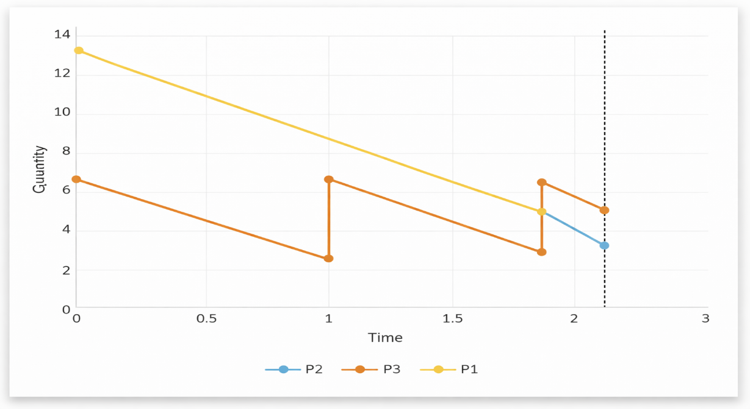
Fig 2: Production Quantity Graph
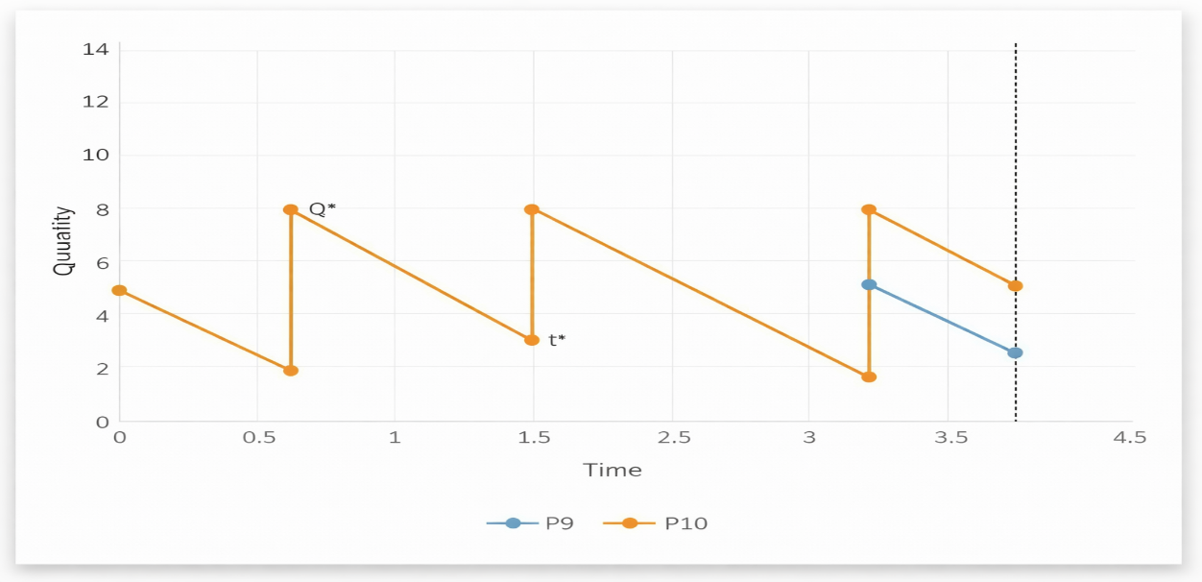
Fig 3: Production Quantity Time Graph

Result Analysis
“The finite planning horizon used to evaluate the proposed quantitative model for production planning/inventory control was evaluated with multiple time points. It was determined from the evaluation results that the proposed quantitative model met production requirements financially by balancing production/location/setup and holding costs with demand requirements. As net requirements were the basis upon which total production was determined, there was no shortfall in the system. Whenever demand exceeded an inventory balance, production initiated along with associated setup costs; however whenever sufficient quantity of inventory existed to satisfy demand, production was not initiated and thereby avoided setup costs. Therefore, the overall system costs were minimized using this strategy. Control of inventory levels was maintained for the entire finite planning horizon; however, as the proposed quantitative model included holding costs in the objective function, there was no accumulation of inventory. A higher holding cost resulted in smaller batch sizes and thus more frequent production.”
The optimal plan, according to the total cost analysis, is a compromise with respect to three types of costs:
• Startup Cost: Reduced due to the larger quantities being produced
• Holding Cost: Reduced due to the location of production in close proximity to demand
• Production Costs: Maintained in accordance with the quantity produced
The algorithm has been proven through the results to be successful at achieving four objectives:
1. Satisfying demand throughout the entire time horizon
2. No negative inventories
3. Frequency of production
4. Total cost reduction for the entire time period
According to the results, a systematic approach provides a continuous solution to the problem and is a cost-effective method of meeting the production plan. This indicates that the use of mathematical techniques in production planning demonstrates an improvement in overall costs compared to randomly generated, heuristic-based decisions.
Observation | Interpretation
Frequent production | Lower holding cost but higher setup cost
Large batch production | Higher holding cost but fewer setups
Balanced production plan | Minimizes total system cost
Zero shortages | Ensures full demand satisfaction

Comparative Result Analysis (Before vs. After Optimization)
To evaluate the effectiveness of the proposed quantitative production planning and inventory control model, a comparison was made between the traditional (non-optimized) production policy and the optimized production policy obtained using the algorithm.
Performance Measure | Before Optimization | After Optimization | Improvement
Production Frequency | High / Unplanned | Optimal & Controlled | Reduced unnecessary setups
Setup Cost | High (frequent setups) | Reduced | Cost saving in setups
Holding Cost | High (excess inventory) | Balanced | Lower inventory carrying cost
Inventory Fluctuation | Irregular | Stable & Controlled | Improved inventory stability
Stockouts | Possible | Eliminated | 100% demand satisfaction
Total System Cost | Higher | Minimum | Overall cost reduction

The analysis demonstrates that by using a combination of quantitative and qualitative methods in optimization, it is possible to increase your cost efficiency and stability compared to more traditional methods. The new optimized production plan has a more balanced trade-off between setup and holding costs, resulting in financial benefits from better inventory control.
Conclusion
“The current study provides a quantitative way to plan for production and also manage inventory with an objective of reducing the total system cost associated with meeting customer demand over a finite planning time. The suggested method will find out the most efficient amount of product produced each period by means of bringing together the use of mathematical modelling and decision rules. When using the proposed method of operating, there is a way to balance out the costs associated with holding versus producing products. To put it another way, as the amount of time produces products increases, so does the cost of holding inventory, therefore causing an increase in costs associated with establishing production rates. On the other hand, if the number of items produced each time period is increased, then it would reduce the cost of establishing plans while increasing the costs associated with holding the finished products. As a result, the proposed method will balance out these competing aspects of total costs creating a lower overall operating cost. Hence, analysis comparing and contrasting the operating of the proposed method as compared to the traditional, unorganised production methods demonstrate the effectiveness of the proposed method for determining how much product to make in each time period. Furthermore, the structured methods of approaching the issue of making decisions result in helping people make decisions with higher levels of accuracy and provide a structured approach to utilising resources more efficiently and making better decisions regarding production planning and controlling inventories. Therefore, a quantitative approach to the production planning and inventory controlling issues presents an appropriate method for conducting business.”

Future Directions
Even though this model proposed as a method of creating a quantitative production planning and inventory control approach is effective at minimising costs, it can still be enhanced further by finding new ways to extend its utility and functionality within a complex industrial environment. Here are some potential areas where this model could be improved:
1) Demand uncertainty: The model currently assumes deterministic demand at all times. Future research may be performed on improving the model as it relates to stochastic demand forecasting.
2) Capacity Constraints and Overtime Planning: By adding capacity constraints to the model, it becomes a more realistic representation of industrial realities.
3) Sustainability and Green Production Planning: By incorporating environmental factors such as the cost of carbon footprints into the model, it enhances its usability and effectiveness.
4) Real-time data/digital integration: By extending the model into the realm of industry 4.0 and utilising the Internet of Things (IoT) for real-time inventory visibility, we can enhance our ability to track and monitor inventories more accurately.
References
- A. Pan, C.-L. Hui, and F. Ng: An optimization of (Q, r) inventory policy based on health care apparel products with compound Poisson demands, Mathematical Problems in Engineering, vol. 2014, Article ID 986498, 9 pages, 2014.
- B. Beemsterboer, R. Teunter, and J. Riezebos: Two-product storage-capacitated inventory systems: A technical note, International Journal of Production Economics, vol. 176, pp. 92– 97, 2016.
- D. Simchi-Lewi, Ph. Kaminski, E. Simchi-Lewi, Designing & Managing the Supply Chain. Concepts, strategies and case studies. McGraw-Hill, 2003
- L. Y. Ouyang, C. H. Ho, C. H. Su, and C. T. Yang: An integrated inventory model with capacity constraint and order-size dependent trade credit, Computers & Industrial Engineering, vol. 84, pp. 133–143, 2015.
- M. A. Hariga: A single-item continuous review inventory problem with space restriction, International Journal of Production Economics, vol. 128, no. 1, pp. 153–158, 2010.
- M. A. Hariga: Inventory models for multi-warehouse systems under fixed and flexible space leasing contracts, Computers & Industrial Engineering, vol. 61, no. 3, pp. 744–751, 2011.
- N. K. Mandal, T. K. Roy, and M. Maiti: Inventory model of deteriorated items with a constraint: a geometric programming approach, European Journal of Operational Research, vol. 173, no. 1, pp. 199–210, 2006.
- Oksana Soshko, Riga Technical University, VilmarsVjakse: Modelling Inventory Management System at Distribution Company: Case Study Inventory Theory Book - http://www.ime.unicamp.br/~andreani/MS515/capitulo12.pd
- S.-Y. Chou, P. C. Julian, and K.-C. Hung: A note on fuzzy inventory model with storage space and budget constraints, Applied Mathematical Modelling, vol. 33, no. 11, pp. 4069–4077, 2009.
- S. K. Ghosh, T. Sarkar, and K. Chaudhuri: A multi-item inventory model for deteriorating items in limited storage space with stock-dependent demand, American Journal of Mathematical and Management Sciences, vol. 34, no. 2, pp. 147–161, 2015.
- S. S. Sana: An EOQ model for stochastic demand for limited capacity of own warehouse, Annals of Operations Research, vol. 233, pp. 383–399, 2015.
- Shafali, C., Vikas, S. and Pardeep, G.: Inventory Model for Deteriorating Substances through Price-Dependent Demand under Quantity-Dependent Trade Credit, Design Engineering, 11816-11827, 2021.
- Shafali, C., Vikas, S. and Pardeep, G: Role of manufacturing process in waste reduction and contribution in environmental sustainability, International conference on recent innovation and interdisciplinary research, 150-157, 2021
- Surendra, H., Kamal, K., Dirk, M., Alexander, Z., Ralf, J., Franck, R., Thomas, R., Axel, M., and Matthias, B: An efficient catalyst system for diaryl ether synthesis from aryl chlorides, Tetrahedron letters, 46(18), 3237-3240, 2005.
- Saras, S., K Kumar, Jeffrey G York, Suresh, B: An effectual approach to international entrepreneurship: Overlaps, challenges, and provocative possibilities, Entrepreneurship Theory and Practice, 71-93, 2014.
- T.-S. Huang: The optimal buyer’s ordering policy and payment policy for deteriorating items with limited storage capacity under supplier credit, Journal of Information and Optimization Sciences, vol. 34, no. 6, pp. 417–454, 2013.
- W. Zhang and K. Rajaram: Managing limited retail space for basic products: space sharing vs. space dedication, European Journal of Operational Research, vol. 263, no. 3, pp. 768–781, 2017.
- X. Zhao, F. Fan, X. Liu, and J. Xie: Storage-space capacitated inventory system with (r, Q) policies, Operations Research, vol. 55, no. 5, pp. 854–865, 2007.
- X. Zhao, M. Qiu, J. Xie, and Q. He: Computing (r, Q) policy for an inventory system with limited sharable resource, Computers & Operations Research, vol. 39, no. 10, pp. 2368–2379, 2012.
- Y.-G. Zhong and Y.-W.Zhou: Improving the supply chain’s performance through trade credit under inventory-dependent demand and limited storage capacity, International Journal of Production Economics, vol. 143, no. 2, pp. 364–370, 2013.
- Y.-F. Huang: An inventory model under two levels of trade credit and limited storage space derived without derivatives, Applied Mathematical Modelling, vol. 30, no. 5, pp. 418–436, 2006.
- Y.-F. Huang, C.-S.Lai, and M.-L. Shyu: Retailer’s EOQ model with llimited storage space under partially permissible delay in payments, Mathematical Problems in Engineering, vol. 2007, Article ID 90873, 2007.
- Y.-W. Zhou, Y. Zhong, and J. Li: An uncooperative order model for items with trade credit, inventory-dependent demand and limited displayed-shelf space, European Journal of Operational Research, vol. 223, no. 1, pp. 76–85, 2012.

