THE ACCEPTABILITY LEVEL AND MOISTURIZING EFFICACY OF WATERMELON PEEL SOAP: AN EXPERIMENTAL STUDY




ABSTRACT

Abdul Jamie Q. Datudacula and Melissa B. Taurac, “THE ACCEPTABILITY LEVEL AND MOISTURIZING EFFICACY OF WATERMELON PEEL SOAP, AN EXPERIMENTAL STUDY”, an Undergraduate Thesis. Department of Home Economics, College of Education, Mindanao State University-Marawi Campus, Marawi City.

Thesis Adviser: Prof. Rohanie M. Sultan, LPT, PhD, RGC
Date of Final Defense: January 6, 2026

This study investigated the acceptability level and moisturizing efficacy of body soap formulated from watermelon peel, an agricultural by-product commonly treated as waste. Anchored on the principles of Green Chemistry and the 3Rs (Reduce, Reuse, Recycle) theory, the research aimed to promote sustainable product development while evaluating the potential of watermelon peel as a natural cosmetic ingredient. A qualitative–experimental one-group pre-test and post-test design was employed. Twenty purposively selected participants from Mindanao State University–Main Campus, Marawi City, composed of students, parents, and beauty product users aged 18 to 40 years old, participated in the study. The watermelon peel soap was produced using a melt-and-pour method combined with extracted watermelon peel and virgin coconut oil. Data were gathered through a checklist rating sheet and documentation of skin condition before and after fourteen days of soap application. Results revealed that the watermelon peel soap was generally acceptable in terms of texture, appearance, scent, and lathering and rinsing properties. Furthermore, findings showed a noticeable improvement in skin hydration after continuous use, indicating a positive moisturizing effect of the product. Participants’ comments and suggestions also reflected favorable impressions and willingness to use the product as an alternative natural soap. The computed return on investment suggested that the product is economically feasible and has potential for commercialization. The study concludes that watermelon peel can be effectively utilized as a raw material in producing an eco-friendly, acceptable, and moisturizing body soap. The findings support the promotion of waste utilization, sustainable cosmetic production, and the development of locally sourced skincare products

Keywords: Watermelon peel soap, product acceptability, moisturizing efficacy natural skincare product, waste utilization, green chemistry, sustainable cosmetics, experimental study.

ACKNOWLEDGEMENT

All praises due to Allah SWT. May Allah’s peace and blessings be upon the one after whom there is no other prophet.
O Allah, I offer and seek your help and guidance. I send prayers and blessings upon your trustworthy Messenger and all his family and companions, and those who follow them in (all good deeds) until the Day of Judgement.
This research will not be possible without the support and help of many individuals. To the following persons who became part of this hard work, thank you.
The highest praises and thanks to the Almighty GOD who continuously provides the researchers all the strength, wisdom, and endurance in making this piece of work.
The researchers would like to express their acknowledgement and gratitude to their thesis adviser and instructor Prof. Rohanie M. Sultan, LPT, PhD., RGC, who helped them with her time, knowledge and effort in guiding and assisting them during the completion of this study. Her insightful guidance, advices, and feedback were instrumental in the development and completion of this research;
To Ms. Sahiba R. Macacuna, LPT, and Prof. Omaimah U. Macadaag, PhD., the panel members, for their thoughtful insights, guidance, and thorough evaluation, which significantly contributed to the improvement of this study;
To Prof. Rohanifah T. Mama-Marohombsar, LPT, PhD., Dean of the College of Education, for the encouragement and unwavering support and assistance she extended to us throughout this process;
To the Faculty members of the Department of Home Economics; Prof. Noralie B. Tejano, LPT, MAHE, Chairperson of the Department of Home Economics, Mr. Nico A. Caballes, LPT, Mr. Khalid R. Sangcopan, LPT, and Ms. Nor- Fatmah Jenan M. Ibrahim, for the guidance, wisdom, support, and pressure that brought us good impact in finishing this work.
To Mr. Mensoare B. Maruhom, MsStat (CAR), for his expert statistical analysis and data interpretation, which were vital to the integrity of this research;
To the Participants, for their time, participation, and valuable effort, which were key to the success of this study.
A special thanks is given to the beloved parents of the researchers. The most supportive persons in their lives, the researchers, are very thankful to Allah for being one of the luckiest sons and daughters for having parents like them. They always understand and provide all the needs of the researchers, may it be financial or moral support to complete this work.
Not to mention, the main contributors of this study. Without their hard work, sweat, tears and support for one another. This study would not be possibly completed. They faced problems, headaches, challenges and even their own limits managed to overcome it. It is a job well done.
And finally, for those who are not mentioned, keep in mind that you are not forgotten.

DEDICATION

I humbly dedicate this to our Almighty God, who gave me strength, hope, knowledge, and wisdom for this entire journey.
To my beloved parents, Mila B. Taurac and Isah P. Taurac, who have been my strength and my top supporter. Thank you for everything. You’ve held me when I’m in my lowest. You always believe in me when I doubt myself. Your love is the reason why I’ve made this far. I will forever be grateful of having you as my parents. Accomplishing this milestone would hopefully make you proud of me as much as how proud am I of having you as my parents. I love you, mama and papa.
To my siblings, Abdul Aden P. Taurac, Ismael B. Taurac, Samil B. Taurac, and Aiza S. Etado, who always support me financially, emotionally, and mentally. Thank you for always making me laugh with some jokes. Your laughter makes everything better. It made me more motivated to strive for more. I may not be able to repay the expenses you've covered for me, but I hope this dedication shows my appreciation.
To my thesis partner, Abdul Jamie Q. Datudacula, we've gone through countless late nights and endless revisions, but our teamwork makes things impossible. Thank you for being an understanding partner and for pushing through the tough times with me.

Melissa B. Taurac

First and foremost, I dedicate this work to Almighty Allah SWT, whose boundless guidance and mercy have carried me through every step of this journey. His divine grace granted me the strength, confidence, and perseverance needed to see this study through to completion.
With all my heart, I dedicate this thesis to my beloved parents, Adjelina Q. Datudacula and Salahudin B. Datudcaula, whose unwavering prayers have lifted me during my most challenging moments. Their boundless love, support, and encouragement have been the pillars that gave me the strength to push forward. To my cherished and lovely sister and brothers; Ate Dimple, Kuya Jr, Kuya Mai, Kuya Oj, most especially Kuya Opaw whose financial assistance has made me this journey possible. I also dedicate this to my dearest friend, whose presence has made my college life both meaningful and fun. Your companionship has been a treasure, filling my life with laughter and warmth.
To my thesis partner Melissa B. Taurac, whose patience, understanding, and incredible decision making have been instrumental in getting us to where we are today. Without your initiative and dedication, many of or brainstorming moments would have been impossible to overcome.
To my agad-agad Family; Sir Khalid, Maam Fats, and Kuya Hassim, whose invaluable encouragements and support, who have been became my strength in finishing this study, they are one of my support system at all times.
To my watermelon Aiman Calel A. Acosta, who supported me all throughout the crafting of this work and became my listener when every time I needed someone to talk to, I also dedicate this to you as an appreciation.
Above all, this accomplishment is for the Almighty Allah SWT, without whose blessings none of this would have been possible. His light has illuminated my path throughout this journey.

Abdul Jamie Q. Datudacula

TABLE OF CONTENTS
Page
Title Page i
Approval Sheet ii
Abstract iii
Acknowledgement iv
Dedication vi
Table of Contents ix List of Tables xi
List of Figures xii

Chapter
1 THE PROBLEM AND ITS SCOPE
Introduction 1
Theoretical Framework 3 Conceptual Framework 6 Statement of the Problem 7 Significance of the Study 7 Scope and Limitations 9 Definition of Terms 9

2 REVIEW OF RELATED LITERATURE AND STUDIES
Related Literature 11 Related Studies 17
3 MATERIALS AND METHODS
Research Design 24 Locale of the Study 26 Participants of the Study 27 Materials and Method 30 Procedures in making the Watermelon Peel Soap 32 Data Gathering Procedure 33 Statistical Tools 36 Future Outcomes 37 Ethical Considerations 38
4 PRESENTATION, ANALYSIS AND INTREPETATIONS OF DATA 40 Part I. Profile of the Respondent 40
Part II. Moisturizing Effect of the Watermelon Peel Soap 41
Part III. The comments and suggestion of the participants 49
Part IV. Return of Investment on Development of Watermelon Peel Soap 52

5 SUMMARY, CONCLUSION AND RECCOMENDATIONS Summary 53 Conclusion 55 Recommendations 56

BIBLIOGRAPHY 58
APPENDICES
Appendix A Research Instrument 64 Appendix B Consent Form 67 Appendix C Certificate of Validation of Statistical Tools 72 Appendix D Certification from Statistician for analyzing & 73 interpretation of data Appendix E Pre – Defense Form 74 Appendix F Final Defense Form 75 Appendix G Ethical Clearance 76 Appendix H Cost – Estimate 77 Appendix I Work Plan Schedule 78 Appendix J Consultation Log 79 Appendix K Originality Report 82 Appendix L Turnitin Digital Receipt 83 Appendix M Certification of Proofreading 84 Appendix N Certification of Validation of Instrument 85
Appendix O Documentation 86
Appendix P Curriculum Vitae 89

LIST OF TABLES
Table No. Page
3.1 General Ingredients of Watermelon Peel
Moisturizer Bar Soap, in bulk buying 30
3.2 Specific Ingredients in a one Watermelon
Peel Moisturizer Bar Soap 30
3.3 Equipment, Utensils, and Unit used in crafting
Watermelon Peel Moisturizer Bar Soap 31
4.1 Frequency Distribution of Participants’ Age 40
4.2 Frequency Distribution of Participants’ Sex 40
4.3 Frequency Distribution of Participants’ Skin Type 41
4.4 Product acceptability in terms of texture 42
4.5 Product acceptability in terms of appearance 43
4.6 Product acceptability in terms of scent or smell 44
4.7 Product acceptability in terms of lathering and rinsing 45
4.8 Product acceptability in terms of skin feel 46
4.9 Product moisturizing efficacy before using the soap 47
4.10 Product moisturizing efficacy after using the soap 48
4.11 Overall moisturizing efficacy of the soap 49

LIST OF FIGURES
Figure No. Page
1.1 Schematic diagram of the Conceptual Framework 6
3.1 Location map of the Mindanao State University –
Main Campus, Marawi City. 27

Chapter 1

THE PROBLEM AND ITS SCOPE

Introduction
Skincare products have gained popularity nowadays. Many people are drawn to products that can help them achieve flawless skin. Cleansers, such as soap, are among the primary skincare products used by consumers. Meanwhile, watermelon peels are often treated as waste and are usually thrown away without realizing that they may have beneficial properties for the skin. Utilizing natural resources, such as fruit waste, is also a good practice for reducing environmental waste.
Watermelon (Citrullus lanatus), locally known as pakwan, is a lucrative agricultural commodity in the Philippines. It is an easy-to-cultivate tropical crop that can be grown even in small areas like backyards. Generally, it takes about 70–100 days of cultivation before the crop matures and becomes ready for harvest (Boeckmann, 2025). Although the regular season for watermelon is from October to January, some farmers cultivate it off-season due to its high market demand.
Lanao del Sur has a climate and land that are well-suited for agricultural production. Farming and fishing are the major sources of income in the province. In fact, Malabang is known as one of the producers of watermelon during the holy month of Ramadan in Lanao del Sur because of its high production (Unson, 2021). Local farmers in Barangays Banga and Cabasaran in Marawi City have also started cultivating watermelon and are now able to produce it successfully. Other municipalities in Lanao del Sur, such as Marantao, Wao, and Masiu, cultivate crops like cassava, grains (rice), and corn (Malawi, 2024).
In addition, Gov. Mamintal A. Adiong, Jr stated that a trading site in Lanao Del Sur is expected to be implemented to help importing and exporting local products (Unson, 2023). This project will help local entrepreneurs to gain income and boost the economic growth of the province.
The average Filipino generates approximately 0.3–0.7 kg of waste per day. It is estimated that households produce about 10 million tons of garbage annually, and this figure is expected to increase by 40% before the end of the decade (Naz & Naz, 2008). To address the growing waste problem, programs promoting the 3Rs—reduce, reuse, and recycle—have been implemented in the Philippines to minimize both biodegradable and non-biodegradable waste. Through these initiatives, people are encouraged to develop products from waste materials, including cosmetic products such as soap, lotion, and other skincare items.
The earliest evidence of soap-making dates to Sumerian clay tablets. By the 7th century, soap-making had become an established craft in Spain, Italy, and France, where olive oil was commonly used as a key ingredient. However, by the 13th century, soap production in Britain became heavily taxed, making it expensive and accessible only to the wealthy (Sakkaravarthi, 2022).
Soap is one of the necessities in every community. However, soap products made from natural ingredients are still relatively rare in the market. Most commercially available soaps today rely heavily on synthetic ingredients, which may cause irritation, especially for individuals with sensitive skin. While many natural raw materials can be used in soap production, manufacturers often continue to use large amounts of chemical-based ingredients that may be harmful to the skin. This situation highlights the need to develop safer, more natural alternatives.
Republic Act No. 9003, also known as the Ecological Solid Waste Management Act of 2000, provides the legal framework for proper waste management in the Philippines. This law promotes waste reduction through the 3Rs and encourages the transformation of waste materials into useful products.
A study by Petchsomrit and colleagues (2020) found that watermelon peel has potential for use in cosmetic products. However, their study did not involve the actual development of such products. Therefore, the researchers of the present study aim to explore and demonstrate the feasibility of utilizing watermelon peel in producing a cosmetic product, specifically soap.
This study focuses on the development of body soap made from watermelon peel. It aims to determine the level of acceptability of watermelon peel soap in terms of texture, scent, appearance, and moisturizing efficacy. Furthermore, the study seeks to introduce watermelon peel soap as a potential local product of Lanao del Sur, contribute a new variant to the soap industry, and create additional opportunities for local farmers. In addition to being environmentally friendly, the use of watermelon peel as a raw material helps address issues related to waste production and resource loss. Moreover, watermelon contains approximately 92% water, which contributes to its moisturizing properties (Jahns, 2024).

Theoretical Framework

The following theories are considered as the anchorage of the study.

Principle of Green Chemistry
Paul Anastas, an organic chemist working at the United States Environmental Protection Agency, together with John Warner, developed the Twelve Principles of Green Chemistry in the 1990s (Richard, 2022). The aim of these principles is to reduce or eliminate the use and generation of hazardous substances throughout a product’s life cycle. Hazardous substances refer to materials that can harm human health or the environment. Anastas and Warner emphasized the development of innovative products that are safe for both humans and the environment using safer chemicals and natural raw materials (De Marco et al., 2018).
Jesse Daystar and her colleagues noted that green chemistry products, particularly bio-based products, have positive impacts in reducing waste production and improving human health. Applying the principles of green chemistry in product development can lead to safer, more sustainable products and a cleaner environment. They also highlighted that green chemistry is increasingly in demand in the cosmetics industry because of its safety and skin-friendly benefits.
The use of toxic chemicals in the cosmetics industry must be addressed. Reducing harmful ingredients and adopting renewable materials, such as animal fats and plant-based sources like fruits and vegetables, can help mitigate environmental issues, including water and air pollution and excessive waste generation (Chhangani & Mehta, 2018). In addition, bio-based cosmetic products are already available in the market, and consumer demand for eco-friendly and sustainable products continues to grow.

3Rs (Reduce, Reuse, Recycle) Theory
According to Luis Diaz, the Hierarchy of Waste Management, commonly known as the 3Rs (reduce, reuse, recycle), was introduced to address environmental crises. On a global scale, the world is currently facing four major environmental challenges: global warming, poor governance, food waste, and biodiversity loss (Robinson, 2024). These crises are closely interconnected with waste production and waste management, which highlights the importance of applying the 3Rs in daily life.
To better understand the concept of the 3Rs, it is important to examine how each principle can be applied in the life cycle of materials. “Reduce” refers to minimizing the use of disposable items to decrease waste generation. This involves using fewer materials and prioritizing prevention before waste is created. For example, bringing a refillable water bottle or tumbler instead of purchasing bottled water daily helps reduce waste.
“Reuse” involves using materials repeatedly, either for their original purpose or for a different function, if they are not hazardous. This strategy is applied after efforts to reduce consumption. Reusing items contributes significantly to lowering overall waste production.
However, when reduction and reuse are not feasible, “recycle” becomes the next option. Recycling involves processing materials to convert them into new and useful products through physical or chemical means instead of discarding them. For instance, common kitchen waste such as fruit peels can be utilized as raw materials in the production of cosmetic products. The 3Rs framework remains one of the most effective approaches to managing waste globally.
Moreover, effective waste management plays a vital role in maintaining environmental and ecological balance. Improper disposal of waste into natural environments contributes to environmental degradation. While waste is often considered hazardous, it can also be viewed as a valuable resource. For example, fruit peels can serve as nutrients in agricultural production or as raw materials in the development of cosmetic products.

Conceptual Framework
Figure 1. Illustrates the conceptual framework of the study. On the first box
represents the participant’s profile, on the second box represents the input which are the level of acceptability of watermelon soap in terms of texture, smell, appearance and effect and the perceives of profitability of watermelon soap, on the third box represents the process and on the fourth box represent the output which is the watermelon soap.

Process
Output
Input
`

Moisturizing Efficacy of watermelon peel soap in terms of;
- Before using the soap.
- After using the soap.
- Overall Moisturizing Efficacy
Level of acceptability of watermelon peel soap in terms of;
- Appearance
- Scent
- Skin Peel
- Lathering and Rinsing

Moisturizer Watermelon Peel soap.

Watermelon soap
- Collecting of equipment and utensils
- Preparation of Ingredients
- Melting of Ingredients
- Mixing of Ingredients
- Molding of Processed Ingredients
- Packaging of Watermelon Peel Soap

Figure 1.1. Schematic diagram of the Conceptual Framework

Statement of the Problem
The study aimed to investigate the response of the participants on the acceptability level in terms of its texture, smell, appearance, and moisturizing efficacy of body soap made from watermelon peel. Specifically sought to answer the following questions:
- What is the Profile of the Respondents in term of:
1.1 Age
1.2 Gender
1.3 Skin Type

- What is the moisturizing effect of the Watermelon Peel Soap in terms of

  - Product Acceptability in terms of
    - Texture
    - Appearance
    - Scent/Smell
    - Lathering and Rinsing
    - Skin Peel

2.2 Product Moisturizing Efficacy

    - Before using the soap
    - After using the soap
    - Overall moisturizing effect
- What are the comments and suggestions of the Participants for the importance of the Product (after the application) in terms of;

3.1. What are your overall impression of the watermelon peel soap?
3.2. Do you have any suggestions for improvement of the Product?

- What is the ROI (Return of Investment) on the development of Watermelon Peel Soap?

Significance of the Study
The study may benefit the following individuals and groups who are considered
the direct recipients of the result of the study.
Farmers. It can increase the demand for watermelon that could improve the income of the local agricultural producers.
DTI (Department of Trade and Industry). It could assist in promoting this new variety of soap and can potentially expand export opportunities.
Consumers. With this study, consumers could use a natural and chemical-free product.
Entrepreneurs. It could encourage the entrepreneurs to develop a eco-friendly and non-chemical base product that can be introduce in the community.
DENR (Department of Environment and Natural Resources). This study could promote waste management and lessen the problem of chemical usage that causes large damage to environment.
Student. This study provides knowledge about the product we can generate from waste. It can encourage students to innovate and create a new product that can address the issue of their community.
Parents. It could inspire them to make a homemade soap that can enhance their skills and to secure their family’s health.
Community. The product of this study is cheaper, easy-to-do as compared to commercial soap. It may encourage the community to create a soap from typical waste such as vegetable peel and fruit peel to promote waste management.
FDA (Food and Drug Administrative). It could approve the product and enhance product development and ensure the product’s safety for consumers.
Future Researcher. This could guide future research by providing basis for further research into soap making. The findings of this study can guide and support future research on using organic ingredients to eliminate hazardous chemical from soap production.
Scope and Limitation
This study only focused on making a moisturizing body soap using watermelon peel as its main component which the researcher will investigate its level of acceptability. The participants are the stakeholders such as parents, beauty products users, college students, and senior high school students to determine the level of acceptability of watermelon soap in terms of its texture, smell, and appearance as well as the moisturizing efficacy of the watermelon soap. A checklist rating sheet is use in conducting the study to evaluate the level of acceptability in terms of texture, smell, and appearance of the watermelon soap and a documentation as well as survey form is use in evaluating the moisturizing efficacy of the watermelon soap. The rating sheet, documentation, and survey form was designed to measure the participant’s responses to the level of acceptability of the watermelon soap.

Definition of Terms
The following are defined conceptually and operationally for better understanding of the study.
Acceptability. This term refers to the quality of being acceptable, of meeting someone’s needs adequately (Raffaeli et al, 2016). In this study, acceptability refers to the degree of participant’s subjective evaluation on the watermelon soap.
Appearance. This term refers to all visual phenomena such as color, gloss, shape, shininess, haze, and translucency that characterize objects (Harold, 2001). In this study, appearance is one of the characteristics of soap that the participants have to evaluate to measure the level of acceptability of the watermelon soap.
Efficacy. This term refers to the power to produce an effect/result, also known as edge, efficiency, and potency (Rundblade, 2017). In this study, efficacy refers to the moisturizing outcome that has been observe by the participants before, after and during using the watermelon soap.
Soap Base. This term refers to the unscented saponified base of any soap, a finished soap, it’s either soap-free base or true soap base (Labonte, 2022). In this study, soap base will be utilized to formulate a soap.
Smell. This term refers to the ability to perceive odors or scents in the environment through the organs within the olfactory system (Marcus, 2019). In this study, smell is one of the characteristics of soap that the participants have to evaluate to measure the level of acceptability of the watermelon soap.
Texture. This term refers to tactile sensation of a surface caused by its three-dimensional structure or the way the surface of a material or substance feels when touched (Matthews, 2016). In this study, texture is one of the characteristics of soap that the participants have to evaluate to measure the level of acceptability of the watermelon soap.
Watermelon. (Citrullus Lanatas), a vine like plant of the gourd family which has high water content, antioxidants, and amino acids (Trinklein, 2020). . In this study, watermelon peel will be utilized to formulate a soap.

Chapter 2

REVIEW OF RELATED LITERATURE AND STUDIES

This chapter contains some literature and studies which are related to the present study. It consists of three parts, the related literature and the related studies, culled from foreign and local studies, and legal basis.

Related Literature
Watermelon Properties
Watermelon has gained global popularity due to its potential skin benefits, which are attributed to its rich composition of vitamins A and C, as well as citrulline. This literature review aims to synthesize existing studies on the cosmetic and therapeutic properties of watermelon peel, particularly its application in soap, by examining its efficacy, acceptability, safety, and potential use in skincare (Gladvin et al., 2017).
Historically, watermelon was cultivated for its high-water content and stored for consumption during dry seasons, serving as both food and water source (Hunter & Leeflang, 2023). Beyond its hydrating properties, watermelon contains essential nutrients such as protein, fiber, vitamin E, and vitamin C, which are beneficial for skin health (Feizy, Jahani, & Ahmadi, 2020). These components contribute to maintaining healthy and nourished skin.
Protein plays a significant role in skin and hair health. It supports collagen production, which helps maintain skin firmness and reduces the appearance of wrinkles. Additionally, protein provides essential amino acids necessary for keratin production, contributing to stronger and healthier hair (Scott, 2023).
Vitamin C is widely recognized for its role in skincare. It helps lighten hyperpigmentation, reduce wrinkles, and promote faster wound healing. According to Siswanto and Aldo (2023), regular application of vitamin C to the skin can significantly reduce dark spots within a week. It also supports collagen synthesis, which is essential for skin repair and regeneration.
Vitamin E is another important nutrient found in watermelon. It is a fat-soluble antioxidant that has been used in dermatology for over 50 years. Vitamin E helps protect the skin from damage caused by solar radiation by neutralizing free radicals. It also acts as a moisturizing agent, improving skin hydration. Studies have also explored its photoprotective and antitumorigenic properties (Keem & Hassan, 2016).
According to Gladvin and his colleagues (2017). Watermelon is a better source for the minerals and vitamins; Calcium, vitamin A, vitamin C and vitamin E which are all essential in having good and appealing skin as it will help heal dark spots. It strengthens the watermelon peel is safe to utilize as flavorings. However, watermelon peel can be possible watery.
Watermelon Rinds is nutritionally by-products of watermelon. Based upon the research studies, it has been reported that watermelon rinds provide 129.9 kcal/100g energy and 0.30% dietary fiber. It possessed 91.22 – 94.62% moisture content and 0.15 – 2.15g/100g of protein. It is also an excellent source of vitamins including Vitamin A (mg/100g) 52.13, Vitamin B1 (mg/100) 1.23, Vitamin B2 (mg/100) 2.71, Vitamin B3 (mg/100) 4.25, Vitamin B6 (mg/100) 5.34, Vitamin C (mg/100) 8.46. (Kataria D, Kaur J. 2023). In line with this, Vitamin A is considered a valuable source of moisturizer due to its numerous benefits for the skin. As such, one of its primary functions is to regulate the skin’s natural hydration processes, promoting the retention of moisture and leaving the skin feeling softer and more supple.
Additionally, Vitamin A supports the process of epithealization, which is the growth and differentiation of new skin cells, helping to repair and restore the skin’s barrier function and reduce moisture.
According to Du, X., Davila, M., Ramirez, J., & Williams, C. (2022), watermelon rinds alone contained higher total amino acid (165 mg/ 100 g fresh weight) compared to the flesh alone (146 mg/ 100 g). Both can be used as moisturizers because the amino acid works to keep skin hydrated by pushing moisture into the skin. In line with the result of the study, it strengthened that watermelon rinds can be use as ingredient to moisturize the skin.
Watermelon Soap marketing efficient distribution is required to maximize economic returns to the marketer and consumer. An economic analysis of watermelon marketing was done in Lagos state, Nigeria, January-February 2018. Observations were made using a questionnaire employed to collect data from 56 marketers within the study area. Half of the marketers sold in urban markets; watermelon soap was properly supplied weekly. Watermelon marketing made profit. The major constraint faced by the marketers is the inability to access credit. Independent of the level of education the marketers had proper market information that enhanced the profit made (Balogun et al, 2018).

Formulation of Soap
The formulation has been reported to prepare and evaluate Soap Base using natural ingredients via the following simple method. The Soap Base was formulated using fats and a form of Lye which is sodium hydroxide and potassium hydroxide not producing any harmful side effect (Munde, Govind, Amant et al., 2021). Melt and pour soap bases have already undergone saponification, making them ready to use and safe for the skin. Soap bases are just your raw material that will come in a block, all melt and pour soap bases contain lye, water, glycerin, and oil.
Sodium hydroxide is also known as caustic soda or lye, is commonly found in bar soaps and detergents. It's also used as a drain cleaner to unclog pipes! It is considered safe for general use but in a small amount, at lower concentrations (Taki, 2023).
Potassium hydroxide is mainly used in a wide variety of chemical, industrial, and manufacturing applications. It is a precursor to other potassium compounds. Potassium hydroxide is used in food, as a pH adjuster, stabilizer, and thickening agent. It has a beauty factor that is said to support new skin cell growth. It also helps heal blemishes and scars and put to use at some point to disbud calve horns and dissolve scales, and hair and put to use at points in diagnosing a fungal infection and dissolve warts and cuticles (Gilliam, Graydon, DW Kirk, et al 2007).
Hand and body lotion is a skin moisturizing cosmetic preparation which belongs to the class of emollient softener with properties: As the source of moisture for the skin, making hands and body soft but not greasy and easy to apply on the skin. The number of moisturizers on the market now days is quite a lot but the number of compounds contained in most of the moisturizers have the potential of interfering with the barrier and the skin structure (Fitria et al., 2020). Therefore, it is necessary to carry out exploratory efforts thoroughly to obtain a moisturizer that is safe against barrier and skin structure. Some natural ingredients that have the potential to be developed into skin moisturizers are papaya latex, yam, VCO (virgin coconut oil), and cocoa fat (Fitria et al., 2020).

Moisturizing Properties of the other Natural Resources
Plant oils such as coconut, olive, argan, and jojoba are also rich in natural emollients and essential fatty acids that moisturize and hydrate the skin. They provide an imperceptible protective film, prevent water loss from, and keep the skin supple (Abdalla et al,. 2024). Thus the researcher will using virgin coconut oil in that coconut oil is rich in vitamin e that moistures our skin.
The cosmetic industry has witnessed significant expansion in recent times. Cosmetics are essential to our routine life for body cleaning, personal hygiene enhancement, body odour prevention, environmental protection for our bodies and making the skin more attractive. Oils and fats are natural products commonly found in both the plant and animal kingdoms, while others originate from minerals. They have been employed in cosmetic formulations and personal care items as solubilizers, emollients for skin hydration, nourishment, and lubrication; as super-fatting agents, and as dispersing agents. Natural essential oils from distinct plant parts form the foundation of the cosmetics industry’s perfumes, fragrances and flavours (Bhatnagar & Khurana, 2024).
Vegetable oils (VOs), abundant in unsaturated fatty acids, polyphenols, phytosterols and vitamins, serve as valuable additive nutrients for the skin, being thus useful ingredients for cosmetic products (Khanal, A., Giri, J., Dall’Acqua, S., & Adhikari, R., 2024).In addition Khanal and the others added that vegetable oils can be extracted from a variety of plant parts sources, for example nuts, seeds, and fruits. Their vital functions in cosmetic products stem from these oils’ properties which lead to protecting, hydrating, regenerating and nourishing effects on skin while boasting skin healing abilities. They can also be exploited in the formulation of cleansers and exfoliators for their failitating.

Skin Type
Xerosis is dry, rough, scaly, itchy skin, due to dysfunction of the skin barrier and is treated with moisturizers. Coconut oil has been used as a moisturizer for hundreds of years in the tropics. It has been found to have antiseptic properties recently (Agero & Verallo-Rowell, 2004). An antiseptic moisturizer is desirable, but there is no study to report the efficacy and safety of coconut oil as a skin moisturizer (Agero & Verallo-Rowell, 2004).

Legal Basis
On its legal basis, Presidential Decree 825 states that “Providing penalty for improper disposal of garbage and other forms of uncleanliness and for other purposes”. Thus, the researchers will be using watermelon peel as one of the major components of the mentioned product. In line with this, this study will help to minimize the production of waste in our community.
Ecological Solid Waste Management Act No. 9003 of 2000, this law provides the basic rules that a single Filipino should follow. The act includes do’s and don’ts in waste management. The act promotes 3Rs commonly known as Reduce, Reuse, Recycle for proper handling of waste. Moreover, this act supports the study of the researchers wherein they will use watermelon peel, a typical kitchen waste to produce a natural body soap.

Related Studies
Foreign Studies
A research study emphasized the use of natural ingredients such as fruit peels to formulate a natural and cheap soap which does not involve much chemical that increases our health safety (Mohamad et al,). As cited in the study, population is increasing from time to time as well as the production of waste. Waste such as fruit peels was utilized in this study as the major ingredient in formulating an antibacterial soap. The researcher test result shows that the antibacterial soap made of fruit peel can kill bacteria. Moreover, fruit peels have nutrients that is beneficial to our body.
In a present study, a typical kitchen waste such as watermelon peel, pineapple peel, lime peel, and pomelo peel was used to produce an antibacterial soap (Fonseca, M., 2019). The researchers investigate the nutrient content of each fruit peel and its capability to kill bacteria. Furthermore, soap made of watermelon peel shows that it is capable to kill germs.
In 2020, Arsa Petchsomrit with his colleagues conducted a study which evaluate the fatty acid content of watermelon as well as it antioxidants content. In addition, the study also investigates the use of watermelon as ingredient in any cosmetic product. The result of this study reveals that watermelon extract from watermelon seed and peel can be a utilize in cosmetic production.
A study utilized watermelon rind and banana peel as an ingredient in making skin lotion (Nilange et al, 2024). The study cited four benefits of watermelon rind; (1) moisturizes the skin, (2) assures equitable skin tone, (3) enhance skin brightness, and (4) calm your skin. The banana peel is known of its high antioxidants content, however while on the process of making it a lotion it reduces the antioxidants content. Mixing it with watermelon rind extract is a good choice because it helps antioxidants improve.
In formulation of herbal soap, they use soap base in making soap process. The researcher concluded that using soap base does not involve synthetic ingredients (chemical) that can harm the skin (Kumari, C. R., 2022.)
A study entitled “The Production of Paper Soaps from Coconut Oil and Virgin Coconut Oil with the Addition of Glycerine as Plasticizer” by Asri Widyasanti and his colleague, coconut oil and virgin coconut oil was utilized as raw material on making soap. They investigate the moisture content of coconut oil and virgin coconut oil with and without glycerine. The result shows that coconut oil and virgin coconut oil have higher water content without the inclusion of glycerine on soap making process. It also shows that coconut oil has slightly higher water content than virgin coconut oil. Moreover, coconut oil can use on making moisturizing soap wherein we include coconut oil in making watermelon soap in addition to water content of watermelon (Widyasanti, 2018).
Used cooking oil is treated as waste that can cause water pollution. Using it repeatedly like most household do, could harm family’s health. Waste cooking oil has a potential to be a raw ingredient in making dish washing liquid. Ni Luh Made Medhiatika formulate a bar soap from cooking oil which can use and made to motivate every household to save environment by recycling a waste into valuable products. As the product launch, most of housewives starts to recreate the soap (Medhiatika, 2021).
Coconut oil is generally considered safe for all skin types and is widely used for skin protection. Due to its beneficial properties, researchers in India have utilized virgin coconut oil as a primary ingredient in the formulation of body lotion. Coconut oil is not only an effective moisturizer but also possesses antibacterial and anti-inflammatory properties. The study found that body lotion made from coconut oil helps prevent skin dryness and roughness. In addition to its moisturizing effects, it also provides protective benefits due to its antibacterial components (Patil et al., 2024).
In a study titled Making of Organic Cosmetic (Soap) Using Fruit Waste, Anoushka Das and her colleagues explored the elimination of harmful chemicals in cosmetic production. They utilized various types of fruit waste, along with natural oils such as olive oil, coconut oil, and sunflower oil, as well as fruits like strawberries and raspberries. The results revealed that fruit waste can serve as an effective raw material in reducing the reliance on synthetic chemicals in cosmetic manufacturing. This suggests that fruit waste has strong potential as a sustainable and natural ingredient in the production of cosmetic products (Das et al., 2020).
A watermelon is made of 92% of water that can be used to moisturize the skin. In present study, watermelon is added to coconut oil and olive oil to produce soap that can treat dry skin. By adding watermelon extract the hydration content increases and with lycopene content of the watermelon they produce a soap that is capable to remove germs and moisturizing the skin (Moldez, M. R., et al, 2019).
A study conducted by Farida SR Simamora, Janice Janice, and Widya Pasca Amir, they utilized watermelon flesh and watermelon white rind on making a beauty cream that can moisturize skin and anti-aging cream. The method they used to get the extract of watermelon white rind is drying and blending. Based on their investigation, watermelon white rind improves the cream’s hydrating and firming ability. As stated, watermelon white rind increases the water content and elasticity. The water content of watermelon white rind increases the moisturizing effect of the cream, therefore watermelon white rind can be a good raw material on making a soap that can moisturize the skin. (Simamora et al, 2023)
Soaps are commonly used for cleansing and are available in various forms, including liquid soap, clay soap, solid soap, sulfur soap, Marseille soap, and Aleppo soap. Among these, solid soap is the most commonly produced by manufacturers. The soap-making process can be classified into four methods: melt-and-pour, cold process, hot process, and re-batching. In a study by Borkar (2023), papaya was used as the main ingredient in soap production. The researcher formulated soaps with varying ingredient proportions to determine which formulation was most effective as an active agent.
In another study, Ishimaru et al. (2023) examined relaxation effects by measuring human skin comfort. The researchers used five different types of wipes and evaluated the responses of 20 participants (10 men and 10 women) before and after use. The findings revealed that the level of comfort and relaxation varied depending on the materials used in the wipes. Additionally, the method of application was found to influence skin response, indicating that both material composition and usage play important roles in skin comfort and overall user experience.
Skin sensitivity is a common skin condition characterized by irritation, itching, redness, and peeling. It varies depending on factors such as age, gender, and genetic background, with females generally being more prone to sensitivity than males. The skin barrier serves as a natural protective layer; however, in individuals with sensitive skin, this barrier can be compromised, reducing its ability to protect against external irritants. Therefore, when developing cosmetic or personal care products, it is important to consider soothing properties alongside the potential for skin sensitivity. These factors can be assessed through self-report questionnaires that measure both discomfort (e.g., itching, redness, irritation) and calming effects (Chen et al., 2024).
According to Partha Mukhopadhyay (2011), cleansers come in different forms, including soap, and each type has varying effects on the skin. The impact of a cleanser largely depends on the type and rinsability of its surfactants, which influence its potential to cause dryness and irritation. Prolonged contact of a cleanser with the skin increases its irritancy. Additionally, the skin’s reaction varies depending on individual skin types. The pH level of a cleanser is another critical factor; products with a high (alkaline) pH can contribute to skin dryness. To address this, modern soaps and cleansers are now formulated with pH levels closer to that of the skin to minimize damage. Therefore, for products with moisturizing properties, the formulation should avoid causing dryness and instead support skin hydration.
Appearance has an important role in consumer’s perspective towards a product. Accordingly, appearance adds aesthetic view and symbolic value in a product. It is classified into shape, size, texture, and color. Appearance illustrates the outer design of a product. Consumers can value the product through scanning it through their bear eyes. Appearance in one of the components in aiming at the consumers level of acceptability because it can draw their attention which what the researchers aims to this study. The researchers include the appearance in the statement of the problem because it has a role in consumer choice. (Creusen & Schoorman, 2004)
A study by Cruesen and Schoormans entitled “The Effect of Scent in Consumers Behavior”, accordingly cent is a very important aspect of consumer to choose a product. The study aims to know how scent or odour could affect the consumer’s approval towards a product. In addition, the researcher added a literature that scent is capable of affecting the rate of people who would like the product. Therefore, scent affects the decision and perception of a consumer. (Ferriera et al, 2015)
One of the factors in measuring moisturizing effect of a product is the age of the consumer. Younger and older female has different skin type and daily routine which can affect the effect of moisturization of a product. With this study, they only consider female respondent since most of cosmetic user are females. (Aimonetti, 2023)
Thus, the related literatures, legal basis, and related studies that are stated in this chapter are all anchored and supports different aspects of the present study. Some of its related literature highlights the important benefits that human can get in the watermelon, while in its related studies, it elaborates the safeness of utilizing soap base as one of the ingredients in soap making that doesn’t give harmful side effect to human. Lastly on its legal basis it strengthened the importance of advocating waste management.

Local Studies
According to a study conducted in Ormoc City, watermelon can produce soap that treats skin problems such as dry skin and acne (Cordero, S., G., et al, 2022). With vitamins, vitamin A, and lycopene content of watermelon, it is good for making cosmetic products such as soap. The respondents of the study are mostly female teenage; they stated that watermelon scented soap reduces dark spot and acne and moisturizes skin.
Lo and his colleagues examine the pectin content of watermelon rind. Wherein pectin helps the skin to maintain moisture and make the skin softer and smoother. In this study shows that the 5000 grams of fresh watermelon rind only has pectin yield of 0.17% which means it has low content of pectin. According to the studies, a concentration of 0.5% to 1.0% pectin in a product helps improve skin hydration. Therefore, 5000 grams of fresh watermelon rind is not enough to produce a moisturizing product (Lo et al, 2019).
A study conducted in in year 2024, the researcher investigated the anti-bacterial property of pineapple and ginger peel soap. They used four (4) different formulation measurements. They test the acceptability of the soap according to its appearance, fragrance, and effect. The result shows that the researcher formulated a sustainable and user-accepted pineapple and ginger peel soap (Lado et al, 2024).

Chapter 3

MATERIALS AND METHODS

This chapter covers the process of collecting data that is used for this study. This includes research design, locale of the study, participants of the study, materials, equipment and tools, procedures, and statistical tool.

Research Design
This study employed a qualitative-experimental research design, specifically a one-group pre-test and post-test design, to determine the moisturizing efficacy and level of acceptability of watermelon peel soap. Although the study did not include separate experimental and control groups, valid results were obtained by applying the intervention which is the watermelon peel soap to a single group of participants and assessing changes before and after treatment. This was done by documenting the condition of participants’ skin through photographs of their arms taken before and after using the soap.
Participants were selected through purposive sampling, wherein individuals were intentionally chosen based on specific criteria aligned with the objectives of the study. The use of a one-group pre-test and post-test design is appropriate in this context, as it allows the researchers to observe measurable changes in both skin condition and participants’ perceptions following the use of the product, without the need for comparison with a control group.

Data were collected using a survey questionnaire consisting of both a checklist and an open-ended (essay) section, enabling the researchers to gather both quantitative and qualitative insights regarding the product’s effectiveness and user acceptability. The researcher used an adopted survey questionnaire from Bartolome M. B. 2020, International Journal of Scientific & Engineering Research Volume 11. Which was measured its reliability through the result of the study entitled “Development and Acceptability of Papaya Body Scrub”, and the indicator of the said questionnaire were modified by the researchers to fit into the study.
The checklist serves as the main tool to gather quantitative data regarding the acceptability level and moisturizing effects experienced by the participants, while the essay section serves as a supporting tool, giving participants the opportunity to explain and confirm their answers on the checklist. This approach ensures that we will not only have numerical data but also qualitative insights that will validate the accuracy and consistency of the participants' responses.
The true-experimental design is therefore ideal for this research because it allows us to properly observe cause-and-effect relationships between the watermelon peel soap and its moisturizing benefits, while also ensuring that the acceptability level is well-assessed through both structured and open-ended feedback from our respondents.

Locale of the Study

This study was conducted around Lanao Del Sur Specifically at Mindanao State University –Main Campus, Marawi City. The Mindanao State University – Marawi Campus was founded on September 1, 1961, through Republic Act 1387. Mindanao State University (MSU) is known as the melting pot of the south.

Figure 3.1: Location map of the Mindanao State University - Main Campus, Marawi City.
This study was conducted at Mindanao State University–Main Campus due to its robust academic environment and access to a diverse student population, which are essential for selecting participants and evaluating the acceptability level and moisturizing efficacy of watermelon peel soap.
Furthermore, Mindanao State University’s focus on sustainability and innovative research aligns with the growing interest in utilizing food waste products, such as watermelon peels, for potential applications, thereby adding relevance to the study.
Participants of the Study
In this study, a purposive sampling design was employed in selecting participants, as the research required individuals who meet specific qualifications. The participants’ criteria were divided into inclusion and exclusion criteria.

For the inclusion criteria: (1) Senior high school and college students aged 18 to 25 years were selected, as this age group differs from older adults in terms of skin condition and absorption capabilities; (2) parents aged 26 to 30, 31 to 40, and above were included to determine whether watermelon peel soap is also applicable to adult users; (3) senior high school students, college students, and parents who regularly use beauty or skincare products were included to assess any observable changes in their skin when using an organic and novel product such as watermelon peel soap; and (4) both male and female participants were considered eligible for inclusion.

For the exclusion criteria: (1) individuals with known allergies to watermelon or those who do not consume watermelon were excluded; (2) individuals with skin disorders, open wounds, or known allergies to soap were not included to avoid adverse reactions and ensure safety; (3) pregnant or breastfeeding individuals were excluded due to possible skin changes and hormonal fluctuations; and (4) minors below 18 years old were excluded as they are not aligned with the study’s target population.

Since the main goal of the study is to determine the acceptability level and moisturizing efficacy of watermelon peel soap, it is essential to select participants who can provide reliable and relevant feedback based on actual product use. Unlike random sampling, purposive sampling allows the deliberate selection of individuals who meet the required characteristics, such as those with normal to dry skin, willingness to participate fully, and absence of skin conditions that could affect the results.
This method ensures that the selected participants are appropriate for the study and that the data collected accurately reflect the effects and acceptability of the watermelon peel soap. Through careful participant selection, the study is able to obtain reliable information regarding the product’s effectiveness and user satisfaction, making purposive sampling a practical and suitable technique for this experimental design.

The participants of this study included key stakeholders such as beauty product users, senior high school students, parents, and college students. A total of twenty (20) participants were selected: five (5) parents, five (5) college students, five (5) beauty product users, and five (5) senior high school students. These participants were chosen based on the criteria set by the researchers to measure the level of acceptability of watermelon peel soap.
However, only five (5) participants were selected for daily documentation of product usage to determine the before-and-after effects of the soap. These participants were chosen based on their familiarity with watermelon-based products, soap preferences, and willingness to provide detailed feedback, ensuring that they could offer relevant and representative insights for the study.
According to Julious (2005), a minimum sample size of 12 participants per group is considered reasonable for pilot or experimental studies that aim to test feasibility, acceptability, or preliminary efficacy of a treatment or intervention. Similarly, Hertzog (2008) emphasized that in small-scale experimental studies, especially in health and behavioral sciences, it is common and acceptable to use 10 to 30 participants when the main goal is to explore effectiveness and gather initial evidence for further research.
In the context of product testing studies, such as cosmetics, skincare, or acceptability studies, it is common for researchers to engage a small but focused group of participants ranging from 15 to 30 (Beasley et al., 2015). Since the present study is exploratory and aims to determine the moisturizing efficacy and acceptability level of the watermelon peel soap without generalizing to a larger population, selecting 20 participants is considered sufficient to provide meaningful insights and observe trends in the data. This sample size will allow the researchers to effectively implement the experimental procedures, collect adequate data through surveys and observations, and assess the acceptability and moisturizing benefits of the product.

Methods and Materials
The materials used in making watermelon soap.

Table 3.1
Watermelon Soap

General Ingredients, in bulk buying

Flavor | Materials | Quantity | Unit | Unit Price | Amount
Watermelon | Soap Base | 1 | Kg | 250 | PHP 250.00
Watermelon | Watermelon Peel | 1 | Kg | 50 | PHP 50.00
Watermelon | Transparent Cellophane | 1 | Roll | 20 | PHP 20.00
Watermelon | TOTAL: |  |  |  | PHP 510.00

Table 3.2
Watermelon Soap

Specific Ingredients needed in a one Watermelon Peel Moisturizer Bar soap.

Flavor | Materials | Quantity | Unit
Watermelon | Soap Base | 60 | g
Watermelon | Watermelon Peel | 3 | Tblsp

Equipment and Utensils

The Equipment and Utensils that was used in making the Watermelon soap.

Table 3.3
Equipment, utensils and Unit

EQUIPMENT AND UTENSIL | UNIT
Blender | 1
Double boiler | 1
Bowls | 3
Chopping Board | 1
Knife | 2
Measuring cup | 1
Tea Spoon | 3
Strainer | 2
Plate | 2
Tablespoon | 1
Soap Molder | 2
Weighing Scale | 1
Measuring Spoon | 1
Procedures

The procedures used in making the watermelon soap.
- Blender
- Double Boiler
- Bowls
- Chopping board
- Knife
- Measuring Cup
- Tea Spoon
- Strainer
- Plate
- Tablespoon
- Soap Molder
- Weighing Scale

Collecting of Equipment and Utensils

Collect and wash all the equipment and utensil needed to ensure cleanliness before the cooking process.

Preparation of Ingredients

Prepare all the needed ingredients needed. Cut, grate, and peel all the ingredients

- Watermelon Peel
- Soap Base

Cut the Watermelon into cubs and blend them together with its peel and extract the water and put it in a bowl. Weigh the Soap Base into 60grams and cut into cubes. Prepare the remaining ingredients in a plate.

- Blended Watermelon peel
- Extracted Water from watermelon peel
- Melted Soap Base

Melting of Ingredients

In a bowl, put the melted Soap base, extracted water from watermelon peel, add the blended watermelon peel then mix well. After mixing, add all the remaining ingredients and stir.

- Transparent - Cellophane
- Sticker

Wrap the soap with transparent cellophane and put a sticker for identification

Packing of Watermelon Soap

Put the processed ingredients into the soap molder. Lastly put the molder in the refrigerator for about 2 hours.

Molding of Processed Ingredients

Data Gathering Procedure
In order to gather data, the first step undertaken by the researchers was the production of watermelon peel soap to obtain an output that would be provided to the participants for product evaluation. In the preparation of the soap, all necessary equipment and utensils were first collected and thoroughly washed to ensure cleanliness and prevent contamination. The materials used included a blender, double boiler, bowls, chopping board, grater, knife, measuring cup, measuring spoon, teaspoon, strainer, plate, tablespoon, soap mold, and weighing scale.
Second, all ingredients were prepared, specifically the soap base and watermelon peel. The ingredients were cut and grated as needed. The watermelon peel was cleaned, blended, and its extract was collected in a bowl. The soap base was weighed to 60 grams and cut into small cubes. All remaining ingredients were prepared and arranged on a plate for easy access during formulation.
Third, after preparation of all materials, the soap base was melted using a double boiler. Once fully melted, the mixture was transferred into a bowl, where the watermelon peel extract and blended watermelon peel were added. The mixture was then stirred thoroughly until well combined. After mixing, all remaining ingredients were added and continuously stirred to ensure uniform consistency.
Fourth, the final mixture was poured into soap molds and refrigerated for approximately two hours to allow solidification. Lastly, the finished soap was removed from the molds, wrapped in transparent cellophane, and labeled with a sticker for identification.

For data collection, the researchers followed a systematic procedure. First, the target participants were approached and formally introduced to the study. Second, informed consent forms were distributed to obtain permission and ensure voluntary participation in the study, including agreement to answer the checklist rating sheet. Third, after consent was secured, the researchers distributed the watermelon peel soap and the evaluation checklist to the participants as part of the experimental procedure.
The survey questionnaire used in evaluating the product was adapted from Bartolome (2020), published in the International Journal of Scientific & Engineering Research (Vol. 11), as it aligns with the objectives of the study and ensures the reliability and validity of the data gathered.
The testing period lasted for fourteen (14) days to determine and evaluate any changes in the moisturizing effect on the participants’ skin. To ensure accurate data collection, the researchers personally documented the daily usage of the soap from Day 1 to Day 14. Documentation was conducted using a specific Android device, the Infinix Hot 30 (Model: Infinix X6831, Android version 13). Photographs were taken daily at 6:00 AM to maintain consistency in lighting and timing. This documentation supported the evaluation of the product’s effects and strengthened the reliability of the collected data.
After completing the testing period, documentation, and questionnaire rating, the participants were given a free watermelon peel soap as a token of appreciation for their time and participation. The researchers used both English and the Filipino language to communicate with participants, as the target respondents included students and parents who can understand both languages. In cases where participants had difficulty understanding either language, the researchers provided translations when necessary to ensure clarity and comprehension.
This study commenced in September 2024 and is expected to be completed in January 2026.
Upon confirmation of the moisturizing properties of the watermelon peel soap, the researchers will submit the manuscript to the committee members for review and validation. Following approval, the study is intended for publication and potential copyright and patent application to protect the intellectual property of the researchers. To further promote the product and generate consumer interest, marketing strategies will be implemented to raise awareness and demand for the watermelon peel soap.
The researchers also aim to generate support and funding to improve product quality and pursue Food and Drug Administration (FDA) approval. This process will allow for further refinement of the product to ensure it meets safety and quality standards. Ultimately, the goal is to introduce an improved, FDA-approved watermelon peel soap to the market, establish partnerships with investors and stakeholders, and support its commercialization. Through this process, the researchers aim to transform the study’s output into a viable and beneficial product for consumers.

Statistical Tools

The following statistical tools used in the analyses and interpretation of the data of this study.

Frequency and Percentage Distribution. Percentage is a way of expressing a proportion, a ratio or fraction in relation to a whole, with 100 as a denominator, Calmorin (1997). This tool was used for the profile of the participants.

Formula:
f
% = × 100
N
Where:
f = Frequency
N = Population
Weighted Mean. It refers to the set of data taken from the average population (Broto, 2006). This will be used to the level of acceptability and their perceive of profitability of the participants on Watermelon Peel Soap.

Formula:
𝒙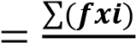 ,
𝑵

Where:
x = Mean f = Frequency N = Number of the respondents
∑= summation i = Points/Score

Future Outcomes
Upon approval of the moisturizing properties of watermelon peel soap, the researchers distributed the manuscript to the committee members. Following validation, the researchers planned to publish the study to secure copyright and patent protection, ensuring that the intellectual property rights of the researchers were safeguarded. To stimulate consumer interest and drive demand for watermelon soap in the market, the researchers implemented strategies to capture the attention of potential customers. By generating awareness around the product through various marketing channels, the researchers aimed to raise funds to enhance the quality of the watermelon peel soap and pursue FDA approval. This crucial step enabled the researchers to further refine the product, ensuring that it met the highest standards of safety and efficacy.
Ultimately, the goal was to introduce the improved, FDA-approved watermelon peel soap product to the industry, fostering partnerships with investors and stakeholders. This collaboration facilitated the commercialization of the product, making it widely available to consumers and establishing a foothold in the market. By achieving this milestone, the researchers successfully transformed their innovative idea into a tangible and beneficial product that could enhance the lives of consumers.

Ethical Considerations
The participants must agree to participate in the study. Letter of participant Consent Form will be provided and discussed to the participants who contain the information and assurances about taking part in the study. Moreover, participants have the right to renounce participation from the study at any range if they need to. In light of securing the confidentiality and anonymity of the participants’ responses, their real name will be kept hidden and will not be presented during the analysis of the data. Rather, participants will be given a pseudonym to avoid possible harmful consequences.

Chapter 4

PRESENTATION, ANALYSIS AND INTREPETATIONS OF DATA

This chapter introduces the presentation of findings, bridging from methodology to interpretation, and this includes an overview of data, presentation in table forms, analysis, and a discussion of implications.

Part I. Profile of the Respondent

Table 4.1
Age of the Respondents

Age Range | Frequency | Percent
18-25 Years Old | 16 | 80.0
26-30 Years Old | 4 | 20.0
Total | 20 | 100.0

As shown in Table 4.1 above, 80% of the respondents belong to the age bracket of 18-25 years old. This is followed by the age 26-30 years old.

Table 4.2
Sex of the Respondents

Sex | Frequency |  | Percent
Male | 7 | 35.0
Female | 13 | 65.0
Total | 20 | 100.0

As shown in Table 4.2, 36% of the respondents are male and 65% are female. The data clearly indicate that most of the respondents are female.

According to Chen et al. (2024), females are more prone to skin sensitivity compared to males. In relation to this, the majority of participants in this study were female, which may help in further assessing the effectiveness of the soap, particularly in determining whether it produces beneficial or adverse effects on sensitive skin. Male participants were also included in the study to evaluate whether there are differences in the soap’s efficacy across gender, considering that males and females may vary in skin characteristics and adaptability to skincare products.

Table 4.3
Skin type of the Respondents

Skin Type | Frequency | Percent
Normal | 10 | 50.0
Dry | 3 | 15.0
Combination | 4 | 20.0
Sensitive | 3 | 15.0
Total | 20 | 100.0

As shown in Table 4.3, 50% of the respondents have normal skin type, followed by 20% with combination skin type, while 15% have dry skin and another 15% have sensitive skin.
According to Chen et al. (2024), skin sensitivity varies depending on factors such as age, sex, skin type, and genetic background. As reflected in Table 4.1, 80% of the participants are aged 18–25 years, while 20% belong to the 26–30 age group. Similarly, Table 4.2 shows that the majority of the participants are female (65%), while males comprise 35% of the respondents. In Table 4.3, regarding skin type, 50% of the participants have normal skin, 20% have combination skin (dry and oily), and 15% each have dry and sensitive skin.
Given these variations, participants in this study were classified according to age, sex, and skin type to ensure that relevant demographic and physiological differences were considered in evaluating the acceptability and moisturizing efficacy of the product.

Part II. Moisturizing Effect of the Watermelon Peel Soap

2.1. Product Acceptability

Table 4.4
Product Acceptability in terms of Texture

 | Sum | Mean | Std. Deviation | Qualitative  Description | Rank
1.The Soap has a smooth even surface. (n = 20) | 74.00 | 3.7000 | .73270 | Acceptable | 1
2.The soap has a rough, grainy/rocky texture (n = 20) | 68.00 | 3.4000 | .82078 | Moderate | 3
3.The soap contains visible particles. | 72.00 | 3.6000 | .75394 | Acceptable | 2
Overall Mean |  | 3.56 |  | Acceptable

Scaling: 4.21-5.00 – “Extremely Acceptable ” 3.41-4.20 –“Acceptable”
2.61-3.40 – “Moderate” 1.81-2.60 – “Fair Acceptable” 1.00-1.80-“Poor acceptable”

As shown on Table 4.4, the respondents obtained an overall mean of 3.56, which is interpreted as acceptable in terms of product acceptability with respect to texture, with the following three topping the list based on their respective means: The Soap has a smooth even surface, $\overset{´}{ x}=3.7000$, interpreted as acceptable; The Soap contains visible particles or grit, $\overset{´}{ x}=3.6000$, interpreted as acceptable; and The Soap has a rough, grainy/ rocky texture, $\overset{´}{ x}=3.4000$, interpreted as moderate.
Appearance adds aesthetic value in a product. It is classified into shape, size, texture and color (Creusen & Schoorman, 2004). As table 4.4 presented, it is shown that in terms of texture, the product is acceptable. Which means that the watermelon peel soap has e good and pleasing texture that catches the participants’ interest through their bear eyes.
Table 4.5
Product Acceptability in terms of Appearance

 | Sum | Mean | Std. Deviation | Qualitative Description | Rank
1. The soap is visually appealing (n=20) | 58.00 | 2.9000 | 1.07115 | Moderate | 3
2. The soap has an appropriate shape (n=20) | 68.00 | 3.4000 | .94032 | Moderate | 1
3. The soap is aesthetically pleasing (n=20) | 52.00 | 2.6000 | .82078 | Moderate | 4
4. The soap has a consistent color throughout use | 65.00 | 2.6000 | 3.2500 | Moderate | 2
Overall Mean | 3.0375 |  |  | Moderate

Scaling: 4.21-5.00 – “Extremely Acceptable ” 3.41-4.20 –“Acceptable”
2.61-3.40 – “Moderate” 1.81-2.60 – “Fair Acceptable” 1.00-1.80-“Poor acceptable”

As shown on Table 4.5, the respondents obtained an overall mean of 3.0375, which is interpreted as moderate in terms of product acceptability with respect to appearance, with the following three topping the list based on their respective means: The Soap has an appropriate shape, $\overset{´}{ x}=3.4000$, interpreted as moderate; The Soap has a consistent color throughout use, $\overset{´}{ x}=3.2500$, interpreted as moderate; The soap is visually appealing, $\overset{´}{ x}=2.9000$, interpreted as moderate; and lastly The Soap is aesthetically Pleasing, $\overset{´}{ x}=2.6000$, interpreted as moderate.
In table 4.5, it is presented that the overall appearance of the soap is moderately acceptable, which are the shape and the color were moderately acceptable. Which is important as this is one of the components in aiming the consumers’ level of acceptability because it can draw their attention to the product and it must be accepted first to the appearance of the product before consuming it Creusen & Schoorman, 2004).

Table 4.6
Product Acceptability in terms of Scent/smell

 | Sum | Mean | Std. Deviation | Qualitative Description | Rank
1. The soap has pleasant and subtle fragrance (n=20) | 62.00 | 3.1000 | .756394 | Moderate | 1
2. The Fragrance is not over aromatic or irritating. (n=20) | 52.00 | 2.6000 | .78807 | Moderate | 2
3. The fragrance lingers pleasantly on the skin. (n=20) | 52.00 | 2.6000 | .94032 | Moderate | 3
Overall Mean | 2.7666 |  |  | Moderate

Scaling: 4.21-5.00 – “Extremely Acceptable ” 3.41-4.20 –“Acceptable”
2.61-3.40 – “Moderate” 1.81-2.60 – “Fair Acceptable” 1.00-1.80-“Poor acceptable”

As shown on Table 4.6, the respondents obtained an overall mean of 2.7666, which is interpreted as Moderate in terms of product acceptability with respect to scent/smell with the following three topping the list based on their respective means: The fragrance is not over aromatic or irritating, $\overset{´}{ x}=3.1000$, interpreted as moderate; The fragrance lingers pleasantly on the skin, $\overset{´}{ x}=2.6000$, interpreted as moderate; and The Soap has pleasant and subtle fragrance, $\overset{´}{ x}=2.6000$, interpreted as moderate.
According to the study conducted by Cruesan and Schoorman (2004), entitled “The Effect of Scent in Consumer Behavior,” scent is an important factor influencing consumers’ product preferences and choices. In relation to this, the researchers of the present study also considered the scent or smell of the product as an initial factor for acceptability prior to its use by the participants, as it contributes to overall product appeal. This is supported by the results presented in Table 4.6, which show that the overall mean in terms of scent/smell is moderately acceptable.

Table 4.7
Product Acceptability in terms of Lathering and Rinsing

 |  | Sum | Mean | Std. Deviation | Qualitative Description | Rank
1. The soap lather well and create a rich foam. (n=20) |  | 68.00 | 3.4000 | .59824 | Moderate | 3
2. The soap rinses off easily and completely clean from the skin. (n=20) |  | 70.00 | 3.5000 | 1.23544 | Acceptable | 1
3. The soap leaves no residue on the skin. (n=20) |  | 69.00 | 3.4500 | .1.31689 | Acceptable | 2
Overall Mean | 3.45 |  |  | Acceptable

Scaling: 4.21-5.00 – “Extremely Acceptable ” 3.41-4.20 –“Acceptable”
2.61-3.40 – “Moderate” 1.81-2.60 – “Fair Acceptable” 1.00-1.80-“Poor acceptable”

As shown on Table 4.7, the respondents obtained an overall mean of 3.45, which is interpreted as Acceptable in terms of product acceptability with respect to Lathering and Rinsing with the following three topping the list based on their respective means: The Soap rinses off easily and completely clean from the skin, $\overset{´}{ x}=3.5000$, interpreted as Acceptable; The Soap leaves no residue on the skin, $\overset{´}{ x}=3.4500$, interpreted as acceptable; and The Soap lather well and create a rich foam, $\overset{´}{ x}=3.4000$, interpreted as moderate.
Soap lather is like a layer of air bubbles that helps your skin slide smoothly. This keeps your skin healthy. The lubrication makes soap spread easily throughout your skin. (Bronner, 2025). In additional, for visual people, foam is helpful because it shows which spots you’ve washed. This helps us to wash more thoroughly.

Table 4.8
Product Acceptability in terms of Skin Feel

 | Sum | Mean | Std. Deviation | Qualitative Description | Rank
1. The soap leaves my skin feeling clean. (n=20) | 63.00 | 3.1500 | 1.34849 | Moderate | 2
2. The soap leaves my skin feeling moisturized. (n=20) | 64.00 | 3.2000 | 1.32188 | Moderate | 1
3. The soap leaves my skin feeling smooth. (n=20) | 62.00 | 3.1000 | 1.16529 | Moderate | 4
4. The soap leaves my skin feeling soft. (n=20) | 62.00 | 3.1000 | 1.20961 | Moderate | 3
5. The soap leaves my skin dry or tight | 47.00 | 2.3500 | 1.26803 | Fair acceptable | 5
Overall Mean | 2.98 |  |  | Moderate

Scaling: 4.21-5.00 – “Extremely Acceptable ” 3.41-4.20 –“Acceptable”
2.61-3.40 – “Moderate” 1.81-2.60 – “Fair Acceptable” 1.00-1.80-“Poor acceptable”

As shown on Table 4.8, the respondents obtained an overall mean of 2.98, which is interpreted as Moderate in terms of product acceptability with respect Skin Feel with the following three topping the list based on their respective means: The Soap leaves my skin feeling moisturized, $\overset{´}{ x}=3.2000$, interpreted as moderate; The Soap leaves my skin feeling clean, $\overset{´}{ x}=3.1500$, interpreted as acceptable; and The soap leaves my skin feeling soft, $\overset{´}{ x}=3.1000$, interpreted as moderate. Following with The soap leaves my skin feeling smooth, $\overset{´}{ x}=3.1000$, interpreted as moderate; lastly The soap leaves my skin dry or tight, $\overset{´}{ x}=2.3500$, interpreted as Fair acceptable.
According to Partha Mukhopadhyay (2011), there are various types of cleansers, and soap is one of them. These different cleansers have varying effects on the skin, particularly in terms of their surfactant type and rinsability, which are key factors that influence their drying and irritancy potential. The longer a cleanser remains on the skin, the higher its potential to cause irritation. Additionally, irritancy may vary depending on an individual’s skin type. The pH level of a cleanser is also a significant factor, as products with alkaline pH may contribute to skin dryness. In response to this, modern soaps and cleansers are formulated with pH levels closer to that of the skin to help prevent damage and maintain skin protection.
Given that the product developed in this study has moisturizing properties, it is expected not to cause skin dryness. This is supported by the results shown in Table 4.8, which indicate that the watermelon peel soap did not cause dryness and was moderately effective in improving skin smoothness.

2.2. Product Moisturizing Efficacy

Table 4.9
Product Moisturizing Efficacy in terms of Before Using the Soap

 | Sum | Mean | Std. Deviation | Qualitative Description | Rank
1. My skin felt dry. (n=20) | 48.00 | 2.4000 | 1.14248 | Fair Acceptable | 1
2. My skin felt dry. (n=20) | 48.00 | 2.4000 | 1.18766 | Fair Acceptable | 2
Overall Mean |  | 2.4000 |  | Fair Acceptable

Scaling: 4.21-5.00 – “Extremely Acceptable ” 3.41-4.20 –“Acceptable”
2.61-3.40 – “Moderate” 1.81-2.60 – “Fair Acceptable” 1.00-1.80-“Poor acceptable”

As shown on Table 4.9, the respondents obtained an overall mean of 2.4000, which is interpreted as fair acceptable in terms of Moisturizing Efficacy with respect to before using the soap with the following two topping the list based on their respective means: My skin felt tight, $\overset{´}{ x}=2.4000$, interpreted as moderate; . My skin felt dry, $\overset{´}{ x}=2.4000$, interpreted as Fair acceptable

Table 4.10
Product Moisturizing Efficacy in terms of After Using the Soap

 |  | Sum | Mean | Std. Deviation | Qualitative Description | Rank
1. My skin felt more hydrated and moisture. (n=20) |  | 66.00 | 3.3000 | 1.12858 | Moderate | 1
2. My skin felt less dry and less tight. (n=20) |  | 61.00 | 3.0500 | 1.19097 | Moderate | 3
3. My skin felt softer and smoother. (n=20) |  | 63.00 | 3.1500 | 1.13671 | Moderate | 2
Overall Mean | 3.1666 |  |  |  | Moderate

Scaling: 4.21-5.00 – “Extremely Acceptable ” 3.41-4.20 –“Acceptable”
2.61-3.40 – “Moderate” 1.81-2.60 – “Fair Acceptable” 1.00-1.80-“Poor acceptable”

As shown on Table 4.10, the respondents obtained an overall mean of 3.1666, which is interpreted as moderate in terms of Moisturizing Efficacy with respect to after using the soap with the following three topping the list based on their respective means: My skin felt more hydrated and moistured, $\overset{´}{ x}=3.3000$, interpreted as moderate; My skin felt less dry and less tight,$\overset{´}{ x}=3.1500$, interpreted as moderate; and My skin felt softer and smoother., $\overset{´}{ x}=3.0500$, interpreted as moderate.

Table 4.11
Product Moisturizing Efficacy in terms of Overall Moisturizing Effect

 |  | Sum | Mean | Std. Deviation |  | Qualitative  Description | Rank
1.The watermelon peel soap effectively moisturized my skin |  | 63.00 | 3.1500 | 1.08942 |  | Moderate | 1
2. I noticed a significant improvement in my skin moisture level after using the soap |  | 62.00 | 3.1000 | 1.20961 |  | Moderate | 2
Overall Mean | 3.125 |  |  |  |  | Moderate

Scaling: 4.21-5.00 – “Extremely Acceptable ” 3.41-4.20 –“Acceptable”
2.61-3.40 – “Moderate” 1.81-2.60 – “Fair Acceptable” 1.00-1.80-“Poor acceptable”

As shown on Table 4.11, the respondents obtained an overall mean of 3.125, which is interpreted as fair acceptable in terms of Overall Moisturizing Efficacy with the following two topping the list based on their respective means: The watermelon peel soap effectively moisturized my skin $\overset{´}{ x}=3.1500$, interpreted as moderate; I noticed a significant improvement in my skin moisture level after using the soap, $\overset{´}{ x}=3.1000$, interpreted as moderate.
According to Simamora et al, 2023, the water content of the watermelon white rind increases the moisturizing effect of the cream, therefore, the watermelon white rind can be a good raw material on making a soap which can moisturized the skin. In line with the results, this strengthens the final result of the study as the overall mean resulted 3.125 – moderately acceptable. As the first question indicated that, “the watermelon peel soap effectively moisturized my skin” resulted moderately acceptable which means majority of the participant’s skin moisturizes and accepted the soap. As well as in the question number two, “I noticed a significant improvement in my skin moisture lever after using the soap”, where technically the watermelon peel soap has a huge impact in the selected participants as it resulted, moderately accepted. In line with these, it strengthened that the watermelon peel has a potential to become a moisturizer soap.

Part III. The comments and suggestions of the Participants for the importance of the Product (after the application) in terms of;

3.1. What is your overall impression of the watermelon peel soap?

P3: It has no good fragrance. It feels itchy and it also has no good effect when it comes to moisturizing effect.
P10: Okay lang. Actually, very rough talaga and skin ko pero upon using this soap , parang nawala pagka-sobrang dry ng akin ko. And nakakaputi rin siya so far. After two weeks of using this soap napansin ko na pumuti ang skin ko and nawala and sobrang pagkadry ng skin ko.
(The soap is okay to used. Actually, I have dry skin but upon using the soap, it reduced the dryness. It also whitened my skin. After two weeks of using the soap, I notice some improvement of my skin.)
P15: It irritated my skin so I stop using it. My skin is sensitive and maybe that’s the reason why I irritates my skin.

Most of the participants liked and accepted the watermelon peel soap. The positive responses, particularly from Participant 10 (P10) and other respondents, further strengthened the overall finding that the product was generally acceptable. However, three participants reported experiencing skin irritation, which may be attributed to differences in skin type. Participant 15 (P15) also noted that having a sensitive skin type may have contributed to the irritation experienced. This suggests that the soap may not be suitable for individuals with highly sensitive skin.
Watermelon is composed of approximately 92% water, which contributes to its potential moisturizing properties. In a related study, watermelon was combined with coconut oil and olive oil to produce a soap intended for dry skin treatment. The addition of watermelon extract was found to enhance hydration, while its lycopene content contributed to antibacterial properties and skin moisturization (Moldez et al., 2019). In the present study, however, only watermelon peel was utilized as the primary ingredient, combined with other materials in soap formulation. Despite this difference in formulation, the findings suggest that watermelon peel alone can still serve as an effective component in moisturizing soap production. This supports the idea that watermelon peel has potential as a natural raw material for skin-moisturizing soap.

3.2. Do you have any suggestions for improvement of the Product?
P10: Okay lang talaga ang texture. Yung smell lang talaga, kasi at first nagdadalawang isip ako if gagamitin ko ba or not kasi ang pangit ng amoy niya. Parang paper paste and parang hindi appropriate ang smell niya for skin. And yung color na rin or appearance mismo ng soap and dapat ma-enhance. Since watermelon siya gawin niyo nalang red and green yung color niya para unique.
Most of the participants suggested improvements in the shape, color, smell, and fragrance of the soap. One participant (P10) commented that while the texture was acceptable, the smell was not pleasant. The participant further noted initial hesitation in using the product due to its odor, describing it as similar to paper paste and inappropriate for a skincare product. The same participant suggested enhancing the color and appearance of the soap, recommending a design inspired by watermelon colors, red and green, to make the product more attractive and unique.
These suggestions indicate participants’ willingness to improve the product, which may also support its future development and refinement.
Product appearance plays a significant role in consumer perception and purchase intention, as it is often the first aspect evaluated by users. According to Cruesen and Schoorman (2004), appearance contributes to the aesthetic and symbolic value of a product. It includes elements such as shape, size, texture, and color, and represents the overall visual design perceived by consumers. Since consumers often assess products visually before use, appearance significantly influences acceptability and product preference. Therefore, it is an important factor considered in this study, as it directly affects consumer choice and overall product acceptance.

IV. What is the ROI (Return of Investment) on development of Watermelon Peel Soap?

Table 4.12
Computation of Return of Investment in Developing Watermelon Peel Soap.

Material | Quantity | Unit | Unit Price | Cost
Watermelon | 1 | kg | Php 100.00 | Php 100.00
Soap Base | 1 | kg | Php 139.73 | Php 139.73
Total Cost |  |  |  | Php 239.73
The listed materials above yield 12 watermelon peel soaps.

With a selling price of ₱30.00 per soap, the total revenue amounts to ₱360.00. Using the formula provided below, the return on investment (ROI) of the watermelon peel soap can be computed.

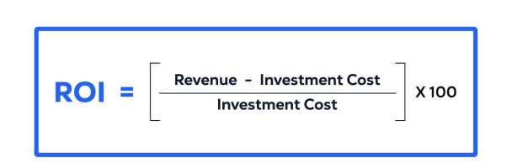

ROI = $\frac{Revenue - Investment Cost}{Investment Cost}$ x 100

ROI = $\frac{360 - 239.73 }{239.73}$ x 100

ROI = $\frac{120.27}{239.73}$ x 100

ROI = 0.5016894 x 100

ROI = 50%

Therefore, the total return on investment (ROI) in developing watermelon peel soap is 50%, indicating that the product has potential for business viability. The watermelon peel soap is priced at ₱30.00 per bar.

Chapter 5
SUMMARY, CONCLUSION AND RECCOMENDATIONS

Summary
The present study focused on determining the acceptability level and moisturizing efficacy of watermelon peel soap. Watermelon peel contains approximately 92% water, suggesting its potential as an effective raw material for skin moisturization. Aside from developing an eco-friendly product, the study also aimed to contribute to waste reduction.
The soap formulation process successfully produced a product with a foamy consistency and a natural aroma, which was evaluated by 7 male and 13 female respondents. The distribution of skin types among the participants showed that half had normal skin, while the remaining participants were categorized as dry (15%), combination (20%), and sensitive (15%).
The acceptability of the product was assessed based on several attributes. Texture obtained an overall mean score of 3.56, interpreted as acceptable. Appearance obtained an overall mean score of 3.0375, also interpreted as acceptable. Scent/smell obtained an overall mean score of 2.7666, indicating that improvement is needed. Lathering and rinsing obtained an overall mean score of 3.45, indicating acceptability, while skin peeling obtained an overall mean score of 2.98, suggesting the need for improvement.
In terms of moisturizing efficacy, the product was initially rated as fair, with an overall mean score of 2.4000 before use. After application, the rating improved to moderately acceptable, with an overall mean score of 3.1666. The overall moisturizing efficacy of the product obtained a mean score of 3.125, indicating a moderately acceptable level.
Therefore, the watermelon peel soap was found to be acceptable in terms of texture, appearance, and lathering and rinsing. However, improvements are needed in scent and skin peeling performance. Overall, the product demonstrated moisturizing benefits, indicating its potential as a skin-moisturizing soap.

Conclusion
The findings of this study establish that watermelon peel is a feasible, sustainable, and effective raw material for the development of a moisturizing body soap. The formulated watermelon peel soap demonstrated an acceptable level of product performance, particularly in terms of texture, lathering, rinsing ability, and overall skin feel, while yielding moderate acceptability in appearance and scent. These results indicate that the product meets fundamental consumer expectations for usability and comfort. Moreover, the pre-test and post-test evaluations revealed a noticeable improvement in skin moisture after regular application, thereby confirming the moisturizing efficacy of the watermelon peel soap. This outcome substantiates existing scientific literature which highlights the high-water content, vitamins, amino acids, and antioxidant properties of watermelon peel as beneficial to skin hydration and maintenance of the skin barrier.
Beyond product efficacy, the study underscores the relevance of watermelon peel soap within the framework of green chemistry and sustainable waste management. By converting an agricultural by-product into a value-added cosmetic product, the research supports the principles of waste reduction, reuse, and recycling, while addressing environmental concerns associated with food waste and synthetic cosmetic ingredients.
Furthermore, the favorable return on investment demonstrates the product’s economic viability, indicating its potential for small-scale commercialization and community-based enterprise development. Overall, this study concludes that watermelon peel soap is a safe, eco-friendly, and economically promising alternative to conventional soaps, with significant implications for sustainable product innovation, local livelihood generation, and future research in natural and waste-derived cosmetic formulations.

Recommendations
Based on the findings and conclusions, the following key recommendations are presented:
- Farmers are recommended to:
  - Expand cultivation of Watermelon to ensure supply for making watermelon peel soap.
- DTI (Department of Trade and Industry) is recommended to:
  - Promote and support the production of watermelon peel soap by providing assistance to local farmers and entrepreneurs.
- Consumers are recommended to:
  - Support local products through purchasing them and using it.
- Entrepreneurs are recommended to:
  - Reduce the use of chemical in production of cosmetic.
- Students are recommended to:
  - Assess the other benefits of watermelon peel to develop another cosmetic product.
  - Take initiative to explore other natural ingredients to produce a local product.
- Parents are recommended to:
  - Educate their families about turning a waste into a useful product such as watermelon peel soap.
- Future Researchers are recommended to:
  - Seek for professional for further testing of the soap.
  - Ensure the skin-safe property of the soap. Make it suitable for sensitive skin user.
  - Compare with commercial products.
  - Consider the appearance of the soap. Make it more aesthetically pleasing, while ensuring any additives are skin-safe and align with the soap’s moisturizing effect.
  - Determine the shelf life and storage condition of the soap.

BIBLIOGRAPHY

Abdalla, S., Aroua, M. K., & Gew, L. T. (2024). A comprehensive review of Plant-Based cosmetic oils (Virgin coconut oil, olive oil, argan oil, and jojoba oil): chemical and biological properties and their cosmeceutical applications. ACS Omega, 9(44), 44019–44032. https://doi.org/10.1021/acsomega.4c04277

Abordo, G. L., Fiedacan, P. T., Labador, R. R., Mercado, G. P., Muan, E. D., Ondona, R. C., Osinsao, E. F., Pilares, J. A., Saguil, J. M., Sakakibara, G. L., Vizcarra, J. N. & Virola-Leh, M. B. (2019). Efficacy of Plumeria acuminata (Kalachuchi) Leaves Extract as an Antibacterial Soap: a Randomized Controlled Trial. Philippine Scientific Journal, 52(1):18-24.

Agero, A. L. C., & Verallo-Rowell, V. M. (2004). A Randomized Double-Blind Controlled Trial Comparing Extra Virgin Coconut Oil with Mineral Oil as a Moisturizer for Mild to Moderate Xerosis. Dermatitis, 15(03), 109. https://doi.org/10.2310/6620.2004.04006

Anastas Paul T. & Eghbali, Nicholas. (2010). Green Chemistry: Principles and Practice. The Royal Societies of Chemistry 2010. 39:301-312.

Antonio, Lisa C. 2009. Study on 3R Policy and Waste Exchange in the Philippines. ERIA Research Project Report. 139-159 pp.

Balogun, O. L., Akinboro, O. S., Akinwole, O. T., & Osuji, E. E. (2018). An Economic Analysis of Watermelon Marketing. International Journal of Vegetable Science, 25(4), 355–361. https://doi.org/10.1080/19315260.2018.1519625

Bhatnagar, S. and Khurana, S. (2024). Oils and Fats as Raw Materials for Cosmetics. In Oils and Fats as Raw Materials for Industry. https://doi.org/10.1002/9781119910558.ch6

Beasley, T. M. (2015). Small Sample Size Considerations for Experimental and Pilot Studies. Journal of Experimental Psychology, 22(4), 1-12

Borkar, D. 2023. A Research on Formulation and Evaluation of Herbal Soap. International Journal of Research Publication and Reviews. 4360-4367 pp.

Bronner, Lisa. (2025, March 3). The Science of Lather: Exploring the fun and function of suds. Going Green With Lisa Bronner.

Chhangani, Manoj K.S. & Mehta, Chayan. (2018). Application of Green Chemistry in Skin Care Product. Journal of Emerging Technologies and Innovative Research (JETIR). 5(6):701-703.

Cocal, Christopher J., Lopez, Rose Dyan M., & Frias, George G. (2017). Culture and Management Practices of Watermelon Farmers in Western Pangasinan, Philippines. Asia Pacific Journal of Academic Research in Business Administration. 3(1):73-78.

Cordero, Sheena Marie G., De Leon, Madeth F., Florentino, Gelly C., et al. Watermelon as Scented Soap. (2022). STI College. Ormoc City, Philippines.

Das, A., Deb, L., Behara, L., & Bose, S. (2020). Making of Organic Cosmetic (Soap) using Fruit Waste. International Journal of Scientific Research and Engineering Development. 3(3):995-1006.

Daystar, Jesse., Golden, Jay., & Handfield, Robert. (2021). Green Chemistry: A Stronger Driver of Innovation, Growth, and Business Opportunity. University of Massachusetts Lowell and Lowell Center.

De Marco, B. A., Rechelo, B. S., Tótoli, E. G., Kogawa, A. C., & Salgado, H. R. N. (2018). Evolution of Green Chemistry and its Multidimensional Impacts: A Review. Saudi Pharmaceutical Journal, 27(1), 1–8. https://doi.org/10.1016/j.jsps.2018.07.011

Du, X., Davila, M., Ramirez, J., & Williams, C. (2022). Free Amino Acids and Volatile Aroma Compounds in Watermelon Rind, Flesh, and Three Rind-Flesh Juices. Molecules,

El-Chaghaby, Ghany, Bassuony, Wahdan, (April 2017). Watermelon White Rind as a Natural Valuable Source of Phytochemicals and Multinutrients, https://journals.ekb.eg/article_335518_a87aa813f9cbb797f5bf2d2cae8a8ac7.pdf

Feizy, J., Jahani, M., & Ahmadi, S. (2020). Antioxidant activity and mineral content of watermelon peel. Journal of Food and Bioprocess Engineering, 3(1), 35-40. doi: 10.22059/jfabe.2020.75811

Fitria, L. N., Jabar, M. A., Dzulfiana, N., Cahyati, S. A. W., & Yuniarsih, N. (2022). Natural Ingredients with Potential as Skin Moisturizers (Body Lotion): A Narrative Literature Review. Archives of the Medicine and Case Reports, 3(4), 293–295. https://doi.org/10.37275/amcr.v3i4.213

Fonseca, Maria R., Karpe, Aakanksha N., Mendes, Ryan. M. (2019). Fruit Peel Soap And Its Antibacterial Properties In Skin Care. International Journal of Current Pharmaceutical Research. 11(3):17–20.

Gladvin, G., Sudhakar, G., Swathi, V., and Santhisri, K.V. (2017). Mineral and Vitamin Compositions Contents in Watermelon Peel (Rind), International Journal of Current Microbiology and Applied Sciences, Department of Foods and Nutritional Sciences, Acharya Nagarjuna University, Nagarjuna Nagar, Guntur, Andhra Pradesh, India

Hanan M.A. Al-Sayed a, Abdelrahman R. Ahmed. (January 2013). Accepted 15 January 2013, Available online 7 March 2013, Utilization of watermelon rinds and sharlyn melon peels as a natural source of dietary fiber and antioxidants in cake, Home Economics Department, Fac. of Specific Education, Ain Shams University, Cairo, Egypt.

Harold, Richard W. (2001). An Introduction to Appearance Analysis. Graphic Arts Technical Foundation.

Hertzog, M. A. (2008). Considerations in determining sample size for pilot studies. Research in Nursing & Health, 31(2), 180-191.

Hunter, Liza and Leeflang, Jacqueline. (2023, May 21). Watermelon Nutrients. Nutrivore. https://nutrivore.com/foods/watermelon-nutrients/

Ilieska, Karolina. (2013). Customer Satisfaction Index – as a Base for Strategic Marketing Management. TEM Journal.

Jahns, Erin. (January 2024). How and When to Use Coconut Oil as a Natural Moisturizer. BYRDIE.

Julious, S. A. (2005). Sample size of 12 per group rule of thumb for a pilot study. Pharmaceutical Statistics, 4(4), 287-291.

Keen, M., & Hassan, I. (2016). Vitamin E in Dermatology. Indian Dermatology Online Journal. 7(4), 311. https://doi.org/10.4103/2229-5178.185494

Khanal, A., Giri, J., Dall’Acqua, S., & Adhikari, R. (2024). Vegetable oils-based cosmetics. In Elsevier eBooks (pp. 139–161). https://doi.org/10.1016/b978-0-12-822189-1.00002-7

Kiron, A. (2024). Research on the three R Reduce^J Reuse^J Recycle Alternative for waste management. SSRN Electronic Journal. https://doi.org/10.2139/ssrn.4970295

Labonte, Wayne. (2020). A Guide to Soap Bases & How to Choose One. Twincraft Skincare Blog.

Lado, J. R. P., Lastimosa, D. J. D., and Pinanong, B. S. 2024. Using Pineapple (Ananas comosus) and Ginger (Zingiber officinale) Peel Extracts as Natural Antibacterial Agents for Sustainable Hand Soap Production. Bais City National Science High School.

Lo, M. J. C., Pesebre, M. A. C., Riza, J. J. C., Samson, A. B. N., and Cruz, C. O. 2019. Characterization of Powdered Pectin from Watermelon (Citrullus Lanatus) Rind. Letran Research Center.

Malawi, Norjana. (2024). New Agri-Facilities in Lanao to Boost Farming Economy. BARMM Official Website.

Marcus, Jacqueline B. (2019). Aging, Nutrition and Taste. In Elsevier eBooks. https://doi.org/10.1016/c2015-0-04905-x

Matthews, Tim. (2016). Semantics of Texture. University of Southampton.

Medhiatika, Ni Luh Made, V. (2021). Making Soap From Waste Cooking Oil As A Product and Behavioral Change in Housing Area. 3(1):70-75.

Mohamad, Nor Fadilah., Onn, Munirah., Alisha, Ain. Enrichment of Soap Formation from Fruit Extraction. Diploma of Chemical Engineering.

Moldez, Maria Rose S., Sañoza, Gabrielle Anne V., Sanchez, Darlene Kate N. (2019). Antibacterial and Hydrating Soap using Watermelon JuiceExtract, Virgin Coconut Oil and Olive Oil. New Era University. Quezon City, Philippines.

Mukhopadhyay, Partha. (2011). Cleansers and their role in various dermatological disorders. Indian Journal of Dermatology, 56(1), 2. https://doi.org/10.4103/0019-5154.77542

Naz, A. C. C., & Naz, M. T. N. (2008). Ecological Solid waste management in suburban municipalities: user fees in Tuba, Philippines. Asean Economic Bulletin, 25(1), 70–84. https://doi.org/10.1355/ae25-1g

Nilange, Sushilkumar S., Bijali. N. R., & Sabale V.U. (2024). Skin Lotion: Banana Peel Extract And Watermelon Rind Extract. 9(11):168-171.

Patil, Shivaji M., Gavali, Shravika T., Sargar, Shreekant. (2024). Formulation and Evaluation of Virgin Coconut Oil Lotion. International Research Journal of Modernization in Engineering Technology and Science.

Petchsomrit, Arsa., McDermott, Mark. I., Chanroj, Salil. (2020). Watermelon Seeds And Peels: Fatty Acid Composition And Cosmeceutical Potential. Oilseeds & Fats Crops and Lipids. 27(54):1-9.

Prior, James. (2023). Cause and Effect: Definition, Meaning and Examples.

Raffaeli, L., Montanini, L., Gambi, E., & Spinsante, S. (2016). User interfaces in smart assistive environments. In Advances In Human And Social Aspects Of Technology Book Series (pp. 420–443). https://doi.org/10.4018/978-1-5225-0435-1.ch017

Rathore, K. ., Tripathi, M. C. ., Tiwari, D. H. ., & Chandrul, D. K. K. (2024). HERBAL COSMETICS. EUROPEAN JOURNAL OF MODERN MEDICINE AND PRACTICE, 4(5), 239–247. Retrieved from https://inovatus.es/index.php/ejmmp/article/view/3186

Robinson, Deena. (2024). 15 Biggest Environmental Problems of 2024. Earth Organization.

Rundblade, Patricia. (2017). The Efficacy of Love. LinkedIn.

Sakkaravarthi, Vinupriya. (2022). History of Soap. Cosmoderma. https://doi.org/10.25259/csdm_152_2022

Scott, S. (2026, March 27). How a High-Protein Diet Can Make You Look Younger. Otis Skincare.https://otisskincare.com/blogs/news/proteinbenefits?srsltid=AfmBOop4 yBGHoQHHzgY15Gb8-J4vkUpJLv8-93e9wzE9VR9MC6BhpFop

Seol, J. E., Cho, G. J., Jang, S. H., Ahn, S. W., Hong, S. M., Park, S. H., & Kim, H. (2024). Effect of amount of daily water intake and use of moisturizer on skin barrier function in healthy female participants. Annals of Dermatology, 36(3), 145. https://doi.org/10.5021/ad.23.067

Simamora, Farida SR., Janice., and Amir, Widya P. (2023). Effectiveness Test of White Skin Extract Cream from Red Watermelon (Citrullus Lanatus) on Increasing Elasticity, Sebum and Hydration in White Mice (Mus Musculus) Skin. International Journal of Health and Pharmaceutica.

Siswanto, A. P. and Aldo, G. (2023). Formulation of Solid Body Wash From Dragon Fruit Peel Waste With Pandan Leaf Extract. ASEAN Journal of Community Engagement, 7(1), 26-36.

Taki, Andre. (2026, April 6). Magic of the Molecule: The Crucial Role of Sodium Hydroxide in Soap Creation and Drain Maintenance. Alliance Chemical.

Trinklein, David. (2020). Watermelon: A Brief History. Missouri Environment & Garden.

Unson, John. (2021). 2 BARMM Provinces Now Have Watermelon, Fishing Capitals. Philstar Global.

Unson, John. (2023). Construction of P182-M Worth Lanao Del Sur Agri Trading Center Begins. Philstar Global.

APPENDIX A
Research Instrument
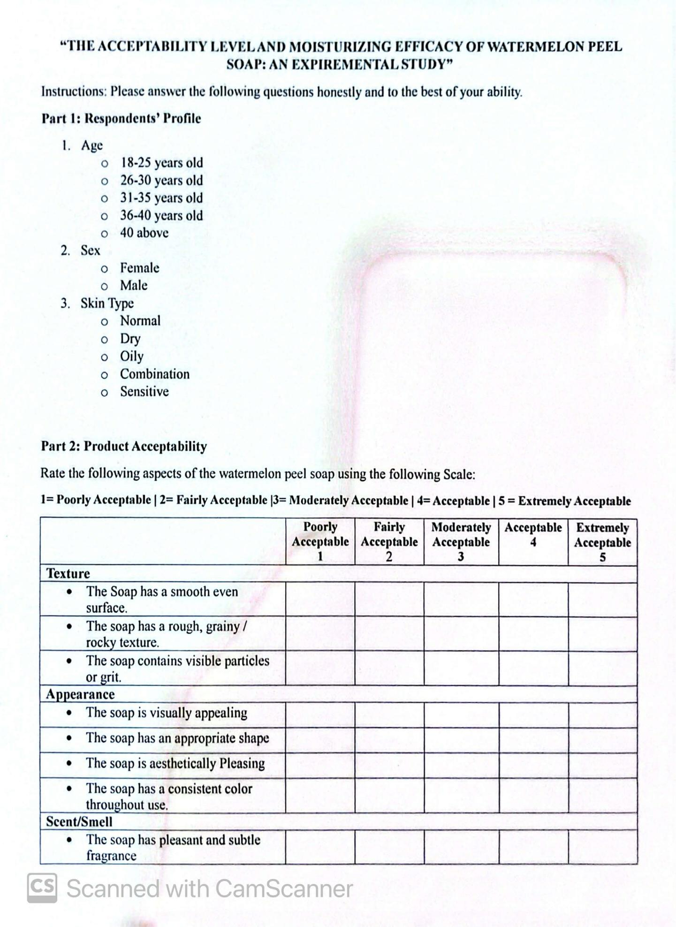

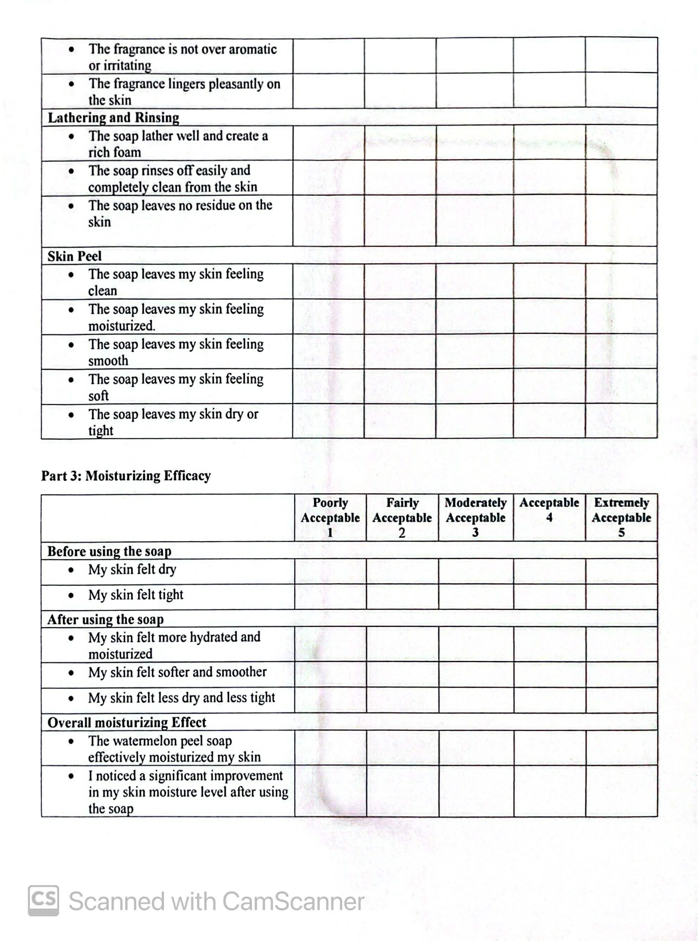

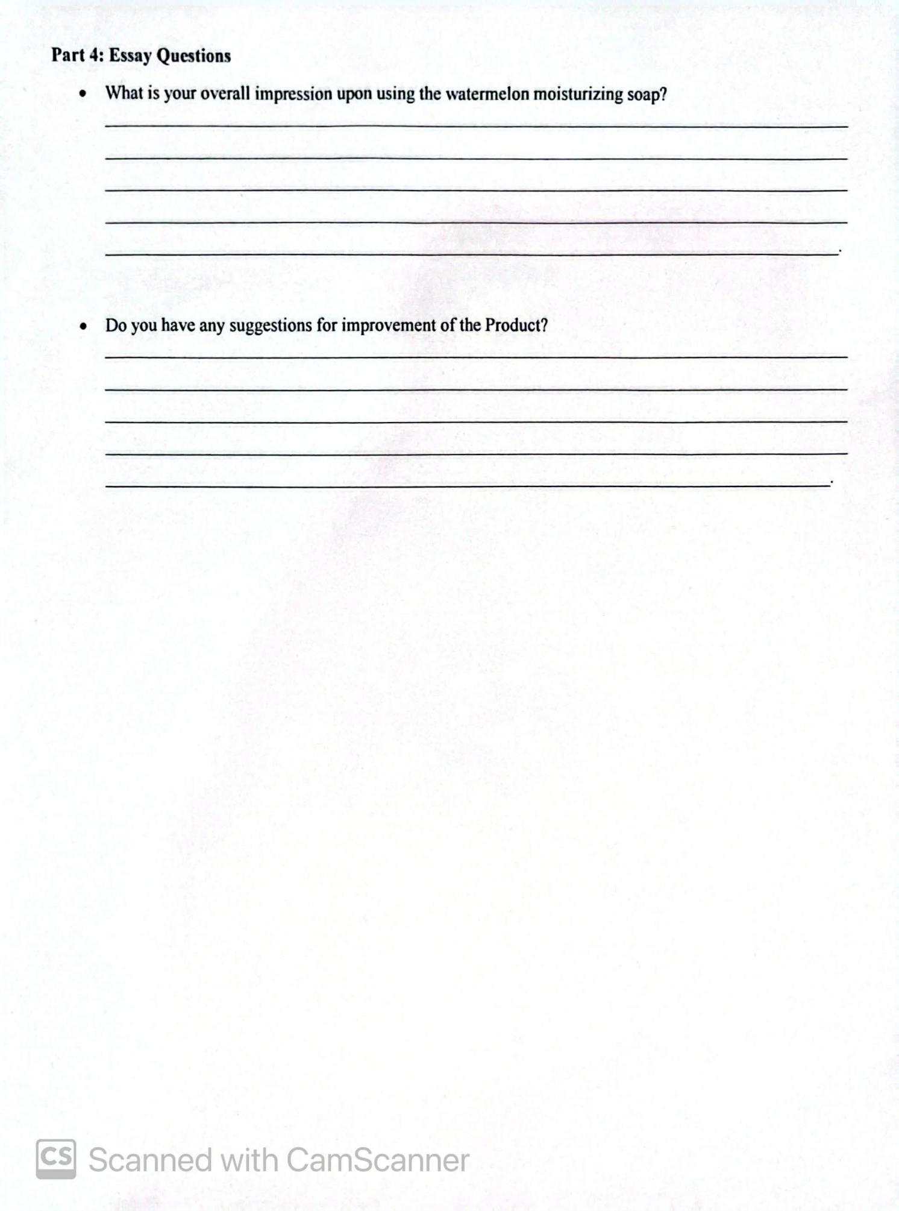

APPENDIX B
Consent Form
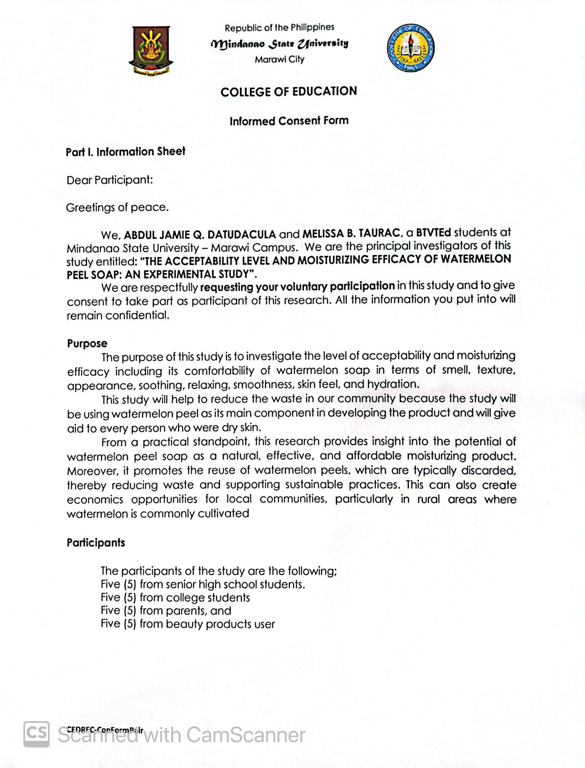

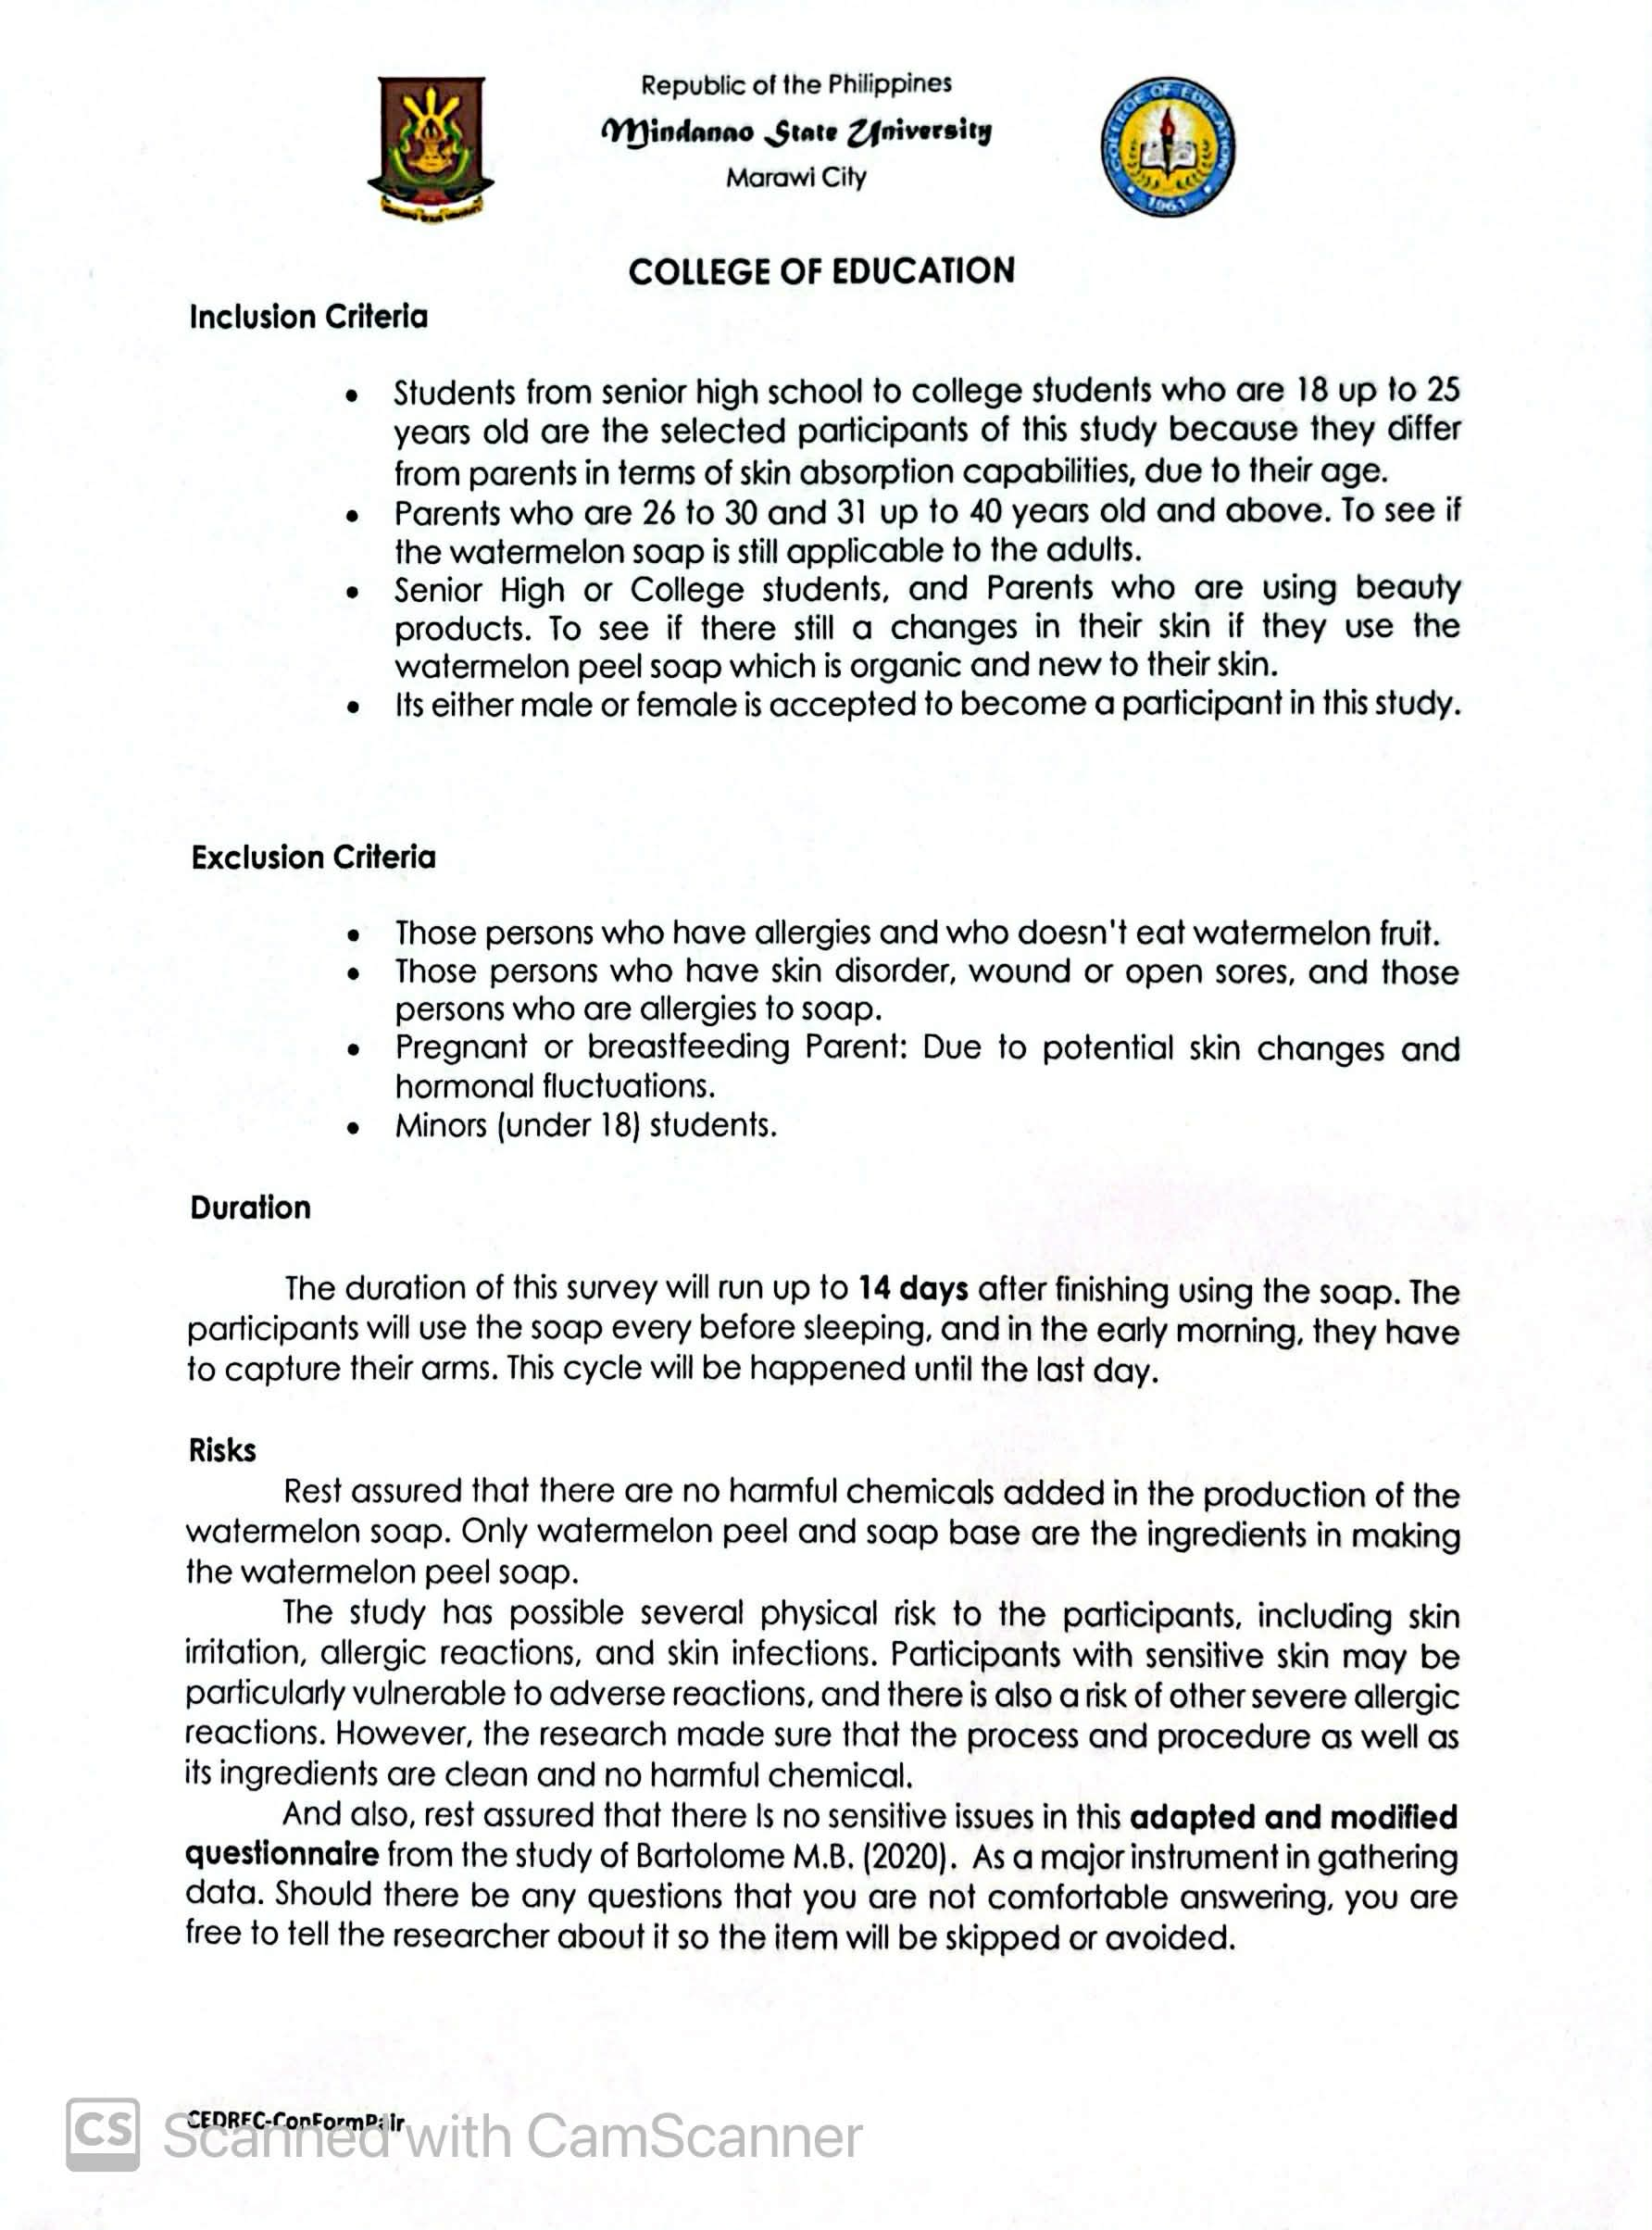

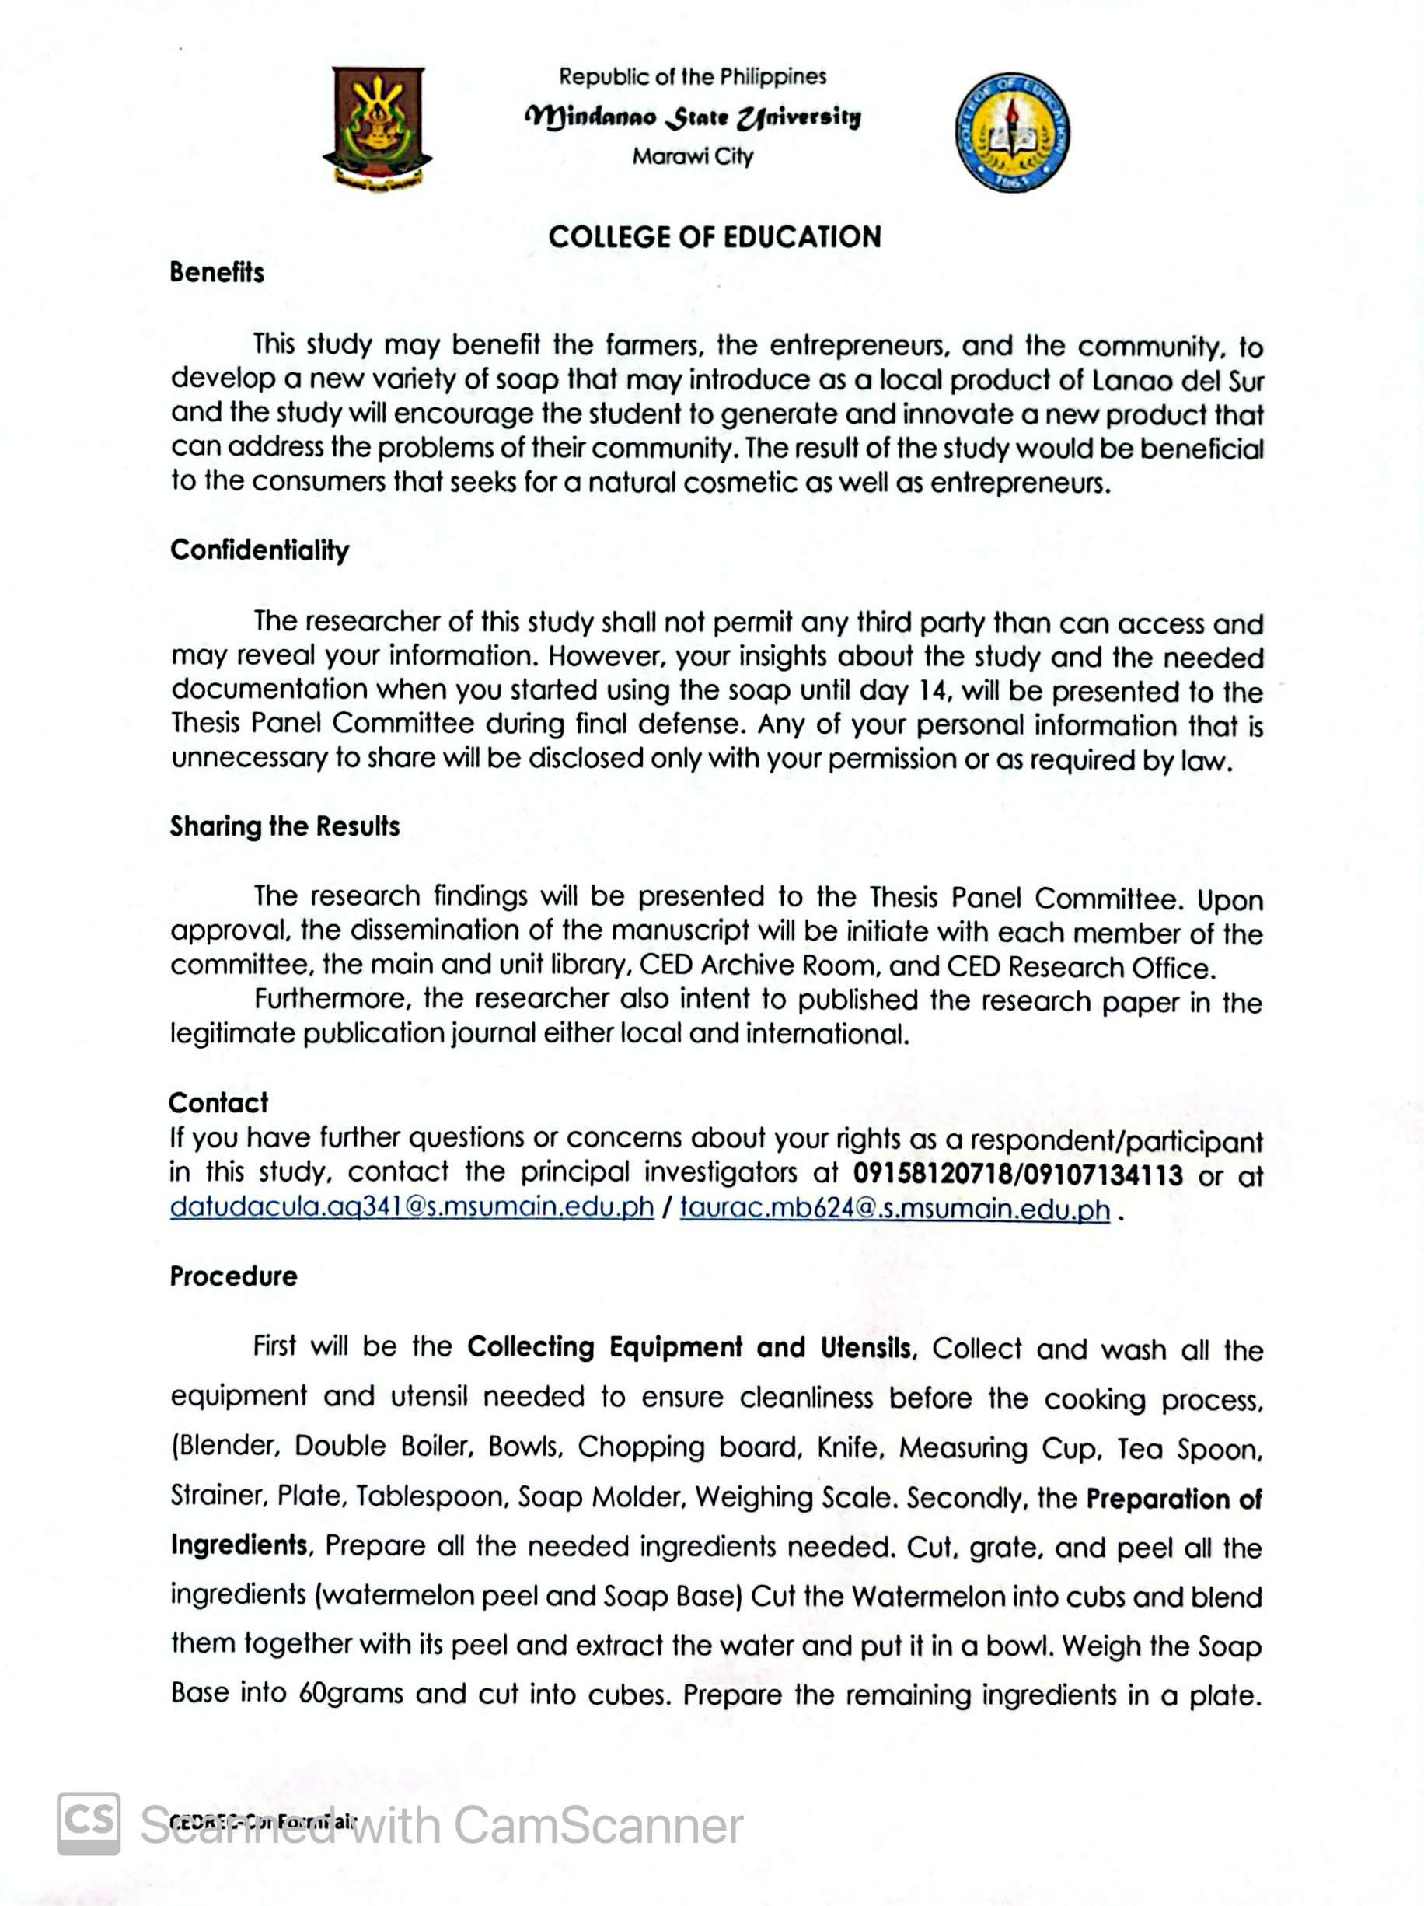

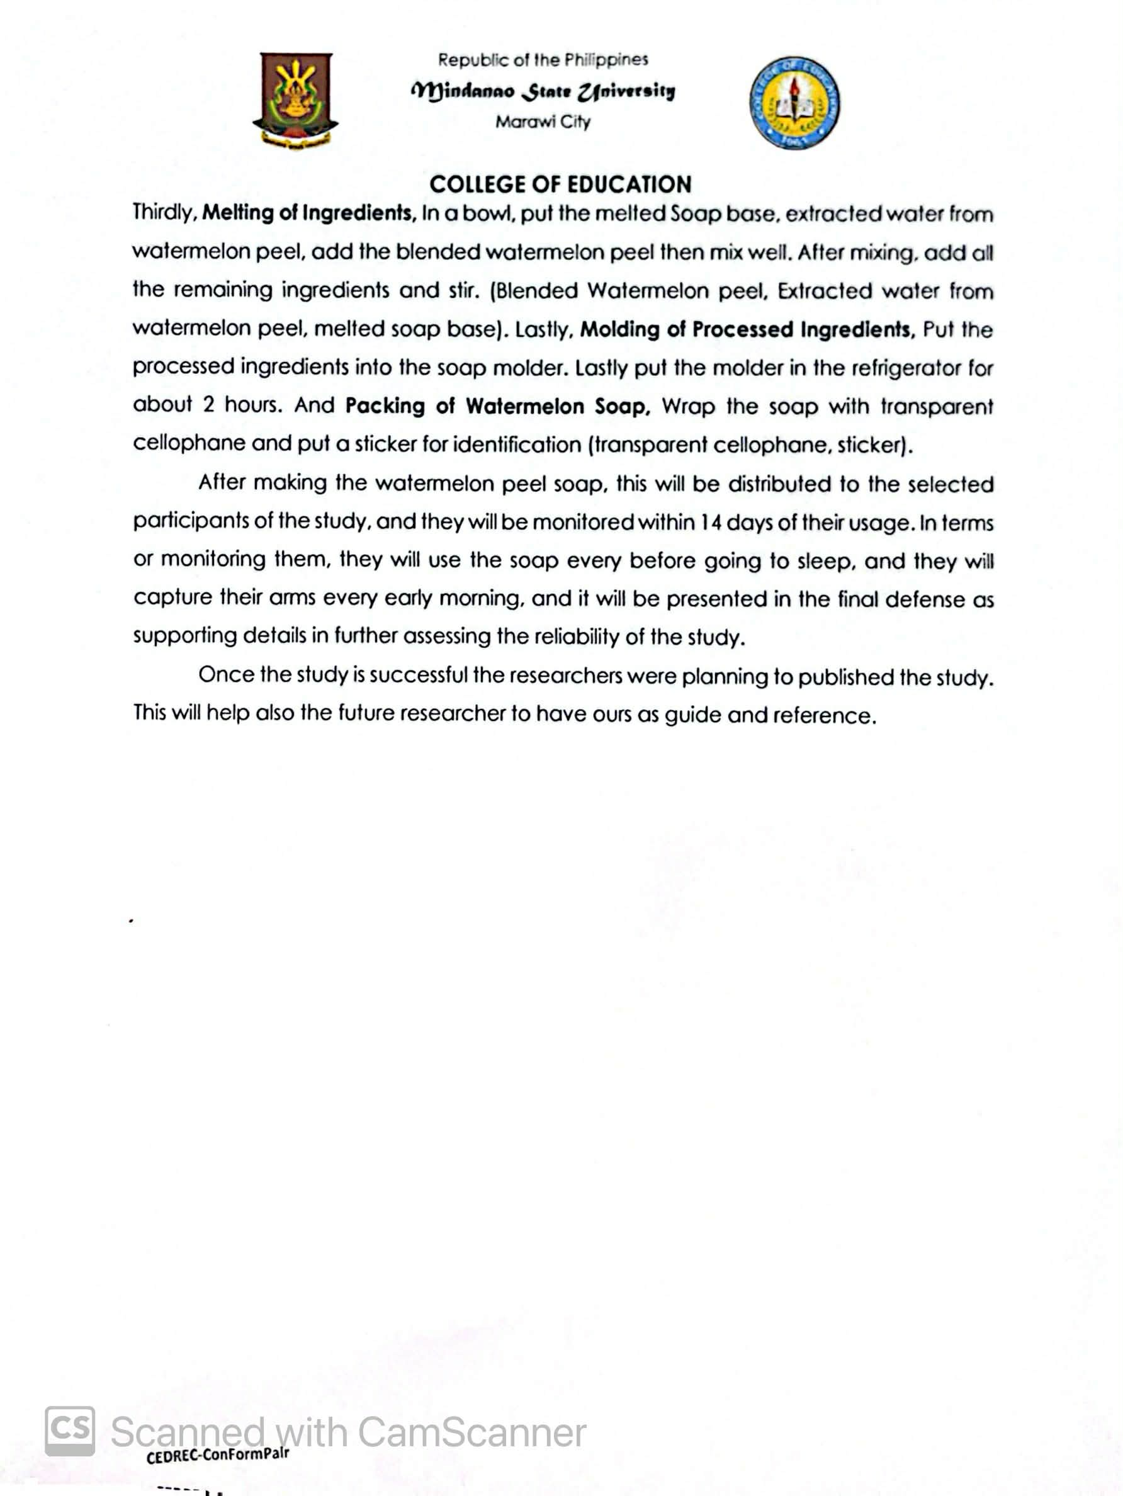

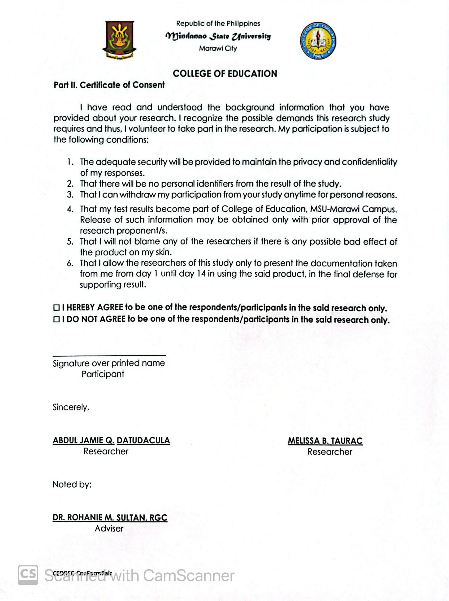

APPENDIX C
Certificate of Validation of Statistical Tool

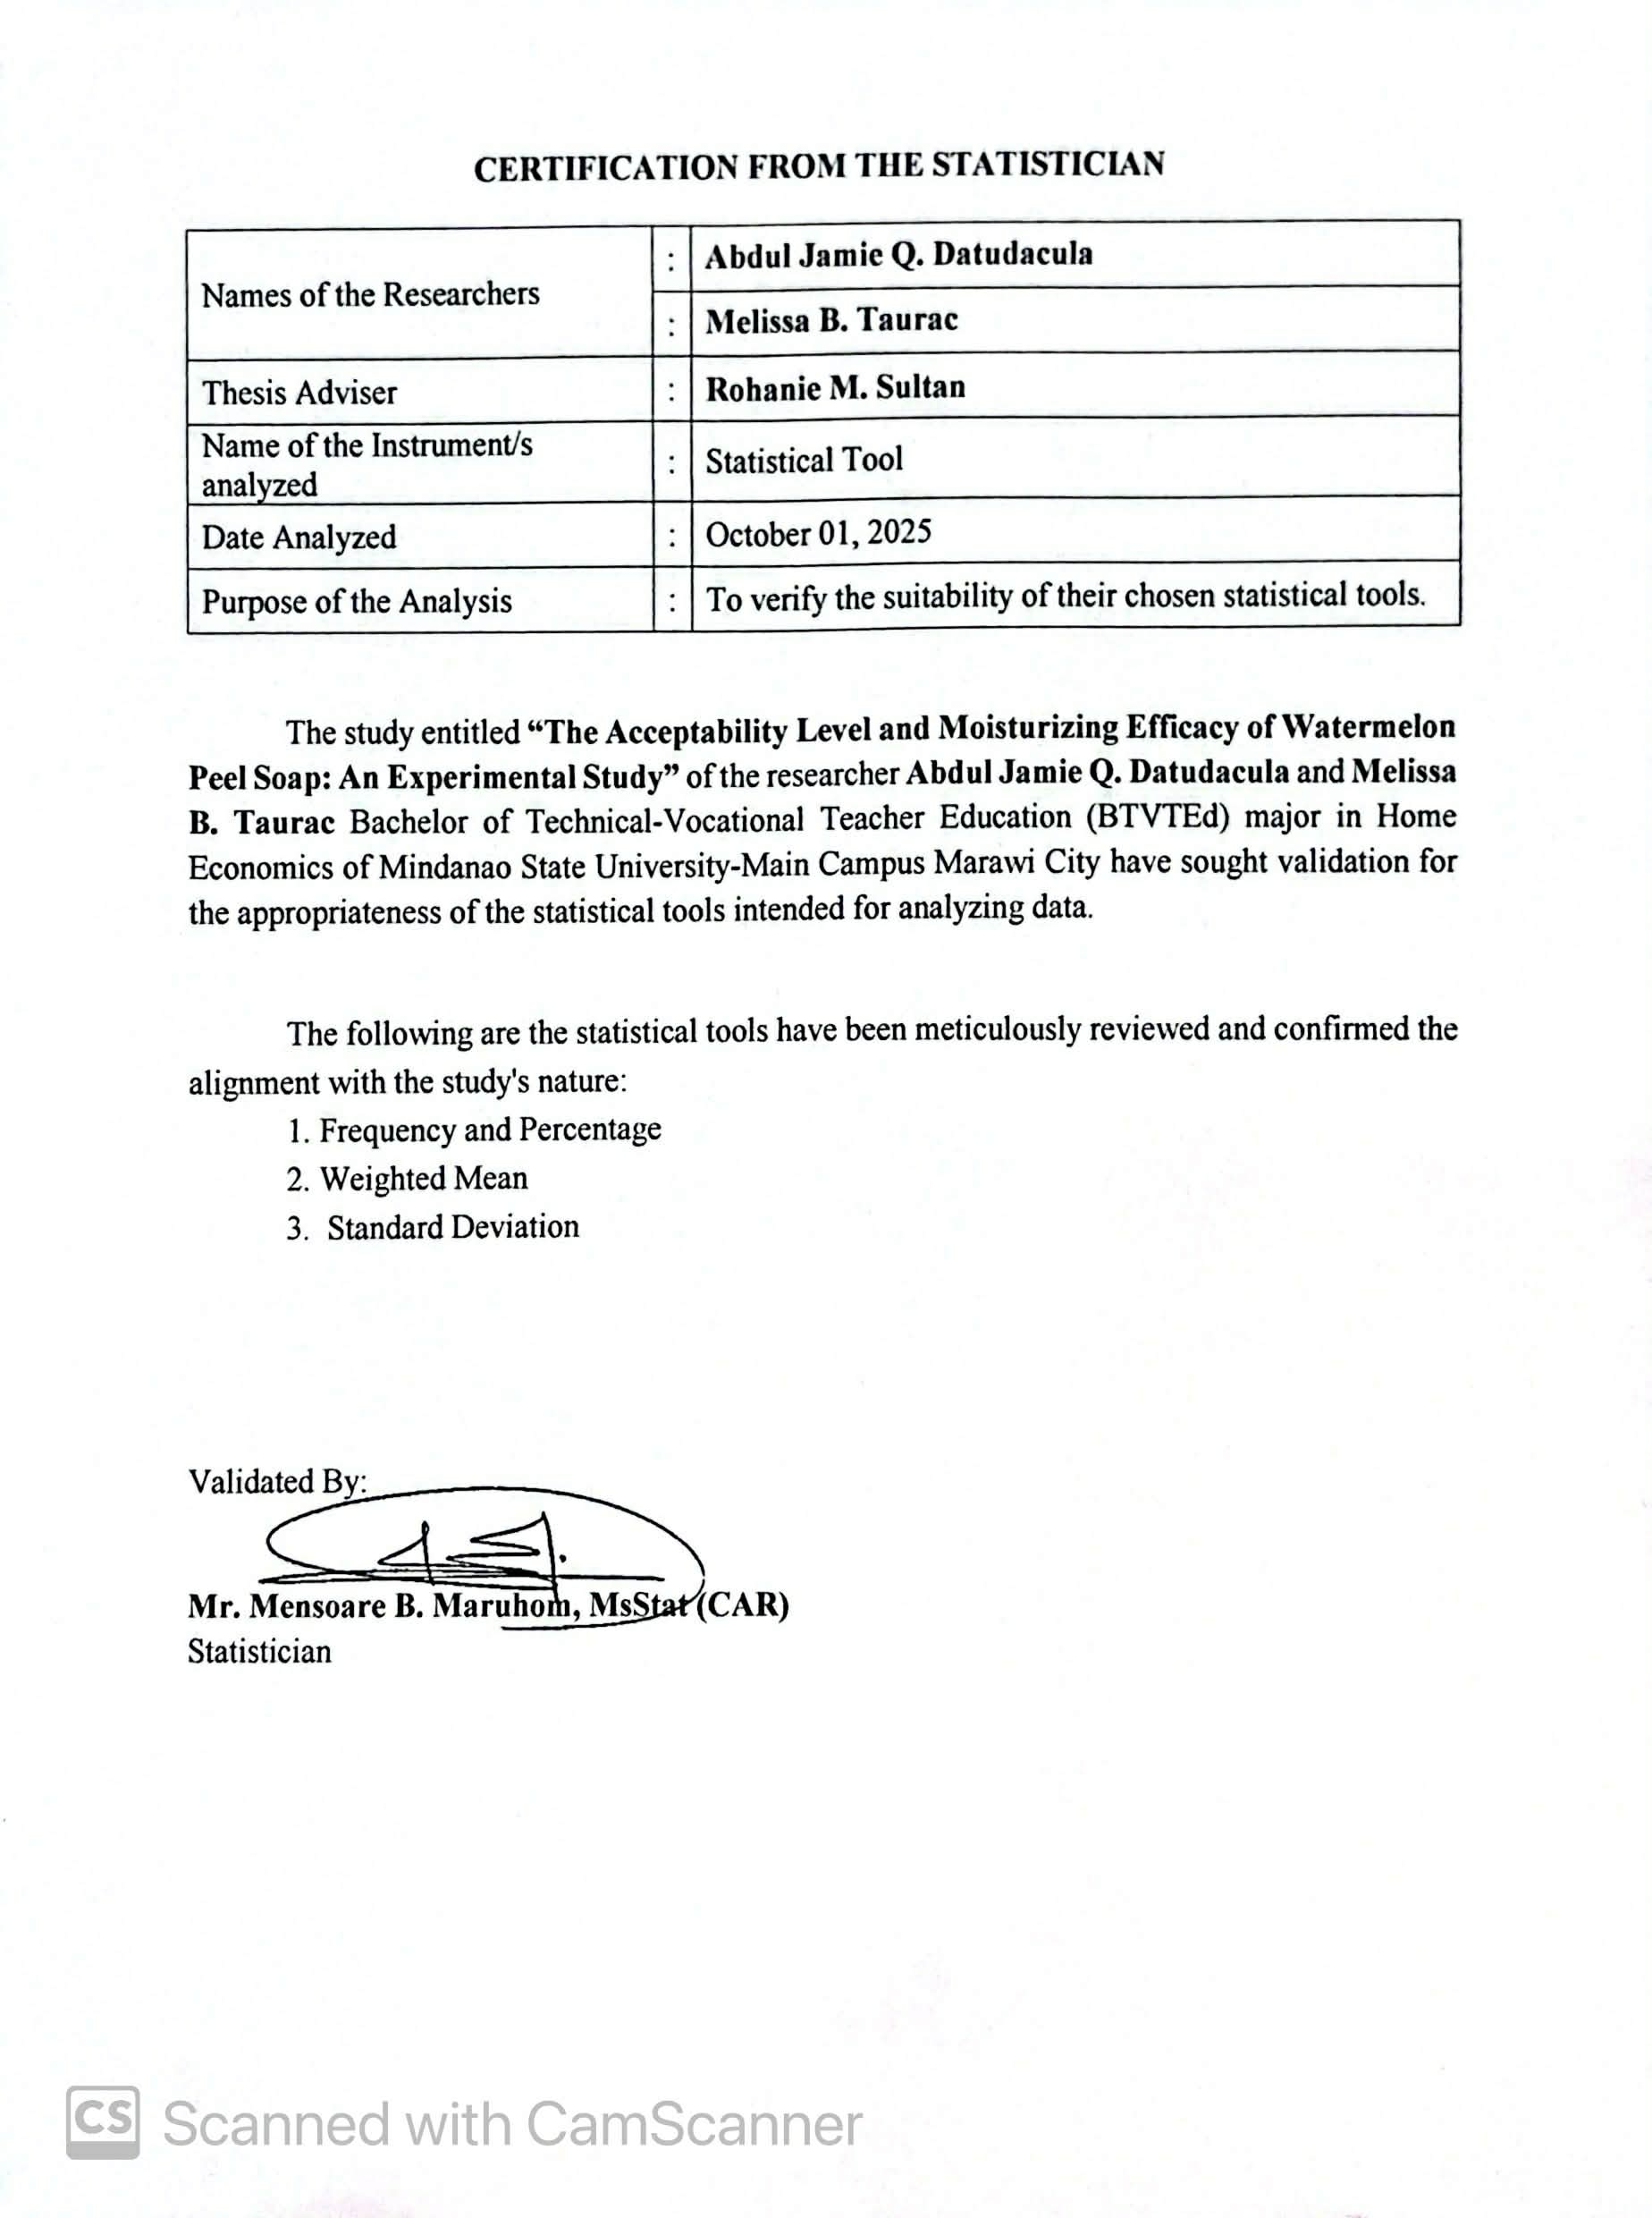

APPENDIX D
Certification from Statistician for Analyzing & Interpreting of Data
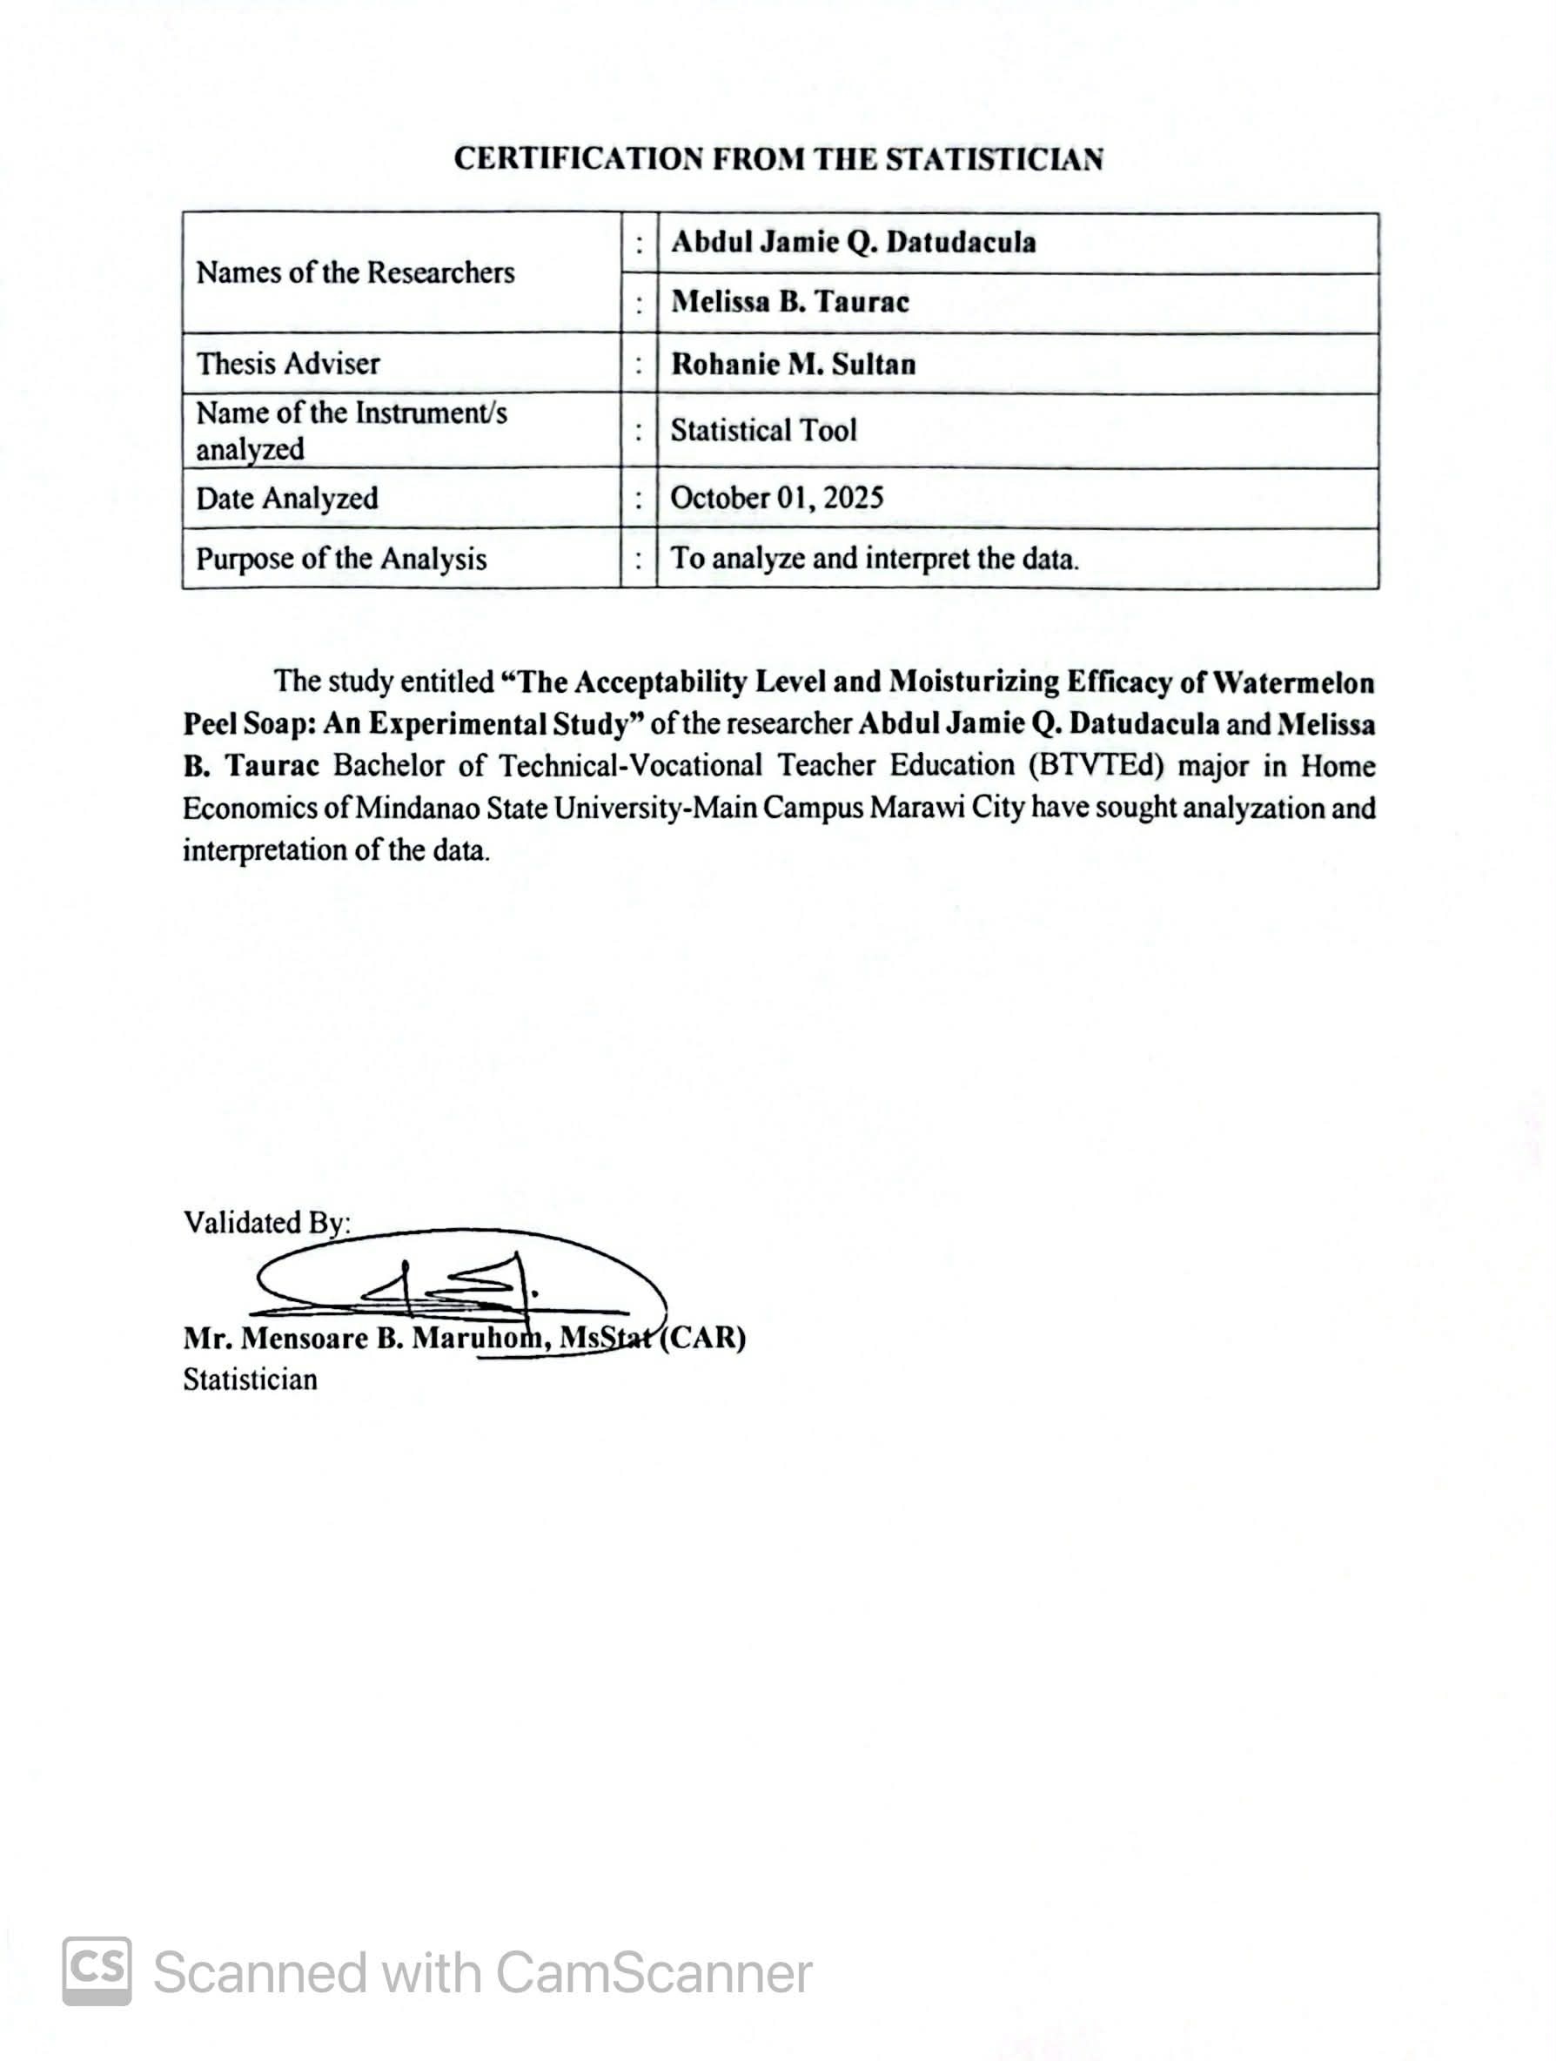

APPENDIX E
Pre-defense Form

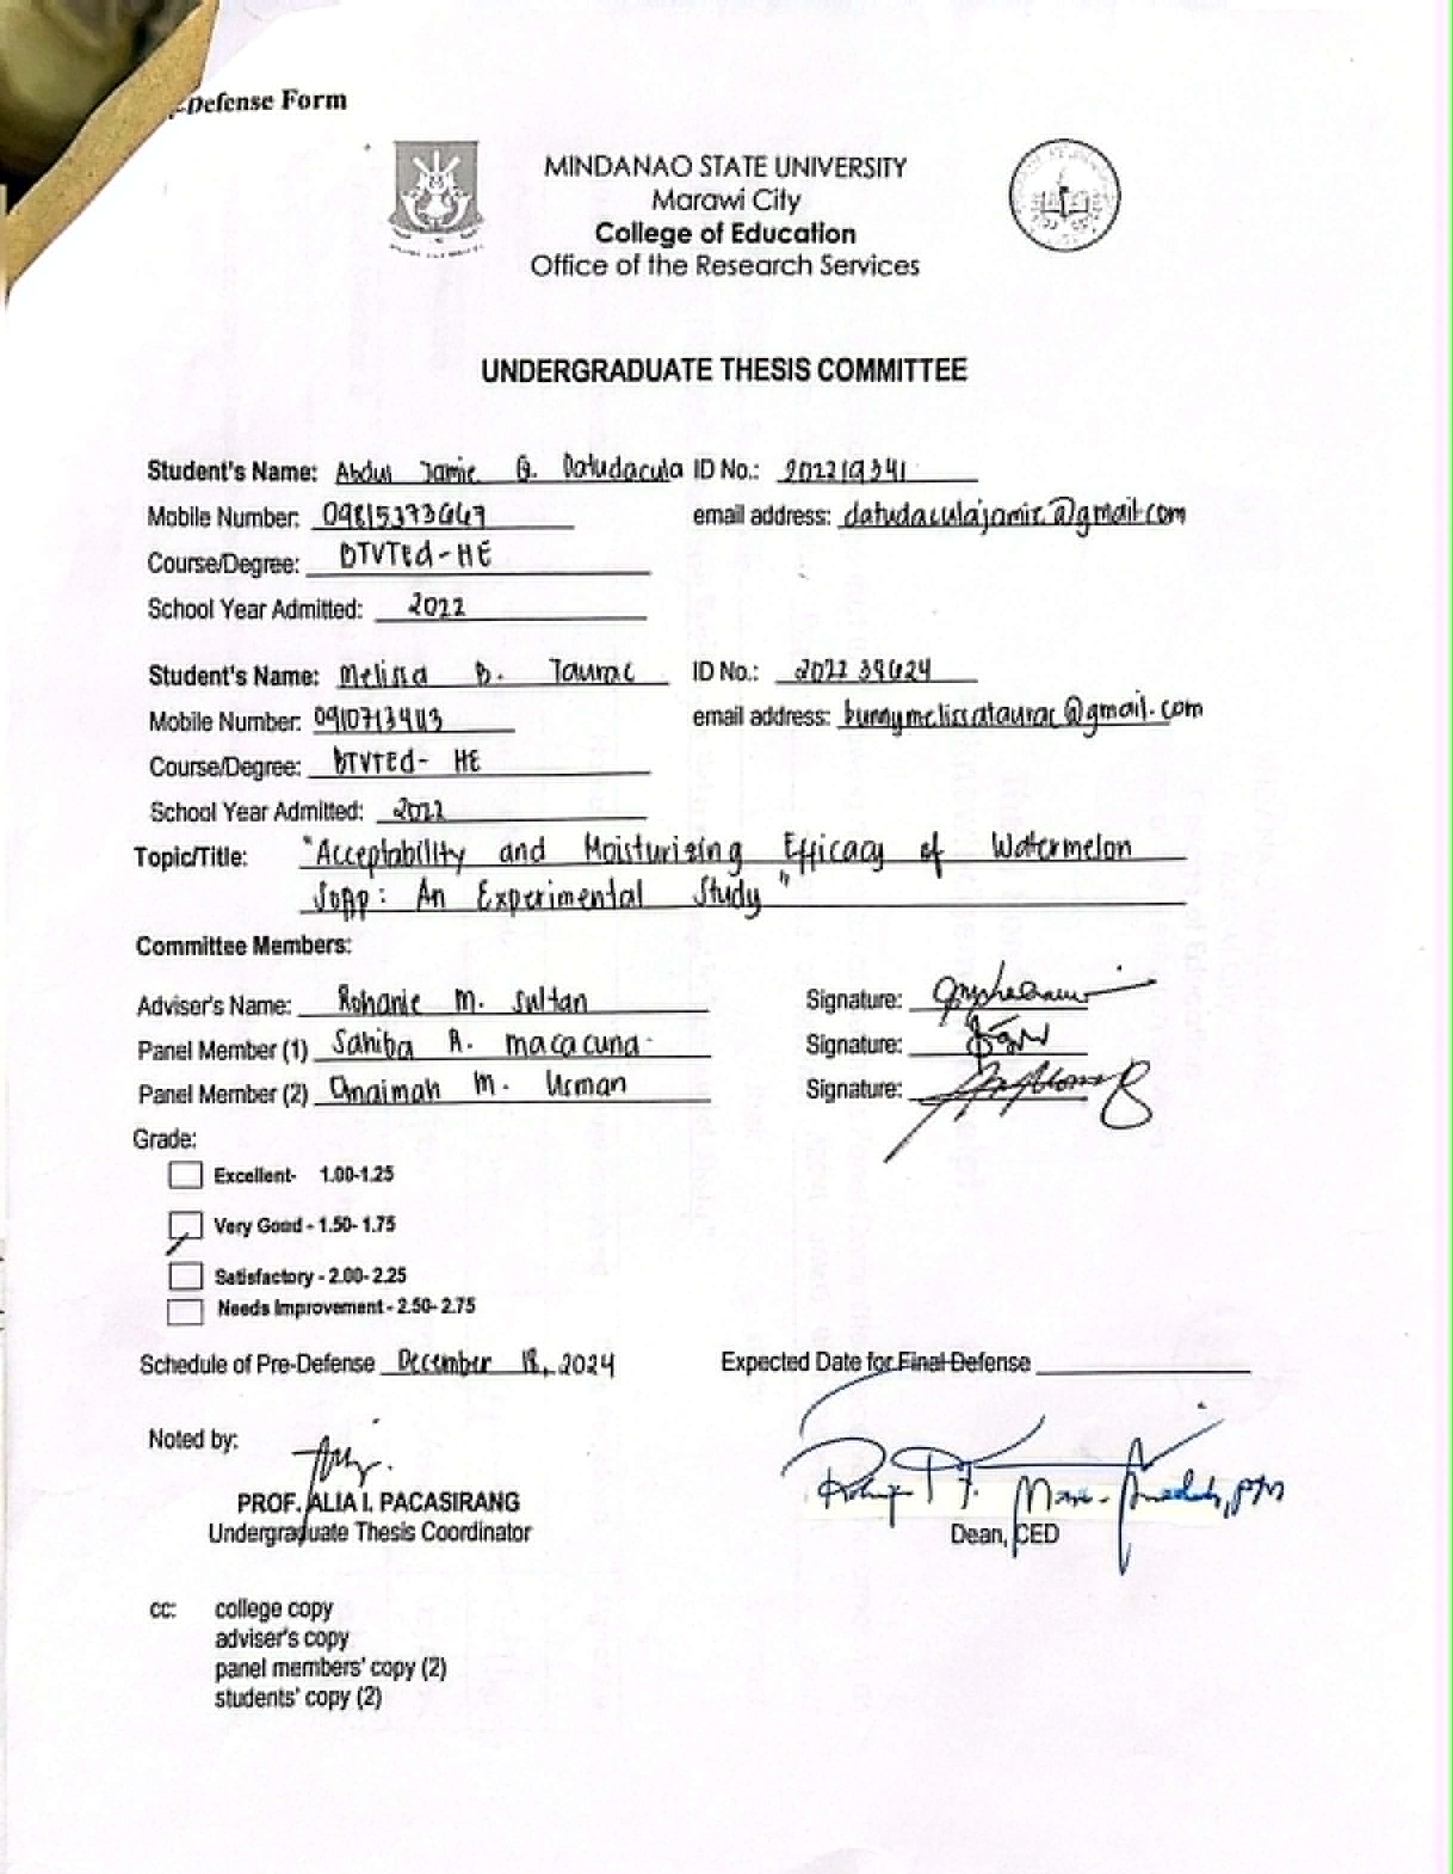
APPENDIX F
Final Defense Form

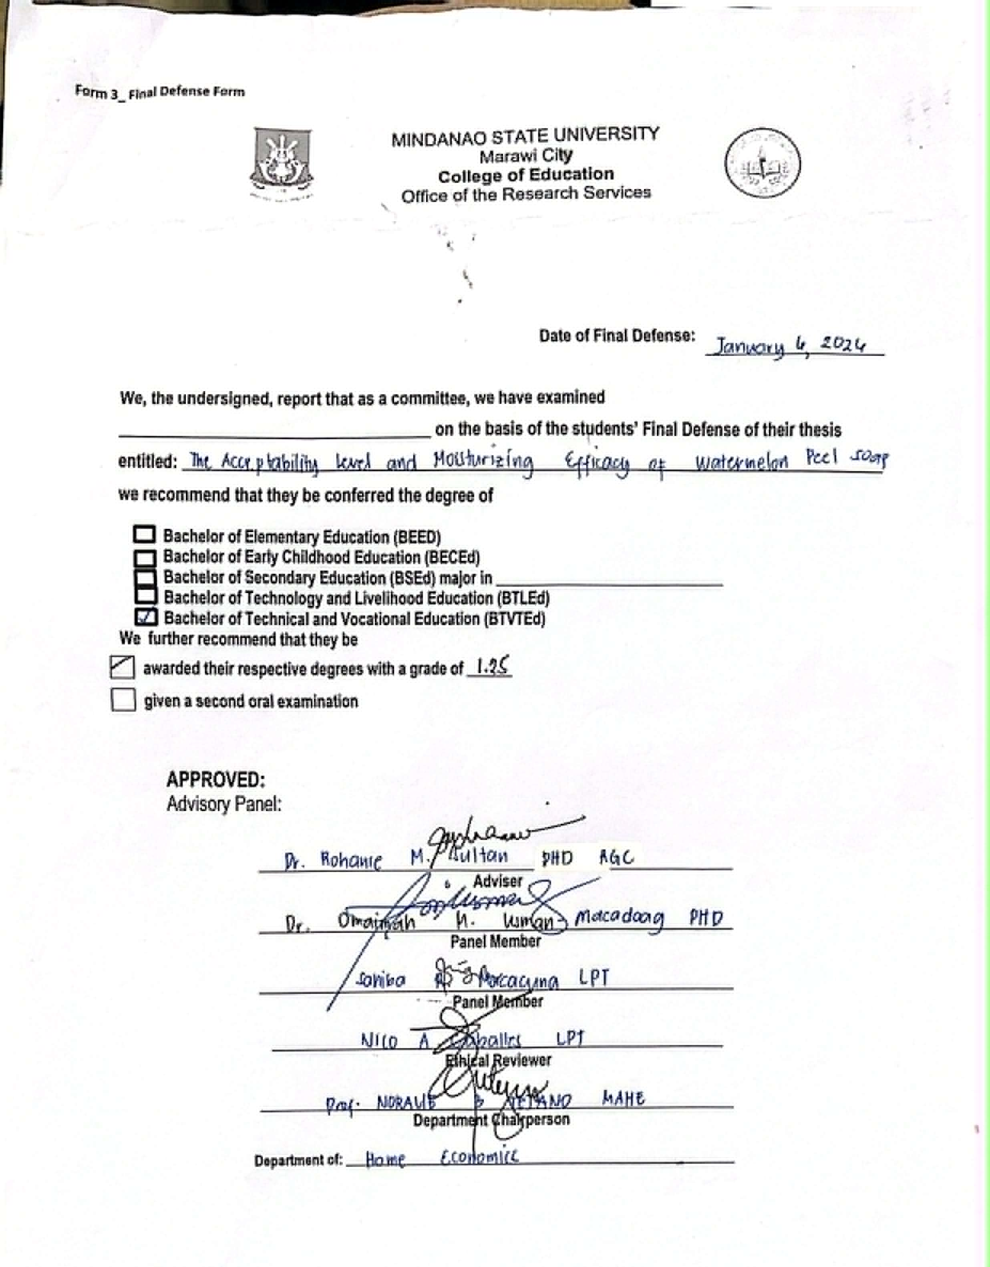

APPENDIX G
Ethical Clearance

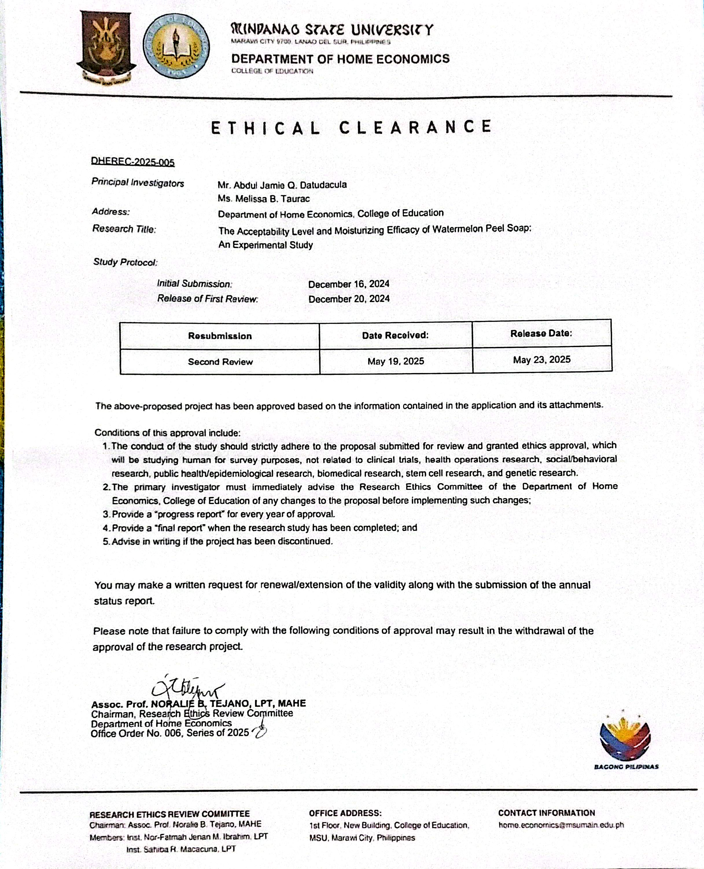

APPENDIX H
Cost – Estimates
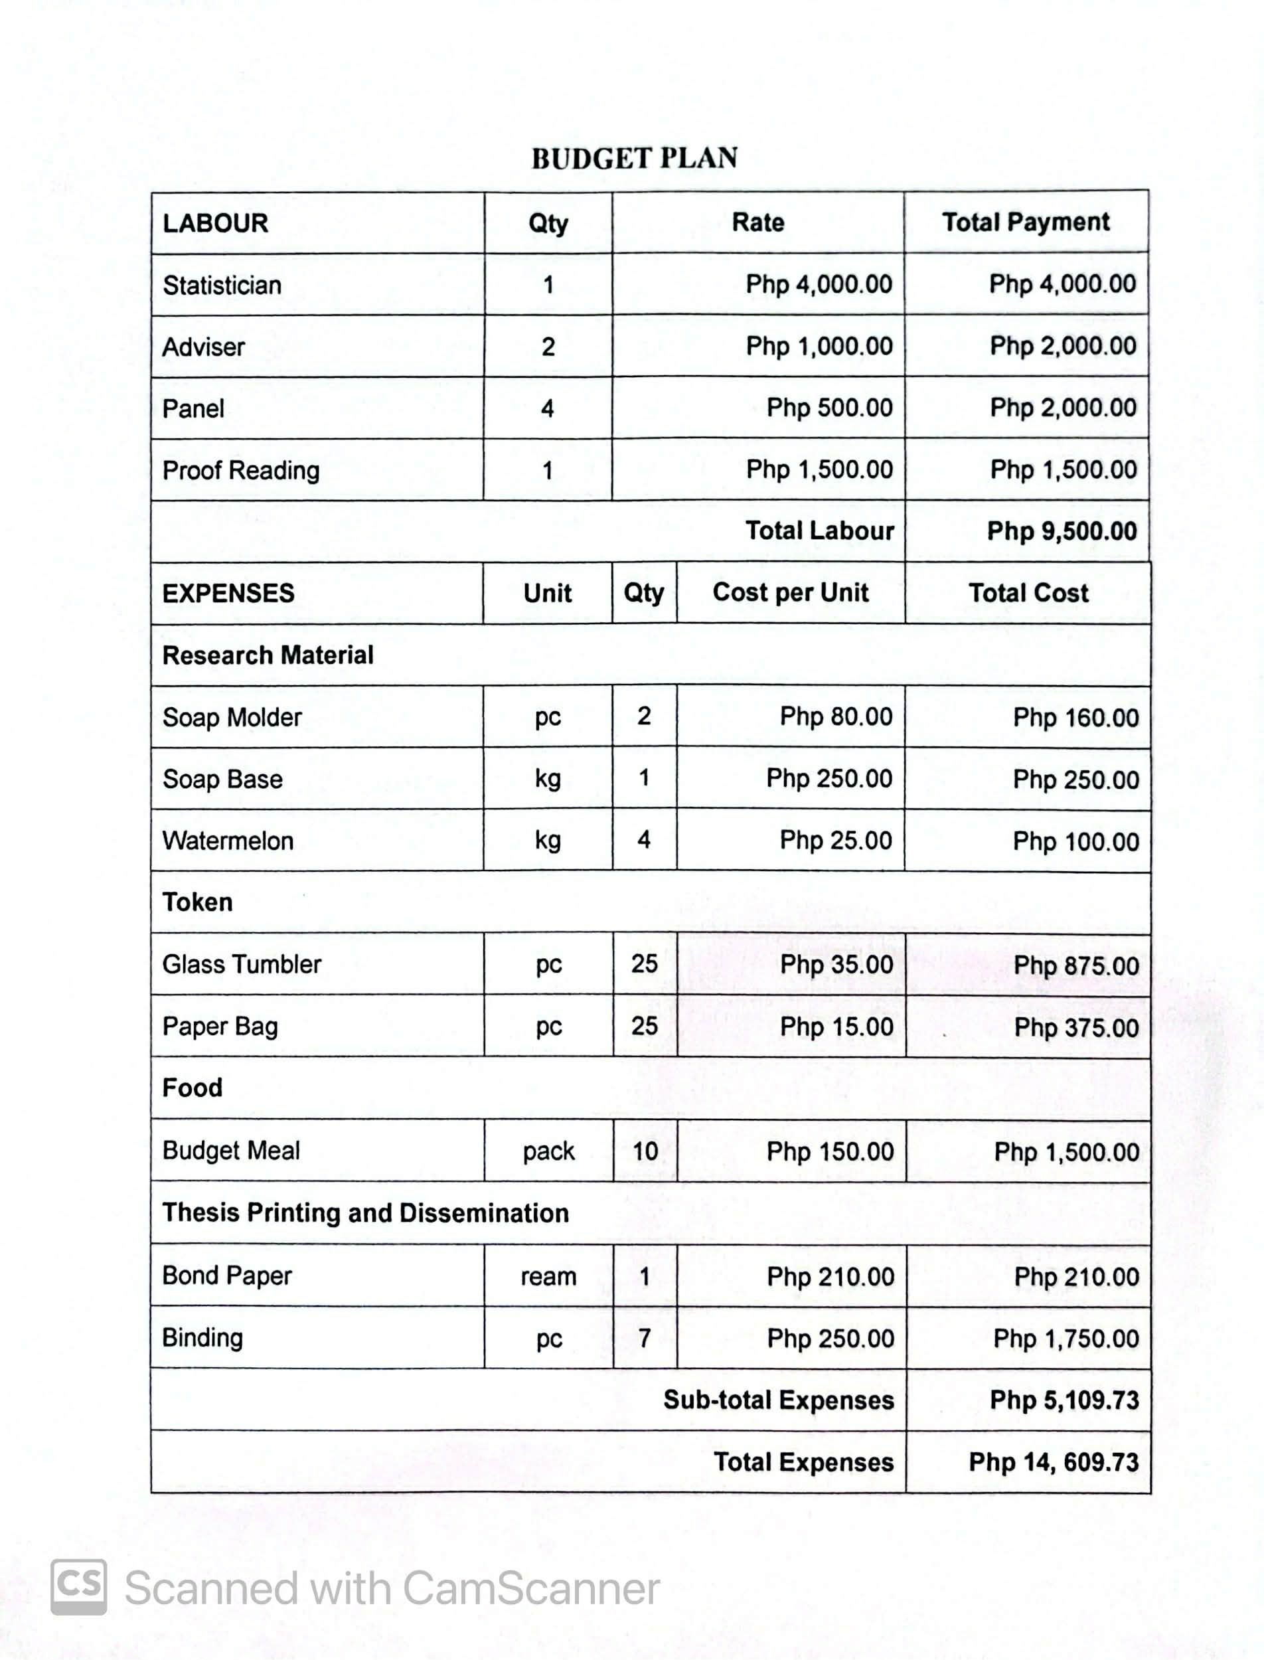

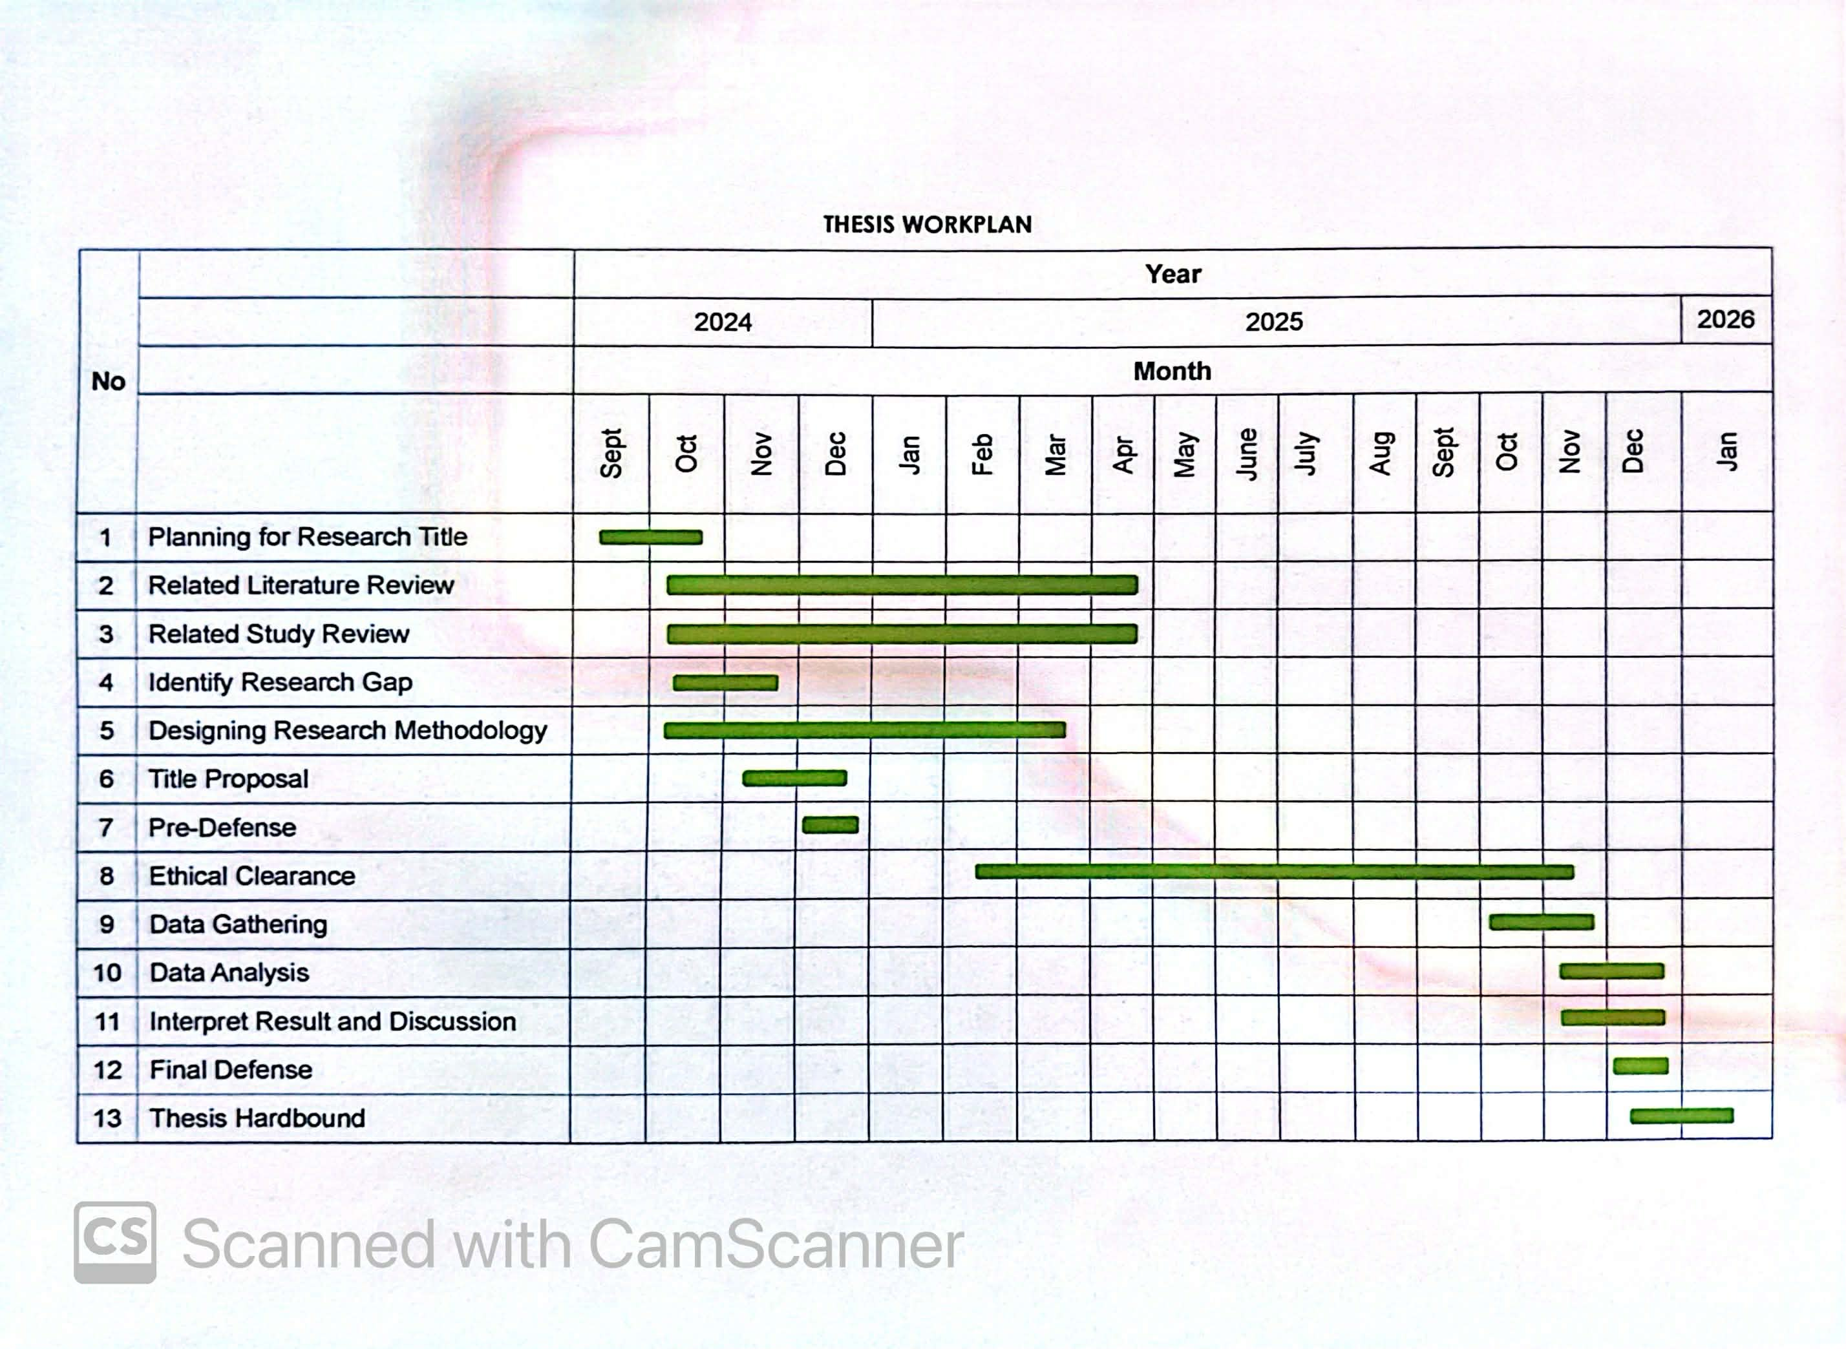
APPENDIX I
Work Plan Schedule

APPENDIX J
Consultation Log
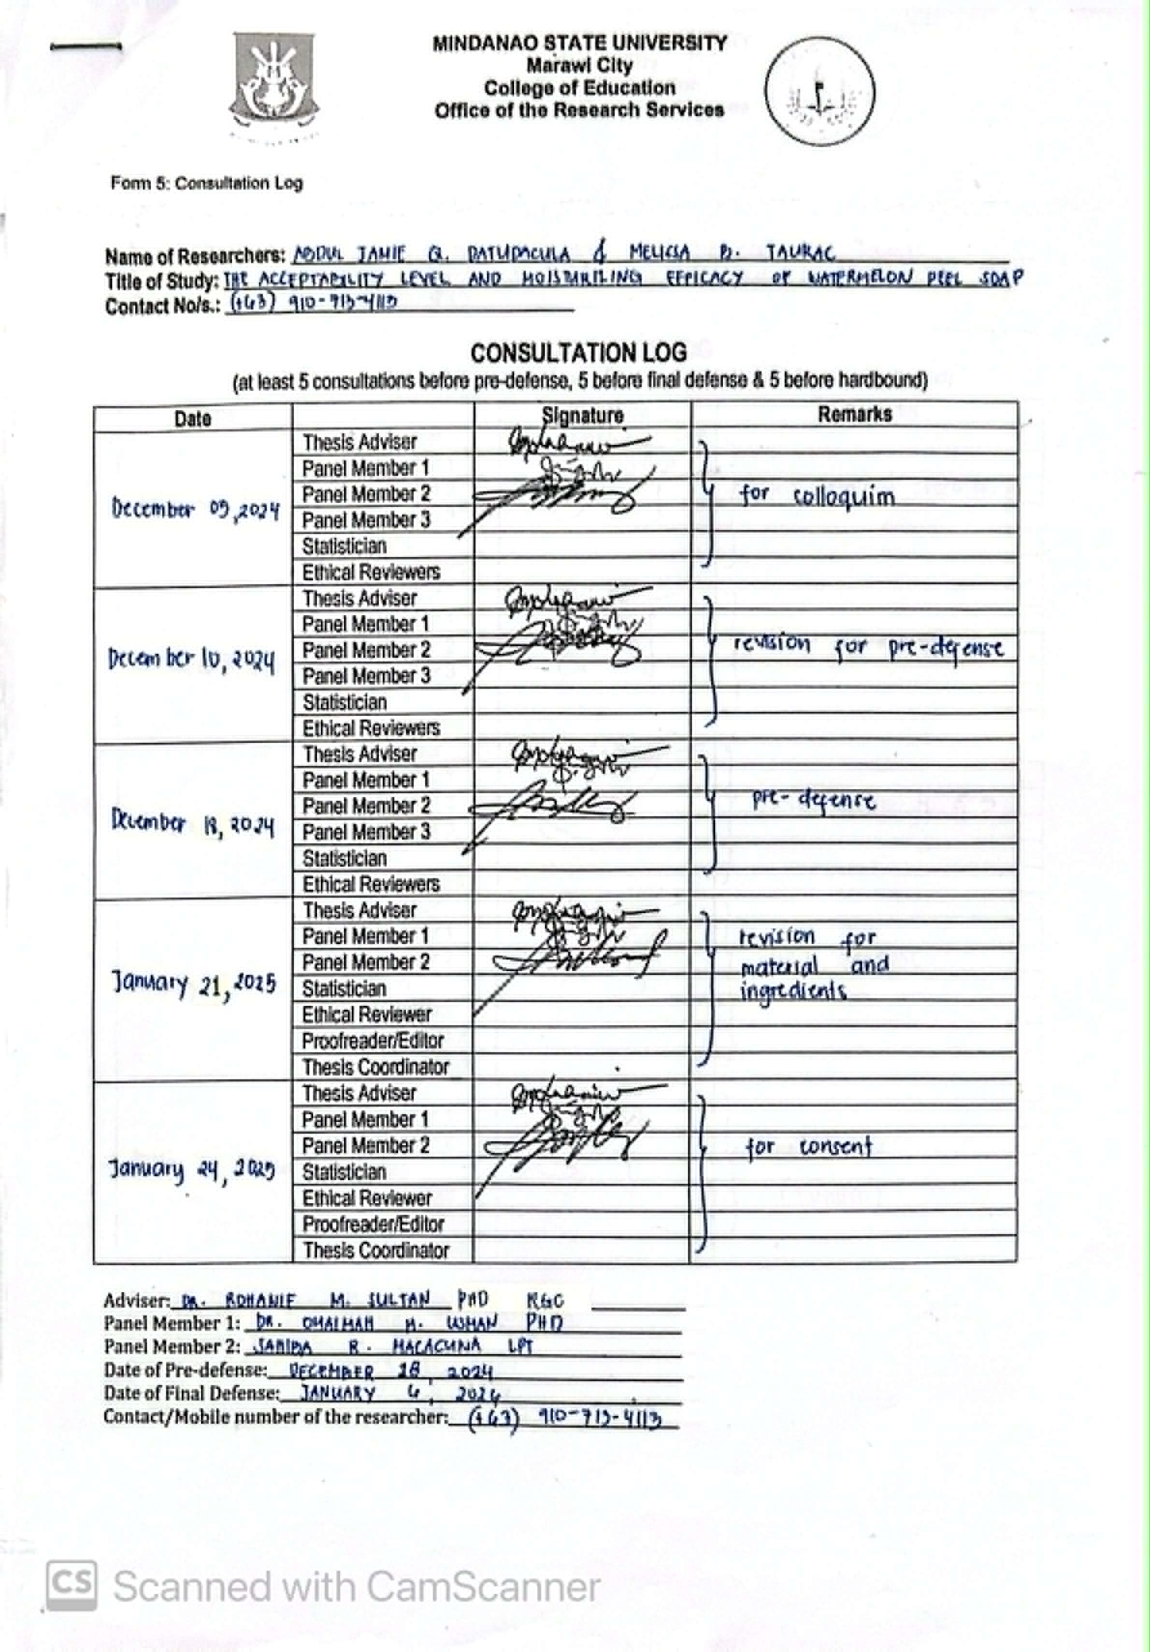

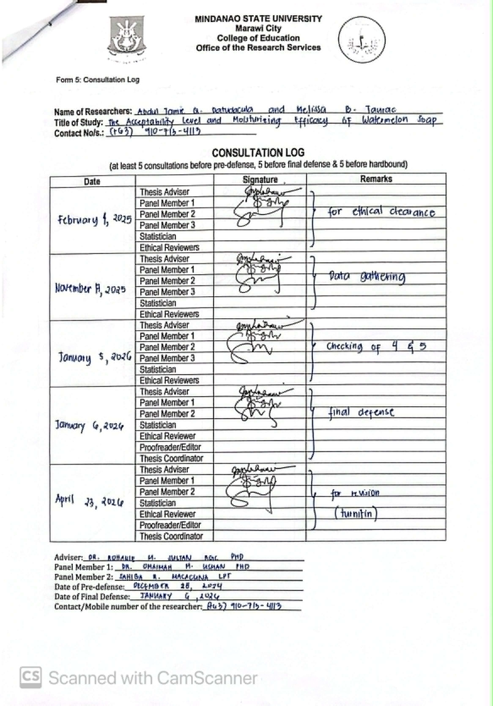

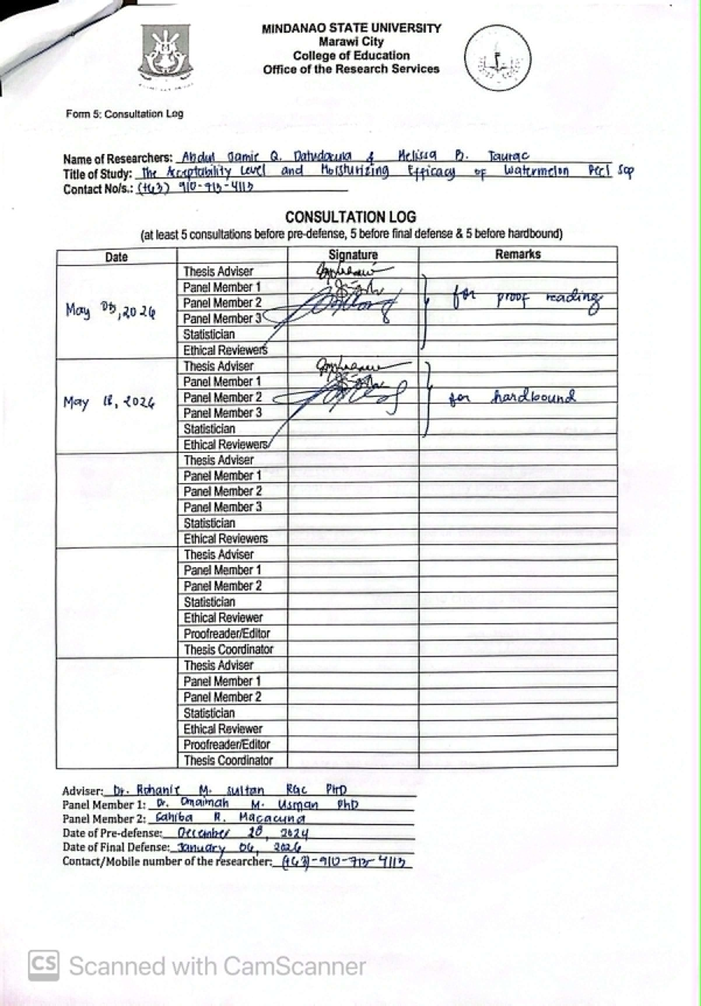

APPENDIX K
Originality Report

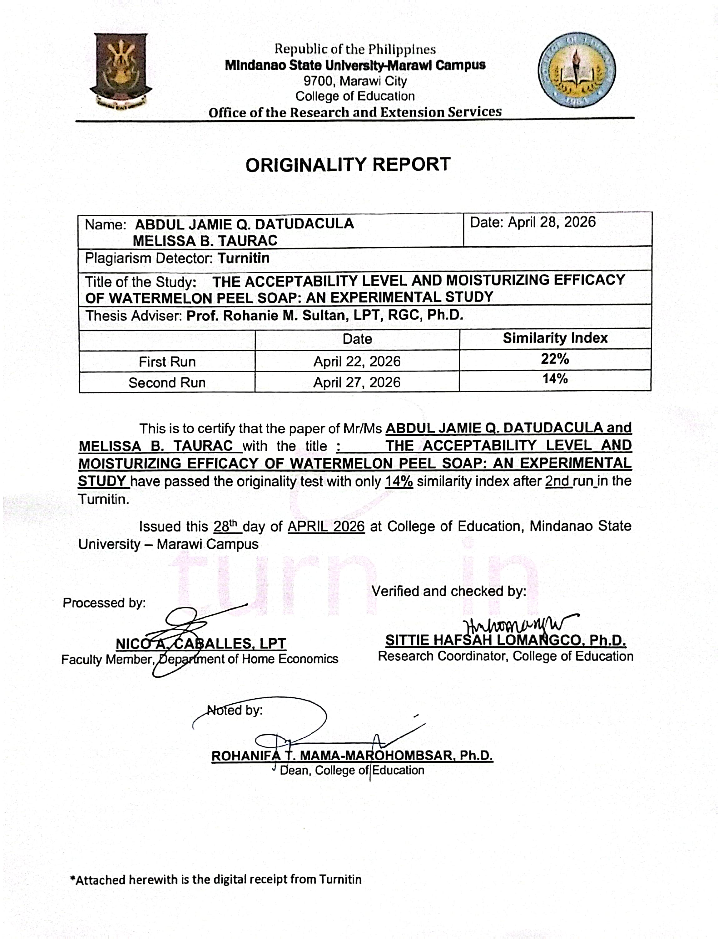

APPENDIX L
Turnitin Digital Receipt

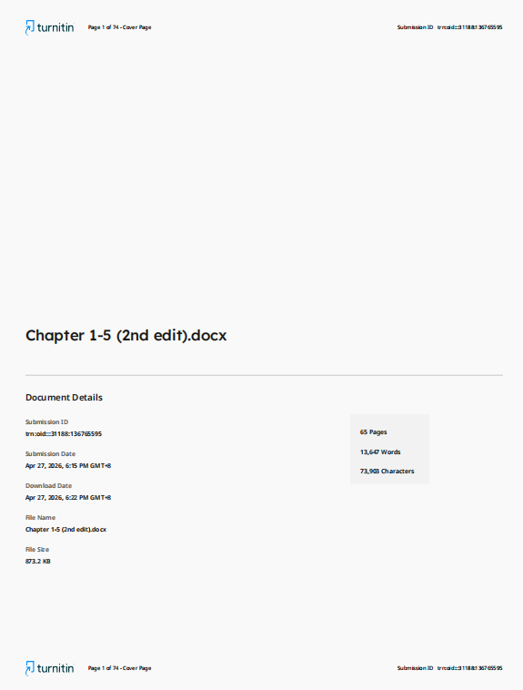

APPENDIX M
Certification of Proofreading

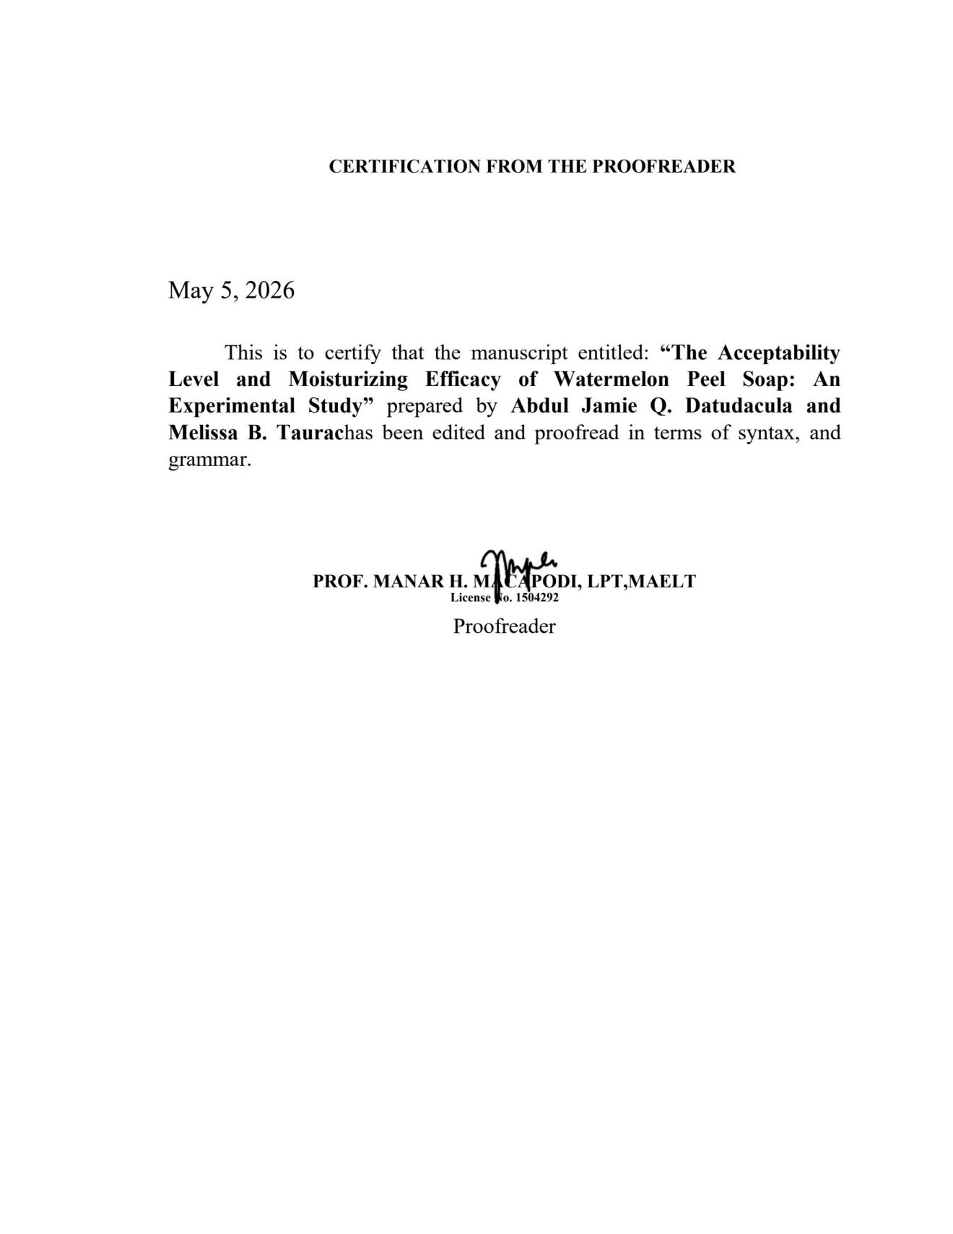

APPENDIX N
Certification of Validation of Instrument

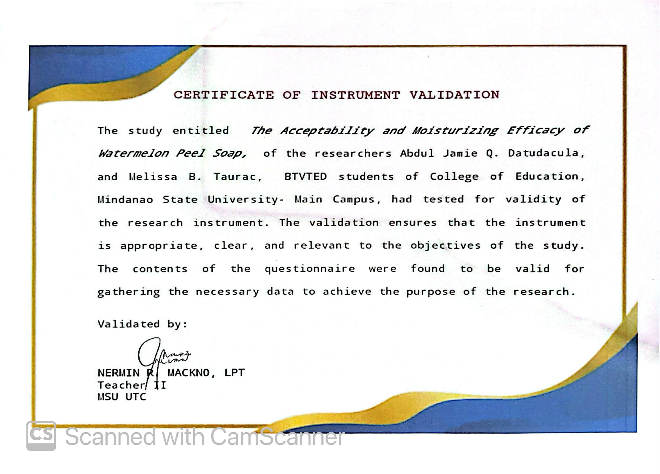

APPENDIX O
Documentation

Respondent 1
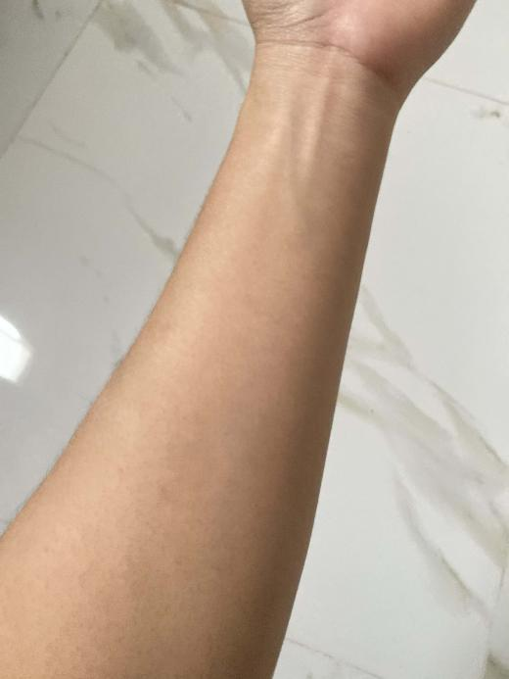 | 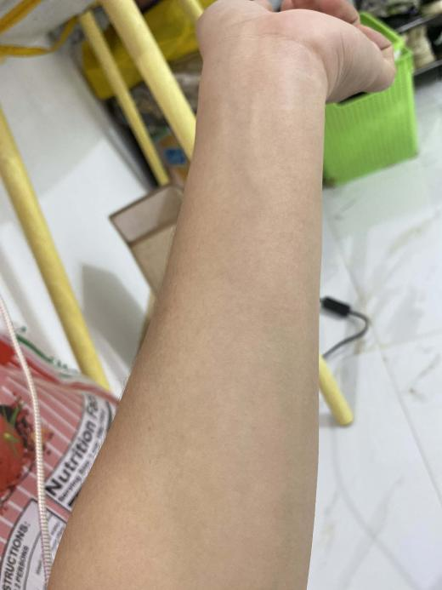
Before using soap | After using soap
Respondent 7
 | 
Before using soap | After using soap
Respondent 11
 | 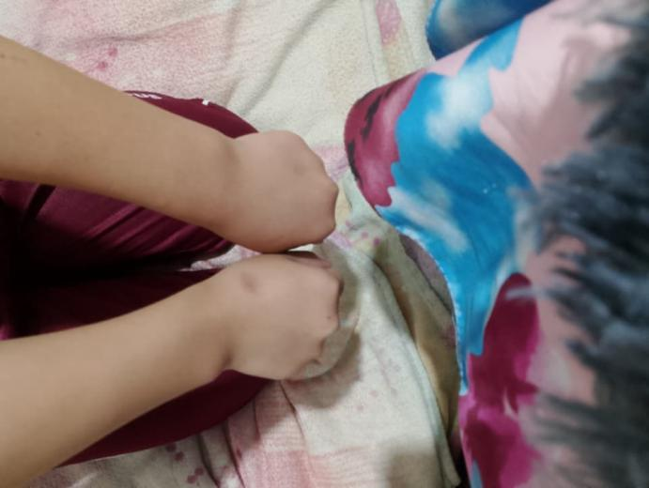
Before using soap | After using soap
Respondent 12
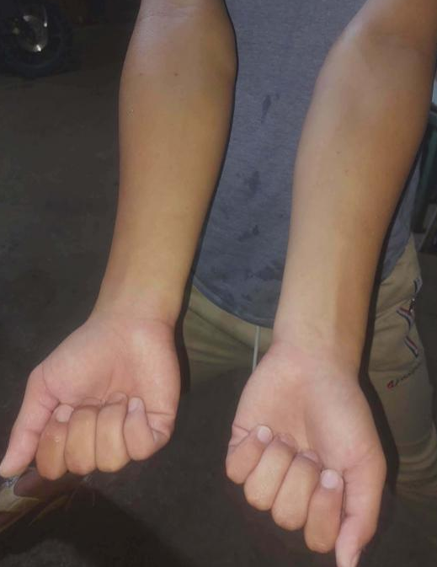 | 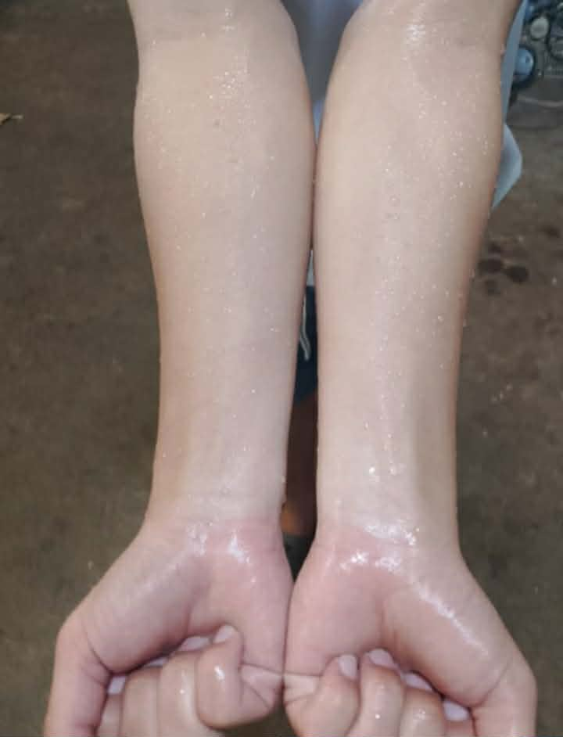
Before using soap | After using soap

Respondent 13
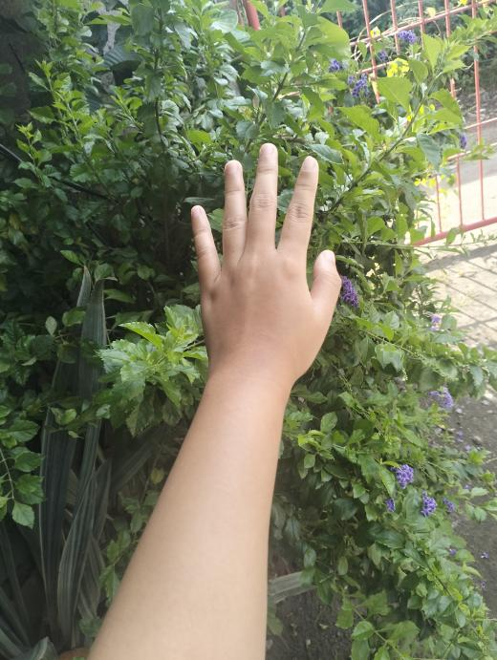 | 
Before using soap | After using soap

APPENDIX P
Curriculum Vitae

ABDUL JAMIE Q. DATUDACULA
Tuboc, 9300 Malabang, Lanao Del Sur, Philippines
Mobile Number: 0915-812-0718
Email Address: jamiedatudacula@gmail.com

PERSONAL BACKGROUND
Name: Abdul Jamie Q. Datudacula
Date of birth: June 4, 2004
Place of birth: Cotabato Regional Medical Hospital, Cotabato City
Age: 21
Citizenship: Filipino
Religion: Islam
Civil status: Single
Height: 5.9 feet
Weight: 57
Skills: Cooking, Public Speaking, Collaborator, Flexible, and Hardworking
Language spoken: English, Tagalog, and Meranao
Mother’s Name: Adjelina Quiano Datudacula
Father’s Name: Salahudin Boloto Datudacula

EDUCATION BACKGROUND

Elementary School: Jose Abad Santos Central Elementary School
Secondary High School: Our Lady of Peace High School
Achiever: Grade 8 Level, A.Y. 2017 – 2018
Achiever: Grade 10 Level, A.Y. 2019 - 2020
Senior High School: Our lady of Peace High School
Best Paper Presenter and Best Paper Awardee in Research entitled “The Effect of Inadequate Water Supply in Cabasaran, Malabang Lanao Del Sur”.
With Honors: Grade 12 Level, A.Y. 2021 - 2022
Tertiary / College: Mindanao State University – Main Campus,
Marawi City

WORK EXPERIENCE
Barangay Health Worker 2 months Encoder

JASCES Summer Class 1 week Lecturer
(2023-2024)

TES Substitute Teacher 1 week Lecturer
250hrs On-the-Job Training at Dietary Department, Amai Pakpak Medical Center
June-July 2025

25hrs On-the-Job Training at University Cafeteria, MSU-Marawi City
April 2025
(2024)

REFERENCES
NORALIE B. TEJANO, MAHE
Chairperson, Department of Home Economics, MSU-Marawi Campus
noralie.tejano@msumain.edu.ph
0909-283-0506

ROHANIE M. SULTAN, PhD RGC
Home Economics Faculty, College of Education, MSU-Marawi Campus
rohanie.sultan@msumain.edu.ph

NICO A. CABALLES, LPT
Home Economics Faculty, College of Education, MSU-Marawi Campus
nico.caballes@msumain.edu.ph

SEMINAR/TRAINING/WORKSHOP

National:
Participated in webinar entitled, "Pedagogical Brilliance: Exploring Dynamic Teaching Techniques for Academic Success" Given this 15th of December 2023, at EARIST Cavite Campus G.M.A, Cavite
Participated in the webinar entitled: "SPOTTING AND AVOIDING SCAMS: A GUIDE TO PROTECTING YOUR FINANCES" Given this 27th of November 2023 via Google Meet.
Participated in the webinar entitled, "MASTERING YOUR CRAFT: TECHNIQUES FOR ENHANCING SKILLS AND EXPERTISE IN TEACHING HOME ECONOMICS" Given this 9th of December 2023 at EARIST Cavite Campus, G.M.A., Cavite
Training on Optimizing Workflow through LEAN Management: An Overview conducted on December 07, 2023, at via Zoom Teleconference Issued on 07th day of December 2023 in Taguig City.
Participated in the webinar entitled "FUTURE READY” Embracing the Digital Transformation for Organizational" Given on November 10, 2023, at PUP Main Campus, Sta. Mesa, Manila, Philippines.

Leadership:
Participated in the topic of Resilient Leadership: Discussing How Leaders Can Develop and Demonstrate Resilience in the Face of Ongoing Uncertainty and Change with the theme: Leadership and Management Supercharged Conquering the Brittle, Anxious, Nonlinear, and Incomprehensible (BANI) Challenge Given this 18th day of November 2023 at Philippines Christian University
Participated in the topic of Strategic Management in the Post Pandemic Era with the theme: Leadership and Management Supercharged Conquering the Brittle, Anxious, Nonlinear, and Incomprehensible (BANI) Challenge, Given this 18th day of November 2023 at Philippines Christian University
Participated in the topic of FUTURE – READY LEADERSHIP with the theme: “Leadership and Management Supercharged Conquering the Brittle, Anxious, Nonlinear, and Incomprehensible (BANI) Challenge.”, Given this 18th day of November 2023 at Philippines Christian University
Participated in the topic of STRATEGIC LEADERSHIP IN A DIGITAL AGE: Harnessing Technology with the theme: “Leadership and Management Supercharged Conquering the Brittle, Anxious, Nonlinear, and Incomprehensible (BANI) Challenge.” Given this 18th day of November 2023 at Philippines Christian University.



MELISSA B. TAURAC
Purok 3, Cogon, Balingasag, Misamis Oriental
bunnymelissataurac@gmail.com
Mobile: (+63) 9107134113

Personal Information  Nickname:  Civil Status:  Gender:  Religion:  Ethnicity:  Citizenship:  Date of Birth:  Place of Birth:  Father’s Name:  Mother’s Name:  Siblings: | Ley  Single  Female  Islam  Bisaya/Meranao  Filipino  July 26, 2003  St. Nazareth, Cagayan De Oro City  Isah P. Taurac  Mila B. Taurac  Ismael B. Taurac  Samil B. Taurac  Ashley B. Taurac
Educational Background  Undergraduate:  Senior High School:  Junior High School:  Elementary: | Mindanao State University - Main Campus  College of Education  Bachelor of Technical-Vocational Teacher Education Major in Home Economics  2022 - Present  SHS in San Nicholas III, Bacoor Cavite  2020 - 2022  St. Peter’s College of Misamis Oriental Inc.  2016 - 2020  Cogon Elementary School  2012 - 2016
Eligibility & Certifications | National Certificate II Holder in Food and Beverages Service
Experience | 250hrs On-the-Job Training at Dietary Department, Amai Pakpak Medical Center  June-July 2025  25hrs On-the-Job Training at University Cafeteria, MSU-Marawi City  April 2025
References | NORALIE B. TEJANO, MAHE  Chairperson, Department of Home Economics, MSU-Marawi Campus  noralie.tejano@msumain.edu.ph  0909-283-0506  ROHANIE M. SULTAN, PhD RGC  Home Economics Faculty, College of Education, MSU-Marawi Campus  rohanie.sultan@msumain.edu.ph  NICO A. CABALLES, LPT  Home Economics Faculty, College of Education, MSU-Marawi Campus  nico.caballes@msumain.edu.ph  0981-134-3602

