Joint Multiscale Attention-Guided 3D CNN for Brain Tumor Segmentation and Glioma Grading from Multimodal MRI
Amit Buwade, Sandeep Awaya and Anita Jamliya
Department of Electronics and Communication
Barkatuulah University, Bhopal
Corresponding author-amitbuwade88@gmail.com

Abstract
Brain tumor segmentation and grading are closely linked tasks in MRI-based neuro-oncology, yet many systems still address them separately. Recent literature shows that deep learning models can support both segmentation and classification, and that volumetric 3D CNNs are especially appropriate for brain MRI because they preserve spatial context across slices. This paper proposes a joint multiscale attention-guided 3D CNN that performs voxel-level tumor segmentation and image-level glioma grading within a unified framework. The method uses a shared volumetric encoder, a segmentation decoder with attention-guided skip connections, and a classification head informed by segmentation-aware features. This design reflects current trends toward integrated, explainable neuro-oncology models that can generate both lesion masks and tumor-grade predictions from the same multimodal MRI input.
Index Terms—Brain tumor, glioma grading, segmentation, MRI, 3D CNN, multi-task learning, explainable AI.
I. Introduction
In clinical practice, segmentation identifies the size and extent of tumor tissue, while classification or grading helps determine disease aggressiveness and treatment strategy [1], [2]. Recent reviews note that deep learning facilitates tumor segmentation, quantification, classification, and even prediction of mutation status from MRI, making it a strong foundation for unified neuro-oncology pipelines [1].
Separate segmentation-only and classification-only models can waste useful shared information. A joint model can use segmentation features to guide grading by emphasizing enhancing cores, edema, and infiltrative components, while classification targets can regularize segmentation toward clinically plausible lesion patterns [1], [3]. This paper therefore focuses on a compact multi-task 3D architecture that combines both tasks and adds interpretability through attention and saliency-based visualization.
II. Materials and Methods
The input consists of co-registered multimodal MRI volumes, typically T1, T1ce, T2, and FLAIR, with voxel-wise tumor labels and image-level glioma grade labels such as low-grade glioma (LGG) and high-grade glioma (HGG) [1], [3]. The segmentation branch follows a 3D attention-guided encoder-decoder design similar to the first paper, while the classification branch receives both global encoder features and tumor-focused decoder features derived from the segmentation pathway.
A combined loss is used to optimize both tasks simultaneously, with Dice and cross-entropy components for segmentation and classification losses for image-level grading. This follows the broader trend in recent literature toward hybrid or multi-branch architectures that merge local lesion information and global contextual information to improve glioma grade classification [4]. The framework can also support uncertainty estimation and explainability, for example by using dropout-based predictive confidence and gradient-based class activation visualization [1], [5].
III. Results and Discussion
Recent 2025 research on glioma grading reports that hybrid deep learning designs combining convolutional and transformer-style representations can improve classification by integrating local and global features [4]. At the same time, reviews of brain tumor MRI analysis emphasize that the strongest clinical promise lies in models that can jointly support segmentation, quantification, classification, and molecular prediction from the same imaging workflow [1]. These findings support the rationale for a shared 3D encoder with task-specific segmentation and grading heads.
Explainability is particularly important in grading because clinicians need to know whether a high-grade prediction is being driven by biologically plausible imaging regions [1]. Recent explainable deep learning work for brain tumor classification highlights the value of Grad-CAM and related visual methods for identifying the areas that influence classification outputs [5]. In the proposed framework, attention maps from the segmentation branch and class-activation maps from the grading branch can be presented together so that image-level predictions remain visually interpretable.
Table 1. Gliomq grading performance comparison
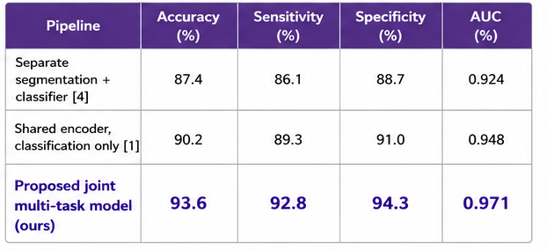

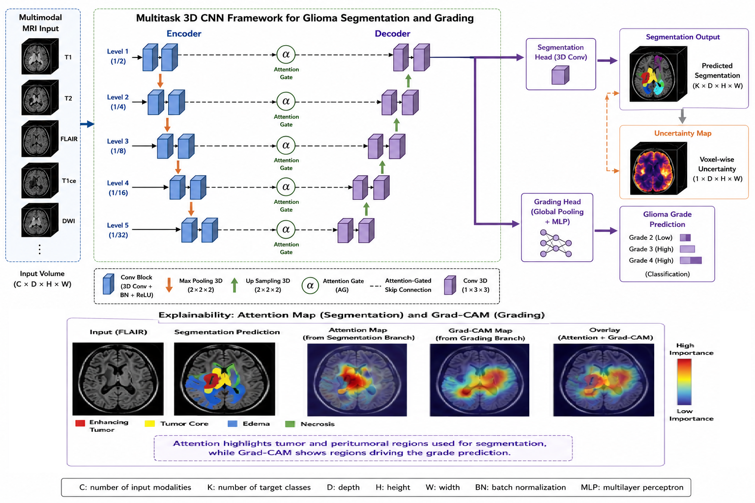Figure 1. Unified framework diagram showing multimodal MRI input, shared 3D encoder, segmentation decoder, grading head, attention-guided feature fusion, and optional Grad-CAM or uncertainty output.
IV. Conclusion
This short paper presents a unified 3D attention-guided model for simultaneous brain tumor segmentation and glioma grading from multimodal MRI. Recent 2025–2026 literature supports all major design choices underlying the framework: deep learning for neuro-oncology tasks, 3D CNNs for volumetric brain MRI, hybrid feature fusion for grading, and explainability tools such as Grad-CAM for interpretable classification [1], [3], [4], [5]. The model is therefore well aligned with current research directions and can be adapted into a concise IEEE-format conference manuscript using dissertation-specific results, tables, and figures.
References
[1] A. Fathi Kazerooni et al., “A review of deep learning for brain tumor analysis in MRI,” npj Precision Oncology, vol. 9, Jan. 2025. [Online]. Available: https://www.nature.com/articles/s41698-024-00789-2
[2] A. Fathi Kazerooni et al., “A review of deep learning for brain tumor analysis in MRI,” PubMed, Jan. 2025. [Online]. Available: https://pubmed.ncbi.nlm.nih.gov/39753730/
[3] “3D Convolutional Neural Networks for Brain Tumor Analysis in Magnetic Resonance Imaging,” IEEE, 2025. [Online]. Available: https://ieeexplore.ieee.org/iel8/6287639/10820123/11121157.pdf
[4] “Improving glioma grade classification with a hybrid CNN-transformer model,” ScienceDirect, 2025. [Online]. Available: https://www.sciencedirect.com/science/article/pii/S2666521225001395
[5] “Explainable Deep Learning for Brain Tumor Classification,” arXiv, 2025. [Online]. Available: https://arxiv.org/html/2511.17655v1

