FORMULATION AND EVALUATION OF HERBAL MOUTH ULCER GEL BY USING POLY-HERBAL DRUGS

1) Maurya Himanshu, 2) Shivam Mali, 3) Mrs. Kumari Priyanka
1) B Pharmacy student, 2) B Pharmacy student, 3) Assistant Professor
Department of Pharmaceutics
School of Pharmacy, Rai University, Ahmedabad, Gujarat, India

Abstract
The use of natural products in pharmaceutical formulation are gaining much attention because of its therapeutic benefit and less side effects. In this study, we aims to formulate and evaluate a gel based preparation containing black catechu extract for topical application. Black catechu contain various bioactive compounds such as phenolic, flavonoid and alkaloid, which exhibits antimicrobial activity and helps to combats oral bacteria.
Mouth ulcer, also known as aphthous ulcer, is common oral mucosa disorders that affects peoples worldwide. The conventional treatment option for mouth ulcer often involves synthetic medication which may causing several side effect. Therefore, the development of safe, effective and natural remedies is warranted. This study aims to formulate and evaluate a herbal mouth ulcer gel as an alternative therapeutic approach.
The formulation process involves selecting potent herbal ingredients known for their anti-inflammatory, antimicrobial and wound healing property. These ingredient includes extracts of black catechu, guava leaf, liquorice roots and peppermint oils, which was incorporated into gel base by using a suitable excipient. The formulated gel was subjected to various physicochemical evaluations to assess its consistency, pH value, viscosity level, spreadability and stability.
The results of the physicochemical evaluation demonstrated that the formulated herbal mouth ulcer gel show desirable properties such as not uniform consistency, inappropriate pH, optimal viscosities and good spreading ability.
Keywords: Black catechu, natural therapeutic benefit, minimal adverse effect, antimicrobial, anti-inflammatory, analgesic property.
- Introduction

1.1 Introduction to Mouth Ulcers and Herbal Management:
Mouth ulcers, or aphthous ulcers, are common disorders of the oral mucous membrane. They are characterized by painful lesions on the mouth's mucous membrane. These ulcers can be caused by various factors, including mechanical trauma, stress, hormonal changes, nutritional deficiencies, and microbial infections. While they are generally harmless, mouth ulcers can impact a person's quality of life due to pain, discomfort, and difficulty eating or speaking.
Traditional medicine systems, such as Ayurveda and Traditional Chinese medicine, have long used medicinal plants for various health conditions, including oral disorders. Black catechu is a well-documented botanical ingredient known for its therapeutic properties, derived from the heartwood of Acacia catechu. In traditional medicine, black catechu has been valued for its astringent, anti-inflammatory, antimicrobial, and wound-healing effects.
Black catechu is astringent due to its high tannin content, particularly catechin and epicatechin. These compounds precipitate proteins and contract tissue, forming a protective layer over the ulcerated mucosa. Additionally, black catechu has anti-inflammatory effects by inhibiting pro-inflammatory cytokines and enzymes involved in the inflammatory process, which helps reduce pain and swelling associated with mouth ulcers.
Black catechu also shows strong antimicrobial activity against a wide range of oral pathogens, including bacteria and fungi that often contribute to the development of mouth ulcers. By slowing down the growth and spread of these microorganisms, it helps prevent secondary infections and supports the natural healing of oral lesions more effectively.
Incorporating black catechu into a topical gel formulation offers several advantages for managing mouth ulcers. The gel base serves as an effective vehicle for delivering its active components directly to the affected area, ensuring longer contact time and better penetration into the ulcerated tissues. Moreover, the gel formulation allows for more convenient application, providing relief and promoting healing without the need for frequent doses.
Overall, this research aim to develops a safe, effective and natural remedy for treating mouth ulcers, giving a promising alternative to the conventional treatment option that are commonly used. The study’s findings may helps to facilitate the development of new herbal formulations for oral healthcare and give valuable insight into the therapeutic potentials of medicinal plants in managing different oral mucosal disorder.
1.2 Definition & Characteristics:
Black catechu, also known as Acacia catechu or Khadir, is a traditional medicinal plant widely valued in Ayurveda and other traditional healing systems for its therapeutic benefits. It has been especially used for managing various oral health problems, including mouth ulcers. Here's a definition and overview of the characteristics of black catechu concerning its application in the treatment of mouth ulcers. ^{[1,3]}

Definition:
Black catechu is deriving from the heartwood of Acacia catechu, which is a deciduous tree that are native to Southeast Asia and the Indian subcontinent. It is often called as “Khadir’’ in Ayurveda, and it is known for its astringent, antimicrobial, anti-inflammatory, and wound-healing properties. Black catechu is usually available in the form of powder, extract, or sometimes as a decocted preparation for many different medicinal use. ^{[1]}

Characteristics:
- Astringent Properties: Black catechu is containing a high amount of tannins, mainly catechin and epicatechin, which gives it strong astringent effects. These tannins helps in contracting the tissues and forming a protective layer over the ulcered mucosa. They also reducing inflammation, bleeding, and extra fluid that is usually seen in mouth ulcers.^{[3]}

- Antimicrobial Activity: Black catechu showing significant antimicrobial action against many oral pathogens, including bacteria and fungus that are involve in causing or worsening mouth ulcers. By stopping the growth and multiplication of these microorganisms, black catechu help to prevent secondary infection and support healing of the oral lesions.^{[3]}

- Anti-inflammatory Effects: The bioactive compounds inside black catechu have anti-inflammatory properties, which helps to reduce pain, swelling, and discomfort related with mouth ulcers. These compounds is inhibiting the production of pro-inflammatory mediators and enzymes, so the inflammatory response becomes lower and tissue repair can happening faster. ^{[2,3]}

- Wound-Healing Potential: Black catechu help to speed up the healing process of mouth ulcers by stimulating fibroblast growth, collagen making, and epithelialization. It also promoting the formation of granulation tissue and improving tissue remodeling, which lead to quicker recovery of the lesions.
- Topical Application: Black catechu can be applied topically as mouthwash, gargle, or gel for managing mouth ulcers. Its application gives relief from symptoms, reducing pain and inflammation, and supporting the natural healing of oral tissues.^{[2]}
Overall, black catechu is valuing for its multi-action therapeutic effects, making it a promising natural remedy for treating mouth ulcers. Its astringent, antimicrobial, anti-inflammatory, wound-healing, and hemostatic properties all contributing to its effectiveness with minimal side effects.

1.3 Types of Mouth Ulcer:
Mouth ulcers are categorized as Major, Minor, or Herpetiform based on the size and number of ulcers. ^{[6]} The following are the most common forms of mouth ulcers:

- Minor ulcers: Minor aphthous ulcers is the most common type, making almost 80% of all the cases. They are usually around 2–8 mm in size and mostly get cleared within 10 days to 2 weeks, but sometimes healing may feels slower. These ulcers are quite superficial and small (mostly less than 1 cm), and they appear either single or in small groups. They usually heal on their own and not leaving any scar afterward. ^{[7]} [Fig 1]
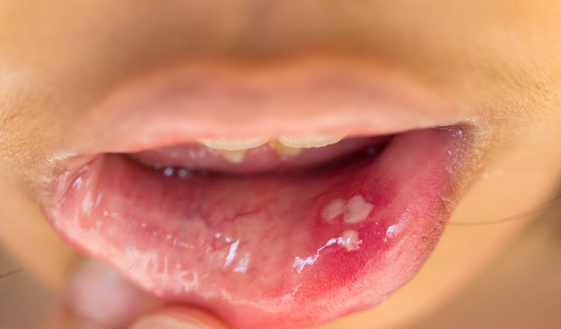
Figure 1: Minor Ulcer

- Major ulcers: Major aphthous ulcers are the type that comes much bigger in size, usually more than 5–10 mm, and they are mostly more painful compared to the minor ones. These ulcers not heal quickly; instead, they can stay for many weeks or even some months before getting better. Because they goes deeper into the tissue, they often leaving behind a scar after healing. [Fig 2]
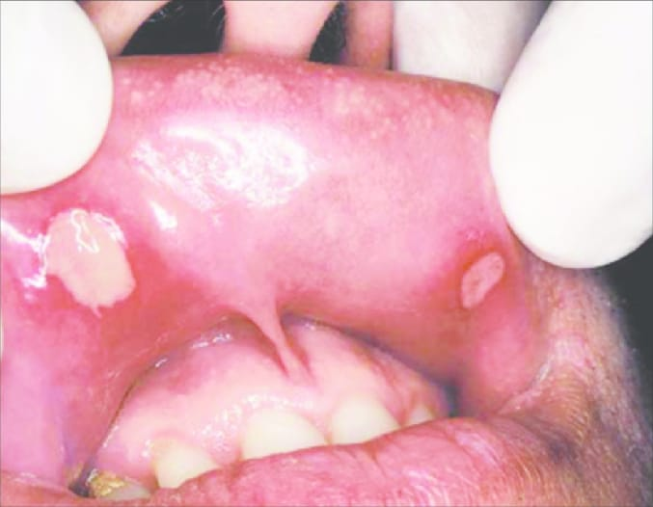
Figure 2: Major Ulcer

- Herpetiform ulcers: Herpetiform ulcers, the third category, is term that refer to the clustered appearance of lesions. This ulcer consist of a cluster of dozens of tiny lesion the size of pinheads. It have nothing to do with the herpes viruses. These appears in enormous numbers, ranging from 10 to 100 at a time, and are made up of several tiny lesion that eventually join to forms larger plaques. They may heals with a scar in 7 to 30 days depend on the size and depth of the ulcer. ^{[7,8]} [Fig 3]
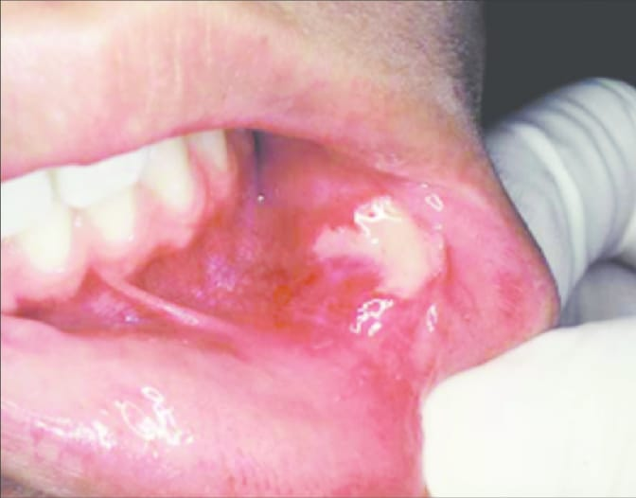
Figure 3: Herpetiform Ulcer

1.4 Local causes of Ulceration:
Chemical burns, heat, ice or ionizing energy burns, or factitious ulceration of the maxillary group includes, can appears at any ages. Ulceration can appears at any age due to trauma, hard meals or equipments. The lingual fraenum can be damages by brushing the lowest incisors repeatedly as in cunnilingus, or by persistent coughs as in rapid cough, or by self mutilation. After receiving a dental local anesthetic, childrens may bites their lower lip, resulting in ulcerations. Non-accidental injury can manifests as ulcers of the higher labial fraenum, particularly in a youngster with slightly swollen lips, subluxed dentition or a fractured jaws. ^{[9]} [Fig 4]

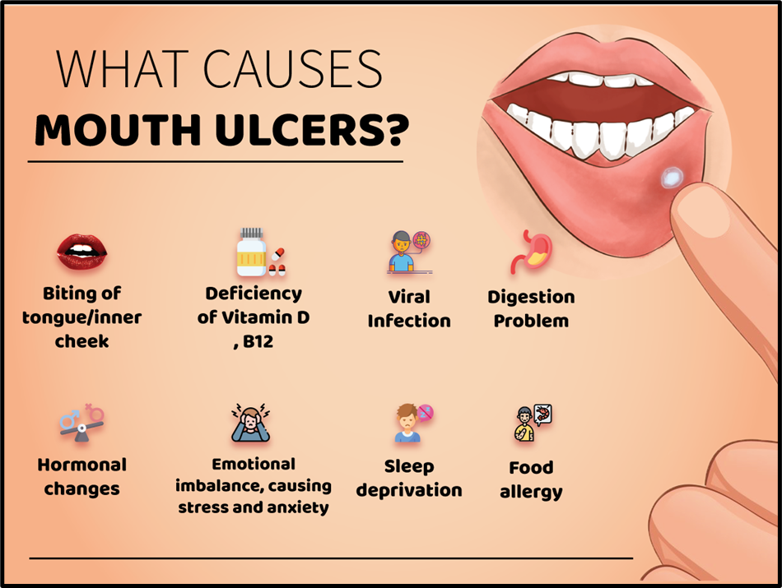
Figure 4: Causes of Ulcer

1.5 Uses of Black Catechu Gel:
The use of black catechu herbal mouth ulcer gel can offer several benefits in the management of mouth ulcers. Here's how black catechu gel can be utilized effectively:

- Symptomatic Relief: When black catechu gel is applying directly on the ulcer area, it is giving almost instant relief from the pain, irritation, and discomfort that comes with mouth ulcers. Because of its strong astringent nature, the gel helps for soothing the damaged mucosa and reducing the pain and inflammation very fastly. ^{[4]}

- Promotion of Healing: Black catechu gel is helping the ulcer to heal more faster by making a kind of protective coating on the wound. This layer is supporting the tissue repair and speeding up the natural healing process. ^{[2]}

- Reduction of Swelling and Inflammation: The anti-inflammatory compounds in black catechu is helping to reduce the swelling and redness around the ulcer. This is giving a sense of comfort and letting the healing process happening more easier. ^{[2]}

- Control of Bleeding: Because black catechu have hemostatic properties, the gel can helps for stopping small bleeding that sometimes happening with mouth ulcers. By forming a protective layer, it is supporting clot formation and reducing the chances of extra bleeding. ^{[5]}

- Convenient Application: The gel form are very easy for apply and can be put exactly on the affected area. It is sticking well to the mouth lining, so it stays there for longer time and giving better therapeutic effect. ^{[2,3]}

- Natural and Safe: Black catechu is a natural herbal substance with long traditional uses, and it is generally being consider safe. Using a herbal mouth ulcer gel made with black catechu gives a safer option compared to many synthetic medicines, with less chances for side effects. ^{[4,5]}

- Literature Review
SR.NO | TOPICS | AUTHORS | JOURNALS | REVIEW
1. | Treatment of mouth ulcer by curcumin loaded  thermoreversible mucoadhesive gel | Y. S. Thorat,  A. M. Sarvagod.  S. V. Kulkarni.  A. H. Hosmani. | International Journal of Pharmacy and Pharmaceutical Science. | Mouth ulcers are quite common, but most available treatments don’t give lasting relief. In this study, researchers created a curcumin-based gel that turns into a gel at body temperature and sticks well to the mouth’s lining. It stayed in place, released the drug steadily for about 4 hours, and showed promise as a better option for treating mouth ulcers. ^{[1]}
2. | A Medicinal Extract of Scutellaria baicalensis and Acacia catechu Acts as a Dual Inhibitor of Cyclooxygenase and 5-Lipoxygenase to Reduce Inflammation | Burnett, B. P.,  Jia, Q.,  Zhao, Y.,  Levy, R. M. | Journal of Medicinal Food | A combination of baicalin and catechin was found to block both COX and LOX enzymes, which are key players in inflammation. The extract reduced prostaglandin and leukotriene production in human cell models and showed strong anti-inflammatory effects in mice. ^{[30]}
3. | Antioxidant, Anti-inflammatory, and Chemoprotective Properties of Acacia catechu Heartwood Extracts | Sidney J. Stohs.  Debasis Bagchi. | Phytotherapy Research | Acacia catechu heartwood extract contains strong antioxidant compounds like catechin and epicatechin which helps in anti-inflammatory, protective and pain relieving effect. It also reduces oxidative stress and support healing process. ^{[25]}
4. | Therapeutic benefits of liquorice in dentistry | Preena sidhu,  Swapnil shankargouda,  Avita Rath,  Priyadarshni H.  Ramamurthy. | Journal of Ayurveda and Integrative Medicine | This paper highlight how liquorice, a traditional herbal remedy, hold strong promises in modern dentistry. It rich in bioactive compound and show potential against oral problem like cavity, gums disease, ulcer and even oral cancers. ^{[31]}
5. | Formulation and Evaluation of Polyherbal Aqueous Gel from Psidium guajava, Piper betel and Glycerrhiza glabra Extract for Mouth Ulcer Treatment | Nem kumar Jain,  Rituparna Roy,  Hero Khan Pathan,  Aditi Sharma. | Journal of Pharmacognosy and Phytochemistry. | This project develop a herbal gel for mouth ulcer using guava leaf, betel leaf and liquorice extract. The gel was smooth, transparant and have skin friendly pH with good spreadbility. It shows strong antifungal activities against common oral pathogen. ^{[2]}
6. | Formulation and evaluation of herbal gel using guava leaves for mouth ulcer | Shaikh S.,  Shete A.,  Doijad R. | International Journal of Pharmaceutical Research | This study aim to prepare and evaluate a herbal gel using guava leaves powder for mouth ulcer treatment. The gel was clear, smooth and shows good pH, consistency and spreadability. It also show antifungal and antioxidant activity due to presence of flavonoids. Overall, the formulation was stable, safe and more effective than synthetic products. ^{[4]}
7. | Recurrent aphthous stomatitis: A review | Edgar N. R.,  Saleh D.,  Miller R. A. | Journal of Clinical and Aesthetic Dermatology | Mouth ulcers also called recurrent aphthous stomatitis is a common condition which causes pain and discomfort in oral cavity. This review explains different causes like stress, minor trauma, and nutritional deficiency. It also describe various treatment options including topical drugs and supportive care which help in reducing pain and healing time. Some natural and supportive methods are also considered helpful for managing symptoms. ^{[10]}
8. | In vitro antimicrobial activity of Acacia catechu | Negi B. S.,  Dave B. P. | Indian Journal of Microbiology | This study show that Acacia catechu extract have strong antimicrobial activity against different bacteria and fungi. It is effective against both gram positive and gram negative microorganism, which help in reducing infection in mouth ulcers and support faster healing. ^{[11]}
9. | Anti-inflammatory and wound healing properties of catechin | Middleton E., Kandaswami C., Theoharides T. C. | Pharmacological Reviews | Catechin which is main component of Acacia catechu shows good anti-inflammatory effect by inhibiting inflammatory mediators. It also help in wound healing by improving tissue repair, so it can be useful in treatment of oral ulcers. ^{[24]}
10. | Role of tannins in mucosal protection and ulcer healing | Scalbert A. | Phytochemistry | Tannins present in plants like Acacia catechu have astringent property which forms protective layer over mucosa. This helps in reducing irritation and also prevent microbial infection, so healing of ulcers become faster. ^{[26]}

- Aim & Objectives

3.1 AIM :
The main aim of this study is to prepare a herbal gel for mouth ulcer by using black catechu as main ingredient. This gel is expected to reduce pain, swelling and discomfort caused by mouth ulcers and also help in faster healing of affected area.

3.2 OBJECTIVES :

1. Selection of Excipients: To choose suitable excipients which is compatible with black catechu and help to improve the stability and overall quality of gel.
2. Preparation of Herbal Gel: To prepare a herbal mouth ulcer gel using black catechu along with other required ingredients, so that it shows good consistency and can be easily applied on affected area.
3. Evaluation of Properties: To check different properties of prepared gel like pH, consistency, viscosity, spreadability and appearance.
4. Antimicrobial Study: To evaluate the antimicrobial activity of gel against common microorganisms present in oral infection.
5. Stability Study: To study the stability of prepared gel under different storage condition and check whether it remain stable or not.
6. User Acceptability: To observe the ease of use, texture and overall acceptability of the gel by users.

- Phytochemical Profile

4.1 Active Ingredients :
4.1.1 Black Catechu:
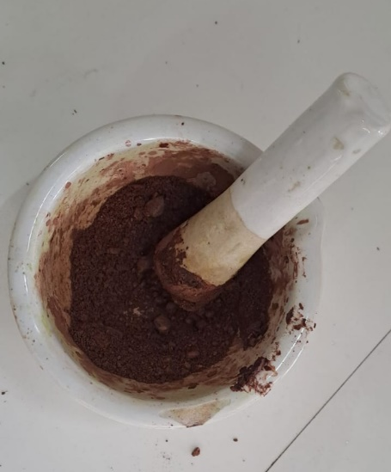
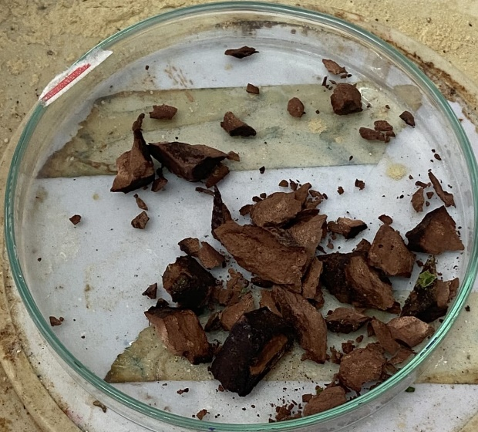
Figure 5: Black Catechu

Table 1: Scientific Classification of Black catechu
Botanical name: | Senegalia catechu
Family: | Fabaceae
Synonyms: | Catechu, Kher, Khadira, Katha
Part which are used: | Root

Chemical Constituents of Black Catechu:
- Catechins: Black catechu is rich with catechin, specially epicatechin and catechine. This polyphenolic compounds is very strong antioxidant and also shows antiinflammatory, antimicrobial and anticancer properties. They mostly contribute for giving the astringent and antioxidant effect in black catechu. ^{[12]}
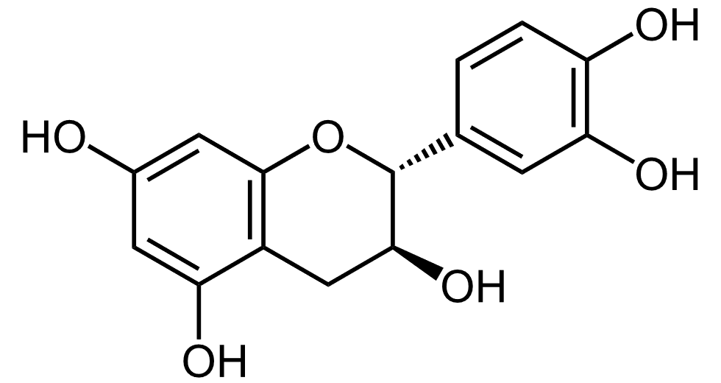
Figure 6: Catechin Chemical Structure
- Tannins: Black catechu have high level of condensed tannins, also called proanthocyanidin. These tannin is mainly responsible for astringent nature which helps in tightening tissue, reducing inflammation and help in fast wound healing. ^{[12]}
- Flavonoids: Black catechu having many type of flavonoid such as quercetin, kaempferol and rutin. The flavonoids have antioxidant and anti inflammatory activities which adding more to the therapeutic effect of black catechu. ^{[13]}
- Phenolic Acids: It also having phenolic acids like galic acid and ellagic acid. This compound shows antioxidant, antimicrobial and antiinflamatory activity which support medicinal importance of black catechu. ^{[12]}
- Alkaloids: Black catechu contains small quantity of alkaloids include catechine, epicatechine and betain. This alkaloids may helps in pharmacological action of black catechu but their exact role is not clear properly till now.
Uses:
- Black catechu are often used in oral care product like mouthwash, toothpastes and dental powder because of it’s astringent and antimicrobial property. ^{[11]}
- It help to relief pain, swellings and discomfort in mouth or other area. ^{[11]}
- Black catechu showing anti inflammatory properties and used for reducing inflammation in condition like arthiritis, gouts and skin disorder which are inflammatory in nature.

4.1.2 Peppermint Oil:

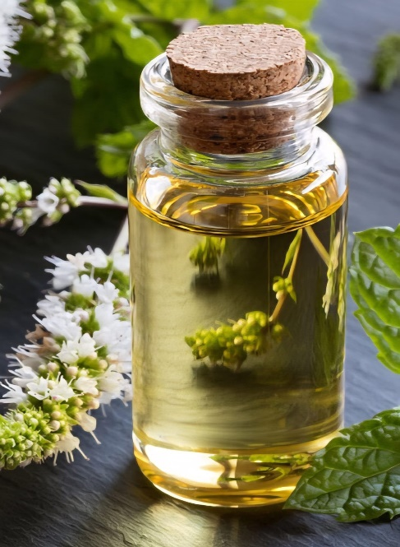
Table 2: Scientific Classification of Peppermint
Botanical name: | Mentha piperita L.
Family: | Lamiaceae
Synonyms: | Balm mint
Part which are used: | Leaves
Figure 7: peppermint oil

Constituent of Peppermint oil:
- Menthol: Menthol is one of the main constituents that is find in peppermint oil, and it basically the thing that gives the cooling feeling and the normal mint-like smell. It have mild analgesic effect and is often using for relieving small aches and pain, and also for soothe different kinds of respiratory discomforts, even though it doesn’t works the same for everyone. ^{[14]}
- Menthone: Menthone is another major compound that are present in peppermint oil, which contribute to its minty taste and aroma. It also have some antimicrobial property and may helps in stopping the growth of certain bacteria and fungus, but the effect is not always working consistent.
- Menthyl Acetate: Menthyl acetate is contributing to the overall fragrance of peppermint oil and shows a slightly fruity aroma. It also showing mild analgesic effects and may be contributing to the oil’s pain-relieving action.

Uses:
- Menthol is one of the major constituent of peppermint oil and it is responsible for giving the cooling and analgesic effect. ^{[15]}
- It is activating the cold receptors on the skin and mucous membrane, which produces a cooling feeling and giving temporary relief from the pain. ^{[15]}
- Menthone is also another significant compound that are present in peppermint oil. It is contributing to the minty aroma and the flavour of the oil.

4.1.3 Guava leaves:
Guava leaves are known for their potent antioxidant properties, which can be attributed to the presence of various phytochemicals. ^{[16]} [Fig 8]
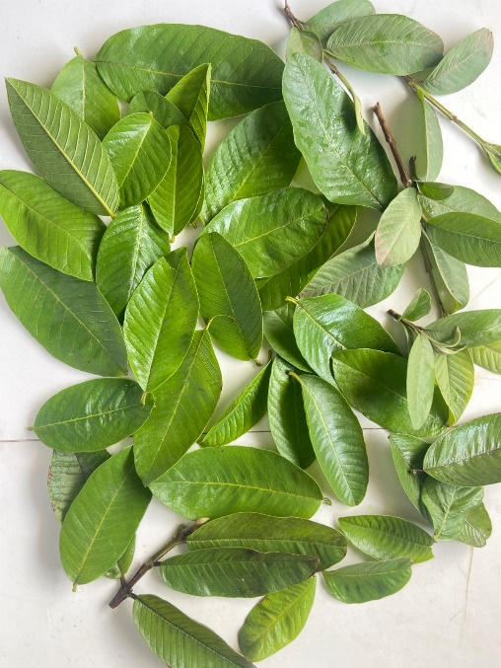
Figure 8: Guava leaves

Table 3: Scientific Classification of Guava
Botanical name: | Psidium guajava L.
Family: | Myrtaceae
Synonyms: | True guava
Part which are used: | Leaves

Constituents of Guava leaves: ^{[17,18]}
- Phenolic Compounds
- Flavonoids
- Tannins
- Essential Oils
- Vitamins and Minerals

Uses:
- Guava leaves is having strong astringent action because of the tannins, which helps to reducing the diarrhea and soothe the GI tract.
- Flavonoids and phenolic compounds is giving guava leaves some antimicrobial activity against many pathogens. ^{[19]}
- Their antimicrobial and anti-inflammatory effects was helping to reduce the plaque, preventing gum diseases, and also lowering the oral inflammations.
- The astringent and antimicrobial properties makes it supporting faster wound healing, reducing the inflammation, and preventing the infections. ^{[19]}

4.1.4 Liquorice root:
Liquorice (Glycyrrhiza glabra L.) oil is obtained from a perennial plant and is widely used as a natural sweetener and flavoring agent. ^{[19]} [Fig 9]
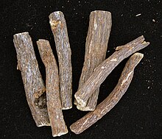

Figure 9: Liquorice root

Table 4: Scientific Classification of Liquorice
Botanical name: | Glycyrrhiza glabra
Family: | Fabaceae
Synonyms: | sweet root
Part which are used: | Root

Constituents of liquorice: ^{[20]}
- Glycyrrhizin (Glycyrrhizic Acid)
- Flavonoids
- Saponins
- Polysaccharides
- Volatile Oils
- Glycosides

Uses:
- Liquorice root is commonly using to soothe heartburn, indigestion and gastritis. It have demulcent property that helps coating the stomach lining and reducing irritation. ^{[20]}
- It is having antimicrobial effects that helps stopping the growth of mouth bacterias. It may using in natural toothpaste or mouthwash for reducing cavity and gum problems. ^{[21]}
- Liquorice root have strong anti-inflammatory action that helping to reduce many body inflammations. It may be use on skin for soothing irritations or taken for arthritis symptoms.
- It is having immune-modulating properties that helps strengthening the body defence. It may using in cold season or for supporting faster recovery from illness. ^{[21]}

4.2 EXCIPIENTS:

Carbopol 934:
- Carbopol 934 is a commonly used pharmaceutical-grade polymer that are using as a gelling agent and thickener in many topical formulations, including gels.
- It help in creating a smooth and more homogenous gel matrix, which allow the uniform distribution of other active ingredients and make the application easier on the target area. ^{[22]}
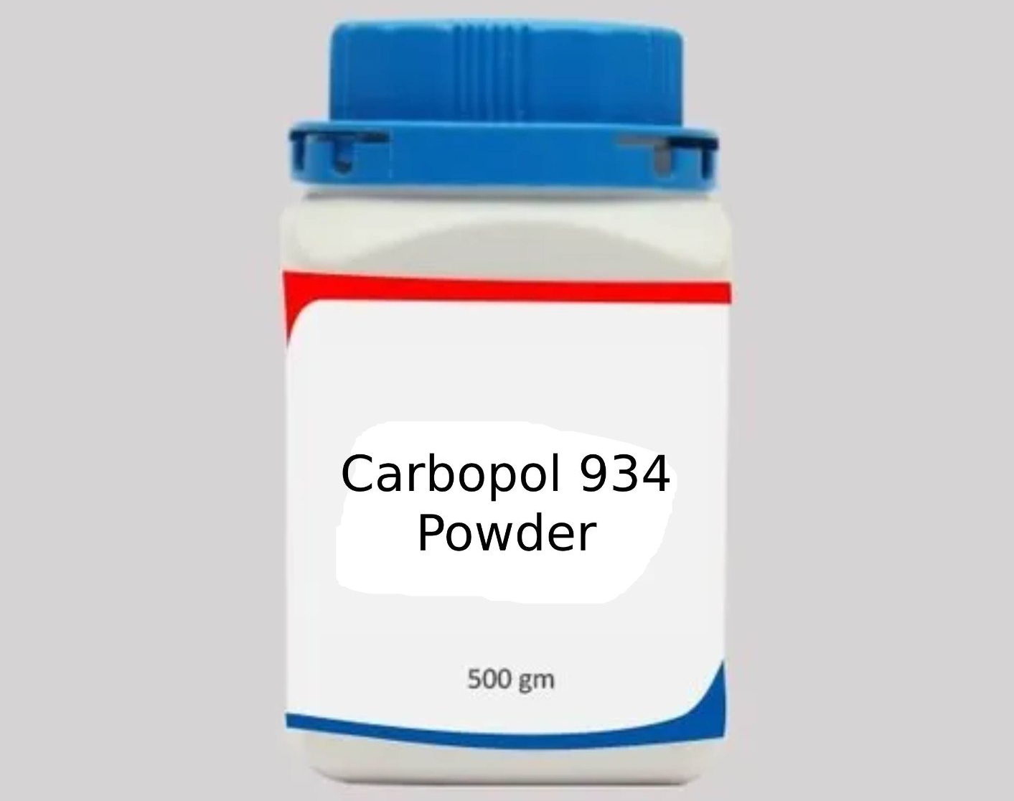
Figure 10: Carbopol 934

Sodium bicarbonate :
• Sodium bicarbonate is mainly used for pH adjustment and neutralization purpose in gel formulation. ^{[22]}
• It is a white crystalline powder and easily soluble in water.
• Since gel formulations needs a proper pH for stability and also for compatibility with oral mucosa, sodium bicarbonate is added to maintain the pH within suitable range. ^{[22]}
• It also shows mild soothing effect which can help in reducing irritation in mouth ulcer.
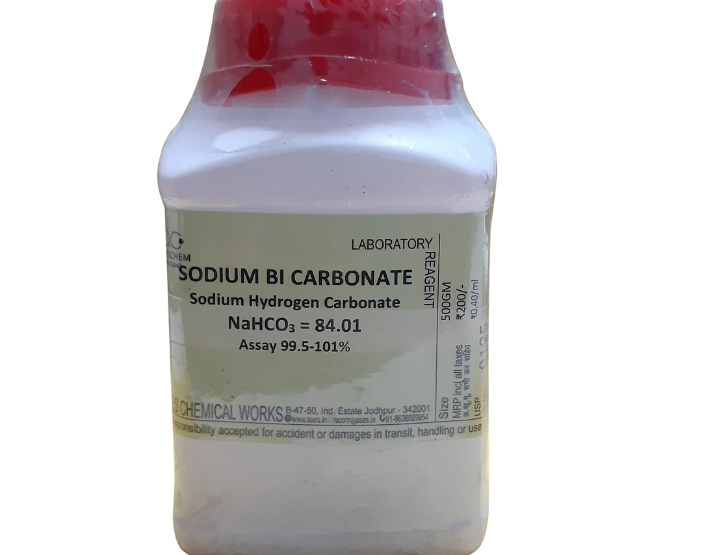
Figure 11: Sodium bicarbonate

Methyl paraben:
- It belongs to the class of parabens that is commonly using as a preservative.
- It helps for extending the shelf life of the product by stopping the growth of spoilage-causing microorganisms, though the effect sometimes not remain same in every condition. ^{[23,29]}
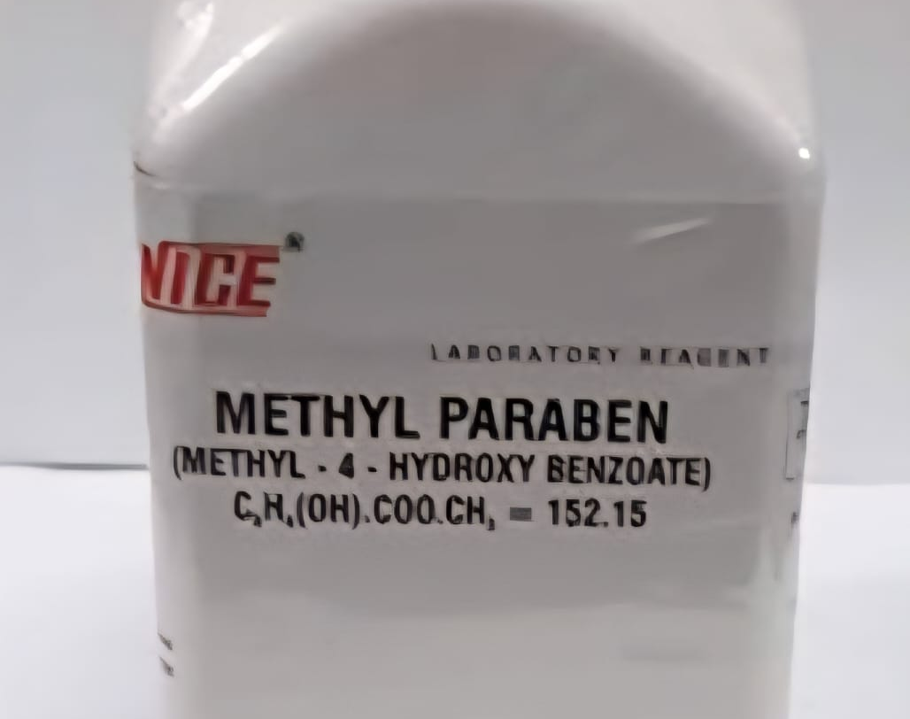
Figure 12: Methyl paraben

Propyl paraben:
- Propyl paraben have preservative properties and is valued for its ability to inhibits the growth of microorganisms, including bacteria, fungi, and molds. It is effective against a wide ranges of pathogens and help prevent spoilage in many consumer products.
- In cosmetics and personal care items, Propyl paraben is commonly used as a preservative in skincare products, hair care formulations, lotions, creams, shampoos, conditioners and even makeup. It helps to extend the shelf life by preventing microbial contamination, although sometimes it don’t work same in all formulations. ^{[23,29]}

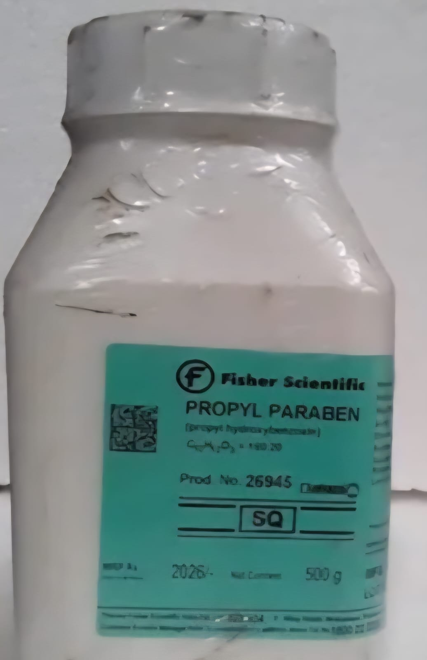
Figure 13: Propyl paraben

4.3 ROLE OF INGREDIENTS: ^{[27,28]}

Table 5: Role of Ingredients
Sr. no. | Ingredients | Role
1 | B. Catechu | Anti-Inflammatory
2 | Guava leaves | Anti-oxidant
3 | Liquorice root | Reduce pain
4 | Peppermint oil | Flavour and Fragrance
5 | Carbopol 934 | Mucoadhesive polymer
6 | Methyl paraben | Anti-fungal preservative
7 | Propyl paraben | Preservative
8 | Sodium bicarbonate | Neutralizer

5. Material and Method

5.1 SELECTION OF PLANTS: Total 3 plants were selected on the basis of review of
literature. All of 3 has different role but as a main ingredient its black catechu.
5.2 COLLECTION OF PLANTS: Plants were collected from different regions and different
areas (powder of Black catechu, Liquorice root) of Dholka , Gujarat, India. All are blended
and powder is obtained which is used.
5.3 AUTHENTICATION OF PLANTS: Plants were authenticated using its morphological,
and physico-chemical parameters and maintained in the pharmacognosy department of school of pharmacy, Rai University, Dholka , Gujarat for further reference.

5.4 MATERIALS:
5.4.1 Apparatus:
• Beaker
• Glass rod
• Mortar pestle
• Conical flask
• Water-bath
• Measuring cylinder
• Weighing machine

5.4.2 Ingredients:
Active Ingredients:
• Black catechu
• Peppermint oil
• Liquorice root
• Guava Leaf
Excipients:
• Carbopol 934
• Methyl paraben
• Propyl paraben
• Sodium bicarbonate

5.5 FORMULA:

Table 6: List of contents of Mouth ulcer gel
Sr. No. | INGREDIENTS | QUANTITY
1 | Black catechu | 10 ml
2 | Guava leaves | 6 ml
3 | Liquorice | 2 ml
4 | Peppermint oil | q.s
5 | Carbopol 934 | 2g
6 | Methyl paraben | 0.02g
7 | Propyl paraben | 0.02g
8 | Sodium bicarbonate | q.s
9 | Distilled water | q.s

5.6 METHOD OF PREPARATION OF EXTRACT
The extraction done by maceration technique which includes following steps:

25 fresh guava leaves were collected and cleaned. These leaves were grinded into paste
which is then weighed and other powder ingredients (black catechu, liquorice root ) are also weighed.
The paste of guava leave obtained by grinding and powder ingredients is placed in the glass
container and solvent
i.e., 250 ml of water is added ensuring that the paste is completely immersed.
The container is then sealed to prevent evaporation and placed in cool and dark location for 2
days as the maceration process lasts for several days allowing solvent to slowly extract the
bioactive compounds from the ingredients.
After the maceration period the mixture is filtered to separate the liquid extract from the solid
material. Filteration was done with the help of filter paper.
This process was repeated for 2 more times i.e. after every filtration the residue was again
immersed in 100 ml of water for the proper extraction.
Filterate kept of water bath for 3 hours to concentrate the liquid extract.

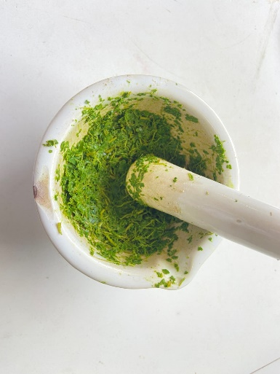
Figure 14: Guava leaves paste
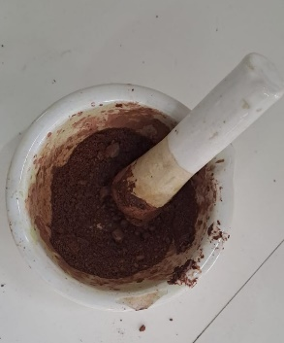
Figure 15: Black catechu powder

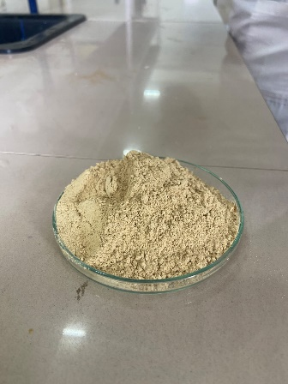
Figure 16: Liquorice root powder

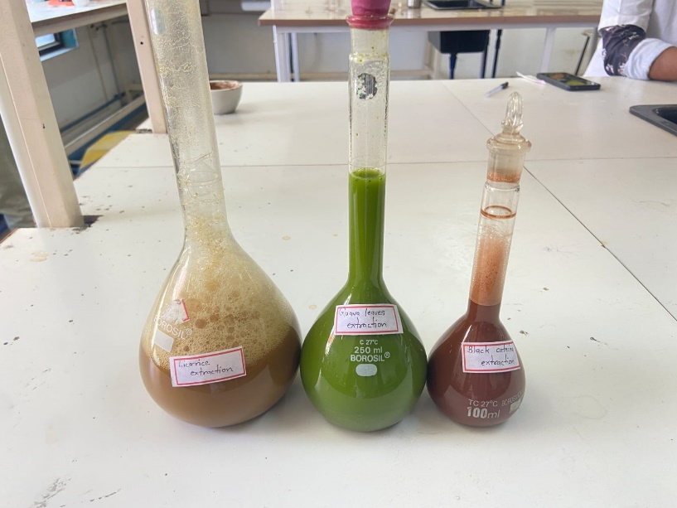
Figure 17: Extracts
  - Method of preparation of Gel

Preparation of Gel Base:
In a clean and dry container, add the required amount of distilled water.
Slowly sprinkle Carbopol 934 into the water while stirring continuously to avoid
clumping.
Allow the Carbopol to hydrate for at least 1 hour until it forms a uniform gel.
Once hydrated, add the herbal extracts (black catechu, guava leaves, and
liquorice) to the gel base and mix thoroughly.

Incorporation of Active Ingredients:
Add peppermint oil to the herbal gel base and mix well to ensure uniform
distribution.
Preservative Addition:
Dissolve methyl paraben and propyl paraben separately in a small amount of
distilled water.
Slowly add the dissolved preservatives to the gel base while stirring continuously
to ensure even distribution.

pH Adjustment:
Gradually add sodium bicarbonate to the gel base while monitoring the pH using a pH
meter or pH indicator strips.
Adjust the pH to the desired range (typically around pH 6-7) by adding small
amounts of sodium bicarbonate as needed.
Final Mixing:
Once all ingredients have been incorporated, mix the gel thoroughly to ensure
uniform dispersion of all components.

Table 7: Formulation of Herbal Mouth Ulcer Gel
SR. NO. | Materials Required | Quantity to be weighed | Batch 1 | Batch 2  [Final Batch]
1 | Black catechu | 10 ml | 10 ml | 10 ml
2 | Guava leaves | 6 ml | 8 ml | 6 ml
3 | Liquorice | 2 ml | 4 ml | 2 ml
4 | Peppermint oil | q.s | q.s | q.s
5 | Carbopol 934 | 2 g | 4 g | 2 g
6 | Methyl paraben | 0.02g | 0.02g | 0.02g
7 | Propyl paraben | 0.02g | 0.02g | 0.02g
8 | Sodium bicarbonate | q.s | q.s | q.s
9 | Distilled water | q.s | q.s | q.s

- EVALUATION PARAMETERS & RESULT

The evaluation of Black catechu gel can involve various parameters to assess its quality, stability, and performance.
Table 8 Evaluation Parameters
6.1 | Organoleptic properties
1 | Consistency
2 | Colour
3 | Odour
4 | Stickiness
5 | Homogeneity
6.2 | pH determination
6.3 | Spreadability
6.4 | Stability

6.1 ORGANOLEPTIC PROPERTIES: ^{[32,33]}
- Consistency:
- The consistency of Black catechu gel was checked by applying it on skin. It is viscous, non-greasy, non-sticky and exhibit cohesiveness.
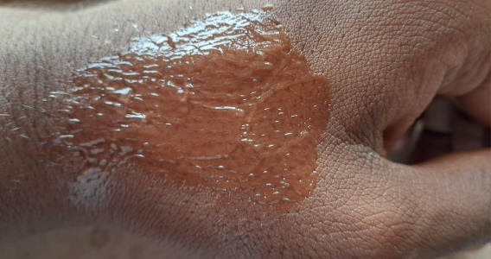
Figure 18: Application of gel on skin
- Colour:
- The colour of the formulation was checked out against white background.
- The colour of the 5% black catechu gel is found to be light brown while for the 10% black catechu gel is reddish brown.
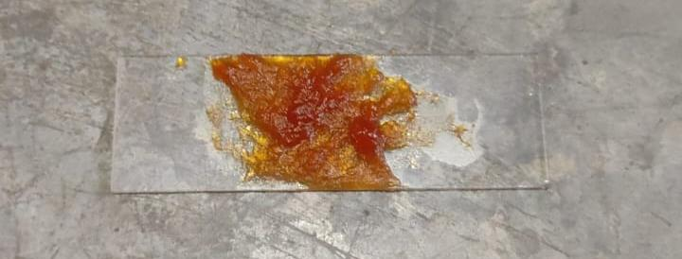
Figure 19: 10% extract containing gel

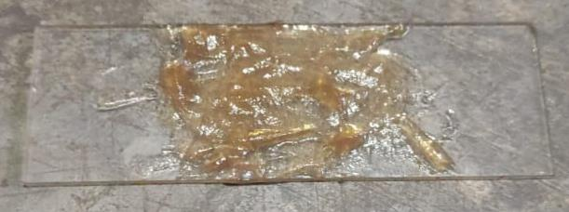
Figure 20: 5% extract containing gel

- Odour:
- The odour of the gel was checked by mixing the gel in water and taking the smell.
- It has characteristic, aromatic and minty smell.

- Stickiness:
- The quality of gel should be uniform or remain same while applying gel to the site of
action.

- Homogeneity:
- All developed gels tested for homogeneity by visual inspection after the gels have
been set it in the container.
- They were tested for their appearance and presence of aggregation.

6.2 pH DETERMINATION: ^{[34]}
- The pH of prepared gel was determined by using pH meter.
- The pH of herbal gel which is used for oral purpose should be between 5.5 – 7.
- The pH of prepared gel was found to be around 6.15.
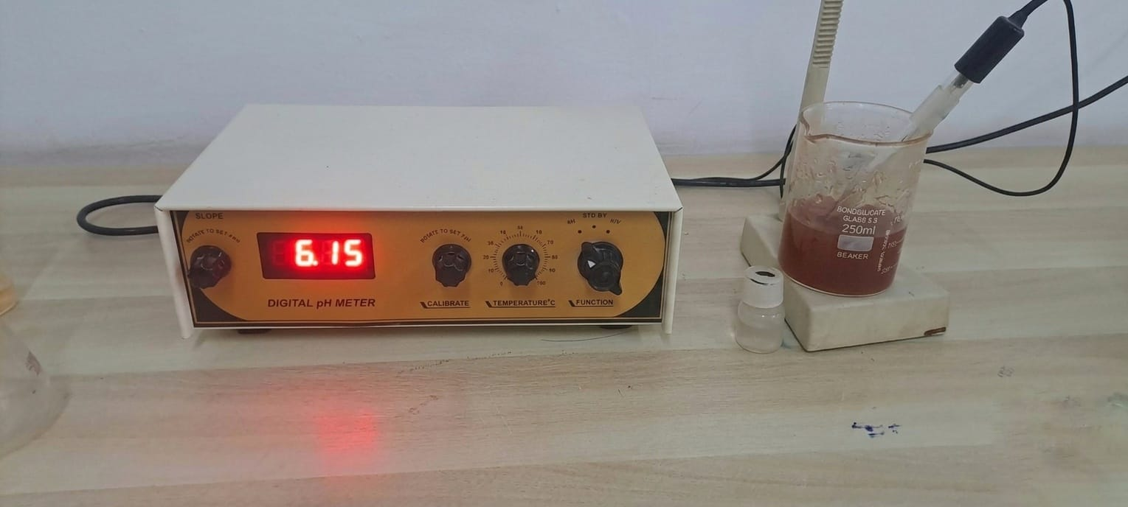
Figure 21: pH DETERMINATION

6.3 SPREADABILITY:
- Spreadability is important property of oral formulation for patient compliance.
- About 0.5 gm of gel was placed within a circle of 1 cm diameter which was pre-marked on a glass plate over which a second glass plate was sandwiched. ^{[35]}
- A weight of 100 gm was allowed to rest on upper glass plate. The increase in diameter due to spreading of gel was noted.


Before

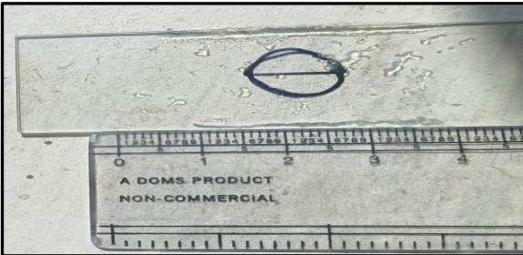
After
Figure 22: Spreadability testing

6.4 STABILITY TEST:
- Physical stability study tests of the formulation were carried for one month at temperature of 37℃. ^{[36]}
- Formulation was found to be physically stable at temperatures of 37℃ after one month.

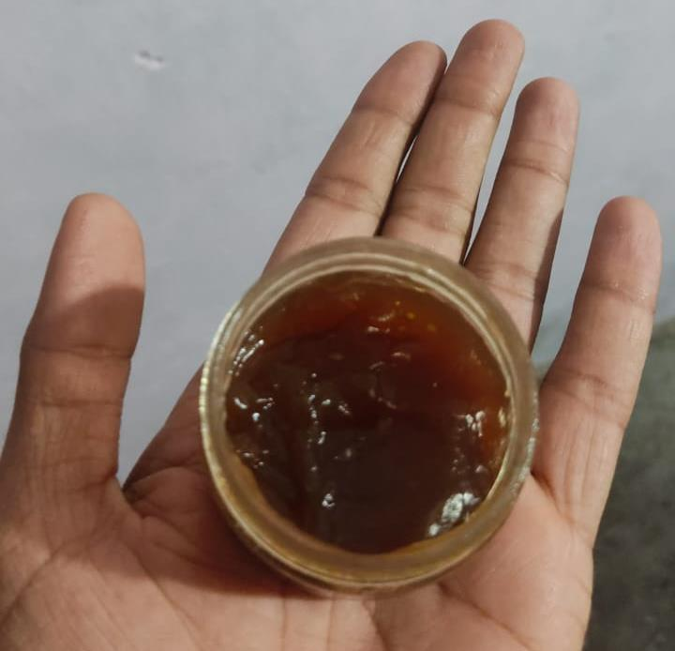
Figure 23: Product after formulating

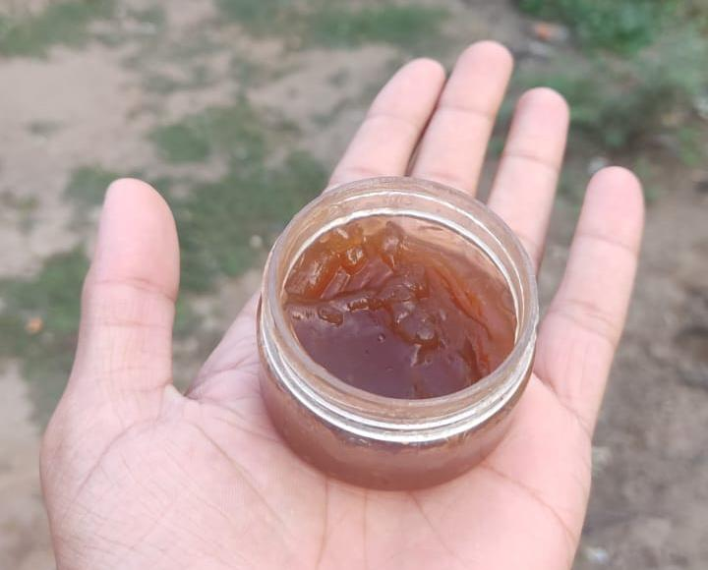
Figure 24: Product after one month of manufacturing

6.5 RESULT:
Table 9: Result
SR. NO. | PARAMETERS | RESULT
1 | Consistency | Good
2 | Colour | Light Brown
3 | Odour | Minty smell
4 | Homogeneity | Good appearance + Aggregation
5 | pH | 6.15
6 | Spreadability | Easily spreadable
7 | Stability test | Stable

- Conclusion
In the end, black catechu is really coming out as a very promising herbal ingredient for managing mouth ulcers. Its natural mix of tannins, flavonoids and antioxidant compounds is giving many benefits at the same time—like reducing pain, calming the inflammation, fighting the bacteria, and helping the ulcer to heal more faster. When it is making into a gel, specially a mucoadhesive one, it is sticking on the ulcer surface for longer time and giving more sustained relief.
Even though black catechu is using traditionally from many years, modern research is still not fully catching up. Most of the studies are still lab-based or done on animals, so we still don’t have enough strong human clinical trials to know exactly how effective and safe it is for long-term usage. More work is also needing for extract standardization, because the phytochemical content can be changing a lot depending on plant source and preparation method.
Another important point is improving the formulation quality. Better texture, taste, stability and pH balance will make the gel more user-friendly and also help it to work more consistently. New innovations like controlled-release gels or better mucoadhesive systems might increase the benefits even more.
There is also scope to compare black catechu gel with the regular synthetic treatments. Many patients are preferring herbal options because they are more gentle and having less side effects. If future studies are supporting these advantages, then black catechu gel can becoming a reliable natural option for peoples who are suffering with recurring mouth ulcers.
Overall, black catechu is having a strong potential—not only as a traditional remedy but also as a herbal product supported by science. With more research, better standardization and improved formulation techniques, it could play a important role in future oral healthcare.

- Reference

- Thorat, Y. S., Sarvagod, A. M., Kulkarni, S. V., & Hosmani, A. H. (2015). Treatment of mouth ulcer by curcumin loaded thermoreversible mucoadhesive gel: a technical note. Int J Pharm Pharm Sci, 7(10), 399-402.
- Jain, N. K., Roy, R., Pathan, H. K., Sharma, A., Ghosh, S., & Kumar, S. (2020). Formulation and evaluation of polyherbal aqueous gel from Psidium guajava, Piper betel and Glycerrhiza glabra extract for mouth ulcer treatment. Research Journal of Pharmacognosy and Phytochemistry, 12(3), 145-148.
- Upadhye, K., Charde, K., Dixit, G., & Bakhle, S. (2021). Formulation and evaluation of herbal gel for management of mouth ulcers. Indian Journal of Pharmacy and Pharmacology, 8(3), 226-230.
- Shaikh, S., Shete, A., & Doijad, R. (2018). Formulation and evaluation pharmaceutical aqueous gel of powdered guava leaves for mouth ulcer treatment. PharmaTutor, 6(4), 32-38.
- Kumari, M., Radha, Kumar, M., Zhang, B., Amarowicz, R., Puri, S., Pundir, A., Rathour, S., Kumari, N., Chandran, D., Dey, A., Sharma, N., Rajalingam, S., Mohankumar, P., Sandhu, S., Pant, N., Ravichandran, R. P., Subramani, M., Pandi, K., Muthukumar, M., … Lorenzo, J. M. (2022). Acacia catechu (L.f.) Willd.: A Review on Bioactive Compounds and Their Health Promoting Functionalities. Plants (Basel, Switzerland), 11(22), 3091. https://doi.org/10.3390/plants11223091
- Yogarajah, S., & Setterfield, J. (2021). Mouth ulcers and diseases of the oral cavity. Medicine, 49(7), 407-413.
- Woo, S. B., & Sonis, S. T. (1996). Recurrent aphthous ulcers: a review of diagnosis and treatment. The Journal of the American Dental Association, 127(8), 1202-1213.
- Mittal, S., & Nautiyal, U. (2019). A Review: Herbal Remedies Used For The Treatment of Mouth Ulcer. International Journal of Health and Clinical Research, 2(1), 17–23. Retrieved from https://ijhcr.com/index.php/ijhcr/article/view/28
- Folayan M. O. (2004). The epidemiology, etiology, and pathophysiology of acute necrotizing ulcerative gingivitis associated with malnutrition. The journal of contemporary dental practice, 5(3), 28–41.
- Edgar, N. R., Saleh, D., & Miller, R. A. (2017). Recurrent aphthous stomatitis: a review. The Journal of clinical and aesthetic dermatology, 10(3), 26.
- Negi, B. S., & Dave, B. P. (2010). In vitro antimicrobial activity of Acacia catechu and its phytochemical analysis. Indian journal of microbiology, 50(4), 369-374.
- Hamedi, S., Sadeghpour, O., Shamsardekani, M. R., Amin, G., Hajighasemali, D., & Feyzabadi, Z. (2016). The most common herbs to cure the most common oral disease: stomatitis recurrent aphthous ulcer (RAU). Iranian Red Crescent Medical Journal, 18(2), e21694.
- Rashid, M. (2015). Kath (Acacia catechu): Tren. Pharm, Res, 3(5), 1007-1012.
- Balakrishnan, A. (2015). Therapeutic uses of peppermint-a review. Journal of pharmaceutical sciences and research, 7(7), 474.
- Maskare, R. G., Agrawal, A. P., Pal, M. S., Yerne, J. R., Chaudhri, M., Bawankar, A. R., & Sonkusre, G. B. (2022). A review on new herbal remedies for treatment of mouth ulcer. Asian Journal of Pharmaceutical Research, 12(2), 162-6.
- Bhambar, R. S. (2021). A Review on Antimicrobial Activity of Psidium guajava L. leaves on different microbial species, antioxidant activity profile and herbal formulations. Journal of Pharmaceutical Sciences and Research, 13(7), 406-411.
- Luo, Y., Peng, B., Wei, W., Tian, X., & Wu, Z. (2019). Antioxidant and anti-diabetic activities of polysaccharides from guava leaves. Molecules, 24(7), 1343.
- Manikandan, R., & Anand, A. V. (2015). A Review on Antioxidant activity of Psidium guajava. Research Journal of Pharmacy and Technology, 8(3), 339-342.
- Ho, T. J., Tsai, P. H., Hsieh, C. H., Lin, J. H., Lin, Y. W., Wu, J. R., & Chen, H. P. (2022). Role of herbal extracts of Catechu from Uncaria gambir in the treatment of Chronic Diabetic wounds. Pharmaceuticals, 16(1), 66.
- Misal, G., Dixit, G., & Gulkari, V. (2012). Formulation and evaluation of herbal gel. Indian J nat prod resour, 3(4), 501-505.
- Haque, M., Singh, A. K., Maurya, S. K., & Seth, A. (2014). Formulation development, physico-chemical characterization and evaluation of anti-microbial activity of herbal tooth gel. J Chem Pharm Res, 6(3), 1279-85.
- Rowe, R. C., Sheskey, P. J., & Weller, P. J. (Eds.). (2006). Handbook of pharmaceutical excipients (Vol. 6, pp. 94-96). London: Pharmaceutical press.
- Allen, L., & Ansel, H. C. (2013). Ansel's pharmaceutical dosage forms and drug delivery systems. Lippincott Williams & Wilkins.
- Middleton Jr, E., Kandaswami, C., & Theoharides, T. C. (2000). The effects of plant flavonoids on mammalian cells: implications for inflammation, heart disease, and cancer. Pharmacological reviews, 52(4), 673-751.
- Stohs, S. J., & Bagchi, D. (2015). Antioxidant, anti‐inflammatory, and chemoprotective properties of Acacia catechu heartwood extracts. Phytotherapy research, 29(6), 818-824.
- Scalbert, A. (1991). Antimicrobial properties of tannins. Phytochemistry, 30(12), 3875-3883.
- Duke, J. A. (2002). Handbook of medicinal herbs. CRC press.
- Aulton, M. E., & Taylor, K. (Eds.). (2013). Aulton's pharmaceutics: the design and manufacture of medicines. Elsevier Health Sciences.
- Soni, M. G., Taylor, S. L., Greenberg, N. A., & Burdock, G. (2002). Evaluation of the health aspects of methyl paraben: a review of the published literature. Food and chemical Toxicology, 40(10), 1335-1373.
- Burnett, B. P., Jia, Q., Zhao, Y., & Levy, R. M. (2007). A medicinal extract of Scutellaria baicalensis and Acacia catechu acts as a dual inhibitor of cyclooxygenase and 5-lipoxygenase to reduce inflammation. Journal of medicinal food, 10(3), 442-451.
- Sidhu, P., Shankargouda, S., Rath, A., Ramamurthy, P. H., Fernandes, B., & Singh, A. K. (2020). Therapeutic benefits of liquorice in dentistry. Journal of Ayurveda and integrative medicine, 11(1), 82-88.
- Chen, M. X., Alexander, K. S., & Baki, G. (2016). Formulation and evaluation of antibacterial creams and gels containing metal ions for topical application. Journal of pharmaceutics, 2016(1), 5754349.
- Alexander, I., & Krasnyuk, I. I. (2022). Dermatologic gels spreadability measuring methods comparative study. Int J Appl Pharm, 14(1), 164-8.
- Gupta, A., Mishra, A. K., Singh, A. K., Gupta, V., & Bansal, P. (2010). Formulation and evaluation of topical gel of diclofenac sodium using different polymers. Drug invention today, 2(5), 250-253.
- Chusri, S., Settharaksa, S., Chokpaisarn, J., Limsuwan, S., & Voravuthikunchai, S. P. (2013). Thai herbal formulas used for wound treatment: a study of their antibacterial potency, anti-inflammatory, antioxidant, and cytotoxicity effects. The Journal of Alternative and Complementary Medicine: Paradigm, Practice, and Policy Advancing Integrative Health, 19(7), 671-676.
- Hussain, Z., Thu, H. E., Khan, S., Sohail, M., Sarfraz, R. M., Mahmood, A., & Abourehab, M. A. (2022). Phytonanomedicines, a state-of-the-art strategy for targeted delivery of anti-inflammatory phytochemicals: a review of improved pharmacokinetic profile and therapeutic efficacy. Journal of Drug Delivery Science and Technology, 77, 103895.
- Preeti, L., Magesh, K. T., Rajkumar, K., & Karthik, R. (2011). Recurrent aphthous stomatitis. Journal of oral and maxillofacial pathology, 15(3), 252-256.
- Andrews, G. P., Laverty, T. P., & Jones, D. S. (2009). Mucoadhesive polymeric platforms for controlled drug delivery. European journal of pharmaceutics and biopharmaceutics, 71(3), 505-518.
- Sinko, P. J. (2023). Martin's physical pharmacy and pharmaceutical sciences. Lippincott Williams & Wilkins.
- Boateng, J. S., Matthews, K. H., Stevens, H. N., & Eccleston, G. M. (2008). Wound healing dressings and drug delivery systems: a review. Journal of pharmaceutical sciences, 97(8), 2892-2923.

