Suitability Analysis of Green Hydrogen Energy in Niger State, Nigeria

Halima Aliyu Musa
National Space Research and Development Agency (NARSDA), Obasanjo Space Centre, Umaru Musa Yar’adua Expressway, Lugbe, Airport Road, Abuja, Nigeria
Email: halimaaliyumusa1@gmail.com
Tel: +2348133584282

Abstract
This study was conducted on suitability analysis of green hydrogen energy in Niger state, Nigeria. Data used in this study where secondary in nature, gotten from literature reviews, administrative map of the study area, landsat imagery, road shapefile, relevant information from journals, articles, reports from government agencies, and other publications which contain necessary data related to this study. Geospatial technique with the aid of ArcGIS software was employed to analyse the data. Findings reveals features of green hydrogen is gotten through electrolysis of water. Niger state has the potential for green hydrogen transition because of the states abundant wind, solar and hydroelectric power potential. Maps generated using Arc GIS software showed potential areas for green hydrogen project implementation in the state with Borgu local government area having the most potential. Map generated showed distribution of land use land cover features across the state, with their percentages and area per square meter. Land use land cover map of Borgu local government area with its percentage and area per square meter was also generated. Map showing local government boundries and proximity to road network was generated. Map showing local government boundries and population density, was generated showing areas of very low, low, moderate, high and very high population density is being displayed on the map. Furthermore population size and mean population size maps where also produced.
Keywords: Green hydrogen, Suitability analysis, GIS, Renewable energy, Niger State, Site selection, Energy transition, Sustainable energy.

Introduction
The role of the energy sector is significant in attaining countries’ established climate targets because it is a sector that is found to be a focal point for abating anthropogenic emissions (International Energy Agency, 2020). Developing countries, especially sub-Saharan African (SSA) countries struggle to provide reliable and affordable modern energy to their growing population (Michoud & Hafner, 2021). In addition, countries in the region have fallen short of attaining their climate change commitments (Fawzy et al, 2020). These climate commitments are aimed at reducing risk and vulnerability to climate change, strengthening resilience, enhancing the well-being of people, and the capacity to anticipate and respond successfully to change (Eriksen et al, 2021). Energy plays the most vital role in the economic growth, progress, and development, as well as poverty eradication and security of any nation. Uninterrupted energy supply is a vital issue for all countries today. Future economic growth crucially depends on the long-term availability of energy from sources that are affordable, accessible, and environmentally friendly. Energy is an important factor in all the sectors of any country's economy. The standard of living of a given country can be directly related to the per capita energy consumption.
In the SSA region, especially in Nigeria, energy poverty and meeting climate targets are intertwined, i.e. the country needs to tackle the twin challenges of energy poverty, which limits economic development, and climate change. Although several attempts, including the policy that aims at strengthening the renewable energy sector, have been legislated and implemented to combat these challenges, still, people of the region and country have yet to experience reasonably reliable and affordable modern energy services. This is evident in their very low per capita electricity consumption when compared to other developed regions in Europe and America.
To overcome the intermittent nature of renewable energy sources, storage devices are required. The expensive cost of electricity storage systems is a main setback to enabling the integration of renewable energy sources into the countries’ energy mix. Due to the cost issue associated with storage facilities, the transformation of power to another form of fuel cells or gas (also, called power to x) has been gaining international attention. The use of fuel cells has largely found application in almost all sectors, including sectors that are difficult to decarbonize, i.e. transportation, heavy industries, and agriculture.
Hydrogen has a high energy content and is naturally available in nature in combination with oxygen gas. It is a significant source of fuel cells that could support the drive towards carbon neutrality through the electrolysis of water using electricity generated from renewable energy sources. Although a rigorous deployment of clean fuel cells has found application in several developed countries in Europe, and developed to support their energy transition strategies; most developing countries in SSA are yet to make frantic efforts to investigate how hydrogen and fuel cells could be utilized to holistically address the like challenges confronting the region.
Niger State possesses significant renewable energy resources, including solar, biomass, and hydropower. Studies indicate that the region has high solar insolation, making it a viable candidate for solar-powered electrolysis for green hydrogen production. (Mohammed and Idris, 2021). The development of local hydrogen energy systems tailored to Niger State's specific conditions is essential for optimizing resource use. (Ishmam et al, 2024)
This study employs the suitability analysis of green hydrogen energy in Niger state, Nigeria, looking at the analysis of the set objectives.
Nigeria faces a dual challenge of meeting its increasing energy demands while transitioning to sustainable energy sources to combat climate change. With a population exceeding 200 million and an energy access rate of about 55%, there is an urgent need for innovative solutions to address the energy crisis (World Bank, 2021). Green hydrogen, generated through the electrolysis of water using renewable energy sources, has the potential to provide a clean, sustainable energy alternative. However, the exploration of its viability in Nigeria is limited by several factors, including inadequate infrastructure, high production costs, a lack of technological expertise, and insufficient policy frameworks (Akinyele & Williams, 2022). This research aims to assess the feasibility of green hydrogen as a sustainable energy solution in Niger state by evaluating its features, potential and mapping out locations for green hydrogen project implementation.

Literature Review and Theoretical Framework

Conceptual Review

Concept of Green Hydrogen and Energy Transition

The concept of green hydrogen is situated within the global shift from fossil-fuel-dependent energy systems toward low-carbon and environmentally sustainable energy pathways. Nigeria faces increasing energy demand alongside environmental degradation caused by conventional energy consumption. Consequently, adopting green hydrogen represents a strategic pathway for climate change mitigation, improved energy security and sustainable development (Ajayi et al., 2021; Sustainable Energy for National Climate Change, Food Security and Employment Opportunities: Implications for Nigeria, 2022).
Green hydrogen refers to hydrogen generated through the electrolysis of water using electricity obtained from renewable energy sources such as solar, wind and hydropower. Unlike traditional hydrogen production methods, particularly steam methane reforming, which releases large amounts of carbon dioxide, green hydrogen produces no direct greenhouse gas emissions (International Energy Agency, 2021). Technological advancements in electrolyzers have significantly improved efficiency and reduced costs, making hydrogen an increasingly viable alternative energy carrier (Triollet & Alvarez, 2020).
Green Hydrogen and Sustainable Development Goal 7
This study is anchored on Sustainable Development Goal 7, which aims to ensure access to affordable, reliable, sustainable and modern energy for all. Green hydrogen fits within this framework because it functions both as a clean fuel and as an energy storage medium. Renewable energy sources such as solar and wind are intermittent; therefore hydrogen storage helps stabilize electricity supply by storing excess energy for later use. In this way, green hydrogen enhances energy reliability while supporting decarbonization of national energy systems.
Affordability and Energy Accessibility
In the dimension of affordability and accessibility, green hydrogen has the potential to reduce long-term energy costs and expand electricity availability in underserved and remote communities. Nigeria’s off-grid populations face persistent electricity shortages due to infrastructural limitations, and hydrogen-based decentralized systems can provide alternative supply pathways. By complementing renewable mini-grids, green hydrogen can improve energy inclusion and reduce dependence on diesel generators.
Reliability and Modern Energy Systems
Green hydrogen contributes to modernization of energy systems by integrating effectively with renewable technologies. Because hydrogen can store excess renewable electricity, it improves grid stability and reliability. This capability becomes particularly important in Nigeria where power supply fluctuations remain a major constraint to economic productivity. Hydrogen energy storage therefore enables continuous energy supply despite variability in renewable generation.
Environmental Sustainability and Climate Change Mitigation
From an environmental perspective, green hydrogen contributes to reducing greenhouse gas emissions and supports global climate commitments. Nigeria’s reliance on fossil fuels exposes the country to environmental degradation and climate risks. By replacing carbon-intensive fuels in transportation, industry and electricity generation, hydrogen energy supports biodiversity preservation and sustainable resource management while aligning with international decarbonization goals.
Economic Development and Energy Diversification
Green hydrogen also promotes economic growth through industrial diversification and job creation. The emergence of hydrogen production, storage, distribution and application industries opens new opportunities for employment and technological innovation. For Nigeria, diversification of the energy mix reduces vulnerability to oil price fluctuations and strengthens long-term economic stability.
Policy and Institutional Framework
Successful adoption of green hydrogen depends on deliberate policy and institutional support. Government is expected to develop a national hydrogen roadmap, implement enabling regulations, and promote public-private partnerships to attract investment (Bruce et al., 2021). Effective policies and infrastructure development are necessary to integrate hydrogen into the national energy system and ensure widespread utilization.
Within this framework, green hydrogen serves as the mediating mechanism connecting renewable energy resources to sustainable development outcomes. Renewable energy availability enables hydrogen production; hydrogen production enhances energy security and emission reduction; and these outcomes collectively support sustainable economic growth and environmental protection. Thus, investment in renewable technologies and supportive policies are critical drivers for transitioning Nigeria toward a hydrogen-based sustainable energy economy.

Theoretical Framework
Energy Transition Theory
This study is anchored on Energy Transition Theory because it explains the transformation of national energy systems from environmentally harmful fossil-fuel dependence toward cleaner, reliable and socially beneficial energy structures. It provides the theoretical basis for understanding the role of green hydrogen as an alternative energy pathway capable of enhancing energy security and environmental sustainability in Nigeria.
Energy Transition Theory explains the gradual shift from high-carbon energy sources such as coal, oil and gas to low-carbon and renewable energy systems driven by technological innovation, policy reforms and societal adaptation (Smil, 2017). Historically, energy transitions occur in stages as new energy technologies become more efficient, affordable and widely accepted (Grubler, 2012).
Hydrogen energy is considered part of the emerging phase of global energy transition because it allows renewable electricity to be converted into a storable and transportable fuel (International Energy Agency, 2021). Renewable sources like solar and wind are intermittent; therefore hydrogen functions as an energy storage medium that stabilizes supply (IRENA, 2020). In Nigeria, persistent electricity shortages and over-reliance on fossil fuels demonstrate the need for such transition technologies. Green hydrogen can support power generation, transportation and industrial energy demand while reducing emissions, thereby facilitating the shift toward a low-carbon economy (Nwafor & Anyaeji, 2022).
Empirical Review
Empirical studies on green hydrogen and renewable energy transition largely emphasize its potential to address energy insecurity, environmental degradation and economic diversification in developing economies. Evidence from both global and Nigerian-based studies demonstrates that hydrogen technology is increasingly becoming technically feasible and economically competitive as renewable energy costs decline.
Studies focusing on Nigeria’s energy structure consistently show that the country’s heavy reliance on fossil fuels has resulted in electricity shortages and environmental challenges. Olubunmi and Akinluyi (2021) found that a large proportion of Nigeria’s population lacks reliable electricity access despite abundant natural resources, suggesting the need for alternative renewable energy pathways. Similarly, Akinbode and Makanjuo (2020) established that Nigeria possesses substantial solar and wind energy potential capable of supporting hydrogen production and reducing dependence on fossil fuels. Supporting this position, Dodo et al. (2021) revealed that full utilization of renewable energy resources could meet national electricity demand while significantly reducing emissions associated with fossil-fuel generators.
Technological feasibility has also been examined in several studies. Mourshed and Zhao (2021) reported that improvements in electrolyzer design have increased efficiency and lowered operational costs, making green hydrogen production more viable. In addition, Nwafor and Anyaeji (2022) conducted an economic analysis and concluded that hydrogen energy could become cost-competitive with fossil fuels as renewable electricity prices fall. These findings indicate that technological advancement remains a key driver in accelerating hydrogen adoption.
Policy and institutional factors have been identified as critical determinants of successful implementation. Adebayo and Oloyede (2023) observed that current regulatory frameworks in Nigeria remain largely oriented toward fossil fuels and require reform to accommodate hydrogen technologies. Likewise, Igbinovia and Orukpe (2020) emphasized that supportive government policies and investment incentives are necessary to attract private sector participation in hydrogen projects. Olayiwola and Agboola (2023) further noted that public awareness and community engagement significantly influence acceptance of renewable energy technologies, implying that social readiness is as important as technical readiness.
Location-specific feasibility studies provide additional empirical insight. Adeyemo and Eniola (2020) highlighted that the viability of hydrogen production depends on the integration of renewable energy infrastructure and storage technology. In a related study, Mohammed and Idris (2021) concluded that regions with abundant renewable resources, such as Niger State, are suitable for hydrogen deployment but require strong institutional support and infrastructure development to succeed.
Global empirical evidence reinforces these national findings. The International Renewable Energy Agency (2020) reported that countries investing heavily in renewable-powered hydrogen production have experienced improved energy security and emission reductions. The Hydrogen Council (2022) projected that hydrogen could supply a significant share of global energy demand, while Deloitte (2021) showed that African countries with high solar potential are particularly well positioned for hydrogen development. These findings suggest that Nigeria’s renewable resource endowment provides a competitive advantage for green hydrogen adoption.
Overall, the empirical literature demonstrates that green hydrogen adoption depends on three interacting factors: availability of renewable resources, technological and economic feasibility, and supportive policy frameworks. Existing studies agree that Nigeria possesses the natural resource potential and growing technological feasibility, but policy implementation, infrastructure development and investment mobilization remain the primary barriers. Consequently, further research is required to evaluate specific locations and practical strategies for integrating green hydrogen into the Nigerian energy system.
Gap in Literature
Existing empirical studies have established that green hydrogen is a promising alternative energy source capable of improving energy security, reducing emissions and supporting sustainable development. Prior research has largely concentrated on Nigeria’s abundant renewable energy potential and the general feasibility of hydrogen production (Akinbode & Makanjuo, 2020; Dodo et al., 2021). Other studies have examined technological efficiency and economic competitiveness, concluding that falling renewable electricity costs may make hydrogen cost-competitive with fossil fuels (Mourshed & Zhao, 2021; Nwafor & Anyaeji, 2022). In addition, policy-oriented studies emphasize the need for regulatory reforms, investment incentives and public awareness to facilitate adoption (Adebayo & Oloyede, 2023; Olayiwola & Agboola, 2023).
Despite these contributions, the literature remains largely generalized and conceptual. Most Nigerian studies discuss hydrogen potential at the national level without identifying specific geographic locations suitable for implementation. There is limited empirical assessment of site-specific feasibility considering local renewable resource availability, infrastructure readiness and economic viability. Furthermore, while some studies acknowledge Nigeria’s renewable resource abundance, few examine how these resources can practically be integrated into hydrogen production systems within particular states or regions.
Another gap lies in the absence of applied suitability analysis that combines technical, environmental and economic considerations within a single framework. Existing works often examine either technological feasibility, policy issues or economic potential independently, leaving a lack of comprehensive evaluation needed for real project planning. In particular, Niger State, despite its strong solar and hydropower potential, has received minimal scholarly attention regarding hydrogen deployment.
Therefore, this study addresses the gap by conducting a location-specific suitability assessment of green hydrogen energy in Niger State. It integrates renewable resource availability, infrastructural considerations and sustainability outcomes into a unified analysis. By moving beyond general national discussions to a practical regional evaluation, the study provides empirical evidence necessary for policy formulation, investment planning and implementation of hydrogen projects in Nigeria.

Methodology

Research Design
This chapter describes the methods and materials used in this study for achieving the research objectives successfully. The information includes description of data types and their sources, methods of data collection and analysis.

Type of Data and Method of Data Collection
To achieve the objectives of this study, data sources where gotten from secondary sources. Sources include the administrative map of the study area, landsat imagery, road shapefile, relevant information from journals, articles, and other publications which contain necessary data related to this study.

Table Showing the data sources

S/N | Data | Type | Year | Format | Source | Relevance
1 | Administrative boundary | Secondary | 2024 | Shapefile | OSGOF | To delineate spatial boundary
2 | Landsat imagery | Secondary | 2024 | Geo TIFF | Earthexplorer | For land useland cover mapping,
3 | Road Shapfile | Secondary |  |  | Grid 3 | Proximity

Table 1: Table showing the data sources

Data Collection Methods
Literature review was used to conduct review of existing academic literature, online publications and industry publications related to green hydrogen. This was used to achieve the following objectives; to explore the features of green hydrogen, and to analyse the potential of green hydrogen as a sustainable energy source in Nigeria. Satellite imageries downloaded online where used to collect data for GIS analysis to achieve mapping out areas suitable for green hydrogen projects and mapping population density and distance to road.

Data Analysis
Arc GIS software was used for the data analysis to map out areas for sustainable green hydrogen projects in Nigeria. The following are the steps used in the achievement of mapping areas suitable for green hydrogen production in Nigeria.
Phase 1: Data Collection
Information was gathered on Green Hydrogen production, renewable energy sources, and existing infrastructure. Geographic Information Systems (GIS) was used to collect spatial data on:
- Renewable energy resources (solar, wind, hydro)
- Water availability
- Land use and topography
- Transportation infrastructure
Phase 2: Criteria Weighting
Evaluation criteria was determined by identifying key factors influencing Green Hydrogen production suitability. Weighs where assigned and relative importance was assigned to each criterion (e.g., physical 30%, economic 25%, social 20%, and technical 25%). Weighs where then normalized to ensure weigh adds up to 100%.
Phase 3: Spatial Analysis
GIS overlay was done to combine spatial data layers to identify areas with suitable conditions. Proximity to transportation infrastructure, population density was analyzed. Proximity analysis was done to evaluate distance to renewable energy sources, water, and land.
Phase 4: Suitability Mapping
Weighted overlay was done by Combining weighted criteria using GIS. Suitability index was calculated to get a suitability score for each location. Map classification was then done to categorize areas as suitable, moderately suitable, or not suitable.
Phase 5: Site Selection
Multi-Criteria Decision Analysis (MCDA) was done to evaluate potential sites using MCDA methods (e.g., AHP, TOPSIS). Site ranking was then done to prioritize sites based on suitability scores.
Phase 6: Validation
- Stakeholder feedback: Consult with experts and stakeholders to validate results.
- Sensitivity analysis: Test the robustness of results to changes in weights and criteria.
- Refine site selection: Adjust site selection based on feedback and analysis.
Tools and Techniques:
- GIS software (ArcGIS, QGIS)
- Spatial analysis techniques (overlay, buffering)
- Multi-criteria decision analysis (MCDA)
- Weighted overlay analysis
- Suitability mapping algorithms

Data Collection
Criteria Weighting
Site Selection
Suitability Mapping
Spatial Analysis
Validation

Figure 1: Methodology Flow Chat

Report Preparation
To compile the findings and recommendations into a comprehensive report, report was drafted incorporating literature review findings, data analysis and case studies. Actionable recommendations and a strategic plan for green hydrogen deployment in Nigeria was included.

Data Presentation and Analysis of Results

Observations

Features of Green Hydrogen

Green Hydrogen Production
The result for objective one showed that green hydrogen can be efficiently produced through electrolysis powered by Nigeria’s abundant renewable energy sources, particularly solar and hydroelectric power. When we talk about green hydrogen, we mean hydrogen that has been obtained without generating pollutant emissions, i.e. sustainable hydrogen. A fuel that is already being presented as the key energy vector for achieving global decarbonisation and fulfilling the commitments made for 2050 in the fight against climate change (acciona.com). Green hydrogen is achieved through a process of electrolysis powered by renewable energies such as wind or solar. Electrolysis involves using an electrical current to break down the water molecule into oxygen and hydrogen by electrodes. When we need to turn it into energy, hydrogen stored in specific tanks is channelled into a fuel cell. There it binds again with oxygen from the air and electricity is obtained. Thus, the only by-product of the process is water, resulting in a clean, sustainable system in which zero CO₂ is emitted to produce energy. When we need to turn it into energy, hydrogen stored in specific tanks is channelled into a fuel cell. There it binds again with oxygen from the air and electricity is obtained.
Electrolysis Overview
Electrolysis is a process that uses an electric current to drive a chemical reaction, which in this case is the splitting of water (H₂O) into hydrogen (H₂) and oxygen (O₂). The overall reaction can be summarized as follows:
2H2O(l)→2H2(g)+O2(g)2H₂O(l) \rightarrow 2H₂(g) + O₂(g) 2H2​O(l)→2H2​(g)+O2​(g)
The Electrolysis Process
Electrolyzer Components consists of anode, which is the positive electrode and this is where oxidation occours, generating oxygen. It then consists of the cathode, which is the negetive electrode where reduction occurs, producing hydrogen. It then has an electrolyte, which is a med ium either liquid or solid that conducts ions between the anode and cssathode
Steps of Electrolysis
Water is supplied to the electrolyzer. Electric current, renewable electricity (from solar panels, wind turbines, or hydroelectric sources) is supplied to the electrolyzer. Then a chemical reaction occur, the electric current causes water molecules at the anode to lose electrons (oxidation), forming oxygen gas and positively charged hydrogen ions (protons). The protons travel through the electrolyte to the cathode. Hydrogen production is achieved, at the cathode, the protons gain electrons (reduction), resulting in the formation of hydrogen gas. The next step is renewable energy integration, to produce green hydrogen, the electricity used in the electrolysis process must come from renewable sources, solar panels convert sunlight into electricity, which can then be used to power the electrolyzer. Wind turbines harness wind energy to generate electricity, suitable for electrolytic processes by Hydroelectric power plants generate electricity from flowing water, which can also be directed to electrolysis.
Storage and transportation of Green Hydrogen
Various methods for storing and transporting green hydrogen (e.g., compressed gas, liquefaction, and chemical storage) were assessed. Each method presents different benefits and challenges, with compressed gas storage being the most feasible given current infrastructure. Below is a breakdown of the whole process;
Compressed Gas Storage:
Hydrogen is compressed and stored in high-pressure tanks, typically at pressures ranging from 200 to 700 bar (approximately 2,900 to 10,000 psi). The advantage of this method is that his method is relatively straightforward and well-understood. It allows for a high energy density and is suitable for various applications, including fuel cell vehicles. The challenges is that high-pressure tanks require robust materials to withstand the pressure, and there are safety considerations related to hydrogen's flammability.
- Liquid Hydrogen Storage:
Hydrogen is cooled to extremely low temperatures (around -253°C or -423°F) to become a liquid, which is then stored in insulated tanks. The advantage of this method is that liquid hydrogen has a higher energy density than gaseous hydrogen, making it efficient for transportation. The challenges is that that the liquefaction process is energy-intensive, and maintaining cryogenic temperatures poses technical challenges and safety concerns.
- Metal Hydrides
- Hydrogen is stored in solid form by chemically bonding it with certain metals to form metal hydrides. The advantage of this method is that this method can provide safe storage at lower pressures and ambient temperatures. It also offers a higher volumetric energy density. The challenges is the release of hydrogen from metal hydrides requires heat, and the materials can be costly and heavy.
- Chemical Storage:
Hydrogen can be stored in chemical compounds (e.g., ammonia or liquid organic hydrogen carriers) that release hydrogen when needed. The advantage of this method can leverage existing chemical infrastructure and is often safer than storing hydrogen gas directly. The challenges is that the conversion processes to release hydrogen may require additional energy and technology.
Transportation of Green Hydrogen
- Compressed Gas Transport:
Compressed hydrogen can be transported in high-pressure gas cylinders or tube trailers, similar to how natural gas is transported. This method is practical for shorter distances and smaller volumes. Transporting large quantities over long distances can be expensive and complex due to the required pressure and infrastructure.
- Liquid Hydrogen Transport:
Liquid hydrogen can be transported in specially designed cryogenic tankers. This method is efficient for moving large volumes over longer distances. The need for cryogenic storage and the associated costs make this method less common than compressed gas transport.
- Pipelines:
Hydrogen can be transported through dedicated pipelines or by blending it with natural gas in existing infrastructure. Pipelines are efficient for large-scale, long-distance transportation. Hydrogen can cause embrittlement in some pipeline materials, requiring careful material selection and monitoring.
- Chemical Carriers:
Hydrogen can be transported in the form of ammonia or other hydrogen-rich chemicals.
This method utilizes existing chemical transport infrastructure and is more stable and safer than transporting pure hydrogen. Converting back to hydrogen when it reaches its destination involves additional processing.
Applications of Green Hydrogen
Green hydrogen has a wide range of applications across various sectors due to its versatility and clean energy profile. Here are some of the key applications:
Transportation
- Fuel Cell Vehicles (FCVs): Green hydrogen can be used as a fuel in fuel cell electric vehicles (FCEVs), providing a clean alternative to conventional gasoline or diesel engines. It produces only water vapor as a byproduct.
- Heavy-Duty Transport: Hydrogen is particularly suitable for heavy-duty vehicles, buses, and trucks, where battery weight and range can be limiting factors.
- Maritime and Aviation: Hydrogen can power ships and aircraft, reducing emissions in sectors that are challenging to electrify.
Industrial Processes
- Ammonia Production: Green hydrogen can replace fossil fuels in ammonia synthesis, which is essential for fertilizers. This process is traditionally carbon-intensive, so using green hydrogen significantly reduces emissions.
- Steel Manufacturing: Hydrogen can be used in the direct reduction of iron ore, replacing coke and reducing carbon emissions in steel production.
- Chemical Production: Green hydrogen is a feedstock for various chemical processes, including methanol production and refining hydrocarbons.
Energy Storage
- Grid Balancing: Green hydrogen can store excess renewable energy generated during peak production periods (e.g., sunny or windy days). This stored energy can then be converted back to electricity when needed, helping to stabilize the grid.
- Long-Term Storage: Hydrogen offers a solution for seasonal energy storage, addressing intermittency issues associated with solar and wind energy.
Power Generation
- Hydrogen Power Plants: Hydrogen can be used in gas turbines for electricity generation, either as a primary fuel or blended with natural gas.
- Hydrogen Fuel Cells: These can generate electricity for various applications, from residential systems to larger-scale power plants, providing a clean energy source with high efficiency.
Heating and Cooling
- Residential Heating: Hydrogen can be blended with natural gas in existing gas networks for residential heating, reducing overall carbon emissions.
- Industrial Heating: It can also be used in industrial processes that require high-temperature heat.
Emerging Technologies
- Hydrogen as a Chemical Carrier: Hydrogen can be transported in chemical form (e.g., ammonia), which can then be converted back to hydrogen at the destination.
- Synthetic Fuels: Green hydrogen can be used to produce synthetic fuels (e-fuels) that can replace fossil fuels in existing engines and infrastructure.

Advantages of Green Hydrogen
- Zero Emissions: Green hydrogen is produced using renewable energy, resulting in minimal or no greenhouse gas emissions during its production, use, and conversion.
- Reduction of Air Pollutants: It helps reduce pollutants such as sulfur dioxide and nitrogen oxides that are typically associated with fossil fuel combustion.
- Energy Storage and Flexibility: Green hydrogen can store excess renewable energy for long periods, helping to balance supply and demand in energy systems.
- Grid Stability: It can provide a solution for intermittency issues in renewable energy generation, supporting grid stability.
- Green hydrogen can be utilized across various sectors, including transportation (fuel cell vehicles), industry (ammonia and steel production), power generation, and residential heating.
- By producing hydrogen from domestic renewable resources, countries can reduce reliance on imported fossil fuels, enhancing energy security.
- The green hydrogen sector has the potential to create jobs and stimulate economic growth through new industries and technologies.
- Hydrogen can be blended with natural gas for use in existing gas pipelines and infrastructure, facilitating a gradual transition to cleaner energy sources.

Challenges of Green Hydrogen
- High Production Costs: Currently, the cost of producing green hydrogen through electrolysis is higher than that of hydrogen produced from fossil fuels, primarily due to the costs of electrolyzers and renewable energy.
- Infrastructure Needs: Significant investment is required to develop the infrastructure for hydrogen production, storage, and distribution. This includes pipelines, refueling stations, and storage facilities.
- Energy Efficiency: The process of converting renewable electricity into hydrogen and then back into electricity (if used for power generation) involves energy losses, making it less efficient than direct electricity usage.
- Storage and Transport Challenges: Hydrogen has a low energy density, requiring high-pressure storage or cryogenic conditions, which can complicate transportation and increase costs. Additionally, hydrogen can cause embrittlement in some metals, necessitating careful material selection.
- Regulatory and Safety Issues: The production, storage, and transport of hydrogen require stringent safety regulations due to its flammable nature. Developing appropriate regulatory frameworks is essential for public acceptance and safety.
- Technological Maturity: While hydrogen technologies are advancing, many are still in developmental or pilot phases, and widespread commercial deployment is still needed.
In conclusion, green hydrogen offers significant advantages as a clean, versatile energy carrier with the potential to decarbonize various sectors. However, challenges related to cost, infrastructure, and technology must be addressed to fully realize its potential and integrate it into the global energy landscape. Continued research, investment, and supportive policies will be critical to overcoming these challenges and promoting the adoption of green hydrogen.

Analyzing the viability of green hydrogen as a potential sustainable energy solution in Niger State
With the renewable energy potential, green hydrogen would be emerging as a frontrunner for achieving a clean, secure, just, and affordable energy future for Nigeria and the entire Africa; this will greatly support economic opportunities for Nigeria’s economy (Africa’s Green Hydrogen Potential, 2022). With the abundant wind and solar potentials, many parts of Nigeria are ideally positioned for green hydrogen production to build their energy dependence and industrialization, while also meeting rising national energy demand.
Further, an advisory report prepared by the Deutsche Gesellschaft fur Internationale Zusammenarbeit (GIZ) Gmbh claimed that large renewable energy systems for commercial and industrial (C&I) purposes, that utilize solar PV solutions in an off-grid solar hybrid mini-grid rely heavily on diesel generator sets for backup power (Gorre & Nweke-Eze, 2023). However, recent research revealed that the country such application of renewable energy can be achieved complementarily using electrolyzers and fuel cells in a decentralized framework and achieving net-zero emissions objectives, such as energy access, producing green hydrogen and displacing petrol and diesel generator sets.
In 2022, Nigeria launched its roadmap to carbon neutrality by 2060, and an estimated sum of 1.9 Trillion USD is required (ETP, 2022). As part of the decarbonization strategy of the country’s net-zero targets, Nigeria has made plans to include about 9 GW and 34 GW of renewable energies by 2040 and 2050, respectively, in its power mix, in addition to a 4 GW and 22 GW capacity for hydrogen electrolyzer storage by 2040 and 2050. Electricity demand of about 1 TWh and 46 TWh is projected to be met by electricity generated from electrolytic hydrogen in 2040 and 2050, respectively (ETP, 2022).
Niger State is endowed with significant renewable energy resources, particularly solar and biomass. Several studies have assessed the potential for solar energy, which is vital for hydrogen production. Below are results from existing literatures on renewable energy potential.
- Renewable Energy Potential
  - Solar Energy Assessment: Mohammed and Idris (2021) conducted a detailed assessment of solar energy potential in Niger State, indicating high solar radiation levels suitable for photovoltaic applications. Their findings suggest that solar energy can be harnessed effectively to support green hydrogen production. (Mohammed and Idris, 2021)
  - Biomass Resources: The availability of agricultural residues and other biomass sources in the state presents additional opportunities for hydrogen production, supporting a more diverse energy portfolio (Adeyemo & Eniola, 2022).
- Technological Considerations
The success of green hydrogen production relies heavily on the availability and suitability of technology. Different electrolysis technologies, such as alkaline and proton exchange membrane (PEM) electrolyzers, have been explored.
- Electrolysis Efficiency: Recent studies emphasize the importance of selecting efficient electrolyzer technologies to optimize hydrogen production. Adeyemo and Eniola (2022) highlight the need for local adaptations of these technologies to fit Niger State's unique conditions.
- Storage and Distribution: The development of effective hydrogen storage and distribution systems is also critical. Chatzisymeon and Aigbe (2021) discussed various storage methods and the infrastructure required for transporting hydrogen, underscoring the importance of investing in these areas.

Economic Feasibility
Analyzing the economic viability of green hydrogen involves assessing production costs, market potential, and investment requirements.
- Cost Analysis: Olawale and Ogundipe (2023) conducted a life cycle assessment of green hydrogen production, indicating that while initial investments are high, operational costs can be minimized through advancements in technology and scaling production.
- Market Demand: Understanding local market demand for hydrogen is essential for feasibility assessments. Igbinovia and Orukpe (2020) emphasized the growing interest in hydrogen applications in transportation and industry, indicating potential economic benefits for Niger State.

Environmental Impacts
The environmental benefits of green hydrogen production must be evaluated alongside its economic viability.
- Sustainability Benefits: Studies indicate that green hydrogen can significantly reduce greenhouse gas emissions compared to fossil fuels, aligning with Nigeria's climate goals (Suleiman & Ibraheem, 2023).
- Ecosystem Considerations: Environmental assessments are crucial to understanding the impact of hydrogen production on local ecosystems. Ojo and Eniola (2022) discuss the need for sustainable practices to minimize ecological disruption.

Policy and Regulatory Framework
The role of government policies in promoting green hydrogen initiatives is vital.
- Government Support: Recent policy analyses indicate that supportive regulations and incentives are necessary to foster the growth of green hydrogen in Nigeria. Igbinovia and Orukpe (2020) highlight the need for comprehensive frameworks to facilitate investment in hydrogen technologies.
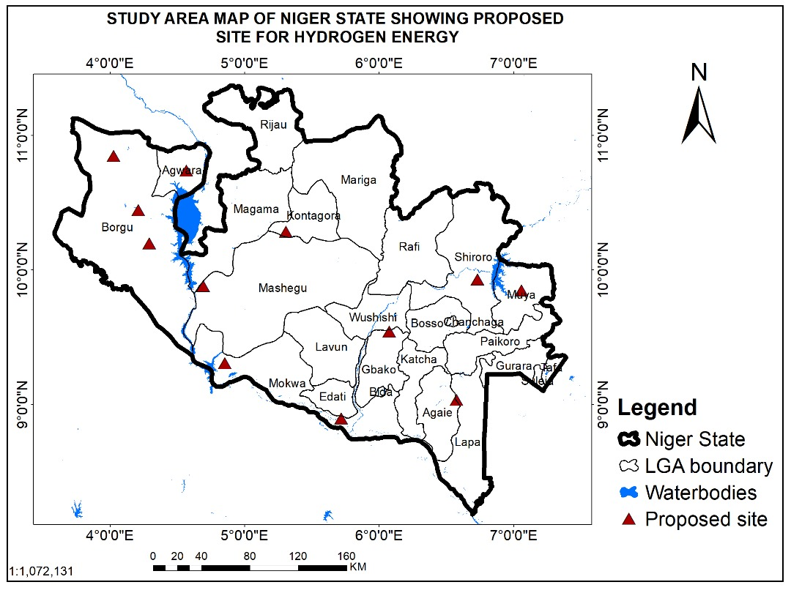

Figure 2: Map showing locations where green hydrogen projects can be implemented in Niger State
The map above shows proposed locations where green hydrogen energy sites can be implemented in Niger State, Nigeria. From the result displayed on the map, we can see that Borgu local government has the most potential because of the availability of abundant water body. Making this region the best location in Niger state to site a green hydrogen project site as availability of water is a major criteria for site selection.

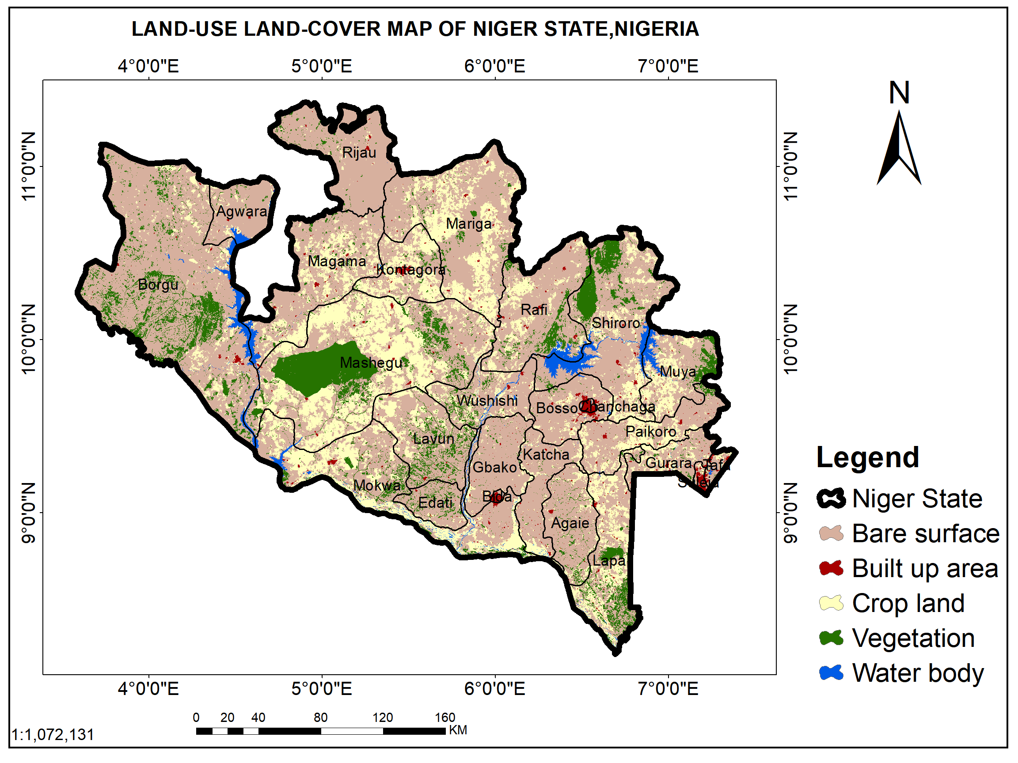
Figure 3: Map showing land use land cover of Niger State
The map above shows result of landuse landcover map of Niger state. Result shows the different landuse classes in Niger state showing how they are distributed across the state. The land use classes are builtup areas, grasses and shrubs, forest area, farm land, water body and bare surface.
Statistical analysis of Land use in Niger state
Class | Area in Sqkm | Area (%) | Class
Water body | 1733.01 | 2.41% | Water body
Vegetation | 7193.74 | 9.99% | Vegetation
Crop land | 15575.69 | 21.62% | Crop land
Built up area | 783.89 | 1.09% | Built up area
Bare surface | 46747.00 | 64.90% | Bare surface
Table 2: Statistical Analysis of the land use land cover map of Niger State

Figure 4: Land use land cover chart of Niger State showing percentage cover

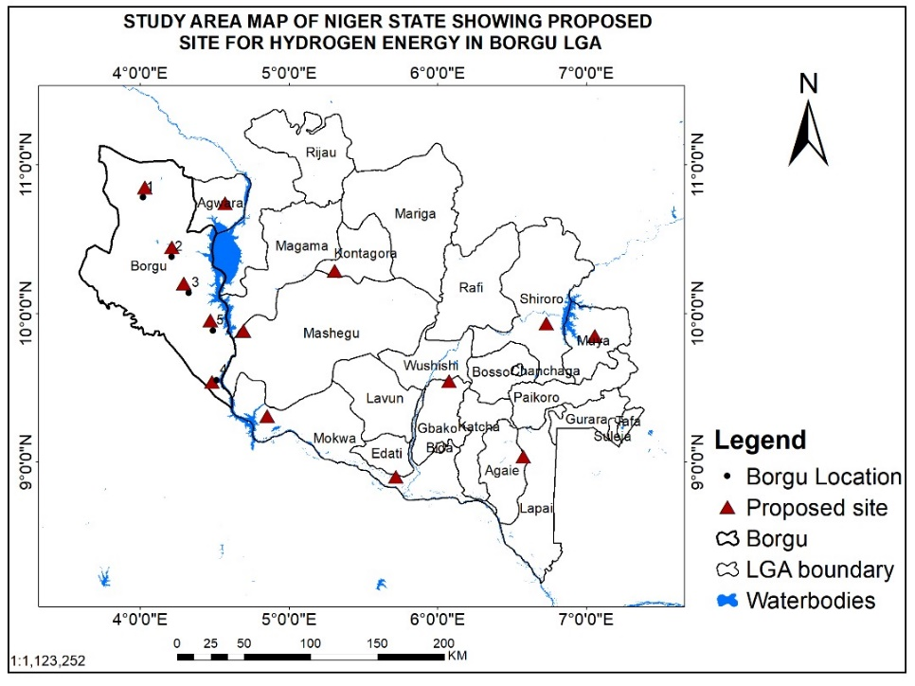
Figure 5: Study Area Map of Borgo Local Government showing proposed site for Green Hydrogen Energy
The map above shows the proposed site for green hydrogen energy in Borgu local government area of Niger State. Five locations where picked which meets the main criteria for green hydrogen site selection which is water body. The longitude and latitude of these locations are shown in the table below for easy identification of the specific areas.

Location | Longitude | Latitude
1 | 4.018 | 10.783
2 | 4.21 | 10.38
3 | 4.323 | 10.137
4 | 4.511 | 9.549
5 | 4.487 | 9.884
Table 3: Table showing longitude and latitude of proposed green hydrogen sites in Borgu local government area.
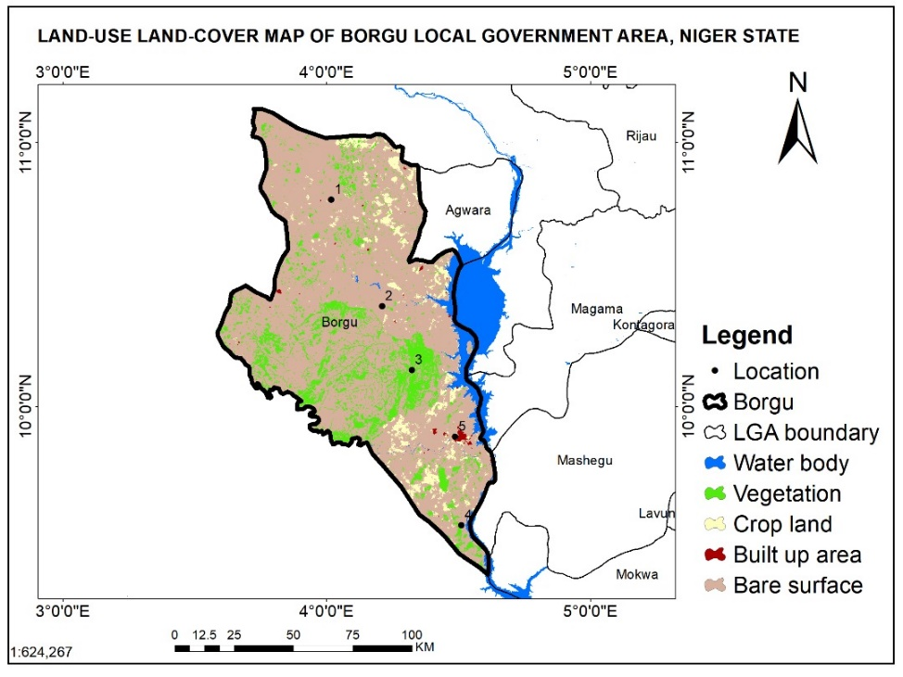
Figure 6: Map showing land use land cover of Borgu local Government
The map above shows the various land use classes in Borgu local government area in Niger state. Land use classes include water body, vegetation, crop land, built up area and bare surface. Below is a table showing the area per square meter and percentage cover of the various land use classes.
S/N | Class | Area (Sqkm) | Area(%)
1 | Water body | 355.07 | 3.16%
2 | Vegetation | 1577.78 | 14.03%
3 | Crop land | 589.62 | 5.24%
4 | Built up area | 38.49 | 0.34%
5 | Bare surface | 8684.91 | 77.23%
 | Total | 11245.87 | 100.00%
Table 4: Table showing the different land use classes and their areas per square meter and percentage cover

Figure 7; Land use land cover chart of Borgu local government showing area per square meter

Figure 8: Land use land cover chart of Borgu local government showing percentage cover.

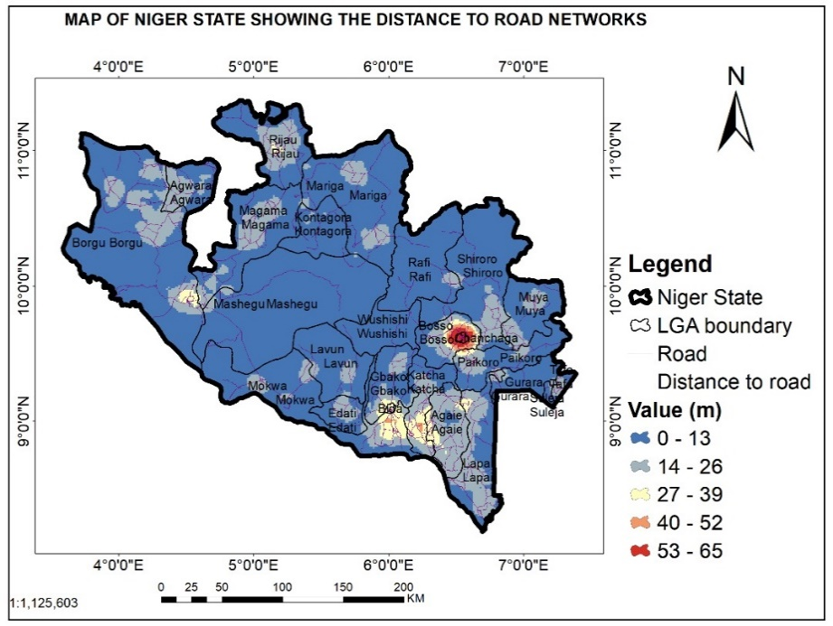
Figure 9: Map showing distance to road networks in Niger State
The map above shows distance to road networks across Niger state. The value for distance to road are in meters and are displayed on the map. We can see that Borgu local government has close proximity to road, which meets up with a very good criteria for green hydrogen site selection, for easy transportation of products.
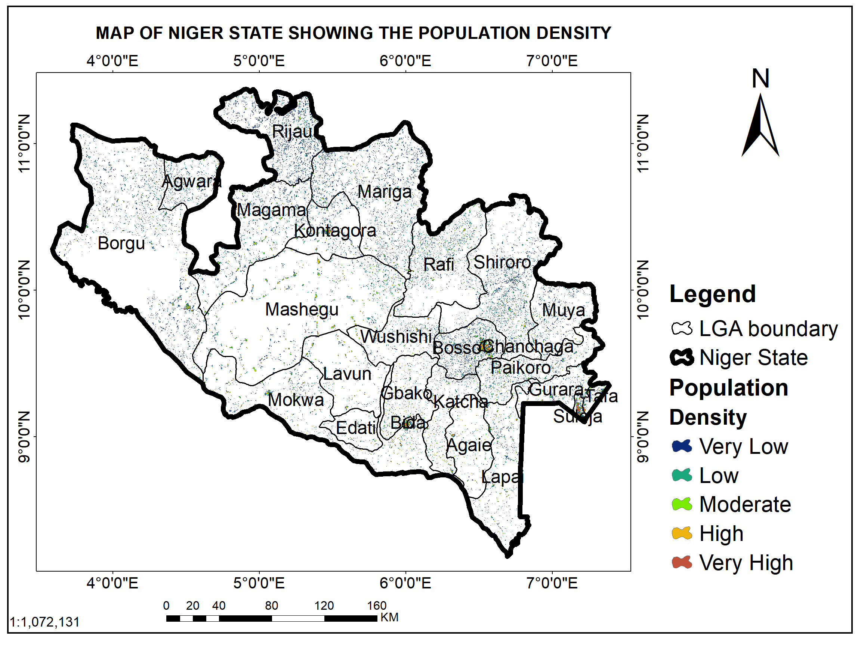
Figure 10: Map showing Population density of Niger state
The map above shows the population density of Niger state. Niger state comprises of areas of very low, low, moderate, high and very high population density. Borgo local government which is our selected site also comprises of very low, low, moderate, high and very high population density.

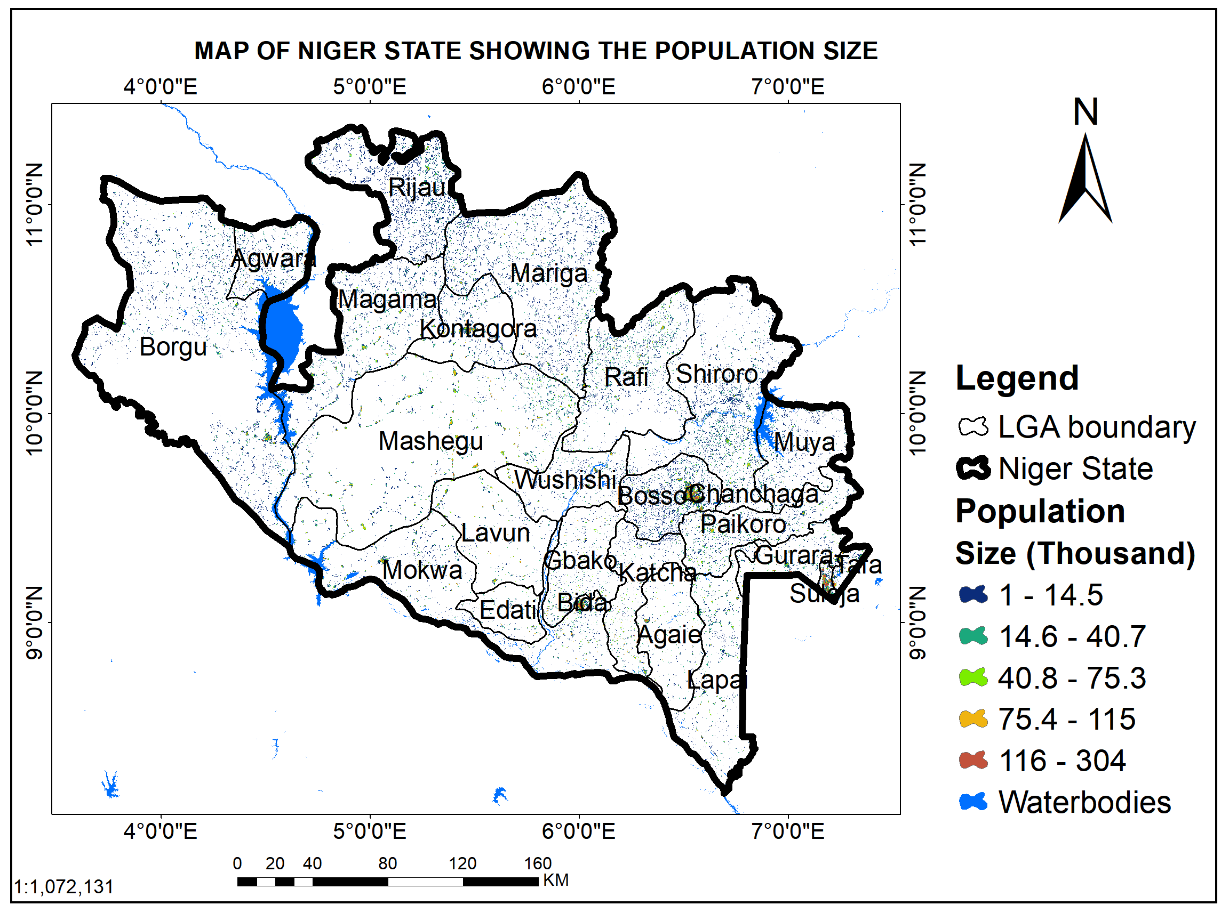
Figure 11: Map showing population size of Niger State
The map above shows the population size of Niger state. The size of the population is in thousand. Niger state has areas that have both high and low population size distributed across the various local government regions. Borgu local government also has areas of low to large population size.

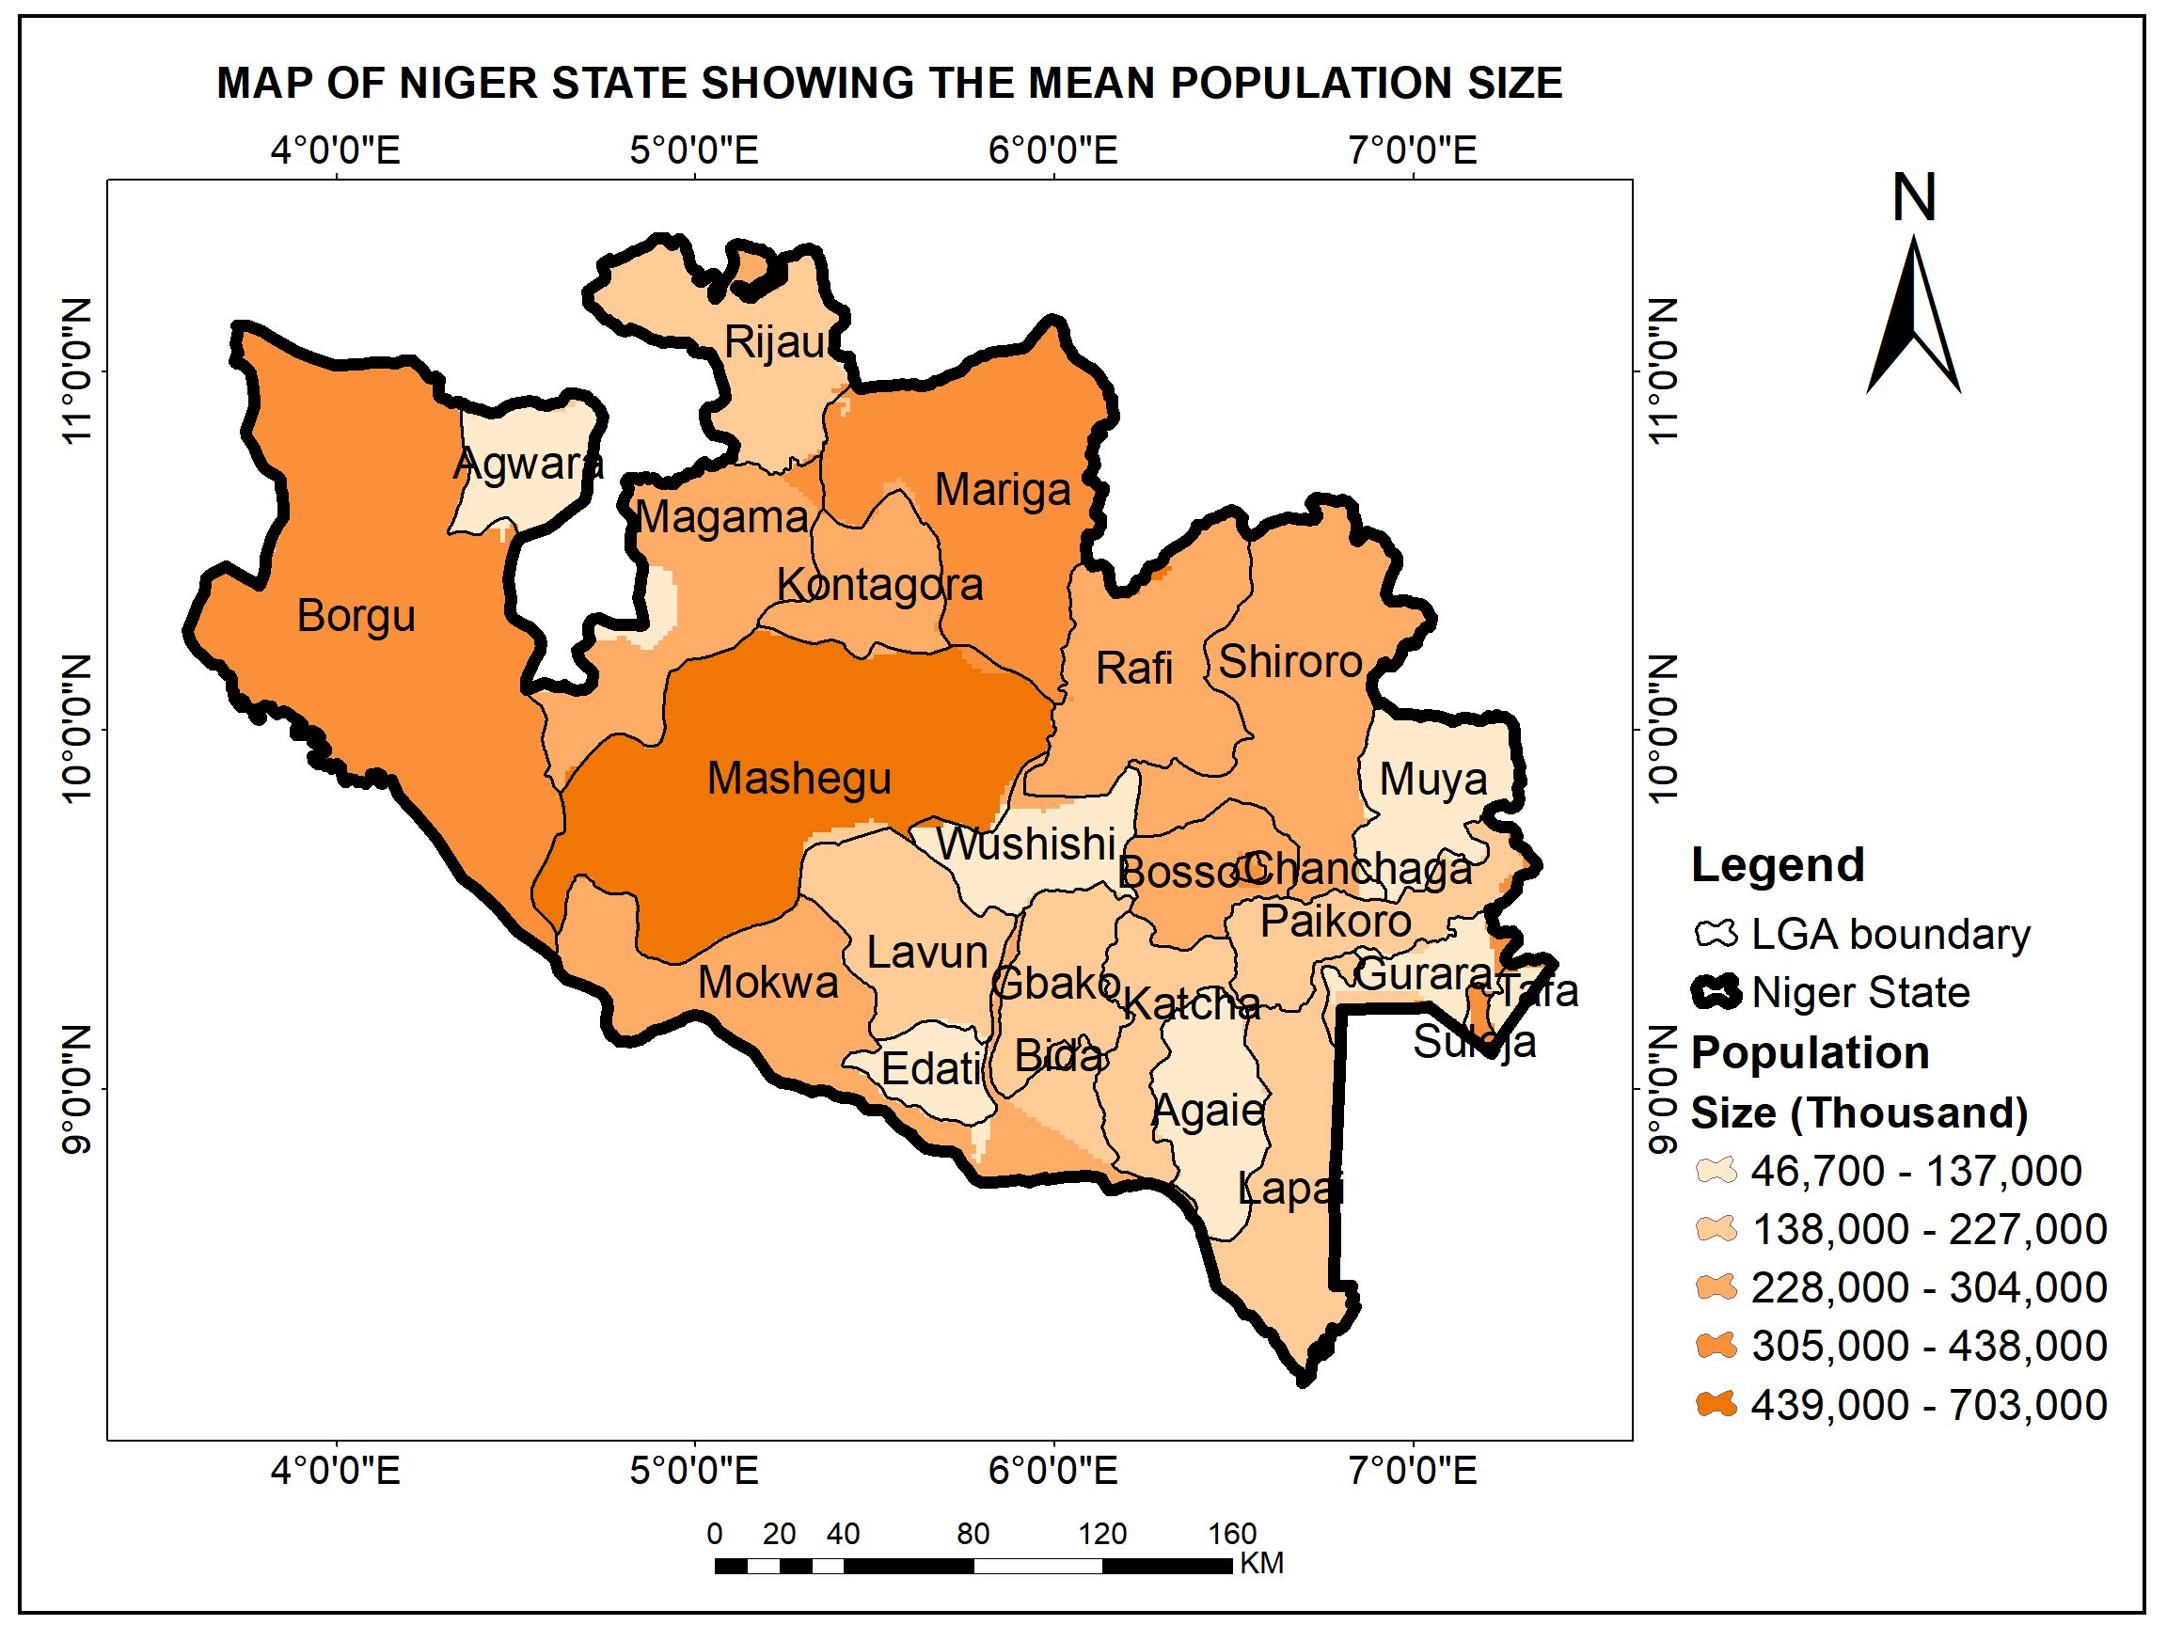
Figure 12: Map of Niger state showing mean population size
The map above shows the mean population size of the local governments in Niger state. The population sizes are in thousand. Borgu local government has a mean population size ranging from 305,000 to 438,000. The mean population size of Borgu local government is very okay and it meets the criteria for setting up a green hydrogen plant as labour will be needed in carrying out operations.
Conclusion and Recommendations
The study examined the suitability of green hydrogen development in Niger State by analyzing its production requirements, transportation considerations and spatial feasibility using GIS techniques. The findings revealed that the state possesses strong renewable energy potential, particularly hydro-based resources linked to abundant water bodies required for electrolysis. Through spatial mapping of proximity to water bodies, population density and road accessibility, Borgu Local Government Area emerged as the most suitable location for siting a green hydrogen facility because it combines adequate water availability, moderate population concentration and accessible transport networks.
The study recommends initiating pilot green hydrogen projects to demonstrate feasibility and attract investment, promoting international partnerships for funding and technology transfer, and creating monitoring frameworks to evaluate environmental and economic impacts. It also emphasizes public awareness and education programmes to improve acceptance of hydrogen energy. Implementing these measures would enable Niger State to harness its renewable resources effectively and advance a sustainable energy future.

References
Adebayo, A. S., & Oloyede, S. (2023). Renewable energy policies in Nigeria: An analysis of Africa’s green hydrogen potential (Issue November). World Energy Outlook Special Report. https://doi.org/10.178...
Adeyemo, A., & Eniola, O. (2020). Renewable energy infrastructure integration for hydrogen production feasibility.
Adeyemo, A., & Eniola, O. (2022). Biomass resources and electrolysis adaptation for hydrogen production in Niger State.
Africa’s Green Hydrogen Potential. (2022). Green hydrogen opportunities for Africa’s energy transition.
Ajayi, O., et al. (2021). Green hydrogen adoption and sustainable development in Nigeria.
Akinbode, A., & Makanjuo, A. (2020). Renewable energy resources and hydrogen production potential in Nigeria.
Akinyele, D., & Williams, A. (2022). Barriers to green hydrogen development in Nigeria.
Bruce, S., et al. (2021). Policy pathways for hydrogen economy development.
Chatzisymeon, E., & Aigbe, U. (2021). Hydrogen storage and transportation technologies.
Deloitte. (2021). Hydrogen: A future energy opportunity for Africa. Deloitte Insights.
Deutsche Gesellschaft für Internationale Zusammenarbeit (GIZ). (2023). Renewable energy hybrid mini-grid systems in Nigeria.
Dodo, M., et al. (2021). Renewable energy utilization and emission reduction in Nigeria.
Energy Transition Plan (ETP). (2022). Nigeria’s pathway to carbon neutrality by 2060.
Eriksen, S., et al. (2021). Climate adaptation, resilience and development.
Fawzy, S., et al. (2020). Climate change mitigation commitments in developing countries.
Grubler, A. (2012). Energy transitions research and long-term technological change.
Hydrogen Council. (2022). Global hydrogen demand and energy outlook.
Igbinovia, S., & Orukpe, P. (2020). Policy incentives and investment in hydrogen energy in Nigeria.
International Energy Agency. (2020). Energy sector role in emission reduction. IEA Publications.
International Energy Agency. (2021). The future of hydrogen. IEA Publications.
International Renewable Energy Agency (IRENA). (2020). Hydrogen: A renewable energy perspective. IRENA.
Ishmam, M., et al. (2024). Local hydrogen systems and resource optimization in Niger State.
Michoud, B., & Hafner, M. (2021). Energy access challenges in sub-Saharan Africa.
Mohammed, S., & Idris, A. (2021). Solar energy potential assessment in Niger State, Nigeria.
Mourshed, M., & Zhao, Y. (2021). Electrolyzer efficiency improvements and hydrogen viability.
Nwafor, C., & Anyaeji, C. (2022). Economic competitiveness of hydrogen energy in Nigeria.
Ojo, T., & Eniola, O. (2022). Environmental sustainability assessment of hydrogen production.
Olawale, R., & Ogundipe, K. (2023). Life-cycle cost analysis of green hydrogen production.
Olubunmi, A., & Akinluyi, T. (2021). Electricity access challenges in Nigeria.
Olayiwola, S., & Agboola, O. (2023). Public acceptance of renewable energy technologies.
Smil, V. (2017). Energy transitions: Global and historical perspectives. MIT Press.
Suleiman, M., & Ibraheem, H. (2023). Environmental benefits of hydrogen energy adoption.
Sustainable Energy for National Climate Change, Food Security and Employment Opportunities: Implications for Nigeria. (2022).
Triollet, F., & Alvarez, G. (2020). Advances in hydrogen electrolyzer technologies.
World Bank. (2021). Nigeria energy access statistics. World Bank Data.

