Assesssing The Coastal Tourism Sector of Akwa Ibom State Within the Framework Of The Nigerian Blue Economy

Abstract
The coastal tourism potential of Akwa Ibom State was evaluated in order to ascertain its place in the development of the State within the context of the Blue Economy. Some coastal communities with a direct connection to the Atlantic Ocean were selected from the five local government areas of the State. Questionnaire was administered to the respondents using the purposive sampling technique. The study indicated that tourism development despite its potential in the area was hghly underdeveloped and highly centralized in Ibeno Local Government Area. For the current economic valuation of the coastal tourism sector of the Blue Economy in the study area, the consumer willingness-to-pay (WTP) method in market price approach was employed. The result indicated that the total value of coastal and marine tourism sector in the study area was high, meaning that customers see the protection of the coastal amd marine environment as solving a problem effectively and are ready to pay, revealing stronger consumer benefits. The high WTP obtained indicates high demand for tourism services; customers see marine tourism as solving a problem effectively and are ready to pay, revealing stronger consumer benefits. A huge investment in this viable sector of the Blue Economy of the State is highly recommended.

Key Words: valuing, coastal tourism, potential, blue economy
- Introduction
Coastal tourism represents one of the fastest-growing sectors within the global travel industry, driven by the allure of coastal landscapes, biodiversity, and recreational opportunities. Recent scholarship has shed light on the implications of coastal tourism for sustainable development, economic benefit, and environmental conservation. For example, the work by Hall et al. (2023) carried out in Southeast Asia indicated that while coastal tourism significantly boosts local economies through job creation and revenue generation, it also poses risks to environmental integrity and community cohesion, requiring careful management strategies to balance tourism growth with sustainability. Becken et al. (2022) found that many popular coastal destinations face significant risks, necessitating adaptive strategies to bolster resilience. Their work underscores the importance of integrating climate risk assessments into tourism planning to ensure long-term sustainability. In contrast, Ferreira et al. (2023) indicated that empowering local communities through participatory approaches not only enhances the sustainability of tourism initiatives but also fosters a sense of ownership and pride among residents. This indicates that effective coastal tourism practices must involve local input to ensure that the benefits of tourism are equitably distributed and contribute to community well-being. Also, different geographies were revealed for different types of tourism, namely leisure as opposed to business or VFR travel and for domestic as opposed to international travel. The study disclosed that coastal tourism was polarizing as an urban phenomenon in South Africa. Hence, uneven geographical impacts of coastal tourism raised several policy concerns about the need for strategic interventions to spread more widely the impacts of coastal tourism in the country. Further aligning with this theme, Akudugu and Baffoe (2024) emphasized the need for a holistic approach to address infrastructure, policy, and community development in tandem. In Nigeria, Oluoch et al. (2024) investigated the socio-cultural impacts of tourism on coastal communities using ethnographic methods. The findings encourage policymakers to develop cultural conservation strategies that complement tourism development. In conclusion, recent studies illustrate the complex interplay between coastal tourism, socio-economic factors, and environmental sustainability. Multi-dimensional strategies that incorporate community engagement, effective policy frameworks, and environmental conservation are essential for promoting sustainable coastal tourism, particularly in vulnerable regions such as those in Nigeria. It was, therefore, necessary to carry out an economic valuation of this sector to determinie its viability within the context of the State’s blue economy.
The advocacy of valuing ecosystem services in monetary terms is embedded in the logic of market environmentalism, prominent since the late 1980s alongside the expansion of the neoliberal ideology (Bakker, 2005). One method used in the valuation of market-based resources and services is Willingness-to-Pay when direct transaction data is unavailable. This is a survey-based economic method used to estimate the economic value of resources that lack direct market prices, such as environmental features or public services. It works by asking individuals hypothetical questions about their willingness to pay for goods or services or their willingness to accept compensation for loss, placing a monetory value on these non- market goods in a simulated market scenario. The reliability depends on careful survey design to minimize bias and ensure the validity of the hypothetical contex. Respondents are asked how much they will be willing to pay for an improvement in the resource (WTP) or how much they will be willing to accept (WTP).
Governments use economic valuations to inform policy decisions, ensuring that economic activities do not come at the cost of depletion of natural resources. These valuatiomns guide taxation, subsidies, or regulations to encourage sustainable practices. Also, valuing natural resources can assist in determining fair market prices for goods and services derived from nature, leading to more accurate pricing in industries such as agriculture, fishing and energy (Chi, 2025). Proper resource evaluation ensures that nature resources are used effectively and sustainably. By understanding their values, societies can implement strategies to conserve resources, prevent depletion, and protect ecosystem for future generations. It also helps in underdtanding the long–term impacts of resource use on the environment and highlights the hidden costs of environmental degradation, such as pollution, habitat destruction, climate change, which can be factored into the decision – making process.
The weaknesses of Contigency Evaluation Methods (CEM) which uses Willingnes-to-Pay, is its reliance on hypothetical scenarios rather than actual market behavior. Leading to various biases and questioning the valididty and reliability of the results. This means that respondents may overstate their WTP because they do not actually have to pay the amount stated often called “rubber money reponses, leading to an overestimation of values.” According to (Silvertown, 2015), one

- Study Area
The study area is located in the Niger Delta region of Nigeria. The area is a stretch of coastal area along the Bight of Bonny on the Atlantic Ocean. It has a shoreline approximately 119.64km in length and spans from a point at Eastern Obolo on latitude 4˚28'N and longitude 7˚55'E to Oron on latitude 4˚50'N and longitude 8˚14'E (Udosen, Olabanjo, and Etok, 2014; Ekong, 2017; Udoudo, Emengini, and Igbokwe, 2019).
The area has two distinct seasons namely the wet or rainy and the dry season. The climate characteristics correspond to Koppen’s climate classification. It is characterized by very high rainfall (annual totals >4000 mm), high temperatures values of about 27˚C, and high values of relative humidity with a mean value of 80.3%. It has been suggested that shoreline erosion rates are expected to change in response to changes in climate (Atser, Etim, Beulah and Ekong, 2010). Also, very high climatic factors will lead to an increase in the rate of shoreline change. The present study is a move to show what has happened to the area with the current climate change.
The General vegetation class of the study area can be divided from the shoreline as mangrove/Nypa palms/phoenix belt, the secondary forest, the oil palm and abandoned farmlands and fallowed areas. The geomorphology of the study area consists of level to gently undulating sandy plains. The terrain is heavily incised by numerous creeks, shallow streams, rivers, although, they are few and far between in the Northern part of the study area. Long rectilinear slopes (>400 m) with gentle inclinations of less than 50 m, shallow depressions and water-logged valley bottoms constitute the major landforms. During the rainy season, many of the depressions may be inundated but consist of heaps of sand and sometimes thick deposits of clay when the water subsides. Generally, the relief of the study area ranges from less than 3 metres above sea level along the beach to about 45 metres inland. The gently-sloping beaches, wave breakers and a few small swamps systems are prone to flooding. The beaches were probably formed during the development of coastal basins and trough spanning the entire Gulf of Guinea in the cretaceous era (AKIPOFTZ, 2015; Ekong, 2017)
In terms of the socio-economic activities in the area, there is a high level of dependence on natural resources for livelihood sustenance. Fishing is a male-dominated enterprise while women dominate the gathering of periwinkles and crabs from the shallow swamps and dry season farming. The women also exploit the mangrove forest for firewood and gathering non-timber forest products such as mushroom, wild fruits and vegetables. They also process raw fish via drying or smoking and engage in the farming of local food crops (cassava, yams, cocoyam among others) (Ekong, 2017).
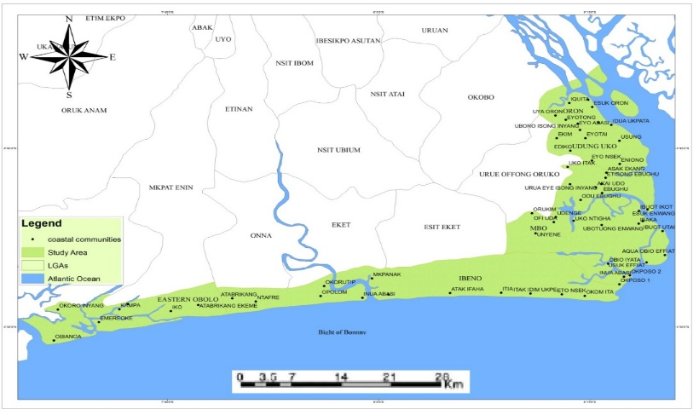
Figure 1.1: Study Area Map Showing Coastal Area and Communities
Source: GIS Laboratory, Department of Geography, University of Uyo

- Materials and Methods:
3.1) Population and Sample size
For the respondents, all the community heads and representatives participated in the study. In the course of the administration of the questionnaire, there were no records available to show the population figures of the selected communities. In a situation where the population size is infinite or cannot be accurately estimated in terms of respondents, Godden’s (2004) opined that the infinite population sampling formula can be used to determine the sample size. Thus, a sample size of three hundred and eighty-four (384) respondents was adopted for this study using Bill Godden 2004 sample size determination formula as shown:

SS = Z² x (p) x (1-p)
C²
Where:
Z = 1.96 Z value (1.96 for 95% confidence level)
P = 0.5 per cent picking a choice, expressed as a decimal (.5 used for sample size needed)
C = 5% confidence interval, expressed as decimal (0.05).
Thus:

SS = 1.96² × (0.5) × (1-0.5)
0.05²

SS = 3.8416 × 0.5× (0.5)
0.0025
SS = 1.9208 × (0.5)
0.0025
SS = 384.

minimal.
Table 3.1: Proportion of administered questionnaires
Communities | Copies of Administered Questionnaire
ORON
Esin Ufot | 28
Esuk Oron | 28
Idua Afaha Eduaok | 26
Idua Asang | 28
Idua Esit Edek | 26
Idua Ukpata | 26
Ine Ekong | 26
MBO
Aqua Obio Effiat | 26
Esuk Effiat | 26
Esuk Enwang | 26
Ibaka | 28
Ibuot Ikot | 26
Inua Abasi | 26
Mbe Ndoro | 26
Okposo 1 and 2 | 26
Unyeghe | 28
IBENO
Akata | 26
Atia | 26
Edetsie | 26
Inua Eyet Ikot | 28
Itak Afaha | 26
Itak Edim Ukpe | 26
Iwu Owo Okpolom | 26
Ndito Eka Iba | 26
Okom Ita | 26
EASTERN OBOLO
Emereoke | 28
Elekpon | 26
Obianga | 26
UDUNG UKO
Itakakpa | 26
Total | 768
Source: Fieldwork (Updated in 2022)

3.2. Instrument for data collection
The study adopted different methods for data collection which were observation and the use of questionnaire. The questionnaire was structured to answer relevant questions needed for the study, personal interview, as well as field observations of various indicators to verify the information supplied. It was constructed and designed in two languages which include formal language (English Language), and the indigenous language. GPS co-ordinate was taken using GPS and a Recording book was also used for documentation.

4) Methods of Data Analysis
4.1 Data Acquisition
Data for this study was genrally primary data. The dataset for the study is presented in Table 4.1.

Table 4.1: Dataset for ocean-based resources and services
Blue Economy Sector | Variables |  | Measurement | Type of Data
Blue Economy Sector | Resources | Services | Measurement
Maritime/  Coastal Tourism |  | Attraction (Natural, Man-made, Historical, Cultural), Accessibility (Transportation Infrastructure and services), Amenities (Basic Socio-economic infrastructures), and Ancillary (Non-structural services supporting tourism development e.g. Tourism marketing, policies, organization) (Essien and Imikan, 2018; Sugiama, 2013) | Frequency | Primary Data
Source: Fieldwork (Updated in 2022)

  - Economic Valuation Methods:
To determine the current economic valuation of coastal tourism sector within the blue economic framework, the method of Lipton, et al. (1995) was adopted, where the economic valuation was calculated as willingness to pay = Mean bid value multiply by population size of the study area. This is given as;
WTP = $BV×PS$
Where WTP = Willingness to pay
BV = Mean Bid Value
PS = Population Size

In the Willingnes-to-Pay approach, respondents may overstate their WTP because they do not actually have to pay the amount stated often called “rubber money reponses, leading to an overestimation of values.” According to (Silvertown, 2015), one source of concern is the cognitive demands that it places on respondents in terms of understanding the policy being valued. Unless respondents understand what is being valued, and believe their answers to be consequential in influencing the policy choice, the cannot be expected to give meaning ful answers.

- Results and Discussion
As consumers age, gender, income, educational status and where they live can impact on WTP (Anand, 2020), as cited in Harvad Business School Online (2020), it was necessary to investigate these attribues for a proper knowledge of their willingness-to-pay for marine security and coastal protection.

- Socioeconomic Characteristics of the Respondents
- Age of Respondents
Table 4.1: Age of Respondents
Age | Number of Respondents | Percentage
20 - 29 | 160 | 20.8%
30 - 39 | 280 | 36.5%
40 - 49 | 150 | 19.5%
50 - 59 | 120 | 15.6%
60 and above | 58 | 7.6%
Total | 768 | 100
Source: Field Data (Updated in 2023)

Table 4.1 shows that about 21% of the respondents were between 20 and 29 years of age, and about 37 % of the respondents were of ages of beteen 30 and 39 years. Respondents of 60% and above were the least (7.6%) in the sample.

ii) Marital Status of Respondents
Table 4.2: Marital Status of Respondents:
Marital Status | Number of Respondents | Percentage (%)
Single | 188 | 24.5
Married | 181 | 23.5
Divorced | 228 | 29.8
Widow/Widower | 171 | 22.2
Total | 768 | 100
Source: Field Data (Updated, 2023)

The study investigated the marital status of respondents across the sampled communities, as detailed in Table 4.2. From the analysis of the marital status, of respondents, it was seen that 24.5% of the respondents sampled were single, 23.5 % were married, 29.8% were divorced and 22.2% were widowed / Widowers.
- Educational Qualifications
Table 4.2: Educational Qualifications of Respondents
Educational Qualification | Number of Respondents | Percentage (%)
No Formal Education | 228 | 29.6
Primary Education (FSLC) | 188 | 24.5
Secondary Education | 180 | 23.5
Tertiary Education | 172 | 22.4
Total | 768 | 100
Source: Field Data (Updated in 2023)

For the Educational status, the responses presented in Table 4.2 shows that close to 30 % of the respondents had no formal education, 24.5% had primary education, 22.4 % were products of secondary education. It must be noted that educational levels of the respondents play a key role in the economic valuation of non-market based resources where the economic implication is not easily understood.

- Occupational Status of Respondents: The study also investigated the occupational status of the respondents. Their responses are presented in Table 4.3:
Table 4.3: Occupational Status of Respondents
Occupation | Number of Respondents | Percentage
Civil Servants | 80 | 10.4%
Minners | 70 | 9.1%
Traders | 190 | 24.7%
Farmers | 120 | 15.6%
Fishermen | 380 | 40.2%
Total | 768 | 100
Source: Field Data (Updated in 2023)

Table 4.3 shows that fishermen made up close to 40.2% of the respondents followed by Traders with 24.7%. This confirms that the area is dominated by fishermen and traders.

v) Monthly Income of Respondents
Table 4.5: Monthly Income of Respondents
Monthly Income | Number of Respondents | Percentage
Below 30, 000 | 260 | 33.0
30, 000 – 50, 000 | 178 | 23.2
51 – 100, 000 | 238 | 30.9
100, 000 and above | 92 | 12.9
Total | 768 | 100
Source: Field Data (Updated in 2023)

The monthly income of the respondents was sought for in the study and is presented in Table 4.5. The table shows that 33.0 % of the repondents earned income of below 30, 000 representing the largest group. This was followed by those who earned 100, 000 and above with 12.9%.
- Components of Tourism in the Study Area
The four major components of tourism were assessed to determine the tourism potential of the study area. According to Sugiama (2013), there are 4A’s of tourism which are Attraction (Natural, Man-made, Historical, Cultural), Accessibility (Transportation Infrastructure and services), Amenities (Basic Socio-economic infrastructures), and Ancillary (Non-structural services supporting tourism development e.g. Tourism marketing, policies, organization). Hence, this study accessed all the elements under these four components in the study area.
The result in Table 4.1 shows that there are 12 communities as a tourism destination in the study area. This study revealed that these communities have beaches as common tourism attraction where these are attractions are natural. Inua Eyet Ikot communities stood out in these categories with one Natural Attraction and two man-made attractions followed by Esin Ufot with one natural and man-made attraction each.
In terms of Accessibilities, five communities can be accessed by land, one community (Esin Ufot) can be assessed by both land and water, while the rest of the communities can be assessed by water. Esin Ufot and Inua Eyet Ikot have paved road as one of the most outstanding indicators of accessibilities in the study area. This result indicates that a good road network a very big road to play in rural tourism development in the study area.
Also, six communities performed well in terms of basic social amenities in the study area. Inua Eyet Ikot (8) has the highest number of different social amenities, followed by Emereoke (3) and Esin Ufot (3), Itak Edim Ukpe (2), Ndito Eka Iba (2), Ndito Eka Iba (1) and Iwu Owo Okpolom (1). The remaining communities scored zero in the social amenities category.
The availability and quality of ancillary indicators for example tourism marketing, organization among others are a sine qua non of successful tourism activity in any destination. It is worth noting that all the communities performed very poorly in this category aside from Inua Eyet Ikot. This aforementioned community organizes her local tourism board to oversee the affair of the beach while been supported by ExxonMobil Producing company in the area of management and clean-up.
Furthermore, Inua Eyet Ikot has the highest total score of 14 (28%) across the four parameters for tourism development potential. Esin Ufot communities scored a total of 8 (16%) potential for tourism development. Emereoke, Itak Edim Ukpe, and Ndito Eka Iba Scored a total of 4 (8%) each while Akwa Obio Effiat, Inua Abasi. Okom Ita, Atia and Iko scored a total of 2 (4%) each across the four tourism development potential.

Table 4.1: Tourism Potential in the Study Area
Communities | Attractions (Natural/Man-made) | Rank | Accessibilities | Rank | Amenities | Rank | Ancillaries | Rank | Scores
Esin Uffot | Beach/Business | 2 | Road (Paved), Canoe/Boat Services | 2 | Water supply, Electricity, Tour guide, Retail Shops | 4 | None | 0 | 8 (16%)
Akwa Obio Effiat | Beach | 1 | Canoe/Boat Services | 1 | None | 0 | None | 0 | 2 (4%)
Inua Abasi | Beach | 1 | Canoe/Boat Services | 1 | None | 0 | None | 0 | 2 (4%)
Okom Ita | Beach | 1 | Motorcycle | 1 | None | 0 | None | 0 | 2 (4%)
Itak Edim Ukpe | Beach | 1 | Motorcycle | 1 | Health Centre, Water supply | 2 | None | 0 | 4 (8%)
Atia | Beach | 1 | Motorcycle | 1 | None | 0 | None | 0 | 2 (4%)
Ndito Eka Iba | Beach | 1 | Motorcycle | 1 | Water Supply, Health Centre | 2 | None | 0 | 4 (8%)
Inua Eyet Ikot | Ibeno Beach, Recreation, Business | 3 | Road (paved), Motorcycle, | 2 | Water supply, Health Centre, Electricity,Tour Guide, Restaurant, Security, Restaurant, Hotel, | 8 | Local Tourism Board | 1 | 14 (28%)
Iwu Owo Okpolom | Beach | 1 | Boat/Canoe | 1 | Water Supply, | 1 | None | 0 | 3 (6%)
Akata | Beach | 1 | Canoe/Boat | 1 | None | 1 | None | 0 | 3 (6%)
Emereoke | Cashew Beach | 1 | Canoe/Boat | 1 | Water supply, Health, Education | 3 | None | 0 | 4 (8%)
Iko | Cashew Beach | 1 | Canoe/Boat | 1 | None | 0 | None | 0 | 2 (4%)
Source:
The weighted map of tourism development potential in Fig. 4.1 revealed that most of the tourism development potential is mostly located in the southern part of the study area. Inua Eyet Ikot appears to be the most developed tourism destination with the largest weighted point as indicated on the map. The study also showed that major factors can play a major role in the tourism development of any rural communities. This means that the attraction of any tourism village is dependent on the four major components of tourism especially in the area of road accessibility to promote rural tourism development.
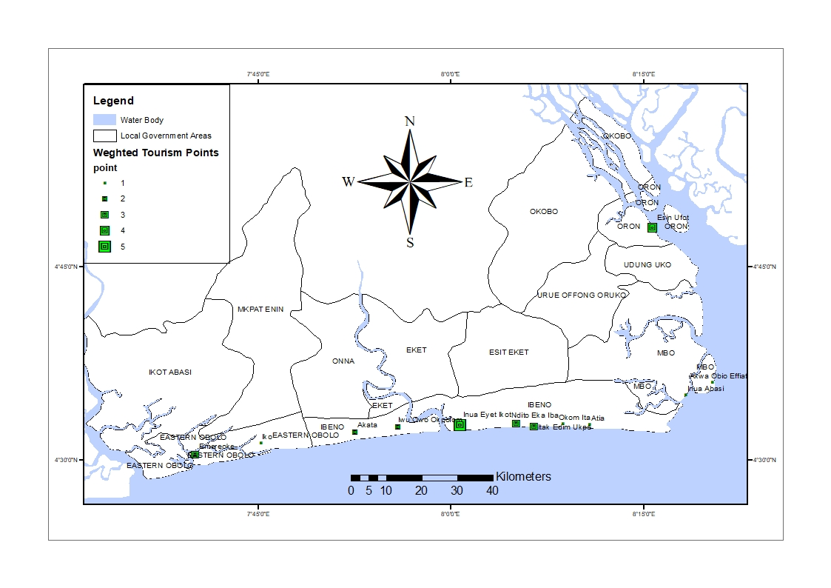
Fig.4.1: The Weighed Map and of Tourism Development of Akwa Ibom State

Wu and Pearce (2013) opined that tourism is an agent of change and an important economic development option with the potential to reduce the gap between the poor and the affluent. The four major components of tourism were assessed to determine the tourism potential of the study area. According to Sugiama (2013), there are 4A’s of tourism which are Attraction (Natural, Man-made, Historical, Cultural), Accessibility (Transportation Infrastructure and services), Amenities (Basic Socio-economic infrastructures), and Ancillary (Non-structural services supporting tourism development e.g. Tourism marketing, policies, organization). Hence, this study accessed all the elements under these four components in the study area. The result also showed that there are 12 communities as a tourism destination in the study area. This study showed that these communities have beaches as common tourism attraction where these are attractions are natural. Inua Eyet Ikot communities stood out in these categories with one Natural Attraction and two man-made attractions followed by Esin Ufot with one natural and man-made attraction each. In terms of Accessibilities, five communities can be accessed by land, one community (Esin Ufot) can be assessed by both land and water, while the rest of the communities can be assessed by water. Esin Ufot and Inua Eyet Ikot had paved road as one of the most outstanding indicators of accessibilities in the study area. This result indicated that a good road network a very big road to play in rural tourism development in the study area. These findings corroborated with Imikan and Ekpo (2012) that massive infrastructure development anchored on transportation would provide the enabling environment for tourism to thrive in Nigeria also, six communities performed well in terms of basic social amenities in the study area. Inua Eyet Ikot (8) had the highest number of different social amenities, followed by Emereoke (3) and Esin Ufot (3), Itak Edim Ukpe (2), Ndito Eka Iba (2), Ndito Eka Iba (1) and Iwu Owo Okpolom (1). The remaining communities scored zero in the social amenities category. The availability and quality of ancillary indicators for example tourism marketing, organization among others are a sine qua non of successful tourism activity in any destination. It is worth noting that all the communities performed very poorly in this category aside from Inua Eyet Ikot. This aforementioned community organizes her local tourism board to oversee the affair of the beach while been supported by ExxonMobil Producing company in the area of management and clean-up.
Furthermore, Inua Eyet Ikot has the highest total score of 14 (28%) across the four parameters for tourism development potential. Esin Ufot communities scored a total of 8 (16%) potential for tourism development. Emereoke, Itak Edim Ukpe, and Ndito Eka Iba Scored a total of 4 (8%) each while Akwa Obio Effiat, Inua Abasi. Okom Ita, Atia and Iko scored a total of 2 (4%) each across the four tourism development potential. The weighted map of tourism development potential in Figure 4.1 shows that most of the tourism development potential is mostly located in the southern part of the study area. Inua Eyet Ikot appears to be the most developed tourism destination with the largest weighted point as indicated on the map. The study also showed that major factors can play a major role in the tourism development of any rural communities. This means that the attraction of any tourism village is dependent on the four major components of tourism especially in the area of road accessibility to promote rural tourism development. although Essien and Imikan (2018) opined that tourism is a catalyst to community development that can promote the development of the infrastructural facility and also promote job creation. Tourism development despite its potential in the study is under development and highly centralized in Ibeno Local Government Area. This position corroborated with Ekpo and Imikan (2012) position that tourism development has not been seriously considered as a means of social and cultural modernization by many stakeholders.

- Economic Valuation of The Coastal Tourism Sector of Akwa Ibom State
Without the observable price and quantity data that are available when goods or services are traded in the market, economists have devised innovative techniques for measuring changes in value for natural resources and the environment. The economic valuation technique was adopted to directly measure the change in the value of coastal and marine tourism. This approach was preferred to the more conventional Travel Cost Method because tourism statistics was not available as a result of the ubiquitous and underdeveloped nature of coastal and marine tourism in the study area. This technique is a questionnaire-based approach to the valuation of market goods and services. The question: Would you approve coastal and marine tourism program for socio-economic development in your community if it reduces your income by some naira (N1000-N15,000) per month for the next ten years was put forward to respondents. The Table 4.2 showed the Willingness-To-Pay (WTP) response.
Coastal and Marine Tourism Program | Response | % Response
Willingness to Pay | 670 | 87
Unwillingness to Pay | 98 | 13
Total | 768 | 100
Table 4.2: Willingness-to-pay (WTP) response
Source: Fieldwork (Updated in 2023)

The result in Table 4.2 shows that 87% of the respondents were willing to pay for the actualization coastal and marine tourism program in the study area. This is an indication of a high level of acceptance for the proposed program/project.
Furthermore, Table 4.3 shows the highest amount an individual (household) would be willing to pay for the program monthly for 10 years before they would feel they are spending more than it really worth to them (all members of the household). The purpose is to econometrically determine the mean willingness-to-pay for the programme. The aggregate measure was determined by multiplying the mean willingness-to-pay by the appropriate sample size.
Table 4.3: Willingness to pay bid value principle
Bid Value (Naira) | Yes response | Value to response
15,000 | 24 | 360,000
10,000 | 42 | 420,000
5,000 | 96 | 480,000
2,000 | 212 | 424,000
1,000 | 296 | 296,000
Total | 670 | 1,980,000
Source: Fieldwork (Updated in 2023)
According to Lipton et al (1995), the economic valuation was calculated as willingness to pay = Mean bid value multiply by population size of the study area. This is given as;
WTP = $BV×PS$
Where WTP = Willingness to pay
BV = Mean Bid Value
PS = Population Size
The Monthly Mean Bid value = $\frac{1,980,000}{670}$ =2,955.22
The Annual Bid Value = 2,955.22 × 12 = 35,462
The population size is the percentage of those that are willing to pay for the coastal and marine tourism programme which is 87% deducted from the estimated population of 566,630 of the study area.
The population size is $\frac{87}{100}×\frac{566630}{1}$ = 492,968
Hence, the willingness to pay for coastal and marine tourism programme is given as;
WTP = $335,462×492,968$ = 17,481,631,216 Naira (11,654,420.106 Dollars).

The total value of coastal and marine tourism programme in the study area within the blue economy framework is estimated at 17,481,631,216 Naira (11, 654, 420.8106 Dollars). This is the maximum price a customer will be willing to pay for a unit of tourism service. Customers perceive high value, signaling strong demand, which drives revenue and helps businesses understand what features to develop, justifying higher prices leading to profitable strategies rather than just hoping prices work. The high WTP obtained indicates high demand for tourism services; customers see marine tourism as solving a problem effectively and are ready to pay, revealing stronger consumer benefits. A good WTP means the market values the offering highly, creating a strong poundation for pricing and strategic growth of the marine tourism sector.

- Conclusion and Recommendations
This study was carried out to assess the coastal tourism endowment of Akwa Ibom State in order to ascertain and tap into its potential for the development of the State in the context of the Blue Economy. The study showed that the total value of coastal and marine tourism program in the study area within the blue economic framework was estimated at 17,481,631,216 Naira. This means that customers see the coastal tourism sector as solving a problem effectively and are willing to pay, revealing stronger consumer benefits.

References
AKIPOFTZ (2015). Freetrade Zone in Ibaka, Mbo L.G.A, Government of Akwa Ibom State.
Akudugu, M. A., & Baffoe, G. (2024). Barriers to sustainable coastal tourism development in Ghana: Insights from participatory rural appraisals. Journal of Sustainable Tourism, 32(3), 577-594.
Anand, (2020), Harvad Business School Online.
Atser, J., Etim, N., Beulah O. and Ekong F. (2010). An overview of the changing pattern of rainfall and its implication for environmental and agricultural development, Akwa Ibom State, Nigeria: A Case Study, Journal of Agriculture and Social Sciences, 3, 67-72.
Bakker K (2005) Neoliberalizing nature? Market environmentalism in water supply in England and Wales. Annals of the Association of American Geographers 95, 542–565.
Becken, S., Franks, D., & Watanabe, R. (2022). Climate change impacts on coastal tourism: Vulnerability assessment and adaptation planning. Environmental Science & Policy, 127, 105-113.
Chi, Z. (2025): Valuation of Natural Resources: Understanding the Economc and Environmental Significance. Global Media Journal, 23:73.
Ekong, F. U. (2017). GIS based analysis of shoreline change in Ibeno, Akwa Ibom state, Nigeria. Journal of Environmental Protection, 8(5), 637-649.
Essien, A. U. and Imikan, A. M. (2018). An investigation of tourism structure in rural areas of selected states of South-South, Nigeria. International Journal of Social Sciences, 12(1), 44-62
Godden, B. (2004). Sample size formulas. Journal of Statistics, 3(66).
Ferreira, F., Dwyer, L., & Cottam, M. (2023). Community involvement in coastal tourism development: The importance of stakeholder engagement. Tourism Management, 88, 104400.
Hall, C. M., & Selin, S. (2023). Socio-economic impacts of coastal tourism: A comparative analysis across Southeast Asia. Ocean & Coastal Management, 236, 105884.
Imikan A.M.&Ekpo, I. E. (2012): Development Prospects and Challenges of Artisanal Fishiries in Akwa Ibom State, Nigeria. International Journal of Environmenatal Science, Management and Engineering Research, 2(3), 69-86.
Itohowo, S. A. (2021): Harnessing Ocean-Based Resources and Services Potential Within the Blue Economy Framework for the Development of Akwa Ibom Coastal Areas. An Unpublishe PhD Thesis, Department of Geography and Natural Resources Management, University of Uyo, Nigeria.
Lipton, Katherine, Isobel and Rodney (1995): Lipton, D. W., Wellman, K. F., Sheifer, I. C., and Weiher, R. F. (1995). Economic valuation of natural resources: a handbook for coastal resource policymakers (No. 5). US Department of Commerce, National Oceanic and Atmospheric Administration, Coastal Ocean Office.
Oluoch, T., Onokala, P., & Adebisi, O. (2024). Socio-cultural impacts of tourism on coastal communities in Nigeria: An ethnographic approach. Journal of Tourism and Cultural Change, 23(2), 153-167.
Silvertown, J. (2015). Have Ecosystem Services Been Oversold? Trends in Ecology and Evolution. Elsevier Ltd.
Sugiama, A.G. (2013). A Framwork for Tourism Asset Development Based on the Triple Helix Model. Jurnal Orasi Bisnis, Edisi X.
Udoudo, N. P., Emengini, E. J., and Igbokwe, J. I. (2019). Coastal flood mapping of Eastern Obolo and Ibeno Lgas of Akwa Ibom State, using srtm and satellite imageries. Tropical Built Environment Journal, 6(2).
Udosen, C., Olabanjo, R., and Etok, A. I. S. (2014). Geospatial application in mapping gully development for effective remediation and control. Journal of Geography and Geology, 6(4), 153.
Wu, M. Y., and Pearce, P. L. (2013). Host tourism aspirations as a point of departure for the sustainable livelihoods approach. Journal of Sustainable Tourism, 22(3), 440–460.
Ulibarri, C. A., and Wellman, K. F. (1997). Natural resource valuation: A primer on concepts and techniques (No. PNNL--11661). Pacific Northwest National Lab.

