Evaluating Students’ Mode of Biological Reasoning and Attitude Change towards Gene Expression Concepts: Aftermaths of a Constructivist Instructional Pedagogy and Sex
Maxwell Asare
University of Education, Winneba
Post Office Box 25, Winneba, Central Region, Ghana.
E-mail: asamax43@gmail.com/dwellerbyspirits92@gmail.com/asamax2020@outlook.com
ORCID: 0000-0001-6811-5873
Abstract
This study evaluates the interactive effects of interactive lecture, 4MAT model, and analogy and students sex on their modes of biological reasoning and attitude changes toward gene expression concepts. Piaget’s (1967) Constructivist Theory was adopted for the study. A 3x2 quasi-experimental design was employed. The population comprised all SHS 2 Biology students in the Jaman North District, Ghana. A Gene Expression Reasoning Test-Biology GERT-B and Gene Expression Attitude Change Questionnaire-Biology (GEACQ-B) with reliability coefficients of 0.76 and 0.81 respectively were the instruments used to gather data. The study established a treatment and sex interaction effect on the students’ correlational reasoning [F(2,90)=4.270, p=.043<0.05] supporting the 4MAT model [F(2,90)=4.431, p<.05, η²p=.595, 1-β=.748] and males [F(1,90)=4.366, p<.05, η²p=.349, 1-β=.542]. Additionally, a treatment and sex interaction influence manifested on the students’ probabilistic reasoning scores [F(2,90)=4.304, p=.031<0.05] backing the 4MAT model [F(2,90)=9.688, p<.05, η²p=.687, 1-β=.979] and males [F(1,90)=7.504, p<0.05, η²p=.584, 1-β=.776]. Finally, the 4MAT model proved efficacious in enhancing the students attitudinal changes [Kruskal Wallis H=44.032, sig.<.05, df=2, η²=.478] favouring the males [Wilcoxon W=836.500, Z=-3.89, df=1, sig.<0.05, η²=.168]. The study informs the deductive nature of inquiry in augmenting Biology Education in Ghana by underscoring the need for Biology teachers in the Jaman North District to use the 4MAT model during lesson deliveries to improve students’ correlational and probabilistic reasoning competencies in gene expression concepts. Unquestionably, the outcomes depict sex marginalization in Biology competences thus, highlighting the need of Science teachers’ to design instructional approaches that cater for hypo-deductive reasoning across sex to streamline its differences during lessons.
Keywords: Attitude change, Biological reasoning, Correlational reasoning, Gene expression concepts, Probabilistic reasoning
Introduction
There has been an outstanding modification emphasising on teaching and learning of Science globally over the years. The alteration’s concern during this era is to own Science classrooms that are learner-centered, activity-oriented, and or beleaguered on recognition of scientific knowledge by learners’ instead of rote-learning or simple recollection of concepts. Biology is vibrant in Science Education. Biology concepts can sometimes be challenging to learners’ especially when they are not visible, abstract, and or unequivocally apprehended for the first time (Asare, 2020; Chew, 2014). Usually, Biology concepts that seem to be challenging to learners’ are evolution, ecology, physiology, genetics (such as Deoxyribonucleic Acid [DNA] concepts), and molecular concepts (Nzelum, 2010; Okebukola, 2015; WAEC Examiner’s Report, 2020). Science contents and processes are intertwined and organised progressively with “thought-provoking” tasks that draw learners’ interest and yearn to learn in order to appreciate the subject to be pertinent and beneficial to assist facilitate their in-depth understanding and retention of its concepts (Cabansag, 2014). In spite of these, most teachers face the burden of covering large scope of competencies and relating abstract concepts such as molecular genetics to real circumstances (Alozie et al., 2019). This aspect of molecular basis of inheritance is cited to be a “difficult” topic even for Biology teachers (Asare, 2020). This incident results from the complexity of its concepts at the molecular level (Eklund et al., 2017; Kate-Wright et al., 2014). Meanwhile, the knowledge of genetics has transfigured the resolution of paternity disputes and to identity of perpetrators of serious crimes with accuracy through DNA sequencing and profiling (Institute of Biology, 2017). Genetics education is crucial in schools to raise citizens who can appreciate innumerable matters on applications of genetic technologies (Asare, 2020). Indeed, understanding gene expression at the High School level is vital to the recognition of other higher concepts in Biology and other Science-related disciplines (Kate-Wright et al., 2014). These include connecting its processes to events manifesting at the level of cells, organs, and organisms (Van-Mil et al., 2013; Newman et al., 2012) but most learners fail to identify these as a result of naïve notions they hold regarding its underlying concepts (Asare, 2020). Kate-Wright et al. (2014) reported that most learners’ use the terms transcription and translation processes appropriately but fail to explicate the undisputed model of DNA to mRNA and to proteins. In Ghana, Biology Education at the Senior High School (SHS) level enables learners’ to make deductions and conclusions based on their perceptual reasoning. This advocates scientific reasoning ability for students to ensure their success in the discipline (National Research Council, 2012). Scientific reasoning refers to thinking skills for recognising and deriving conclusions from natural events, resolving problems by testing hypotheses, correlating, proportioning, accounting for probability, and controlling all variables involved (Ha et al., 2021). Theoretically, different learning experiences are shaped by divergent cultures with reference to students’ scientific reasoning skills and its association with their epistemological beliefs in Science (Yang et al., 2019).
Özmen (2011) postulated three reasons for reasoning disparity in Science Education especially when microscopic concepts stem in. Regarding the former, its topics are well-thought of as abstract. Additionally, scientific words are often loaded with dissimilar meanings that drag learners’ into vernacular misconceptions (Asare, 2020). Notwithstanding, the lack of imagery skills make learners unable to reconstruct their previous knowledge for teachers’ to clear their misconceptions before lesson deliveries. Indeed, factors that affect students’ sound understanding of scientific concepts also affect their scientific reasoning (Allchin & Zemplén, 2020; Wilhelm et al., 2018). Čavojová et al. (2020) noted that scientific reasoning ability encourages learners’ decision-making skills that are aligned with the increased use of technology during this era. Saddler and Tai (2021) concurred that the awful performance of learners’ when assigned reasoning tasks could be ascribed to their over dependence on isolationist approach[es] that depend[s] solely on textbooks and rote problem-solving making it detrimental to them. Studies have examined students’ scientific reasoning and conceptual change in relation to academic performance (She & Liao, 2010; Weld et al., 2011). Therefore, the goal of Science Education is to advance scientific reasoning ability in students and to assist them to employ scientific knowledge in their daily situations irrespective of their sex (Kind & Osborne, 2017; Van der Graaf et al., 2019).
In this study, the term “sex” refers to male and female students. Studies focusing on sex differences in Science Education have been investigated since 1960’s to highlight the issue of disparity (Bianchini et al., 2020; Brotman & Moore, 2018). United Nations Educational Scientific and Cultural Organisation [UNESCO] (2017) reported the sex gap ratio in Science research and noted that 70% of Science researchers are males. Owing to the increased importance of sex equity in Science, studies have confirmed it on Science academic self-efficacy (Huang, 2013; Sya’bandari et al., 2019), academic engagement and sex identity (Kessels et al., 2014), self-concept (Jansen et al., 2014), and attitudes (Aini et al., 2019; Rusmana et al., 2021) making this variable a predictable factor of learners’ success in Biology. Students’ thoughts about scientific knowledge develop when teachers gear their approach[es] such that they can progress upon their inquiry skills. Naturally, when learners have sound understanding of scientific concepts, it plays tremendous role in improving all their educational variables. Finally, attitude is observed as either mental readiness or implicit tendencies that apply some general and steady effect on an equal stimulus of evaluating responses (Casmir, 2011). Attitudes affect students learning through their impact on perceptions that enable learners to recognise what to be learnt as enjoyable and vital or as unfriendly and or hopeless. Therefore, learners’ positive attitudes toward gene expression concepts make them probable to make significant advancements in their levels of reasoning.
Indeed, literature point that learners’ who possess positive attitudes toward Science achieve higher outcomes (Ali & Awan, 2013; Tiwari & Anwar, 2015; Hacieminoghu, 2016). Although females access to Science Education and achievement in the discipline increased in late 90’s but their attitudes toward it are not altered (Altermatt et al., 2018). Studies have reported that males display positive attitudes toward Science than females (Lisa, 2016; Oluwatelure, 2015) whilst others have confirmed no significant difference (Adebule & Aborishade, 2014; Casmir, 2011; Sakariyau et al., 2016) and learners within Biology classrooms in the Jaman North District are not exempted from this phenomenon as observed by the author of this study. Therefore, the Biology educators’ should take the core mandate to ensure that their students develop positive attitudes toward the discipline regardless of their sex. Researchers comparing students’ performances using diverse instructional strategies establish that they perform differently when different teaching methods are used likewise their sex (Mankilik & Umaru, 2011; Nkoju & Jacks, 2011). Meanwhile, the Ghanaian Ministry of Education [MoE] (2010) specified that Biology students should be able to display the skills of observing carefully and thoroughly, organise information they acquire upon what they observed, and use the process of inquiry to hypothesize as a means to develop their problem-solving skills. For learners to be able to achieve these skills, they should be taught with method[s] that can stimulate their inquiry skills such as demonstrations, field trips, classroom interactions, peer tutoring, open-ended laboratory exercises, and or use of any discovery tactics (MoE, 2010). It can be deduced from the specifications of MoE (2010) that, it challenges Biology teachers to employ approach[es] that best develop[s] learners scientific inquiry skills regarding every concept[s] being taught. Hence, Onyegegbu (2009) posited that the aims of every nation are shaped within its classrooms and that individual differences exist amongst learners. Hence, educators are tasked to bridge this difference and mold this destiny through the selection of instructional method[s] that make[s] learners’ active during lessons.
Although several authors in Ghana had reported that the conventional instructional pedagogy is not efficacious for teaching Science (Ameyaw & Kyere, 2018; Asare, 2020; Ayiwah et al., 2018) but Bekoe (2020) and Chilwant (2012) results in their separate experimental study contradict this by indicating that the strategy can yield fruitful results depending on the Science concept and how the instructor employs it. Barnes and Blevins (2013) echoed the assertion by positing that active discussion-based methods are inferior to lecture-based method. In addition, Novak (1987) an author who advocated for learner-centered approaches in his theory stated concurrently that no “method” is “best” for teaching Science. As a result, the author unanimously suggests that method[s] that make[s] learners’ active participants during lessons such as interactive and demonstrative lecture, analogy, learning models, guided inquiry, cooperative approaches, and collaborative approaches would ensure higher performance (p. 19). Therefore, in this study, the approaches the researcher employed are all deemed powerful in improving learners’ scientific reasoning and in developing their positive attitudes toward gene expression concepts but the researcher decided to investigate the strategy that can best upsurge these variables.

Statement of the Problem
Numerous SHS and post-secondary students in Ghana swerve from Science, Technology, Engineering, and Mathematics [STEM] pathways into other disciplines (Carnevale et al., 2011) and females’ contribution to STEM workforce are at lesser rates than males (National Science Board, 2010; National Science Foundation, 2019). Information flow is a core concept identified by the American Association for Advancement of Science [AAAS] Vision and Change report (AAAS, 2009). Indeed, Biology teaching in SHS classrooms in Ghana is for teachers to guide and inculcate into the learners with skills such as observing and measuring, hypotheses formulation, predicting and designing, exploring, record of data and result interpretation, drawing conclusions, and communicating them. However, the Ghanaian West African Examination Council [WAEC] Chief Examiner’s Report (2017-2021) outlined learners’ weaknesses in scientific reasoning abilities such as planning, engaging in hands-on activities such as measuring, critical thinking, making predictions, and scientific inquiry. However, learners construction of eloquent and theoretical concepts such as gene expression are connected to intellectual development because the processes underlying it relies on reasoning patterns that depends not only on maturation but individual self-regulatory mechanisms (Piaget, 1967). Learning of Science requires intellectual skills and high levels of reasoning by students (Johnson & Lawson, 1998). This implies that Biology teachers should gear their instructional approach[es] such that learners’ can be able to reason in abstract forms in order to alter their misconceptions (Asare, 2020) to cater for students poor understanding of gene expression concepts (Asare, 2020; Ameyaw & Kyere, 2018; Tidon & Lewontin, 2014). This stem from the fact that most learners’ hold misconceptions concerning its concepts are of the notion that genes determine traits likewise appreciating that genes contain information that can be passed to progenies (Bray et al., 2010; Marbach-Ad, 2011; Reinagel & Bray, 2016). Therefore, any discrepancy that arouses between students’ pre-existing conceptions and new concepts that can result in cognitive disequilibrium among learners need to be altered by teachers. These advocate that Biology teachers need to employ teaching method[s] that enhance[s] scientific reasoning among students irrespective of their sex.
Biology teachers’ can select several instructional strategies rooted in either behaviourism, constructivism, and cognitivism to enhance students’ scientific reasoning and to alter their attitude changes toward gene expression concepts. For instance, interactive lecture, rooted in Watson’s (1878-1958) and Skinner’s (1904-1990) behaviorism theory is effective in improving learners’ academic performance and attitudes (Bekoe, 2020), application of theories (Powell, 2013), perform above grade level (Miranda & Landmann, 2021), and engagement and critical thinking (Chilwant, 2012). Analogy approach based on Bruner’s (1961) theory of human constructivism has positive impact on learners’ conceptual change (Chiu & Lin, 2015), inferential reasoning (Yanowitz, 2011), and thinking skills (Fathi et al., 2013; Pratoomtong, 2011; Salih, 2010), and positive attitudes (Coll et al., 2015; Huitt, 2020; Pratoomtong, 2011). Finally, 4MAT model based on Kolb’s (1984) philosophy is potent in improving students Science achievement and positive attitude changes (Alhadaybeh & Ambusaedy, 2016; Alanazi, 2020), reflective thinking (Alhadaybeh & Ambusaedy, 2016; Ghazal, 2016), and the application of scientific knowledge (Azam, 2016). The empirical evidences from these pedagogies inform that they are all potent. This therefore, prompted the researcher to evaluate compare their interactive effects and students sex on their students’ their biological reasoning and attitude changes toward gene expression concepts in a Ghanaian District.
Related Hypotheses
Ho1-There is no statistically significant treatment and sex interaction effect between the mean correlational reasoning scores of students taught gene expression concepts using interactive lecture, 4MAT model, and analogy approach.
Ho2-There is no statistically significant treatment and sex interaction effect between the mean probabilistic reasoning scores of students taught gene expression concepts using interactive lecture, 4MAT model, and analogy approach.
Ho3- There is no statistically significant treatment effect between interactive lecture, 4MAT model, and analogy and students sex on their attitude change towards gene expression concepts.
Theoretical Lens
Piaget’s (1967) cognitive Constructivist Theory mirrored the study. Herron (1978) spelled out: “Why does most Science educators’ want to recognise learners’ reasoning abilities during commencement of a term?” (p. 22). The researcher upon this assertion concluded that the ability to classify learners as concrete or formal is not “vital” as the recognition that learners in SHS classrooms in Ghana have reached formal operational level and that, they differ in terms of their sexes, learning styles, cognitive style preferences, and ability levels. Therefore, Ghanaian Biology teachers’ should appreciate that the discussion of Piaget’s work contained the words assimilation, accommodation, and equilibration are geared towards the need for learners’ to construct ideas themselves. It depicts that during interactive lecture, analogy, and 4MAT, because the students are actively involved during lessons, they will be able to construct knowledge meaningfully by themselves as they attempt to restructure their own experiences by using their pre-existing schema (Piaget, 1967). Piaget (1967) distinguished between physical, logico-mathematical, and social knowledge. The former knowledge for instance, is the probability that a Science student pursues a Science-related career in future and or a glass beaker breaks when dropped on the floor. Logico-mathematical knowledge consists of interconnections between objects such as linking the way information written in DNA is rewritten into mRNA and finally to proteins. As a result, teachers’ should examine Piaget’s (1967) concepts, assimilation and accommodation being the cognitive structures or “schemes” vividly when selecting instructional strategies. The “scheme” being the mental structure of every learner comprises three parts; a trigger, a reaction, and the consequence of the reaction (von Glasersfeld, 1980). von Glasersfeld (1980) made emphasis on an example of a scheme as how babies shape their cognition to suck breast milk. The author observed that whenever an individual touches a child’s cheek, it will turn its head and take whatsoever touched its cheek into its mouth and begin to suck (von Glasersfeld, 1980). The feedback to the trigger is when the mother’s nipple or the child’s own thumb is identical then, the child restructures its cognitive framework and therefore, begins to suck (p, 19). It implies that the babies associate ideas from what they had already experienced from people to assist them in recognising novel ones. This raises a significant question that, if learners’ construct their own knowledge, how can groups of students appear to share similar knowledge? This implies that teachers’ should design approaches such as analogy, 4MAT, and interactive lecture to make learners appreciate that the knowledge they construct by themselves must be conceptually meaningful to fit realism. This is to make their experiences to test practicality of their knowledge in much the same way that Darwin’s theory of evolution tests the viability of an organism (von Glasersfeld, 1983) based on the principle of restraints; not cause and effect (Bateson, 1967). This verifies that learners’ knowledge is practicable as long as it works or as far as it meets the constraints of experiences exposed to him/her by teachers. Hence, learners test these concepts, ideas, theories, and models in their cognitive framework based on their experiences and they last longer depending on how teachers subject gene expression concepts to them. Constructivists therefore, necessitate subtle change for educators thus, a change from being a teacher to a facilitator and a shift from imposing knowledge on learners to teaching by negotiation to make students active rather than passive (Herron, 1984). This authenticates that even during a large lecture, instructors should deduce from students what they consider to be practical solutions to problems. It commences when teachers pose open-ended questions and or comes out with concepts that make sense to the learner to help him/her build from their understanding concerning what they had exemplified. Therefore, Confrey and Upchurch (1985) noted that:
“. . . One of the issues that emerges as learners begin to relate to teachers is that, they draw closer to them and they fill in their blanks in return”. Science is not just a buildup of laws and a set of discrete facts. It is a construction of the human mind with its freely invented ideas and concepts (p. 55).
This advocates that, every individual whether a student or a scientist constructs his or her own model of the cosmos based on their previous cognitive structures. Progresses in Science stem from the fact that group of scientists not individuals, determine conflicts between theories (Piaget 1967). Therefore, when Biology teachers’ design suitable approaches such interactive lecture, 4MAT model, and analogy approach, it shall assist their learners’ to construct knowledge meaningfully by themselves the former and to render them capable of making subtle changes in their metacognition to enhance their reasoning capabilities the latter. With this done, they will be able to analyse the conflicts between theories as Piaget (1967) advocated.
Methodology
Research Design, Population, and Sample
A 3x2 factorial quasi-experimental design with instructional strategies at three (3) levels (interactive lecture, 4MAT model, and analogy) and sex at two levels (males and females) was employed. The population comprised all second-year Biology students at Jaman North District, Bono Region, Ghana. The target population comprised all SHS 2 students in three SHS’s. However, the accessible population was all Science One students. Mixed method sampling was employed to select ninety-one (91) students for the study comprising of sixty-three (63) males and twenty-eight (28) females. The researcher employed convenience sampling to select respondents from each class initially. Afterwards, systematic sampling was employed to select every second member in each class. This researcher adopted this method because it improves validity and reliability of research findings (Teddlie & Yu, 2017). The distribution of the students in each school and their respective sex is indicated in Table 1.

Table 1: Distribution of Students across the Schools and their Respective Sex
School | Students Sampled | Males | Females
SHS A | 31 | 23 | 8
SHS B | 28 | 19 | 9
SHS C | 32 | 21 | 11
Total | 91 | 63 | 28
Each of the instructional approach was assigned to a school by means of balloting technique. Hence, students at SHS B were assigned as the Control Group (CG) and were taught using interactive lecture approach whilst students at SHS A and SHS C were assigned as Experimental Group One (EG1) and Experimental Group Two (EG2) respectively and they were also taught using 4MAT approach and analogy approach.
Instrumentation, Validity, Piloting, and Reliability
The researcher constructed Gene Expression Reasoning Test-Biology (GERT-B) and Gene Expression Attitude Change Questionnaire-Biology (GEACQ-B) to gather data from the respondents. The GERT-B comprised thirty (30) multiple-choice items and ten single-worded items catering for analysis and synthesis domain. The GEPQ-B comprised twenty (20) items on a four-point Likert scale; 1=Strongly Disagree; 2=Disagree; 3=Agree; 4=Strongly Agree. The instruments were handed to three (3) Biology instructors in different Colleges of Education for validation. Their role was to scrutinize them for:
- the need for the items to appear clearer to respondents;
- them to eliminate or reconstruct items that contains grammatical errors and or verbose;
- the GERT-B to meet the content requirements of the syllabus, and
- the language used in the construction of the GEACQ-B to match the educational level of students.
After the exercise, the researcher rewrote the items that he grammatically framed, those with implausible distractors, likewise those that were not meeting the content requirements of the syllabus. Thereafter, he adopted accidental sampling select twenty (20) Biology students from Drobo SHS and pretested the instruments on them. Saunders (2019 p. 394) opined that “prior to using an instrument to gather data, it should be pretested…the goal of piloting is to shape the instrument so that respondents will face no challenges in attempting the items likewise the recording of data”. The pretesting carried out in this study aimed to ascertain the reliability of the instruments. After the process, the researcher calculated the reliability coefficient of the GERT-B and the GEACQ-B using the Kudder-Richardson (20) and the Cronbach’s alpha formula correspondingly; where he obtained a coefficient of 0.76 and 0.81 respectively hence reliable for data collection (Kvale, 2019).
Data Collection Procedures
Using an introductory letter obtained from the Jaman North Educational Directorate, the researcher visited the study sites and sought for permission from the administrative heads of the institutions in each school. After permission had been granted, he visited the Departmental Head for Biology within each institution to introduce himself to the Biology teacher in charge of the respective classes to seek for their consent and to establish positive rapport with them.

Training of the Teachers Research Assistants
After the teachers consent were sought, the researcher explained the aim of the research to him or her and to introduce each teacher to his exact instructional method. Thereafter, the researcher handed the instructional tasks each teacher should perform during lessons in a form of a lesson plan. The researcher trained each teacher for five working days comprising seventy minutes daily. Next, the researcher handed the necessary teaching and learning materials required in each instructional group to the respective teacher. All the teachers in control and the experimental groups had obtained a Bachelor of Science (BSc.) Degree in Biology Education with at least five (5) years of teaching experience. Before the treatment, the researcher handed a pre-GERT-B to each teacher to administer it on the students. The aim of the pre-GERT-B was to ascertain whether the instructional groups do not differ in terms of their level of biological reasoning likewise that of males and females. Each of the teaching group was exposed to their teaching approach for three weeks comprising of six periods a week with each period lasting for 40 minutes. Pictures illustrating key concepts/information were used in each instructional group (Appendix A). The treatment administered to each instructional grouping is outlined below.
Treatment in the CG
The teacher provided the lessons to the control group by preparing it in accordance with the use of interactive lecture embedded in cooperative learning method. The teacher therefore, resorted to the designed lesson plan the researcher handed to him about what the learners are to achieve at the end of each lesson based on WAEC teaching syllabus for Biology. During each lesson delivery process, the teacher wrote key concepts on the board and through discussion, brainstorming, and questioning and answering the teacher assisted the learners to come out with the meanings and understandings of those concepts. During each lesson, the teacher was mandated to allow the students to sit in pairs to visualise, jaw jaw, and or use the think pair share approach to conceptualise what is being taught.
Treatment in the EG 1
Step 1. (Creating and Experiencing): In initiating any of the lessons, the teacher solicited for the students’ alternative opinions. The teacher therefore, guided the students to engage in activities individually or in groups. Learners were mandated to exchange their views about significant activities such as; case studies, what they perceive about gene expression, proteins, and the TATA box. For example, in a lesson on “translation”, the instructional package was designed such that students were given a case of a learner who was given a DNA segment reading 5’-ACCAAACCG-3’ illustrated the resulting the mRNA molecule that had undergone transcription as 3’-TGGTTTGGC-5’. Afterwards, they were asked to deliberate on the student’s answer in groups.
Step 2. (Examining): In this step, the facilitator made the learners to share their opinions concerning the case in stage 1. This stage is when the naïve notions that were held by students’ became evident to the teacher. Therefore, the teacher observed the answer each group has diagnosed regarding the problem. The groups that obtained the right answer as 3’-UGGUUUGGC-5’ were put in groups again with those that were not able to obtain the correct answer for them to share their views with them. Afterwards, the teacher interacted with them by inferring to them that the student who gave an answer as 3’-TGGTTTGGC-5’ was not correct because he/she failed to appreciate that the pyrimidine base thymine is replaced by uracil in RNA. The learners’ were mandated to throw more light on the topic by giving them opportunities to come out with their own experiences.
Step 3. (Imagining): In this step, the teacher assisted the learners’ to transmogrify their own experiences they hold about the topic into scientific knowledge. Therefore, the teacher fostered cognitive disequilibrium amongst learners by subjecting them to diverse examples that oppose their explanations on concepts such as the various roles played by the various types of RNA. In this step, the teacher employed interaction, verbal presentation of concepts, questioning and answering, discussion, and modeling approaches.
Step 4. (Defining): During this phase, the facilitator explained key concepts underlying the topic to the learners by being traditional (McCarthy, 2000). As a result, the methods for lesson deliveries included verbal presentation of concepts, demonstrations, problem-solving, and visualisation of charts. It is often anticipated that during this stage, certain learners’ will still hold alternative ideas concerning the topic principally; on how for instance, they should link the key enzymes and molecules to their exact roles they play in protein synthesis.
Step 5. (Trying): The learners’ were given the mandate to work together during this step mostly by observing the charts used during the lesson. The teacher therefore, introduced the students to multiple activities to practice using the knowledge given to them during Step 4 and to deal with their misconceptions that continue to emerge. Activities mandated of the teacher during this stage included; worksheets, concept maps, open-ended problems, case studies, and discovery techniques. The learners were given appropriate time interval to reason logically about the activities they were exposed to during the lesson and also given opportunities to make joint decisions. In the researcher’s quest for the learners to improve upon their scientific inquiry skills, the instructional plan obliged the teacher to assign problems to the students expecting them to answer questions like “RNA plays a critical role in protein synthesis. How does it look like? Where can it be found?”; “Codons are triplet nucleotide sequences that play critical roles in translation. Where are they located? “During chromosomal replication, DNA is built in the 5’-3’ direction. Explain”. “A segment of mRNA reads: 5’-AUGGUGACGUUUUAG-3’. State the number of amino acids the segment codes by using this genetic code provided
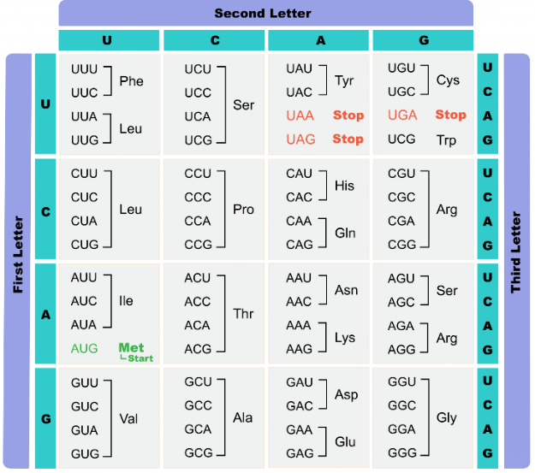
“A segment of an mRNA molecule reads: 5’–AUGAAUUGG–3’. Outline the amino acids in the correct sequence.” “The codon chart illustrates a redundancy but not a mistake in the genetic code. Explain.”
Step 6. (Extending): In this stage, the teacher engaged the students’ in hand-on activities. A sequence of transcribed DNA segment was illustrated on the board and students were mandated to come out with the correct sequence of proteins using the genetic code. This was to enable them to link what they tried their hands on in Step 5.
Step 7. (Refining): Central to this stage is making learners’ to be able to apply what they have learnt to events they encounter in their daily lives (McCarthy & McCarthy, 1997). Therefore, the teacher assigned to the learners’ to make inquiries by posing open-ended questions to them, giving an account of events they encounter in their daily lives such as associating wound healing and digestion as enzymatic actions and that, all those enzymes are proteins made by transcription and translation. The students were assigned tasks like: “When RNA polymerase I is destroyed by mutation, what will be the consequences”? “If a protein is created via the translation of 705 nucleotides, including a start and a stop codon, how many amino acids are included in the final product?”; “A DNA strand reading 5’-GATATC-3’ undergoes a mutation to result in 5’- GATCATC-3’. Identify the exact mutation undergone by the DNA segment”. The answers to all these problems require conceptual reasoning amongst students.
Step 8. (Integrating): During this step, the learners’ were made to teach each other and their friends (McCarthy & McCarthy, 2006). The teacher’s role was to guide the students to give presentations individually and or in groups where their colleagues were given the mandate to ask them questions. The students’ were evaluated by asking them open and close-ended questions, to demonstrate, and also given written exercises and assignments to work on to shape their level of competencies.
Treatment in the EG 2
The instructional package designed for this teacher required him to inform the students’ that the concept of gene expression will be taught by associating its key concepts or assertions with an event they encounter in their daily lives; thus, rice preparation. The lesson plan required that during each lesson, a chart illustrating the key concepts to be learnt with its associated analogy likewise its diagrammatic representations should be pasted on the board. Afterwards, the teacher should engage the learners in cognitive conflict by challenging them to come out with the exact concept in the analogy that represents gene expression. The concepts and their associated analogs are illustrated in Appendix B.
After each lesson in each group, the teachers are required to give them an exercise and a take-home assignment concerning the concepts treated in class. After the teachers had taught their respective class, a post-GERT-B was handed to them to administer to their students to determine the extent to which each teaching approach contributed to the improvement of their correlational reasoning. Two weeks after the post-GERT-B, a parallel form of it thus, a post-post-GERT-B was also handed to them to subject to their students aimed at assessing their probabilistic reasoning skills. The researcher mandated the teachers to subject the GEACQ-B to their students a week after the post-post-GERT-B to determine the approach that best influenced the students’ positive attitude changes toward the topic.
Data Analysis Procedures and Ethical Issues
Version 26 of Statistical Package of Social Sciences (SPSS) was used for analysis using data obtained from the GERT-B’s and GEACQ-B. Analysis of Covariance (ANCOVA), Least Significant Difference (LSD) Post-Hoc Analysis, Box Plot Analysis, effect sizes (partial eta squared [η²p] and observed power [1-β] were used to address the post-GERT-B (correlational reasoning scores) and the post-post-GERT-B (probabilistic reasoning scores) of students. Kruscal-Wallis H Analysis, Mean Ranks [MR], Kruscal-Wallis pairwise comparison, effect size (eta squared [η²]), and Mann Whitney U was carried out to address the final hypothesis (attitude change towards gene expression concepts) using the responses obtained from the GEACQ-B. The author protected the research subjects from harm likewise ensuring their anonymity, informed consent, and confidentiality throughout the study.

Results
Ho1- Significant Treatment and Sex Interaction Effect between the Mean Correlational Reasoning Scores of Students taught Gene Expression Concepts using Interactive Lecture, 4MAT Model, and Analogy Approach
Table 2: ANCOVA of Students Correlational Reasoning Scores
Sources of Variation | Type III Sum of Squares | df | Mean Square | F | p | η²p | 1-β
Corrected Model | 285.004 | 6 | 47.501 | 2.922 | .012 | .173 | .876
Intercept | 876.858 | 1 | 876.858 | 53.931 | .000 | .391 | 1.000
Covariate (Pre-GERT-B Scores) | 16.863 | 1 | 16.863 | 1.037 | .311 | .012 | .172
Approaches | 144.090 | 2 | 72.045 | 4.431 | .015 | .595 | .748
Sex | 70.986 | 1 | 70.986 | 4.366 | .040 | .349 | .542
Approaches X Sex | 2.264 | 2 | 1.132 | 3.940 | .043 | .012 | .160
Error | 1365.743 | 84 | 16.259
Total | 56937.000 | 91
Corrected Total | 1650.747 | 90
The data in Table 3 verifies that [F(2,90)=4.270, p=.043<0.05]; confirms a statistical significance. Therefore, the alternative hypothesis is maintained. It confirms a treatment and sex interaction effect on the students’ correlational reasoning scores. In furtherance, the Table points that [F(2,90)=4.431, p=.015<0.05]; suggesting a statistically significant difference so the null hypothesis is rejected. Finally, the data establishes that [F(1,90)=4.336, p=.040<0.05] confirms a statistical significance. Therefore, the null hypothesis is rejected because the mean correlational reasoning scores of males and females are different. Since both treatment and sex are significant, LSD Post Hoc analysis and mean plot was conducted the find out the exact pedagogy that was potent in enhancing the correlational reasoning of the students. The outcome is presented in Table 4.
Table 4: LSD Post Hoc Analysis of Students Correlational Reasoning Scores
(I) Approaches | (J) Approaches | Mean Difference (I-J) | SE | p
INTERACTIVE LECTURE | 4MAT Model | -2.870 | 1.117 | .012
INTERACTIVE LECTURE | Analogy | -2.780 | 1.109 | .014
4MAT MODEL | Interactive Lecture | 2.870 | 1.117 | .012
4MAT MODEL | Analogy | .089 | 1.164 | .939
ANALOGY | Interactive Lecture | 2.780 | 1.109 | .014
ANALOGY | 4MAT Model | -.089 | 1.164 | .939
SE=Standard Error
It can be inferred from the data in Table 4 that the pairwise comparison between interactive lecture and 4MAT model likewise analogy are all statistically significant [p=0.012<0.05] and [p=0.014<0.05] respectively. Therefore, the alternative hypothesis becomes a reality. This suggests that the efficacies of interactive lecture in improving the correlational reasoning abilities of students differed from 4MAT model and analogy. Again, the Table established that pairwise comparison between 4MAT model and analogy yielded [p=0.989>0.05]; confirming no statistical difference. Therefore, the null hypothesis is maintained. It implies that the potentials of the approaches in improving students’ correlational reasoning are similar. Therefore, it is empirical to conclude that 4MAT model was superior in increasing learners’ correlational reasoning followed by analogy and finally interactive lecture since 4MAT model yielded a smaller p value with interactive lecture than analogy did. This fact is buttressed with a boxplot analysis in Figure 1.

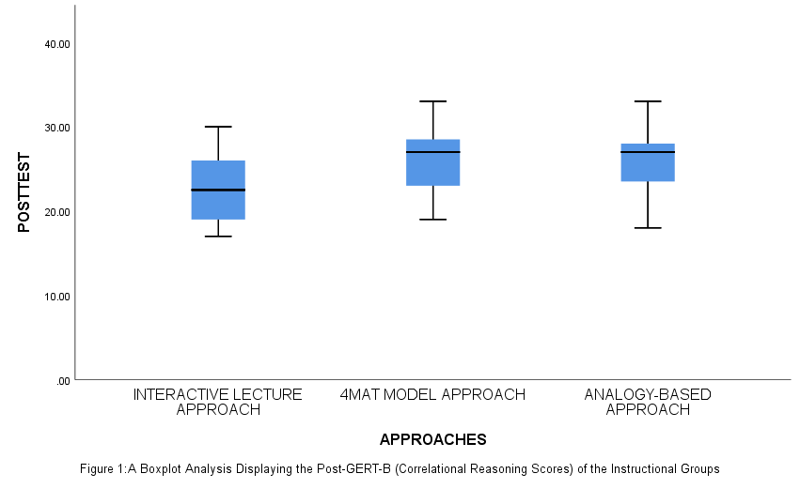
From Figure 1, it can be observed that 4MAT model’s whisker revealed a minimum score of 19 that eventually rose to 33 as the maximum mark. Meanwhile, majority of learners (about 60%’s) score fell within the lower interquartile range of the plot that was hovering from 23-26 marks. It can be verified from the plot that the inter quartile range mark (median) was somewhat 27. However, (about 20%) of the students had their mark falling within the upper quartile range with marks ranging from 28-33. In contrast, with reference to the analysis of the analogy-based group, the Figure established a minimum score of 18 that eventually projected to 33 as the minimum mark. This teaching group had majority of the learners score within the lower quartile range with scores between 23 and 26 and a median of 27; the same as that of 4MAT model. From a critical look at the Figure, only few learners (about 7%) of the students score fell within the upper quartile range thus; marks between 28-33 and this arrangement contributed in making the 4MAT model to obtain a high mean score than analogy. From Table 3, [F(2,90)=4.431, p<.05, η²p=.595, 1-β =.748] suggests that 59.5% of the variance of the correlational reasoning scores were influenced by being subjected to 4MAT model likewise the post-GERT-B playing 74.8% role in assisting 4MAT model to contribute the significant effect. Consequently, the data in Table 2 established that males obtained a higher mean compared to females and a statistically significant difference existed between their means it can be concluded that male students achieved significant gains in their correlational reasoning than females. Nonetheless, Table 3 revealed that [F(1,90)=4.366, p<.05, η²p=0.349, 1-β =0.542]. It depicts that being taught gene expression concepts as a male using 4MAT model, interactive lecture, and or analogy contribute to 34.9% of the variance of your correlational reasoning scores whereas the post-GERT-B was 54.2% powerful in assisting males to obtain the effect.

Ho2- Significant Treatment and Sex Interaction Effect between the Mean Probabilistic Reasoning Scores of Students taught Gene Expression Concepts using Interactive Lecture, 4MAT Model, and Analogy Approach

Table 6: ANCOVA of Students Probabilistic Reasoning Scores
Sources of Variation | Type III Sum of Squares | df | Mean Square | F | p | η²p | 1-β
Corrected Model | 541.883 | 6 | 90.314 | 8.151 | .000 | .368 | 1.000
Intercept | 1028.904 | 1 | 1028.904 | 92.865 | .000 | .525 | 1.000
Covariates (Post- GERT-B Scores) | 36.600 | 1 | 36.600 | 3.303 | .073 | .038 | .435
Approaches | 214.674 | 2 | 107.337 | 9.688 | .000 | .687 | .979
Sex | 83.807 | 1 | 83.807 | 7.564 | .007 | .583 | .776
Approaches X Sex | 2.308 | 2 | 1.154 | 4.304 | .031 | .231 | .265
Error | 930.689 | 84 | 11.080
Total | 61644.000 | 91
Corrected Total | 1472.571 | 90
Table 6 verifies that [F(2,90)=4.304, p=.031<0.05] and it means a statistical significance. Therefore, the null hypothesis is rejected. It exemplifies a treatment and sex interaction effect on the students’ probabilistic reasoning scores. Additionally, the Table reveals that [F(2,90)=9.688, p=0.000<0.05]; establishes statistical significance claiming the need for the null hypothesis to be rejected. This validates that the contribution of each approach in advancing the students’ probabilistic reasoning are different. Finally, the data confirms that [F(1,90)=7.564, p=0.007<0.05]; validates an issue of statistical significance. Therefore, the alternative hypothesis is retained because the probabilistic reasoning scores of males and females differ. However, in order to examine the precise treatment that was prudent in increasing the learners’ probabilistic reasoning scores, LSD Post Hoc analysis was carried out and is indicated in Table 7.
Table 7: LSD Post Hoc Analysis of Students Probabilistic Reasoning Scores across the Teaching Groups
(I) Approach | (J) Approach | Mean Difference (I-J) | SE | p
INTERACTIVE LECTURE | 4MAT Model | -4.918 | .850 | .000
INTERACTIVE LECTURE | Analogy | -1.853 | .873 | .037
4MAT MODEL | Interactive Lecture | 4.918 | .850 | .000
4MAT MODEL | Analogy | 3.066 | .880 | .001
ANALOGY | Interactive Lecture | 1.853 | .873 | .037
ANALOGY | 4MAT Model | -3.066 | .880 | .001
Data in Table 10 verify that pairwise comparison between 4MAT model and interactive lecture likewise analogy are all statistically significant [p=.000<0.05] and [p=.001<0.05] respectively. Therefore, the null hypothesis is not maintained. This validates that the effectiveness of 4MAT model in enhancing the probabilistic reasoning scores of the students’ are not similar to that of interactive lecture and analogy. Furthermore, the Table reveals that pairwise comparison between interactive lecture and analogy yielded [p=.037<0.05]. This also authenticates a statistically significant difference purporting the need for the null hypothesis to be rejected. It implies that the potentials of each approach in refining learners’ probabilistic reasoning are different. Inferring from the data, since the p value generated between 4MAT model and interactive lecture is less than that of its comparison between analogy, it authenticates that, students’ taught using analogy had more gain in probabilistic reasoning than interactive lecture group learners. Boxplot analysis in Figure 2 provides an evidential value to substantiate this claim.

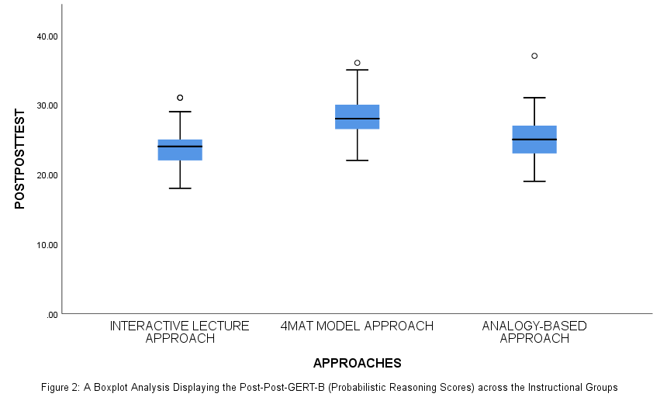
Data in Figure 2 verifies a minimum score of 18 as verified by interactive lecture group’s whisker that eventually rose to 31 as the minimum mark. In contrast, 4MAT model produced a high minimum mark of 22 as revealed by their whisker and eventually rose to 36 as the minimum mark. Analogy based group had their lower whisker pointing to 19 and rose sharply to 37 as the maximum. From interactive lecture’s group plot, most of the scores (about 75%) fell within the lower quartile range thus; from 20-25 whilst their inter quartile range score (median) hovered around 25. This group had few students’ score falling within the upper quartile range thus, from 26-31 and this made them to obtain a minimum mean compared to their colleagues. From 4MAT model’s whisker, few students (about 34%) had their scores within the lower quartile range thus; from 22-27 with their median mark around 28 compared to analogy-based group that had majority of the learners (about 48%) of their scores ranging from 20-25 and their median score around 26. (This score arrangement is a potent reason underlying 4MAT model’s attainment of a high mean mark than analogy). Finally, the Figure validates that majority of students in the 4MAT group (about 53%) had their scores falling within the upper quartile range thus; marks ranging between 29-36 whilst few students (about 30%) in the analogy-based group had their marks falling within the range. Aside from the few students, the scores ranged from 27-37. (This final arrangement made it imperative for 4MAT model to have a significant mean compared to analogy-based group).
Table 6 establishes that [F(2,90)=9.688, p<.05, η²p=.595, 1-β=.979] suggests that 4MAT model contributed 68.7% role in increasing the variance of the learners probabilistic reasoning whereas the post-post-GERT-B was 97.9% supreme in making students exposed to 4MAT model to obtain such significant gain. Since males achieved higher mean probabilistic reasoning score than females did and was statistically significant, it confirms that males scores improved better than females. From Table 6, [F(1,90)=7.504, p<.05, η²p=.583, 1-β=0.776] signals that being taught gene expression concepts as a male using 4MAT model, interactive lecture, and or analogy enhances the individual’s probabilistic reasoning by 58.3% whilst the post-post-GERT-B exhibited 77.6% power in making males to display such effect.
Ho3- Significant Treatment Effect between Interactive Lecture, 4MAT Model, and Analogy and Students Sex and their Attitude Changes toward Gene Expression Concepts
In order to establish whether the attitude change of the students depended on treatment and or their sex, their responses from the GEACQ-B were subjected to Kruscal-Willis H and Mann Whitney U Analysis and the result is presented in Table 8 and 9 respectively.

Table 8: Kruscal-Wallis H Analysis of Attitude Change across the Teaching Groups
 | Methodology | N | MR | Kruskal-Wallis H | df | sig. | η²
ATTITUDE | INTERACTIVE LECTURE | 28 | 22.59 | 44.032 | 2 | .000 | .478
ATTITUDE | ANALOGY | 31 | 44.73
ATTITUDE | 4MAT MODEL | 32 | 67.72
ATTITUDE | Total | 91
The data in Table 8 verifies that [Kruskal-Wallis H=44.032, df=2, sig.=0.000>0.05] and it suggests a statistical difference in the attitude changes of students subjected to either strategy. However, in establishing the exact strategy that was efficacious enough to imbibe positive attitudes, Kruskal-Wallis H multiple comparison test was carried out and as shown in Table 12.
Table 9: Pairwise Comparison of Attitude Change across the Teaching Groups
Methodology | TS | SE | STS | p | Adjusted p
INTERACTIVE LECTURE VRS ANALOGY | -22.137 | 6.861 | -3.227 | .001 | .004
INTERACTIVE LECTURE VRS 4MAT MODEL | -45.129 | 6.810 | -6.627 | .000 | .000
ANALOGY VRS 4MAT MODEL | -22.993 | 6.632 | -3.467 | .001 | .002
It can be deduced from the data in Table 9 that pairwise comparison between interactive lecture and analogy was statistically significant [p=.000<0.05]; implying the need for the null hypothesis to be rejected because the potentials of each approach in enhancing students attitude changes yielded different results. The Table again establishes that pairwise comparison between interactive lecture and 4MAT model resulted in [p=.000<0.05]. It therefore, suggests an issue of statistical significance making it empirical to validate that the efficacies of each approach in improving the students’ attitude changes was dissimilar. Moreover, it was revealed by the data that pairwise comparison between analogy and 4MAT model resulted in [p=.001>0.05]. As a result, statistical significance manifests between the potentials of each of the strategies in improving students’ attitude changes. Making inferences from the data, 4MAT model established significance with both interactive lecture and analogy [p=.000>0.05] and [p=.001>0.05]; suggests that 4MAT was effective in promoting students attitude changes followed by analogy approach and finally interactive lecture. Even their MR in Table 8 buttresses the fact since MR of [interactive lecture=22.59<MR of analogy=44.73<MR of 4MAT model=67.72]. In conclusion, Table 8 established that [Kruskal Wallis H=44.032, df=2, η²=.478]; implies that using 4MAT model to deliver gene expression concepts to a learner contributes 47.8% of his/her ability to develop positive attitudes towards the topic. Nevertheless, in determining the gender that had altered their attitudes toward gene expression concepts, their responses from the GEACQ-B was subjected to Mann-Whitney U analysis as presented in Table 10.
Table 10: Mann-Whitney U Analysis of Attitude Change of Males and Females
SEX | N | MR | Mann Whitney U | Z | Wilcoxon W | df | Sig. | η²
MALES | 63 | 53.17 | 430.5000 | -3.89 |  | 1 | .000 | .168
FEMALES | 28 | 29.88
Total | 91
The data in Table 10 points clearly that [Z=-3.89, df=1, sig.=.000<0.05]; reveals a statistically significant difference. Hence, the null hypothesis is rejected. It means that the attitude changes of males and females regarding gene expression concepts differ from each other. The Table verified further that the mean rank of males is 53.17 whilst that of females is 29.88. It confirms that males developed more positive attitude changes than females. Finally, the Table establishes that [Wilcoxon W=836.500, df=1, η²=.168]. It confirms that being subjected to any of the treatments (interactive lecture, analogy, and or 4MAT model) as a male contributes 16.8% of the student’s ability to develop attitude changes about when learning gene expression concepts.
Discussion
The study established a treatment and sex interaction effect on students’ correlational reasoning scores [F(2,90)=4.270, p=.043<0.05] supporting the 4MAT model [F(2,90)=4.431, p<.05, η²p=.595, 1-β=.748] and males [F(1,90)=4.366, p<.05, η²p=.349, 1-β=.542]. Additionally, the study found a treatment and sex interaction influence effect on the students’ probabilistic reasoning scores [F(2,90)=4.304, p=.031<0.05] backing the 4MAT model [F(2,90)=9.688, p<.05, η²p=.687, 1-β=.979] and males [F(1,90)=7.504, p<0.05, η²p=.584, 1-β=.776]. This reasoning improvement might stemmed from the fact that every phase of the 4MAT model compels students’ to make use of their cognitive thoughts in coming out with solutions to problems. Nonetheless, the microscopic mature of the concepts could have undermined females interchange between “watching” of images, “doing of actions”, and “hypo-deductive reasoning” that are crucial for providing them the impetus on their internal ideas. These findings corroborate Alhadaybeh and Ambusaedy (2016) and Ghazal (2016) reported positive impacts of 4MAT’s approach on reflective thinking among learners’ in their separate studies. Finally, Azam (2016) reported the positive impact of 4MAT approach on learners’ understanding and application of scientific knowledge. Yenilmez et al. (2016) reported that males achieved higher scores than females on probabilistic reasoning. Similarly, Valanides’ (2017) study using 12th grade Cypriot students revealed that males had significantly better performance than females on probabilistic reasoning items. These findings contradict Yenilmez et al. (2016) who found that females achieved better than males on correlational reasoning items. Finally, the study revealed that 4MAT model was efficacious in enhancing students attitude changes [Kruskal Wallis H=44.032, sig.<.05, df=2, η²=.478] whereas males displayed positive attitudinal changes than females [Wilcoxon W=836.500, Z=-3.89, df=1, sig.<0.05, η²=.168]. This positive changes were so because 4MAT model made every learner an active participant in each of the stages thereby making them very active throughout lessons thereby leading to their development of positive attitudes. The findings mimic Coll et al. (2015) and Pratoomtong (2011) study showed that 4MAT approach was superior to other approach[es] in developing learners’ attitudes toward Science. Similarly, Lisa (2016) and Oluwatelure (2015) reported that males display positive attitudes toward Science than females in their separate studies.
Implications of the Findings
- To educationists, the findings established that most learners face challenges when learning gene expression concepts that are resilient to alterations. It implies that the current instructional approaches used in teaching Biology in Ghana cannot effectively enhance scientific reasoning patterns and positive attitude change of students with respect to their sexes. Strategies that cater for the differences in students’ hemispheric and learning style preferences would be more appropriate for teaching Biology. The 4MAT model was potent to engage the role of the hemispheres of the brain to address the conceptual reasoning of learners with diverse backgrounds regardless of their sex that makes it potent for educationists to resort to it.
- For Biology teachers’, the findings verified that most of them do not usually select suitable instructional method[s] in teaching the discipline and this has led to constant decline in performance of students in the subject. Biology teachers’ therefore, have to be selecting a learner-centered approach like 4MAT other than conventional teaching methods and other unsuitable approaches since the latter do not address effective scientific reasoning and attitudinal changes in male and female students.
- The findings signal for Biology textbooks review within the nation. With the effectiveness of 4MAT model in improving students’ scientific reasoning and attitude changes, it is apparent that the present Biology textbooks endorsed by the MoE are insufficient to meet the needs of the learners thus; making it vital for them to be revised. This will without hesitation, facilitate students’ conceptual reasoning and to develop their positive attitudes toward Biology.
Conclusions
As 4MAT model is rooted in the brain’s hemisphericity, it made the students’ to build interpersonal and intrapersonal mental progress for themselves, by themselves and with their colleagues made them very active during lessons that in turn had a significant influence on their reasoning patterns and their attitudes toward the concepts being taught. Therefore, the study concludes that 4MAT model enhances students’ logical reasoning and positive attitudes toward Biology. Meanwhile, the microscopic nature of the concepts might had lessened the female students’ abilities to test ideas in reality and to adapt effectively what they learn had learnt thereby affecting their scientific reasoning patterns and attitude change. As such, the study draws that logical reasoning and attitudes of students toward Biology is dependent on sex.
Contributions to Knowledge
- The researcher adapted the 4MAT model to examine its efficacies on learners correlational and probabilistic reasoning likewise their attitudinal changes irrespective of their sex for the first time to teach the concept of gene expression to SHS Biology students. Thus, it serves as contribution to knowledge because it confirmed its potentials in improving the learners’ reasoning and positive attitudes despite the challenging and abstract nature of DNA concepts. Besides, the 4MAT model has not been employed at any educational level in Ghana to measure any of these educational variables in a single study.
- The GERT-B and GEACQ-B were supreme in enhancing the students’ reasoning abilities and in developing males’ attitude change towards gene expression concepts compared to their female counterparts. Knowledge-wise, it is the only study in Ghana that had compared three constructivist approaches in a study with all variables being measured statistically significant in favour of males. Hence, the study had revealed a wide sex gap between males and females concerning scientific reasoning and attitude changes in Biology.
- Finally, the 4MAT model’s efficacies in enhancing the learners’ scientific reasoning might stem from the fact that they were able to recognize that though different enzymes and molecules play critical roles in the formation of proteins (enzymes) but appreciated the need to explicate the actual cause-effect between RNA polymerase I and other enzymes and molecules involved in gene expression. Therefore, they were able to conceptualize the actual roles played by the various enzymes and molecules involved in the process. This reasoning capacity displayed strengthens the inferential learning theory propounded by Ryszard (1983).
Recommendations
- Biology teachers’ in the Jaman North District should use 4MAT model when delivering gene expression concepts to enable learners to build interpersonal and intrapersonal mental progress for themselves, by themselves and with their colleagues to enable them to link what they had previously learnt to new ones in order to improve their biological reasoning patterns.
- Teaching using 4MAT model was found to appease the learners’ by making them excited in carrying out tasks, made lessons enjoying, and made learners very happy as reported by the teacher handling the group. Therefore, Biology teachers should use 4MAT approach for other topics that belongs to microscopic level of organization such as cell division, cell structure, genetics, and the likes.
- Biology teachers’ should take students sex into cognisance during their lesson deliveries. The study concluded that students’ sex was a significant factor in determining the correlational and probabilistic reasoning likewise their attitude changes. Hence, teachers’ should try to recognise each learner within their classroom as an individual. This will enable them to select instructional strategies that cater for hypo-deductive reasoning to streamline sex differences in Science classrooms.
Acknowledgements
The researcher expresses his in-depth gratitude to all staff at the Jaman North District Educational Directorate, administrative heads, teachers, and all students within SHS’s in the Jaman North District and the Jaman South Municipality that made the study successful.
References
Adebule, S. O., & Aborishade, O. J. (2014). Gender comparison of attitude of Senior Secondary School students toward Mathematics in Ekiti State, Nigeria. European Scientific Journal, 10(19), 153-160.
Aini, R. Q., Rachmatullah, A., & Ha, M. (2019). Indonesian Primary School and Middle School students’ attitudes toward Science: Focus on gender and academic level. Journal of Baltic Science Education, 18(5), 654-667.
Alanazi, F. H. (2020). The effectiveness of the 4MAT teaching approach in enhancing conceptions of electricity in Physics for female students in the Kingdom of Saudi Arabia. Journal of Turkish Science Education, 17(2), 271-288.
Alhadaybeh, E., & Ambusaedy, A. (2016). The effect of using McCarthy model in improving reflective thinking and Science achievement for Grade 6th Basic female students. Jordan Journal of Educational Sciences, 12(1), 1-15.
Ali, M. M., & Awan, R. E. (2013). Changes in student attitudes regarding Science when taught by teachers without experiences with a model professional development program. School Science and Mathematics, 113(3), 109-119.
Allchin, D., & Zemplén, G. Á. (2020). Finding the place of argumentation in Science Education: Epistemics and Whole Science. Science Education, 104(5), 907-933.
Alozie, N. M., Moje, E. B., & Krajcik, J. S. (2019). An analysis of the supports and constraints for scientific discussion in High School project-based Science. Science Education, 94(3), 395- 427.
Altermatt, E., Jovanovic, J., & Perry, M. (2018). Bias or responsivity? Sex and achievement-level effects on teachers’ classroom questioning practices. Journal of Educational Psychology, 90, 516-527.
American Association for the Advancement of Science. [AAAS]. (2009). Vision and change in undergraduate Biology Education: A call to action. American Association for the Advancement of Science.
Ameyaw, Y., & Kyere, I. (2018). Analogy-based instructional approach: A panacea to students’ performance in studying deoxyribonucleic acid (DNA) concepts. International Journal of Sciences, 7(5), 1-13.
Asare, M. (2020). Effect of classroom discussion on academic outcomes of second year Biology students at Winneba Senior High School (Unpublished MPhil. thesis), University of Education, Winneba.
Ayiwah, M. W., Nunifant, T., Akantagriwon, D., & Nyamekye, P. (2018). Effects of analogy instructional strategy on students’ performance in wave concept. Journal of Education and Practice, 9(5), 111-119.
Azam, M. (2016). The effectiveness of using McCarthy model (4MAT) in acquisition the scientific concepts and developing the learning and thinking styles for 8th Grade students. Retrieved from https://www.minia.edu.eg/edu/images/Scientific-Journal/Fifthvolume- 2016/Mahmoud-Ramadan.doc on May 2, 2020
Barnes, N. H., & Blevins, P. (2013). Comparison between interactive lecture and inquiry approaches. Strengths and weaknesses. Fortress.
Bateson, G. A. (1967). The invented reality: How do we know what we believe we know Behavior, 10(8), 2-9.
Bekoe, V. D. (2020). Effect of computer assisted instruction (CAI) on students’ academic outcomes and attitude in human circulatory system among selected Senior High Schools in Accra Metropolitan Assembly (Unpublished MEd. thesis), University of Cape Coast.
Bianchini, J. A., Cavazos, L. M., & Helms, J. V. (2020). From professional lives to inclusive practice: Science teachers and scientists’ views of gender and ethnicity in Science Education. Journal of Research in Science Teaching, 37(6), 511-547.
Bray, E. B., Shaw, N., Momsen, J., Reinagel, A., Le, P., & Taqieddin, R (2010). Introductory Biology students’ conceptual models and explanations of the origin of variation. CBE Life Science Education, 13, 529-539.
Brotman, J. S., & Moore, F. M. (2018). Girls and Science: A review of four themes in the Science Education literature. Journal of Research in Science Teaching, 45(9), 971-1002.
Cabansag, M. (2014). Impact statements on the K-12 Science program in the enhanced Basic Education Curriculum in Provincial Schools. International Refereed Research Journal, 5(2), 22-29.
Carnevale, A. P., Smith, N. & Melton, M. (2011). STEM: Science, Technology, Engineering, Mathematics. Georgetown University Center on Education and the Workforce.
Casmir, N. E. (2011). Influence of gender on students’ attitude towards Biology in Enugu East Local Government Area of Enugu State. The Nigerian Journal of Research and Production, 18(1), 1-9.
Čavojová, V., Šrol, J., & Jurkovič, M. (2020). Why should we try to think like scientists? Scientific reasoning and susceptibility to epistemically suspect beliefs and cognitive biases. Applied Cognitive Psychology, 34(1), 85-95.
Chew, F. T. (2014). Use of analogies to teach general Biology to non-Biology majors. Retrieved September 9, 2024 from http://.www.edt/.nus.edu.sg/link/mar2004/tm3htm
Chilwant, K. (2012). Comparison of two teaching methods, structured interactive grouping and conventional lectures. Biomedical, 23(3), 363–376.
Chiu, M. N., & Lin, J. W. (2015). Promoting fourth graders’ conceptual change of their understanding of electric current via multiple analogies. Journal of Research in Science Teaching, 42(4), 429-464.
Coll, R. K., France, B., & Taylor, I. (2015). The role of models and analogies in Science education: Implication from research. International Journal of Science Education, 27(2), 183-198.
Confrey, J., & Upchurch, R. (1985). Psychological basis of education. Paper presented at the American Educational Research Association Meeting, Chicago.
Eklund, J., Rogat, A., Alozie, N., & Krajcik, J. (2017). Promoting student scientific literacy of molecular genetics and genomics. Paper presented at the annual meeting of the National Association for Research in Science Teaching, April, 2017, New Orleans.
Fathi, Azar, E., Mansor, B., Shahram V., & Vahideh A. (2013). The effect of instructional analogies in interaction with logical thinking ability on achievement and attitude toward Chemistry. Chemistry Education Research Practicum, 14, 566-575.
Ghazal, R. (2016). The effectiveness of using format (4MAT) system in developing the scientific concepts and thinking skills among seventh graders in Gaza. Retrieved from http://library.iugaza.edu.ps/thesis/119485.pdf on December 12, 2020
Ha, M., Sya‘bandari, Y., Rusmana, A. N., Aini, R. Q., & Fadillah, S. M. (2021). Comprehensive analysis of the FORT instrument: Using distractor analysis to explore students’ scientific reasoning based on academic level and gender difference. Journal of Baltic Science Education, 20(6), 906-926.
Hacieminoglu, E. (2016). Elementary school students’ attitude toward Science and related variables. International Journal of Environmental & Science Education, 11(2), 35-52.
Herron. J. D. J. (1984). Implications of Piagetian theory. Chemical Education, 6(1), 38-50.
Huang, C. (2013). Gender differences in academic self-efficacy: A meta-analysis. European Journal of Psychology of Education, 28(1), 1-35.
Huitt, W. G. (2020). Using the 4MAT system to design web-based instruction. Retrieved April 20th 2021 from http://chiron.valdosta.edu/whuitt/papers/4matonweb.html
Institute of Biology. (2017). Annual report 2017. http://www.10b.org/user files/ar-www.pdf on March 30, 2023
Jansen, M., Schroeders, U., & Lüdtke, O. (2014). Academic self-concept in Science: Multidimensionality, relations to achievement measures, and gender differences. Learning and Individual Differences, 30, 11-21.
Johnson, M. A., & Lawson, A. E. (1998). What are the relative effects of reasoning ability and prior knowledge on Biology achievement in expository and inquiry classes. Journal of Research in Science Education, 35, 89-103.
Kate-Wright, K. L., Fisk, N. J., & Newman, D. L. (2014). DNA’! RNA: What do students think the arrow means? CBE–Life Science Education, 13, 338–348.
Kessels, U., Heyder, A., Latsch, M., & Hannover, B. (2014). How gender differences in academic engagement relate to students’ gender identity. Educational Research, 56(2), 220-229.
Killen, R. (2017). Teaching strategies for quality teaching and learning. Shuman Printers.
Kind, P. M., & Osborne, J. (2017). Styles of scientific reasoning: A cultural rationale for Science Education? Science Education, 101(1), 8-31.
Kvale, S. (2019). Interviews: Learning the craft of qualitative research interviewing. SAGE Publications.
Lisa, M. H. (2016). Gender differences in student attitudes toward Science in Secondary School classrooms with resident scientists. (Masters’ thesis), Texas State University.
Mankilik, M., & Umaru, M. G. (2011). Effects of teaching methods and ability levels on students’ achievement in Physics. African Journal of Science Technology and Mathematics Education (AJSTME), 1(1), 39-49.
Marbach-Ad, G. (2011). Attempting to break the code in student comprehension of genetic concepts. Journal of Biology Education, 35(4), 183-189.
McCarthy, B. (1997). A tale of four learners: 4MAT’s learning styles. Educational Leadership, 54, 46-51.
McCarthy, B. (2000). About teaching 4MAT in the classroom. About Learning, Inc.
Ministry of Education. [MOE]. (2010). Teaching syllabus for Biology. Author.
Miranda, E., & Landmann, R. (2011). Instructional system. Roeper Review, 23(4), 230–235.
National Science Board. (2010). Science and Engineering Indicator. National Science Foundation.
National Science Foundation (2019). Women, minorities, and persons with disabilities in Science and Engineering: 2019. National Science Foundation.
Newman, D., Catavero, C., & Wright, L. (2012). Students fail to transfer knowledge of chromosome structure to topics pertaining to cell division. CBE-Life Sciences Education, 11, 425– 436.
Nkoju, Z. C., & Jacks, A. N. (2011). Identification of difficult process skills in Physics practical activities amongst Advanced Level Physics. African Journal of Science Technology and Mathematics Education (AJSTME), 1(1), 61-69.
Novak, J. D. (1987). Meta-cognitive strategies to help students learn how to learn. National Association of Research in Science Teaching Newsletter, 29(3), 5-18.
NRC. [National Research Council]. (2012). A framework for K-12 Science Education: Practices, crosscutting concepts, and core ideas. National Academy Press.
Nzelum, V. N. (2010). Molecular Biology. Amaka Dreams Limited.
Okebukola, P. A. (2015). The race against obsolescence: Enhancing the relevance of STAN to national development. Memorial lecture of STAN. Taste & Styles Company.
Oluwatelure, T. A. (2015). Gender difference in achievement and attitude of public Secondary School students towards Science. Journal of Education and Practice, 6(2), 87-92.
Onyegegbu, N. (2009). Effects of video and audio-rolliograph on students’ achievement and reaction in the understanding of Biology (Unpublished PhD thesis), University of Ibadan, Nigeria.
Özmen, H. (2011). Turkish primary students’ conceptions about the particulate nature of matter. International Journal of Environmental & Science Education, 6(1), 99-121.
Piaget, J. (1967). Six psychological studies. Vintage.
Powell, K. (2013). Spare me the lecture. Nature, 42(5), 234–246.
Pratoomtong, W. (2011). A development of Science learning activities based on 4MAT system and learning styles to promote multiple intelligences of Sixth Grade students (Unpublished PhD thesis), Srinakharinwirot University.
Reinagel, A., & Bray, S. E. (2016). Beyond the central dogma: Model-based learning of how genes determine phenotypes. CBE Life Science Education, 15, 1-13.
Rusmana, A. N., Sya’bandari, Y. Aini, R. Q., Rachmatullah, A., & Ha, M. (2021). Teaching Korean Science for Indonesian middle school students: Promoting Indonesian students’ attitude towards Science through the Global Science Exchange Program. International Journal of Science Education, 43(11), 1837-1859.
Saddler, P. M., & Tai, R. H. (2021). Success in Introductory College Physics: The role of High School preparation. Science Education, 85(2), 111-136.
Sakariyau, A. O., Taiwo, M. O., & Ajagbe, O. W. (2016). An investigation on Secondary School students’ attitude towards Science in Ogun State, Nigeria. Journal of Education and Practice, 7(28), 125-128.
Salih, M. (2010). Developing thinking skills in Malaysian Science students via an analogical task. Journal of Science and Mathematics Education in Southeast Asia, 3(3), 110-128.
She, H. C., & Liao, Y. W. (2010). Bridging scientific reasoning and conceptual change through adaptive web-based learning. Journal of Research in Science Teaching, 47(1), 91-119.
Sya’bandari, Y., Ha, M., Lee, J. K., & Shin, S. (2019). The relation of gender and track on High School students’ attitude toward convergence. Journal of Baltic Science Education, 18(3), 417-434.
Teddlie, C., & Yu, F. (2017). Mixed methods sampling: A typology with examples. Journal of Mixed Methods Research, 1(1), 77-100.
Tidon, R., & Lewontin, R. (2014). Teaching evolutionary Biology. Genetics and Molecular Biology, 27(1), 124-131.
Tiwari, S. & Anwar, E. (2015). Environmental awareness and attitude towards Science: A correlation study. Paripex-Indian Journal of Research, 4(2), 197-198.
United Nations Educational, Scientific and Cultural Organization. [UNESCO]. (2017). Cracking the code: Girls’ and women’s education in Science, Technology, Engineering and Mathematics (STEM). UNESCO.
Uyangor, S. M. (2012). The effectiveness of the 4MAT teaching model upon student achievement and attitude levels. International Journal of Research Studies in Education, 1(2), 43-53.
Valanides, N. C. (1996). Formal reasoning and Science teaching. School Science and Mathematics, 96(2), 99-107.
Van der Graaf, J., Van de Sande, E. Gijsel, M., & Segers, E. (2019). A combined approach to strengthen children’s scientific thinking: Direct instruction on scientific reasoning and training of teacher’s verbal support. International Journal of Science Education, 41(9), 1119-1138.
Van-Mil, M. H. W., Boerwinkel, D. J., & Waarlo, A. J. (2013). Modelling molecular mechanisms: A framework of scientific reasoning to construct molecular level explanations for cellular behaviour. Science and Education, 22, 93–118.
von Glasersfeld, E. (1980). Constructivism theory. Paper presented at the International Congress on Applied Systems Research and Cybernetics, Acapulco, Mexico.
von Glasersfeld, E. (1983). Constructivism and psychology. Paper presented at the North American Group for Psychology and Mathematics Education meeting, Montreal.
Weld, J., Stier, M., & McNew-Birren, J. (2011). The development of a novel measure of scientific reasoning growth among college freshmen: The constructive inquiry Science reasoning skills test. Journal of College Science Teaching, 40(4), 101-107.
West African Examinations Council. [WAEC]. (2013-2021). Chief examiners’ report for Biology. WAEC Press Limited.
Wilhelm, J., Cole, M., Cohen, C., & Lindell, R. (2018). How Middle Level Science teachers visualize and translate motion, scale, and geometric space of the earth-moon-sun system with their students. Physical Review Physics Education Research, 14(1), 101-115.
Yang, F. Y., Bhagat, K. K., & Cheng, C. H. (2019). Associations of epistemic beliefs in Science and scientific reasoning in university students from Taiwan and India. International Journal of Science Education, 41(10), 1347-1365.
Yanowitz, K. L. (2011). The effects of analogies on elementary school students’ learning of scientific concepts. School Science and Mathematics, 10(1), 133-142.
Yenilmez, A., Sungur, S., & Tekkaya, C. (2016). Investigating students’ logical thinking abilities: The effects of gender and grade level. Hacettepe University Journal of Education, 28(28), 219-225.

Appendix A
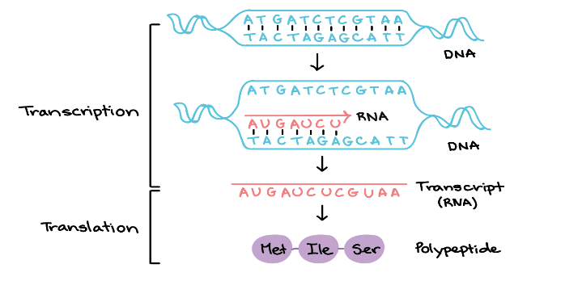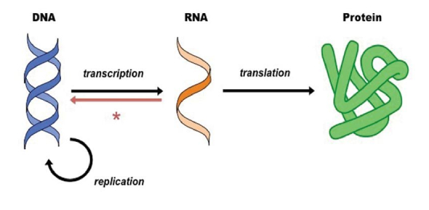

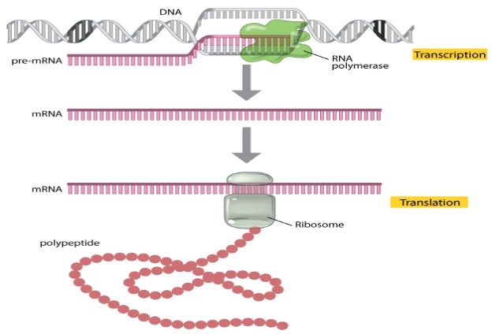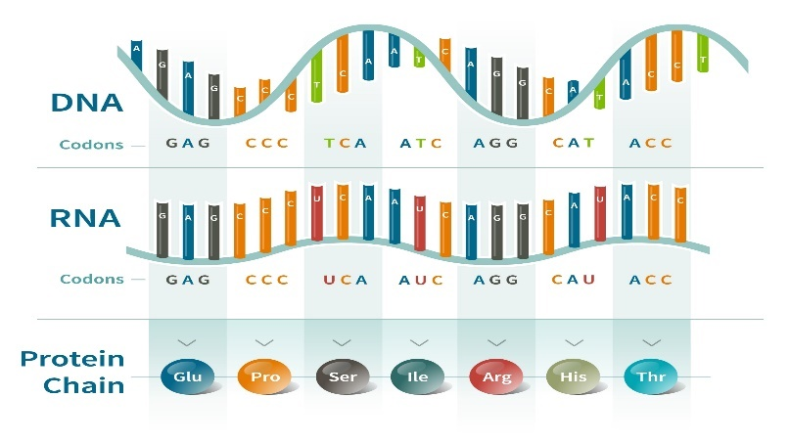

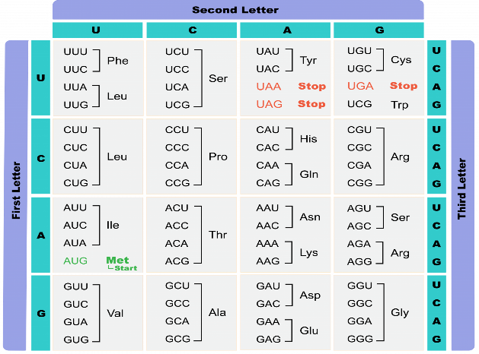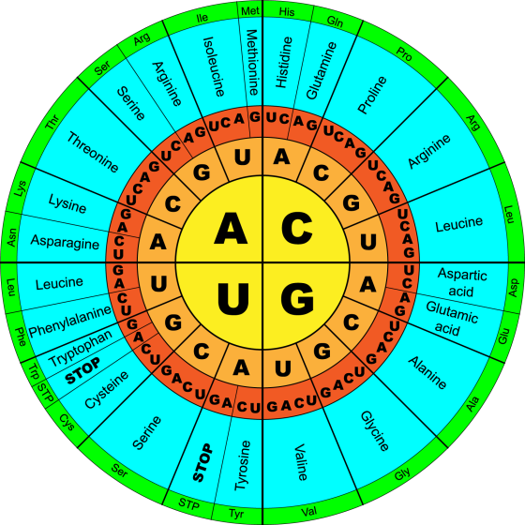
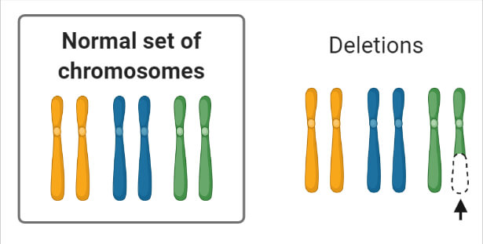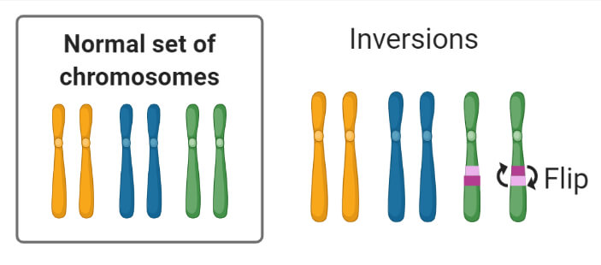
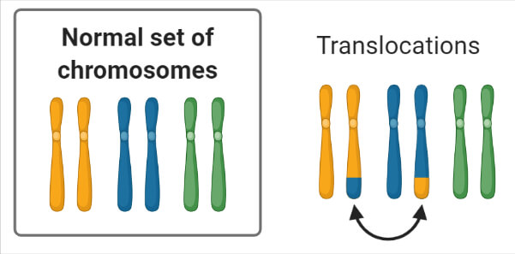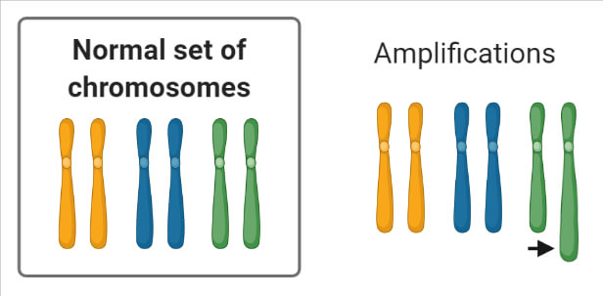
Appendix B
Concept | Analogy (Rice Preparation)
Gene expression-The process by which DNA directs protein synthesis | A situation whereby an ideal checklist directs a cook about how to prepare rice he/she is not familiar and or not familiar with for a patient
Protein-Product of gene expression | The exact rice prepared for the patient’s well-being
DNA-Carries hereditary information | The checklist illustrating the steps involved in the preparation of the rice
Origin of gene expression (TATA box)-The exact location in an organism’s DNA sequence where gene expression begins | The precise equipment/activity that initiates the preparation of rice thus; a source of heat and or making ingredients ready
RNA-A molecule similar to DNA | Another checklist demonstrating a similar way of preparing rice for the patient
Gene-Basic unit of hereditary | Simple ingredient required for rice preparation e.g., water
Ribosome-Site for protein synthesis | The ideal place where the rice is prepared thus, the kitchen
Cytoplasm-Location where all metabolic activities occur in cells | A kitchen having all appropriate equipment and the ingredients to cater for the preparation of every meal
Nucleus-Stores hereditary information | The precise place where the checklist is kept e.g., in a file which is placed in a cupboard
Amino acids-Monomers/building blocks of protein | The exact ingredients for preparing the rice
Transcription-Changing a segment of DNA molecule to RNA segment | Making a black and white photocopy of the checklist
RNA polymerase-The enzyme that catalyses the orderly pairing when DNA helix unwound for its information to be written into mRNA | An involuntary signal that informs the cook during preparation that it can be prepared in a similar manner
Messenger RNA (mRNA)-Sends information regarding how amino acids is arranged in proteins | The kitchen attendant alerting the cook immediately he/she skips a step in the checklist in order to obtain the exact meal
Transfer RNA (tRNA)-Sends amino acids to the ribosome | The kitchen assistant sending ingredients to the kitchen
Anticodon-Any three base triplets that pairs with a codon | Three of the uncooked ingredients that can be combined to form the rice e.g., water, salt, and rice
Codon-Any three base triplets in mRNA | Three ingredients that had been cooked together to form a similar rice for the patient
A ribosome reads a codon once at a time | The cook reads the kitchen instructions on how to prepare any raw ingredient once at a specific time
Each codon corresponds to a specific amino acid | Each step in the checklist illustrates how to make use and or cook a specific ingredient
Ribosomes join amino acids to form peptide bonds between proteins (translation) | The cook abides by the instructions on the checklist consciously to produce a nice and palatable meal
Energy is release when a peptide bond is formed | A source of heat is required for the cook to be able to prepare the rice
Translation stops when RNA polymerase reaches a stop codon | The cook switches off all sources of heat whenever any ingredient is well boiled and or puts off any electrical appliance such as a blender, rice cooker, and or any appliance off after its services are completed
Genetic code-Made up of 64 base triplets | Three specific ingredients; water, salt, and rice that had been mixed and cooked to produce the exact rice in 64 locations
Genetic code is redundant-One or more codons can specify a particular amino acid | The cook can prepare the same kind of rice when given the three ingredients under the same conditions and instructions
Mutation-Alterations made in DNA sequence | Errors that can be made by the cook during preparation
Deletion | Failure for the cook to add some of the ingredients during preparation
Inversion | Exchanging some of the steps in the checklist for another which in turn can change the would-be color of the rice
Duplication | Repeating some steps in the checklist twice. For example, using two cups of water instead of one and or adding two spoons of salt instead of one.
Substitution | Exchanging any of the ingredients for a different one

Analogy Breaks/Limitations (Where Primer and Vernacular Misconceptions can evolve amongst Learners)
- The process of gene expression is microscopic whereas rice preparation is macroscopic.
- Gene expression is the metabolic role played by DNA only in living cells but rice preparation as employed in the study was geared toward animals capable of insight learning; precisely, humans. Notwithstanding, rice can be prepared by any human who had observed how it is being prepared before; not necessarily; a professional cook.
- Cytoplasm is a watery medium but when a kitchen has its all ingredients suspended in such medium, and or the floor is covered with water, as the analogy adapted utilised, the cook cannot move about freely in the kitchen. Indeed, hazards such as falling, fracture, and dislocation may result. Even some of the ingredients may get rotten.
- In rice preparation, when three different ingredients are given to a cook under the same conditions on different occasions, the rice that will be prepared would not be similar; but the genetic code being redundant depicts that, one or more codons can specify the same amino acid.
- Gene expression occurs in cells as an involuntary action in their nuclear region anywhere and anytime with its frequency dependent on the organism’s life processes. Meanwhile, the kitchen was ascribed as the appropriate place for preparing rice but the situation is not always true because rice can be prepared outside the kitchen.

