Effect of calcination temperature on biodiesel production from palm kernel oil using a bifunctional catalyst derived from calcium carbide residue (CCR) and anthill clay (AC)
¹Justina Oduwa Okhonmina* and ²Kessington Obahiagbon
¹²Department of Chemical Engineering, Faculty of Engineering, University, of Benin, Benin City,
Edo State, Nigeria.
justina.okhonmina@uniben.edu

ABSTRACT
The aim of this study is to investigate the effect of calcination temperature on biodiesel production from palm kernel oil using a bifunctional catalyst derived from calcium carbide residue (CCR) and anthill clay (AC). The specific objectives include to synthesize a ZnO-doped CaO/Anthill clay composite using CCR and anthill clay as precursors, to evaluate the effect of various calcination temperatures (650 °C to 850 °C) on the catalyst’s chemical and structural properties, to identify the optimal temperature that maximizes the density of active sites while preventing structural degradation, and to test the catalyst's effectiveness by converting palm kernel oil into biodiesel and evaluating the final yield. The CCR and AC precursors were prepared and characterized using X-ray diffraction (XRD), scanning electron microscopy (SEM), Fourier Transform Infrared (FT-IR) spectroscopy, X-ray fluorescence (XRF), and Brunauer-Emmett-Teller (BET). Composites of the prepared CCR and AC were formulated in ratios 1:4, 2:3, 1:1, 3:2, and 4:1 of CCR:AC and doped with 1.5 M zinc nitrate, by wet impregnation and calcined at 3 different temperatures (650 ºC, 750 ºC, and 850 ºC), resulting in 15 different catalyst samples (A1 – E3) which were used for the biodiesel production. Ratio 2:3 catalyst (D2) calcined at 750 ºC gave the highest yield (92.73%). Its XRF analysis result gave compositions of 52.1% CAO, 10.4% SiO₂, and 7.4% Al₂O₃. Its surface area, pore diameter and pore volume were 226.9m²/g, 2.9nm and 0.2cc/g respectively. The palm kernel oil (PKO) used for the biodiesel production was characterized and its properties showed it was suitable for the production. The produced biodiesel properties aligned with ASTM D6571 and EN 14214 standards upon characterization. This study successfully synthesized a high-performance ZnO-doped CaO/Anthill clay composite from sustainable materials, identifying calcination temperature as the key factor influencing catalyst activation and structural stability and also contributes to the promotion of renewable and sustainable energy.
Keywords: Palm kernel oil, Calcium Carbide Residue, Anthill clay, Calcination Temperature, Biodiesel.

INTRODUCTION
The global shift toward sustainable energy has positioned biodiesel as a viable, carbon-neutral alternative to traditional fossil fuels. Biodiesel is an alternate energy source which is made from biological components like vegetable or animal fats and used cooking oils [17]. Transesterification is the most widely used technique for producing biodiesel [12]. It involves the reaction of triglycerides with alcohol (often methanol or ethanol) in the presence of a catalyst to produce glycerol and biodiesel [4]; [6]; [8]. While biodiesel offers lower emissions and high biodegradability, its commercial production is often limited by high costs. Homogeneous catalysts are largely responsible for this, as they cannot be recovered and require expensive water-washing steps. To overcome these barriers, recent research has focused on the "circular economy" by developing heterogeneous catalysts from industrial and environmental waste, such as calcium carbide residue (CCR) and anthill clay [11]; [17]; [19]. When heterogeneous catalysts are used in transesterification, they yield glycerin with greater purity and lower levels of dissolved ions [15].

The performance of these waste-derived catalysts depends heavily on the calcination temperature. This thermal treatment is necessary to convert inactive mineral precursors into reactive oxides like CaO and ZnO. However, finding the optimal temperature is a major challenge. If the temperature is too low, the catalyst remains chemically inactive; if it is too high, the material undergoes sintering, which causes the internal pores to collapse and reduces the surface area available for the reaction [2]; [14]. Identifying the precise thermal "sweet spot" is therefore essential for creating an efficient and stable catalyst.

MATERIALS & METHODS
Collection of materials
The CCR and AC precursors were obtained from some welder’s shop and anthill respectively, in Ugbowo in Benin City, Edo State, Nigeria. The PKO was purchased from a local vendor in Benin City also.
Catalyst preparation
According to Okhonmina et al. [17], the locally sourced precursors were beneficiated, pulverized and screened to < 200µm and calcined at 800 ºC for 4 hours. The calcined AC was treated with 2M H₂SO₄, washed and dried. It was calcined again at 800 ºC for 2 hours, 30 minutes. The precursors were combined in 5 different ratios; 1:4, 2:3, 1:1, 3:2, and 4:1 of CCR:AC and doped with 1.5 M zinc nitrate, by wet impregnation and calcined at 3 different temperatures (650 ºC, 750 ºC, and 850 ºC), resulting in 15 different catalyst samples (A1 – E3) which were used for the biodiesel production.
Catalyst characterization
The precursors and formulated catalyst were characterized using X-ray diffraction (XRD) analysis for crystalline phase, Scanning electron microscopy (SEM) with Energy Dispersive X-ray (EDX) for the surface structure, Fourier transform infrared spectroscopy (FTIR) for bond structure and interaction, X-ray fluorescence (XRF) analysis for elemental composition, and Brunauer-Emmett-Teller (BET) analysis for surface area and pore properties.
Characterization of palm kernel oil
The palm kernel oil was characterized to determine its suitability as feedstock for biodiesel production.
Production of biodiesel
Production of biodiesel was carried out using the 15 different catalysts at fixed input parameters of 65 ºC, 90 mins, 9:1 and 3 wt % reaction temperature, reaction time, methanol to oil ratio and catalyst loading respectively. A one-step technique transesterification process was used for the biodiesel production, based on the bi-functionality of the synthesized catalyst. A batch-type stirred reactor which comprised a hot plate magnetic stirrer with a magnetic stirring bar for proper mixing to obtain uniform mixture, and a 250ml conical flask with a cork was employed for the biodiesel production. 50g of the PKO was transferred into the reactor and heated to 65 ºC. 3 wt % of catalyst and 9:1 methanol to oil ratio mixture was added, and the mixture was left to react for 90 mins [17], using a fixed stirring speed.
After each production, the resulting mixture was transferred into a separating funnel and left to stay overnight for proper settling, after which the glycerol at the bottom layer was run out with the aid of the separating funnel. The biodiesel with the unreacted methanol mixture was washed and transferred to an oven. The unreacted methanol evaporated while the biodiesel was stored. The transesterification process, separation process and the produced PKO biodiesel are displayed below in figure 1 (a), (b) and (c) respectively. Equation 1 below was used to determine the biodiesel yield.
$biodiesel yield \left(\%\right)=\frac{(weight of biodiesel produced)}{(weight of PKO used)}×100$ (1)
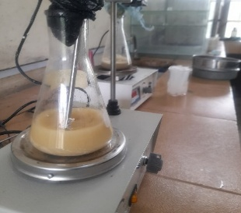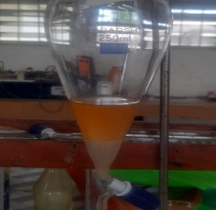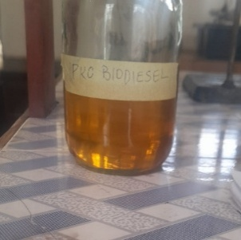
- (b) (c)
Figure 1: Biodiesel production process (a) transesterification process (b) separation process (c) produced PKO biodiesel
Characterization of the produced biodiesel
The produced biodiesel was characterized to determine its properties such as acid value, FFA, saponification value, average molecular weight, density, kinematic viscosity, moisture content, iodine value, peroxide value, etc.

RESULTS AND DISCUSSION

X-ray diffraction (XRD) analysis
With the aid of the XRD analysis, identification of the crystalline phases was achieved and the structure and physical properties of the precursors and composite catalyst were determined [18]. Figure 2 (a), (b) and (c) below show the XRD pattern of the precursors and composite catalyst.
The XRD pattern of the calcined calcium carbide residue (CCR) precursor in figure 2 (a) reflects the complete thermal transformation of its original carbonate and hydroxide phases. The pretreatment at 800 °C ensures the full decomposition of Portlandite [Ca(OH)₂] and Calcite [CaCO₃] into cubic calcium oxide (CaO). This is evidenced by sharp, high-intensity diffraction peaks at 2θ values of approximately 32.2°, 37.4°, and 53.9° [14]. The high degree of crystallinity at this temperature provides a stable source of basic active sites, which are essential for the subsequent transesterification of triglycerides [13].
The diffraction pattern of the anthill clay (AC) precursor in figure 2 (b), also calcined at 800 °C, indicates a structural shift toward a more reactive aluminosilicate state. The thermal energy at this level facilitates the transition of Kaolinite into metakaolinite, characterized by the disappearance of kaolinite reflections and the presence of a broad amorphous halo between 2 θ = 20° and 30° [22]. The persistent sharp peak at 26.6° signifies the stable crystalline Quartz (SiO₂) fraction of the clay. This combination of a stable crystalline framework and a reactive amorphous phase provides the necessary acidic sites and structural support for the composite material.
The XRD pattern of the final composite catalyst in figure 2 (c) —prepared at a 3:2 ratio of CCR to AC and calcined at 750 °C—demonstrates the successful integration of the 1.5 M zinc nitrate dopant into the precursor matrix. This pattern is characterized by the co-existence of sharp reflections for cubic CaO and hexagonal wurtzite ZnO, with the latter appearing at 2 θ values of 31.8°, 34.4°, and 36.2° [3]. The secondary calcination at 750 °C serves as the critical activation stage for the doped zinc species, ensuring they are well-dispersed across the aluminosilicate surface of the anthill clay and the basic surface of the CaO.
The presence of distinct CaO and ZnO peaks confirms the bifunctional nature of the catalyst. The basic sites provided by the CCR-derived CaO and the acidic sites provided by the ZnO and AC framework work in synergy to facilitate both transesterification and esterification. This 3:2 composition and 750 °C calcination temperature avoid the structural sintering often observed at 850 °C, maintaining a high active surface area. This structural arrangement is responsible for the peak biodiesel yield of 92.73%, as it provides the optimal electronic environment for methanol activation and free fatty acid conversion [16].
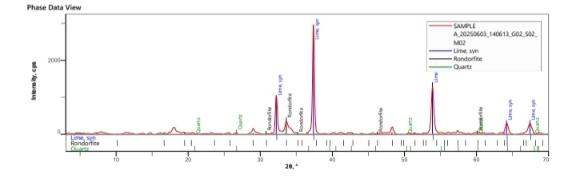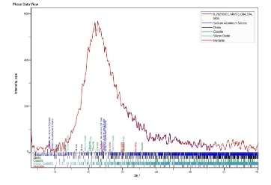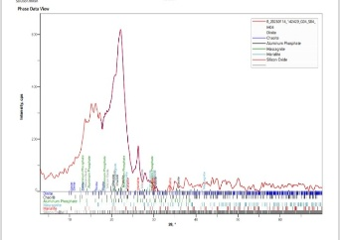
Figure 2(a): XRD pattern Figure 2(b): XRD pattern Figure 2(c): XRD pattern of
of CCR precursor of AC precursor composite catalyst
Scanning electron microscopy (SEM) with Energy Dispersive X-ray (EDX)
The surface morphology of the precursors and composite catalyst were observed using SEM. The results obtained at different magnifications are displayed below in figures 3, 4 and 5.
The calcined calcium carbide residue (CCR) (Figure 3) displays a highly agglomerated and irregular morphology. The 800 °C pretreatment promotes the formation of dense crystalline clusters, providing a robust source of basic active sites essential for initiating the transesterification process. The utilization of waste-derived precursors for catalyst synthesis not only reduces production costs but also promotes environmental sustainability by repurposing industrial byproducts. This approach is supported by Makarevičienė et al. [11], who demonstrated that properly prepared catalysts from natural waste and industrial residues exhibit superior catalytic properties for commercial-grade biodiesel conversion.
The anthill clay (AC) (Figure 4) exhibits a contrasting flaky and layered architecture. This sheet-like arrangement, typical of thermally treated aluminosilicates, provides a porous structural scaffold. This morphology is critical for enhancing the surface-area-to-volume ratio and facilitating the anchoring of metal oxide dopant [22].
The composite catalyst (Figure 5) reveals a significant transition toward a more granular and textured surface after 1.5 M zinc nitrate doping and 750 °C calcination. The images show a uniform distribution of active nanoparticles across the aluminosilicate flakes, creating an interconnected network of micro-pores. This morphology minimizes mass transfer resistance, allowing large triglyceride molecules to easily access active sites, which justifies the observed peak yield of 92.73% [20]. The absence of severe particle fusion suggests that the 750 °C treatment successfully optimized the catalyst's crystallinity without triggering the sintering-induced structural collapse often observed at higher temperatures [10].
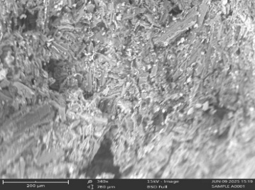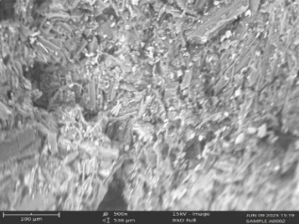
Figure 3: SEM images of CCR precursor (a) x340 (b) x500
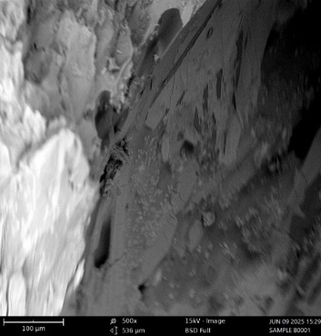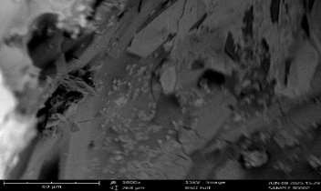
Figure 4: SEM images of THC precursor (a) x500 (b) x1000
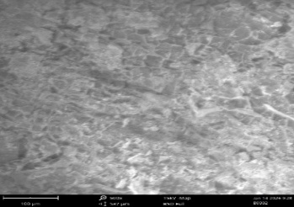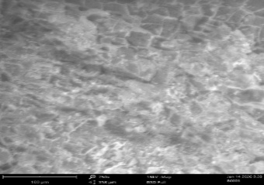
Figure 5: SEM images of composite catalyst (a) x500 (b) x750
Fourier transform infrared (FTIR) spectroscopy analysis
The identification of different functional groups available on the precursors and composite catalyst surfaces was carried out using Fourier transform infrared (FTIR) analysis. Figures 6 to 8 show the FTIR results of the precursors and composite catalyst.
The spectrum of the calcined CCR (Figure 6) shows a significant reduction in the O–H band (3640 cm⁻¹), indicating the dehydration of calcium hydroxide into Calcium Oxide (CaO). The remaining peaks at approximately 1420 cm⁻¹ and 875 cm⁻¹ are attributed to the stretching and bending vibrations of C–O bonds from atmospheric CO₂ adsorption on the basic CaO surface, confirming its high chemical reactivity [14].
The calcined anthill clay (AC) spectrum (Figure 7) reflects the thermal transition of kaolinite into metakaolinite. The loss of structural hydroxyl groups at 3695 cm⁻¹ and 3620 cm⁻¹ indicates successful dehydroxylation. The dominant band shifting toward 1050-1080 cm⁻¹ represents the reactive amorphous Si–O–Al framework, while persistent peaks at 798 cm⁻¹ confirm the stable Quartz fraction [22].
The composite catalyst (Figure 8), subsequently calcined at 750 °C, demonstrates the successful chemical integration of the 1.5 M zinc nitrate dopant. The spectrum is characterized by a broad, intense absorption band in the 400-600 cm⁻¹ range, which is the direct result of metal-oxygen (M–O) vibrations for both Zn–O and Ca–O. This overlap confirms the formation of an integrated metal-oxide-aluminosilicate matrix. The presence of these combined functional groups validates the bifunctional nature of the catalyst, providing the acidic and basic sites necessary for the high biodiesel yield achieved in the production phase [2]; [11].
Figure 6: FTIR spectra of CCR precursor Figure 7: FTIR spectra of AC precursor
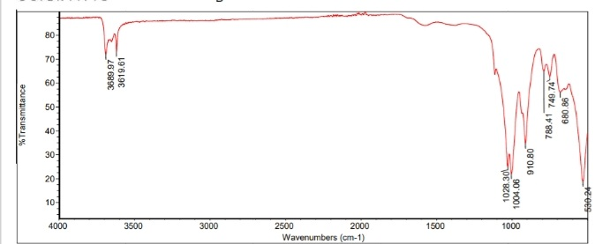

Figure 8: FTIR spectra of the composite catalyst

X-ray Fluorescence (XRF) Analysis
The elemental composition of the calcium carbide residue (CCR), anthill clay (AC), and the resulting composite catalyst reveals a strategic combination of active components and structural supports. The CCR precursor is highly rich in CaO (89.8%), establishing it as the primary source of basic active sites essential for the transesterification reaction [1]; [9]. The AC precursor contains significant amounts of SiO₂ (46.9%) and Al₂O₃ (24.1%), characteristic of aluminosilicate clays that serve as stable, high-surface-area frameworks for catalyst immobilization [5]; [21].
A significant chemical transformation is observed in the composite catalyst, specifically the inclusion of ZnO (20.9%), which was not present in substantial quantities in either precursor. This
enrichment indicates the successful introduction of a zinc-based dopant during synthesis to enhance the catalyst's bifunctionality and thermal stability [7]. The final composition effectively balances basicity from CaO (52.1%) with structural integrity and acidic sites provided by SiO₂, Al₂O₃, and ZnO, which is a hallmark of high-performance heterogeneous catalysts capable of achieving biodiesel yields above 90% [1]; [7]. Table 1 shows the elemental composition of CCR precursor, AC precursor and the composite catalyst.
Table 1: Elemental composition of CCR precursor, AC precursor and composite catalyst
Component | CCR precursor | AC precursor | Concentration (%) of composite catalyst
CaO | 89.8 | 1.5 | 52.1
SiO₂ | 4.04 | 46.9 | 10.4
Al₂O₃ | 3.9 | 24.1 | 7.4
SO₃ | 0.6 | 0.4 | 0.3
Fe₂O₃ | 0. 4 | 20.6 | 5.2
Cl | 0. 43 | 0.7 | 0.9
SnO₂ | 0. 25 | 0.0 | 0.3
TiO₂ | 0.13 | 3.8 | 0.9
CoO | 0.09 | 0.1 | 0.02
BaO | 0.09 | 0.0 | 0.02
SrO | 0.06 | 0.02 | 0.06
CuO | 0.06 | 0.14 | 0.05
Ta₂O₅ | 0.05 | 0.06 | 0.2
ZrO₂ | 0.03 | 0.5 | 0.3
Cr₂O₃ | 0.03 | 0.1 | 0.03
WO₃ | 0.02 | 0.0 | 0.5
NiO | 0.02 | 0.01 | 0.0
PbO | 0.01 | 0.04 | 0.03
V₂O₅ | 0.01 | 0.2 | 0.07
MnO | 0.01 | 0.1 | 0.04
Cs₂O | 0.01 | 0.09 | 0.08
ZnO | 0.01 | 0.04 | 20.9
Rb₂O | 0.00 | 0.01 | 0.01
Nb₂O₅ | 0.0 | 0.04 | 0.03
P₂O₅ | 0.0 | 0.2 | 0.02
MgO | 0.0 | 0.0 | 0.0
K₂O | 0.0 | 0.31 | 0.03
Ag₂O | 0.0 | 0.04 | 0.05

Brunauer-Emmett-Teller (BET) analysis.

The surface characteristics of the precursors and composite catalyst were quantitatively ascertained using the Brunauer-Emmett-Teller (BET) analysis. The surface area, pore diameter and pore volume determined from the analysis are displayed in table 2 below.
The textural properties of the precursors and the resulting composite catalyst highlight a strategic structural evolution suitable for high-efficiency catalysis. The anthill clay (AC) precursor exhibits the highest specific surface area at 314.2 m²/g, confirming its role as a superior aluminosilicate scaffold with an inherent capacity for high active-site dispersion [5]; [22]. Following the integration of calcium carbide residue (CCR) and the 1.5 M zinc nitrate dopant, the surface area of the composite catalyst settles at 226.9 m²/g. This reduction, alongside a decrease in pore volume from 0.28 cc/g to 0.2 cc/g, indicates that the metal oxides successfully occupied the AC pore network during the 750 °C calcination phase [1].
Critically, all materials maintain a consistent pore diameter within the 2.8–2.9 nm range, identifying the system as distinctly mesoporous. This pore size is ideal for biodiesel production as it allows for the unhindered diffusion of bulky triglyceride molecules to the active sites within the catalyst matrix, thereby minimizing mass transfer resistance [13]. The final composite combines a robust surface area with an optimized mesoporous architecture, ensuring the necessary site accessibility to facilitate the peak yields observed in the production tests [7]; [16].

Table 2: Surface characteristics of precursors and composite catalyst
Parameter | CCR | AC | Composite catalyst
Surface area (m²/g) | 221.7 | 314.2 | 226.9
Pore diameter (nm) | 2.9 | 2.8 | 2.9
Pore volume (cc/g) | 0.20 | 0.28 | 0.2

Characterization of the oil feedstock (PKO)
The physicochemical properties of the Palm Kernel Oil (PKO) as presented in Table 3 indicate that while the oil is a viable feedstock for biodiesel production, its high acidity necessitates the use of a specialized catalytic system. The Acid Value of 7.3 mgKOH/g and a corresponding Free Fatty Acid (FFA) content of 3.7% exceed the typical 1% threshold for simple base-catalyzed transesterification. This level of acidity confirms the importance of using the ZnO-doped bifunctional catalyst synthesized in this study, as the Lewis acidic sites provided by the ZnO are essential for the simultaneous esterification of FFAs and transesterification of triglycerides to prevent soap formation [2].
The structural and energy characteristics of the PKO are further defined by its Saponification Value of 234.2 mgKOH/g and Average Molecular Weight of 742 g/mol. These high values suggest a prevalence of short-to-medium chain fatty acids, which are beneficial for producing biodiesel with low viscosity and high volatility. Furthermore, the Iodine Value of 19 mg I₂/100g is notably low, indicating a high degree of saturation. This is a positive indicator for the resulting biofuel’s oxidative stability, suggesting it will be less prone to rancidity or sludge formation during long-term storage [13]; [19].
Physical and purity parameters such as the Density (0.90 g/cm³) and Viscosity (5.2 m²/s) align with standard profiles for tropical vegetable oils. However, the Moisture Content of 1.09% and Peroxide Value of 16 mEq/kg suggest a slight degree of primary oxidation and water presence, which can lead to competitive side reactions. Despite these impurities, the overall profile confirms that the PKO is an ideal candidate for conversion into high-quality biodiesel when processed with an optimized, thermally activated bifunctional catalyst [1].

Table 3: Physiochemical properties of PKO
Property | Value
Density (g/cm³) | 0.90
Average molecular weight (g/mol) | 742
Peroxide value (mEq/kg) | 16
Acid value (mgKOH/g oil) | 7.3
Free Fatty Acid (%) | 3.7
Saponification value (mgKOH/g oil) | 234.2
Viscosity @ 40ºC, 30.0 RPM & 22% (m²/s) | 5.2
Moisture content (%) | 1.09
Iodine value (mg I₂/100g oil) | 19
Biodiesel production

Table 4: Results of biodiesel production for effect of calcination temperature on catalysts functionality
Catalyst | Catalyst composition (CCR:AC) | Calcination temperature (ºC) | Reaction temperature (ºC) | Reaction time (mins) | Methanol-to-oil ratio (-) | Catalyst loading (wt.%) | Biodiesel yield (%)
A1 | 1:4 | 650 | 65 | 90 | 9 | 3 | 64.36
A2 | 1:4 | 750 | 65 | 90 | 9 | 3 | 70.58
A3 | 1:4 | 850 | 65 | 90 | 9 | 3 | 68.59
B1 | 2:3 | 650 | 65 | 90 | 9 | 3 | 71.44
B2 | 2:3 | 750 | 65 | 90 | 9 | 3 | 76.23
B3 | 2:3 | 850 | 65 | 90 | 9 | 3 | 74.81
C1 | 1:1 | 650 | 65 | 90 | 9 | 3 | 75.34
C2 | 1:1 | 750 | 65 | 90 | 9 | 3 | 77.53
C3 | 1:1 | 850 | 65 | 90 | 9 | 3 | 76.86
D1 | 3:2 | 650 | 65 | 90 | 9 | 3 | 80.23
D2 | 3:2 | 750 | 65 | 90 | 9 | 3 | 92.73
D3 | 3:2 | 850 | 65 | 90 | 9 | 3 | 87.45
E1 | 4:1 | 650 | 65 | 90 | 9 | 3 | 79.32
E2 | 4:1 | 750 | 65 | 90 | 9 | 3 | 88.74
E3 | 4:1 | 850 | 65 | 90 | 9 | 3 | 85.23
Biodiesel production
The data in Table 4 illustrates a distinct parabolic relationship between calcination temperature and catalytic activity across all catalyst groups (A through E). While the catalyst composition (the ratio of CCR to AC) sets the baseline for potential yield, the thermal treatment—specifically the choice of 750 °C—acts as the critical "activation switch" for achieving maximum efficiency.

Thermal Activation and the 750 °C Optimum
Across every series, the biodiesel yield peaks at a calcination temperature of 750 °C (e.g., A2, B2, C2, D2, and E2). This temperature appears to be the "sweet spot" for several physicochemical transformations. At 750 °C, the precursors undergo optimal decomposition and phase transformation—specifically the conversion of calcium carbonates from CCR into active CaO and the integration of the zinc dopant into the metal oxide matrix. This creates a high density of active basic sites and a well-developed pore structure that facilitates the diffusion of large triglyceride molecules. Recent studies confirm that this temperature range is ideal for maximizing crystallinity and surface basicity in heterogeneous calcium-based catalysts [14].

The Decline at 850 °C: Sintering and Structural Degradation
A consistent decline in yield is observed when the calcination temperature is increased further to 850 °C (e.g., A3, B3, C3, D3, and E3). For instance, in the D-series, the yield drops from its peak of 92.73% (D2) to 87.45% (D3). This "thermal over-treatment" typically leads to a phenomenon known as sintering, where small catalyst particles fuse together. This fusion reduces the total surface area and causes "pore collapse," effectively burying active sites that were previously accessible for the reaction. Modern characterization research highlights that excessively high temperatures can also lead to the formation of less active mixed-metal oxides or solid-state reactions that neutralize the basic sites necessary for methanol activation [13].

Synergistic Effect of Composition and Temperature
The table also reveals that the effect of temperature is more pronounced as the CCR (Calcium) content increases. In Group A (1:4 ratio), the jump from 650 °C to 750 °C only improves the yield by about 6%. However, in Group D (3:2 ratio), the same 100 °C increase results in a massive 12.5% surge in yield (from 80.23% to 92.73%). This suggests that a higher concentration of the basic precursor requires this specific thermal energy to fully unlock its bifunctional potential. The combination of high CCR content and 750 °C calcination provides the most effective acidity/basicity balance for simultaneous esterification and transesterification [20].
Influence of Calcination Temperature on Catalyst Activity and Biodiesel Yield
The biodiesel yield profiles demonstrate that 750 °C is the optimal calcination temperature for maximum catalytic efficiency, yielding a peak of 92.73%. This temperature acts as a critical threshold, providing sufficient thermal energy to fully activate the CaO and ZnO species while preserving the catalyst's porous structure.
Lower temperatures, such as 650 °C, result in "under-calcination," where incomplete precursor decomposition leads to a deficit of active basic sites and lower yields (e.g., 80.23%). Conversely, increasing the temperature to 850 °C triggers thermal sintering and pore collapse, reducing the accessible surface area and causing the yield to drop to 87.45%.
The superior performance at 750 °C ensures high site accessibility and stable crystallinity, consistent with recent findings that identify this window as the "activation sweet spot" for bifunctional catalysts [13]; [16].
Characterization of the produced biodiesel
The physicochemical properties of the produced biodiesel, as detailed in Table 5, demonstrate that the fuel is of high quality and fully complies with the international ASTM D6751 and EN 14214 standards. A standout feature of this fuel is its Cetane number of 67.44, which significantly exceeds the minimum requirements of 47 and 51, respectively. This high value indicates superior ignition quality, which leads to smoother engine performance and reduced noise during combustion. Furthermore, the Higher Heating Value (40.64 MJ/kg) confirms that the biodiesel possesses an energy content comparable to conventional petroleum diesel, ensuring efficient power generation [2].
The safety and flow characteristics of the fuel are also well within the optimized range for engine use. The Flash point of 179 °C is substantially higher than the required minimum of 130 °C, making the biodiesel exceptionally safe for long-term storage and transportation. Additionally, the Viscosity at 40 °C (3.6 mPa.s) falls perfectly within the standard limits, which is critical for ensuring proper fuel atomization and preventing wear on the fuel injection pump. The cold flow properties, represented by a Pour point of -5 °C and a Cloud point of -6 °C, suggest that the fuel will remain liquid and functional in moderately cold climates [1]; [19].
Finally, the chemical stability and purity of the biodiesel are confirmed by its low acidity and saturation levels. The Acid value (0.266 mgKOH/g) and Free Fatty Acid content (0.133%) are well below the corrosive thresholds, protecting engine components from damage. Moreover, the low Iodine value (23.5 g I₂/100g) suggests a low level of unsaturation, which significantly improves the fuel's oxidative stability and prevents the formation of sludge during storage. Overall, these properties validate the effectiveness of the ZnO-doped CaO/Anthill clay catalyst in producing a high-grade, stable, and environmentally friendly biofuel [13].
Table 5: Properties of biodiesel
Properties | Biodiesel | ASTM D6751 | EN 14214
Colour | Golden yellow | Not specified | Not specified
Physical state at room temperature | Liquid | Not specified | Not specified
Density (g/cm³) | 0.863 | Not specified | Not specified
Acid value (mgKOH/g) | 0.266 | <0.5 | <0.5
Free fatty acid (%) | 0.133 | Not specified | Not specified
Saponification value (mgKOH/g) | 206.44 | Not specified | Not specified
Iodine value (I₂/100g) | 23 .5 | Not specified | <120
Viscosity @ 40 ºC (mPa.s) | 3.6 | 1.9 to 6.0 | 3.5 to 5.0
Pour point (ºC) | -5 | <0 | <0
Flash point (ºC) | 179 | >130 | >120
Cloud point (ºC) | -6 | Not specified | Not specified
Cetane number | 67.44 | ≥47 | ≥51
Higher heating value | 40.64 | Not specified | ≥35
Aniline point | 81 | Not specified | Not specified

CONCLUSION
This study successfully achieved its primary goal of synthesizing a high-performance ZnO-doped CaO/Anthill clay composite using calcium carbide residue and anthill clay as sustainable precursors. By evaluating a thermal range from 650 °C to 850 °C, it was determined that the calcination temperature is the critical factor in balancing chemical activation with structural stability. The research identified 750 °C as the optimal temperature, as it successfully maximized the density of active sites while preventing the structural degradation and sintering observed at higher temperatures. Testing the catalyst's effectiveness on palm kernel oil confirmed its high efficiency, reaching a peak biodiesel yield of 92.73%. These findings demonstrate that utilizing waste materials provides a cost-effective and environmentally friendly pathway for biodiesel production. The produced biodiesel properties aligned with ASTM D6571 and EN 14214 standards upon characterization. This study contributes to the promotion of renewable and sustainable energy.
ACKNOWLEDGEMENTS
The authors wish to acknowledge the Petroleum Technology Development Fund (PTDF) for supporting thi s study, through the PTDF Professorial Chair on Renewable Energy in the Department of Chemical Engineering, University of Benin, Nigeria.
REFERENCES
1 Ajala, E. O., Ajala, M. A., Afolabi, F. D., Ajala, J. O., Opawoye, S., & Ariyoosu, D. A. (2024). Waste-ram-fat as a Feedstock for Biodiesel Production using Heterogeneous Catalyst of Kaolinite-clay Impregnated Calcium-oxide from Chicken Eggshell. Nigerian Journal of Technological Development, 21(4), 168–179. https://doi.org/DOI:10.63746/njtd.v21i4.3104
2 Akpan, I., Edeh, I., & Uyigue, L. (2026). The Influence of bifunctional Heterogeneous Catalyst on Biodiesel Production from Oleochemicals. 9(10), 1864–1870. https://doi.org/10.64388/IREV9I10-1716580
3 Al-bayati, B. B., Özdemir, O. K., Khudhur, A. G., Özdemir, J. H., Hantosh, A. A., Al-sheikh, F., Özdemir, O. K., Khudhur, A. G., & Özdemir, J. H. (2025). Mitigation of SrO catalyst leaching and recyclability in biodiesel transesterification : comprehensive parameter optimization and characterization via FTIR spectroscopy. Biofuels, 1–19. https://doi.org/10.1080/17597269.2025.2560708
4 Al-Sakkari, E. G., El-Sheltawy, S. T., Attia, N. K., & Mostafa, S. R. (2017). Kinetic study of soybean oil methanolysis using cement kiln dust as a heterogeneous catalyst for biodiesel production. Applied Catalysis B: Environmental, 206, 146–157. https://doi.org/10.1016/j.apcatb.2017.01.008
5 Babatunde, E. O., & Mekuto, L. (2025). Optimization of Biodiesel Production from Used Vegetable Oil using Functionalized Catalyst derived from Anthill. Ngerian Journal of Technological Development, 22(1), 1–9.
6 Fattah, R. I. M., Ong, H. C., Mahlia, T. M. I., Mofijur, M., Silitonga, A. S., Rahman, A. S. M., & Ahmad, A. (2020). State of the Art of Catalysts for Biodiesel Production. Frontiers in Energy Research, 8, 101. https://doi.org/10.3389/fenrg.2020.00101
7 Hughes, J., Hart, A., Das, B., & Wood, J. (2026). Advances in the Application of Low-Cost , Natural Materials , and Waste-Derived Catalysts for Catalytic Upgrading of Plastic and Biomass Pyrolysis Oil. Energy Fuels, 40(5), 2338−2371. https://doi.org/10.1021/acs.energyfuels.5c05623
8 Ifeanyi-Nze, F. O., Omiyale, C. O., Okonkwo, I. U., Chukwu, J. C., Nwankwor, Maryjane, C., Onabanjo, A. O., Adoga, S. O., Chukwu, J. O., Chukwurah, K. F., Ebikemiyen, M., Okon, G. U., Adeleke, O. J., & Tajudeen, K. A. (2023). Biodiesel Synthesis from Waste Vegetable Oil Utilizing Eggshell Ash as an Innovative Heterogeneous Catalyst. Archives of Advanced Engineering Science, 1–18. https://doi.org/10.47852/bonviewAAES32021761
9 Krishnan, S. G., Pua, F., & Lim, H. (2022). Synthesis of Magnetic Base Catalyst from Industrial Waste for Transesterification of Palm Oil. Bulletin of Chemical Reaction Engineering & Catalysis, 17(1), 53–64. https://doi.org/10.9767/bcrec.17.1.12412.53-64
10 Macheli, L., Leteba, G. M., Jewell, L. L., George, S. L., & Lang, I. (2026). Enhancing waste eggshell-derived CaO catalysts for biodiesel production through synergistic oxide modification : a comprehensive catalytic and kinetic study. RSC Advances, 16, 5990–6001. https://doi.org/10.1039/D5RA06382E
11 Makarevičienė, V., Gaidė, I., & Sendžikienė, E. (2025). Heterogeneous Catalysts from Food Waste for Biodiesel Synthesis — A Comprehensive Review. Catalysts, 15(10), 957. https://doi.org/doi.org/10.3390/catal15100957
12 Malabadi, R. B., Kolkar, K. P., & Chalannavar, R. K. (2023). Biodiesel production : An updated review of evidence. International Journal of Biological and Pharmaceutical Sciences Archive, 06(02), 110–133.
13 Mohammed, J., Aremu, M. O., & Usman, A. (2026). Synthesis and characterization of biodiesel from black date ( Canarium schweinfurtii ) seed kernel oil in the presence of green-synthesized Cu-Mn / TiO 2 nanocatalyst using central composite design approach. Recent Advances in Natural Sciences 4 227, 4, 227. https://doi.org/10.61298/rans.2026.4.1.227
14 Nurdina, R. A., Kamiya, Y., Hatmanto, A. D., & Pambudi, F. I. (2025). Ultrasonic-Assisted Transesterification of Tripalmitin Using Limestone-Derived CaO Catalyst. Bulletin of Chemical Reaction Engineering & Catalysis, 20(4), 672–682. https://doi.org/10.9767/bcrec.20456
15 Obahiagbon, K., Offiah, U., & Ahonkhai, D. O. (2025). Optimized Biodiesel Production from Palm Kernel Oil Using a Bifunctional Catalyst from Cocoa Pod and Pig Bone. Petroleum Technology Development Journal, 15(2), 1–15.
16 Ogunkunle, O., & Olusanya, M. O. (2026). Biodiesel synthesis from Blighia sapida seed oil : comparative modelling via RSM and ANFIS – PSO hybrid optimization. Frontiers in Energy Research, 14, 1783127. https://doi.org/10.3389/fenrg.2026.1783127
17 Okhonmina, J. O., Obahiagbon, K., & Oyedoh, E. A. (2026). Optimum Biodiesel Production from Palm Kernel Oil Using Heterogeneous Catalyst from Carbide Slag and Termite Hill Clay. International Journal of Research and Innovation in Applied Science (IJRIAS), 11(3), 520–543. https://doi.org/10.51584/IJRIAS
18 Singh, D., Singh, K., Jadeja, Y., Menon, S. V, Singh, P., Ibrahim, S. M., & Singh, M. (2025). Magnetic nano-sized solid acid catalyst bearing sulfonic acid groups for biodiesel synthesis and oxidation of sulfides. Scientific Reports, 15(1), 1397. https://doi.org/https://doi.org/10.1038/s41598-024-84494-x
19 Uzuegbu, J. N., Babayemi, A. K., Ezeugo, J. O., & Umeuzuegbu., J. C. (2026). Biodiesel Production from Jatropha Seeds Using a Waste-Derived Periwinkle Shell Heterogeneous Catalyst. Chemical Science International Journal, 35(2), 19–34.
20 Widayat, W., Hadiyanto, H., Hargono, H., Abdullah, A., Syalom, M. N., Setiawan, A., & Philia, J. (2025). Optimization of biodiesel production from candlenut oil via simultaneous reaction using a bifunctional CeO 2 . CaO catalyst. International Journal of Renewable Energy Development, 14(6), 1273–1284.
21 Yusuff, A. S., Adeniyi, O. D., Olutoye, M., & Akpan, U. G. (2018). The potential of composite anthill-waste chicken eggshell as heterogeneous catalyst in biodiesel production. Petroleum and Coal, 60(1), 58–70.
22 Yusuff, A. S., & Adesina., O. A. (2020). Biodiesel Synthesis from Palm Olein Oil using Anthill as Catalyst. Journal of Chemical Technology & Metallurgy, 55(2).

