Isolation, Charecterization And Eficacy Assessment Of Microbial Flora From Fish Amino Acid Fertilizer For Sustainable Biofertilizer And Biopesticide Application In Enhancing Plant Growth
INTRODUCTION
Commercial fertilizers are an affordable means of increasing soil nitrogen for plant development and high crop yields, but excessive or improper use of them can pollute water sources with nitrates. Farmers can reduce nutrient losses and stop run off by implementing Best Management Practices (BMPs). By using fish amino acid and Indigenous Microorganisms (IMO), on the other hand, Natural Farming techniques increase soil nitrogen availability, increase crop yields, and preserve water quality. It is known that fish emulsions stimulate the growth of seedlings (Murray and Anderson 2004), fruiting (Aung and Flick 1980), and soil microbial activity(El-Tarabily et al.,. 2003).
Fish Amino Acid (FAA) is an extremely effective organic liquid fertilizer that promotes healthy development and brilliant blooming in fruiting trees. FAA is an excellent natural arming supplement since it contains amino acids and other critical elements. To produce FAA, combine fish waste, brown sugar, irrigation water, and ripe papaya and allow to ferment. Fish-based fertilizers have been demonstrated in studies to improve seedling development, stimulate fruiting, and encourage beneficial microbial activity. "Fish amino acid (FAA) is produced through the fermentation of fish byproducts with brown sugar. This natural fertiliser is administered via foliar mist or soil drench to give vital nitrogen (N) to plants, supporting healthy growth and chlorophyll production while minimising waste and environmental effect (Aung, L.H., and G.J. Flick, 1980).

By fermenting fish waste with jaggery and purifying the resulting liquid after ten days, fish amino acid was produced. A nutrient-rich fluid with a noticeable odour was the end result, and its impact on plant growth was subsequently examined. Fish amino acid (FAA) is fermented to improve its nutritional value, digestibility, and extract stability, making it a safe and effective plant fertiliser. Additionally, FAA stands out for its critical macro and micronutrients, which are needed for plant physiology, including vegetative growth, such as nitrogen, phosphorous, potassium, calcium, magnesium, sulphur, iron, zinc, copper, boron, manganese, and molybdenum (Siddique et al., 2023). Fortification against pathogenic threats and fruit and blossom maturation (Hung-Chang Huang et al., 2005). To lessen its phytotoxicity in the concentrated form, the extract must be diluted (BalrajThendral and Arumugam, 2019). According to earlier research on the physicochemical characterisation of FAA, the manure's potential is evident starting at 50% dilution. One part FAA to one hundred parts water is the usual dilution ratio used. (Thendral Hepsibha Balraj & Arumugam Geetha, 2019; Balraj et al., 2017).

An organic mixture called fish amino acid (FAA) is utilised to encourage crop growth and development. Further more, liquid organic manure, or FAA, is made from fish waste. Fish offer vital nutrients that promote the growth of plants and soil microorganisms because they include a variety of minerals and amino acids. Fertilizers based on FAA are thought to be a cost-effective way to raise soil nitrogen (N) levels, which will improve plant growth and agricultural output. However, nitrate pollution of surface and groundwater can result from the incorrect or overuse of nitrogen fertilizers. Many academics are trying to create organic fertilizers that farmers can use without endangering the environment and ecosystem in order to address this problem (Manavalan Murugan, 2024).

(FAA) are organic substances that are known to encourage plant development because they contain vital nutrients. In addition to several agricultural institutions in the northern Philippines, FAA is widely employed in tropical regions like India, Thailand, Indonesia, Laos, and other parts of Asia. Fish waste has long been used as fertilizer because it is high in essential elements, especially phosphorus (P) and nitrogen (N), and it breaks down rapidly. Usually, a concentrated liquid that has been diluted with water is used. Approximately 75% of the fish's weight is wasted solid during processing, including the intestines, head, skin, bones, fins, and frames. Fish waste contains trace minerals, nitrogen, potassium, and phosphorus that can be used as raw materials to make a variety of nutrient-rich and non-nutrient products. An efficient method for maintaining soil organic matter, improving soil fertility, and giving plants the nutrients they need is to use organic waste in soil management. To investigate and evaluate how various FAA concentrations affect photosynthetic pigment levels, plant biomass, root and shoot development, and seed germination rates (Ladalin Ryntathiang, 2024).

Commercially available liquid organic fertilizers are an affordable way to provide nitrogen (N) to the soil for plant growth and high crop yields; nevertheless, excessive or inappropriate application of N fertiliser can contaminate surface or ground water with nitrates (Foley et al., 2012). FAA to maintain water quality while boosting crop yields and soil N availability. The development and application of FAA in Natural Farming are covered in this fact sheet. One vegetable that can withstand freezing temperatures is the pumpkin. Pumpkins are grown all over the world because of their many applications and advantages. Fish amino acid to maintain water purity, boost crop yields, and increase N availability in soils. (Du Ponte and Park, 2008).
The precise biopesticidal characteristics of FAA have not been thoroughly studied scientifically, despite these encouraging signs. To date, there has been no comprehensive evaluation of the precise mechanisms of action, effective application rates against certain pests and pathogens, and the best way to incorporate FAA into integrated pest management (IPM) methods. This information gap emphasizes how urgently thorough study is required to confirm and clarify Fish Amino Acid's function as a workable biopesticide. Therefore, the purpose of this study is to determine the effectiveness of FAA in managing common agricultural pests, to identify the underlying mechanisms of its pesticidal activity, and to evaluate its potential as a key component of ecologically friendly and sustainable pest management systems. Anderson, R. G. (2004)

MATERIAL AND METHODOLOGY
Preparation process of Fish Amino Acid (FAA) Fertilizer:
Fish Amino Acid (FAA) fertilizer was prepared using the fish. The fish that used in this experiment was Tilapia. The making process for this liquid organic fertilizer was the fish was mixed with the brown sugar with ratio 1:1 and the mixture was left for Four weeks, fermentation process breaks down the protein and turns it into amino acids. After Four weeks, the solution was filtered and 1 ml & 2ml of the solution was added with 1000 ml of water. This solution was used with different volume as the treatments for the study.
The process of producing FAA (Fish Amino Acids) includes the following steps:
- Collection of Fish Waste: Gather fish by-products such as heads, bones, and entrails.
- Mixing with Fermenting Agent: Combine the collected fish waste with a fermenting agent, such as sugar or molasses.
- Fermentation: Allow the mixture to ferment for several weeks, ensuring to stir periodically.
- Straining and Storage: Once fermentation is complete, strain the liquid and store it in a cool, dark environment.

Experimental Design:
The effects of Fish Amino Acid (FAA) on the growth and yield of Green chilli(Capsicum annuum),Brinjal (Solanum melongena), Black gram (Vigna mungo) , Red spinach (Amaranthus dubius). The study was conducted over a growing season with the following treatments:
    - Control: No foliar application
    - FAA: Foliar application of Fish Amino Acid
    - AA: Each treatment was replicated two times for these crops

Application Schedule Of FAA Fertilizer: Foliar applications were conducted at [specify growth stages, e.g., 7 day stage, 14 day stage] at [specify interval, e.g., 7 days]. Applications were performed early in the morning or late in the afternoon to minimize the risk of foliar burn and to maximize absorption.

Isolation And Identification
The primary step in the development of liquid biofertilizer involved isolating bacteria from spoiled and fermented fish waste with brown sugar, which served as a microbial source. The methodology was designed to ensure the recovery of diverse beneficial bacterial strains
Sample Preparation:
Take 1 mL of the fermented fish aminoacid (FAA) sample and add it to a sterile test tube containing 9 mL of sterile distilled water
Seriel Dilution:
Label six additional sterile test tubes containing 9 mL of sterile distilled water as 10⁻² to 10⁻⁶. Transfer 1 mL from the 10⁻¹ tube to the 10⁻² tube using a sterile micropipette and mix well. Repeat this process sequentially until the 10⁻⁶ dilution is prepared, ensuring that each dilution is mixed properly before transferring.
Spread Plating On Nutrient Agar:
Label the nutrient agar plates with the corresponding dilution factor (10⁻³ to 10⁻⁶, as higher dilutions reduce colony crowding).Take 100 µL (0.1 mL) of the selected diluted sample using a micropipette and dispense it onto the center of a labeled nutrient agar plate.Use a sterile glass spreader (previously dipped in ethanol and flame-sterilized) to evenly spread the sample across the surface of the agar.Allow the plates to absorb the liquid for a few minutes before incubation.
Morphological Identification:
Isolated colonies were observed for color, shape, and size. Gram staining was performed to determine the Gram reaction of the bacterial isolates.
Gram’s Staining:
A loopful of the overnight culture was subjected to Gram’s staining. The culture was smeared and heat fixed on a clean glass slide and stained using crystal violet for 1 minute followed by a water wash. Gram’s iodine was added to the smear and was kept undisturbed for 1 minute after which water wash was done. The smear was later stained with Gram’s decolourizer for 15 seconds after which it was water washed. The smear was counterstained with saffranin for 1 minute and it was finally water washed with tap water. The smear was air dried and examined under 100X oil immersion microscope and the results were noted.

BIOCHEMICAL CHARACTERIZATION
Catalase Test
A clean glass slide was taken to which a loopful of the test culture was placed on it and one drop of H₂O₂ was placed over it. Release of oxygen was noted. Bubble formation indicates the presence of catalase enzyme. No bubble formation indicates the absence of catalase enzyme. Results were noted.
Oxidase Test
From the 48 hours broth culture, a loopful of the test inoculum was taken and placed on an oxidase disc. Formation of violet colour was recorded as positive and no colour formation indicated the negative result.
Indole Test
Tryptone broth tubes were prepared and sterilized at 121ºC for 15 minutes. The culture was then inoculated into the tubes containing sterilized tryptone broth medium and incubated at 37ºC for 24-48 hours. After the incubation period, 0.2ml of Kovac’s reagent was added into the tubes and the results were observed. Results were noted for the development and absence of bright red colour at the interface of the reagent and the medium.
Methyl Red Test
The MR-VP broth tubes were prepared and sterilized at 121ºC for 15 minutes. The culture was then inoculated into the tubes containing sterilized MR-VP broth medium and inoculated at 37ºC for 24-48 hours. After the incubation period, about 5-6 drops of Methyl Red indicator solution was added. The development of stable bright red colour of the indicator indicates sufficient acid production which constitutes a positive reaction. A weekly positive test will be red orange. Yellow orange colour indicates a negative reaction.
Voges-Proskauer Test
The MR-VP broth tubes were prepared and sterilized at 121ºC for 15 minutes. The test culture was then inoculated into the tubes containing sterilized MR-VP broth medium and incubated at 37ºC for 24-48 hours. After the incubation period, about 3ml of 5%, α-naphthol in absolute ethanol (Barrit’s Reagent A) and 1ml of 40% Potassium hydroxide (Barrit’s Reagent B) were added. The tubes were allowed to remain undisturbed for 15-20 minutes. The development and absence of red colour was noted and recorded.

Citrate Utilization Test
Simmons Citrate Agar was prepared and dispensed on test tubes and sterilized at 121ºC for 15 minutes and allowed to set as slant. The culture was then inoculated into the tubes containing Simmons Citrate Agar slants (stabbed into the bud and streaked on the surface of slants) and incubated at 37ºC for 24-48 hours. After the incubation period, the development of intense blue colour from the original green colour and of the medium indicates the ability of the organism to utilize citrate as carbon source and constituted the positive reaction. The absence of blue colour indicates negative reaction.
Triple Sugar Iron Test
It is based on the ability of the organism to ferment sugar and to produce hydrogen sulphide. The Triple Sugar Iron was prepared and sterilized at 121ºC for 15 minutes and was dispensed on test tubes and allowed to set as slants. The test culture was later inoculated into the tubes containing Triple Sugar Iron slant (stabbed into the bud and streaked of the surface of slants) and incubated at 37ºC for 24-48 hours. After the incubation period, the development of intense red colour constitutes positive reaction. The absence of the red colour indicates negative reaction.
Starch Hydrolysis Test
Starch Agar medium was prepared and sterilized. The test organisms were inoculated under sterile condition. The plates were incubated at 37°C for 24 hours. After incubation, the iodine solution was flooded over the entire starch agar surface and the results were observed.
Instrumentation Analysis
Molecular analysis will be done using Gas Chromatography – Mass Spectroscopy(GC-MS) and Fourier-Transform Infrared (FTIR)

RESULT AND DISCUSSION
This study focuses on the formulation of a liquid biofertilizer using fish waste and brown suger, leveraging their natural fermentation process to enrich microbial populations beneficial for plant growth. The fermentation process promotes the proliferation of plant growth-promoting bacteria (PGPB), which aid in Numerous L-form amino acids (the form that is biologically active) can be found in abundance in fish amino acid, which is frequently a form of fish protein hydrolysate.These amino acids are used as; Building Blocks: These are the basic building blocks of proteins, which are necessary for the synthesis of hormones, enzymes, and new plant tissue.
Direct Nutrient Source: Plants can avoid the energy-intensive process of synthesising some amino acids from inorganic nitrogen by directly absorbing L-amino acids through their leaves and roots.

Fig.1 Shows the fermentation of Fish amino acid Biofertilizer

Isolation of bacteria from Fish amino acid biofertilizer

Fig.2 Bacterium isolated from Fish amino acid biofertilizer
Gram’s Staining
The Gram staining was done to identify the morphological characteristics of the isolated microbes . The smear was examined under the microscope, bacterium S1 retained violet colour and it was confirmed as Gram-positive which appeared as rod shaped bacterium. Bacterium S2 also retained violet colour and it was confirmed as Gram-positive with the culture as rod shaped bacterium.
Fig.3 shows the Gram stained images of isolated bacterial cultures. (S1) Gram positive clustering cocci (S2) Gram positive single cocci shaped bacterium

Biochemical Test
A Series of Biochemical tests were performed to identify the cultures.The entire test were carried out with positive and negative controls.
Table 1 Biochemical characterization of the isolated bacterial cultures.
Tests | S1 | S2
Methyl Red | + | +
Voges proskauer | - | -
Indole | - | -
Catalase | - | +
Oxidase | + | +
Starch hydrolysis | - | -
Trible suger iron | + | +
Citrate | + | +
+: Positive -: Negative
Table 1 represents the biochemical characteristics of the two bacterial cultures S1, S2 Isolated from the Fish aminoacid fertilizer

Methyl Red Test

Fig.4 Shows result of Methyl red Test

Voges-Proskauer Test

Fig.5 Shows result of Voges-Proskauer Test
Indole test

Fig.6 Shows result of Indole Test
catalase Test

Fig.7 Shows resut of Catalase Test

Oxidase Test

Fig.8 Shows result of Oxidase
Starch hydrolysis Test

Fig. 9 Shows result of Starch Hydrolysis Test
Triple Sugar ironTest

Fig.10 Shows result of Triple Sugar Iron Test

Citrate Utilization Test

Fig.11 shows result of citrate utilization
BIOFERTILIZER FORMULATION
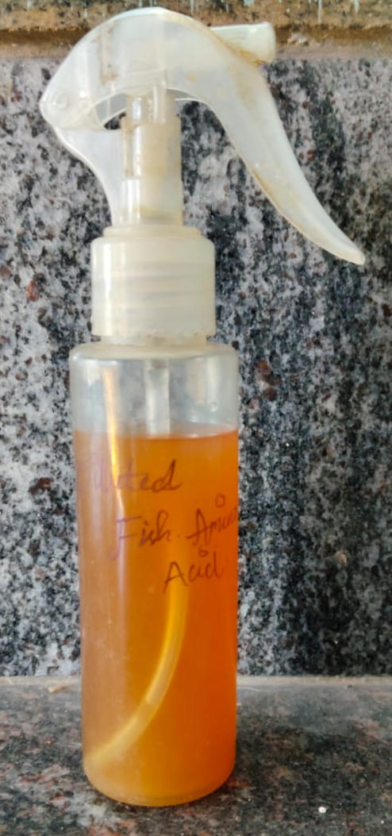
Fig.12 Biofertilizer was formulated into 1:5 ratio for better plant growth
Biofertilizer : sterile water
Using a 1:5 dilution for biofertilizer application optimizes microbial activity, prevents phytotoxicity, enhances nutrient absorption, and ensures uniform application, making it a practical and effective strategy for sustainable agriculture.The diluted biofertilizer promotes microbial diversity and nutrient cycling, leading to sustainable soil fertility. It act as the Easier foliar sprayingA less viscous solution ensures even coating on leaves, increasing nutrient absorption through stomata and leaf surfaces.

Field trial
This field trial was conducted to evaluate the effect of liquid biofertilizer derived from Fish waste and brwon suger on the germination, seedling vigor, and early growth of Green chilli(Capsicum annuum),Brinjal (solanum melongena), Black gram (vigna mungo) , Red spinach (Amaranthus dubius) plants. The trial was set up in green grow bags under open field conditions, using normal soil without any compost to assess the standalone impact of the biofertilizer.
Experimental Setup:
• Control Group (T0): Green chilli ,Brinjal,Black gram ,Red spinach seeds irrigated with plain water (no biofertilizer).
• Treatment Group (T1): Green chili ,Brinjal ,Black gram , Red spinach seeds treated with a 1:5 biofertilizer solution (1 part biofertilizer + 5 parts water).

Table ;2 shows result ofthe measurement of plant growth

Seed | Overall plant growth |  | Root length |  | Shoot length |  | Biomass
Seed | Sample | Control | Sample | Control | Sample | Control | sample | control
Green chilli | 14.8 | 7.9 | 3.5 | 1.1 | 11.3 | 6.8 | 1.2 | 0.8
Brinjal | 78.8 | 30 | 11.8 | 10.9 | 67 | 19.1 | 30.5 | 15.1
Blackgram | 32.5 | 20.4 | 7.5 | 6 | 25 | 16.2 | 13.7 | 9
Red spinach | 12.5 | 8.2 | 2.5 | 3 | 10 | 5.2 | 2.2 | 1.3

Fig.13 shows result of Green chilli plant growth
The Green chilli plant's maximum root length was 3.5 cm and stem length was11.3 cm respectively, The plants overall length was 14.8 cm. while the control group's root length was 1.1cm and stem length was 6.8 cm respectively, The control plant measured7.9 cm in total length. (Fig14.) . By using fish amino acid (FAA) and indigenous microorganisms (IMO), on the other hand, Natural Farming techniques increase soil nitrogen availability, increase crop yields, and preserve water quality. It is known that fish emulsions stimulate the growth of seedlings (Murray and Anderson 2004), fruiting (Aung and Flick 1980), and soil microbial activity(El-Tarabily et al. 2003).

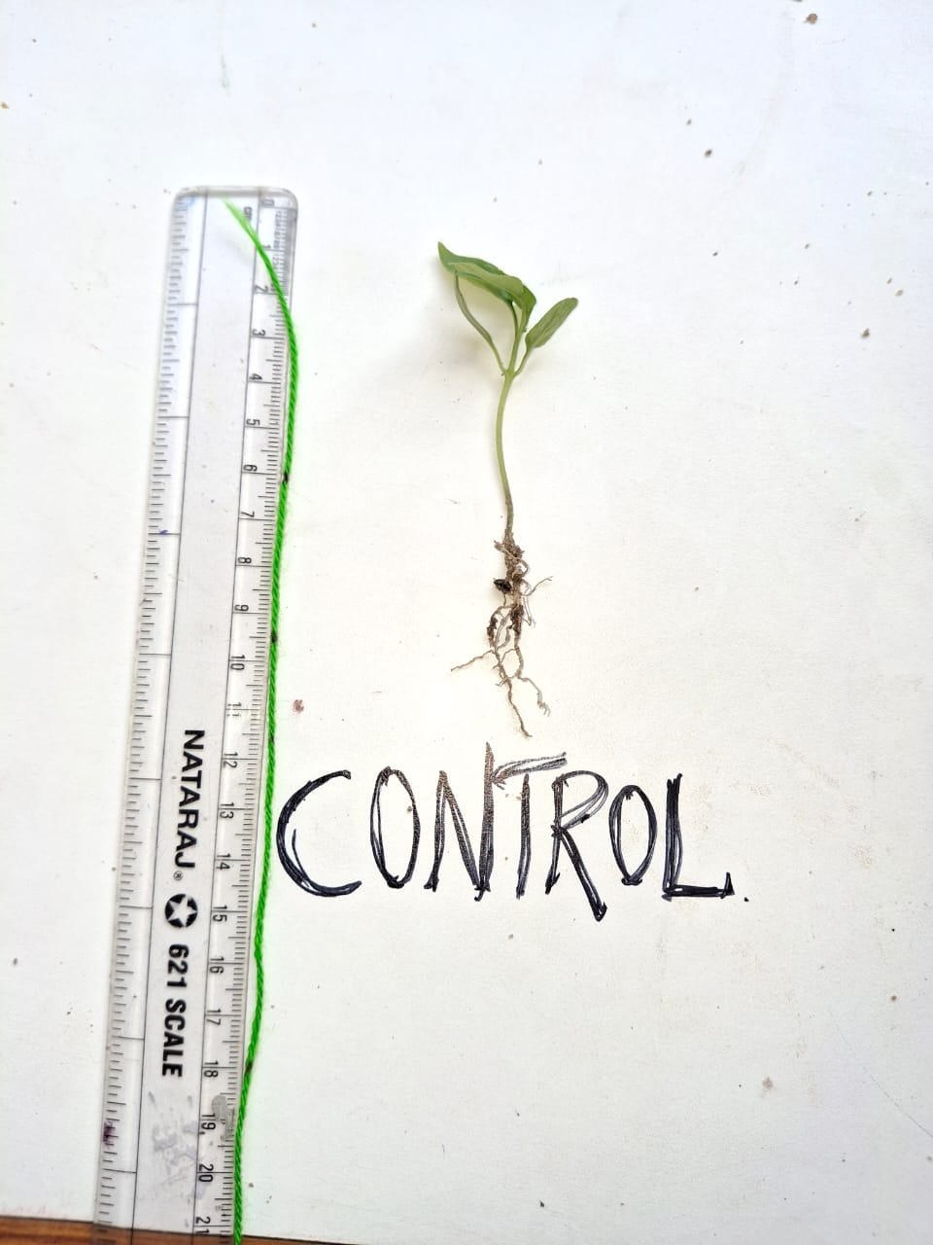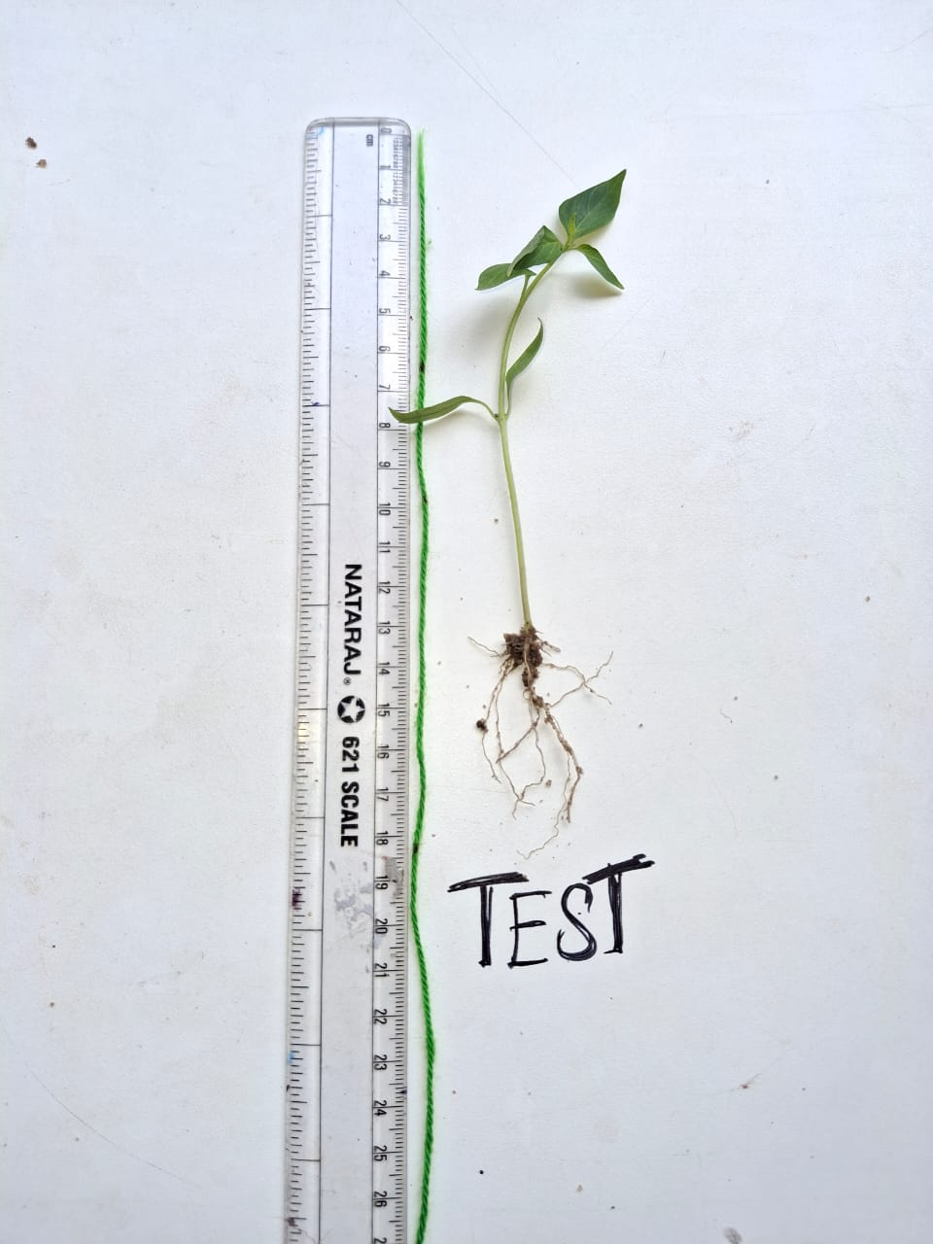
Fig.14 Shows result of root and shoot measurement of green chilli plant
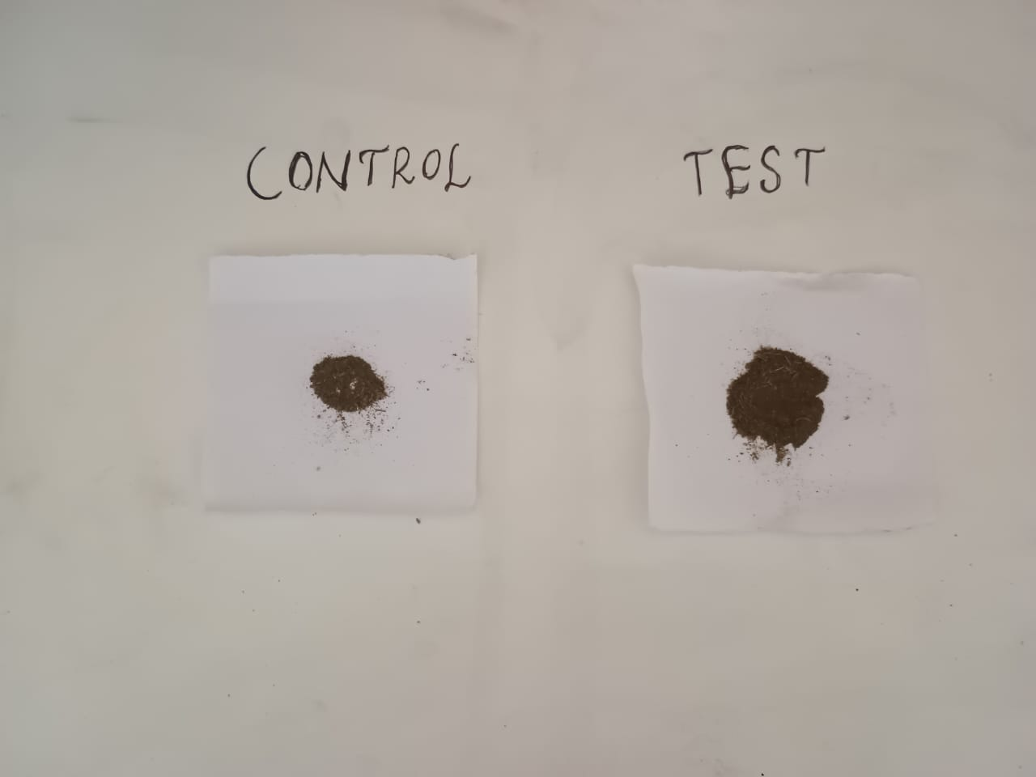
Fig.15 shows result of chilli plant Biomass

Fig .16shows result of Brinjal plant growth

The Brinjal plant's maximum root length was 11.8 cm and stem length was 67 cm respectively, The plants overall length was 78.8 cm, while the control group's root length was 10.9 cm and stem length was 19.1 cm respectively, The control plant measured 30 cm in total length. (Fig.16) . Fish-based fertilizers have been demonstrated in studies to improve seedling development, stimulate fruiting, and encourage beneficial microbial activity .This natural fertiliser is administered via foliar mist or soil drench to give vital nitrogen (N) to plants, supporting healthy growth and chlorophyll production while minimising waste and environmental effect (Aung, L.H., and G.J. Flick, 1980).

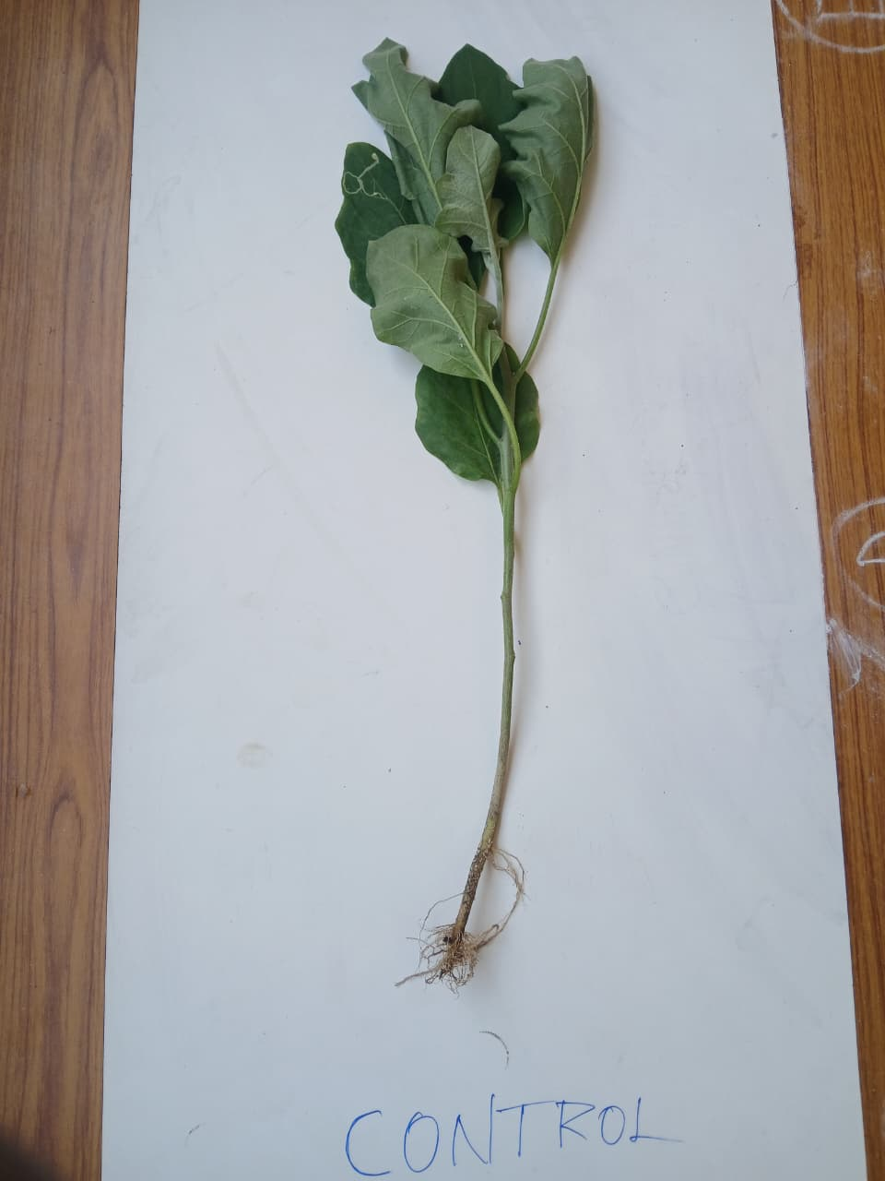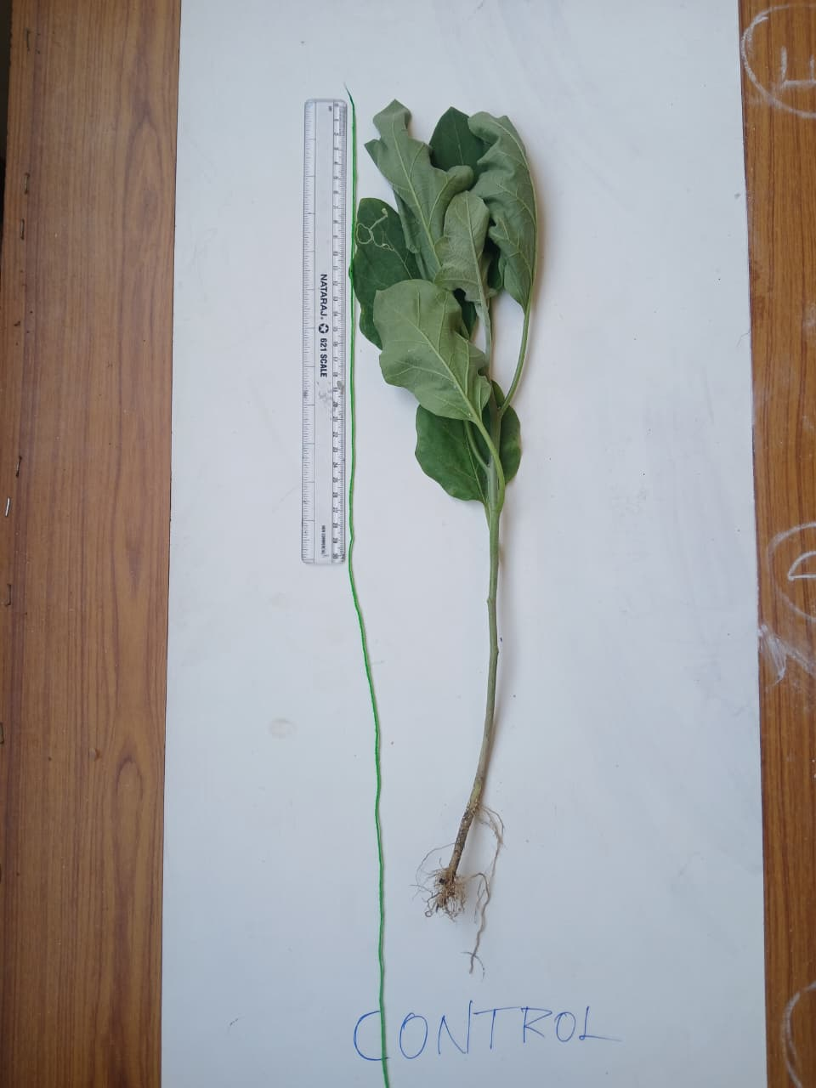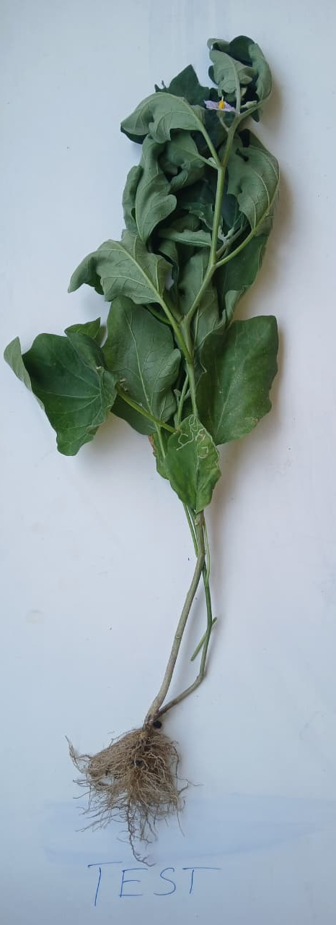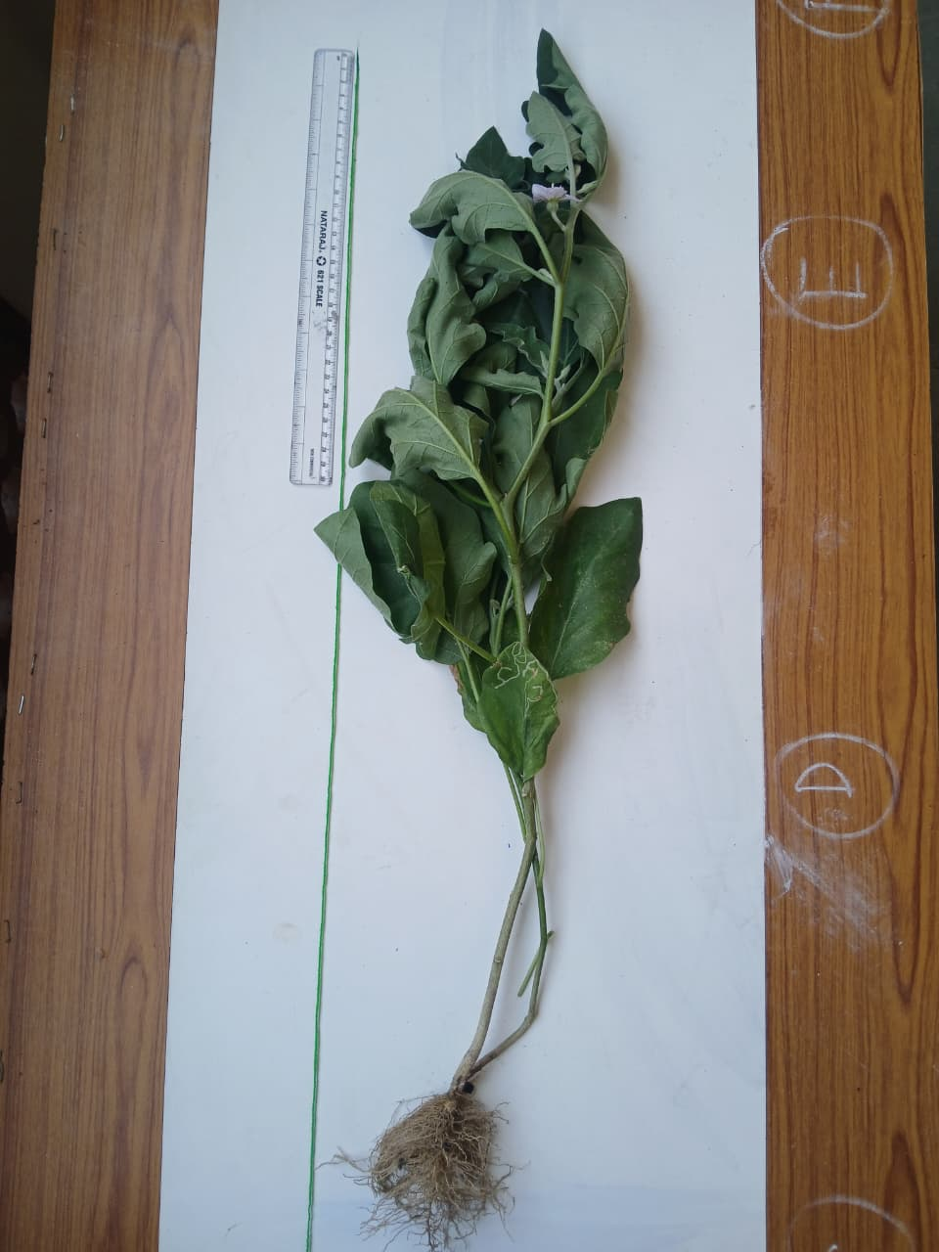
Fig.17Shows result of Root and Shoot measurement of Brinjal plant

Fig.18 shows reasult of brinjal pant biomass

Fig.19 Shows result of Black gram plant growth
The Black gram plant's maximum root length was 7.5 cm and stem length was 25 cm respectively, The plants overall length was 32.5 cm. while the control group's root length was 6 cm and stem length was 16.2 cm respectively, The control plant measured 20.4 cm in total length. (Fig18.) Essential macro and micronutrients such as nitrogen, phosphorous, potassium, calcium, magnesium, sulphur, iron, zinc, copper, boron, manganese, and molybdenum (Siddique et al., 2023) are also what set FAA apart. These nutrients are essential for plant physiology, including vegetative growth, fruit and flower maturation, and fortification against pathogenic challenges (Hung-Chang Huang et al., 2005).

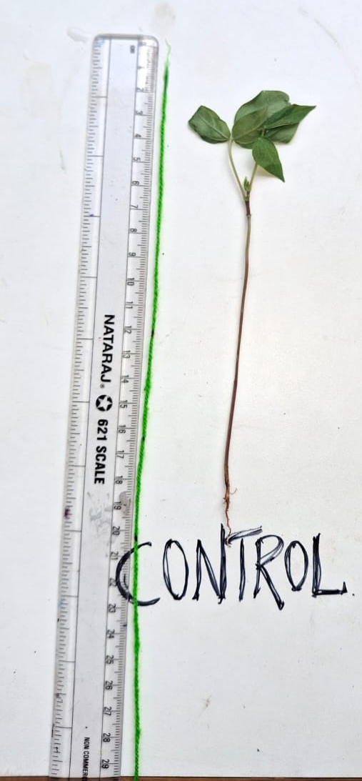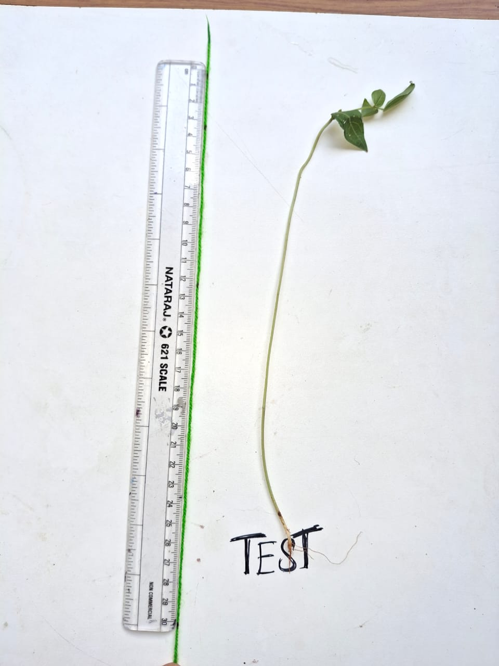
Fig. 20 shows result of Root and Shoot Measurement of Black gram

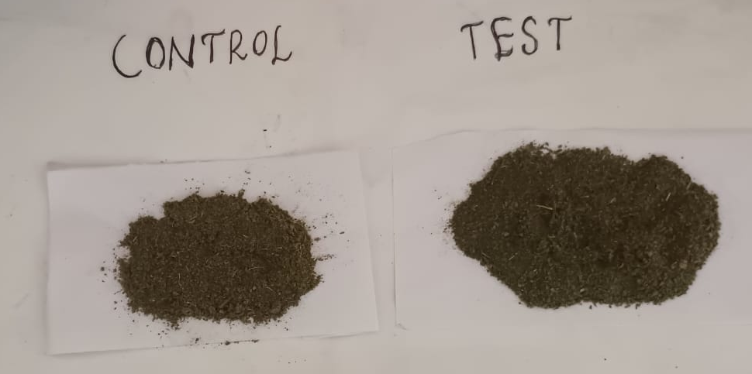
Fig .21 shows result of black gram plant Biomass

Fig.22 Shows the result of Spinach plant growth
The Red spinach plant's maximum root length was 2.5 cm and stem length was 10 cm respectively, The plants overall length was 12.5cm. while the control group's root length was 3cm and stem length was 5.2 cm respectively, The control plant measured 8.2 cm in total length. (Fig.20) FAA helps to maintain water quality and improve crop yields by increasing the amount of nitrogen available in soils (T. Ramesh, 2020).
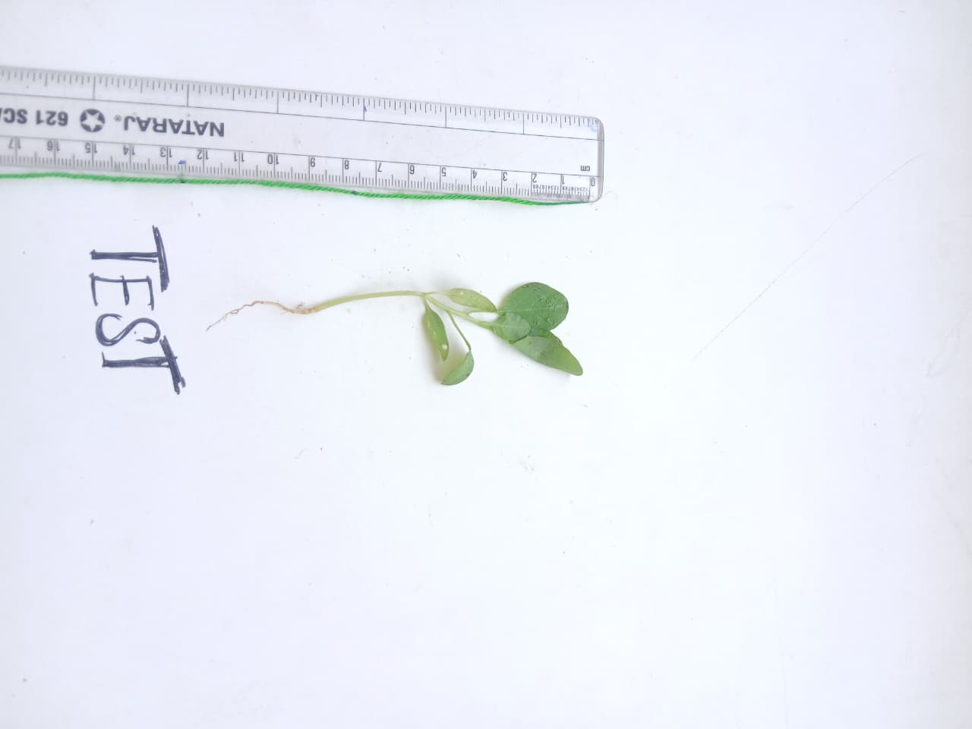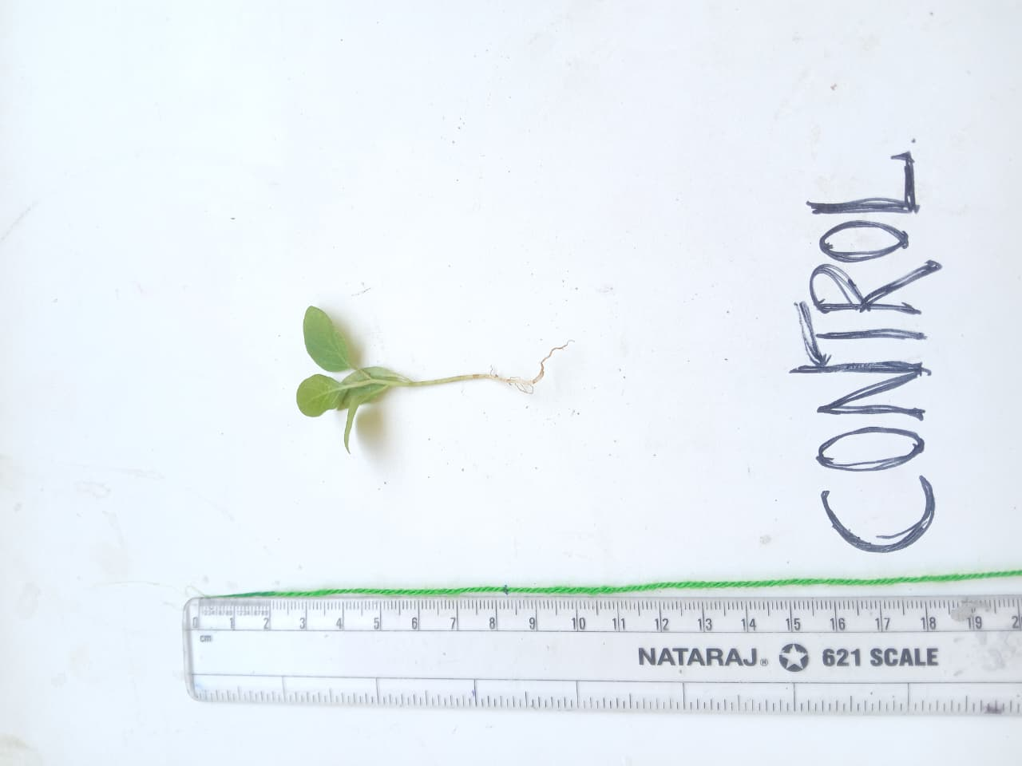
Fig.23shows result of Root and shoot measurement of Spinach plant
Fig.24shows result of spinach plant Biomass
Plant Growth and Soil Health
Treated plants had better leaf expansion, higher chlorophyll content, and increased root biomass, indicating improved nutrient uptake.
Microbial analysis showed increased populations of phosphate-solubilizing bacteria, nitrogen-fixing bacteria, and beneficial fungi in biofertilizer-treated plots.
Tomato plants treated with biofertilizer showed earlier flowering and stronger fruit set compared to control plants.
BIO PESTICIDE
An organic liquid fertilizer called fish amino acid (FAA) promotes plant development and fortifies a plant's defenses against illnesses and pests. A crop's resistance is greatly increased by its repellant qualities and capacity to enhance plant health, even though it is not a direct biopesticide that actively kills bugs. FAA's scent and bioactive ingredients are reported to deter some pests, including mites and worm moths, when applied topically. It is also effective against rice and pod pests, according to some farmers. FAA is a soil drench that promotes the activity of earthworms and beneficial bacteria. This aids in establishing a healthy, balanced soil environment that inhibits harmful organisms.
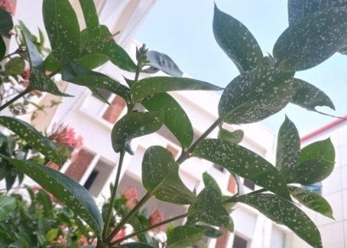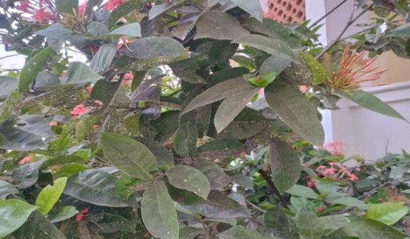
Fig.25Pest Attacks on plants before the application of Biofertilizer.
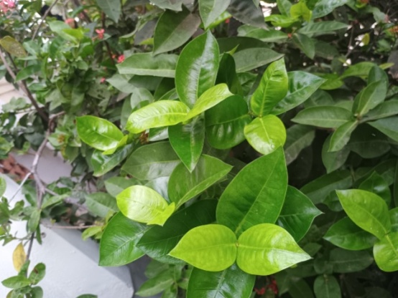
Fig.26shows Healthy leaves after the application of biofertilizer
FTIR Analysis of Biofertilizer/Biopesticide Components
The Fourier-Transform Infrared (FTIR) spectrum exhibits distinct absorption peaks that strongly indicate the presence of organic and biological components, which are characteristic of both biofertilizers and biopesticides.
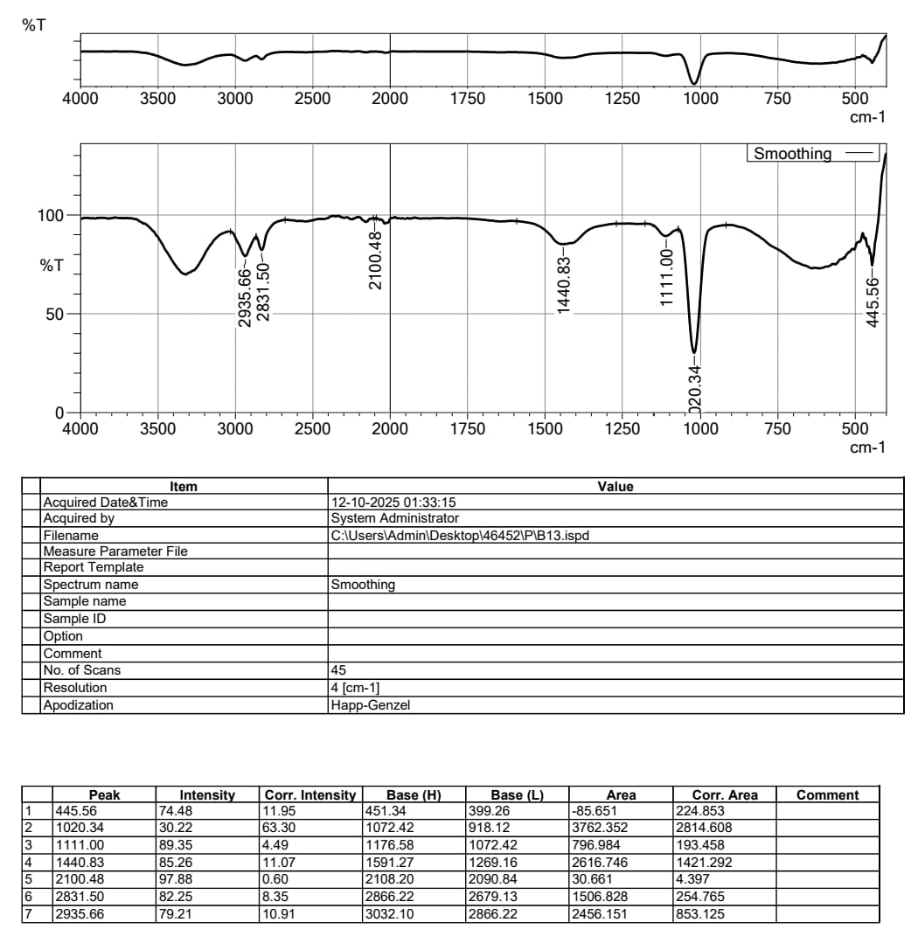
Fig.27shows result of FTIR Analysis
Wavenumber (cm−1) | Functional Group Assignment | Interpretation and Relevance
2935.51 | C-H Stretching | Aliphatic Hydrocarbons: Represents the C-H bonds in lipids, fatty acids, and cellular membranes. This confirms a significant content of general organic matter from the base biological material.
2831.33 | C-H Stretching | Aliphatic Hydrocarbons: Further supports the presence of long-chain organic molecules.
1440.85 | C-HBending | MethylCH_2 and Methylene CH_2groups: A common signature in all organic materials and biological compounds.
1111.45 | C-O-C or C-O-P Stretching | Carbohydrates and Phosphates: This region is typical for polysaccharides (sugars) that make up microbial cell walls (e.g., Exopolysaccharides/EPS) or plant structure. C-O-Pindicates the presence of phosphate groups (essential nutrients and part of DNA/RNA).
1020.80 | C-O-Cor C-O-P Stretching | Carbohydrates and Phosphates: Another prominent peak in the carbohydrate region, often associated with the backbone structure of organic matter derived from biological sources.

Table.3Shows result of FTIR Analysis of Biofertilizer/Biopesticide Components

The detected peaks indicate complex organic compounds, as those present in plant extract or microbial cells (fungi, bacteria).
The material is made of or generated from biological matter (e.g., microbial cells, metabolites, or plant extracts) because of the strong presence of peaks that correspond to lipids and carbohydrates (C-H and C-O groups).

For Biofertilizers: The living microorganisms (such as Rhizobium, Azotobacter, or phosphate-solubilizing bacteria) and the organic carriers they are manufactured with are identified by these groupings.

For biopesticides, these groups are a feature of the active substances, which can be plant-based extracts (like essential oils or neem extracts) or microorganisms (like Bacillus thuringiensis) that are rich in organic functional groups. The material that comprises the necessary biological components of a biopesticide or biofertilizer is very consistent with the FTIR results.

Gas Chromatography-Mass Spectrometry (GC-MS) analysis
Analysis using gas chromatography-mass spectrometry (GC-MS), which is frequently used in biological research of this kind: The sample contains a number of chemicals with known biofertilizer (plant growth/health enhancement) and/or biopesticide (antimicrobial/insecticidal) properties, according to the Gas Chromatography-Mass Spectrometry (GC-MS) data you supplied.
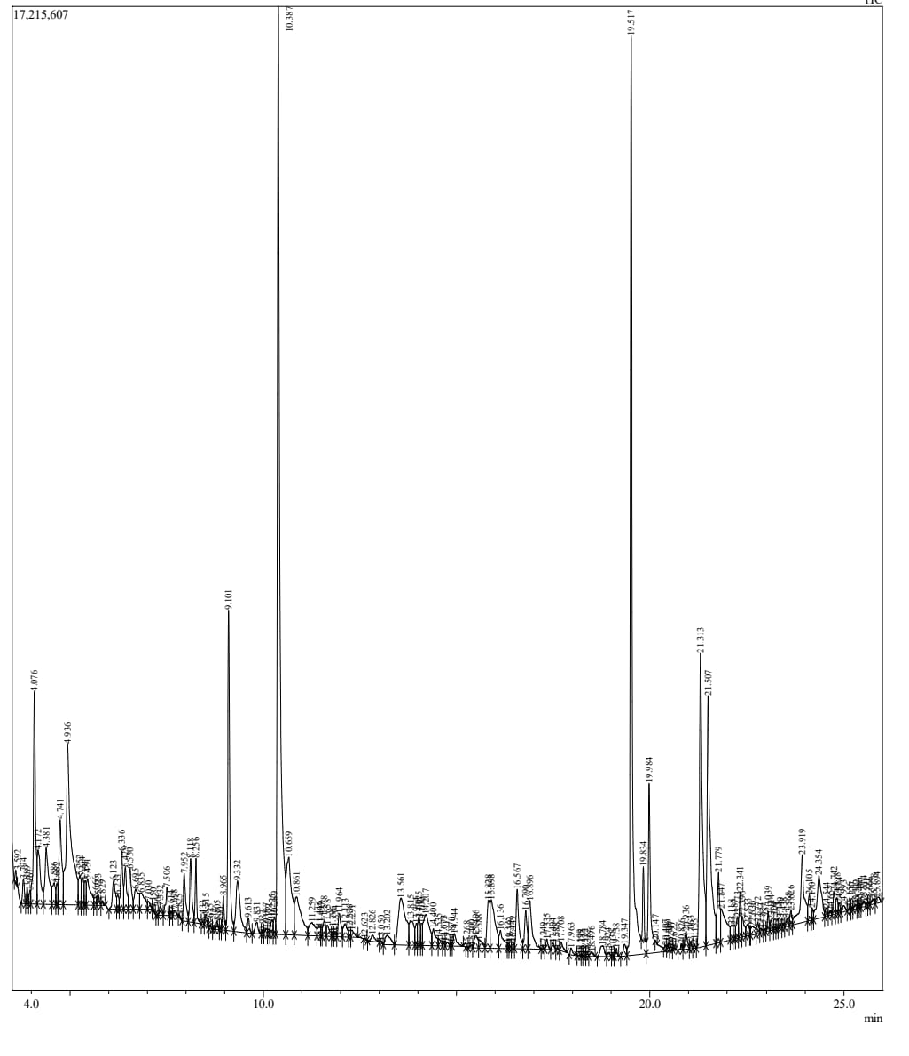
Fig.28shows result of Gas Chromatography-Mass Spectrometry (GC-MS) analysis
Component Name | Peak # (Approximate) | Area % (Concentration) | Primary Bio-Activity
Hexadecanoic Acid (Palmitic Acid) & Esters | 6, 19, 87, 109, 110, 154 | High (Totaling over 10%) | Biopesticide: Known to have strong antimicrobial (antifungal/antibacterial) and nematicidal properties.
Hexadecenoic Acid& Esters | 111, 126, 128, 153 | High (Totaling over 6%) | Biopesticide: Reported to have antimicrobial activity. Fatty acids are vital components of microbial cell walls.
Linalool | 68 | 0.06% | Biopesticide: A monoterpene that acts as a potent insecticide and repellent.
Citronellol Epoxide | 143 | 0.05% | Biopesticide:Terpenoid with common antimicrobial and insect-repellent activity, often found in essential oils.
Octadecanoic Acid (Stearic Acid) | 150 | 0.12% | Biopesticide: Fatty acid with documented antimicrobial effects.
gamma-Butyrolactone Derivatives | 23, 44, 127 | 0.63% (and others) | Biofertilizer/Biocontrol: Related to quorum sensing molecules that regulate the gene expression and virulence of bacteria, influencing plant-microbe interactions and growth promotion.
Phenol Derivatives | 78, 46 | Various | Biopesticide: Phenolic compounds are generally excellent antimicrobial and antifungal agents.

Table.4shows resut of Gas Chromatography-Mass Spectrometry (GC-MS) analysis
Components of biofertilizer, often known as growth-promoting:
squalene, phytol, and other fatty acids (such as oleic and hexadecanoic acids): extracts frequently contain them. Although they are not biofertilizers in and of themselves, they are secondary metabolites of the organisms (such as microbes or plants) that produce the biofertilizer, and some of them can promote plant growth or act as precursors for vital molecules.
Substances derived from organisms that fix nitrogen or solubilize phosphate (for example, several organic compounds can be found in an azolla extract, a well-known biofertilizer).
potential for biofertilizer: chemicals such as gamma-butyrolactone derivatives and butanoic acid derivatives (microbial metabolites) indicate that the source organism may have chemicals that can regulate plant growth or be involved in beneficial soil microbial activities.

Biopesticide components (or having pesticidal/antimicrobial activity):
Terpenoids, such as germacrene-d, trans-caryophyllene, and neophytadiene: numerous terpenoids (such as components of essential oils) are well-known for their insecticidal, repellant, or antifungal qualities.

Phenolic compounds, such as different types of phenols: frequently possess antifungal and antibacterial properties.
Certain fatty acids and their derivatives have nematoidal, insecticidal, or antibacterial properties. One example of this is methyl esters of hexadecanoic acid.
Potential as a biopesticide: the extract's high concentration of different fatty acids (octadecanoic and hexadecanoic acids) and the identification of well-known natural insecticides and repellents like linalool and other terpenoids make it evident that it has the potential to be used as a biopesticide.

SUMMARY AND CONCLUSION
The study aims to isolate and characterize bacterial isolates from liquid bio-fertilizer prepared using fish waste and brown sugar in 1:1 composition.Rich in nutrients and can be converted into Biofertilizer and Biofertilizer.FAA can serve as a nutrient-rich fertilizer, reducing the need for synthetic fertilizers. The bacterial isolates obtained from this study show promise as biofertilizers or biopesticides, and further research is needed to explore their potential applications.
The successful characterization and identification of these bacterial isolates provide a foundation for future research on their ecological roles and potential applications.While FAA is not a registered chemical or microbial pesticide designed to kill pests on contact, its role as a powerful biofertilizer and plant growth stimulant leads to:
• A stronger, healthier, and more resilient plant.
•A natural repellent effect due to its odor.
In organic and sustainable farming, this immune-boosting and repellent function allows farmers to reduce their reliance on synthetic pesticides, making FAA a valuable component of an integrated pest management (IPM) strategy.
Fish Amino Acid (FAA) is mainly utilised as an organic biofertilizer and plant growth promoter, its additional role as a biopesticide—more precisely, a pest repellent and plant immunity booster—makes it an Intro part popular choice for organic and natural agricultural methods

REFERENCE:
- Abbasi, P. A., Cuppels, D. A., & Lazarovits, G. (2003). Effect of foliar applications of neem Oil and fish emulsion on bacterial spot and yield of tomatoes and peppers. Canadian Journal of Plant Pathology, 25(1), 41–48. https://doi.org/10.1080/07060660309507048
- Abdalla, K., Sun, Y., Zarebanadkouki, M., Gaiser, T., Seidel, S., & Pausch, J. (2022). Long-Term continuous farmyard manure application increases soil carbon when combined With mineral fertilizers due to lower priming effects. Geoderma, 428, 116216.https://doi.org/10.1016/j.geoderma.2022.116216
- Abebe, B., & Abebe, A. (2016). Effect of the Time and Rate of N-Fertilizer Application on Growth and Yield of Wheat (Triticum aestivum L.) at Gamo-gofa Zone, Southern Ethiopia. In Journal of Natural Sciences Research www.iiste.orgISSN (Vol. 6, Issue 11). Online. www.iiste.org
- Adams, T. S., & Sterner, R. W. (2000). The effect of dietary nitrogen content on trophic level 15 N enrichment. Limnology and Oceanography, 45(3), 601–607. https://doi.org/10.4319/lo.2000.45.3.0601
- Balraj, T. H., & Arumugam, G. (2021). Effect of Biofertilizer (Fermented fish waste –Gunapaselam) on structure and biochemical components of Vigna radiata leaves. Research Journal of Chemistry and Environment, 25(7), 64–70. https://doi.org/10.25303/257rjce6421
- Balraj, T. H., Hepsibha, B. T., & Geetha, A. (2017). Effect of Fermented Fish waste (Gunapaselam) Application on the Soil Fertility with Special Reference to Trace Elements and the Growth Characteristics of Vigna radiata. In International Journal of Agriculture Innovations and Research (Vol. 5). https://www.researchgate.net/publication/313595368
- Baqir, H. A., Zeboon, N. H., & Al-Behadili, A. A. J. (2019). THE ROLE AND IMPORTANCE OF AMINO ACIDS WITHIN PLANTS : A REVIEW (Vol. 19, Issue 2).
- Bian, Z.-H., Cheng, R.-F., Yang, Q.-C., Wang, J., & Lu, C. (2016). Continuous Light from Red, Blue, and Green Light-emitting Diodes Reduces Nitrate Content and Enhances Phytochemical Concentrations and Antioxidant Capacity in Lettuce. Journal of the American Society for Horticultural Science, 141(2), 186–195. https://doi.org/10.21273/JASHS.141.2.186
- Bloom, A. J., Chapin, F. S., & Mooney, H. A. (1985). Resource limitation in plants – an Economic analogy. In Ann. Rev. Ecol. Sysl (Vol. 16). www.annualreviews.org
- Brück, H., & Guo, S. (2006). Influence of N form on growth photosynthesis of Phaseolus Vulgaris L. plants. Journal of Plant Nutrition and Soil Science, 169(6), 849–856.https://doi.org/10.1002/jpln.200520570

- Calvo, P., Nelson, L., & Kloepper, J. W. (2014). Agricultural uses of plant biostimulants. In Plant and Soil (Vol. 383, Issues 1–2, pp. 3–41). Kluwer Academic Publishers.https://doi.org/10.1007/s11104-014-2131-8
- Chan, T. Y. K. (2011). Vegetable-borne nitrate and nitrite and the risk of Methaemoglobinaemia. Toxicology Letters, 200(1–2), 107–108. https://doi.org/10.1016/j.toxlet.2010.11.002
- Dalias, P., Anderson, J. M., Bottner, P., & Coûteaux, M.-M. (2002). Temperature responses Of net nitrogen mineralization and nitrification in conifer forest soils incubated under Standard laboratory conditions. Soil Biology and Biochemistry, 34(5), 691–701. https://doi.org/10.1016/S0038-0717(01)00234-6
- Davidson, E. A., & Janssens, I. A. (2006). Temperature sensitivity of soil carbon Decomposition and feedbacks to climate change. Nature, 440(7081), 165–173. https://doi.org/10.1038/nature04514
- Ekanayake, U. I., Fernando, M., Ekanayake, E. M. U. I., & Fernando, K. M. C. (2023). Influence of organic liquid fertilizers on growth and yield of Abelmoschus esculentus, Raphanus sativus and Amaranthus spp in container gardening. https://www.researchgate.net/publication/366740307
- Ekinci, M., Atamanalp, M., Turan, M., Alak, G., Kul, R., Kitir, N., & Yildirim, E. (2019). Integrated Use of Nitrogen Fertilizer and Fish Manure: Effects on the Growth and Chemical Composition of Spinach. Communications in Soil Science and Plant Analysis, 50(13), 1580–1590. https://doi.org/10.1080/00103624.2019.1631324
- Erland, L. A. E., & Saxena, P. (2019). Auxin driven indoleamine biosynthesis and the role of Tryptophan as an inductive signal in Hypericum perforatum (L.). PLoS ONE, 14(10).https://doi.org/10.1371/journal.pone.0223878
- FAO. (2022). The State of World Fisheries and Aquaculture 2022. FAO.https://doi.org/10.4060/cc0461en
- Farzadfar, S., Knight, J. D., & Congreves, K. A. (2021). Soil organic nitrogen: an Overlooked but potentially significant contribution to crop nutrition. Plant and Soil, 462(1–2), 7–23. https://doi.org/10.1007/s11104-021-04860-w
- Finzi, A. C., & Berthrong, S. T. (2005). The uptake of amino acids by microbes and trees in Three cold-temperate forests. Ecology, 86(12), 3345–3353. https://doi.org/10.1890/04-1460
- Foley, K. M., Doniger, A. R., Shock, C. C., Horneck, D. A. & Welch, T. K. (2012). Nitrate pollution In groundwater. Sustainable Agriculture Techniques, Oregon State University, Department of Crop and Soil Science Ext/CrS 137.
- Foro Económico Mundial., Marsh & McLennan., & Zurich Insurance Group. (2023). The Global risks report 2023. World Economic Forum.Franklin, O., Cambui, C. A., Gruffman, L., Palmroth, S., Oren, R., & Näsholm, T. (2017). The carbon bonus of organic nitrogen enhances nitrogen use efficiency of plants. Plant Cell and Environment, 40(1), 25–35. https://doi.org/10.1111/pce.12772
- Galamini, G., Ferretti, G., Rosinger, C., Huber, S., Medoro, V., Mentler, A., Díaz-Pinés, E., Gorfer, M., Faccini, B., & Keiblinger, K. M. (2023). Recycling nitrogen from liquid Digestate via novel reactive struvite and zeolite minerals to mitigate agricultural Pollution. Chemosphere, 317, 137881. https://doi.org/10.1016/j.chemosphere.2023.137881
- Gao, L., Liu, M., Wang, M., Shen, Q., & Guo, S. (2016). Enhanced Salt Tolerance under Nitrate Nutrition is Associated with Apoplast Na+ Content in Canola ( Brassica. Napus L.) and Rice ( Oryza sativa L.) Plants. Plant and Cell Physiology, 57(11), 2323–2333. https://doi.org/10.1093/pcp/pcw141
- Ge, T., Song, S., Roberts, P., Jones, D. L., Huang, D., & Iwasaki, K. (2009). Amino acids as A nitrogen source for tomato seedlings: The use of dual-labeled (13C, 15N) glycine to Test for direct uptake by tomato seedlings. Environmental and Experimental Botany, 66(3), 357–361. https://doi.org/10.1016/j.envexpbot.2009.05.004
- Gemede, H. F., Ratta, N., Haki, G. D., Woldegiorgis, A. Z. & Beyene, F. (2014). Nutritional Quality and health benefits of okra (Abelmoschus esculentus): A review. Global Journal of Medical Research.
- Ghasemi, S., Khoshgoftarmanesh, A. H., Hadadzadeh, H., & Jafari, M. (2012). Synthesis of Iron-Amino Acid Chelates and Evaluation of Their Efficacy as Iron Source and Growth Stimulator for Tomato in Nutrient Solution Culture. Journal of Plant Growth Regulation, 31(4), 498–508. https://doi.org/10.1007/s00344-012-9259-7
- Gould, D., Compagnoni, A., & Lembo, G. (2019). Organic Aquaculture: Principles, Standards and Certification. In Organic Aquaculture (pp. 1–22). Springer International Publishing. https://doi.org/10.1007/978-3-030-05603-2_1
- Govindasamy, P., Muthusamy, S. K., Bagavathiannan, M., Mowrer, J., Jagannadham, P. T. K., Maity, A., Halli, H. M., G. K, S., Vadivel, R., T. K, D., Raj, R., Pooniya, V., Babu, S., Rathore, S. S., L, M., & Tiwari, G. (2023). Nitrogen use efficiency—a key to Enhance crop productivity under a changing climate. In Frontiers in Plant Science (Vol. 14). Frontiers Media S.A. https://doi.org/10.3389/fpls.2023.1121073
- Gao, S., Zhou, Y., Shen, Q., & Zhang, F. (2007). Effect of Ammonium and Nitrate Nutrition On Some Physiological Processes in Higher Plants ‐ Growth, Photosynthesis, Photorespiration, and Water Relations. Plant Biology, 9(1), 21–29. https://doi.org/10.1055/s-2006-924541
- Hagemann, N., Harter, J., & Behrens, S. (2016). Elucidating the Impacts of Biochar Applications on Nitrogen CyclinMicrobial Communities. In Biochar Application (pp. 163–198). Elsevier. https://doi.org/10.1016/B978-0-12-803433-0.00007-2
- Handley, L. L., Austin, A. T., Stewart, G. R., Robinson, D., Scrimgeour, C. M., Raven, J. A.,Heaton, T. H. E., & Schmidt, S. (1999). The 15N natural abundance (δ15N) of ecosystem samples reflects measures of water availability. Functional Plant Biology, 26(2), 185. https://doi.org/10.1071/PP98146
- Harishchand, R., Khan, M. M. & Singh, P. K. (2013). Effect of spacing and cultivars on growth And yield of okra [Abelmoschus esculentus (L.) Moench]. Asian Journal of Horticulture, 8, 507-511.
- Huang, J. W., Grunes, D. L., & Welch, R. M. (1990). Magnesium, Nitrogen Form, and Root Temperature Effects on Grass Tetany Potential of Wheat Forage. Agronomy Journal, 82(3), 581–587. https://doi.org/10.2134/agronj1990.00021962008200030029x
- Huang, X., Jia, Z., Jiao, X., Wang, J., & Huang, X. (2022). Long-term manure applicationsto increase carbon sequestration and macroaggregate-stabilized carbon. Soil Biologyand Biochemistry, 174, 108827. https://doi.org/10.1016/j.soilbio.2022.108827
- Huber, S., Bernardini, L. G., Bennett, A., Fohrafellner, J., Dohnke, K., Bieber, M., Vuolo, F., Mentler, A., Bodner, G., & Keiblinger, K. (2024). Suitability of microbial and organic matter indicators for on‐farm soil health monitoring. Soil Use and Management, 40(1).https://doi.org/10.1111/sum.1299
- Ingrisano, R., Tosato, E., Trost, P., Gurrieri, L., & Sparla, F. (2023). Proline, Cysteine andBranched-Chain Amino Acids in Abiotic Stress Response of Land Plants andMicroalgae. Plants, 12(19), 3410. https://doi.org/10.3390/plants12193410
- Janssen, B. H. (1996). Nitrogen mineralization in relation to C:N ratio and decomposability of organic materials. Plant and Soil, 181(1), 39–45.https://doi.org/10.1007/BF00011290
- Ji, R., Dong, G., Shi, W. & Min, J. (2017). Effects of liquid organic fertilizers on plant growth And rhizosphere soil characteristics of chrysanthemum. Sustainability, 9, 841.
- Johari, N. S.1*, Asilah, A. M.1, Zalina, I.1*, Fazhana, I.1, Ab-Latif, Z.2,Shaibatul’ Islamiah, C. M.1, Tang, J. R¹, Effects Of Fish Amino Acid (Faa) Application on Growth and Development of Okra (Abelmoschus Esculentus) at Different Sampling Times.JOURNAL OF VOCATIONAL EDUCATION STUDIES (JOVES) Volume 3, Number 2, 2020, pp. 128-135.p-ISSN: 2614-7483, e-ISSN: 2614-7475, DOI: https://doi.org/10.12928/joves.v3i2.2932
- Johari, N. S., Abdul Mutalib, A., Ismail, Z., Ismail, F., Ab Latif, Z., Che Man, S. ’ I., & Tang, J. R. (2020). Effects Of Fish Amino Acid (Faa) Application on Growth and Development of Okra (Abelmoschus Esculentus) at Different Sampling Times. Journal of Vocational Education Studies, 3(2), 35. https://doi.org/10.12928/joves.v3i2.2932
- Jones, D. L., Healey, J. R., Willett, V. B., Farrar, J. F., & Hodge, A. (2005). Dissolved organic nitrogen uptake by plants—an important N uptake pathway? Soil Biology and Biochemistry, 37(3), 413–423. https://doi.org/10.1016/j.soilbio.2004.08.008
- Jones, D. L., Owen, A. G., & Farrar, J. F. (n.d.). Simple method to enable the high resolution determination of total free amino acids in soil solutions and soil extracts. www.elsevier.com/locate/soilbio
- Karthikeyan KUMARAVEL,Efficacy of Fish Amino Acid (FAA) organic manure Compared to mineral fertilizer on wheat crop in sandy soil.GEORG-AUGUST UNIVERSITE. In publica commoda SEIT 1737.
- Khandaker, M. M., Jusoh, N., Hafiza, Ralmi, N. H. A. A. & Ismail, S. Z. (2017). The effect of Different types of organic fertilizers on growth and yield of Abelmoschus esculentus L. Moench (Okra). Bulgarian Journal of Agricultural Sciemce, 23, 119-125.
- Khursheed, M. Q., & Muhammad, M. Q. (2015). Effect of different Nitrogen fertilizers on growth and yield of wheat. https://www.researchgate.net/publication/313508313
- Kiers, J. L., Van Laeken, A. E. A., Rombouts, F. M., & Nout, M. J. R. (2000). In vitro digestibility of Bacillus fermented soya bean. In International Journal of Food Microbiology (Vol. 60). www.elsevier.nl/locate/ijfoodmicro
- Latif Malghani, A., Ullah Malik, A., Sattar, A., Hussain, F., Abbas, G., & Hussain, J. (2010). Response of growth and yield of wheat to NPK fertilizer. Sci.Int.(Lahore), 24(2), 185–189.
- Li, M., Zhou, X., Zhang, Q., & Cheng, X. (2014). Consequences of afforestation for soil nitrogen dynamics in central China. Agriculture, Ecosystems & Environment, 183, 40 -46.https://doi.org/10.1016/j.agee.2013.10.018
- Li, X., Li, Z., Zhang, X., Xia, L., Zhang, W., Ma, Q., & He, H. (2020). Disentangling immobilization of nitrate by fungi and bacteria in soil to plant residue amendment. Geoderma, 374, 114450. https://doi.org/10.1016/j.geoderma.2020.114450
- Madende, M., & Hayes, M. (2020). Fish by-product use as biostimulants: An overview of the current state of the art, including relevant legislation and regulations within the EU and USA. In Molecules (Vol. 25, Issue 5). MDPI AG. https://doi.org/10.3390/molecules25051122
- OECD and Food and Agriculture Organization of the United Nations. (2021). Wheat Projections: Consumption, food. https://doi.org/10.1787/agr-outl-data-en
- Okamoto, M., Okada, K., Watanabe, T., & Ae, N. (2003). Growth responses of cereal crops To organic nitrogen in the field. Soil Science and Plant Nutrition, 49(3), 445–452. https://doi.org/10.1080/00380768.2003.10410030
- Onica, B.-M., Vidican, R., Sandor, V., Brad, T., & Sandor, M. (2017). Priming effect induced By the use of different fertilizers on soil functional diversity.https://doi.org/10.15835/buasvmcn-agr
- Pahalvi, H. N., Rafiya, L., Rashid, S., Nisar, B., & Kamili, A. N. (2021). Chemical Fertilizers and Their Impact on Soil Health. In Microbiota and Biofertilizers, Vol 2 (pp. 1–20). Springer International Publishing. https://doi.org/10.1007/978-3-030-61010-4_1
- Priyanka, B., Ramesh, T., Rathika, S., & Balasubramaniam, P. (2019). Foliar Application of Fish Amino Acid and Egg Amino Acid to Improve the Physiological Parameters of Rice. International Journal of Current Microbiology and Applied Sciences, 8(02), 3005–3009. https://doi.org/10.20546/ijcmas.2019.802.351
- Priyanka, B., Anoob, D., Gowsika, M., Kavin, A., Sri, S. K., Kumar, R. V. K, Gomathi, R. S., Sivamonica, B., Devi, G. V., & Theradiman”, M. (2019). Effect of fish amino acid and Egg amino acid as foliar application to increase the growth and yield of green gram. The Pharma Innovation Journal, 8, 684-686.
- Raab, T. K., Lipson, D. A., & Monson, R. K. (1999). Soil amino acid utilization among Species of the Cyperaceae: Plant and soil processes. Ecology, 80(7), 2408–2419.https://doi.org/10.1890/0012-9658(1999)080[2408:SAAUAS]2.0.CO;2
- Ramesh, T., Rathika, S., Murugan, A., Soniya, R.R., Mohanta, K.K., & Prabharani, B. (2020). Foliar spray of fish amino acid as liquid organic manure on the growth and yield of Amaranthus. Chemical Science Review and Letters, 9, 511-515.
- Trevisan, S., Pizzeghello, D., Ruperti, B., Francioso, O., Sassi, A., Palme, K., Quaggiotti, S., & Nardi, S. (2010). Humic substances induce lateral root formation and expression of the early auxin-responsive IAA19 gene and DR5 synthetic element in Arabidopsis. Plant Biology, 12(4), 604–614. https://doi.org/10.1111/j.1438-8677.2009.00248.x
- Trisilawati, O., Hartoyo, B., Bermawie, N., & Pribadi, E.R. (2019). Application of AMF (Arbuscular Mycorrhizal Fungi) and Organic Fertilizer to Increase the Growth, Biomass and Bioactive Content of Centella. IOP Conference Series: Earth and Environmental Science, 292, 012067.
- United Nations. (2015). The 2030 Agenda for sustainable development.https://www.un.org/en/development/desa/population/migration/generalassembly/docs/globalcompact/A_RES_70_1_E.pdf
- Urakawa, R., Shibata, H., Kuroiwa, M., Inagaki, Y., Tateno, R., Hishi, T., Fukuzawa, K., Hirai, K., Toda, H., Oyanagi, N., Nakata, M., Nakanishi, A., Fukushima, K., Enoki, T., & Suwa, Y. (2014). Effects of freeze–thaw cycles resulting from winter climate change on soil nitrogen cycling in ten temperate forest ecosystems throughout the Japanese archipelago. Soil Biology and Biochemistry, 74, 82–94. https://doi.org/10.1016/j.soilbio.2014.02.022
- Vance, E. D., Brggke~, P. C., & Jenkin~on, D. S. (1987). AN EXTRACTION METHOD FOR MEASURING SOIL MICROBIAL BIOMASS C. In Soil Eiol. Biochem (Vol. 19, Issue 6).
- Wang, Z. H., Li, S. X., & Malhi, S. (2008). Effects of fertilization and other agronomic measures on nutritional quality of crops. In Journal of the Science of Food and Agriculture (Vol. 88, Issue 1, pp. 7–23). https://doi.org/10.1002/jsfa.3084
- Wang, Z., Li, S., & Malhi, S. (2008). Effects of fertilization and other agronomic measures on nutritional quality of crops. Journal of the Science of Food and Agriculture, 88(1), 7–23. https://doi.org/10.1002/jsfa.3084
- Wang, Z., Miao, Y., & Li, S. (2015). Effect of ammonium and nitrate nitrogen fertilizers on wheat yield in relation to accumulated nitrate at different depths of soil in drylands of China. Field Crops Research, 183, 211–224. https://doi.org/10.1016/j.fcr.2015.07.019
- Weinert, E. J., Miller, S. A., Ikeda, D. M., Chang, K. S., McGinn, J. M., & DuPonte, M. W. (2014). Natural Farming: Fish Amino Acid. Sustainable Agriculture, SA-12. University of Hawai’I, College of Tropical Agriculture and Human Resources.

