Digital Technology and Artificial Intelligence in Korean Language Learning: A Survey of Undergraduate Students at TNU – University of Sciences

Abstract
Amid the digital transformation of education, digital technology and artificial intelligence (AI) are being increasingly applied in foreign language learning. This study examines the use of digital technology and AI in Korean language learning among students at TNU - University of Sciences. Data were collected from 403 students through a questionnaire and analyzed using descriptive statistics. The results show that 84.4% of students considered digital technology and AI to be necessary or very necessary for learning Korean, while 64.27% reported that these tools had a positive impact on their learning. Students engaged with a diverse range of tools - including online dictionaries, digital learning platforms, language-skill training applications, machine translation tools, and AI chatbots - to support reference, practice, and self-directed learning. Alongside benefits such as broader access to learning resources, greater learner autonomy, and increased motivation, students continued to face several difficulties related to overreliance on translation tools, limitations in verifying information, insufficient skills in leveraging AI, and risks to academic integrity. On this basis, the study puts forward a set of implications for instructors, students, and training institutions aimed at enhancing the use of digital technology and AI in Korean language teaching and learning at the tertiary level.

Keywords: Korean studies; digital technology; Korean language; artificial intelligence; University of Sciences
1. Introduction
Amid the ongoing wave of digital transformation, digital technologies and artificial intelligence are being increasingly adopted in education, particularly in foreign language teaching and learning. Tools such as online dictionaries, digital learning platforms, language-support applications, and AI chatbots have given rise to new modes of learning, enabling students to access richer learning resources, strengthen self-directed learning, and extend opportunities for language practice beyond the classroom.
In parallel with the expansion of Vietnam–Korea cooperation across multiple sectors, the demand for learning Korean in Vietnam has continued to grow. The advancement of digital technology has substantially reshaped the learning practices of Korean language students. Alongside traditional learning materials, students can now draw on a diverse range of supporting tools - including language-learning applications, online video platforms, translation software, and AI systems - to develop their listening, speaking, reading, and writing skills, as well as to enhance their capacity for self-directed learning.
A growing body of research suggests that digital technology and AI can effectively support foreign language learning by personalizing learning content, expanding practice opportunities, and providing timely feedback to learners. The use of these technologies, however, also raises several challenges, including overreliance on translation tools, difficulties in assessing the accuracy of information, limited digital literacy among students, and concerns regarding academic integrity in the use of AI. The effectiveness of technology-enhanced learning therefore depends not only on the tools themselves but also on students' competence in deploying and exploiting them.
In Vietnam, research on the application of digital technology and AI in foreign language learning has attracted increasing scholarly attention. Nevertheless, studies focusing on students of Korean as a foreign language remain relatively scarce, particularly in the context of the rapidly expanding use of generative AI. Moreover, no comprehensive survey has yet examined the use of digital technology and AI among Korean language students at TNU – University of Sciences (Thai Nguyen University).
Against this background, the present study investigates the use of digital technology and AI among students majoring in Korean Language at TNU – University of Sciences in the course of their studies. The study seeks to identify the tools employed, the purposes and frequency of their use, the benefits perceived by students, and the difficulties encountered in engaging with digital technology and AI. Drawing on these findings, the article puts forward several implications for enhancing the application of digital technology and AI in Korean language teaching and learning at the tertiary level.
The study contributes empirical evidence on the application of digital technology and AI in Korean language education at the tertiary level and provides a reference base for Korean language teaching and learning in the context of digital transformation.
The integration of digital technology and artificial intelligence (AI) into foreign language teaching and learning has drawn considerable scholarly attention worldwide. Early research focused primarily on Computer-Assisted Language Learning (CALL). Warschauer and Healey [1] outlined the emergence and development of CALL and underscored the increasingly central role of technology in language learning environments. Stockwell [2] subsequently synthesized the main research and practical directions in CALL, identifying both the opportunities and the challenges of integrating technology into foreign language learning. These foundational works established an important theoretical basis for the use of technology in language education.
The rapid expansion of mobile devices and the Internet broadened the field of inquiry to Mobile-Assisted Language Learning (MALL). Godwin-Jones [3] argued that mobile learning applications enable students to access knowledge anytime and anywhere, thereby enhancing flexibility and supporting self-directed learning. In recent years, the rapid advancement of generative AI has further shifted research attention toward chatbots, speech recognition technology, machine translation, and intelligent tutoring systems in language education. In a systematic review of AI in language education, Zhu and Wang [4] reported that AI is now widely applied in writing support, speaking practice, language assessment, and the personalization of learning activities. These findings indicate that AI is progressively becoming a key component of contemporary foreign language learning environments.
In the field of Korean as a foreign language, research has largely followed two main strands: the use of mobile technology and the application of AI in learning. With respect to mobile technology, Kim [5] showed that the use of the WeChat platform helped Korean language students extend their study time, broaden communication opportunities, and sustain learning activities beyond the classroom. Lubis et al. [6], working with Indonesian students, similarly found that mobile-based learning enhanced learners' motivation, flexibility, and autonomy, although some limitations persisted with respect to technological infrastructure and application quality.
In recent years, AI and chatbots have emerged as a prominent research focus in Korean language teaching and learning. Kim and Su [7] demonstrated that interaction with AI chatbots enhanced students' willingness to communicate (WTC) in Korean by reducing anxiety and increasing self-confidence in language use. Shin and Choi [8] examined the use of AI chatbots for learning Korean grammar as a second language through chatbot-integrated learning tasks. Their findings indicated that interaction with AI chatbots improved students' grammatical knowledge, particularly in tasks involving the recognition and application of linguistic structures, while also creating a flexible environment for language practice outside the classroom. Taken together, these studies suggest that AI functions not only as a reference tool but also as an effective environment for interaction and language practice for Korean language learners.
In Vietnam, research on digital technology and AI in foreign language learning has expanded considerably in recent years, although most studies have focused on English. Nguyen Thi Phuong Hoa [9] found that ChatGPT is being used increasingly by students for writing practice and academic support. Nguyen Thi Ngoc Anh and Tran Nhat Vy [10] similarly observed that students tend to use AI as a tool for reference, study, and self-directed learning of English, while remaining aware of both the benefits and the limitations of the technology. In addition, Nguyen Thi Nha Phuong and Pham Thi Thuy Duy [11], in their study of the ELSA Speak application for developing speaking skills, found that AI-based tools can help improve pronunciation and intonation while providing additional practice opportunities beyond the classroom. Their study also emphasized that the effectiveness of such technology depends on how students engage with it and that teacher guidance and support remain essential throughout the learning process.
Prior studies have largely confirmed the potential of digital technology and AI to enhance foreign language learning by expanding learning opportunities, strengthening learner autonomy, and supporting the development of language skills. Most domestic studies, however, have concentrated on English or evaluated the effectiveness of a single tool, while research on the combined use of digital technology and AI in Korean language learning remains relatively limited. Studies targeting students majoring in Korean Language in Vietnam are particularly scarce, especially in light of the rapid growth of generative AI. This research gap motivates the present study, which seeks to clarify the current state of digital technology and AI use in Korean language learning among students and to propose implications for enhancing Korean language teaching and learning amid the ongoing digital transformation of higher education.
The study addresses the following research questions:
(1) Which digital technology and AI tools do students at TNU – University of Sciences use in learning Korean?
(2) How do students perceive the role of digital technology and AI in learning Korean?
(3) For what purposes do students use these tools?
(4) How do students evaluate the effectiveness of digital technology and AI in learning Korean?
(5) What difficulties and limitations do students encounter when using these tools?
(6) What needs and recommendations do students have for enhancing the use of digital technology and AI in learning Korean?
Building on the research objectives and the literature review, the article analyzes the use of digital technology and AI in Korean language learning along six dimensions: (1) the current use of digital and AI tools; (2) students' perceptions of the role of digital technology and AI; (3) purposes of use; (4) effectiveness of use; (5) difficulties and limitations during use; and (6) students' needs and recommendations for enhancing the application of digital technology and AI in Korean language learning.
2. Research Methodology
The study primarily employed a questionnaire-based survey, administered via Google Forms in May 2026 to students studying Korean at TNU – University of Sciences. The questionnaire was distributed to the full cohort of 526 students enrolled in the Korean Language program, and participation was entirely voluntary. A total of 403 valid responses were obtained, yielding a response rate of 76.6%. Because the questionnaire was designed with mandatory items, all 403 responses were retained for data analysis. The respondents comprised 128 first-year, 110 second-year, 101 third-year, and 64 fourth-year students. The instrument consisted of 13 items addressing the types of digital technology and AI tools used, their frequency and purposes of use, perceived effectiveness, difficulties encountered, and students' recommendations. Items concerning perceptions, effectiveness, and difficulties were constructed on a 5-point Likert scale. The questionnaire was developed on the basis of a synthesis of prior studies and was reviewed by four faculty members of the Korean Language program before the official survey was launched. Data were processed using Google Forms and Microsoft Excel. In addition, document analysis and synthesis were applied to establish the theoretical foundation and to delineate an appropriate research framework for the study.
3. Results and Discussion
3.1. The Use of Digital Technology and Artificial Intelligence Tools in Korean Language Learning
The survey results indicate that students at TNU – University of Sciences employ a fairly diverse range of digital technology and AI tools in their Korean language learning. Among the tools surveyed, AI platforms such as ChatGPT, Gemini, and Copilot were the most widely used. A total of 345 out of 403 students (85.6%) reported using these tools in the course of learning Korean. This finding suggests that AI has become one of the most frequently leveraged learning-support tools among students majoring in Korean Language. This trend diverges from earlier studies conducted prior to the rise of generative AI, in which electronic dictionaries and language-learning platforms were the most commonly used tools.

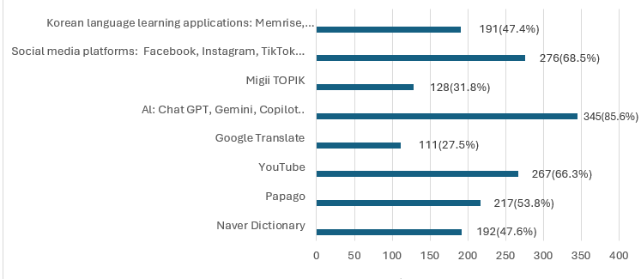
Figure 1: Digital technology and AI tools frequently used by students
Figure 1 shows that, in addition to AI tools, students also frequently engage with video and social media platforms such as YouTube, TikTok, Facebook, and Instagram. For learners of Korean, these platforms serve not only as resources for developing language skills but also as channels for accessing Korean culture in a vivid and immediate manner through television dramas, entertainment programs, music, and user-generated content produced by native speakers. Regular exposure to Korean language media enables students to expand their vocabulary and to become familiar with the intonation, speech rate, and natural pronunciation of native speakers. At the same time, learners have the opportunity to observe discrepancies between the linguistic forms presented in textbooks and those used in authentic communication, thereby gaining a deeper understanding of nuances of meaning, contextual usage, and the cultural features of Korean communication. Such engagement contributes to the development of both linguistic competence and intercultural communicative competence.
Many students also use language-learning applications such as Duolingo, Memrise, Quizlet, and Anki, together with TOPIK preparation platforms, to support their self-directed learning. This pattern reflects a defining characteristic of students majoring in Korean Language: the need to obtain the Test of Proficiency in Korean (TOPIK), an internationally recognized certification widely used to assess Korean language proficiency. TOPIK results not only serve as an important criterion for scholarship applications and study-abroad programs in Korea, but are also a common requirement among Korean enterprises, organizations, and companies operating in Vietnam during recruitment. The use of TOPIK preparation platforms thus indicates that students draw on digital technology not only to meet their immediate learning needs but also to pursue longer-term academic and career goals.
Overall, the findings in Figure 1 reveal that students have been actively engaging with a wide range of digital tools in their Korean language learning, with AI platforms playing an increasingly prominent role. This pattern reflects the growing integration of technology into foreign language learning amid the ongoing digital transformation.
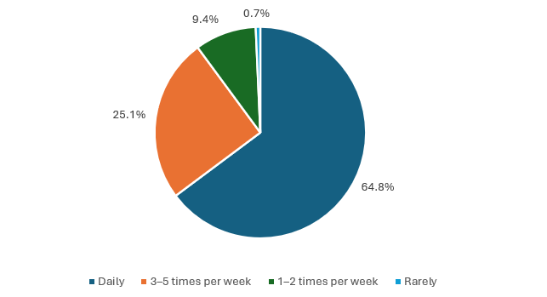
Figure 2: Frequency of digital technology and AI use in Korean language learning
The results in Figure 2 show that the majority of students use digital technology and AI with high frequency. Specifically, 64.8% reported using these tools daily, 25.1% used them three to five times per week, and 9.4% used them one to two times per week. The proportion of students who rarely used such tools was very low. These data indicate that digital technology and AI have become familiar learning-support tools for students of Korean.
Overall, the findings reveal that students at TNU – University of Sciences are engaging with a diverse range of digital technology and AI tools in their Korean language learning, and at a relatively high frequency. Among these, AI platforms are playing an increasingly prominent role and have become a familiar means of learning support for many students. This pattern reflects the growing integration of technology into foreign language learning amid the ongoing digital transformation.
3.2. Students' Perceptions of the Role of Digital Technology and Artificial Intelligence in Korean Language Learning
Students' perceptions of the role of digital technology and AI constitute one of the key factors influencing the effectiveness of digital learning activities. Accordingly, the present study examined how students rated the necessity of digital technology and AI in their Korean language learning. The survey results are presented in Figure 3.
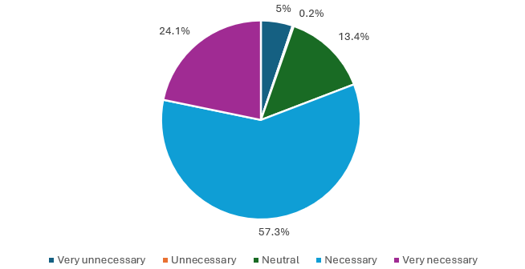
Figure 3: Students' ratings of the role of digital technology and AI in Korean language learning
The survey results indicate that students at TNU – University of Sciences generally hold positive perceptions of the role of digital technology and artificial intelligence (AI) in Korean language learning. As shown in Figure 3, 57.3% of respondents considered digital technology and AI to be necessary, while 24.1% regarded them as very necessary. In contrast, 13.4% reported a neutral view, and only 5.2% perceived these technologies as unnecessary or very unnecessary. Overall, 84.4% of the surveyed students acknowledged digital technology and AI as necessary tools for learning Korean.
The high proportion of students who viewed digital technology and AI as necessary or very necessary suggests a strong appreciation of their educational value in supporting Korean language learning. This finding is consistent with the growing integration of AI into higher education reported by Nguyen Thi Phuong Hoa (2024), which found that 42.8% of students had used ChatGPT to support writing practice. Although the indicators are not directly comparable, both studies reflect the increasing presence of AI in students’ learning activities and its expanding role in academic support.
Students’ positive perceptions may be attributed to the flexibility and accessibility that digital technologies provide. Through smartphones, personal computers, and Internet-based platforms, learners can access a wide range of learning resources beyond the constraints of time and place. In addition, AI-powered tools such as ChatGPT, Gemini, Copilot, Papago AI, and language-learning chatbots offer various forms of support, including grammatical explanations, vocabulary assistance, writing correction, dialogue generation, and communication practice. These findings are consistent with Zhu and Wang [4], who highlighted the potential of AI to facilitate personalized learning and provide immediate feedback in language education.
Nevertheless, the proportion of students expressing neutral or negative views indicates that perceptions of digital technology and AI are not entirely uniform. This finding suggests the need for greater instructional support to help learners understand not only the benefits but also the limitations of AI, thereby promoting its effective, critical, and responsible use in Korean language learning.
3.3. Purposes of Using Digital Technology and Artificial Intelligence in Korean Language Learning
To gain insight into how students engage with digital technology and AI in their Korean language learning, the study examined the most common purposes for which these tools are used. This approach makes it possible to identify the areas of learning that benefit most from digital and AI tools, and thereby to assess the broader trend of technology use in the development of students' language competence. The survey results are presented in Figure 4.
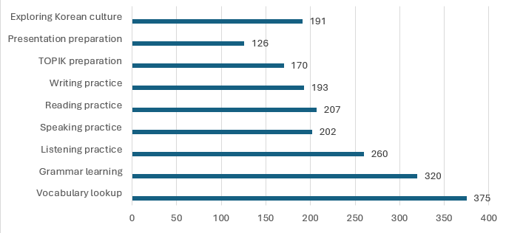
Figure 4: Purposes of students' use of digital and AI tools in Korean language learning
The survey results indicate that students use digital technology and AI for a wide range of learning purposes. Because respondents could select multiple options, the percentages exceed 100%. Vocabulary lookup was the most frequently selected purpose, reported by 375 of 403 students (93.1%), followed by grammar learning (79.4%), listening practice (64.5%), reading practice (51.4%), speaking practice (50.1%), writing practice (47.9%), and exploring Korean culture (47.4%). This finding reflects the importance of vocabulary acquisition in Korean language learning, where learners are required to master a large number of Sino-Korean words, native Korean vocabulary, and context-dependent expressions that frequently appear in TOPIK examinations and authentic communication settings.
The second main purpose is grammar support. Students commonly use digital tools to search for the usage of sentence patterns, compare structures with similar meanings, look up examples, and ask AI to explain difficult grammatical points. Korean grammar differs considerably from Vietnamese, particularly in its system of particles, honorific expressions, speech levels, and sentence-final endings.
Another important purpose is the development of language skills, particularly listening and speaking. The survey results show that 64.5% of students use these tools for listening practice, while 50.1% use them to improve their speaking skills. Students often use YouTube, short-form videos, films, dramas, and Korean entertainment programs to familiarize themselves with authentic pronunciation, intonation patterns, conversational expressions, and cultural norms embedded in real-life communication. Some students additionally use AI chatbots that support Korean-language conversation or pronunciation-training applications in order to expand their opportunities for communicative practice. This finding is consistent with Kim and Su (2024), who reported that AI chatbots can enhance students' willingness to communicate in Korean.
Beyond receptive and communicative skills, students also use digital tools to improve their Korean writing skills. A total of 193 of 403 respondents (47.9%) selected this purpose. The tools most commonly used include translation software, error-checking applications, and AI chatbots, which assist students in constructing sentences, detecting and correcting grammatical errors, selecting appropriate vocabulary, and refining Korean-language paragraphs. The use of AI for writing practice, however, also carries the risk of fostering dependence if students simply copy AI-generated output without actively analyzing, revising, and learning from it. The use of AI therefore needs to be accompanied by students' own processes of self-assessment and revision.
Another notable finding is that 170 students (42.2%) reported using digital technology and AI for TOPIK preparation. This reflects the importance of TOPIK as an internationally recognized Korean proficiency test that plays a significant role in scholarship applications, overseas study opportunities, and employment at Korean companies operating in Vietnam. Digital platforms provide learners with convenient access to mock tests, vocabulary lists, grammar exercises, and test-taking strategies.
In addition to the purposes mentioned above, students also use digital technology to explore Korean culture, prepare presentations, study for the TOPIK, attend online classes, and exchange learning materials with peers. These results indicate that digital technology and AI not only support individual language skills but are also embedded in a wide range of student learning activities. The pattern is consistent with the trend reported by Nguyen Thi Ngoc Anh and Tran Nhat Vy [10], who found that AI is increasingly used by students as a tool for self-directed learning and information retrieval. Overall, the findings suggest that digital technology and AI have become integral components of students' Korean language learning practices, supporting not only language development but also examination preparation, cultural exploration, and autonomous learning.
3.4. Effectiveness of Using Digital Technology and Artificial Intelligence in Korean Language Learning
Learning effectiveness is one of the key criteria for assessing the suitability of applying digital technology and AI in foreign language education. Accordingly, the study examined students' views on the extent to which these tools affect various aspects of Korean language learning, including vocabulary expansion, grammar support, the development of listening and speaking skills, and overall academic performance. The survey results are presented in Figure 5.

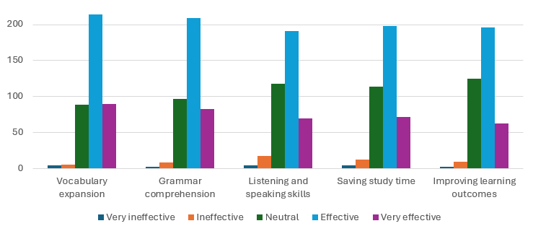
Figure 5: Learning effectiveness of digital and AI tools
The survey results indicate that students generally hold positive perceptions regarding the effectiveness of digital technology and AI in Korean language learning. Overall, 64.3% of respondents rated the impact of these tools on their Korean learning outcomes as either "effective" or "very effective." This finding suggests that digital technology and AI have become important resources for supporting language learning, facilitating access to information, and promoting autonomous learning.
As illustrated in Figure 5, the perceived effectiveness of digital technology and AI varies across different learning activities. The highest positive ratings were recorded for vocabulary expansion, with 75.0% of students evaluating these tools as effective or very effective. This was followed by grammar learning (72.5%), time-saving in learning (66.7%), improving academic performance (64.0%), and enhancing listening and speaking skills (64.0%). These findings indicate that students perceive digital technology and AI as particularly useful for supporting vocabulary acquisition and grammar learning, especially vocabulary and grammar, which constitute fundamental components of Korean language learning.
The positive evaluation of vocabulary and grammar support may be related to the characteristics of Korean as a foreign language. Students frequently encounter difficulties in understanding grammatical structures, honorific expressions, sentence endings, and context-dependent vocabulary. Digital tools and AI platforms can provide immediate explanations, examples, and feedback, thereby facilitating comprehension and independent study. This finding is consistent with Zhu and Wang [4], who highlighted the potential of AI to personalize learning experiences and provide timely instructional support.
In addition, approximately two-thirds of respondents reported that digital technology and AI helped them save study time and improve their listening and speaking skills. Through video-sharing platforms, language-learning applications, speech-recognition tools, and AI chatbots, students can access authentic Korean-language materials and engage in language practice beyond the classroom. These findings are consistent with previous studies emphasizing the role of technology in expanding learning opportunities and fostering learner autonomy [3], [6], [7].
Nevertheless, a considerable proportion of respondents selected the "neutral" option across all surveyed items, ranging from approximately 22% to 31%. This suggests that the benefits of digital technology and AI are not experienced equally by all students. The effectiveness of these tools depends not only on their technical capabilities but also on learners' digital literacy, learning strategies, and ability to critically evaluate AI-generated information. Therefore, appropriate guidance and training are necessary to help students maximize the educational value of digital technology and AI in Korean language learning.
3.5. Difficulties and Limitations in the Use of Digital Technology and Artificial Intelligence
In addition to documenting the positive effects of digital technology and AI on Korean language learning, the study also examined the challenges that students encounter when using these tools. Identifying such difficulties and limitations not only enables a more balanced assessment of the effectiveness of technology use, but also provides a basis for proposing measures to enhance the quality of learning support in digital environments. The survey results are presented in Figure 6.
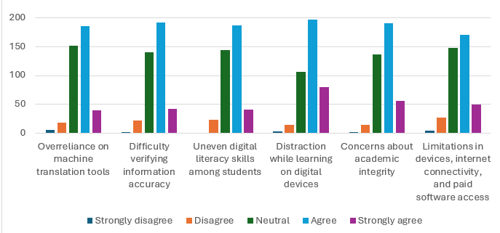
Figure 6: Difficulties and limitations encountered by students in using digital technology and AI
Despite the benefits of digital technology and AI, the survey results indicate that students encounter several challenges when using these tools in Korean language learning. As shown in Figure 6, the proportion of respondents selecting "agree" or "strongly agree" exceeded 50% across all surveyed difficulties, suggesting that these issues are relatively common among Korean language learners.
One of the most frequently reported difficulties was distraction while studying on digital devices. Approximately 68.2% of respondents agreed or strongly agreed that learning through smartphones, computers, and online platforms often exposes them to distractions such as social media, entertainment content, messaging applications, and online games. This finding suggests that although digital technology increases access to learning resources, it may also reduce concentration and learning efficiency when students lack effective self-regulation strategies.
Another major concern relates to the verification of information accuracy, with around 58.1% of students reporting difficulties in this area. Although AI tools can provide rapid responses and explanations, the information generated is not always accurate or contextually appropriate. This issue is particularly important in Korean language learning, where honorific expressions, speech levels, pragmatic meaning, and cultural context play crucial roles in communication. AI-generated explanations or translations may sometimes overlook these nuances, potentially leading to inappropriate language use if students rely on them without verification.
The survey also revealed concerns regarding overreliance on machine translation and AI tools, reported by approximately 55.3% of respondents. Many students use tools such as Papago, Google Translate, ChatGPT, and other AI applications to translate vocabulary, sentences, or entire texts. While these tools provide convenience and immediate support, excessive dependence may reduce opportunities for learners to develop independent problem-solving skills and linguistic competence.
In addition, more than half of the respondents indicated difficulties related to uneven digital literacy skills (56.3%) and concerns about academic integrity when using AI (60.8%). These findings suggest that some students are still uncertain about how to use AI appropriately and responsibly in learning activities. The use of AI-generated content in assignments, presentations, and writing tasks may raise issues concerning originality, authorship, and academic ethics if clear guidelines are not provided.
Finally, although receiving the lowest level of agreement among the surveyed items, limitations in technological infrastructure, including devices, Internet connectivity, and access to paid software, remained a challenge for approximately 54.3% of respondents. This result indicates that unequal access to technological resources may still affect students' ability to benefit fully from digital learning tools.
Overall, the findings suggest that while digital technology and AI offer substantial support for Korean language learning, their effective use requires not only technological access but also adequate digital literacy, critical evaluation skills, and responsible learning practices. These results are consistent with previous studies emphasizing that the educational value of technology depends largely on learners' ability to use it critically and purposefully [4], [6].
3.6. Students' Needs and Recommendations Regarding the Use of Digital Technology and Artificial Intelligence in Korean Language Learning
Building on the benefits and limitations identified in the use of digital technology and AI, the study further examined students' needs and recommendations concerning the application of these tools in Korean language learning. The responses obtained provide insight into students' expectations regarding guidance on technology use, the development of their capacity to leverage AI, and the deeper integration of technology into the learning environment. The results are presented in Figure 7.
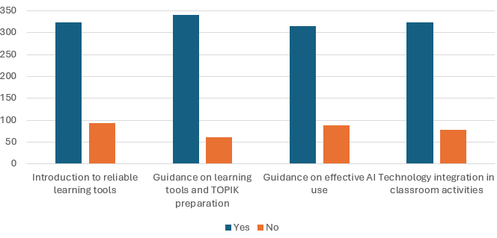

Figure 7: Students' needs and recommendations regarding the use of digital technology and AI
The survey results presented in Figure 7 indicate that students have a substantial demand for support in applying digital technology and AI to Korean language learning. Among the 403 respondents, 324 students (80.4%) expressed a desire to be introduced to reliable learning tools, while 340 students (84.4%) reported a need for instruction on the use of online dictionaries, language-learning applications, and TOPIK preparation platforms. In addition, 315 students (78.2%) wished to develop competencies for using AI effectively, and 323 students (80.1%) recommended greater integration of digital technology into classroom activities.
Although digital technology and AI have become widely accessible and are frequently used by students, the findings suggest that learners still require support in selecting and exploiting tools that align with specific learning objectives. This result is consistent with the study of Nguyen Thi Ngoc Anh and Tran Nhat Vy [10], which found that students need not only access to AI tools but also instruction in how to employ them effectively and responsibly. The development of digital literacy and AI literacy therefore emerges as an increasingly important component of foreign language education in higher education.
Among the surveyed items, the strongest demand concerned guidance on the use of online dictionaries, language-learning applications, and TOPIK preparation platforms (84.4%). This result reflects the specific characteristics of Korean language learners, who often rely on resources such as Naver Dictionary, Papago, vocabulary-learning applications, and TOPIK preparation tools to support vocabulary acquisition, grammar learning, honorific expressions, and examination preparation. Given that TOPIK certification is widely recognized as an important qualification for employment in Korean enterprises and for postgraduate study opportunities, students are particularly interested in learning how to use these resources efficiently and systematically.
The findings also reveal a strong expectation that digital technology should be more deeply integrated into classroom teaching. More than four-fifths of respondents (80.1%) supported the incorporation of interactive activities, multimedia learning materials, and AI-assisted learning tasks into Korean language courses. Such integration is expected to enhance learner engagement, increase classroom interaction, and provide students with more opportunities to apply Korean language knowledge in meaningful contexts.
With respect to AI, 78.2% of students expressed a desire to develop practical competencies in prompt writing and in using AI for grammatical explanations, error correction, dialogue generation, writing support, and communicative practice. These findings suggest that students are interested not only in accessing AI tools but also in understanding how to use them effectively and critically. At the same time, many learners recognize the importance of verifying information, identifying inaccuracies, and understanding the limitations of AI-generated content, particularly when dealing with honorific forms, pragmatic meanings, cultural nuances, and context-dependent expressions in Korean.
Overall, students’ support needs can be grouped into two broad dimensions: developing competencies for the effective use of digital technology and AI, and strengthening the integration of technology into teaching and learning activities. The results suggest that the key challenge is no longer access to technological resources but rather the ability to use them effectively, critically, and responsibly in support of language learning.
Based on these findings, several implications can be proposed to enhance the use of digital technology and AI in Korean language education.
For instructors, greater emphasis should be placed on helping students select and exploit digital tools that correspond to specific learning objectives, such as vocabulary development, grammar acquisition, honorific usage, communicative competence, and TOPIK preparation. Learning activities involving AI should be designed to encourage critical thinking by requiring students to compare AI-generated responses with textbook content or authoritative Korean-language resources and to explain any necessary revisions. Such activities can promote deeper learning while reducing excessive dependence on AI-generated outputs.
For students, digital technology and AI should be viewed as learning support tools rather than substitutes for independent thinking and language practice. Learners need to develop competencies in prompt writing, information evaluation, and source verification. In addition, AI-generated content should be cross-checked against reliable resources such as Naver Dictionary, Papago, official Korean language learning materials, and instructor feedback. These practices can contribute to stronger self-directed learning habits and more effective use of digital resources.
For TNU – University of Sciences and the Department of Korean Studies, it is advisable to establish guidelines on the responsible use of AI in learning activities in order to promote academic integrity and ethical technology use. Training workshops on AI and digital literacy should be provided from the first year of study to help students develop the competencies required in contemporary learning environments. Furthermore, the integration of digital skills training into the curriculum and the expansion of technology-enhanced learning activities would contribute to strengthening students’ digital literacy, self-directed learning capacity, and readiness for future academic and professional contexts shaped by digital transformation.
4. Conclusion
This study investigated the use of digital technology and artificial intelligence (AI) in Korean language learning among 403 students at TNU – University of Sciences. The findings indicate that digital technology and AI have become widely used learning-support tools among students. Generative AI platforms constituted the most frequently used category, with 85.6% of respondents reporting their use. Furthermore, 84.4% of students rated digital technology and AI as "necessary" or "very necessary" for learning Korean, while 64.27% reported that these technologies had a positive impact on their Korean language learning outcomes.
In addition to facilitating information retrieval, expanding access to learning resources, fostering learner autonomy, and enhancing learning motivation, digital technology and AI also present several challenges. These include overreliance on support tools, difficulties in verifying information accuracy, disparities in students' digital competence, concerns regarding academic integrity, and distractions associated with digital learning environments.
The findings further reveal a substantial demand among students for guidance on the effective use of digital technology and AI in Korean language learning. In response to these needs, the study proposes several pedagogical implications aimed at promoting the effective and responsible integration of digital technology and AI into Korean language education at the tertiary level.
From a practical perspective, the findings provide useful insights for instructors and educational institutions seeking to design technology-enhanced learning activities that reflect the specific characteristics of Korean language education. Several limitations of the study should nevertheless be acknowledged. First, the survey was conducted solely among students at TNU – University of Sciences, which may limit the generalizability of the findings. Second, the study relied primarily on self-reported questionnaire data, meaning that the results reflect students' perceptions and experiences at the time of data collection. Given the rapid development of AI technologies, changes in students' technology-use practices warrant continued monitoring and investigation.
Future research could expand the scope of investigation to other institutions, employ mixed-methods approaches, and examine in greater depth the effects of specific digital technologies and AI tools on particular aspects of Korean language learning. Overall, the study contributes additional empirical evidence regarding the application of digital technology and AI in Korean language education and offers practical implications for the design of AI-integrated language learning environments in the context of digital transformation.
Acknowledgements
This research was partially funded by the TNU- University of Sciences under the Grant Number:
CS2024-TN06-45.
REFERENCES
[1] Warschauer, M., & Healey, D. (1998). Computers and language learning: An overview. Language Teaching, 31(2), 57–71.
[2] Stockwell, G. (Ed.). (2012). Computer-assisted language learning: Diversity in research and practice. Cambridge University Press.
[3] Godwin-Jones, R. (2011). Mobile apps for language learning. Language Learning & Technology, 15(2), 2–11.
[4] Zhu, M., & Wang, C. (2025). A systematic review of research on AI in language education: Current status and future implications. System, 128, Article 103539.
[5] Kim, A. (2022). Mobile-Assisted Language Learning in L2 Korean Using WeChat: A Case Study. International Journal of Interactive Mobile Technologies, 16(1), 94–105.
[6] Lubis, A. H., Triarisanti, R., Samsudin, D., & Ansas, V. N. (2023). Mobile-Assisted Language Learning in Korean Language Classes: Indonesian Undergraduate Students’ Experiences and Perceptions. LLT Journal: A Journal on Language and Language Teaching, 26(2), 696–710.
[7] Kim, A., & Su, Y. (2024). How implementing an AI chatbot impacts Korean as a foreign language learners’ willingness to communicate in Korean. System, 122, 103256.
[8] Shin, J., & Choi, Y. (2025). Using an AI-powered chatbot for improving L2 Korean grammar: A comparison between proficiency levels and task types. Language Learning & Technology, 29(2), 135–166.
[9] Nguyen Thi Phuong Hoa. (2024). Students’ usage of ChatGPT for writing practice. TNU Journal of Science and Technology, 229(12), 260–269.
[10] Nguyen Thi Ngoc Anh, & Tran Nhat Vy. (2025). Behavioral research on AI as a tool for supporting English learning in first-year students. The University of Danang - Journal of Science and Technology, 23(8C), 51–54.
[11] Nguyen Thi Nha Phuong, & Pham Thi Thuy Duy. (2026). The use of ELSA Speak in speaking skills of non-English majors: Effects and challenges. TNU Journal of Science and Technology, 231(03), 100–106.

