EMPOWERING ACCESSIBLE NEUROSCIENCE THROUGH AFFORDABLE SENSORS INNOVATIONS

ABSTRACT

The rapid advancement of affordable neuro-sensor technologies is transforming the accessibility, usability, and impact of neuroscience across research, healthcare, and pharmaceutical domains. This report explores the principles of neuroscience and biosensor technology, followed by an in‑depth review of emerging low‑cost neuro-sensing devices such as BrainBit, Muse 2, NeuroSky Mindwave Mobile 2, OpenBCI Ultracortex Mark IV, and GSR‑based stress sensors. These devices utilize dry electrodes, wireless connectivity, and user-friendly interfaces to provide real-time monitoring of brain activity, stress levels, cognitive states, and emotional responses outside traditional laboratory settings. Literature studies demonstrate their capability to capture meaningful neural markers—including ERPs like the N400, autonomic indicators such as PRV and GSR, and cognitive performance metrics—highlighting their potential in neurofeedback, mental wellness, education, and mobile neuroscience.

The report further examines the growing relevance of neuro-sensors in pharmaceutical sciences, where they support drug discovery, digital biomarker development, clinical trials, usability testing, and remote patient monitoring. Their affordability and portability democratize access to neurotechnology, enabling universities, startups, and healthcare practitioners to integrate objective physiological data into research and patient care. Overall, affordable neuro-sensors represent a significant step toward accessible neuroscience, bridging the gap between laboratory-grade tools and real-world applications, and paving the way for personalized, data-driven, and patient-centered innovations in healthcare and pharmacology.
Keywords-Biosensors,Neuroscience,Neurotechnology,Patient monitoring

What is NEUROSCIENCE?
Neuroscience is the branch of science that studies the nervous system, which includes the brain, spinal cord, and peripheral nerves. Its main goal is to understand how the brain and nervous system develop, function, and control behavior, thoughts, emotions, and bodily processes.
The nervous system acts as the body’s control and communication network. It receives information from the environment, processes it, and sends signals that allow us to move, think, feel, learn, and remember. Neuroscience seeks to explain how all of this happens at different levels—from tiny cells to complex behaviors.
Neuroscience:
- Helps improve treatments for brain and mental health disorders
- Advances understanding of learning and education
- Contributes to artificial intelligence and brain-computer interfaces
- Helps explain human behavior and emotions
- Improves quality of life by understanding brain health
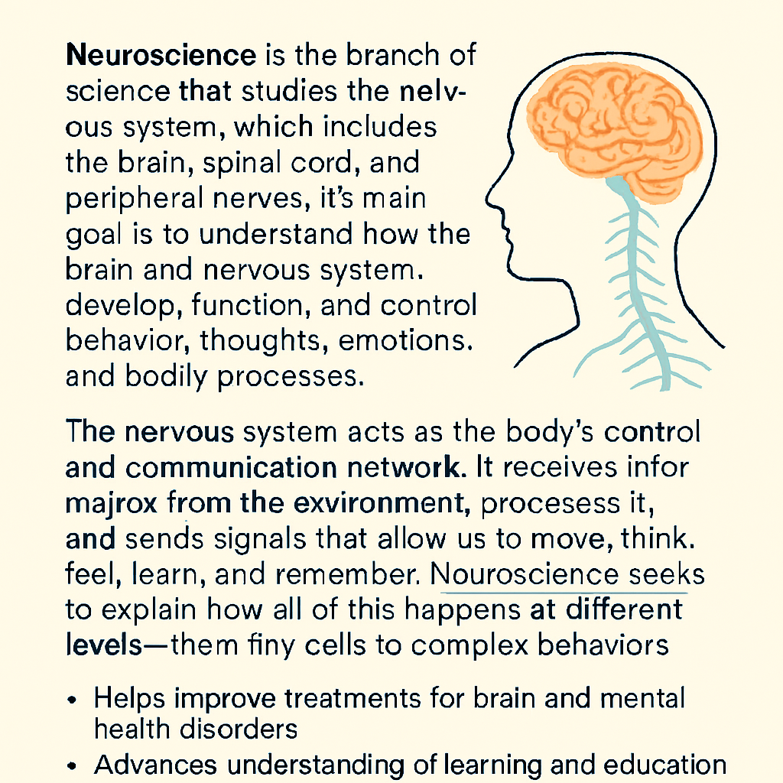

What are Neurosensors or BIOSENSORS?
A biosensor is more than just a device that detects substances — it’s an integrated analytical system where biology meets technology. At its core, a biosensor uses a biological recognition element (such as enzymes,
antibodies, nucleic acids, or even whole cells) to interact specifically with
target analyte. This interaction is then converted by a transducer into a measurable signal — electrical, optical, thermal, or mechanical. Finally, a signal processor interprets and displays the result in a user-friendly format.
What makes biosensors unique is their ability to combine biological specificity (only binding to the intended target) with technological sensitivity (detecting even tiny amounts). Modern biosensors are not just lab tools; they are portable, wearable, and implantable systems capable of continuous, real-time monitoring.

Core Components of Biosensors.
- Biorecognition element:
This is the biological “sensor” part that ensures selectivity. It interacts only with the target analyte, much like a lock-and-key mechanism. Common examples include enzymes (for glucose detection), antibodies (for disease biomarkers), nucleic acids (for genetic testing), and aptamers (synthetic molecules designed for high specificity). Modern biosensors also use engineered proteins, synthetic peptides, or even whole cells to broaden the detection range. The choice of biorecognition element directly determines the biosensor’s accuracy and application domain.
- Transducer:
The transducer is the conversion unit — it translates the biological event into a measurable physicochemical signal. Depending on the design, this signal can be:
- Electrochemical: current, voltage, or impedance changes (common in glucose meters).
- Optical: changes in fluorescence, absorption, or refractive index (used in medical diagnostics).
- Piezoelectric: frequency shifts due to mass changes on a sensor surface.
Thermal: heat released or absorbed during biochemical reactions

- Magnetic: detection of magnetic labels or nanoparticles bound to analytes:
Nanomaterials like graphene, carbon nanotubes, and quantum dots enhance transducer performance by increasing surface area, improving electron transfer, and lowering detection limits. This makes biosensors more sensitive and capable of detecting very small concentrations of analytes.
- Signal processor/display:
Once the transducer generates a raw signal, it needs to be processed into something meaningful. The signal processor amplifies weak signals, filters out noise, and converts analogy data into digital form. Advances in
microelectronics now allows biosensors to integrate wireless modules, enabling real-time transmission to smartphones or cloud platforms. This means users can monitor health parameters continuously, receive alerts instantly, and even share data with healthcare providers. In wearable biosensors, this component is crucial for turning biochemical reactions into user-friendly dashboards or predictive analytics powered by AI.
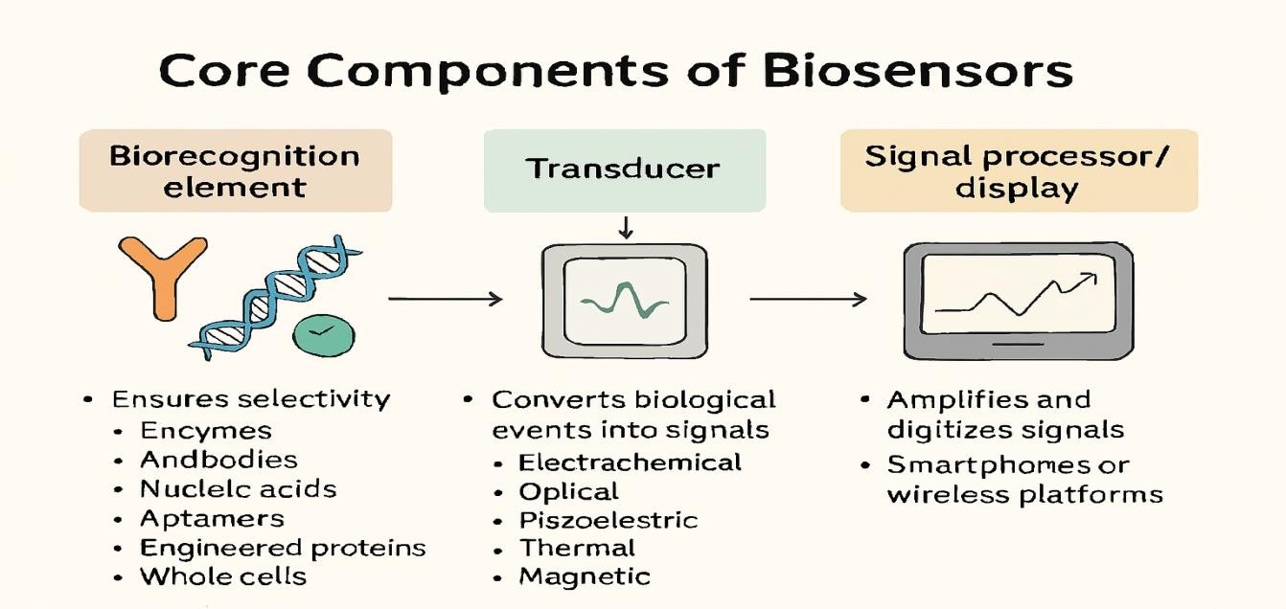

Types of Biosensors
- Electrochemical Biosensors:
These are the most widely used due to their simplicity, affordability, and fast response. They detect changes in current, voltage, or impedance caused by biochemical reactions — commonly used in glucose meters, pathogen detection, and drug monitoring.
- Optical Biosensors:
These rely on changes in light properties — such as absorption, fluorescence, or refractive index — when a target molecule binds. They’re highly sensitive and often used in medical diagnostics, biomolecular
interaction studies, and environmental sensing.
- Piezoelectric and Thermal Biosensors:
- Piezoelectric: Measure frequency shifts caused by mass changes on a sensor surface.
- Thermal: Detect heat released or absorbed during biochemical reactions.
Both are useful in environmental monitoring and clinical assays where physical changes are key indicators.
- DNA and Immunosensors:
- DNA Biosensors: Identify specific genetic sequences, ideal for pathogen detection and genetic testing.
- Immunosensors: Use antibody-antigen interactions to detect toxins, diseases, or allergens with high specificity.
- Wearable and Resonant Biosensors:
Designed for continuous, non-invasive monitoring of physiological parameters like glucose, lactate, heart rate, and hydration. Resonant sensors detect analyte binding through shifts in resonance frequency, often used in advanced wearable platforms.
Emerging Nanomaterial and Magnetic Biosensors: These use nanostructures (graphene, carbon nanotubes, quantum dots) or magnetic fields to achieve ultra-sensitive, multiplexed detection. They’re paving the way for next-gen diagnostics, especially in AI-integrated and IoT- enabled systems.
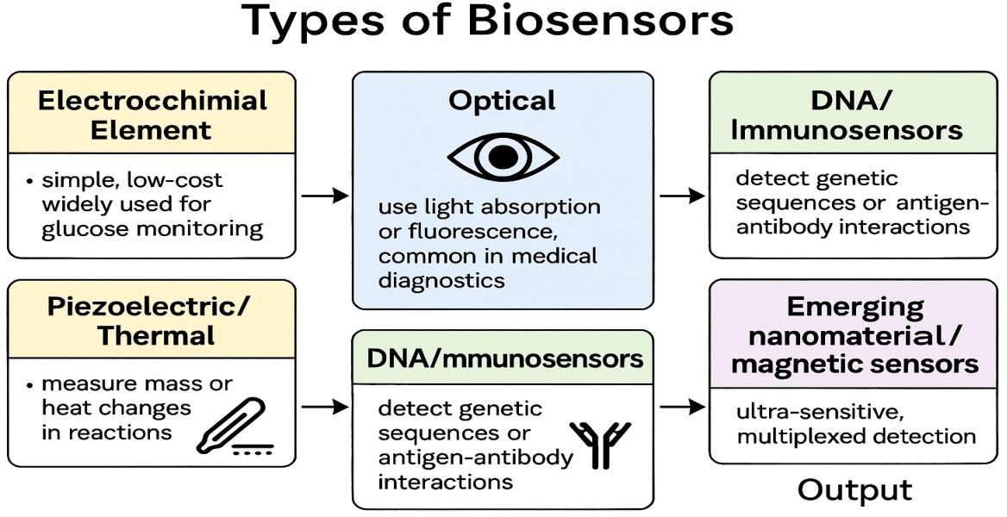
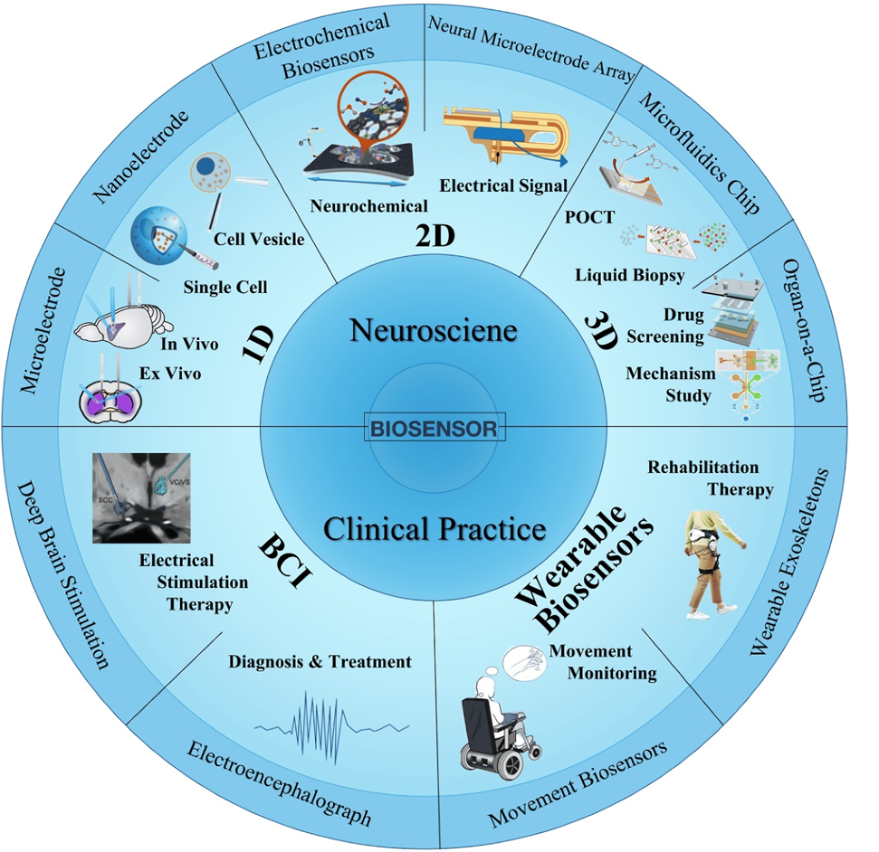
1. Literature review
Title: NEUROSCIENCE Exploring the Brain
authour: MARK F. BEAR ; BARRY W. CONNORS ; MICHAEL A. PARADISO.
journal: Lippincott Williams & Wilkins
Neuroscience, though formally established only in 1970 with the founding of the Society for Neuroscience, is rooted in humanity’s age‑old curiosity about perception, movement, memory, emotion, and mental states, and has evolved from diverse disciplines including medicine, biology, psychology, physics, chemistry, and mathematics into a unified, interdisciplinary science. The modern neuroscience revolution emerged when researchers recognized that understanding the brain required synthesis across molecular, cellular, systems, and behavioral levels, linking phenomena as small as the structure of water molecules to complex processes such as Pavlov’s conditioning. Today, neuroscience is the fastest‑growing field in experimental biology, encompassing molecular neuroscience, systems neuroscience, cognitive neuroscience, and clinical applications, with scholars such as Kandel, Bear, and others emphasizing its breadth and integrative nature. This interdisciplinary expansion underscores neuroscience’s role as a hub discipline, bridging natural sciences and psychology to unravel the mysteries of the nervous system and provide insights into both fundamental brain function and the treatment of neurological and psychiatric disorders.

2. Literature review
Title: NeuroSky Mindwave Mobile Headset 2 as an Intervention for Reduction of Stress and Anxiety Measured With Pulse Rate Variability
authour: Habshi Al-Kaf1, Ahsan Khandoker1, Kinda Khalaf1, Herbert F Jelinek1 1Khalifa University, Abu Dhabi, United Arab Emirates
journal: Khalifa UniversitY
In this study, pulse rate variability (PRV) was measured for 10 minutes before and after participants engaged with the MMH2 neurofeedback device for a 10‑minute relaxation session. The MMH2 sensor was positioned on the forehead, with auxiliary sensors clipped to the left earlobe, while participants were guided in diaphragmatic breathing, a mindfulness technique commonly employed in relaxation training. The MMH2 was connected via Bluetooth to the Brainwave Visualiser application, which provided real‑time feedback in the form of a floating ball on the screen: the more relaxed the participant, the higher and longer the ball remained afloat. This gamified feedback mechanism allowed participants to monitor their progress through metrics such as Best Float Time and Best Float Height, reinforcing engagement and self‑regulation during training. To complement neurofeedback, an infrared sensor was attached to the index finger to record blood volume pulse (BVP) using equipment from Thought Technology (Montreal, Canada), thereby integrating physiological monitoring with cognitive‑behavioral relaxation strategies.

3.Literature review
Title: Exploring the Utility of the Muse Headset for Capturing the N400: Dependability and Single-Trial Analysis
authour: Hannah Begue; Hayes andCyrilleMagne
journal: MDPI
The present study sought to evaluate the efficacy of the Muse 2 headset in measuring the N400 component, a well‑established event‑related potential (ERP) marker of semantic processing and one of the most extensively studied components in language research. The N400, a negative deflection occurring between 250–600 ms post‑stimulus onset and peaking around 400 ms, reflects the brain’s response to meaningful stimuli such as words, pictures, and environmental sounds. Its amplitude is modulated by expectancy, being larger for unpredictable words and smaller for predictable ones, making it a valuable index of semantic integration. Experimental paradigms such as the semantic relatedness judgment task (SRJT) reliably elicit the N400, with unrelated prime–target pairs (e.g., icing–bike) producing larger responses than related pairs (e.g., pedal–bike). Beyond its linguistic relevance, the N400 has demonstrated clinical utility as a biomarker for learning disabilities (e.g., dyslexia) and neurological or psychiatric disorders (e.g., Alzheimer’s disease, schizophrenia). Traditionally measured with mastoid‑referenced electrodes, the N400’s broad scalp distribution suggests feasibility with alternative electrode configurations, including consumer‑grade devices like Muse. Accordingly, this study employed the SRJT to test whether Muse 2 could capture the expected N400 effect, hypothesizing that target words in unrelated pairs would elicit larger amplitudes than those in related pairs.

AFFORDABLE NERUO-SENSORS :

1.The BrainBit EEG Headband:
The BrainBit EEG Headband is a breakthrough in neurotechnology, designed to make brain monitoring accessible, affordable, and practical for everyday use. Traditional EEG systems are bulky, require messy conductive gels, and are often limited to clinical settings. BrainBit solves these problems with a lightweight, flexible headband that uses spring-loaded dry electrodes. These electrodes adapt to different hair types and maintain stable contact with the scalp, eliminating the need for gels and long setup times.
Electrode placement and signal quality:
The electrodes are positioned at the T3, T4, O1, and O2 sites according to the international 10–20 system. This allows BrainBit to capture electrical activity from the temporal and occipital lobes — regions linked to attention, visual processing, and relaxation. It records across four EEG channels at a sampling rate of 250 Hz, which is high enough to capture subtle brainwave patterns. Importantly, the system distinguishes genuine brain activity from artifacts caused by muscle movement or eye blinks, ensuring clean, reliable data suitable for research and practical applications.
Connectivity and usability:
BrainBit connects wirelessly via Bluetooth Low Energy to smartphones, tablets, or computers. Its rechargeable battery supports up to 12 hours of continuous use, with a charging time of about 4 hours. The lightweight design makes it comfortable for extended wear, whether in classrooms, meditation sessions, or research labs.
Platform for innovation:
BrainBit is not just hardware — it’s a platform. The included software development kit (SDK) supports Windows, macOS, iOS, and Android, enabling developers to stream, record, and analyze EEG data in real time. This opens the door for custom applications in neurofeedback, meditation, cognitive training, and even creative projects.
Applications across fields:
• Neurofeedback training: Users can see their brain states in real time and practice focus, relaxation, or cognitive control.
• Meditation and wellness: Tracks brainwave patterns during mindfulness exercises, offering measurable insights into stress reduction.
• Research: Provides reliable EEG data for cognitive neuroscience, consumer behavior, and educational psychology studies.
• Creative arts: Artists and technologists use brain signals to drive interactive installations, digital art, or music that responds to neural activity.
Affordability and accessibility:
Priced at around $600, BrainBit is far cheaper than hospital-grade EEG systems that cost tens of thousands. This makes it accessible to universities, startups, and individual researchers. Its portability means experiments can happen outside traditional labs — in classrooms, clinics, or even at home. The dry electrode design and wireless connection make it easy to use, appealing for demonstrations and wellness coaching.
Compliance and limitations:
BrainBit is FCC-cleared and CE-marked, meeting international standards. However, it is not classified as a medical device — it is intended for research, education, and wellness, not clinical diagnosis.
Impact and vision:
BrainBit is versatile across disciplines. Educators use it to make neuroscience tangible for students. Wellness practitioners integrate it into meditation coaching. Researchers study attention, cognitive load, and decision-making. Digital artists create immersive experiences where brain activity drives visuals or sound. By lowering the barrier to entry, BrainBit democratizes neurotechnology, shifting EEG from a specialized clinical tool to a widely available instrument for exploration, creativity, and personal development.

2. Muse 2 Consumer-Grade EEG Headset :
The Muse 2 EEG headset is part of a new generation of consumer neurotechnology, designed to make brain monitoring affordable, portable, and practical outside of traditional labs. Unlike hospital-grade EEG systems that are bulky, expensive, and require gels, Muse 2 offers a streamlined design with dry electrodes and open access to raw EEG data, making it a powerful tool for democratizing neuroscience research.
Electrode placement and signal quality:
Muse 2 uses electrodes at AF7, AF8, TP9, and TP10, with FPz as the reference. This configuration allows it to capture frontal and temporoparietal brain activity. While the electrode coverage is limited compared to clinical systems, the headset records reliable signals at sufficient resolution to detect event-related potentials (ERPs). In studies, Muse 2 successfully captured the N400 effect, a language-related ERP linked to semantic processing, showing that even consumer-grade devices can measure complex brain responses.
Connectivity and usability:
The headset streams raw EEG data wirelessly via Bluetooth, using tools like BlueMuse to integrate with research platforms. Data can be synchronized with stimuli through the Lab Streaming Layer (LSL), ensuring precise timing. Lightweight and portable, Muse 2 is easy to set up, requires no gels, and can be used in classrooms, clinics, or at home.
Platform for innovation:
Muse 2 provides open access to raw EEG signals, enabling researchers to preprocess and analyze data with standard tools like MATLAB and EEGLAB. This flexibility allows integration into custom experiments, cognitive tasks, and mobile applications. Its affordability and portability make it suitable for ecologically valid studies outside the lab.
Applications across fields:
• Language research: Captures ERPs like the N400, useful for studying semantic processing.
• Education: Allows students to engage with real EEG data in classroom settings.
• Clinical potential: Because the N400 is linked to disorders such as dyslexia, Alzheimer’s, and schizophrenia, Muse 2 opens doors for accessible screening and applied neuroscience.
• General research: Supports studies on attention, cognitive load, and decision-making in diverse environments.
Affordability and accessibility:
Muse 2 is priced far below traditional EEG systems, making it accessible to universities, startups, and independent researchers. Its portability and ease of use expand research beyond specialized labs, enabling inclusive participation and broader innovation.
Compliance and limitations:
Muse 2 is a consumer device, not a medical instrument. While it can capture reliable ERPs, its limited electrode coverage means it cannot replace clinical EEG systems for diagnosis. Instead, it serves as a research and educational tool.
Impact and vision:
Muse 2 demonstrates that consumer-grade EEG can deliver dependable data for meaningful neuroscience. By lowering financial and logistical barriers, it democratizes brain research, supports ecologically valid studies, and fosters innovation in mobile neurotechnology. It represents a shift from EEG being confined to labs to becoming a widely available tool for exploration, education, and applied science.

3. NeuroSky Mindwave Mobile Headset 2 (MMH2):
The NeuroSky Mindwave Mobile Headset 2 is a consumer-grade EEG biofeedback device designed to make stress and anxiety management more accessible. Unlike clinical EEG systems that are expensive and complex, MMH2 uses a simple dry electrode on the forehead and an ear clip to record brain signals. It connects wirelessly via Bluetooth to applications like Brainwave Visualizer, turning neurofeedback into an engaging, gamified experience.
Electrode placement and signal quality:
The headset records EEG activity using a single dry electrode on the forehead and a reference on the earlobe. While this setup is minimal compared to multi-channel EEG systems, it is sufficient for biofeedback tasks. In the study, participants used the device to control a floating ball on a screen — the ball’s height reflected their relaxation level. This design provided immediate feedback, encouraging users to regulate their brain states.
Connectivity and usability:
MMH2 is lightweight, portable, and easy to set up. It connects via Bluetooth to smartphones or computers, making it suitable for home use. The gamified interface lowers the barrier to entry, allowing older adults and non-specialists to engage with neurofeedback without technical training.
Platform for innovation:
The headset integrates with software that supports real-time visualization and recording of brain activity. In the study, it was paired with diaphragmatic breathing exercises — a mindfulness technique — to enhance relaxation. Simultaneously, blood volume pulse (BVP) was recorded with a finger sensor, enabling analysis of heart rate variability (HRV) as an additional measure of stress reduction.
Applications across fields:
• Stress and anxiety reduction: Neurofeedback combined with breathing lowered stress indices and sympathetic nervous system activity.
• Wellness and mindfulness: Supports relaxation training and gamified meditation practices.
• Research: Provides preliminary evidence that consumer EEG can modulate autonomic balance.
• Potential clinical bridge: Could complement traditional protocols for stress management and mental health care.
Affordability and accessibility:
As a low-cost consumer device, MMH2 makes neurofeedback available outside labs and clinics. Its simplicity and gamified design make it appealing for older adults, wellness practitioners, and individuals seeking home-based interventions.
Compliance and limitations:
The study involved only six participants aged 60–74, limiting generalizability. While results showed significant reductions in stress indices, larger and more diverse samples are needed. MMH2 is not a medical device but an accessible tool for research, education, and wellness.
Impact and vision:
The study demonstrated measurable physiological effects: reduced stress index, lowered sympathetic activity, and improved autonomic balance. By combining EEG feedback with breathing and gamified tasks, MMH2 offers a practical, engaging way to manage stress. It highlights the promise of affordable neurotechnology in democratizing mental health care, enabling home-based interventions, and bridging consumer neuroscience with clinical practice.

4.The OpenBCI Ultracortex Mark IV EEG Headset:
The OpenBCI Ultracortex Mark IV is a consumer-grade EEG headset designed to make brain-computer interface (BCI) research more accessible, affordable, and customizable. Traditional medical-grade EEGs are reliable but expensive, require conductive gels, and involve long setup times. The Mark IV solves these problems with a modular, 3D-printed frame and dry electrodes, offering researchers flexibility, reduced costs, and faster usability.
Electrode placement and signal quality:
The Mark IV supports 8- or 16-channel configurations, with electrodes positioned according to the international 10–20 system (e.g., AF3, AF4, F7, F3, F4, F8, T7, C3, C4, T8, P7, P3, P4, P8, O1, O2). Dry, passive electrodes eliminate the need for gels, while impedance checking via the OpenBCI GUI ensures signal quality. In experiments using the P300 Speller task, the headset achieved an average classification accuracy of 82.9%, second only to the medical-grade Biosemi system, despite using fewer electrodes.
Connectivity and usability:
The headset is compatible with OpenBCI’s Cyton and Ganglion biosensing boards, supporting 4, 8, or 16 channels. It connects to software platforms like OpenViBE for data acquisition and classification. Setup time averaged just 2.7 minutes, significantly faster than medical-grade systems (e.g., Biosemi at 20 minutes). Participants rated ease of setup and speed highly, and appearance scored best among compared headsets.
Platform for innovation:
The Mark IV’s open-source design allows researchers to 3D-print parts, customize electrode mounts, and integrate with multiple software platforms. This flexibility supports diverse applications in BCI research, cognitive neuroscience, and usability studies.
Applications across fields:
• P300 Speller tasks: Enables communication through event-related potentials.
• Usability research: Evaluates comfort, ease of setup, and accessibility compared to medical-grade EEGs.
• Cognitive neuroscience: Supports studies on attention, decision-making, and brainwave classification.
• Educational and DIY projects: Affordable entry point for universities, startups, and hobbyists.
Affordability and accessibility:
The full 16-channel Mark IV system (including boards, batteries, and charger) costs around $1,414 — far cheaper than medical-grade systems like Biosemi ($23,855) or g.Sahara ($11,359). Its cost-effectiveness ratio (CER = 17.06) demonstrates strong performance relative to price, making it one of the most competitive consumer-grade EEGs.
Compliance and limitations:
The Mark IV is not a medically certified device; it is intended for research, education, and non-clinical applications. Electrode placement options are fewer than some medical-grade systems, which may limit certain studies.
Impact and vision:
The Mark IV democratizes EEG research by lowering barriers to entry. It combines affordability, usability, and strong classification accuracy, making advanced neurotechnology accessible outside clinical labs. Researchers, educators, and innovators can use it to explore BCIs, cognitive processes, and creative applications. By bridging the gap between consumer-grade and medical-grade EEGs, the Mark IV represents a catalyst for expanding neurotechnology into everyday research and development.
5. Stress Sensor Based on Galvanic Skin Response (GSR) Controlled by ZigBee:
This device is a wireless stress-monitoring system designed to detect emotional states through galvanic skin response (GSR). Unlike complex multi-sensor systems, it uses only two electrodes placed on the fingers to measure skin conductance, which varies with sweat gland activity during stress. Data are transmitted via ZigBee to a coordinator board and then to a computer, enabling integration with home automation systems that can adjust lighting or music to help users relax.
Electrode placement and signal quality:
The sensor measures skin resistance using a voltage divider circuit. Increased stress lowers skin resistance, producing higher output voltage. Tests confirmed that the device’s 12-bit ADC resolution (0.573 mV) was sufficient to capture meaningful changes without amplification.
Connectivity and usability:
The system employs Jennic JN-5148 ZigBee boards for low-power, short-range communication (up to 10 m). It is lightweight, portable, and suitable for home or office use. Up to 255 nodes can be connected, making it scalable for broader healthcare or domotic applications.
Platform for innovation:
The device was tested with tasks such as relaxation, mathematical operations, deep breathing, and rapid reading. Data were analyzed using Matlab and classified with machine learning algorithms (BayesNet, J48, SMO) in WEKA, achieving high accuracy in distinguishing stress versus relaxed states.
Applications across fields:
• Stress detection: Differentiates between relaxed and effortful states with an average success rate of 76.56%.
• Healthcare support: Potential integration with medical devices for stress management.
• Smart homes: Can trigger automated responses (e.g., adjusting environment to reduce stress).
• Research: Provides a platform for studying emotional states using simple, low-cost hardware.
Affordability and accessibility:
The design is inexpensive, requires minimal hardware, and leverages ZigBee’s low-power communication. Its simplicity makes it accessible for everyday use outside laboratories.
Compliance and limitations:
Trials involved 16 adults aged 23–56. Success rates varied across individuals, highlighting the need for personalized thresholds. Emotional image tests were excluded due to insignificant results, and larger studies are needed for generalization.
Impact and vision:
The study demonstrated measurable physiological responses to stress and relaxation, with machine learning classifiers achieving over 90% accuracy. By combining GSR sensing with ZigBee connectivity, the system offers a practical, affordable solution for stress monitoring. It points toward future integration with adaptive environments and personalized healthcare, democratizing stress detection and management in daily life.

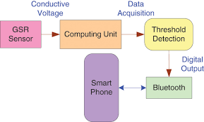

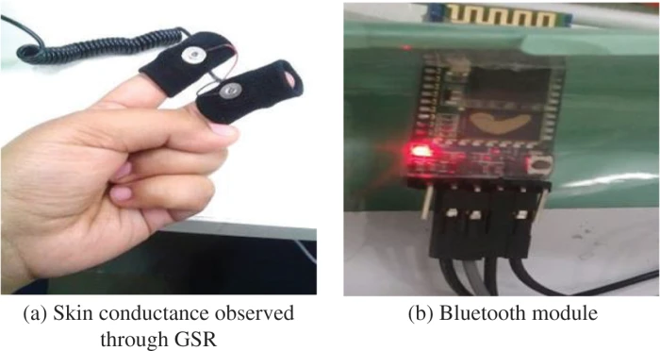

Role of neuro-sensor in pharmaceutical industries:
Biosensors have become increasingly relevant to pharmaceutical research and practice because they bridge biology with analytical technology. At their core, they combine a bioreceptor (enzyme, antibody, DNA, cell) with a transducer to generate measurable signals. This integration allows pharmaceutical scientists to monitor, detect, and quantify biological changes with speed and precision.
Pharmaceutical Relevance
• Drug Discovery & Development: Biosensors enable rapid assays for screening drug candidates, monitoring binding interactions, and studying pharmacokinetics. Their sensitivity shortens timelines compared to conventional analytical methods.
• Therapeutic Monitoring: Devices like glucose biosensors are already embedded in patient care, but newer biosensors are being designed to track drug levels, metabolites, and biomarkers in real time.
• Quality Assurance: In manufacturing, biosensors help ensure purity, detect contaminants, and validate bioprocesses, which is critical for regulatory compliance.
• Pathogen Detection: Pharmaceutical industries rely on biosensors to identify microbial contamination in raw materials, formulations, and production environments.
• Personalized Medicine: Biosensors support individualized treatment by monitoring patient biomarkers (e.g., cardiac markers, cancer antigens) and guiding dosage adjustments.
Types with Pharmaceutical Impact
• Amperometric biosensors: Widely used for glucose and nucleic acid detection, crucial in metabolic disease research.
• Optical biosensors: Applied in pathogen diagnostics and pollution monitoring, ensuring drug safety and environmental compliance.
• Acoustic wave biosensors: Useful in studying molecular binding events, supporting drug design.
• Potentiometric and calorimetric biosensors: Applied in assays for enzymatic activity and metabolite detection.
Challenges for Pharma
Despite their promise, only a fraction of biosensors reach commercialization. For pharmaceutical adoption, the hurdles are:
• Cost‑effective immobilization techniques.
• High reproducibility and sensitivity.
• Integration with nanomaterials (carbon nanotubes, graphene) to enhance stability and multi‑analyte detection.
• Meeting strict regulatory standards for clinical and industrial use.
Future Outlook
The pharmaceutical industry is moving toward implantable biosensors for continuous drug monitoring, multi‑analyte platforms for complex disease diagnostics, and nanobiosensors that combine high sensitivity with portability. These advances promise faster drug development cycles, safer manufacturing, and more personalized therapies.

References
- Robinson, J. T., Pohlmeyer, E., Gather, M. C., Kemere, C., Kitching, J. A., Malliaras, G. G., Marblestone, A., Shepard, K. L., Stieglitz, T., & Xie, C. (Year).
Developing next-generation brain sensing technologies: A review.
(Review on emerging neural interfaces and brain sensing technologies)
- Bear, M. F., Connors, B. W., & Paradiso, M. A. (Year).
Neuroscience: Exploring the Brain.
Lippincott Williams & Wilkins.
(Foundational textbook in neuroscience)
- Munghate, S. G. (Year).
Biosensors: Types, principles, and emerging applications – A comprehensive review.
International Journal / Conference Name.
Assistant Professor, Shri Govindrao Munghate Arts and Science College, Kurkheda, Dist. Gadchiroli, Maharashtra, India.
- Innovative Publication. (2025).
Biosensors: Types, principles, and emerging applications – A comprehensive review.
Retrieved from:
https://eprint.innovativepublication.org/id/eprint/1935/1/IJISRT25JUL967.p
- BrainBit Inc. (Year).
BrainBit EEG Headband: Technical specifications.
BrainBit Official Documentation (PDF).
- Hayes, H. B., & Magne, C. (Year).
Exploring the utility of the Muse headset for capturing the N400: Dependability and single-trial analysis.
(Study on consumer EEG for cognitive neuroscience research)
- Begue Hayes, H., & Magne, C. (Year).
Utility of consumer-grade EEG devices in language-related event-related potential studies.
- Al-Kaf, H., Khandoker, A., Khalaf, K., & Jelinek, H. F. (Year).
NeuroSky MindWave Mobile Headset 2 as an intervention for reduction of stress and anxiety measured with pulse rate variability.
Khalifa University
- Audrey Aldridge, Eli Barnes, Cindy L. Bethel, and Daniel W. Carruth. Accessible Electroencephalograms (EEGs): A Comparative Review with OpenBCI’s Ultracortex Mark IV Headset
- ZigBee María Viqueira Villarejo, Begoña García Zapirain and Amaia Méndez Zorrilla A Stress Sensor Based on Galvanic Skin Response (GSR) Controlled
- Shraddha T. Nemane, 1Sachin B. Gholve*, 1Omprakash G. Bhusnure, 1Shrikrishna T. Mule, 2Priyanka V. Ingle
Biosensors: An Emerging Technology in Pharmaceutical Industry

