CONFLICT ECONOMIES AND POST-COLONIAL REALIGNMENT IN THE SAHEL: THE CASE OF BURKINA FASO UNDER IBRAHIM TROARE, 2022–2025.

ABSTRACT
The persistence of insecurity and political instability in Burkina Faso raises critical questions about how conflict economies shape state transformation in the Sahel. Since the rise of Ibrahim Troare in 2022, the country has undergone significant political and economic restructuring, marked by a shift toward militarized governance, economic nationalism, and new geopolitical alliances. This article examines how conflict economies function not merely as byproducts of war but as instruments of state-building and post-colonial realignment. The study adopts a qualitative methodology, combining document analysis, secondary literature review, and discourse analysis of official statements and policy orientations between 2022 and 2025. It draws on political economy and conflict theory to interpret the evolving relationship between insecurity, economic control, and sovereignty. The findings reveal that the Burkinabe state has actively integrated elements of the conflict economy such as resource extraction, civilian mobilization, and labour deployment into its governance strategy. This has been accompanied by a deliberate break from France and a strategic pivot toward Russia, reflecting a broader regional trend. While these measures have strengthened regime legitimacy among certain domestic constituencies, they have also intensified authoritarian practices and external dependencies. The article concludes that conflict economies in Burkina Faso are central to a redefinition of sovereignty rather than evidence of state collapse. It recommends strengthening institutional accountability, promoting inclusive economic reforms, and balancing external partnerships to ensure sustainable and equitable development.
KEYWORDS: Conflict economies, Post-colonial realignment, Sahel, Burkina Faso, Ibrahim Troare, Militarized governance, Resource sovereignty, Economic nationalism, Geopolitics, State-building

INTRODUCTION
The Sahel region has, over the past decade, become one of the most significant arenas for examining the interaction between insecurity, governance, and economic transformation. Countries such as Burkina Faso have experienced a dramatic escalation of armed violence linked to jihadist insurgencies, communal conflicts, and state fragility. This context has generated not only humanitarian crises but also profound transformations in how economies are structured and governed, with conflict economies becoming embedded within state practices rather than remaining peripheral phenomena (Keen, 1998, p 11). The rise of Ibrahim Troare in September 2022 must be understood within this broader regional and historical context of political instability and declining public trust in governance. His accession to power through a military coup reflects a wider Sahelian pattern in which civilian governments have struggled to manage insecurity and economic decline, thereby opening space for military intervention (International Crisis Group, 2023, p 4). In Burkina Faso, this dissatisfaction has been closely tied to perceptions of ineffective counterinsurgency strategies and continued dependence on former colonial powers, particularly France (Bayart, 2009, p 19).
This article argues that the transformations underway in Burkina Faso cannot be adequately understood through conventional state fragility frameworks alone. Instead, they should be analyzed through the lens of conflict economies, which emphasize how economic activities adapt to and sustain conditions of violence. Conflict, rather than simply destroying economic systems, often generates alternative systems of accumulation and survival that reshape both state and non-state behavior (Keen, 1998, p 12). In this regard, political authority is frequently maintained through the strategic control of both formal and informal economic networks.
Under Troare, Burkina Faso has witnessed a deliberate effort to integrate elements of the conflict economy into state-building strategies, including the mobilization of civilian populations, the restructuring of resource governance, and the redefinition of external partnerships. These transformations are closely linked to a broader process of post-colonial realignment, characterized by a shift away from Western influence toward actors such as Russia. Such shifts reflect long-standing patterns of extraversion in African political economies, where leaders strategically engage external partners to reinforce domestic authority. By situating Burkina Faso within the political economy of conflict, this article contributes to ongoing debates on how states in crisis reconstitute authority, legitimacy, and sovereignty. It explores whether current transformations represent a genuine break from neo-colonial dependency or a reconfiguration of it within a changing geopolitical order.
CONFLICT ECONOMIES IN THE SAHEL: CONCEPTUAL FRAMEWORK
The concept of conflict economies provides a critical analytical framework for understanding the relationship between violence and economic organization in regions affected by prolonged instability. Rather than viewing conflict as a disruption to normal economic activity, scholars argue that war generates alternative systems of production, exchange, and accumulation that are deeply embedded in political and social structures (Collier, 2003, p 27). These systems often involve a complex interaction between state actors, armed groups, and civilian populations, thereby blurring the boundaries between legality and illegality (Keen, 1998, p 15). In the Sahel, conflict economies have expanded significantly due to weak institutional capacity, porous borders, and the availability of valuable natural resources. Activities such as artisanal mining, pastoral trade, and transnational smuggling networks have become central to livelihoods and power dynamics in the region.
In particular, artisanal gold mining has emerged as a key economic sector in Burkina Faso, providing income for local populations while also serving as a source of financing for armed groups and state actors (Hilson & McQuilken, 2014, p 104). A defining characteristic of conflict economies is their role in reshaping governance structures. In many cases, political elites rely on informal and illicit economic networks to maintain authority, using control over resources as a mechanism for consolidating power and ensuring loyalty (Reno, 2011, p 63). This challenges the conventional dichotomy between state and non-state actors by demonstrating how informality can be incorporated into state strategies. In Burkina Faso, this dynamic is evident in the increasing involvement of military institutions in economic activities and the mobilization of civilians into both productive and security roles (International Crisis Group, 2023, p 9).
Conflict economies are also deeply embedded in global systems, as they depend on transnational flows of goods, capital, and weapons. Contemporary conflicts are often sustained not by isolation but by their integration into global markets, which provide opportunities for resource extraction and exchange (Duffield, 2001, p 74). The Sahel exemplifies this pattern, with external actors playing a crucial role in shaping both economic and security dynamics. The growing partnership between Burkina Faso and Russia highlights how local conflict economies intersect with broader geopolitical strategies (Stronski, 2023, p 11). Another important dimension of conflict economies is their relationship to legitimacy and social order. Participation in wartime economies can create new forms of social contract, in which populations support authorities that provide access to resources, protection, and economic opportunities (Keen, 1998, p 142).
In Burkina Faso, state-led initiatives to mobilize citizens for agricultural production and local defense can be interpreted as efforts to construct legitimacy through economic inclusion, even in the absence of electoral democracy (Reno, 2011, p 70). This article adopts a political economy perspective that treats conflict economies as dynamic and adaptive systems rather than symptoms of disorder. By applying this framework to the case of Ibrahim Troare, it seeks to demonstrate how economic practices associated with conflict are being reconfigured to support new forms of governance, sovereignty, and international alignment in the Sahel
FROM COUP TO CONSOLIDATION: THE RISE OF TROARE
The rise of Ibrahim Troare in September 2022 marked a decisive turning point in the political trajectory of Burkina Faso. His accession followed a second military coup within the same year, reflecting deepening frustration within both the armed forces and the civilian population over the state’s inability to contain jihadist insurgencies and restore territorial control. This pattern of repeated coups illustrates the erosion of institutional legitimacy and the growing centrality of the military as a political actor in the Sahel (International Crisis Group, 2023, p 5).
Plate 1: Ibrahim Troare the transitional president of Burkina Faso
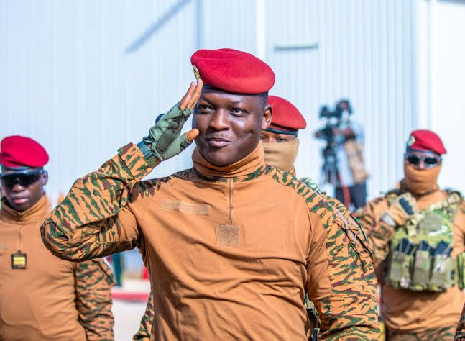
Source: Extracted from the website of B.B.C at www.BBC.com/ Ibrahim Troare on the 20 January 2025 at 14:30 am.
Troare justified his takeover as a necessary corrective to state failure, emphasizing the urgency of restoring security and national sovereignty. Upon assuming power, his regime suspended constitutional processes and extended the political transition period, thereby consolidating authority within a centralized military structure. Such measures align with broader regional trends in which military regimes legitimize their rule through security imperatives rather than democratic mandates (Powell et al., 2022, p 8).
The consolidation of power under Troare has also involved the restructuring of state institutions and the suppression of political dissent. Media restrictions, limitations on civil society activity, and the marginalization of opposition groups have been implemented as part of a broader strategy to maintain control and manage public narratives. While these measures are framed as necessary for national unity and security, they raise significant concerns regarding governance and human rights (Human Rights Watch, 2025, p 2). At the same time, the regime has sought to build legitimacy through direct engagement with the population, particularly through mass mobilization initiatives.
The expansion of civilian defense forces and the integration of local communities into security operations reflect an attempt to create a participatory model of governance rooted in collective resistance. This approach resonates with historical patterns of revolutionary mobilization in Africa, where popular participation is invoked as a source of political legitimacy (Reno, 2011, p 88). Regionally, Burkina Faso’s political trajectory under Troare mirrors similar developments in Mali and Niger, where military governments have capitalized on anti-incumbent sentiment and insecurity to justify their rule. These cases suggest the emergence of a new political order in the Sahel, characterized by the normalization of military governance and the redefinition of state authority in the context of protracted conflict (Stronski, 2023, p 6).
ECONOMIC NATIONALISM AND RESOURCE SOVEREIGNTY
Economic nationalism has become a central pillar of governance under Ibrahim Troare, reflecting a broader effort to reassert control over national resources and reduce external dependency. In Burkina Faso, this shift is particularly evident in the mining sector, where gold production plays a critical role in the national economy. The state has increased its involvement in regulating and overseeing resource extraction, seeking to ensure that revenues are retained within the country and directed toward national development priorities (Hilson & McQuilken, 2014, p 105). This emphasis on resource sovereignty is closely linked to historical narratives of anti-colonial resistance. The legacy of Thomas Sankara continues to shape contemporary political discourse, particularly his advocacy for self-reliance and economic independence. Traore’s policies echo these principles, framing economic control as essential to political sovereignty and national dignity (Harsch, 2014, p 132). In addition to resource governance, the regime has promoted policies aimed at achieving greater self-sufficiency in agriculture and domestic production.
Plate 2: Ibrahim Troare promoting agriculture
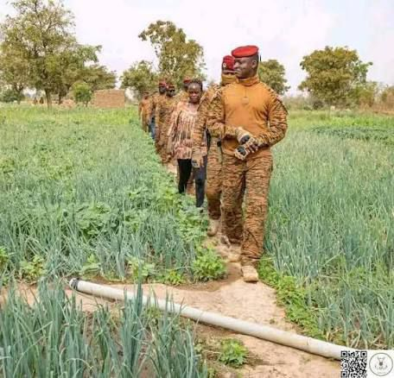
Source: Extracted from the website of B.B.C at www.BBC.com/ Ibrahim Troare on the 20 January 2025 at 15:30 am.
Plate 3: Ibrahim Troare in contact with rural farmers
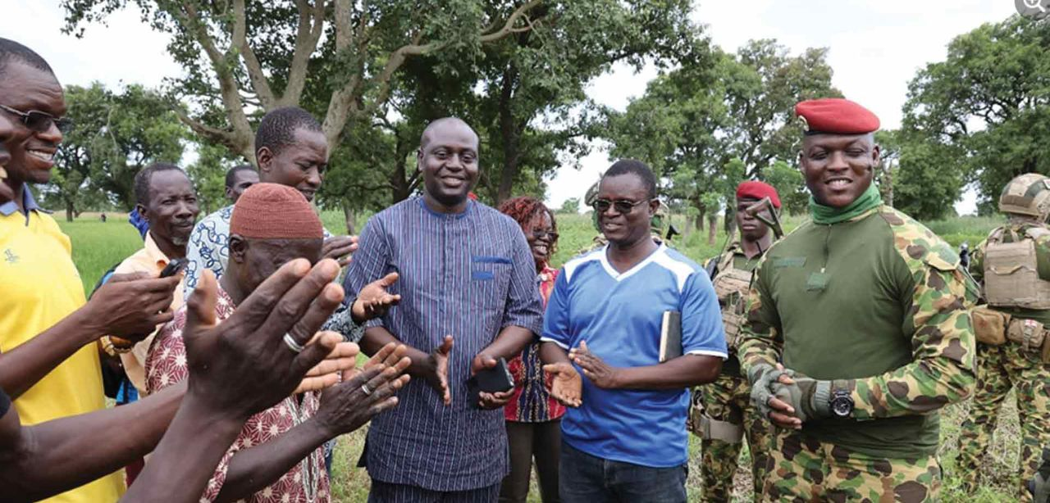
Source: Extracted from the website of B.B.C at www.BBC.com/ Ibrahim Troare on the 20 January 2025 at 12:30 am.
These initiatives are presented as strategies to reduce reliance on imports and strengthen resilience in the face of external shocks. However, they also reflect the broader militarization of the economy, as agricultural production is increasingly linked to national security objectives and population mobilization (International Crisis Group, 2023, p 11). The pursuit of economic nationalism has also involved a reconfiguration of external economic relationships. The reduction of ties with France and other Western partners has been accompanied by efforts to diversify alliances, particularly with Russia. These shifts are framed as necessary to escape neo-colonial dependency and assert greater autonomy in economic decision-making. However, they also raise questions about the extent to which new partnerships may reproduce existing patterns of dependency under different geopolitical conditions (Bayart, 2009, p 23).
Furthermore, the integration of conflict economy practices into state policy is evident in the use of labor mobilization and local production systems. Reports of prisoner labor and community-based production initiatives suggest an attempt to harness all available human resources for economic and security purposes. While such measures may contribute to short-term productivity, they also highlight the tension between economic necessity and ethical governance (Keen, 1998, p 150). Ultimately, economic nationalism in Burkina Faso under Troare represents both a political project and a survival strategy. It seeks to redefine the relationship between the state, its resources, and its citizens, while navigating the constraints imposed by ongoing conflict and global economic pressures. As such, it illustrates how resource sovereignty can function as a central component of state-building in conflict-affected contexts (Reno, 2011, p 95).
MILITARIZATION OF THE ECONOMY
The militarization of the economy in Burkina Faso under Ibrahim Troare represents a significant transformation in the relationship between security and production. In contexts of protracted conflict, economic systems are often reorganized to serve military objectives, resulting in what scholars describe as a fusion between warfare and livelihood strategies. This dynamic is particularly visible in the Sahel, where state survival increasingly depends on the capacity to mobilize both human and material resources for security purposes (Duffield, 2001, p 75). One of the most notable features of this transformation is the expansion of civilian participation in defense and production activities.
The Burkinabe government has significantly increased the recruitment of auxiliary forces, particularly the Volunteers for the Defense of the Homeland, integrating local populations into counterinsurgency efforts. This mobilization extends beyond security functions, as communities are also encouraged to contribute to agricultural production and local economic initiatives that support the war effort. Such practices reflect a broader shift toward a war economy in which civilian life is reorganized around national defense imperatives (International Crisis Group, 2023, p 10).
Plate 5: Ibrahim Troare Inspecting Military Equipments
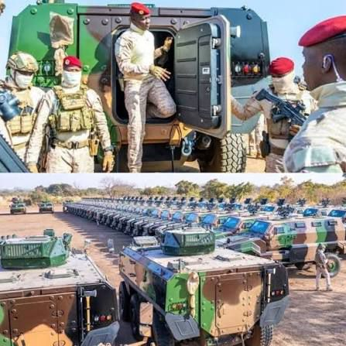
Source: Extracted from the website of B.B.C at www.BBC.com/ Ibrahim Troare on the 20 January 2025 at 14:30 am.
Plate 6: Ibrahim Troare inspecting military weapons from Russia
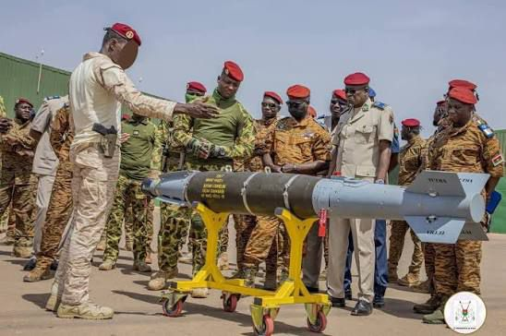
Source: Extracted from the website of B.B.C at www.BBC.com/ Ibrahim Troare on the 20 January 2025 at 14:30 am.
The militarization of the economy also involves the direct participation of military institutions in economic activities. Armed forces and associated structures have become increasingly involved in sectors such as logistics, infrastructure development, and resource management. This expansion of military influence blurs the boundaries between civilian and military domains, reinforcing the central role of the state in directing economic activity under conditions of insecurity (Reno, 2011, p 90). In addition, the use of coercive labor practices has emerged as a controversial aspect of this transformation. Reports of forced recruitment and the deployment of prisoners in productive activities highlight the extent to which the state seeks to harness all available labor resources. While such measures are often justified as necessary responses to crisis conditions, they raise important ethical and legal concerns regarding human rights and governance standards (Human Rights Watch, 2025, p 3).
From a political economy perspective, the militarization of the economy can also be understood as a strategy for consolidating state authority. By controlling access to resources, employment, and security, the state is able to reinforce its legitimacy and maintain loyalty among key constituencies. As Keen argues, participation in wartime economic systems can create incentives for cooperation with authorities, even in the absence of formal democratic accountability (Keen, 1998, p 143). Ultimately, the militarization of the economy in Burkina Faso reflects a broader transformation in which economic production is subordinated to security objectives. While this approach may enhance short-term resilience and state control, it also risks entrenching authoritarian practices and limiting the prospects for inclusive and sustainable development (Reno, 2011, p 95).

POST-COLONIAL REALIGNMENT: FROM FRANCE TO RUSSIA
The political and economic transformation of Burkina Faso under Ibrahim Troare is closely linked to a broader process of post-colonial realignment, characterized by a redefinition of external partnerships and geopolitical orientation. Central to this shift is the gradual disengagement from France, which has historically played a dominant role in the region’s security and economic affairs. This disengagement reflects growing dissatisfaction with French military interventions and perceptions of continued neo-colonial influence (Charbonneau, 2014, p 52). The termination of military cooperation agreements and the withdrawal of French troops marked a symbolic and strategic break with the past. These actions were widely supported by segments of the population, particularly youth groups who have increasingly mobilized around anti-French sentiment and demands for greater sovereignty. This popular support has reinforced the legitimacy of the regime’s foreign policy shift, framing it as a reclaiming of national autonomy rather than a mere change in alliances (International Crisis Group, 2023, p 12).
In parallel, Burkina Faso has strengthened its engagement with Russia, reflecting a broader trend across the Sahel. This partnership encompasses military cooperation, security assistance, and political su
pport, often accompanied by the involvement of actors such as the Wagner Group. Russia’s approach is frequently perceived as less conditional than that of Western partners, making it an attractive alternative for regimes seeking to consolidate power without external interference in domestic governance (Stronski, 2023, p 9). However, this realignment raises important questions about the nature of sovereignty and dependency.

Plate 7: Ibrahim Troare and the Russian president Vladimir Putin
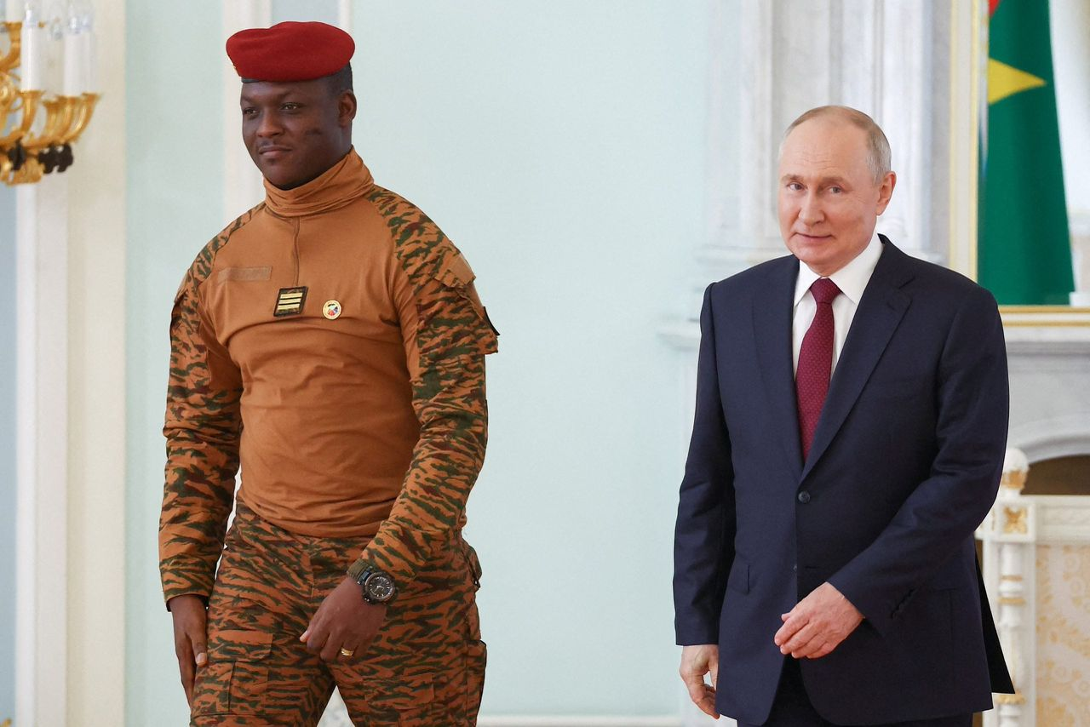
Source: Extracted from the website of B.B.C at www.BBC.com/ Ibrahim Troare on the 20 January 2025 at 14:30 am.
Plate 8: Ibrahim Troare in diplomatic talks in Moscow
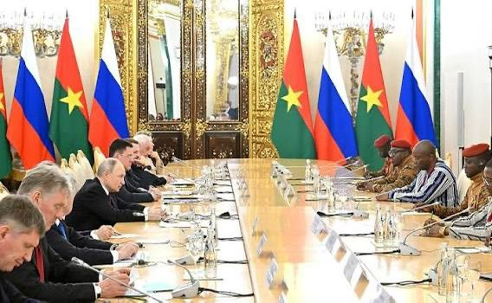
Source: Extracted from the website of B.B.C at www.BBC.com/ Ibrahim Troare on the 20 January 2025 at 14:30 am.
While the shift away from France is framed as a rejection of neo-colonialism, the increasing reliance on Russian support may reproduce similar patterns of external dependence. Bayart’s concept of extraversion is particularly relevant here, as it highlights how African states historically navigate global systems by leveraging external relationships to strengthen domestic authority (Bayart, 2009, p 23).
The geopolitical shift also has significant implications for the structure of the conflict economy. External actors influence not only security dynamics but also access to resources, markets, and financial flows. The integration of Burkina Faso into new networks of military and economic cooperation may therefore reshape the distribution of power and wealth within the country, reinforcing certain actors while marginalizing others (Duffield, 2001, p 78). Regionally, Burkina Faso’s realignment aligns with similar developments in Mali and Niger, suggesting the emergence of a new geopolitical configuration in the Sahel. This configuration challenges the dominance of Western influence and reflects a broader reordering of global power relations. At the same time, it underscores the complexity of post-colonial statecraft, where efforts to assert independence are often constrained by the need for external support (Stronski, 2023, p 11).
In this context, post-colonial realignment should be understood not simply as a binary shift from one partner to another, but as a dynamic process in which states seek to renegotiate their position within the international system. For Burkina Faso, this process is deeply intertwined with the logic of conflict economies, as external partnerships play a crucial role in shaping both security strategies and economic governance (Keen, 1998, p 150).
LEGITIMACY THROUGH CONFLICT ECONOMIES
The relationship between conflict economies and political legitimacy in Burkina Faso under Ibrahim Troare reflects a broader transformation in how authority is constructed in conflict-affected states. In contexts where formal democratic institutions are weak or contested, regimes often seek alternative sources of legitimacy rooted in performance, security provision, and economic inclusion rather than electoral competition (Reno, 2011, p 88). In Burkina Faso, legitimacy has increasingly been derived from the state’s ability to respond to insecurity and mobilize economic resources in support of national objectives. The regime has framed its actions as part of a broader struggle for sovereignty and self-determination, appealing to historical narratives of anti-colonial resistance. This discourse resonates with segments of the population that have experienced marginalization and exclusion under previous governments, particularly in rural and conflict-affected regions (Bayart, 2009, p 25).
Conflict economies play a central role in this process by providing both material and symbolic foundations for legitimacy. Materially, the redistribution of resources through state-led initiatives, including agricultural programs and local development projects, creates incentives for cooperation with authorities. Symbolically, the rhetoric of economic sovereignty and resistance to external domination reinforces the regime’s claim to represent national interests. As Keen argues, participation in economic systems associated with conflict can generate forms of social contract in which populations support authorities that provide access to resources and protection (Keen, 1998, p 142). At the same time, the integration of conflict economy practices into governance raises important questions about inclusivity and accountability. While some groups benefit from increased access to resources and opportunities, others may be excluded or coerced into participation. Reports of forced recruitment into defense forces and the use of coercive labor practices highlight the uneven distribution of benefits and burdens within the system (Human Rights Watch, 2025, p 3).
Legitimacy in this context is therefore both constructed and contested. On one hand, the regime’s emphasis on economic mobilization and national unity contributes to a sense of collective purpose. On the other hand, the reliance on militarized governance and restrictive political measures may undermine long-term legitimacy by limiting participation and suppressing dissent. This duality reflects the inherent tension within conflict economies, where mechanisms that sustain authority can also generate grievances that threaten stability (Reno, 2011, p 95). Ultimately, legitimacy through conflict economies in Burkina Faso is best understood as a dynamic and evolving process. It is shaped by the interaction between material conditions, political narratives, and external influences, all of which contribute to the regime’s capacity to maintain authority in a challenging security environment (Duffield, 2001, p 78).
REVOLUTION OR RECONFIGURATION
The transformation underway in Burkina Faso under Ibrahim Troare raises a fundamental analytical question regarding the nature of political and economic change in the Sahel. Specifically, it is necessary to assess whether the current trajectory represents a genuine revolutionary break from existing structures or a reconfiguration of power within established constraints. On one hand, the regime presents itself as revolutionary, emphasizing sovereignty, anti-imperialism, and economic independence. The deliberate distancing from France and the pursuit of alternative partnerships, particularly with Russia, signal a clear departure from traditional patterns of external dependency. This shift is accompanied by rhetoric that challenges long-standing geopolitical hierarchies and seeks to reposition Burkina Faso within a multipolar global order (Stronski, 2023, p 11).
Moreover, the emphasis on economic nationalism, resource control, and internal mobilization suggests an attempt to restructure the foundations of the state. Policies aimed at increasing domestic production, regulating resource extraction, and integrating citizens into national development projects indicate a vision of transformation that extends beyond simple regime change. In this sense, the current moment can be interpreted as an effort to redefine the relationship between the state, its economy, and its citizens (Bayart, 2009, p 23).
On the other hand, several structural continuities complicate the characterization of this process as a full revolution. The persistence of centralized authority, the dominance of military leadership, and the limited nature of political pluralism suggest that the underlying governance model remains rooted in authoritarian traditions. While the actors and external partners may have changed, the concentration of power and the limited scope of institutional accountability remain significant features of the political system (International Crisis Group, 2023, p 13).
In addition, the integration of Burkina Faso into new geopolitical networks raises questions about the extent to which external dependency has truly been reduced. The growing reliance on Russian security support, including cooperation with actors such as the Wagner Group, may reproduce forms of external influence under different terms. This reflects Bayart’s notion of extraversion, whereby African states engage external actors strategically to reinforce domestic power, even if such engagements create new dependencies (Bayart, 2009, p 21).
From a conflict economy perspective, the current transformation can also be seen as a reconfiguration of existing economic and political structures rather than their complete replacement. The incorporation of informal networks, resource extraction systems, and militarized economic practices into state governance suggests continuity with historical patterns of adaptation in conflict-affected environments (Keen, 1998, p 150). Therefore, rather than framing the situation as either a revolution or a mere continuation, it is more analytically accurate to view it as a hybrid process. This process combines elements of rupture and continuity, where new political actors and alliances reshape but do not entirely overturn the structural conditions of governance. The Burkinabe case thus illustrates how post-colonial states in conflict environments navigate between transformation and constraint, producing outcomes that reflect both agency and structural limitations (Duffield, 2001, p 80)
CONCLUSION
This article has examined the evolving relationship between conflict economies and post-colonial realignment in the Sahel, with particular reference to Burkina Faso under Ibrahim Troare between 2022 and 2025. The analysis has demonstrated that conflict economies are not peripheral or temporary distortions of normal economic systems but are deeply embedded structures that shape governance, legitimacy, and international relations in conflict-affected states. In Burkina Faso, these dynamics have been central to the reconfiguration of state authority in response to persistent insecurity and political instability.
A key finding of this study is that the Burkinabe state has increasingly integrated elements of the conflict economy into its governance framework. Mechanisms such as the mobilization of civilian populations, the expansion of military roles in economic activities, and the emphasis on resource control illustrate how economic practices associated with conflict can be harnessed to support state objectives. This integration reflects a broader shift toward militarized governance, where security imperatives guide both political decision-making and economic organization. At the same time, the article has shown that the regime’s emphasis on economic nationalism and resource sovereignty constitutes a central pillar of its political adventure. By prioritizing domestic control over natural resources and reducing reliance on external actors, the government seeks to redefine sovereignty in both symbolic and material terms.
However, these efforts are taking place within a constrained environment characterized by ongoing insecurity, institutional limitations, and external dependencies. As a result, the pursuit of autonomy remains partial and contested rather than fully realized. The study has also highlighted the significance of post-colonial realignment in shaping Burkina Faso’s external relations. The gradual disengagement from France and the increasing engagement with Russia reflect a strategic repositioning within a changing global order. While this shift is often framed as a rejection of neo-colonial influence, it may also represent a reconfiguration of external dependencies rather than their elimination. In this sense, Burkina Faso’s foreign policy illustrates the continued relevance of extraversion, whereby states leverage external partnerships to reinforce domestic authority while navigating global power asymmetries.
Importantly, the analysis suggests that the current transformations in Burkina Faso should not be interpreted as a simple transition from fragility to stability or from dependency to autonomy. Instead, they represent a complex and ongoing process in which elements of continuity and change coexist. The persistence of militarized governance, limited political pluralism, and security challenges indicates that structural constraints continue to shape the trajectory of the state. At the same time, new political actors and strategies are actively reshaping the ways in which authority, resources, and legitimacy are organized. From a broader regional perspective, the Burkinabe case contributes to understanding the evolving political economy of the Sahel, where conflict, governance, and international relations are increasingly intertwined.
The rise of military-led governments, the reconfiguration of external alliances, and the centrality of conflict economies all point to a shifting landscape in which traditional models of statehood and development are being redefined. These developments underscore the need for analytical frameworks that move beyond binary distinctions between stability and collapse to capture the adaptive and hybrid nature of governance in conflict-affected contexts. In conclusion, this article argues that conflict economies in Burkina Faso are not merely outcomes of insecurity but active components in the construction and redefinition of state power. The trajectory under Ibrahim Troare reflects both an attempt to assert sovereignty and the constraints imposed by structural, institutional, and geopolitical factors. Future research should continue to explore how these dynamics evolve over time, particularly in relation to regional cooperation, external interventions, and internal political developments, in order to better understand the long-term implications of conflict economies for state-building and governance in the Sahel.

REFERENCES
Bayart, J. F. The state in Africa: The politics of the belly (2nd ed.). London: Polity Press, 2009.
Charbonneau, B. “Intervention in Mali building peace between peacekeeping and counterterrorism”, Journal of Contemporary African Studies. 32 4, 2014: 1–18
Collier, P. Breaking the conflict trap: Civil war and development policy. London: World Bank, 2003.
Duffield, M. Global governance and the new wars: The merging of development and security. London: Zed Books, 2001.
Harsch, E. Thomas Sankara: An African revolutionary. USA: Ohio University Press, 2014.
Hilson, G., & McQuilken, J. “Four decades of support for artisanal and small-scale mining in sub-Saharan Africa”. The Extractive Industries and Society, 1(1), 2014. 104-118.
Human Rights Watch. (2025). World report 2025 Burkina Faso
International Crisis Group. (2023). Burkina Faso stopping the spiral of violence Africa Report No 311
Keen, D. The economic functions of violence in civil wars. London: Oxford University Press, 1998.
Powell, J. M., Thyne, C. L., & Clayton, G. “Coups and the future of African politics”. Journal of Democracy, 33(1), 2022: 7–21
Reno, W. Warfare in independent Africa. London: Cambridge University Press, 2011.
Stronski, P. (2023). Russia’s growing footprint in Africa’s Sahel region Carnegie Endowment for International Peace

