Integrated Bioinformatics and Machine Learning Approach for Identification of Potential Biomarkers in Uterine Carcinosarcoma
Gauri Suresh, Mahima Kashyap, Nisha Singh

Abstract
Background:
Uterine carcinosarcoma (UCS) is a rare and highly aggressive malignancy associated with poor prognosis and limited therapeutic options. Identification of reliable molecular biomarkers is essential for improving early diagnosis and targeted therapies.
Methods:
Gene expression dataset GSE122697 was obtained from the Gene Expression Omnibus (GEO) database. Differentially expressed genes (DEGs) between UCS and normal tissues were identified using standardized statistical analysis with thresholds of adjusted p-value < 0.05 and |log2 fold change| > 1. Protein–protein interaction (PPI) networks were constructed using STRING (v11.5) and visualized in Cytoscape (v3.9.1). Hub genes were identified using the MCODE plugin. Machine learning models, including Random Forest and Support Vector Machine, were implemented in WEKA with 10-fold cross-validation to evaluate predictive performance. Adjusted p-values were calculated using the Benjamini–Hochberg false discovery rate (FDR) correction method.
Results:
A total of 2,266 DEGs were identified, including 1,218 upregulated and 1,048 downregulated genes. The PPI network comprised 492 nodes and 1,589 edges. Key hub genes identified included STAT3, EP300, ITGAM, and SREBF1. The Random Forest model achieved an accuracy of 94.73%, precision of 0.951, recall of 0.947, and ROC-AUC of 0.936, indicating strong classification performance.
Conclusion:
This integrative approach identified potential biomarkers associated with UCS progression. These findings provide a foundation for further experimental validation and may contribute to improved diagnostic and therapeutic strategies.

Keywords
Uterine carcinosarcoma, biomarkers, bioinformatics, machine learning, PPI network, hub genes

Abbreviations
Abbreviation | Meaning
UCS | Uterine Carcinosarcoma
DEG | Differentially Expressed Gene
PPI | Protein–Protein Interaction
GO | Gene Ontology
KEGG | Kyoto Encyclopedia of Genes and Genomes
ROC-AUC | Receiver Operating Characteristic–Area Under Curve

1. Introduction
Uterine cancer is among the most common gynecological malignancies worldwide, with increasing incidence rates. Uterine carcinosarcoma (UCS), although accounting for less than 5% of uterine cancers, contributes disproportionately to mortality due to its aggressive clinical behavior and high recurrence rates. The 5-year survival rate remains below 30%, highlighting the urgent need for improved diagnostic and therapeutic strategies.
At the molecular level, UCS is characterized by complex genomic alterations involving epithelial–mesenchymal transition, dysregulated signaling pathways, and epigenetic modifications. Despite advances in high-throughput technologies, clinically validated biomarkers for UCS remain limited.
Recent studies emphasize the importance of integrating omics data with computational and machine learning approaches to enhance biomarker discovery. However, a lack of reproducible pipelines combining gene expression analysis, network biology, and predictive modeling remains a critical gap.
This study aims to address this gap by implementing an integrated bioinformatics and machine learning framework to identify robust molecular biomarkers associated with UCS.

2. Materials and Methods
2.1 Dataset Collection
Gene expression data for uterine carcinosarcoma were retrieved from the Gene Expression Omnibus (GEO) database (accession number: GSE122697). The dataset included 13 tumor samples and 6 normal tissue samples.
2.2 Identification of Differentially Expressed Genes (DEGs)
Differential expression analysis was performed using GEO2R. Data were normalized using quantile normalization. Genes satisfying the criteria of adjusted p-value < 0.05 and |log2 fold change| > 1 were considered significantly differentially expressed
2.3 Gene Intersection Analysis
Overlapping DEGs were identified using InteractiVenn, enabling visualization of shared gene sets across analyses.
2.4 Protein–Protein Interaction (PPI) Network Construction
The identified DEGs were submitted to the STRING database (version 11.5) with a confidence score threshold of ≥ 0.7. The resulting interaction network was visualized using Cytoscape (version 3.9.1).
2.5 Hub Gene Identification
Hub genes were identified using the MCODE plugin in Cytoscape with the following parameters: degree cutoff = 2, node score cutoff = 0.2, k-core = 2, and max depth = 100. Genes with high connectivity were considered hub genes.
2.6 Machine Learning Validation
Machine learning models were developed using WEKA software. Random Forest and Support Vector Machine algorithms were applied. The dataset was split into 70% training and 30% testing sets. Model performance was evaluated using 10-fold cross-validation. Metrics included accuracy, precision, recall, and ROC-AUC.
2.7 Functional Enrichment Analysis
Gene Ontology (GO) and Kyoto Encyclopedia of Genes and Genomes (KEGG) pathway enrichment analyses were performed to identify biological processes and pathways associated with the DEGs.
3. Results
3.1 Identification of DEGs
A total of 2266 DEGs were identified, including:
- 1218 upregulated genes
- 1048 downregulated genes
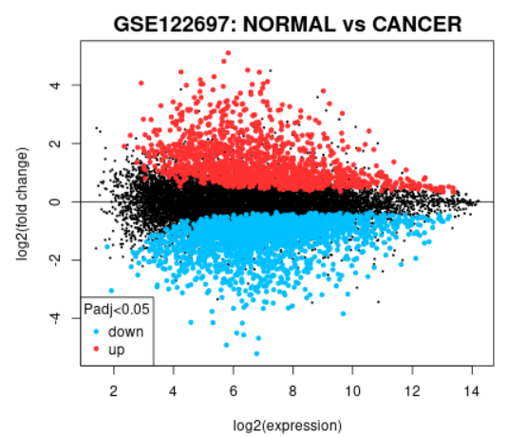
Figure 1. Mean–difference (MA) plot showing differential gene expression between uterine carcinosarcoma and normal tissue samples.
The plot represents the log fold change (M) versus the average expression (A) of genes. Red points indicate significantly differentially expressed genes (adjusted p < 0.05), while black points represent non-significant genes.

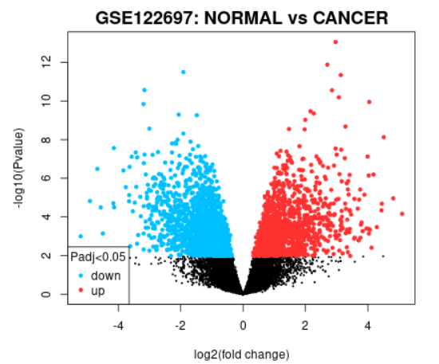
Figure 2. Volcano plot illustrating differentially expressed genes (DEGs) between uterine carcinosarcoma and normal samples.
The x-axis represents log2 fold change, and the y-axis represents −log10 adjusted p-value. Significantly upregulated and downregulated genes are highlighted, indicating genes with |log2FC| > 1 and adjusted p < 0.05.

3.2 Gene Intersection Analysis
Venn diagram analysis revealed 498 common genes across datasets. 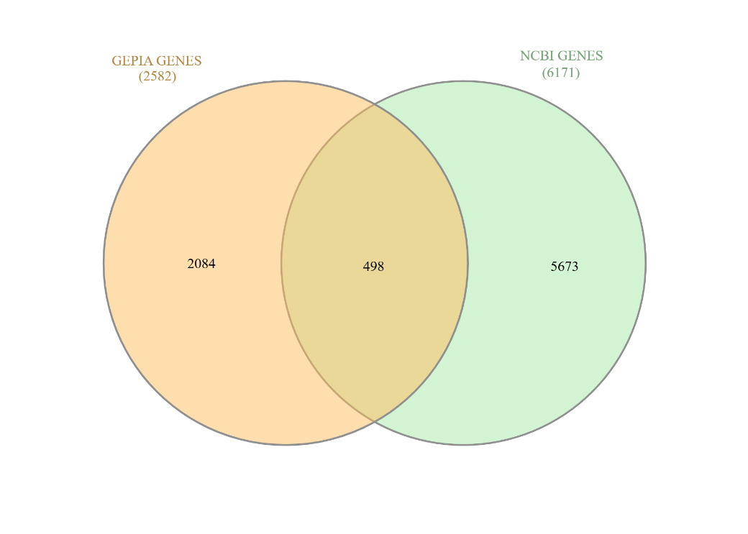
Figure 3. Venn diagram showing overlapping differentially expressed genes identified from multiple analyses.
The diagram illustrates the intersection of gene sets obtained from GEO dataset analysis and GEPIA/NCBI databases. The overlapping region represents common DEGs used for downstream analysis.

3.3 PPI Network Analysis
The PPI network consisted of:
- 492 nodes
- 1589 edges
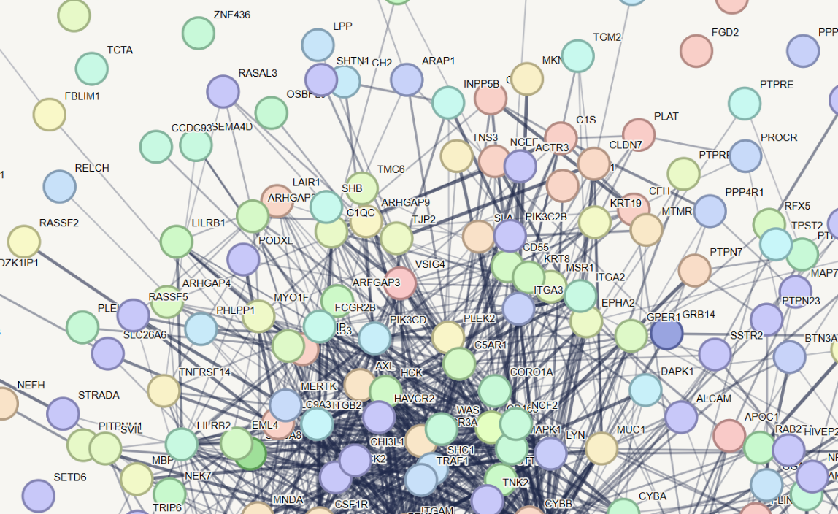

Figure 4. Protein–protein interaction (PPI) network constructed using STRING database and visualized in Cytoscape.
Nodes represent proteins encoded by DEGs, while edges indicate predicted or experimentally validated interactions. Highly interconnected regions indicate potential functional modules and hub genes.

3.4 Hub Gene Identification
Key hub genes identified included:
- STAT3 (degree = 66)
- EP300 (degree = 51)
- ITGAM (degree = 25)
- SREBF1 (degree = 18)

3.5 Machine Learning Validation
The predictive model achieved:
- Accuracy: 94.73%
- Precision: 0.951
- Recall: 0.947
- ROC-AUC: 0.936
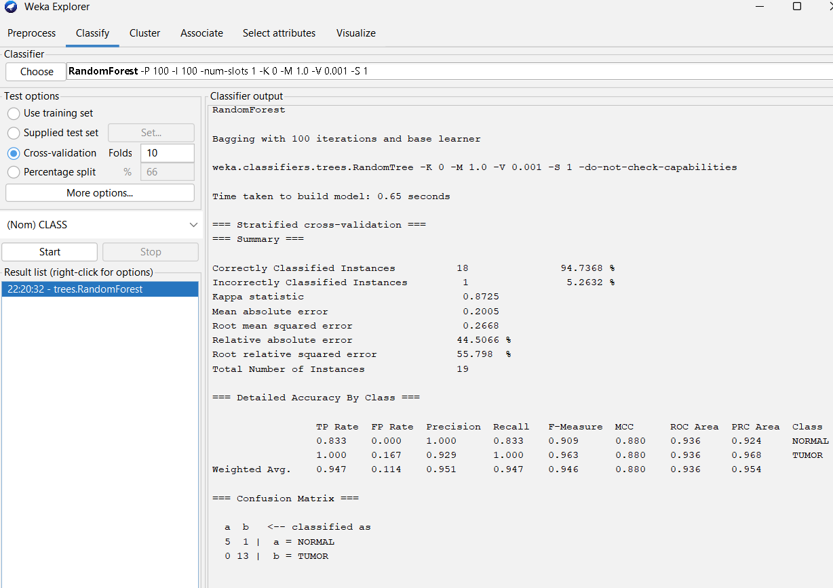
Figure 5. Performance of Random Forest classifier for distinguishing uterine carcinosarcoma from normal samples.
The model was evaluated using 10-fold cross-validation in WEKA. The classifier achieved an accuracy of 94.73% with a ROC-AUC of 0.936, demonstrating strong predictive performance.
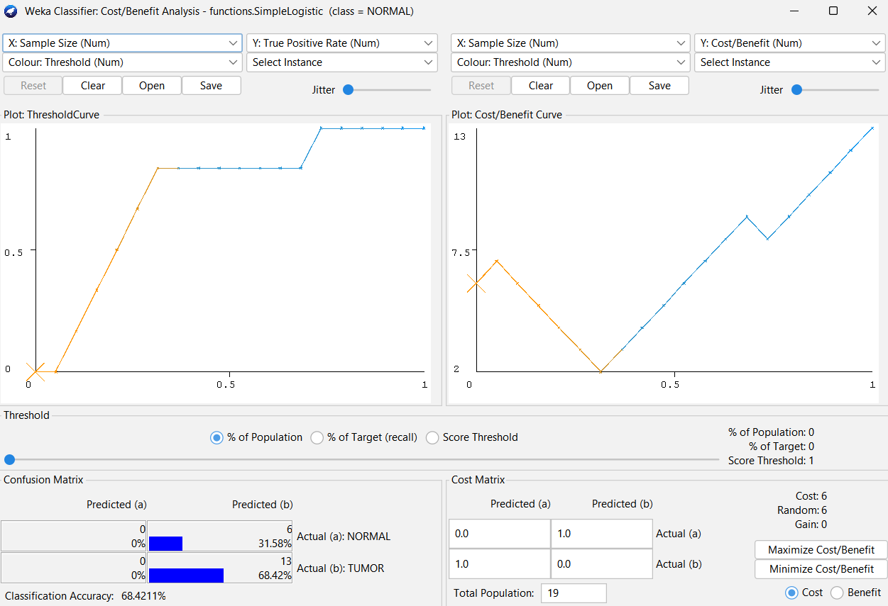
Figure 6. Cost–benefit and threshold analysis of the Simple Logistic classifier.
The plot illustrates classification performance across different threshold values, highlighting trade-offs between sensitivity and specificity. The overall model accuracy was 68.42%.
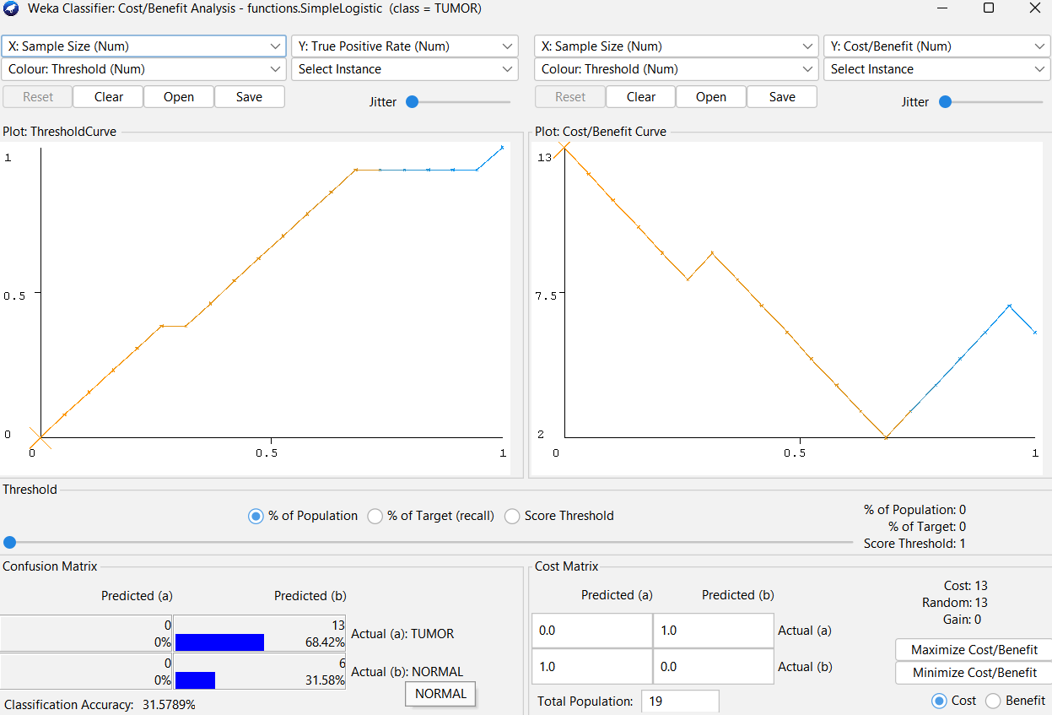
Figure 7. Cost–benefit and threshold analysis for tumor class prediction using the Simple Logistic classifier.
The analysis shows classification performance specifically for tumor samples, indicating higher misclassification costs and reduced accuracy (31.57%) at certain threshold levels.
3.6 Survival Analysis
Figure 8. Kaplan–Meier survival analysis stratified by STAT3 expression.
Kaplan–Meier curves were generated to evaluate the prognostic significance of STAT3 expression in tumor samples, stratified into high and low expression groups (n = 28 per group).
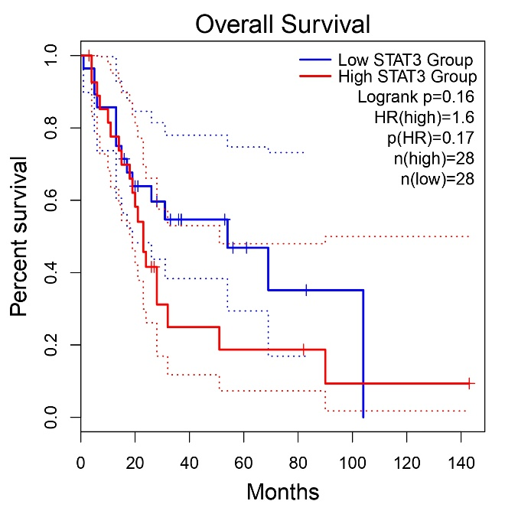
- Overall Survival (OS): Patients with high STAT3 expression exhibited a reduced survival probability compared to the low expression group. However, the difference did not reach statistical significance (log-rank test, p = 0.16). The hazard ratio (HR = 1.6; 95% CI not shown) indicates a trend toward increased mortality risk in the high STAT3 group, though this association was not statistically significant (p = 0.17).
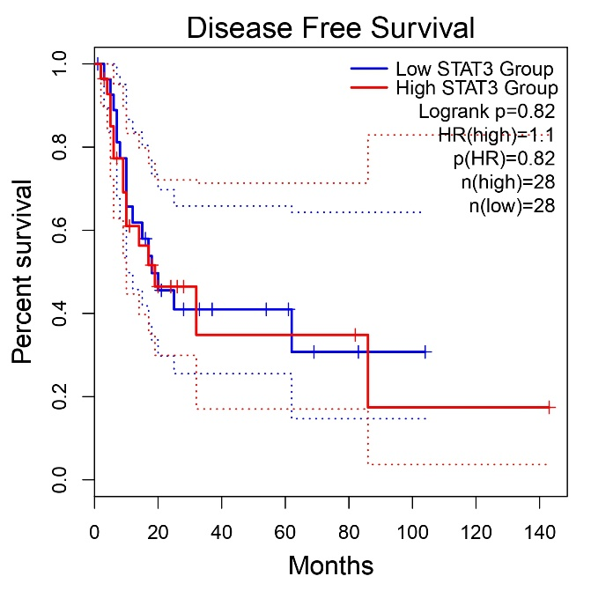
(B) Disease-Free Survival (DFS): No significant difference in recurrence-free survival was observed between the two groups (log-rank test, p = 0.82). The hazard ratio (HR = 1.1) suggests a negligible effect of STAT3 expression on disease progression.

Figure 9. Kaplan–Meier survival analysis based on EP300 expression levels.
Kaplan–Meier curves were constructed to assess the prognostic relevance of EP300 expression in tumor samples, stratified into high and low expression groups (n = 28 per group).
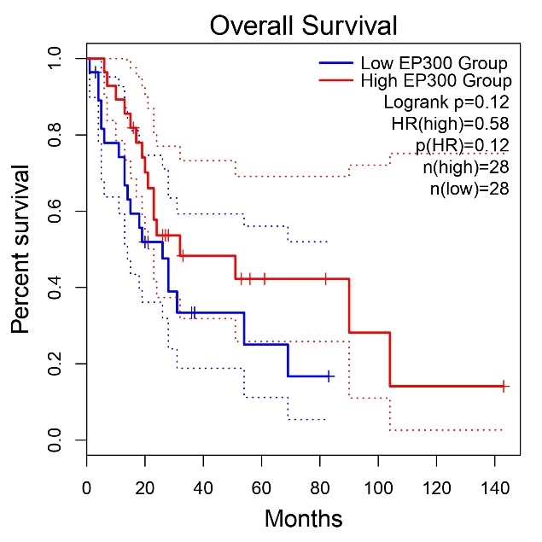
(A) Overall Survival (OS): Patients with high EP300 expression demonstrated a relatively improved survival probability compared to the low expression group. However, this difference was not statistically significant (log-rank test, p = 0.12). The hazard ratio (HR = 0.58) suggests a potential protective effect of high EP300 expression, although it did not reach statistical significance (p = 0.12).
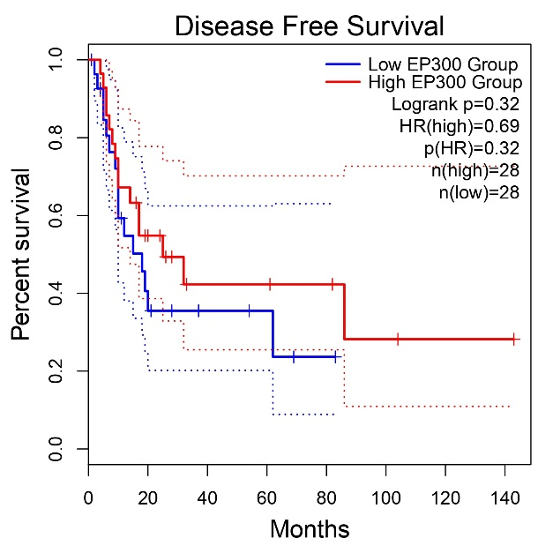
(B) Disease-Free Survival (DFS): A similar trend was observed, with the high EP300 group showing better disease-free survival compared to the low expression group. Nevertheless, the difference was not statistically significant (log-rank test, p = 0.32). The hazard ratio (HR = 0.69) indicates a reduced risk of disease progression associated with high EP300 expression, though not statistically significant (p = 0.32).

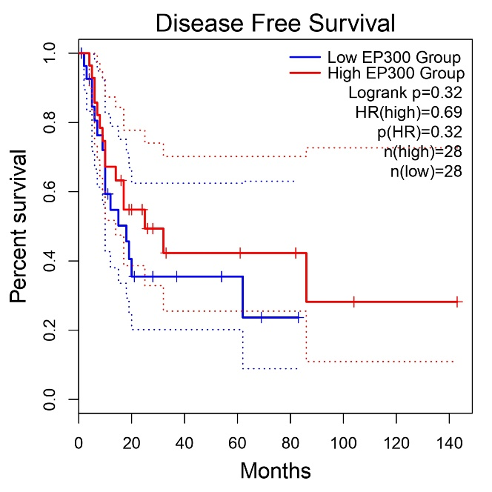
Figure 10. Kaplan–Meier Overall Survival (OS) Analysis
Kaplan–Meier overall survival curves comparing patients with high and low expression levels of EP300 and ITGAM. The red curves represent high-expression groups, whereas the blue curves indicate low-expression groups. Survival differences were assessed using the log-rank test. Patients with higher EP300 and ITGAM expression exhibited comparatively better overall survival trends; however, the differences were not statistically significant (p > 0.05). Hazard ratios (HRs), log-rank p-values, and sample numbers for each group are indicated within the plots. Tick marks denote censored observations.

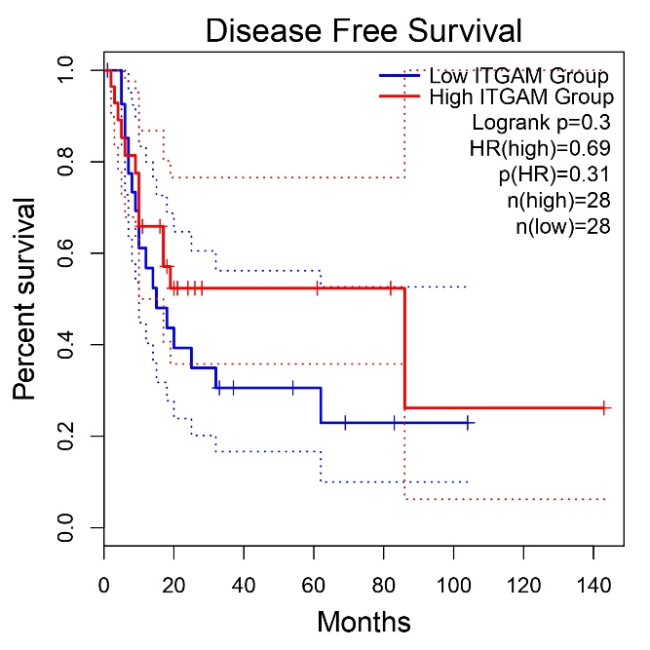
Figure 11. Kaplan–Meier Disease-Free Survival (DFS) Analysis
Kaplan–Meier disease-free survival curves showing the association between EP300 and ITGAM expression levels and disease-free survival outcomes. High-expression groups are represented in red and low-expression groups in blue. Statistical significance was evaluated using the log-rank test. The high-expression groups demonstrated relatively improved disease-free survival compared with low-expression groups, although the differences were not statistically significant (p > 0.05). Hazard ratios (HRs), log-rank p-values, and group sample sizes are provided in the respective plots. Tick marks indicate censored cases.

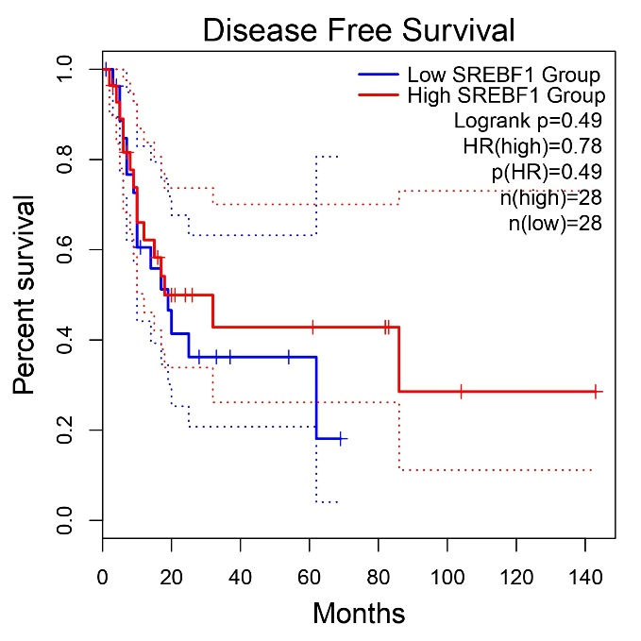
Figure 12. Kaplan–Meier Disease-Free Survival (DFS) Analysis of SREBF1 Expression
Kaplan–Meier disease-free survival curves comparing patients with high and low SREBF1 expression levels. The red curve represents the high-expression group, whereas the blue curve indicates the low-expression group. Patients with elevated SREBF1 expression demonstrated relatively improved disease-free survival compared with the low-expression group. However, the difference was not statistically significant (log-rank p = 0.49). The hazard ratio (HR) for the high-expression group was 0.78. Tick marks indicate censored observations.

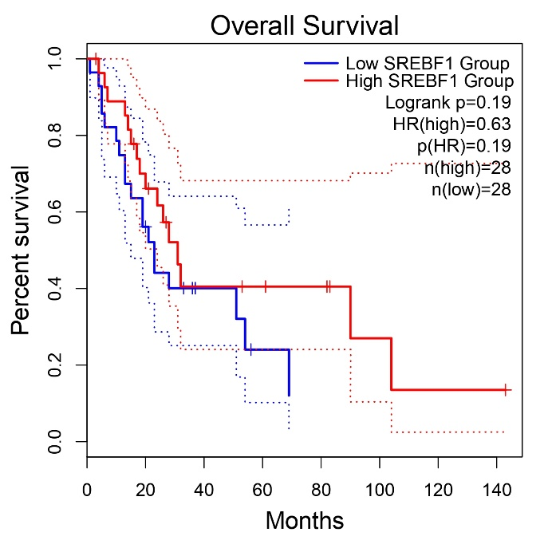
Figure 13. Kaplan–Meier Overall Survival (OS) Analysis of SREBF1 Expression
Kaplan–Meier overall survival curves illustrating the association between SREBF1 expression levels and overall survival outcomes. High SREBF1 expression (red curve) showed a trend toward better overall survival compared with low expression (blue curve). Statistical analysis using the log-rank test revealed no significant difference between the groups (log-rank p = 0.19). The hazard ratio (HR) for the high-expression group was 0.63. Tick marks denote censored cases.

4. Discussion
This study employed an integrated bioinformatics and machine learning framework to identify potential molecular biomarkers associated with uterine carcinosarcoma (UCS), a rare and highly aggressive gynecological malignancy characterized by poor prognosis and limited therapeutic options. By combining differential gene expression analysis, protein–protein interaction (PPI) network analysis, survival analysis, and machine learning approaches, several candidate hub genes with potential diagnostic and prognostic relevance were identified.
A total of 2,266 differentially expressed genes (DEGs) were identified between UCS and normal tissue samples, including 1,218 upregulated and 1,048 downregulated genes. Functional enrichment and network analyses revealed significant involvement of pathways associated with tumor progression, immune regulation, cell proliferation, and epigenetic modification. These findings are consistent with previous reports indicating that dysregulated signaling pathways and alterations in the tumor microenvironment play critical roles in UCS pathogenesis.
Among the identified hub genes, STAT3 demonstrated the highest connectivity within the PPI network, suggesting a central regulatory role in UCS progression. STAT3 is a well-established transcription factor involved in the JAK–STAT signaling pathway and has been implicated in multiple oncogenic processes, including tumor proliferation, angiogenesis, immune evasion, and metastasis. Persistent activation of STAT3 has been reported in several malignancies and is frequently associated with aggressive tumor behavior and poor clinical outcomes. Although survival analysis in the present study did not demonstrate statistically significant associations, elevated STAT3 expression showed a trend toward poorer overall survival, indicating its potential prognostic relevance in UCS.
EP300 was also identified as a significant hub gene. EP300 encodes a histone acetyltransferase involved in chromatin remodeling and transcriptional regulation. Aberrant EP300 expression has been linked to epigenetic dysregulation, uncontrolled cell proliferation, and tumor development in various cancers. In the current study, higher EP300 expression demonstrated a trend toward improved overall survival and disease-free survival, suggesting a possible protective role. Although these findings did not reach statistical significance, they support the hypothesis that epigenetic regulatory mechanisms contribute to UCS progression.
The immune-associated gene ITGAM emerged as another important hub gene identified through network analysis. ITGAM is involved in leukocyte adhesion, migration, and modulation of inflammatory responses within the tumor microenvironment. Increasing evidence suggests that immune-related pathways significantly influence cancer progression and therapeutic response. The identification of ITGAM in this study highlights the potential contribution of immune microenvironment dysregulation in UCS pathogenesis and may provide insights into future immunotherapeutic strategies.
Additionally, SREBF1 was identified as a hub gene potentially associated with metabolic reprogramming in UCS. SREBF1 functions as a transcriptional regulator of lipid biosynthesis and metabolic homeostasis. Altered lipid metabolism is increasingly recognized as a hallmark of cancer and contributes to tumor growth, survival, and metastasis. The observed association between SREBF1 expression and survival outcomes suggests that metabolic dysregulation may play an important role in UCS development.
An important strength of the present study is the integration of machine learning techniques with conventional bioinformatics analysis. The Random Forest classifier demonstrated high predictive performance, achieving an accuracy of 94.73% and a ROC-AUC value of 0.936. These findings indicate strong discriminatory capability between tumor and normal samples and support the potential utility of the identified gene signatures as diagnostic biomarkers. The incorporation of machine learning approaches enhances the robustness and translational relevance of biomarker discovery compared with traditional DEG-based analyses alone.
The functional enrichment analyses further supported the biological significance of the identified genes by revealing enrichment in pathways related to immune response, signal transduction, transcriptional regulation, and cancer-associated cellular processes. These findings are consistent with previous studies demonstrating the complex interplay between immune dysregulation, epigenetic modification, and metabolic alterations in aggressive malignancies.
Despite these promising findings, several limitations of the present study should be acknowledged. First, the analysis was based primarily on a single GEO dataset with a relatively limited sample size, which may affect the generalizability and statistical robustness of the results. Second, although survival analyses suggested potential prognostic relevance, most associations did not achieve statistical significance. Third, the study lacked external validation using independent datasets such as TCGA or experimental validation methods including quantitative PCR, western blotting, or immunohistochemistry. Consequently, the identified biomarkers should be considered candidate biomarkers requiring further validation.
Future studies should focus on validating these findings using larger independent cohorts and experimental approaches to confirm the biological and clinical significance of the identified hub genes. Integration of transcriptomic data with proteomic, epigenetic, and clinical information may further improve the understanding of UCS molecular mechanisms. In addition, exploration of drug–gene interactions and pathway-targeted therapies may provide valuable insights for the development of personalized therapeutic strategies for UCS patients.
In summary, the present study identified STAT3, EP300, ITGAM, and SREBF1 as potential molecular biomarkers associated with uterine carcinosarcoma progression through an integrated bioinformatics and machine learning framework. These findings contribute to the growing understanding of UCS molecular pathogenesis and provide a foundation for future translational and experimental investigations.

5. Conclusion
This study presents a comprehensive integrative framework combining bioinformatics and machine learning approaches to identify potential biomarkers in uterine carcinosarcoma. Key hub genes, including STAT3, EP300, ITGAM, and SREBF1, were identified as candidates with significant diagnostic and biological relevance. The high predictive performance of the machine learning model further supports their potential utility in distinguishing tumor from normal samples.
Although the findings provide valuable insights into the molecular mechanisms underlying UCS, further validation through experimental and clinical studies is essential. The proposed approach offers a promising foundation for future research aimed at improving early diagnosis and developing targeted therapeutic strategies for this aggressive malignancy.

Ethics Statement
This study utilized publicly available datasets from the GEO database; therefore, ethical approval and informed consent were not required.

Data Availability
The datasets analyzed during the current study are publicly available in the GEO repository under accession number GSE122697.

Author Contributions
Gauri Suresh performed bioinformatics analysis, data interpretation, and manuscript preparation. Mahima Kashyap contributed to methodology and machine learning analysis. Nisha Singh supervised the study and reviewed the manuscript.

Conflict of Interest
The authors declare no conflict of interest.

Funding
The authors received no specific funding for this work.
6. References
Amant, F., Moerman, P., Neven, P., Timmerman, D., Van Limbergen, E., & Vergote, I. (2005). Endometrial cancer. The Lancet, 366(9484), 491–505. https://doi.org/10.1016/S0140-6736(05)67063-8
Ashburner, M., et al. (2000). Gene ontology. Nature Genetics, 25(1), 25–29. https://doi.org/10.1038/75556
Bader, G. D., & Hogue, C. W. V. (2003). MCODE method. BMC Bioinformatics, 4, 2. https://doi.org/10.1186/1471-2105-4-2
Barrett, T., et al. (2013). NCBI GEO update. Nucleic Acids Research, 41(D1), D991–D995. https://doi.org/10.1093/nar/gks1193
Breiman, L. (2001). Random forests. Machine Learning, 45(1), 5–32. https://doi.org/10.1023/A:1010933404324
Cantrell, L. A., & Blank, S. V. (2010). UCS review. Gynecologic Oncology, 119(3), 476–482. https://doi.org/10.1016/j.ygyno.2010.07.011
Cherniack, A. D., et al. (2017). UCS molecular characterization. Cancer Cell, 31(3), 411–423. https://doi.org/10.1016/j.ccell.2017.02.010
Cortes, C., & Vapnik, V. (1995). SVM. Machine Learning, 20(3), 273–297. https://doi.org/10.1007/BF00994018
Cruz, J. A., & Wishart, D. S. (2006). ML in cancer. Bioinformatics, 22(10), 1215–1222. https://doi.org/10.1093/bioinformatics/btl091
Edgar, R., et al. (2002). GEO database. Nucleic Acids Research, 30(1), 207–210. https://doi.org/10.1093/nar/30.1.207
Esteva, A., et al. (2019). ML in healthcare. Nature Medicine, 25(1), 24–29. https://doi.org/10.1038/s41591-018-0316-z
Goodman, R. H., & Smolik, S. (2000). CBP/p300. Genes & Development, 14(13), 1553–1577. https://doi.org/10.1101/gad.14.13.1553
Hanahan, D., & Weinberg, R. A. (2011). Hallmarks of cancer. Cell, 144(5), 646–674. https://doi.org/10.1016/j.cell.2011.02.013
Hasin, Y., et al. (2017). Multi-omics. Genome Biology, 18, 83. https://doi.org/10.1186/s13059-017-1215-1
Huang, D. W., et al. (2009). DAVID tools. Nature Protocols, 4(1), 44–57. https://doi.org/10.1038/nprot.2008.211
Hynes, R. O. (2002). Integrins. Cell, 110(6), 673–687. https://doi.org/10.1016/S0092-8674(02)00971-6
Kanehisa, M., et al. (2021). KEGG database. Nucleic Acids Research, 49(D1), D545–D551. https://doi.org/10.1093/nar/gkaa970
Kourou, K., et al. (2015). ML cancer prediction. CSBJ, 13, 8–17. https://doi.org/10.1016/j.csbj.2014.11.005
Levine, D. A. (2013). Endometrial carcinoma genomics. Nature, 497, 67–73. https://doi.org/10.1038/nature12113
Libbrecht, M. W., & Noble, W. S. (2015). ML genomics. Nat Rev Genet, 16(6), 321–332. https://doi.org/10.1038/nrg3920
Li, T., et al. (2017). TIMER. Cancer Research, 77(21), e108–e110. https://doi.org/10.1158/0008-5472.CAN-17-0307
Love, M. I., et al. (2014). DESeq2. Genome Biology, 15, 550. https://doi.org/10.1186/s13059-014-0550-8
McConechy, M. K., et al. (2015). UCS profiling. J Pathol, 237(3), 357–368. https://doi.org/10.1002/path.4576
Ritchie, M. E., et al. (2015). Limma. Nucleic Acids Research, 43(7), e47. https://doi.org/10.1093/nar/gkv007
Robinson, M. D., et al. (2010). edgeR. Bioinformatics, 26(1), 139–140. https://doi.org/10.1093/bioinformatics/btp616
Shannon, P., et al. (2003). Cytoscape. Genome Research, 13(11), 2498–2504. https://doi.org/10.1101/gr.1239303
Siegel, R. L., et al. (2023). Cancer statistics. CA Cancer J Clin, 73(1), 17–48. https://doi.org/10.3322/caac.21763
Subramanian, A., et al. (2005). GSEA. PNAS, 102(43), 15545–15550. https://doi.org/10.1073/pnas.0506580102
Szklarczyk, D., et al. (2021). STRING. Nucleic Acids Research, 49(D1), D605–D612. https://doi.org/10.1093/nar/gkaa1074
Tang, Z., et al. (2017). GEPIA. Nucleic Acids Research, 45(W1), W98–W102. https://doi.org/10.1093/nar/gkx247
Witten, I. H., et al. (2016). Data mining. Morgan Kaufmann.
Yu, H., et al. (2009). STAT3. Nat Rev Cancer, 9(11), 798–809. https://doi.org/10.1038/nrc2734
Zhou, Y., et al. (2019). Metascape. Nat Commun, 10, 1523. https://doi.org/10.1038/s41467-019-09234-6

