AI in Art Education: Generative Tools, Pedagogical Methods, and Collaborative Partners: A Systematic Review
Huichun Ning Nanchang Polytechnic University China, Jiangxi province, Nanchang
Tel: 86-138-7093-5090 E-mail: ninghuichun@163.com
- https://orcid.org/0000-0002-0798-2006 Gevorg Grigoryan
Nanchang Polytechnic University China, Jiangxi province, Nanchang
Tel: 86-178-0703-1807 Email: gevorg.grigoryan93@gmail.com
- https://orcid.org/0000-0002-1689-8375 Yinping Chen
Nanchang Polytechnic University China, Jiangxi province, Nanchang
Tel: 86-139-7002-2342 Email: 316279932@qq.com

Introduction
Generative AI (GenAI) is rapidly emerging as a transformative force in art and design education. It not only expands the boundaries of creative expression but is also reshaping traditional teaching models. Tools such as Midjourney, DALL·E, Stable Diffusion, Leonardo, and Firefly are now widely adopted in classrooms and studios, demonstrating formidable capabilities in image generation, visual storytelling, and creative exploration. These technologies empower students to generate high-quality visual works and design sketches at unprecedented speeds, fundamentally altering learning approaches and creative workflows.
However, despite GenAI's growing adoption, related research remains in its infancy. Existing literature predominantly focuses on technical performance or creative potential, with limited systematic comparisons and analyses across different regions, disciplines, and teaching contexts. Concurrently, practical challenges and deeper educational implications have yet to be fully explored. Therefore, comprehensive

research is needed to map current developments, unlock AI's untapped potential, and address emerging challenges.
Accordingly, this study categorizes AI's role in education into three core dimensions to establish a systematic analytical framework: First, Generative Tools—emphasizing their function in creating artworks, optimizing techniques, and transforming styles; Second, Pedagogical Methods—focusing on AI's application in interactive learning and instant feedback, integrating it as a pedagogical scaffold; Third, Collaborative Partners—exploring AI's participation in artistic evaluation and its potential for realtime collaborative creation with humans. This three-dimensional framework enables a more comprehensive understanding of generative AI's multifaceted roles and value within higher education in art and design.

Background
The Development of AI in Art and Design Higher Education
The emergence of large language models (LLMs) marked a major turning point for artificial intelligence in higher education. Trained on extensive datasets, LLMs can generate contextually coherent and meaningful text (Qian, 2025). With the public release of advanced conversational systems in the early 2020s, AI quickly entered university classrooms (Caires et al., 2024). In art and design programs, these tools began supporting idea generation, conceptual development, and the drafting of artist statements and project proposals (Lee & Suh, 2024;Liu & Zhu, 2025;Lacey & Smith, 2023). Through interactive dialogue, LLM-based systems helped students clarify and refine their creative thinking rather than merely retrieve information.
The rapid development of image-generative models soon expanded AI’s impact on studio-based learning. These systems enabled students to create visual drafts, test stylistic variations, and prototype design ideas efficiently (O’Dea, 2024; Models, 2025) . In art and design higher education, this significantly accelerated ideation and lowered technical barriers, allowing more iterative and exploratory workflows (Fleischmann, 2024). AI thus shifted from a text-based assistant to an embedded component of visual production.
By late 2023, multimodal GenAI systems emerged, integrating text, image, audio, and video generation within unified platforms (Giannakos et al., 2024). This development was particularly relevant for art disciplines that operate across multiple media. Multimodal AI allowed students to combine narrative, visual, and auditory elements in more immersive and interactive projects (O’Dea, 2024). From an educational perspective, GenAI’s adaptability such as real-time feedback and adjustable content complexity has further supported personalized and experimental learning in art and design higher education.

Extant Systematic Reviews on AI in Art and Design Higher Education
Several prior systematic reviews have examined AI applications in art and design

education. Su & Mokmin (2024) screened and analyzed 685 relevant publications over the past decade, 36 core findings reveals that technology-supported arts education, though still in its infancy, has demonstrated significant potential in driving arts education reform. On one hand, it reduces reliance on physical materials and minimizes waste during the creative process, on the other hand, it leverages digital platforms to enable more learners to overcome geographical barriers and access high-quality arts education resources.
With the rapid advancement of generative AI technologies, recent studies have begun to examine their growing influence on creative practice and studio-based learning. Amini (2025) revealed that AI tools like DALL·E and Midjourney have provided students with unprecedented creative efficiency and exploratory space, becoming collaborative partners in the creative process. At the same time, scholars have raised concerns regarding authorship attribution, intellectual property rights, and academic integrity in AI-assisted creative work (Amini, 2025). Emerging discussions also highlight the risk of aesthetic homogenization, as generative systems often reproduce dominant stylistic patterns embedded in large-scale dataset (Sáez-Velasco et al., 2024a). Moreover, some researchers argue that excessive reliance on AI-generated imagery may undermine the development of foundational artistic skills and aesthetic sensitivity, particularly in early-stage studio learning (Sáez-Velasco et al., 2024;Zhu et al., 2025).
Despite the growing body of research on AI in creative education, several gaps remain. Existing studies tend to focus on specific tools or isolated classroom cases, while providing limited systematic analysis of broader adoption patterns across geographic regions, disciplines, and technologies. Moreover, relatively little attention has been paid to how GenAI is pedagogically deployed within studio-based teaching and learning, how these practices vary across different art and design disciplines, and what challenges may emerge from such implementations.

Research Questions
Based on the aforementioned theoretical and practical gaps, this study aims to address the following questions:
What patterns characterize the geographic, disciplinary, and technological distribution of GenAI adoption in art and design education?
How are GenAI being pedagogically deployed in art and design teaching and learning (e.g., studio practice, creative project development)?
What are disciplinary differences in the deployment of GenAI in art and design education?
What challenges emerge from current GenAI implementations in art and design teaching and learning?

Methodology
This study adopted a Systematic Literature Review (SLR) approach to comprehensively map the existing research on the applications and risks of generative artificial intelligence (AI) in Art and Design Education. The review was conducted following the PRISMA (Preferred Reporting Items for Systematic Reviews and Meta-Analyses) guidelines to ensure a transparent and replicable process. Besides, a qualitative analysis tool NVivo was adopted for the analysis of selected literatures.

Search Strategy
Relevant literature was retrieved from two major academic databases—Scopus and Web of Science—because of their broad coverage of high-quality peer‑reviewed journals. To ensure the comprehensiveness and authority of the sources. The ERIC database was also consulted to supplement relevant research in the field of education. Besides, additional records were identified from reference lists of key papers.
In order to conduct a comprehensive literature search in the database, a set of keywords was developed to capture the intersection of generative artificial intelligence and art and design education within the context of higher education. The search strategy combined three major dimensions: Generative Artificial Intelligence — including terms such as “generative AI,” “large language models (LLMs),” “ChatGPT,” “creative AI,” and specific tools (e.g., Midjourney, Stable Diffusion). Educational Context in Art and Design — encompassing “higher education,” “university education,” “art education,” “design education,” “art and design,” “creative arts,” “visual arts,” and related concepts. These keyword clusters were combined using Boolean operators (AND/OR) in the Topic (TS) field to ensure both precision and breadth.
Meanwhile, to ensure all selected papers accurately reflect the research objectives, the Inclusion and Exclusion Criteria are followed: Inclusion: (a) Published between 2021 and 2025; (b) Focused on applications or risks of generative AI in art and design education; (c) Written in English; (d) Peer-reviewed journal articles, conference papers, or authoritative reports. Exclusion: (a) Papers unrelated to education or creative industries;(b) Non-academic sources (e.g., blog posts, news articles); (c) Duplicate records.

Screening Process
The initial search identified 271 records from 3 database. After removing 58 duplicates, 213 records remained for title and abstract screening. Of these, 11 could not be accessed and 169 records were failed to meet inclusion requirements. Among these 169, 6 articles were not in the field of higher education; 3 were review articles; 18 were conference papers; 59 articles were unrelated to the theme of “Teaching and Learning”; 16 articles were written in Korean or Spanish; and 67 articles were not specialized in art and design education. Finally, 33 studies were included in the review. A PRISMA flow diagram (see Figure 1) illustrates the identification, screening, eligibility, and

inclusion stages of this process. Each included study was further analyzed in NVivo. Studies were then grouped into two main themes: Applications and potential of generative AI in Art and Design Education.
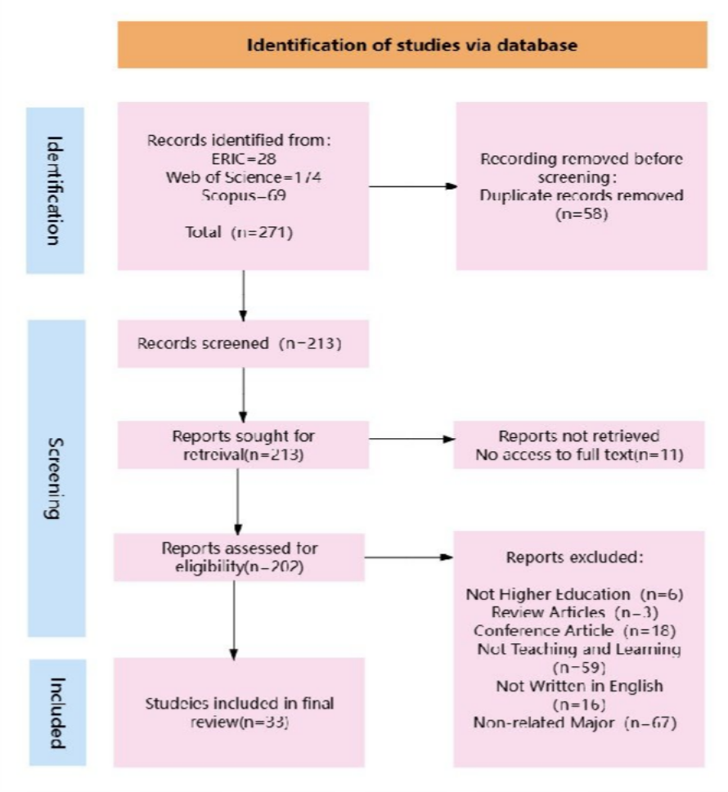
Figure 1 Identification of Studies via Database Findings and Discussion
What patterns characterize the geographic, disciplinary, and technological distribution of GenAI adoption in art and design education?
Geographical Distribution

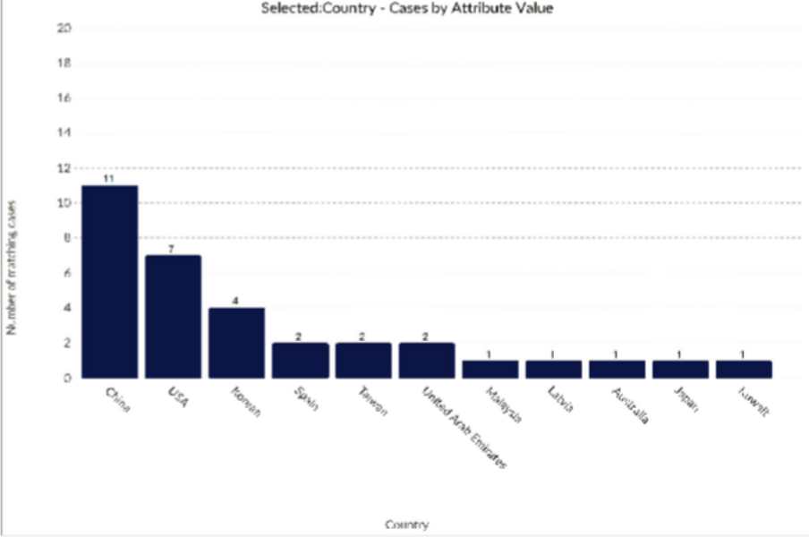
Figure 2 Geographical Distribution
Studies on GenAI in Art and Design education are predominantly concentrated in China (including Hong Kong, a Special Administrative Region of China), with a combined total of 11 publications, highlighting a strong regional focus on using GenAI to enhance teaching and learning. The United States follows with 7 publications. Beyond these two regions, contributions span multiple continents, including Korea (4 cases), Spain (2 cases), the United Arab Emirates (2 cases), Taiwan (2 cases), and several countries with single publications such as Malaysia, Latvia, Australia, Japan, and Kuwait. This distribution reflects a growing yet uneven global engagement with GenAI in Art and Design education, with Asia and North America emerging as the primary contributors.
China’s national strategy—shown in the Next Generation Artificial Intelligence Development Plan (2017)—places strong emphasis on AI innovation (Qian, 2025). The government provides major funding for AI in education and encourages universities to carry out research that supports national goals. This approach has accelerated empirical studies on GenAi in higher education. Furthermore, given that China has one of the largest populations engaged in art and design education and digital creative industries, the practical demand for GenAI tools is even stronger, further driving research activities in this field.

Academic Disciplines

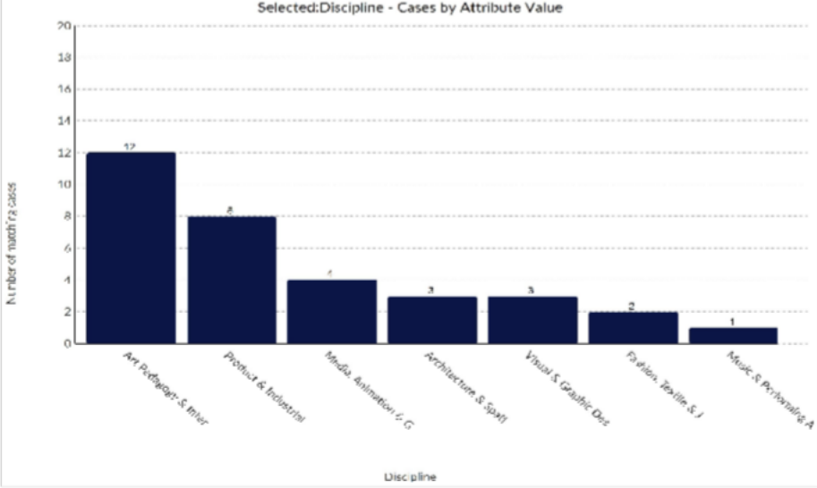
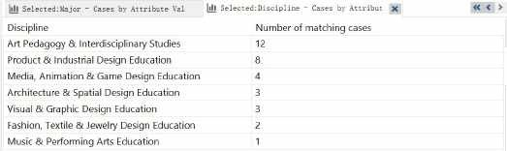
Figure 3 Academic Disciplines
Figure 3 illustrates the distribution of GenAi application studies by academic discipline. To categorize these 33 studies, each was coded based on its primary educational context. Studies with disciplinary overlaps-such as those interviewees are from various art majors -were classified according to their predominant pedagogical focus. Note that Art Pedagogy & Interdisciplinary Studies also include general education courses related to the arts (e.g., Art Appreciation, Introduction to Art History) as well as interdisciplinary courses that combine the arts with other fields (e.g., Art and Technology.)
Among these 33 studies, Art Pedagogy & Interdisciplinary Studies constitute the largest cluster (12 studies). This is unsurprising because art education is inherently situated within educational research, where new teaching tools—such as GenAI—are often examined early through classroom practices, creative ideation exercises, and foundational art instruction. Product & Industrial Design Education accounts for another major proportion (8 studies), indicating strong interest in AI-assisted prototyping and design workflows. Medium-sized clusters include Media, Animation

& Game Design (4 studies) and Fashion Design (3 studies), while smaller but noteworthy contributions were found in Architecture & Spatial Design (3 studies), Visual & Graphic Design (3 studies), Textile & Jewelry Design (2 studies), and Music & Performing Arts (1 study). This distribution highlights both the maturity of certain subfields (e.g., art pedagogy, industrial design) and the emerging potential of others, illustrating the heterogeneous stages of GenAI adoption across the creative education landscape.
GenAI Tools Used
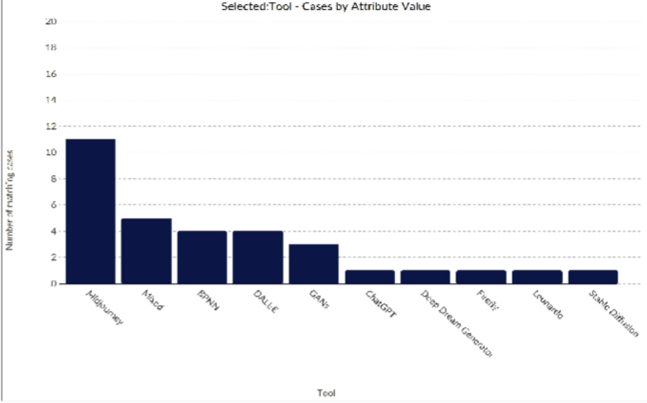

Figure 4 GenAI Tools Used
Note: “Mixed” refers to the application of multiple user-facing generative AI tools within a single case. BPNN (Backpropagation Neural Network) and GANs (Generative Adversarial Networks) are model types rather than direct user-facing generative AI tools. They are listed here as some research classifies them as generative methods.

How are GenAI being pedagogically deployed in art and design teaching and learning (e.g., studio practice, creative project development)?
The systematic review indicates that GenAI is being pedagogically deployed in art and design education through progressively deepening forms of integration. Rather than functioning in a single fixed capacity, AI appears along a continuum—from technical instrument, to learning scaffold, to co-creative collaborator (Amini, 2025). These roles—AI as Tool, AI as Method, and AI as Partner—reflect increasing degrees of pedagogical transformation. While early adoption emphasizes efficiency and technical enhancement, more advanced integrations begin to reshape studio processes, critique culture, and even assumptions about authorship.

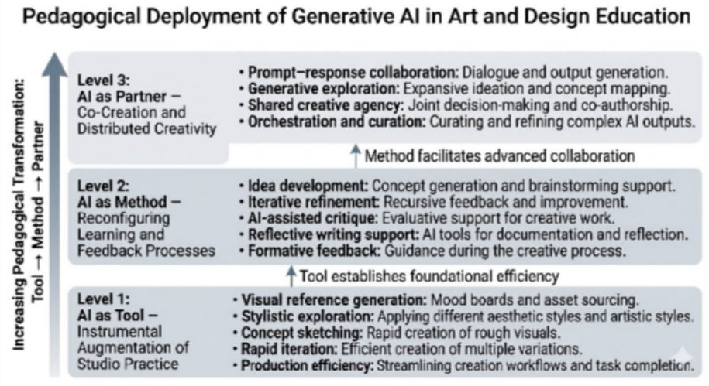

Figure 5 Pedagogical Deployment of GenAI in Art and Design Education AI as a Tool: Instrumental Augmentation of Studio Practice
Generative AI is increasingly adopted in art and design education as a production tool embedded within existing studio workflows. Several scholars from Korea suggest that platforms such as Midjourney, DALL·E, and Stable Diffusion enable students to rapidly generate visual references and explore diverse stylistic variations during the early stages of design development (Magee, 2024;Kang et al., 2025). By automating technically demanding processes such as image rendering, compositional experimentation, and style transformation, these systems can significantly lower technical barriers that often constrain creative exploration (Magee, 2024;Kang et al., 2025;Lee & Suh, 2024;Hall & Schofield, 2025).
Fleischmann conducted a qualitative study with 85 undergraduate graphic design students in Australia compared hand-drawn logos, hand-drawn plus AI-assisted designs, and AI-generated logos, analyzing the advantages and limitations of each approach in creative design (Fleischmann, 2024). He argued that this instrumental use of AI primarily extends rather than fundamentally transforms traditional studio practice. Similar to earlier transitions from manual drafting to digital design software, AI functions as an advanced creative medium that enhances production efficiency while maintaining the central role of the student as the primary creative agent (Fleischmann, 2024).As a result, AI as a tool mainly expands the scope of experimentation and accelerates iterative design processes within existing studio pedagogies (Fleischmann, 2024).

AI as a Method: Reconfiguring Learning and Feedback Processes
Beyond production support, generative AI is increasingly discussed as a pedagogical method that supports learning, reflection, and feedback in art and design education.

(Sáez-Velasco et al., (2024) note that conversational systems can assist students in developing project ideas, refining artistic narratives, and articulating design rationales during the creative process. Others suggest that AI-driven dialogue can simulate critique interactions and provide immediate feedback, allowing students to explore alternative perspectives during iterative design development (Fan & Li, 2023;Fang & Jiang, 2024).
Xiaoxia Fan and Jiayin Li proposed in their 2023 research that utilizing a backpropagation neural network (BPNN) for AI assessment effectively addresses the challenges in art and design education where manual evaluation is highly subjective, time-consuming, and difficult to scale across large student populations (Fan & Li, 2023). Compared to expert assessment, AI evaluation offers significant objectivity and consistency, providing standardized feedback through automated analysis of massive image datasets to ensure uniformity in evaluation criteria (Fang & Jiang, 2024). Experiments demonstrate that the optimized AI model achieves high accuracy when valuing artistic works (Fan & Li, 2023; Fang & Jiang, 2024).

AI as a Partner: Co-Creation and Distributed Creativity
A more transformative perspective emerges when generative AI is framed as a collaborative partner in artistic creation. Several researchers suggest that AI systems can participate in the generative process through iterative prompt–response interactions that introduce unexpected visual directions and conceptual alternatives (Lataifeh et al., 2024;Chen et al., 2024;Lyu et al., 2024). Such interactions may expand the exploratory space of studio practice by exposing students to aesthetic possibilities that they might not independently envision (Hwang & Wu, 2025).
When AI operates as a co-creative partner, scholars argue that the role of the student gradually shifts from solely producing artistic outputs to orchestrating and curating generative possibilities (Bartlett & Camba, 2024;Lee & Suh, 2024). Students evaluate AI-generated variations, refine prompts, and select outputs that align with their conceptual intentions (Lataifeh et al., 2024). This collaborative process redistributes elements of creative agency across human–AI interaction and places greater emphasis on judgment, interpretation, and conceptual framing (Lacey & Smith, 2023). As a result, the integration of AI in studio learning increasingly reshapes how creativity and authorship are understood in contemporary art and design education.

What are disciplinary differences in the deployment of GenAI in art and design education?

Table 1 reveals notable differences in how GenAI is pedagogically deployed across art and design fields. In practice-oriented disciplines such as Product and Industrial Design, Visual and Graphic Design, and Architecture and Spatial Design, GenAI is most commonly used as a creative tool that supports ideation, visual exploration, and rapid prototyping during early stages of the design process (H. Liu et al., 2024;Fareed

et al., 2024;L. Chen et al., 2025; Jiang et al., 2025). These fields typically emphasize iterative workflows and visual experimentation, making AI-generated imagery and form exploration particularly useful for accelerating concept development. In contrast, disciplines such as Art Pedagogy and Interdisciplinary Studies often integrate GenAI as a pedagogical method within teaching and learning activities. In these contexts, AI is used to support idea generation, classroom discussion, reflective writing, and conceptual exploration, allowing students to engage critically with both artistic practice and emerging technologies (De Silva et al., 2024;Kondo et al., 2024;Amini, 2025). Meanwhile, fields such as Media, Animation, and Game Design, as well as emerging applications in Fashion Design, increasingly position GenAI as a collaborative partner in creative production. Through iterative prompt–response interactions, AI contributes to narrative development, visual storytelling, and stylistic experimentation, enabling new forms of human–AI co-creation in digital media production (Xie & Zhao, 2025;Hutson et al., 2024;Lataifeh et al., 2024).

In a word, these patterns suggest that the pedagogical role of GenAI varies across disciplines. While some fields primarily adopt AI as a tool for production efficiency, others integrate it more deeply into learning processes or creative collaboration, reflecting diverse priorities in studio practice and creative education.

Discipline AI as Tool AI as Method AI as Partner

Product & Industrial Design
Visual & Graphic Design

Architecture & Spatial Design
Art Pedagogy & Interdisciplinary Studies
Media, Animation & Game Design

Fashion Design
Ideation, Prototyping Visual exploration,
layout generation
Spatial visualization, form exploration

Idea generation, reflective discussion

Storytelling, content generation Style exploration, co-

creation

Table 1: Disciplinary Differences in the Pedagogical Use of Generative AI

What challenges emerge from current GenAI implementations in art and design teaching and learning?
Skill Erosion and Aesthetic Homogenization

When GenAI is used primarily as a production tool, the central concern is over-reliance. Rapid image generation and automated visual solutions reduce the need for prolonged material experimentation and technical struggle—processes traditionally considered essential for artistic growth. If students outsource ideation and visualization too early, foundational skills such as drawing, modeling, and compositional reasoning may weaken.
In addition, generative systems often reproduce stylistic patterns embedded in large training datasets. This creates the risk of aesthetic convergence, where outputs appear polished but lack depth or distinctiveness. The challenge at this level is not whether AI improves efficiency—it clearly does—but whether efficiency comes at the cost of craft development and creative diversity.

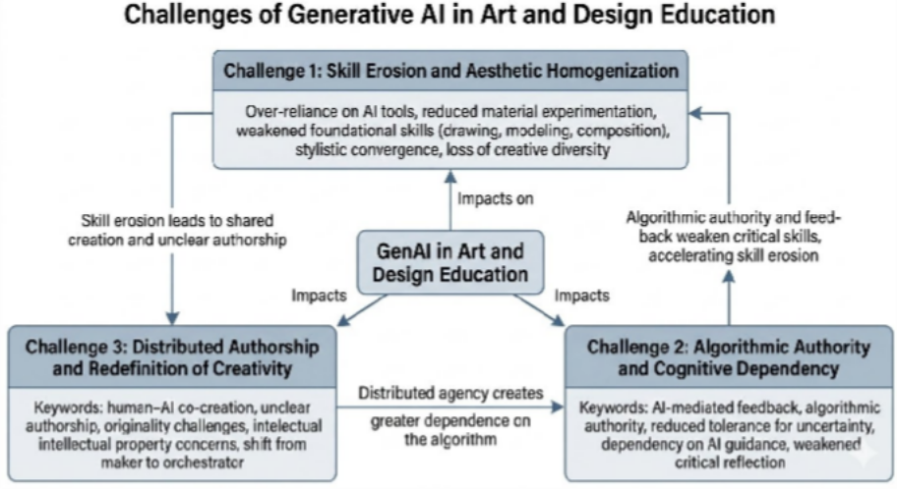

Figure 6 Challenges of GenAI in Art and Design Education Algorithmic Authority and Cognitive Dependency
As GenAI becomes embedded in feedback and reflective processes, a more subtle challenge emerges: the restructuring of critique. Studio pedagogy has long relied on dialogic, situated evaluation shaped by human interpretation. AI-generated feedback, while immediate and scalable, introduces algorithmic mediation into this space.
Students may begin to treat AI responses as neutral or authoritative, even though such feedback is shaped by statistical patterning rather than contextual judgment. Over time, habitual consultation of AI during early ideation stages may reduce tolerance for uncertainty and weaken independent critical thinking. The concern here is less about correctness and more about intellectual formation. When AI becomes a constant cognitive companion, reflective autonomy may gradually shift toward algorithmic

validation.

Distributed Authorship and the Redefinition of Creativity
The most profound challenge arises when GenAI functions as a co-creative partner. In prompt-based collaboration, AI materially influences visual and conceptual outcomes. This complicates traditional notions of authorship, originality, and ownership— concepts deeply embedded in art education.
If creative output results from iterative human–AI interaction, it becomes difficult to determine what constitutes individual contribution. Assessment criteria grounded in intentionality and manual execution may no longer fully apply. At the same time, generative models trained on vast and opaque datasets raise concerns about intellectual property and embedded bias.
More fundamentally, co-creation with AI shifts the student’s role from maker to orchestrator. Creativity becomes less about producing every element and more about selecting, refining, and directing generative systems. While this may expand creative possibilities, it also demands new literacies that many curricula have yet to formally integrate.

Post-2025 Perspectives: Emerging Paradigms in 2026
While this review primarily synthesizes literature up to 2025, early 2026 scholarship suggests a shift from "generative efficiency" to "evaluative agency". Recent frameworks emphasize "Generative Synesthesia," where the educational focus moves beyond prompt engineering to the critical filtering and orchestration of AI outputs. Furthermore, the emergence of specialized AI models in 2026, such as those for few-shot cultural motif generation, indicates that the technology is moving from generic visual production toward deep disciplinary integration. These developments underscore the necessity for "Productive Difficulty" in curricula to ensure that students’ cognitive depth is not bypassed by automated workflows.

Implications
Based on the preceding discussion, this study provides clear practical guidance for the transformation of higher art education. At the pedagogical level, educators should shift the focus of instruction from singular visual output to critical evaluation of creative intent, prompt logic, and generated outcomes. This can be achieved by designing “human-machine differentiation” experiments to safeguard students' foundational skills and sensory acuity. In curriculum development, academic institutions must formally establish “AI literacy” as a core general competency, integrating algorithmic bias analysis, intellectual property ethics, and the definition of distributed authorship into assessment frameworks. Additionally, policymakers should encourage the establishment of interdisciplinary experimental studios that not only focus on technological application but also develop AI ethical guidelines specific to art education. This ensures the preservation of artistic creation's epistemological autonomy

and humanistic spirit amid deepening technological intervention.

Limitations
Despite GenAI's immense transformative potential, this review identifies several limitations in the current research landscape. Empirical studies remain heavily concentrated in China and the United States, as well as specific disciplines like industrial design, with a notable lack of in-depth exploration in developing countries and fields such as fine arts, music, and performing arts. Furthermore, existing literature predominantly focuses on observing short-term application effects, lacking follow-up research on the long-term impacts of AI integration on students' cognitive structures and creative psychology. Consequently, future research should prioritize transforming evaluation paradigms by developing metrics to quantify human-machine co-creation contributions. Interdisciplinary comparative studies are needed to analyze variations in AI generative logic across different artistic media. Simultaneously, redefining the educator's role is critical—exploring how instructors transition from traditional knowledge providers to curators and facilitators within AI-driven creative processes.

Conclusion
In summary, generative AI is driving a profound shift in art and design education from “outcome-oriented” to “process-oriented” approaches. Through the progressive framework of “tool-method-partner,” GenAI not only transforms technical means of creation but fundamentally reconstructs the ecosystem of studio pedagogy. However, successful pedagogical integration should not be blind technological adoption. Through careful instructional design, it must harness AI to amplify creativity while upholding core values in art education: critical inquiry, personal expression, and humanistic literacy. Ultimately, art education should cultivate a new generation of creators adept at navigating complex human-machine collaborative environments, ensuring the enduring essence of craftsmanship and creativity amidst technological iteration.
Amini, H. (2025). AI in Art Education: Innovation, Ethics, and the Future of Creativity. Art and Design Review, 13(02), 115–129. https://doi.org/10.4236/adr.2025.132008
Bartlett, K. A., & Camba, J. D. (2024). Generative Artificial Intelligence in Product Design Education: Navigating Concerns of Originality and Ethics. International Journal of Interactive Multimedia and Artificial Intelligence, 8(5), 55–64. https://doi.org/10.9781/ijimai.2024.02.006
Caires, C. S., Estadieu, G., & Olga Ng Ka Man, S. (2024). Design Thinking Methodology and Text-To-Image Artificial Intelligence: A Case Study in the Context of Furniture Design Education. In Springer Series in Design and Innovation (Vol. 33). Springer Nature Switzerland. https://doi.org/10.1007/978-3-031-41770-2_7
Chen, J.-F., Ni, C.-C., Lin, P.-H., & Lin, R. (2024). Designing the Future: A Case

Study on Human-AI Co-Innovation. Creative Education, 15(03), 474–494. https://doi.org/10.4236/ce.2024.153028
Chen, L., Song, Y., Guo, J., Sun, L., Childs, P., & Yin, Y. (2025). How generative AI supports human in conceptual design. Design Science, 11, 1–23. https://doi.org/10.1017/dsj.2025.2
De Silva, D., Jayatilleke, S., El-Ayoubi, M., Issadeen, Z., Moraliyage, H., & Mills, N. (2024). The Human-Centred Design of a Universal Module for Artificial Intelligence Literacy in Tertiary Education Institutions. Machine Learning and Knowledge Extraction, 6(2), 1114–1125. https://doi.org/10.3390/make6020051
Fan, X., & Li, J. (2023). Artificial Intelligence-Driven Interactive Learning Methods for Enhancing Art and Design Education in Higher Institutions. Applied Artificial Intelligence, 37(1). https://doi.org/10.1080/08839514.2023.2225907
Fang, F., & Jiang, X. (2024). The Analysis of Artificial Intelligence Digital Technology in Art Education under the Internet of Things. IEEE Access, 12(February), 22928–22937. https://doi.org/10.1109/ACCESS.2024.3363655
Fareed, M. W., Bou Nassif, A., & Nofal, E. (2024). Exploring the Potentials of Artificial Intelligence Image Generators for Educating the History of Architecture. Heritage, 7(3), 1727–1753. https://doi.org/10.3390/heritage7030081
Fleischmann, K. (2024). The commodification of creativity: Integrating Generative Artificial Intelligence in higher education design curriculum. Innovations in Education and Teaching International, 00(00), 1–15. https://doi.org/10.1080/14703297.2024.2427039
Giannakos, M., Azevedo, R., Brusilovsky, P., Cukurova, M., Dimitriadis, Y., Hernandez-Leo, D., Järvelä, S., Mavrikis, M., & Rienties, B. (2024). The promise and challenges of generative AI in education. Behaviour and Information Technology, 1–27. https://doi.org/10.1080/0144929X.2024.2394886
Hall, J., & Schofield, D. (2025). The Value of Creativity: Human Produced Art vs. AI-Generated Art. Art and Design Review, 13(01), 65–88. https://doi.org/10.4236/adr.2025.131005
Hutson, J., Fulcher, B., & Ratican, J. (2024). Enhancing Assessment and Feedback in Game Design Programs: Leveraging Generative AI for Efficient and Meaningful Evaluation. International Journal of Educational Research and Innovation, 2024(22). https://doi.org/10.46661/ijeri.11038
Hwang, Y., & Wu, Y. (2025). Graphic Design Education in the Era of Text-to-Image Generation: Transitioning to Contents Creator. International Journal of Art and Design Education, 44(1), 239–253. https://doi.org/10.1111/jade.12558
Jiang, Y., Tao, Y., Han, K., wang, zuyao, & Zhu, Y. (2025). Impact of AI-generated imagery on foundation course design in industrial design education: An empirical

study of curriculum value transformation. Journal of Computational Methods in Sciences and Engineering, 0(1), 1–16. https://doi.org/10.1177/14727978251364457
Kang, W., Lee, H. S., & Hong, J. H. (2025). AI-assisted design communication in ceramic-crafts education: Investigating image generation tools for concept representation and pedagogical practice. Computers and Education, 239(July), 105419. https://doi.org/10.1016/j.compedu.2025.105419
Kondo, K., Nagayoshi, H., Nagata, M., & Kanebako, J. (2024). Analysis of AI Prompts for Introductory Education in Generative Art. Journal for Geometry and Graphics, 28(2), 213–227.
Lacey, M. M., & Smith, D. P. (2023). Teaching and assessment of the future today: higher education and AI. Microbiology Australia, 44(3), 124–126. https://doi.org/10.1071/MA23036
Lataifeh, M., Carrasco, X. A., Elnagar, A. M., Ahmed, N., & Junejo, I. (2024). Human–machine co-creation: a complementary cognitive approach to creative character design process using GANs. Journal of Supercomputing, 80(11), 16574–16610. https://doi.org/10.1007/s11227-024-06083-z
Lee, J., & Suh, S. (2024). AI Technology Integrated Education Model for Empowering Fashion Design Ideation. Sustainability (Switzerland), 16(17). https://doi.org/10.3390/su16177262
Liu, H., Zhang, X., Zhou, J., Shou, Y., Yin, Y., & Chai, C. (2024). Cognitive styles and design performances in conceptual design collaboration with GenAI. In International Journal of Technology and Design Education (Vol. 35, Issue 3). Springer Netherlands. https://doi.org/10.1007/s10798-024-09937-y
Liu, Y., & Zhu, C. (2025). The use of deep learning and artificial intelligence-based digital technologies in art education. Scientific Reports, 15(1), 1–14. https://doi.org/10.1038/s41598-025-00892-9
Lyu, Y., Shi, M., Zhang, Y., & Lin, R. (2024). From Image to Imagination: Exploring the Impact of Generative AI on Cultural Translation in Jewelry Design. Sustainability (Switzerland), 16(1). https://doi.org/10.3390/su16010065
Magee, M. D. (2024). Generative Artificial Intelligence as a Tool for Jewelry Design.
FEATURE ARTICLES GENERATIVE, 60(3), 330–347.
Models, R. (2025). EXPLORING HIGHER EDUCATION FACULTY INSIGHTS
ON GENERATIVE AI IN CREATIVE COURSES. Journal of Information Technology Education Research, 24, 54–62.
O’Dea, X. (2024). Generative AI: is it a paradigm shift for higher education? Studies in Higher Education, 49(5), 811–816. https://doi.org/10.1080/03075079.2024.2332944
Qian, Y. (2025). Pedagogical Applications of Generative AI in Higher Education: A

Systematic Review of the Field. TechTrends. https://doi.org/10.1007/s11528-025-01100-1
Sáez-Velasco, S., Alaguero-Rodríguez, M., Delgado-Benito, V., & Rodríguez-Cano,
S. (2024a). Analysing the Impact of Generative AI in Arts Education: A Cross-Disciplinary Perspective of Educators and Students in Higher Education. Informatics, 11(2). https://doi.org/10.3390/informatics11020037
Sáez-Velasco, S., Alaguero-Rodríguez, M., Delgado-Benito, V., & Rodríguez-Cano,
S. (2024b). Analysing the Impact of Generative AI in Arts Education: A Cross-Disciplinary Perspective of Educators and Students in Higher Education. Informatics, 11(2). https://doi.org/10.3390/informatics11020037
Su, H., & Mokmin, N. A. M. (2024). Unveiling the Canvas: Sustainable Integration of AI in Visual Art Education. Sustainability (Switzerland), 16(17). https://doi.org/10.3390/su16177849
Xie, H., & Zhao, Z. (2025). The analysis of entrepreneurship evaluation system for talent cultivation in artistic creativity and animation under artificial intelligence. Scientific Reports, 15(1), 1–17. https://doi.org/10.1038/s41598-025-01437-w
Zhu, W., Xing, W., Kim, E. M., Li, C., Wang, Y., Yang, Y., Zhu, W., Xing, W., Kim,
E. M., Li, C., & Wang, Y. (2025). Integrating image-generative AI into conceptual design in computer-aided design education Integrating image-generative AI into conceptual design in computer-aided design education : Exploring student perceptions , prompt behaviors , and artifact creativit. Educational Technology & Society, 19. https://doi.org/10.30191/ETS.

