Vitamin Deficiency Detection Using Image Processing

K.Venkata Ramana Devi
Information Technology Institute of Aeronautical Engineering
Hyderabad , India k.venkataramanadevi@iare.ac.in

N.Deeksha
Information Technology Institute of Aeronautical Engineering
Hyderabad , India 22951a1213@iare.ac.in

M.Harini
Information Technology Institute of Aeronautical Engineering
Hyderabad , India markaharini@gmail.com

R.Karthik
Information Technology Institute of Aeronautical Engineering
Hyderabad , India 22951a1229@iare.ac.in

Abstract—The early detection of vitamin deficiencies is impor- tant since even a slight imbalance might cause serious health consequences. This research develops an automatic vitamin defi- ciency detection system which combines deep learning with image processing for visual inspection. The system includes a graphical user interface (GUI) which simplifies all stages from dataset upload to prediction and procedure execution and preprocessing. The system recognizes five different vitamin categories which include A, B, C, D and E. The system extracts texture infor- mation from images through histogram analysis and Gray-level Co-occurrence Matrix (GLCM) methods. The SVM classifier achieved a poor result of 50% when trained with these features. The system used the same features to train a Convolutional neural Network (CNN) which produced better results than the SVM. The CNN achieved the highest performance at 86.77% which made it the preferred model for vitamin classification above the SVM. The system shows performance metrics including recall and F-score through a comparison bar chart. Users can upload images to the GUI system which performs true-word predictions. The system uses the input image to detect vitamin deficiencies and show their expected results. The system provides an automated method to detect vitamin deficiencies through picture table analysis without requiring invasive procedures.
Index Terms—Vitamin Deficiency Classification, Convolutional Neural Network (CNN), Support Vector Machine (SVM), GLCM Features, Histogram Analysis, Image Processing, Feature Ex- traction, Texture Analysis, Deep Learning, Medical Diagnosis, Tkinter GUI, Predictive Modeling

- Introduction
Vitamin deficiencies exist as a common health issue which affects people of different ages and geographic locations with- out proper detection. People commonly experience fatigue, dry skin, mass reputation and pale eyes but these symptoms get missed or misread which results in delayed medical diagnosis. The standard diagnostic approach depends on blood tests which prove expensive and need medical facilities that remain inaccessible to many rural and low-income areas. The restricted access to diagnostic services results in fewer cases of proper diagnosis and prolonged health issues. The devel-
opment of computer vision and artificial intelligence enables us to extract substantial health data from visual information. The traditional diagnostic approach depends on blood tests which prove expensive while needing medical facilities to perform them. The absence of medical facilities in rural and low-income areas prevents people from getting proper medical care which results in unsolved health problems. The project fills this gap through its non-invasive affordable solution. The system examines skin appearance to detect visible signs which indicate nutritional deficiencies. The extraction of vital health information from visual data has become possible because of computer vision and artificial intelligence progress. The system will gain wider accessibility through its integration with community health programs.

- Literature Review

Litjens et al. [1] imply the growth of deep skill for tasks like classes and segmentation by examining CNN applications in medical similitude table. Esteva et al. [2] developed a CNN-based example for husk cancer classes that achieved example similar to that of dermatologists. For example, the success of CNNs with big dermatoscopic datasets supports their use for symptom-based classes in visual data, proposition as husk, eyes, and nails. Tajbakhsh et al. [3] explored whether CNNs should be fine-tuned using pre-trained models or trained term scratch. Their investigation on transfer skill provides return assistance for building models with close datasets, thing is significant for detecting vitamin deficiencies. As¸kın et al. [4] presented a detailed clinical table of how various vitamin deficiencies appear on the skin. Based on, the study examines the ways in which vitamin deficiencies demonstrate up as various skin disorders, stressing that changes proposition as hyperpigmentation can be significant markers of dietary deficiencies. Maruthamuthu and Harika [5] proposed a non- invasive approach to identifying vitamin deficiencies that uses

Convolutional Neural Networks (CNNs) and similitude pro- cessing.
- Existing Systems
- Old Feature-Based Methods
Earlier attempts at detecting vitamin deficiencies using images relied on feature tincture methods created by hand. Methods involving portion Binary Patterns, LBP, and His- togram of Oriented Gradients focused on edges and textures of areas such as skin, lips, and nails. Less skillful conventional models, such as the Support Vector Machines and AdaBoost, further classified these extracted features. but, in real world scenarios these did not perform well. This dependency upon manually created features limited their accuracy and flexibility in uncontrolled environments.
- outer skill Approaches
The automatic feature learning ability of Convolutional Neural Networks (CNNs) has upgraded how computer vision problems get solved. The convolutional layers of CNNs detect spatial patterns in data which enables them to detect edges and textures without needing human-designed features. The VGG16 and ResNet-50 and Inception-v3 pre-trained models serve as base models for systems which detect vitamin defi- ciencies. The medical imaging field uses ISIC and DermNet resources to develop models which extract similar visual information from huge datasets. The lack of extensive publicly accessible datasets for vitamin deficiency detection continues to be a major obstacle which requires additional research. The development of multi-class classification systems focuses on creating a system which can identify multiple deficiencies through a single image input. Researchers evaluate model performance through accuracy measurements and precision and recall rates and F1-score values and AUC-ROC results.
- Limitations of Existing Systems
The current systems operate with multiple major restric- tions. The systems fail to meet real-world requirements be- cause they possess excessive complexity and weight. The sys- tems operate as black boxes while performing their functions. The system identifies complete word-level deficiencies as its only capability. The process becomes difficult when working with small labeled datasets because it leads to overfitting. The systems face limitations in low-any environments because they require substantial computational power. The models fail to achieve better equivocal predictions because they disregard essential textual intelligence which includes patient symptoms and story information.
- Methodology
This section shows the process for the vitamin deficiency detection system. It follows step by step process to preprocess dataset ages, extract relevant features from images, and train classification models.
- Dataset Preparation
The data used in this research was extracted from kaggle. The dataset contains subfolders which organize images based on their relation to specific vitamin deficiencies including vitamin A, vitamin B, vitamin C, vitamin D and vitamin E. Each subfolder (i,e each vitamin deficiency folder) contains 80 images, resulting in a balanced dataset suitable for classi- fication. The folders contain images that show visible signs of the related deficiencies. The organized labeling system enables supervised learning because it establishes direct connections between images and their corresponding deficiency types.
- Preprocessing
To ensure uniform input dimensions, all images are resized to 64×64 pixels. A color filter is applied to remove excessive green tones that could interfere with feature extraction and introduce background noise. Additionally, pixel values are normalized to a range between 0 and 1, improving training efficiency and maintaining consistency across the dataset. These preprocessing measures help eliminate irrelevant details and allow the model to focus on facial features that are indicative of vitamin deficiencies.
- Feature Extraction
Two main types of features which are texture-based and statistical based are extracted. The Gray-Level Co-occurrence Matrix (GLCM) is used to capture texture properties like con- trast, correlation, energy, and homogeneity, which describes skin texture patterns. At the same time, statistical measures including mean, standard deviation, entropy and RMS are calculated from the image’s RGB channels. The extracted texture and statistical descriptors are concatenated to form a unified feature vector representing each image. All feature vectors are organized into a feature matrix
- Dataset Splitting and Normalization
After feature extraction, The dataset was divided into train- ing(80%) and testing subsets(20%) with 80:20 split ratio while maintaining class distribution across both sets. This ensures both sets are representative of the overall data. The extracted feature vectors are then normalized using Min-Max scaling, bringing all values into a common range i,e 0-1.If larger numerical values are considered it fully dominates learning process which in turn decreases accuracy.
- CNN Architecture Setup
The dataset undergoes stratified sampling after feature ex- traction to achieve balanced class distribution between training and testing sets. Following the convolutional blocks, a flatten- ing layer converts the feature maps into a one-dimensional representation. After this comes a dense network that is fully connected. ReLU activation and 256 neurons in the layer. The network was taught using the Adam optimizer for 10 epochs with a learning rate of 0.001 and batch size of 12, which yielded a consistent result convergence that does not need human adjustment. The final output layer consists of

five neurons which corresponds to the five vitamin deficiency classes, using a softmax activation function to produce class probability distributions.
- Model Training
The CNN model performs classification through the Adam optimizer and categorical cross-entropy loss function. The training process runs for a set number of epochs with a batch size that strikes a balance between speed and accuracy. The model applies rotation and flipping and zooming techniques for data augmentation to enhance dataset diversity and min- imize overfitting. The model tracks validation accuracy and loss values during training to evaluate its performance and implement changes when necessary.
- Model Evaluation
The model achieves performance evaluation through test set assessment using accuracy and precision and recall and F1- score metrics after finishing training. The confusion matrix shows all incorrect predictions together with detailed perfor- mance results for each class. The deep learning approach through CNN produces better results than SVM because of its superior performance according to the comparison results.
- Implementation
The technical details about the proposed system for detect- ing vitamin deficiencies appear in this section. The system operates through Python libraries which include TensorFlow and scikit-learn and NumPy and OpenCV and matplotlib. The system processes data through a sequence of operations which start with information input followed by preprocessing and feature calculation and model construction and finally evaluation.
- Data Loading and Label Encoding
The system retrieves images from an organized file struc- ture. The system organizes its classes through separate subdirectories which represent different vitamin deficiency types. The os. walk() function enables the system to access file paths together with their corresponding labels. The LabelEncoder transforms labels into numerical values which most learning algorithms require for operation.
- Image Preprocessing
The cv2.resize() function from OpenCV enables users to resize their images into 64×64 pixel dimensions. The system removes green backgrounds through pixel-based filtering to enable feature extraction operations. The system converts all images to the [0, 1] range through normalization of their pixel values.
- Feature Extraction
The system uses GLCM properties to extract texture features from images through inherent and contrast and parallelism and homogeneity calculations. The system uses RGB channels to extract color-based statistical features which include mean, standard deviation, entropy and RMS values. The combination

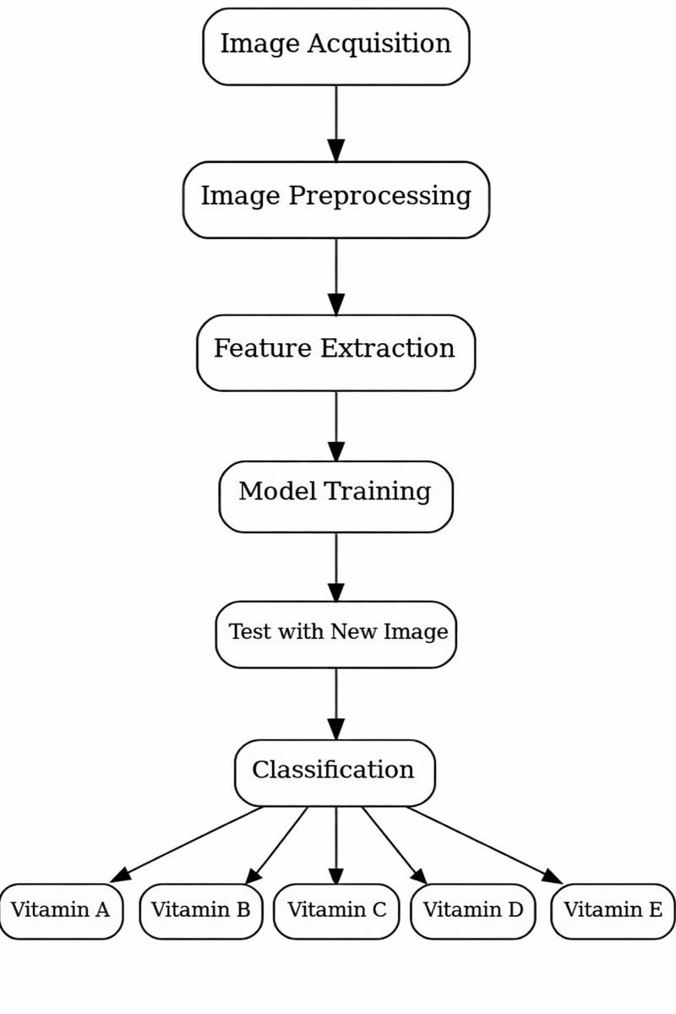
Fig. 1. Architecture

of all features produces the final input vector for traditional classification systems.
- Feature Normalization and Dataset Splitting
The style feature vector obtained through statistical and texture-based methods get combined into a matrix structure where each disturbance point represents the features of an individual image.The features become difficult to process because their numerical values show significant differences between them; entropy values differ substantially from pixel intensity values.
The Min–Max normalization technique gets applied through scikit-learn’s ‘MinMaxScaler‘ to solve this problem. The scal- ing method converts all features into a unified range which gives them equal impact during the classification process.
- SVM Model Training and Evaluation
By using Scikit-learn library we can create an SVM model with Radial Basis Function (RBF) through the ‘SVC()‘ function. The RBF kernel is effective for detecting com- plex patterns in characteristics which link to vitamin lev-

els of deficiencies. The SVM model gets trained on pre processed features from the process subset. The model achieves its best results after training on the test dataset. The classification_report() function generates evalua- tion metrics.
- CNN model Construction and Training
This deep learning model was built using the Keras library. TensorFlow was used for backend. Architecture of the network includes the following key elements:
  - Two Conv2D layers for 2D convolution, with filter counts increasing from 32 to 64, each followed by a MaxPool- ing2D layer to reduce spatial dimensions.
  - A flatten layer that converts the 2D feature maps into a 1D vector, preparing the data for the fully connected layers.
  - A hidden Dense layer with dropout applied to help prevent overfitting.
  - A final Dense output layer using a softmax activation method for determining the probability scores for each class.
- Model Assessment and Comparison
The evaluation of SVM and CNN models uses the same test set after process completion. The evaluation procedure is dependent on based on the following criteria for quality metrics.
  - Accuracy
  - Precision
  - Recall
  - F1-score
We use Seaborn to create a confusion matrix so that we can visually inspect the results of the classification and mistakes between classes. The bar plot from matplotlib allows us to visualize both models by their performance metrics. This comparison between deep learning methods and conventional approaches becomes evident through this evaluation.
- Prediction and Visualization in Real Time
Once an image is captured, it undergoes reshaping, normal- ization, and all the other steps defined in the preprocessing pipeline. When a CNN is used, the image is converted into a four-dimensional NumPy tensor before being fed into the ‘model.predict()‘ function. The predicted class index is then mapped back to its original label using the saved ‘LabelEn- coder‘. The ‘cv2.putText()‘ function is applied to overlay the label on the image, which, along with giving feedback to the user, is displayed in an OpenCV window. This workflow illustrates real-time, practical classification that the model is able to perform.
- Result and Discussions
- GUI and Dataset Loading
Another feature included in the system is a GUI to ease user interaction. Users can upload datasets, trigger the preprocess- ing, model training, and making predictions via this interface.



Fig. 2. Upload dataset

Once a dataset is uploaded, images are automatically sorted into separate folders by the specific type of vitamin deficiency they represent.
- Model Training and Performance
Two models, a conventional Support Vector Machine with manually engineered features and a Convolutional Neural Network trained end-to-end, were developed and evaluated. Whereas the SVM reached an accuracy of about 50%, indi- cating basic viability but limited reliability, the CNN reached an accuracy of 86.77%.
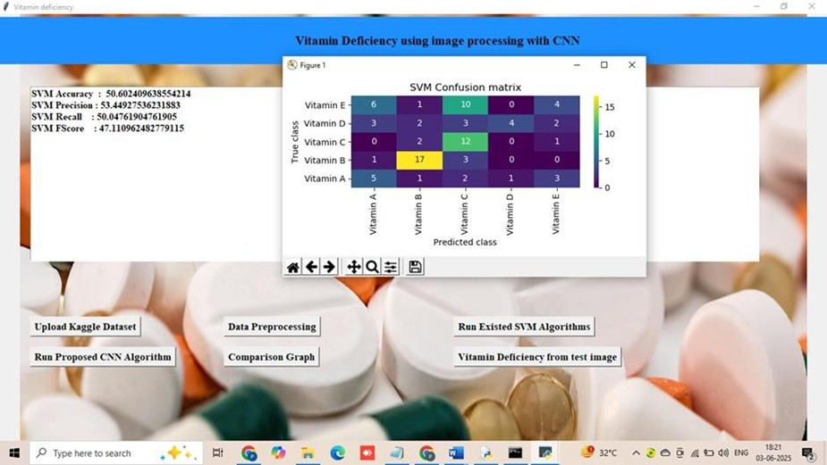
Fig. 3. Train SVM Algorithm
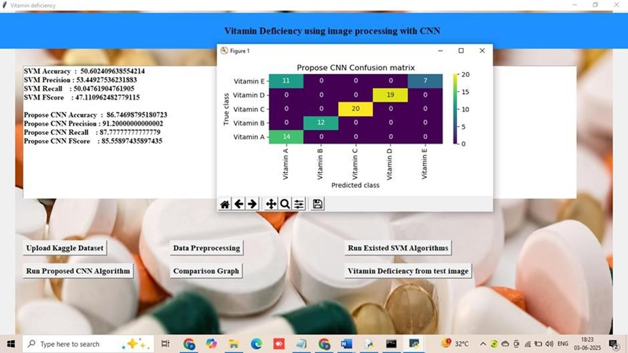

Fig. 4. Train CNN algorithm

- Model Comparison
Both models were compared for their performance using standard accuracy, precision, recall, and F1-score metrics. For all the mentioned measures, the CNN gave better accuracy than SVM.
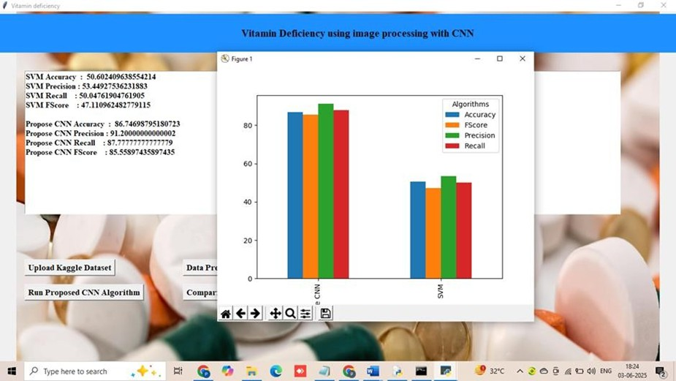
Fig. 5. Comparison graph

- Prediction Output
By CNN model sample predictions can be also made. For each prediction, the model detects the inferred vitamin deficiency category accompanied by corresponding confidence scores.
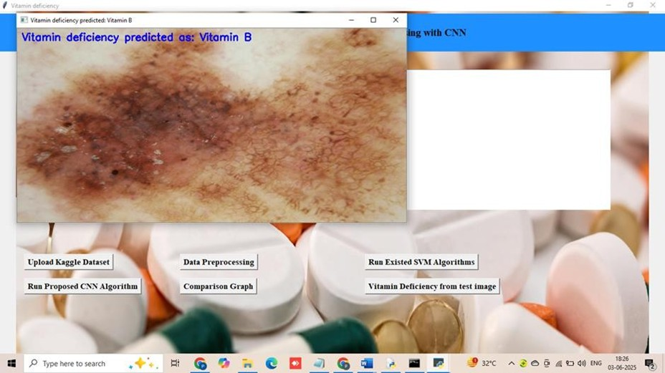
Fig. 6. Vitamin Deficiency prediction

- CONCLUSION
The study will detect vitamin deficiencies based on Images containing physical features in it using image processing techniques. comparison between traditional machine learning techniques, namely Support Vector Machines, and Convolu- tional Neural Networks has done. The results show that CNN- based models are significantly more effective and reliable. The proposed system accurately detected deficiencies in various categories of vitamins with an accuracy of 86.77%. Besides, its non-invasiveness allows its application in both clinical and preventive health.
- A. Esteva et al., ”Dermatologist-level classification of skin cancer with deep neural networks,” Nature, vol. 542, no. 7639, pp. 115–118, 2017.
- N. Tajbakhsh et al., ”Convolutional neural networks for medical image analysis: Full training or fine tuning?” IEEE Transactions on Medical Imaging, vol. 35, no. 5, pp. 1299–1312, 2016.
- O¨ . As¸kın, T. K. U¨ . Uzunc¸akmak, N. Altunkalem, and Y. Tu¨zu¨n, “Vitamin deficiencies/hypervitaminosis and the skin,” Clinics in Dermatology, vol. 39, no. 5, pp. 847–857, Sep.–Oct. 2021, doi:
- Maruthamuthu and T. Harika, “Vitamin Deficiency Detection Using Im- age Processing and Neural Network,” International Journal of Computer Sciences and Engineering (IJCSE), vol. 9, no. 4, pp. 200–205, Jul.–Aug. 2023.
- P. Rojanaphan, “Automated Nutrient Deficiency Detection and Recom- mendation Systems Using Deep Learning in Nutrition Science,” Inter- national Journal of Scientific Research and Management (IJSRM), vol. 12, no. 11, pp. 1746–1763, Nov. 2024, doi: 10.18535/ijsrm/v12i11.ec09
- T. Padma, K. M., H. Praveen M., and K. Kumar G., “Vitamin Deficiency Detection Using CNN-Based Image Analysis of Skin, Tongue and Nails,” in Proceedings of the 2025 3rd International Conference on Communication, Security, and Artificial Intelligence (ICCSAI), Apr. 2025, doi: 10.1109/ICCSAI64074.2025.11064050.
- N. Caballe´-Cervigo´n, J. L. Castillo-Sequera, J. A. Go´mez-Pulido, J. M. Go´mez-Pulido, and M. L. Polo-Luque, “Machine Learning Applied to Diagnosis of Human Diseases: A Systematic Review,” Applied Sciences, vol. 10, no. 15, p. 5135, 2020, doi: 10.3390/app10155135.
- Kalyanapu Srinivas, Satyavada Hemanth Sai Nivas, Pulagam Tarun Reddy, Akshintala Naga Venkata Durga Rajesh, Jakkireddy Karthika Venkata Satish Reddy and G. Ramcharan Kumar, “Deep Learning Models for Micronutrient Deficiency Detection Using Fingernails,” International Journal for Research in Applied Science & Engineering Technology (IJRASET), 2024, doi:10.22214/ijraset.2024.59602.
- Sri Vishva Mohan K G, Siddaram Baburao Madabhavi, Sandeep Dhimal and Vijendra S N, “Detection of Vitamin Deficiencies Using Convo- lutional Neural Networks: A Novel Approach,” Iconic Research and Engineering Journals, vol. 8, no. 9, Mar. 2025, pp. 865–868.
- R. Agarwal and D. Godavarthi, “Skin Disease Classification Using CNN Algorithms,” EAI Endorsed Transactions on Pervasive Health and Technology, vol. 9, 2023, doi:10.4108/eetpht.9.4039.
- Vitamin a deficiency and clinical disease: an historical overview. [on- line] Available at: https://www.ncbi.nlm.nih.gov/pubmed/18806089.
- I. K. E. Purnama, et al., ”Disease classification based on dermoscopic skin images using convolutional neural network in teledermatology system,” 2019 International Conference on Computer Engineering, Net- work, and Intelligent Multimedia (CENIM). IEEE, pp. 1-5, 2019.
- A. S. Eldeen, M. AitGacem, S. Alghlayini, W. Shehieb, and M. Mir, “Vitamin Deficiency Detection Using Image Processing and Neural Network,” in Proceedings of the 2020 Advances in Science and En- gineering Technology International Conferences (ASET), 2020, pp. 1–5, doi: 10.1109/ASET48392.2020.9118303
- Adult blindness secondary to vitamin A deficiency as- sociated with an eating disorder. [online] Available at: https://www.ncbi.nlm.nih.gov/pubmed/15850971.
- Glossitis with linear lesions: an early sign of vitamin B12 deficiency. [online] Available at: https://www.ncbi.nlm.nih.gov/pubmed/19231648.

References
- G. Litjens et al., ”A survey on deep learning in medical image analysis,” Medical Image Analysis, vol. 42, pp. 60–88, 2017.

