From Plastic Waste to Sustainable Textiles: Innovative Development of Hybrid Woven Structures Using Recycled Bottles and Kenaf Yarns
Mohamad Faizul Yahya, Aminah Awang, Suzaini Abdul Ghani
Faculty of Applied Sciences,
Universiti Teknologi MARA, Shah Alam, MALAYSIA

ABSTRACT
Plastic pollution is a critical environment issue, with significant plastic waste contaminating soil, oceans, and the atmosphere, posing serious health risks. Kibria et al., (2023) emphasize the need for innovative solutions to manage plastic waste. This research analyses the relationship between textile structure and the physical and mechanical characteristics of plastic bottle yarn and kenaf yarn textiles. Three weave structures—plain weave, twill 2/2, and twill 3/1—were tested by their tensile strength, percentage crimp, weight, and thickness. A control sample made entirely of kenaf yarn was also subjected to analysis for comparison. The statistics were used to analyse the data in order to determine the correlations among these variables. The findings indicate that fabric structure significantly influences mechanical performance. The twill 3/1 weave had the highest thickness (3.84 mm) and weight (8.021 g/cm²) and is therefore the strongest, while the plain weave had the lowest thickness (2.85 mm) and weight (6.544 g/cm²) and is therefore most appropriate for lightweight applications. Tensile strength tests confirmed that twill 3/1 weaving structure was more effective than the other structures. Additionally, percentage crimp differed, with higher percentage crimp in the control sample (100% kenaf) and better dimension stability for fabrics with plastic bottle yarn. These results affirm the influence of fabric construction to determine performance as well as durability. The study also establishes the economic and environmental worth of plastic bottle yarn in sustainable textile production. For example, in Bangladesh, which is becoming a top manufacturer of recycled yarn and fabrics. Future research should examine larger populations and advanced testing methods to further optimize recycled textile applications.

INTRODUCTION
One of the most important and often used materials in the world is plastic. According to Evode et al., (2021) the word “plastic” originates from “pliable,” which means “easily shaped.” Depending on the intended use, plastic can be easily shaped into different forms. Plastic is also known as polymers, which are "long chains of monomers" joined together to form these versatile materials. Natural sources of polymers include cellulose, which serves as the building block of plant cell walls and enables them to adapt to their roles Evode et al., (2021). It is commonly known that plastic is a synthetic polymer created by combining various chemicals with monomers taken from petrochemicals to polymerize it (Torres-Agullo et al., 2021). Long-chain polymers are made up of repeating units called monomers, which are bonded together by covalent bonds and consist of carbon, hydrogen, and oxygen. examples of lightweight monomers that are frequently utilized in the production of plastic are propylene and ethylene (Nayanathara & Ratnayake, 2024).

Background
Plastic waste is one of the most significant environmental concerns today. According to Nayanathara et al., (2024) worldwide plastic production is estimated to be 400.3 million tons in 2022. In Malaysia, it is estimated 9 billion tons plastic items are consumed annually on average (Abdullah et al., 2023). The packaging sector is the largest consumer of plastic across various applications. Plastic packaging applications involve protective packaging, bottles, babies’ accessories, and containers. These types of plastic products can be found in a number of garbage streams around the world.
Polyethylene terephthalate (PET) is a thermoplastic polymer that is typically used in a very wide variety of applications. According to Muringayil Joseph et al., (2024), manufacturers commonly utilize PET for making products ranging from water bottles, food packaging, and textiles. Inasmuch as it is transparent, light in weight, and strong, it uses are in many fields due to its high temperature resistance, generally effective chemical resistance, and excellent dimensional stability. For instance, PET is used for bottles because it has great transparency that can allow consumers to see what is inside the bottle. Second, PET is often used in the production of food packages that are microwaveable since it can bear moderate oven temperatures without deforming or releasing harmful chemicals into the food. PET is a material that is preferred for many different uses.

Methodology
The research discussed the methodology of making plastic bottle strips (PB strips). Throughout the chapter, the abbreviation “PB strips” was used consistently to facilitate the discussion. The chapter detailed each of the steps, highlighting the procedure, materials and equipment used in the production process. The production of PB strips involved a systematic approach that began with the collection of plastic bottle waste. The procedure for making PB strips included several critical steps, such as cleaning, sanitizing, and cutting the PB strip. The warp yarn is made from kenaf, while the weft is composed of plastic bottle strips for weaving process. The fabric is produced by integrating Kenaf yarn and plastic bottle strips using three different weave structures (plain, twill 2/2, and twill 3/1). Additionally, the research included evaluating the physical and mechanical properties of fabric constructed from PB strips and kenaf yarns. These tests were essential to evaluate the quality and performance of the PB yarn.
Figure 1. Flow process of the research

Fabric Weight Measurement
In taking the weight measurement of the fabric, some of the steps had to be followed. Three specimens of 10 cm x 10 cm needed to be carefully cut out. The scale was then zeroed by taring using an analytical balance or a digital scale. The scale was zeroed, and the fabric samples were placed on it. The first square of fabric was set on the scale, and its weight was recorded in grams. The process was repeated for the second and third squares of fabric. Again, all the weight measurements were recorded separately for accuracy. Lastly, the three weight readings were averaged to obtain the overall weight of the fabric per square. These procedures are according to ISO 3801:1977, which outlines how to determine the mass per unit area of fabric. These included cutting samples of 10 cm x 10 cm to determine the weight.
Ends per Inch (EPI)
The procedure for measuring Ends per Inch (EPI) followed ASTM D 3775-08. The fabric was laid flat on a smooth horizontal surface with edges aligned parallel to each other. A 1-inch width section was to be selected for measurement. Using a ruler or measuring tape marked in millimetres, count how many warp yarns (ends) were within the 1-inch section. To confirm repeat in several places on fabric. Record the number counted within that 1-inch section as EPI. The whole process was repeated 10 times to ensure that the measurements were both accurate and reliable. The results obtained from all the measurements were then averaged to obtain an overall EPI for the fabric sample. In this way, the EPI of the fabric sample was determined.
Picks per Inch (PPI)
The procedure for measuring Picks per Inch (PPI) followed ASTM D 3775-08. The fabric was laid on a smooth horizontal surface having its edges up and parallel to each other for accurate measurement. Then, a 1-inch-long section from the length of the fabric was taken. Using a ruler or measuring tape with millimetre markings, count the number of weft yarns (picks) within the 1-inch section. The whole process was repeated 10 times to ensure that the measurements were both accurate and reliable. The results obtained from all the measurements were then averaged to obtain an overall PPI for the fabric sample. In this way, the PPI of the fabric sample was determined.
Fabric Thickness measurement
The measurement of the thickness of fabrics involves several steps. The testing procedures are according to ASTM D1777. Place the fabric on a flat hard surface like that of a table. The thickness is measured using a thickness gauge or micrometer. Place the fabric carefully in between the two measuring surfaces without it getting tightly pressed and its thickness measurement distorted. The thickness was recorded using a reading from the gauge. All these were done 10 times to ensure accuracy and reliability in the measurements. After getting the results of all the measurements, they were averaged to get an overall thickness for the fabric sample. Based on the steps highlighted above, the fabric thickness was measured, considered an important variable for indicating fabric density and, therefore, the overall feel.
Crimp Warp Measurement
The measurement of crimp in warp yarns was done in steps. First, the fabric sample was cut into 10 cm x 10 cm squares according to ASTM standards D3883. Then the crimp in the warp yarns was measured by recording the length of the warp yarn before they were pulled out from the fabric. After carefully pulling the warp yarns to their maximum length, the length was measured again. Three runs were performed in order to ensure the results obtained were consistent and reliable. Before and after pulling out the warp yarns from the fabric, measurements were taken each time. Overall crimp of the warp threads was calculated through averaging the three readings obtained from this particular test. These steps served to measure the crimp in the warp threads accordingly and provided enough information about the texture and elasticity of the fabric.
Crimp Weft Measurement
The crimp of the weft yarns was done in steps. The fabric sample was cut out as a 10x10 cm square according to ASTM standards D3883. Allow the sample to relax thoroughly, it is very important not to keep the weft yarns under tension. The length of the weft yarns was recorded before they were pulled out from the fabric. The length was measured again after the weft yarns were pulled out to their full length. This was done three times to ensure that the results were both accurate and consistent. Each time, a measurement was taken before and after pulling out the weft yarns from the fabric. The overall crimp in the weft yarns was determined by averaging the results of all three readings. These steps were followed to measure the crimp in weft yarns, which gives important information about the elasticity and texture of the fabric.
Fabric Tensile Testing
The procedure for tensile testing followed ASTM D5034. The tensile testing of the fabric samples was done in the following way: the fabrics were first cut into rectangular specimens, 2 inches in width and 4 inches in length. Separate specimens were prepared for testing both warp and weft directions in order to evaluate the tensile properties along these orientations. Careful attention was given that the edges of the specimens were free from defects or fraying.
Then, every test sample was clamped in the tensile testing machine, with 70 mm of length between the clamps. The speed specified by the machine, at which the force should be applied steadily and controllably, was 20 mm/min. For each sample, three repetitions for every direction (warp and weft) were executed to assure accuracy and reliability of the results.
In each test, the tensile strength required to break the fabric and the percentage elongation when the fabric broke were measured. After all tests were run, the overall results in each direction were averaged to give an average tensile strength and elongation value for both the warp and weft directions.
Results and Discussion
This chapter focuses on the fabric analysis of laboratory testing conducted on three different weave structures: plain structure, twill 2/2 structure, and twill 3/1 structure, constructed using kenaf yarn for the warp and plastic bottles for the weft. The control sample is a fabric made from kenaf yarn for warp and weft. Begum & Milašius, (2022) states that fabric structures are formed by weaving yarns together or by interlocking loops to produce flexible two-dimensional (2D) materials. The most common type of structure is woven fabrics, which consist of two sets of yarns that cross each other at right angles. The performance and the properties of the fabric are evaluated and compared based on the type of weave against several parameters, including ends per inch (EPI), picks per inch (PPI), warp and weft crimp percentages, weight, thickness of the fabric and tensile testing. The experimental data obtained from this research serves as a guideline for evaluating the practical implications of each fabric structure.

Fabric’s appearance comparison

Table 1. Fabric’s appearance comparison of three different weave structures: Plain, Twill 2/2 and Twill 3/1 structure

Weave Structure | Fabric’s appearance
Control Sample | 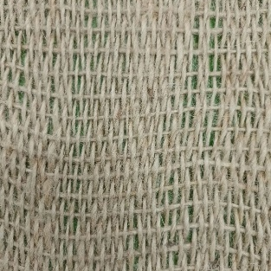
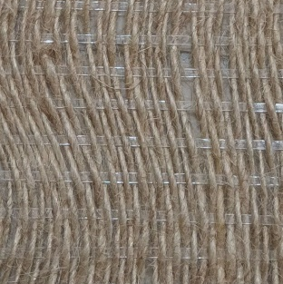

Plain Structure

Twill 2/2 Structure

Twill 3/1 Structure | 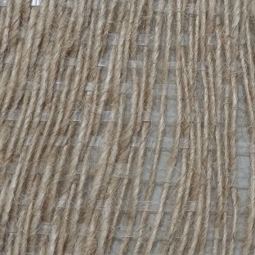  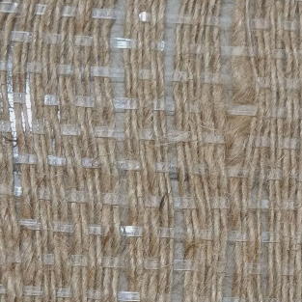

Fabric Weight

Table 2. Fabric weight of three different weave structures: Plain, Twill 2/2 and Twill 3/1 structure

Sample | Average weight | g/cm²
Control Sample | 6.956 g | 0.06956 g/cm².
Plain | 6.544 g | 0.06544 g/cm²
Twill 2/2 | 7.201 g | 0.07201 g/cm²
Twill 3/1 | 8.021 g | 0.08021 g/cm²

Table 2 shows differences in the weight and density among the fabric samples. The control sample, which was made of kenaf yarn, has an average weight of 6.956 g and a weight per cm² of 0.06956 g/cm². The plain weave is the lightest, having an average weight of 6.544 g and a density of 0.06544 g/cm², showing that the interlacement of the threads is not as dense. This makes the material suitable for applications like packaging, where weight-saving is important. On the other hand, twill weaves are progressively heavier and denser. The twill 2/2 sample weighs an average of 7.201 g with a density of 0.07201 g/cm², which stipulates higher yarn density and durability. The sample of twill 3/1 is the heaviest one, having an average weight of 8.021 g and a density of 0.08021 g/cm², reflecting its intricate weave structure and enhanced strength. Overall, the analysis highlights the relationship between weight and durability, offering insights for selecting the appropriate fabric type based on the intended application.

Ends per inch (EPI)

Table 3. Ends per inch (EPI) of three different weave structures: Plain, Twill 2/2 and Twill 3/1 structure

Sample | Average EPI
Control Sample | 10.3
Plain | 10.2
Twill 2/2 | 9.6
Twill 3/1 | 9.3

The ends per inch (EPI) values, which indicate the density of kenaf yarns for the three weave structures, showed differences in the density of warp yarn. Table 3 above shows that the control sample, with 10.3 EPI, has the highest density of warp yarns, which reflects that the fabric is tightly woven and made of kenaf yarn. The EPI for the plain weave is lower at 10.2 EPI, probably due to the simpler interlacement of the yarns in the structure. In the case of twill weaves, EPI is even further reduced, with twill 2/2 presenting at 9.6 EPI and the lowest EPI being for twill 3/1 at 9.3 EPI. The lower EPI in twill 3/1 is due to its longer floats, which lead to fewer warp yarns being packed per inch compared to the other structures. These differences explain how different weaving structures affect warp density and thus all the physical properties of the fabric.

Picks per Inch (PPI)

Table 4. Picks per inch (EPI) of three different weave structures: Plain, Twill 2/2 and Twill 3/1 structure

Sample | Average EPI
Control Sample | 10.3
Plain | 10.2
Twill 2/2 | 9.6
Twill 3/1 | 9.3

Table 4 above shows picks per inch (PPI) values, which indicate the density of plastic bottle strips used as the weft material, were consistent across the three types of weaves with an average of 3 PPI for each. This consistency emphasizes the careful placement of the plastic bottle strips during the weaving process, regardless of the weaving structure. Even with variations in float lengths and interlacement patterns, both the twill and plain weaves maintained the same weft density, showing the adaptability of plastic bottle strips to different weaving structures. This observation highlights the potential of plastic bottle strips as a versatile and dependable weft material in textile production.

Fabric Thickness

Table 5. Fabric thickness of three different weave structures: Plain, Twill 2/2 and Twill 3/1 structure

Sample | Average thickness
Control Sample | 3.55 mm
Plain | 2.85 mm
Twill 2/2 | 3.14 mm
Twill 3/1 | 3.84 mm

The control sample, made completely from Kenaf yarn for both the warp and weft, serves as a baseline in comparing fabric thickness. Since no plastic bottle yarn is used, the thickness depends only on the compact Kenaf yarn, which gives a moderate thickness of 3.55 mm. This places it between the plain weave and twill 2/2 structures.

Table 5 indicates that the plain weave is the thinnest, 2.85 mm, due to its tight interlacing. Twill 2/2 weave thickness is 3.14 mm because of its pattern in diagonal and longer floats. The thickest will be the twill 3/1 structure, with its thickness at 3.84 mm, since its longer floats create more space between yarns.

This indicates that the weave structure does affect the thickness of the fabric. because of the longer floats, the 3/1 was thicker in comparison with other twill weaves. The control sample shows, from an insightful point of view, how the absence of plastic bottle yarn in the fabric results in thickness, thereby showing the role of plastic bottle strips in the other samples. The control sample is thicker than plain weave because Kenaf yarn is denser but not as thick as the twill structures that allow more space between yarns.

Weft Crimp Measurement

Table 6. Weft crimp of three different weave structures: Plain, Twill 2/2 and Twill 3/1 structure

SAMPLE | Reading 1 |  | Reading 2 |  | Reading 3
SAMPLE | Before | After | Before | After | Before | After
Control Sample | 10 | 10.2 | 10 | 10.2 | 10 | 10.2
Plain | 10 | 10.1 | 10 | 10.1 | 10 | 10.1
Twill 2/2 | 10 | 10.1 | 10 | 10.1 | 10 | 10.1
Twill 3/1 | 10 | 10.1 | 10 | 10.1 | 10 | 10.1

Weft crimp measurement refers to the amount of wave or crimp in the weft yarns that occur during the weaving process, represented as a percentage of the original length. This measurement is crucial for assessing the fabric’s elasticity and mechanical characteristics. Table 6 above shows the crimp weft result, including before and after measurements, highlighting the consistent behavior of plastic bottle strips as a weft material across all three weave structures. The average weft length before pulling out from the fabric was consistently measured at 10 cm across all weave structures. These values increased slightly to 10.1 cm after the pull – out process, reflecting minimal elongation during the weaving process. This small change shows the stability and adaptability of plastic bottle strips under the tension applied during weaving.

Table 7. Weft crimp percentage of three different weave structures: Plain, Twill 2/2 and Twill 3/1 structure

Sample | Weft Crimp %
Sample | Reading 1 | Reading 2 | Reading 3 |  | Average
Control Sample | 2 | 2 | 2 | 2
Plain | 1 | 1 | 1 | 1
Twill 2/2 | 1 | 1 | 1 | 1
Twill 3/1 | 1 | 1 | 1 | 1

From the Table 7 above, the average weft crimp percentage of all the weave structures is 1%, indicating that the structural characteristics of the plastic bottle strips remain unchanged regardless of the weave structure. During the weaving process of a plain weave with a structure of tightly interlaced strips, the low crimp percentage represents the compactness of the arrangement of the plastic bottle strips. Meanwhile, the twill 2/2 and twill 3/1 structures had similar crimp percentages even though their floats were longer. This consistency demonstrates that plastic bottle strips as weft material exhibit excellent dimensional stability, minimal deformation, and adaptability to various weave structures.

On the other hand, the crimp percentage for the control sample made from Kenaf yarn was higher, at 2%, which can be attributed to the natural crimp of Kenaf yarn. The control sample demonstrates that Kenaf yarn naturally has more crimp due to its fiber structure, whereas the plastic bottle strips show the same crimp value in all weave structures.

Warp Crimp Measurement

Table 8. Warp crimp of three different weave structures: Plain, Twill 2/2 and Twill 3/1 structure

SAMPLE | Reading 1 |  | Reading 2 |  | Reading 3
SAMPLE | Before | After | Before | After | Before | After
Control Sample | 10.4 | 10.8 | 10.3 | 10.7 | 10.3 | 10.7
Plain | 10.5 | 10.8 | 10.5 | 10.7 | 10.6 | 10.8
Twill 2/2 | 10.2 | 10.4 | 10.4 | 10.6 | 10.5 | 10.7
Twill 3/1 | 10.4 | 10.6 | 10.3 | 10.4 | 10.4 | 10.6

Crimp in the warp refers to the bends or undulations that occur in the warp yarns during the weaving process, which are influenced by their interaction with the weft. Table 8 above shows the results of crimp warp measurements, both before and after, illustrating how various weaving structures affect the behavior of warp yarns during weaving.

In the control sample, the crimp values increase by 0.4 cm, from 10.4 to 10.8 across the three readings. This indicates that the Kenaf yarn shows a slight expansion in crimp, with a moderate increase overall. In the case of a plain weave, crimp values increased by an average of 0.3 cm. While it was between 10.5 and 10.6, it moved up to 10.7-10.8. This slight increase can be related to the compact structure of the plain weave, which restricts the yarn from expanding.

The values of crimp in the 2/2 twill structure record a similar rise of 0.3 cm. From the first measurement of 10.2-10.5 cm, it has gone up to 10.4-10.7 for the third measurement. The 3/1 twill weave structure shows the least increase—about 0.2 to 0.3 cm. Similarly, the crimp values increased only from 10.3-10.4 to 10.4-10.6. The longer floats of the 3/1 twill provide somewhat more room for crimp expansion than in the twill 2/2 or the plain weaves. In general, the warp crimp increases in all structures, with the minimum increase being the plain weave, followed by twill 3/1 and twill 2/2, while the control has the highest increase.

Table 9. Warp crimp percentage of three different weave structures: Plain, Twill 2/2 and Twill 3/1 structure

Sample | Warp Crimp %
Sample | Reading 1 | Reading 2 | Reading 3 | Average
Control Sample | 3.85 | 3.88 | 3.88 | 3.87
Plain | 2.86 | 1.90 | 1.89 | 2.22
Twill 2/2 | 1.96 | 1.92 | 1.90 | 1.93
Twill 3/1 | 1.92 | 0.97 | 1.92 | 1.60

Table 9 above shows the result of the crimp warp percentages. The crimp warp percentages highlight how weave design influences warp deformation. The average crimp percentage for the control sample was the highest, 3.87%, due to the Kenaf yarn used in both the warp and weft, leading to moderate bending of the warp. The plain weave structure showed a moderate average crimp percentage of 2.22%. In twill 2/2, the percentage crimp fell slightly to 1.93%. At last, the 3/1 twill structure recorded the lowest percentage of average crimp percentage at 1.60% since the presence of longer float in the weave has reduced warp bending. These results mean that weave structures make a big difference in the crimp behavior of fabrics: the tighter the weaves, the greater the crimp percentage, and the looser, the lower the crimp percentage.

Weft Tensile Testing

Table 10. Tensile Properties of Weft Samples: Elongation and Force Measurements

Sample | Average Elongation (%) | Average Force (N)
Control Sample | 4.13 | 372.98
Plain | 76.57 | 352.81
Twill 2/2 | 75.72 | 300.47
Twill 3/1 | 74.72 | 484.97

Figure 2. Graph of Elongation and Force for Weft Samples

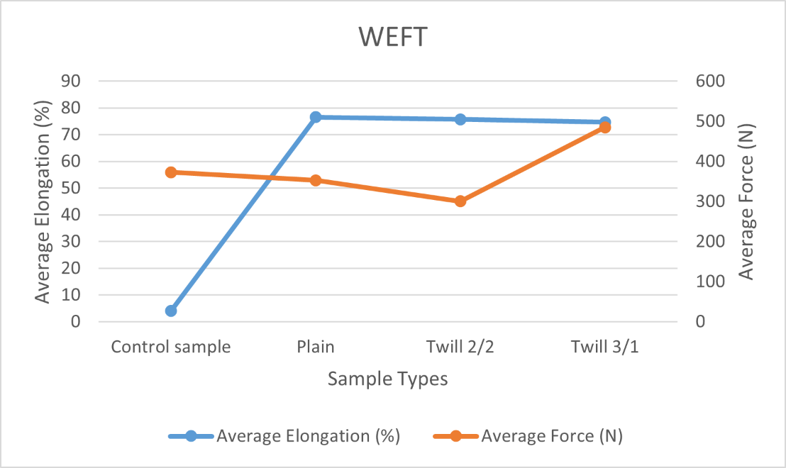

Table 10 and graph above show weft tensile tests. The results show how the different weaves and materials (Kenaf yarn and plastic strips) affect the fabric’s stretch (elongation) and strength (force to break). The control sample, made only of Kenaf yarn, had a low stretch of 4.13% but was able to withstand a high force before breaking at 372.98 N. It means that Kenaf yarn is strong and doesn't stretch much. The plain weave that combines Kenaf yarn with plastic bottle strips had a much higher stretch of 76.57%, though it could handle a little less force at 352.81 N. The presence of plastic strips makes the fabric more elastic, while it is a little weaker compared to the Kenaf-only fabric.

Next the twill 2/2 structure also showed high stretch, 75.72%, with a lower force, 300.47 N, compared to the control sample. This pattern also allows the fabric to stretch but makes it weaker in strength because of the plastic strips. The twill 3/1 structure, having longer floats, gave the maximum force to break of 484.97 N, though the percentage of its stretch was slightly lower than the others, at 74.72%. The longer floats make this fabric stronger, but the plastic strips don't stretch as much as Kenaf yarn. In other words, plastic strips added to the weave make it more stretchy but weaker in the sense of the force required to break it. The strongest turns out to be the twill 3/1 with the longest floats, while the plain and twill 2/2 are more stretchy yet less strong.

Warp Tensile Testing

Table 11. Tensile Properties of Warp Samples: Elongation and Force Measurements

Sample | Average Elongation (%) | Average Force (N)
Control Sample | 8.286 | 1243.09
Plain | 10.29 | 1515.39
Twill 2/2 | 9 | 1604.83
Twill 3/1 | 7.42 | 1828.81

Figure 3. Graph of Elongation and Force for Warp Samples

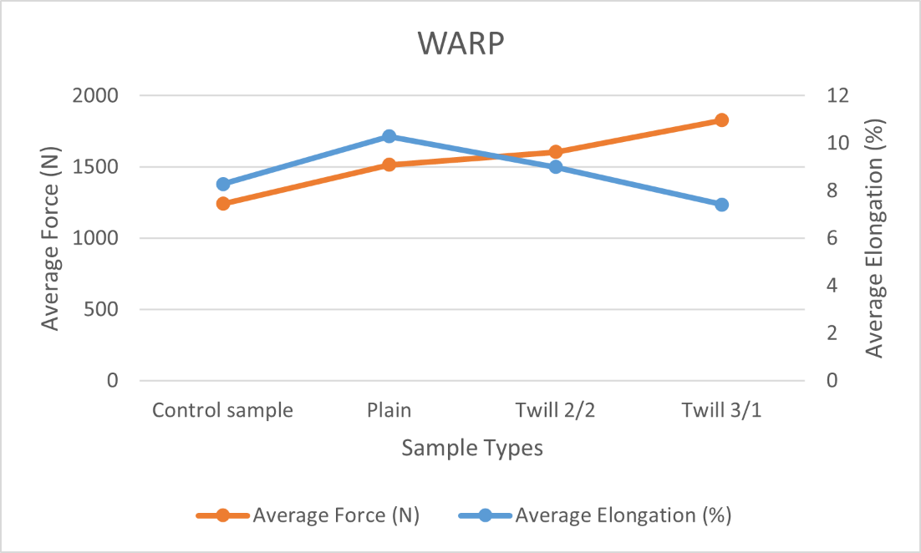

Table 11 and graph above show warp tensile tests. The results show how the different weaves and materials (Kenaf yarn and plastic strips) affect the fabric’s stretch (elongation) and strength (force to break). The control sample, made from Kenaf yarn for both warp and weft, had an average elongation of 8.286% and a force resistance of 1243.09 N. Kenaf yarn provides a balance in stretch and strength with its moderate elongation and solid force resistance. The plain weave made of Kenaf yarn in the warp and plastic strips in the weft had an average elongation of 10.29% and a force resistance of 1515.39 N. The balanced structure of the plain weave allows it to have higher elongation, while the kenaf yarn contributes to good force resistance.

In the 2/2 twill structure, Kenaf yarn in the warp shows an elongation of 9% and a force resistance of 1604.83 N. The diagonal pattern this weave presents reduces its elongation slightly but improves the fabric's strength. The twill 3/1 structure with Kenaf yarn in the warp showed a minimum elongation of 7.42%. It showed the maximum force resistance with a value of 1828.81 N. The longer float lengths in this weave make it less stretchy but much stronger. In conclusion, the Kenaf yarn in each structure's warp balances the yarn's percentage elongation and strength. The plain weaves have higher elongation, while the twill weaves—3/1, in particular-offer a greater resistance to force with less elongation.

CONCLUSION

In conclusion, this study successfully explored the innovative use of plastic bottle waste and kenaf yarn in textile production, focusing on how different weave structures affect fabric properties. The important findings revealed that the selected weave structure significantly influenced the weight, density, thickness, and mechanical properties of the fabrics. The twill 3/1 structure resulted in the heaviest and most compact fabric with maximum strength, whereas the plain weave was the lightest and most suitable for weight-sensitive applications. From the tensile test, it could be concluded that the control sample, pure kenaf yarn, has the highest strength and durability, while the addition of plastic bottle strips makes the fabrics more flexible with less strength. These findings emphasized the importance of the proper selection of weaves that would suit particular applications.

This research thus found that plastic bottle waste and kenaf yarn together can be used in the development of sustainable and functional textiles. Such use not only addresses the problem of plastic waste but also contributes to developing ecologically acceptable textile materials with a wide range of applications, especially in the production of bags and packaging. It will form a basis for further research in the study of sustainable textile manufacturing in terms of long-term durability and environmental effects.

REFERENCES

- Abdullah, E. N., Rahman, H. A., Nadhirah, I., & Zain, M. (2023). Knowledge and Practice on the No Plastic Bag Campaign Among Undergraduate Students in Universiti Putra Malaysia (UPM). In Malaysian Journal of Medicine and Health Sciences (Vol. 19, Issue SUPP10).
- Evode, N., Qamar, S. A., Bilal, M., Barceló, D., & Iqbal, H. M. N. (2021). Plastic waste and its management strategies for environmental sustainability. Case Studies in Chemical and Environmental Engineering, 4. https://doi.org/10.1016/j.cscee.2021.100142
- Kibria, M. G., Masuk, N. I., Safayet, R., Nguyen, H. Q., & Mourshed, M. (2023). Plastic Waste: Challenges and Opportunities to Mitigate Pollution and Effective Management. In International Journal of Environmental Research (Vol. 17, Issue 1). Springer Science and Business Media Deutschland GmbH. https://doi.org/10.1007/s41742-023-00507-z
- Muringayil Joseph, T., Azat, S., Ahmadi, Z., Moini Jazani, O., Esmaeili, A., Kianfar, E., Haponiuk, J., & Thomas, S. (2024). Polyethylene terephthalate (PET) recycling: A review. Case Studies in Chemical and Environmental Engineering, 9. https://doi.org/10.1016/j.cscee.2024.100673
- Nayanathara Thathsarani Pilapitiya, P. G. C., & Ratnayake, A. S. (2024). The world of plastic waste: A review. In Cleaner Materials (Vol. 11). Elsevier Ltd. https://doi.org/10.1016/j.clema.2024.100220
- Torres-Agullo, A., Karanasiou, A., Moreno, T., & Lacorte, S. (2021). Overview on the occurrence of microplastics in air and implications from the use of face masks during the COVID-19 pandemic. In Science of the Total Environment (Vol. 800). Elsevier B.V. https://doi.org/10.1016/j.scitotenv.2021.149555

