ETAP-Based Load Flow and Arc Flash Study of a 132/33 kV Substation at Kachna, Raipur

INTRODUCTION
In modern electrical distribution networks, ensuring system reliability, operational efficiency, and personnel safety has become more critical than ever. Increasing demand, system complexity, and the need for strict compliance with safety regulations necessitate accurate modelling, analysis, and hazard assessment of power systems. Simulation tools like ETAP enable engineers to virtually replicate real-world networks, analyze operational behaviour, and predict potential risks[1]. Through strategic load flow and arc flash studies, it becomes possible to optimize system performance, reduce energy losses, and implement effective safety measures for maintenance and operation teams[2].

In this work, a detailed modelling and analysis of an electrical distribution system has been carried out using ETAP. The system comprises multiple power sources, several interconnected feeders, and a variety of loads distributed across different sections. Initially, the system topology was established by accurately mapping the sources, feeders, transformers, protective devices, and load centres. Continuing simulations, arc flash studies took place to ascertain incident energy levels and determine safety zones around critical equipment, and load flow analysis followed employing the Newton-Raphson method to determine voltage profiles and power losses[6]. The methodology ensures that practical scenarios are realistically captured without oversimplification.

The developed model finds applications in improving operational planning, enhancing maintenance safety, and optimizing protection coordination in industrial and utility-scale networks. By integrating detailed load flow and arc flash analysis into system design, this work contributes to the development of more resilient, efficient, and safer power distribution infrastructures[5].

LITERATURE REVIEW
Numerous studies have been conducted to analyze power flow and assess arc flash hazards in electrical distribution systems. Traditional approaches focus on steady-state load flow methods and empirical models based on IEEE 1584 standards for arc flash analysis. However, limited integration of software-based simulations like ETAP in academic work highlights a gap in practical validation and industrial relevance.

Existing Work on Load Flow Analysis
Mehtre et al. explored the optimization of power system load flow analysis using ETAP software integrated with Single Line Diagram (SLD) representations. Their study demonstrated that combining SLD with ETAP enhances visualization, simplifies model creation, and improves workflow efficiency for load flow analysis.[4] Key findings include:

- Improved Visualization - SLDs provide an intuitive graphical representation of power systems, aiding engineers in understanding system topology and connections.[4]
- Efficient Modeling - The integration reduces manual data entry errors and accelerates the conversion of SLDs into simulation models, enabling faster analysis.[4]
- Scenario Analysis - Engineers can perform sensitivity analyses by modifying SLDs to evaluate voltage profiles, current flows, and system losses under varying conditions.[4]

The significance of transformer MVA ratings in reactive power control was also emphasized by the authors. Their case studies showed that decreasing transformer MVA ratings increases reactive power demand due to higher impedance, emphasizing the need for precise component sizing in load flow optimization.[4]

In a thorough investigation of load flow analysis in distributed power systems, Ghiasi et al. concentrated on the power network of the Tehran Metro. [5] The research compared three numerical methods—Newton-Raphson (NR), Fast Decoupled (FD), and Accelerated Gauss-Seidel (AGS)—using ETAP software. Key contributions include:

- Methodology Comparison - The NR method was found to be the most accurate but computationally intensive, while the FD method offered a balance between accuracy and speed by decoupling active and reactive power equations.[5]
- Practical Application - The study modelled an actual 63kV/20kV/0.75kV network, revealing transformer and cable losses totalling 1,354.6 kW and 13,854.1 kVar, respectively.[5]
- Critical Findings - Voltage violations (exceeding 2% drop) and transformer overloads (exceeding 5%) were identified, underscoring the need for robust load flow tools to ensure grid stability.[5]

The author emphasized ETAP's role in streamlining load flow analysis, particularly for large-scale systems, and advocated for further research into advanced computational methods to enhance efficiency.[5]

B. Arc Flash Study Approaches
The first man who did research on electric arc blast burns was Ralph Lee in 1985. Lee described the electric arc's thermal event and the way the human body replies to it. According to Lee, the curable burn level is 1.2 cal/cm², which is the lower limit for a third-degree burn and is still used to calculate the curable burn distance of an electric arc in air.[2]
IEEE Std 1584-2002 provides empirically derived equations to calculate arc flash boundaries and incident energy based on system parameters like fault current, voltage, equipment type, grounding, and working distance. It accommodates a wide voltage range and accounts for the effects of current-limiting devices. While accurate and comprehensive, its complexity necessitates software-based implementation.[1]
Saeed Mohajeryami et. al., Rapid energy release by an arcing fault set on by a short circuit between two energized conductors is termed as an arc flash. The hottest known element on Earth, apart perhaps from lasers, is the electrical arc that forms between these electrified conductors. The arc's temperature may exceed and rise above 20,000 K, that's about four times greater than the sun's surface.[3] Inhaled gases, blinding light, flying shrapnel, shock waves, and heat radiation may all result in wreckage during an arc flash. Furthermore, if the arc flash generates an enormous amount of unwanted energy, it has the potential to damage equipment severely. Recognizing this occurrence is thus critical for avoiding the issues mentioned above.[2]
TABLE I: Factors for equipment and voltage classes [2]
System Volt (kV) | Equipment Type | Typical gap between conductors (in mm) | Distance x Factor
0.208 - 1 | Open Air | 10-40 | 2.000
0.208 - 1 | Switchgear | 32 | 1.473
0.208 - 1 | MCC and Panels | 25 | 1.641
0.208 - 1 | Cable | 13 | 2.000
>1-5 | Open Air | 102 | 2.000
>1-5 | Switchgear | 13-102 | 0.973
>1-5 | Cable | 13 | 2.000
>5-15 | Open Air | 13-153 | 2.000
>5-15 | Switchgear | 153 | 0.973
>5-15 | Cable | 13 | 2.000
Traditional Methods for reducing ARC flash hazards -
- Reducing the Arcing Current- Current-limiting devices like specific fuses or breakers can interrupt fault currents before peak levels, especially when currents are 10–15 times the device rating. This significantly reduces incident energy during short clearing times (1–3 cycles). However, accurate IEEE 1584 calculations require tested data, which is currently limited to select low-voltage fuses. In one case, energy was reduced from 43.27 to 28.13 cal/cm², lowering PPE requirements.[2]
- Increasing the Working distance— In open air, incident energy reduces with the square of distance, thus it's an effective approach. Tools like remote racking units or hot sticks can extend this distance. For instance, increasing it from 18" to 72" reduced energy from 12.62 to 3.28 cal/cm², enhancing personnel safety.[2]
- Reducing the Clearing Time - Faster fault clearing reduces arc flash severity. This can be achieved using optimized relay settings, bus differential schemes, or zone-selective interlocking. Temporary setting reductions via SCADA or relay inputs during maintenance also help, though they reduce selectivity. A breaker failure, for example, raised incident energy from 38.7 to 78.1 cal/cm², stressing the importance of reliable coordination .[2]

C. Use of ETAP in Industry/Academia
In their study, Raheel Muzzammel et al. claim that power flow analysis is a numerical technique used to analyze the flow of electric power in a connected power system. The per unit system and the single line diagram are the primary tools used in this approach. The study's primary variables are active power (P), reactive power (Q), voltage (V), and voltage angle (δ). Reactive power and voltage angles are computed through analysis, whereas active power and voltage are typically known on the generating side. Active and reactive power are provided at the load side, and power flow techniques are used to calculate voltage and voltage angles.[7]
In power flow analysis, there are three types of buses: swing, generator (PV), and load (PQ) buses. Known and unknown parameters at each bus vary, and power flow equations help determine the unknowns using system impedance. After analysis, key parameters like voltage, angle, active and reactive power are known, enabling calculation of other values like current and power factor. [7]
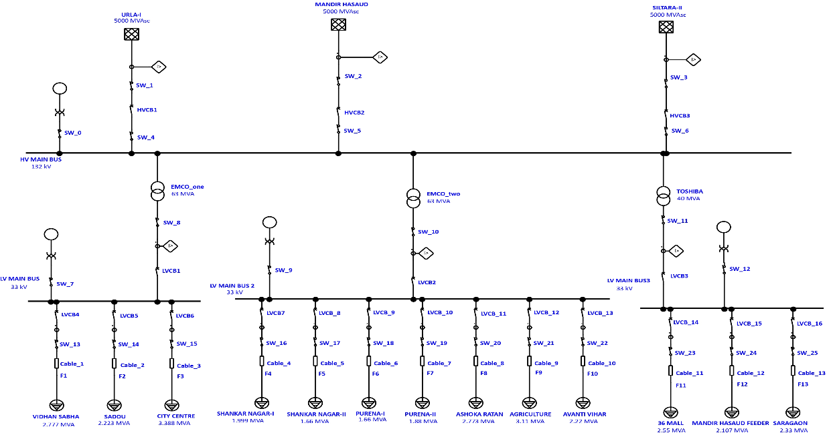
Manual calculations are impractical for complex modern power systems. Early methods like Gauss elimination couldn’t manage large non-linear systems, prompting the use of iterative methods like Gauss-Seidel and Newton-Raphson. This paper uses Newton-Raphson for better accuracy and faster convergence, despite its programming complexity. ETAP software is chosen for its real-time monitoring and control capabilities.[7]
Figure 1 Simulation of Single line diagram of 132/33 kV sub-station, Kachna, Raipur
M Rif’an et. al. in their paper, discussed that electricity demand tends to increase with a country's development. Between 2014 and 2019, Indonesia's per capita electricity usage increased by 21.18%. To meet this, PT PLN boosted its power capacity to 62,600 MW and expanded its network to 1,028,679 km. Voltage stability, ensuring consistent voltage across the network, is crucial for system reliability. Load Flow Analysis (LFA) helps assess voltage stability by calculating voltages and power flow in the system, providing insights for system planning and expansion.[6]
LFA is essential for designing future power system expansions and optimizing current system operations. Various methods like Gauss-Seidel, Newton-Raphson, and Fast-Decoupled are used to solve load flow problems, with software like PSAT and ETAP making these analyses easier and more reliable.[6]
M Rif’an’s paper develops and tests a simulation model of the Gandul Substation (GIG) using PSAT (a free tool for MATLAB Simulink) and ETAP The simulation results were compared with PLN data from April 1, 2019, with a load of 15.37 MW, to evaluate the performance.[6]

SYSTEM DESCRIPTION
The different components connected in the simulation follow the same order as it is in the 132/33 KV sub-station, Kachna, Raipur.

Brief about the single-line diagram
The single-line diagram illustrates the substation’s connection to three utility grids—URLA-I, MANDIR HASAUD, and SILTARA-II—which are interfaced with the 132 kV High Voltage (HV) Main Bus through a series of protective devices. Each grid connection includes a Current Transformer (CT) for metering and protection, followed by an Overcurrent Relay, an Isolator, a High Voltage Circuit Breaker (HVCB), and another Isolator before reaching the HV Bus. Additionally, a Potential Transformer (PT) is connected at the left end of the HV Bus via an Isolator for voltage measurement and relay input. The voltage is stepped down from 132 kV to 33 kV through three transformers—two identical in make and rating, and one different, referred to as EMCO_1. The EMCO_1 transformer connects directly to the HV Bus and is followed by an Isolator, a CT, and a Low Voltage Circuit Breaker (LVCB) before linking to the 33 kV Low Voltage (LV) Main Bus. A PT is also connected to the LV Bus via an Isolator for monitoring and protection. The other two transformers and their associated 33 kV LV buses follow the same configuration. Feeder connections from each LV Bus include an LVCB, a CT, an Isolator, and a cable terminating at a lumped load representing the feeder; this arrangement is uniformly applied across all twelve feeders in the system.

Components and their ratings
The electrical network analyzed in this study is modelled using ETAP. The system includes one main utility source feeding multiple feeders and lumped loads through various protection and transformation stages. The overcurrent relays connected to the current transformers (CTs) are configured to operate their respective circuit breakers in case of fault conditions. For example, in the URLA-I supply section, the overcurrent relay will trigger the high-voltage circuit breaker HVCB1. The major components involved in the system are described in the table below:
TABLE II: Low Voltage (LV) Side Electrical Components and Ratings
S.No | Component (LV side) | Function | Typical Rating
1. | LV Current Transformer | Steps down current for metering/protection | 800/1 A
2. | LV Circuit Breaker | Protects the LV side from faults | 33 kV, 25 kA, 800 A
3. | LV Isolator | Disconnects the circuit during maintenance | 33 kV / 800A
4. | LV Cable | Connects LV equipment and loads | 30 m, 50 mm², XLPE BS6622,1/C, 33 kV
5. | Lumped Load | Represents load centres (motors, lighting, etc.) | 250 kW, PF 0.85–0.9

TABLE III: High Voltage (HV) Side Electrical Components and Ratings
S.No | Component (HV side) | Function | Typical Rating
1. | Utility Grid | Primary Source | 132 kV, 3-phase, 50 Hz
2. | HV Current Transformer (CT) | Steps down current for metering/protection | 600/1 A
3. | HV Potential Transformer (PT) | Steps down voltage for metering/protection | 132 kV/110 V
4. | HV Isolator | Disconnects the circuit during maintenance | 132 kV/ 630A
5. | HV Circuit Breaker | Interrupts HV fault currents | 132 kV, 40 kA, 630 A
6. | HV Bus | Distributes power to downstream transformers | 132 kV
7. | 2-Winding Transformer | Steps down voltage from HV to LV | 63 MVA, 40MVA, 132/33 kV

Assumptions made
In this study, the power system was modelled and analyzed in ETAP under standard operating assumptions. The system frequency was set at 50 Hz in alignment with Indian grid standards. Loads were assumed to be balanced three-phase with a nominal lagging power factor (typically between 0.85–0.95) where actual data was unavailable. Transformers and cables were modelled using ETAP’s default impedance values or manufacturer specifications. The utility supply was considered stable, without voltage fluctuations or transients, for steady-state load flow calculations.
For arc flash analysis, the system was assumed to be solidly grounded as per IEEE 1584-2002 guidelines. All protective devices were considered to be properly rated and fully functional, operating per the coordination study settings. Environmental conditions were assumed to be standard, and arc flash was analyzed under worst-case fault scenarios, including both maximum and minimum fault currents. No enclosure de-rating factors were applied during the simulation.

METHODOLOGY
This section outlines the procedures followed for conducting both the load flow analysis and the arc flash study using ETAP software. The system under consideration was modelled based on practical parameters, and standard guidelines were followed to ensure the accuracy and reliability of the results. The analysis was carried out in a stepwise manner—first focusing on the electrical performance of the network under normal operating conditions, followed by a detailed arc flash hazard assessment to evaluate safety compliance.

Load Flow Analysis
The load flow analysis was carried out using ETAP software, employing the Adaptive Newton-Raphson method for enhanced convergence and numerical stability. The study case was configured with a maximum iteration limit of 99 and a solution precision of 0.0001, ensuring accurate results for large and complex radial systems such as the 132/33 kV Kachna substation, Raipur. The system inputs included rated voltages in kilovolts (kV), power values in megavolt-amperes (MVA), and real-time operating voltage as a percentage of the nominal rating. Equipment cables were included, while the load diversity factor was excluded to represent maximum expected load conditions. Initial bus voltages were selected as the starting condition for simulation, and operating load and voltage data were enabled for dynamic load evaluation. This configuration allowed for a realistic and high-fidelity representation of the substation’s operating profile, facilitating accurate analysis of voltage levels, power flows, and system losses under steady-state conditions.
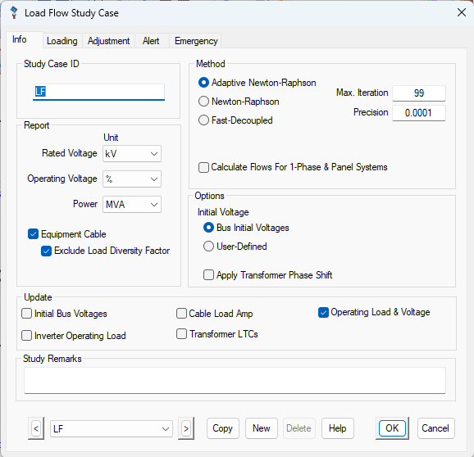
Figure 2 Load Flow methodology

Arc Flash Study
The arc flash study was conducted using a structured simulation environment adhering to both IEC and NFPA 70E standards. The study began with defining the study case ID (A_SC) where specific low-voltage buses such as LV MAIN BUS, LV MAIN BUS 2, and LV MAIN BUS 3 were subjected to fault simulations. The transformer taps were set to adjust base kV, allowing accurate voltage profiling during faults. Panel-based fault assessment was prioritized for 1-Phase and UPS systems. Equipment cable and overload heater impedances for medium-voltage and low-voltage motors were selectively excluded to focus on mainline fault propagation, with motor contribution modelled based on status.
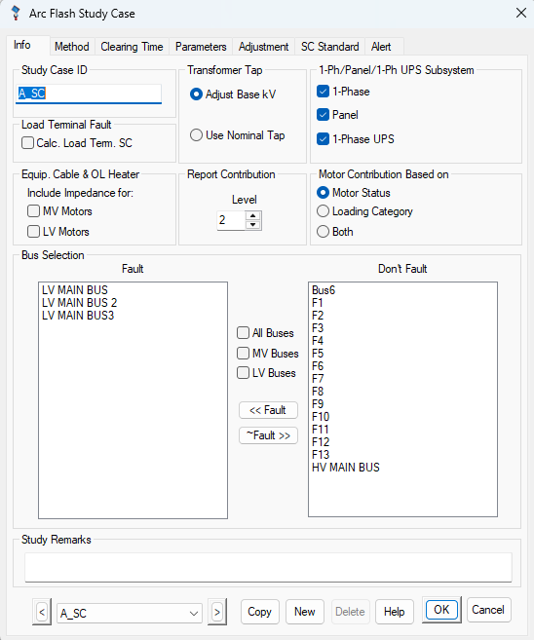
Figure 3 Arc Flash Study, defining faulted buses
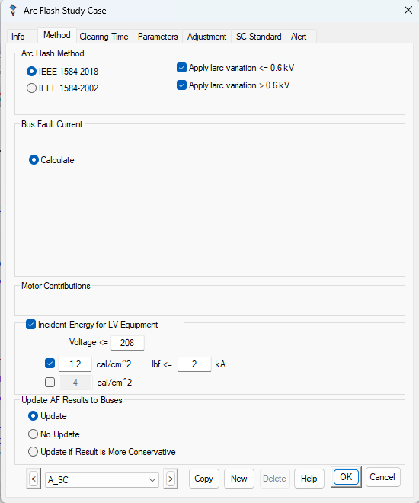
Figure 4 Defining methodology for arc flash study case
Incident energy calculations were configured in alignment with NFPA 70E 2012 to 2018 standards. Customized PPE (Personal Protective Equipment) levels were defined, with incident energy thresholds ranging from Level A (2 cal/cm²) to Level G (120 cal/cm²). Each level included a description of required protective gear to ensure safety during electrical maintenance. These categories served as a basis for classifying arc flash risk and for designing mitigation measures by assessing energy exposure at various points in the system.
The SC Standard tab settings included the selection of the IEC standard, applying a short-circuit current factor (c-factor) of 1.05 for voltages below 1 kV and 1.1 for higher voltage tiers. The method for X/R ratio calculation was set to Method C, offering balanced accuracy for peak asymmetrical current estimation. The calculation also used the maximum fault current for short-circuit analysis and total bus fault current for equipment duty assessment.
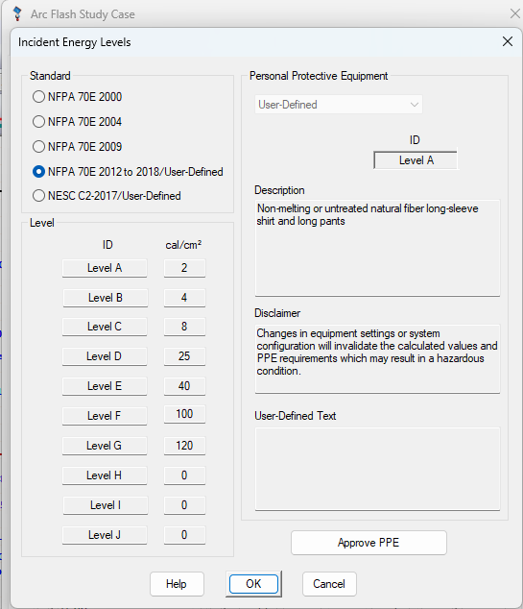
Figure 5 Incident Energy levels for PPE consideration
The thermal withstand parameters were modelled using Tkr, ensuring accurate thermal stress prediction. Throughout the study, the device duty and breaker settings were evaluated against the simulated fault current levels. The incident energy values, clearing times, and arc flash boundaries were calculated to determine the appropriate PPE levels, assess the potential risks, and recommend suitable protective actions. This comprehensive methodology ensured high-fidelity modelling of arc flash hazards and provided a strong foundation for safety planning and equipment protection strategies.

Software/simulation environment
All simulations were performed using ETAP version 19.0.1. The system was modelled in single-line diagram format, and all data inputs — such as equipment ratings, cable lengths, and protection settings — were entered according to manufacturer datasheets or standard assumptions where data was unavailable. Arc flash simulations were performed with solid grounding assumptions, and the arc duration was derived from protective device time-current characteristics. The software’s coordination module was also used to verify whether protection devices operate within required clearing times to limit arc energy.

RESULTS
This section presents the findings obtained from the load flow and arc flash analysis performed in ETAP. The results have been interpreted for system performance, voltage stability, and personnel safety. Key observations are discussed to highlight system behaviour and compliance with electrical and safety standards.
- Load Flow Results (voltage Profiles, power loss)
The load flow study was conducted using ETAP to evaluate the active and reactive power distribution across various buses and load centres. The single line diagram shows real power (kW) and reactive power (kVAR) flow from the 132 kV grid to multiple low-voltage loads via transformers and feeder cables.
The simulation provided several key insights into system performance:
- Grid Inputs: Three grid sources—Urla-I, Mandir Hasaud, and Siltara-II—each inject 9206 kW / 4620 kVAR, providing a well-balanced high-voltage supply to the network.
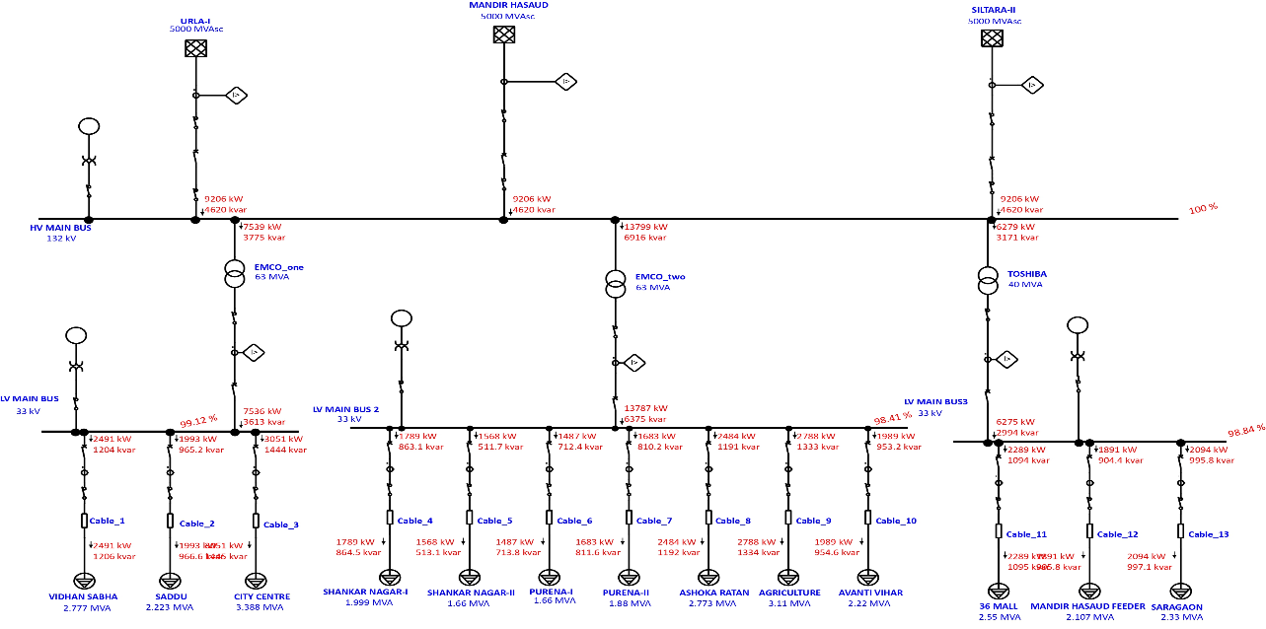
- Transformers: Two 63 MVA transformers (EMCO_one and EMCO_two) and one 40 MVA transformer (TOSHIBA) step down voltage to 33 kV. EMCO_two handles the highest load at 17,399 kW /6916 kVAR.
Figure 6 Load flow analysis results showing active and reactive powers
- Main Buses: LV MAIN BUS2 and LV MAIN BUS3 distribute 7536 kW /3631 kVAR and 6275 kW /2994 kVAR respectively, with voltage levels near nominal.
- Load Distribution: Major consumption centres include CITY CENTRE (3.588 MVA), AGRICULTURE (3.11 MVA), and VIDHAN SABHA (2.777 MVA). Load distribution across 17 cables is balanced, with no signs of feeder overload.
- Power Factor and Stability: Power factors range between 0.85–0.92, indicating satisfactory performance. The system remains voltage-stable with no critical violations or abnormal conditions observed.
E. Arc Flash Results
An arc flash analysis was performed using ETAP to assess incident energy levels, arc flash boundaries, and potential hazard levels at various switchgear and bus locations within the system. The study follows IEEE 1584 standards. Key findings from the arc flash simulation are as follows:
- High-Risk Areas: The most severe arc flash incident was identified at LV MAIN BUS 2, specifically at LVCB-9, where the incident energy
- (IE) reached 9.275 cal/cm² at a working distance of 457 mm. This falls under PPE Category Level 3, indicating a serious risk and requiring arc-rated suits with higher protection.
- Arc Flash Boundaries (AFB): The arc flash boundary at Relay Level D close to EMCO_one was determined to be 2.047 m, with an IE of 2.9371 cal/cm², indicating PPE Category 2.
- Moderate and Low-Risk Zones: Several areas, including LVCB-14 (36 MALL) and LVCB-16 (SARGAON), showed lower IE values of 2.552 cal/cm² and 1.663 cal/cm², corresponding to PPE Level 1 or below. These locations are still hazardous but pose lower risks with standard PPE sufficing.
- Zero Arc Fault Current Areas: Certain switches (e.g., SW_7, SW_8, SW_9, SW_12) recorded 0.0 kA fault currents, indicating either open circuit conditions or protection through isolation, with no arc flash risk under current system status.
- Current Limiting Observations: Arc fault current values (Ia) varied across the network, with a peak of 10.233 kA observed at LVCB-16 and consistent values of 10.166 kA in several locations (LVCB-8, LVCB-9, LVCB-10), suggesting substantial fault exposure in those regions.
- Key Results and Insights of Load Flow Analysis
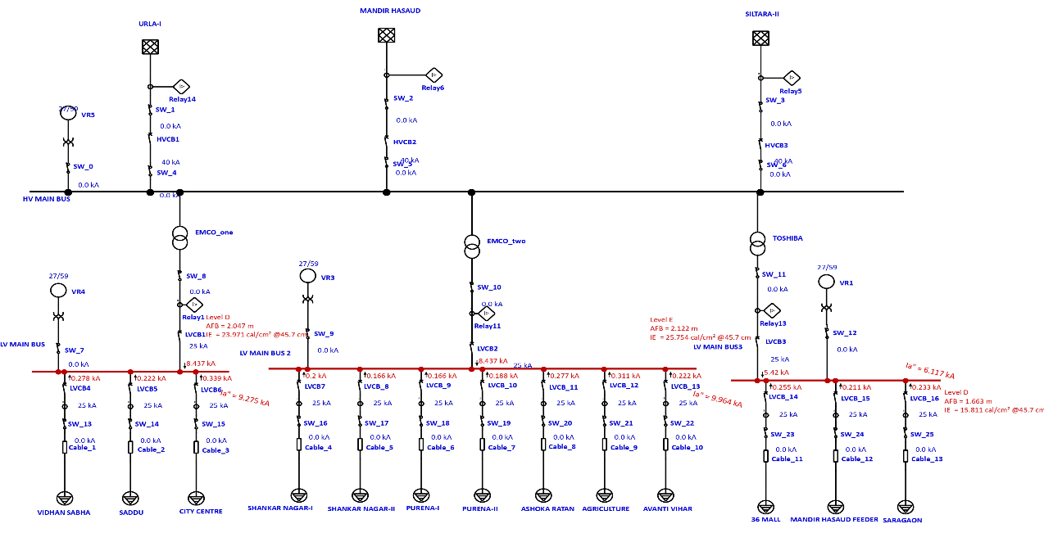
- Voltage Profile Across Buses: Most buses maintain a voltage near the nominal rating (e.g., 32.9–33.1 kV for 33 kV systems), suggesting a well-regulated voltage profile.
Figure 7 Arc Flash results showing incident energy levels
- Bus Loading: All bus voltages are within ±5% tolerance, confirming there are no under-voltage or over-voltage conditions under normal operating scenarios.
- Transformer and Feeder Health:
  - Transformers are not overloaded, and there is no significant voltage drop at the load ends.
  - System impedance and losses appear minimal, indicating good system efficiency.
G. Key Results and Insights of Arc Flash Hazard Assessment
- Incident Energy Levels and PPE Classification:
  - The maximum incident energy observed is 9.964 cal/cm² at LV MAIN BUS 2, which falls under PPE Level E (typically requiring arc-rated clothing above 8 cal/cm²).
  - Other buses such as LV MAIN BUS and LV MAIN BUS 3 reported incident energies of 9.275 and 6.117 cal/cm², corresponding to PPE Level D.
- Arc Flash Boundary (AFB): The Arc Flash Boundaries range from 15.8 cm to 25.8 cm, which defines the minimum safe distance for workers without PPE.
- Fault Current Analysis: Bolted fault currents range between 5.420 kA and 8.437 kA. Arc fault currents are slightly lower due to arcing impedance (ranging from 6.117 kA to 9.964 kA).
- Trip Settings and Clearing Time: All circuits show a trip time of 0.10 seconds (6 cycles), indicating fast response of protection devices.
Thus, the results confirm that the electrical system is both operationally stable and safely protected, with effective power distribution and clearly identified arc flash risk zones requiring appropriate PPE and safety measures.
H. Results of Arc Flash Analysis for Different Fault Locations
The arc flash analysis was conducted by inserting faults at three distinct bus locations in the low-voltage distribution system. The results for each scenario are presented below, highlighting key metrics such as incident energy (IE), arc flash boundary (AFB), and fault clearing time (FCT).
    - Fault Insertion at the First Bus (LV MAIN BUS) -The fault at the first bus resulted in an incident energy of 23.971 cal/cm² and an arc flash boundary of 2.047 m, indicating a high-risk hazard level. The fault current measured 8.437 kA, with the relay clearing the fault in 0.032 seconds. The elevated IE suggests the need for robust protective measures, such as faster-acting circuit breakers, near the power source.
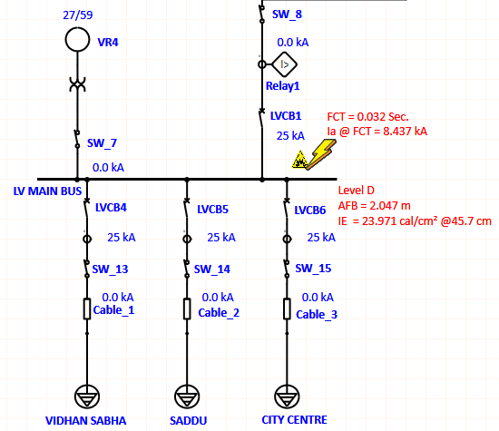
Figure 8 Fault insertion at the first bus (LV MAIN BUS) showing protective device response and arc flash parameters.
    - Fault Insertion at the Mid-Bus (Between LV MAIN BUS and LV MAIN BUS3) - The mid-bus fault produced the highest incident energy (25.754 cal/cm²) and widest arc flash boundary (2.122 m), classifying it as Level E—a severe hazard. The fault current remained at 8.437 kA, with the same FCT of 0.032 sec. This suggests that intermediate buses may experience amplified arc flash risks due to cumulative fault contributions from upstream sources.
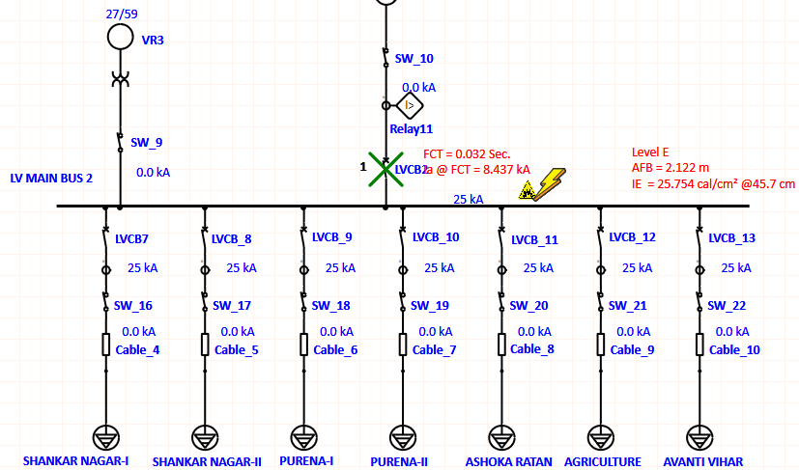
Figure 9 Fault insertion at the mid-bus, demonstrating increased IE and AFB compared to the first bus.
    - Fault Insertion at the Last Bus (LV MAIN BUS3) - The fault at the last bus exhibited lower incident energy (15.811 cal/cm²) and a reduced arc flash boundary (1.663 m), indicating a comparatively lower hazard level. The fault current dropped to 5.42 kA, likely due to impedance effects in the downstream network. Despite the decrease, the hazard remains significant, requiring proper PPE and safety protocols.
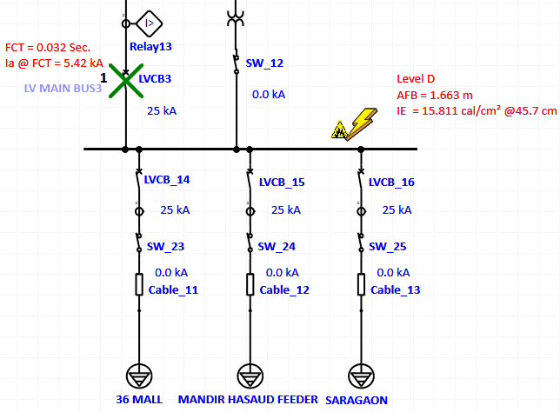
Figure 10 Fault insertion at the last bus, showing reduced arc flash severity relative to upstream locations.

CONCLUSION
In conclusion, the integrated load flow and arc flash analysis demonstrated that the electrical distribution system operates under stable conditions with balanced power flow, acceptable voltage levels, and no overloading, while also identifying critical zones with elevated arc flash risks requiring higher PPE levels. Such studies are essential for ensuring both operational efficiency and personnel safety, particularly in rapidly growing power networks. In the context of India’s expanding industrial and infrastructure sectors, these assessments provide a vital foundation for optimizing system design, enhancing grid reliability, and enforcing electrical safety standards. Future work can focus on real-time monitoring, predictive fault analysis, and integration of renewable energy sources, further advancing the resilience and sustainability of power systems across the country.

REFERENCES
- IEEE Guide for Arc-Flash Hazard Calculations, IEEE Standard 1584-2002.
- Ralph H Lee, “The Other Electrical Hazard: Electric Arc Blast Burns”, IEEE Transactions on Industry Applications, vol. IA-18, no. 3, May/June 1982.
- Saeed Mohajeryami, Mahmoodreza Arefi, Zia Salami, “Arc Flash Analysis: Investigation, Simulation and Sensitive Parameter Exploration”.
- V. V. Mehtre and A. Dubey, "A case study for optimization of power system load flow analysis using ETAP software," World Journal of Advanced Engineering Technology and Sciences, Apr. 2024.
- M. Ghiasi, "A detailed study for load flow analysis in distributed power systems," International Journal of Industrial Electronics, Control and Optimization, Jun. 2018.
- M Rif’an, I A Raharjo, S Syufrijal and E Pradana, “Comparison of load flow analysis using PSAT and ETAP”, The 5th Annual Applied Science and Engineering Conference (AASEC 2020)
- Raheel Muzzammel, Ibrahim Khail, “Design and Power Flow Analysis of Electrical System Using Electrical Transient and Program Software” Energy and Power Engineering, 2019, 11, 186-199.

