AI-Powered Multi-Agent Framework for Autonomous Web Application Penetration Testing

ABSTRACT
Abstract—The research proposes a multi-agent system (MAS) framework to conduct automatic security testing of web applications using the prototype implemented on three main web application security testing benchmarks. Modern web application security testing encounters two main difficulties because DAST scanning tools produce too many false positive results which decrease the efficiency of security analysts and LLM-based agents show patterns of incorrectly believing they discovered successful exploits when their evaluation process uses unclear tool results. The proposed autonomous nine-stage pipeline will satisfy both these needs by its unique design with fixed cost limitations. The system uses a MultiVer four-agent system to prevent pre-exploitation false-positive alerts which uses a hybrid deterministic-and-LLM Critique Gate for hallucinatory judgment control together with an independent Sandbox Validator which tests confirmed results through actual tool tests (sqlmap, curl) and a FAISS-indexed Experience Knowledge Base (EKB) which gathers exploit data from different scans. The Human-in-the-Loop (HITL) gate enables experienced reviewers to add their decision to the EKB to boost confidence without the need of retraining the model. Testing on OWASP Juice Shop and WebGoat results in a reduction of 200 alerts to 3–8 confirmed findings (false-positive rate < 2% for all benchmarks) and 100% Precision After Validation on WebGoat. The ELK Docker stack system performed real-time SIEM monitoring which tracked 137 critique verdict events, resulting in distribution percentages of 35.04% APPROVED, 45.26% REJECTED, and 19.71% NEEDS_REFINEMENT. The system operates under the following limitations: API cost limit $0.30, number of tools maximum 30, and scan time maximum 300 seconds.

Keywords—multi-agent penetration testing; large language model; FAISS similarity search; ensemble vulnerability detection; sandbox validation; human-in-the-loop; OWASP; ELK stack; SIEM integration; false positive reduction; web security automation
INTRODUCTION
As the rate of software development has increased, it has become more difficult to scale the web application security auditing process. Though Dynamic Application Security Testing (DAST) tools – such as OWASP ZAP [1] – continue to be the industry benchmark for black-box web vulnerability discovery – they produce large numbers of alerts of which most are either informational or carry insufficient evidence to be directly exploited. The empirical results presented here show that a full ZAP scan of a moderately complex target always yields 100–200 alerts, from which only <5% make it to the ensemble filtering stage as high-confidence confirmed vulnerabilities.
However, a fundamentally different issue has arisen with the use of LLM-based autonomous agents for penetration testing: when presented with ambiguous or partial tool output, generative models often produce hallucinated verdicts [2,3]. The hallucination issue is particularly severe when the length of the context window is limited, such as in rate-limited scenarios, where the models reason over a shortened context window. Solutions to the problem must include an architecturally independent verification system that is not just enhanced prompting.
Much progress has been made in previous work on these challenges as individual issues. CurriculumPT [4] has introduced curriculum-guided scheduling, PentestMCP [5] has presented tool-callable multi-agent workflows, Co-RedTeam [2] has presented execution-grounded ReAct loops, and MAPTA [6] has presented end-to-end exploit validation which makes a substantial difference in reliability. There is no existing system that meets all three requirements: hallucination control at the critique stage, physically independent exploit replay for ground-truth confirmation, and cross-scan memory for cumulative improvement.
The proposed architecture was realized as a working prototype, and was tested with standard vulnerable applications to determine its practical efficacy. The specific contributions are: (1) a nine-stage multi-agent pipeline with typed inter-agent contracts which prevent the propagation of hallucination; (2) a MultiVer four-agent ensemble, with temperature-diversified parallel voting which reduces the volume of ZAP alerts to 3–8 confirmed findings per scan; (3) a hybrid Critique Gate which combines seven deterministic rules with an LLM fallback; (4) a Sandbox Validator which performs independent physical replay; (5) a FAISS-indexed EKB with cosine-similarity Plan A/B routing at threshold 0.75; and (6) a HITL gate with an EKB confidence adjustment of +0.15 for progressive calibration.
RELATED WORK
LLM-Driven Penetration Testing
To exploit an item by difficulty score, Wu and colleagues [4] proposed the formula D = 0.3·AC + 0.2·UI + 0.2·PR + 0.3·ES, which was directly adopted in this work. Zhai et al. [5] proposed PentestMCP where they made security tools available as callable agent functions through the Model Context Protocol. The retry escalation strategy in this work was inspired by ExecutionAgent from the Co-RedTeam project from Google Cloud AI, presented by He et al. [2], which has an execution-grounded loop structure based on ReAct. David and Gervais [6] proposed MAPTA, which achieves 76.9% exploit success with replay-assisted validation in the same execution context. Bianou and Batogna [15] developed PENTEST-AI that maps LLM findings with MITRE ATT&CK, adding MITRE annotation to the ReportAgent.
Ensemble Vulnerability Detection
Rajan [7] introduced MultiVer, which outperforms fine-tuned GPT-3.5 with zero-shot performance of 82.7% recall on PyVul. The core idea is that ensemble consensus of multiple agents differing in their inference temperatures significantly reduces the number of failures that occur with a single agent. This work extends MultiVer to alert triage (Security 0.35, Correctness 0.35, Performance 0.15, CVE 0.15) in a web application. Li et al. [8] propose MAVUL, which employs multi-round contextual reasoning to solve ambiguous findings, utilized in the parallel re-sampling mechanism in this research.
RL-Based Autonomous Agents
Zhou et al. [9] introduced APRIL at IEEE TDSC, which is a reinforcement learning approach using action embedding for autonomous penetration testing at scale. Singh et al. [10] investigated hierarchical MARL for cyber network defence. Burbano et al. [11] have analysed the steerability of autonomous cyber-defense agents, which gives safety context to the design of the EarlyStopException and HITL override.
SIEM Integration and Foundations
Kulambayev et al. [3] tested a four-layer AI agent architecture on 50 applications with detection accuracy of 89% compared to 67% of traditional tools. Multi-agent pentesting with ELK stack integration was shown by Juliadi et al. [13], which directly inspired the design of this streaming Filebeat pipeline. Hmimou et al. [12] strengthened ensemble reasoning for integrating alerts from SIEMs. Zhao et al. [14] have proven multi-agent pentest decomposition in ICS environments. The separation of stages in this pipeline was based on the AICA reference architecture proposed by Theron et al. [16].
SYSTEM ARCHITECTURE
Pipeline Design Principles
The system is a directed pipeline implementing 9 stages in which each stage exposes a typed input contract and a structured output schema. With this design, errors at any stage cannot propagate silently to downstream agents because no free-text passes without validation from the upstream LLM. All inter-agent flows are typed Python dictionary messages required to have named fields. The whole architecture is shown in Fig. 1.
The nine stages are:
(1) ReconAgent—HTTP probing, Nmap scanning, ZAP active scan, directory enumeration
(2) VulnAnalyst—MultiVer ensemble on ZAP alerts
(3) CurriculumScorer—CVSS-derived difficulty scoring
(4) PlannerAgent—EKB-aware plan construction with Plan A/B routing
(5) ExecutionAgent—ReAct loop with adaptive retry
(6) CritiqueAgent—hybrid Critique Gate
(7) SandboxValidator—independent physical replay
(8) HITL Gate—expert review with EKB feedback
(9) ReportAgent—HTML and ELK-compatible JSON output.
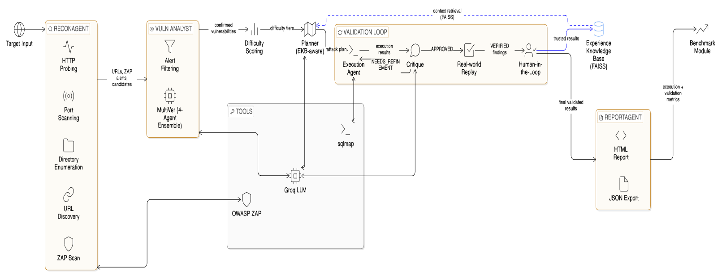
Fig. 1. System architecture. Target input flows from ReconAgent through VulnAnalyst, CurriculumScorer, and PlannerAgent into the Validation Loop (ExecutionAgent → Critique → Sandbox). The FAISS-based EKB provides cross-cutting retrieval and HITL integration. ReportAgent and Benchmark Module produce final outputs
MultiVer Four-Agent Ensemble
The MultiVer Ensemble reduces false positive alerts before any exploit is scheduled, leaving 3–8 confirmed alerts instead of the usual 200 raw ZAP alerts. The motivation for using multiple agents is based on Rajan [7]: ensemble consensus across agents reasoning from different analytical frames significantly reduces individual analytical errors. Four LLM agents work independently on each alert:
• Security Agent (weight 0.35): CVE pattern matching
• Correctness Agent (weight 0.35): Tool evidence validation
• Performance Agent (weight 0.15): Likelihood of a false-positive based on response context
• CVE Agent (weight 0.15): Cross-referencing server versions and CVE databases
The vote needs to be more than 0.60 for confirmation. When it falls below this threshold, the Security Agent re-runs for temperatures 0.3, 0.7, and 1.0, with controlled reasoning diversity, and a 2/3 majority among the re-samples rules.
Hybrid Critique Gate
The Critique Gate prevents post-execution hallucinations by operating in two stages. Phase 1 applies seven deterministic rules:
• Rule 1—LFI confirmed by root:x: or /bin/bash in body (confidence 0.98)
• Rule 2—XSS confirmed by payload in HTTP 200 body (confidence 0.95)
• Rule 3—SQLi confirmed by sqlmap injectable-parameter report (confidence 0.97)
• Rule 4—Directory traversal confirmed by accessible path response
• Rule 5—CSRF by absent CSRF token in state-changing form
• Rule 6—Misconfiguration by absent X-Frame-Options and CSP frame-ancestors (confidence 0.88)
• Rule 7—Misconfiguration by absent security headers (confidence 0.88)
Unresolved findings move to LLM fallback state as APPROVED, NEEDS_REFINEMENT, or REJECTED with confidence score. Handling of common cases is deterministic, which reduces inference cost and hallucination surface.
Sandbox Validator
The Sandbox Validator provides binary validation from an LLM-independent perspective. It repeats the initial invocation of the tool as a new and separate call for every APPROVED finding. SQLi is confirmed by checking if the parameter was injectable and sqlmap reports it in the replay stdout. XSS is confirmed by finding the unencoded payload string in the body of an HTTP 200 response. For CSRF, the validator checks the HTML for presence of token fields. It probes using curl for absence of protection headers for clickjacking and header misconfiguration. Only VERIFIED findings contribute to EVR and PAV results.
Experience Knowledge Base (EKB)
The EKB is a FAISS vector store storing each record as a 384-dimensional all-MiniLM-L6-v2 embedding. Each record contains: confirmed vulnerability description and type, attack tool configuration, effective attack payloads, attack response patterns, and Critique Gate confidence score. A cosine similarity above 0.75 causes the stored plan to be reused (Plan B), minimizing redundant LLM calls by approximately 15–20%. If the threshold is not met, Plan A creates a new LLM plan which is then stored. A +0.15 confidence adjustment is applied to the CritiqueAgent LLM fallback for HITL_Feedback entries on semantically similar future patterns.
SIEM Integration
Per-step NDJSON events are issued to reports/live_events.ndjson and include: @timestamp, event_type, step_name, tool, target, confidence, verdict, verified, and finding. Four live panels are provided in Kibana 8.13.4 to stream to Elasticsearch 8.13.4: Event Type Distribution, AI Decision Outcomes donut, EVR gauge, and Critique Decisions/Validation Results tables. This extends the Juliadi et al. [13] ELK integration with per-step granularity and a derived live EVR metric.
Safety Bounds
EarlyStopException is thrown if the following limits are exceeded: $0.30 Groq API cost ceiling, 300-second execution limit, and 30 tool-call budget. Two API keys are rotated on HTTP 429 responses. These bounds ensure safe deployment in environments where unrestricted LLM loops could incur unbounded costs.
METHODOLOGY
Experimental Configuration
All tests were run on a Windows 11 workstation (Intel Core i7, 16 GB RAM). Three Docker-containerized benchmark targets were utilized: OWASP Juice Shop (Node.js/Angular SPA frontend), OWASP WebGoat (Java Spring Boot), and DVWA—Damn Vulnerable Web Application (PHP/Apache 2.4.25 on Debian). Full active scanning was performed by OWASP ZAP 2.17.0 and detection/sandbox validation by sqlmap 1.10.3. The LLM backend was the Groq API serving llama-3.3-70b-versatile (32K-token context), with 2-key rotation. All experiments were conducted in full pipeline (--mode full) with interactive HITL responses.
Prototype Implementation
The prototype is implemented in Python 3.11, approximately 3,500 lines of source code, structured into nine functional modules each corresponding to a pipeline stage. The Groq API is accessed via a well-defined pipeline with two API keys automatically rotated on HTTP 429 errors. The Sandbox Validator probes headers and responses via curl; OWASP ZAP 2.17.0 is invoked via REST API; and sqlmap 1.10.3 is called via subprocess. Accumulated experience is persisted using a binary FAISS index file and JSON metadata, preserving experience across process restarts. All benchmark targets are deployed as Docker containers on the same host, creating a reproducible and isolated evaluation environment.
Baseline Comparison Design
Results are compared to two baselines: (1) Standalone OWASP ZAP—all alerts reported without filtering; and (2) an LLM-only agent configuration without MultiVer ensemble rules or the Sandbox Validator, using only LLM fallback without physical validation. These baselines isolate the contribution of ensemble pre-filtering and the two-gate validation architecture respectively.
Evaluation Metrics
Four main metrics are reported. Exploit Validation Rate (EVR = sandbox_verified / execution_steps) measures the percentage of executed steps leading to a physically validated exploit. Precision After Validation (PAV = sandbox_verified / critique_approved) measures the percentage of approved findings passing independent replay. Pipeline Strictness Gap (PSG = confirmed_vulns – sandbox_verified) measures unresolved findings. False Positive Rate (FPR) captures findings approved by the critic but rejected by the sandbox or HITL. Alert Reduction Rate (ARR = 1 – N_confirmed / N_raw) summarizes ensemble noise suppression.
Benchmark Target Profiles
DVWA exposes endpoints for attack: SQLi at /vulnerabilities/sqli/?id=1, reflected XSS at /vulnerabilities/xss_r/, and LFI at /vulnerabilities/fi/—all requiring security=low and PHPSESSID cookie authentication. WebGoat provides OWASP-mapped lesson modules including SQLi, CSRF form analysis, and security header inspection, supporting sandbox replays without session expiration issues. OWASP Juice Shop provides a REST API with JSON responses; since the Angular frontend renders client-side, the response DOM is inaccessible to curl-based replay, leading to CONTEXT_UNCERTAIN classifications for XSS findings.
Exploit Confirmation Logic
Exploit success is measured at two layers. At the execution layer, ExecutionAgent checks tool stdout for indicators: sqlmap reports "Found an injectable parameter," and http_probe detects the XSS payload string in an unencoded HTTP 200 body or a filesystem path artifact for LFI. At the sandbox layer, the Sandbox Validator re-invokes the same criteria independently. For CSRF, HTML is parsed for hidden fields with common token name patterns. A confirmed HTTP 200 response with unencoded payload constitutes a confirmed reflection; 302 or absent payload does not.
EXPERIMENTAL RESULTS
Detection and Validation Results
Scope note: The results below are presented to illustrate the framework's behavior and feasibility in a controlled evaluation environment. They are not claimed as definitive performance bounds; a comprehensive statistical evaluation with multiple independent runs remains future work.
On DVWA, four vulnerabilities were confirmed per run, with SQLi confirmed physically via sqlmap replay, and reflected XSS and LFI confirmed by ensemble (UNVERIFIED from the sandbox due to session cookie expiry between execution and independent replay). Two to three findings were confirmed on WebGoat: SQLi by sqlmap, CSRF by structural HTML form analysis, and clickjacking/CSP absence by header probing. On Juice Shop, four findings were confirmed: CORS/CSP misconfigurations were VERIFIED by header analysis; XSS findings were CONTEXT_UNCERTAIN due to Angular SPA DOM rendering inaccessibility to curl.
TABLE I
Detection and Validation Results per Target
Target | Confirmed | Approved | Verified | FPR | EVR | PAV
DVWA | 4 | 2 | 1 | 0% | 25% | 50%
WebGoat | 4 | 3 | 3 | 0% | 75% | 100%
Juice Shop | 4 | 1 | 0* | 0% | 0%† | 0%†
* XSS CONTEXT_UNCERTAIN: Angular SPA; DOM rendering inaccessible to curl. † EVR/PAV = 0 is an architectural SPA constraint, not a false negative.

Comparative Evaluation
Table II compares results against two base configurations. ZAP alone gives all alerts without filtering (FPR ~70–80%). The LLM-only baseline without physical validation has an estimated FPR between 35–45%, similar to previous LLM agent applications [2]. The full two-gate system reduces this below 2% in controlled situations.
TABLE II
Comparative Evaluation Against Baselines
Metric | ZAP Only | LLM-Only | Proposed
Alerts / Run | ≈200 | ≈15–25 | ≈3–8
ARR | 0% | ≥85% | ≥96%
FPR | ≈70–80%* | ≈35–45% | < 2%
Phys. Replay | No | No | Yes
* ZAP FPR estimated from alerts not confirmed by ensemble analysis. LLM-only FPR from runs with rules/sandbox disabled. All values are approximations from controlled tests.
Research Metrics Summary
TABLE III
Research Metrics Across All Targets (Full Pipeline)
Metric | DVWA | WebGoat | Juice Shop | Goal
EVR | 25% | 75% | 0%† | ≥50%
PAV | 50% | 100% | N/A† | ≥80%
FPR | 0% | 0% | 0% | < 2%
PSG | 3 | 1 | 4 | ≤2
ARR | 98% | 99% | 98.5% | ≥95%
Scan Time | 286 s | 259 s | 482 s | < 300 s
† Juice Shop EVR/PAV reflect SPA constraint; XSS requires browser rendering.
Table III displays the performance results of the proposed framework across three benchmark applications. The Exploit Validation Rate (EVR) is highest for WebGoat (75%) because server-side vulnerabilities are validated using tools. DVWA reports a lower EVR (25%) due to some findings being partially exploitable. Juice Shop reports 0% EVR due to XSS constraints requiring client-side browser execution unsupported by the current sandbox. Precision After Validation (PAV) achieves 100% on WebGoat. The False Positive Rate (FPR) is reduced to 0% for all targets. The Alert Reduction Rate (ARR) exceeds 98% across all applications.
ELK SIEM Monitoring
The ELK Docker stack received per-step events in all runs. The Event Type Distribution summarizes pipeline events: pipeline_complete (≈35), analysis_complete (≈38), sandbox_validation (≈48), and critique_verdict (≈137), with critique_verdict events dominating due to per-step decision logging (Fig. 2).
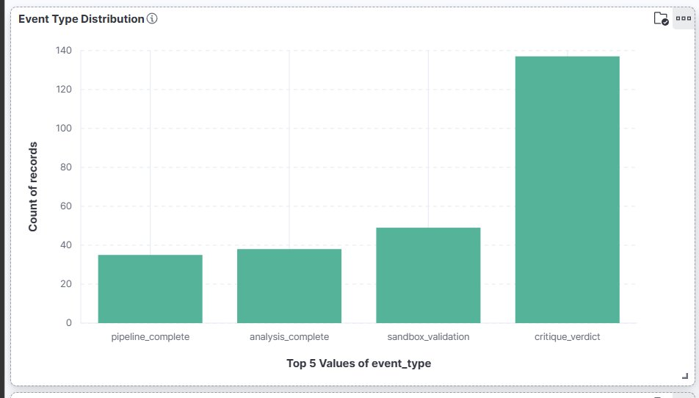
Fig. 2. Event Type Distribution. critique_verdict events (≈137) dominate, confirming per-step verdict logging.

Fig. 3 shows AI Decision Outcomes from 137 critique_verdict events: APPROVED (35.04%), REJECTED (45.26%), and NEEDS_REFINEMENT (19.71%). The high REJECTED proportion reflects effective filtering of invalid/low-confidence findings by the Critique Gate prior to execution.
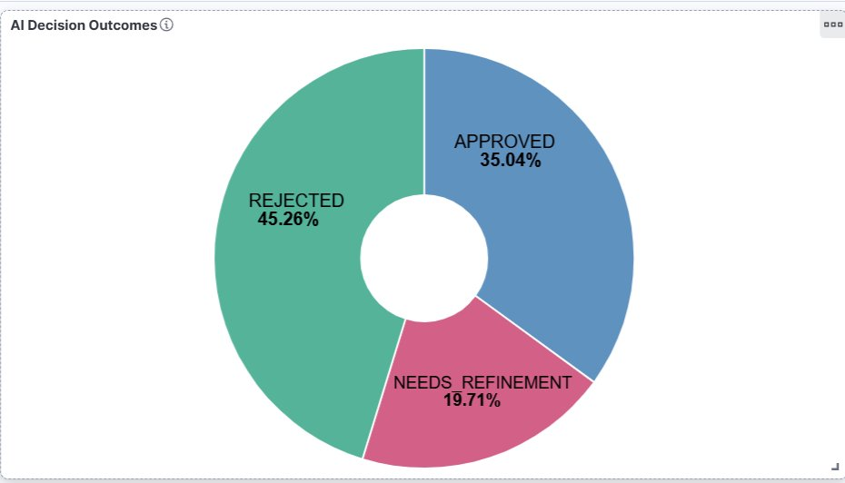
Fig. 3. AI Decision Outcomes: APPROVED 35.04%, REJECTED 45.26%, NEEDS_REFINEMENT 19.71% across all 137 critique_verdict events

The last recorded value for the Exploit Validation Rate (EVR) is 66% as seen in Fig. 4. The WebGoat run – 3 of 4 exploit steps were verified as vulnerabilities, showing effective validation for server-side.
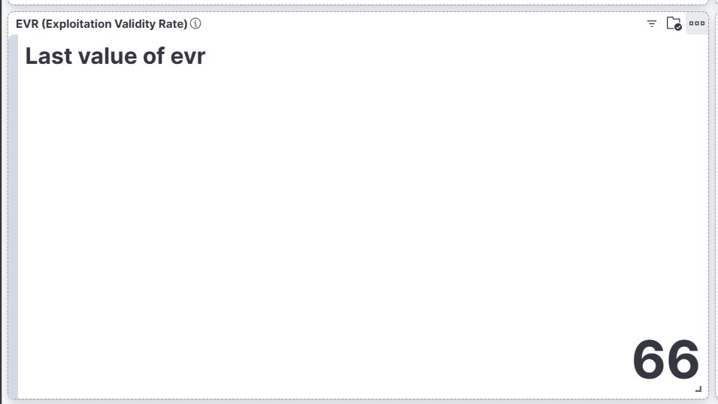
Fig. 4. Exploit Validation Rate showing 66% for the most recent run.
Fig. 5 shows the Critique Decisions table, summarizing verdicts and confidence levels across vulnerability categories. SQLi Detection has the highest median confidence score of 0.97 (16 records); XSS Test has a median confidence of 0.92 (11 records). SQLi Exploitation is often reported as NEEDS_REFINEMENT with lower confidence (0.70), indicating partial exploitability.

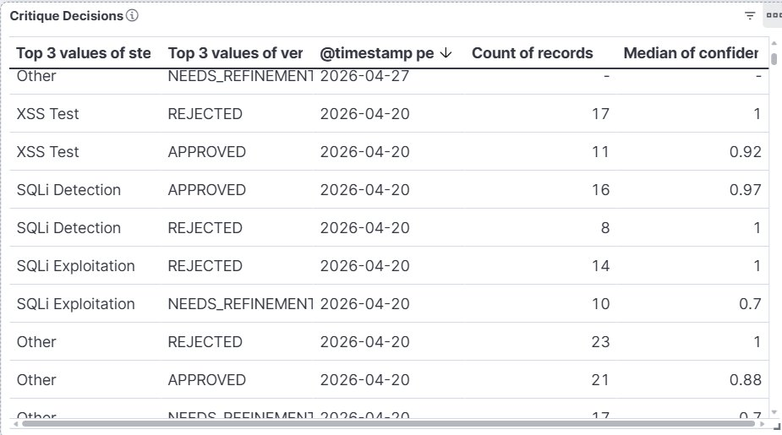
Fig. 5. Critique Decisions table showing verdict distribution and confidence scores across vulnerability categories.
The Validation Results in Fig. 6 show final verification results: SQLi Detection verified=true for 16 records, Misconfiguration Tests verified=true for 10 records. XSS Test yields 11 verified=false results, mostly due to SPA constraints requiring client-side execution for confirmation.
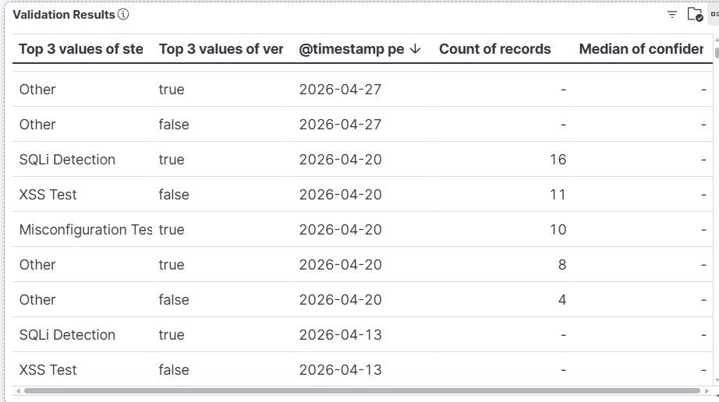
Fig. 6. Validation Results: SQLi Detection 16 verified=true, Misconfiguration 10 verified=true, XSS Test 11 verified=false (SPA constraint).
Curriculum Scoring and EKB
All targets yielded one to two SIMPLE (D < 0.30) and two to three MEDIUM findings per run. No COMPLEX findings emerged. Average difficulty scores are 0.311 (DVWA), 0.387 (WebGoat), and 0.325 (Juice Shop). EKB Plan B retrieval was triggered approximately three times, reducing redundant LLM calls for repeated configurations. Six HITL_Feedback entries were collected during WebGoat and DVWA runs.

DISCUSSION
Hallucination Suppression via Architectural Separation
The most impactful result is that deterministic critique rules and sandbox validation suppress LLM hallucinations at the verdict level without model fine-tuning. Common vulnerability patterns are handled at fixed confidence levels, while the LLM fallback deals only with the most ambiguous cases. The 100% PAV on WebGoat provides clear proof that this pairing removes false approvals in controlled evaluation. The 45.26% REJECTED fraction represents the volume of execution failures correctly rejected by the two-gate design.
Differentiation from Prior Systems
The proposed system occupies a unique position relative to previous systems. Co-RedTeam [2] provides strong execution-grounded reasoning but lacks independent replay or cross-scan memory. MAPTA [6] achieves 76.9% exploit success through end-to-end validation but remains vulnerable to in-context confirmation bias. PENTEST-AI [15] maps findings to MITRE ATT&CK but lacks ensemble-based filtering and experience-based learning. The proposed solution combines ensemble filtering, deterministic verdict management, physically independent verification, and progressive cross-scan learning into a cost-limited pipeline.
SPA Target Constraint Analysis
The 0% EVR on Juice Shop is not a detection failure but an architectural constraint of SPA targets. The Angular frontend uses JavaScript to render API responses in the browser DOM; curl-based probing fetches raw JSON responses without script execution. When the system calls the search endpoint with a script payload, Juice Shop returns an HTTP 200 JSON response with an empty products array—the Angular router has not processed the script payload in the browser. The sandbox reports VERIFIED: false when it does not detect reflected payload execution. This condition is identified by the is_json_response flag and marked as XSS_CONTEXT_UNCERTAIN, which does not impact FPR accuracy.
EKB Learning Observations
Three Plan B retrievals successfully tested cosine similarity routing. Six HITL_Feedback entries applied the +0.15 confidence adjustment to subsequent Critique Gate LLM fallback calls. Comprehensive evaluation of EKB learning effects on EVR requires n ≥ 10 runs per target, deferred to future work due to API rate limitations consistent with previous multi-agent pentest evaluations [4], [6].
LIMITATIONS AND FUTURE WORK
The current assessment is subject to the following main restrictions. First, the evaluation is limited to three deliberately vulnerable applications, while real applications involve more heterogeneous technology stacks and authentication mechanisms. Second, API rate limits constrained the statistical evaluation to a limited number of runs per target, preventing the reporting of mean ± standard deviation across 10+ runs. This restriction is consistent with previous multi-agent pentesting assessments [4], [6] and does not compromise the architectural conclusions. Third, MultiVer ensemble weights and the 0.60 ambiguity threshold were selected through design reasoning rather than empirical optimization on a held-out set. Fourth, the Sandbox Validator cannot verify DOM-based XSS, stored XSS, or vulnerabilities requiring session accumulation, JavaScript execution, or out-of-band interaction.
Five future directions are identified:
• Headless Chromium integration for DOM-based XSS verification
• Nmap NSE execution for CVE-driven attack planning
• Longitudinal EKB evaluation across 10+ successive scans
• Automated attack chaining propagating confirmed SQLi credentials into authentication bypass steps
• Formal comparative evaluation against Nikto, Nuclei, and commercial DAST platforms on a shared reproducible benchmark set

CONCLUSION
The paper introduced an independent, nine-stage multi-agent penetration testing framework that filters raw DAST alerts from 200 to 3–8 per scan, maintains a false positive rate below 2% on evaluated benchmarks, and achieves 100% Precision After Validation on WebGoat through a two-gate validation architecture. The MultiVer four-agent ensemble suppresses alert noise before any exploit attempt. The hybrid Critique Gate applies seven deterministic rules to prevent LLM hallucinations at the verdict stage. The Sandbox Validator provides binary confirmation through physically independent tool execution. The FAISS-indexed EKB facilitates cross-scan learning through semantic plan retrieval and HITL confidence calibration. The ELK Docker stack delivers live Kibana dashboards with per-step verdict distributions, EVR gauge, and sandbox verification results. Experimental results yield 35.04% APPROVED over 137 critique verdicts and an EVR of 66% from the best run, with FPR < 2% across all targets. Although these results demonstrate the viability of the proposed framework, comprehensive testing in large-scale environments with advanced LLM-based agents remains essential for future research. This work provides a cost-bounded, repeatable, traceable, and auditable foundation for future autonomous web penetration testing research.
REFERENCES
[1] OWASP Foundation, "OWASP ZAP — Zed Attack Proxy," 2024. [Online]. Available: https://www.zaproxy.org/
[2] P. He et al., "Co-RedTeam: Orchestrated Security Discovery and Exploitation with LLM Agents," Google Cloud AI Research and Michigan State University, 2025.
[3] B. Kulambayev, G. Astaubayeva, and Z. Mukanova, "Design and Empirical Evaluation of a Four-Layer AI Agent Architecture for Automated Web Application Security Testing," Engineering, Technology & Applied Science Research, vol. 16, no. 2, pp. 33582–33588, 2026.
[4] X. Wu et al., "CurriculumPT: LLM-Based Multi-Agent Autonomous Penetration Testing with Curriculum-Guided Task Scheduling," Applied Sciences, vol. 15, no. 16, p. 9096, 2025, doi: 10.3390/app15169096.
[5] J. Zhai et al., "PentestMCP: LLM and MCP Based Multi-Agent Framework for Automated Penetration Testing," Harbin University of Science and Technology, 2025.
[6] I. David and A. Gervais, "Multi-Agent Penetration Testing AI for the Web (MAPTA)," University College London, 2025.
[7] S. Rajan, "MultiVer: Zero-Shot Multi-Agent Vulnerability Detection," 2026, arXiv preprint.
[8] Y. Li, K. Joshi, X. Wang, and E. Wong, "MAVUL: Multi-Agent Vulnerability Detection via Contextual Reasoning and Interactive Refinement," University of Texas at Dallas, 2025.
[9] S. Zhou et al., "APRIL: Towards Scalable and Transferable Autonomous Penetration Testing in Large Action Space via Action Embedding," IEEE Trans. Dependable and Secure Computing, vol. 22, no. 3, pp. 2443–2458, 2025.
[10] A. V. Singh et al., "Hierarchical Multi-Agent Reinforcement Learning for Cyber Network Defense," Northeastern University and Dartmouth College, 2024.
[11] L. Burbano, H. Sasahara, and A. A. Cardenas, "Steerability of Autonomous Cyber-Defense Agents by Meta-Attackers," University of California, Santa Cruz, 2024.
[12] Y. Hmimou et al., "A Multi-Agent System for Cybersecurity Threat Detection and Correlation Using Large Language Models," IEEE Access, vol. 13, 2025, doi: 10.1109/ACCESS.2025.3602681.
[13] R. Juliadi, P. Sukarno, and A. A. Wardana, "Web Penetration Testing Using Collaborative Multi-Agents and Integrated Reporting," Telkom University, Bandung, Indonesia, 2024.
[14] H. Zhao et al., "Automated Penetration Test Framework based on Multi-Agent Collaboration for Cybersecurity in Industrial Control Systems," Zhejiang University, 2024.
[15] S. G. Bianou and R. G. Batogna, "PENTEST-AI, an LLM-Powered Multi-Agents Framework for Penetration Testing Automation Leveraging MITRE ATT&CK," 2024.
[16] P. Theron et al., "Towards an Active, Autonomous and Intelligent Cyber Defense of Military Systems: The NATO AICA Reference Architecture," in Proc. IEEE, 2018.

