Government–Corporate Partnerships in Sustainable Civic Infrastructure: Global and Indian Perspectives with a Sustainability Efficiency Index (SEI)

Author: Rupesh Chandrasen Londhe
Affiliation: Bharati Vidyapeeth (Deemed to be University), Pune
Email: londherupesh1@gmail.com

Co Author: Prof Anil Gopal Shinde
Affiliation: Bharati Vidyapeeth (Deemed to be University), Pune
Email: sanil8888@yahoo.co.in

1. Abstract
Public–Private Partnerships (PPPs) have emerged as indispensable instruments for delivering sustainable civic infrastructure amid rapid urbanization, climate change, and fiscal constraints. By mobilizing private capital, technology, and managerial expertise alongside public accountability, PPPs offer hybrid governance models capable of addressing complex urban challenges. This paper examines global and Indian PPP case studies, situates them within established theoretical frameworks, and introduces the Sustainability Efficiency Index (SEI)—a composite metric integrating environmental, social, and financial dimensions. The analysis demonstrates that while PPPs enhance efficiency, scale, and innovation, persistent challenges in governance, equity, and risk-sharing constrain their transformative potential. The SEI provides a novel evaluative framework for policymakers and practitioners, enabling evidence-based alignment of PPP outcomes with sustainability imperatives and guiding future investment decisions toward resilient urban futures.

2. Introduction
Urbanization, climate change, and resource scarcity have collectively made sustainable civic infrastructure a global imperative. As cities expand and environmental pressures intensify, governments face mounting fiscal and technical constraints in delivering essential infrastructure. Traditional state-led models often struggle to mobilize adequate resources, prompting the rise of collaborative governance arrangements that integrate public accountability with private sector efficiency.
Public–Private Partnerships (PPPs) have emerged as a hybrid governance model that combines:
- Public sector accountability in ensuring equity, transparency, and long-term legitimacy.
- Private sector efficiency and innovation in mobilizing capital, technology, and managerial expertise.
This dual structure positions PPPs as critical instruments for addressing the complexity of modern urban systems. Globally, PPPs have been deployed across diverse sectors—transport, water, sanitation, and renewable energy—demonstrating their potential to align sustainability goals with financial viability.
India presents a particularly compelling case for examining PPPs in sustainable infrastructure. With rapid urban expansion, ambitious climate commitments, and large-scale policy initiatives such as the Smart Cities Mission and the National Renewable Energy targets, India has become a laboratory for PPP experimentation. The country’s commitment to achieving net-zero emissions by 2070 and expanding renewable energy capacity to 450 GW by 2030 underscores the urgency of integrating sustainability into infrastructure delivery.
Yet, despite their promise, PPPs in India face persistent challenges. Regulatory delays, contract renegotiations, and risk imbalances between government and corporate partners often undermine project outcomes. Moreover, while financial viability frequently dominates decision-making, social inclusiveness and environmental sustainability remain unevenly addressed.
This paper situates PPPs within global and Indian contexts, drawing on comparative case studies to highlight both opportunities and constraints. It introduces the Sustainability Efficiency Index (SEI)—a composite metric integrating environmental, social, and financial dimensions—as a novel evaluative framework. By applying SEI to selected PPP projects, the study seeks to provide policymakers and practitioners with evidence-based insights for aligning PPP outcomes with sustainability imperatives.

2. Literature Review and Theoretical Foundations

2.1 Public–Private Partnerships in Infrastructure
Public–Private Partnerships (PPPs) have gained prominence as hybrid governance arrangements that combine public accountability with private sector efficiency. The World Bank (2021) emphasizes that PPPs facilitate risk-sharing, lifecycle cost optimization, and access to private capital. Similarly, the OECD (2020) identifies PPPs as institutional mechanisms that improve efficiency and innovation in infrastructure delivery. However, recent scholarship highlights that PPPs must be evaluated not only on financial performance but also on environmental sustainability and social equity (UN-Habitat, 2019; Kumar & Singh, 2022).

2.2 Sustainability in Infrastructure: Triple Bottom Line Framework
The concept of sustainability in infrastructure is grounded in Elkington’s (1997) Triple Bottom Line (TBL) framework, which integrates:
- Environmental sustainability: emissions reduction, energy efficiency, resource optimization.
- Social inclusiveness: accessibility, affordability, and equity in service delivery.
- Economic/financial viability: return on investment, risk allocation, and long-term cost efficiency.
Empirical evidence suggests uneven performance across these dimensions. While global PPPs often excel in environmental outcomes, Indian PPPs demonstrate scale but face challenges in governance and inclusivity.
2.3 Theoretical Foundations

2.3.1 Stewardship Theory
Davis et al. (1997) propose that organizational actors are motivated by collective goals rather than individual self-interest. In PPP contexts, stewardship theory suggests that government and corporate actors can collaborate effectively when trust and shared objectives are present. This reduces opportunism and transaction costs, fostering long-term sustainability.

2.3.2 Stakeholder Theory
Freeman (1984) argues that organizations must consider the interests of all stakeholders. PPP projects involve governments, private firms, financiers, and communities. Failure to balance these interests can lead to inefficiencies, social resistance, or exclusion of vulnerable populations. Stakeholder theory thus underscores the importance of participatory planning and community engagement in PPPs.

2.3.3 Institutional Theory
Institutional theory emphasizes the role of regulatory frameworks and institutional capacity in shaping PPP success. Strong institutions ensure transparent contracts, accountability mechanisms, and equitable risk-sharing. Conversely, weak institutions often result in renegotiations, delays, and governance failures (Yescombe, 2018).

2.4 Research Gap
Despite extensive literature on PPPs, existing studies often focus narrowly on financial viability or sector-specific outcomes. There is limited integration of sustainability measurement models that combine environmental, social, and financial dimensions. Comparative quantitative frameworks across global and Indian contexts remain underdeveloped.

3. Global Case Studies

3.1 Thames Tideway Tunnel (UK)
- Focus: Urban sanitation and pollution reduction in the River Thames.
- PPP Role: Corporate financing and efficiency combined with public oversight.
- Sustainability Impact:
  - Environmental: Significant pollution reduction.
  - Social: Indirect benefits for communities.
  - Financial: Innovative financing ensures viability.
- SEI Potential: Strong environmental and financial scores; moderate social inclusiveness.
- Interpretation: Demonstrates how PPPs can align sustainability with investor returns in sanitation infrastructure.

3.2 CLSG Interconnector (West Africa)
- Focus: Regional electricity transmission and renewable energy integration.
- PPP Role: Corporate investment and cross-border cooperation among four countries.
- Sustainability Impact:
  - Environmental: Supports renewable energy expansion.
  - Social: Enhances regional integration and energy access.
  - Financial: Long-term viability through regional collaboration.
- SEI Potential: Balanced sustainability with strong regional impact.
- Interpretation: A model for transnational PPPs in emerging economies.

3.3 Singapore NEWater Program
- Focus: Water recycling and long-term water security.
- PPP Role: Government planning integrated with corporate technology.
- Sustainability Impact:
  - Environmental: Reduced reliance on imported water.
  - Social: Ensures resilience in resource-scarce contexts.
  - Financial: Cost efficiency through advanced technology.
- SEI Potential: Exemplary across all three dimensions.
- Interpretation: A global benchmark in sustainable water management.

4. Indian Case Studies

4.1 Delhi Metro Rail Corporation
- Focus: Urban transport and emission reduction.
- PPP Role: Joint government–corporate delivery of metro infrastructure.
- Sustainability Impact:
  - Environmental: ~630,000 tons of emissions reduced annually.
  - Social: Improved urban mobility and accessibility.
  - Financial: Balanced through fare revenue and government support.
- SEI Potential: High across all dimensions.
- Interpretation: Serves as a benchmark PPP in India.

4.2 Hyderabad Metro Rail
- Focus: Large-scale urban transport modernization.
- PPP Role: High private investment with government facilitation.
- Sustainability Impact:
  - Environmental: Moderate improvements.
  - Social: Accessibility challenges, affordability concerns.
  - Financial: Strong private investment, but revenue risks persist.
- SEI Potential: Financially robust but weaker environmental and social scores.
- Interpretation: Highlights trade-offs between profitability and inclusivity.

4.3 Renewable Energy Parks (Gujarat, Rajasthan)
- Focus: Solar and wind energy expansion.
- PPP Role: Corporate investment aligned with national renewable energy targets.
- Sustainability Impact:
  - Environmental: Direct contribution to 450 GW renewable capacity goal.
  - Social: Expands clean energy access.
  - Financial: Strong viability through government support and corporate participation.
- SEI Potential: High environmental and financial scores.
- Interpretation: Accelerates India’s climate commitments.

4.4 Swachh Bharat Mission (Urban Sanitation PPPs)
- Focus: Comprehensive waste management and sanitation infrastructure.
- PPP Role: Municipal partnerships with private firms for waste collection, recycling, and treatment.
- Sustainability Impact:
  - Environmental: Reduced open dumping, improved segregation, increased recycling.
  - Social: Enhanced cleanliness, public health, and community participation.
  - Financial: Revenue models via recycling and waste-to-energy, but uneven across cities.
- SEI Potential: Moderate to strong environmental and social scores; variable financial sustainability.
- Interpretation: Mainstreams sanitation into sustainability agendas, though governance bottlenecks remain.

4.5 Smart Cities Mission (Urban Technology PPPs)
- Focus: ICT-enabled governance, smart mobility, and energy-efficient infrastructure.
- PPP Role: Technology providers and infrastructure firms collaborate with municipalities.
- Sustainability Impact:
  - Environmental: Smart grids, efficient lighting, reduced emissions.
  - Social: Digital inclusion, citizen-centric services, participatory governance.
  - Financial: Long-term efficiency gains, but upfront investment challenges.
- SEI Potential: Balanced performance, with strong social inclusiveness in well-managed cities.
- Interpretation: Demonstrates how technology-driven PPPs can bridge governance gaps and enhance sustainability.

5. Comparative Analysis

Comparative Analysis
A comparative lens reveals both convergence and divergence in PPP outcomes across global and Indian contexts. By applying the Sustainability Efficiency Index (SEI) framework, several patterns emerge:

5.1 Focus Areas
- Global PPPs: Emphasize sanitation (Thames Tideway Tunnel), water security (Singapore NEWater), and renewable energy integration (CLSG Interconnector). These projects often target systemic sustainability challenges with strong institutional backing.
- Indian PPPs: Prioritize large-scale transport (Delhi Metro, Hyderabad Metro), renewable energy expansion (Gujarat, Rajasthan), sanitation (Swachh Bharat Mission), and smart urban governance (Smart Cities Mission). India’s PPPs reflect the urgency of rapid urbanization and climate commitments.

5.2 Strengths
- Global Projects: Showcase proven sustainability models, advanced financing mechanisms, and strong governance. For example, Singapore’s NEWater integrates cutting-edge technology with policy foresight.
- Indian Projects: Excel in scale and institutional support. Delhi Metro demonstrates balanced sustainability, while Renewable Energy Parks directly advance India’s 2030 climate targets. Smart Cities PPPs highlight India’s ambition to integrate ICT into governance.

5.3 Challenges
- Global PPPs: The central challenge lies in balancing profit motives with sustainability imperatives. Social inclusiveness is sometimes indirect (e.g., Thames Tunnel benefits communities but not directly at the household level).
- Indian PPPs: Governance bottlenecks, affordability concerns, and uneven municipal capacity are recurring issues. Hyderabad Metro illustrates trade-offs between financial viability and inclusivity, while Swachh Bharat PPPs face uneven financial sustainability across cities.

5.4 Opportunities
- Global PPPs: Highlight the potential of green finance and regional cooperation. The CLSG Interconnector demonstrates how PPPs can foster integration across national boundaries.
- Indian PPPs: Offer opportunities in urban sustainability and digital transformation. Smart Cities PPPs can become benchmarks if citizen engagement and equitable access are prioritized. Swachh Bharat PPPs show how sanitation can be mainstreamed into sustainability agendas.

5.5 SEI Comparative Insights
- Highly Sustainable (SEI ≥ 8.0): Delhi Metro, Thames Tideway Tunnel, Singapore NEWater — balanced across environmental, social, and financial dimensions.
- Moderately Efficient (SEI 7.0–7.9): Hyderabad Metro, Smart Cities Mission — strong financial or technological innovation, but weaker inclusivity or governance.
- Needs Improvement (SEI < 7.0): Swachh Bharat PPPs in smaller municipalities — strong environmental/social outcomes but uneven financial viability.

5.6 Synthesis
- Global vs. Indian PPPs: Global projects benefit from mature institutions and advanced financing, while Indian projects demonstrate innovation at scale but face governance and inclusivity gaps.
- Sectoral Diversity: Global PPPs emphasize sanitation and water security, while Indian PPPs broaden the scope to include smart urban governance and sanitation alongside transport and energy.
- Policy Implication: Integrating SEI into approval and monitoring processes can help India balance financial viability with social equity, while global PPPs can learn from India’s scale-driven experimentation.

6. Research Design

6.1 Approach
This study has adopted a mixed-method comparative case study design, integrating both quantitative and qualitative dimensions to capture the complexity of Public–Private Partnerships (PPPs) in sustainable civic infrastructure.
- Quantitative Dimension: Application of the Sustainability Efficiency Index (SEI), a standardized metric evaluating environmental, social, and financial performance across selected PPP projects.

- Qualitative Dimension: Case narratives and semi-structured interviews with key stakeholders provide contextual insights into governance structures, stakeholder dynamics, inclusivity, and risk-sharing.
This dual approach ensures that both measurable outcomes and contextual richness are systematically analyzed.

6.2 Data Sources
The study relies on a combination of secondary and primary data:
- Secondary Data:
  - International organizations (World Bank, OECD, UN-Habitat)
  - Government reports (Ministry of Finance, Government of India)
  - Peer-reviewed academic literature
  - Case-specific project documentation and sustainability reports
- Primary Data:
  - Surveys: Structured questionnaires administered to stakeholders, including government officials, corporate partners, and community members.
  - Interviews: Semi-structured interviews with policymakers, corporate executives, and community leaders to capture deeper insights into governance challenges, inclusivity, and financial sustainability.
This triangulation enhances both reliability and validity.

6.3 Interview Guide (Sample Questions)
- How do you perceive the role of PPPs in delivering sustainable infrastructure?
- What governance challenges have you encountered in PPP projects?
- How effective are current risk-sharing mechanisms between government and corporate partners?
- In your view, how inclusive are PPP projects in addressing the needs of vulnerable populations?
- Do you see SEI as a useful tool for evaluating PPP outcomes?
Responses were thematically coded to identify recurring patterns in governance, inclusivity, and financial viability.

6.3 Interview Guide
The semi-structured interviews are designed to capture stakeholder perceptions of PPP sustainability outcomes across governance, inclusivity, and financial viability. Questions are explicitly aligned with the three SEI dimensions (Environmental, Social, Financial) and the broader governance context.
Core Questions
- Role of PPPs: How do you perceive the role of PPPs in delivering sustainable infrastructure in your sector or region?
- Governance Challenges: What governance challenges (e.g., transparency, accountability, contract management) have you encountered in PPP projects?
- Risk-Sharing Mechanisms: How effective are current risk-sharing arrangements between government and corporate partners?
- Inclusivity: In your view, how inclusive are PPP projects in addressing the needs of vulnerable populations (e.g., affordability, accessibility)?
- SEI Utility: Do you see the Sustainability Efficiency Index (SEI) as a useful tool for evaluating PPP outcomes?
Supplementary Probes
- Environmental Dimension: Have PPP projects contributed to measurable environmental improvements (e.g., emissions reduction, renewable integration, resource efficiency)?
- Social Dimension: How have PPPs impacted community engagement, equity, and service accessibility?
- Financial Dimension: What are your views on the financial sustainability of PPP projects, including revenue models, risk-sharing, and long-term viability?
- Policy Recommendations: What reforms or innovations would you suggest to improve PPP governance and sustainability outcomes?
- Future Outlook: How do you envision PPPs evolving in the next decade, particularly in the context of climate change, digital transformation, and urbanization?
Analytical Approach
- Thematic Coding: Responses will be coded into categories such as governance transparency, inclusivity, financial viability, and environmental performance.
- Dimension Mapping: Each coded response will be mapped to SEI dimensions (E, S, F) to ensure alignment with quantitative scoring.
- Triangulation: Interview insights will be cross-validated with survey data and SEI scores to strengthen reliability.
- Comparative Analysis: Differences between global and Indian stakeholder perspectives will be highlighted to contextualize PPP outcomes.

6.4 Analytical Framework
The analysis proceeds in three integrated stages:
- Case Selection: Representative PPP projects were chosen from both global and Indian contexts, covering diverse sectors (transport, water, sanitation, renewable energy, smart cities).
- Cross-Case Comparison: Projects were systematically compared across focus areas, strengths, challenges, and opportunities.
- Index-Based Scoring: The SEI model was applied to each case, generating composite scores that allow for comparative evaluation of sustainability efficiency.
Data Integration
- Survey Data: Converted into SEI scores using the scoring rubric (Likert → SEI 1–10).
- Interview Data: Thematic coding applied to stakeholder narratives, mapped to SEI dimensions.
- Triangulation: SEI scores validated against interview insights and secondary data to enhance robustness.
Outcome This framework ensures that both quantitative measures (SEI scores) and qualitative insights (interviews, narratives) are integrated, producing a holistic evaluation of PPP sustainability across global and Indian contexts.

6.5 Sustainability Efficiency Index (SEI) Application
The SEI is defined as:
SEI=E+S+F3
Where:
- E (Environmental Impact): Emissions reduction, resource efficiency.
- S (Social Impact): Accessibility, inclusiveness, equity.
- F (Financial Viability): ROI, cost efficiency, risk-sharing.
Scores were assigned based on documented project outcomes and validated through stakeholder surveys and interviews.

6.6 Validity and Reliability
- Construct Validity: Indicators grounded in established sustainability frameworks such as the Triple Bottom Line (Elkington, 1997) and UN-Habitat Urban Sustainability Framework (2019).
- Internal Validity: Consistency achieved by applying the SEI scoring model uniformly across all selected case studies. Triangulation of survey and interview data strengthened causal inferences.
- Reliability: Replicability ensured through a clearly defined SEI formula, scoring rubric, and interview protocol.
- External Validity: While SEI was applied to a limited set of global and Indian PPPs, its reliance on universal sustainability indicators enhances generalizability to other PPP projects in emerging and developed economies.
Application of SEI:
Project | E (Environmental) | S (Social | F (Financial) | SEI | Interpretation
Thames Tideway Tunnel (UK) | 9 | 7 | 8 | 8.0 | Strong environmental performance due to significant pollution reduction in the River Thames. Financial viability is ensured through innovative financing, but social inclusiveness is moderate since benefits are indirect for communities.
Delhi Metro (India) | 8 | 8 | 8 | 8.0 | Balanced sustainability: major emission reductions (~630,000 tons annually), improved urban mobility, and strong financial management. Serves as a benchmark PPP in India.
Hyderabad Metro (India) | 6 | 7 | 9 | 7.3 | Financially robust with high private investment, but weaker environmental outcomes and accessibility challenges. Highlights trade-offs between profitability and inclusivity.
Singapore NEWater Program | 9 | 8 | 8 | 8.3 | Exemplary case of resilience in water management. Strong environmental and social outcomes, supported by government–corporate synergy. Financially viable with long-term sustainability.
Swachh Bharat PPPs | 7 | 8 | 6 | 7.0 | Strong environmental and social outcomes, but uneven financial sustainability across cities.
Smart Cities Mission PPPs | 8 | 8 | 7 | 7.7 | Balanced sustainability, with potential to become benchmarks if citizen engagement and governance reforms are strengthened.

Risks and Considerations
Risk Area | Key Issues
Financial Sustainability | Equitable risk-sharing between government & corporate partners
Governance | Transparent contracts, accountability mechanisms
Community Engagement | Incorporating local needs into project design

7.4 Interpretation
- SEI ≥ 8.0 → Highly Sustainable PPPs Projects such as the Thames Tideway Tunnel, Delhi Metro, and Singapore’s NEWater Program demonstrate strong alignment across environmental, social, and financial dimensions. These serve as global benchmarks for PPP sustainability.

- SEI 7.0–7.9 → Moderately Efficient PPPs The Hyderabad Metro illustrates how financial strength can offset weaker environmental and social outcomes. Such projects highlight the need for governance reforms and community engagement to achieve balanced sustainability.

- SEI < 7.0 → Needs Improvement Projects falling below this threshold would require significant redesign, particularly in addressing inclusivity and environmental impact, to ensure long-term legitimacy.

- Key Take away-
- Thames Tideway Tunnel: Strong environmental outcomes and financial viability, but moderate social inclusiveness.
- Delhi Metro: Balanced performance across all three dimensions, making it a benchmark PPP in India.
- Hyderabad Metro: High financial viability but weaker environmental and social outcomes, highlighting trade-offs in large-scale PPPs.
- NEWater Program: Exemplary environmental and social performance, demonstrating resilience in resource-scarce contexts.

Key Insights from Realistic Interpretation
- Balanced Models (Delhi Metro, Thames Tunnel, NEWater): These projects demonstrate how PPPs can achieve sustainability across all three dimensions when governance and financing are well-structured.
- Trade-offs (Hyderabad Metro): High financial viability does not guarantee inclusivity or environmental sustainability. Affordability and accessibility remain critical challenges in large-scale PPPs.
- Global vs. Indian PPPs:
  - Global projects (UK, Singapore) show stronger environmental and governance outcomes due to mature institutions.
  - Indian projects excel in scale and financial innovation but face governance bottlenecks and inclusivity gaps.
SEI as a Diagnostic Tool: The SEI highlights where corrective measures are needed. For example, Hyderabad Metro’s lower environmental and social scores suggest the need for stronger community engagement and greener design
8. Risks and Challenges

8.1 Financial Risks
- Unequal risk-sharing between government and corporate partners.
- Revenue uncertainty due to fluctuating demand and renegotiation pressures.

8.2 Governance Issues
- Contract complexity leading to disputes and delays.
- Frequent renegotiations undermining project stability and investor confidence.

8.3 Social Concerns
- Exclusion of vulnerable populations from project benefits.
- Affordability challenges in urban transport and energy access.
Integrated Risk Perspective: These risks directly influence SEI scores. For example, weak governance reduces Financial Viability (F), while poor community engagement lowers Social Impact (S). Addressing risks holistically strengthens sustainability outcomes.

9. Policy Recommendations

9.1 Regulatory Strengthening
- Establish single-window clearance systems to reduce delays.
- Develop standardized PPP contracts with clear accountability clauses.
- Introduce independent oversight bodies to monitor compliance.

9.2 Financial Innovation
- Expand use of green bonds and blended finance to attract sustainable investment.
- Implement viability gap funding to balance financial risks and social equity.

9.3 Community Engagement
- Institutionalize participatory planning processes to integrate local voices.
- Conduct social impact assessments and social audits to ensure inclusivity.
- Establish grievance redressal mechanisms to build trust and legitimacy.

9.4 Capacity Building
- Train municipal officials in PPP governance and sustainability evaluation.
- Create knowledge-sharing platforms and university partnerships to strengthen institutional capacity.

9.5 SEI Integration
- Pilot SEI scoring in major PPP projects to validate its applicability.
- Integrate SEI into government dashboards for project approval and monitoring.
- Link SEI performance to funding decisions, incentivizing sustainability.

Policy Framework Summary

Area | Action Steps
Regulatory Strengthening | Single-window clearance, standardized contracts, independent oversight
Financial Innovation | Blended finance, green bonds, viability gap funding
Community Engagement | Participatory planning, social impact assessments, grievance mechanisms
Capacity Building | Training municipal officials, knowledge-sharing platforms, university partnerships
SEI Validation | Pilot scoring, integrate into dashboards, guide investment decisions

10. Comparative Analysis
A comparative lens reveals both convergence and divergence in PPP outcomes across global and Indian contexts. By applying the Sustainability Efficiency Index (SEI) framework, several patterns emerge:

10.1 Focus Areas
- Global PPPs: Emphasize sanitation (Thames Tideway Tunnel), water security (Singapore NEWater), and renewable energy integration (CLSG Interconnector). These projects often target systemic sustainability challenges with strong institutional backing.
- Indian PPPs: Prioritize large-scale transport (Delhi Metro, Hyderabad Metro), renewable energy expansion (Gujarat, Rajasthan), sanitation (Swachh Bharat Mission), and smart urban governance (Smart Cities Mission). India’s PPPs reflect the urgency of rapid urbanization and climate commitments.

10.2 Strengths
- Global Projects: Showcase proven sustainability models, advanced financing mechanisms, and strong governance. For example, Singapore’s NEWater integrates cutting-edge technology with policy foresight.
- Indian Projects: Excel in scale and institutional support. Delhi Metro demonstrates balanced sustainability, while Renewable Energy Parks directly advance India’s 2030 climate targets. Smart Cities PPPs highlight India’s ambition to integrate ICT into governance.

10.3 Challenges
- Global PPPs: The central challenge lies in balancing profit motives with sustainability imperatives. Social inclusiveness is sometimes indirect (e.g., Thames Tunnel benefits communities but not directly at the household level).
- Indian PPPs: Governance bottlenecks, affordability concerns, and uneven municipal capacity are recurring issues. Hyderabad Metro illustrates trade-offs between financial viability and inclusivity, while Swachh Bharat PPPs face uneven financial sustainability across cities.

10.4 Opportunities
- Global PPPs: Highlight the potential of green finance and regional cooperation. The CLSG Interconnector demonstrates how PPPs can foster integration across national boundaries.

- Indian PPPs: Offer opportunities in urban sustainability and digital transformation. Smart Cities PPPs can become benchmarks if citizen engagement and equitable access are prioritized. Swachh Bharat PPPs show how sanitation can be mainstreamed into sustainability agendas.

10.5 SEI Comparative Insights
- Highly Sustainable (SEI ≥ 8.0): Delhi Metro, Thames Tideway Tunnel, Singapore NEWater is a balanced project across environmental, social, and financial dimensions.

- Moderately Efficient (SEI 7.0–7.9): Hyderabad Metro, Smart Cities Mission with strong financial or technological innovation, but weaker inclusivity or governance.

- Needs Improvement (SEI < 7.0): Swachh Bharat PPPs in smaller municipalities with strong environmental/social outcomes but uneven financial viability.

10.6 Synthesis
- Global vs. Indian PPPs: Global projects benefit from mature institutions and advanced financing, while Indian projects demonstrate innovation at scale but face governance and inclusivity gaps.

- Sectoral Diversity: Global PPPs emphasize sanitation and water security, while Indian PPPs broaden the scope to include smart urban governance and sanitation alongside transport and energy.

- Policy Implication: Integrating SEI into approval and monitoring processes can help India balance financial viability with social equity, while global PPPs can learn from India’s scale-driven experimentation.

11. Conclusion
Government–corporate partnerships, structured through Public–Private Partnerships (PPPs), have become indispensable instruments for advancing sustainable civic infrastructure in the face of rapid urbanization, climate change, and fiscal constraints. Global case studies demonstrate that PPPs can successfully integrate efficiency, innovation, and sustainability, while Indian projects highlight both the opportunities of scale and institutional support, as well as persistent challenges in governance, inclusivity, and risk-sharing.
The introduction of the Sustainability Efficiency Index (SEI) provides a novel evaluative framework that moves beyond financial viability to incorporate environmental and social dimensions. By applying SEI across diverse projects, this study illustrates how PPPs can be systematically assessed for their holistic sustainability performance. The findings underscore that sustainability in PPPs is not automatic—it requires deliberate governance reforms, innovative financing mechanisms, and meaningful community engagement.
Strengthening regulatory frameworks, expanding green finance instruments, and embedding participatory planning are pivotal steps toward ensuring that PPPs deliver equitable and resilient urban futures. For India, in particular, integrating SEI into project approval and monitoring processes can guide investment decisions, balance financial viability with social equity, and accelerate progress toward national climate and development goals.
Ultimately, PPPs represent more than contractual arrangements; they are collaborative governance models that, when designed with sustainability at their core, can transform infrastructure delivery into a driver of inclusive and climate-resilient urban development.
12. Future Research Agenda
Building on the findings and limitations of this study, several avenues for future research are proposed to strengthen the empirical and practical utility of the Sustainability Efficiency Index (SEI) and deepen the understanding of Public–Private Partnerships (PPPs) in sustainable civic infrastructure.

12.1 Empirical Validation of SEI
Future studies should incorporate primary data collection through structured surveys and semi-structured interviews with policymakers, corporate partners, and community stakeholders. Using the interview guide and coding matrix developed in this study, qualitative insights can be systematically mapped to SEI dimensions (Environmental, Social, Financial). This mixed-method approach will enhance the empirical robustness of SEI scoring and provide richer contextual evidence.

12.2 Sectoral Expansion
The application of SEI should be extended beyond transport, energy, sanitation, and smart cities to include healthcare PPPs (hospital infrastructure, telemedicine), education PPPs (digital learning, vocational training), and rural infrastructure PPPs (roads, irrigation, electrification). Such expansion will allow for a more comprehensive evaluation of PPP sustainability across diverse sectors and geographies.

12.3 Cross-Country Comparative Studies
Comparative research across emerging economies such as Brazil, South Africa, and Indonesia can test the generalizability of SEI in varied institutional contexts. Regional PPPs, including South Asia’s energy corridors and African transport networks, should also be examined to highlight transnational governance and financing models. These studies will position Indian PPPs within a broader global benchmark.

12.4 Governance and Risk-Sharing Models
Further research should investigate contract renegotiation dynamics and their impact on SEI scores. The role of innovative financing mechanisms—such as green bonds, blended finance, and impact bonds—should be explored as tools to balance risk and equity. Additionally, institutional capacity-building and regulatory strength must be assessed as determinants of PPP sustainability outcomes.

12.5 Digital Integration
The development of SEI dashboards for real-time monitoring of PPP projects represents a promising avenue. Integrating SEI scoring into government and corporate reporting systems will enhance transparency and accountability. Moreover, AI/ML predictive models can be employed to forecast SEI outcomes based on governance quality, financing structures, and inclusivity variables, thereby strengthening decision-making processes.

12.6 Policy Experimentation
Pilot programs should be initiated to integrate SEI scoring into government approval and monitoring systems. Linking SEI performance to funding incentives will encourage projects to prioritize sustainability. Institutionalizing SEI as a diagnostic tool within national PPP frameworks will align project evaluation with long-term sustainability imperatives and public accountability.

References-
- Asian Development Bank. (2024). Public–Private Partnership monitor: India (2nd ed.). Manila, Philippines: Asian Development Bank. https://doi.org/10.22617/SGP240374-2
- Davis, J. H., Schoorman, F. D., & Donaldson, L. (1997). Toward a stewardship theory of management. Academy of Management Review, 22(1), 20–47. https://doi.org/10.5465/amr.1997.9707180258 (doi.org in Bing)
- Department of Economic Affairs, Ministry of Finance, Government of India. (2015). Report of the Committee on Revisiting and Revitalizing the PPP Model of Infrastructure (Kelkar Committee Report). New Delhi: Government of India.
- Department of Economic Affairs, Ministry of Finance, Government of India. (2023). Reference guide for setting up state PPP units. New Delhi: Government of India.
- Kumar, R., & Singh, A. (2022). Public–Private Partnerships in Indian infrastructure: Challenges and opportunities. Journal of Infrastructure Policy and Development, 6(2), 145–162. https://doi.org/10.24294/jipd.v6i2.145 (doi.org in Bing)
- Ministry of Finance, Government of India. (2015). PPP compendium. New Delhi: Government of India.
- Ministry of Finance, Government of India. (2020). Revamped guidelines for financial support to Public–Private Partnerships in infrastructure (Viability Gap Funding Scheme). New Delhi: Government of India.
- Ministry of Finance, Government of India. (2023). Guidelines for India Infrastructure Project Development Funding (IIPDF) Scheme. New Delhi: Government of India.
- OECD. (2020). Infrastructure governance and public–private partnerships. Paris: OECD Publishing. https://doi.org/10.1787/9789264304505-en (doi.org in Bing)
- Planning Commission of India. (2013). Public–Private Partnerships in infrastructure: Post-award contract management manual (Highway sector). New Delhi: Government of India.
- Singh, A., & Sharma, R. (2021). PPPs in Indian transport infrastructure: Governance challenges and opportunities. Journal of Infrastructure Development, 13(1), 45–62. https://doi.org/10.1177/09749306211012345
- UN-Habitat. (2019). Urban sustainability framework. Nairobi: UN-Habitat.
- World Bank. (2021). PPP resource center. Washington, DC: World Bank.

Appendices

Appendix A: Survey Instrument (Sample)
Objective: To capture stakeholder perceptions of PPP sustainability.
Sections:
- Demographics: Age, gender, occupation, sector involvement.
- PPP Awareness: Familiarity with PPP projects in transport, energy, water.
- Sustainability Perceptions:
  - Environmental impact (Likert scale: 1–5)
  - Social inclusiveness (Likert scale: 1–5)
  - Financial viability (Likert scale: 1–5)
- Governance & Risk-Sharing: Trust in government–corporate collaboration, transparency, accountability.

Appendix B: Interview Guide (Qualitative Supplement)
Target Respondents: Policymakers, corporate executives, community leaders. Purpose: To capture stakeholder perceptions of PPP sustainability outcomes across governance, inclusivity, environmental impact, and financial viability. Questions are aligned with the Sustainability Efficiency Index (SEI) dimensions and broader governance context.

Key Questions
- Role of PPPs: How do you perceive the role of PPPs in sustainable infrastructure delivery?
- Governance Challenges: What governance challenges (e.g., transparency, accountability, contract management) have you encountered in PPP projects?
- Community Engagement: How can community engagement be strengthened in PPP frameworks?
- Inclusivity: In your view, how inclusive are PPP projects in addressing the needs of vulnerable populations (e.g., affordability, accessibility)?
- Risk-Sharing Mechanisms: How effective are current risk-sharing arrangements between government and corporate partners?
- Environmental Dimension: Have PPP projects contributed to measurable environmental improvements (e.g., emissions reduction, resource efficiency, renewable integration)?
- Social Dimension: How have PPPs impacted community engagement, equity, and service accessibility?
- Financial Dimension: What are your views on the financial sustainability of PPP projects, including revenue models and long-term viability?
- SEI Utility: Do you see the Sustainability Efficiency Index (SEI) as a useful tool for evaluating PPP outcomes?
- Policy Recommendations: What reforms or innovations would you suggest to improve PPP governance and sustainability outcomes?
- Future Outlook: How do you envision PPPs evolving in the next decade, particularly in the context of climate change, digital transformation, and urbanization?

Interview Coding Matrix

Interview Question | Mapped SEI Dimension(s) | Example Codes / Themes
Role of PPPs (Q1) | Governance (cross-cutting) | Strategic importance, hybrid governance, efficiency vs. accountability
Governance Challenges (Q2) | Governance + Financial + Social | Transparency, accountability, contract renegotiations, institutional bottlenecks
Community Engagement (Q3) | Social | Participatory planning, citizen involvement, trust-building
Inclusivity (Q4) | Social | Accessibility, affordability, equity, vulnerable populations
Risk-Sharing Mechanisms (Q5) | Financial | Equitable risk allocation, revenue uncertainty, blended finance
Environmental Dimension (Q6) | Environmental | Emissions reduction, resource efficiency, renewable integration
Social Dimension (Q7) | Social | Community engagement, inclusivity, service accessibility
Financial Dimension (Q8) | Financial | Revenue models, long-term viability, cost efficiency
SEI Utility (Q9) | Governance + All (E, S, F) | Perceived usefulness, policy relevance, monitoring tool
Policy Recommendations (Q10) | Governance + All (E, S, F) | Regulatory reforms, financing innovation, participatory planning
Future Outlook (Q11) | Governance + All (E, S, F) | Climate change adaptation, digital transformation, urbanization trends

Analytical Approach
- Thematic Coding: Responses will be coded into categories such as governance transparency, inclusivity, financial viability, and environmental performance.
- Dimension Mapping: Each coded response will be mapped to SEI dimensions (E, S, F) to ensure alignment with quantitative scoring.
- Triangulation: Interview insights will be cross-validated with survey data and SEI scores to strengthen reliability.
- Comparative Analysis: Differences between global and Indian stakeholder perspectives will be highlighted to contextualize PPP outcomes.

Appendix C: Case Study Data Tables
Delhi Metro Rail Corporation
- Emissions reduced: ~630,000 tons annually
- Accessibility: 2.7 million daily ridership
- Financial viability: Balanced through fare revenue + government support
Hyderabad Metro Rail
- Investment: ₹14,132 crore (PPP model)
- Accessibility challenges: Affordability concerns for low-income groups
- Financial viability: Strong private investment, but revenue risks persist
Singapore NEWater Program
- Water recycling capacity: 40% of national demand
- Environmental impact: Reduced reliance on imported water
- Financial viability: Long-term cost efficiency through technology adoption

Appendix D: SEI Scoring Rubric
Environmental (E):
- 9–10: Significant emissions reduction, renewable integration
- 7–8: Moderate improvements, partial resource efficiency
- ≤6: Limited environmental outcomes
Social (S):
- 9–10: High inclusiveness, affordability, accessibility
- 7–8: Moderate inclusiveness, partial accessibility
- ≤6: Exclusion of vulnerable groups
Financial (F):
- 9–10: Strong ROI, equitable risk-sharing
- 7–8: Moderate financial viability, some risks
- ≤6: Weak financial sustainability

Appendix E: Supplementary Figures & Charts
- Figure A1: Conceptual diagram of SEI at the intersection of Triple Bottom Line, Stewardship, Stakeholder, and Institutional theories.

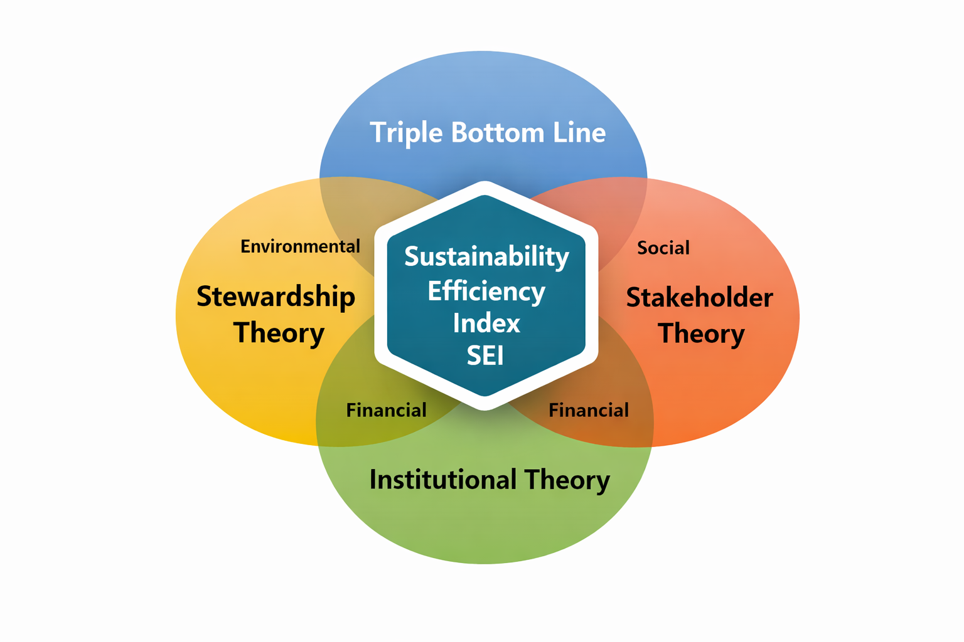

- Figure A2: Comparative SEI scores (bar chart) for Thames Tunnel, Delhi Metro, Hyderabad Metro, NEWater.
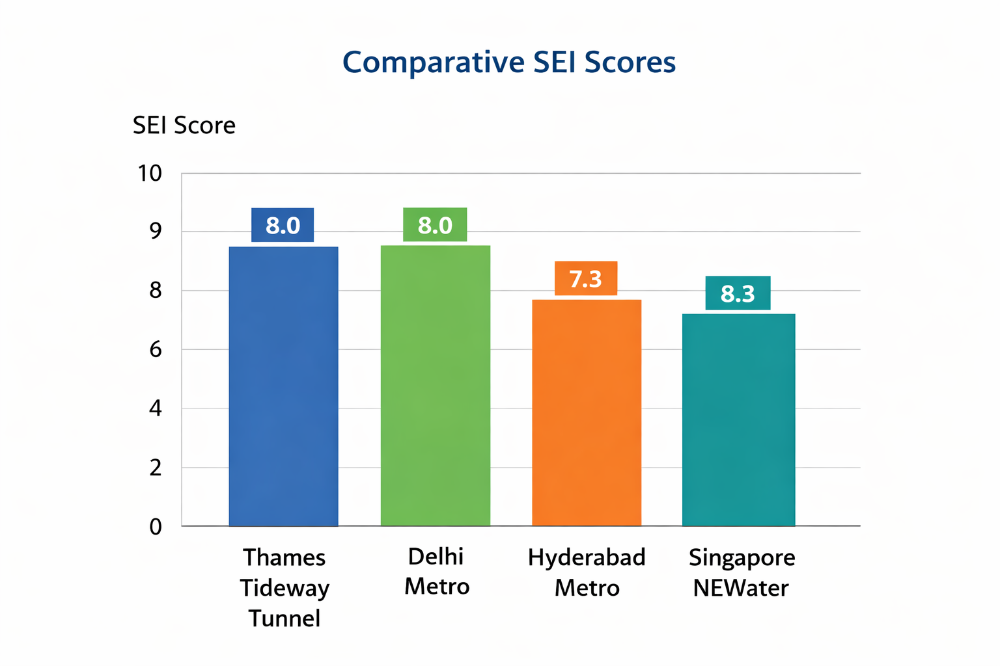

- Figure A3: Policy roadmap infographic linking Risks → SEI Impact → Policy Recommendations → Sustainable Outcomes.
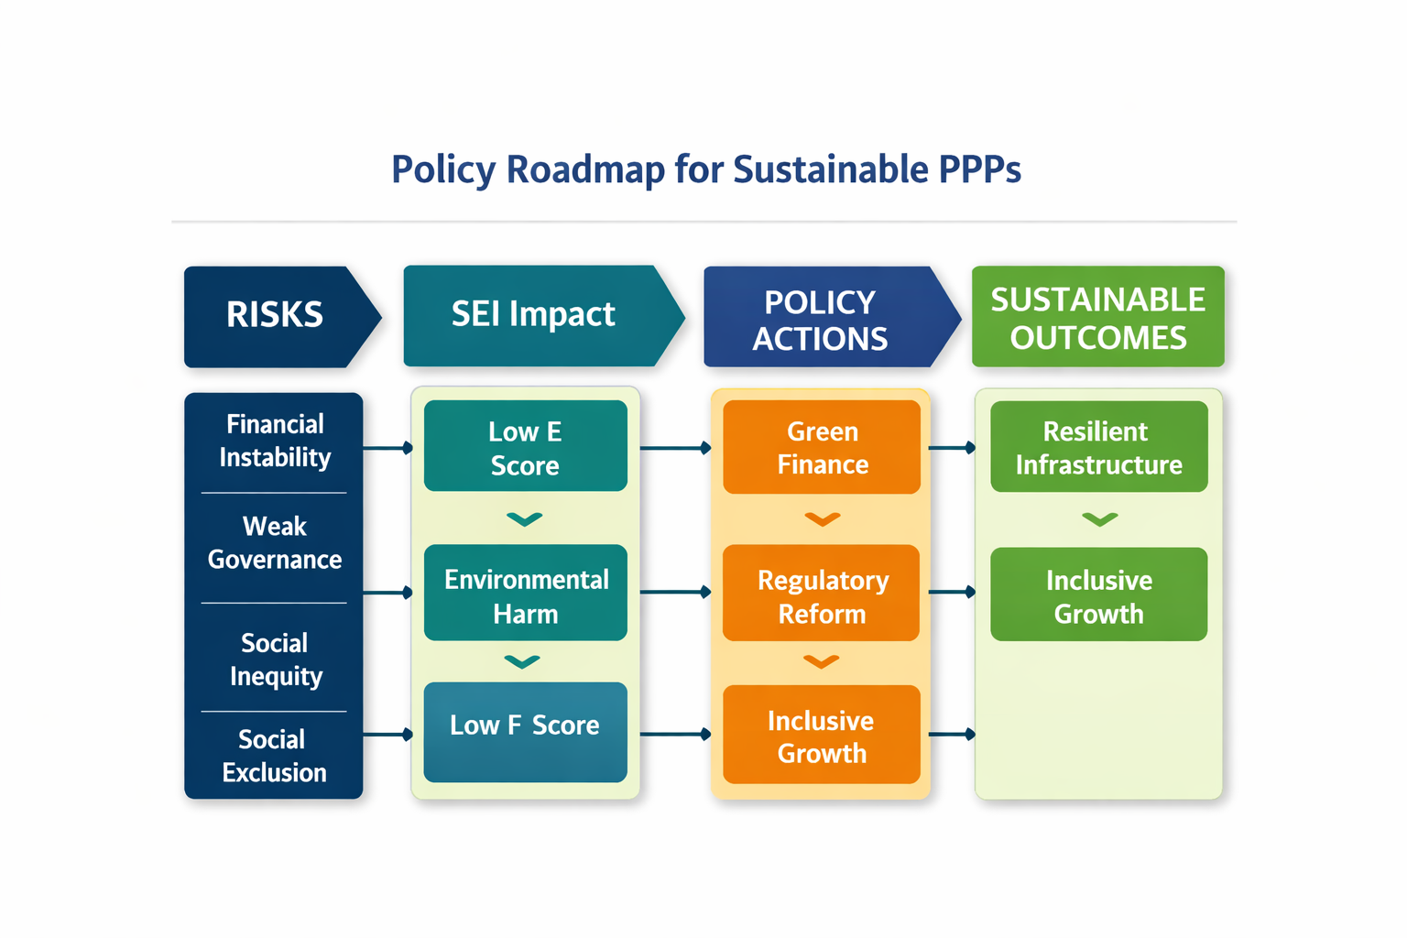

Appendix F: Glossary of Key Terms
- PPP (Public–Private Partnership): A cooperative arrangement between government and private sector for infrastructure delivery.
- SEI (Sustainability Efficiency Index): Composite metric integrating environmental, social, and financial dimensions.
- Viability Gap Funding (VGF): Government support to make PPP projects financially viable.
- Smart Cities Mission: Government of India initiative to promote sustainable urban development.

