Synthesis, Characterization and Antimicrobial applications of Silver Nanoparticles against Pathogens isolated from Shrimp Farm Aquaculture Effluent

ABSTRACT
The investigation demonstrated the applications of nanotechnology in the analysis and treatment of shrimp farm effluent. A novel method of green synthesis of silver nanoparticles were obtained for studying the antimicrobial properties of nanoparticles against the major pathogens isolated from shrimp farm effluent. Appearance f reddish brown indicates the formation of silver nanoparticles. A characteristic peak obtained at 430 nm by UV visible spectroscopy analysis confirmed the reddish brown precipitate of silver nanoparticle formation. An average particle size of 263.3 nm was contributed to 92.3 percentage compostion of nanoparticle synthesis was revealed by particle size analysis. Based on the Scherer’s formula, the absolute size of the particle was determined as70.35nm and 40.85 nm by XRD analysis. The surface morphology of the obtained nanoparticles was found to be relatively ball shaped structure.The FTIR analysis of silver nanoparticles expressed the formation of C=0 C=N, C-C bonds formed during the reduction of the substrate silver nitrate to silver nanoparticle formation.
The shrimp farm effluent sample collected was serially diluted and plated on macconkey agar and Luria bertani agar for typical isolation of the colonies. Two morphologically distinct colonies, namely, creamy white and transulent greenish blue colonies were subcultured on agar slants and stabs. Biochemical characterization of the colonies were performed and the organisms dominating the effluents was found to be Pseudomonas aerogenosa 30% and Escherichia coli 70%. It was noted that silver nanoparticles produced pronounced zone of clearance of 6mm diameter, which was found to be similar to that of zone of clearance produced by cefitaxamine, where as Polymixin exhibits 0.5mm and penicillin exhibits 5mm diameter against Pseudomonas aerogenosa. Similarly, the zone of clearance produced by silver nanoparticle was found to be 5.5mm, whereas polymixin, penicillin and cefitaxamine exhibit 3.0mm, 5.4mm and 5.7mm diameter against Escherichia coli. From the investigation, it was reported that for the two shrimp farm effluent dominating pathogens namely Pseudomonas aerogenosa and Escherichia coli, the silver nanoparticles exhibit potential antimicrobial activity which was found to be equal to that of the antibiotics, used in aquaculture farms and shrimp farms. This antimicrobial property and surface plasmon resonance of silver nanopartilces were exploited in the microbial load reduction in shrimp farms as well as in load detection and effluent treatment of aquaculture farms and shrimp farms.

Keywords: Silver nanoparticle, Pseudomanas aerogenosa, Escherichia coli, Polymixin, Penicillin, Cefitaxamine
INTRODUCTION
Most of the chemical methods used for the synthesis of nanoparticles are too expensive and also involved with the use of toxic and hazardous chemicals that are responsible for various biological risks. But, synthesis of nanoparticles using plant extracts is the most adopted method as green, eco-friendly production of nanoparticles and also has a special advantage in such a away, that the plants are widely distributed, easily available, much safer to handle and act as a source of several metabolites (Ankamwar et al 2005).
Also, most of the antibiotics seem to be less sensitive towards many organisms. Hence, researchers started to find a new potential antimicrobial agent (Kim et al 2007). With this respect, silver and silver- based compounds are established to have a strong bacteriocidal and fungicidal activity (Zhao et al 1998, Spadaro et al 1974). Nanoparticles having larger surface area to volume ratio tend to pose higher antimicrobial activity (Lok et al 2007). Also, Silver has a lower propensity to stimulate microbial resistance than many other antimicrobial agents (Silver et al 2007). Based on these properties, green synthesis of silver nanoparticle was investigated.
Rajeev et al., 2021 reported that the aquaculture industry is the fastest growing industry posing increasing demand on wild fish on export which was found to be estimated to reach one million worldwide by the end of 2030. Iber et al., 2021 reported that the feed of the shrimp constitute only 20–25 percent of the crude protein, whereas the remaining was left over a organic waste at the bottom of the shrimp pond. Investigations revealed that one kilogram of shrimp feed intake liberate 50 g of ammonia nitrogen.
Ni et al., 2021 stated that the Bioremediation of wastewater treatment inside the pond as well as outside the pond for effluent treatment were being carried out by growing beneficial organisms for reducing the contaminants. Thornber et al., 2010 stated that shrimp aquaculture precisely relies on the external nutriet supplement so that excess of the feed would remain as sediments causing cotamination load to the pond.
Lyle-Fritch et al., 2006 notfied that excess feed additives, antibiotics, pesticides and disinfectants were identified as major pollutant of shrimp farm. Lee et al., 2019 reported that disease causing organisms were developing antimicrobial resistance AMR which was found to be a big threat to the environment. León-Cañedo et al., 2019 stated that Shrimp farmers and consumers exposed to toxic effluent of shrimp farm might develop infectious disease.
Md. Yusoff et al., 2011 reported that excess accumulation of nutrients leads to eutrophiation an algalbloom, in the ecosystem. Wang et al., 2021 investigated and reported that untreated effluent discharge into te environment mightleads to ozone layer depletion by emission of nitrous oXide (N₂O) and methane (CH₄) to the atmosphere.
. Manyangadze et al., 2020 demonstarted that the adsorption of cotaminants over the active site of nanoadsorbents was made into usage for effluent treatment process.

MATERIALS AND METHODS

Green synthesis and characterization of silver nanoparticles
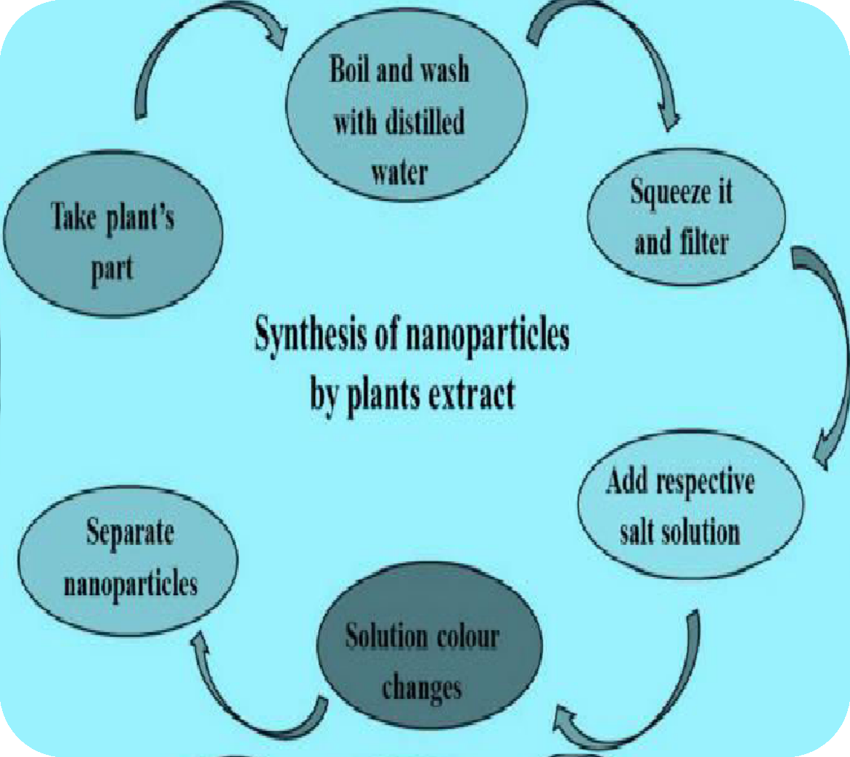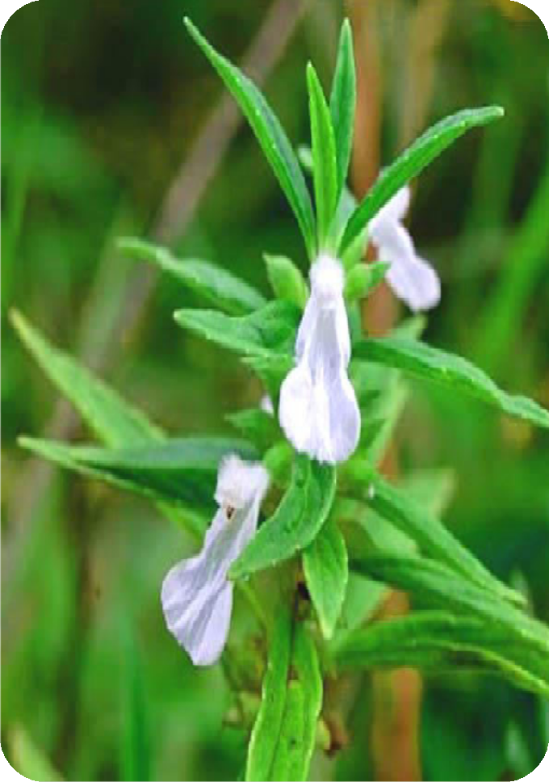

Fig.2 Thumbai (Lucas aspera) - medicinal plant

1mM aqueous AgNO₃ solution was prepared. 0.5 ml of the Lucas aspera leaf extract was added to 10 ml of 1 mM AgNO₃ (aqueous) solution and kept in dark for 48 hours for the formation of silver nanoparticles.
Characterization of the synthesized silver nanoparticles were performed by UV visible spectrophotometry(UV-Vis), Particle Size Analysis (PSA), X-Ray Diffraction analysis(XRD), Scanning Electron Microscopy(SEM) and Fourier Transform Infra-Red Spectroscopy (FTIR).

Screening and identification of microbes isolated from the shrimp farm aquaculture effluent through serial dilution technique

A stock solution of Shrimp farm aqualculture effluent (15ml) was taken in a conical flask. 1ml of stock solution was taken and it was serially diluted from 10⁻¹ to 10⁻⁶ dilution. The sample taken from the last dilutions were plated on Macconkey agar and Luria Bertani agar plates by spread plate technique. Morphologically distinct colonies were then subcultured on agar slants and stabs. Biochemical characterization of the colonies were studied and grouping of organisms was made.

Well diffusion assay for the determination of antimicrobial activity of silver nanoparticles against the isolated effluent microbes

Two Petriplates containing macconkey agar and two petriplates containing Luria bertani agar were inoculated with the bacterial strains isolated through serial dilution of the Shrimp aquaculture effluent treatment. Four wells were made by well puncture and the first well was loaded with 10µg/ml concentrations of Ag nanoparticles and the remaining wells were loaded with 10µg/ml concentrations of reference antibiotics namely polymixin, Penicillin, and cefitaxamine. The plates were kept for 24 hours of incubation at 37ºC. The zone of inhibition (in diameter) was measured.

RESULTS AND DISCUSSION

Formation of Silver Nanoparticles
When 1mM AgNO₃ solution was added to the leaf extract of Lucas aspera, pale yellow coloured broth gradually changes to brownish red coloured solution, which indicates the formation of silver nanoparticles. The formed nanoparticles were found to be stable and are uniformly distributed throughout the solution.


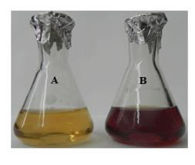

Fig.1 Formation of reddish brown colour indicating silver nanoparticle formation

U-V Spectrophotometry Analysis

A characteristic peak was observed at 430 nm confirmed the formation of silver nanoparticles. The broadening of the peak indicates the uniform distribution and polydispersion of silver nanoparticles obtained from the leaf extract of Lucas aspera.
The frequency and width of the surface plasmon absorption depends on the size and shape of the metal nanoparticles as well as on the dielectric constant of the metal itself and the surrounding medium.
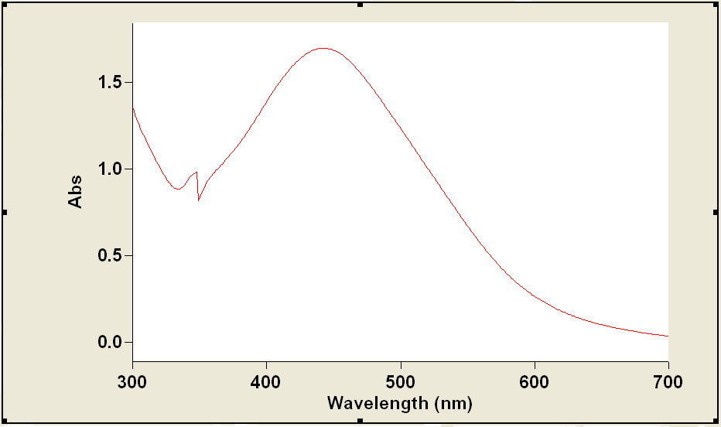

Fig.2 A characteriestic peak at 430nm indicates the absorbance of reddish brown colour formation of silver nanoparticles

Particle Size Analysis
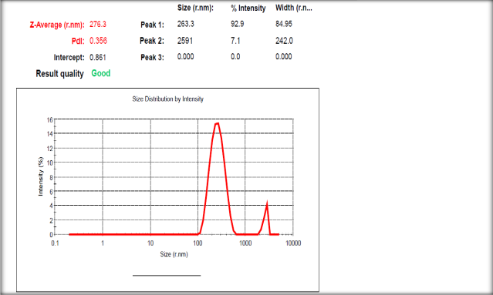

Fig.3 An average size of 263.3 nm constitutes 92.9 percentage of silver nanoparticle formation

The average size of the particle was calculated to be 263.3nm, which constitutes 92.9 percentile for the synthesized silver nanoparticles at 100% intensity.

X-RD Analysis

Based on the characteristic peaks obtained, the average size of the particle was calculated as 70.35 nm and 40.85 nm respectively, using scherer’s formulae. The presence of intense peaks of silver nanoparticles was indexed as crystalline silver face-centered cubic (fcc) phase.
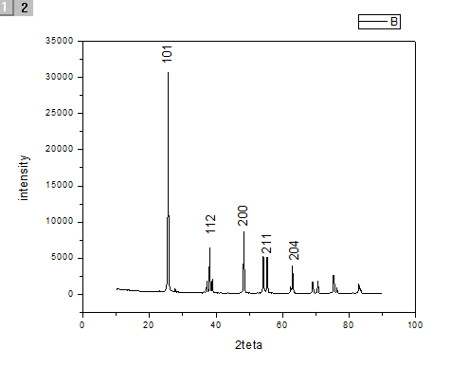
Fig.4 The absolute size of the nanoparticle was ranges between70.35nm and 40.85nm

SEM Analysis

Based on the SEM results, the morphology of the particle was found to be ball shaped. Almost similar type of SEM image was precisely reported for silver NPs synthesized by chemical reduction method which are spherical in shape and have a smooth surface morphology.

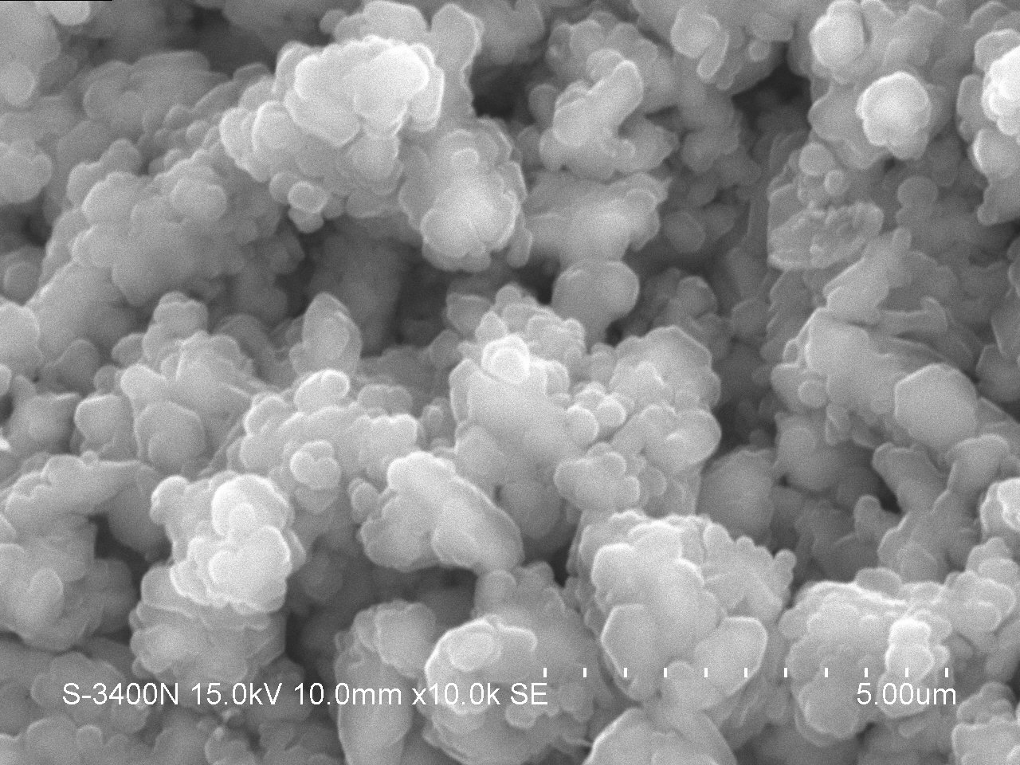
Fig 5 SEM image depicting relatively ball shaped Ag Np

FTIR Analysis

The higher energy region peaks at 3440 cm⁻¹ corresponds to alchohol or phenol O-H stretching (broad) was observed. The peaks 2946cm⁻¹, 2351cm⁻¹and 2108cm⁻¹ are assigned to alkyl C-H stretches of silver nanoparticles respectively. Besides, a stretch of carboxylic acid C=O and an amide stretch of C=O was observed at 1714 cm⁻¹ and 1638cm⁻¹ respectively.

The FTIR spectra indicate various functional groups present at different positions. The appearance of peaks in the amide I and amide II regions corresponds to of proteins/enzymes that have been found to be responsible for the reduction of metal ions when using the plant extract for the synthesis of silver nanoparticle (Yamini S et al 2011).
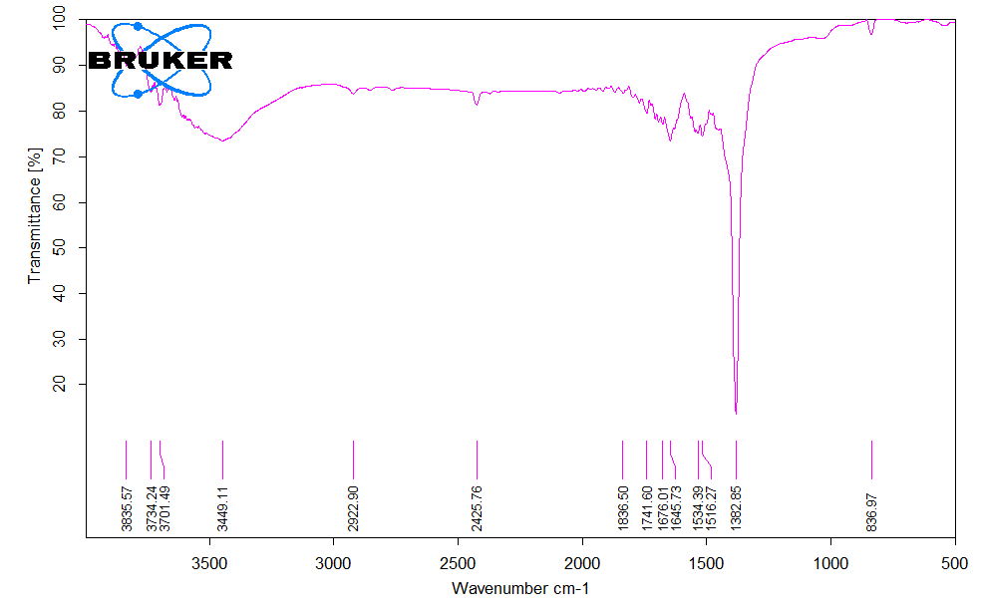
Fig.6 FTIR analysis depicting the bonds and linkages involving the reduction of characteristic functional groups of silver nanoparticle formation.

Isolation of microbes taken from the shrimp aquaculture effluent through serial dilution technique

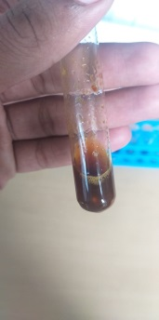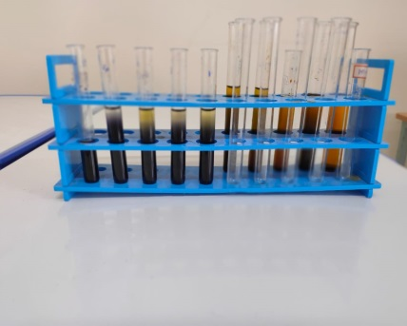
Fig.7 Serial Dilution of shrimp farm effluent
The effluent was serially diluted from 10⁻¹ to10⁻⁶ dilution and randomly the difference in the turbidity of the solution was observed .The effluent was found to be concentrated at 10⁻¹ dilution, whereas it was lighter as it reached the dilution of 10⁻⁶.
If the solution was concentrated, the colonies were found to be uncountable. The study was mainly aimed to isolate the morphologically distinct individual colonies, highest dilution of the effluent 10⁻⁶ was taken for investigation.

Screening of colonies by spread plate technique and sub culturing of the screened colonies by quadrant streaking

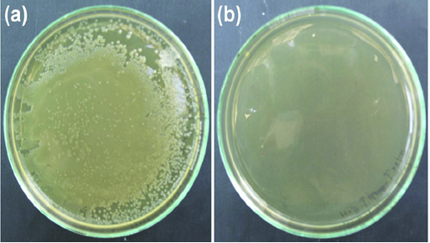
Fig.8 Morphologically distinct Colonies formed by Spread Plate technique

The figure 8 (a) exhibit the growth of colonies on the media, whereas the figure 8 (b) exhibits no growth, which was served as control. The colonies are countable and enumerated as colony forming Unit.
Two characteristic morphologically different colonies were observed. A typical creamy white colony and a transculent greenish colony were subcultured by quadrant streaking.

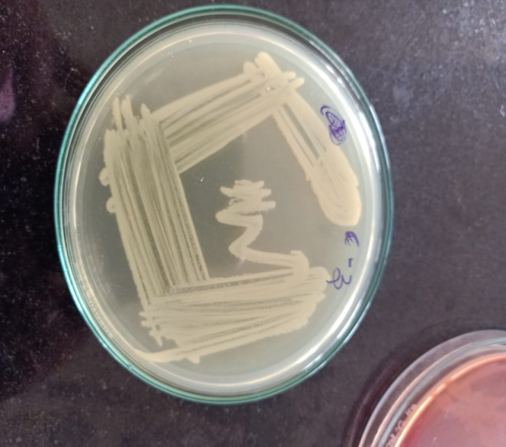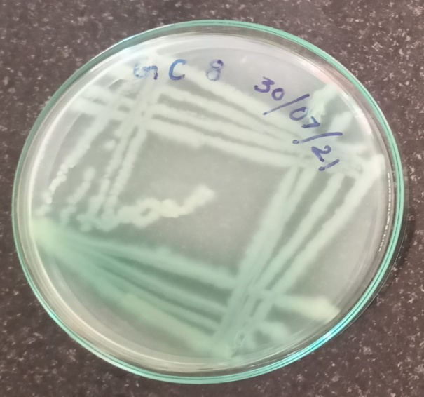

Fig. 9 Creamy white colony Fig. 10 Transulent greenish white colony

Identification of the Microbes by biochemical Characterization
Biochemical characterizationof the screened colonies were performed by IMVIC test and Gram’s staining procedure and the genus were identified as Pseudomonas and Escherichia. Based on the results obtained, the organisms are grouped under Bergey’s Manual of Determinative Bacteriology and the genus were identified as Pseudomonas aerogenosa and Escherichia coli, which was isolated and screened from the shrimp farm effluent.

Determination of antimicrobial activity of the silver nanoparticles against Pseudomonas aerogenosa with reference to the activity of polymyxin, penicillin & cefitaxamine by well diffusion assay
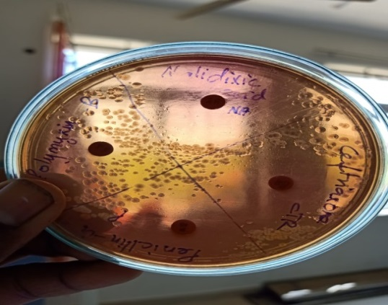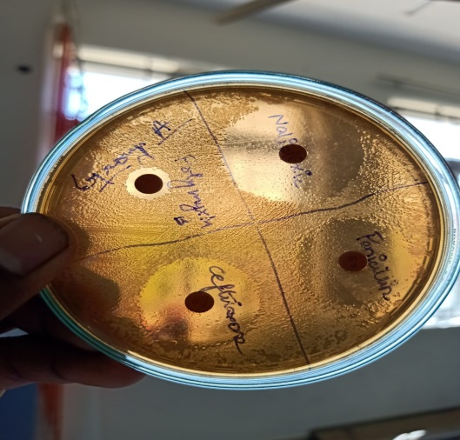
Fig.11. Zone of clearance produced Ag Np, polymixin, penicillin & cefitaxamine against Pseudomonas aerogenosa

Two Macconkey agar petriplates were inoculated with Pseudomonas aerogenosa. It was observed that 10µg/ml concentration of silver nanoparticle and 10µg/ml concentration of reference antibiotics namely polymyxin, penicillin, and cefitaxmine were loaded on the four wells consequetively. A characteriestic zone of clearance was observed. The diameter of zone of inhibition was calculated from the centre of the cavity to the boundary of the zone. It was predicted that 30% of the colonies on the plate were found to be pseudomonas aerogenosa, the second dominating organism present in the shrimp farm effluent
Replica of the experiment was performed. It was observed that silver nanoparticles exhibit 6.0 mm diameter of zone of clearance, whereas polymyxin exhibit 0.5mm, penicillin exhibit 5mm, and cefitaximine exhibit 6mm diameter.

This inferred the potency of the antimicrobial property of silver nanoparticles against pathogens present in the effluent. Also, even at lower concentration 10µg/ml, the bactericidal effect was pronounced by silver nanoparticle which was found to be equal to that of antibiotics, which was taken as reference.

Determination of antimicrobial activity of the silver nanoparticles against Escherichia coli with reference to the activity of polymyxin, penicillin & cefitaxamine by well diffusion assay

Two Luria bertani agar plates were inoculated with Escherichia coli. . It was also observed that 70% of the colonies present in the effluent was E.coli and it was the first dominating organism present in the shrimp farm effluent. Four wells were made by well puncture and the wells were loaded with 10µg/ml concentration of silver nanoparticles and reference antibiotics 10µg/ml concentration of polymyxin, penicillin and cefitaxamine consequetively. After 24 hrs of incubation, a typical zone of clearance was observed around the wells
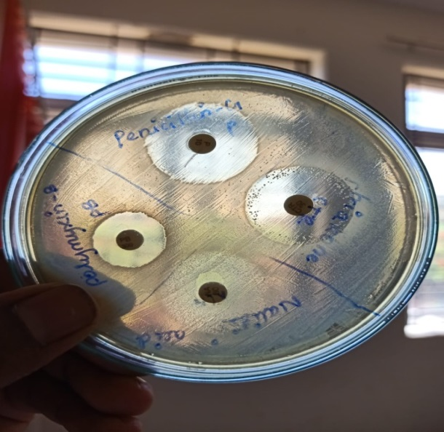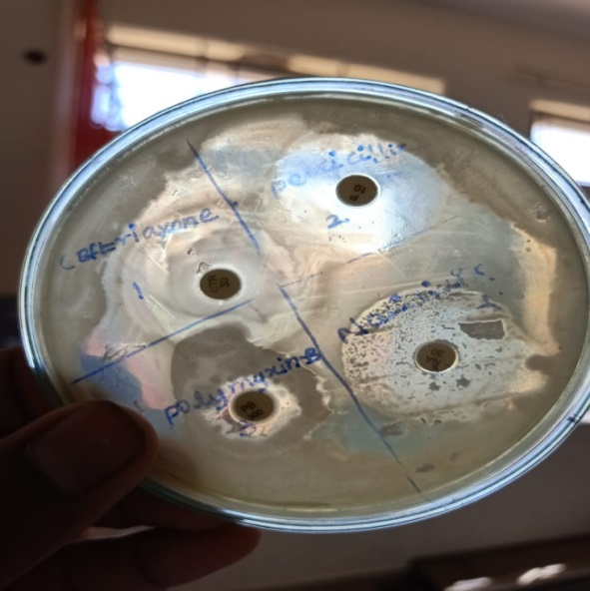
Fig, Zone of clearance produced Ag Np, polymixin, penicillin & cefitaxamine against Escherichia coli
The diameter of the zone of clearance was measured. It was found that silver nanoparticles exhibit 5.5mm diameter, whereas polymyxin exhibit 3mm diameter,penicillin exhibit 5.7mm diameter and cefitaxamine exhibit 5.4mm diameter of zone of clearance.
From the investigation, it was observed that the silver nanoparticle exhibit potenctial antibacterial effect , which was found to be equal to that of penicilin against the predominant pathogen Eschericha coli present in the effluent.

- CONCLUSIONS

From the above experimental analysis, it was concluded that, the silver nanoparticle synthesized through green synthesis will serve as a good antimicrobial agents exhibiting pharmacological effects equal to that of the antimicrobial effects of antibiotics. This antimicrobial property was exploited in the treatment of shrimp farm effluent. This research work demonstrates the implementation of new technology named as” Nanotechnology” in environmental applications. The silver nanoparticles can be used in similar to that of antibiotics in shirmp farm as well as in fish farm aquaculture to achieve microbial load reduction. Silver nanoparticles are extensively used in Biosensors to detect the microbial load present in the effluent.
REFERENCES
- Kaviya et al 2008 Kaviya, S, Santhanalakshmi, J & Viswanathan, B 2008, 'Green Synthesis of silver nanoparticles using Polyalthia longifolia Leaf extract along with D-Sorbitol', Journal of nanotechnology, vol. 2011, no.10, pp 1-5.

- Ankamwar et al 2005 Ankamwar, B, Chaudhary, M, Sastry, M, Tamarind, K & Govindaraju 'Gold nanoparticles biologically synthesized using leaf extract and potential application in vapour sensing', Synthesis and Reactivity in Inorganic,Metal-organic and Nano-metal Chemistry,vol.35, pp. 19-26.

- Kim et al 2007 Kim, JS,Kuk, E, Yu, KN, Kim, JH, Park, SJ, Lee, HJ, Kim, SH, Park, YK,Park, YH, Hwang, CY, Kim, YK, Lee, YS,Jeong, DH & Cho, MH 2007, 'Antimicrobial effects of silver nanoparticles', Nanomedicine, vol.3, no.l, pp. 95 -101

- Zhao et al 1998 Zhao,G & Stevens, SE 1998, 'Multiple parameters or the comprehensive evaluation of the susceptibility of Escherichia coli to the silver ion', Biometals, vol.11, no.l, pp. 27-32.

- Spadaro et al 1974, Spadaro, JA, Berger, TJ, Barranco, SD, Chapin, SE & Becker, RO 1974, 'Antibacterial effects of silver electrodes with weak direct current', Antimicrobial agents chemotherapy, vol. 6, no. 1, pp. 637-642

- Lok et al 2007Lok, CN,Ho, CM, Chen, R, He, QY, Yu, WY, Sun, H, Tarn, PK, Chiu, JF & Che, CM 2007, Silver nanoparticles: partial oxidation and antibacterial activities', Journal of biological inorganic chemistry, vol.12, no.4, 572-534

- Silver et al 2007Silver, S, Phung, LT & Silver, G 2007, 'Silver as biocides in burn and wound dressings and bacterial resistance to silver compounds', Journal of Indian Microbiology Biotechnology, vol.33, no. 1, pp. 627 -634.

- Jeong et al 2005 Jeong, SH, Yeo, SY & Yi, SC 2005, 'The effect of filler particle size on the antibacterial properties of compounded polymer/ silverfibers', Journal of Material Science, vol. 40, no.l, pp. 5407-5411.

- Krutyakov et al 2008 Krutyakov, YA, Kudrynskiy, A, Olenin, AY & Lisichkin, GV 2008, 'Extracellur biosynthesis and antimicrobial activity of silver nanoparticles*, Russian Chemical reviews, vol.77, no.3, pp.233257- 233259.

- Kasthuri et al 2009 Kasthuri, J, Kathiravan, K & Rajendran, N 2009, 'Phyllanthin assisted biosynthesis of silver and gold nanoarticles a novel biological approach, Journal of nanoparticle research, vol.11, no.l, pp.1075-1085

- Rai et al 2009, Rai, M & Yadav, A, 'Silver nanoparticles as a new generation of antimicrobials', Biotechnology advances, vol.12, no.l, pp.76 - 83.

- Thomas et al 2007 Thomas, V, Yallapu, VV, Sreedhar, B & Bajpai, SK 2007, 'A versatile strategy to fabricate hydrogel silver nanocomposites and investigation of their antimicrobial activity Journal of Colloid and Interface Science, vol. 315, no. 1, pp. 389-395.

- Amarendra etal 2010 Amarendra Dhar Dwivedi & Krishna Gopal 2010, 'Biosynthesis of silver and goldnanoparticles using Chenopodiumalbum leaf extract', Colloid Surface A, vol. 20, pp. 27-33

- Guidelli et al 2011.) Guidelli, EJ, Ramos, ME, Zaniquelli, D & Baffa, O 2011, 'Green synthesis of colloidal silver nanoparticles using natural rubber latex extracted from Hevea brasiliensis', Spectrochimca Acta A Molecular and Biomolecular Spectroscopy, vol. 82, no.l, pp.140-145.

- Peter et al 2004 Peter HM Hoet, Irene, BH & Oleg, VS 2004, 'Nanoparticles : Known and unknown health risks', J. biotechnology, vol. 2, no. 12, pp. 3155-212

- Mehrdad & Khalil 2010 Mehrdad, F & Khalil, F 2010, 'Biological and green synthesis of silver nanoparticles', Turkish J. Eng. Env. Sci., vol. 34, pp. 281-287.

- Ramya & Sylvia Subapriya 2012 Ramya, M & Sylvia Subapriya 2012, 'Green synthesis of silver nanoparticles', Int. J. Pharm. Med.& Bio. Sc., vol. 1, no.l, pp. 54-61.

- Rajeev, R., Adithya, K.K., Kiran, G.S., Selvin, J., 2021. Healthy microbiome: a key to successful and sustainable shrimp aquaculture. Rev. Aquacult. 13 (1), 238–258

- Patil, P.K., Antony, L., Avunje, S., Viswanathan, B., Lalitha, N., Jangam, A.K., Kumar, D.,Solanki, H.G., Reddy, M.A., Alavandi, S.V., Vijayan, K.K., 2021. Bioaugmentation with nitrifying and denitrifying microbial consortia for mitigation of nitrogenous metabolites in shrimp ponds. Aquaculture 541 (July 2020), 736819.

- Iber, B.T., Okomoda, V.T., Rozaimah, S.A., Kasan, N.A., 2021. Eco-friendly approaches to aquaculture wastewater treatment: assessment of natural coagulants vis-a-vis chitosan. Bioresour. Technol. Rep. 15 (March), 100702.

- Ni, M., Yuan, J., Zhang, L., Hua, J., Rong, H., Gu, Z., 2021. In- situ and ex- situ puriﬁcation effect of ecological ponds of Euryale ferox Salisb on shrimp aquaculture. Aquaculture 540 (March), 736678

- Mo€ller, D.M., Ferrante, M., Mo€ller, G.M., Rozenberg, T., Segoli, M., 2020. The Impact ofTerrestrial Oil Pollution on Parasitoid Wasps Associated With Vachellia (Fabales: Fabaceae) Trees in a Desert Ecosystem, Israel. Environ. Entomol. 49 (6), 1355–1362

- Ge, J., Zhang, Y., Heo, Y.J., Park, S.J., 2019. Advanced design and synthesis of composite photocatalysts for the remediation of wastewater: A review. Catalysts 9 (2), 122

- Tampangallo, B.R., Asaad, A.I.J., Undu, M.C., Kadriah, I.K., Anshary, H., 2020, September. Bacterial diversity in superintensive vanname shrimp aquaculture wastewater treatment plants in Barru and Takalar Regencies. In: In IOP Conference Series: Earth and Environmental Science (Vol. 564, No. 1, p. 012007). IOP Publishing.

- Thornber, B., Drikakis, D., Youngs, D.L., Williams, R.J.R., 2010. The inﬂuence of initial conditions on turbulent mixing due to Richtmyer–Meshkov instability. J. Fluid Mech. 654, 99–139

- Lyle-Fritch, L.P., Romero-Beltr´an, E., P´aez-Osuna, F., 2006. A survey on use of thechemical and biological products for shrimp farming in Sinaloa (NW Mexico). Aquacult. Eng. 35 (2), 135–146.

- Anh, P.T., Kroeze, C., Bush, S.R., Mol, A.P., 2010. Water pollution by intensive brackish shrimp farming in south-east Vietnam: Causes and options for control. Agric. Water Manag. 97 (6), 872–882.

- Jasmin, M.Y., Syukri, F., Kamarudin, M.S., Karim, M., 2020. Potential of bioremediation in treating aquaculture sludge. Aquaculture 519, 734905

- Lyles, C., Boopathy, R., Fontenot, Q., Kilgen, M., 2008. Biological treatment of shrimp aquaculture wastewater using a sequencing batch reactor. Appl. Biochem. Biotechnol. 151 (2–3), 474–479.

- Md. Yusoff, F., Mohamed Din, M., Banerjee, S., Khatoon, H., 2011. Biological approaches in management of nitrogenous compounds in aquaculture systems. Dyn. Biochem. Process Biotechnol. Mol. Biol. 5 (1), 21–31.

- Thornber, K., Verner-Jeffreys, D., Hinchliffe, S., Rahman, M.M., Bass, D., Tyler, C.R., 2020. Evaluating antimicrobial resistance in the global shrimp industry. Rev.Aquacult. 12 (2), 966–986.

- Lee, G., Suzuki, A., Nam, V.H., 2019. Effect of network-based targeting on the diffusion ofgood aquaculture practices among shrimp producers in Vietnam. World Dev. 124, 104641

- Leo´n-Can~edo, J.A., Alarco´n-Silvas, S.G., Fierro-San~udo, J.F., de Oca, Partida- Ruvalcaba, L., Díaz-Vald´es, T., P´aez-Osuna, F., 2019. Mercury and other trace metals in lettuce (Lactuca sativa) grown with two low-salinity shrimp efﬂuents: Accumulation and human health risk assessment. Sci. Total Environ. 650, 2535–2544.

- Md. Yusoff, F., Mohamed Din, M., Banerjee, S., Khatoon, H., 2011. Biological approaches in management of nitrogenous compounds in aquaculture systems. Dyn. Biochem. Process Biotechnol. Mol.Biol.5(1),21–31.

- Wang, D., Xie, X., Tang, W., Pan, H., Luo, J., 2021. Suitability of Nansha mangrovewetland for high nitrogen shrimp pond wastewater treatment. Bull. Environ. Contam. Toxicol. 106 (2), 349–354.

- Johnson, F.A., Hutton, C.W., Hornby, D., L´az´ar, A.N., Mukhopadhyay, A., 2016. Is shrimpfarming a successful adaptation to salinity intrusion? A geospatial associative analysis of poverty in the populous Ganges–Brahmaputra–Meghna Delta of Bangladesh.Sustain. Sci. 11 (3), 423–439.

- Khan, M.S., Abdullah, S., Salam, M.A., Mandal, T.R., Hossain, M.R., 2021. Review assessment of biodiversity loss of Sundarban forest: highlights on causes and impacts. Indones. J. For. Res. 8 (1), 85–97.

- Manyangadze, M., Chikuruwo, N.H.M., Chakra, C.S., Narsaiah, T.B., Radhakumari, M.,Danha, G., 2020. Enhancing adsorption capacity of nano-adsorbents via surface modiﬁcation: A review. South Afr. J. Chem. Eng. 31 (1), 25–32. https://hdl.ha ndle.net/10520/EJC-1d762a36ff

