A STUDY TO FIND THE EFFICIENCY OF KINESIO TAPING VERSUS RIGID TAPING IN ANKLE INSTABILITY AMONG BADMINTON PLAYERS



 | Abstract | 16
2. | Introduction | 19
3. | Need of study | 24
4. | Aim and objectives | 26
5. | Hypothesis | 28
6. | Reviews of literature | 30
7. | Methodology | 37
8. | Statistical analysis | 46
9. | Results | 67
10. | Discussion | 69
11. | Summary | 71
12. | Conclusion | 73
13. | Limitation and recommendation | 75
14. | Bibliography | 77
15. | Annexures | 82

LIST OF TABLES

Table  No. | Description | Page No.
1. | Distribution of male and females in two groups (kinesio Taping, rigid  taping) | 47
2. | Comparison of two groups (kinesio Taping, rigid taping) with mean age  by independent t test | 48
3. | Normality of pre-test and post-test scores of all parameters in two  groups (kinesio Taping, rigid taping) by Kolmogorov Smirnov test | 49
4. | Comparison of two groups (kinesio Taping, rigid taping) with pre-test  and post-test strength and balance in ankle sprain at posterior side by independent t test | 50
5. | Comparison of two groups (kinesio Taping, rigid taping) with pre-test  and post-test strength and balance | 53
6. | Comparison of pre-test and post-test strength and balance in ankle  sprain at PosterioLateral side in two groups (kinesio Taping, rigid taping) by dependent t test | 54
7. | Comparison of two groups (kinesio Taping, rigid taping) with pre-test  and post-test strength and balance in ankle sprain at Posterio medial side by independent t test | 55
8. | Comparison of pre-test and post-test strength and balance in ankle  sprain at Posterio medial side in two groups (kinesio Taping, rigid taping) by dependent t test | 56
9. | Comparison of two groups (kinesio Taping, rigid taping) with pre-test  and post-test strength and balance in ankle sprain at lateral side by independent t test | 57
10. | Comparison of pre-test and post-test strength and balance in ankle  sprain at lateral side in two groups (kinesio Taping, rigid taping) by dependent t test | 58

11. | Comparison of two groups (kinesotaping, rigid taping) with pre-test  and post-test strength and balance in ankle sprain at medial side by independent t test | 59
12. | Comparison of pre-test and post-test strength and balance in ankle  sprain at medial side in two groups (kinesio Taping, rigid taping) by dependent t test | 60
13. | Comparison of two groups (kinesio Taping, rigid taping) with pre-test  and post-test strength and balance in ankle sprain at anterior side by independent t test | 61
14. | Comparison of pre-test and post-test strength and balance in ankle  sprain at anterior side in two groups (kinesio Taping, rigid taping) by dependent t test | 62
15. | Comparison of two groups (kinesio Taping, rigid taping) with pre-test  and post-test strength and balance in ankle sprain at Anterio lateral side by independent t test | 63
16. | Comparison of pre-test and post-test strength and balance in ankle  sprain at Anterio lateral side in two groups (kinesio Taping, rigid taping) by dependent t test | 64
17. | Comparison of two groups (kinesotaping, rigid taping) with pre-test  and post-test strength and balance in ankle sprain at Anterio medial side by independent t test | 65
18. | Comparison of two groups (kinesotaping, rigid taping) with pre-test  and post-test strength and balance in ankle sprain at Anteromedial side | 66

LIST OF FIGURES

Figure  No. | Description | Page No.
1. | Star excursion balance test chart | 41
2. | Applying of kinesio tape 1 | 42
3. | Applying of kinesio tape 2 | 42
4. | SEBT training after applying kinesio tape | 43
5. | Applying of rigid tape 1 | 44
6. | Applying of rigid tape 2 | 44
7. | SEBT training after applying rigid tape | 45

LIST OF GRAPHS

Graph  No. | Description | Page No.
1. | Distribution of male and female in two groups. | 47
2. | Comparison of two groups with mean age. | 48
3. | Comparison of two groups with pre and post-test at  posterior side by independent‘t’ test. | 50
4. | Comparison of two groups with pre and post-test at  Posterior side by dependent‘t ‘test. | 51
5. | Comparison of two groups with pre and post-test at  PosterioLateral side by independent‘t’ test. | 52
6. | Comparison of two groups with pre and post-test at  PosterioLateral side by dependent‘t’ test. | 53
7. | Comparison of two groups with pre and post-test at  Posterior medial side by independent‘t’ test. | 54
8. | Comparison of two groups with pre and post-test at  Posterior medial side by dependent‘t’ test. | 55
9. | Comparison of two groups with pre and post-test at  Lateral side by independent‘t’ test. | 56
10. | Comparison of two groups with pre and post-test at  Lateral side by dependent‘t’ test. | 57
11. | Comparison of two groups with pre and post-test at  Medial side by independent‘t’ test. | 58
12. | Comparison of two groups with pre and post-test at  Medial side by dependent‘t’ test. | 59

13. | Comparison of two groups with pre and post-test at  Anterior side by independent‘t’ test. | 60
14. | Comparison of two groups with pre and post-test at  Anterior side by dependent‘t’ test. | 61
15. | Comparison of two groups with pre and post-test at  Anterolateral side by independent‘t’ test. | 62
16. | Comparison of two groups with pre and post-test at  Anterolateral side by dependent‘t’ test. | 63
17. | Comparison of two groups with pre and post-test at  Anteromedial side by independent‘t’ test. | 64
18. | Comparison of two groups with pre and post-test at  Anteromedial side by dependent‘t’ test. | 65

LIST OF ABBREVIATIONS

ABBREVIATION | EXPANSION
KT | KINESIO TAPING
RT | RIGID TAPING
SEBT | STAR EXCURSION BALANCE  TRAINING

LIST OF ANNEXURES

ANNEXURE NO | DESCRIPTION | PAGE NO
1. | Institutional ethical clearance certificate | 83
2. | Consent form | 84
3. | Assessment form | 86
4. | Master chart Group1  Master chart Group 2 | 89

ABSTRACT

ABSTRACT

Background: The ankle is one of the important weight bearing joint in our body. Which is commonly injured by improper placing the foot on the ground or with a sudden deviation of gait pattern .commonly injury area in ankle is lateral side mainly lateral ligaments. The most frequent type of sprain is lateral ankle sprain .Mechanism of injury involves when the foot is an inverted position combined with plantar flexion. Which usually damages the lateral complex of ankle?

Ankle sprain is common among people who participate in sports. That involves running or frequent changes directions such as badminton players and other sports persons. In badminton players lateral ankle sprain happens when the foot rolls inwards stretching the lateral ligaments. It happens when badminton players steps on uneven ground.

Objective:
- To determine the effects of kinesio taping on lateral ankle instability in badminton players.
- To determine the effects of rigid taping on lateral ankle instability in badminton players.
- To compare the effects of kinesio taping versus rigid taping among badminton players for lateral chronic instability.

Methods:
40 participants both male and female with lateral ankle sprain with age between 18 -32years were included in the study based on inclusion and exclusion criteria, and were randomly assigned in to two groups, Group A and Group B. Group A received kinesio taping where as participants in Group B received rigid technique for two weeks strength and balance were checked by SEBT (star excursion balance test ) in both pre and post intervention

Results:
Data were analysed using paired t-test and one way ANOVA. Inter group data analysis
Shows p value as 0.001 for both the group but group 1 had greater effect as compared to group 2. There is significant difference in between the group (p < 0.05) thus rejecting the null hypothesis

Conclusion:
The study concludes that both the groups were effective in improving stability and strength of ankle but kinesio taping show more improvement than compared to rigid taping.

Keywords:
Lateral ankle sprain, rigid taping, kinesotaping, SEBT, Badminton players.

INTRODUCTION

INTRODUCTION:

Lateral ankle is one of the important weight bearing joint in our body which is commonly and most frequently injured joint in the ankle. Common injury site in ankle is the lateral side which is mainly the lateral ligaments. The Mechanism of injury involves when the foot is in an inverted position combined with plantar flexion which usually damage the lateral complex of ankle.

The ankle joint is the most congruent joint in the body and it is due to bony articulations, ligamentous capsules and tendons. The lateral complex of the ankle is made up the anterior talo-fibular ligament, calcaneo-fibular ligament and posterior talo-fibular ligament. The anterior talo-fibular ligament is the weakest among the three ligaments and is the most common to be injured. Its role is to limit plantar flexion and inversion of the ankle. ^{[1]}

Ankle sprains may be associated with long term complaints of pain, functional disability and absence from work. For these lateral ankle sprains standard treatments usually comprises of rest, ice, compression and leg elevation but additional treatment should be necessary. ^{[2]}

Ankle sprains may account for approximately 20%-40% of athletic injuries. 85% of athletic sprain are caused by excessive inversion. When the ankle rolls inward at a high velocity, it may lead to stretching or tearing of the lateral ligament complex. Ankle sprains are common among people who participate in sport. That involves running, jumping and hopping and also sudden frequent changes of directions in sports such as badminton, volleyball, soccer, football. Most ankle sprains can be treated successfully with an aggressive non-surgical care. ^{[3]}

The most common residual impairments includes re-sprains perceived instant instability and episodes of giving away joint laxity, pain, swelling and a feeling of weakness and subsequently reduces the level of physical activity. The residual impairments alone or in combination, are frequently its termed to chronic ankle instability.

Some ankle sprain causes various sensorimotor deficits that can lead to instability, that presence of instability increases the risk of further sprain. Despite the frequency of ankle sprains in athletes. The outcome associated with these injuries is less than optimal individual who sustain initial ankle sprain. ^{[4]}

For a player with sprained ankles, tapings—either elastic or non-elastic—are the most popular clinical therapeutic approach. Sports medicine specialists and players frequently employ the elastic therapeutic taping known as Kinesio taping (KT). The potential of KT to provide more comfort than regular taping has been described as acting as a prophylactic strategy against fast excessive supination of the ankle joint. Numerous studies have been done in this area to examine the effects of ankle KT on joint stability in people with chronic ankle sprains.There is conflicting research regarding how ankle KT affects postural sway. ^{[5]}

When such a condition in ankle is not identified in acute phase, it can be progressed to synovitis, tendinopathies, joint stiffness, muscle weakness, joint instability and persistent pain swelling. After the ankle sprain most of cases are likely to present with symptoms up to 16-18months after injury. In this acute phase of ankle sprain swelling is the most immediate response of the injury site which further progresses to the inflammation. ^{[6]}

Balance and coordination training are common components at intervention programmes for the prevention and treatment of lateral ankle sprain and chronic instability. Balance and coordination training could diminish proprioceptive defective which is associated with ligamentous injury to the ankle. The balance and coordination training may have both local and control effects of sensorimotor system. ^{[7]}

A concern for health care providers is the potential progression of acute ankle sprain to chronic problems, including arthritic changes in the joint. Symptoms have been shown to persist for 6weeks to 18months after a lateral ankle sprain in 55-72% of patients. ^{[8]}

In badminton players lateral ankle sprain happens when the foot rolls inwards stretching the lateral ligaments. It happens when a badminton player lands on uneven ground. In grade 1 ankle sprains the ligaments are stretched and have slight tear, in grade 2 ankle sprains ligaments are partially torn, in grade 3 ankle sprains ligaments are completely torn.

A person who sprains their ankle will feel pain with injury. The ankle will soon begin to swell and may form a bruise along the outside of ankle and foot. If someone has a grade 2 or 3 ankle sprain the ankle may feel unstable and wobbly, and walking may be difficulty. ^{[9]}

External support is the most common preventive method among the badminton players. Many studies have been done to establish its effectiveness. Some study suggest that orthoses reduces the incidence of ankle sprain in previously sprained ankles. The proprioception defects occur after an ankle sprain and the main effect of orthoses is to improve the proprioceptive function of previously injured ankle rather than to provide mechanical support alone. Additional biomechanical and clinical research is needed to determine the exact mechanism were by prophylactic ankle stabilisers effective in reducing ankle injuries. ^{[10]}

The kinesio-taping is a new type of technique was introduced by Kenzo Kase .it is supposed to improve local circulation, reduce oedema, facilitate or relax muscle, and improve joint function by enhancing sensory mechanism. Kinesio tape application of single strip can be left on skin for 3 to 5 days’ time, which is used to prevent ankle sprains. ^{[11]}

Kinesio tape provides constant pulling force to the skin. Kinesio tape is air permable and water resistant. It is used following injury and during the rehabilitation. Kinesio tape has therapeutic benefits. A) Altered muscle function by the tapes effects on weakened muscles. B) Improves circulation of blood and lymph by eliminating tissue fluid or bleeding beneath the skin. C) Decreased pain through neurological suppression. D) Repositioning of subluxed joints by
relieving abnormal muscle tension, and helping to affect the function of fascia and muscles. ^{[12]}

Rigid taping is the most common technique which has been used for a long time in sport injuries. It is mainly used on the joints such as ankles, knees, wrists, elbows and shoulders. The main role of the tape is to physically support the joint by limiting movement. The rigid tape is used in returning to sport after a joint sprain, for example an ankle sprain. It provides support and
stability that gives the players confidence to return to sports. ^{[13]}

SEBT is the most useful objective test for ankle sprain. It is useful for both balance and stability. It consists a series of lower extremity reaching tests in 8 directions that challenges the subject’s strength and balance. A subject can reach with 1 leg while balancing on the opposite leg. The ability to reach further with a limb requires a combination of better balance, strength and motion on the contralateral stance limb. ^{[14]}

Star excursion balance training was instructed and supervised during every session of exercise. The participants had to balance their body weight on the sprained ankle, while using another foot to reach as far as they could into eight directions as performed in the star excursion balance test.
[15]

The person who performing there tests couldn’t contact foot on ground while standing on the stance leg moving the stance foot. These star excursion balance test provides accurate data in the measurement of deviation length. The main aim of star excursion balance test is to reach the further possible point with one leg while maintaining balance on the contralateral leg. Subjects stand with the involved limb placed at the centre of grid. ^{[16]}

NEED OF THE STUDY

NEED OF STUDY:

- The purpose of this study is to compare the effectiveness of kinesio taping and rigid tapping to improve the muscle strength in badminton players with ankle instability.
- Ankle instability is the most common injury in the badminton players and affecting the muscular strength, balance, gait pattern and there are limited studies on the balance, strength and stability along with kinesio taping and rigid taping.
- So, the aim of this study is the compare both the kinesio and rigid taping in badminton players with ankle instability.

AIM AND OBJECTIVE

OBJECTIVES OF THE STUDY:

- To determine the effects of kinesio taping on ankle instability in badminton players.
- To determine the effects of rigid taping on ankle instability in badminton players.
- To compare the effects of kinesio taping versus rigid taping among badminton players for ankle instability.

HYPOTHESIS

NULL HYPOTHESIS:

There will be no significant difference between kinesio taping and rigid taping on ankle instability in badminton players.

ALTERNATIVE HYPOTHESIS:

There will be a significant difference between kinesio taping and rigid taping on ankle instability in badminton players.

REVIEW OF LITERATURE

REVIEW OF LITERATURE:
- Hengxian Liu et al, 2023: The purpose of this study was to know the effect of acute kinesio taping intervention on the muscle strength and balance ability of college basketball players with functional ankle instability. The study was conducted on a sample of 30 college basketball players were taken as sample to check the balance and muscle strength ability. The outcome measures used in this study was stick firm method, balance ability test and ankle isokinetic muscle strength test. The study result shows significant improvement in balance ability in functional ankle instability. This study also shows that kinesio taping is weaker in static balance test than compared to dynamic balance test. The study concludes that kinesio taping can increase the ankle muscle strength for the college basketball players who re affected with functional ankle instability. ^{[17]}

- Hisham M. Hussein et al, 2023: The aim of this study was to investigate the effect of Kinesio taping on balance and dynamic stability in recreational runners with ankle instability. The study was conducted on a sample of 90 recreational runners with ankle instability was taken. Three groups were taken KT group, mixed group (KT and exercise) and exercise group.
The outcome measures used was Biodex balance system and a star excursion balance test.
It’s a total of 8 weeks programmer. The result shows that the statically significant is better in mixed group when compared to kinesio taping group and exercise group. The study concludes that kinesotaping or exercise along ill not improve dynamic stability in individual. Kinesio taping along with exercise will improve the dynamic stability. Therefore the recreational runners are advised to practice both on balance and exercises also. ^{[18]}

- Yunqi Tang et al, 2023: The aim of this study was to know the effect of ankle orthoses, taping and insoles on postural stability of individuals with chronic ankle instability. The study was conducted on a total of 18 studies including chronic ankle instability. The outcome measures used in this study was Static and dynamic postural stability tests, such as the single-leg stance test, star excursion balance test, Y-balance test, single-leg landing test, lateral jump test, walking

Test and running test. The result of this study shows that orthoses, kinesio taping and insoles Show significant improvement in chronic ankle instability individuals. Orthoses reduces ankle Joint motion, taping improves cutaneous responses and insoles improve foot position awareness. The conclusion of this study shows that orthoses, taping and insoles in postural stability in the individuals with chronic ankle instability. ^{[19]}

- Pietro Nicoletti et al, 2022: Aim of this study shows to evaluate the effects of Kinesio Taping (or KT) on sports performances and ankle functions in athletes with chronic ankle instability. The study was conducted on a total of 8 studies as taken with a total 270 athletes. The outcome measures used in this study were gait functions, ROM, muscle activation, postural sway, dynamic balance, lateral landing from a monopodalic drop and agility. The result of this study shows a significant effect on ROM, muscles activity and postural sways. The study concludes that systematic review and meta-analysis shows that kinesio taping used chronic ankle instability in athletics. ^{[20]}

- Sara Mahmoudzdeh Khalili et al, 2022: The aim of this study was to know the effect of Combined Balance Exercises and Kinesio Taping on Balance, Postural Stability, and Severity of Ankle Instability in Female Athletes with Functional Ankle Instability. Total of 24 female athletes were taken as sample. The study was done for period of 6 weeks. The outcome measures used in this study were single-leg Biodex Balance system and Cumberland Ankle Instability Tool. The result of this study shows a significant effect on balance, postural instability and also severe ankle instability. The conclusion of this study identified that balance exercises on WB combined with KT enhanced balance and postural stability and reduced the severity of ankle instability in female athletes who had FAI, and it has a more significant effect than solitary balance exercises. ^{[21]}

- Chairat Phuaklikhit et al, 2020: The purpose of this study is to compare the two techniques of kinesiology taping to promote ankle stability in male football athletes with chronic ankle instability. A total of 40 samples were taken for this study who have chronic ankle instability. These players were treated with three different taping method Kenzo Kase’s technique, new technique and placebo technique. One technique per day was done. The outcome measures used was modified star excursion balance test, the result of this study shows significant difference between the techniques which help in ankle instability. The conclusion of this study states that kinesio taping improves balance stability and ankle instability in football players. ^{[22]}

- Dimitrios Athanasiadis et al, 2019: The aim of this study was to known the effectiveness of Adhesive Taping (AT) and Kinesiology Taping (KT) on the ankle proprioception on a multi axial plane of motion and compares the two methods for any pre-eminence between them. a total of 20 participants were taken as a sample for this study. The outcome measures used in this study was Biodex Balance Scale (BBS), in three parameters: non-taped, AT and KT taping in a random order. The result of this study was to know that KT had statistically significant influence on the ankle proprioception at the sagittal plane of motion (p=0.037). The comparison between the KT and the non-taped for the Overall Stability Index was close to be significant (p=0.051). The conclusion of this study was to indicate that an inexpensive modality, such as KT, can enhance ankle proprioception in healthy population and therefore reduce the occurrence of ankle injuries.
[23]

- Jae-Hong Kim et al, 2018: The aim of this study s to known the effects of Kinesiotape on acute lateral ankle sprain. A total of 30 samples were taken Participants (n = 60) with a lateral ankle sprain occurring within 1 week of the study will be randomly assigned to either an acupuncture group (n = 10 at each centre (total n = 30)) or an AcuKT group (n = 10 at each centre (total n = 30)). The outcome measures used in this study were VAS assessments, Foot and Ankle Outcome Scores (FAOSs), and oedema measurements and Quality of Life Five Dimension-Five Level Scale. The result of this study shows a significant effect on the ankle

sprain in participants who have grade 1 and grade 2 injuries. Therefore the study concluded that the effect of kinesio tape while help improving grade 1 and 2 injury in lateral ankle sprain. ^{[24]}

- Ghada Aly et al, 2017: The aim of the study was to know the EFFECT OF KINESIO TAPING ON ISOKINETIC PARAMETERS OF ANKLE JOINT. A total of 30 samples were
taken in this study. Using the Biodex 3 isokinetic dynamometer the isokinetic of ankle joint was taken. The outcome measures used where Kenzo Kase’s Kinesio taping Manual. The result of this study shows significant effect on eccentric and concentric strength of the ankle joint. The conclusion of this study states that investigating the effects of kinesio taping on the muscle strength and strength ratios of the ankle joint. This indicates that Kinesio taping of ankle evertors and invertors in healthy volunteers is associated with an immediate improvement in both concentric and eccentric peak torque of ankle evertors and invertors at 30%sec and 120%sec. ^{[25]}

- Janet E. Simon et al, 2016: The aim of this study states that Extended Use of Kinesiology Tape and Balance in Participants with Chronic Ankle Instability. A total of 30 samples were taken with chronic ankle instability. The outcome measure used in this study was the Balance Error Scoring System. The time period was 48 hours and the second group was for 72 hours. The result of this study was Differences between the groups occurred at 48 hours post–application of the tape (mean difference = 4.7 ± 1.4 errors, P < .01; 95% confidence interval = 2.0, 7.5) and at 72 hours post–removal of the tape (mean difference = 2.3 ± 1.1 errors, P = .04; 95% confidence interval = 0.1, 4.6). The conclusion of this study was that kinesotaping improved balance after it had been applied for 48 hours when compared with the pre-test and with the control group. ^{[26]}

- Claire Farquharson et al, 2015: The aim of the study was to know the comparative efficacy of kinesiology tape vs. rehabilitation training on dynamic stability in uninjured participants. A total of 48 recreationally active Sports Therapy students with no ankle injury were taken as sample for this study. The outcome measures used in this study was athletic single leg stance (ASLS) on the Biodex Stability System (BSS). The total duration of the study was for 6 weeks

12 sessions. The result of this study states that Both the Rehabilitation (R) and Kinesiology Tape (KT) interventions produced a significant (P = 0.02) improvement in OSI. Whilst the magnitude of improvement was equivalent between interventions, the mechanism was different. The conclusion of this study was to know the both a training program and prolonged kinesiology tape
application produced equivalent improvements in single legged balance performance. ^{[27]}

- Marjan Someeh et al, 2015: The aim of the study was to know the immediate effects of Mulligan's fibular repositioning taping on postural control in athletes with and without chronic ankle instability. A total of 16 participants were taken for this study as a sample. The outcome measures used in this study were Star excursion balance test (postural control) in anteromedial (AM), medial (M), and posteromedial (PM) directions were measured for the both group in two conditions: tape and untape. The result of this study states that FRT improved significantly postural control (M, AM and PM) in both groups (p < 0.05). The conclusion of this study was we observed that FRT can significantly improve postural control in athletes with CAI and healthy athletes. Therefore, FRT can be an effective management for athletes who suffer from CAI. ^{[28]}

- Sacha Lardenoye et al, 2012: The aim of this study was to known the effect of taping versus semi-rigid bracing on patient outcome and satisfaction in ankle sprains. A total of 100 patients were taken as a sample for this study. It was a 4 week study. The outcome measures used in this study were predefined questionnaire and numeric rating scale and g the Karlsson scoring scale and range of motion. The result of this study states that during treatment with a semi-rigid brace was significantly increased. The rate of skin complication in this group was significantly lower compared to the tape group (14.6% versus 59.1%, P < 0.0001). Functional outcome of the ankle joint was similar between the two treatment groups, as well as reported pain. The conclusion of this study states that Treatment of acute ankle sprain with semi-rigid brace leads to significantly higher patient comfort and satisfaction, both with similar good outcome. ^{[29]}

- Bijal Tarun Shah et al, 2012: The aim of this study was to known Kinesio taping versus Mulligan’s mobilization with movement in sub-acute lateral ankle sprain in secondary school Hockey players. A Total of 30 participants were taken as a sample. The outcome measures used in this study was Numerical pain Rating Scale and Quantitative outcome. The result of this study states that In Numerical pain rating scale Group B show 74.90% (p=0.01) of reduction as compare to Group A there is 55.69% (p=0.01) of reduction. In Dorsiflexion range of motion Group B there is 71.07% (p=0.000) of improvement as compare to Group A there is 27.64%

(p=0.000) of improvement. The conclusion of this study demonstrated an effect of Mulligan’s, Mobilization with movement technique on sub-acute lateral ankle sprain in secondary hockey players. These results suggest that this technique should be considered in rehabilitation program following sub-acute lateral ankle sprain. ^{[30]}

- Kristin Briem et al, 2011: The aim of this study was to know the Effects of Kinesio Tape Compared with Nonelastic Sports Tape and the Untaped Ankle during a Sudden Inversion Perturbation in Male Athletes. A total of 51 participants were taken as a sample for the study. The test was done under three conditioned ankle taped with Nonelastic white sports tape, ankle taped with Kinesio Tape, and no ankle taping. The outcome measures used in this study was the Star Excursion Balance Test. The result of the study stated that significantly greater mean muscle activity was found when ankles were taped with Non elastic tape compared to no tape, while Kinesio Tape had no significant effect on mean or maximum muscle activity compared to the no-tape condition. The conclusion of this study as Nonelastic sports tape may enhance dynamic muscle support of the ankle. The efficacy of Kinesio Tape in preventing ankle sprains via the same mechanism is unlikely, as it had no effect on muscle activation of the fibularis longus. ^{[31]}

METHODOLOGY

METHODOLOGY:

SOURCE OF DATA:

Garden city university physio care Joy sports.
Phoenix sports.

MATERIALS REQUIRED:
- Kinesio tape (mendwell)
- Rigid tape (mendwell)
- Tissue paper
- Micro pore
- Scissor
- Inch tape
- Pen
- Pencil
- Eraser
- Sharpener
- SEBT

METHODS OF COLLECTING DATA:
40 Number of subjects aged between 18-32 years will be assigned by using convenience sampling methods. The persons are than screened for the inclusion and exclusion criteria and those who pass through all the criteria will be considered for the study. In case of any drop out during the study, subjects with same inclusion criteria will be selected.

STUDY DESIGN:

An Experimental study group

SAMPLE SIZE:

Sample size is 40 (20 samples in each group)

SAMPLING TECHNIQUE:

Convenience sampling technique

DURATION OF THE STUDY:

Approximately 2 weeks

INCLUSION CRITERIA:
- Players with 18- 32 years of age.
- Both Genders.
- Grade 1-2 ankle sprains.
- NPRS more than 5 score.
- Star excursion balancing test (SEBT) positive.
- Healthy participants with no restriction on their fitness level.

EXCLUSION CRITERIA
- Complete grade 3 ankle ligament rupture (mechanical instability diagnosed by a positive anterior drawer test and inversion stress test.
- No open wounds.
- No allergy.
- No infections.
- No implants.

METHODOLOGY:
40 number of subjects aged between 18-32 years are taken. The department approval and IEC approval has to be taken., Then people with ankle instability are selected based on the inclusion and exclusion criteria. Instruction and consent are given to the sampling population. The patients will be assessed using SEBT test. A pre-test and post-test study is done were in the pre-test we have two groups that is Group1: ultrasound SEBT kinesio tape
Group2: ultrasound SEBT rigid tape

OUTCOME MEASURES:
1. BALANCING EXERCISE (SEBT):
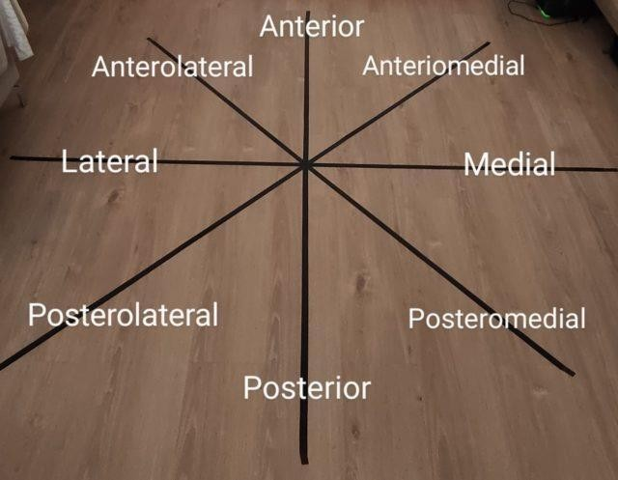
In these performing of reach directions in the star excursion balance test (SEBT) to evaluate the functional deficits in the ankle instability the posterior medial reach direction distance were most strongly associated with performance of all reach directions by the subjects.

FIG 1: SEBT

DESCRIPTION OF TREATMENT:
GROUP A: Subjects was received Kinesio taping with following of strengthening exercises. The programme can be held in 2 weeks for 5 session in a week whereas total it is 10 session in a period of 2 weeks. At the starting every subject was tested with star excursion balancing test for stability and balance. During first application

of Kinesio tape and strengthening exercises, In the section of second week application of kinesio tape and continuing with strengthening exercises. After giving 2 weeks of treatment following of star excursion balancing test and strengthening level was checked to see the risk of instability.

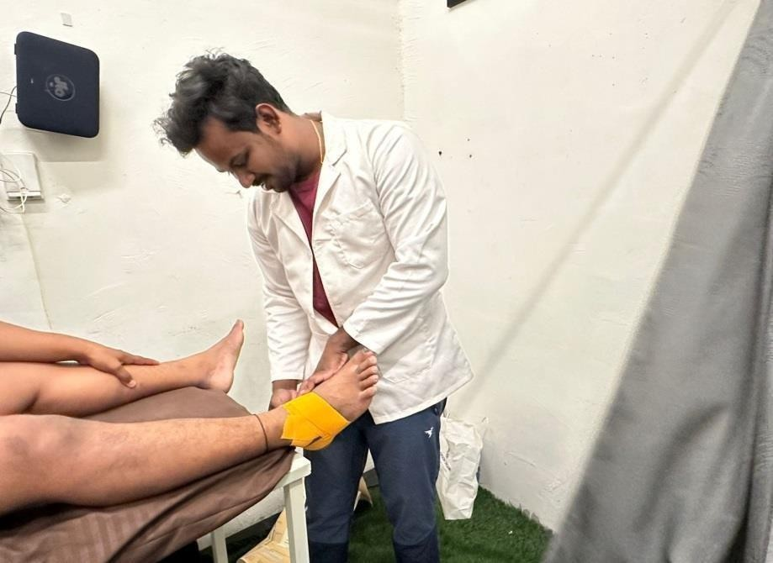

FIG 2: APPLYING OF KINESIO TAPE
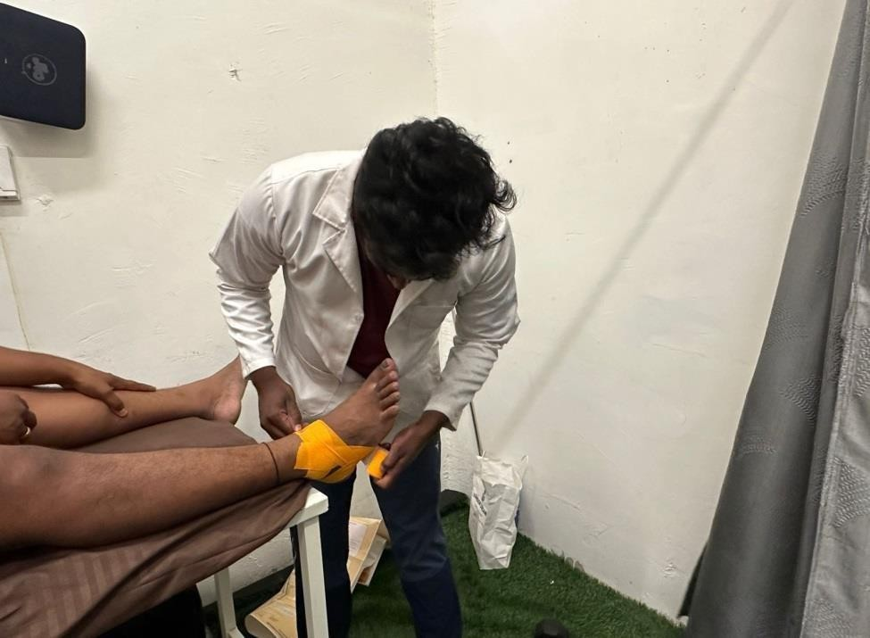

FIG 3: APPLYING OF KINESIO TAPE

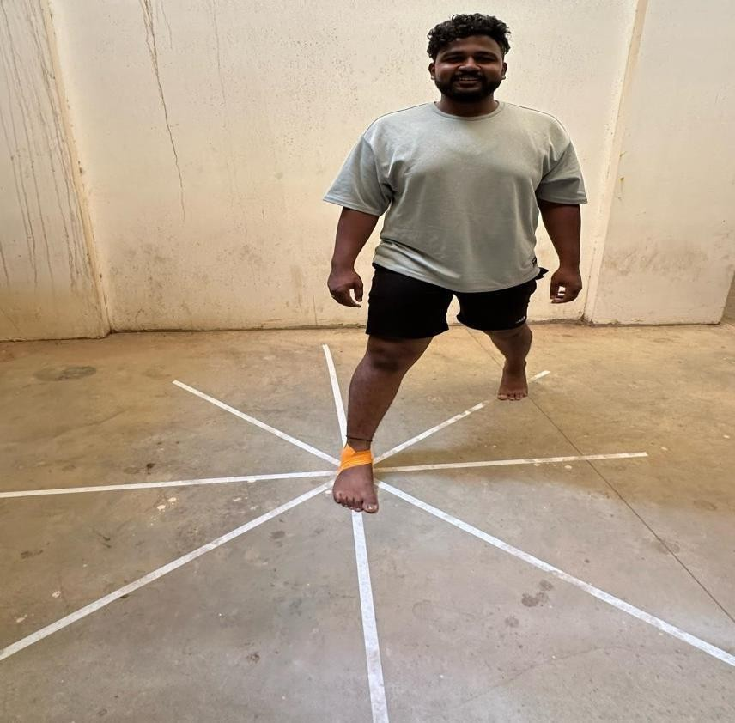

FIG 4: SEBT TRAINING

GROUP B: Subjects was recieved Rigid taping with following of strengthening exercises. The programme was held in 2 weeks for 5 session in a week whereas total it is 10 session in a period of 2 weeks. At the starting every subject was tested with star excursion balancing test for stability and balance, during first application rigid tape and strengthening exercises, in the section of second week application of rigid tape and continuing with strengthening exercises. After giving 2 weeks of treatment following of star excursion balancing test and strengthening level of checking to see the risk of instability.

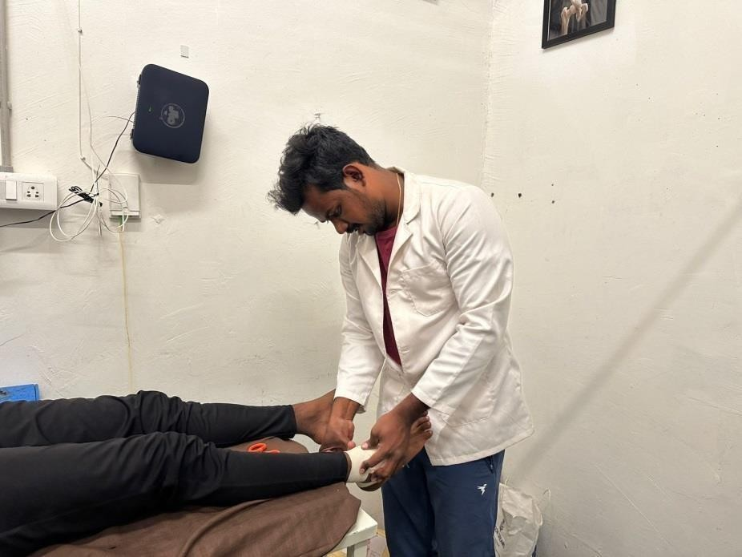

FIG 5: APPLYING OF RIGID TAPE
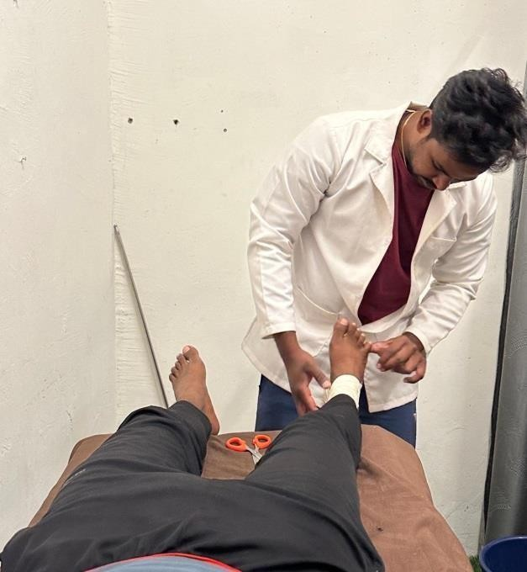

FIG 6: APPLYING OF RIGID TAPE

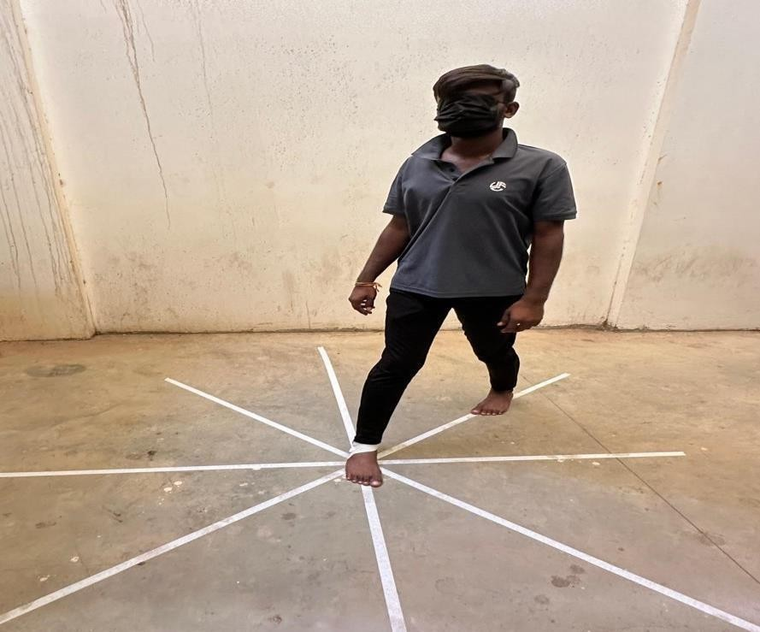

FIG 7: SEBT TRAINING

STATISTICAL ANALYSIS

STATISTICAL ANALYSIS:

Table: 1 Distribution of male and females in two groups (kinesio Taping, rigid taping)

Gender | Kinesotaping  group | % | Rigid  taping | % | Total
Male | 17 | 85.00 | 20 | 100.00 | 37
Female | 3 | 15.00 | 0 | 0.00 | 3
Total | 20 | 100.00 | 20 | 100.00 | 40
Chi-square with Yates's correction = 1.4410 P = 0.2300
120

100

80

60

40

20
0
Gender
Kinesotaping
group
%
Rigid
taping
%
Total

Table: 2 Comparison of two groups (kinesio Taping, rigid taping) with mean age by independent t test

Groups | Mean | SD | SE | t-value | P-value
Kinesio  taping group | 19.75 | 2.17 | 0.49 | -0.9181 | 0.3644
Rigid taping  group | 20.35 | 1.95 | 0.44
1.2
1
0.8
0.6
#REF!
#REF!
0.4
0.2
0
No difference between two groups (kinesio Taping, rigid taping) with mean age (t=-0.9181, p>0.05). The mean is similar in two groups (kinesio Taping, rigid taping).

Table:3 Normality of pre-test and post-test scores of all parameters in two groups (kinesio Taping, rigid taping) by Kolmogorov Smirnov test

Parameters | Treatment | Kinesio Taping group |  | Rigid taping group
Parameters | Treatment | Z-value | p-value | Z-value | p-value
Posterior | Pre-test | 1.1860 | 0.1200 | 1.2830 | 0.0740
Posterior | Post-test | 1.2680 | 0.0800 | 0.9710 | 0.3020
Posterior | Difference | 0.6430 | 0.8020 | 1.0730 | 0.1990
Posterio lateral | Pre-test | 0.7130 | 0.6890 | 0.6820 | 0.7410
Posterio lateral | Post-test | 1.0430 | 0.2260 | 0.9480 | 0.3300
Posterio lateral | Difference | 1.0000 | 0.2700 | 0.7860 | 0.5670
Posterio medial | Pre-test | 0.9090 | 0.3800 | 0.9480 | 0.3300
Posterio medial | Post-test | 0.9430 | 0.3360 | 0.6350 | 0.8140
Posterio medial | Difference | 0.9040 | 0.3870 | 0.5920 | 0.8750
Lateral | Pre-test | 1.1690 | 0.1300 | 0.7830 | 0.5720
Lateral | Post-test | 0.8240 | 0.5060 | 0.6890 | 0.7290
Lateral | Difference | 0.6860 | 0.7340 | 0.6370 | 0.8120
Medial | Pre-test | 0.9370 | 0.3440 | 0.9270 | 0.3570
Medial | Post-test | 1.1320 | 0.1540 | 1.3512 | 0.0509
Medial | Difference | 0.4870 | 0.9710 | 0.5880 | 0.8790
Anterior | Pre-test | 0.7200 | 0.6780 | 1.0744 | 0.1990
Anterior | Post-test | 0.6240 | 0.8310 | 0.9710 | 0.3030
Anterior | Difference | 0.7280 | 0.6640 | 0.9310 | 0.3520
Anterio lateral | Pre-test | 0.9350 | 0.3460 | 1.3512 | 0.0509
Anterio lateral | Post-test | 0.8050 | 0.5360 | 1.2270 | 0.0990
Anterio lateral | Difference | 0.5780 | 0.8920 | 0.5310 | 0.9410
Anterio medial | Pre-test | 1.2360 | 0.0940 | 1.1130 | 0.1680
Anterio medial | Post-test | 1.2000 | 0.1120 | 1.0740 | 0.1990
Anterio medial | Difference | 0.7610 | 0.6090 | 0.5620 | 0.9100

1.2
1
0.8

0.6

0.4
#REF!
#REF! #REF! #REF! #REF!
#REF!
0.2
0
Note: The pre-test and post-test scores of all parameters in two groups (kinesio Taping, rigid taping) follow a normal distribution. Therefore, the parametric tests were applied.

Table:4 Comparison of two groups (kinesio Taping, rigid taping) with pre-test and post-test strength and balance in ankle sprain at posterior side by independent t test
Variable | Groups | Mean | SD | SE | t-value | P-value
Pre-test | Kinesotaping group | 40.65 | 2.13 | 0.48 | 1.6922 | 0.0988
Pre-test | Rigid taping group | 39.40 | 2.52 | 0.56 | 1.6922 | 0.0988
Post-test | Kinesotaping group | 70.60 | 2.39 | 0.54 | 3.4364 | 0.0014*
Post-test | Rigid taping group | 67.85 | 2.66 | 0.60 | 3.4364 | 0.0014*
Difference | Kinesotaping group | 29.95 | 3.24 | 0.72 | 1.5245 | 0.1357
Difference | Rigid taping group | 28.45 | 2.98 | 0.67 | 1.5245 | 0.1357

1.2
1
0.8

0.6

0.4
#REF!
#REF! #REF! #REF! #REF!
#REF!
0.2
0

*p<0.05
There is no significant difference between two groups (kinesio Taping, rigid taping) with pre-test strength and balance in ankle sprain at posterior side (t=1.6922, p>0.05) at 5% level. It means that, the mean pre-test strength and balance in ankle sprain at posterior side are similar in two groups (kinesio Taping, rigid taping).

There is a significant difference between two groups (kinesio Taping, rigid taping) with post-test strength and balance in ankle sprain at posterior side (t=3.4364, p<0.05) at 5% level. It means that, the mean post strength and balance in ankle sprain at posterior side are significantly higher in Kinesio Taping group as compared to rigid taping group.

There is no significant difference between two groups (kinesio Taping, rigid taping) with changes from pre-test to post-test strength and balance in ankle sprain at posterior side (t=1.5245, p>0.05) at 5% level. It means that, the mean changes from pre-test to post-test strength and balance in ankle sprain at posterior side are similar in two groups (kinesio Taping, rigid taping).

Group | Treatme  nt | Mean | Std.D  v. | Mean  Diff. | SD  Diff. | % of  change | Paired t-  value | p-value
Kineso taping group | Pre- test | 40.65 | 2.13 | -29.95 | 3.24 | -73.68 | -41.3920 | 0.0001*
Kineso taping group | Post- test | 70.60 | 2.39
Rigid  taping group | Pre-test | 39.40 | 2.52 | -28.45 | 2.98 | -72.21 | -42.6673 | 0.0001*
Rigid  taping group | Post-test | 67.85 | 2.66
1.2
1
#REF!
0.8

0.6

0.4
#REF!
#REF! #REF! #REF! #REF!
#REF!
0.2
0
*p<0.05

There is a significant difference between pre-test and post-test strength and balance in ankle sprain at posterior side in kinesio Taping group (t=-41.3920, p<0.05) at 5% level. It means that, the post-test strength and balance in ankle sprain scores at posterior side are significantly higher

as compared to pre-test. It means that, a significant of 73.68% increase in post-test strength and balance in ankle sprain scores at posterior side in kinesio Taping group.
There is a significant difference between pre-test and post-test strength and balance in ankle sprain at posterior side in rigid taping group (t=-42.6673, p<0.05) at 5% level. It means that, the post-test strength and balance in ankle sprain scores at posterior side are significantly higher as compared to pre-test. It means that, a significant of 72.21% increase in post-test strength and balance in ankle sprain scores at posterior side in rigid taping group.

Table:5 Comparison of two groups (kinesio Taping, rigid taping) with pre-test and post-test strength and balance.

Variable | Groups | Mean | SD | SE | t-value | P-value
Pre-test | kinesotaping group | 41.40 | 3.22 | 0.72 | 1.8983 | 0.0653
Pre-test | Rigid taping group | 39.85 | 1.73 | 0.39 | 1.8983 | 0.0653
Post-test | Kinesotaping group | 71.80 | 4.76 | 1.07 | 5.9102 | 0.0001*
Post-test | Rigid taping group | 64.10 | 3.35 | 0.75 | 5.9102 | 0.0001*
Difference | Kinesotaping group | 30.40 | 5.25 | 1.17 | 4.1302 | 0.0002*
Difference | Rigid taping group | 24.25 | 4.10 | 0.92 | 4.1302 | 0.0002*
1.2
1
0.8
0.6
0.4
0.2
#REF!
#REF! #REF! #REF! #REF!
#REF!
0
*p<0.05

Table: 6 Comparison of pre-test and post-test strength and balance in ankle sprain at Posterio Lateral side in two groups (kinesio Taping, rigid taping) by dependent t test

Groups | Treatmen  t | Mean | Std.Dv. | Mean  Diff. | SD Diff. | % of  change | Paired t-  value | p-value
Kinesotaping  group | Pre-test | 41.40 | 3.22 | -30.40 | 5.25 | -73.43 | -25.9178 | 0.0001*
Kinesotaping  group | Post-test | 71.80 | 4.76
Rigid taping  group | Pre-test | 39.85 | 1.73 | -24.25 | 4.10 | -60.85 | -26.4362 | 0.0001*
Rigid taping  group | Post-test | 64.10 | 3.35
1.2
1
0.8

0.6

0.4
#REF!
#REF! #REF! #REF! #REF!
#REF!
0.2
0
*p<0.05

Table:7 Comparison of two groups (kinesio Taping, rigid taping) with pre-test and post-test strength and balance in ankle sprain at Posterio medial side by independent t test

Variable | Groups | Mean | SD | SE | t-value | P-value
Pre-test | Kinesotaping group | 39.30 | 5.10 | 1.14 | -0.4056 | 0.6873
Pre-test | Rigid taping group | 39.80 | 2.09 | 0.47 | -0.4056 | 0.6873
Post-test | Kinesotaping group | 72.30 | 4.57 | 1.02 | 6.4288 | 0.0001*
Post-test | Rigid taping group | 63.20 | 4.38 | 0.98 | 6.4288 | 0.0001*
Difference | kinesotaping group | 33.00 | 4.77 | 1.07 | 6.4692 | 0.0001*
Difference | Rigid taping group | 23.40 | 4.62 | 1.03 | 6.4692 | 0.0001*
*p<0.05
1.2
1

0.8

0.6

0.4

0.2
#REF!
#REF! #REF! #REF! #REF! #REF! #REF!
#REF!
0

Table:8 Comparison of pre-test and post-test strength and balance in ankle sprain at Posterio medial side in two groups (kinesio Taping, rigid taping) by dependent t test
Groups | Treatment | Mean | Std.Dv. | Mean  Diff. | SD  Diff. | % of  change | Paired t | p-value
Kinesio  Taping group | Pre-test | 39.30 | 5.10 | -33.00 | 4.77 | -83.97 | -30.9502 | 0.0001*
Kinesio  Taping group | Post-test | 72.30 | 4.57
Rigid taping  group | Pre-test | 39.80 | 2.09 | -23.40 | 4.62 | -58.79 | -22.6719 | 0.0001*
Rigid taping  group | Post-test | 63.20 | 4.38
*p<0.05
1.2
1
0.8

0.6

0.4
#REF!
#REF! #REF! #REF!
#REF!
0.2
0

Table:9 Comparison of two groups (kinesio Taping, rigid taping) with pre-test and post-test strength and balance in ankle sprain at lateral side by independent t test
Variable | Groups | Mean | SD | SE | t-value | P-value
Pre-test | Kinesotaping  group | 35.50 | 6.72 | 1.50 | 1.2111 | 0.2333
Pre-test | Rigid taping  group | 33.35 | 4.23 | 0.95 | 1.2111 | 0.2333
Post-test | Kinesotaping  group | 70.15 | 3.80 | 0.85 | 6.0959 | 0.0001*
Post-test | Rigid taping  group | 63.05 | 3.56 | 0.80 | 6.0959 | 0.0001*
Difference | Kinesio  Taping group | 34.65 | 9.58 | 2.14 | 1.9046 | 0.0644
Difference | Rigid taping  group | 29.70 | 6.58 | 1.47 | 1.9046 | 0.0644
*p<0.05
1.2
1
0.8
0.6
0.4
0.2
#REF!
#REF! #REF! #REF! #REF!
#REF!
0

Table:10 Comparison of pre-test and post-test strength and balance in ankle sprain at lateral side in two groups (kinesio Taping, rigid taping) by dependent t test

Groups | Treatment | Mean | Std.Dv. | Mean Diff. | SD  Diff. | % of change | Paired t-value | p-value
Kinesio Taping group | Pre-test | 35.50 | 6.72 | -34.65 | 9.58 | -97.61 | -16.1716 | 0.0001*
Kinesio Taping group | Post-test | 70.15 | 3.80
Rigid taping group | Pre-test | 33.35 | 4.23 | -29.70 | 6.58 | -89.06 | -20.1911 | 0.0001*
Rigid taping group | Post-test | 63.05 | 3.56
*p<0.05
1.2
1

0.8

0.6

0.4
#REF!
#REF! #REF! #REF!
#REF!
0.2

0

Table:11 Comparison of two groups (kinesotaping, rigid taping) with pre-test and post-test strength and balance in ankle sprain at medial side by independent t test

Variable | Groups | Mean | SD | SE | t-value | P-value
Pre-test | Kinesio Taping group | 34.90 | 5.82 | 1.30 | 0.8071 | 0.4247
Pre-test | Rigid taping group | 33.75 | 2.59 | 0.58 | 0.8071 | 0.4247
Post-test | Kinesio Taping group | 68.95 | 6.35 | 1.42 | 4.9349 | 0.0001*
Post-test | Rigid taping group | 59.95 | 5.11 | 1.14 | 4.9349 | 0.0001*
Difference | Kinesio Taping group | 34.05 | 7.07 | 1.58 | 4.2341 | 0.0001*
Difference | Rigid taping group | 26.20 | 4.32 | 0.97 | 4.2341 | 0.0001*

*p<0.05

1.2
1
0.8

0.6

0.4
#REF!
#REF! #REF! #REF! #REF!
#REF!
0.2
0

Table:12 Comparison of pre-test and post-test strength and balance in ankle sprain at medial side in two groups (kinesio Taping, rigid taping) by dependent t test
Groups | Treatment | Mean | Std.Dv. | Mean  Diff. | SD  Diff. | %of  change | Paired t-  value | p-value
Kinesio  Taping group | Pre-test | 34.90 | 5.82 | -34.05 | 7.07 | -97.56 | -21.5244 | 0.0001*
Kinesio  Taping group | Post-test | 68.95 | 6.35
Rigid  taping group | Pre-test | 33.75 | 2.59 | -26.20 | 4.32 | -77.63 | -27.0992 | 0.0001*
Rigid  taping group | Post-test | 59.95 | 5.11

*p<0.05

1.2
1
0.8

0.6

0.4
#REF!
#REF! #REF! #REF! #REF!
#REF!
0.2
0

Table:13 Comparison of two groups (kinesio Taping, rigid taping) with pre-test and post-test strength and balance in ankle sprain at anterior side by independent t test
Variable | Groups | Mean | SD | SE | t-value | P-value
Pre-test | kinesotaping group | 41.60 | 4.08 | 0.91 | 1.5929 | 0.1195
Pre-test | Rigid taping group | 39.95 | 2.19 | 0.49 | 1.5929 | 0.1195
Post-test | Kinesio Taping group | 70.35 | 4.82 | 1.08 | 4.5221 | 0.0001*
Post-test | Rigid taping group | 63.85 | 4.26 | 0.95 | 4.5221 | 0.0001*
Difference | Kinesio Taping group | 28.75 | 8.03 | 1.79 | 2.3879 | 0.0220*
Difference | Rigid taping group | 23.90 | 4.25 | 0.95 | 2.3879 | 0.0220*
*p<0.05
1.2
1
0.8

0.6

0.4
#REF!
#REF! #REF! #REF! #REF!
#REF!
0.2
0

Table:14 Comparison of pre-test and post-test strength and balance in ankle sprain at anterior side in two groups (kinesio Taping, rigid taping) by dependent t test
Groups | Treatment | Mean | Std.Dv. | Mean  Diff. | SD  Diff. | % of  change | Paired t-  value | p-value
Kinesio  Taping group | Pre-test | 41.60 | 4.08 | -28.75 | 8.03 | -69.11 | -16.0208 | 0.0001*
Kinesio  Taping group | Post-test | 70.35 | 4.82
Rigid  taping group | Pre-test | 39.95 | 2.19 | -23.90 | 4.25 | -59.82 | -25.1268 | 0.0001*
Rigid  taping group | Post-test | 63.85 | 4.26
*p<0.05
1.2
1
0.8

0.6

0.4
#REF!
#REF! #REF! #REF!
#REF!
0.2
0

Table:15 Comparison of two groups (kinesio Taping, rigid taping) with pre-test and post-test strength and balance in ankle sprain at Anterio lateral side by independent t test
Variable | Groups | Mean | SD | SE | t-value | P-value
Pre-test | Kinesio Taping group | 44.40 | 4.16 | 0.93 | 1.3569 | 0.1828
Pre-test | Rigid taping group | 42.40 | 5.11 | 1.14 | 1.3569 | 0.1828
Post-test | Kinesio Taping group | 72.25 | 2.67 | 0.60 | 9.8580 | 0.0001*
Post-test | Rigid taping group | 62.20 | 3.69 | 0.83 | 9.8580 | 0.0001*
Difference | Kinesio Taping group | 27.85 | 5.13 | 1.15 | 5.6634 | 0.0001*
Difference | Rigid taping group | 19.80 | 3.75 | 0.84 | 5.6634 | 0.0001*
*p<0.05
1.2
1
0.8

0.6

0.4
#REF!
#REF! #REF! #REF! #REF!
#REF!
0.2
0

Table:16 Comparison of pre-test and post-test strength and balance in ankle sprain at Anterio lateral side in two groups (kinesio Taping, rigid taping ) by dependent t test
Groups | Treatment | Mean | Std.Dv. | Mean  Diff. | SD Diff. | % of  change | Paired t | p-value
Kinesio Taping  group | Pre-test | 44.40 | 4.16 | -27.85 | 5.13 | -62.73 | -24.2657 | 0.0001*
Kinesio Taping  group | Post-test | 72.25 | 2.67
Rigid taping  group | Pre-test | 42.40 | 5.11 | -19.80 | 3.75 | -46.70 | -23.6123 | 0.0001*
Rigid taping  group | Post-test | 62.20 | 3.69

*p<0.05
1.2
1

0.8

0.6

0.4
#REF!
#REF! #REF! #REF! #REF! #REF!
#REF!
0.2
0

Table:17 Comparison of two groups (kinesotaping, rigid taping) with pre-test and post-test strength and balance in ankle sprain at Anterio medial side by independent t test
Variable | Groups | Mean | SD | SE | t-value | P-value
Pre-test | kinesotaping group | 35.65 | 12.65 | 2.83 | 0.7724 | 0.4446
Pre-test | Rigid taping group | 33.35 | 4.15 | 0.93 | 0.7724 | 0.4446
Post-test | Kinesotaping group | 67.00 | 5.81 | 1.30 | 6.2673 | 0.0001*
Post-test | Rigid taping group | 58.05 | 2.65 | 0.59 | 6.2673 | 0.0001*
Difference | kinesotaping group | 31.35 | 12.89 | 2.88 | 2.1998 | 0.0340*
Difference | Rigid taping group | 24.70 | 4.07 | 0.91 | 2.1998 | 0.0340*

*p<0.05
1.2
1
0.8

0.6

0.4
#REF!
#REF! #REF! #REF! #REF!
#REF!
0.2
0

Table:18 Comparison of pre-test and post-test strength and balance in ankle sprain at Anterio medial side in two groups (kinesotaping, rigid taping) by dependent t test.
Groups | Treatment | Mean | Std.Dv. | Mean  Diff. | SD  Diff. | % of  change | Paired t | p-value
Kinesio  Taping group | Pre-test | 35.65 | 12.65 | -31.35 | 12.89 | -87.94 | -10.8739 | 0.0001*
Kinesio  Taping group | Post-test | 67.00 | 5.81
Rigid taping  group | Pre-test | 33.35 | 4.15 | -24.70 | 4.07 | -74.06 | -27.1635 | 0.0001*
Rigid taping  group | Post-test | 58.05 | 2.65

*p<0.05





80
60
40
20
0
-20
-40
-60
-80
-100

RESULTS

RESULTS

The data was analysed using SPSS 16.0 version and Microsoft office excels 2007. The mean and standard deviation of all the variables were analysed by independent and dependent‘t’ test. The comparison of two groups with pre-test and post-test strength and balance in at posterior side by independent ‘t’ test the p- value is (0.0014).In dependent ‘t’ test ‘t’ value is (1.6922) p-value is (0.0001) in kinesotaping and (0.0001) in rigid taping. It means that a significant of 73.68% increase in post-test in kinesotaping and the 72.2% increase in rigid taping group. In all other directions like posterior lateral, posterior medial, anterior lateral, anterior medial, medial, lateral with independent and dependent ‘t’ test that the ‘t’ value of posterior lateral is (1.8983)and p-value is (0.0001) in dependent and p-value is (0.0001) in post-test.
In posterior medial side by independent test ‘p-value is (0.0001) and in dependent test p-value is (0.0001).
When comparing the both group values between pre-test and post-test there is no significant difference between two groups with changes from pre-test to post-test strength and balance in ankle sprain at 5% level .It means that mean changes from pre to post-test strength and balance in ankle sprain are similar in two groups.

DISCUSSION

DISCUSS ION

The incidence of ankle sprain is constantly increasing. Ankle injury is often associate with distressing and disability sequel. Most badminton players experience decrease in level of strength and balance and limitation of the range of movement. This study was to evaluate the effect of kinesotaping and rigid taping for improving the strength and balance in ankle sprain. Although both the treatment techniques were effective in balance and strength in ankle joint, there was marked significant difference in the strength and balance. Following techniques as comparison between rigid taping and kinesotaping in pre-test and there is no significance in post-test. The strength and balance was markedly increased by kinesotaping because the techniques stabilize the joint effectively following lateral ankle sprain. Which reduced progression of inflammation, as compared to the patients who were treated by ultrasound and kinesotaping with rigid taping typically, the injured tissue is protected by stabilization during the treatment sections.
Stabilization with kinesotaping and rigid taping facilitates proprioception and undisturbed fibroblast invasion which results in cell proliferation and collagen fibre production. That occurs in early stage of healing however physical training by star excursion balancing exercises has found to increase the tensile strength of tendons and the ligaments.
This states that stabilization with both rigid taping and kinesotaping is beneficial for patients with lateral ankle sprain. Rigid taping facilitates normal alignment of joint even in inflammatory phase of ankle sprain. Kinesotaping facilitates normal joint position sense and that allow the patient to move or walk.
The both rigid taping and kinesotaping have their own technical properties to improving the strength and balance in lateral ankle sprain patients. This study was limited to sample size of 40 subject’s age group 18 – 32 years. Subjects were only recruited from a single centre and data was collected only from badminton players. Future studies may be conducted with large sample size and addressing the limitations of study.

SUMMARY

S UMMA RY

The prevalence of ankle sprain is amongst the most common sports related injury experienced by high intensity game players in sports like football, volleyball, running, badminton etc. conservative management is the first line of treatment that is considered for managing this sort of injuries most of the affected part of ankle is lateral side.
The study was taken to know the knowledge of body and also to understand the effects of kinesotaping with rigid taping on incidence of lateral ankle sprain. In some studies authors concluded that kinesotaping is not effective in ankle sprains and some concluded that kinesotaping and rigid taping had beneficial properties to treat the ankle sprains.
The result of the study indicated significance of important p-values in both the techniques with minimal difference in p-values. Both treatment techniques are effective in treating the ankle sprain in badminton players to improve the strength and balance.
So many studies have done the outcome measures by using the single leg balance test (SLBT), single limb hurdle test (SLHT), star excursion balance test (SEBT). Star excursion balance training and test was used for the improving of the balance and strength it showed positive outcome.
As a goal of treatment physiotherapeutic strategies are concerned mostly in musculoskeletal disorders where the rate of success in preventing the patient form invasive techniques are highly regarded.
Hence it can be informed that conservative line of management can be established as an

, Standardized management pertaining to ankle sprain. However further studies can be taken with broader population to co-relate a better effect of it in future.

CONCLUSION

CON CLUSI ON

The purpose of the study was to extend the knowledge with respect to the effects of Kinesio taping and rigid taping to improve the strength and balance in lateral ankle sprain in badminton players . The data analysis and results attained reveal kinesotaping shows significant important in balance and strength in every individual in different directions by star excursion balance test.
The study also revealed that in the pre-test score both groups are having the difference in some directions for strength and balance.
Hence the study concludes that there is no significant statistical difference between two groups when comparison strength and balance are shoeing important results and the effects of both the techniques are similar.

LIMITATION AND RECOMMENDATION

L IMITAT IONS OF T HE S T UDY :

- This study was limited to sample size of 40 subjects
- Age group of 18-32 years.
- Subjects were only requited from a single centre.
- Data was collected only from badminton players.
- P-value in some statistical comparison is showing equal distribution of result.

RECOMME NDAT IONS :

- Study can be further done by taking large sample size.
- Duration of study can be increased.
- Educate the players about the mechanism of injury to decrease the sprains.
- Further study can be done to decrease the level of re- injury.

BIBLIOGRAPHY

BIBLIOGRAPHY:

- Evan corey.et.al. Lateral ankle sprains. UNC school of sports medicine.2010 April

- Danielle A van der windt, Gerben Terreit.et.al., Therapeutic ultrasound for acute ankle sprain.
, European journal of physical and rehabilitation medicine. January 2011:1.

- Joshua.C.Dubin Dc, Doug comeau Do Rebecca.et.al. Lateral and syndesmotic ankle sprain injuries. Journal of chiropractic medicine.2011; 10:.204-219.

- Fereahteh Pourkazeni.et.al. Predictors of chronic ankle instability after an index lateral ankle sprain. Journal of science and medicine in sport.2014; 17:568-573.

- * Riley, M., ** Goodman, M. and*** Fritz VU, An objective measure of gait using ink footprints, South African Journal of Physiotherapy. 1999 May 1; 55(2):8-11.

- Guilherme S. Nunes.et.al. Kinesotaping does not decrease swelling in acute lateral ankle sprain of athletes. Journal of physiotherapy.2014; 11:002.
- Patrick.et.al, Systemic review of postural control and lateral ankle instability. Journal of athletic training.2008; 43; 3:305-315.
- Janice k Loudon.et.al, Efficacy of manual joint mobilization/ manipulation in treatment of lateral ankle sprain. Journal of sports medicine.2013; 0:1-6.

- Petra Margetic.et.al. Understand the value of ultrasound in acute ankle injury with magnetic resonance imaging. European journa.2009; 2:605-610.

- D. Stasnopoulos.et.al. Comparison of three preventive methods in order to reduce the incidence of ankle inversion sprains among female volley ball players. Journal of sports medicine.2004; 38:182-185.

- Guilherme S. Nunes.et.al, kinesotaping does not decrease swelling in acute lateral ankle sprain of athletes. Journal of physiotherapy.2014; 11:002

- Seda Bicici.et.al. Effects of athletic taping and kinesotaping on measurement of functional performance in basketball players with inversion ankle sprains. International journal of sports physical therapy.2012; 7:154-166.

- Chiropractic MV, Rigid vs Kinesio Taping [Internet].Mona Vale Chiropractic. 2017. Availablefrom:https://www.monavalechiropractic.com/2017/08/rigid-vs-kinesio-taping/#:~:text=Rigid%20Taping%3A&text=The%20role%20of%20the%20tape

- Jay hertal.et.al simplifying the star excursion balance test, Analysis of subjects with and without chronic ankle instability, Journal of orthopaedic and sports physical therapy.2006; 36:131-137.
- Dootchai chaiwanichisri.et.al. Star excursion balance training: effects on ankle functional stability after ankle sprain. Journal of medical association.thailamnd.2005; 88:90-94.

- Dootchai chaiwanichisri.et.al. Star excursion balance training: effects on ankle functional stability after ankle sprain. Journal of medical association.thailamnd.2005; 88:90-94.

- Biz C, Nicoletti P, Tomasin M, Bragazzi NL, Di Rubbo G, Ruggieri P. Is Kinesio Taping Effective for Sport Performance and Ankle Function of Athletes with Chronic Ankle Instability (CAI)?, A Systematic Review and Meta-Analysis. Medicina [Internet]. 2022 May 1; 58(5):620. Available from: https://www.mdpi.com/1648-9144/58/5/620

- Khalili SM, Barati A, Oliveira R, Nobari H. Effect of Combined Balance Exercises and Kinesio Taping on Balance, Postural Stability, and Severity of Ankle Instability in Female Athletes with Functional Ankle Instability, Life. 2022 Jan 26; 12(2):178.

- Li R, Qin R, Tan Y, Liu H, Wang K, Cheng L. Effect of kinesio taping intervention on the muscle strength and balance of college basketball players with functional ankle instability, Frontiers in Physiology. 2023 Mar 29; 14.

- Hussein HM, Kamel WM, Kamel EM, Attyia MR, Acar T, Kanwal R, et al, The Effect of Kinesio Taping on Balance and Dynamic Stability in College-Age Recreational Runners with Ankle Instability, Healthcare [Internet]. 2023 Jun 1; 11(12): NA–NA. Availablefrom:https://link.gale.com/apps/doc/A758284574/AONE?u=nysl_li_hhhsw &sid=bookmark-AONE&xid=32870648

- Tang Y, Liang P, Jing Wen Pan, Zhang C, Ren H, Cheng S, et al. Effects of Ankle Orthoses, Taping, and Insoles on Postural Stability of Individuals with Chronic Ankle Instability: A Systematic Review, Healthcare. 2023 Sep 18; 11(18):2570–0.

Comparison_of_Kinesiology_Taping_Techniques_to_Promote_Ankle_Stability_in_M ale_Football_Athletes_with_Chronic_ankle_instability.

- Briem K, Eythörsdöttir H, Magnúsdóttir RG, Pálmarsson R, RúnarsdÖttir T, and Sveinsson T. Effects of Kinesio Tape Compared With Nonelastic Sports Tape and the Untaped Ankle During a Sudden Inversion Perturbation in Male Athletes, Journal of Orthopaedic & Sports Physical Therapy. 2011 May; 41(5):328–35.

- Lardenoye S, Theunissen E, Cleffken B, Brink PR, de Bie RA, Poeze M. The effect of taping versus semi-rigid bracing on patient outcome and satisfaction in ankle sprains: a prospective, randomized controlled trial, BMC Musculoskeletal Disorders. 2012 May 28; 13(1).

- Jackson K, Simon JE, Docherty CL. Extended Use of Kinesiology Tape and Balance in Participants with Chronic Ankle Instability, Journal of Athletic Training. 2016 Jan; 51(1):16–21.

- Athanasiadis D, Papadopoulos K. Comparison of Proprioception between Kinesiology and Adhesive Ankle Taping: A Randomised Experimental Study, Journal of Novel Physiotherapies [Internet].2019; 09(01). Available from: https://www.omicsonline.org/open-access/comparison-of-proprioception-between-kinesiology-and-adhesive-ankle-taping-a-randomised-experimental-study-2165- 7025-1000406-107271.html

- Kinesio_taping_versus_Mulligan’s_mobilization_with_movement_in_sub-acute_lateral_ankle_sprain_in_secondary_school_Hockey_players.

- Kim JH, Cho MR, Park JH, Shin JC, Cho JH, Park GC, et al. The effects of Kinesiotape on acute lateral ankle sprain: study protocol for a randomized controlled trial, Trials, 2018 Feb 20; 19(1).

- Effect_of_Kinesio_Taping_on_Isokinetic_Parameters_of_Ankle_joint.

- Edgehill.ac.uk.2024.Availablefrom:https://research.edgehill.ac.uk/files/20171051
/ c1staffhome1_STAFFHOME1_Greigm_Desktop_Edge%20Hill%20Research_public ations_In%20Progress_Claire%20Farquharson_KT%20vs%20Rehab_JAthlEnh_JAE%2 0Farq%20&%20Greig%202015.docx

- Someeh M, Norasteh AA, Daneshmandi H, Asadi A. Immediate effects of Mulligan’s fibular repositioning taping on postural control in athletes with and without chronic ankle instability, Physical Therapy in Sport. 2015 May; 16(2):135–9.

ANNEXURES

ANNEXURE. 1



ANNEXURE. 2

PATIENT CONSENT FORM

Garden City University

I agree to take part in the research study

Conducted by NOOLU BALAJI. Post graduate student (M.P.T. Musculoskeletal disorders & Sports Physiotherapy), Garden City University, entitled —A STUDY TO FIND EFFICIENCY OF KINESIO TAPING VERSUS RIGID TAPING IN ANKLE INSTABILITY AMONG BADMINTON PLAYERS ’’.
I acknowledge that the research study has been explained to me and I understand that And agreeing to participate in the research means that I am willing to

- To Provide information about my health status to the researcher
  - I have been informed about the purpose; procedure, measurements and risks involved in the study
- The research and my queries towards the research have been clarified.
- I provide consent to the researcher to use the information, for research and educational Purpose only.
- I understand that my participation is voluntary and can be withdraw at any stage of this Research project.

- I understand that no monitory benefit will be given for participation in this research study.

I have been informed about the purpose; procedure, measurements and risks involved in the research and my queries towards the research have been clarified. I provide consent to the researcher to use the information, for research and educational
Name of the Applicant/ Parent:

Signature:

Date and Signature of the researcher:

ANNEXURE. 3

ANKLE ASSESSMENT

SUBJECTIVE:
NAME:

AGE:
GENDER:

CHIEF COMPLAINTS: PRESENT MEDICAL HISTORY: PAST MEDICAL HISTORY. :
- ANY INJURIES:
- ASSOCIATED ILLNESS: PERSONAL HISTORY:
  - FAMILY HISTORY:
  - SOCIAL HISTORY:

OBJECTIVE: ON OBSERVATION: GENERAL EXAMINATION: a. BUILT:
b. POSTURE:
C. ANYDEFORMITY:
86

LOCAL OBSERVATION:

- REDNESS: present/absent
- stability: present/absent

ON PALPATION

- TENDERNESS: Present/absent
- Local rise of temperature:

ON EXAMINATION:
- ACTIVE RANGE OF ANKLE:

- PLANTAR FLEXION:
- DORSI.FLEXION :
- INVERSION: :
- EVERSION:

OUTCOMEMEASURES:
  - SEBT: (Star excursion balance test).:

Pre-test: Post-test:

- Posterior: 1. posterior:

- Posterio lateral: 2. poster lateral:
- Posteromedial: 3. posteromedial:
- Lateral: 4. Lateral:
- Medial: 5. Medial:
- Anterior: 6. Anterior:

- Anterolateral: 7. Anterolateral:
- Anteromedial: 8. Anteromedial

NAME OF THE INVESTIGATOR: SIGNATURE OF GUIDE: SIGNATURE OF INVESTIGATOR:

ANNEXURE. 4

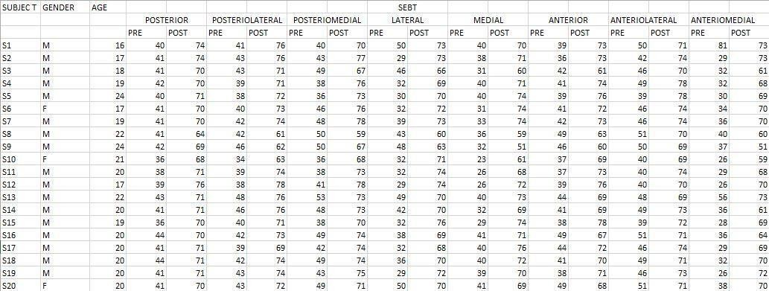

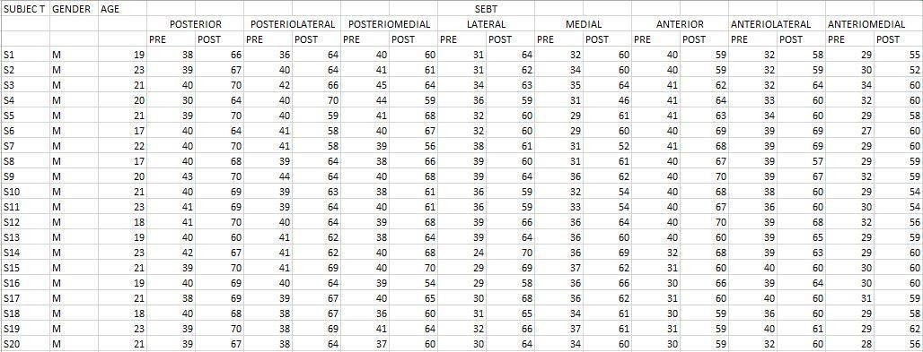

90

