Design and Evaluation of a Web-Based Personal Financial Management System for Young Professionals

ABSTRACT
This study designed and evaluation of a web-based personal financial management system for young professionals. The system was developed to support expense tracking, budgeting, bill monitoring, savings goal management, and visual reporting through an accessible web platform. A developmental and descriptive research design was used. The prototype was built using an Agile development approach and evaluated using a software quality instrument based on functionality, usability, reliability, performance, and supportability. Twenty-seven young professionals evaluated the user-facing system, while three information technology professionals assessed technical quality. Weighted means and qualitative comments were used to interpret the results. Findings showed that the system was generally rated positively by young professional respondents, with an overall weighted mean of 3.61, interpreted as Strongly Agree. Usability received the highest mean score of 3.69, followed by reliability at 3.63, performance at 3.61, functionality at 3.60, and supportability at 3.50. IT professionals also gave favorable ratings, particularly in functionality, where the system received a mean of 4.00. The results suggest that analytics-supported features, including dashboards, category-based spending summaries, and budget alerts, can help young professionals understand their financial behavior and improve personal financial monitoring. However, the evaluation also identified areas for improvement, including clearer user guides, faster loading of reports, more consistent reminders, and possible integration with banks or e-wallets. The study contributes to applied financial technology research by demonstrating a practical prototype that combines personal finance management functions with basic data analytics for young professionals.
Keywords: Personal financial management system; young professionals; usability evaluation; financial technology
INTRODUCTION
Personal financial management is an important life skill for young professionals because this stage often marks the transition from financial dependence to regular income earning, debt management, savings planning, and long-term financial decision making. In the Philippine context, young employees are exposed to daily expenses, rising living costs, digital payments, subscription-based spending, and household obligations. These conditions require a practical way to record income, monitor expenses, plan bills, and review savings targets. Without consistent monitoring, young professionals may have difficulty identifying spending patterns and adjusting financial behavior before problems such as late payments, overspending, or insufficient savings become more serious.
Traditional personal budgeting tools, such as paper notebooks or spreadsheets, remain useful but often require manual effort and regular updating. Many users stop using them because they are time-consuming or do not provide immediate interpretation of their spending. Digital financial tools can address this limitation by organizing financial information and presenting summaries that are easier to understand. Recent studies on financial literacy and digital financial behavior emphasize that users need not only access to financial products but also tools that convert financial data into simple and actionable information (Eloriaga et al., 2022; Koskelainen et al., 2023; Rodriguez, 2025).
Data analytics is relevant to personal finance because it can transform raw transactions into useful insights. When income and expense records are categorized, summarized, and visualized, users can see where their money goes, which budget categories are increasing, and whether their financial goals are realistic. Analytics may also support reminders, spending alerts, visual dashboards, and basic forecasting. In broader financial technology research, analytics has been linked to improved financial inclusion, more personalized services, and better decision support when implemented responsibly and clearly (Adeoye et al., 2024; Laudon & Laudon, 2022).
This study focuses on young professionals, particularly those who need simple and accessible tools for personal budgeting. The business process outsourcing sector and other entry-level professional work settings are relevant contexts because employees often manage regular salaries, work-related expenses, and family responsibilities. The Philippine BPO sector has grown as a major employment area, but young employees still face financial management challenges related to saving, spending discipline, and long-term planning (Arriola, 2025; Liu et al., 2024; Fajardo, 2021).
The general objective of this study was to design and evaluate a web-based personal financial management system for young professionals with data analytics. Specifically, it aimed to: (1) develop a web-based platform that allows users to record income, expenses, bills, budgets, accounts, and savings goals; (2) incorporate basic data analytics through visual summaries, category-based reports, and alerts; (3) evaluate the system in terms of functionality, usability, reliability, performance, and supportability; and (4) identify user and technical recommendations for improving the system. The study is anchored on the view that a usable and analytics-supported system can help young professionals make more informed financial decisions. The results may be useful to system developers, financial literacy advocates, schools, employers, and young workers who need simple digital support for managing personal income, everyday financial obligations, bill payment schedules, and savings plans in a practical web environment.
LITERATURE REVIEW
Personal financial management is influenced by financial knowledge, motivation, habits, and available tools. Studies on young adults and young professionals show that financial literacy and financial behavior are connected to saving, budgeting, investment interest, and responsible spending. Eloriaga et al. (2022) examined financial literacy and financial behavior among young professionals in Metro Manila and reported that financial awareness remains important in shaping financial decisions. Similarly, Pastor et al. (2022) identified factors affecting savings and investment behavior among young professionals, while Cagatao and Garcia (2023) discussed actual personal finance management practices among personnel in a state university setting. These studies indicate that financial behavior is not only a matter of income but also of consistent planning and monitoring.
Recent works also show that young professionals and middle-class workers experience challenges in translating financial knowledge into routine behavior. Salsabilla et al. (2022) emphasized that personal financial management may be affected by financial attitude, literacy, and behavioral control. Jennifer and Widoatmodjo (2023) likewise found that financial knowledge, literacy, and financial technology shape financial management behavior among young adults. From a motivational perspective, Di Domenico et al. (2022) explained that personal financial management can be understood through self-determination, where users are more likely to continue a behavior when they find it meaningful and manageable. These findings support the need for tools that are easy to use and motivating rather than overly technical.
The Theory of Planned Behavior also provides a useful lens for financial management behavior. The theory suggests that intention is shaped by attitudes, subjective norms, and perceived behavioral control. In financial contexts, perceived control is important because users may know that budgeting is necessary but still fail to practice it when the process is difficult, unclear, or inconvenient. Hapsari (2021) and Shih et al. (2022) applied the theory to financial intentions and behavior, highlighting the role of perceived control in financial decision making. A web-based system can support perceived control by providing organized records, reminders, and simple visual feedback.
Digital financial tools have become more relevant because users increasingly conduct transactions through online platforms and mobile services. Personal finance management applications often include transaction logs, expense categories, budgeting modules, savings goals, and reports. Vasyliuk and Basyuk (2022) described features and development considerations for personal finance management systems, while Jasmin and Suhaila (2024) presented a web application focused on personal finance management. Maury et al. (2024) also documented a budget tracker app case study, showing that structured financial tracking can be implemented through accessible software features. These studies support the feasibility of developing a focused personal financial management system for young professionals.
Data analytics adds value to personal finance tools by allowing users to interpret their records instead of only storing them. Charts, spending distribution summaries, category comparisons, and trend reports help users make sense of their financial activities. Sonjaya (2024) noted the shift from traditional budgeting practices to technology-supported approaches, while Prakhar and Bajpai (2024) and Priyatno et al. (2024) showed how analytical techniques may be used for financial time series and prediction tasks. Although the present system does not claim to provide advanced predictive financial advising, it uses basic analytics to organize and visualize transactions in a way that can guide user decisions.
Usability and software quality are essential for the success of financial management systems. A system with strong functions may still fail when users find it difficult to navigate or understand. Nielsen (2020) emphasized that clear user interface design improves the user experience. Pressman and Maxim (2020) and Sommerville (2016) discussed software quality attributes such as reliability, performance, maintainability, and supportability, which are important in evaluating web-based systems. For systems that handle financial data, security and reliability are especially important because users need confidence that their records are protected and consistently processed (Espiritu & Jocson, 2023; Laudon & Laudon, 2022).
Related systems and case studies show that personal finance applications often become more helpful when they combine recording functions with feedback mechanisms. Budget trackers, savings applications, and dashboard-based systems allow users to view transactions and compare income with expenses, but the usefulness of these systems depends on whether users can interpret the information quickly. NextLeap (2024) and Maury et al. (2024) illustrate how budgeting applications can organize financial activities through digital interfaces, while Salvador and Gabronino (2024) and Flores (2025) emphasize the continuing need to strengthen financial literacy among Filipino users. These works support the development of tools that are practical, localizable, and understandable for users who may not have advanced financial knowledge.
Another important consideration is data privacy and cybersecurity. Personal finance systems handle sensitive information, including account names, transaction amounts, bill schedules, and financial goals. Even when a prototype does not connect directly to banks or e-wallets, users still need assurance that access is protected and records are handled carefully. Espiritu and Jocson (2023) noted that digital transformation in the Philippines creates cybersecurity challenges that must be addressed through safeguards and responsible system design. For this reason, the present system includes log-in authentication and avoids reporting identifiable user information in the manuscript.
The reviewed literature shows three important points. First, young professionals need stronger support for routine budgeting, savings, and financial decision making. Second, web-based tools can improve financial management when they are accessible, user-friendly, and aligned with actual user habits. Third, analytics features are useful when they are presented in simple and understandable formats. However, there remains a need for applied studies that develop and evaluate a personal financial management system specifically for young professionals using both user and IT professional feedback. This study addresses that gap by designing a web-based system and evaluating it through software quality dimensions.
THEORETICAL AND CONCEPTUAL FRAMEWORK
This study was guided by the Theory of Planned Behavior and the Technology Acceptance perspective. The Theory of Planned Behavior explains that behavior is influenced by attitude, subjective norms, and perceived behavioral control. In the context of personal finance, a young professional may believe that budgeting is important but may still fail to practice it when the process is inconvenient or difficult to monitor. The system addresses perceived behavioral control by providing a structured way to record income and expenses, organize bills, and review dashboards. When users can clearly see their financial records and progress, they may feel more capable of managing their finances and making better financial decisions.
The Technology Acceptance perspective also supports the study because a system is more likely to be accepted when users perceive it as useful and easy to use. For this study, perceived usefulness is reflected in the system's ability to help users monitor expenses, manage bills, set budgets, and review financial summaries. Perceived ease of use is reflected in the clarity of the interface, navigation, labels, charts, and account management functions. These ideas are connected to the usability and functionality dimensions used in the evaluation instrument.
The conceptual framework follows an input-process-output structure. The inputs include user information, income records, expense transactions, accounts, budget limits, bill details, and savings goals. The process includes user authentication, transaction recording, categorization, budget monitoring, bill scheduling, and analytics generation. The outputs include system access, updated transaction records, visual reports, account summaries, budget alerts, bill reminders, and feedback for future financial decisions. Feedback from users and IT professionals serves as the basis for improving the prototype. This framework shows that the value of the system depends not only on storing financial data but also on converting those data into understandable financial information.
METHODOLOGY
Research Design. This study employed a developmental and descriptive research design. The developmental component involved the planning, design, implementation, testing, and refinement of a web-based personal financial management system. The descriptive component involved the evaluation of the developed system using weighted mean ratings and qualitative feedback from users and IT professionals.
System Development Approach. The system followed the Agile software development methodology. Agile was appropriate because it allowed the researchers to improve the system in stages based on feedback and testing. The development process included planning user requirements, designing the interface and database structure, developing system modules, testing functions, and reviewing areas for improvement. The major system modules include account creation, log-in authentication, financial dashboard, income and expense recording, budgeting, bill reminders, accounts, goals, and reports.
Participants of the Study. The final evaluation involved two groups of respondents. The first group consisted of 27 young professionals who evaluated the system from the perspective of target users. They assessed whether the system was useful, understandable, responsive, and helpful for personal financial management. The second group consisted of three IT professionals who evaluated the system from a technical perspective, particularly in relation to functionality, reliability, performance, usability, and supportability. The respondents were selected because they could provide practical feedback on the system as either intended users or technical evaluators.
Research Instrument. The instrument was divided into sections. The first section gathered basic respondent information relevant to the evaluation. The second section measured the five software quality dimensions: functionality, usability, reliability, performance, and supportability. Each item used a four-point Likert scale: 1 = Strongly Disagree, 2 = Disagree, 3 = Agree, and 4 = Strongly Agree. The final part included open-ended questions asking respondents to identify useful features, difficulties experienced, and suggestions for improvement.
Data Gathering Procedure. The respondents were given access to the prototype and were asked to perform basic tasks such as creating an account, adding financial records, checking the dashboard, creating a budget, recording a bill, viewing reports, and reviewing transactions. After interacting with the system, they completed the evaluation instrument. IT professionals also reviewed system behavior and technical quality based on the same software quality dimensions. Responses were encoded, checked, and summarized for analysis.
Data Analysis. The study used frequency counts, weighted means, and verbal interpretation to analyze the quantitative responses. The weighted mean was computed by multiplying each rating by its frequency, dividing the product by the total number of respondents, and averaging the item means within each dimension. The following interpretation was used: 3.25-4.00 = Strongly Agree; 2.50-3.24 = Agree; 1.75-2.49 = Disagree; and 1.00-1.74 = Strongly Disagree. Open-ended feedback was reviewed and summarized according to recurring suggestions, such as clearer guides, faster report loading, reminder accuracy, privacy, and possible integration with banks or e-wallets.
The use of weighted means was appropriate for describing the respondents' level of agreement with the prototype features, but the results were interpreted cautiously. The ratings were not used to claim that the system already improves actual savings or long-term financial behavior. Instead, they were treated as evidence of perceived software quality during prototype testing. The comments from young professionals and IT professionals were also considered because numerical ratings alone may not show why users experienced the system as useful or difficult. This combination of rating results and open-ended feedback helped identify both the strengths of the prototype and the features that still need refinement before wider deployment.
Ethical Considerations. The study was a minimal-risk software usability evaluation involving adult respondents. It did not involve patients, medical intervention, minors, or clinical records. Respondents were informed about the purpose of the evaluation, the voluntary nature of participation, and the confidentiality of their responses. No personally identifiable respondent data are reported in the manuscript. The system screenshots included in the manuscript were anonymized to avoid disclosing personal names or email addresses.
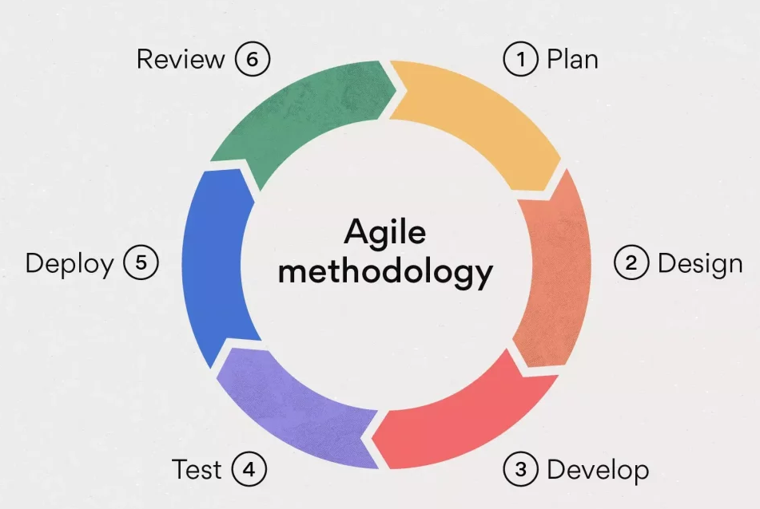
Figure 1. Agile methodology used in the system development process. Source: Researcher-created illustration based on Agile development stages.
The figure 1 illustrates the Agile software development cycle, depicted as a continuous loop comprising six core stages: Plan, Design, Develop, Test, Deploy, and Review. This cycle highlights the iterative and adaptive nature of Agile, which supports rapid development and continuous refinement based on evolving insights and requirements.
In the development of designed and evaluation of a web-based personal financial management system for young professionals, the Agile methodology was selected due to its adaptability, iterative process, and user-focused development approach. Rather than relying on a linear structure like the Waterfall model, Agile allows for ongoing adjustments, which would have been especially beneficial given the evolving requirements identified through the comprehensive Review of Related Literature (RRL).

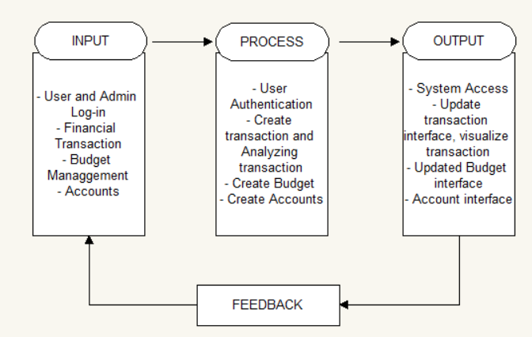
Figure 2. Conceptual framework of the web-based personal financial management system. Source: Authors' framework.
Figure 2 illustrates the core functions and data transformations within the financial management system, focusing on three primary operations: input, process, and output, along with a continuous feedback loop. In the input phase, users log into the system—administrators to manage the system and regular users to track their finances—and provide transaction data such as income, expenses, budgets, and account details. The process phase involves verifying credentials to determine access levels, categorizing transactions, updating logs, and adjusting account balances and budgets based on user entries, all securely managed to ensure data accuracy. In the output phase, the system generates tailored dashboards: administrators access system management tools, while users receive visual summaries of their financial status, categorized transactions, and trends to support informed decision-making. The feedback loop allows real-time updates as users adjust budgets, modify accounts, or review transactions, enabling the system to adapt, refresh analytics, and provide timely suggestions or alerts, ensuring continued relevance and responsiveness to user behavior and financial goals.

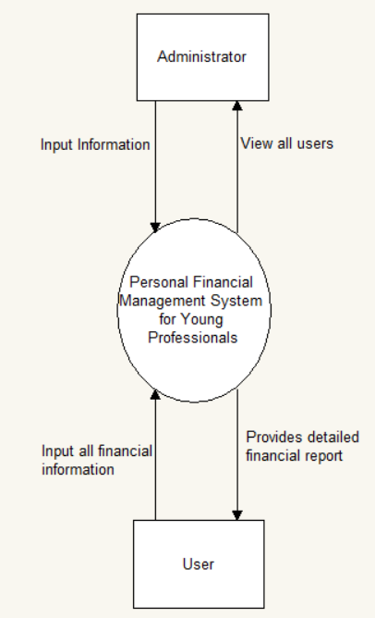
Figure 3. Context diagram showing system interaction between users and administrator. Source: Authors' system model.
The diagram shows how the system works as a whole. The main users are young professionals who use the system by creating an account and logging in. After logging in, they can enter their financial details, like expenses, budget, savings goals, and transactions. The system then gives them detailed reports and helpful insights based on their financial data. These reports can show how they spend money, how much they save, and suggestions to help them manage their money better.

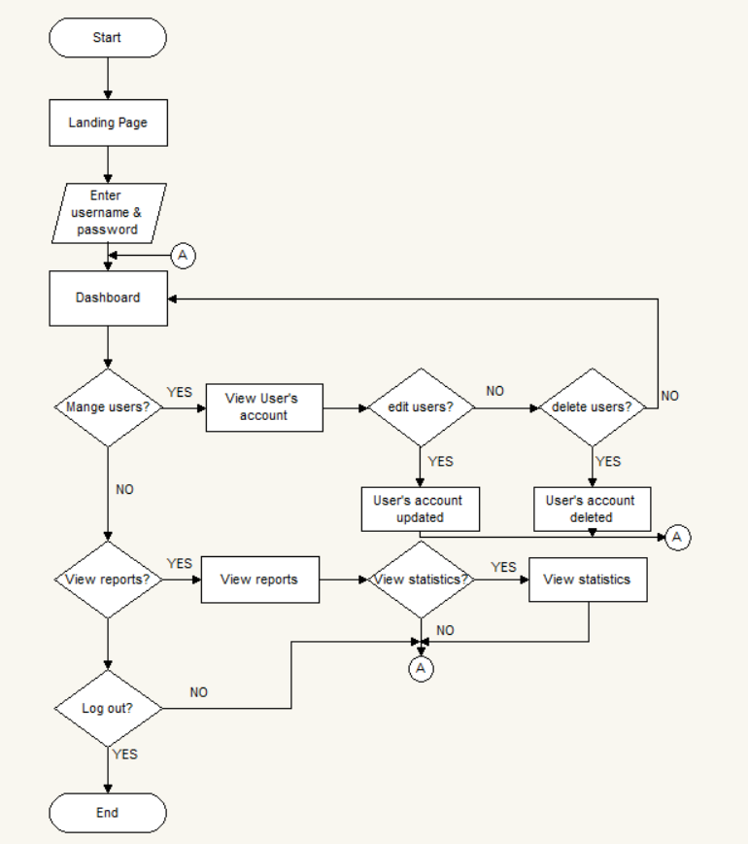
Figure 4. Flowchart of the system process. Source: Authors' system flowchart.
Figure 4 shows the system flowchart for design and evaluation of financial management system for young professionals. The process starts on the landing page, where users can either register for a new account or log in if they already have one. If a user chooses to log in, they are directed first to the login form, where they must enter their login details. After successful login, users are taken to their financial dashboard, which serves as the main menu of the system.
RESULTS AND DISCUSSION
A total of 27 young professional respondents and three IT professionals evaluated the web-based personal financial management system. The young professional respondents assessed the user-facing features of the system using the FURPS dimensions of functionality, usability, reliability, performance, and supportability. Results are presented using weighted means and verbal interpretation. The IT professional ratings are discussed after the user evaluation results to provide a technical perspective.
Overall, the system received positive ratings from young professionals. The combined overall weighted mean was 3.61, interpreted as Strongly Agree. This indicates that respondents generally found the system functional, easy to use, reliable, responsive, and supportable. However, the dimension with the lowest mean was supportability at 3.50, showing that the system would benefit from stronger user guides, demos, and support features.
The system obtained a composite mean of 3.60 for functionality, interpreted as Strongly Agree. Respondents agreed that the system helps users record income and expenses, organize transactions, and monitor financial information. The highest-rated item was the accuracy and reliability of financial records, with a mean of 3.67. This suggests that users were confident in the system's ability to support basic financial planning and record keeping. From a technical perspective, IT professionals rated functionality at 4.00, indicating that they found the core functions working correctly and consistently. The result supports the importance of aligning software functions with actual user tasks rather than adding features that users may not regularly need.
Table 1. Functionality evaluation results
Item | SD (1) | D (2) | A (3) | SA (4) | Weighted Mean | Interpretation
Q1 | 0 | 0 | 11 | 16 | 3.59 | Strongly Agree
Q2 | 0 | 0 | 10 | 17 | 3.63 | Strongly Agree
Q3 | 0 | 0 | 12 | 15 | 3.56 | Strongly Agree
Q4 | 0 | 0 | 9 | 18 | 3.67 | Strongly Agree
Q5 | 0 | 0 | 12 | 15 | 3.56 | Strongly Agree
Composite Mean |  |  |  |  | 3.60 | Strongly Agree
Note. N = 27 young professional respondents. SD = Strongly Disagree; D = Disagree; A = Agree; SA = Strongly Agree.
Usability obtained the highest composite mean among the user-rated dimensions at 3.69, interpreted as Strongly Agree. Respondents found the interface understandable, the layout organized, and the dashboard useful. The highest-rated usability item was related to icons, charts, and graphs, with a mean of 3.78. This indicates that visual presentation helped users interpret their financial records more easily. However, the lowest item was ease of learning without extensive instruction, with a mean of 3.59. This means the system is usable overall, but first-time users would benefit from brief onboarding guides, labels, or tooltips.
Table 2. Usability evaluation results
Item | SD (1) | D (2) | A (3) | SA (4) | Weighted Mean | Interpretation
Q1 | 0 | 0 | 10 | 17 | 3.63 | Strongly Agree
Q2 | 0 | 0 | 6 | 21 | 3.78 | Strongly Agree
Q3 | 0 | 0 | 8 | 19 | 3.70 | Strongly Agree
Q4 | 0 | 0 | 7 | 20 | 3.74 | Strongly Agree
Q5 | 0 | 0 | 11 | 16 | 3.59 | Strongly Agree
Composite Mean |  |  |  |  | 3.69 | Strongly Agree
Note. N = 27 young professional respondents. SD = Strongly Disagree; D = Disagree; A = Agree; SA = Strongly Agree.
Reliability received a composite mean of 3.63, interpreted as Strongly Agree. Respondents generally agreed that the system saves records, performs consistently, and protects access through log-in authentication. The highest item was secure log-in before access, with a mean of 3.74. The lowest item involved bill reminders, with a mean of 3.52, which means the reminder feature should still be improved for consistency and timeliness. Since the system handles financial records, reliability is closely connected to user trust. Errors in saving, reminders, or reports may affect users' willingness to depend on the system for regular budgeting.
Table 3. Reliability evaluation results
Item | SD (1) | D (2) | A (3) | SA (4) | Weighted Mean | Interpretation
Q1 | 0 | 0 | 11 | 16 | 3.59 | Strongly Agree
Q2 | 0 | 1 | 9 | 17 | 3.59 | Strongly Agree
Q3 | 0 | 0 | 8 | 19 | 3.70 | Strongly Agree
Q4 | 1 | 0 | 10 | 16 | 3.52 | Strongly Agree
Q5 | 0 | 0 | 7 | 20 | 3.74 | Strongly Agree
Composite Mean |  |  |  |  | 3.63 | Strongly Agree
Note. N = 27 young professional respondents. SD = Strongly Disagree; D = Disagree; A = Agree; SA = Strongly Agree.
Performance received a composite mean of 3.61, interpreted as Strongly Agree. Respondents agreed that the system responds quickly when adding or editing transactions, which obtained the highest mean of 3.74. However, report and chart loading, as well as alerts, received lower means of 3.56. This finding indicates that while the system performs well in routine transactions, performance optimization is still needed for analytics-related features. As more records are added, efficient database queries, caching, and optimized visual reporting may be necessary to maintain good response times.
Table 4. Performance evaluation results
Item | SD (1) | D (2) | A (3) | SA (4) | Weighted Mean | Interpretation
Q1 | 0 | 0 | 10 | 17 | 3.63 | Strongly Agree
Q2 | 0 | 0 | 7 | 20 | 3.74 | Strongly Agree
Q3 | 0 | 0 | 12 | 15 | 3.56 | Strongly Agree
Q4 | 0 | 0 | 12 | 15 | 3.56 | Strongly Agree
Q5 | 0 | 1 | 10 | 16 | 3.56 | Strongly Agree
Composite Mean |  |  |  |  | 3.61 | Strongly Agree
Note. N = 27 young professional respondents. SD = Strongly Disagree; D = Disagree; A = Agree; SA = Strongly Agree.
Supportability obtained a composite mean of 3.50, interpreted as Strongly Agree. The highest item was the clarity of layout for finding and using features, with a mean of 3.63. The lowest item was the availability of guides or demos, with a mean of 3.33. This was the weakest result among the user-rated items. The finding suggests that the system should include clearer user support materials, such as short tutorials, pop-up instructions, and a help section. Supportability is important because a financial management system should remain usable even after updates or feature expansion.
Table 5. Supportability evaluation results
Item | SD (1) | D (2) | A (3) | SA (4) | Weighted Mean | Interpretation
Q1 | 0 | 2 | 14 | 11 | 3.33 | Strongly Agree
Q2 | 0 | 2 | 10 | 15 | 3.48 | Strongly Agree
Q3 | 0 | 0 | 13 | 14 | 3.52 | Strongly Agree
Q4 | 0 | 1 | 11 | 15 | 3.52 | Strongly Agree
Q5 | 0 | 0 | 10 | 17 | 3.63 | Strongly Agree
Composite Mean |  |  |  |  | 3.50 | Strongly Agree
Note. N = 27 young professional respondents. SD = Strongly Disagree; D = Disagree; A = Agree; SA = Strongly Agree.
Table 6. Overall weighted mean of young professional respondents
Indicator | Weighted Mean | Verbal Interpretation
Functionality | 3.60 | Strongly Agree
Usability | 3.69 | Strongly Agree
Reliability | 3.63 | Strongly Agree
Performance | 3.61 | Strongly Agree
Supportability | 3.50 | Strongly Agree
Overall Weighted Mean | 3.61 | Strongly Agree
IT professionals gave favorable ratings across all dimensions, with an overall weighted mean of 3.77. Functionality received the highest rating at 4.00, followed by reliability at 3.80. Usability and performance both received means of 3.73, while supportability received 3.60. Their comments were consistent with the user evaluation: the system functions correctly and has a clear structure, but navigation, report loading, reminder accuracy, and user documentation can still be improved. This agreement between user and technical feedback strengthens the credibility of the findings.
Table 7. IT professional evaluation summary
Indicator | Weighted Mean | Verbal Interpretation
Functionality | 4.00 | Strongly Agree
Usability | 3.73 | Strongly Agree
Reliability | 3.80 | Strongly Agree
Performance | 3.73 | Strongly Agree
Supportability | 3.60 | Strongly Agree
Overall Weighted Mean | 3.77 | Strongly Agree
The findings show that the system is effective as a prototype for young professionals who need a practical platform for tracking money, monitoring bills, and reviewing spending patterns. The strong usability rating suggests that respondents were able to understand and navigate the system with minimal difficulty. This is important because financial tools are more likely to be used consistently when they reduce effort and provide immediate feedback. The positive functionality and reliability ratings also show that the system can support core financial tasks. However, the evaluation also shows that data analytics features should be supported by strong performance and clear explanations. Reports and charts are useful only when they load quickly and are easy to interpret. Therefore, future improvement should focus not only on adding advanced analytics but also on making existing analytics clearer, faster, and more dependable.
The pattern of results is also meaningful because the highest and lowest dimensions point to different stages of system readiness. Usability received the highest rating, which suggests that respondents were able to understand the interface, interpret the dashboard, and use the visual elements without major difficulty. This is important for personal finance applications because a system that is confusing may discourage regular recording of expenses even when the functions are technically complete. On the other hand, supportability received the lowest rating, although it was still interpreted as Strongly Agree. This means that the system is usable during guided testing, but it may still need stronger support materials when used independently by first-time users.
The user and IT professional evaluations also show that the prototype has a working foundation but should not yet be treated as a finished financial technology product. The high technical rating for functionality means that the main modules were working during evaluation, while the lower supportability and performance concerns show where refinement is needed. For a finance-related system, even small issues in reminders, report loading, or user guidance can affect user trust. Therefore, the practical contribution of the study is not only the completed prototype but also the identification of specific improvement areas that can guide the next development cycle.
Sample Input, Output, and Reports
Figures 5 to 16 present the main prototype screens used during testing. The screenshots show anonymized sample data and are included to demonstrate how the system supports registration, account creation, bill monitoring, dashboard viewing, transaction recording, and report generation. These figures are not presented as separate research results; they serve as visual evidence of the developed system modules evaluated by the respondents.
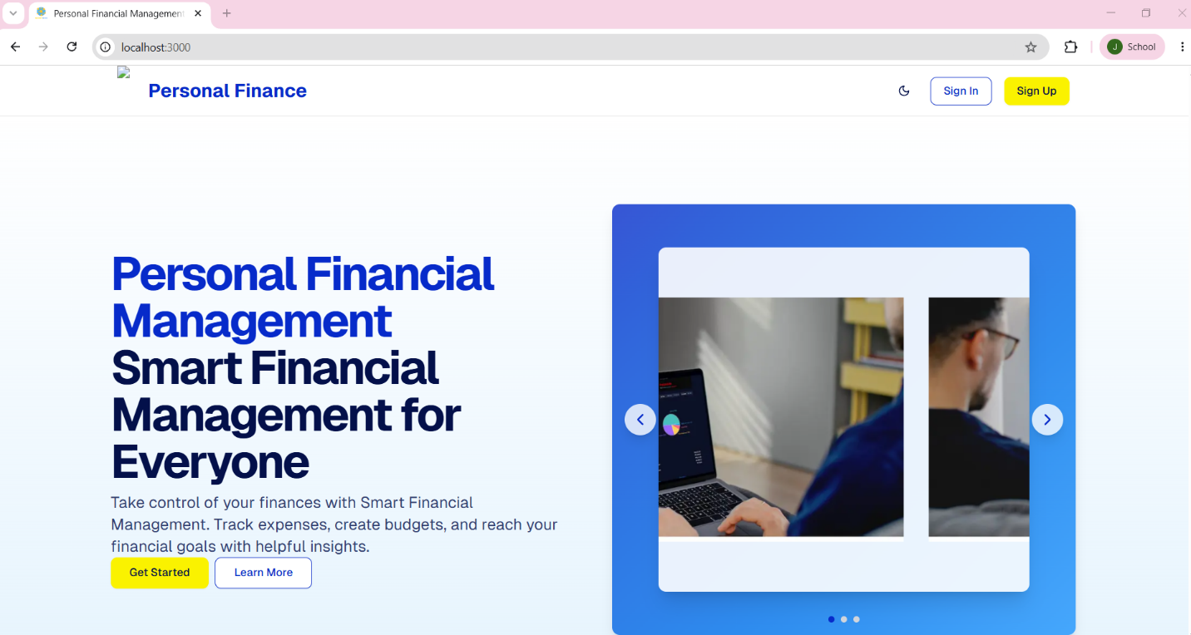
Figure 5. Landing page of the web-based personal financial management system.
The landing page provides the entry point for users to sign in or create an account. To run the prototype during testing, the researchers used Docker and command prompt tools to start the system environment.

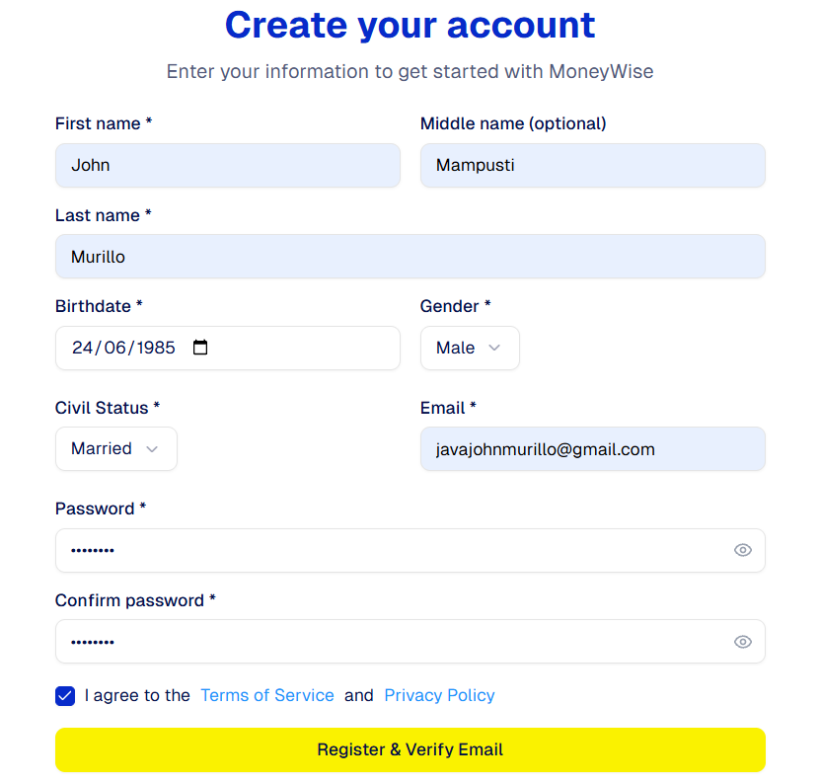
Figure 6. Create account page with anonymized sample user information.
Figure 6 presents the account creation interface of the system, populated with anonymized sample user information for demonstration purposes. The page allows new users to enter required details, such as username, email address, and password, to register an account. The use of anonymized data protects user privacy while showcasing the functionality and layout of the registration process.
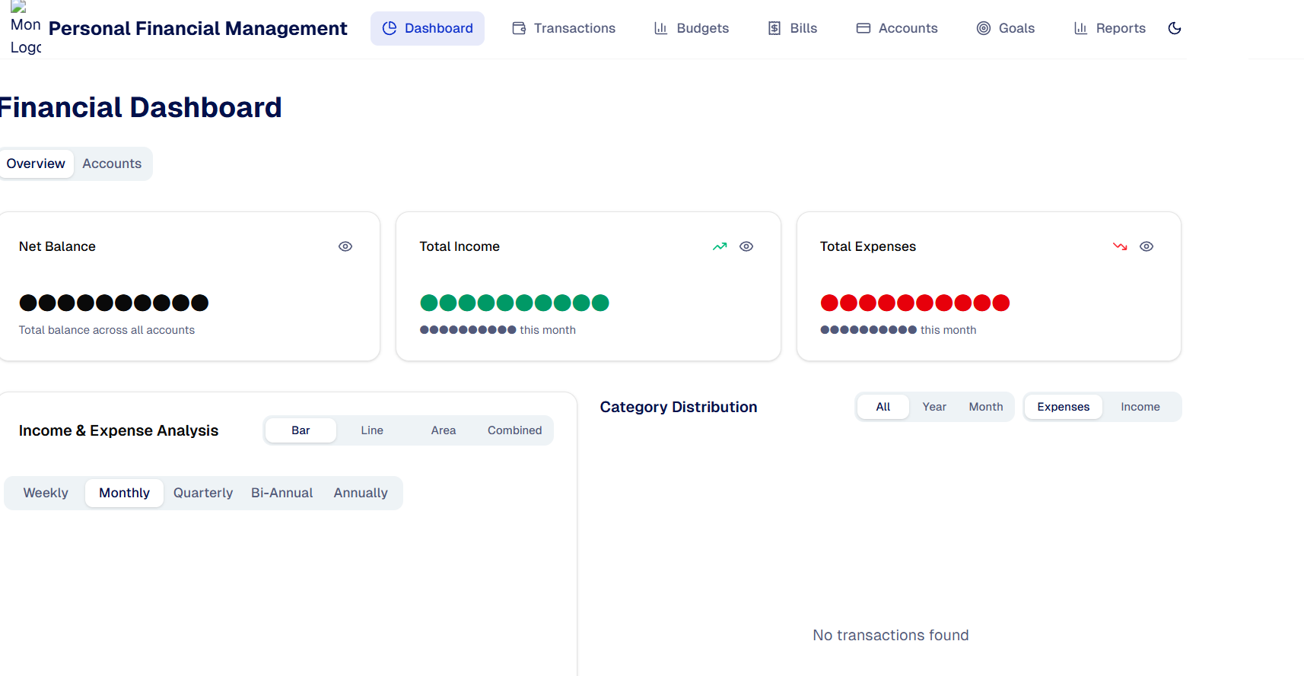
Figure 7. Financial dashboard after account creation.
After registering, users are directed to the financial dashboard, where income, expenses, balance, and category summaries can be viewed. Users may also create accounts and record savings or other sources of funds.
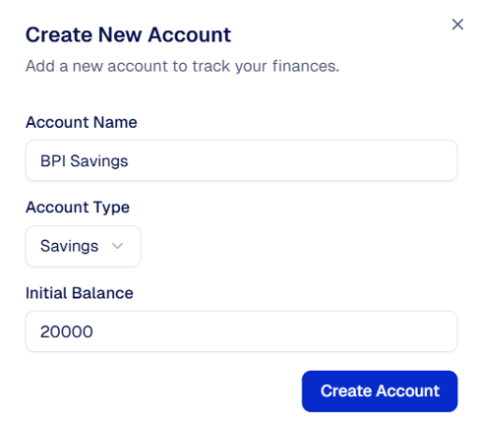
Figure 8. Create account function for savings.
Figure 8 shows the savings account creation feature of the system. This function enables users to set up a savings account by entering relevant information such as the account type, and initial balance. The feature helps users organize their finances, monitor their savings progress, and manage financial objectives more effectively within the system.
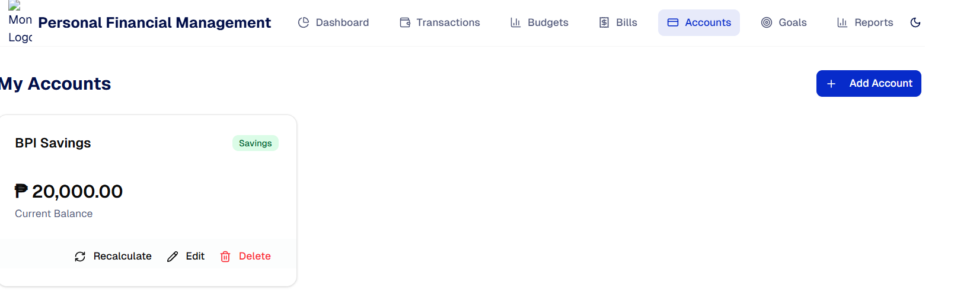
Figure 9. Savings account display and account-related options.
Figure 9 displays the savings account dashboard, where users can view the details of their savings account, including the current balance and account information. The interface also provides account-related options, such as editing account details, adding transactions, viewing account history, or managing savings goals. This feature allows users to efficiently monitor and manage their savings activities.

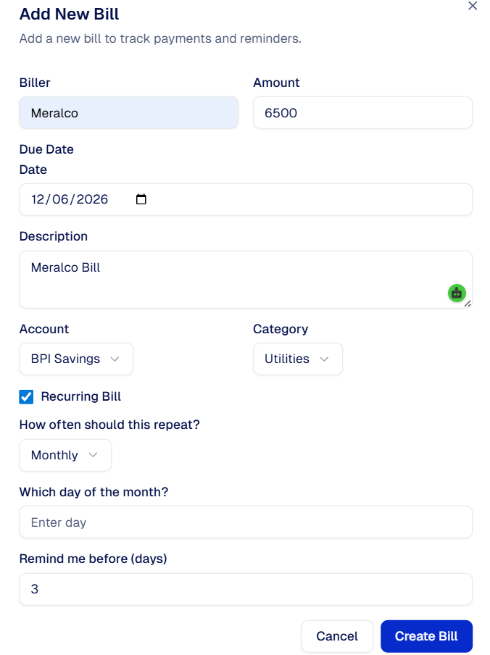
Figure 10. Add new bill form.
Figure 10 shows the form used to add a new bill to the system. Users can enter important bill details such as the bill name, amount due, due date, and payment frequency. This feature helps users keep track of upcoming financial obligations, organize recurring payments, and improve overall financial management.
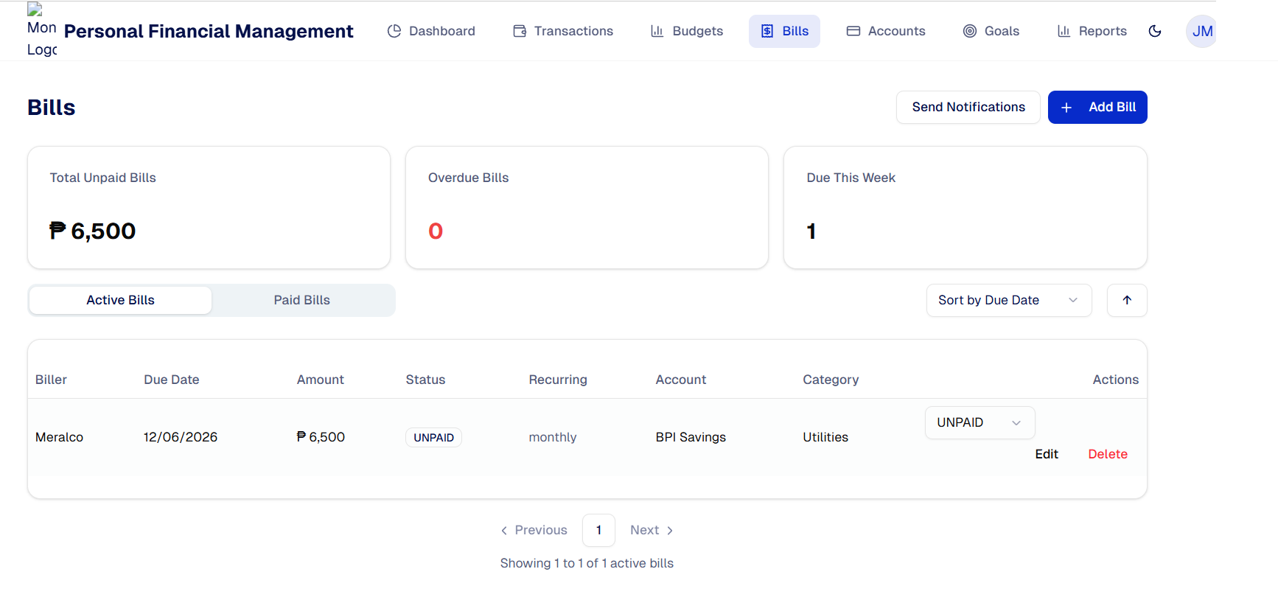
Figure 11. Bills page showing an active billing record.
The bill module allows users to enter the biller, amount, due date, category, recurrence, and reminder details. This supports users who need to monitor recurring household or utility payments.
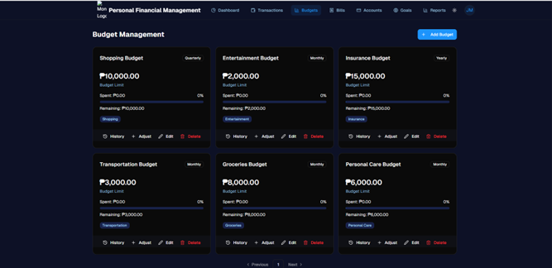
Figure 12. Creating of Budget
Figure 12 Creating of Budget illustrates the process of planning and allocating financial resources for a project or activity. It shows how estimated costs are identified, categorized, and distributed across different components such as materials, labor, and other expenses. The figure highlights the importance of organizing funds effectively to ensure that the project stays within financial limits and resources are used efficiently.

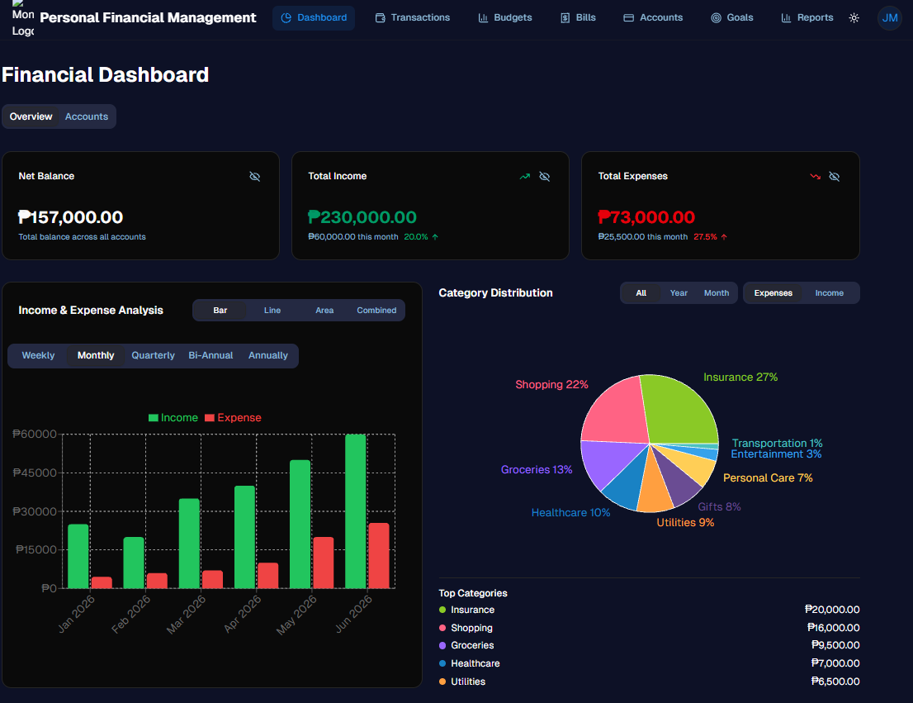
Figure 13. Dashboard after expense recording.
Figure 13 presents the dashboard after an expense has been successfully recorded in the system. The updated dashboard reflects the newly added expense, showing changes in financial summaries, account balances, and expense tracking data. This provides users with a real-time overview of their financial status and helps them monitor spending patterns more effectively.
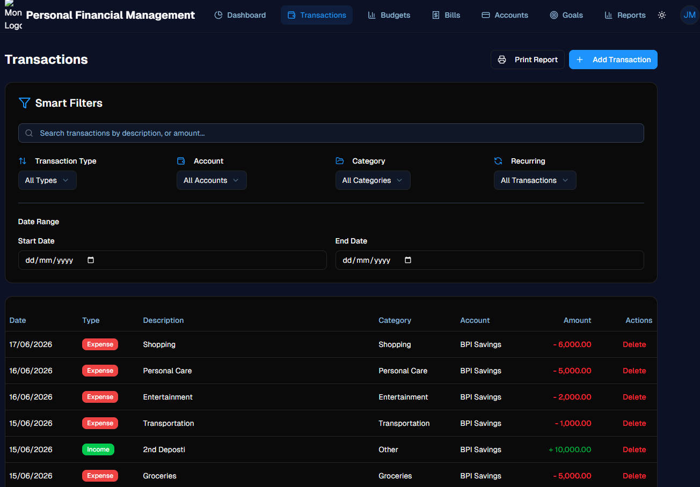
Figure 14. Transactions page showing recorded income and expenses.
Figure 14 displays the transactions page, where all recorded income and expense entries are listed. The page provides users with a detailed overview of their financial activities, including transaction amounts, dates, categories, and descriptions. This feature helps users track cash flow, review past transactions, and maintain accurate financial records.
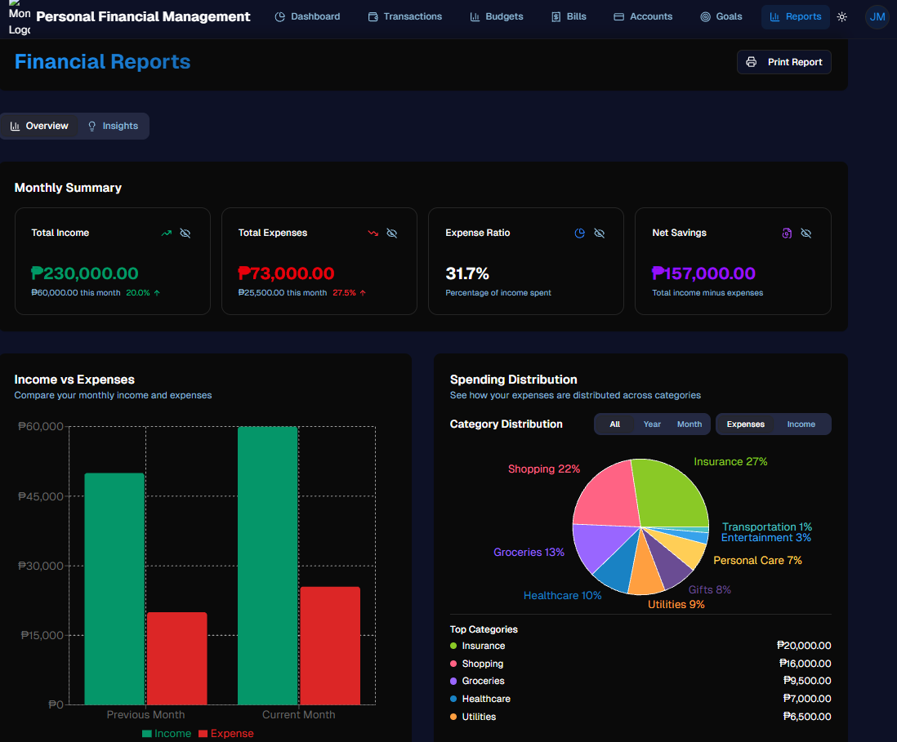
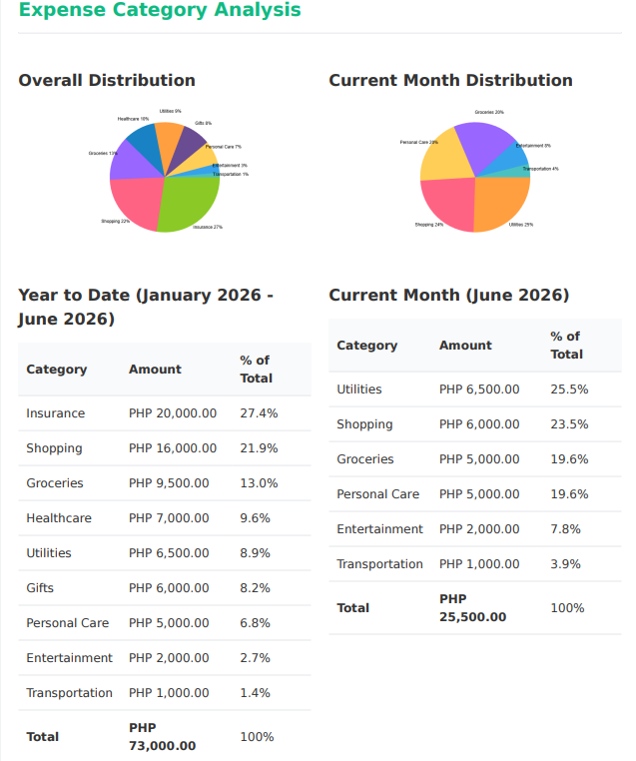
Figure 15. Reports page with visual summaries of income, expenses, and spending distribution.
Figure 15 presents the reports page, which provides visual summaries of the user's financial data through charts and graphs. The page highlights key information such as total income, total expenses, and spending distribution across different categories. This feature helps users analyze financial trends, identify spending patterns, and make informed budgeting decisions.
SCOPE AND LIMITATIONS
The study focused on the design and evaluation of a web-based personal financial management prototype for young professionals. The evaluation measured software quality perceptions using functionality, usability, reliability, performance, and supportability. It did not measure long-term behavioral change, actual savings improvement, or financial outcomes after extended use. Therefore, the findings should be interpreted as an evaluation of prototype readiness rather than as proof that the system directly improves financial behavior over time.
Another limitation is that the evaluation was conducted in a controlled prototype-use setting. Respondents were able to test selected tasks, but the study did not monitor whether they would continue using the system across several pay cycles or during real financial decision making. Because of this, the findings are best understood as evidence that the prototype is acceptable and functional for initial use, not as proof of sustained adoption. Future testing should include longer use periods, more diverse respondent groups, and comparison with existing budgeting practices such as spreadsheets, mobile wallet histories, or manual expense tracking.
The sample size was limited to 27 young professional respondents and three IT professionals. While the responses provided useful feedback, the results may not fully represent all young professionals in different industries, income levels, or regions. The system also used manually encoded sample transactions during evaluation. Future implementation with bank or e-wallet integration may produce different usability, security, and performance requirements.
The analytics features in the prototype were limited to basic summaries, category distribution, budget monitoring, and visual reports. More advanced analytics, such as predictive financial coaching, automated classification, and machine learning-based recommendations, were not fully implemented in this version. These limitations point to opportunities for future system development and additional research.
CONCLUSION
The study developed and evaluated a web-based personal financial management system for young professionals. The system allowed users to record income and expenses, create accounts, manage budgets, track bills, set financial goals, and view visual reports. These features were designed to help young professionals organize their financial records and understand their spending patterns in a simple and accessible manner.
The evaluation results showed that the system was positively rated by young professional respondents, obtaining an overall weighted mean of 3.61, interpreted as Strongly Agree. Usability received the highest rating, followed by reliability, performance, functionality, and supportability. The IT professional evaluation also showed positive results, with an overall weighted mean of 3.77. These findings suggest that the system works well as a prototype and has potential as a practical tool for personal financial monitoring.
The results further indicate that data analytics can improve the value of personal financial management systems when analytics are presented through simple dashboards, spending summaries, charts, and alerts. However, the study also found that the system needs improvement in user support, report loading speed, reminder accuracy, and future integration with banks or e-wallets. Overall, the system is considered functional, usable, and helpful, but further development and testing are recommended before broader implementation.
RECOMMENDATION
Based on the results, the first recommendation is to add a simple onboarding guide for first-time users. Short tutorials, tooltips, pop-up explanations, and a help page can make the system easier to learn, especially for users who are not familiar with digital financial tools.
Second, the system should improve the performance of reports, charts, and alerts. Optimizing database queries, reducing unnecessary page loads, and improving the way charts are generated can help users access analytics faster. This is important because dashboards and reports are major features of the system.
Third, the bill reminder feature should be strengthened. Reminders should be tested for accuracy, timing, and consistency. Users should also be allowed to adjust reminder settings based on their preferred number of days before the due date.
In addition, the analytics dashboard should include short explanations beside charts and summaries. Some users may see graphs and percentages but may not immediately know what action to take from them. Simple labels such as highest spending category, remaining budget, upcoming bills, and suggested review points can make the analytics more practical without making the system too complex.
Fourth, future versions may include optional integration with e-wallets and online banking platforms. This can reduce manual encoding and improve record accuracy. However, such integration should be implemented only with strong security safeguards, user consent, data privacy protection, and secure authentication.
Finally, future researchers may evaluate the system using a larger sample of young professionals from different industries. Additional studies may also examine whether regular use of the system improves actual budgeting behavior, saving habits, and financial decision making over time.
ACKNOWLEDGMENTS AND DECLARATIONS
Acknowledgments. The authors thank the young professional respondents and IT professionals who evaluated the system and provided feedback for improvement.
Funding. The authors declare that no external funding was received for this study.
Conflict of Interest. The authors declare no conflict of interest.
Informed Consent. Informed consent was obtained from the respondents prior to participation in the system evaluation.
Data Availability. The summarized data used in this manuscript are available from the corresponding author upon reasonable request, subject to privacy and confidentiality restrictions.
Authors' Contributions. All authors contributed to the conceptualization, system development, data analysis, manuscript preparation, and final review of the study.
Use of Artificial Intelligence Tools. Artificial intelligence-assisted editing tools were used only for language refinement, organization, and formatting support. The authors reviewed and verified the manuscript and take full responsibility for its content.
REFERENCES
Adeoye, O. B., Addy, W. A., Ajayi-Nifise, A. O., Odeyemi, O., Okoye, C. C., & Ofodile, O. C. (2024). Leveraging AI and data analytics for enhancing financial inclusion in developing economies. Finance & Accounting Research Journal, 6(3), 288-303. https://doi.org/10.51594/farj.v6i3.856
Arriola, A. (2025, August 28). History of business process outsourcing (BPO) in the Philippines. CoDev. https://www.codev.com/article/history-of-business-process-outsourcing-bpo-in-the-philippines-27e4f
Cagatao, P. P., & Garcia, M. J. (2023). Personal finance management practices among personnel of a state university in Ifugao. eJournals.ph. https://ejournals.ph/article.php?id=21640
Di Domenico, S. I., Ryan, R. M., Bradshaw, E. L., & Duineveld, J. J. (2022). Motivations for personal financial management: A self-determination theory perspective. Frontiers in Psychology, 13, Article 977818. https://doi.org/10.3389/fpsyg.2022.977818
Eloriaga, E. F., Roxas, E. R. F., Cuaresma, P. J. R., & Cabauatan, R. R. (2022). A study on financial literacy and financial behavior of young professionals in Metro Manila. International Journal of Research in Engineering, Science and Management, 5(1), 226-236. https://journal.ijresm.com/index.php/ijresm/article/view/1713
Espiritu, P. G. G., & Jocson, J. C. (2023). Navigating cybersecurity challenges in the era of digital transformation: Threats and mitigation strategies in the Philippines. International Journal of Progressive Research in Science and Engineering, 4(11), 10-23. https://journal.ijprse.com/index.php/ijprse/article/view/994
Fajardo, D. F. (2021). Opportunities and challenges experienced by fresh graduate students in a home-based BPO industry. METHOLANGUE: Language Teaching and Literature, Linguistics and Literature, 6(2). https://ejurnal.methodist.ac.id/index.php/metholangue/article/view/2446
Flores, C. A. R. (2025). Financial freedom of Filipinos in personal finance management. Pantao: International Journal of the Humanities and Social Sciences, 4(1), 108-116. https://pantaojournal.com/wp-content/uploads/2025/01/7-Flores.pdf
Hapsari, S. A. (2021). The theory of planned behavior and financial literacy to analyze intention in mutual fund product investment. Advances in Economics, Business and Management Research. https://doi.org/10.2991/aebmr.k.210831.028
Jasmin, P., & Suhaila, M. Y. (2024). AstroWealth: Personal finance management web application. Applied Information Technology and Computer Science, 5(2), 1180-1199. https://publisher.uthm.edu.my/periodicals/index.php/aitcs/article/view/16223
Jennifer, J., & Widoatmodjo, S. (2023). The influence of financial knowledge, financial literacy, and financial technology on financial management behavior among young adults. International Journal of Application on Economics and Business, 1(1), 344-353. https://doi.org/10.24912/ijaeb.v1i1.344-353
Koskelainen, T., Kalmi, P., Scornavacca, E., & Vartiainen, T. (2023). Financial literacy in the digital age: A research agenda. Journal of Consumer Affairs, 57(1), 507-528. https://doi.org/10.1111/joca.12510
Laudon, K. C., & Laudon, J. P. (2022). Management information systems: Managing the digital firm (17th ed.). Pearson.
Liu, C., Li, L., Zhou, W., & Hao, Y. (2024). Financial management practices and financial behavior among young professionals of business process outsourcing companies. Journal of Business and Management Studies, 6(6), 286-297. https://doi.org/10.32996/jbms.2024.6.6.14
Maury, P., Ghatkar, P., Rane, M., & Bhosale, S. (2024). Case study on budget tracker app. International Journal of Research Publication and Reviews, 5(2), 3539-3544. https://ijrpr.com/uploads/V5ISSUE2/IJRPR22995.pdf
NextLeap. (2024). Budgeting and tracking made easy! Tools used [Case study]. https://assets.nextleap.app/submissions/Untitled-b8e2f978-adbf-4b35-a9a3-2e3abbd751b2.pdf
Nielsen, J. (2020). 10 usability heuristics for user interface design. Nielsen Norman Group. https://www.nngroup.com/articles/ten-usability-heuristics/
Pastor, M., Almazan, D., Flores, L., Lopez, L., Maralit, A., & Melo, M. (2022). Factors affecting the behavior of young professionals towards savings and investment. American International Journal of Business Management, 5(5), 44-50. https://www.aijbm.com/wp-content/uploads/2022/05/D554450.pdf
Prakhar, & Bajpai, C. (2024). Comparative analysis of simple moving average and cumulative moving average in financial time series forecasting. International Journal of Innovative Research in Computer Science & Technology, 12(1), Article 17. https://doi.org/10.55524/CSISTW.2024.12.1.17
Pressman, R. S., & Maxim, B. R. (2020). Software engineering: A practitioner's approach (9th ed.). McGraw-Hill Education.
Priyatno, A. M., Ningsih, L., & Noor, M. (2024). Harnessing machine learning for stock price prediction with random forest and simple moving average techniques. Journal of Engineering and Science Application, 1(1), 1-8. https://doi.org/10.69693/jesa.v1i1.1
Rodriguez, M. J. P. (2025). Personal financial management of Pantawid Pamilyang Pilipino Program (4Ps) beneficiaries in the municipality of Canaman, Camarines Sur. Cognizance Journal of Multidisciplinary Studies, 5(2), 114-129. https://doi.org/10.47760/cognizance.2025.v05i02.009
Salsabilla, S. I., Tubastuvi, N., Purnadi, P., & Innayah, M. N. (2022). Factors affecting personal financial management. Jurnal Manajemen Bisnis, 13(1), 168-184. https://doi.org/10.18196/mb.v13i1.13489
Salvador, M. V., & Gabronino, R. (2024). Enhancing personal financial literacy among young professionals: An impact study. Diversitas Journal, 9(1 Special). https://doi.org/10.48017/dj.v9i1_special.2943
Shih, H., Chen, B. H., Chen, M., Wang, C., & Wang, L. (2022). A study of the financial behavior based on the theory of planned behavior. International Journal of Marketing Studies, 14(2), 1. https://doi.org/10.5539/ijms.v14n2p1
Sommerville, I. (2016). Software engineering (10th ed.). Pearson.
Sonjaya, Y. (2024). Exploring the evolution of budgeting practices from traditional to technology. Advances in Management & Financial Reporting, 2(1), 36-45. https://doi.org/10.60079/amfr.v2i1.265
Vasyliuk, A., & Basyuk, T. (2022). Peculiarities of building a personal finance management system. In COLINS (pp. 1520-1530). https://ceur-ws.org/Vol-3171/paper107.pdf

