Bridging the Gap to Prepare Communication Graduates for the Workforce

Dr. Sonia B. SyGaco
Negros Oriental State University

ABSTRACT
Soft skills acquired from the academe are important if these skill sets are relevant in the workforce. Thus, this research aims to connect the theory and practice of communication graduates of Negros Oriental State University in the Philippines. Of the 108 graduates spanning three years, only 53 responded. They express that their soft skills are aligned with their current work and agree that technology integration, artificial intelligence, and marketing strategies must be included in the curriculum review. It is also taken into consideration to have other avenues for internships and increase the duration of the on-the-job training and not limited to radio broadcasting opportunities. They further suggest that the department must invest in procuring modern facilities and employing experts in the field who can transfer their soft skills to the graduates.

Keywords: Communication, Workforce
INTRODUCTION
The study evaluates if the current CHED-designed curriculum has effectively met the needs of the graduates of the Bachelor of Arts in Communication in their professional careers. Suppose the findings indicate that there is a need to revise the curriculum. The Department of Communication at NORSU must take note of the suggested recommendations in its curriculum review to ensure that it bridges the gap between the skills acquired at NORSU and the skills needed in the workplace.
Scope and Delimitation
This study solely focuses on the graduates of Bachelor of Arts in Communication spanning from 2022,2023, and 2024 who completed the revised curriculum in 2017 with revisions in 2021 and have completed the K-12 program.

REVIEW OF RELATED LITERATURE
Soft skills, specifically skills in communication, are important aspects of the workplace and have been fused into education and program training. However, a study by by Anna K. Touloumakos (2021), Taking a step back to move forward: understanding communication skills and their characteristics in the workplace, suggests that communication skills should begin in the university, which are transferable behaviors in the workplace.
Effective communication requires continuous adaptation and alignment of behaviors with three critical factors: the purpose of the communication encounter, the positional identities of the participants, and the forms of knowledge they bring to the interaction.
This research undertakings take a look at acquiring communication skills which now are focused on soft skills acquired by the students at Negros Oriental State University.
The research, Employers' Perspectives on Workplace Communication Skills: The Meaning of Communication Skills (Coffelt T. et al., 2019), provides how employers evaluate the various skills of new workers. Employers evaluate written communication through various document kinds, writing styles, and interactions. Meanwhile, they also observe oral communication through interaction, presentation performance, and conducting meetings professionally. It is noted that visual communication has been associated with non-verbal cues and data visualization, while electronic communication is via email correspondence.
These results help bridge academic training and expectations in the workplace, where employers’ interpretations must align with instructional approaches. It is for this reason that educators in communication fields leverage these data to create course designs, refine learning outcomes, and prepare learners for the demands of the professional set-up.
Likely, the CHED Memorandum Order (CMO) 35 of 2017 has been used in crafting the curriculum for the Bachelor of Arts in Communication. Subjects such as news writing, research, public speaking, radio, television and film production, graphics and design, video making and editing, advertising and public relations, and Visayan journalism allow communication students of NORSU to earn soft skills (CMO 35, 2017). By acquiring these skill sets, communication graduates will become effective workers in their respective work tasks.
Previous NORSU research reflecting the skills gap of theory and practice is thoroughly discussed in the study, Investigating the Alignment of Skills Acquired by Mass Communication Graduates and Workplace Demands by Sonia B. SyGaco and Gherelene Mae Rafols (2023). This research provides valuable insights into the gap between the skills gained by mass communication graduates of the old curriculum and the competencies required by employers. The research reveals a misalignment of academic instruction and the labor needs of the market, showing the importance of the educational curriculum in providing real-world challenges even during their college years.
A major aspect of this skills gap is the fast development of technology, especially artificial intelligence (AI) tools and other online platforms that have not been embedded in the old curriculum. It is further noted that the absence of Grades 11 and 12 for these learners has resulted in limited exposure to modern content and emerging trends.
This deficiency was only addressed in 2017 with the restructuring of the Philippine K-12 curriculum, which introduced senior high schools to bridge these gaps and better align academic training with contemporary industry demands.

RESEARCH METHODOLOGY
This research study utilizes the quantitative method of gathering the data. Fifty-seven out of 108 research participants from the Bachelor of Arts in Communication at Negros Oriental State University answered the electronic questionnaire. The research environment is the first three-year graduates of the Bachelor of Arts of Negros Oriental State University in Dumaguete City. This research used and modified the Commission on Higher Education (CHED) tracer study.
The researcher uses the graduation list provided by the NORSU Registrar to identify the respondents for this undertaking. Each graduate has been subsequently contacted via Facebook Messenger and invited to complete a Google Form designed for data collection. This research uses the frequency method to interpret the data collected.

RESULTS AND DISCUSSIONS
Demographic Profile of the Respondents
Age
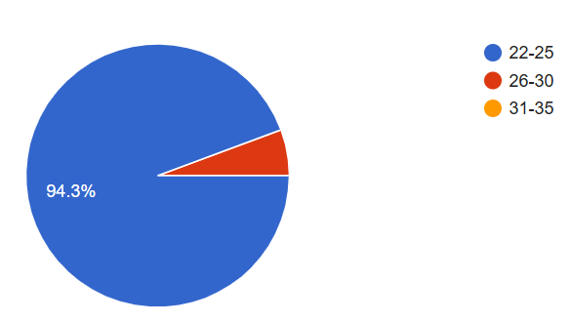
Figure 1 Age
Most of the respondents, comprising 94%, are 22-25 years old, while 6% are 26-30 years old.
Civil Status and Gender
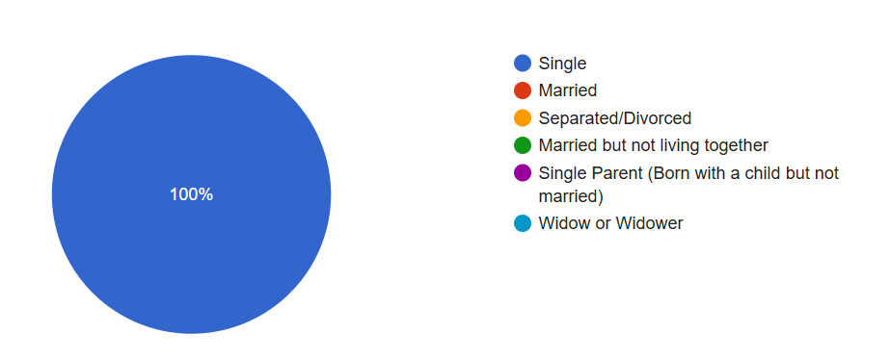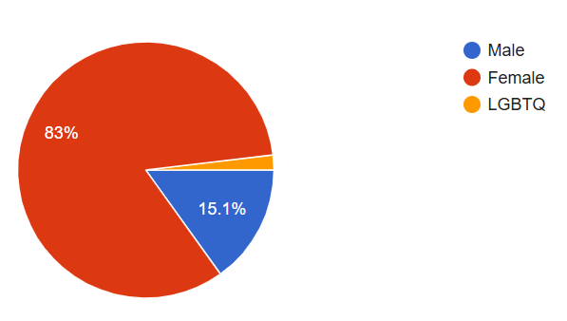
Figure 2 Civil Status and Gender
All the respondents are single, 83% are women, and 15% are male, while 2% come from the LGBTQ.

Region of Origin
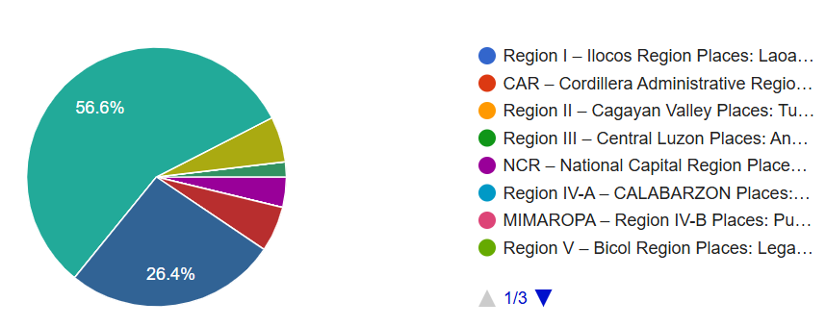
Figure 4 Region of Origin
Most of the respondents comprising 56%, come from the Negros Island, while 26% are from Region VII (Central Visayas) region and the split of 6% for Region VI (Western Visayas) and Region XI (Zamboanga Peninsula), respectively.

Location of Residence

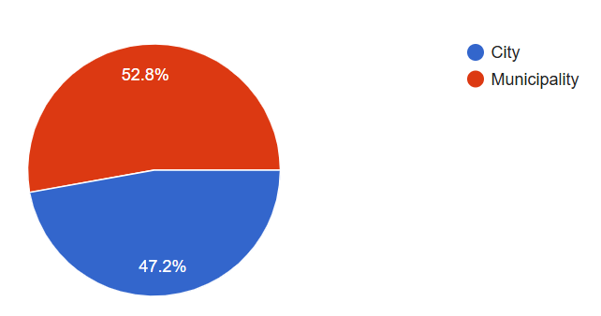
Figure 5 Location of Residence

A slim margin of difference between 53% living in the municipalities and 47% of respondents living in cities.

Reasons for Taking BA in Communication
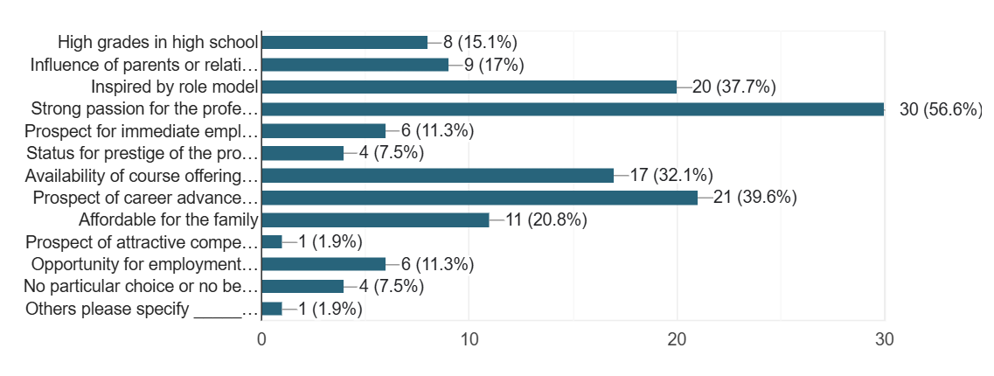
Figure 6 Reasons for Taking BA in Communication
The top five major reasons of the respondents for taking Bachelor of Arts in Communication at Negros Oriental State University are: Strong passion for the profession (56%), the prospect of career advancement (39%), inspired by a role model (37%), availability of course offering (32%), and affordable for the family (20%).

Employment Data

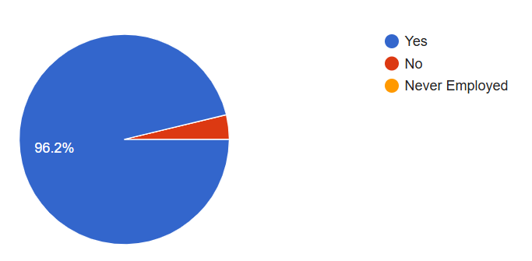
Figure 7 Employment

Nearly 96% of the respondents are employed.

Sector of Work
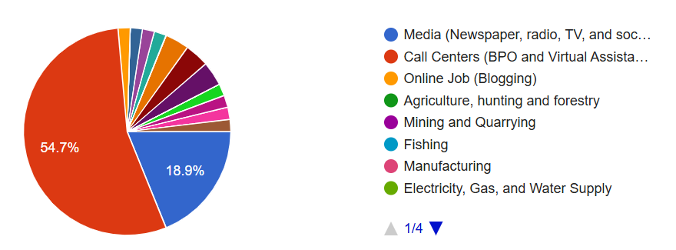
Figure 8 Line of Work
The majority of the research respondents work in call centers, while the remaining respondents are from the media. The rest of them are distributed in local government units and other community social and personal service activities.

Place of Work
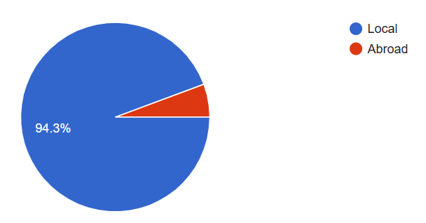
Figure 9 Place of Work
Nearly 94% of the respondents work in the Philippines, while a small margin of 6% work abroad.
Curriculum
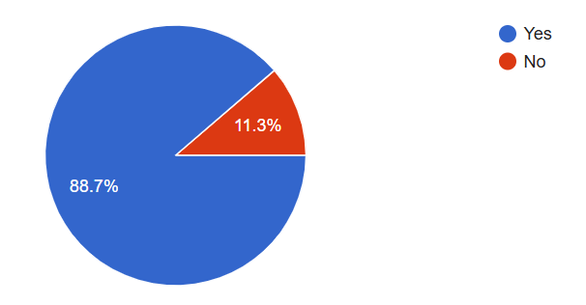
Figure 10 Curriculum
Based on the results, 88.7% of the respondents say that their soft skills match the skills needed in the workplace, while 11.3% disagree with it.

CONCLUSION
The 2017 curriculum and its revision in 2021 of the BA in Communication of Negros Oriental State University has prepared the graduates for the demands of their professional roles in media and other areas of their respective workplaces. They have shown a high employability rate and relevance of their soft skills, with 88% agreeing that the skills they learned in the academe align with the needs of the workplace. However, some gaps need to be addressed, like industry exposure, advanced technological integration, and faculty investment.

RECOMMENDATIONS FROM RESPONDENTS
Specialized tracks in broadcast journalism, marketing communications, and multi-media productions should be embedded in the Bachelor of Arts in Communication curriculum program of Negros Oriental State University. By providing these specializations, student graduates will be tailored as they work toward their career aspirations, providing a deeper knowledge and expertise in specific fields. The curriculum should include artificial intelligence (AI) integration and contemporary marketing techniques to match the industry’s advancements.
It is also noted that practical learning opportunities provide hands-on activities in news writing, videography, broadcasting, and multi-media productions will allow learners to gain real-world experience with the university. These experiences will prepare students for their future roles in the professional world.
To bridge the gap between theory and practice, fieldwork and intensive internships will allow students to be exposed to the various media industries. Extending the duration of the internships will surely prepare them to be competent media practitioners in the future.
Meanwhile, integrating contemporary technology into the program is highly suggested. Smart classrooms must be set in the department where Adobe Creative Suite and AI tools are provided for the students. Not only this, but mobile journalism, virtual reality applications, and other engaging AI software will result in competition and always be on the go for the students.
To optimize the learning of students’ experiences, it is necessary to allow a stronger focus on the core subjects. Enhanced training in analytical thinking, grammar, and writing builds a strong foundation for their communication roles in the future.
Moreover, the program must invest in faculty who can supervise and transfer skills and updated knowledge to the students. It is also recommended that students engage in campus newspapers, podcasts, and workshops on networking, negotiation, and presentation to enhance and prepare students for professional roles. These undertakings will allow the program to produce competent and highly skilled communication graduates who will be able to meet the demands of media.

REFERENCES
Coffelt, T. A., Grauman, D., & Smith, F. L. M. (2019). Employers' Perspectives on Workplace
Communication Skills: The Meaning of Communication Skills. Business and Professional
Communication Quarterly, 82(4), 418-439. https://doi.org/10.1177/2329490619851119

SyGaco S. & Rafols, G. (2023). Investigating the Alignment of Skills Acquired by Mass
Communication Graduates and Workplace Demands. Int. J. Adv. Multidiscip.Res. 10(5):
76-83. DOI: http://dx.doi.org/10.22192/ijamr.2023.10.05.008

Touloumakos, A. K. (2022). Taking a step back to move forward: understanding communication
skills and their characteristics in the workplace. Studies in Continuing Education, 45(2),
188–207. https://doi.org/10.1080/0158037X.2022.2030698

