THE RELATIONSHIP BETWEEN SOCIAL MEDIA USE AND ADOLESCENT MENTAL HEALTH: A SYSTEMATIC LITERATURE REVIEW USING THE PRISMA METHOD

ABSTRACT

Background:
Advances in digital technology have significantly increased social media use among adolescents. Although social media offers various benefits in terms of communication and access to information, excessive use can impact adolescents’ mental health. Various studies have shown a link between social media use and depression, anxiety, stress, and psychological well-being in adolescents (Smout et al., 2025; Mojtabai, 2024).

Objective:
This study aims to identify and analyze the relationship between social media use and adolescents’ mental health based on original research published between 2022 and 2025 (Brand et al., 2024; López-Fernández et al., 2025).

Methods:
This study employed a Systematic Literature Review (SLR) method following the Preferred Reporting Items for Systematic Reviews and Meta-Analyses (PRISMA) guidelines. Articles were retrieved from the PubMed, ScienceDirect, SpringerLink, BMC Public Health, and Affective Science databases using keywords related to social media, mental health, and adolescents. The selection process was conducted based on predetermined inclusion and exclusion criteria (Birgisson et al., 2025).

Results:
A total of seven original articles met the inclusion criteria and were analyzed in this study. The review findings indicate that excessive and problematic social media use is associated with an increased risk of depression, anxiety, psychological stress, sleep disturbances, and reduced psychological well-being among adolescents (Fassi et al., 2025; Smout et al., 2025). However, some studies indicate that social media can also have positive effects, such as providing social support, increasing social connectivity, and offering access to mental health information (EMA Study, 2024).

Conclusion:
Social media use is significantly associated with adolescents’ mental health. The resulting effects can be either positive or negative, depending on the intensity, patterns, and purposes of social media use. Therefore, digital literacy education and supervision of social media use are necessary to support adolescents’ mental health (Mojtabai, 2024; López-Fernández et al., 2025).
Keywords: social media, mental health, adolescents, depression, anxiety

INTRODUCTION
The development of digital technology over the past two decades has brought about significant changes in the way individuals communicate, socialize, and access information. This transformation is marked by the emergence of various social media platforms that allow individuals to connect with one another in real time without geographical boundaries. Social media has now become an integral part of daily life, particularly among adolescents, who are in a phase of highly dynamic social and psychological development.
Adolescents are the age group most active in social media use. This is closely tied to their need to build a sense of self, expand their social networks, and gain recognition from their peers. Social media serves as the primary space for adolescents to express themselves, communicate, and shape their self-image through various forms of digital content such as photos, videos, and status updates.
In this context, social media functions not only as a communication tool but also as a new social space that exerts a significant influence on adolescents’ psychological development. However, the increasing intensity of social media use has also raised various concerns regarding its impact on mental health. A number of studies indicate that high social media usage may be associated with an increased risk of psychological disorders such as depression, anxiety, stress, sleep disturbances, and reduced self-esteem among adolescents (Mojtabai, 2024; Smout et al., 2025). These conditions are influenced by various psychosocial factors, including cyberbullying, social comparison, and the “fear of missing out”
(FOMO), which drives individuals to stay constantly connected to others’ activities on social media.
Additionally, compulsive or addictive social media use is a major concern in research on adolescent mental health. Several studies indicate that excessive social media use can disrupt daily functioning, including concentration while studying, sleep quality, and face-to-face social interactions (Brand et al., 2024; López-Fernández et al., 2025). In the long term, this condition can contribute to the emergence of more complex psychopathological symptoms, particularly in individuals with pre-existing psychological vulnerabilities.
Nevertheless, social media does not always have a negative impact. Several studies indicate that social media can also provide positive benefits for adolescents, such as increased social support, easier access to mental health information, and a broader space for self-expression. In some cases, social media can also help socially isolated adolescents stay connected to their social environment, thereby
potentially improving their psychological well-being (Fassi et al., 2025).
Thus, the relationship between social media use and adolescent mental health is complex and cannot be simplified as an entirely positive or negative relationship. The resulting impact depends heavily on various factors, such as the intensity of use, interaction patterns, the purpose of use, and the individual’s own characteristics. This complexity indicates that social media is a multidimensional phenomenon that requires more in-depth study from various perspectives.

Previous studies on the relationship between social media and mental health have yielded mixed results. Some studies report a significant association between social media use and increased mental health problems, while others find a weak or even insignificant association. These differing results may be influenced by variations in research design, sample size, measurement instruments, and the social and cultural contexts in which the studies were conducted.
Furthermore, most existing studies still employ cross-sectional designs, which only describe associations at a single point in time. This design has limitations in explaining the causal relationship between social media use and mental health. Meanwhile, longitudinal studies and real-time methods such as ecological momentary assessment (EMA) remain relatively limited, even though these approaches can provide a more accurate picture of the dynamics of the relationship between these two variables over time.
Therefore, a systematic review is needed to integrate the latest original research findings and provide a more comprehensive picture of the relationship between social media use and mental health among adolescents. A Systematic Literature Review (SLR) is the appropriate approach for systematically and structurally identifying, evaluating, and synthesizing the available scientific evidence. Thus, this study is expected to make a scientific contribution to understanding the impact of social media on adolescents’ mental health and to serve as a foundation for the development of more targeted interventions and policies in the field of digital mental health.

RESEARCH METHOD
The research method used was a Systematic Literature Review (SLR). This method consists of two main stages: the process of systematically reviewing and identifying relevant scientific articles. This process follows established guidelines proposed by Triandini et al. (2019) and is guided by the Preferred Reporting Items for Systematic Reviews and Meta-Analyses (PRISMA). PRISMA is a structured, evidence-based framework that assists researchers in conducting systematic literature reviews in a transparent and reproducible manner (Pati & Lorusso, 2018).
A literature review of various international and national journals was conducted using a descriptive analysis approach. In this study, a systematic review design was applied by searching for relevant articles in several electronic databases, including PubMed, Scopus, ScienceDirect, SpringerLink, BMC Public Health, and JMIR Mental Health. The keywords used in the search process were: (“social media” OR “social networking” OR “screen time”) AND (“mental health” OR depression OR anxiety OR “psychological well-being”) AND (adolescent OR teenager OR youth)
Articles were selected through a screening process based on titles and abstracts that specifically addressed the relationship between social media use and mental health among adolescents. Articles that did not focus on adolescent populations or did not examine mental health outcomes were excluded from the study.

Table 1. Inclusion and
Exclusion Criteria
Figure 1. Prisma Flowchart

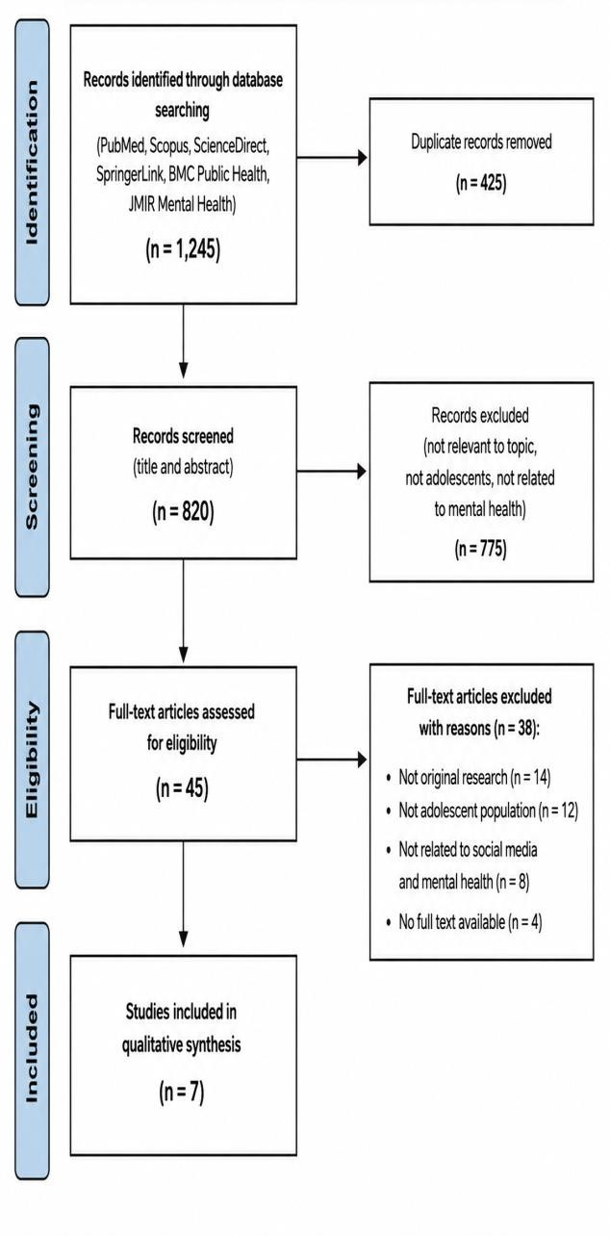
Inclusion | Exclusion
original research articles (non-review studies) | systematic reviews, meta-analyses, or literature reviews
published between 2022 and 2025 | Less than 2022 to 2025
studies involving adolescent participants aged 10–19 years | articles for which the full text is not available.
articles that | articles without full-
examined the | text availability.
relationship
between social
media use and
mental health
outcomes such as
depression,
anxiety, stress, or
psychological
well-being.

RESULTS
After applying the PRISMA guidelines, the study’s results were relevant to the relationship between social media use and mental health among adolescents. Of the 1,245 articles initially identified from various databases (PubMed, Scopus, ScienceDirect, SpringerLink, BMC Public Health, and JMIR Mental Health), 820 articles remained after removing duplicates. From these, 45 full-text articles were assessed for eligibility based on predefined inclusion and exclusion criteria. Finally, 7 articles were found to be suitable and were included in this systematic literature review. After conducting a search for articles in the selected databases using predefined keywords, the researchers then screened and selected studies that met the previously defined eligibility criteria. Seven articles were identified as suitable and were included in the final synthesis. These studies consistently examined the relationship between social media use (including problematic use, screen time, and addictive behavior) and mental health outcomes such as depression, anxiety, psychological distress, and well-being among adolescents.
The results obtained from the literature review are summarized in the following table:

Table 2. Article Data Mapping
Author Year Research Method Results

Fassi, L. 2025 Research Type: Cross-sectional study Sample:
>23,000 adolescents Analysis Technique: Statistical regression analysis to examine the association between social media use
and depressive symptoms
Smout, S. 2025 Research Type: Longitudinal study (4 waves)
Sample: Adolescents aged 10–16 years Analysis Technique: Cross-lagged panel modeling
Higher social media use was significantly associated with increased depressive symptoms among adolescents, with variations based on gender and age groups.

Social media behaviors predicted increases in anxiety and depression over time, particularly in early adolescence.

Mojtabai, R. | 2024 | Research | Type: | Cross-sectional | study | Problematic social media use was strongly associated with
 |  | Sample: | National | adolescent | sample | higher levels of anxiety and depressive symptoms.

Analysis Technique: Regression analysis
Brand, C. 2024 Research Type: Cross-sectional psychological
study
Sample: Adolescents
Analysis Technique: Psychosocial assessment scales

Addictive patterns of social media use were associated with reduced mental well-being and increased psychological distress.

Birgisson, O. 2025 Research Type: Cohort study
Sample: Adolescents aged 15–17 years Analysis Technique: Longitudinal statistical modeling
Online communication patterns were associated with an increased risk of depressive symptoms over time.

López-
Fernández, F. J.
2025 Research Type: Longitudinal study
Sample: Adolescents
Analysis Technique: Path analysis
Social media addiction predicted higher levels of
psychopathology, including anxiety and depression.

EMA | Study | 2024 | Research Type: | Ecological | Momentary | A bidirectional relationship was found between social media
(Affective |  |  | Assessment |  | (EMA) | use and negative emotional states.
Science) |  |  | Sample: |  | Adolescents
Analysis Technique: Real-time data modeling

DISCUSSION
The results of this systematic literature review indicate that there is a consistent relationship between social media use and adolescents’ mental health. Of the seven studies analyzed, the majority found that high or uncontrolled social media use is associated with an increased risk of mental health disorders such as depression, anxiety, psychological stress, and a decline in psychological well-being (Fassi et al., 2025; Smout et al., 2025).
These findings support social comparison theory, which explains that individuals tend to compare themselves with others on social media. Among adolescents, this process is particularly vulnerable due to the unstable phase of identity development. Exposure to social media content depicting idealized lives often triggers feelings of low self-esteem, self-dissatisfaction, and depressive symptoms (Mojtabai, 2024).
Furthermore, the theory of problematic social media use explains that compulsive social media use can resemble addictive behavior. This is evident in several studies showing that excessive social media use not only impacts mental health but also disrupts adolescents’ social and academic functioning (Brand et al., 2024; López-Fernández et al., 2025).
Interestingly, findings from several longitudinal studies indicate that the relationship between social media and mental health is bidirectional. This means that not only can social media use influence adolescents’ psychological well-being, but adolescents who are already experiencing depression or anxiety also tend to use social media more frequently as a coping mechanism or emotional escape (Birgisson et al., 2025).
These findings are supported by ecological momentary assessment (EMA) studies, which show that the interaction between social media use and negative emotions can occur in real time. In other words, social media use can immediately trigger mood changes within a very short period, and conversely, negative emotional states can also drive increased social media activity (EMA Study, 2024).
However, not all effects of social media are negative. Several studies indicate that social media also has positive potential, particularly in terms of enhancing social connectivity, providing emotional support, and offering access to mental health information. Adolescents with supportive social networks on social media tend to have higher levels of psychological well-being compared to those experiencing social isolation (Fassi et al., 2025).
Differences in findings across studies may be attributed to several factors, such as variations in research design, sample size, and social and cultural contexts. Cross-sectional studies tend to capture relationships at a single point in time, whereas longitudinal studies provide a stronger picture of long-term relationships. Therefore, the combination of various research designs in this review offers a more comprehensive understanding of the complexity of the relationship between social media and adolescent mental health.
Overall, the results of this study indicate that social media use is not a single determinant of adolescents’ mental health but is influenced by various factors, such as intensity of use, purpose of use, and individual psychological characteristics. Therefore, intervention approaches should not only focus on limiting social media use but also on improving

, emotional regulation skills, and strengthening social support for adolescents.

CONCLUSIONS
The results of this systematic literature review indicate that social media use is associated with adolescents’ mental health. High or uncontrolled social media use can increase the risk of depression, anxiety, and psychological stress, as well as reduce psychological well-being among adolescents. Adolescents who frequently engage in social comparison on social media tend to experience low self-esteem and dissatisfaction with themselves. Furthermore, compulsive social media use can disrupt social and academic functioning, such as concentration during study and face-to-face social interactions. The relationship between social media and mental health is also bidirectional; adolescents experiencing psychological problems tend to use social media more frequently as a coping mechanism.
However, social media can also have positive effects, such as providing social support and access to information on mental health. Therefore, social media use needs to be managed wisely so that it does not negatively impact adolescents’ mental health, and it should be supported by digital literacy and strong emotional regulation skills.

REFERENCES
Affective Science Study. (2024). Momentary associations between social media use and emotional states in adolescents. Affective Science.
Birgisson, O., et al. (2025). Bidirectional associations between social media use and depression in adolescents. BMC Public Health.
Brand, C., et al. (2024). Addictive social media use and psychosocial distress in adolescents. Child and Adolescent Psychiatry and Mental Health.
Fassi, L., et al. (2025). Social media use and depressive symptoms among adolescents: A large-scale cross-sectional study. Journal of Psychiatric Research.
López-Fernández, F. J., et al. (2025). Social media addiction and psychopathology in adolescents: A longitudinal analysis. Adicciones.
Mojtabai, R. (2024). Problematic social media use and psychiatric symptoms in adolescents. Social Psychiatry and Psychiatric Epidemiology.
Smout, S., et al. (2025). Social media behaviors and mental health in adolescents: A longitudinal study. Journal of Adolescence.
Pati, D., & Lorusso, A. (2018). How to write a systematic review of the literature. Herald of Medicine.
Triandini, E., Jayanatha, S., Indrawan, A., Putra, G. W., & Iswara, B. (2019). Systematic literature review method for identifying platforms in information system research. *Procedia Computer Science*, 161, 1209–1218.

