SMART BMS
Boomika S¹*
Department of Electrical Engineering, Sri Ranganathar Institute of Engineering and Technology, Coimbatore, India
Gmail: boomika0143@gmail.com
Contact : 8610821789

Megasudha V, Annamalai J, Kabilan E^{3*}
Department of Electrical Engineering, Sri Ranganathar Institute of Engineering and Technology, Coimbatore, India

I.ABSTRACT
The rapid growth of electric vehicles (EVs) has increased so the need for efficient and reliable Battery Management Systems (BMS) to ensure safe and optimal battery operation. This paper presents the design and implementation of a smart BMS for a load-carrying electric vehicle powered by a 60 V, 60 Ah Lithium Iron Phosphate (LiFePO₄) battery. The system utilizes a 32-bit microcontroller integrated with a smart BMS to monitor key battery parameters such as voltage, current, and temperature. The proposed system incorporates features such as fault detection and alert mechanisms, adaptive on-board charging, and an LCD-based display for real-time monitoring. In addition, a multi-mode access system using NFC/Wi-Fi card, remote control, and key-based operation is implemented along with an anti-theft alarm to enhance vehicle security. The EV also includes a three-level gear system and reverse operation for improved usability. The system ensures reliable performance, enhanced safety, and efficient energy utilization. The proposed smart BMS provides a practical and effective solution for modern load-carrying electric vehicle applications.
KEYWORDS
Smart Battery Management, Electric Vehicle System, LiFePO₄ Battery, State of Charge, Fault Detection System
II.INTRODUCTION
The rapid advancement of electric vehicles (EVs) has driven the need for efficient, reliable, and intelligent energy storage systems. The battery pack is a critical component of an EV, directly influencing its performance, range, and safety. However, lithium-based batteries require careful monitoring and control due to their sensitivity to operating conditions. This necessitates the implementation of an advanced Battery Management System (BMS) to ensure safe, efficient, and prolonged battery operation.
A Battery Management System is responsible for continuously monitoring key battery parameters such as voltage, current, and temperature, and performing control actions to maintain these parameters within safe operating limits. It also plays a vital role in estimating internal battery states such as the State of Charge (SOC), which indicates the remaining capacity of the battery. Accurate SOC estimation is essential for predicting driving range and optimizing battery usage. In this work, SOC estimation is achieved using a combination of techniques such as Coulomb Counting, Open Circuit Voltage (OCV) method, and advanced filtering approaches like the Kalman Filter, which improves accuracy by reducing noise and estimation errors.
The proposed system is designed for a load-carrying electric vehicle powered by a 60 V, 60 Ah Lithium Iron Phosphate (LiFePO₄) battery, selected for its high thermal stability, long cycle life, and enhanced safety characteristics. A 32-bit microcontroller-based architecture is employed in conjunction with a smart BMS unit to enable real-time data acquisition, processing, and control.
To ensure reliable operation, the system incorporates multiple sensing mechanisms. Voltage sensing is implemented to monitor individual cell voltages and overall pack voltage, enabling detection of over-voltage and under-voltage conditions. Current sensing is achieved using shunt resistors or Hall-effect sensors to track both charging and discharging currents. Temperature sensing, typically using NTC thermistors, is integrated to monitor thermal conditions and prevent overheating.
Cell balancing is another critical function of the BMS, ensuring uniform voltage distribution across all cells in the battery pack. Both passive balancing, where excess energy is dissipated as heat, and active balancing, where energy is redistributed among cells, are considered to improve battery efficiency and lifespan.
The system also incorporates comprehensive fault detection and protection mechanisms. These include over-voltage protection, under-voltage protection, over-current protection, short-circuit protection, and over-temperature protection. Upon detection of abnormal conditions, the BMS triggers fault alerts and takes necessary actions to safeguard the battery and connected systems. All the fault will be displayed in LCD display and whenever fault occurs it trips the circuit via MCB.
In addition to core battery management functions, the proposed system integrates advanced features such as adaptive on-board charging, which adjusts charging parameters based on battery condition to enhance efficiency and longevity. A user interface is provided through an LCD display for real-time monitoring of system parameters and fault indications.
Furthermore, the electric vehicle is equipped with a multi-mode access and security system, including NFC/Wi-Fi card access, remote control, and key-based operation, along with an anti-theft alarm mechanism. The vehicle also incorporates a multi-level gear system and reverse operation to improve usability and control.
Designed to support a load capacity of up to 500 kg, the proposed smart BMS offers a comprehensive solution that combines intelligent monitoring, advanced control algorithms, robust protection mechanisms, and enhanced user interaction. This integrated approach significantly improves battery performance, operational safety, and overall system reliability, making it highly suitable for modern load-carrying electric vehicle applications
III.IMAGE
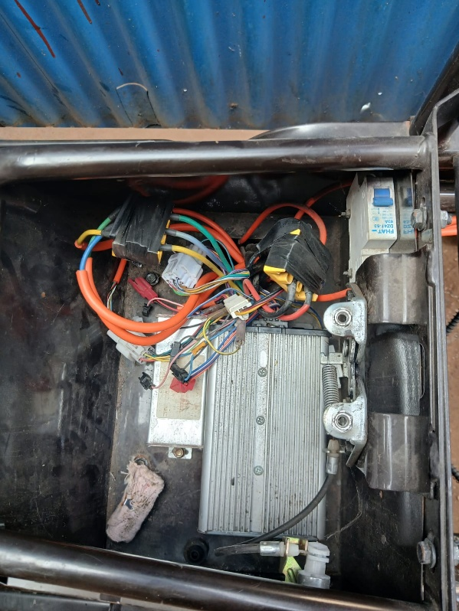

IV.METHODOLOGY
The proposed smart Battery Management System (BMS) for the load-carrying electric vehicle is implemented using a structured approach involving data acquisition, processing, control, and protection. The methodology ensures continuous monitoring and efficient management of the 60 V, 60 Ah Lithium Iron Phosphate (LiFePO₄) battery system.

🔹 1. Data Acquisition
The initial stage involves the measurement of key battery parameters such as voltage, current, and temperature using appropriate sensors. Voltage sensing circuits are employed to monitor both individual cell voltages and overall battery pack voltage. Current sensing is achieved using shunt resistors or Hall-effect sensors to measure charging and discharging currents. Temperature sensors, such as NTC thermistors, are used to continuously monitor the thermal condition of the battery.

🔹 2. Data Processing and Monitoring
The acquired sensor data is fed into a 32-bit microcontroller, which serves as the central processing unit of the BMS. The microcontroller processes the real-time data to evaluate battery performance and operating conditions. Continuous monitoring ensures that the battery operates within safe and predefined limits.

🔹 3. State of Charge (SOC) Estimation
The system implements SOC estimation techniques to determine the remaining battery capacity. Methods such as Coulomb Counting and Open Circuit Voltage (OCV) are utilized, along with filtering techniques to improve estimation accuracy. This enables effective energy management and prediction of battery usage.

🔹 4. Control and Decision-Making
Based on the processed data, the microcontroller executes control actions to regulate battery operation. These include managing charging and discharging processes, controlling power delivery to the motor, and ensuring stable system performance under varying load conditions.

🔹 5. Cell Balancing
To maintain uniform voltage levels across all battery cells, cell balancing techniques are implemented. Passive balancing dissipates excess energy through resistors, while active balancing redistributes energy among cells. This improves battery efficiency and extends its operational lifespan.

🔹 6. Fault Detection and Protection
The system continuously checks for abnormal conditions such as over-voltage, under-voltage, over-current, short-circuit, and over-temperature. Upon detection of any fault, the BMS activates protection mechanisms and generates alerts to prevent damage to the battery and associated components.

🔹 7. Adaptive Charging Control
An adaptive on-board charging system is incorporated to regulate the charging process based on battery condition. The charging rate is adjusted dynamically to ensure safe and efficient charging, thereby enhancing battery life and performance.

🔹 8. User Interface and Monitoring
An LCD display is integrated into the system to provide real-time information about battery status, system parameters, and fault conditions. This improves user awareness and enables effective monitoring of the system.

🔹 9. System Integration
The BMS is integrated with the motor controller and vehicle system to ensure seamless operation. Additionally, a multi-mode access and security system, including NFC/Wi-Fi card, remote control, and key-based operation, is incorporated along with an anti-theft alarm mechanism.

🔷 SUMMARY OF METHODOLOGY
The overall methodology follows a cyclic process of sensing, processing, control, and protection to ensure efficient and safe operation of the battery system. This structured approach enhances system reliability, battery performance, and operational safety in load-carrying electric vehicle applications
V.GRAPH

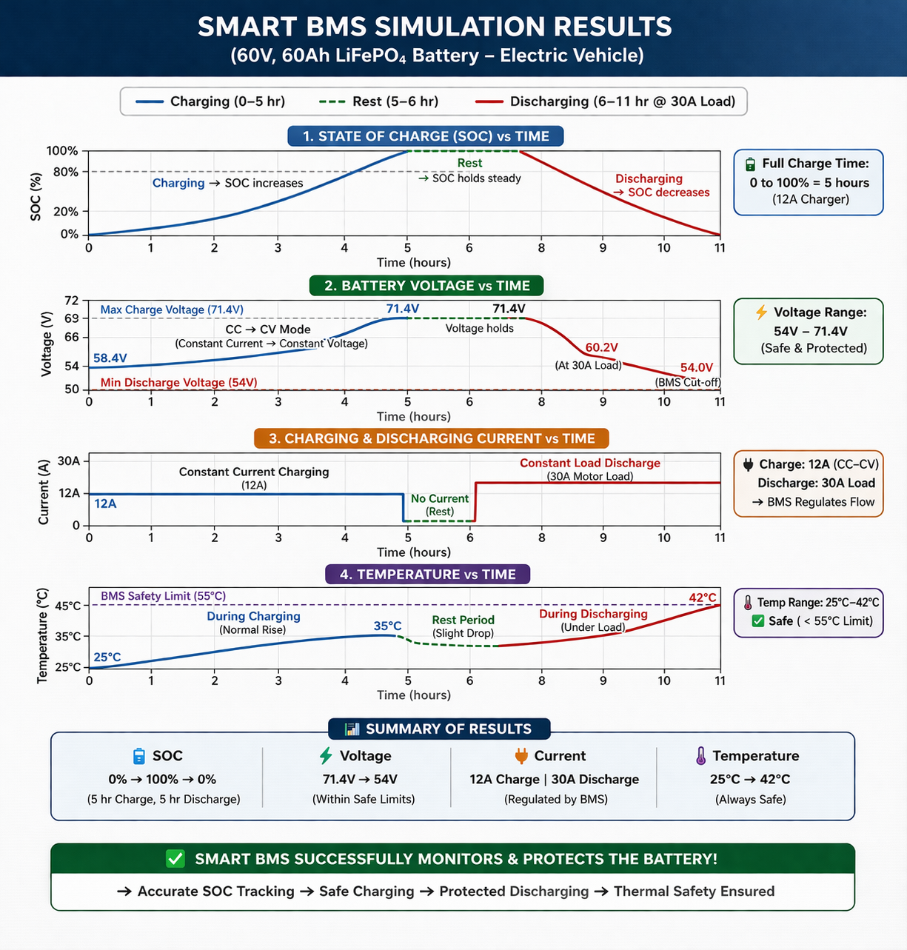
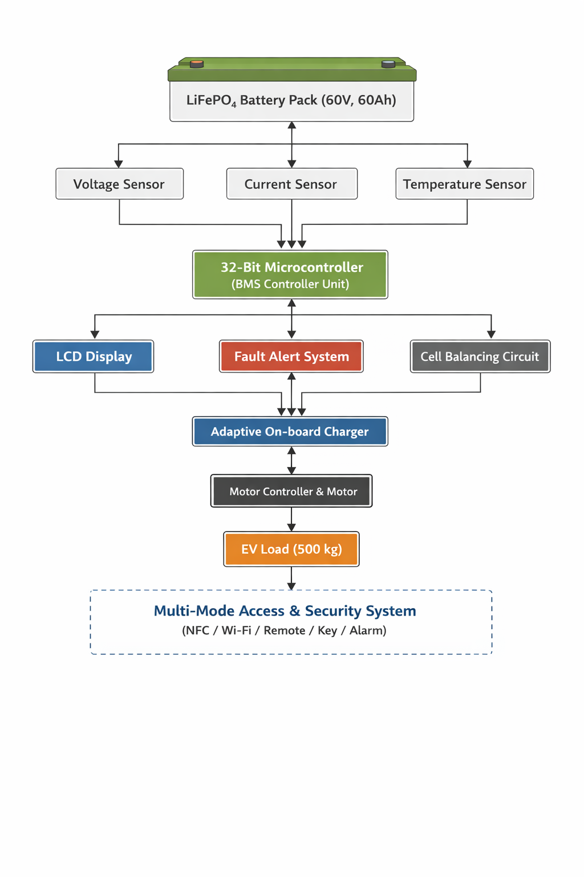VII.RESULTS AND DISCUSSION
VI.BLOCK DIAGRAM
The proposed smart Battery Management System (BMS) for the load-carrying electric vehicle was successfully designed and implemented using a 32-bit microcontroller integrated with a smart BMS unit. The system was tested under various operating conditions to evaluate its performance, reliability, and safety.
The results demonstrate that the BMS effectively monitors key battery parameters such as voltage, current, and temperature in real time. The implemented State of Charge (SOC) estimation provides a reliable indication of the remaining battery capacity, enabling efficient energy utilization. The system also ensures stable operation under different load conditions, supporting a load capacity of up to 500 kg.
The adaptive on-board charging mechanism was observed to regulate the charging process efficiently, preventing overcharging and improving overall battery performance. The charging and discharging characteristics were found to be consistent with expected theoretical values, with charging time varying based on input current and discharging time depending on load conditions.
The fault detection and protection mechanisms responded effectively to abnormal conditions such as over-voltage, over-current, and temperature rise. The system generated timely alerts through the LCD interface, ensuring user awareness and system safety.
Cell balancing functionality contributed to maintaining uniform voltage levels across battery cells, thereby enhancing battery life and operational efficiency. Additionally, the integration of a user-friendly LCD display and multi-mode access system improved usability and security of the vehicle.
Overall, the system exhibited reliable performance, efficient battery management, and enhanced safety features, making it suitable for practical load-carrying electric vehicle applications.

🔷 CONCLUSION
In this project, a smart Battery Management System (BMS) for a load-carrying electric vehicle was successfully designed and implemented. The system effectively integrates real-time monitoring, control, and protection mechanisms to ensure safe and efficient operation of a 60 V, 60 Ah Lithium Iron Phosphate (LiFePO₄) battery.
The implementation of advanced features such as State of Charge (SOC) estimation, adaptive on-board charging, fault detection, and cell balancing significantly improves battery performance, lifespan, and reliability. The inclusion of a user-friendly interface and multi-mode access system further enhances usability and security.
The proposed system addresses the limitations of conventional BMS by providing intelligent monitoring, accurate estimation, and robust protection under varying load conditions. The results validate the effectiveness of the system in maintaining battery safety, optimizing energy utilization, and ensuring reliable vehicle operation.
Thus, the developed smart BMS offers a practical and efficient solution for modern load-carrying electric vehicles and can be further extended with advanced features for future enhancements.

VIII.REFERENCE
[1] T. Duraisamy and D. Kaliyaperumal, “Machine Learning-Based Optimal Cell Balancing Mechanism for Electric Vehicle Battery Management System,” IEEE Access, 2021. — ML for cell balancing (BMS feature/algorithm).
[2] Abdullah, H. M., et al., “Reinforcement Learning Based EV Charging Management Systems — A Review,” IEEE Access, 2021. — RL for smart EV charging orchestration and scheduling
[3] Hasib, S. A., et al., “A Comprehensive Review of Available Battery Datasets, RUL Prediction Approaches, and Advanced Battery Management,” IEEE Access, 2021. — datasets, RUL/SOH estimation and advanced BMS topics.
[4] P. Mondal, D. Bhavsar, et al., “Estimating State-of Charge in Lithium-Ion Batteries Through Deep Learning Techniques: A Comparative Evaluation,” IEEE Access, 2024. — deep-learning SOC estimation comparisons (useful for BMS SOC module).
[5] Ismail, M. and Ahmed, R., “A Comprehensive Review of Cloud-Based Lithium-Ion Battery Management Systems for Electric Vehicle Applications,” IEEE Access, 2024. — cloud/telemetry aspects of modern BMS.
[6] Na, S.-J., Sim, J.-U., Kim, B.-J., Kwon, D.-H., & Cho, I.-H., “Design of Bluetooth Communication-Based Wireless Battery Management System for Electric Vehicles,” IEEE Access, 2024. — wireless BMS communications (BMS ↔ VCU/UI).
[7] “Data-Driven Approaches for Estimation of EV Battery SoC and SoH: A Review,” IEEE Access, 2025. — survey of data-driven SOC/SOH methods (helps pick estimation approach).
[8] H. M. Abdullah and S. A. Khan, “Reinforcement Learning and Optimization for EV Charging Management,” IEEE Transactions / IEEE Access (related works 2021–2023). — (practical control/charging policy literature for adaptive charging).
[9] Selected IEEE Transactions on Industrial Electronics / Power Electronics articles (2020–2024) addressing MPPT controller design and DC–DC converter topologies for PV EV charging (search IEEE Xplore for MPPT + EV + 2020–2024). — (useful for MPPT & DC-DC design).
[10] EEE Vehicular Technology / IEEE Transactions on Transportation Electrification papers (2020–2024) discussing vehicle-integrated photovoltaics (VIPV) and PV-assisted EV charging systems. — (system integration & experimental studies)

