Wall-Climbing Robot for Structural Crack Detection Using YOLOv8
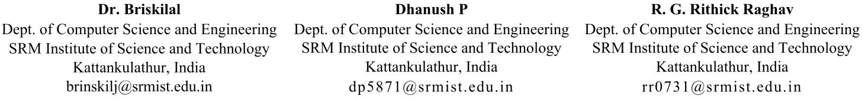

Abstract—Structural cracks are early signs that civil infras- tructure like bridges, buildings, and tunnels are falling apart. It takes a lot of time and money to manually check vertical surfaces, and it puts inspectors at risk. Using OpenCV to find edges is an example of a traditional computer vision technique that doesn’t work well in different lighting conditions. This paper presents a semi-autonomous wall-climbing robotic system designed for automated structural inspection. The system uses a deep learning model called YOLOv8 to find cracks in images taken by an onboard camera. A module for estimating crack severity figures out the ratio of the area of the crack to the area of the whole image and sorts the damage levels. The system also has an ultrasonic sensor for measuring distance, a manually controlled manipulator arm to help with inspections, and an energy monitoring system to make sure it runs smoothly. The proposed system has a precision of 0.877, a recall of 0.752, and a mAP@0.5 of 0.867, which is better than traditional OpenCV-based methods. The suggested method is an effective and dependable way to automate structural inspections and damage assessments.
Index Terms—Wall-climbing robot, YOLOv8, crack detection, deep learning, structural health monitoring, computer vision, inspection robotics, automated infrastructure inspection.

- Introduction
To keep people safe, it is important to keep an eye on the structural health of civil infrastructure like bridges, buildings, tunnels, and dams. These structures are the backbone of modern infrastructure and are always exposed to harsh weather and mechanical stress. If these problems aren’t fixed quickly, they can lead to serious failures over time.
One of the first signs that a structure is falling apart is when it starts to crack. Thermal expansion and contraction, material shrinkage, overloading, bad building practices, and exposure to the environment are all possible causes. If these cracks aren’t found, they could spread and cause serious damage to the structure. Fig.1 shows the difference between a surface that is healthy and one that is cracked.
The age of the building, the weather, the quality of the materials, and how well it is maintained all play a role in how cracks form and spread. Structures that are more than 30 years old or have been exposed to harsh weather are more likely to fall apart. Coastal and industrial areas make damage happen even faster because chemicals can get in and moisture can get in.
Traditional inspection methods depend on people looking at things by hand, which takes a lot of time, work, and is often dangerous. Inspectors may have to go to dangerous or hard-to-reach places, which raises the chance of accidents.
To get around these problems, automated inspection meth- ods that use robotics and computer vision have become very popular. Robotic inspection systems have benefits like better safety, more reliable data collection, lower operational costs, and the ability to get to hard-to-reach places.
Wall-climbing robots are one of the best ways to check out vertical structures. These robots can stick to surfaces and take high-resolution pictures for later analysis.
This paper describes a wall-climbing robot system that can work on its own to check structures. The system has a fan-based suction adhesion mechanism for climbing walls, a camera for taking pictures, an ultrasonic sensor for measuring distance, a YOLOv8-based deep learning model for finding cracks, a crack severity estimation module for assessing dam- age, and an energy monitoring mechanism for making sure it works as well as possible.
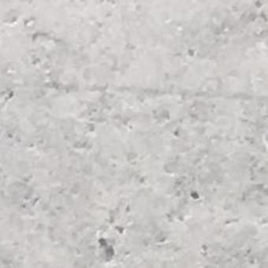
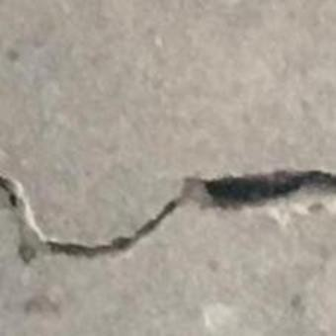
(a) Crack image 1 (b) Crack image 2 Fig. 1: Sample crack images captured during inspection
The key contributions of this study are summarized as follows:
- Putting together a wall-climbing robotic inspection plat- form with a YOLOv8 deep learning crack detection model.
- Creation of a way to figure out how bad a crack is based on the percentage of the area that is cracked.

- Putting in place a framework for making maintenance recommendations for infrastructure inspections.
- Create a semi-autonomous inspection system that uses robotic movement and automated crack detection.
- Combining manual manipulation with energy-aware mon- itoring for safe robotic inspection.
- Related Work
A lot of people are interested in automated inspections of infrastructure because they want to keep an eye on structural systems in a more efficient way. Robotic platforms like aerial drones have been made to help with inspections. People often use aerial drones to look at tall structures like bridges and towers. But they can also have trouble getting clear pictures of small cracks in the surface because they can’t stay still and close to the ground. It might be a good idea to use robots that can climb walls to do inspections. Wall-climbing robots can move straight up and down vertical surfaces and take high-resolution pictures while they are being inspected.There are many ways that things can stick together, like magnetic adhesion, vacuum suction, and fan-induced suction systems.
Crack detection has gotten better since the days when people used old-fashioned image processing methods like edge detection and thresholding. Changes in the lighting and texture of the surface being looked at can mess up these older methods, which often leads to false detections.
Recent progress in deep learning has made it much easier to find cracks. Convolutional neural networks (CNN) and object detection models based on YOLO, for instance, have done a great job of showing that structural defects are real. YOLO version 8 (YOLOv8) is especially good at finding cracks, and it can do it quickly and in real time. The integration of deep learning crack detection with wall-climbing robotic inspection systems represents an emerging field that requires further investigation.
- Proposed System
- System Overview
The proposed system uses a deep learning-based crack detection framework and a wall-climbing robot platform to automate the inspection of vertical infrastructure surfaces. The robot has a suction adhesion mechanism that lets it stick to vertical walls and a camera that lets it take pictures. The processing unit gets the pictures and uses the YOLOv8 deep learning model to look at them and find cracks. The system determines how bad the cracks are and suggests ways to fix them. When the operator needs to, they can touch the surface they are looking at with a manual manipulator arm. The robot also checks the battery’s power levels while it works to make sure it’s safe.If something goes wrong with the robot’s operation, operators can safely stop or control it with a manual override.
- Wall-Climbing Mechanism
The system that has been suggested includes a wall- climbing mechanism that is very important. The robot stays

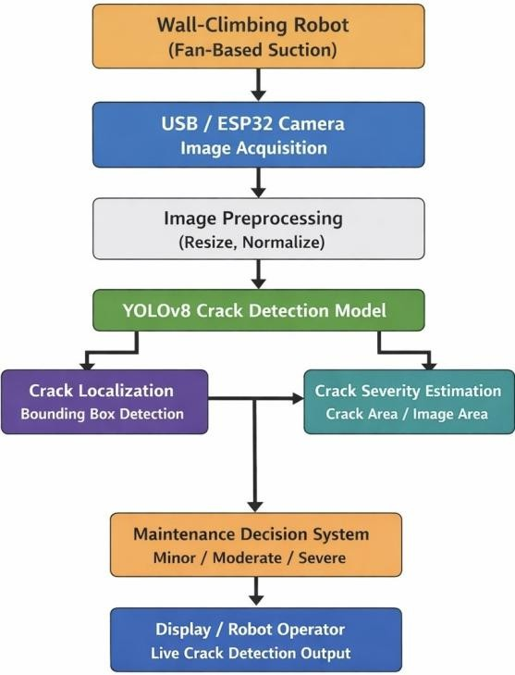
Fig. 2: System overview

in touch with vertical surfaces by using a suction system that works with fans. A fast DC fan makes the space between the robot base and the wall negative pressure. This makes a suction force that keeps the robot attached while it moves. Unlike magnetic adhesion systems, this mechanism can work on a wide range of surfaces, including concrete, painted walls, and glass.

- Traditional OpenCV-Based Crack Detection
Fig. 3 Shows what happens when you use the OpenCV- based method to find cracks.
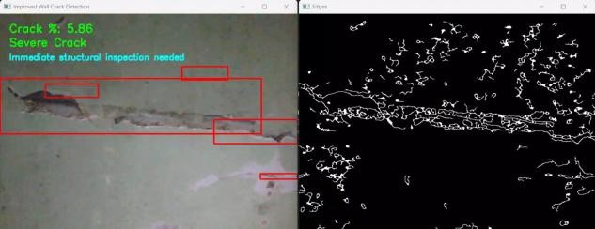
Fig. 3: OpenCV-based crack detection result.

We tried a more traditional way to find cracks with OpenCV image processing tools before using the deep learning model. To start, the process changes the colors of the images to grayscale. Then, it uses Gaussian blur to get rid of noise. Finally, it uses the Canny edge detection algorithm to find possible crack edges.
This method works quickly on computers, but it has some problems. For example, it can be fooled by changes in lighting

and surface textures, which can cause false detections or missed cracks.
- YOLOv8-Based Crack Detection
The proposed system employs the YOLOv8 object detection architecture to circumvent the limitations of conventional image processing techniques.
YOLOv8 predicts bounding boxes around places where cracks are and gives them scores of how sure they are. The model learns how to find cracks by looking at training data with labels, which makes it very trustworthy.
- Methodology
The proposed methodology delineates the comprehensive processing pipeline for automated crack detection and struc- tural damage evaluation utilizing a wall-climbing robotic plat- form integrated with a deep learning model. The first step is to get images from the robot-mounted camera. Then, the images are preprocessed, cracks are detected using deep learning, the severity is estimated, and maintenance is suggested. The system is made to work in real time while the robot moves across vertical surfaces, which allows for constant inspection and analysis.
- Image Acquisition
The first step in the inspection pipeline is getting images. A USB camera is attached to the wall-climbing robot so it can take pictures of the wall as it moves. The camera is set up so that it can see the inspection area clearly and steadily. While the robot moves over vertical surfaces, it keeps taking pictures to make sure the whole structure is covered. A processing unit, like a laptop, gets these pictures and does more analysis on them. To find fine crack patterns, especially thin hairline cracks, it’s very important to keep the image quality high. So, for accurate detection, the mounting must be stable and the lighting must be right.
- Image Preprocessing
Before training and detection, preprocessing was done to make the images better and make sure that the input was always the same so that cracks could be found accurately. Step 1: Collecting Pictures We got images from two places: real-time images taken with a USB camera mounted on the wall-climbing robot and extra crack images from datasets that are open to the public. This makes the model work better in different settings. Step 2: Getting the dataset ready and adding
labels Roboflow was used to preprocess and label the dataset.
Time Noise reduction and brightness adjustment were used on real-time images to make them look better and make sure that cracks were found correctly. Step 7: Add to the YOLOv8 Model The YOLOv8 model was then given the preprocessed images as input to find cracks.
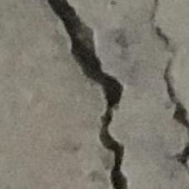
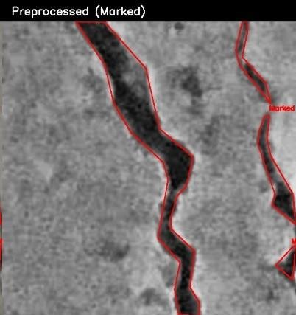
Before preprocessing After preprocessing
Fig. 4: Comparison of crack image before and after prepro- cessing

- Deep Learning-Based Crack Detection
The YOLOv8 deep learning model looks for cracks in the images after they have been preprocessed. YOLOv8 is an object detection architecture that works in real time with high accuracy. It uses convolutional neural networks (CNNs) to do this. There are three main steps in the detection process:
  - Feature Extraction: The convolutional layers pull out hierarchical features like edges, textures, and shapes that show crack patterns.
  - Feature Aggregation:Multi-scale feature maps are put together to find cracks of different sizes, from small hairline cracks to larger structural cracks.
  - Detection Head: The model predicts bounding boxes around crack regions and also gives confidence scores that show how likely it is that the detection is correct.
YOLOv8 processes the whole image in one go, which makes it very fast and perfect for real-time robotic inspection.
- Crack Severity Estimation
The system checks for cracks and then does a quantitative severity estimate to figure out how bad the damage is. The severity is the total area of the cracks divided by the total area of the image:
Total Crack Area

It used bounding boxes to mark crack areas and prepared images for training. Step 3: Resize the image All of the images
Severity Ratio =

Total Image Area
(1)

were made to be 640 × 640 pixels so that they would fit the YOLOv8 model’s input size. Step 4: Normalization of the Image To make the model work better and more stable, the pixel values were changed to a range of 0 to 1. Step 5: Adding more data We changed the brightness and contrast of the dataset to make sure the model would work well in different lighting conditions. Step 6: Improvement in Real
Severity (%) = Severity Ratio × 100 (2)
Cracks are put into three groups based on the severity percentage that was calculated:
  - 0–2% : There is no major crack
  - 2–5% : Small crack (needs to be watched)
  - >5% : Big crack (needs to be fixed right away)

This quantitative method provides a more useful assessment than just binary detection.

- Maintenance Recommendation System
The last part of the methodology is the maintenance rec- ommendation module. The system makes maintenance sug- gestions based on how bad the cracks are thought to be.
  - Regular checks are suggested if there aren’t any big cracks.
  - If there are only small cracks, it is best to do preventive maintenance like sealing or making small repairs.
  - If there are big cracks, it is best to have a detailed structural inspection and fix them right away.
This module turns detection results into useful information that helps engineers make smart decisions about maintenance.

- Experimental Setup and Evaluation
The experimental setup was designed to evaluate the per- formance of the proposed wall-climbing robotic inspection system under real-world conditions. The robot was tested on multiple wall surfaces containing visible cracks. During operation, the robot moved along vertical surfaces while cap- turing images using the onboard camera. These images were processed using the trained YOLOv8 model to detect cracks and estimate severity. The evaluation focused on detection accuracy, robustness under varying lighting conditions, and real-time performance.

- Dataset Description
The experimental setup was designed to evaluate the effi- cacy of the proposed wall-climbing robotic inspection system in practical scenarios. The robot was tested on a few walls that had visible cracks. While it was working, the robot moved along vertical surfaces and took pictures with the camera that was built in. We used the trained YOLOv8 model to find cracks in these pictures and tell how bad they were. The test checked how well the system could find things, how well it worked in different lighting situations, and how well it worked in real time.

- Training Details
The Ultralytics framework’s YOLOv8 architecture was used to build the crack detection model. The YOLOv8n (nano) model was chosen for this project because it is small and works well in real time. Using the prepared dataset, the model was trained for 30 epochs. The training process used normal hyperparameters. The model learned with a batch size of 16 and a learning rate of 0.001. The training took place on a laptop with both CPU and GPU support. To keep an eye on how well the model was working and to avoid overfitting, the dataset was split into training and validation sets. We chose the model that did the best on validation accuracy and saved it as ”best.pt.” We then used it for testing.
- Hardware Setup
The proposed system’s hardware setup has a wall-climbing robot platform, a vision acquisition module, and a processing unit. The robot has a light chassis and uses a fan-based suction adhesion system to stay in touch with vertical surfaces. A fast DC fan makes negative pressure between the robot and the wall, which lets it climb and move safely while it is being inspected. The robot has a USB webcam that takes pictures of the wall and sends them to a laptop for processing. A rechargeable battery powers the motors, suction fan, and other electronic parts of the system. The laptop is the computer that runs the YOLOv8 model, which looks for cracks in the images it takes in real time.
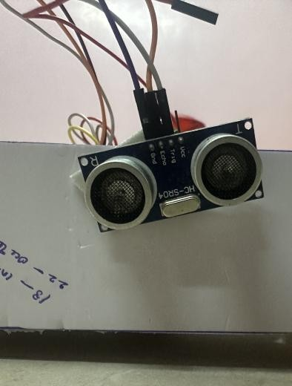

Fig. 5: Ultrasonic sensor

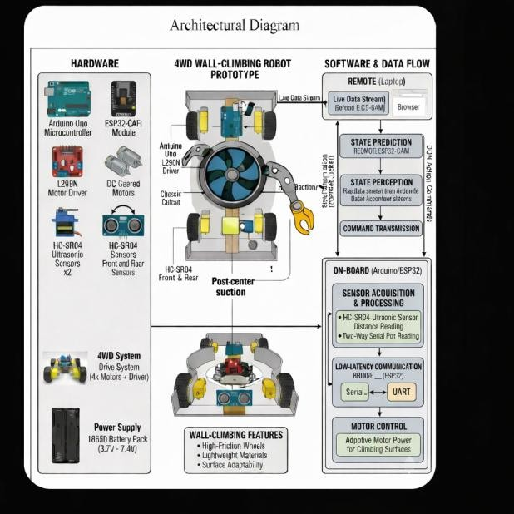
Fig. 6: Hardware setup

- Performance Metrics

We used standard object detection metrics to check how well the system worked:
  - Precision: This tells you how many of the predicted detections were correct.
  - Recall: This checks how well the model can find real cracks in the picture.
  - Mean Average Precision (mAP): This combines preci- sion and recall to give an overall picture of how well detection is working.
There were two mAP metrics that were looked at:
  - mAP@0.5
  - mAP@0.5–0.95
These metrics give a full picture of how well the proposed system can find things and how strong it is.

- YOLOv8 Detection Results

After 30 epochs of training the YOLOv8 model, the follow- ing performance results were achieved:
  - Precision: 0.877
  - Recall: 0.752
  - mAP@0.5: 0.867
  - mAP@0.5–0.95: 0.692
The model consistently detected cracks on various wall surfaces and under different lighting conditions. It was able to find cracks of different sizes, from thin hairline cracks to larger structural flaws. The YOLOv8 model also kept its ability to make inferences in real time, which meant that the robot could keep checking as it moved along the wall. After 30 epochs of training, the YOLOv8 detection system produced the following performance data:
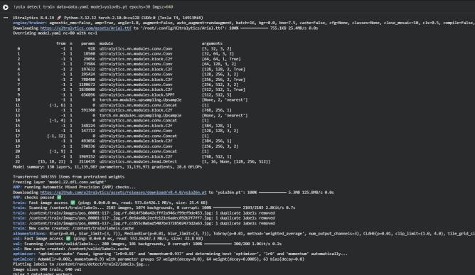
Fig. 7: Model training.

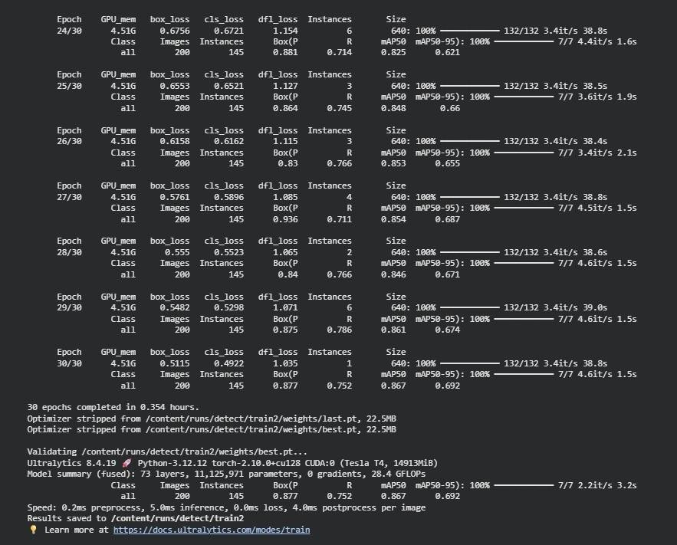
Fig. 8: Model Training.

- YOLOv8-Based Crack Detection
  - Precision: 0.877
  - Recall: 0.752
  - mAP@0.5: 0.867
  - mAP@0.5–0.95: 0.692
The YOLOv8 model can reliably find cracks when looking at structures, as these results show.
Another important thing to know is that the detection system can work in real time.The YOLOv8 architecture is made for fast inference, which means that the model can quickly process the images it takes so that the robot can look at them as it moves along the wall.
The experimental assessment demonstrates that the pro- posed robotic inspection system effectively integrates robotic mobility with deep learning-driven crack detection.For this reason, it is a good choice for monitoring infrastructure automatically.
- Comparative Performance Evaluation
A comparative analysis was performed between the con- ventional OpenCV-based crack detection technique and the YOLOv8 deep learning model. The OpenCV-based method uses Canny edge detection, Gaussian filtering, and changing the color to gray. It works quickly, but it is very sensitive to noise, changes in lighting, and different surface textures, which can cause false detections. But YOLOv8 learns complex visual features directly from the training data. When the weather is bad, it’s easier to find cracks.
TABLE I: Comparison of Crack Detection Methods

Method | Precision | Recall | mAP@0.5
OpenCV Edge Detection | 0.72 | 0.65 | 0.69
YOLOv8 Detection | 0.877 | 0.752 | 0.867

Table I Shows how well the two methods work. The results clearly show that YOLOv8 is a lot more accurate and dependable than older methods that use OpenCV.

- Results and Discussion

The testing indicates that a wall climbing robot fitted with a YOLOv8 based crack detection system will work together as intended in multiple environmental conditions. The model has been successful at identifying the location of cracks and functioning correctly under varying lighting conditions and different textures of the wall surface. When compared to OpenCV based systems, YOLOv8 is capable of reducing false detections while ensuring that locating cracks within walls occurs much more accurately. Additionally, since the crack is being located while the robot is moving, the user can actively view the progress of the robot on the wall in real-time.
The crack severity estimation module enhances the system’s performance by providing a qualitative and quantitative mea- sure of the damage to the wall. This enables the end user to make more informed decisions regarding the necessary repairs for the wall and surrounding structures.
With respect to the YOLOv8 configuration, the wall climb- ing robot has the capability to identify cracks at the point of occurrence over the course of several linear motions along the wall’s surface. Furthermore, the crack severity estimation module will allow the robot to determine the actual extent of structural degradation associated with the wall from the shape of the crack’s location relative to the total area of the wall.
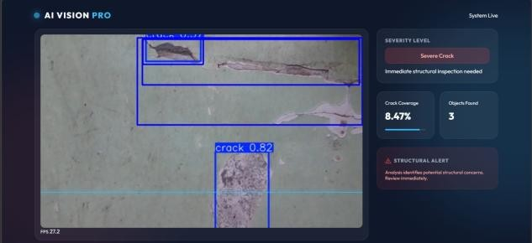
Fig. 9: AI-based crack detection result.

Overall, the results confirm that the proposed method pro- vides a valid and reliable automated structural crack detection and inspection method for infrastructure systems.

- Conclusion

This research study provides insight into a semi autonomous wall climbing robot inspection technology that integrates a crack detection Algorithm developed using YOLO version
8. The technology combines several areas of technology into a total inspection solution including; robotic mobility, deep learning based detection, assessment of severity, as well as recommendations for maintenance. Experimental results demonstrate that the robotic inspection technology provides a higher level of accuracy and reliability than traditional inspection methods. The convergence of robotics with artificial intelligence has made it possible to conduct infrastructure inspection safely, quickly, and effectively.
- Future Work
Future work will concentrate on enhancing the robot’s structural integrity and operational efficacy. You can also add more features, like an automated manipulator arm for cleaning up or fixing things. You can use advanced processing units like Raspberry Pi or NVIDIA Jetson for onboard computing. Also, large-scale inspections can use autonomous navigation methods like SLAM and path planning. You can also use cloud-based monitoring systems to look at your infrastructure over time.
References
- S. Hirose and K. Yoneda, ”Development of wall-climbing robots for inspection of vertical structures,” Advanced Robotics, vol. 12, no. 2, pp. 143–158, 1998.
- H. Zhang, J. Wang, and L. Wang, ”Design and implementation of a wall- climbing robot for infrastructure inspection,” IEEE/ASME Transactions on Mechatronics, vol. 22, no. 3, pp. 1243–1252, 2017.
- J. Wang and R. Zhang, ”A suction-based wall-climbing robot for inspection of high-rise buildings,” Robotics and Autonomous Systems, vol. 96, pp. 32–44, 2017.
- G. Shi, J. Zhang, and L. Sun, ”Design and control of a wall-climbing robot for structural health monitoring,” IEEE Access, vol. 6, pp. 43043– 43051, 2018.
- J. Tan and W. Chen, ”A review of wall-climbing robots for inspection applications,” Robotics and Autonomous Systems, vol. 126, p. 103453, 2020.
- K. Xu, Y. Zhao, and Z. Wang, ”Robotic inspection of infrastructure using wall-climbing robots,” Automation in Construction, vol. 103, pp. 1–12, 2019.
- M. Tavakoli, A. Marjovi, and A. Marques, ”Bio-inspired wall-climbing robots for inspection and maintenance tasks,” IEEE Robotics and Au- tomation Letters, vol. 5, no. 2, pp. 2843–2850, 2020.
- Y. Sun, Z. Li, and Q. Liu, ”Design of a magnetic wall-climbing robot for inspection of steel structures,” IEEE Transactions on Industrial Electronics, vol. 65, no. 1, pp. 113–122, 2018.

