The Scent That Remembers: Why Floral Odors Can Evoke Autobiographical Memories
Aleksandra Filatova

Keywords
Olfaction, floral scent, autobiographical memory, odor-evoked memory, emotional memory, floristry, floral-based sensory practices, sensory engagement, hippocampus, amygdala.

Abstract
Olfactory stimuli have a distinctive capacity to evoke emotionally intense autobiographical memories. Unlike purely visual or verbal cues, odors may produce a strong subjective sensation of being mentally transported back to a previous event. This phenomenon has been associated with the close neuroanatomical and functional relationships between the olfactory system and brain structures involved in emotion and memory, particularly the amygdala and hippocampal formation.
This article examines the relationship between scent, autobiographical memory, and emotional experience in the context of floral-based sensory practices. Drawing on research in olfactory neuroscience, autobiographical memory, and sensory processing, as well as the author’s professional observations in floristry and supportive floral sessions, the article considers natural floral scents as potential sensory cues capable of activating personal associations and spontaneous recollections.
Particular attention is given to odor-evoked autobiographical memory, the so-called Proust phenomenon, and the importance of individual scent associations. The article does not propose floral practices as a substitute for psychotherapy, psychiatric care, or medical treatment. Instead, it suggests that natural floral odors may represent a promising area for further investigation within supportive sensory and creative practices.

Introduction
A memory does not always return as a conscious thought.
Sometimes a person first perceives a scent. An emotional sensation follows—familiar, but not immediately identifiable. Several seconds later, an image, a place, or a person may emerge. Only then does the individual consciously recognize the experience as a memory.
In my professional work with flowers, I have repeatedly observed such reactions. A participant holds a flower, brings it closer, and suddenly says, “This smells like my grandmother’s house,” or, “I just remembered a summer from my childhood.”
As a florist and practitioner working with floral-based sensory activities, these spontaneous reactions led me to a broader question: why can scent evoke events and emotional experiences that a person may not have consciously recalled for many years?
The relationship between olfaction and memory has attracted considerable attention in neuroscience and cognitive psychology. Current research suggests that the unusual emotional potency of odor-evoked memories may be partially explained by the organization of the human olfactory system and its close interaction with neural structures involved in emotion and autobiographical memory [1–6].
The purpose of this article is to examine the scientific basis of odor-evoked autobiographical memory and to consider its potential relevance to floral-based sensory practices.

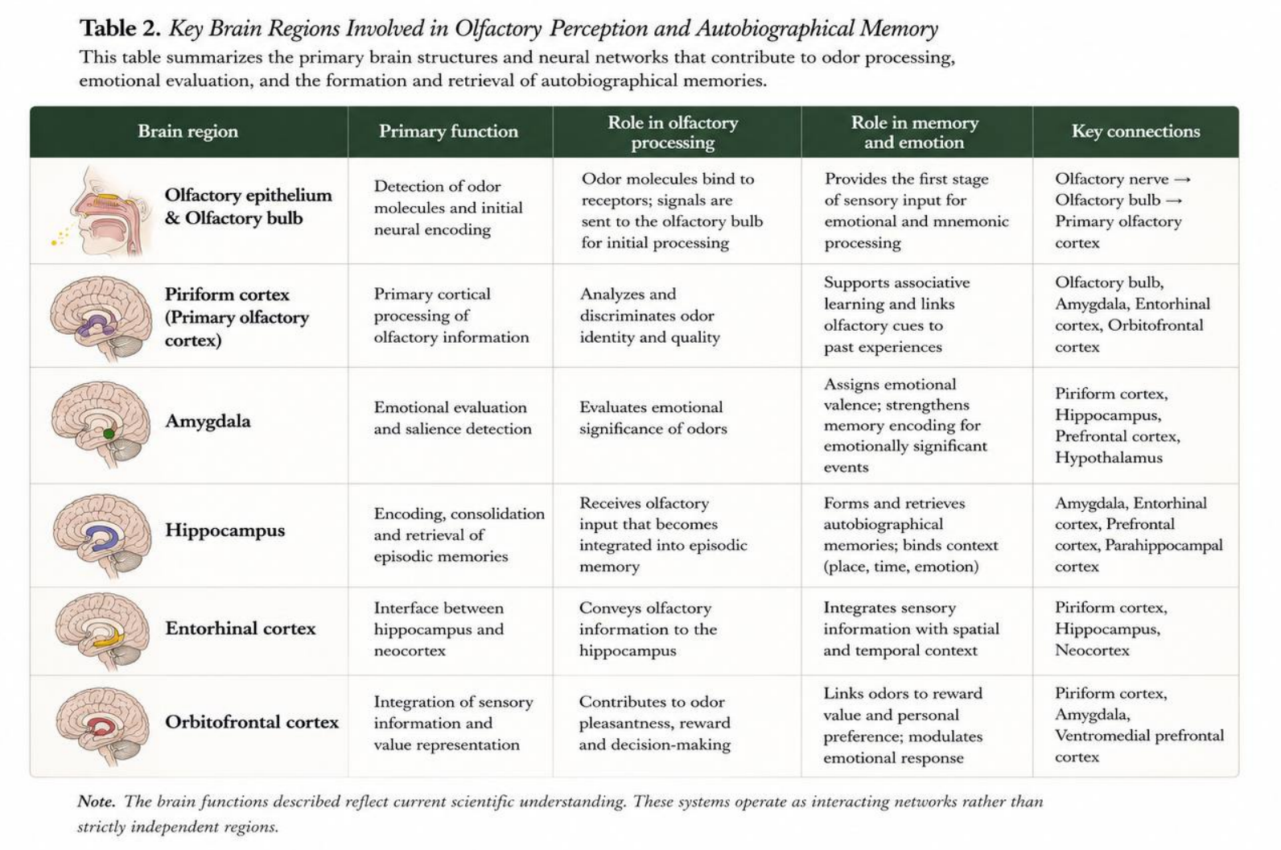

Olfaction and the Neural Systems of Memory
Olfaction occupies a distinctive position among human sensory systems.
When volatile odor molecules interact with olfactory receptors in the nasal epithelium, neural signals are transmitted to the olfactory bulb and subsequently distributed through olfactory cortical networks.
A popular explanation often states that “the center of smell is located next to the center of memory.” Although intuitively understandable, this description is neuroanatomically oversimplified.
A more accurate explanation is that the olfactory system has particularly close anatomical and functional relationships with neural structures involved in emotional processing and memory.
Two structures are especially relevant: the amygdala and the hippocampal formation.
The amygdala participates in assigning emotional significance to sensory experiences.
The hippocampal system plays a central role in episodic and autobiographical memory, including the formation and retrieval of personally experienced events.
Olfactory processing is closely interconnected with these limbic and medial temporal structures. This organization may contribute to the ability of odors to become strongly associated with emotionally significant events [5,6].
Recent neurophysiological evidence further supports the distributed processing of odors across brain regions associated with both olfaction and memory. A 2024 single-neuron study in awake human participants identified odor-responsive neuronal activity not only in the piriform cortex, a major olfactory cortical region, but also within the amygdala, entorhinal cortex, and hippocampus [7].
These findings are particularly relevant when considering scent as more than a perceptual characteristic of a flower.
An odor may become incorporated into a broader neural representation of an experience involving a place, a person, an emotional state, and a particular period of life.

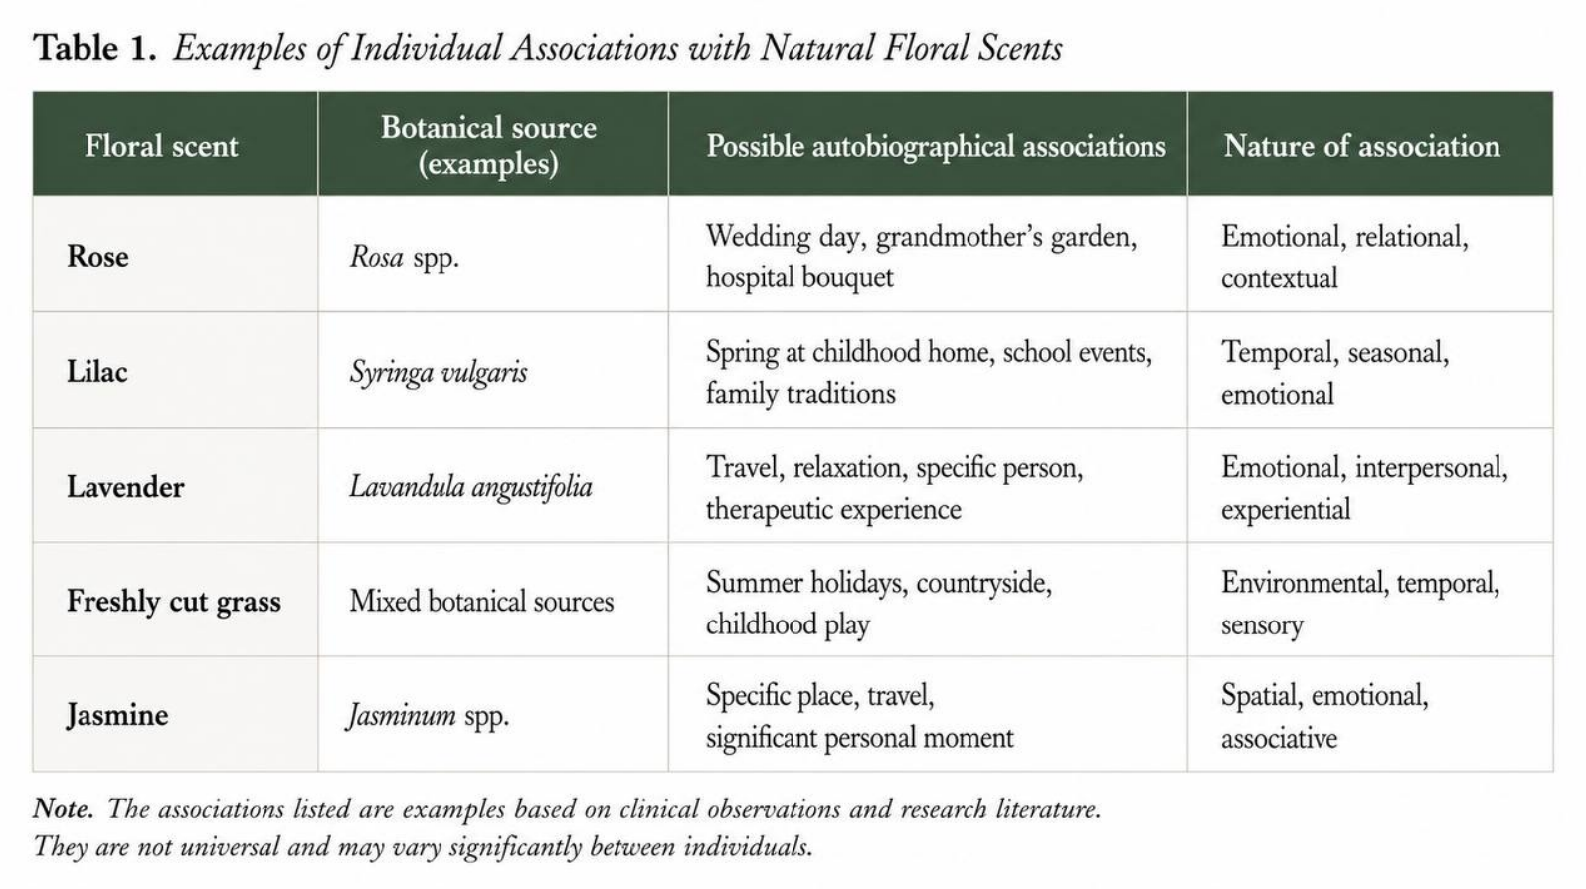

Why an Odor Can Create the Sensation of “Being There Again”
One of the most distinctive characteristics of odor-evoked autobiographical memories is their subjective emotional intensity.
Herz and Schooler compared autobiographical memories elicited by olfactory and other sensory cues. Their findings suggested that memories experienced in the presence of an odor were associated with stronger emotional responses and a more pronounced subjective feeling of being “brought back” to the original event [1].
This distinction is important.
An odor-evoked memory should not automatically be considered more historically accurate than a memory triggered by an image, word, or sound.
Its distinctive characteristic may instead be the intensity of the subjective re-experiencing of the event.
A person may not simply think:
“I remember my childhood garden.”
For several moments, the experience may feel closer to:
“I feel as if I am there again.”
Neuroimaging research has also demonstrated that emotionally potent odor-evoked memories involve brain regions associated with emotional and mnemonic processing. Herz and colleagues reported neural activation patterns consistent with the particular emotional intensity of memories elicited by odors [2].
These observations provide a scientific basis for a phenomenon that people frequently describe in everyday life but may find difficult to explain.

The Proust Phenomenon and Autobiographical Memory
The relationship between scent and involuntary memory is frequently described as the Proust phenomenon.
The term originates from a well-known episode in Marcel Proust’s In Search of Lost Time, in which the taste and aroma of a madeleine dipped in tea unexpectedly evoke an extensive sequence of childhood memories.
In contemporary memory research, the episode is frequently used as a literary representation of odor-evoked autobiographical memory.
Scientific studies suggest that memories triggered by odors may differ from memories elicited through verbal or visual cues.
Willander and Larsson found that odor-cued autobiographical memories tended to originate from earlier periods of life than memories elicited by verbal or visual stimuli [3]. Subsequent research has continued to examine the relationship between olfaction, emotion, and autobiographical memory [4–6].
This may help explain why the scent of an old rose variety, lilac, freshly cut grass, or particular greenery can unexpectedly evoke memories from early childhood rather than from the previous year.
The odor functions as a sensory cue connected to an earlier personal experience.

One Scent, Different Memories
An important consideration in floral-based sensory practice is the highly individual nature of odor associations.
It would be scientifically inappropriate to claim that a specific floral scent has one universal psychological meaning.
Lavender does not automatically represent calmness for every individual.
A rose does not universally evoke love.
The scent of roses may remind one person of a wedding. For another, it may be associated with a mother’s garden. For someone else, the same odor may be linked to flowers placed in a hospital room during a difficult period of life.
The botanical source of the odor may be identical.
The autobiographical association is not.
Research on odor-evoked autobiographical memory emphasizes the importance of personal experience and previously formed associations between an odor, an event, and an emotional state [5].
For this reason, my practical approach is not based on interpreting a participant’s choice of flower or assigning a predetermined emotional meaning to a scent.
Instead, I observe the individual’s spontaneous sensory response.
Simple, non-directive questions may be used:
“Is this scent familiar to you?”
“Would you like to smell it again?”
“Does it remind you of anything?”
Sometimes the answer is no.
At other times, a brief silence is followed by a personal story.

Natural Floral Odors as Sensory Cues
My previous work examined the therapeutic value of creating floral arrangements by hand, with particular attention to repetitive manual actions, tactile interaction with botanical materials, focused attention, and multisensory engagement.
The practical observations described in that work suggested that interaction with flowers involves several sensory channels simultaneously. Participants perceive color and form, experience the texture of petals and stems, perform sequential manual actions, and may also perceive natural floral odors.
During floral-based sessions, including supportive activities conducted with participants in nonprofit mental health programs, I began to pay closer attention specifically to scent.
Not as a decorative property of a flower.
But as a sensory cue.
This observation raises several research questions.
Can the natural odor of a flower function as a cue for spontaneous autobiographical memory?
Are familiar floral odors more likely to elicit personal memories than unfamiliar odors?
Does emotional response differ when an individual recognizes a scent from childhood?
How does a participant’s behavior or verbal engagement change following a spontaneous odor-evoked recollection?
At present, these questions require systematic investigation. However, existing research on odor-evoked autobiographical memory provides a scientific basis for considering natural floral scents as a relevant area of study within sensory and creative practices.

Practical and Ethical Considerations
Floral-based sensory practices should not be presented as a replacement for psychotherapy, psychiatric care, or medical treatment.
It is also important to recognize that odor-evoked memories are not necessarily positive.
A scent may be associated with childhood, family, or a joyful event. However, it may also be connected to illness, bereavement, fear, or another difficult personal experience.
For this reason, the use of scent in programs involving individuals experiencing psychological or emotional difficulties requires caution.
Participation should be voluntary. Individuals should be free to move away from an odor, discontinue interaction with a particular flower, or decline to discuss an emerging memory.
The purpose of a floral-based sensory activity should not be to force memory retrieval.
Rather, it may provide a structured environment in which an individual can notice and respond to personal sensory and emotional reactions.
This distinction is essential.
A practitioner should not attempt to interpret a memory, diagnose a participant, or assign psychological meaning to the person’s choice of flower.
Within appropriate professional boundaries, the role of the floral practitioner is to facilitate interaction with natural materials and observe the sensory and creative process.

Discussion
The scientific literature indicates that olfaction has particularly close relationships with neural systems involved in emotion and autobiographical memory.
Odor-evoked memories may be characterized by emotional intensity and a pronounced subjective sensation of returning to a previous experience. The close functional interaction between olfactory regions, the amygdala, entorhinal cortex, and hippocampal structures provides a plausible neurobiological basis for this phenomenon.
These findings are relevant to floral-based sensory practice because natural flowers represent complex multisensory stimuli.
A flower is simultaneously a visual object, a tactile material, and, in many species, a source of a distinctive natural odor.
The process of creating a floral arrangement therefore differs from passive visual exposure to nature. The participant actively touches, selects, cuts, arranges, and smells botanical materials.
My previous research considered this process primarily through the mechanisms of manual activity, concentration, and multisensory engagement.
The present analysis suggests that the olfactory component deserves separate investigation.
Future studies could compare familiar and unfamiliar floral odors, document self-reported autobiographical associations, and assess changes in emotional state before and after odor exposure.
It may also be valuable to examine whether natural floral odors produce different autobiographical responses from synthetic fragrance reproductions.
Such research could contribute to a more precise understanding of the role of olfaction in supportive floral and nature-based sensory practices.
Conclusion
Human memory is commonly preserved through photographs, written records, and personal narratives.
However, autobiographical experience can also become strongly associated with sensory cues.
Odor is particularly notable because of its close functional relationship with neural systems involved in emotional processing and memory.
A familiar floral scent may unexpectedly evoke a person, a place, or an event from many years earlier.
Current scientific evidence does not justify describing floral scent as a treatment for memory or psychological disorders.
It does, however, support further investigation of natural odors as sensory cues capable of eliciting emotionally significant autobiographical memories.
For floral practitioners working within supportive sensory and creative programs, this creates an important area for future study.
Sometimes a person smells a flower and quietly says:
“I remember.”
The neuroscience of olfaction suggests that this simple moment may involve a complex interaction between sensory perception, emotion, and autobiographical memory.
Understanding that interaction more precisely may help define a new and scientifically grounded direction for research in floral-based sensory practice.

References
Herz RS, Schooler JW. A naturalistic study of autobiographical memories evoked by olfactory and visual cues: Testing the Proustian hypothesis. American Journal of Psychology. 2002;115(1):21–32.
Herz RS, Eliassen J, Beland S, Souza T. Neuroimaging evidence for the emotional potency of odor-evoked memory. Neuropsychologia. 2004;42(3):371–378. doi:10.1016/j.neuropsychologia.2003.08.009.
Willander J, Larsson M. Smell your way back to childhood: Autobiographical odor memory. Psychonomic Bulletin & Review. 2006;13(2):240–244.
Willander J, Larsson M. Olfaction and emotion: The case of autobiographical memory. Memory & Cognition. 2007;35(7):1659–1663.
Herz RS. The role of odor-evoked memory in psychological and physiological health. Brain Sciences. 2016;6(3):22. doi:10.3390/brainsci6030022.
Saive AL, Royet JP, Plailly J. A review on the neural bases of episodic odor memory: From laboratory-based to autobiographical approaches. Frontiers in Behavioral Neuroscience. 2014;8:240. doi:10.3389/fnbeh.2014.00240.
Kehl MS, et al. Single-neuron representations of odours in the human brain. Nature. 2024.
Masaoka Y, et al. Odors associated with autobiographical memory induce psychological and physiological responses. Frontiers in Neuroscience. 2021.

