The Evolution of women’s Traditional Costume Production in Tambunan

Abstract— This study aims to examine the evolution of the traditional clothing of the people of Tambunan District from the perspective of history, culture and contemporary transformation. Traditional clothing not only serves as a basic necessity, but also reflects the community's ethnic identity, social structure and belief system. However, the process of modernization and globalization has had an impact on the form, function and meaning of such traditional clothing. This study used a qualitative approach through interview methods, field observation and document analysis. The findings of the study show that the change of traditional clothing occurs through the adaptation of materials, design innovations and market influences, yet still retains certain symbolic elements. This study contributes to the understanding of cultural sustainability as well as the implications of transformation in the context of local community identity.

Keywords: Evolution, Income, Traditional Clothing, Tambunan , Cultural Sustainability, Identity

I. INTRODUCTION

Traditional clothing is an important manifestation of an intangible cultural heritage that reflects the identity, values and social structure of a society. In the context of the Dusun Tambunan community in Sabah, traditional clothing not only serves as a daily necessity, but also plays an important role in traditional ceremonies, rituals and festivals such as Tadau Kaamatan. Nevertheless, the current developments driven by globalization, lifestyle changes and the influence of the modern fashion industry have led to significant transformations in the design, materials and functions of these traditional clothing. Despite the efforts of cultural preservation, the changes that have taken place raise questions about the extent to which the authenticity of traditional clothing can be maintained. Therefore, this study is important to understand the evolutionary process as well as its implications for the cultural identity of the people of Tambunan District.

II. LITERATURE REVIEW

The study of traditional dress is often associated with the concepts of cultural identity, heritage, and social change. Traditional clothing is not just a basic necessity, but a symbol that reflects the values, beliefs, and social structure of a society (Kaiser, 2012). In the context of indigenous peoples, traditional clothing plays an important role as a marker of ethnic identity and cultural heritage that is inherited from generation to generation.

According to Eicher and Roach-Higgins (1992), clothing serves as a form of non-verbal communication that carries symbolic meanings related to an individual's social status, gender, and role in society. In ethnic communities such as Dusun Tambunan, traditional clothing is not only used in daily life but also in ritual ceremonies, festivals, and customs, which shows the close relationship between clothing and belief systems. From a historical perspective, the evolution of traditional clothing is often influenced by cultural interactions and economic changes. Craik (2009) pointed out that traditional clothing underwent a transformation due to the factors of globalization, colonialism and the development of textile technology. In the Malaysian context, a study by Ibrahim and Hassan (2020) shows that traditional ethnic clothing has undergone changes in terms of materials, manufacturing techniques and designs due to modern influences and market demands.

In addition, globalization has also had a significant impact on the transformation of traditional clothing. According to Appadurai (1996), the global flow of culture and economics has changed the way people interpret and use their cultural symbols. In the fashion industry, this phenomenon can be seen through the adaptation of traditional clothing to more practical and commercial contemporary forms. Nevertheless, these changes often create a dilemma between the maintenance of cultural authenticity and the need for innovation (Niessen et al., 2003). In the context of Sabah, studies by Pugh-Kitingan (2011) and Ibrahim (2018) show that the traditional dress of the Kadazandusun community, including Dusun Tambunan, has symbolic elements that are closely related to social status, spiritual beliefs and community identity. The motifs, colours and accessories of traditional clothing often carry a certain meaning that reflects man's relationship with nature and belief in the spirit of ancestors. Clothing is a very important aspect of human life. Prior to the invention of textiles-based clothing, the early people in Sabah used bark and leaf weaving as clothing to protect themselves from the weather and climate. Textile weaving in Sabah has been around since the time of Dong-Son which developed between 700 years and 300 years b.c. The early settlers in Sabah started producing textiles when they learned about the method of producing yarn from plant fibres such as acapela bananas. Back-strap loom looms with unbroken warp threads were used by early people to weave fabrics.

Qualitative approaches are often used in studies related to traditional clothing because they allow researchers to deeply understand cultural meanings and experiences (Creswell, 2014). Methods such as interviews, field observations, and document analysis help in examining the changes that have occurred as well as how society interprets those transformations. From the point of view of design innovation, a study by Gwilt (2014) emphasizes that the adaptation of materials and designs in traditional fashion can contribute to cultural sustainability if done sensitively to the original values. In the creative industry, innovation involves not only aesthetic changes, but also adaptation to market needs without neglecting cultural identity. However, there are gaps in existing studies, especially related to the evolution of traditional clothing in local contexts such as the Dusun of Tambunan. Most studies focus more on cultural documentation or general analysis without placing an emphasis on contemporary transformation processes in depth. Therefore, this study is important to fill the gap by focusing on how change occurs and its implications for cultural identity and heritage sustainability.

III. METHODOLOGY

This study uses an interpretive qualitative approach to understand the evolution of the traditional clothing of Dusun Tambunan community in a real social and cultural context. This approach is ideal because it allows researchers to examine changes not only from the physical aspect, but also the symbolic meaning, social function, and cultural values embodied in traditional clothing. The interpretive qualitative approach involves researchers to be in the field to collect data through observation, interviews and documentation methods. The research aims to unravel the evolution of the production of traditional clothing in Tambunan District.

In this research, researchers analysed the evolution of traditional clothing based on cultural evolution as a dynamic process involving the interaction between cultural, social and economic factors. Therefore, the analysis of cultural evolution needs to be based on a sound theoretical framework to explain the process of change occurring, why it occurs, and what its implications are for cultural identity. This approach is in line with the view of Henrich (2016) who states that cultural evolution occurs through the process of social learning, adaptation and transmission between generations. In the context of traditional dress, change is not just the result of individual innovation, but is the result of collective interaction within the community.

Therefore, in this research, the theory of Modification by O'Connor (2021), is used to identify the evolution or modification that occurs. Modification refers to changes that occur to an existing element without removing the original identity. The changes involve three aspects, namely renovation through the use of modern materials, changes in sewing techniques and design adaptation for comfort. In this study, renovation can be seen as a community strategy to balance between tradition and current needs.



Figure 1: The Evolutionary Process of Traditional Clothing Production
Source: Modified from O'Connor (2021)

Figure 1 shows the evolutionary process of the production of traditional clothing in Tambunan District modified from O'Connor (2021) through three modification processes. The first process, renovation is seen through the traditional use of modern materials, Dusun Tambunan clothes are produced using materials such as hand-woven fabrics and natural fibres which have high cultural and symbolic value. However, the development of textile technology as well as ease of access to the market has led to the use of modern materials such as synthetic fabrics, velvet, satin and commercial yarns.

The second process is seen in terms of the modification of sewing techniques and production from the point of view of production techniques, the evolution can be seen through the transition from hand sewing to the use of modern sewing machines. These changes have a significant impact on time efficiency, quality consistency and production productivity. The third process is seen in terms of design customization for comfort and functionality. The design aspect is the most obvious dimension showing the evolution of the traditional clothing of Dusun Tambunan District . Clothing that was originally heavier, less flexible and limited to a particular ceremonial context has undergone adaptations to meet current needs.

IV. RESULTS

Like other Kadazandusun people, Tambunan District also has its own unique traditional clothing. There are two types of women traditional clothing in Tambunan known as Sinombiaka and Rasuk Pinolongan.
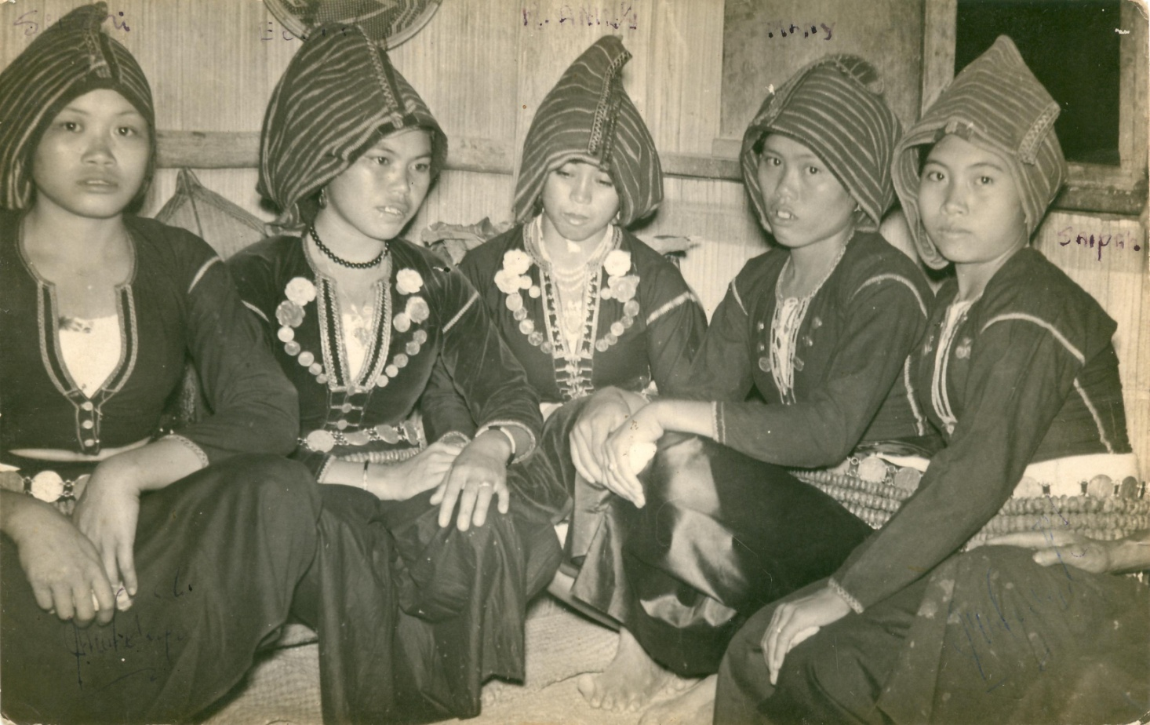
Figure 2: Traditional Women's Clothing of Tambunan Rasuk Pinolongon, worn during a wedding ceremony.
Source: Author's collection (Photo taken on 21.08.1961)

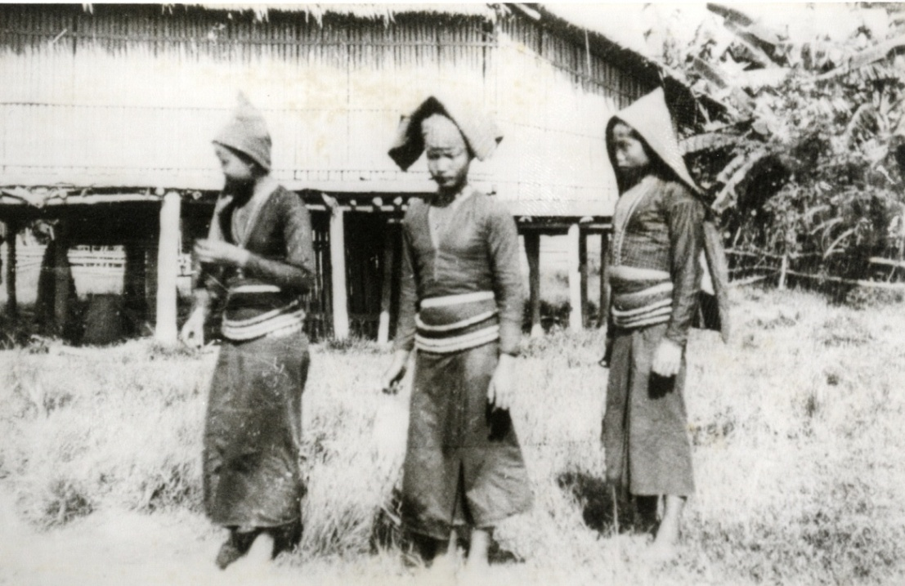
Figure 3: Tambunan Dusun Women wearing the rasuk pinolongon during a ritual.
Source: Sabah State Museum

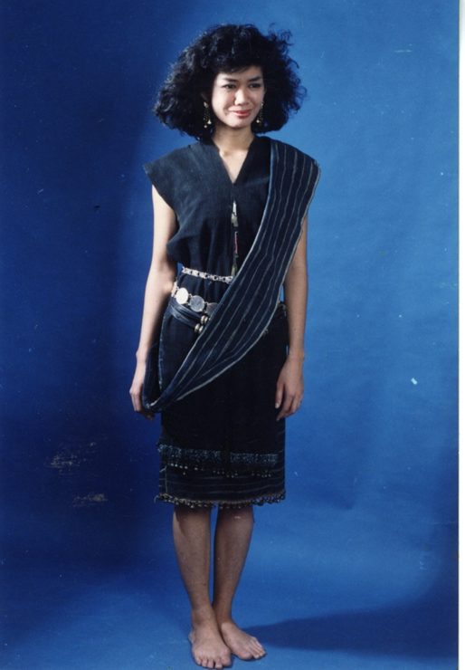
Figure 4: Traditional Clothing of Women in Tambunan Lapoi Tinombunan” a Bobolian or priestess woven clothing
Source: Sabah State Museum, Exhibition Division

COSTUME STRUCTURE

The traditional costumes of Tambunan has undergone many changes. In 2016, the Unduk Ngadau advocated a ‘ Back to Basic“ traditional costumes of all ethnic tradtional costumes so that the original structure of traditional costumes are worn by the Unduk Ngadau contestants instead of the embellish tradtional clothings with blings that shines on stage.
This figure shows the “ Back to Basic” of Sinombika which only showed the hand woven motif of the Sinombiaka without the linangkit.
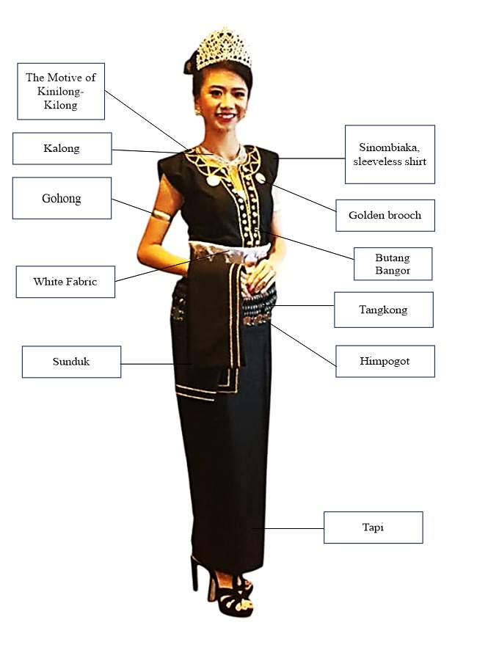
Figure 5: Clothing Structure of Tambunan traditional costumes ‘sinombiaka’: front view
Source: Author collection

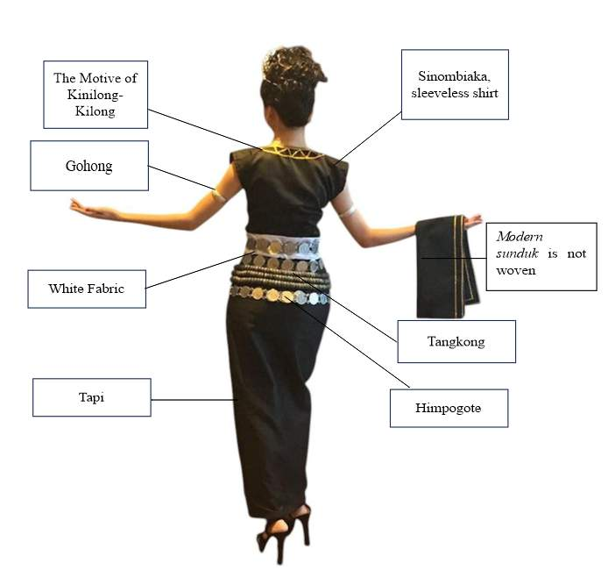
Figure 6: Clothing Structure of Tambunan traditional costumes sinombiaka: back view
Source: Author collection

Figure 5 and 6, are the Sinombiaka Tinombunan clothing structure of the Tambunan Dusun community which is worn with various ornaments. The top-level shirt is known as Sinombiaka which is a sleeveless designed for young women made from black cotton black sown with green, yellow and red embroidery. Green is the greenish colour of nature and yellow is the colour of padi ripening and ready for harvesting.

Table 1: Components found in Sinombiaka clothing

Components | Description
Sinombiaka | Black sleeveless shirt made of cotton fabric
Tapi | Tapi or sarong is worn with sinombiaka
Himpogot | Belts made of British coins to hold the long skirt or tapi as well as to embellish the waist
Tangkong | 3 layers of tangkong are worn around waist to hold the long skirt. This is made of ring-shaped gongs threaded with rattan
Sunduk | Head covering when performing rituals by bobolian or during weddings
Kohu | Necklace
Golong/gohong | Bangles
Tingot | White fabric belt to cover the gap between the sinombiaka and the tapi and to keep tapi in place
Butang emas | Golden brooch dated in 1905 with the embossed head of Roman soldier
Butang | Buttons

Table1 shows the component and accesories in sinombiaka traditional costume, combining functional elements such as belts and buttons with ornamental features like necklaces, bangles, and brooches. Together, they reflect the craftsmanship and cultural identity of the Dusun Tambunan community.

V. ANYLISIS AND EVOLUTION

The analysis of the evolution of the production of traditional women's clothing in Dusun Tambunan is seen through three renovation processes, namely, renovation is seen through the traditional use of modern materials, modification of sewing techniques and design modification for comfort and function.

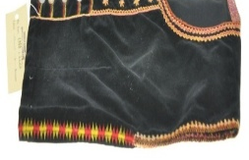
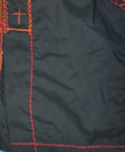
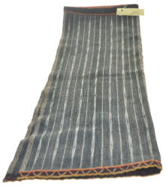
Figure 7: Evolution of traditional women's clothing production techniques Sinombiaka

The evolution of materials from this transition not only improves the durability and quality of clothing, but also simplifies the production process and expands aesthetic potential through variations in textures and finishes. In addition, the use of modern materials allows traditional clothing to be produced on a larger scale, specifically for commercial, tourism and cultural performance purposes. Despite the material changes, important elements such as symbolic colours such as black which symbolise the identity of the community as well as traditional motifs are still maintained. This shows that the modification of materials takes place in a controlled manner and does not affect the cultural meaning, but rather reinforces the usability and relevance of the garment in the current context.

The early people in Sabah used bark and woven leaves as clothing to protect themselves from the weather and climate. Textile weaving in Sabah has been around since the time of Dong-Son which developed between 700 years and 300 years b.c. The early settlers in Sabah started producing textiles when they learned about the method of producing yarn from plant fibres such as acapela bananas. Back-strap loom looms with unbroken warp threads were used by early people to weave fabrics.

There are several types of yarn woven by the earliest societies known as coarse yarn processed from banana nuts (Musa textilis) and lamba leaves (Curculigo latifolia). Fine cotton yarn is produced through self-spinning and there is yarn produced from the bark of the Tangkapon tree (Colona serratifolia).

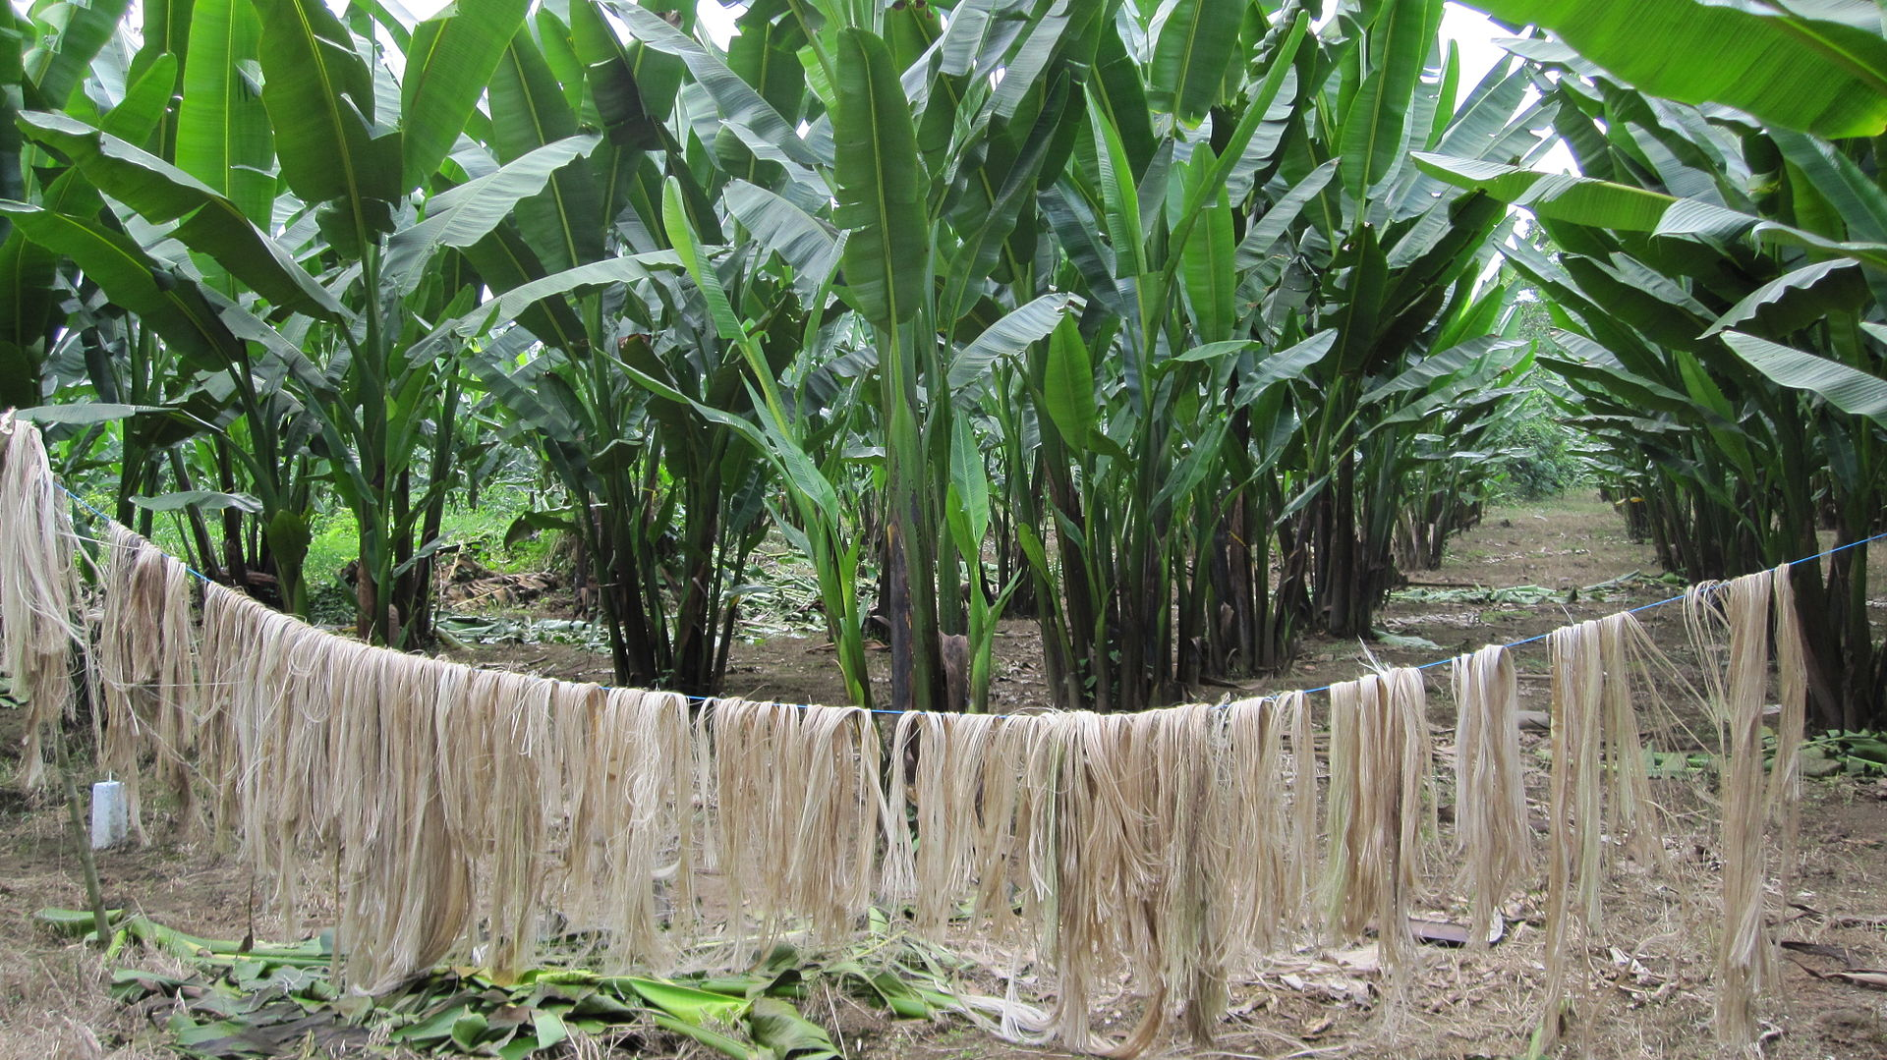
Figure 8: Coarse yarn processed from banana nuts (Musa Textilis)

Figure 8 shows the process of producing coarse threads processed from bananas. This yarn was made by Tindal Hamlet of Belud City. Fabrics woven from this yarn are used as short sheaths, and headgear or headgear for women.

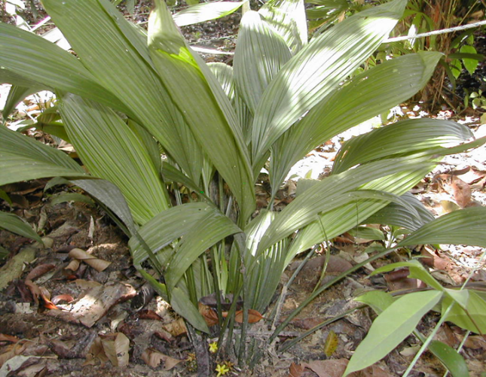
Rajah 9: Daun Lamba (Curculigo latifolia)

Figure 9, shows an image of lamba leaves used to produce coarse threads. The cloth produced from the thread of the lamba leaves is a cloth used as a head covering or headscarf that is usually worn by Kiulu Dusuns women.
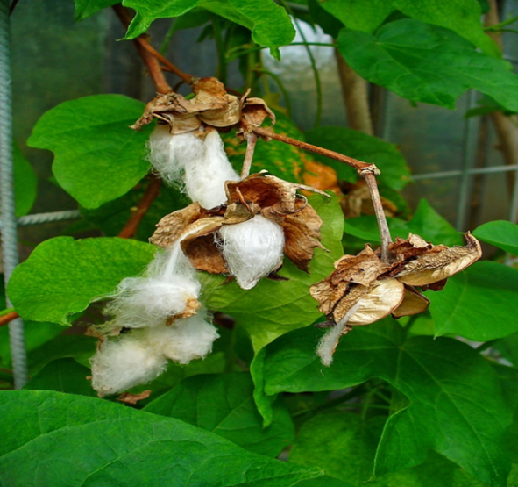
Figure 10: Cotton or Cotton (Gossypium herbacum)

Figure 10, shows images of cotton grown by the Rungus, Kudat and Pitas tribes, the Murut tribe from the Sook district, the Lobou tribe from Keningau and the small communities of Dusun-Kadazan from the West Coast Division and from the Kudat district. Bark of Tangkapon Tree (Kolona Serra folia).

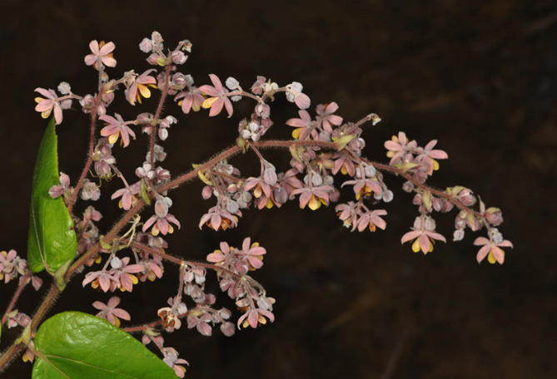
Figure 11: Bark of Tangkapon Tree (Kolona serrafolia)

Figure 11, shows an image of the bark of a tangkapon tree. The fibre threads obtained from the bark of this tree are woven into a piece of cloth called 'Binidang'. This cloth is used to make 'gonob' which is a type of knee-level sarong cloth and 'sunduk' which is a type of cloth used as a head covering. The four types of yarn produced are the creation of the Kadazandusun community in Sabah, which is the earliest in the process of producing clothes. The yarn is used in the production process of traditional clothing that has evolved today. The evolution of clothing that will be focused on in this study is the women traditional clothing of Tambunan.
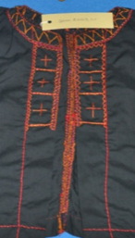
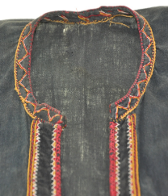
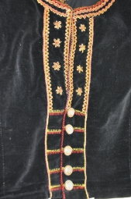
Figure 12: Evolution of traditional women's clothing production Materials in Tambunan, Sinombiaka

Figure 12, illustrates the evolution of production techniques in traditional women’s clothing of the Dusun Tambunan community. The transformation is evident in the shift from hand sewing to the adoption of modern sewing machines, reflecting broader changes in textile production. Decorative practices such as embroidery, linangkit, and accessory detailing have also evolved, incorporating commercial decorative materials and more diverse modern embroidery techniques.
Despite these innovations, certain traditional methods remain preserved, particularly in garments intended for customary ceremonies and rituals. This selective retention highlights the community’s conscious distinction between attire for everyday or commercial use and clothing imbued with sacred and cultural significance. Such an approach aligns with the theoretical concept of modification, which emphasizes adaptation and innovation while safeguarding the fundamental elements of tradition

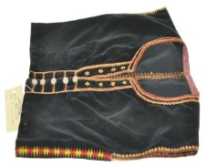
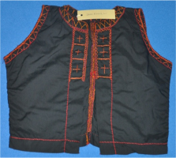
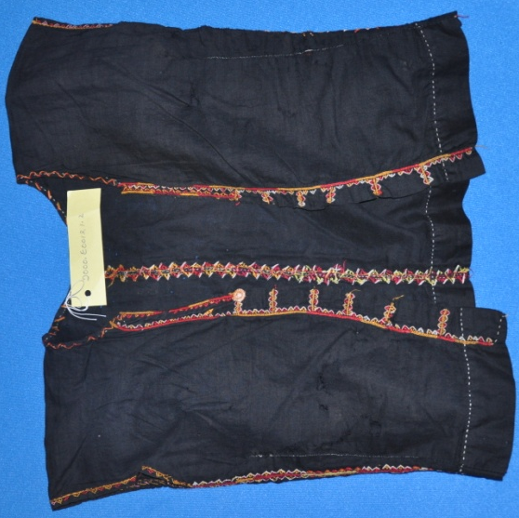

Figure 13: Evolution of the design of the production of traditional women's clothing in Tambunan Hamlet

Figure 13, illustrates the evolution of design in the production of traditional women’s clothing among the Dusun community in Tambunan District. Over time, the design has shifted toward garments that are more practical, lightweight, and comfortable, making them suitable for a variety of contexts such as stage performances, official events, and everyday use.
Notable changes include the simplification of garment cuts, adjustments in size to fit modern body shapes, and the expansion of function from attire used solely in rituals to garments that also serve as expressions of fashion and visual identity. Nevertheless, the fundamental structure, including the silhouette and arrangement of key components, continues to preserve traditional characteristics.
This indicates that the process of design adaptation has taken place in a balanced manner, ensuring the preservation of visual identity and cultural continuity while enhancing functionality and comfort within the context of contemporary life.

VI. EVOLUTIONARY IMPLICATIONS FOR TRADITIONAL CLOTHING IDENTITY

The transformation that took place on the fashion motif of Dusun Tambunan was not a loss of identity but rather a process of visual adaptation that allowed the community to retain the original symbol in a new form that suited the current medium, technique and context. Stylization is an effort to preserve cultural meaning through forms reinforced by contemporaries. Stylization is also a method of conveying cultural symbols in order to remain relevant in modern aesthetics (Schapiro, 1994; Khan & Alghamdi, 2019; Widiyanto, 2020). The transformation process occurs because of several factors such as the influence of external cultures, i.e. the interaction of other communities, prompting style adaptation. Modern commodification with Tambunan Dusun fashion is now also presented in the context of contemporary cultural, tourism and fashion festivals. Therefore, this garment requires a visual transformation to make it more attractive and universal.

Traditional fashion transformation is an adaptation process that occurs due to the clash between cultural heritage and the current of modernity. A balanced transformation can maintain the value of originality while allowing traditional clothing to remain relevant and accepted in the modern context. However, if the transformation is carried out without control, the risk of erosion of cultural meaning is inevitable. Therefore, the preservation of original values and the public's awareness of symbolic motives must be given attention in every traditional innovation process.

VIII. CONCLUSION

This research describes the process of transferring production in technique, materials and design of women’s traditional costume Sinombiaka and Pinolongan in Dusun Tambunan Community which goes through three stages namely figurative, abstract and stylize to adapt the visual heritage to modern techniques and contexts. The three main changes from nature-based forms to larger, subtle, creative and contemporary designs as a result of the development of materials and embroidery techniques. This transformation is not a loss of identity, but a form of adaptation to maintain cultural significance while ensuring that traditional clothing remains relevant, even if it still requires control so that the original symbols are not eroded.

X. REFERENCES

- Ab Aziz, S. (2012). The use of elements of traditional Kelantan aesthetic values in contemporary residential architecture. Proceeding Bridging Between Old & New: Towards Future Sustainable Built Environment (pp. 7–15). Johor: Universiti Teknologi Malaysia.
- Appadurai, A. (1996). Modernity in general: The cultural dimension of globalization. Minneapolis: University of Minnesota Press.
- Craik, J. (2009). Fashion: Key concepts. London: Berg.
- Creswell, JW (2014). Research design: A qualitative, quantitative and mixed method approach (4th edition). Thousand Oaks, CA: Sage.
- Eicher, J.B., & Roach-Higgins, M.E. (1992). Definition and classification of clothing: Implications for the analysis of gender roles. In R. Barnes & J.B. Eicher (Eds.), Clothing and gender: Manufacture and meaning in cultural contexts (pp. 8–28). Oxford: Berg.
- Gwilt, A. (2014). Fashion design for life: Sustainable fashion practices. London: Routledge.
- Halimatan, S. H., Rahimah, A. A., Sarah Aziz, A. G. A., & Chan @ Geraldine, C. K. (2010). Geopark Governance: Langkawi Geopark as a reference. Academics, 80, 39–59.
- Hanafi, H. (2007). Rituals, identity and change on the West Coast of Sabah: The experience of the Kadazan community of Penampang. Journal of Southeast Asian Studies, 12(1), 189–210.
- Henrich, J. (2016). The secret of our success: How culture is driving human evolution, taming our species, and making us smarter. Princeton: Princeton University Press.
- Hu, T., & Junior, K. (2024). Integration and research of transformative design of plant dyeing techniques in Dong brocade with sustainable materials. Journal of Infrastructure, Policy and Development, 8(12), 8530. https://doi.org/10.24294/jipd.v8i12.8530 (doi.org in Bing)
- Humin, J., Ismail, I., & Angeline, T. Y. Y. (2015). Murut fashion heritage: Motifs and patterns. Kuala Lumpur: Dewan Bahasa dan Pustaka.
- Ibrahim, I. (2018). Heritage of motifs and patterns. Kota Kinabalu: Universiti Malaysia Sarawak.
- Ibrahim, I., & Hassan, H. (2020). Transformation of ethnic traditional clothing in Malaysia: Materials, techniques and designs. Journal of Malaysian Cultural Studies, 5(2), 45–62.
- Kaiser, S.B. (2012). Fashion and cultural studies. London: Bloomsbury.
- Khan, M.A., & Alghamdi, H. (2019). An explanation of the relationship between silhouette clothing and motifs and their effect on perception. Fashion and Textiles. Open Springer.
- Niessen, S., Leshkowich, A.M., & Jones, C. (2003). Reorienting fashion: The globalization of Asian clothing. Oxford: Berg.
- Noria, T. (2018). Sinipak costume for Sabah Tindal Hamlet women. International Journal of Applied and Creative Arts, 1(1), 32–41. https://doi.org/10.33736/ijaca.838.2018 (doi.org in Bing)
- Pugh-Kitingan, J. (2011). Kadazandusun cultural heritage: Symbolism in traditional clothing. Sabah Heritage Journal, 3(1), 21–35.
- Ranavaade, V.V., & Karolia, A. (2016). A study of the Indian fashion system with a special emphasis on women's event attire. International Journal of Textile and Fashion Technology (IJTFT), 6, 19–34.
- Schapiro, M. (1994). Theory and philosophy of art: Style, artist, and society. New York: George Braziller.
- Silverman, H., & Ruggles, D.F. (2007). Cultural heritage and human rights. New York: Springer.
- Slade, T. (2009). Japanese Fashion: Cultural History. Oxford: Berg.
- Sulaiman, N. B., Rahman, R. B. A., Apandi, S. N. A. B. M., Saari, F. A. B., Zain, M. Z. B. M., Hasbullah, S. W. B., & Warisan, F. T. K. D. (2022). Inspiration of modern elements for Riau baju kurung : Function analysis. Preservation of Heritage, 213.
- Widiyanto, A. S. (2020). Creation of a 3D animated short film about the masks of Malang in the adventure genre with fashionable techniques (Doctoral Dissertation, University of Dynamics).
- Yahaya, I., & Abd. Hair, A. (2008). Human capital development: Issues and challenges. Bangi: Universiti Kebangsaan Malaysia.
- Noriah ak Tugang, Salbiah Kindoyop, Junior Kimwah, & Nurul Aisyah Othman. (2018). Sinipak Women's Costume of Dusun Tindal Rakyat Sabah. International Journal of Applied and Creative Arts, 1(1), 32-41.
- Patricia Regis. (1997). Foreword. (1997). In Rita Lasimbang & Moo-tan, S. (Eds.). Introduction to Sabah Traditional Clothing (pp. ix-xi). Natural History Publication in collaboration with the Sabah Museum Department.
- Rita Lasimbang & Moo-tan, S. (Eds.). (1997). Introduction to Sabah Traditional Clothing. Natural History Publication in collaboration with the Sabah Museum Department.
- Salbiah Kindoyop, Junior Kimwah, & Normadiah Nassir. (2017a). Local Knowledge of Tindal Dusun in the Production of Kobog (Bark Cloth). Borneo Research Bulletin, 48, 201-210.
- Salbiah Kindoyop, Humin Jusilin, & Noriah ak Tugang. (2017b). Culture of Traditional Clothing Design of the Tindal Hamlet Community in Sabah. Gendang Alam, 7, 137-149. DOI: https://doi.org/10.51200/ga.v7i.1054
- Salbiah Kindoyop, Humin Jusilin, & Noriah ak Tugang. (2019). The Wisdom and Concept of the Design of the Heritage Weaving Craft of Tindal Hamlet in Sabah: The Wisdom and Concept of the Heritage of the Weaving Craft of Tindal Hamlet in Sabah. Nature Drum, 9, 1-16. DOI: https://doi.org/10.51200/ga.v9i.2138

INTERVIEWS WITH INFORMANTS

- The late Saungit, Costume making, Kg. Keranaan Tambunan. Interview on year 2013.
- Paula Damian, Costume making, Kg. Keranaan, Interview on 13 February 2023.

