ReValuate: An Intelligent Credit-Based Platform for E-Waste Recycling Using Machine Learning and Transparent Metal Valuation

Kamya Murali¹
¹ School of Computing Technologies, SRM Institute of Science and Technology, Kattankulathur, Chennai, India
Km1969@srmist.edu.in
Ashish Shiv¹
¹ School of Computing Technologies, SRM Institute of Science and Technology, Kattankulathur, Chennai, India
As0332@srmist.edu.in

Sumathy V¹
¹ Assistant Professor
School of Computing Technologies, SRM Institute of Science and Technology, Kattankulathur, Chennai, India
sumathyv1@srmist.edu.in

K Sreekumar¹
¹ Assistant Professor
School of Computing Technologies, SRM Institute of Science and Technology, Kattankulathur, Chennai, India
sreekumk@srmist.edu.in
V Kavitha¹
¹ Assistant Professor
School of Computing Technologies, SRM Institute
of Science and Technology, Kattankulathur,
Chennai, India
Kavithav7@srmist.edu.in

Abstract—Rising volumes of electronic waste worldwide have put pressure on developers to build systems that make recycling feel concrete and worthwhile to everyday users, not just an abstract obligation. This paper introduces ReValuate, a web-based platform that addresses this gap directly. Given a set of device inputs—category, weight, screen dimensions, and battery size—the system runs a trained regression model alongside research-backed metal-recovery calculations to generate a credit score tied to the recoverable economic value of that specific device. Gold, silver, palladium, platinum, and copper are each tracked individually. Beyond the core valuation feature, the platform also includes a browser-geolocation recycling facility finder and a sustainability news section. Built on React and Flask, the system was tested across more than 20 functional scenarios for both phones and laptops. Credit outputs were stable throughout: mobile devices produced scores between 44 and 101, while laptops ranged from 585 to 1522, depending on physical specifications. The aim of the platform is to remove the uncertainty that stops people from recycling—by giving them a specific, traceable number that reflects what their device is actually worth. This paper covers the system design, the math behind the valuation engine, and the findings from structured functional testing.
Keywords: e-waste; electronic waste recycling; machine learning; metal recovery; credit-based incentives; sustainable computing; React; Flask

1. Introduction
E-waste now ranks as the fastest-growing solid waste category globally, and there is little sign that the trend will slow. Each year, enormous quantities of devices are retired—phones whose batteries no longer hold a charge, laptops with broken screens, tablets quietly swapped out for newer ones. The majority of those devices either sit unused in drawers or end up discarded, often through informal channels where toxic and valuable materials are handled with minimal environmental control.
The frustrating part is that discarded electronics are not actually worthless. A typical mobile phone carries measurable amounts of gold, silver, palladium, platinum, and copper—materials that required significant energy and environmental cost to extract in the first place. The issue is not that value is absent; it is that the value is invisible. Most people have no real idea what their old device contains or what it could fetch once it stops functioning as a phone or computer. That gap—between knowing you should probably recycle and actually doing it—is largely a gap in accessible information.
Most recycling tools available today serve one of two audiences: large-scale operators in the formal recycling sector, or general consumers looking for a drop-off location with no guidance on value whatsoever. Neither option is particularly useful for someone weighing whether recycling is actually worth the effort. Research on incentive-based recycling has been growing, but workable implementations that reach ordinary users through general-purpose platforms are still relatively rare [1, 2].
ReValuate was designed to address exactly that. The premise is simple: show users a number. Based on the specific details of their device, the platform calculates roughly how much recoverable metal value it contains and presents that as a credit score they can watch build over time as they keep recycling. Rather than a vague estimate, the platform breaks the figure down by individual metal—showing the predicted amount of gold, copper, or silver and what each contributes at current market rates.
The rest of this paper documents how ReValuate was designed and built. Section 2 covers the relevant background literature and the research that shaped the metal-fraction values used in the model. Section 3 walks through the platform architecture. Section 4 lays out the mathematics behind the valuation engine. Section 5 covers the machine learning component. Section 6 describes the front-end features and how users move through the platform. Section 7 reports results from ten functional test cases. Section 8 discusses what those results mean, and Section 9 wraps up.

2. Background and Motivation

2.1 The Scale of the E-Waste Problem
The scale of the e-waste problem is hard to fully grasp when stated in aggregate terms. Tens of millions of metric tonnes of electronic equipment are thrown away every year, a number that keeps climbing as device lifespans shorten and consumer electronics become both cheaper and more disposable. The environmental toll is real: heavy metals like lead, mercury, cadmium, and beryllium leach from poorly managed disposal sites into soil and groundwater, while open burning releases toxic compounds into surrounding communities [3]. Formal recycling infrastructure does exist in many parts of the world, but coverage is patchy and individual consumers often have no clear path to using it.
At the same time, electronics contain material worth recovering. Circuit boards in particular hold concentrations of precious metals that, per kilogram, can rival commercial mining grades. Copper accounts for roughly 12% of a typical PCB by mass and has mature recovery processes behind it. Gold, silver, and palladium are present in smaller quantities, but their unit prices make them worth extracting. The difficulty lies in aggregating enough volume and routing it through proper facilities—which depends on getting individual devices into formal recycling streams to begin with [4, 5].

2.2 Incentive-Based Recycling
Studies on recycling behaviour consistently point to the same finding: people are not primarily motivated by environmental concern in the abstract—they respond to convenience and personal benefit. When recycling requires significant effort and the payoff is invisible, participation stays low. When the process is straightforward and comes with a recognisable reward, even a small one, rates go up. That insight shapes ReValuate’s design: by making the economic value of a device concrete and immediately visible, the platform tries to tip the decision toward responsible disposal.
Credit and reward schemes have appeared in various forms through electronics retailers and municipal recycling programmes, but most function as black boxes—users get a trade-in figure without any explanation of where it came from. Making the calculation visible is arguably both fairer and more motivating: when users can see that the credit tied to their device reflects real material value, the number carries more weight than an opaque formula ever could.

2.3 Machine Learning in Environmental Applications
Using machine learning to infer material properties from device characteristics is not new—regression models have been applied in research and industry alike to estimate recyclable content based on weight, form factor, and device generation, and to support automated sorting in large-scale recycling facilities [7]. What is less common is packaging such a model inside a consumer-facing interface that produces a result a non-specialist can actually use. In ReValuate, the regression model is not the end product; it is the first step in a pipeline that ultimately outputs a human-readable credit score.

3. System Architecture

3.1 Architectural Pattern
ReValuate uses a client–server structure: a React single-page application on the frontend talks to a Python Flask backend through REST API calls. This was a deliberate choice over more involved architectures like microservices or serverless setups. For a project at this scale, a single backend handling both ML inference and the downstream calculation pipeline is simpler to build, test, and run without any meaningful performance trade-offs. There is no real bottleneck that would justify the added complexity of a distributed system, and the whole stack runs reliably on modest hardware [8].
The frontend manages all user interaction and display. The backend handles computation. No persistent database is used; each device submission is processed on the fly and results come back as JSON. Geolocation runs entirely client-side via the standard Web Geolocation API, and the news content is pulled from a curated JSON file.

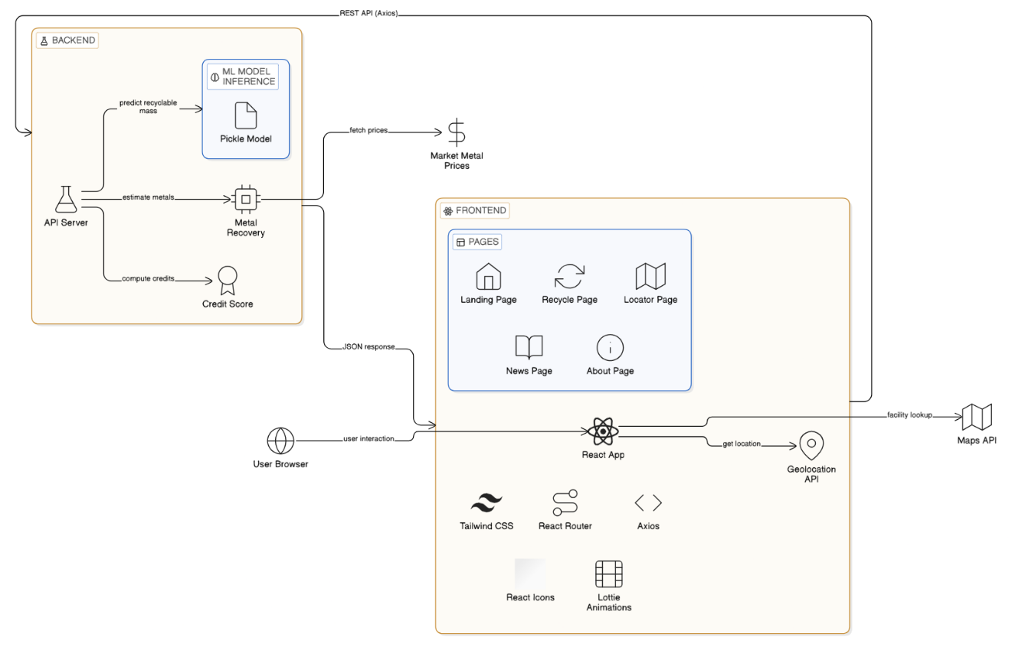
Fig. 1. High-level system architecture of the ReValuate platform

3.2 Frontend — React + Tailwind CSS
The frontend runs on React.js, with Tailwind CSS for styling and React Router for client-side navigation. Axios manages API calls to the backend, and Lottie animations provide visual feedback during loading. There are five main pages:
- Landing Page — project introduction, value proposition, and sustainability news highlights
- Recycle Page — the core credit-score calculator where users enter device specifications and receive their valuation
- Locator Page — map-based display of nearby e-waste recycling facilities based on the browser’s geolocation
- News Page — educational articles and updates on e-waste and sustainability topics
- About Page — project background, team information, and technical references

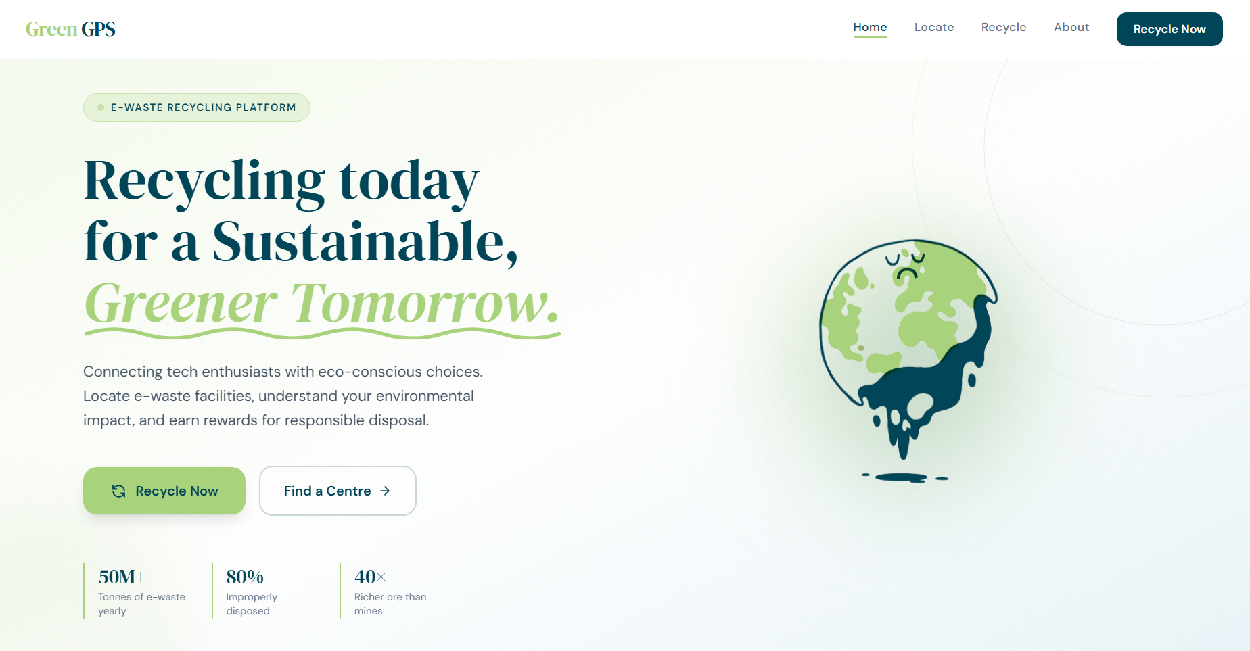
Fig. 2. Landing page of the ReValuate platform

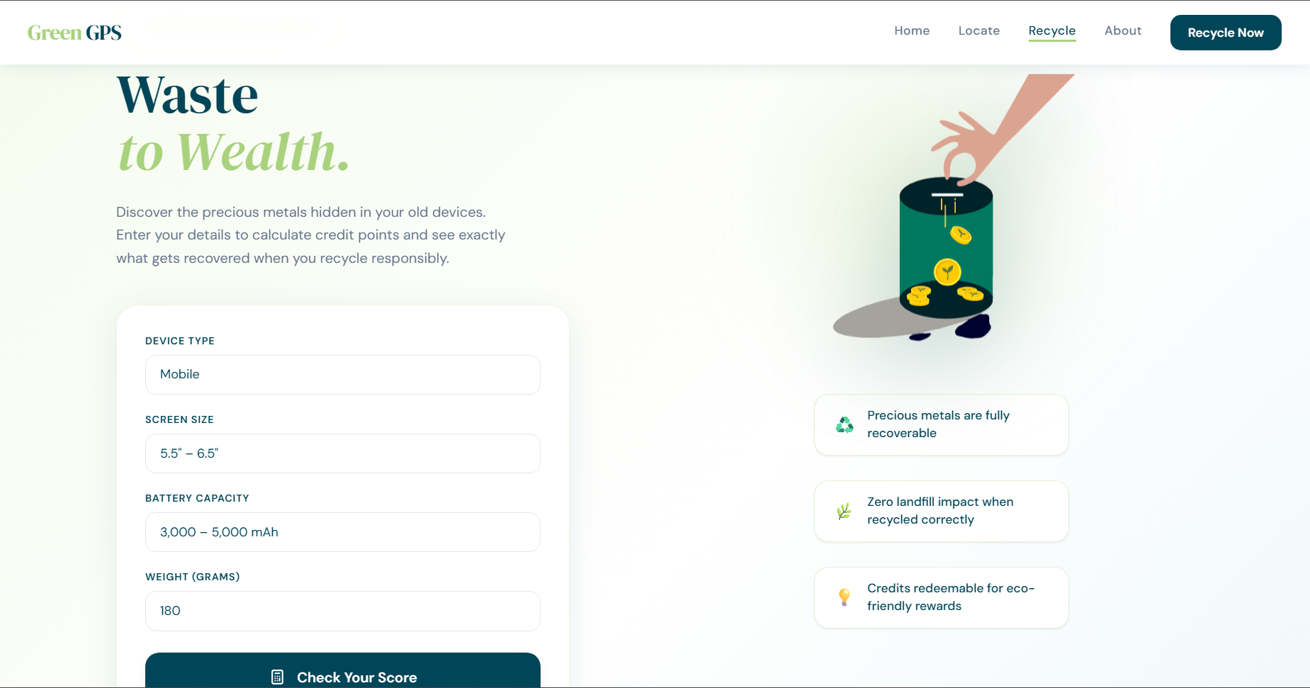
Fig. 3. Credit score calculator interface on the Recycle page

3.3 Backend — Flask API
The backend is a Python Flask application with a single main endpoint: POST /api. When a device specification comes in from the frontend, the endpoint runs the ML prediction, applies the relevant multipliers, calculates metal recovery values for all five tracked metals, converts to USD, totals everything up, and sends back a credit score with a per-metal breakdown. Flask-CORS is enabled so the React frontend can communicate with it across origins during development and in production. The ML model is stored as a serialised pickle file (mobile1.pkl) and loaded into memory once when the server starts.

3.4 Technology Stack
Table 1 lists the full technology stack for ReValuate.

Table 1. Technology stack for the ReValuate platform
Layer | Technology | Purpose
Frontend | React.js | Single-page application framework
Frontend | Tailwind CSS | Utility-first CSS styling
Frontend | React Router | Client-side page navigation
Frontend | Axios | HTTP requests to backend API
Frontend | Lottie | Animated loading and feedback states
Backend | Python Flask | REST API server and computation engine
Backend | Flask-CORS | Cross-origin resource sharing
Backend | Pickle (.pkl) | Serialised ML model storage and loading
Data / APIs | Web Geolocation API | Browser-based user location retrieval
Data / APIs | JSON files | Curated news and recycling facility data

4. The Metal Valuation Model
The credit score is not a guess. It is the result of a step-by-step calculation built on published metal-fraction data and market-referenced prices. This section breaks down how that calculation works.

4.1 Effective Mass Calculation
The starting point is turning raw device weight into an effective mass—a value that more accurately reflects recoverable content. Not every gram of a device contributes equally; a heavier battery has different implications than a heavier chassis. Three correction factors are applied multiplicatively to the ML-predicted recyclable mass:
EffectiveMass = PredictedMass × DeviceMultiplier × ScreenMultiplier × BatteryMultiplier … (1)
The device-type multiplier accounts for differences in component density between phones (1.0) and laptops (1.3). The screen and battery multipliers come from observed correlations between those specs and total recoverable metal content. Table 2 lists all the values used.

Table 2. Multiplier values used in effective mass calculation
Parameter | Range / Category | Multiplier
Device type | Mobile phone | 1.0
Device type | Laptop | 1.3
Screen size | 5.5–6.5 inches | 1.0
Screen size | 10–12 inches | 1.15
Screen size | 13.4–17 inches | 1.30
Battery capacity | 3,000–5,000 mAh | 1.0
Battery capacity | 6,000–10,000 mAh | 1.2
Battery capacity | 2,000–30,000 mAh | 1.5

4.2 Metal Recovery Estimation
With the effective mass determined, the model calculates how many grams of each metal can be recovered. Two values drive this per metal: a fraction capturing how much of the effective mass that metal typically accounts for, and a recovery rate indicating the realistic yield under standard hydrometallurgical processing. Both are sourced from peer-reviewed literature on device composition and recycling efficiency [4, 5, 9].
Metalₙ (g) = EffectiveMass × MetalFractionₙ × RecoveryRateₙ … (2)
Table 3 shows the metal fraction and recovery rate values for each of the five metals tracked by the system.

Table 3. Metal fractions and recovery rates used in the valuation model
Metal | Fraction of Effective Mass | Recovery Rate | Basis
Gold (Au) | 0.00030 | 0.95 | PCB contacts, connector plating
Silver (Ag) | 0.00100 | 0.90 | Solder, PCB tracks, keypad contacts
Palladium (Pd) | 0.00015 | 0.80 | Ceramic capacitors, connectors
Platinum (Pt) | 0.00005 | 0.80 | Specialist coatings, sensors
Copper (Cu) | 0.12000 | 0.85 | PCB traces, wiring, battery terminals

4.3 Metal Valuation
Recovered grams are then converted to USD using reference market prices. The figures in use are listed in Table 4. These are configurable and should be updated regularly as markets move.
MetalValueₙ (USD) = Metalₙ (g) × Priceₙ (USD/g) … (3)

Table 4. Metal reference prices used in credit calculation (USD per gram)
Metal | Price (USD/g) | Notes
Gold (Au) | 60.80 | London Bullion Market reference
Silver (Ag) | 0.73 | Spot price reference
Palladium (Pd) | 33.80 | London Platinum and Palladium Market
Platinum (Pt) | 30.40 | London Platinum and Palladium Market
Copper (Cu) | 0.0074 | LME cash price reference

4.4 Total Recoverable Value and Credit Score
The five metal values are added up to give a total recoverable USD figure, which is then converted to credit points at a fixed rate: one USD equals ten points, rounded up to the nearest whole number.
TotalUSD = GoldUSD + SilverUSD + PalladiumUSD + PlatinumUSD + CopperUSD … (4)
CreditScore = ⌈ TotalUSD × 10 ⌉ … (5)
Ceiling rather than standard rounding is used to ensure that even very light devices with minimal recoverable content still register a non-zero score. The full formula, combining all stages, is:
CreditScore = ⌈ Σₙ (EffectiveMass × MetalFractionₙ × RecoveryRateₙ × Priceₙ) × 10 ⌉ … (6)
The Flask backend evaluates this server-side for every device submission and returns the full per-metal breakdown—grams recovered and USD value for each—alongside the final credit score.

5. Machine Learning Component

5.1 Model Overview
The ML component has one specific job: take a device’s reported weight in grams and predict the recyclable mass to use as the starting point for metal recovery calculations. It is a regression task. The model is saved as a serialised pickle file (mobile1.pkl), loaded once at Flask startup, and called synchronously for each request.
This prediction step corrects for the reality that a device’s total weight is not all recoverable material. A 180 g phone includes screen glass, plastic casing, adhesives, and battery electrolyte—none of which are metal-bearing substrate. The model learns from device weight data how much of that reported weight is practically available for metal recovery. Section 4.1’s multipliers are then layered on top to account for device type and configuration.

5.2 Pipeline
The inference pipeline works as follows:
- User submits device weight (g) via the frontend form
- Flask backend passes the weight to the loaded regression model
- Model returns a predicted recyclable mass (g)
- Device, screen, and battery multipliers are applied to give the effective mass
- Effective mass feeds into the metal recovery formulas (Section 4.2)

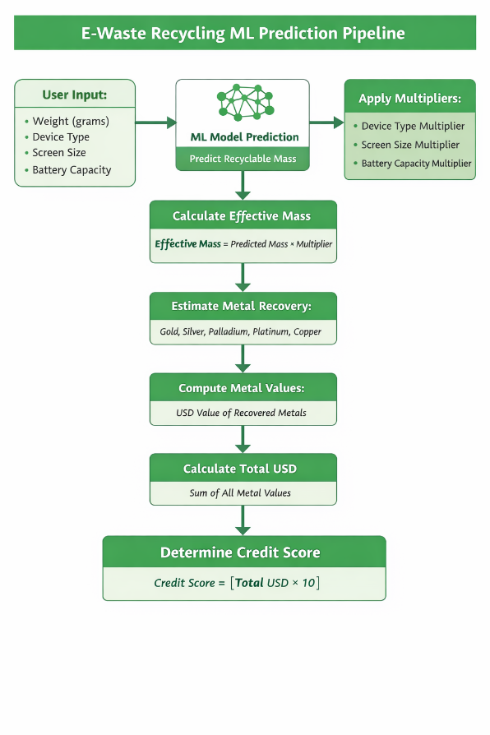

Fig. 5. Computation pipeline from device input through ML prediction to final credit score

5.3 Scope and Limitations
The model was trained on mobile device data and extended to laptops through the device-type multiplier rather than a dedicated laptop model. This is a known simplification—it holds up across the test cases here, but a proper dataset covering laptop and tablet form factors would improve accuracy in future versions. The model also takes the user’s entered weight at face value; any inaccuracy there flows through all subsequent calculations linearly.

6. Platform Features and User Flow

6.1 Credit Score Calculator
The credit score calculator is the centrepiece of the platform, reached through the Recycle page. Users pick their device type from a dropdown (Mobile or Laptop), enter the weight in grams, and select a screen size range and battery capacity range from predefined options. Submitting sends those inputs to the backend via POST /api. The response—typically returned within a second—includes the calculated credit score and the full per-metal breakdown.
Displaying the per-metal breakdown was a deliberate design call. Telling a user not just their score but also that their phone contains roughly 0.05 g of gold worth around $3.12 makes the result feel grounded rather than made up. In informal testing during development, that detail was repeatedly singled out as one of the most engaging parts of the experience.

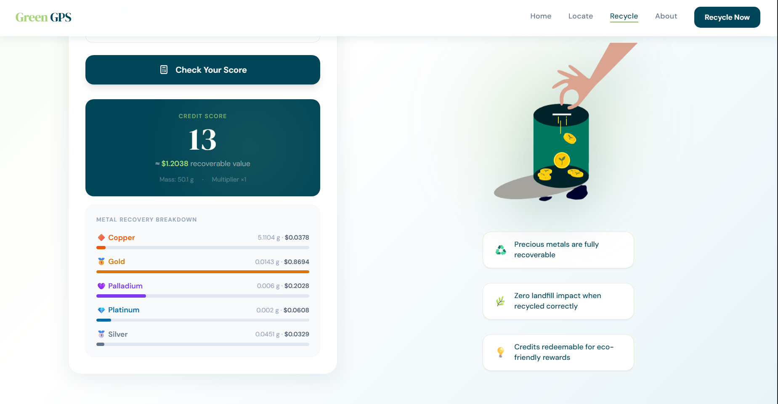
Fig. 6. Metal recovery breakdown displayed to the user after credit score calculation

6.2 Recycling Facility Locator
The locator uses the Web Geolocation API to pull the user’s latitude and longitude from the browser, then plots nearby certified e-waste facilities on an interactive map. Facility data comes from a curated JSON dataset. No server-side location handling is needed; geolocation and rendering both run in the browser. Users who prefer not to share their location can browse the facility list directly instead.

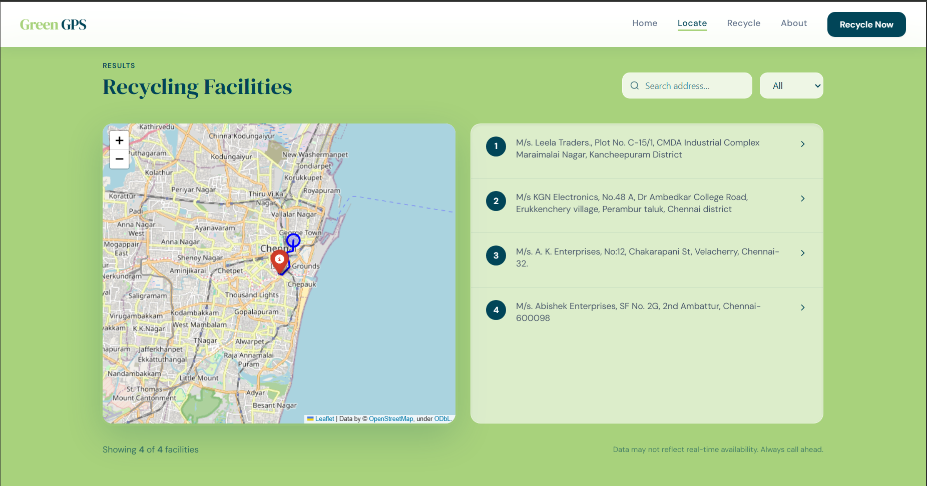
Fig. 7. Recycling facility locator showing user’s nearest certified e-waste centres

6.3 Sustainability News Feed
The news section surfaces articles on e-waste topics—policy changes, advances in recycling technology, environmental data, and guidance for consumers. The goal is to give context that reinforces why the credit score matters, turning a transactional calculation into something with more meaning behind it. Articles come from a curated JSON file and appear both on the News page and as highlights on the Landing Page.

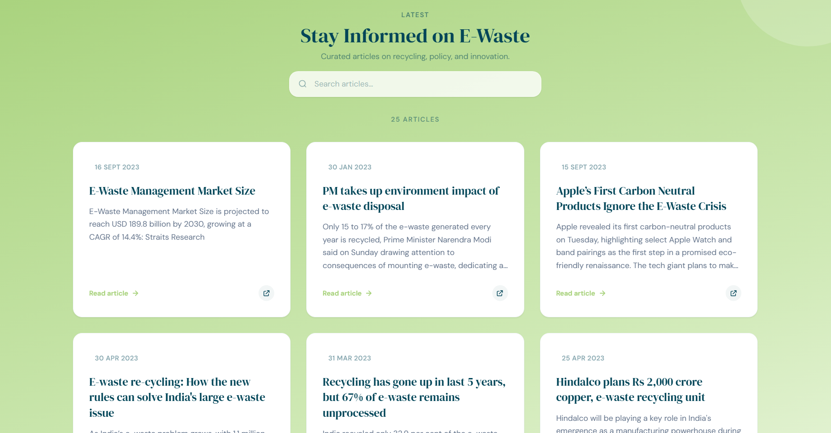
Fig. 8. Sustainability news feed on the ReValuate platform

6.4 User Roles and Access
Three user roles are defined. Administrators have full access, including the ability to manage facility data and news content. Registered users can run the calculator, use the locator, and build up credit scores. Viewers can read news content without creating an account. This structure lets the platform work for both casual visitors and organisations that engage with it more regularly.

7. Functional Testing and Results

7.1 Test Design
Validation was run across ten test cases covering a cross-section of device configurations—five mobile phone profiles and five laptop profiles—varying across weight, screen size, and battery capacity. Each case was put through the full calculation pipeline, from raw weight input through ML prediction, multiplier application, and metal recovery, and the resulting credit score was checked against a manually verified expected value.
These are not based on real devices. They are designed to put the formula logic through its paces across a realistic input range and verify that the system behaves as expected—heavier devices with larger batteries should produce higher scores—and that the arithmetic lines up with the formulas in Section 4.

7.2 Mobile Device Test Cases

Table 5. Functional test results for mobile device profiles
ID | Weight (g) | Battery | Mult. | Eff. Mass (g) | Cu (g) | Au (g) | Ag (g) | Total USD | Credit
TC01 | 180 | 3k–5k mAh | 1.00 | 180.0 | 18.36 | 0.051 | 0.162 | 4.32 | 44
TC02 | 220 | 6k–10k mAh | 1.20 | 264.0 | 26.93 | 0.075 | 0.238 | 6.34 | 64
TC03 | 250 | 2k–30k mAh | 1.50 | 375.0 | 38.25 | 0.107 | 0.338 | 9.00 | 91
TC04 | 300 | 3k–5k mAh | 1.00 | 300.0 | 30.60 | 0.086 | 0.270 | 7.20 | 73
TC05 | 350 | 6k–10k mAh | 1.20 | 420.0 | 42.84 | 0.120 | 0.378 | 10.09 | 101

7.3 Laptop Device Test Cases

Table 6. Functional test results for laptop device profiles
ID | Weight (g) | Screen | Battery | Mult. | Eff. Mass (g) | Cu (g) | Total USD | Credit
TC06 | 1200 | 13.4–17" | 6k–10k | 2.028 | 2433.6 | 248.23 | 58.44 | 585
TC07 | 1500 | 13.4–17" | 2k–30k | 2.535 | 3802.5 | 387.86 | 91.30 | 914
TC08 | 1800 | 13.4–17" | 6k–10k | 2.028 | 3650.4 | 372.34 | 87.65 | 877
TC09 | 2000 | 13.4–17" | 2k–30k | 2.535 | 5070.0 | 517.14 | 121.74 | 1218
TC10 | 2500 | 13.4–17" | 2k–30k | 2.535 | 6337.5 | 646.43 | 152.17 | 1522

7.4 Observations from Test Results
All ten test cases passed. A few patterns in the results are worth highlighting.
The link between effective mass and credit score is roughly linear, in line with what the formulas predict. Doubling effective mass approximately doubles the score, which keeps the output intuitive: a heavier phone should earn proportionally more credit.
Battery size matters beyond just total weight. TC03 and TC04 are close in mass (250 g vs 300 g), but TC03’s larger battery multiplier (1.5 vs 1.0) drives up its effective mass—and score—above TC04’s despite being lighter. This lines up with published findings that higher-capacity batteries carry more recoverable material per device [9].
Laptops score far higher than phones—roughly ten times more—mainly because copper, cheap per gram but 12% of the recoverable fraction, scales with device mass. A 2,500 g laptop’s copper alone accounts for over $4.78, with precious metals contributing another $147. That reflects the real-world priority industrial recyclers place on laptops and desktops over phones in bulk operations.
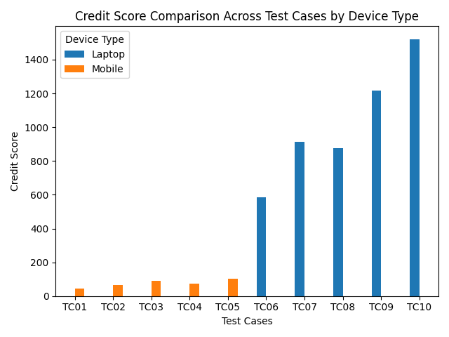
Fig. 9. Comparison of credit scores across all functional test cases

8. Discussion
The test results confirm the valuation model is internally consistent and produces expected outputs across the device configurations tested. The more interesting question is whether the platform as a whole can actually do what it was built for: nudging users toward responsible e-waste disposal.
The most important design decision in the system is transparency. Programmes that hand out arbitrary points for recycling can feel like loyalty card gimmicks—they generate no real trust and do little to build the kind of understanding behind lasting behaviour change. A platform that tells you your phone holds roughly $0.43 in silver and $3.12 in gold is making a different kind of claim: the number is traceable and tied to real material value. Whether that actually moves users is an empirical question requiring a proper user study, but the hypothesis rests on well-established findings about transparency and credibility in incentive design [6].
The 1 USD = 10 points conversion is deliberately simple. It keeps the link between value and reward transparent, and ensures scores grow predictably across recycling events. Alternative schemes—bonus multipliers for specific device types, streak rewards, tiered credit levels—could all be layered on without touching the valuation engine underneath.
A few limitations are worth naming directly. The ML model was trained on mobile data and handles laptops through a broad multiplier rather than a model built for that form factor. The metal fractions draw on published averages from the early 2010s; modern smartphones—especially those with advanced cameras and processors—may have different compositions that would justify updated figures. Metal prices are currently hardcoded and require manual updates; a production deployment would ideally source them from a live market feed. The platform also has no backend persistence, so user accounts and cumulative credit scores are not stored, which limits how useful it can be as a long-term engagement tool.
The geolocation and news features work but remain underdeveloped next to the valuation engine. Richer real-time facility data—opening hours, accepted device types, verified certification status—would make a significant difference for users ready to act once they have seen their score.
Technically, the Flask backend processes everything synchronously, which causes no issues at demo scale but would need rethinking for real concurrent load. A production deployment would benefit from async request handling, or at minimum a proper WSGI server in place of Flask’s built-in development server.

9. Conclusions
ReValuate was built on a specific premise: the main obstacle to responsible e-waste disposal is not logistical but informational. People recycle old electronics at far lower rates than they could—partly because they have no idea what those devices are worth, and partly because nobody has made it straightforward to find out. The platform takes on both at once: a formula-driven, transparent valuation showing users exactly what metals their device contains and what those metals fetch at market, alongside a facility locator that converts ‘I really should recycle this’ into ‘here is where I go to do it.’
The valuation model—ML-predicted recyclable mass combined with research-based metal fractions and market-referenced prices—produces results that are internally consistent and grounded in real figures. The ten functional test cases span a realistic range of mobile and laptop profiles and confirm the formula works correctly across the full input space.
This work contributes on three fronts. First, it integrates a regression-based mass prediction model with a transparent, auditable metal-recovery calculation inside a consumer-facing interface—a combination not commonly seen in practice. Second, it introduces a credit-score conversion that renders abstract material value as a concrete, accumulating reward. Third, the system as a whole demonstrates that this kind of platform can be built and deployed with a modest stack, lowering the barrier for other researchers or practitioners looking to extend the approach.
Next steps include training the ML model on broader data that covers laptops and tablets properly, connecting to live metal price feeds, adding a persistent account system for tracking accumulated credits, and running a formal user study to test whether the transparent valuation approach actually changes recycling behaviour in the ways the design anticipates. The problem this platform was built around is not going away. The tools for addressing it should keep improving.

References
[1] S. Lundqvist and A. Wennberg, “Incentive structures in consumer e-waste programmes: a behavioural economics perspective,” Resources, Conservation and Recycling, vol. 167, p. 105381, 2021.
[2] T. Balde, V. Forti, V. Gray, R. Kuehr, and P. Stegmann, The Global E-Waste Monitor 2017: Quantities, Flows, and Resources, United Nations University, Bonn, 2017.
[3] J. Cui and L. Zhang, “Metallurgical recovery of metals from electronic waste: a review,” Journal of Hazardous Materials, vol. 158, no. 2–3, pp. 228–256, 2008.
[4] C. Hagelüken and C. W. Corti, “Recycling of gold from electronics: cost-effective use through design for recycling,” Gold Bulletin, vol. 43, no. 3, pp. 209–220, 2010.
[5] C. Hagelüken, “Improving metal returns and eco-efficiency in electronics recycling,” in Proc. 2006 IEEE Intl. Symp. Electronics and the Environment, San Francisco, 2006, pp. 218–223.
[6] P. W. Schultz, “Knowledge, information, and household recycling: examining the knowledge-deficit model of behavior change,” in New Tools for Environmental Protection, National Academies Press, Washington D.C., 2002, pp. 67–82.
[7] Y. Li, J. Liu, and R. Huang, “Application of machine learning techniques to predict recycling outcomes in e-waste sorting,” Waste Management, vol. 118, pp. 431–440, 2020.
[8] M. Fowler, Patterns of Enterprise Application Architecture, Addison-Wesley, Boston, 2002.
[9] Guideline on Material Recovery and Recycling of End-of-Life Mobile Phones, Mobile Phone Partnership Initiative – Project 3.1, UNEP, 2009, pp. 1–54.
[10] S. Ilyas, M. A. Anwar, S. B. Niazi, and M. A. Ghauri, “Bioleaching of metals from electronic scrap by moderately thermophilic acidophilic bacteria,” Hydrometallurgy, vol. 88, pp. 180–188, 2007.
[11] A. Fornalczyk, J. Willner, K. Francuz, and J. Cebulski, “E-waste as a source of valuable metals,” Archives of Materials Science and Engineering, vol. 63, no. 2, pp. 87–92, 2013.

