Examining the Mediating Effect of Self-Confidence in Pair Work

ABSTRACT
Pair work is widely recognized as an effective pedagogical strategy for promoting collaboration, engagement, and meaningful learning experiences. However, limited empirical evidence exists regarding the role of self-confidence as a mediating mechanism linking learners’ satisfaction with pair work outcomes. This study examined the mediating effect of self-confidence on the relationships between satisfaction, social interactions, and socio-cultural context in pair work settings. Grounded in Sociocultural Theory, Social Constructivist Theory, and Self-Efficacy Theory, the study employed a quantitative research design involving 225 respondents from various academic disciplines. Data were collected using a structured questionnaire adapted from established instruments and analyzed using Partial Least Squares Structural Equation Modeling (PLS-SEM) through SmartPLS 4. The findings revealed that satisfaction significantly predicted self-confidence, while self-confidence had significant positive effects on both social interactions and socio-cultural context. In contrast, satisfaction did not have significant direct relationships with social interactions or socio-cultural context. These results indicate that self-confidence functions as an important mediating variable through which learners’ satisfaction influences their collaborative experiences in pair work. The model demonstrated satisfactory reliability, validity, and predictive relevance, supporting the robustness of the proposed framework. The study contributes to the growing body of literature on collaborative learning by highlighting the central role of self-confidence in enhancing learners’ social engagement and socio-cultural adaptation within pair work environments. The findings provide practical implications for educators seeking to design learner-centered collaborative activities that foster confidence, meaningful interaction, and positive learning outcomes.
KEYWORDS: pair work, self-confidence, social interaction, socio-cultural context, PLS-SEM

- INTRODUCTION.
  - Background of Study

Pair work has become an important pedagogical strategy in contemporary education because it promotes collaboration, communication, and active engagement among learners. Through interactions with peers, students have opportunities to exchange ideas, provide feedback, and develop social and cognitive skills. According to Järvenoja et al. (2025) peer influence plays a significant role in shaping learners’ experiences, particularly through mechanisms such as peer feedback, social comparison, and group identity formation. These social processes can affect learners’ self-esteem and self-confidence, which are important factors influencing participation and engagement in learning activities. As pair work relies heavily on interpersonal interaction, understanding the factors that contribute to effective collaboration is essential for enhancing learning outcomes.
Despite the recognized importance of peer interactions, the role of self-confidence in pair work remains insufficiently understood. Previous research has highlighted that peer relationships can have both positive and negative effects on learners’ confidence, depending on the nature of the interactions and social comparisons involved (Järvenoja et al., 2025). While studies have examined the influence of peer interactions on motivation, self-esteem, and learning experiences, limited attention has been given to how self-confidence functions within pair work settings. Specifically, there is a lack of empirical evidence on whether self-confidence serves as a mediating mechanism through which pair work interactions influence learners’ learning experiences and outcomes. Therefore, this study seeks to address this gap by examining the mediating effect of self-confidence in pair work, contributing to a better understanding of how peer interactions shape learners’ engagement and development in collaborative learning environments.

  - Research Objective, Research Questions, and Hypothesis
The research questions will be answered using SmartPLS analysis using both measurement and structural models.

Table 1- Distribution of Research Objectives, Questions, and Hypotheses
RO | RQ | RESEARCH  HYPOTHESIS
To investigate if there is a significant relationship between Satisfaction and Social Interaction | Is there a significant relationship between Satisfaction and Social Interaction? | Ho1: There is no significant relationship between Satisfaction and Social Interaction
To investigate if there is a significant relationship between Satisfaction and Socio-Cultural Context | Is there a significant relationship between Satisfaction and Socio-Cultural Context? | Ho2: There is no significant relationship between Satisfaction and Socio-Cultural Context
To investigate if there is a significant relationship between Satisfaction and Self-Confidence | Is there a significant relationship between Satisfaction and Self-Confidence? | Ho3: There is no significant relationship between Satisfaction and Self-Confidence
To investigate if there is a significant effect between Self-Confidence and Social Interactions | Is there significant effect between Self-Confidence and Social Interactions | Ho4: There is no significant between Self-Confidence and Social Interactions
To investigate if there is a significant effect between Self-Confidence and Socio-Cultural Context | Is there effect significant effect between Self-Confidence and Socio-Cultural Context | Ho5: There is no significant effect between Self-Confidence and Socio-Cultural Context

- LITERATURE REVIEW
  - Theoretical Framework
    - This study is anchored by three main theories: (i) Sociocultural Theory, (ii) Social Constructivist Theory, and (iii) Self-Efficacy Theory.

    - Sociocultural Theory

(Vygotsky, 1978) Sociocultural Theory posits that learning is fundamentally a social process that occurs through interaction with others within a cultural context. According to the theory, cognitive development is facilitated through social communication, collaboration, and the use of language as a mediating tool. A central concept of the theory is the Zone of Proximal Development (ZPD), which refers to the gap between what learners can accomplish independently and what they can achieve with guidance from more capable peers or instructors. In the context of pair work, learners engage in meaningful dialogue, exchange ideas, and provide mutual support, enabling them to construct knowledge collaboratively. Through these interactions, learners can scaffold each other’s understanding, develop problem-solving skills, and enhance their participation in learning activities. Therefore, Sociocultural Theory provides a strong theoretical foundation for pair work, as it emphasizes the importance of social interaction and collaborative learning in promoting cognitive and academic development.

    - Social Constructivist Theory

(Vygotsky, 1978) Social Constructivist Theory emphasizes that knowledge is constructed through social interaction and collaboration with others. The theory argues that learning is not an individual process but occurs when learners actively engage in dialogue, share experiences, and negotiate meaning within a social context. Through interaction with peers, learners are exposed to diverse perspectives that help them develop new understanding and refine existing knowledge. In pair work settings, students collaborate to solve problems, exchange ideas, and provide feedback, creating opportunities for meaningful social interaction. These interactions foster a supportive learning environment that can enhance learners’ satisfaction by promoting a sense of belonging, participation, and achievement. As learners work together toward common goals, they become more engaged in the learning process, leading to positive learning experiences. Therefore, Social Constructivist Theory provides a strong foundation for understanding how pair work promotes both social interaction and learner satisfaction.

    - Self-Efficacy Theory

(Bandura, 1977) Self-Efficacy Theory explains how individuals’ beliefs in their capabilities influence their motivation, behavior, and performance. Self-efficacy refers to a person’s confidence in their ability to successfully complete a task or achieve a desired outcome. According to Bandura, self-efficacy is developed through four primary sources: mastery experiences, vicarious experiences, verbal persuasion, and physiological or emotional states. In educational settings, learners who possess higher self-efficacy are more likely to participate actively, persevere through challenges, and demonstrate greater confidence in their abilities. In the context of pair work interactions, learners can enhance their confidence through collaborative experiences with their peers. Working in pairs allows students to observe their partners’ successful performance, receive constructive feedback and encouragement, and engage in shared problem-solving activities. These interactions can reduce anxiety and create a supportive learning environment, enabling learners to develop stronger beliefs in their own abilities. Therefore, Self-Efficacy Theory provides a valuable framework for understanding how pair work interactions contribute to the development of learners’ confidence and willingness to engage in learning activities.

  - Past Studies on The Influence of Pair Work Interactions

Past studies suggest that pair work and collaborative learning environments play an important role in shaping learners’ interactions, motivation, and social experiences. (Järvenoja et al., 2025) found that peer interactions within collaborative learning groups significantly influenced students’ situational motivation. Their study showed that learners perceived stronger motivational support when social interaction was combined with cognitive regulation processes. Students highlighted both social and cognitive aspects of collaboration as essential for maintaining engagement and motivation. These findings indicate that pair work creates opportunities for meaningful interaction, mutual support, and shared regulation of learning, which can enhance learners’ participation and involvement in tasks.
Research has also examined the effects of pair work on learners’ confidence and satisfaction. According to Rahman & Golamgouse-Toraub (2025) in their study of a modified Think-Pair-Share approach, they reported significant improvements in students’ critical thinking and understanding, suggesting positive learning experiences and satisfaction with collaborative activities. However, the intervention had an insignificant impact on learners’ confidence, indicating that increased interaction alone may not automatically strengthen self-confidence. In contrast, Farxadovna (2024) emphasized that peer relationships can strongly influence self-esteem and self-confidence through feedback, social comparison, and group identity formation. Positive peer support can encourage confidence, whereas negative comparisons may have adverse effects.
From a sociocultural perspective, these studies collectively highlight that learning in pairs is shaped by social contexts and peer relationships. Interaction, dialogue, and collaborative problem-solving enable learners to co-construct knowledge while developing social connections. Thus, pair work can foster social interaction, motivation, and learner satisfaction, although its impact on self-confidence may depend on the quality of peer relationships and the broader sociocultural environment in which learning occurs.

  - Conceptual Framework and Proposed Model of the Study

Figure 1 shows the conceptual framework of the proposed model of the study. This study is done to predict a model to examine the mediating effect of self-confidence in pair work.

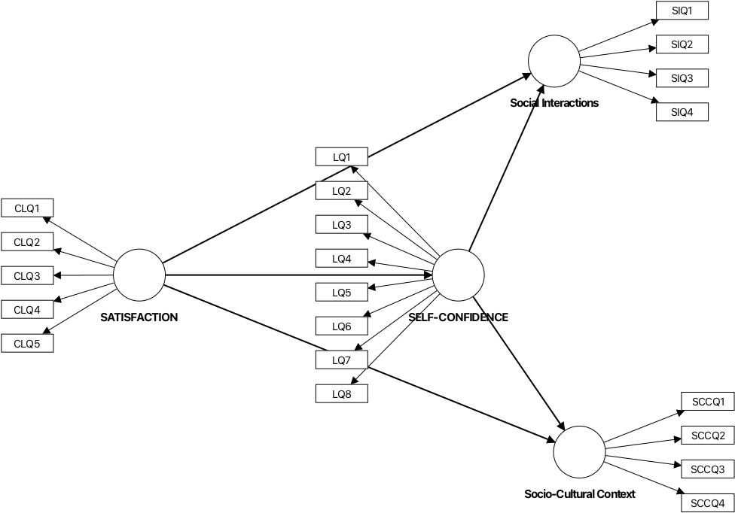
Figure 1- The Conceptual Framework –
Examining the Mediating Effect of Self-Confidence in Pair Work

The conceptual framework for this study is grounded in the interaction between pair work and students’ learning outcomes, with self-confidence acting as a mediating variable. Drawing on Bandura’s (1977) self-efficacy theory, self-confidence is conceptualized as learners’ belief in their capability to perform tasks successfully. In pair work settings, increased interaction and collaboration can enhance learners’ confidence through mastery experiences and peer support, which in turn influences their engagement and overall learning outcomes. This justification aligns with Studnicka’s (2023) instrument, which measures constructs such as self-confidence in learning and learning satisfaction, highlighting the importance of internal beliefs in shaping positive learning experiences.
Additionally, the framework is supported by Vygotsky’s (1978) social constructivist theory, which emphasizes that knowledge is co-constructed through social interaction. Pair work promotes active communication, negotiation of meaning, and shared understanding, thereby enhancing social interaction and learning satisfaction. These constructs are reflected in Baleghizadeh and Farhesh’s (2014) instrument, which captures dimensions of social interaction in collaborative learning environments. Furthermore, Vygotsky’s sociocultural theory underscores the role of the socio-cultural context in shaping learning processes, suggesting that learners’ background, cultural practices, and social environment influence how they interact and build knowledge. Thus, the framework integrates these theories to explain how pair work fosters interaction and satisfaction within a socio-cultural context, while self-confidence mediates the relationship by enabling learners to actively participate and benefit from collaborative learning experiences.

- METHODOLOGY
  - Research Design
This study employs a quantitative design. The research goal is to explore an extension of an existing theory/predict a theory. The model (Figure 1)chosen for this study is a hierarchical component model, Type II, which utilizes a combination of reflective-reflective models. According to (Fornell & Bookstein, 1982), a reflective model is employed when the construct is a trait and explains the indicators.

  - Population and Sample
The demographic analysis is presented in percentages. According to (Ziegenfuss et al., 2021) researchers report demographic data in percentages to establish sample representatives and allow for generalizability to a larger population. Presenting in percentages also provides an overview of participants’ characteristics and offers a clear and understandable picture of the sample makeup. 225 respondents

Table 2- Percentage for Demographic Profile
Question | Demographic Profile | Categories | Percentage (%)
1 | Gender | Male | 44%
 |  | Female | 56%
2 | Discipline | Science & Technology | 29%
 |  | Social Sciences, Humanities, Business & Management | 71%

Table 2 presents the demographic profile of the respondents in terms of gender and academic discipline. The data indicate that a higher proportion of participants were female (56%) compared to male respondents (44%), suggesting a relatively balanced but female-dominated sample. In terms of discipline, the majority of respondents were from Social Sciences, Humanities, Business, and Management fields, accounting for 71% of the sample, while only 29% were from Science and Technology. This distribution shows that the study primarily represents students from non-science backgrounds, which may influence the overall interpretation of the findings.

3.3 Instrument

Table 3 presents the distribution of items included in the questionnaire. The instrument used a 5 Likert scale with scale 1 is never. Scale 2 represents rarely. Scale 3 represents sometimes, while scale 4 is often and scale 5 is always.

Table 3- Distribution for Item in Instrument
SECTION | VARIABLE | CONSTRUCT | ITEM | TOT
B | STUDENT SATISFACTION AND SELF-CONFIDENCE IN LEARNING  Studnicka (2023) | Satisfaction with Current Learning | 5 | 13
B |  | Self-Confidence in Learning | 8
C | PAIR WORK  Baleghizadeh & Farhesh (2014) | Social Interactions | 4 | 12
C | PAIR WORK  Baleghizadeh & Farhesh (2014) | Knowledge Construction | 4
C | PAIR WORK  Baleghizadeh & Farhesh (2014) | Social & Cultural Context | 4
 |  |  |  | 25

The questionnaire, adapted from who (Studnicka et al., 2023) to represent Satisfaction and Self-Confidence, and (Baleghizadeh & Farhesh, 2014) comprises variables representing the Pair Work.

  - Data Collection and Data Analysis
Data is collected via a Google Form. The data is then analyzed using SmartPLS 4 through two main stages. As suggested by J. F. , Hair et al. (2017), data analysis is done at two levels: the measurement and structural model. The first stage is the measurement model, which measures the outer model. The second stage is the structural model, which measures the inner model. The analyzed data is used to answer the research questions and also to confirm the model chosen.

- FINDINGS
The findings are presented in two stages. The first stage presents the measurement model, and the third stage reveals the structural model as well as answers research questions.

  - Measurement Model
In SmartPLS, the measurement model assesses the reliability and validity of the constructs. This is done by examining the relationships between them and their observable behavior. The measurement model measures the outer model. Figure 3 below shows the measurement model for this study. Further detailed explanation of this model is elaborated in the tables below, representing (i) reliability, and (ii) validity of the model.

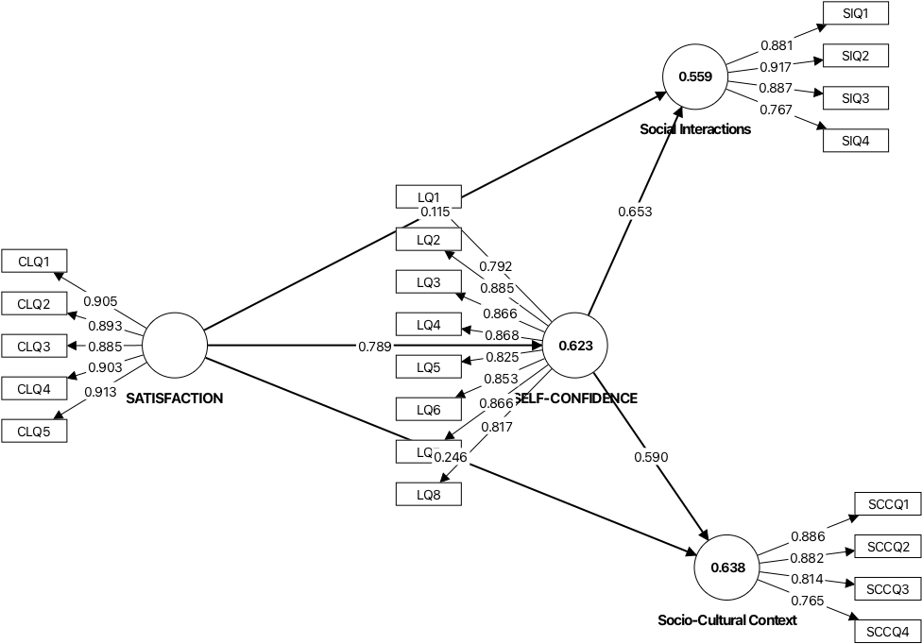

Figure 2- Measurement Model

    - Reliability

According to (J. F. , Hair et al., 2017) reliability is assessed by checking indicator reliability and internal consistency reliability. Internal consistency is done using Composite reliability (rho_c) and Cronbach’s Alpha. The cut-off value for Cronbach’s Alpha is 0.70 to 0.90. The cut-off values for composite reliability (rho_c) are 0.70-0.90. For indicator reliability, the factor loadings cut-off values are >0.70 and squared loadings ≥0.50. Finally, the cut-off values for Average Variance Extracted (AVE) ≥0.50.

Table 4 -Results for Reliability- Satisfaction

CONSTRUCT/  ITEM | FACTOR LOADING | CRONBACH’S ALPHA | COMPOSITE RELIABILITY (rho_c) | AVERAGE VARIANCE EXTRACTED (AVE)
 |  | 0.941 | 0.955 | 0.81
CLQ1 | 0.905
CLQ2 | 0.893
CLQ3 | 0.885
CLQ4 | 0.903
CLQ5 | 0.913

Table 4 presents the reliability results for Satisfaction. Factor loading of all items was found to be between 0.885 and 0.913. The loadings comply with the indicator reliability of more than 0.7. Next, the Cronbach’s Alpha for Satisfaction is 0.941, the composite reliability is 0.955, and the AVE is 0.81.

Table 5 -Results for Reliability- Self-Confidence

CONSTRUCT/  ITEM | FACTOR LOADING | CRONBACH’S ALPHA | COMPOSITE RELIABILITY (rho_c) | AVERAGE VARIANCE EXTRACTED (AVE)
 |  | 0.941 | 0.955 | 0.81
LQ1 | 0.792
LQ2 | 0.885
LQ3 | 0.866
LQ4 | 0.868
LQ5 | 0.825
LQ6 | 0.853
LQ7 | 0.866
LQ8 | 0.817

Table 5 presents the reliability results for the Self-Confidence. Factor loading of all items were found to be between 0.792 and 0.885. The loadings comply with the indicator reliability of more than 0.7. Next, the Cronbach’s Alpha for Self-Confidence is 0.941, composite reliability is 0.955 and AVE is 0.81.

Table 6 -Results for Reliability- Social Interaction

CONSTRUCT/  ITEM | FACTOR LOADING | CRONBACH’S ALPHA | COMPOSITE RELIABILITY (rho_c) | AVERAGE VARIANCE EXTRACTED (AVE
 |  | 0.887 | 0.922 | 0.748
SIQ1 | 0.881
SIQ2 | 0.917
SIQ3 | 0.887
SIQ4 | 0.767

Table 6 presents the reliability results for Social Interaction. Factor loading of all items were found to be between 0.767 and 0.917. The loadings comply with the indicator reliability of more than 0.7. Next, The Cronbach’s Alpha for Social Interaction is 0.887, composite reliability is 0.922 and AVE is 0.748.

Table 7 -Results for Reliability- Socio-Cultural Context
CONSTRUCT/  ITEM | FACTOR LOADING | CRONBACH’S ALPHA | COMPOSITE RELIABILITY (rho_c) | AVERAGE VARIANCE EXTRACTED (AVE
 |  | 0.858 | 0.904 | 0.703
0.881 | 0.886
0.917 | 0.882
0.887 | 0.814
0.767 | 0.765

Table 7 presents the reliability results for the Socio-Cultural Context. Factor loading of all items was found to be between 0.765 and 0.886. The loadings comply with the indicator reliability of more than 0.7. Next, the Cronbach’s Alpha for Socio-Cultural Context is 0.858, the composite reliability is 0.904, and AVE is 0.703.

    - Validity

According to (Ramayah et al., 2018) , for validity, the Discriminant validity (HTMT) needs to be <0.85 or <0.90.

Table 8- Discriminant Validity (HTMT)
 | SATISFACTION | SELF-CONFIDENCE | Social Interactions
SELF-CONFIDENCE | 0.837
Social Interactions | 0.679 | 0.804
Socio-Cultural Context | 0.785 | 0.871 | 0.893

Table 8 presents the discriminant validity of the model. The HTMT for SELF-CONFIDENCE and SATISFACTION is 0.837. The HTMT for Social Interactions and SATISFACTION is 0.679, for Social Interactions and SELF-CONFIDENCE of 0.804. Next, the HTMT for Socio-Cultural Context and SATISFACTION is 0.785, for Socio-Cultural Context and SELF-CONFIDENCE is 0.871 and for Socio-Cultural Context and Social Interactions 0.893.

  - Structural Model

In SmartPLS, the structural model visualizes the hypothesized causal relationships between constructs. The structural model is thus formed after the researcher has established the reliability and validity in the measurement model. For the analysis of the structural model, the researcher runs bootstrapping and examines the collinearity, path coefficients of determination, effect size, PLS predict, and IPMA. In addition to that, the analysis in the structural model allows the researcher to answer research questions 1-5 and hypotheses 1-5). Figure 4 below shows the structural model for this study. Detailed explanation is elaborated through the analysis of (i) collinearity, (ii) coefficients (R²), (iii) P-value, (iv) Effect Size (f²), (v) PLS Predict (Q²), and IPMA.

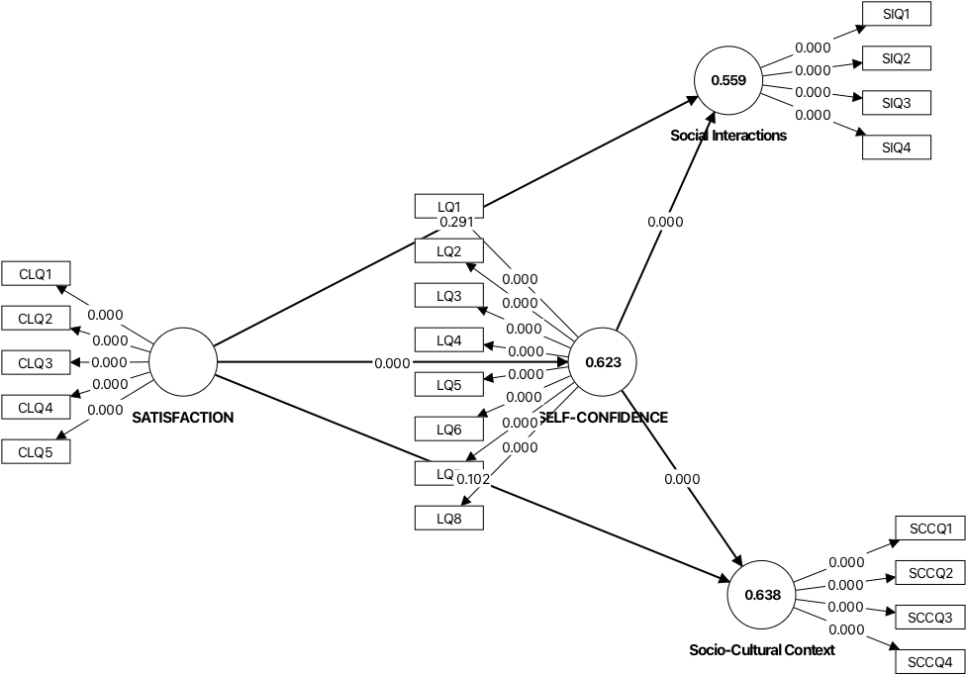
Figure 3- Structural Model

    - Collinearity

According to Ringle & Sarstedt (2016),), the cut-off value for collinearity inner model VIF is ≤ 5.0.

Table 9- Collinearity
 | Original sample (O)
SATISFACTION -> SELF-CONFIDENCE | 1
SATISFACTION -> Social Interactions | 2.654
SATISFACTION -> Socio-Cultural Context | 2.654
SELF-CONFIDENCE -> Social Interactions | 2.654
SELF-CONFIDENCE -> Socio-Cultural Context | 2.654

Table 9 above presents the collinearity results for this study. According to (J. F. Hair et al., 2011) the inner model VIF must be less than or equal to 5.0. All interactions met the threshold for Collinearity.

    - Coefficients of determination (R²)

According to (Ramayah et al., 2018) For coefficients of determination (R²) range from 0.2 to 0;7, depending on the field of study. Social Sciences & Economics follows the range above.

Table 10-R²

 | Original sample (O)
SELF-CONFIDENCE | 0.611
Social Interactions | 0.381
Socio-Cultural Context | 0.486

Table 10 shows the results for coefficients of determination (R²). Results indicate that the R² for Self-Confidence is 0.611 (61.1%), for Social Interactions is .0.381 (38.1%), and for Socio-cultural Context is 0.486 (48.6%).

    - P-Value

Table 11- Interpretation for p-value
Thresholds | Interpretation | Decision
p ≤ 0.05 | Often considered statistically significant | Reject H₀
p ≤ 0.01 | Indicates very strong evidence against H₀ | Reject H₀
p> 0.05 | Weak or no evidence against H₀ | Fai to reject H₀

According to Goodman (1999) , a threshold of p-value is the cut-off for determining statistical significance, most commonly set at 0.05. Below is the table that interprets the threshold.
Table 11 shows the interpretation for p=value. According to (Goodman (1999), if the p-value is p ≤ 0.05, the data is often considered statistically significant, and the null hypothesis is rejected. If it is p ≤ 0.01, then it indicates very strong evidence to reject the null hypothesis (H₀₎. However, a p> 0.05 is considered weak, and there is no evidence to reject the null hypothesis.

Table 12 Path Coefficient for current study
 | T statistics (|O/STDEV|) | P values
SATISFACTION -> Social Interactions (H₀₁) | 1.056 | 0.291
SATISFACTION -> Socio-Cultural Context(H₀₂) | 1.634 | 0.102
SATISFACTION -> SELF-CONFIDENCE(H₀₃) | 14.399 | 0
SELF-CONFIDENCE -> Social Interactions(H₀₄) | 5.715 | 0
SELF-CONFIDENCE -> Socio-Cultural Context(H₀₅) | 4.633 | 0

Table 12 presents data to answer research questions and hypotheses. Path coefficients are presented in beta and t-value. The significant value (t-statistic) must be more than 1.65, and p-values must be less than 0.05 to show significant relationships.
Out of five interactions, three had significant relationships. The interactions of SATISFACTION -> SELF-CONFIDENCE (p=0, t=14.399), SELF-CONFIDENCE -> Social Interactions (p=0, t=5.715), and SELF-CONFIDENCE -> Socio-Cultural Context (p=0, t=4.633).
On the other hand, there were no significant relationships for SATISFACTION -> Social Interactions (p=0.291, t=1.056), and SATISFACTION -> Socio-Cultural Context(p=0.102, t=1.634).
This means the null hypotheses for Ho1 and Ho2 and is accepted. The null hypotheses for Ho3, Ho4, and Ho5 are rejected.

    - Effect Size (f²)

According to (Ramayah et al., 2018), the cutoff values for effect sizes (f²) are 0.02 (small), 0.15 (medium), and 0.35 (large). This section presents data to answer research questions and hypotheses;

RQ5- Is there a significant effect for connectivism on diversity, openness, connectedness, and autonomy?
H₀₅- There is no significant effect for connectivism on diversity, openness, connectedness, and autonomy

According to (Ringle & Sarstedt, 2015) for effect size, values from 0.02 to 0.15 are considered small. Values between 0.15 to 0.35 are considered medium, while values 0.35 and above are considered large.

Table 13- Effect Size
 | Original sample (O) | Interpretation
SATISFACTION -> SELF-CONFIDENCE | 1.654 | large
SELF-CONFIDENCE -> Social Interactions | 0.365 | large
SELF-CONFIDENCE -> Socio-Cultural Context | 0.363 | large

    - PLS Predict (Q²)

In PLS-SEM, it is stated that Q² ≥ 0 (Ringle & Sarstedt, 2015) Table 18 below reveals the PLS Predict (Q²) for the dependent variable. The analysis reveals the Q² for all items in the dependent variable -connectedness.

Table 14- PLS Predict (Q²)
 | Q²predict | RMSE | MAE
SELF-CONFIDENCE | 0.611 | 0.636 | 0.399
Social Interactions | 0.381 | 0.798 | 0.55
Socio-Cultural Context | 0.486 | 0.729 | 0.513

Table 14 above shows the results for Q² Predict in the study. According to Cohen (1988), Q² Predict is used to interpret the magnitude of the predictive relevance. For Q² > 0 indicates the model has predictive relevance. Secondly, 0.02 indicates small predictive relevance. Next, 0.15 indicates medium predictive relevance. Finally, 0.35 indicates large predictive relevance. Results for table 13 that all variables indicate predictive relevance. Specifically, SELF-CONFIDENCE shows high predictive relevance. Social Interactions shows high predictive relevance and Socio-Cultural Context also shows high predictive relevance.

    - IPMA

IPMA or Importance-Performance Matrix Analysis. According to Ringle & Sarstedt (2016), IPMA is used to evaluate the performance and importance of the chosen constructs or indicators within a model. In the context of this study, individual IPMA analysis was done on each construct and reported in the figures below.

According to (Hauf, 2024) for PLS-SEM IPMA (Importance-Performance Map Analysis), there isn’t a single "good score," but rather constructs with high importance (total effects) but low performance scores (rescaled 0-100) are key areas for improvement, indicating high potential for managerial action, while high importance/high performance is good, and low importance/low performance means less priority. Performance scores range 0-100, with higher values showing better attainment, but you interpret them relative to their importance.

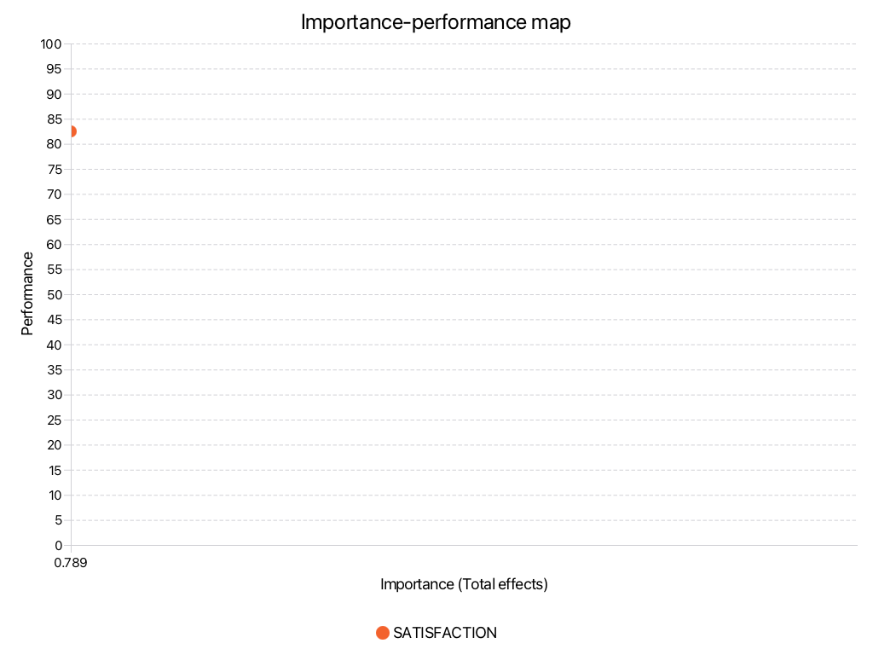
Figure 4- Importance-Performance Map for Self-Confidence

Figure 4 above shows the importance and performance analysis for Self-Confidence. When paired with Satisfaction, there is High Importance/High Performance (Importance = 0.789; Performance = 82.47).

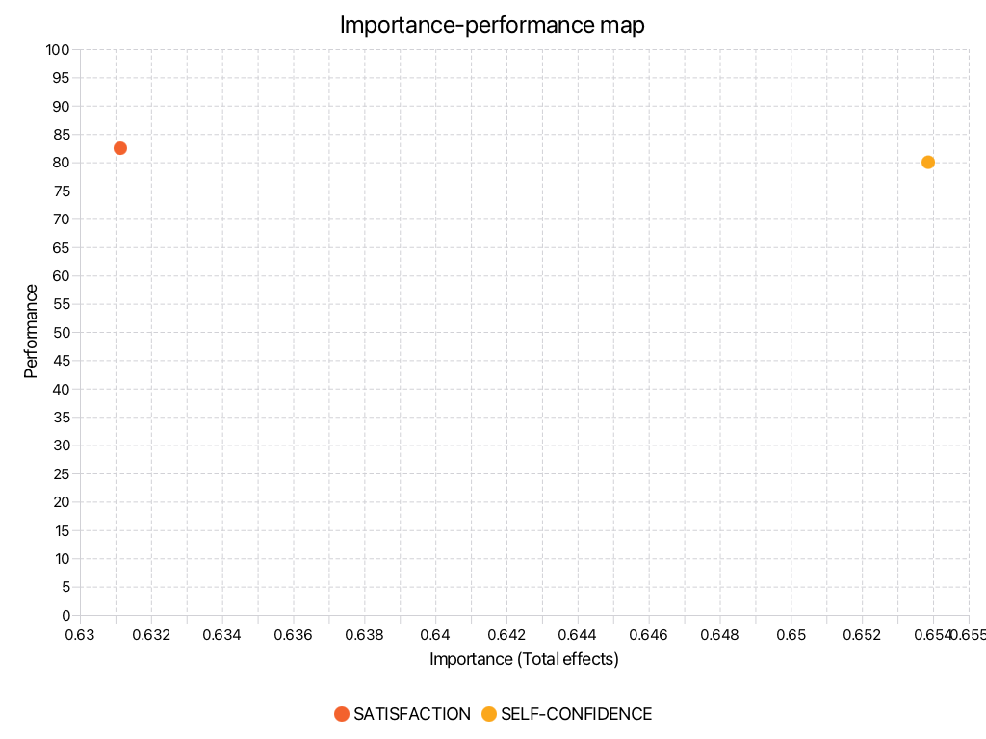
Figure 5- - Importance-Performance Map for Social Interactions

Figure 5 above shows the importance and performance analysis for Social Interactions. When paired with Satisfaction, there is High Importance/High Performance (Importance = 0.631; Performance = 82.471).
When paired with Self-Confidence, there is High Importance/High Performance (Importance = 0.653; Performance = 80.002)
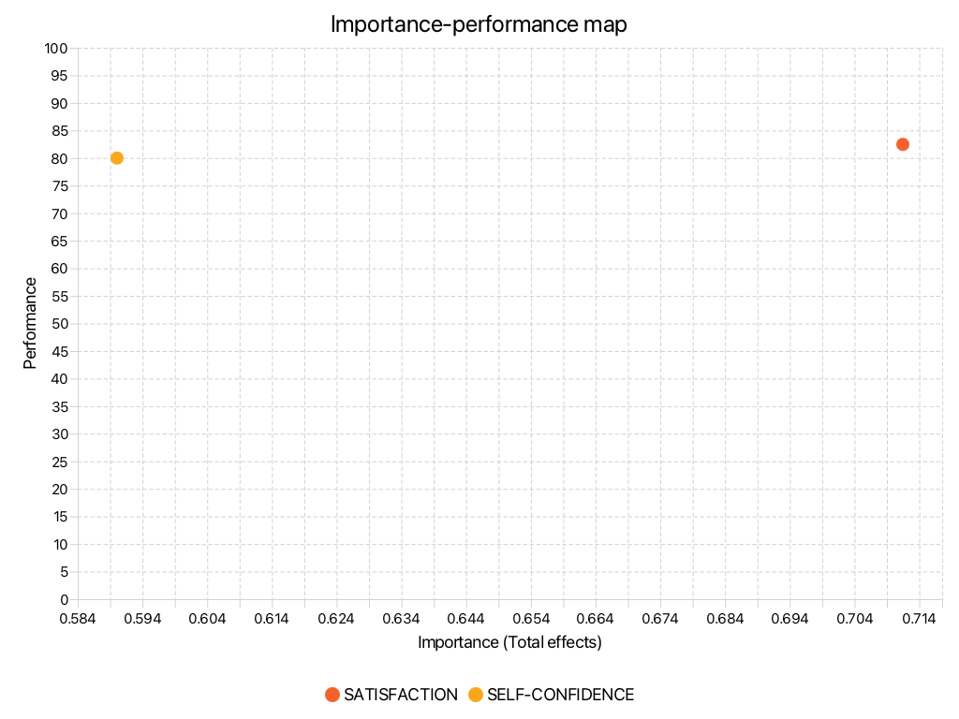

Figure 6- - Importance-Performance Map for Socio-Cultural Contexts
Figure 6 above shows the importance and performance analysis for Social Interactions. When paired with Satisfaction, there is High Importance/High Performance (Importance = 0.712; Performance = 82.259).
When paired with Self-Confidence, there is High Importance/High Performance (Importance = 0.590; Performance = 80.002).

5.0 CONCLUSION
5.1 Summary of Findings and Discussions

Table 15- Outcome of Research Hypothesis
NO | Research Question | Research Hypothesis | Outcome
1 | Is there a significant relationship between Satisfaction and Social Interaction? | Ho1: There is no significant relationship between Satisfaction and Social Interaction | Accept null hypothesis  There is a relationship between fear of oral presentation and personal components.
2 | Is there a significant relationship between Satisfaction and Socio-Cultural Context? | Ho2: There is no significant relationship between Satisfaction and Socio-Cultural Context | Reject null hypothesis  There is a relationship between fear of oral presentation and behavioural components.
3 | Is there a significant relationship between Satisfaction and Self-Confidence? | Ho3: There is no significant relationship between Satisfaction and Self-Confidence | Accept null hypothesis  There is a relationship between fear of oral presentation and environmental components.
4 | Is there significant effect between Self-Confidence and Social Interactions | Ho4: There is no significant between Self-Confidence and Social Interactions | Effect of Fear on;  Personal factors= medium  Behavioural factors=medium  Environmental factors=large
5 | Is there effect significant effect between Self-Confidence and Socio-Cultural Context | Ho5: There is no significant effect between Self-Confidence and Socio-Cultural Context

Table 15 above shows the presentation of the outcome of the research questions and hypothesis. The null hypothesis is accepted for the research hypotheses 1, and 2, which means that there were no significant relationships between Satisfaction and Social Interaction; and Satisfaction and Socio-cultural Contexts
Nevertheless, null hypotheses are rejected for Satisfaction and Self-Confidence, Satisfaction and Social Interaction, and Self-Confidence and Socio-Cultural Contexts.
This study examined the mediating effect of self-confidence in pair work by investigating the relationships among satisfaction, self-confidence, social interactions, and socio-cultural context. The findings revealed that satisfaction had a significant positive relationship with self-confidence, while self-confidence significantly influenced both social interactions and socio-cultural context. However, satisfaction did not directly influence social interactions or socio-cultural context. These results suggest that self-confidence serves as an important mechanism through which learners’ satisfaction translates into positive pair work experiences. The findings are consistent with previous studies that emphasized the importance of peer interactions in shaping learners’ confidence and engagement. For example, Järvenoja et al. (2025) highlighted the role of peer feedback and social relationships in influencing learners’ self-confidence, while Farxadovna (2024) noted that positive peer support contributes to self-esteem and confidence development. The findings also support the theoretical assumptions of Sociocultural Theory, Social Constructivist Theory, and Self-Efficacy Theory, which emphasize the importance of social interaction and confidence in collaborative learning environments.

5.2 Implications and Suggestions for Future Research
Figure 7 below presents the proposed model for fear of oral presentation from the perspectives of social cognitive theory. This study has shown that fear does have effects on the behavioral, personal, and environmental components.

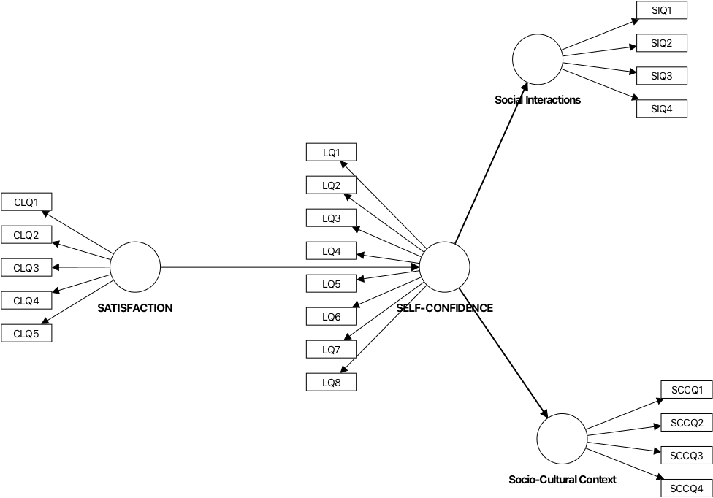
Figure 7- The Proposed Model

The study has important implications for educators and curriculum designers. Since self-confidence was found to influence both social interaction and socio-cultural engagement, instructors should design pair work activities that encourage peer support, constructive feedback, and collaborative problem-solving. Such practices can strengthen learners’ confidence and improve the quality of interaction in pair work settings. Future research should further investigate the mediating role of self-confidence using different educational contexts, larger and more diverse samples, and additional variables such as motivation, communication skills, or academic achievement. Longitudinal studies may also provide deeper insights into how self-confidence develops over time and influences learners’ collaborative learning experiences.

References

Baleghizadeh, S., & Farhesh, S. (2014). The Impact of Pair Work on EFL Learners’ Motivaion. NEXTESOL Journal, 38(3), 1–11.
Bandura, A. (1977). Self-efficacy: Toward a unifying theory of behavioral change. Psychological Review, 84(2), 191–215. https://doi.org/10.1037/0033-295X.84.2.191
Farxadovna, X. A. (2024). THE ROLE OF PEER INFLUENCE IN BUILDING SELF-CONFIDENCE AMONG STUDENTS. http://www.academicpublishers.org
Fornell, C., & Bookstein, F. L. (1982). Two Structural Equation Models:LISREL and PLS Applied to Consumer Exit-Voice Theory. Journal of Marketing Research, 19(4), 440–452.
Goodman, S. N. (1999). Toward Evidence-Based Medical Statistics. 2: The Bayes factor. Academia and Clinic, 130(12).
Hair, J. F. , Mathews, L. , M., Mathews, R. L., & Sarstedt, M. (2017). PLS-SEM or CB-SEM: updated guidelines on which method to use. International Journal of Multivariate Data Analysis, 1(2), 107–123.
Hair, J. F., Ringle, C. M., & Sarstedt, M. (2011). PLS-SEM: Indeed a Silver Bullet" . Journal of Mrketing Theory and Practices, 19(2), 139–152.
Hauf, S. , R. N. F. , S. M. , R. C. M. (2024). The Importance and Performance in PLS-SEM. Journal of Retailing and Consumer Services, 78(2024)(100723).
Järvenoja, H., Törmänen, T., Lehtoaho, E., Turunen, M., Suoraniemi, J., & Edwards, J. (2025). Investigating peer influence on collaborative group members’ motivation through the lens of socially shared regulation of learning. British Journal of Educational Psychology, 95(4), 1063–1079. https://doi.org/10.1111/bjep.12754
Rahman, S. U., & Golamgouse-Toraub, H. (2025). The impact of a think, write, pair, and share (TWPS) activity on pupils’ confidence, critical thinking, and understanding of mathematics lesson. Discover Education, 4(1). https://doi.org/10.1007/s44217-025-00852-5
Ramayah, T. , Cheak, F., Ting, H., & memon, M. A. (2018). Partial least Squares Structural Equation Modeling (PLS-SEM) using Smart PLS 3.0: An Updated Guide and practical guide to statistical analysis (2nd ed). . Pearson.
Ringe, C. M. , S. M. (2016). Gain more insights from your PLS-SEM results: The Importance-performance map analysis. . Industrial Management & Data System, 116(9), 1865–1886.
Ringle, C., & Sarstedt, M. (2015). Gain more insight from your PLS-SEM results:The importance-performance map analysis. Industrial Management & Data Systems, 119(9), 1865–1886.
Studnicka, K., Zarzycka, D., & Zalewski, J. (2023). Student satisfaction and self confidence in learning scale (SSCL)—reliability and validity test of the Polish version. Signa Vitae, 19(5), 104–111. https://doi.org/10.22514/sv.2023.069
Vygotsky, L. S. (1978). Mind in SOciety: The Development of higher psychological processes. Harvard University Press.
Ziegenfuss, J. Y., Easterday, C. A., Dinh, J. M., JaKa, M. M., Kottke, T. E., & Canterbury, M. (2021). Impact of demographic survey questions on response rate and measurement: A randomized experiment. Survey Practice, 14(1), 1–11. https://doi.org/10.29115/sp-2021-0010

APPENDIX

ROLE PLAY /ACTIVITY AND PAIR WORK
This instrument is adapted from Studnicka (2023) and Baleghizadeh & Farhesh (2014)

SECTION | VARIABLE | CONSTRUCT | ITEM
B | STUDENT SATISFACTION AND SELF-CONFIDENCE IN LEARNING  Studnicka (2023) | Satisfaction with Current Learning | 5 | 13
 |  | Self-Confidence in Learning | 8
C | PAIR WORK  Baleghizadeh & Farhesh (2014) | Social Interactions | 4 | 12
 |  | Knowledge Construction | 4
 |  | Social & Cultural Context | 4
 |  |  |  | 25

SECTION B- STUDENT SATISFACTION AND SELF-CONFIDENCE IN LEARNING (SSCL)
- Satisfaction with Current Learning (CL)

ITEM | 1 | 2 | 3 | 4 | 5
CLQ1 The methods used in this role play /activity were supportive and effective
CLQ2 The role play /activity provided me with a variety of educational materials and activities to promote my learning.
CLQ3 I liked the way my instructor taught me the role play /activity
CLQ4 The teaching materials used in this role play /activity were motivating and helped me learn.
CLQ5 The way my instructor taught the role play /activity was appropriate to my way of learning.

- Self-Confidence in Learning (L)

ITEM | 1 | 2 | 3 | 4 | 5
LQ1 I am confident that I am mastering the class role-play/activity presented to me by my instructors.
LQ2 I am confident that this role play/activity covered the essential content necessary to master the material covered in the curriculum.
LQ3 I am confident that I am developing the skills and gaining the required knowledge from this role play/activity to perform the necessary tasks in my course
LQ4 My instructors used a variety of helpful resources to teach this role play/activity
LQ5 It is my responsibility as a student to learn what I need during role play /activity classes.
LQ6 I know how to get help when I do not understand the concepts in the role play/activity.
LQ7 I know how to use role play exercises to learn the critical/key aspects of this course.
LQ8 It is the instructor’s responsibility to show me what I need to learn during the role play /acidity class.

SECTION C- PAIR WORK

- Social Interaction (SI)

ITEM | 1 | 2 | 3 | 4 | 5
SIQ1I like learning activities in which students work together in pairs
SIQ2 Pair work create a relaxing learning environment.
SIQ3 Students give more help to each other during pair work
SIQ4 I prefer to work within a pair rather than work alone.

- Knowledge Construction (KC)

ITEM | 1 | 2 | 3 | 4 | 5
KCQ1 Pair work help students solve tasks better and faster.
KCQ2 Pair work help students more chances to exchange ideas with each other.
KCQ3 Pair work help students understand information better after explaining it to others.
KCQ4 When pairs are well organized, the work gets done fast.

- Social and cultural context (SCC)

ITEM | 1 | 2 | 3 | 4 | 5
SCCQ1 Students learn more about how to share the responsibilities when working in pairs
SCCQ2 I feel more accepted by others after working within a pair
SCCQ3 It is important that each person takes responsibility for the learning as well.
SCCQ4 I never felt let down by when I work in pairs.

