AI-Powered Drainage Monitoring System Using Computer Vision And Iot Sensors For Proactive Flood Prevention

ABSTRACT
Flooding is one of the most significant results of urban drainage blockages; the impact is often property damage, health problems, or economic losses. Traditional manual inspections of urban drainage systems require several hours of labor at each location and frequently do not provide monitoring of obstructions in an efficient manner. The purpose of this study was to develop a fully AI-enabled drainage monitoring system to monitor urban drainage systems in real-time and proactively prevent urban flooding. The AI-Enabled Drainage Monitoring System was developed using a Raspberry Pi as the main processor, a USB webcam to acquire images of drainage conditions, an ultrasonic sensor for continuous monitoring of drainage systems, and a water level sensor to measure actual water levels in the drainage system. An AI-based image classification model (ICM) was created to classify drainage conditions as either clear, partially blocked, or fully blocked. A web-based dashboard using Flask provides real-time monitoring data, alert notifications, historical records, and weather forecasts; this dashboard allows Local Government Units (LGUs) to make more informed decisions and also provides selected historical data to the public to help increase public awareness of the importance of monitoring urban drainage systems. The study employed a developmental research design and the Agile Software Development Life Cycle (SDLC). Results indicate that the system can effectively detect drainage blockages and generate timely alerts, demonstrating a scalable and cost-effective solution for urban flood risk mitigation.
Keywords: AI-powered drainage monitoring, computer vision, IoT sensors, flood prevention, real-time monitoring, Raspberry Pi
INTRODUCTION
Urban drainage systems are essential for managing rainwater and protecting the surrounding area from environmental impacts. Solid waste can build up and prevent water from moving, creating localized flooding and damaging properties. Currently, traditional approaches to monitoring rely heavily on manual inspections that are time-consuming, costly, and do not respond to changing conditions quickly enough for effective disaster response. The development of IoT and AI technologies can change this situation. IoT sensors allow for continual collection of environmental data [1], while computer vision using AI can automatically identify physical objects in real time [2]. As demonstrated by existing studies on smart grate inlets, we have provided an example of how these technologies may be implemented to improve urban drainage systems.

[3] Integrating these technologies serves to heighten precision in monitoring and enable rapid action to be taken. Even though there have been significant advances in these technologies, most urban drainage networks are still not being monitored until a major failure happens. Without real-time visibility, local government agencies have no way of taking timely, preventive action. This research focuses on the development of an AI-powered monitoring system for drainage that will provide local governments with tools to reduce the risk of flooding through proactive measures. The system consists of a Raspberry Pi that collects information from ultrasonic and water level sensors to monitor hydrologic conditions and a USB camera for image-level identification of the drainage condition. A custom image-analysis model identifies whether a drainage is clear, partially blocked, or fully blocked. The data from these multiple sensors are combined with weather forecast information and backed by automated alerts in a single web-based dashboard that will assist local government units (LGUs) with necessary actionable information prior to potential flooding of their communities and help them manage their infrastructure effectively.

METHODOLOGY
This section outlines the methodology employed in developing the AI-Powered Drainage Monitoring System Using Computer Vision and IoT Sensors for Proactive Flood Prevention. It discusses the adoption of a developmental research design, the development and preparation of sensor and image datasets, as well as the application of the Agile Model through iterative development phases. Additionally, this chapter presents the system architecture, hardware and software specifications, and the tools and methods utilized during system design, implementation, and testing.
Research Design
This study employs a Developmental Research Design, as it is concerned with the design, development of a functional system. Developmental research is appropriate because the intent is to design and evaluate a technology-based solution to an increasingly prevalent real-world urban problem, particularly those factors contributing to blocked drainage systems, unresponsive urban flood management, and the absence of a systematic monitoring process for drainage infrastructure.
The Software Development Life Cycle (SDLC) provides a structured framework for developing the AI-Powered Drainage Monitoring System, guiding every stage of the development process from initial planning through continuous improvement. The SDLC model utilized in this study consists of multiple phases: Requirements Collection, Requirements Analysis, Design Development, Code Development, Testing and Verification, and System Maintenance. All phases of the SDLC model were followed in developing the key components of the system, such as the 10- to 30-minute monitoring cycle, drainage image capture, water level sensing, ultrasonic sensing, server-side data processing, database storage, and the web-based dashboard with automated alert notifications. Adhering to the SDLC model has enabled the researchers to organize development tasks systematically, verify system performance through structured testing, and continuously improve the system through maintenance based on observed results.

Requirements Collection
The researchers established the functional requirements necessary for the system's operation. These include the need for a scheduled monitoring cycle integrating both sensor and camera surveillance, the classification of drainage conditions into three categories — Clear, Partially Blocked, and Fully Blocked — and a structured web-based interface that allows authorized users to access real-time device status information and retrieve historical recorded data.

Analysis
The researchers analyzed the methods by which data would be collected from field-deployed instruments. This included defining the process by which data would be transmitted over a network connection through the server, and how the information would be interpreted and translated into usable drainage condition data. Furthermore, the researchers conducted an analysis of the required system inputs, the logic employed to classify drainage conditions, and the automated notification mechanism — whereby upon the detection of a blockage, users would receive an alert indicating a potential blockage along with any associated water level risk.

Designing
During the design phase of the system, the researchers defined the overall system architecture, encompassing the three operational layers — field, controller, and server — as well as the structure for storing image data, sensor readings, and their corresponding timestamps and location identifiers. Additionally, the researchers established the structural layout of the web-based dashboard, including the conditions and thresholds that determine when automated notifications would be triggered and delivered to users.

Coding
The researchers developed the code for each system component in accordance with the documented design plan. The implemented components included timer-based data collection from field-deployed instruments, data transmission to the server, processing of captured images and sensor data, and based on the processed image and sensor data the generation of drainage condition classifications, the insertion of corresponding classification results into the database, and the triggering of the necessary web-based dashboard notifications.

Testing
To validate that the system operates accurately, dependably, and consistently as intended, comprehensive testing was conducted across the entire monitoring platform. This included verifying that images captured by the imaging sensors were accurate, that sensor measurements were correct and free of errors, that data from the imaging sensors were properly transmitted to the server, that classification results were accurate, that information from the imaging sensors was properly stored in the database, and that dashboard users could intuitively navigate the interface and retrieve monitoring results with ease. Furthermore, the system demonstrated reliable generation of automated alerts at each monitoring cycle, confirming that the system is operationally sound and performs as designed.

Maintenance
System maintenance following deployment was centered on an iterative process aimed at continuously improving system performance based on actual monitoring data. To achieve this objective, the following tasks were completed: resolving issues identified during the monitoring process, enhancing sensor stability, improving the accuracy of image analysis and classification results, and calibrating threshold settings based on tested outcomes. Furthermore, modifications were applied to both the dashboard and the alerting system to facilitate more effective communication of monitoring results and to enhance the overall usability and reliability of the system.

Table 1. Dataset for AI-Powered Drainage Monitoring System
Image Filename | Timestamp | Location ID | Water Level(cm) | Ultrasonic Reading (cm) | Condition Label | Weather | Remarks
images/clear/LOC01_20251024_080000.jpg | 10/24/2025 8:00 | LOC01 | 3.5 | 10 | Clear | Sunny | Normal flow
images/partial/LOC01_20251024_090000.jpg | 10/24/2025 9:00 | LOC01 | 12 | 5 | Partially Blocked | Rain | Slow flow
images/blocked/LOC01_20251024_103000.jpg | 10/24/2025 10:30 | LOC01 | 26 | 0 | Blocked | Rain | Overflow

System Architecture
The AI-Powered Drainage Monitoring System detects blockage conditions and flood risks through the analysis of surface drainage images and data collected from field-deployed sensors. Surface drainage images are classified into the following conditions: Clear, Partially Blocked, and Fully Blocked. Water level and ultrasonic sensor measurements are collected and integrated to provide a more accurate interpretation of the overall drainage status.

Figure 1. The System Architecture of the Proposed System
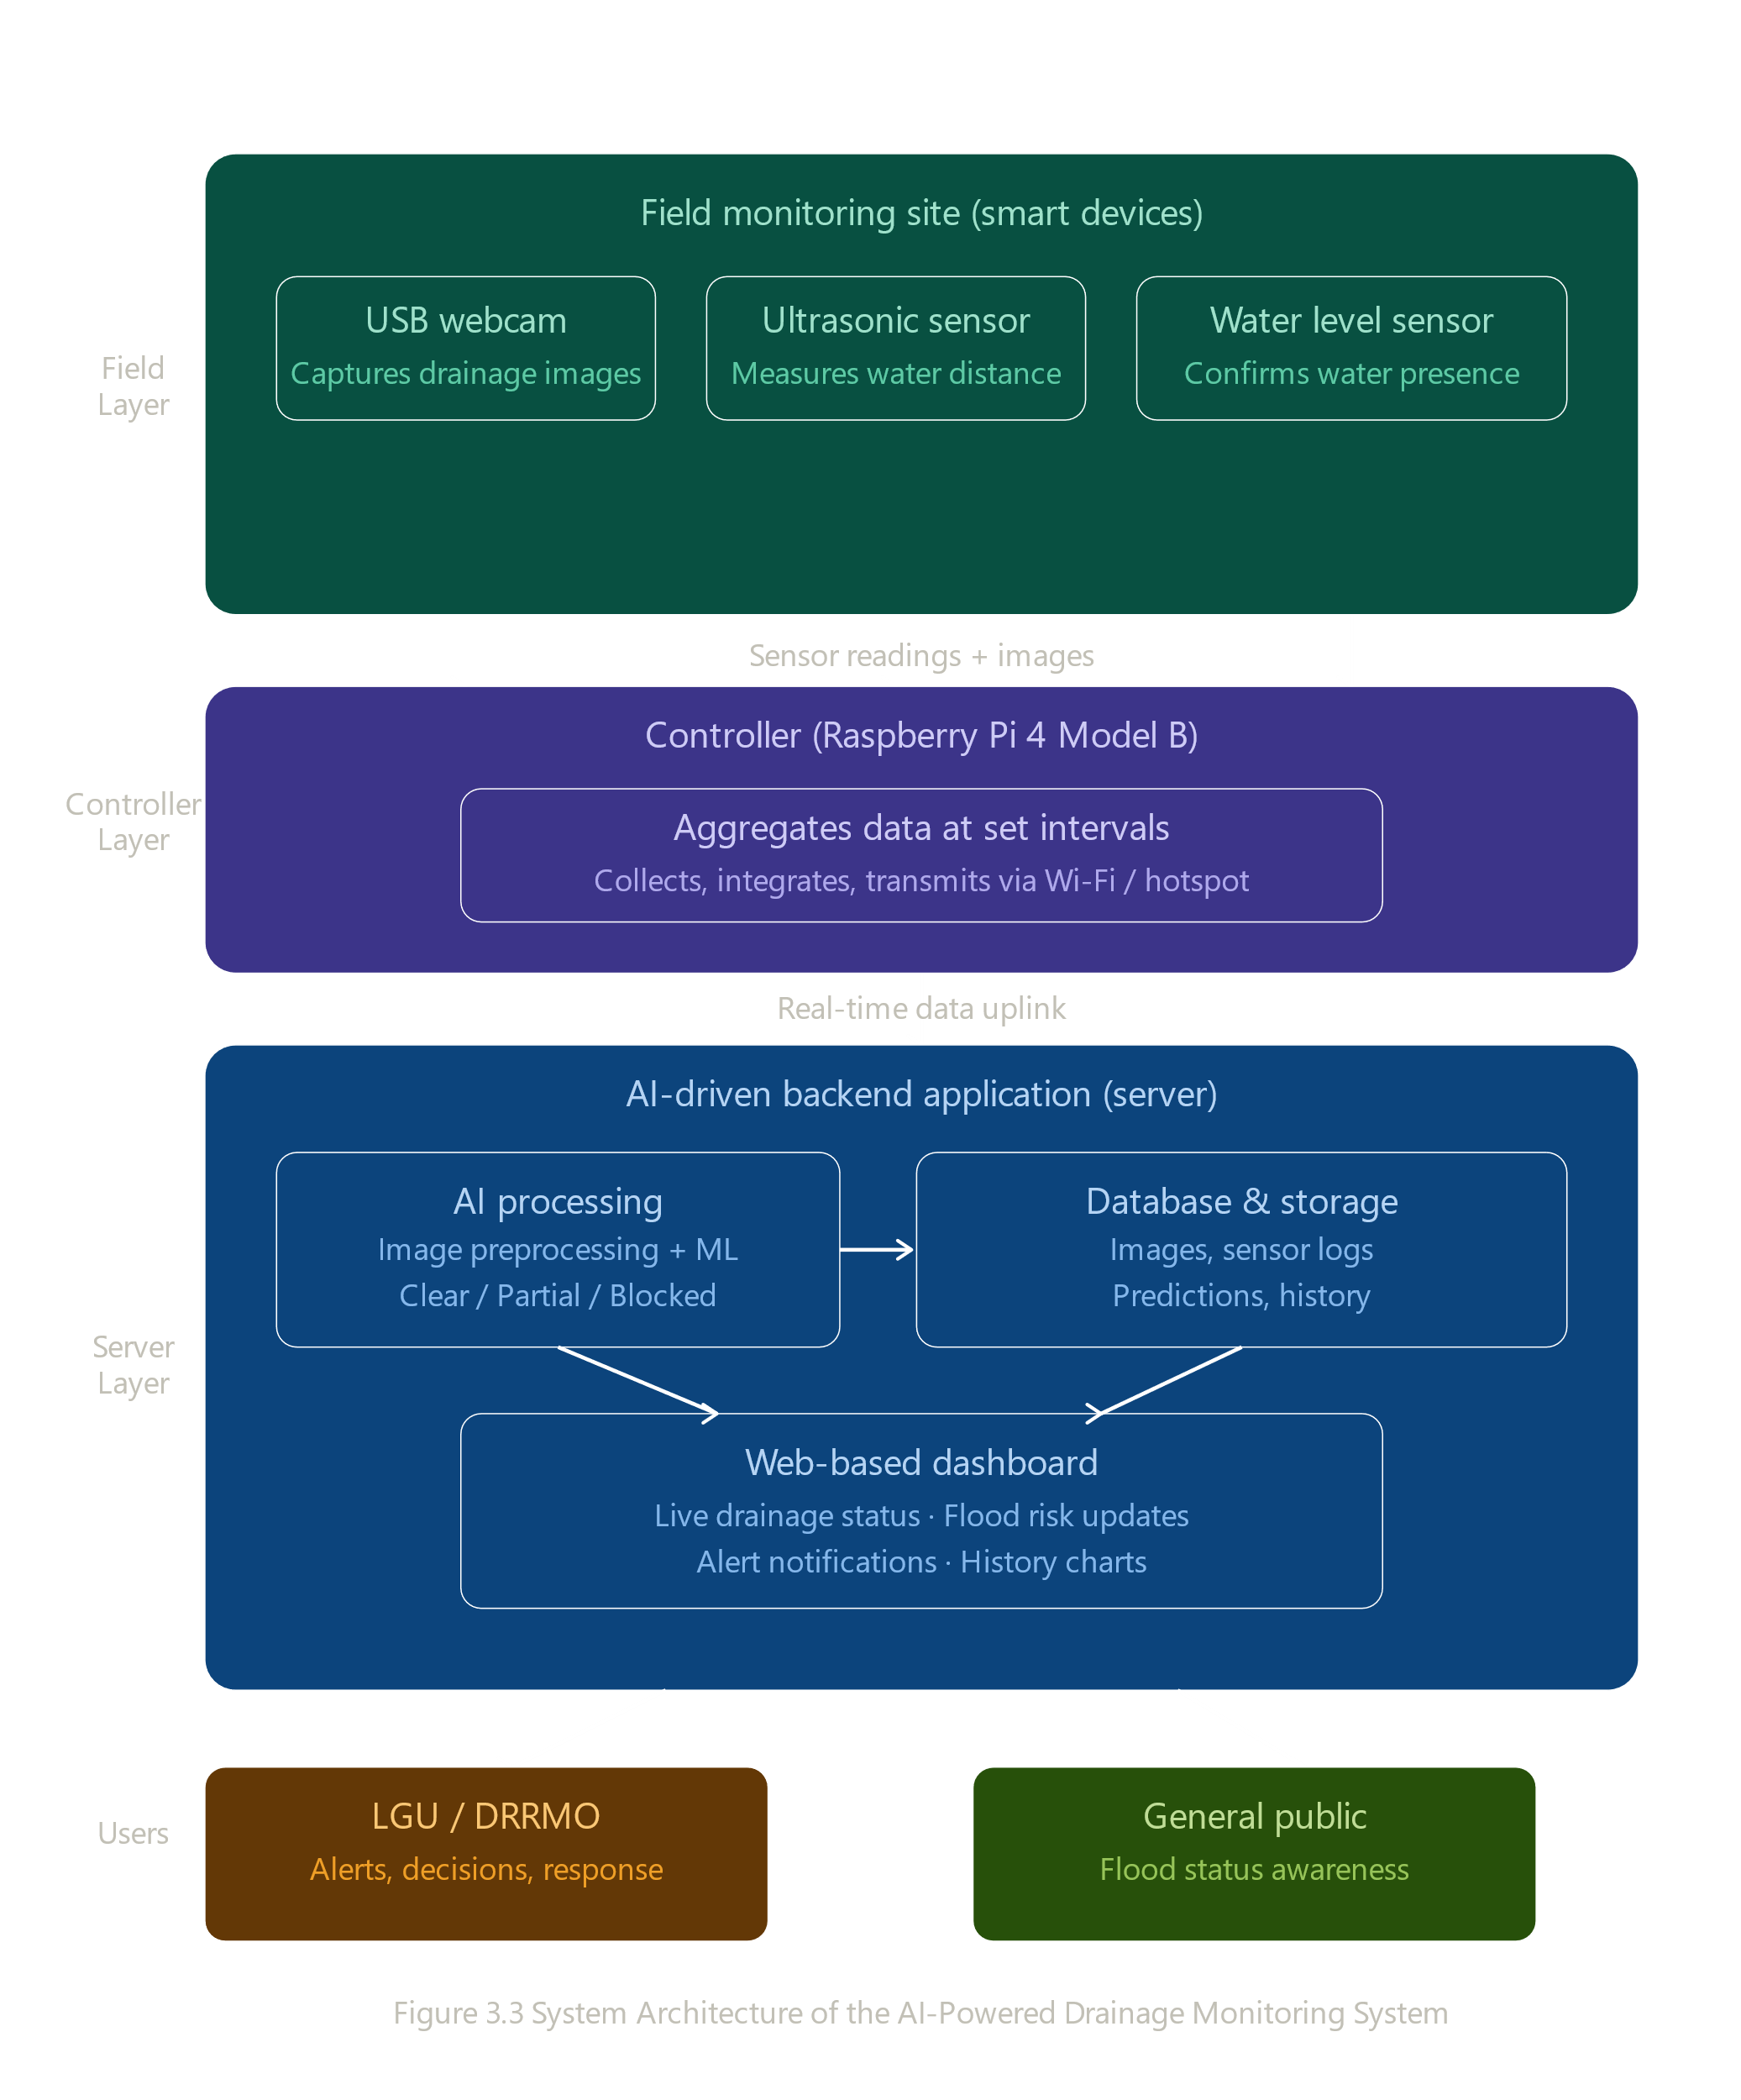
The architecture consists of three layers: the Field Layer, the Controller Layer, and the Server Layer. The Field Layer comprises a USB camera for capturing images of the drainage area, along with a water level sensor and an ultrasonic sensor. The Controller Layer aggregates the data at regular intervals and transmits it to the server via an established network connection. The Server Layer receives the captured images and sensor readings and processes them through data processing and machine learning algorithms to determine the drainage condition.

Methods and Tools
This section outlines the methods and tools utilized during the design, development, and testing phases of the proposed system. Flowcharts were utilized to illustrate the operational workflow, providing a clear visualization of the sequence of processes, decision points, and system interactions. Data Flow Diagrams (DFDs) were used to represent the movement of data within the system, highlighting how information is collected, processed, and transmitted across different components. In addition, Entity Relationship Diagrams (ERDs) were developed to depict the structural design of the database, including the relationships between data entities and attributes.
The data acquisition process begins with the USB webcam capturing real-time images of the drainage environment. Simultaneously, the ultrasonic sensor estimates the water level by measuring distance, while the water level sensor confirms the presence of water within the drainage area. The collected image and sensor data are then transmitted to the Raspberry Pi, which serves as the central processing and integration unit of the system.
After preprocessing, the system performs AI-based analysis to classify the drainage condition as clear, partially blocked, or fully blocked. The classification results are further validated using sensor data to ensure accuracy and reliability. Based on the validated results, the system determines the corresponding flood risk level. If a critical condition is identified, the system generates an alert and transmits the information to the monitoring system and web dashboard.
Methods

To provide a clearer understanding of the proposed system’s operational workflow, the researchers present the process diagrams of the AI-Powered Drainage Monitoring System. These diagrams illustrate the processes involved in data acquisition, AI-based analysis, and system response for real-time drainage monitoring and flood risk prevention.

Figure 2. AI-Powered Drainage Acquisition

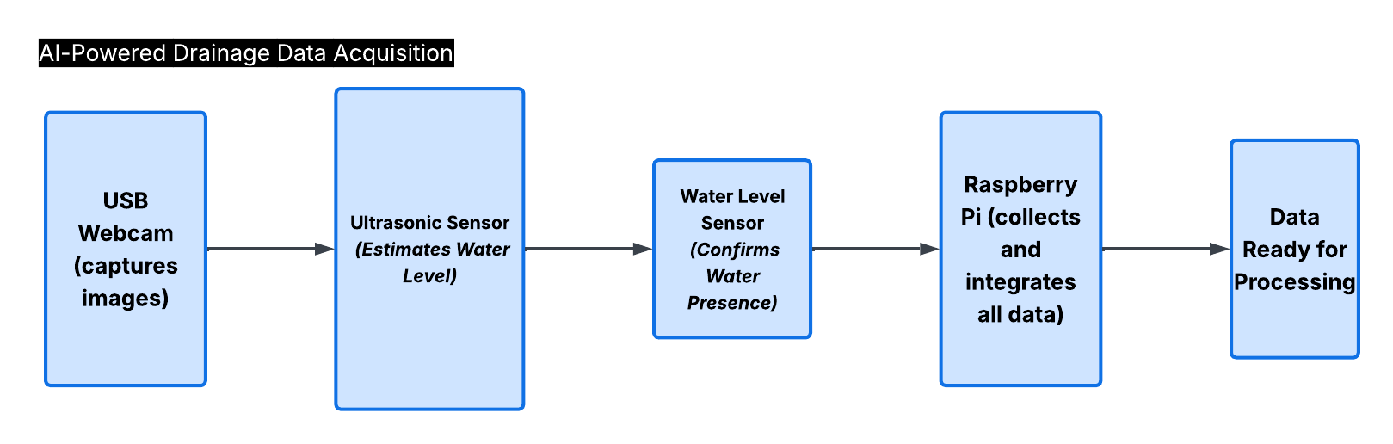
Figure 2 illustrates the data acquisition process of the proposed AI-Powered Drainage Monitoring System. The process begins with the USB webcam capturing real-time images of the drainage environment. Simultaneously, the ultrasonic sensor estimates the water level by measuring distance, while the water level sensor confirms the presence of water within the drainage area. The collected image and sensor data are then transmitted to the Raspberry Pi, which serves as the central processing and integration unit of the system. After integration, the gathered data becomes ready for further processing and AI-based analysis.
Figure 3. AI-Powered Drainage Detection & Analysis
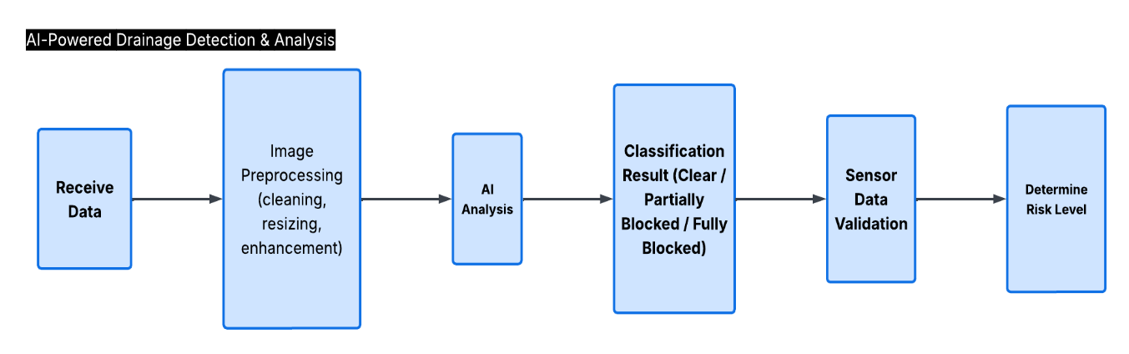
Figure 3 illustrates the AI-powered drainage detection and analysis process of the proposed system. The process begins with receiving integrated image and sensor data collected during the data acquisition phase. The captured images then undergo preprocessing techniques such as cleaning, resizing, and enhancement to improve image quality for analysis. After preprocessing, the system performs AI-based analysis to classify the drainage condition as clear, partially blocked, or fully blocked. The classification results are further validated using sensor data to ensure accuracy and reliability. Based on the validated results, the system determines the corresponding flood risk level for monitoring and response purposes.
Figure 4. AI-Powered Drainage Detection & Analysis
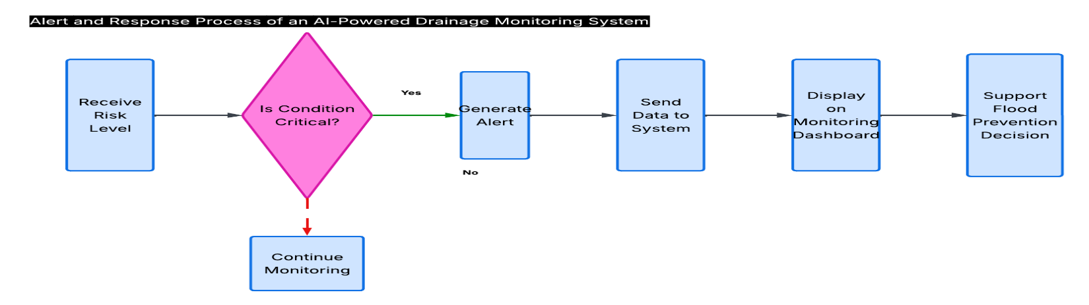
Figure 4 illustrates the alert and response process of the proposed AI-Powered Drainage Monitoring System. After the system receives the assessed risk level, it determines whether the detected condition is critical. If a critical condition is identified, the system generates an alert and transmits the information to the monitoring system. The processed data is then displayed on the monitoring dashboard to support real-time monitoring and flood prevention efforts. If no critical condition is detected, the system continues monitoring the drainage environment for further analysis.
RESULTS AND DISCUSSION
Overview of System Testing
The findings from testing and assessing the AI-Powered Drainage Monitoring System Using Computer Vision and IoT Sensors for Proactive Flood Prevention are outlined herein. This system was tested on May 16, 2026, through a web-based local dashboard at the system's local server address. Testing and evaluation were performed on three main components of the system: the IoT Sensor Module, the AI-based Camera Classification Module, and the Integrated Weather Forecast Module. The results for all of these components are presented in reference to the main objective of providing proactive flood prevention in real-time.
IoT Sensor Performance and Water Level Monitoring
The Ultrasonic sensor and a water level sensor are used in an Internet of Things (IoT) sensor module that has gone through various test cycles with different monitoring periods. The ultrasonic sensor measures the distance from the sensor to the top of the water while the water level sensor monitors the water depth in cm. Figure 5 below lists all of the data collected on the Admin Dashboard that provide a summary of the results recorded by the administrator during the test.
Figure 5. AI-Powered Drainage Monitoring System — Admin Dashboard
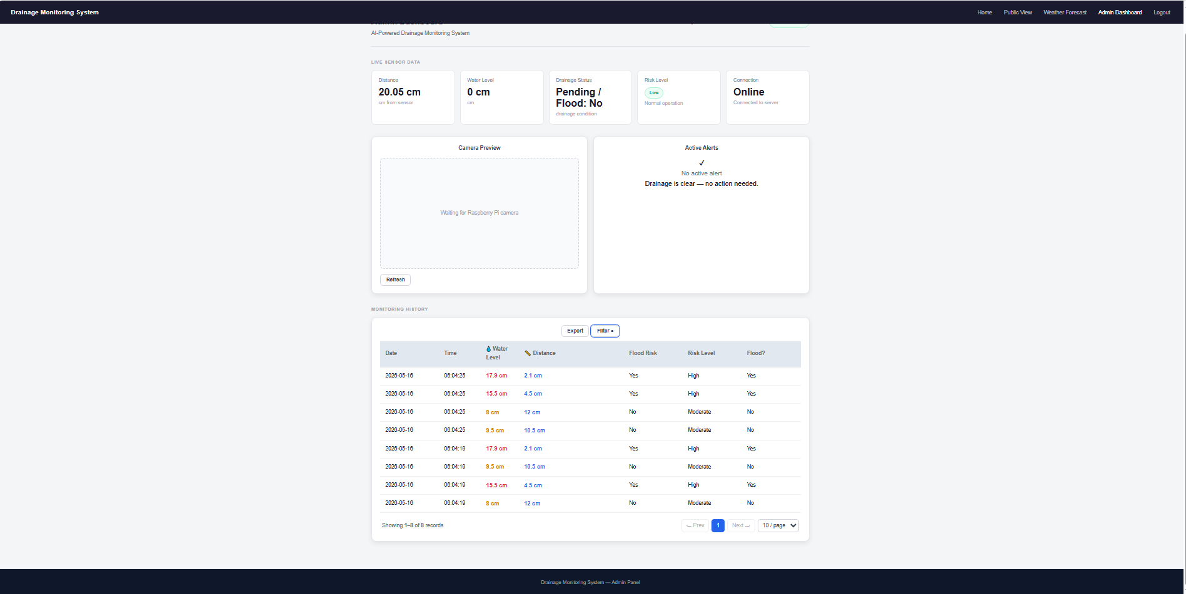
The Admin Dashboard of the AI-Based Drainage Monitoring System is shown in Figure 5 based on the results of the trial held on May 16, 2026. The header of the dashboard shows five status indicators: the current sensor distance reading is 20.05 cm, there was no water present at that time (0 cm), the current drainage status is pending with no flooding issues, the risk level currently reported is low with normal operation, and the connection status indicates that the monitoring system has a live connection to the server. There is no display from the camera at this moment (the camera preview panel is waiting for information to be received from the Raspberry Pi camera), but there is an active alerts panel that indicates "Drainage is clear; need to take no action" at the time this picture was taken. At the bottom of the dashboard is the Monitoring History section, which displays eight entries from two monitoring cycles taken at 06:04:19 and 06:04:25. Water levels at 17.9 centimeters and 15.5 centimeters (ultrasonic distances of 2.1 centimeters and 4.5 centimeters, respectively) are flagged by high-risk entries with confirmed flood activity occurring at that site. Water levels of 8.0 centimeters and 9.5 centimeters (ultrasonic distances of 12.0 centimeters and 10.5 centimeters, respectively) are classified as moderate-risk entries with no detection of flooding occurring during the entire monitoring period. Users who have access to the dashboard can use the Export and Filter controls located on the dashboard to administer and/or obtain any historical monitoring report as required.
AI-Based Camera Classification Results
By analyzing the pictures taken by the USB webcam, the computer vision module of the detection system was able to classify drainage conditions. The AI model could classify the drain conditions as either Clear, Partially Blocked, or Blocked and further categorize each based upon risk level (Low for Clear, Moderate for Partially Blocked, and High for Blocked). The results of the camera classification are shown in Figure 6 as recorded in the system's monitoring log.
Figure 6. AI Camera Classification Results — Drainage Condition Monitoring Log
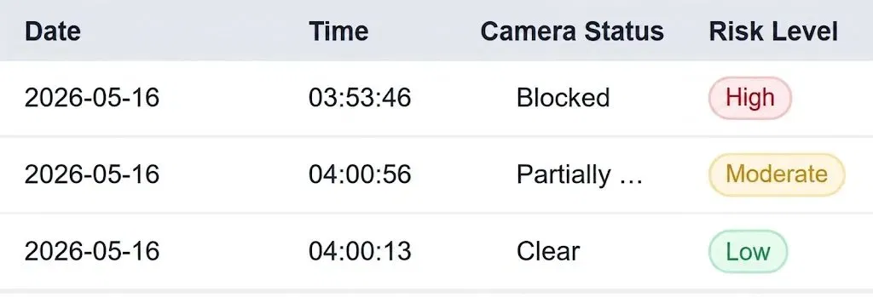
The AI-based camera classifier's results for the monitoring of drainage conditions on May 16th, 2026, contain three recorded instances for various classifications of drainage conditions, as determined by the system. The Drainage Condition Monitoring Log's first entry (03:53:46) depicts that the camera is blocked and poses an immediate flood risk (red badge) to the drainage infrastructure; therefore, the drainage infrastructure must be attended to immediately, as it is completely blocked. The Drainage Condition Monitoring Log's second entry (04:00:56) depicts that it is in a state of partial blockage and presents a moderate risk to the drainage infrastructure (yellow badge). Thus, at this time, the camera was deemed to warrant preventive maintenance on the drainage infrastructure.
Entry number three shows a drainage system, which has a camera that was free of blockage and is currently operational, while showing a green color coding (providing a low-risk score). Entry number three also indicates that at this time, there were no obstructions existing within the drainage system. All of the above-mentioned color indicators give the ability to easily provide fast weather identification confirmation to users regardless of their technical skills (e.g., local governmental organizations and non-technical users), so multiple people can quickly see the condition of the drainage systems via the cameras in a one-shot view. Each of the three entries proved that the computer vision function of the complete model accurately and consistently scored appropriately in determining the blockage status in drainage systems.

Figure 7. Weather Parameters Recorded by the Weather Forecast Module
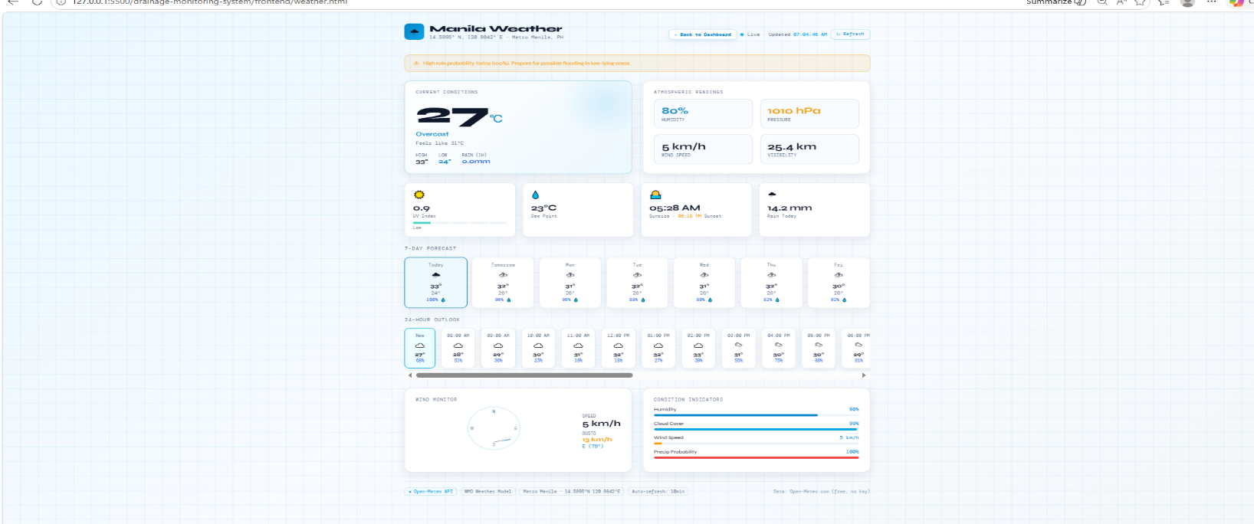Figure 7 shows the real time weather data that was gathered by the incorporated weather forecasting module of this system for Metro Manila, Philippines. At 00:33:37 local time May 16 2026, an alert was displayed by the module and this warns users to take proper action against the threat of flood impact at low-lying areas and that there is 100% of rain on the given day. Given, ambient temp is 26 C, wind chill is 31 C, relative humidity is 84%, atmospheric pressure is 1010 hPa, wind speed is 5 km/hr and percentage of cloud cover is 90%. This data displays a very humid atmosphere and indicates a possible start of the tropical wet season for Manila.

The data recorded on test day indicates that significant rain had already fallen earlier on, and that the drainage system was already operating at elevated levels. This is confirmed by the 14.2 mm precipitation recorded to date on test day, and the 23 C dew point, indicating high humidity. This dew point suggests a further high chance of ongoing rain, even over the 7-day forecast (e.g., daily rain probabilities between 88 and 100% are likely to be sustained throughout the forecast period). Sustained high temperatures (between 27-33 C) and the likely sustained high cloud cover (88-100% cloud cover likely to be sustained throughout forecast period), suggest it is possible to maintain the high levels and flood risk classification. Therefore, it is possible that the weather forecast module can supply additional information concerning the environmental situation, to allow for better predictions about actual drainage conditions, and to make better informed decisions concerning flood preventative measures.

Weather Forecast Module Performance
Weather forecasting module retrieved local weather data (14.5995 °N, 120.9842 °E) for Metro Manila, Philippines from system's built-in weather monitoring page. All relevant atmospheric data were collected at 12:32:37 AM on 16 May 2026 and included floods' risk assessment information. Weather parameters sourced during test were summarized in Figure 7.

Overall System Dashboard Performance
The Admin Dashboard, a web app, proved to be reliably operational during the time it was tested. Connected to the system and receiving live updates, the Dashboard provided evidence that communication had occurred among the sensors in the field, the Raspberry Pi controller, and the server. The distance measured from the sensor was 20.05 cm, and the water level was 0 cm in the current monitoring session. The dashboard snapshot you see was taken at a time when the drainage was still pending but not flooding, and the risk levels were low, meaning that it was safe to drain water in the area of the screenshot image and that there was currently no risk of flooding at that time.
Authorized users may access the Monitoring History tab on the Dashboard for a review of prior Monitoring Records, Filter Applications, and Data Import/Export capabilities; therefore, offering users a complete, simple user experience for managing their drainage condition. The Alert Panel will accurately display "No Active Alert" and "Drainage Clear - No Action Required" while viewing the Clear Condition and will transition to Active Alert notification upon Blocked Condition or High-Water Condition events. Collectively, these features demonstrate that the AI-Powered Drainage Monitoring System provides an effective, integrated and proactive tool for preventing urban flooding.

Discussion
System testing results have confirmed that the AI-Powered Drainage Monitoring System meets all initial objectives for successful operation: real-time monitoring of drainage conditions, automated classification of flood risk, and timely notification of potentially dangerous situations. The ultrasonic water level sensing module accurately detects multiple water depths and classifies the risk level of water depth in the same structure as found in the system design phase. The AI camera classification module can accurately classify drainage conditions into three categories (Clear, Partially Blocked, Blocked), and provide appropriate functionality according to each classification.
Additionally, the integration of a live weather forecast module to the system further enhances the flood prevention capability of this system by providing environmental context to augment sensor and image data. The 100% probability of rain and 14.2 mm of rainfall during testing were directly correlated to High flood risk classification and the active flooding determined by the sensor module. Therefore, the results of this test indicate that using multiple sources of data in combination with one another significantly benefits the accuracy and reliability of flood risk assessment information.
The findings are in agreement with other studies that noted the combined AI, computer vision, and IoT methods offer the best way to enhance drainage monitor and early warning systems for floods. This study provided a new addition to that body of work by creating a unified system utilizing visual blockage detection, real-time sensor readouts, automated notification alerts, and weather-based flood predictions all being delivered through an accessible web-based platform. The results from testing the system in a local application area indicate that this system could also be used in other urban drainage areas if additional testing confirms its viability under the limits documented.
CONCLUSION
This study successfully developed and validated an AI-powered drainage monitoring system to provide real-time, proactive flood prevention through computer vision and IoT measurements to overcome the limitations of traditional manual inspections of the drainage system. Testing of the system took place on May 16, 2026, with all three main goals being met in full.
The image classification (AI) portion of the system was capable of classifying the condition of the drainage system under test into three categories: Clear, Partially Blocked, or Blocked according to low, moderate, and high levels of risk; all test entries were correctly classified. The IoT sensor provides additional information about drainage systems through two types of sensors: ultrasonic and water level sensors. It provides real-time measurements to the drainage system manager and correctly identifies high-risk conditions at water levels of 15.5-17.9 cm and moderate-risk conditions at water levels of 8.0-9.5 cm. The Flask-based admin dashboard successfully combined the three components of the AI-powered drainage monitoring system into one platform, allowing the user to access the data in real-time using live visualizations of the sensors, receive notifications of automated alerts, review monitoring history, and export or filter the data to allow the local government unit to make informed investment decisions.
functionalities, by integrating atmospheric real-time data such as: a 100% chance of rain, an average of 14.2 mm of rain per weather forecast, and a relative humidity of 84%. The atmospheric condition data directly correlated with High-Risk Sensor Classes for the same testing period. The overall system is a viable solution for urban flood monitoring, both in terms of cost and scalability. This technology is highly applicable for larger-scale implementation to help reduce the risk of flooding in urban areas and improve community resilience.
RECOMMENDATIONS
Based on the findings and limitations identified during the development and testing of the system, the following recommendations are presented for future researchers and developers who may extend or build upon this work:
Field Deployment in Actual Drainage Infrastructure
Future studies should deploy the system in real urban drainage sites to validate performance under actual environmental conditions, including water turbulence, varying debris types, outdoor lighting, and weather exposure. Field testing will provide more representative data on system accuracy and hardware durability, and will help identify additional improvements needed for large-scale deployment.

Expansion of the AI Training Dataset
The AI classification model's performance can be further improved by training it on a larger and more diverse image dataset that includes drainage conditions captured under different lighting environments, times of day, drainage sizes, and types of blockage materials. A richer training dataset will improve model robustness and ensure reliable classification across varied real-world scenarios.
Integration of SMS and Email Alert Notifications
While the current system delivers alerts through the web dashboard, future development should incorporate automated SMS or email notifications to immediately inform concerned LGU authorities and stakeholders when a critical drainage condition is detected. This is particularly important for areas where dashboard access may be limited or delayed during emergency situations.
Addition of Supplementary Sensors
Future versions of the system may benefit from the inclusion of additional sensors such as flow rate sensors, turbidity sensors for water quality monitoring, or hazardous gas detectors for drainage safety assessment. These additions would provide a more comprehensive and accurate picture of overall drainage health beyond water level and visual blockage detection.
Weatherproofing and Outdoor Hardware Enclosure
For sustained real-world deployment, all hardware components including the USB camera, ultrasonic sensor, water level sensor, and Raspberry Pi must be housed in weather-resistant and waterproof enclosures. This is essential to ensure reliable operation in outdoor drainage environments subject to continuous rain, high humidity, and potential submersion.
Scalability to Multiple Monitoring Locations
The system architecture should be further developed to support simultaneous monitoring from multiple drainage sites, with all data transmitted to a centralized dashboard. This would enable city-wide drainage condition management, allowing LGUs to prioritize maintenance and emergency response resources more efficiently across different urban areas.
Long-Term Deployment and Performance Evaluation
A sustained deployment study spanning at least one full rainy season is recommended to assess the system's long-term reliability, maintenance requirements, and actual impact on flood prevention response times. Long-term data will also provide a broader basis for refining the AI model and improving the weather forecast module's flood risk predictions.
ACKNOWLEDGEMENT
The researchers would like to express their sincere gratitude to everyone who contributed to the completion of this study entitled AI-Powered Drainage Monitoring System Using Computer Vision and IoT Sensors for Proactive Flood Prevention.

First and foremost, the researchers thank Almighty God for providing guidance, strength, wisdom, and perseverance throughout the conduct of this study.

The research team wishes to thank both Vivien Agustin Research Advisor and Ronald Fernandez Head of the IT Department for their kind guidance, helpful recommendations, and support in completing this research project; these contributions have helped the researchers achieve significant gains in knowledge during this time.
Special thanks are also given to their groupmates and classmates for their unwavering collaboration, dedication, and teamwork throughout the entire development of the system. Their shared commitment to the project, willingness to contribute ideas, and support during the most challenging phases of the study played a significant role in bringing this research to completion.

The researchers are deeply grateful to their families and friends whose unconditional love, encouragement, and patience served as their greatest source of strength and motivation throughout the entire journey of this study.
Finally, the Researchers express their sincere appreciation to everyone who helped in any manner to get financing for the completion of this research. Individual assistance may appear insignificant to you, but it is essential to the Researchers and is much appreciated by them all.

REFERENCES
- Abalos, M. S., & Fajardo, A. C. (2023). IoT-based flood detection, alarm and monitoring system using multilayer perceptron and regression. International Journal of Multidisciplinary Research and Analysis, 6(7).
https://ijmra.in/v6i7/Doc/16.pdf
- Abella, A. P. N., & Enriquez, M. D. (2024). Community-based flood alert system using long-range technology for Brgy. San Agustin, San Jose, Occidental Mindoro. Mindoro Journal of Social Sciences and Development Studies, 1(2), 27–34.
https://journal.omsc.edu.ph/index.php/mjssds/article/view/10
- Arante, H., Sybingco, E., Roque, M. A. C., Ambata, L., Chua, A. K. C., & Gutierrez, A. N. (2025). Development of a secured IoT-based flood monitoring and forecasting system using genetic-algorithm-based neuro-fuzzy network. Sensors, 25(13).
https://doi.org/10.3390/s25133885
- Arshad, B., Ogie, R. I., Barthelemy, J., Pradhan, B., Verstaevel, N., & Perez, P. (2019). Computer vision and IoT-based sensors in flood monitoring and mapping: A systematic review. Sensors, 19(22), 5012.
https://doi.org/10.3390/S19225012
- Calapini, W. D., Tan, F. J., Monjardin, C. E. F., & Gacu, J. G. (2025). Geospatial analysis of flood hazard using GIS-based hydrologic–hydraulic modeling: A case of the Cagayan River Basin, Philippines. Geomatics, 5(4), 845–864.
https://doi.org/10.3390/geomatics5040064
- Chettri, P., Tomy, A., Mandal, R., & Choudhury, N. (2024). Early prediction of urban flood using ML and IoT. In Studies in autonomic, data-driven and industrial computing (pp. 187–200). https://doi.org/10.1007/978-981-99-5435-3_13
- Dabas, R., Imam, T. S., Safwat, F., Rizwan, S. M., & Alam, K. (2025). Smart drainage system for urban flood prevention. International Journal of Civil, Environmental and Agricultural Engineering, 1–7. https://doi.org/10.34256/ijceae2511
- Diamse, M. J., Frasco, J. N., Nogra, B., Venasquez, T., & Araña, J. M. P. (2023). A design of IoT-based capture efficiency monitoring and alert system for storm grate inlets through LoRaWAN. https://doi.org/10.1109/hnicem60674.2023.10589262
- Duncan, A., Keedwell, E., Djordjevic, S., & Savic, D. (2013). Machine learning-based early warning system for urban flood management.
- Magbanua, M. B., & Sison, A. M. (2023). IoT-based flood detection, alarm and monitoring system using multilayer perceptron and regression. Journal of Engineering and Computer Technology, 12(1). https://isujournals.ph/index.php/ject/article/view/207
- Nakada, T., Kichise, H., & KIRI, H. (2025). Practical feasibility of AI image analysis and digital twins for remote management of drainage pump stations and agricultural canal gates. E-Journal of Nondestructive Testing, 30(10).
https://doi.org/10.58286/31723
- Oñate, J. J., Omorog, C. D., Onesa, R. O., Fortuno, K. M. N., & Benosa, B. (2023). Project Apaw: Spatiotemporal forecasting of river flood using deep learning. https://doi.org/10.1109/hnicem60674.2023.10589082
- Pahuriray, A. V., & Cerna, P. D. (2025). IoT-enabled flood monitoring and early warning systems: A systematic review. International Journal of Computer Science and Mobile Computing, 14(4), 50–67. https://doi.org/10.47760/ijcsmc.2025.v14i04.005
- Panfilova, T., Kukartsev, V., Tynchenko, V., Tynchenko, Y., Kukartseva, O., Kleshko, I., Wu, X., & Malashin, I. (2024). Flood susceptibility assessment in urban areas via deep neural network approach. Sustainability, 16(17), 7489.
https://doi.org/10.3390/su16177489
- Parilla, R. A. G., Leorna, O. J. C., Attos, R. D. P., Palconit, M. G. B., & Obiso, J. A. (2020). Low-cost garbage level monitoring system in drainages using internet of things in the Philippines. Mindanao Journal of Science and Technology, 18(1)
https://mjst.ustp.edu.ph/index.php/mjst/article/view/2501
- Philippine Information Agency. (2022, June 20). DOST pushes science, data-powered modern flood management.
https://pia.gov.ph/
- Ramos, K. A., Toledo, M., & Cruz, F. R. G. (2025). Flood levels and trash detection: Integrating sensors with support vector machines and YOLOv8.
https://doi.org/10.1109/i2cacis65476.2025.11101566
- Sarmiento, P. J. D. (2022). Disaster preparedness and resiliency of the community in the Philippines. Asia Pacific Higher Education Research Journal, 8(2). https://po.pnuresearchportal.org/ejournal/index.php/apherj/article/view/433
- Selvam, D. P., Reddy, G. G., & Kumar, N. M. (2020). Designing a smart and safe drainage system using artificial intelligence. International Journal of Engineering Research and Technology, 9(11).
- Suheb, S. S., Soni, S., Saravanan, P., Pandian, M. T., & Berlin, M. A. (2023). IoT-based smart drain monitoring system with real-time alert messages and data analysis. https://doi.org/10.1109/icimia60377.2023.10426169
- Te, M. C. L., Bautista, J. A. T., Dimacali, S. M. E. V., Lood, A. V. M., Pangan, M. G. M., & Chua, A. Y. (2024). A smart IoT urban flood monitoring system using a high-performance pressure sensor with LoRaWAN. HighTech and Innovation Journal, 5(4), 918–936. https://hightechjournal.org/index.php/HIJ/article/view/929
- Thanigaivelu, P. S., Sairam, A. S., Vijayan, P., Kumar, A. S., Mohankumar, N., & GaneshBabu, T. R. (2024). Revolutionizing urban drainage: A smart IoT approach to stormwater management using AdaBoosting algorithm.
https://doi.org/10.1109/amathe61652.2024.10582217
- UP Diliman College of Science. (2024, April 13). UP scientists develop advanced impact-based flood forecasting systems.
https://science.upd.edu.ph/up-scientists-develop
- UP Resilience Institute. (2023). From streets to screens: Real-time flood and rainfall monitoring through IoT-based sensors. University of the Philippines.
https://resilience.up.edu.ph/from-streets-to-screens-real-time-flood
- Veerappan, S. (n.d.). Edge-enabled smart storm water drainage systems: A real-time analytics framework for urban flood management.
https://aasrresearch.com/index.php/JSIES/article/view/28

