Stitching and Printing Ghana’s Past: Exploring Historical Narratives through Textile Design

Abstract
This study examines how embroidery, appliqué, and textile printing can serve as visual storytelling techniques for representing and preserving aspects of Ghana’s history. Although Ghana’s historical experiences and cultural heritage are conventionally transmitted through oral tradition and written record, this study explores textile art as an additional medium for translating historical narrative into visual and tactile form. Adopting a practice-based qualitative design, the researcher produced three textile artworks addressing the Akwaaba symbol of hospitality, the transatlantic slave trade at Cape Coast Castle, and Ghana’s struggle for independence, using embroidery, appliqué, and screen-printing techniques on cotton fabric. The creative process was documented through sketches, photographs, and reflective notes, and the completed works were analysed for their capacity to communicate historical and cultural meaning. The findings indicate that embroidery contributes texture, intimacy, and emotional depth to historical representation, while printing supports broader compositional and symbolic narrative. Together, the two techniques produce textile artworks that function as visual archives of collective memory. The study concludes that textile art offers a viable, under-used medium for historical education and cultural preservation in the Ghanaian context.
Keywords: Embroidery, Appliqué, Textile Printing, Historical Narratives, Ghanaian Heritage, Visual Storytelling.

1. Introduction
Textiles have long functioned as cultural documents, carrying the histories, values, and identities of the societies that produce them. Across Africa, and in Ghana in particular, textile traditions such as Kente and Adinkra encode philosophical ideas, historical reference, and social commentary through colour, pattern, and symbol, illustrating how a society’s deepest values become embedded in everyday material culture (Geertz, 1973), and offering a form of collective memory that is read and re-read across generations (Boateng, 2011).
Embroidery, appliqué, and printing extend this archival function by using the needle, the screen, and the dye to fix narrative content directly onto cloth. Embroidery decorates fabric with a needle and thread, producing textured, raised imagery through stitches such as the satin stitch, the long and short stitch, and the running stitch. Appliqué builds an image by attaching cut pieces of fabric onto a base cloth, while textile printing transfers colour onto fabric through a stencil, block, or screen to reproduce a design across a surface. Used separately, each technique communicates differently; used together, as in the present study, they allow a single piece of cloth to combine the intimacy of hand-stitched detail with the broader compositional reach of print.
The concept of the archive is usually associated with paper, photographs, and institutional collections. This study treats cloth itself as an archival surface, capable of recording memory, identity, and historical experience through deliberate stitching and printing rather than through writing. As Ghanaian society continues to change under the pressures of globalisation, urbanisation, and shifting cultural practice, there is a growing need for accessible, visually engaging means of documenting both historical experience and contemporary identity. This study responds to that need by translating three themes from Ghana’s past, the Akwaaba symbol of hospitality, the transatlantic slave trade at Cape Coast Castle, and the country’s struggle for independence, into embroidered, appliquéd, and printed textile artworks.

1.1 Statement of the Problem
Ghana’s history has traditionally been preserved through oral tradition, written record, and cultural artefact, but the pace of modernisation and the dominance of digital media have weakened the transmission of historical knowledge, particularly among younger generations. Textile art, despite its long history as a medium of communication and cultural expression in Ghana, remains under-used as a tool for historical storytelling. Existing textile production is overwhelmingly oriented towards fashion, décor, and commerce, and comparatively little practice-based or scholarly work investigates how embroidery and printing might be combined deliberately to interpret and represent specific historical events and experiences. This gap limits the contribution that textile artists could otherwise make to heritage preservation and historical education, and it is the gap this study addresses.

1.2 Objectives of the Study
This study pursues three objectives, namely:
1. to identify historical events, cultural symbols, and national heritage elements that can be represented through textile art;
2. to examine the aesthetic and communicative potential of embroidery, appliqué, and printing techniques in visual storytelling; and
3. to design and produce textile artworks that depict selected historical narratives of Ghana using embroidery, appliqué, and printing methods.

2. Literature Review and Theoretical Framework

2.1 Textile Printing and Embroidery in Context
Textile printing applies colour to fabric in a controlled pattern rather than across the whole cloth, as happens in dyeing, and has historically been achieved through carved wooden blocks, engraved rollers, and stencils, and more recently through photo-emulsion screens and digital inkjet systems (Kadolph, 2014; Knecht & Cole, 1911). Block printing, the oldest of these methods, presses colour from a hand-carved block directly onto cloth and remains valued for the irregular, hand-made quality of its results, while screen printing, now the most common commercial method, forces ink through a stencilled mesh using a squeegee. Digital and direct-to-film printing have more recently extended the range of imagery that can be reproduced on fabric, allowing photographic detail that earlier methods could not achieve. Across these methods the process follows broadly the same sequence: the fabric is prepared, the colour and printing paste mixed, the design transferred or exposed onto a block, roller, or screen, the design impressed onto the cloth, and the colour fixed by heat, steam, or chemical treatment (Kadolph, 2014).
Embroidery, by contrast, builds an image directly from stitches rather than from colour alone. It is conventionally divided into free or surface embroidery, in which the design is worked without reference to the weave of the fabric, counted-thread embroidery, in which stitches are placed according to a fixed number of threads in an even-weave fabric, and canvas work or needlepoint, in which a dense pattern is stitched through a fabric mesh (Fowler, 2019). Historically, embroidery was widely practised as domestic and devotional work, and in many societies it offered women who had limited access to formal literacy a means of recording personal and communal experience in stitched form, in effect producing a textile equivalent of a written diary (Fowler, 2019). This documentary use of embroidery has continued into more recent contexts: embroidery initiatives among women in Inner Mongolia have responded to the economic pressures of desertification, and embroidered story cloths in South African communities have preserved perspectives that conventional written history has tended to omit (Fowler, 2019). It is this documentary and narrative capacity of embroidery, combined with the broader compositional reach of printing, that the present study draws on in visualising Ghana’s history.

2.2 Theoretical Framework
This study is informed by three complementary frameworks, namely Visual Culture Theory, Cultural Memory Theory, and Arts-Based Research. Each is introduced below and is returned to directly in the Discussion, where it is used to read the three completed artworks rather than treated only as background.
Visual Culture Theory. Visual Culture Theory holds that images and visual artefacts are not merely decorative but function as cultural texts through which people construct and interpret social reality (Andrew, 2018). Meaning, in this view, is produced jointly by maker and viewer and is carried through the specific signs, colours, and motifs a maker chooses, a concern that overlaps with the semiotic reading of textile pattern. Applied to embroidered and printed cloth, this framework treats motif, colour, and composition as a visual language through which historical events, cultural identity, and collective experience can be represented and read.
Cultural Memory Theory. Cultural Memory Theory, developed principally by Jan Assmann, distinguishes between communicative memory, the everyday, informally transmitted memory of recent events, and cultural memory, the more formalised, symbolically encoded memory that societies deliberately preserve across generations through ritual, artefact, and artistic practice (Assmann, 2008). Textiles sit comfortably within this second category, functioning as mnemonic objects that record and transmit historical experience long after the people who lived through it have died, a dynamic also documented in other textile traditions where cloth has been shown to carry nostalgic and memorial content across generations (Asavei, 2025). The framework is used in this study to distinguish how the Akwaaba and independence pieces draw on a more celebratory, continuously rehearsed cultural memory, while the slave-trade piece engages a more difficult, less openly rehearsed memory that the artwork itself attempts to hold open rather than resolve.
Arts-Based Research. Arts-Based Research treats artistic practice itself as a legitimate means of generating, interpreting, and communicating knowledge, on the understanding that the creative process can surface insight that more conventional research methods overlook. Within this framework, the act of designing, sketching, stitching, and printing is itself a form of inquiry, and the completed textile pieces function simultaneously as creative output and as research data. This framework justifies the practice-based design adopted for the present study, in which the three artworks are read alongside the historical material they represent rather than treated as illustration produced after the fact.

3. Methodology

3.1 Research Design
This study adopts a practice-based qualitative design that integrates artistic production with scholarly inquiry, allowing knowledge to be generated through the act of making rather than solely through the analysis of existing material. The research proceeded in three connected phases. The first involved identifying and researching historical themes, symbols, and motifs relevant to Ghana’s past. The second involved translating selected themes into design through sketching, motif selection, and compositional planning. The third involved the physical production of three textile pieces using embroidery, appliqué, and screen printing. Throughout, the researcher kept a reflective record of artistic decisions, technical challenges, and outcomes, treating the studio process itself as a source of data alongside the completed artworks.

3.2 Data Sources
Primary data for this study consist of the researcher’s own design and production process, namely sketches, working photographs, reflective notes, and the three completed textile pieces themselves. No interviews or other human-subject data were collected; an earlier draft of this study referred to interview-based data that did not, in fact, correspond to material used in the analysis, and this section has been revised accordingly. Secondary data were drawn from published literature on Ghanaian history and textile traditions, museum and heritage-body documentation, and existing visual records relating to Akwaaba symbolism, Cape Coast Castle, and Ghana’s independence movement. These secondary sources provided the historical and cultural grounding against which the three artworks were designed and subsequently interpreted.

3.3 Data Analysis
The studio process and the completed artworks were analysed through visual and reflective analysis consistent with arts-based and practice-based research. Particular attention was given to the symbols, colours, composition, and stitching or printing techniques used in each piece, and to how these choices related to the historical content being represented. Reflection on the production process, recorded throughout the three phases described above, was used to evaluate how effectively each completed piece communicated its intended historical narrative. The resulting interpretations are presented descriptively in the Design Process and Discussion sections below, read against the theoretical framework set out in section 2.2.

3.4 Ethical Considerations and Positionality
Because the study did not involve interviews or other human participants, no separate human-subjects ethical clearance applied. The transatlantic slave-trade piece nonetheless engages directly with the trauma of enslavement, and the researcher has been deliberate in representing that subject through restrained, symbolic visual means, muted colour, and partially obscured figuration, rather than through literal or graphic depiction, out of respect for the descendants of those affected. The researcher writes as a Ghanaian textile artist and educator working from within the cultural context the study represents, and acknowledges that this positionality shapes both the choice of themes and the interpretive claims made about them.

4. Design Process and Production
This section sets out the materials, tools, and production process used for the three textile pieces, organised by case study. Procedural detail has been condensed to its essential stages; a fuller studio record is available from the researcher on request.

4.1 Materials and Tools
Table 1.
Materials and Tools Used for Embroidery and Appliqué
Item | Purpose
Embroidery hoop or wooden frame | Holds the fabric taut during stitching.
Embroidery needles | Carry thread through the fabric; sizes vary with thread and fabric weight.
Embroidery threads | Cotton floss, silk, wool, or metallic thread used for stitching.
Calico cotton fabric | Support surface on which each piece was produced.
Pencil and carbon paper | Used to trace the design onto the fabric.
Scissors, thimble, needle threader | Standard hand-sewing tools for cutting thread and protecting the fingers.
Backing, interfacing, transfer paper | Stabilise the fabric and assist in transferring designs.
Beads, sequins, and decorative materials | Embellishments used for texture and visual detail.
Table 2.
Materials and Tools Used for Screen Printing
Item | Purpose
Silk screen frame and squeegee | Used to transfer the design onto fabric.
Photo emulsion and sensitiser | Light-sensitive coating used to expose the design onto the screen.
Printing table | Flat surface for positioning the fabric during printing.
Printing paste and pigment | Colour applied to the fabric through the screen.
Cotton fabric | Surface on which the design was printed.
Pressing iron | Used for heat-setting and fixing the printed colour.
Masking tape and pins | Hold the fabric and screen in place during printing.

4.2 The Akwaaba Piece
Akwaaba, an Akan word meaning welcome, is one of Ghana’s most recognisable cultural symbols and is displayed across homes, airports, hotels, and public institutions to greet visitors with warmth and acceptance (Ministry of Tourism, Culture and Creative Arts Ghana, n.d.). An Akwaaba image typically shows a figure in traditional dress, often with an open gesture of welcome, sometimes incorporating Kente pattern, beadwork, or other cultural motifs. Beyond the greeting itself, Akwaaba carries social values of hospitality, community, and peaceful coexistence that Ghanaians have long extended to strangers and visitors, including, historically, to the European traders who first reached the Gold Coast in the fifteenth century and were initially received through peaceful trade rather than conflict. The piece produced for this study takes this concept of hospitality as its subject, depicting a woman in traditional dress reaching toward a water pot, a gesture intended to recall the welcome and generosity at the centre of Akwaaba.
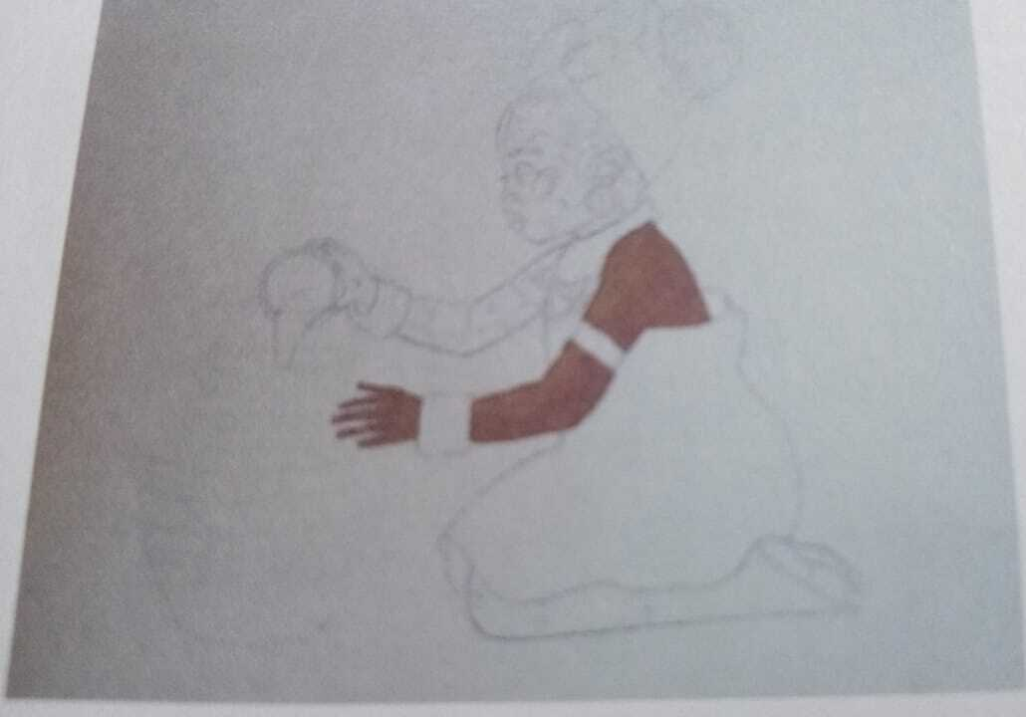
Figure 1. Sketch of the Akwaaba piece, traced in pencil and carbon paper onto calico cotton.
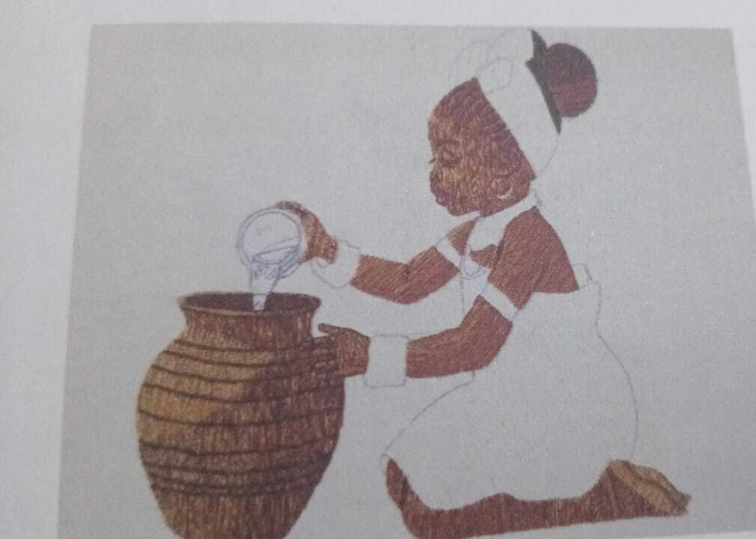
Figure 2. The Akwaaba piece during embroidery, showing the long and short stitch used to render the figure and water pot.
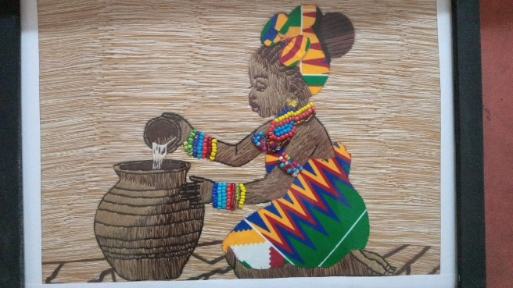
Figure 3. The completed and framed Akwaaba piece.
The design was first traced onto calico cotton using pencil and carbon paper, then worked in two shades of brown embroidery thread using the long and short stitch, a technique in which rows of stitches of varying length are blended to create graduated tone and texture. The braided hair was rendered in a blend of black and brown thread using satin stitch, and the water pot was built up in varying shades of brown using satin and running stitch to suggest its tonal variation. The finished piece was completed with a beaded bracelet and necklace, formed by hand-threading beads selected to match the colours of the dress, and the background was filled using a blend of ash and black thread in long and short stitch before the work was framed.

4.3 The Transatlantic Slave Trade Piece
Cape Coast Castle began as a Swedish trading post built in 1655 and was taken over by the British in 1663, after which it developed into one of the largest slave-trading posts on the West African coast, holding captured Africans in its dungeons before they were forced onto ships bound for the Americas (Hyland, 1995). The castle’s so-called Gate of No Return marked, for many of those held there, a final point of departure from the African continent and the start of the Middle Passage. It is today preserved as a museum and UNESCO World Heritage Site (UNESCO World Heritage Centre, 2025), and remains one of the most direct physical reminders of Ghana’s place within the history of the transatlantic slave trade, a trade that lasted more than four centuries and is documented to have caused immense population loss, family separation, and social disruption across the societies it drew from (Cavendish, 2025). Among the few first-hand accounts to survive from inside such a dungeon is that of Ottobah Cugoano, a man taken from the Gold Coast as a teenager in the eighteenth century, whose later published narrative remains one of the most frequently cited testimonies in the historiography of the slave trade.
The design for this piece was developed in Adobe Photoshop and CorelDraw from an image chosen to convey the fear, vulnerability, and physical distress experienced by enslaved people, with facial expression and body language deliberately emphasised over background detail. Colour was kept deliberately dim and subdued, a choice intended to symbolise suffering and oppression rather than to depict it literally, and the motif was arranged into a repeat pattern suitable for printing before being reviewed for clarity and fabric application.
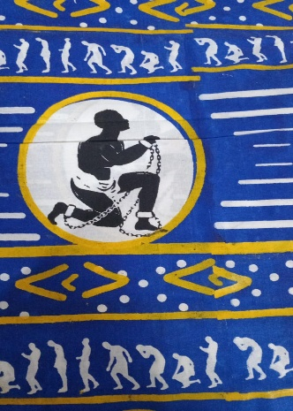
Figure 4. Printed motif for the transatlantic slave-trade piece, repeated across a wax-print-style background.
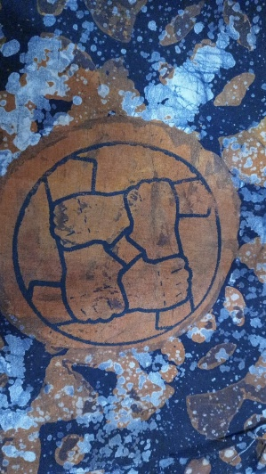
Figure 5. Final printed composition for the transatlantic slave-trade piece, set against a dimmed, subdued background.
The design was reproduced using the screen-printing method. A polyester mesh screen was stretched evenly over a frame, cleaned, and coated on both sides with light-sensitive photo emulsion, then dried away from light. The design was reproduced on a transparent film and used to expose the coated screen under strong light, hardening the emulsion everywhere except beneath the opaque design; the screen was then rinsed, leaving open mesh in the design areas, and inspected for pinholes before its edges were taped. With the fabric secured flat on the printing table, the screen was positioned, ink applied along one edge, and a squeegee drawn firmly across the mesh at a consistent angle to press ink through the open areas onto the cloth. The print was lifted, air-dried, and heat-set with an iron to fix the colour permanently, with the process repeated using a separate screen for each additional colour.

4.4 The Independence and Unity Piece
Ghana became the first country in sub-Saharan Africa to gain independence from colonial rule on 6 March 1957, following a movement that combined grassroots mobilisation, political activism, and diplomatic negotiation under the leadership of Kwame Nkrumah, who declared at the independence ceremony that Ghana’s freedom would be meaningless unless linked to the wider liberation of Africa. The date is commemorated annually as Ghana’s Independence Day.
The piece produced for this theme depicts three women in differently patterned Kente dress, their raised arms meeting above a stitched outline of the African continent, intended to symbolise the unity of Ghana’s diverse ethnic groups in the collective pursuit of freedom and, more broadly, Pan-African solidarity. The design was traced onto calico using pen and carbon paper, and the women’s facial features were rendered using the long and short stitch in graduated shades of brown.
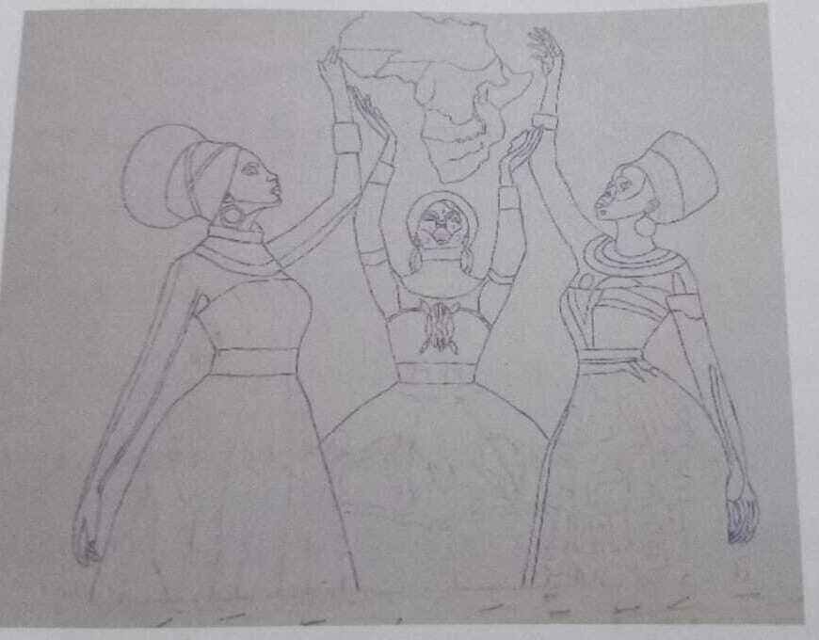
Figure 6. Sketch of the independence and unity piece, showing three women raising a map of Africa.
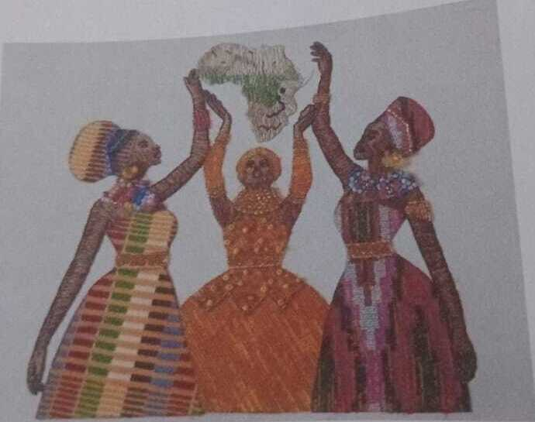
Figure 7. The independence and unity piece during embroidery and appliqué, showing the completed Kente-patterned dresses.
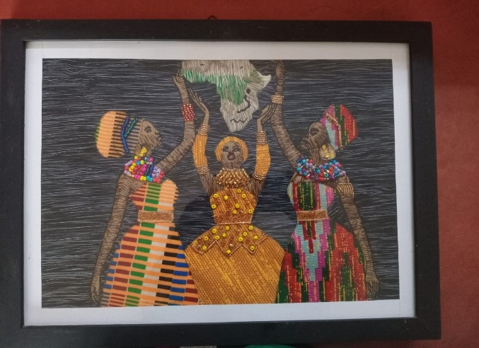
Figure 8. The completed and framed independence and unity piece.
The dresses were constructed through appliqué, with Kente-patterned fabric pieces ironed onto stiffened backing, cut to shape, and attached using running stitch, while bracelets and necklaces were formed by hand-threading beads chosen to match each dress. The background was completed in a blend of ash and black thread using satin and long and short stitch, and the finished piece was framed.

5. Discussion of Findings
The three completed artworks indicate that embroidery and textile printing can function as effective media for communicating historical events, cultural values, and national identity, transforming significant moments in Ghana’s history into textile pieces that operate as both aesthetic objects and educational tools.
Embroidery contributed depth, texture, and emphasis throughout the three pieces. Raised stitches, blended thread colour, and detailed needlework gave the represented figures, particularly their facial features and clothing, a tactile quality that printing alone could not achieve, supporting the view that embroidery functions as a storytelling medium rather than as purely decorative finish. Printing, by contrast, established background imagery, symbolic motifs, and the broader compositional structure of the slave-trade piece, allowing the reproduction of a repeating motif across a larger surface than embroidery alone could practically cover. Across the three pieces, printing supplied compositional and contextual structure while embroidery supplied focal detail and emotional emphasis, the two techniques working together rather than in competition.
Indigenous symbols, including Kente pattern, beadwork, and the stitched outline of the African continent, reinforced the cultural authenticity of the three pieces and connected them visibly to Ghanaian and Pan-African heritage, supporting the broader claim that visual symbol can carry and transmit collective memory.
Read against the frameworks set out in section 2.2, the three pieces support different aspects of that framework. Visual Culture Theory is most directly supported by the Akwaaba piece, where warm brown tones, beadwork, and an open, welcoming gesture function as a visual language of hospitality that depends on a Ghanaian viewer’s prior cultural knowledge to be read correctly. Cultural Memory Theory is most directly supported by the contrast between the slave-trade piece and the other two: where the Akwaaba and independence pieces draw on a memory that is celebrated openly and rehearsed often, in festival, ceremony, and national holiday, the slave-trade piece engages a memory that is held more carefully, its dimmed, subdued palette and restrained figuration deliberately withholding the kind of literal depiction that might otherwise overwhelm or simplify a historically traumatic subject. Arts-Based Research is supported across all three pieces by the design process itself, in which sketching, stitching, and printing decisions, for example the choice to mute colour in the slave-trade piece, or to raise three women’s arms together over a map of Africa in the independence piece, functioned as a means of working out historical interpretation rather than simply illustrating a conclusion reached beforehand.
Beyond the three pieces themselves, the study points to a broader distinction between embroidery and printed textiles as historical media. Embroidery tends toward personal and spiritual storytelling: hand-stitched motifs often carry family, lineage, or devotional meaning, and the slow, cumulative nature of stitching sustains artisanal knowledge across generations at the level of the individual maker. Printed textiles tend toward collective and political narrative: wax prints and commemorative cloths have long documented independence struggles and civic milestones in Ghana, functioning as a kind of wearable mass communication, and have absorbed imported techniques such as Dutch wax printing and screen printing into local aesthetic practice. Embroidery and print can therefore be read as two halves of a single narrative system, personal memory stitched into cloth and national history printed onto it, a dual structure that bridges the private and public dimensions of Ghanaian life rather than separating them.

6. Conclusion
This study set out to examine how embroidery, appliqué, and textile printing can be used to visualise and preserve aspects of Ghana’s history, and produced three textile artworks, addressing Akwaaba hospitality, the transatlantic slave trade, and the struggle for independence, to test that potential directly. The findings indicate that embroidery contributes texture, intimacy, and emotional depth to historical representation, while printing supplies broader compositional structure and symbolic reach, and that the two techniques combine to produce layered narratives capable of representing difficult as well as celebratory aspects of Ghana’s past. The consistent use of indigenous symbol, colour, and pattern across the three pieces reinforced their cultural authenticity and their connection to Ghanaian and Pan-African heritage. Taken together, the study supports the broader claim that textile art is not solely a decorative practice but a viable cultural resource for preserving collective memory and promoting historical awareness, with potential application in education, museum exhibition, and cultural heritage documentation in Ghana and comparable contexts.

References
Andrew, S. (2018). Textile semantics: Perception and memory. In G. Montagna & C. P. Carvalho (Eds.), Textiles, identity, and innovation: Design the future (pp. 187–194). CRC Press. https://doi.org/10.1201/9781315100210-36
Asavei, M. A. (2025). The material world of textiles and its nostalgic renderings in Romanian contemporary art. Journal of Material Culture, 30(2). https://doi.org/10.1177/13591835251316082
Assmann, J. (2008). Communicative and cultural memory. In A. Erll & A. Nünning (Eds.), Cultural memory studies: An international and interdisciplinary handbook (pp. 109–118). De Gruyter.
Boateng, B. (2011). The copyright thing doesn’t work here: Adinkra and Kente cloth and intellectual property in Ghana. University of Minnesota Press.
Cavendish, R. (2025, September 26). Cape Coast Castle. In Encyclopedia Britannica. https://www.britannica.com/topic/Cape-Coast-Castle
Fowler, C. (2019). The modern embroidery movement (1st ed.). Bloomsbury Visual Arts.
Geertz, C. (1973). The interpretation of cultures. Basic Books.
Hyland, A. (1995). The architectural history of Cape Coast. Transactions of the Historical Society of Ghana, 16(1), 163–184.
Kadolph, S. J. (2014). Textiles (11th ed.). Pearson.
Knecht, E., & Cole, A. S. (1911). A manual of dyeing.
Ministry of Tourism, Culture and Creative Arts Ghana. (n.d.). Akwaaba! Retrieved June 15, 2026, from https://motac.gov.gh
UNESCO World Heritage Centre. (2025). Forts and castles, Volta, Greater Accra, Central and Western Regions. https://whc.unesco.org

