Smart Crop Advisory
Dr. M. Duraipandian*, Tarun kumar S**, Ranjani M**, Gowtham Arasu S**, Sowndharrajan**
* HOD, IT, Hindusthan Institute of Technology, Coimbatore
** Student, Fourth year, IT, Hindusthan Institute of Technology, Coimbatore

Abstract- Agriculture continues to face challenges due to unpredictable climatic conditions, increasing input costs, and limited access to precise advisory support for farmers. This paper introduces a Smart Crop Advisory System, a web-based solution designed to assist farmers in making informed decisions using data-driven approaches. The system employs machine learning techniques, particularly the XGBoost algorithm, to analyze soil characteristics, weather conditions, and crop data for predicting crop yield, recommending suitable fertilizers, and identifying potential pest risks. In addition to advisory services, the system integrates features such as an equipment rental platform and access to government subsidy information, thereby supporting small and marginal farmers. The application is developed using FastAPI to ensure efficient performance and real-time response. The proposed system aims to enhance agricultural productivity, optimize resource utilization, and promote sustainable farming practices.

Keywords: Smart Agriculture, Crop Yield Prediction, Fertilizer Recommendation, Pest Detection, Machine Learning, XGBoost, FastAPI, Equipment Rental, Government Subsidy, Sustainable Farming..

I. Introduction
Agriculture plays a crucial role in the Indian economy, with a large portion of the population depending on it for their livelihood, especially small and marginal farmers. However, agricultural activities are increasingly affected by factors such as climate change, irregular rainfall patterns, and soil degradation, which contribute to rising cultivation costs. In many cases, farmers rely on traditional practices or generalized advice that may not be suitable for specific soil conditions, crop types, or regional weather variations.
With the advancement of Artificial Intelligence (AI) and Machine Learning (ML), new opportunities have emerged to provide data-driven solutions in agriculture. Machine learning algorithms, such as XGBoost, can analyze large volumes of data including soil properties, weather conditions, and historical crop records to generate accurate predictions and recommendations. In addition,

modern web technologies like FastAPI enable the development of efficient and scalable applications capable of delivering real-time advisory services to users.
Despite these technological developments, there is still a lack of an integrated platform that combines crop advisory services, equipment rental support, and information on government subsidy schemes in a single system. This gap highlights the need for a unified, intelligent, and user-friendly Smart Crop Advisory System that can assist farmers in making informed decisions and improving overall agricultural productivity.

II BLOCK DIAGRAM
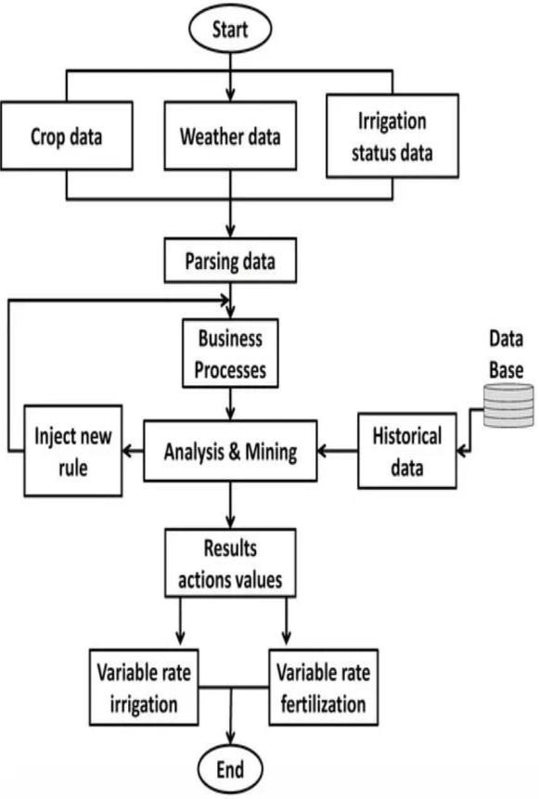

- FEASIBILITY STUDY

The feasibility of the Smart Crop Advisory System is analyzed in terms of technical, economic, and operational aspects. Technically, the system is feasible as it utilizes proven machine learning algorithms such as XGBoost for accurate prediction and reliable results. The backend development using FastAPI ensures fast API responses, scalability, and smooth integration with the web application.
  - Economic feasibility
  - Technical feasibility
  - Behavioral feasibility

ECONOMIC FEASIBILITY:
The Smart Crop Advisory System is economically feasible as it primarily relies on software-based development rather than expensive hardware infrastructure. The implementation cost includes model development, cloud hosting, and maintenance, which are relatively low compared to traditional agricultural support systems. By using efficient machine learning algorithms such as XGBoost, the system optimizes fertilizer usage, reduces crop losses through early pest detection, and improves yield planning, thereby lowering overall farming expenses.
Additionally, the platform supports an equipment rental marketplace, helping small farmers avoid high capital investment in machinery. Developed using scalable technologies like FastAPI, the system ensures cost-effective deployment and maintenance. Overall, the project is financially viable as it minimizes operational costs while maximizing economic benefits for farmers.

3.2 TECHNICAL FEASIBILITY:
The feasibility of the Smart Crop Advisory System is based on its use of technology, as it is created using established and reliable technologies. For instance, the prediction model is based on machine learning algorithms such as XGBoost, which is efficient for working with structured data related to agriculture, such as soil, weather, and crop information.
These models are able to produce accurate predictions with high performance.
The backend of the application is created using FastAPI, which is able to provide fast API responses, scalability, and integration with AI models. Additionally, it can be hosted on cloud platforms for accessibility and performance. Thus, with appropriate datasets, computational power, and internet connectivity, it is possible to implement and maintain the application. Firebase or Things Board support real-time data visualization. Wi-Fi, GSM, modules enable remote data transmission.

3.3 BEHAVIORAL FEASIBILITY
The Smart Crop Advisory System is behaviorally possible because it is simple and user- friendly and can be accessed by farmers of different literacy levels. The system offers clear recommendations on crop yield, fertilizer usage, and pest risk using reliable machine learning algorithms such as XGBoost. This is important because users will be able to understand and believe in the results of the application.
The application is also structured in such a way that it is not complex and is user- friendly, making it easier for users to adopt it without any resistance. The application is developed using efficient technologies such as FastAPI, making it fast and efficient.

4.1 REQUIREMENTS

4.1.1 Functional Requirements
The Smart Crop Advisory System should be capable of performing the following functions:
- Allow users to enter essential data such as soil type, location, and season.
- Provide suitable crop recommendations based on the input data.
- Offer guidance on fertilizer usage, irrigation methods, and crop management practices.
- Display weather information that may influence crop cultivation.
- Provide alerts and suggestions for pest and disease control.
- Maintain a simple and user-friendly interface for easy access by farmers.
- Ensure high reliability and accuracy in recommendations.
- Provide fast response time for quick decision-making.
- Enable access through devices such as smartphones and computers.
- Support internet connectivity for retrieving real-time weather and agricultural data.
- Optionally integrate sensors such as soil moisture and temperature sensors for real-time monitoring.

4.1.2 Non-Functional Requirements
In addition to functional capabilities, the system should meet the following quality requirements:
- The system should be reliable and provide consistent results.
- It should be scalable to handle multiple users simultaneously.
- The application should ensure data security and privacy.
- The interface should be user-friendly and easy to navigate.
- The system should maintain high performance with minimal delay.

4.1.3 Hardware Requirements
The following hardware components are required for the effective operation of the system:
- A computer or laptop with basic processing capability.
- Smartphones for users accessing the application.
- Optional sensors such as soil moisture and temperature sensors.
- Communication modules such as Wi-Fi or GSM for data transmission.
These hardware components ensure smooth system operation and support accurate data collection and processing.

4.1.4 Software Requirements
The system requires the following software tools and technologies:
- Programming languages such as Python, Java, or JavaScript.
- Database systems such as MySQL or MongoDB for data storage.
- Weather APIs for retrieving real-time environmental data.
- A web or mobile application interface for user interaction.
The software should be reliable, scalable, and capable of handling multiple users efficiently.

4.2 ANALYSIS

4.2.1 Functional Analysis
The system is designed to support key operations that assist farmers in making informed agricultural decisions. The major functions include:

- Crop recommendation based on soil type and climatic conditions.
- Display of weather forecasts that affect crop growth.
- Guidance on fertilizer application and irrigation scheduling.
- Pest and disease management recommendations.
- Storage of historical data for future reference and analysis.
These functionalities enable farmers to manage their agricultural activities more efficiently and improve overall productivity.

METHODOLOGY

  - SYSTEM DESIGN AND DEVELOPMENT METHODOLOGY

Requirement Analysis:
The first step in developing the Smart Crop Advisory System is identifying the needs of farmers and agricultural stakeholders. In this phase, information such as soil conditions, weather patterns, crop types, and farming practices is studied. The system requirements are analyzed to determine what features the application should provide, such as crop recommendations, fertilizer suggestions, irrigation guidance, and pest management advice.

The goal of this stage is to clearly define the system objectives and understand the problems faced by farmers so that the system can provide accurate agricultural recommendations.

Data Collection
In this stage, relevant agricultural data is collected from different sources. The data includes soil data, weather information, crop characteristics, and fertilizer requirements. These data sources help the system understand environmental conditions and farming requirements. Modern smart agriculture systems combine data from sensors, weather forecasts, and historical agricultural databases to generate useful insights for farmers. The collected data is then stored in a database for further processing.

5.2. FEATURES
The Smart Crop Advisory System includes several useful features that help farmers make better agricultural decisions. The system allows users to enter important details such as soil type, location, and season in order to provide suitable crop recommendations. It also gives suggestions about fertilizers, irrigation methods, and proper farming practices that can improve crop productivity. Another important feature of the system is providing weather-related information that helps farmers plan their farming

VI. IMPLEMENTATION

6.1. IMPLENTATION TECHNIQUES
The Smart Crop Advisory System is implemented using a combination of data collection, data processing, and analytical techniques to provide useful recommendations for farmers. In the first stage, the system gathers important agricultural data such as crop information, weather conditions, and irrigation status.
This data may be entered by the user or obtained from external sources. Once the data is collected, it is processed and organized through a parsing and preprocessing stage to remove errors and convert it into a structured format suitable for analysis.

After preprocessing, the system applies rule- based logic and data analysis techniques to interpret the information. These rules are designed based on agricultural knowledge and crop requirements. The system also uses historical data stored in the database to compare past conditions and identify useful patterns. By combining the current data with historical information, the system can generate accurate recommendations.
Finally, the analyze results are used to provide decision support for farmers. The system suggests appropriate irrigation levels and fertilizer requirements based on the crop type, soil condition, and weather data. These recommendations help farmers manage their crops efficiently and improve productivity.
.

6.2 MAINTENANCE
Maintenance of the Smart Crop Advisory System refers to the regular activities performed to ensure that the system continues to work efficiently and provide accurate recommendations to farmers. This includes:

- Software Updates: Keeping the system software, databases, and algorithms updated with the latest agricultural rules, crop information, and weather data.
- Hardware Checks: Regular inspection of devices like computers, sensors, and irrigation monitoring equipment to ensure they are functioning properly.
- Data Backup: Periodically backing up the collected data and historical records to prevent loss due to system failure.
- Error Correction: Identifying and fixing any bugs or errors in the system to maintain accurate outputs. Providing assistance to users for any issues related to system operation or data entry. Proper maintenance ensures that the Smart Crop Advisory System remains reliable, accurate, and effective in helping farmers make informed decisions.

VII. RESULTS AND DISCUSSION
The Smart Crop Advisory System was evaluated using sample agricultural data to analyze its performance and effectiveness. The system provides user-friendly interfaces and generates accurate recommendations based on the given inputs. The following figures illustrate the working of the system.

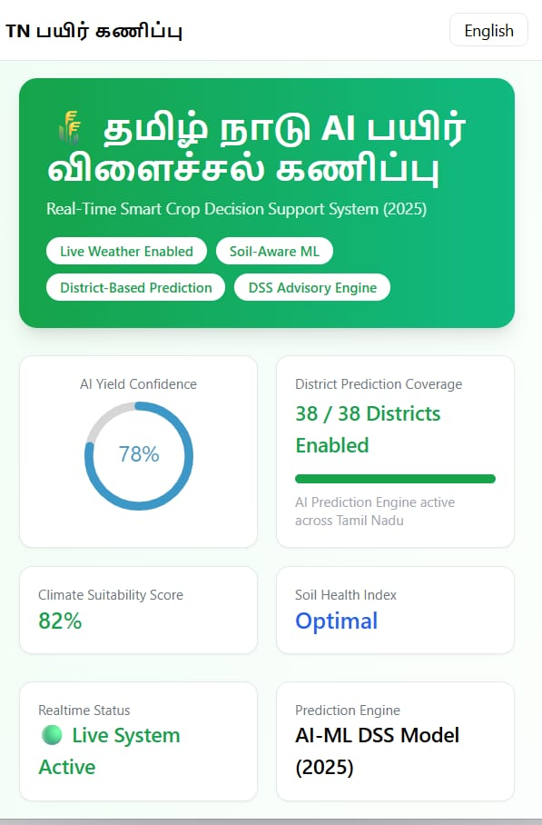

Fig. 1: User Interface of the Smart Crop Advisory System

The user interface displays the home screen of the application, including language selection options, district selection, and overall system design. It also shows important parameters such as AI yield prediction confidence, providing users with an overview of system capabilities.

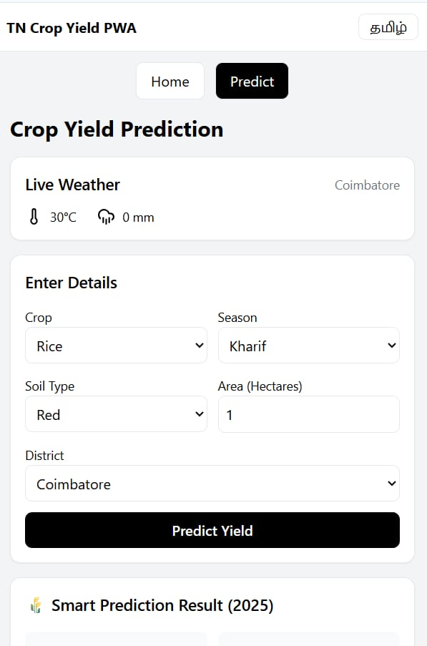

Fig. 2: Input Data Entry Interface

This interface allows users to enter essential agricultural details such as season, land area (in hectares), crop type, soil type, and district. These inputs are used by the system to generate accurate predictions and recommendations.
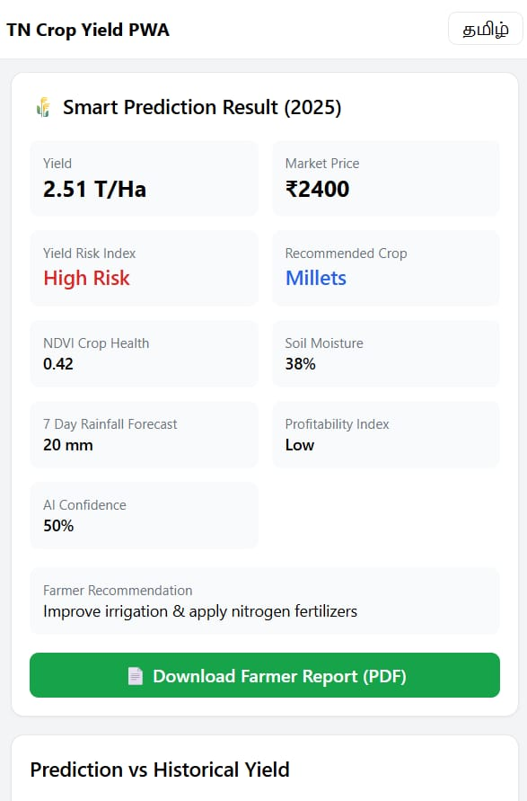

Fig. 3: Smart Prediction Result Output

The output screen displays the prediction results generated by the system. It includes key information such as crop yield, market price, risk index, recommended crop, soil moisture level, rainfall forecast, and profitability index. Additionally, the system provides actionable recommendations for farmers, such as improving irrigation and applying suitable fertilizers. This helps farmers make informed decisions to enhance productivity.

VIII. TESTING TECHNIQUES
Testing techniques are applied to ensure that the Smart Crop Advisory System functions correctly, provides accurate recommendations, and remains reliable for users. The major testing methods are as follows:
8.1 UNIT TESTING
Each module of the system, such as crop recommendation, weather data processing, and irrigation suggestion, is tested individually to ensure proper functionality.
8.2 INTEGRATION TESTING
After unit testing, all modules are integrated and tested collectively to verify proper interaction and smooth data flow between components.
8.3 SYSTEM TESTING
System testing ensures that all integrated hardware and software components function correctly according to the specified requirements.
8.4 USER ACCEPTANCE TESTING
User Acceptance Testing (UAT) is conducted with actual users, such as farmers or agricultural officers, to verify that the system is user-friendly and provides meaningful recommendations.
8.5 REGRESSION TESTING
Regression testing ensures that new updates or changes do not affect existing functionalities. For example, when new crop rules are added, previous recommendations are re-tested to ensure consistency.

IX. ADVANTAGES
- Provides a single platform for crop yield prediction and advisory
- Improves decision-making for farmers
- Reduces farming costs, especially for small-scale farmers
- User-friendly and easy to operate
- Supports new farmers entering agriculture

X. DISADVANTAGES
- Depends heavily on the accuracy of input data
- Requires regular updates and maintenance

XI. CONCLUSION
The Smart Crop Advisory System is a technology-driven solution designed to assist farmers in making informed decisions related to crop cultivation, irrigation, fertilization, and overall farm management. By integrating multiple data sources such as soil properties, weather conditions, crop requirements, and historical agricultural data, the system provides accurate and timely recommendations that help improve crop yield and reduce farming risks.
The system combines features such as data collection, preprocessing, rule-based analysis, and decision support to deliver actionable insights. Its user-friendly interface ensures accessibility even for farmers with limited technical knowledge, making it practical for real-world applications.
Furthermore, the implementation and maintenance strategies ensure long-term reliability, while testing techniques validate system performance and accuracy. Overall, the Smart Crop Advisory System acts as an effective decision-support tool that promotes better resource utilization, increased productivity, and sustainable agricultural practices.

XII. REFERENCES
[1] V. R. Ramanuja, K. Chaitanya Kamduri, and P. Gupta, “Smart Agriculture Advisor: A Machine Learning Approach to Precision Farming,” Proc. IEEE World AIoT Congress (AIIoT), May 2025.
[2] M. Joshi and S. Murali, “An Efficient Smart Flood Detection and Alert System Based on Automatic Water Level Recorder Using IoT,” March 2025.
[3] S. A. Mou, “AI-Driven Agricultural Advisor: Real-Time Multilingual Support with Lang Graph and Weather APIs,” Automation, Control and Intelligent Systems, vol. 13, no. 2, pp. 22–30, Jun. 2025.
[4] V. S. Sardeshmukh, S. B. Patil, and S. Bedage, “An AI-Driven Smart Crop Recommendation and Advisory Framework,” Jun. 2025.
[5] S. Kurre, P. Chandrakar, and S. S. Dadsena, “Smart AI Farmer: A Scalable AI-Based Web Application to Solve Real-World Agricultural Challenges Without IoT Dependency,” Int. J. Innov. Sci. Res. Technol., vol. 10, no. 5, May 2025.
[6] K. Khan, S. Mehmood, M. Imran, H. Anwar, and A. Rauf, “Enhancing Flood Monitoring and Prevention Using Machine Learning,” Oct. 2024.
[7] R. Priyadharshini, S. Rasika, and S. J. S. Daisy, “SMART AGRO ADVISOR: A Mobile App Solution for Sustainable Farming,” Int. J. Adv. Res. Comput. Commun. Eng., vol. 14, no. 5, May 2025.

[8] R. Singh, A. Kumar, and S. Yadav, “High Value Crop-Based Integrated Farming System Model for Peri-Urban Small Farmers,” Indian Journal of Agricultural Sciences, vol. 95, no. 2, pp. 234–245, Feb. 2025.
[9] H. Vishwakarma, R. Patel, and S. Mishra, “Forecasting Pre-Harvest Rice Yield: A Regression Analysis of Meteorological Factors,” Indian Journal of Agricultural Sciences, vol. 95, no. 1, pp. 45–56, Jan. 2025.
[10] V. K. Singh, R. Kumar, and A. Sharma, “Improving Productivity of Maize–Wheat Cropping Sequence Using Nutrient Management,” Indian Journal of Agricultural Sciences, vol. 94, no. 11, pp. 1890–1902, Nov. 2024

