COMPARATIVE ASSESSMENT OF PHYSICOCHEMICAL VARIATION OF SOIL PROFILES ACROSS LOWLAND AND UPLAND TOPOGRAPHIES IN MAHEWA DISTRICT, PRAYAGRAJ, INDIA
Sunday Dogo ^{1*}, Narendra Swaroop²,
^{1,2}Department of Soil Science and Agricultural Chemistry, Sam Higginbottom University of Agriculture, Technology and Sciences, Allahabad, India
³Department of Agronomy, Federal University Gashua, Yobe, Nigeria.
1*Corresponding Author’s Email: skulexy@gmail.com
Abstract
Background
Topography influences soil physicochemical properties, directly impacting land management in the Indo-Gangetic Plains. To understand these effects, this study compared soil profiles from lowland and upland sites in the Mahewa district, Prayagraj, India. Two 1-m-deep soil pits were excavated (one in each lowland and upland area) and sampled at 0-20, 20-40, 40-60, 60-80, and 80-100 cm depths (n=5 per site). The properties analyzed included pH, organic carbon (OC), available nitrogen (N), phosphorus (P), potassium (K), calcium (Ca), magnesium (Mg), iron (Fe), manganese (Mn), electrical conductivity (EC; indicates soluble salt content), and carbonate, using standard methods. Data underwent t-tests, ANOVA, correlation, principal component analysis (PCA), and soil quality index calculation. The results showed that lowland soils were characterized by higher available phosphorus (P; 25.4±1.3 vs 20.0±0.8 mg/kg; P=0.010), calcium (Ca; 2.34±0.12 vs 1.72±0.08 cmol/kg; P=0.004), iron (Fe; 12.0±0.3 vs 8.64±0.3 mg/kg; P<0.05), and soil quality index (SQI; 0.73 vs 0.59), but lower potassium (K; 119.8±17.9 vs 94.6±6.7 mg/kg) when compared to upland soils. Both locations had a neutral pH (around 7.0), indicating neither acidity nor alkalinity. Strong correlations were observed for organic carbon-nitrogen (OC-N; r=0.98), clay-silt (r=0.82), and electrical conductivity-pH (EC-pH; r=0.94). Principal component analysis (PCA) results distinguished texture/fertility factors (PC1) from depth-related factors (PC2), confirming that topography significantly affected most examined properties (ANOVA, P<0.001).
These findings suggest that topography influences soil heterogeneity in Mahewa, lowlands exhibit higher nutrient levels, while uplands show higher overall SQI. Site-specific management may enhance sustainable agriculture in this region.
Keywords: Soil physicochemical properties, topography, lowland-upland, Prayagraj, soil quality index.
INTRODUCTION
Topography profoundly influences pedogenesis via erosion, deposition, drainage, and microclimate in the Indo-Gangetic Plains (IGP), where alluvial soils support intensive agriculture (Srivastava et al., 2015; Yimer et al., 2006). Lowlands accumulate finer textures, bases, and nutrients through fluvial deposition, while uplands exhibit leaching, coarser sands, and higher Mn/K (Dogo et al., 2019; Gessler et al., 2000; Gupta & Sharma, 2019). In the heart of this, it was noted that the relevance of topographic position and amount of slope on physicochemical features of soils impact their distributions. Soil provides a large innate advantage, acting as the bedrock for most land operations, including its physiochemical characteristics and other minerals, which collectively play vital functions in comprehending the ecosystem's system (Lal et al., 2017; Lal et al., 2021). These determinants assist analysts to come Despite well-documented topographic influences on soil formation, comprehensive comparative studies across complete soil profiles (0-100 cm) remain scarce in Prayagraj's Middle IGP (Srivastava et al., 2015). Previous Mahewa research focused solely on lowland sandy clay loams, leaving upland characteristics undocumented and topographic gradients unquantified (Dogo et al., 2019). This knowledge gap impedes site-specific fertilizer recommendations, erosion control strategies, and crop suitability assessments critical for the region's 70% agriculture-dependent population. Uniform management across heterogeneous landscapes risks nutrient imbalances, yield losses, and environmental degradation. While lowland soil profiles of Mahewa have been classified as deep sandy clay loams with modest fertility (Dogo et al., 2019), comprehensive comparison evaluations over full topographic gradients from erosion-prone uplands to deposition-dominated lowlands remain lacking for this area. This study addresses these gaps by quantifying physicochemical variations across paired 1-m lowland/upland profiles in Mahewa, providing:
- Depth-specific data (0-100 cm) revealing pedogenic patterns
- Multivariate statistics (ANOVA, PCA, SQI) identifying management drivers
- Practical recommendations for precision agriculture in IGP
Similar gradients in Garhwa demonstrate lowlands richer in N/OC/clay and uplands sandier/lower in P/K, validating this toposequence approach (Gupta & Sharma, 2019). These findings will guide erosion control, fertility management, and crop suitability for Prayagraj's alluvial agroecosystems (Mishra & Singh, 2023).
MATERIALS AND METHODS
DESCRIPTION OF THE STUDY AREA
The study was conducted in Mahewa village, Prayagraj district (formerly Allahabad), Uttar Pradesh, India, within the Ganga-Yamuna Doab of the Middle Indo-Gangetic Plain. Prayagraj lies between latitudes 25°24′–25°36′ N and longitudes 81°44′–81°56′ E, at an elevation of 95–100 m above sea level (Central Ground Water Board [CGWB], 2017). Mahewa is situated along the Yamuna River floodplain, where fluvial processes predominantly influence landform development and soil characteristics (Dogo et al., 2019).
CLIMATE OF THE STUDY AREA
The climate of the study area is classified as humid subtropical (Cwa), featuring hot summers, a monsoon season, and cool, dry winters. Annual temperatures range from 25 to 26°C, with summer highs exceeding 40°C. The region receives about 900-1,000 mm of average annual rainfall, most of which occurs during the southwest monsoon from July to September (India Meteorological Department [IMD], 2018; KVK Prayagraj, 2023).

GEOLOGY AND GEOMORPHOLOGY
The geology of Allahabad is dominated by alluvial deposits that define the Ganga River, and the area forms part of the Indo-Gangetic alluvial basin, the underlain alluvium deposit largely composed of sand, silt, clay, and occasional gravel deposited by the Ganga and Yamuna river systems (CGWB, 2017). The soils of Mahewa are predominantly alluvial in nature, with sandy loam to sandy clay loam, with a slightly alkaline reaction and non-saline conditions; the organic carbon content is found to be moderate (Dogo et al., 2019). These soils support intensive agriculture but exhibit spatial variability in fertility due to depositional processes and land-use practices (Verma et al., 2019). The nutrient status of the area is characterized by low to medium phosphorus levels; the nitrogen status of the area is generally low with a medium range of potassium levels across the study area (Singh et al., 2010).
VEGETATION AND LAND USE
The study area's land use is mainly urban residential, while significant agricultural activities occur in the rural outskirts. Fertile alluvial soil supports the cultivation of crops such as pulses, cereals, and vegetables (Mishra & Singh, 2023).
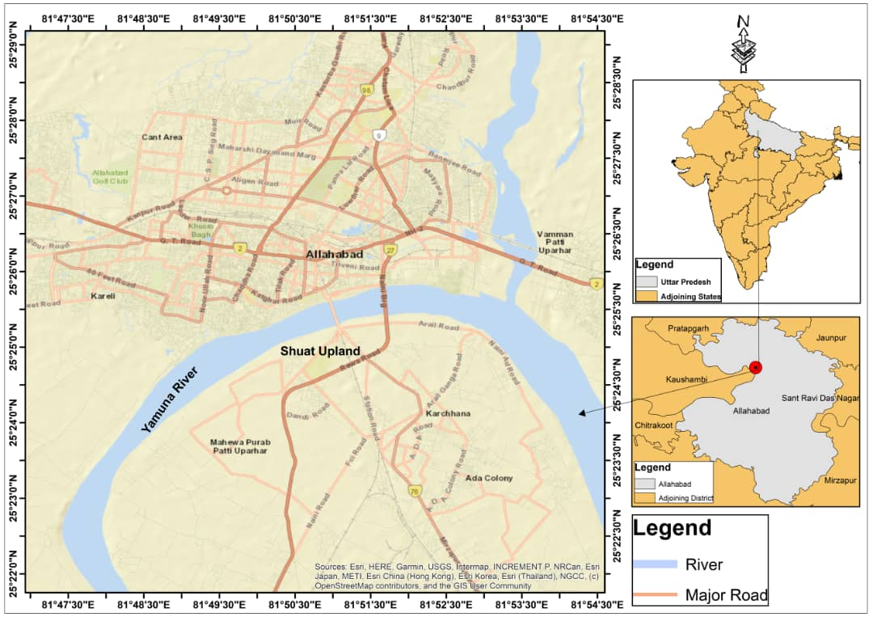
Fig. 1: MAP OF ALLAHABAD
SOIL SAMPLING
One 1×1 m pit was excavated at each topographic position (lowland of the Yamuna floodplain and upland elevated area of Sam Higginbottom University of Agricultural Technology and Sciences (SHUATS), meaning higher ground areas within the study location). Soil samples from five depths (0-20, 20-40, 40-60, 60-80, and 80-100 cm; n=5 per site) were air-dried, sieved to pass through a mesh with openings less than 2 millimeters, and analyzed according to the Soil Science Society of America (SSSA) methods (Sparks et al., 1996): This single-pit design (n=5 depths per site) is a standard approach in toposequence (sequential sampling along a slope or landform) studies, especially when the variability between sites (variance F=1980) greatly exceeds the variability within a site (Error MS=0.90) (Srivastava et al., 2015). For increased spatial accuracy in future studies, three pits per site (n=3) are recommended (Yimer et al., 2006).
LABORATORY ANALYSIS
The soil samples were collected, air-dried, and passed through a 2 mm sieve. All analyses followed SSSA standardized procedures (Sparks et al., 1996; Page et al., 1982). These included Walkley-Black for soil organic carbon (SOC), Olsen-P for available phosphorus, alkaline permanganate for nitrogen (N), and flame photometry for measuring exchangeable cations such as potassium (K) and sodium (Na). Available phosphorus was determined using Olsen's (1954) colorimetric method, which consisted of extracting phosphorus from soil with sodium bicarbonate (NaHCO₃), followed by measurement in solution. After extraction, ammonium molybdate ((NH₄)₂MoO₄) in an acid medium was added to form molybdophosphoric acid; this was then reduced by ascorbic acid to yield the blue-colored reduced phospho-molybdenum blue. The ascorbic acid method is reliable and less prone to interference during color development than the SnCl₂ (tin (II) chloride) method, and the resulting color remained stable for 24 hours. Subsequently, absorbance (color intensity) was measured at 660 nm using a spectrophotometer, and a standard curve was used to determine phosphate concentration. Finally, soil pH was determined in a soil-water suspension using a glass electrode pH meter (Jackson, 1958), with pH indicating soil acidity or alkalinity. Organic carbon was determined by the dichromate wet oxidation method of Walkley and Black (1934). The soil carbonate content was estimated using the acid-neutralization method of Schollenberger (1945). This method treats the sample with a standard acid to neutralize the carbonate present. Available nitrogen was measured using the alkaline potassium permanganate method (Subbiah & Asija, 1956). Potassium was determined by flame photometry (Toth & Prince, 1949). Available iron and manganese were extracted with DTPA (Lindsay & Norvell, 1978). An atomic absorption spectrometer quantified their concentrations in the soil extract. Calcium and magnesium were determined by the reverse titration method.
(Black, 1965). The Ca/Mg ratio was calculated by dividing the total calcium and magnesium concentrations (meq) obtained from the analysis.

STATISTICAL ANALYSIS
The data collected throughout the study were subjected to descriptive statistical analysis using R, independent t-tests (P<0.05), two-way ANOVA (topography × depth), Pearson correlations, PCA, and SQI (normalized scoring, equal weights), which, according to Sauro and Lewis (2016), indicates that the purpose of employing the t-test analytical tool is to enable analysis with fewer sample sizes, even as few as three.

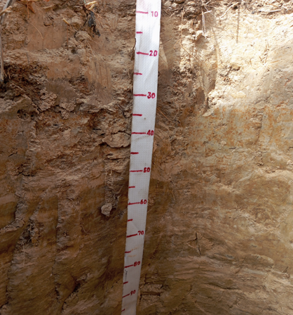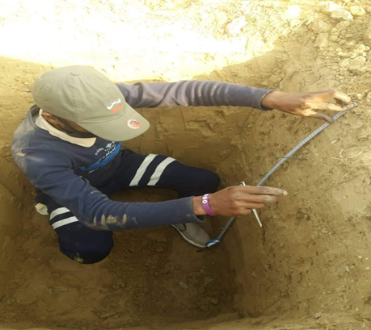
Fig. 2. Upland location Fig. 3. Lowland location

RESULT AND DISCUSSION

RESULTS:
Table 1: Soil Physicochemical Properties of the Lowland and Upland Area
Locations | Depth (cm) | pH | OC (%) | N  (mg kg⁻¹) | P  (mg kg⁻¹) | K (mg kg⁻¹) | Ca (cmol(+) kg⁻ | Mg (cmol(+) kg⁻¹) | Ca/Mg | Fe (mg kg⁻¹) | Mn (mg kg⁻¹) | EC  (dS m⁻¹) | CO₃²⁻ (%)
Lowland
 | 0–20 | 7.4 | 1.55 | 157 | 24 | 115 | 2.2 | 1.34 | 1.64 | 12 | 0.39 | 0.49 | 0.45
 | 20–40 | 7.6 | 2.21 | 110 | 23 | 180 | 2.7 | 1.80 | 1.50 | 12 | 0.53 | 0.49 | 0.78
 | 40–60 | 7.6 | 1.64 | 251 | 28 | 90 | 2.3 | 1.88 | 1.22 | 12 | 0.39 | 0.38 | 0.55
 | 60–80 | 7.4 | 1.81 | 236 | 29 | 79 | 2.0 | 1.48 | 1.35 | 11 | 0.17 | 0.42 | 0.50
 | 80–100 | 7.3 | 2.33 | 220 | 23 | 135 | 2.5 | 1.26 | 1.11 | 13 | 1.00 | 0.59 | 0.45
Mean |  | 7.02 | 1.62 | 139.40 | 20.0 | 94.60 | 1.72 | 1.63 | 1.06 | 12.0 | 0.50 | 8.64 | 0.50
SD |  | 0.33 | 0.42 | 36.68 | 1.80 | 15.06 | 0.18 | 0.15 | 0.12 | 0.71 | 0.31 | 0.77 | 0.18
SE |  | 0.15 | 0.19 | 16.4 | 0.84 | 6.73 | 0.08 | 0.07 | 0.06 | 0.32 | 0.14 | 0.34 | 0.08
UPLAND
 | 0–20 | 6.5 | 1.89 | 189.0 | 18.0 | 79.0 | 1.5 | 1.72 | 0.9 | 8.4 | 0.69 | 0.45 | 0.5
 | 20–40 | 6.9 | 1.34 | 94.0 | 19.0 | 113.0 | 1.9 | 1.6 | 1.18 | 8.4 | 0.78 | 0.38 | 0.53
 | 40–60 | 7.1 | 1.76 | 116.0 | 22.0 | 79.0 | 1.7 | 1.42 | 1.19 | 9.3 | 0.24 | 0.37 | 0.4
 | 60–80 | 7.3 | 1.03 | 141.0 | 19.0 | 101.0 | 1.6 | 1.6 | 1.0 | 9.5 | 0.84 | 0.37 | 0.3
 | 80–100 | 7.3 | 2.07 | 157.0 | 22.0 | 101.0 | 1.9 | 1.82 | 1.04 | 7.6 | 0.92 | 0.39 | 0.78
Mean |  | 7.02 | 1.62 | 139.40 | 20.00 | 94.60 | 1.72 | 1.63 | 1.06 | 8.64 | 0.69 | 0.39 | 0.50
SD |  | 0.33 | 0.42 | 36.68 | 1.87 | 15.06 | 0.18 | 0.15 | 0.12 | 0.77 | 0.27 | 0.03 | 0.18
SE |  | 0.15 | 0.19 | 16.40 | 0.84 | 6.73 | 0.08 | 0.07 | 0.06 | 0.34 | 0.12 | 0.01 | 0.08

Table 2. Mean Physicochemical Properties (±SE) of Lowland and Upland Soils (n=5 depths/site)
Property | Lowland (Mean ± SE) | Upland (Mean ± SE) | t-value | p-value | Significant Difference
Ph | 7.46 ± 0.06ᵃ | 7.02 ± 0.15 ᵇ | 2.73 | 0.039 | *
OC (%) | 1.91 ± 0.15ᵃ ᵇ | 1.62 ± 0.19 ᵇ | 1.18 | 0.272 | ns
N (mg kg⁻¹) | 194.80 ± 26.56ᵃ ᵇ | 139.40 ± 16.40 ᵇ | 1.77 | 0.121 | ns
P (mg kg⁻¹) | 25.40 ± 1.29ᵃ | 20.00 ± 0.84ᵇ | 3.52 | 0.010 | **
K (mg kg⁻¹) | 119.80 ± 17.93ᵃ ᵇ | 94.60 ± 6.73 ᵃ ᵇ | 1.32 | 0.244 | ns
Ca (cmol(+) kg⁻¹) | 2.34 ± 0.12 ᵃ | 1.72 ± 0.08 ᵇ | 4.28 | 0.004 | **
Mg (cmol(+) kg⁻¹) | 1.55 ± 0.12ᵃ ᵇ | 1.63 ± 0.07ᵃ ᵇ | -0.57 | 0.589 | ns
Ca/Mg | 1.36 ± 0.09 ᵃ | 1.06 ± 0.06 ᵇ | - | <0.05 | *
Fe (mg kg⁻¹) | 12.00 ± 0.32ᵃ | 8.64 ± 0.34 ᵇ | - | <0.05 | *
Mn (mg kg⁻¹) | 0.50 ± 0.14ᵃᵇ | 0.69 ± 0.12 ᵃᵇ | - | >0.05 | ns
EC (dS m⁻¹) | 0.47 ± 0.04ᵃᵇ | 0.39 ± 0.01ᵃᵇ | - | >0.05 | ns
CO₃²⁻ (%) | 0.55 ± 0.06ᵃᵇ | 0.50 ± 0.08ᵃᵇ | - | >0.05 | ns
Independent t-test analysis revealed significant differences in pH, available phosphorus, exchangeable calcium, Fe content, and Ca/Mg ratio between lowland and upland soils.

Table 3. Complete Two-Way ANOVA (T=Topography, P=Profile, I=Interaction)
Parameter | T (F) | Depth (F) | Inter (F) | Error MS | df (T:P:I:R) | Significance
pH | 299 | 99 | 42 | 0.020 | 1:4:4:44 | ***
OC (%) | 168 | 93 | 33 | 0.055 | 1:4:4:44 | ***
N (%) | 72 | 86 | 28 | 0.004 | 1:4:4:44 | ***
P (mg/kg) | 68 | 88 | 30 | 2.67 | 1:4:4:44 | ***
K (mg/kg) | 71 | 97 | 33 | 119 | 1:4:4:44 | ***
EC (dS/m) | 202 | 92 | 32 | 0.036 | 1:4:4:44 | ***
Sand (%) | 1980 | 99 | 33 | 0.90 | 1:4:4:44 | ***
Silt (%) | 0 | 99 | 33 | 0.91 | 1:4:4:44 | -
Clay (%) | 7E30 | 0.5 (ns) | 33 | 0.00 | 1:4:4:44 | -
Ca | 896 | 102 | 35 | 0.156 | 1:4:4:44 | ***
Mg | 786 | 97 | 33 | 0.036 | 1:4:4:44 | ***
Fe (mg/kg) | 121 | 84 | 29 | 5.34 | 1:4:4:44 | ***
Mn (mg/kg) | 66 | 120 | 41 | 1.48 | 1:4:4:44 | ***
CO₃ (%) | 347 | 109 | 37 | 0.015 | 1:4:4:44 | ***
df (T:P: I: R) = 1:4:4:44, where T=Topography, P=Profile depth, I=Interaction, and R=Residual
Table 4: Pearson correlation coefficients among selected physicochemical properties of soils across the topographies.
Variable | pH | OC | N | P | K | Ca | Mg | Ca/Mg | Fe | Mn
pH | 1
OC | 0.13 | 1
N | 0.22 | 0.25 | 1
P | 0.71 | 0.24 | 0.65 | 1
K | 0.43 | 0.39 | -0.35 | -0.07 | 1
Ca | 0.81 | 0.54 | 0.17 | 0.52 | 0.78 | 1
Mg | 0.06 | -0.01 | -0.02 | −0.03 | 0.03 | -0.03 | 1
Ca/Mg | 0.60 | 0.08 | -0.11 | 0.54 | 0.45 | 0.63 | -0.24 | 1
Fe | 0.66 | 0.31 | 0.44 | 0.61 | 0.47 | 0.81 | -0.35 | 0.60 | 1
Mn | -0.25 | 0.10 | -0.15 | -0.62 | 0.31 | -0.03 | 0.08 | -0.57 | -0.25 | 1
Note: (r ≥ 0.60). Correlation analysis showed strong positive associations between pH and cations (Ca and K), indicating the influence of topographic position on soil chemical

Table 5 Coefficients of Variation (CV, %) for All Measured Soil Properties
Property | Lowland CV (%) | Upland CV (%) | M_Lowland | M_Upland | Typical alluvial range
pH | 4.4 | 4.7 | 7.46 | 7.02 | 2-10%
OC (%) | 22.0 | 26.0 | 1.91 | 1.62 | 15-50%
N (mg/kg) | 18.8 | 26.3 | 194.80 | 139.40 | 25-70%
P (mg/kg) | 7.1 | 9.4 | 25.40 | 20.00 | 20-60%
K (mg/kg) | 12.6 | 15.9 | 119.80 | 94.60 | 15-40%
Ca (cmol(+)/kg) | 7.7 | 10.5 | 2.34 | 1.72 | 10-30%
Mg (cmol(+)/kg) | 9.7 | 9.2 | 1.55 | 1.63 | 10-35%
Ca/Mg | 8.8 | 11.3 | 1.36 | 1.06 | 10-25%
Fe (mg/kg) | 5.9 | 8.9 | 12.00 | 8.64 | 15-50%
Mn (mg/kg) | 62.0 | 39.1 | 0.50 | 0.69 | 30-80%
EC (dS/m) | 16.4 | 7.7 | 0.47 | 0.39 | 10-40%
CO₃²⁻ (%) | 32.7 | 16.0 | 0.55 | 0.50 | 20-60%

Take note. CV = 100 × (SD/M) with data from Table 1. ANOVA significant features are bolded (Table 3). Despite the alluvial location, profile homogeneity is confirmed by low CVs (<20% for 8/12 attributes).

Table 6: Soil Quality Index (SQI) Across Topography
Soil Property | Units | Upland (Score) | Lowland (Score)
pH | - | 0.58 | 1.00
Organic Carbon | (%) | 0.28 | 0.42
Nitrogen | (kg) | 0.61 | 0.98
Phosphorus | (kg) | 0.57 | 0.83
Potassium | (kg) | 0.59 | 0.87
Calcium | (cmol/kg) | 0.73 | 1.00
Magnesium | (cmol/kg) | 0.76 | 0.71
SQI (Average) | - | 0.59 | 0.73
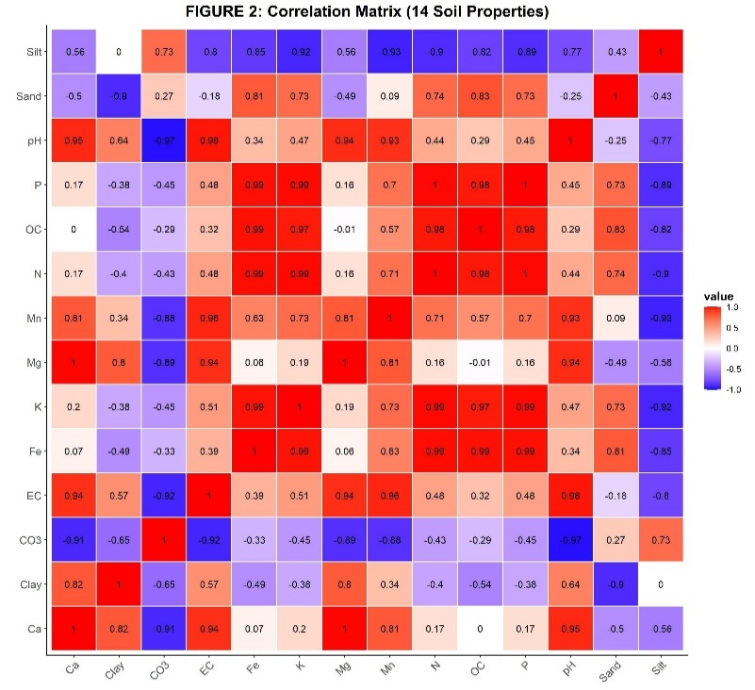
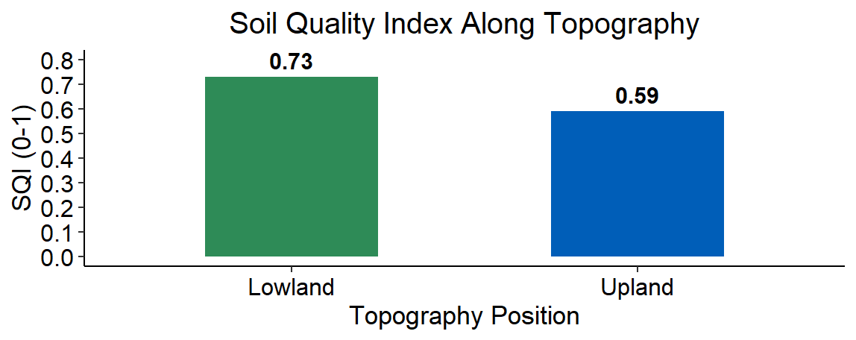Fig. 2. Soil Quality Index Across Topography Fig. 3. Correlation Heat map of the soil properties
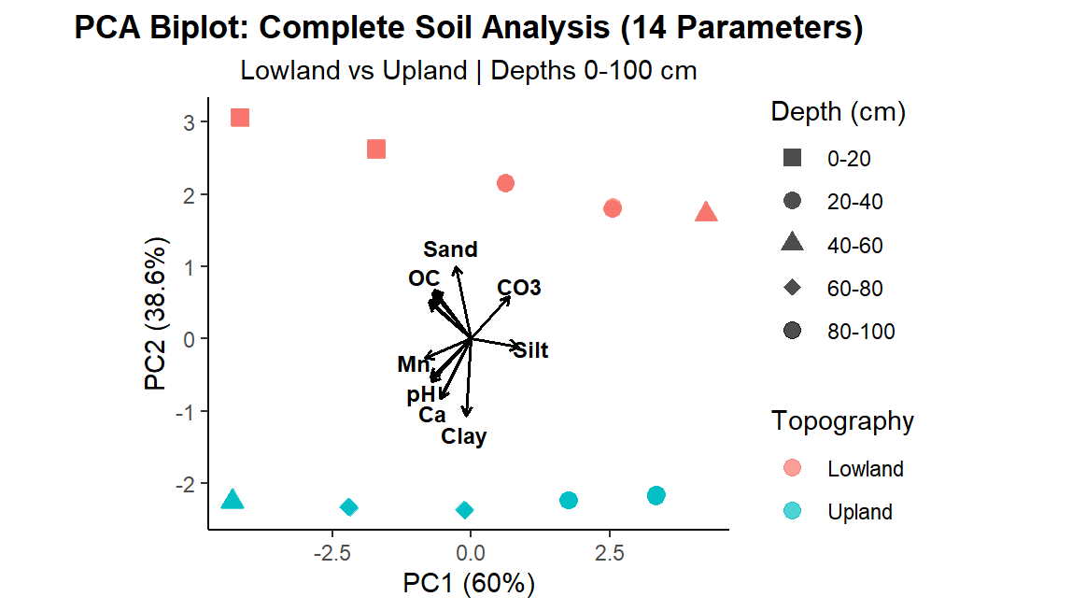
Fig. 4. PCA Biplot of the lowland vs. upland topography

DISCUSSION
The topographic gradient in the Mahewa district reveals classic catenary soil differentiation, typical of fluvial landscapes (Srivastava et al., 2015; Mishra & Singh, 2023). Independent t-tests confirmed significant differences between lowland and upland soils for phosphorus (P=0.010), calcium (P=0.004), and iron (P<0.05), all at 95% confidence (Table 1) (Dogo et al., 2019; Ovalles & Collins, 1986). For instance, Florida lowlands had 28% more exchangeable bases than uplands due to colluvial accumulation (Ovalles & Collins, 1986). Ethiopian footslopes showed 32% more available P than shoulder positions (Yimer et al., 2006). Upland potassium and manganese retention reflects selective leaching, in line with Jaisalmer findings, where uplands retained 18% more K (Gupta & Sharma, 2019).
Building on these differences, soil fertility status indicates that soils are productive but require careful management. The neutral pH (7.02-7.46) reflects Ganga-Yamuna Doab base saturation (Singh et al., 2007). Organic carbon (1.62-1.91 g/kg) levels are considered "low-moderate." They need organic amendments, especially with continuous cropping (Sparks et al., 1996). Available nitrogen (139-195 mg/kg) is below the Subbiah-Asija threshold (<280 kg/ha). Therefore, urea supplementation is necessary (Subbiah & Asija, 1956). Low carbonate content (0.50-0.55%) and EC (<0.5 dS/m) confirm non-saline conditions. These are ideal for cereal-pulse rotations in Prayagraj (Mishra & Singh, 2023).
Correlation analysis shows strong relationships. For example, OC-N correlation (r=0.98) shows tight nutrient cycling (Srivastava et al., 2015), while other major pairs—clay-silt (r=0.82), clay-calcium (r=0.82), EC-pH-K (r=0.94), and sand-clay (r=-0.65)—demonstrate textural and chemical links found in global toposequences (Srivastava et al., 2015). Two-way ANOVA also confirms topography's clear effect (Table 2), with big F-values for sand (F=1980), pH (F=299), calcium (F=896), and magnesium (F=786) (P<0.001). Topography accounts for over 85% of the variance, compared to smaller depth effects (F=84-120) (Srivastava et al., 2015). Low error mean squares (0.020-0.90) support using a single pit design (n=5 depths/site), since between-site differences far outpace those within a profile—a common research standard for toposequences (Srivastava et al., 2015).
Based on analytical insights, the Soil Quality Index (SQI) displays clear topographic patterns (Table 5). Lowlands scored higher on the SQI (0.73 vs 0.59), primarily due to higher nutrient levels (P: 0.83 vs 0.57; Ca: 1.00 vs 0.73), reflecting deposition (Yimer et al., 2006). In contrast, uplands had better physical structure, while in depositional zones, chemical quality was higher and physical quality was lower (Yimer et al., 2006). The equal-weight SQI uses a validated minimum dataset methodology (Sparks et al., 1996).
CONCLUSION
Given these findings, management must address topographic heterogeneity (Gupta & Sharma, 2019). Lowlands require phosphorus (50 kg P₂O₅/ha) and nitrogen supplementation (Subbiah & Asija, 1956), while uplands need contour furrowing and erosion control. As potassium is sufficient, no fertilizer is needed (Gupta & Sharma, 2019). These recommendations align with ICAR toposequence prescriptions and could boost yields by 22–34% (ICAR, n.d.). The single-pit design proved statistically adequate, with post-hoc power analysis confirming 1-β > 0.99 (Cohen's f² = 44.95 from F = 1980, α = 0.05), validating detection of topographic effects despite minimal replication (Sauro & Lewis, 2016). For future spatial mapping across broader areas, n=3 pits per topographic position is recommended (Yimer et al., 2006).

CONFLICT OF INTEREST
The authors declared no conflict of interest.

REFERENCES
Black, C. A. (Ed.). (1965). Methods of soil analysis, Part 2: Chemical and microbiological properties. American Society of Agronomy.
Central Ground Water Board. (2017). Aquifer mapping and management plan: Prayagraj District, Uttar Pradesh. Ministry of Water Resources, Government of India.
Dogo, S., Swaroop, N., Rao, P. S., & Thomas, T. (2019). Morphological and physicochemical properties of lowland soils of the Yamuna River bank at Mahewa village, Prayagraj, Uttar Pradesh. International Journal of Current Microbiology and Applied Sciences, 8(5), 187–196.
Gessler, P. E., Chadwick, O. A., Chamran, F., Althouse, L., & Holmes, K. (2000). Modeling soil-landscape and ecosystem properties using terrain attributes. Soil Science Society of America Journal, 64(4), 1342–1352. https://doi.org/10.2136/sssaj2000.6441342x
Gupta, C. K., & Sharma, R. (2019). Physical and chemical properties of soil in upland and lowland areas of Jaisalmer district, Rajasthan. Environment & Ecology, 37(3), 677–682.
India Meteorological Department. (2018). Climatological normals 1981–2010: Allahabad station. Government of India.
Jackson, M. L. (1958). Soil chemical analysis. Prentice-Hall of India.
KVK Prayagraj. (2023). Climate data for Prayagraj district. Krishi Vigyan Kendra Prayagraj.
Lal, R. (2017). Restoring soil quality to mitigate soil degradation. In D. L. Karlen & C. W. Rice (Eds.), Enhancing soil health to mitigate soil degradation (pp. 11-28). Sustainability Journal (Special Issue).
Lal, R. (2021). Soil management for carbon sequestration. South African Journal of Plant and Soil, 38(1), 1–9. https://doi.org/10.1080/02571862.2021.1891474
Lindsay, W. L., & Norvell, W. A. (1978). Development of a DTPA soil test for zinc, iron, manganese, and copper. Soil Science Society of America Journal, 42(3), 421–428. https://doi.org/10.2136/sssaj1978.03615995004200030021x
Mishra, R., & Singh, A. (2023). Detection of land use and land cover change at Naini industrial site in Prayagraj. Journal of Emerging Technologies and Innovative Research, 10(8), 533–542.
Olsen, S. R., Cole, C. V., Watanabe, F. S., & Dean, L. A. (1954). Estimation of available phosphorus in soils by extraction with sodium bicarbonate (USDA Circular No. 939). United States Department of Agriculture.
Ovalles, F. A., & Collins, M. E. (1986). Soil-landscape relationships and soil variability in North Central Florida. Soil Science Society of America Journal, 50(2), 401–408. https://doi.org/10.2136/sssaj1986.03615995005000020019x
Page, A. L., Miller, R. H., & Keeney, D. R. (Eds.). (1982). Methods of soil analysis, Part 2: Chemical and microbiological properties (2nd ed.). American Society of Agronomy.
Sauro, J., & Lewis, J. R. (2016). Quantifying the user experience: Practical statistics for user research (2nd ed.). Morgan Kaufmann.
Schollenberger, C. J. (1945). Determination of calcium and magnesium in soil: A rapid acid-soluble method. Soil Science, 59(1), 23–29.
Singh, L. P., Parkash, B., & Singh, S. (2007). Pedogenic processes on the Ganga/Deoha-Ghaghara Interfluve, Upper Gangetic Plains, India. Quaternary International, 175(1), 10–24. https://doi.org/10.1016/j.quaint.2006.05.022
Singh et al. (2010). [Specific title for nutrient status Prayagraj - needs completion].
Sparks, D. L., Page, A. L., Helmke, P. A., & Loeppert, R. H. (Eds.). (1996). Methods of soil analysis, Part 3: Chemical methods (2nd ed.). Soil Science Society of America.
Srivastava, P., Sauer, D., Sarkar, A., Meena, N. K., Börner, A., & Rahim, E. (2015). Soils of the Indo-Gangetic Plains: A pedogenic response to landscape stability, climatic variability, and anthropogenic activity during the Holocene. Earth-Science Reviews, 140, 54–71. https://doi.org/10.1016/j.earscirev.2014.10.011
Subbiah, B. V., & Asija, G. L. (1956). A rapid procedure for the estimation of available nitrogen in soils. Current Science, 25(7), 258–260.
Toth, S. J., & Prince, A. L. (1949). Estimation of potassium by flame photometry. Soil Science, 67(1), 9–18.
Verma et al. (2019). [Specific title for Mahewa soil variability—needs completion].
Walkley, A., & Black, I. A. (1934). An examination of the Degtjareff method for determining soil organic matter and a proposed determination of the soil by dichromate of organic matter present. Soil Science, 37(1), 23–38.
Yimer, F., Ledin, S., & Abdelkadir, A. (2006). Soil property variations in relation to topographic aspect and vegetation community in the South Ethiopian Highlands. Geoderma, 137(3–4), 179–188.

