THE ROLE OF TRADITIONAL IRRIGATION ON IMPROVING FOOD SECURITY AMONG SMALL HOLDER FARMERS IN TANZANIA

ABSTRACT
This study intended to investigate the effects of traditional irrigation system on improving food security among smallholder farmers in Moshi rural. The study used both qualitative and quantitative design because the qualitative approach allowed a researcher to collect data that enabled him to understand the entity being studied and quantitative approach aimed at collecting numerical data. In quantitative research design the researcher employed cross sectional design because data are collected from the target population or sample at one time and did not consume a lot of time for completion, hence less expensive. And in qualitative research design the researcher employed phenomenology because it describes the direct or lived experience for several individuals about a phenomena or concept. The sample size of this study involved small scale farmers, Agricultural Officers and ward executive officer in Moshi rural since they provided detailed data on the effects of traditional irrigation system on improving food security among smallholder farmers in Moshi rural. Also, this study used purposive sampling and simple random sampling to obtain a one hundred (100) people in Moshi rural which used as a sample of the study. The study comprised a population size of 100 smallholder farmers. This study used questionnaire and observation of documents as methods of collecting data and analyze them by descriptive statistics and SPSS which summarized and describe numerical data. The study employed quantitative approach whereby cross- sectional survey employed because it collected information from different study areas at the same time. The study found that, majority of respondents 95%of the respondents reapplied yes when the researcher asked that, are there any relationship between traditional irrigation and food security in Moshi rural, while 85.5% of respondents reapplied yes when the researcher asked that, are there any factors influencing the adoption of traditional irrigation in Moshi rural. The study analyzed that farmers for traditional irrigation should be improved with technical skills related to irrigation system so that they can be able to improve or increase their agricultural production so as to ensure food security per annual.

INTRODUCTION
This chapter provides the effects of traditional irrigation system on improving food security among smallholder farmers in Moshi rural. In this chapter, the study describes the background to the problem, statement of the problem, objectives, research questions, significance and the conceptual frame work.

1.1 Background of the problem
Globally, agricultural production is heavily sustained by irrigation, but irrigation system efficiencies are often surprisingly low. However, our knowledge of irrigation efficiencies is mostly confined to rough indicative estimates for countries or regions that do not account for spatiotemporal heterogeneity due to climate and other biophysical dependencies. To allow for refined estimates of global agricultural water use, and of water saving and water productivity potentials constrained by biophysical processes and also non-trivial downstream effects, we incorporated a process-based representation of the three major irrigation systems such as surface, sprinkler, and drip into a bio-and agro-sphere model.
Based on this enhanced model we provide a gridded world map of irrigation efficiencies that are calculated in direct linkage to differences in system types, crop types, climatic and hydrologic conditions, and overall crop management. We find pronounced regional patterns in beneficial irrigation efficiency (a refined irrigation efficiency indicator accounting for crop-productive water consumption only), due to differences in these features, with the lowest values (< 30 %) in south Asia and sub-Saharan Africa and the highest values (> 60 %) in Europe and North America. We arrive at an estimate of global irrigation water withdrawal of 2469 km² (2004–2009 average); irrigation water consumption is calculated to be 1257 km³of which 608 km³ are non-beneficially consumed, i.e., lost through evaporation, interception, and conveyance. Replacing surface systems by sprinkler or drip systems could, on average across the world's river basins, reduce the non-beneficial consumption at river basin level by 54 and 76 %, respectively, while maintaining the current level of crop yields.
In Africa, agriculture is the backbone of most of the continent z economies, providing about all employment (Birendra, 2011). During the last decade, per capital agricultural production has not kept pace with population growth. Consequently, as per the food and Agriculture Organizations (FAO’s) assessment at the end of the 1990s, 30 countries in Africa had over 20% of their population undernourished, rising to 35% in the worse affected countries. In terms of absolute numbers, between 1997-1999, 200 million people were malnourished, with 194 million of these people living in sub- Saharan Africa (SSA). The food gap estimate at 17 million tons in 2000 was filled by imports (14.2 million tons) and food aid (2.8 million tons) at cost of US$18.7 billion. In 2001 close to 30 million people required food emergencies due to drought, floods, and civil strife (You et al, 2010). Agricultural growth offers possibilities for reducing risks of food shortages at all level s, increasing overall supply of food, creating economic opportunities for vulnerable people and improving dietary diversity and the quality of food consumed by farm households (Lyne et al, 2009). Development of the agricultural sector in Africa is therefore seen as central to combating hunger, reducing poverty, an generating economic growth (through the reduction of food imports and the boosting of exports). However, progress in the sector can only be achieved if the main constraints are successfully addressed such as: variability in climate; limited access to technology; low level of rural infrastructure; and poor institutional structure.
Other areas that need addressing are the poor political and economic governance, the need to introduce supportive policy and legislation, the need to develop rural entrepreneurship capacity, combat HIV/AIDS, mobilize savings for investment and improve the performance of cash crops (Ortman and King, 2015)
In Eastern Africa traditional irrigation practiced in countries like Kenya and Tanzania. The most common area in Tanzania where the indigenous engaged in traditional irrigation is the slope of the Mount Kilimanjaro.
In Tanzania agricultural production is mainstay of economy. In 2009, agriculture accounted for 24.6% of the Gross Domestic Production (GDP) and about 80% of the population was dependent on agriculture for their rural households (Tanzania Economy survey, 2009). In 1997 Tanzania irrigation policy shows that irrigation is a means of stabilizing agricultural production and livestock keeping, both being adversely affected by periodic droughts. The developed policy is to have an important aspect because its strategies are to improve food security, increase farm productivity and income rural production. Irrigation has the potential to stabilize agricultural production and mitigate the negative impacts of variable or insufficient rainfall (Chiwaya, 2013).
Kilimanjaro is one among of region in Tanzania which practice traditional irrigation system. The irrigation tradition on the southern slopes of Mt. Kilimanjaro can be called Mfongo irrigation, from the term denoting an irrigation ditch in the local vernacular (Kichagga). The Mfongo technology has been described in sources starting with 19th century European travelers, who documented the technology as characteristic of resource use in locations around Mt. Kilimanjaro. Rebmann (1860, 242) reported the construction of canals by the clients of Mangi (Kichagga: prince, chief) Masaki and the practice of zero grazing following a visit to Kilema in 1848. More detailed incidental reports from subsequent decades show that irrigation infrastructure was developed in locations across the southern slope of Mt. Kilimanjaro (v1886; New 1971 [1873]).
Apart from the previous studies conducted by various Researchers, this study showed theory of contribution of small-scale irrigation through the study on the “The effect of traditional irrigation on improving food security among small holder farmers” that was conducted at Moshi rural district in Kilimanjaro.

1.2 Statement of the problem
Moshi rural is one of the districts located in highland areas of the Kilimanjaro region. According to the documents of zonal irrigation office (1994) Kilimanjaro region has irrigation potentials of 28000 hectares out of which only 19115 hectares are under traditional irrigation scheme where crops like coffee, banana, cardamom and fruity commonly use traditional canals. Though there are a lot of households using traditional irrigation in the study area, the impact that it has brought on the food security of the household is not yet well studied in the area. Several related studies reviewed lack appropriate impact evaluation methods in studying the impact of traditional irrigation on food security that may result in overestimation or underestimation of the impact. To this end, the main motivation behind this study was to examine whether traditional irrigation in the study area is creating positive change on household food security or not using the propensity score matching approach.
Also, the study conducted by (Noajesh, 2013) shows that, areas within the surface water irrigation schemes suffer from chronic and severe water shortages, especially those located in tail-end reaches, resulting in low productivity and persistent poverty among the farmers caused by inequitable and unreliable water supplies. It is necessary to address these problems since the agricultural sector needs to meet the dual challenge of increasing agricultural growth and looming water scarcity.
Apart from those that have been discussed in agricultural field above this study explored the effect of traditional irrigation system on improving food security among small holder farmers of rural households in Moshi district.

1.3 Research Objective

1.3.1 General objective
To provide an understanding on the effect of traditional irrigation on food security among small holder farmers in Moshi rural.

1.3.2 Specific objectives
i. To determine the nature of traditional irrigation in Moshi rural.
ii. To determine factors for adoption of traditional irrigation in Moshi rural
iii. To determine the relationship between traditional irrigation and food security.

1.4 Research questions
i. How does traditional irrigation is practiced in Moshi rural?
ii. What are the factors lead to the adaptation of traditional irrigation in Moshi rural?
iii. What is the relationship between traditional irrigation and food security?

1.5 Conceptual framework of the study
The study focused on the contribution of traditional irrigation to livelihoods of smallholder farmers in terms of food security and household income in Moshi district. Livelihoods analysis of irrigation water is essential. Firstly, it builds on better understanding of multiple perspectives and values of water as economic capital (agricultural input, domestic needs), physical capital (irrigation infrastructure), managerial and institutional capital (water organizations), social capital (collective action) as well as political capital (Nicol, 2000). It helps to identify what options have better potential to reduce food insecurity within the given context and what enabling conditions, policies and incentives are needed for the poor to increase the range of better livelihood options (Ellis, 2000; Moriarty et a., 2004; Lankford,
2005). The approach is a relationship between the assets or resources that people own or can access to, including land, irrigation water, skill and education levels of family members, which are categorized as natural, human, social, financial and political capitals (Scoones, 1998; Nicol, 2000; Ellis and Freeman, 2005). The households utilize these assets in their productive activities in order to create food and income and satisfy their consumption needs, maintain their asset levels and invest in their future activities.
The impact of improved smallholder farmers’ livelihood was reflected in the changes of income and food security. Efficiency agricultural production increases crop yields; such efficiency was influenced by other factors of agricultural production such as inputs availability, market for the produce, education, age of the individual, extension services, financial services and improved infrastructures. Traditional irrigation, apart from normal irrigation, also plays a significant role in supplementing rain fed agriculture when there is a shortage of rainfall which in turn increases crops yields and hence it improves food security and income.
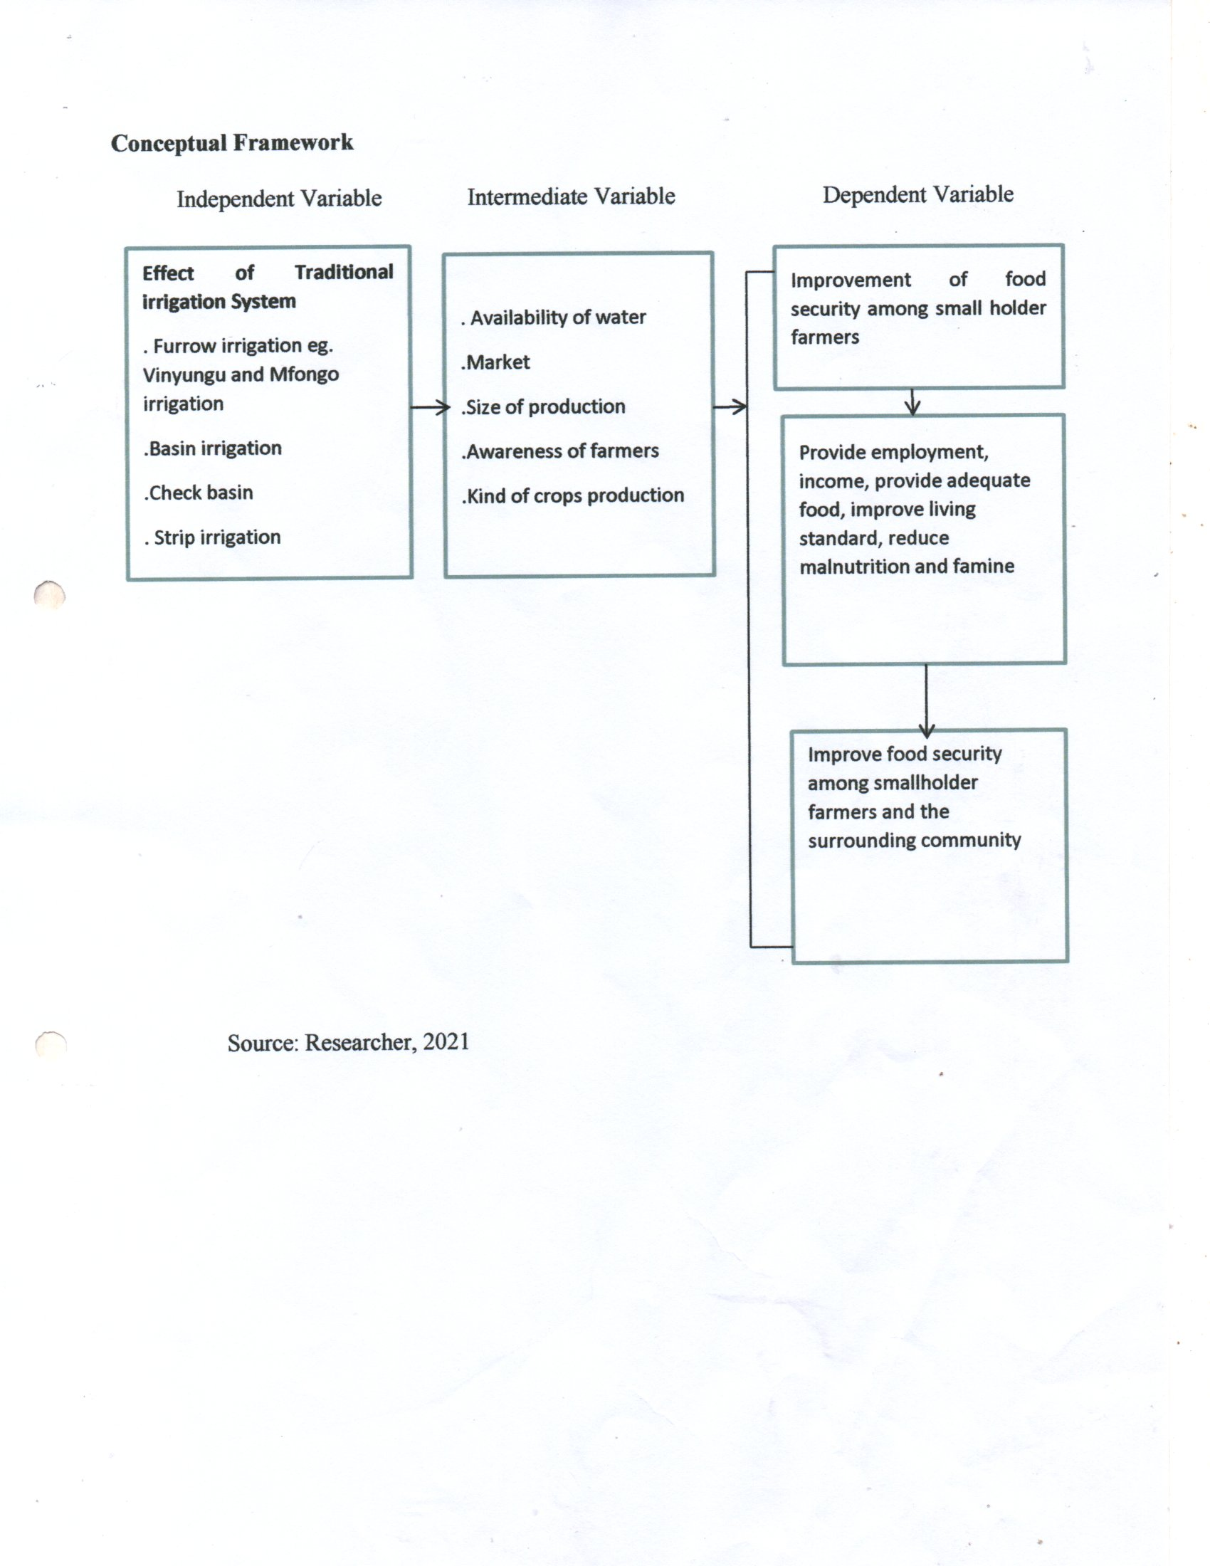
Figure 1.1 Conceptual Framework

LITERATURE REVIEW

2.0 Introduction
This chapter provides a theoretical frame work for the study. The chapter is divided into the following main categories that are review of the related theory, empirical theory, review of the empirical studies and demonstration of knowledge gap.

2.1 Review of the Related Theory

2.1.1 The high Payoff Input Model Theory
Initially developed by Theodore W. Schultz (1902 – 1998) was used in Agricultural Development. The high Payoff Input Model theory postulate key of transforming a traditional agriculture designed to make modern, high-pay off inputs available to farmers in poor countries. Peasants, in traditional agricultural systems were viewed as rational, efficient resource allocators. They remained poor because in most poor countries, there were only limited technical and economic opportunities to which they could respond.
Strength of the theory
The theory enhances the farmers to acquire new knowledge and use new inputs effectives to increase productivity. Enhance the public and private sector research institutions to produce new technical knowledge and also enable the industrial sector to develop, produce and market new technical inputs.
Weakness of the Theory
The model remains incomplete as a theory of agricultural development. However, education and research are public goods not traded through the market place. The mechanism by which resources is allocated among education, research and other alternative public and private sector economic activities are not fully incorporated into the model. More so, the model does not treat investment in research as the source of new high-pay off techniques. It does not explain how economic conditions induce the development and adaption of an efficient set of technologies for a particular society. Nor does it attempt to specify the process by which factor and product price relationships induce investment in research in a particular direction.

2.2 Review of Empirical Studies
Relationship between traditional irrigation and food security.
According to Musa (2008) conducted a research try to examine the relationship between traditional irrigation and food security as he stated that; There are strong direct and indirect linkages between traditional irrigation and food security. Direct linkages operate via localized and household level effects, and indirect linkages operate via aggregate or national level impacts. Traditional irrigation benefits the smallholder farmers though higher production, higher yields, lower risk of crop failure, and higher and year-round farm and nonfarm employment. Irrigation enables smallholders’ farmers to adopt more diversified cropping patterns and to switch from low value subsistence production to high-value, market-oriented production. The transition to the market economy integrates the poor into land, labor, and commodity markets and empowers the poor by putting them at a level playing field with other market entities, including the non-poor Increased production makes food available and affordable for the poor. The poor and the landless are main beneficiaries of low food prices as they are net buyers of the products. Indirect linkages operate via regional, national, and economy wide effects . Traditional irrigation investments act as production and supply shifters, and have a srong positive effect on growth, benefiting the poor smallholder farmers in the long run . Recent advances in irrigation technologies, such as traditional irrigation systems, have strong increased food security . Ongoing studies in Asian countries document strong evidence that traditional irrigation helps reduce permanent and temporary food security.
The study of Musa, explore on the nature of traditional irrigation in Same district, but this study explores on the nature of traditional irrigation in Moshi rural.
Nature of traditional irrigation
According to Kapungwe 2013, conducted research about traditional irrigation practice high crop diversification and multiple agricultural cycle in wastewater irrigation farming in Peru urban areas, Zambia. Studies conducted on peri urban wastewater irrigation agriculture in Zambia have not adequately tackled issues pertaining to farmer managed irrigation systems in heavy metal contaminated wastewater irrigation farming. The study focused on characteristics of farmer managed irrigation systems in wastewater irrigation farming contaminated with heavy metals at New Farm in Mufulira and

2.3 Demonstration of Knowledge Gap
The researches discussed in Empirical Study above showed various ways used in data collection and analyzed them. The research conducted by (Musa,2008), and (Justus,2013) together with the study conducted by (Kapungwe, 2013) All of them used observation as a method of collecting data but this study used both questionnaire and field observation as a method of data collection which require short time to collect data. Also, this study investigated on the effects of traditional irrigation on food security among small holder farmers in Moshi rural.

RESEARCH DESIGN AND METHODOLOGY

3. 0 Introduction
This chapter consist of research design, description of the study area, target population, description of sample and sampling plan, description of data collection instruments, description of data collection procedures, reliability and validity of research instruments, description of data analysis procedures and ethical consideration in research

3.1 Research Design
The research design is the overall strategy that is chooses to integrate different components of the study in a coherent and logical way, thereby, help to ensure effectively address the research problem; it constitutes the blueprint for collection, measurement, and analysis of data. The study employed quantitative approach where by cross-sectional survey design was employed because it collected information from different study area at the same time. The design helps the researcher to collect data from farmers, ward agricultural extension officers. Therefore, the designs were enabling the researcher to use a little in collecting a massive amount of data.

3.2 Description of the Study Area
The Moshi Rural district is one of the seven districts of the Kilimanjaro Region of Tanzania. The district is bordered to the north by the Rombo District, to the west by the Hai District, to the east by the Mwanga District and Kenya, and to the south by the Moshi Urban district. The municipality is in the Kilimanjaro Region and is situated on the lower slopes of Mt Kilimanjaro, a dormant volcano that is the highest mountain in Africa. According to the 2012 Tanzania National Census, the population of Moshi Rural District was 466,737. The Moshi Rural District is administratively divided into 31 wards: Arusha chini,Kahe, Kahe Mashariki, Kibosho Kati, Kibosho Magharibi, Kibosho Mashariki, Kilime kaskazini, Kilema kati, Kilema Kusini, Kimochi, Kindi, Kirima, Kirua Vunjo Kusini, Kirua Vunjo Magharibi, Kirua vunjo Mashariki, Mamba kaskazini, Mamba kusini, Marangu Magharibi, Marangu Mashariki, Mabogini, Makuyuni, Mbokomu, Mwika kaskazini, Mwika Kusini, Okoani, Old Moshi Magharibi, Old Moshi Mashariki, Uru Mashariki, Uru shimbwe, Uru kusini,and Uru kasikazini

A MAP OF MOSHI RURAL DISTRICT
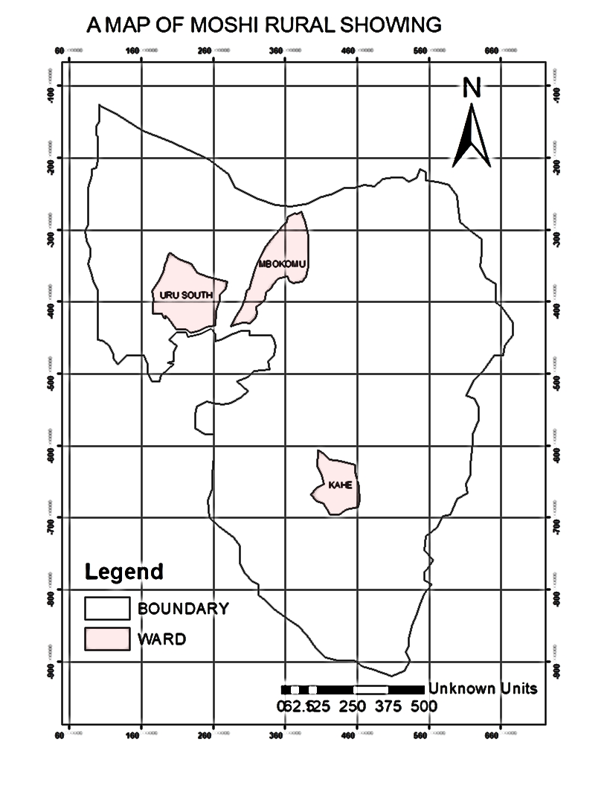
Figure 3.1: A Map Showing Description of the Study Area
Source: researcher (2026)

3.3 Land Area and Administration Units
The district had an area of 1,713-kilometer squares or 171,300 in Moshi rural had 34.9kha of tree, extending over 25% of its land area, Recall, the economy of Moshi rural district is mainly from agricultural sector with land under cultivation accounting for 108,389Ha (87.3%) of total arable land. More than 80% of District population largely depends on agricultural activities. However, contribution of the agricultural sector to the District Economy had been affected by unpredictable weather conditions, taking into consideration that the agricultural sector depends on rainfall (URT, 2010).

3.4 Economic Activities
The main economic activities that are conducting in Moshi rural district are specifically including agriculture, transportation and tourism activities
Agriculture
Moshi rural cash crops and subsistence agricultural activities is dominants, production of banana and coffee take place at every household for instance, Uru kusini, Uru Shimbwe and Kibosho Magharibi are famous in production of banana and coffee due to the presence Kilimanjaro Plantation Limited playing a vital role to motivate small holder farmers to engage in both cash crops and subsistence agriculture.
Tourism
Moshi rural District has a number of the tourist attraction including Marangu waterfall, Materuni water fall, Ndoro water falls also the presence of Marangu gate and Mweka gate played a big role in tourism activities. Also, availability of social services like Kirima kyaro, college like Mweka college of Wild life management and Hospital like kibosh hospital opening a big opportunity to promote tourism industries.
Trade and Transportation activities
Trading activities exists in the study area, shops, bars markets and butcher sites are main centers of trading activities in Moshi rural district where people sell goods and services with profit making as the means of income generation. But also transport activities are commerce and trading activities taking place in Moshi rural where by main road transport prevail in the study area. Buses, Mini buses, and motor bikes makes the major means of transport of public transport. But also, Lorries and heavy trucks exit in Moshi rural for Transportation of goods like banana, tomatoes, bricks, cement and other similar goods.

3.5 Target Population
Target population refers to the entire group of individual or object to which researcher are interested in generalizing the conclusion (Castillo, 2009).
The target population were the resident of Moshi rural district. And will comprise of 99 sample size that included normal resident, an agricultural extensional officer, ward executive officer and village chair person.

3.6 Description of Sample and Sampling Procedure
Sample size
Sample is an act of choosing the number of observation or replicates to include in statically sample (Ahn, 2014). The sample size of this study is 99 from 90% which include 95 normal residents using random sampling, 2Agricultural extension officer, 1 ward executives’ officer and 1 chair person. That will be obtained using purposive sampling to obtain specific information that cannot be collected from the normal residents. Therefore the formula of Yamane (1967) will be used to find sample size. According to the United Republic of Tanzania (URT), National Population Census 2012 the population of Moshi rural district was estimated to be 466737
formula. S=N
Whereby;
S= is sample size
N= is the total number of population study
e= is the level of precision
Number of respondents
Mbokomu =14606
Uru kusini= 22904
Kahe = 19142
Total number of respondents = 56652
Therefore; S= 56652/1+56652(0.01) = 99.8
Mbokomu =14606
14606 x 99.8/56652=27
Uru kusini = 22904
22904x99.8/56652 =40
Kahe =19142
19142 x9 9.8/56652 =33
Table 3.1: Showing summary of the selected sample size
Ward | Number of samples | Sampling techniques
Uru kusini | 40 | Simple random sampling
Mbokomu | 27 | Simple random sampling
Kahe | 33 | Simple random sampling
Total | 100
Source: Researcher (2026)

3.7 Sampling Procedures
Ward Sampling
The researcher used cluster sampling to select wards. Here the researcher l identified and group wards of Moshi rural district into clusters. After that the researcher was randomly picked wards from those clusters. The name of the ward that appear in the picked paper was used as the study area.
Village Sampling
A researcher used simple random sampling to select villages in this study. The researcher wrote down on pieces of paper the names of villages in the selected ward an put them into a box and thoroughly mix. Then the researcher was randomly picking four pieces of paper from the box. The name of the villages that was appeared in the picked papers was used as study area.
Smallholder Farmers Sampling
The researcher used simple randomly sampling to select the smallholder farmers to be used in the study, where by the they were selected randomly and purely by chance. As each member has an equal chance to be selected to present the smallholder farmers of the entire population.
Sampling of key Informant
Key informants were sampled using the purposive sampling, where such key informant were selected basing on the knowledge, experience and awareness of the study problem in the study area, hence the key informants included of the Ward Executive Officer [WEO], village Executive Officers (VEO), agricultural officers and chairpersons.

3.8 Method of Data collection
Is the process of gathering information on variables of interest in an established systematic fashion that enables one to answer stated research questions, test hypothesis and evaluate outcome. Data collection is a common component of research in all fields of study only the methods vary but emphasis on ensuring accurate and honest collection remains the same (Laws, 2003).
The collection of data in this study used interview guide for key informants such as to the Ward Executive Officer and Agricultural extension officers, questionnaires to normal residents, observation for comparison of the provided information to actual situation in the field and documentary review to obtain additional information that was not provided in the field. The process was clearly conducted to ensure the data integrity accuracy and secure the research integrity.
Also, the data was accurately collected to reduce the likelihood of occurrence of errors, inability to answer the research questions accurately, inability to repeat and validate the study, and distorted findings. To ensure the integrity of data collection quality assurance and quality control will be observed which means activities before data collection and activities after data collection (Laws, 2003). The following are the methods of data collection that were involved in this study.

3.8.1 Structured interview
Is an instrument in which respondents provide written response to questions mark items that indicate their response (Ary et al 1996). This study involved both closed and open-ended questions that were asked to normal residents, an agricultural extension officer’s officer, ward executive officer, and street chairpersons. The use of questionnaire as the method provided the researcher with substantial quantitative data that was used in the analysis of the results. Questionnaires have questions asking the nature of irrigation system used by the small-scale farmers and other questions that were delivered from the research questions that aimed at collecting information in one ward of involving in utilization of traditional irrigation system in Moshi rural district Specifically at Uru kusini ward.
The reason we have decided to use this method was because this method provides adequate time to the respondents to provide accurate answers, but also the questionnaires and answers are in writing form hence there is accurate recording of information

3.8.2 In-depth interview
An interview schedule is a flexible tool for data collection that enable the use of verbal, non-verbal, spoken and heard (Cohen, 2011). The order of questions in an interview may be controlled at the same time giving space foe spontaneity and the interview can express not only for complete answers but for responses about complex and deep issues. In this the set of questions were prepared for interview, and the researcher asked questions to the individual. The researcher was guided with the prepared questions guide in conducting the interview.
I have chosen to use interview method because this technique of data collection is easy, less time consuming and does not require people with skills and much knowledge to provide answers.

3.8.3 Field Observation
This method of data collection involves the researcher’s direct observation in the from the field area of data collection. MacLeod, (2018) has it that; observation is used to get information through different human organs by hearing, touching, vision, and smelling. Same wise observations can be used to get information in both qualitative and quantitative studies. This helped the researcher to see the area on how people practiced traditional irrigation in a sustainable way hence ensures sustainable environmental management.
The researcher used observation method because this method gave the researcher an access to view real situation of the problem and relate it to what is acquired by using questionnaire method and interview method in order to increase efficiency in collecting data.

3.8.4 Documentary Review
Secondary data obtained from various secondary sources such as mainly publications, internet sources, journal, articles, academic theses, organization departmental reports or official documents, library materials, literatures and reports. This method requires critical analysis and citation of the secondary data sources being reviewed. Secondary data sources were enabled this study to obtain information that enabled to examine the contribution of traditional small scale irrigation farming in socio-economic development in rural area.
I used this method because Secondary data resource helped in the development of the field survey questionnaire and in provided further evidence to analyze and explain data findings from the field. Furthermore, secondary data sources allowed this study to benefit from a wide range of current scholarly work on the effects of traditional irrigation system in improving food security.
I considered reviewing documentaries so as to obtain more information related to my study so as to get more knowledge and assistance to accomplish my study. Review of various articles and research works helped me to get the highlights of what had been done to conduct my study and what other research work related to my topic were conducted.

3.9 Data Analysis Procedures
According to Kothari (2004), analysis of the data is a process of inspecting, cleaning, transforming and modeling data with the goal of discovering useful information. Suggesting decision making, the data in this study will be both quantitative and qualitative but to a great extent qualitative. The data that will be collected in this study will code and feed into Statistical Package for Social Science (SPSS) for analysis and interpretation. Descriptive and inferential statistics will be used through graphs and table. The data will be analyzed in tables, maps as well as graph for better understanding and researcher will categorize the data into means, frequency and percentage for easy interpretation.

3.10 Reliability and Validity of Research Instruments
Validation of research defined by Cohen et al, (2011) as referring to the quality of data gathering instrument or procedures which means what is supposed to be. The instruments used in this study was tested to the selected sample which was normal residents, Agriculture extension officers, ward executive officer and street chairpersons at Moshi rural District in Uru kusini ward specifically.
Reliability of research instruments refers to the extent to which instrument produces the same results on repeated trials (Ogula, 2009). The reliability of instruments in this study was tested basing on the actual results from the data collected from the selected study area. Avoiding errors during data collection helped to provide effective reliability of this study which wis conducted in Moshi Rural District.

DATA PRESENTATIONS AND DISCUSSION OF FINDINGS

4.0 Introduction

This chapter presents the data obtained from the field collection on the effect of traditional irrigation on improving food security among small holder farmers in Moshi rural in Kilimanjaro region. The first part presents demographic information of the respondents including sex, age, marital status, education level, ethnic group as well as economic activities of the households. The second part is about how traditional irrigation is practiced in Moshi rural of. The third part is about relationship between tradition irrigation and food security. And the fourth one is about factors lead to the adaptation of traditional irrigation in Moshi rural.

4.1 Demographic information of households

4.1.1 Sex and Age of the Respondents
The results in table 4.1 represents sex and age of household respondents whereby 46 respondents were males while 54 were females thus making a ratio of 46% males and 54% females. this implies that female respondents were many than males by 6%. The results are summarized in table 4.1. 12 respondents were aged between 18 to 23 years old; 18 respondents were aged between 24 to 29 years old; 28 respondents were aged between 30 to 35 years old; 23 respondents were aged between 39 to 44 years old, 12 were aged between 45 to 49 years old, and 7 respondents were 50 and above years old. according to the table majority of the respondents were youths aged between 39 to 44 making 23.0% of the respondents. The results is summarized in table 4.1.1
Table 4.1 Show Age and Sex of Respondents
Variables |  |  | Male |  | Female
 |  |  | F | % | F | %
age | 18-23 | sex | 4 | 4.0% | 8 | 8.0%
age | 24-29 | sex | 10 | 10.0% | 8 | 8.0%
age | 30-35 | sex | 8 | 8.0% | 20 | 20.0%
age | 39-44 | sex | 13 | 13.0% | 10 | 10.0%
age | 45-49 | sex | 6 | 6.0% | 6 | 6.0%
age | 50 – above | sex | 5 | 5.0% | 2 | 2.0%
Source: Research Data (2026)

4.1.2 Marital Status of the Respondents
The results in table 4.1.2 represents marital status of the respondents where 48 respondents were married a king 48% of all respondents while 39 were single and they make 39% of the respondents, 8 were widows and 5 were separated. this means that majority of the respondents were in marriage followed by single persons. The results is summarized on the table below.
Table 4.2 show marital status of the respondents
variables | Married |  | Single |  | widow |  | Separated
variables | F | % | F | % | F | % | F | %
marital status | 48 | 48.0% | 39 | 39.0% | 8 | 8.0% | 5 | 5.0%

4.1.3 Economic Activities
The findings in table 4.1.3 represents economic activities of the households respondents where 12 respondents were industrial workers 12% of all respondents while 39 were involved in farming activities and they make 39% of the respondents, 15 were involved in livestock keeping. this means that majority of the respondents practiced farming followed by livestock keepers. The results are summarized in table 4.1.3

Table 4.3 Shows economic activities of the Respondents
Variable | industrial worker |  | Farming |  | business |  | livestock keeping
Variable | F | % | F | % | F | % | F | %
economic activities | 12 | 12.0% | 39 | 39.0% | 34 | 34.0% | 15 | 15.0%

Source: Research Data (2026)

4.1.4 Ethnic groups
The results in table 4.1.4 represents ethnic groups of the respondents where.45 respondents were Chagga and they make 45% of all respondents while 29 were pare and they make 29% of the respondents, 10 were involved in livestock keeping. this means that majority of the respondents were Chagga followed by pare. The results are summarized in table 4.1.4
Table 4.4 Shows Ethinic groups of the respondents
variables | Chagga |  | pare |  | Masai |  | Others
variables | F | % | F | % | F | % | F | %
ethic group | 45 | 45.0% | 29 | 29.0% | 10 | 10.0% | 16 | 16.0%
Source: Research Data (2026)

In demographic aspects, the social and economic aspects in the area are as shown in Tables 4.1,4.1.2,4.1.3, and 4.1.4. The dominant tribe is Chagga with few pare indicating a minimal influx to the villages. The average number of people per household is 10. Majority of adult farmers have primary school education, very few have secondary school education and non-formal education. The age range for majority of farmers is between 35 and 45 years. Major economic activities are agriculture (mfongo irrigation system), livestock keeping and other minor businesses (Table 4.1.3). Unlike in low potential areas, all farmers in this area are involved in mfongo irrigation (canals) farming due to availability of local streams and canals.

4.2. Relationship between Traditional Irrigation System and Food Security
This chapter covers the analysis of data gathered from the field which is presented according to the objectives of the study and in conjunction with its underlying hypotheses.

4.2.1 There is relationship between traditional irrigation and food security
The findings in table 4.2.1 represents the results of the question when the households asked the question by the researcher, that, is there any relationship between traditional irrigation and food security. where 8 respondents refused that there is no any relationship between trational irrigation and food security and they make only 8% of all respondents while 92 respondents agree that there is relationship between traditional irrigation and food security they make 92% of the respondents. this means that majority of the respondents accept by replying yes that there is relationship between traditional irrigation and food security. The results is summarized in table 4.2.1
Table 4.5 shows relationship between traditional irrigation and food security
Variables | no |  | Yes
Variables | F | % | F | %
Have relationship between traditional irrigation and food security | 8 | 8.0% | 92 | 92.0%

Source: Research Data (2026)
Field data reveals that traditional irrigation system has significant relationship with food security since it plays the following significant roles in food security and poverty alleviation:
(i) Food security
Farmers reported that even when rainfall is sufficient the production from rainfed remaining 33% (3 months) of food needs come from traditional irrigation. Rainfall in many cases has been unreliable in onset dates and amounts, resulting to frequent crop failures. In these cases, traditional irrigation is the most reliable option, that enables farmers to grow different types of vegetables, which cannot be grown under rainfed conditions thus improving their nutritional status while getting cash.

(ii) Income generation
Average prices for the major crops in traditional and rainfed fields are indicated
Although there is no significant difference in prices, traditional irrigation crops generate more cash income than rainfed due to the following reasons; Most crops grown in traditional irrigation system take shorter time to mature than in rainfed because of relatively higher temperature during dry season. This enables farmers to sell them and increase their cash income for different needs within a short time. Another factor for generating higher income from traditional irrigation than rainfed is that most of the crops in traditional irrigation are grown at least twice a year. Although this study did not quantitatively analyze the expenditures from traditional irrigation the items mentioned by farmers which included paying school fees, buying building materials, clothing and medical expenses are evidence that the income from traditional irrigation contributes to poverty alleviation among smallholder farmers. If a farmer sells green maize (mali mbichi) at a reported price of 500Tsh/Pc, s/he gets Tsh 7500 from 15 cobs which are equivalent to 5kg of dried maize grain sold at only Tsh 3500. This is almost 2times the income from dried maize grain. This explains why farmers keep selling mali mbichi despite the frequent government ban. However, selling green maize encourages maize stealing and if the income is not used properly it may lead to food shortage because the cash obtained from selling mali mbichi is enough.

4.2.2 Relationship between traditional irrigation and food security
The findings from this study shows that the major things that lead the relationship between traditional irrigation and food security are production of food which occupied 53.0%, followed by selling of agriculture products which occupied 40.0%, followed by transportation of goods which occupied 26.0%, followed by harvesting of produces 23.0%, followed by pumping and supplying of water which occupied 20.0%, followed by cultivation of farms which occupied 19.0%. the result is summarized.

Table 4.6 Shows Relationship between traditional irrigation and food security

variables | strongly disagree |  | disagree |  | Undecided |  | agree |  | strongly agree
variables | F | % | F | % | F | % | F | % | F | %
through selling agriculture products | 3 | 3.0% | 4 | 4.0% | 18 | 18.0% | 35 | 35.0% | 40 | 40.0%
through production of food | 0 | 0.0% | 9 | 9.0% | 13 | 13.0% | 25 | 25.0% | 53 | 53.0%
through transportation of goods | 4 | 4.0% | 11 | 11.0% | 23 | 23.0% | 36 | 36.0% | 26 | 26.0%
by cultivating of farms | 4 | 4.0% | 9 | 9.0% | 21 | 21.0% | 47 | 47.0% | 19 | 19.0%
through harvesting of produces | 1 | 1.0% | 13 | 13.0% | 21 | 21.0% | 42 | 42.0% | 23 | 23.0%
by pumping and supplying water | 2 | 2.0% | 7 | 7.0% | 22 | 22.0% | 49 | 49.0% | 20 | 20.0%

4.2.3 Negative Relationships Between Traditional Irrigation and Food Security
In this part the household asked by the researcher that is there any negative relationship between traditional irrigation and food security, where 100 respondents said that there is no negative relationship between traditional irrigation and food security and makes 100% this means there is only positive relationship between traditional irrigation and food security as show in table 4.2.3
Table 4.7 shows no negative relationship between traditional irrigation and food security
Variables | no |  | Yes
Variables | F | % | F | %
are there any negative relationship between tradional irrigation and food security | 100 | 100.0% | 0 | 0.0%
Source: Research Data (2026)

4.2.4 Positive Relationship Between Traditional Irrigation and Food Security
The findings from this study shows that the major things that lead the positive relationship between traditional irrigation and food security are to ensure food availability per annual which occupied 64.0%, followed by providing employment to the people which occupied 20.0%, followed by provide income which occupied 16.0%, this means that traditional irrigation plays a great roles in ensuring availability of food throughout the year in Moshi rural hence support food security as summarized in figure 1

Figure 4.1 Positive relationship between traditional irrigation and food security

Source: Research Data (2026)
Farmers reported that even when rainfall is sufficient the production from rainfed remaining 33% (3 months) of food needs come from traditional irrigation. Rainfall in many cases has been unreliable in onset dates and amounts, resulting to frequent crop failures. In these cases, traditional irrigation is the most reliable option that enables farmers to grow different types of vegetables, which cannot be grown under rained conditions thus improving their nutritional status while getting cash.

Table 4.8 Positive relationship between traditional irrigation and food security
Variables | ensure food availability per annual |  | provide income |  | employment to the people
Variables | F | % | F | % | F | %
if no circle in the answer below | 64 | 64.0% | 16 | 16.0% | 20 | 20.0%
Source: Research Data (2026)
4.3 Nature of Traditional Irrigation System
In these findings the researcher asked the household that, if they practice traditional irrigation in their areas and the results were ñ85 Respondents practiced traditional irrigation in their areas and make 85% while 15 respondents do not practice traditional irrigation in their areas and make 15%. This means that the majority of respondents engage in traditional irrigation system. This is summarized in figure 2.
Table 4.3 shows respondents who practice traditional irrigation

Source: Research Data (2026)

4.3.2 Nature of traditional irrigation

The findings from this study shows that the nature of traditional in Moshi rural based much on cash crops production in most of the areas which accupied38.0%, followed by food production like banana maize and vegetable which occupied 36.0%, followed by based on production of food and cash crops which occupied 33.0%, followed by production of fruits and vegetables like tomatoes which occupied 32% , followed by cash crops production and vegetables and fruits which occupied 30%, followed by the system involved all of the above which occupied 17% as summarized in the table 4.3.1

Table 4.9 Shows the nature of traditional irrigation
Variables | strongly disagree |  | disagree |  | undicided |  | agree |  | strongly agree
Variables | F | % | F | % | F | % | F | % | F | %
it based on cash production only | 6 | 6.0% | 11 | 11.0% | 18 | 18.0% | 27 | 27.0% | 38 | 38.0%
it based on food production like bananas and maize | 1 | 1.0% | 6 | 6.0% | 21 | 21.0% | 36 | 36.0% | 36 | 36.0%
it is for production of fruits and vegetables like tomatoes | 0 | 0.0% | 8 | 8.0% | 18 | 18.0% | 42 | 42.0% | 32 | 32.0%
the system involves both production of food and cash crops | 1 | 1.0% | 11 | 11.0% | 21 | 21.0% | 34 | 34.0% | 33 | 33.0%
it involves both cash crops production and vegetables and fruits | 2 | 2.0% | 14 | 14.0% | 17 | 17.0% | 37 | 37.0% | 30 | 30.0%
it involves all of the above | 2 | 2.0% | 7 | 7.0% | 16 | 16.0% | 48 | 48.0% | 27 | 27.0%

Source: Research Data (2026)
Results in table 4.3.1 shows, major crops and cropping system Major crops grown in Moshi rural through traditional on the medium potential areas are maize, beans, onion, sweet potatoes and tomatoes particularly in Kahe ward and Mbokomu. Different types of vegetables such as cabbage, figiri and spinach are also grown. Others are round potatoes and peas. maize, bean inter-crop is the most common cropping system. As in low potential areas proper agronomic practices such as use of improved seeds and proper plant spacing are not follow since it is traditionally farming system.

Main crops planted through traditional irrigation at Uru Kusini ward

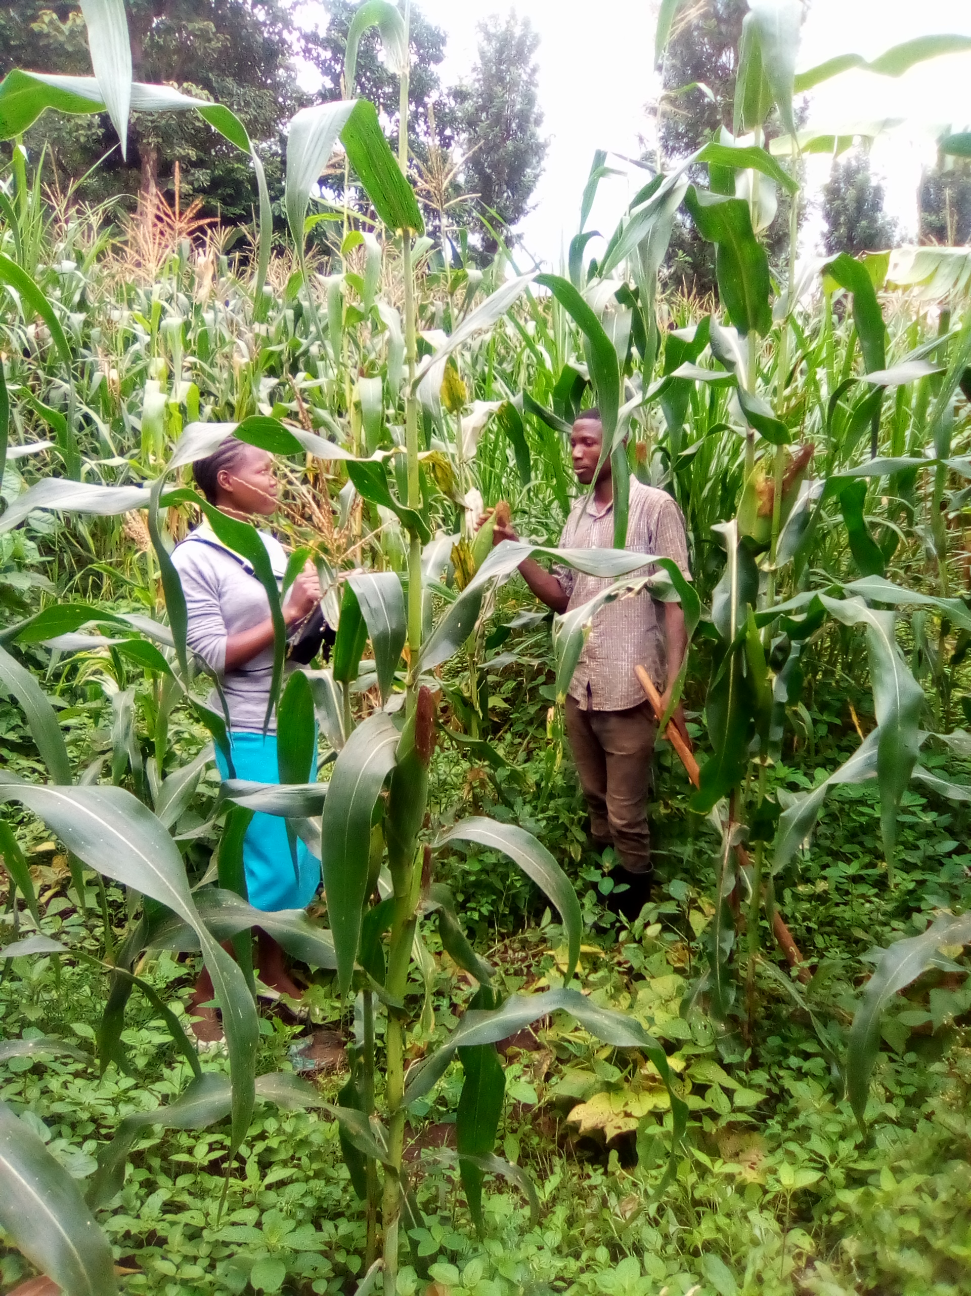
Source: Research Data (2026)

4.3.3 Access Water for Irrigation
32 respondents access water for traditional irrigation from canals which makes 32.0%, whereby 30 respondents access water for irrigation activities from river stream which make 30% followed by 26 respondents who access water from rainfall harvesting buy which make 26% and 12 respondents access water for irrigation from wells which makes 12%. This show that majority of respondents access water for traditional irrigation from local canals.as summarized in table 4.3.3

Table 4.10 Shows places where water for irrigation is accessible
Variables | from river stream |  | rainfall harvesting buy |  | from canals |  | wells
Variables | F | % | F | % | F | % | F | %
where do you access water for traditional irrigation system | 30 | 30.0% | 26 | 26.0% | 32 | 32.0% | 12 | 12.0%
Research Data (2026)
Results in table 4.3.3 shows that in Moshi rural the major source of water used for irrigation is canals and river streams where by river streams are dominant in Kahe ward and local canals at Uru Kusini and Mbokom wards.
According to Kapande (2022), the amount of water to irrigate or drain depends on experience in crop conditions and amount of water in furrows. Through experience some farmers have already established water requirements for various crops. For instance, few farmers in Uru Kusini ward reported that 2 litres per planting hole per day is enough for maize - bean inter-crop and in Kahe 15 litres per 3-5 planting holes was reported to be enough. These figures need to be verified by scientific research so that farmers can be advised accordingly so as to increase water use efficiency by minimizing unnecessary water application to crops.

4.4 Factors for Adaptation of Traditional Irrigation
In these findings 99 respondents agree that their factors that influencing the adaptation of traditional irrigation in Moshi rural and this about 99% of the respondents while only 1 respondent disagree the statements which make only 1% as shown in the table below

Table 4.11 Shows that there are factors that influences adaptation of traditional irrigation
Variables | yes |  | No
Variables | F | % | F | %
are there any factors that influence adaptation of traditional irrigation | 99 | 99.0% | 1 | 1.0%

Research Data (2026)

Results in table 4.4 shows the percentage where respondents from household and we're asked if there is any factors that influence the adoption of traditional irrigation. Majority of respondents agreed by replying yes. And most of respondents reply that water accessibity is one among the factors that influence the adoption of traditional irrigation system in Moshi rural followed by ensure food availability per annual as the results in table 4.4.1 shows.

4.4.1 Factors That Influence the Adaptation of Traditional Irrigation
Table 4.12 Shows Factors That Influence the Adaptation of Traditional Irrigation

Variables | strongly disagree |  | disagree |  | undicided |  | agree |  | strongly agree
Variables | F | % | F | % | F | % | F | % | F | %
water access | 1 | 1.0% | 3 | 3.0% | 12 | 12.0% | 20 | 20.0% | 64 | 64.0%
knowledge of traditional irrigation | 3 | 3.0% | 6 | 6.0% | 18 | 18.0% | 48 | 48.0% | 25 | 25.0%
farming experience | 3 | 3.0% | 8 | 8.0% | 16 | 16.0% | 34 | 34.0% | 39 | 39.0%
farm income per person | 1 | 1.0% | 7 | 7.0% | 16 | 16.0% | 57 | 57.0% | 19 | 19.0%
need to ensure food availability per annual | 2 | 2.0% | 3 | 3.0% | 20 | 20.0% | 27 | 27.0% | 48 | 48.0%
household size | 2 | 2.0% | 5 | 5.0% | 13 | 13.0% | 67 | 67.0% | 13 | 13.0%
The findings from this study shows that the major factors that influence the adaptation of traditional irrigation are water access which occupied 64.0%, followed by need to ensure food availability per annual which occupied 48.0%, followed by farming experience which occupied 39.0%, followed by the knowledge of tradition irrigation which occupied 25.0% ,followed by farming income per person which occupied 19.0% ,and household size which occupied 13.0% this means that the accessibility or availability of water influence much the adoption of traditional irrigation in Moshi rural followed by the need to ensure food availability per annual summarized in the table 4.4.1
Research Data (2026)
Unlike low agricultural potential areas, the findings revealed that water access is the major factor that influences the adoption of traditional irrigation in Moshi rural as shown in ta Le 4.4. three different sources of water for irrigating traditional irrigation exist in medium potential agricultural areas. About 47% of smallholder farmers in Kahe ward village use spring water, 41 % use river streams and 12% use shallow wells. In Uru Kusini ward 94% use river streams like Karanga river and 6% use s
Farmers who use spring water have no problem of water shortage and construction of furrows is for drainage purpose. Traditional irrigation in spring sources is smaller but many to allow for more drainage furrows. For those who use river streams, they divert water to Mfongo system by earth channels, which have several wells for temporary storage and accumulation of water for traditional irrigation. The channels are made during traditional irrigation construction and they have no intake structures and normally are not cleaned until next season. Water use efficiency is low because of loss through seepage.

References
Dimbley, G.W. (2007). The domestication and exploitation if plants and animals. New Brunswick, New Jersey: Transaction publishers.
Johnston, H.H. (1998). The Kilimanjaro expedition. A record of scientific exploration in Eastern Equatorial Africa. London: Kegan, Paul trench.
Lawton, H.W.& Wilke, P.J. (2012). Ancient agricultural systems in dry regions of the old world. Berlin: springer science & business media.
Rebmann. (1860). Journey to Jagga, London: Rubner.
Von der Decken, C.C. (1869). Reisen in East-Africa in denhahren, Leipzig: Wintersche verlagshandlung.
Williams, J.F. (2007). Managing water for weed control in rice, UC Davis; Department of plants science.
Ojungu, O.P.H. (1992). Resource Management in Developing Countries. Longman, John Wiley and Sons, New York. 29pp.
Nhkoma, O.S. (1998). Modeling of Field-to-Field Irrigation Method in Paddy Basin for Efficient Water Management. Dissertation for Award of MSc Degree at Sokoine University of Agriculture, Morogoro, Tanzania. 140pp.
Nicol, A. (2000) ‘Adopting a Sustainable Livelihoods Approach to Water projects: Implications for Policy and Practice, Overseas Development Institute (ODI), London. 43pp.
Musa, A (2008), the contribution of tradional irrigation in the economic development in Same district
Justus, B. (2013) The contribution of small-scale irrigation in improving living standard of household in Ghana.
Kapungwe, S. (2013), Factors influencing the practices of small-scale irrigation in Zambia
Malleod, N. (2018), the history of irrigation, California: California university press.
Ogula, P. (2009) Research Methods, Nairobi: The Catholic university of eastern Africa.
Cohel, L. (2011), Research Methods In education. London.
Yamane. (1967), Statistic. An introductory analysis. New York Harper and raw.

