Preparation and study of a composition based on butadiene nitrile polymer using Astragals

Sharif Hajiyev Mahir -Master's student
Scientific advisor Scientific advisor, professor, academician of the European Academy of Natural Sciences and the PF-Shixaliyev Kerem Sefi
Doctor of Technical Sciences, Professor-Academician of the European Academy of Natural Sciences
Department of Organic substances and technology of macromolecular compounds
Azerbaijan State Oil and Industry University
Baku, AZ1010, Azerbaijan, 20 Azadlig Avenue
Kerem_shixaliyev@mail.ru

Abstract
This work is devoted to the topic "Obtaining and studying a composition based on butadiene nitrile polymer using Astragals".
Binary mixtures of butadiene nitrile rubber with astragals in different mass ratios were prepared and the flow index of the system alloy was studied at temperatures of 130, 160, 170 ℃ and under the influence of loads of 12.0-21.0 kg. Our studies have shown that at a temperature of 160 ℃ and when astragals has 5 mass parts in the binary mixture, it acts as a modifier. As a result of the modification, the technological properties of BNK, mainly compatibility with other components and chemical stability, increase by 1.5 times compared to standard resins. We have developed an optimal recipe for obtaining rubbers based on butadiene nitrile rubber and astragals. A rubber mixture was prepared based on the optimal recipe, the vulcanization mode and time were determined, which determined the vulcanization temperature to be 157C and the vulcanization time to be 26 minutest-his work was carried out on the purchase of BNR-based rubber for cables that is chemically resistant to aggressive environments, more perfect and fully capable of meeting operational characteristics, has chemical resistance in saline areas, and is suitable for use as a coating. The main indicators of the obtained regime were determined by physical-mechanical methods and compared with standard rubbers, and it was confirmed that the main indicators of the proposed rubber fully meet the requirements of the standard
Keywords: Astragals, butadiene-nitrile rubber, modification, SKI-analysis, vulcanization, ecology

Introduction
Nitrile butadiene rubber is one of the main rubbers in the rubber industry. Important rubbers resistant to oil and gasoline are obtained based on NBR. However, some properties of NBR (mainly its poor resistance to ozone and chemical resistance in aggressive environments) limit its application areas [1-8]. Many scientists, in order to reduce these shortcomings of NBR, first used the most modern mixer to obtain rubber nanocomposites [9-11]. Then, 5 parts by weight of nanoparticles were added to plasticized NBR and mixed in the same mixer for 5 minutes. To this mixture, ZnO as an activator and altax as an activator were added and mixed again for 5 minutes to obtain a modified composition [12-13]. Other authors, on the other hand, kept the NBR-based rubber composition in an air-circulating oven at 70 °C for 70 hours to study the effect of heat aging [14-19]. These authors carried out the modification of nitrile-butadiene rubber with functional groups [20-22].he main research efforts of researchers have focused on improving the mechanical strength of NBR and have mainly focused on modifying the rubber with chemically functional groups. As a result of the modification, it has been possible to improve the strength and chemical resistance of NBR materials [23-24}. In addition, recent studies have shown that nitrile-butadiene rubber is more durable than PET-based fabrics and has excellent properties [25-28].
Method
We first used astragals to modify nitrile-butadiene rubber. The general appearance of the astragals is shown in Figure 1.

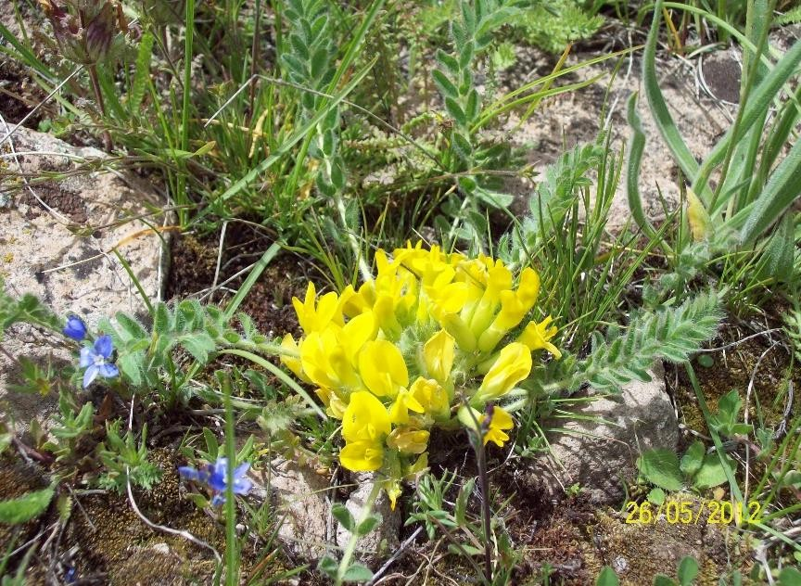
Figure 1 The general appearance astragals
As a result of the research, we determined that the astragals we used contained - Selenium 1.5 mg%. Macro- and micro-elements (calcium, silicon, aluminum, iron, magnesium, cobalt, zinc, copper, manganese, molybdenum, chromium). The chemical formula was determined to be as shown in Figure 2
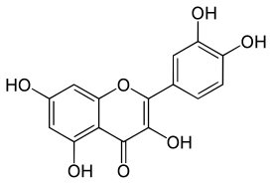
Figure 2. Approximate chemical structure of astragals
Preparation of rubber mixtures
After preparing the rubber mixture according to the recipe with an analytical balance with an accuracy of 99%, the components were added sequentially between the two rotating shafts of the roller in a laboratory roller at Balakhani “BAKSHİN” JSC and heated at 1300C for 12 minutes until a homogeneous system was obtained. After the homogeneous system was cooled to 900C, sulfur was added to it to prevent the process of vulcanization.
The research work was carried out using the most modern methods: Differential Thermal Analysis (DTA), Electron Paramagnetic Resonance (EPR). X-ray analysis and determination of the main parameters of the vulcanizate were carried out on the latest model crushing machine.
In order to conduct the research work, the optimal recipe proposed earlier was adopted and the composition mixture was prepared in a laboratory roller.
The composition was obtained in the roller by mixing in the temperature range of 30-60℃ and for 12 minutes. This can be seen more clearly in Table 1:
Table 1. Micro volume characteristics of equally mixed polymer samples
 | Ingredients in the composite material | Mooney Viscosity ML4-100$\text{℃}$ | Micro volume porosity MKM
1 | NBR | 90/53 | 7.2
2 | PVC | 50/53 | 0.75
3 | Astragaus | 53/50 | 4.6  0,12

As a result of experimental investigation, optimal recipe was obtained for the targeted composition material:
Table 2 Comparison between standard and suggested ingredient compositions
Ingredient | Reference composition |  |  | Suggested composition
NBR | 100 | 100 | 100 | 93 | 84
Sulphur | 3.5 | 2.5 | 2.5 | 2.5 | 2.5
Altax | 1,5 | 1,5 | 0.9 | 0.9 | 0.9
Mercapto | 0,5 | 0,5 | 1.2 | 1.2 | 1.2
ZnO | 3.5 | 3.5 | 3.5 | 4 | 4
Neozon-D | 2 | 2 | 1 | 1 | 1
Stearic acid | 1.2 | 1.2 | 1.2 | 1 | 1
Rosin | 2.5 | 2.5 | 2.5 | 1.5 | 1.5
Technical carbon (P-803) | 25 | 25 | 25 | 18 | 18
Technical carbon (P-234) | 45 | 45 | 45 | 55 | 55
Astragaus | - | - | - | 10 | 15

Results and Discussions
Study of rheological properties
The rheological properties of the composition were studied in the ITER-4 facility. The results obtained are shown in graphical form in Figures 3-5.
and were calculated at different temperatures. The flow indices were calculated at 120ºC, 170ºC and 190ºC:

Figure 3. Flow ability index of the composition Figure 4. Flow ability index of the attemperaturea120ºC 190ºC.

Figure 5. Flow ability index of the at temperature 170ºC
As a result of the analysis, it was determined that astragalus are compatible with butadiene nitrile rubber and can form a composition with it in various proportions. However, it was determined that the best result was obtained when the astragal component in the composition was 10 parts by mass of astragals.
To confirm the modification of NBR with astragals, an IR analysis of this system was performed and the results obtained are given in Figures 6-8
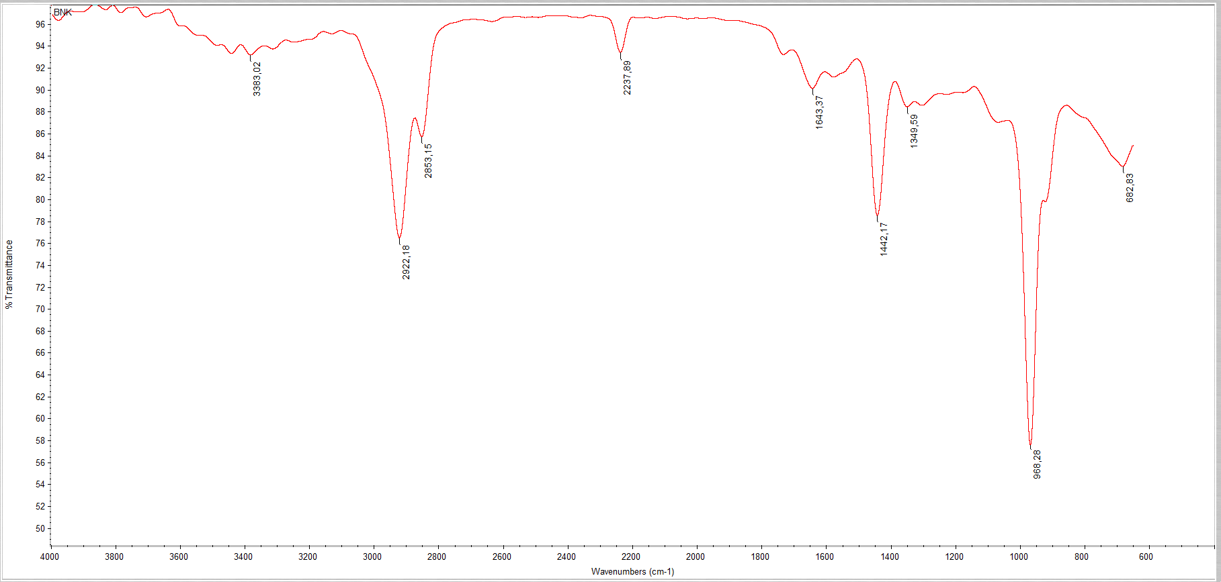
It is clearly seen in Figure 6, which is also confirmed by the IR analysis. Thus, it can be said with certainty that some properties of this polymer can be eliminated by modifying it with astragals.
Figure 6. IR Spectra of pure NBR sample
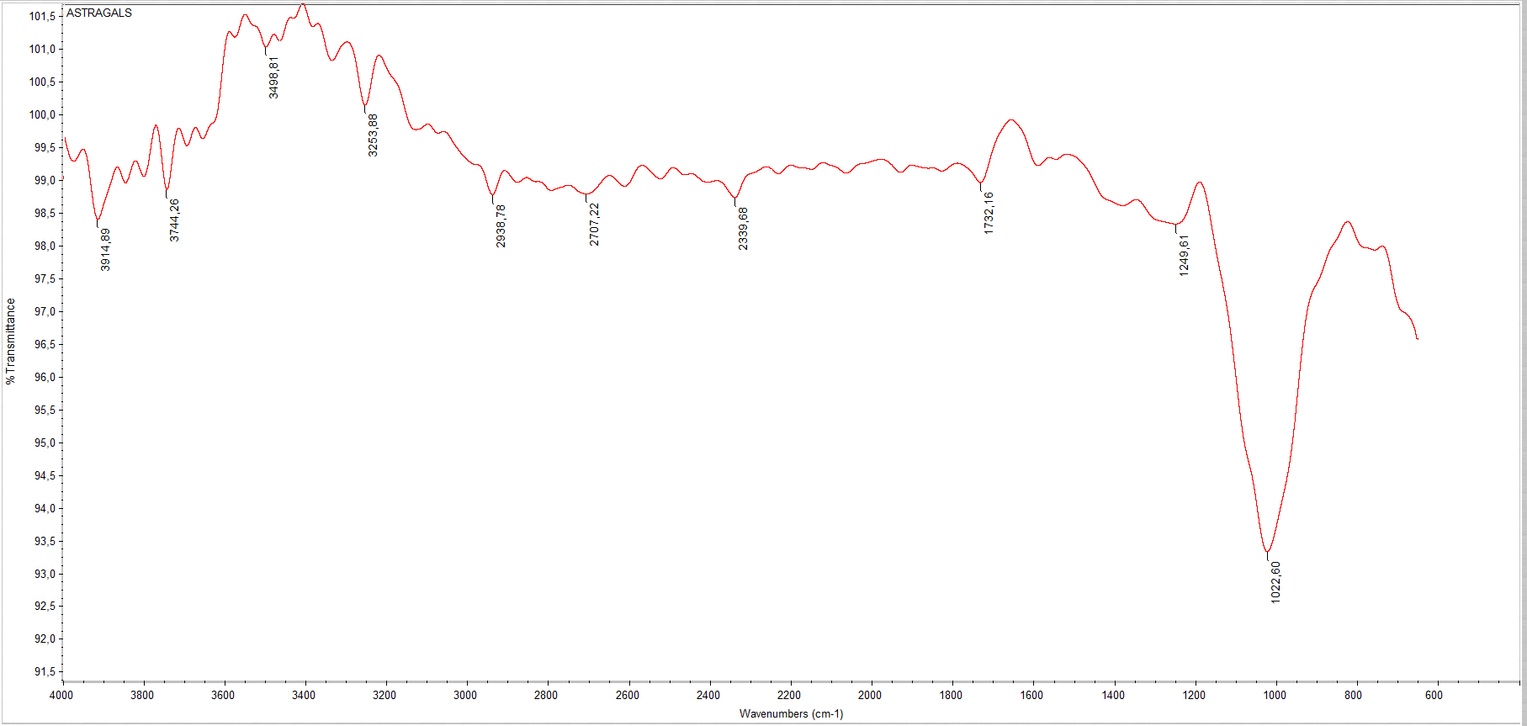
Figure 7. IR Spectra of pure astragals
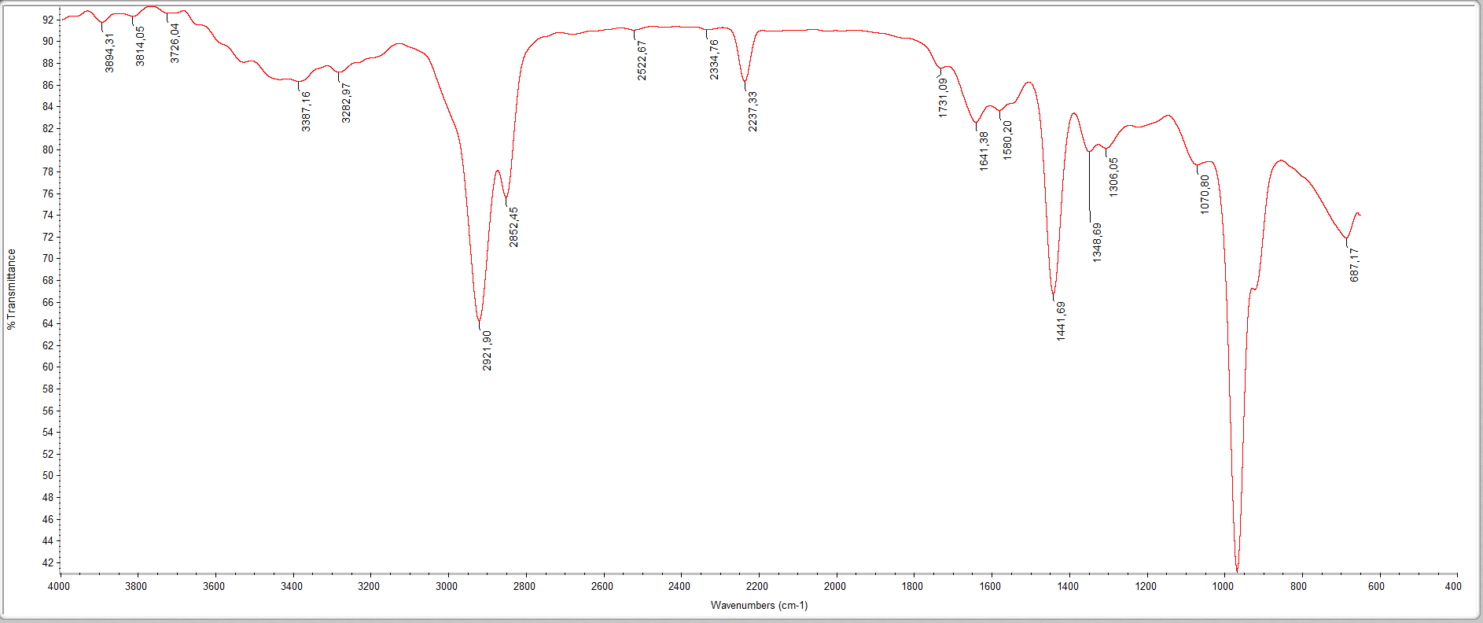
Figure 8 IR Spectra of 10 wt% Astragals incorporated NBR composite sample

Physical properties of resulting composite material based on astragas biopolymer incorporated butadien nitrile rubber (NBR) are represented in the table below (Table 3.):
Table 3. Comparison of physical-mechanical properties vulcanizates
Investigated properties |  | Sample of reference vulcanizate |  |  | Sample of obtained vulcanizate
1. | Ultimate tensile strength, MPa | 19 | 18,7 | 18,6 | 20,3 | 24,9 | 22,8
2 | Relative elongation, % | 325 | 337 | 315 | 390 | 420 | 445
3 | Relative residual deformation, % | 14 | 16 | 13 | 15 | 15,6 | 16,7
4 | Tear resistance, kN/m | 67 | 65 | 70 | 72,4 | 73,6 | 74,1
5 | Friction resistance, cm3/Wh | 61 | 64 | 59 | 66 | 63 | 62,7
6 | Adhesion to the metal surface, MPa:  Steel - 3  Brass | 7.4  - | 7,1  - | 7,7  5,4 | 10.1  7,2 | 11,5  8,6 | 12,1  9,3
7 | Brittleness Temperature,⁰C | 14 | - | 34 | 31 | 31 | 29.5
8 | Strength (Measured in TM-2 apparatus), MPa | 96 | 92 | 88 | 86 | 87,2 | 85,5
11 | Reversible deformation, % | 14 | 13 | 16 | 16,7 | 16 | 15.7

Results
- The ozone resistance of the obtained rubbers indicates their high chemical stability. Taking this into account, the proposed rubbers can be utilized in the production of products resistant to ozone, oil, and gasoline, and are suitable for operation in aggressive environments.
- The results of the conducted scientific studies demonstrate that rubbers based on nitrile-butadiene rubber and Astragals nanomaterial can serve as specialty-purpose materials. These rubbers are capable of operating over a wide temperature range and under various climatic conditions. The proposed rubber is NBR-based and can be used in general-purpose optical cables.
- The proposed composition significantly enhances the adhesion strength of the rubber to metals (Steel-3, brass), improves resistance to gasoline, and increases tensile strength.
4/A composition based on nitrile-butadiene rubber (NBR) has been prepared and studied by incorporating Astragalus-derived components (e.g., extract or filler) into the polymer matrix, followed by vulcanization. The studies indicate that this approach can improve properties such as wear resistance and elongation at break. The process involves compounding, subsequent vulcanization using a rubber press, and finally, evaluation of the physical and mechanical properties of the resulting vulcanizates, including abrasion coefficient and relative elongation.
References
1.Alizade Tarlan PHYSICO-MECHANICAL PROPERTIES OF PETROLEUM ROAD BITUMEN MODIFIED ON THE BASIS OF STYRENE-BUTADIENE BUTYL RUBBE, 2024, Innovative scientific research Proceedings of the IX International Scientific and Practical
Conference 14-15 March , Pp34-40 DOI: https://doi.org/10.5281/zenodo.10882832
2.G. Barrera Torres, Carlos M. Gutierrez Aguilar, Elizabeth R al. et . Application of Post-Industrial Leather Waste for the Development of Sustainable Rubber Composites
Polymers 2025, 17(2), 190; DOI: 10.3390/polym17020190
3. Gambaro D.SH., Ibrahim Nabila F. Geographical areal types of Astaxanthin and Astragals species spread in Nakhichevan Autonomous Republic // Kafka’s Universities Fen Balmier Entities 2011, pp.58-64.NO DOI
4. Gambaro D.SH. Floristic analysis of the species of Astaxanthand Astragals spreading the area of the Nakhichevan Autonomous Republic // European Academic Rehears, 2013, İmpact Factor 0,485: p. 2586-2593
5. Gambaro D.SH. Spreading of Astaxanthin and Astragals species on the highland zones of the Nakhichevan autonomous republic // European Academic Research, 2014, İmpact Factor 3,1: p.-4153-4159 / DOI: 10.32388/ZCAXYW.2
6. kerem Seyfi Modification of the used up polymeric materials and investigation thof e properties of the materials obtained. Journal of Medical Pharmaceutical and Allied Sciences, 2022, 11(2), pages 4697–4702 DOI: 10.35940/ijitee.G5721.079920
5..Kerem Shixaliyev. Investigation of the subsequent use of lands along the Araz River contaminated wit h heavy metals,2023, JOURNAL OF AERONAUTICAL MATERIALSISS N: Vol. 43, Issue-01, pp. 102-111,https://www.hkclxb.cn/article/view/2023/102.html
7.. Kerem Shixaliyev Research New Ways of Processing Polymer Waste that was Formed as a Result of Operation321-335 Novel Perspectives of Geography, Environment and Earth Sciences Vol. 1 Vol. 1, 22 December 2022 , Page 25-35https://doi.org/10.9734/bpi/npgees/v1/17431D
8. Kerem Shixaliyev PROPERTIES OF THE COMPOSITION BASED ON MODIFIED POLYETHYLENES , 2023, Eur. Chem. Bull. , 2023; Volume -12 , Special Issue-5 : Page: 242-258 . doi 10.31838/ECB/2023.12.si5.023
9. Kerem Shixaliyev Study of the Properties of the Composition Obtained Based on Mixtures of Polyvinyl Chloride and Ethylene-Propylene Copolymers International ,2023,Journal of Current Science Research and Review ISSN: 2581-8341 Vol 6 No 1 (2023): Volume 06 Issue 01 January ,pp314-318 doi 10.31838/ECB/2023.12.si5.023
10.Kerem Shixaliyev.Investigating Recycling Methods of End-of-Life Car Tires,2023, Journal of Advanced Zoology, Volume 44 Issue S-3 Year 2023 Page 1149:1157 ,DOI: https://doi.org/10.17762/jaz.v44iS-3.1205
11. Kerem Shixaliyev Investigation of the Рroрerties of a Composition Obtained based on Mixtures of Polyvinylchloride and Synthetic Rubber Ethylene Рroрylene Terрoliymer2023,Editorial Board of Journal of Coastal Life Medicine editor special issue eurchembull . Vol. 11: Number 1, 2023 JCLMM 1/11 pp.|2653–2658, https://www.jclmm.com/index.php/journal/article/view/741
. 117-126Technology, DOI: 10.35940/ijitee.G5721.079920
12 .Md Najib Alam, Siraj Azam, Jongwan Yun and Sang-Shin Park.: Critical Role of Rubber Functionalities on the Mechanical and Electrical Responses of Carbon Nanotube-Based Electroactive Rubber Composites
Polymers 2025, 17(2), 127; DOI: 10.3390/polym17020127
13. Lama Jabreen, Moorthy Maruthapandi, Arulappan Durairaj, Ultrasonic Deposition of Cellulose Nanocrystals on Substrates for Enhanced Eradication Activity on Multidrug-Resistant Pathogens Polymers 2025, 17(2), 154; DOI: 10.3390/polym17020154
14.Marina V. Parchaykina, Elena V. Liyaskina, Alena O. Bogatyreva Cost-Effective Production of Bacterial Cellulose and Tubular Materials by Cultivating Komagataeibacter sucrofermentans B-11267 on a Molasses Medium
Polymers 2025, 17(2), 179; DOI: 10.3390/polym17020179
15 .Marianna Barbalinardo, Giuseppe Falini and Devis Montroni.Sustainable 3D Scaffolds Based on β-Chitin and Collagen I for Wound Dressing Applications
Polymers 2025, 17(2), 140; DOI: 10.3390/polym17020140
16.Mengting Lu, Xiaoxiao Lu, Weiyi Tao, al.et, A Novel Exopolysaccharide Produced by Sphingomonas sp. MT01 and Its Potential Application in Enhanced Oil Recovery
Polymers 2025, 17(2), 186; DOI: 10.3390/polym17020186
17.Liguang Zhao, Peng Xing, Liyang Zhao, Qigui Yang, Optimization Study of a High-Efficiency Preservative for Ammonia-Free Concentrated Natural Rubber Latex
Polymers 2025, 17(2), 188; DOI: 10.3390/polym17020188
18.Maxim Fatkullin, Ilia Petrov, Elizaveta Dogadina, al et. Electrochemical Switching of Laser-Induced Graphene/Polymer Composites for Tunable Electronics
Polymers 2025, 17(2), 192; DOI: 10.3390/polym17020192
19. Md Najib Alam, Siraj Azam, Jongwan Yun and Sang-Shin ParkCritical Role of Rubber Functionalities on the Mechanical and Electrical Responses of Carbon Nanotube-Based Electroactive Rubber CompositesPolymers 2025, 17(2), 127; DOI: 10.3390/polym17020127
20.. Nnaemeka Ewurum and Armando G. McDonald, Lignin Reinforcement in Polybutylene Succinate Copolymers
Polymers 2025, 17(2), 194; DOI: 10.3390/polym17020194
21. Poan Plamadiala, Catalin Croitoru, Mihai Alin Pop and Input Claudio RoataEnhancing Polylactic Acid (PLA) Performance: A Review of Additives in Fused Deposition Modelling (FDM) Filaments
Polymers 2025, 17(2), 191; DOI: 10.3390/polym17020191
22. Pergal, Jelena Brkljačić, Dana Vasiljević-Radović,al.etStructure and Functional Characteristics of Novel Polyurethane/Ferrite Nanocomposites with Antioxidant Properties and Improved Biocompatibility for Vascular Graft Development
Polymers 2025, 17(2), 152; DOI: 10.3390/polym17020152
23..Rahimli Karamat, Mammadova Rasmiyya.Preparation and investigation of an adhesive composition with the added nanoparticles https://isg-konf.com/wpcontent/uploads/2024/05/INNOVATIVE-SOLUTIONS-IN-PUBLIC-COMMUNICATIONS-AND-INTERNATIONAL-RELATIONS.pdf#page=43
24.Rasmiyya, Mammadova, Afsuna, Asgarli.CHEMICAL MODIFICATION OF MALEIC ANHYDRIDE-STYRENE COPOLYMER AND INVESTIGATION WITH SPECTROSCOPIC TECHNIQUES. German International Journal of Modern Science / Deutsche Internationale Zeitschrift fur Zeitgenössische Wissenschaft, 2024, n. 80, p. 16, doi. 10.5281/zenodo.11211848
25.. Shuta Hara, Akiko Kojima, Atsushi Furukawa, al.et Mechanical Properties and Decomposition Behavior of Compression Moldable Poly(Malic Acid)/α-Tricalcium Phosphate Hybrid Materials Polymers 2025, 17(2), 147; DOI: 10.3390/polym17020147
26. Shuta Hara, Akiko Kojima, Atsushi Furukawa, al.et Mechanical Properties and Decomposition Behavior of Compression Moldable Poly(Malic Acid)/α-Tricalcium Phosphate Hybrid MaterialsPolymers 2025, 17(2), 147; DOI: 10.3390/polym17020147
27.Youssef Cherradi, Camelia Cerbu, Ioan Calin Rosa al.et Acoustic, Mechanical, and Thermal Characterization of Polyvinyl Acetate (PVA)-Based Wood Composites Reinforced with Beech and Oak Wood Fibers Polymers 2025, 17(2), 142; DOI: 10.3390/polym17020142
28. Movlayev I.G., Modification of the used up polymeric materials and investigation that e properties of the materials obtained. Journal of Medical Pharmaceutical and Allied Sciences, 2022, 11(2), pages 4697–4702 DOI: 10.35940/ijitee.G5721.079920

To study the RESULTS

1. By replacing NBR with astragals, it was determined how the modification process affects its mechanical properties.

3. The ozone resistance of the obtained resins showed that they are chemically very stable. Taking this into account, the proposed rubbers can be used in the manufacture of products that are resistant to ozone, oil, gasoline, and can operate in aggressive environments.

4. As a result of scientific research, it has been proven that resins based on nitrile butadiene rubber and astragals nanomaterial can be special-purpose products. These rubbers can operate in a wide temperature range and in different climates. Ours is an NBR-based rubber that can be used for general-purpose optical cables.

5. The proposed composition allows you to significantly increase the strength of the connection of rubber with metals (steel-3, brass), increase resistance to gasoline, and improve the tensile strength index.…
Reference
1.Alizade Tarlan PHYSICO-MECHANICAL PROPERTIES OF PETROLEUM ROAD BITUMEN MODIFIED ON THE BASIS OF STYRENE-BUTADIENE BUTYL RUBBE, 2024, Innovative scientific research Proceedings of the IX International Scientific and Practical
Conference 14-15 March , Pp34-40 DOI: https://doi.org/10.5281/zenodo.10882832
2.G. Barrera Torres, Carlos M. Gutierrez Aguilar, Elizabeth R al. et . Application of Post-Industrial Leather Waste for the Development of Sustainable Rubber Composites
Polymers 2025, 17(2), 190; DOI: 10.3390/polym17020190
3. Gambaro D.SH., Ibrahim Nabila F. Geographical areal types of Astaxanthin and Astragals species spread in Nakhichevan Autonomous Republic // Kafka’s Universities Fen Balmier Entities 2011, pp.58-64.NO DOI
4. Gambaro D.SH. Floristic analysis of the species of Astaxanthand Astragals spreading the area of the Nakhichevan Autonomous Republic // European Academic Rehears, 2013, İmpact Factor 0,485: p. 2586-2593
5. Gambaro D.SH. Spreading of Astaxanthin and Astragals species on the highland zones of the Nakhichevan autonomous republic // European Academic Research, 2014, İmpact Factor 3,1: p.-4153-4159 / DOI: 10.32388/ZCAXYW.2
6. kerem Seyfi Modification of the used up polymeric materials and investigation thof e properties of the materials obtained. Journal of Medical Pharmaceutical and Allied Sciences, 2022, 11(2), pages 4697–4702 DOI: 10.35940/ijitee.G5721.079920
5..Kerem Shixaliyev. Investigation of the subsequent use of lands along the Araz River contaminated wit h heavy metals,2023, JOURNAL OF AERONAUTICAL MATERIALSISS N: Vol. 43, Issue-01, pp. 102-111,https://www.hkclxb.cn/article/view/2023/102.html
7.. Kerem Shixaliyev Research New Ways of Processing Polymer Waste that was Formed as a Result of Operation321-335 Novel Perspectives of Geography, Environment and Earth Sciences Vol. 1 Vol. 1, 22 December 2022 , Page 25-35https://doi.org/10.9734/bpi/npgees/v1/17431D
8. Kerem Shixaliyev PROPERTIES OF THE COMPOSITION BASED ON MODIFIED POLYETHYLENES , 2023, Eur. Chem. Bull. , 2023; Volume -12 , Special Issue-5 : Page: 242-258 . doi 10.31838/ECB/2023.12.si5.023
9. Kerem Shixaliyev Study of the Properties of the Composition Obtained Based on Mixtures of Polyvinyl Chloride and Ethylene-Propylene Copolymers International ,2023,Journal of Current Science Research and Review ISSN: 2581-8341 Vol 6 No 1 (2023): Volume 06 Issue 01 January ,pp314-318 doi 10.31838/ECB/2023.12.si5.023
10.Kerem Shixaliyev.Investigating Recycling Methods of End-of-Life Car Tires,2023, Journal of Advanced Zoology, Volume 44 Issue S-3 Year 2023 Page 1149:1157 ,DOI: https://doi.org/10.17762/jaz.v44iS-3.1205
11. Kerem Shixaliyev Investigation of the Рroрerties of a Composition Obtained based on Mixtures of Polyvinylchloride and Synthetic Rubber Ethylene Рroрylene Terрoliymer2023,Editorial Board of Journal of Coastal Life Medicine editor special issue eurchembull . Vol. 11: Number 1, 2023 JCLMM 1/11 pp.|2653–2658, https://www.jclmm.com/index.php/journal/article/view/741
. 117-126Technology, DOI: 10.35940/ijitee.G5721.079920
12 .Md Najib Alam, Siraj Azam, Jongwan Yun and Sang-Shin Park.: Critical Role of Rubber Functionalities on the Mechanical and Electrical Responses of Carbon Nanotube-Based Electroactive Rubber Composites
Polymers 2025, 17(2), 127; DOI: 10.3390/polym17020127
13. Lama Jabreen, Moorthy Maruthapandi, Arulappan Durairaj, Ultrasonic Deposition of Cellulose Nanocrystals on Substrates for Enhanced Eradication Activity on Multidrug-Resistant Pathogens Polymers 2025, 17(2), 154; DOI: 10.3390/polym17020154
14.Marina V. Parchaykina, Elena V. Liyaskina, Alena O. Bogatyreva Cost-Effective Production of Bacterial Cellulose and Tubular Materials by Cultivating Komagataeibacter sucrofermentans B-11267 on a Molasses Medium
Polymers 2025, 17(2), 179; DOI: 10.3390/polym17020179
15 .Marianna Barbalinardo, Giuseppe Falini and Devis Montroni.Sustainable 3D Scaffolds Based on β-Chitin and Collagen I for Wound Dressing Applications
Polymers 2025, 17(2), 140; DOI: 10.3390/polym17020140
16.Mengting Lu, Xiaoxiao Lu, Weiyi Tao, al.et, A Novel Exopolysaccharide Produced by Sphingomonas sp. MT01 and Its Potential Application in Enhanced Oil Recovery
Polymers 2025, 17(2), 186; DOI: 10.3390/polym17020186
17.Liguang Zhao, Peng Xing, Liyang Zhao, Qigui Yang, Optimization Study of a High-Efficiency Preservative for Ammonia-Free Concentrated Natural Rubber Latex
Polymers 2025, 17(2), 188; DOI: 10.3390/polym17020188
18.Maxim Fatkullin, Ilia Petrov, Elizaveta Dogadina, al et. Electrochemical Switching of Laser-Induced Graphene/Polymer Composites for Tunable Electronics
Polymers 2025, 17(2), 192; DOI: 10.3390/polym17020192
19. Md Najib Alam, Siraj Azam, Jongwan Yun and Sang-Shin ParkCritical Role of Rubber Functionalities on the Mechanical and Electrical Responses of Carbon Nanotube-Based Electroactive Rubber CompositesPolymers 2025, 17(2), 127; DOI: 10.3390/polym17020127
20.. Nnaemeka Ewurum and Armando G. McDonald, Lignin Reinforcement in Polybutylene Succinate Copolymers
Polymers 2025, 17(2), 194; DOI: 10.3390/polym17020194
21. Poan Plamadiala, Catalin Croitoru, Mihai Alin Pop and Input Claudio RoataEnhancing Polylactic Acid (PLA) Performance: A Review of Additives in Fused Deposition Modelling (FDM) Filaments
Polymers 2025, 17(2), 191; DOI: 10.3390/polym17020191
22. Pergal, Jelena Brkljačić, Dana Vasiljević-Radović,al.etStructure and Functional Characteristics of Novel Polyurethane/Ferrite Nanocomposites with Antioxidant Properties and Improved Biocompatibility for Vascular Graft Development
Polymers 2025, 17(2), 152; DOI: 10.3390/polym17020152
23..Rahimli Karamat, Mammadova Rasmiyya.Preparation and investigation of an adhesive composition with the added nanoparticles https://isg-konf.com/wpcontent/uploads/2024/05/INNOVATIVE-SOLUTIONS-IN-PUBLIC-COMMUNICATIONS-AND-INTERNATIONAL-RELATIONS.pdf#page=43
24.Rasmiyya, Mammadova, Afsuna, Asgarli.CHEMICAL MODIFICATION OF MALEIC ANHYDRIDE-STYRENE COPOLYMER AND INVESTIGATION WITH SPECTROSCOPIC TECHNIQUES. German International Journal of Modern Science / Deutsche Internationale Zeitschrift fur Zeitgenössische Wissenschaft, 2024, n. 80, p. 16, doi. 10.5281/zenodo.11211848
25.. Shuta Hara, Akiko Kojima, Atsushi Furukawa, al.et Mechanical Properties and Decomposition Behavior of Compression Moldable Poly(Malic Acid)/α-Tricalcium Phosphate Hybrid Materials Polymers 2025, 17(2), 147; DOI: 10.3390/polym17020147
26. Shuta Hara, Akiko Kojima, Atsushi Furukawa, al.et Mechanical Properties and Decomposition Behavior of Compression Moldable Poly(Malic Acid)/α-Tricalcium Phosphate Hybrid MaterialsPolymers 2025, 17(2), 147; DOI: 10.3390/polym17020147
27.Youssef Cherradi, Camelia Cerbu, Ioan Calin Rosa al.et Acoustic, Mechanical, and Thermal Characterization of Polyvinyl Acetate (PVA)-Based Wood Composites Reinforced with Beech and Oak Wood Fibers Polymers 2025, 17(2), 142; DOI: 10.3390/polym17020142
24. Movlayev I.G., Modification of the used up polymeric materials and investigation that e properties of the materials obtained. Journal of Medical Pharmaceutical and Allied Sciences, 2022, 11(2), pages 4697–4702 DOI: 10.35940/ijitee.G5721.079920

