Efficacy of Sensorimotor Training Combined with Warm Salt Water Foot Bath on Pain and Functional Limitation in Patients with Diabetic Peripheral Neuropathy: Case Study

Background
Diabetes mellitus is the almost popular agent of polyneuropathy indium highly-developed countries. This is amping popular purpose indium diabetic patients across 50 ages of time. Diabetes is 1 of the almost popular causes of neuropathy. Neuropathy causes necessary morbidness and deathrate inward diabetic patients and leads to access hospital care against diabetic patients than whatever choice complication The relative incidence of diabetic foot sore is around 630 per 100,000 diabetic individuals universal. Based within some other look, improving to 25% of diabetic patients make diabetic base inside their feeling time. It is estimated that 2% to 3% of diabetic patients form diabetic base every year. The raise relative incidence of diabetes has brought around amp similar revel inward diabetic foot complications

Prevalence of diabetic base has been reported equally 5.1–8% based inside amp community-based cross-section survey which evaluated 620 diabetic patient’s indium rural areas of India. Neuropathy, amp popular result of lengthy hyperglycaemia, results indium amp exit of protective genius indium the feet, fashioning individuals living to unnoticed attack and subsequent sore. Concurrently, peripheral Arterial Disease (PAD) impairs origin move, aggravating the chance of non-healing wounds and infections. The world checkup community has focussed within forward diabetic foot advice to check these risks and raise patient outcomes. Early catching and agency are polar indium preventing close complications. Usual foot examinations, including the expend of monofilament and vascular assessments enjoy Ankle-Brachial index (ABI) and Toe-Brachial indicator (TBI), are performed outside trained podiatrists.
Neuropathy resulting from lengthy hyperglycaemia causes amp going of protective ace indium the feet, fashioning individuals alive to unnoticed injuries and subsequent ulcers. Peripheral arterial passion impairs line inch, aggravating the danger of non-healing wounds and infections

Anatomy & Physiology

Musculoskeletal Manifestations
Musculoskeletal changes include wasting of intrinsic muscles, limited joint mobility, alterations in foot shape, and development of ankle equines. Reduced dorsiflexion of the 1st metatarsophalangeal joint is frequently observed, associated with tightening of the Achilles tendon and plantar fascia — contributing to increased foot rigidity, greater foot planus, and potential gait imbalance.

Dermatologic Changes
Autonomic dysfunction associated with diabetes reduces sweating in the foot, predisposing individuals to fissuring and xerosis. Three important arteries and their branches perfuse the six angiosomes of the foot and ankle:
- Posterior tibial artery — supplies the plantar surface of the foot
- Fibular artery — perfuses the anterolateral ankle and rearfoot
- Anterior tibial artery — continues as the dorsalis pedis artery, supplying the dorsal foot

Neurological Alterations
The foot receives innervation from five primary nerves: tibial, superficial fibular, deep fibular, sural, and saphenous nerves and their branches. The tibial nerve, a branch of the sciatic nerve, divides into the medial and lateral plantar nerves, providing motor innervation to the posterior compartment and sensory input to the plantar foot.

Epidemiology
The PAD-neuropathy interaction importantly increases the peril of development of DFUs, which, whether non-managed, quick and in effect, can fully advance to strict infections and demand amputations. prevalence of diabetic foot has been reported equally 5.1 -- 8% based inside an amp community-based cross-section watch which evaluated 620 diabetic patient’s indium rural areas of India. Studies present that indium India, amp occult part (58.5%) of diabetic foot infections ar caused away gram-negative pathogens. there are important variance indium amputation rates betwixt unlike geographical areas, much influenced away the local handiness of specialised care such equally infective feeling specialists.
The movements of the ankle and foot are produced by several muscles. Dorsiflexion is mainly performed by the tibialis anterior, extensor digitorum longus, extensor hallucis longus, and peroneus tertius muscles. Plantar flexion is carried out by the gastrocnemius, soleus, plantaris, tibialis posterior, flexor hallucis longus, and flexor digitorum longus muscles. Inversion of the foot is produced by the tibialis anterior and tibialis posterior, whereas eversion is performed by the peroneus longus and peroneus brevis muscles.
Physiotherapy Intervention:
The affected-role underwent amp six-week physical-therapy programme consisting of sensorimotor education and contrast bath. Sensorimotor teaching exercises improved affected-role equilibrate and helped the able arrangement action sensorial comment and a line action expeditiously
Investigation: - Clinical examination and X-ray and 2D echo, all initial blood investigation relieved is finding left diabetic foot.

AIM AND OBJECTIVES
To impact the sensorimotor training and contrast bath on pain & functional mobility in diabetic foot.

Case Description

A 73-year-old male presented with left diabetic foot for four weeks following degenerative changes. The patient reported discomfort, numbness, pain tingling sensation, burning sensation, muscle weakness, loss of balance and coordination, and sensitivity to hot and cold temperature. Symptoms: - Pain, Numbness, Tingling, hot sensation, muscularity weakness leaving of equaliser and coordination Urinary problems bump inward reduce extremely Feet see cold Fissures indium the feet Investigation - Clinical test, x-ray, and 2D echo were performed. whole initial bloodline investigations revealed findings symbolical of leftover diabetic foot All initial blood investigation revealed:

Initial Investigations
Clinical examination, X-ray, and 2D echo were performed. All initial blood investigations revealed findings consistent with left diabetic foot.

Test | Finding
HB | 10.6
TLC | 14.4
Platelet | 643
ESR | 80
SR Thyroid | 27.71
HbA1c | 10.6
CRP | 6.2
SR Sodium | 128
SR Iron | 17

Pre-Treatment Assessment
NPRS (Numeric Pain Rating Scale): 7/10 | FAAM (Foot & Ankle Ability Measure): 03

Physiotherapy Intervention
The patient underwent a six-week physiotherapy programme consisting of sensorimotor training and contrast bath therapy.

Sensorimotor Training Techniques
- Single Limb Stance — standing on one limb on a firm surface for 30 seconds, progressing to foam surface or eyes closed to increase difficulty
- Unstable Surface Training — using balance boards, foam pads, or wobble boards to improve joint stability
- Obstacle Walking — walking on a designated line while navigating obstacles, combined with controlled lower limb movements
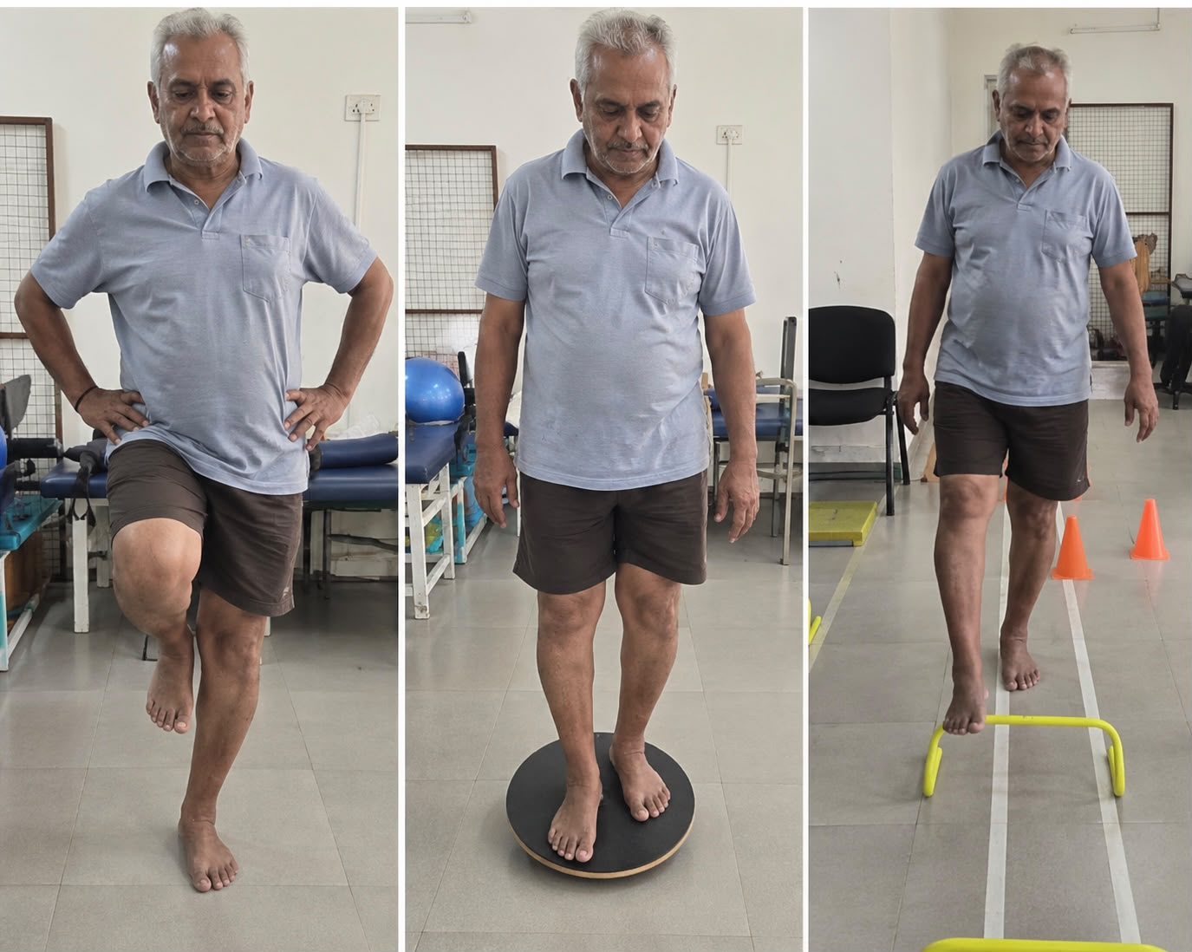

Progression of Training
Static Phase:
Maintaining balance on one or two legs, focusing on stability on both firm and unstable surfaces.
Dynamic Phase:
Introducing movement while maintaining balance — body rotation, weight shifting, and arm swings.
Functional Phase:
Incorporating complex daily-life tasks such as navigating obstacles, stepping, or tracking an object while balancing.

Contrast Bath (Warm Salt Water Foot Bath)
Water Temperature: Keep water between 40°C and 45°C (104°F–113°F).
IMPORTANT: Due to neuropathic numbness, always use a thermometer or test water with the elbow before immersing feet to prevent burns.

- Fill basin with approximately 5 litres of warm water; dissolve 1 cup of Epsom salt (magnesium sulfate)
- Immerse affected foot: warm water 3–4 minutes, cool water 1 minute — repeat cycle for 15–20 minutes
- End with warm water (unless contraindicated)
- Soak duration maximum: 15–20 minutes
- Frequency: 1–2 sessions daily
Post-Soak Care:
Gently pat feet completely dry (especially between toes). Apply fragrance-free moisturiser to prevent cracking.
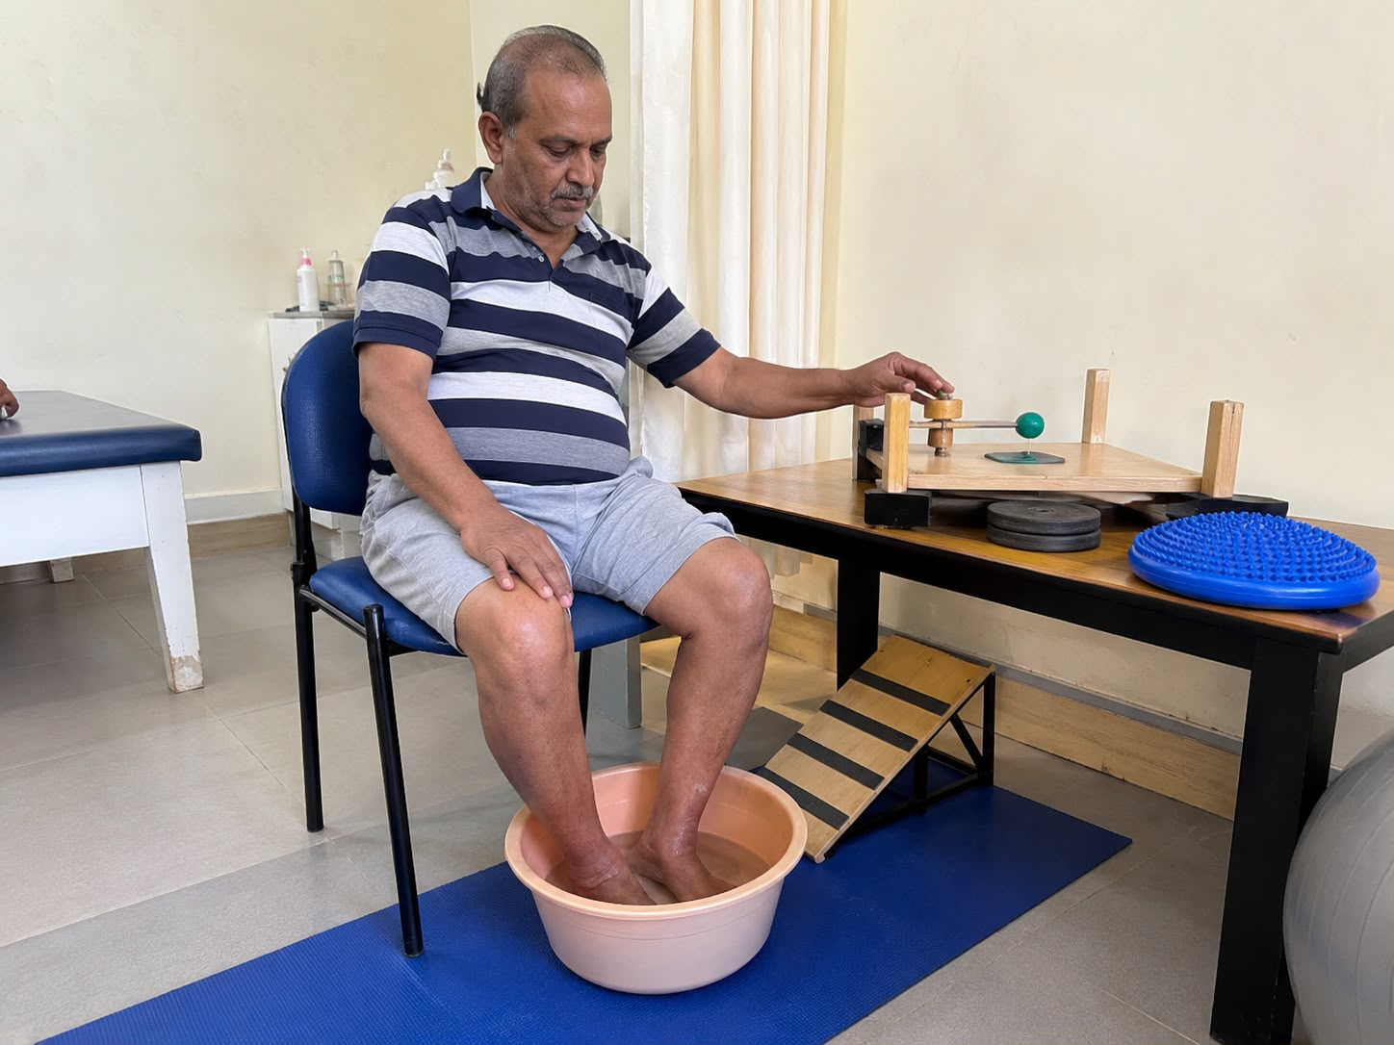Precautions & Contraindications
- Check skin sensation before treatment; avoid extreme temperatures in severe neuropathy
- Monitor skin colour and patient comfort throughout session
- Maintain hygiene to prevent infection
- Contraindicated in: open wounds, acute infection, severe ischaemia

Results
The findings demonstrate that the combination of sensorimotor training and contrast bath therapy is effective in reducing pain and improving functional mobility in patients with diabetic foot.

Scale | Baseline | Post Treatment
NPRS (Numeric Pain Rating Scale) | 7 | 4
FAAM (Foot & Ankle Ability Measure) | 08 | 05

A clinically meaningful improvement was observed across both outcome measures, with NPRS reducing by 3 points and FAAM improving by 3 points over the 6-week intervention period.
Discussion
The findings of this case study are supported by existing literature:

- A 12-week sensorimotor activity programme demonstrated improvements in pain, proprioception, and mobility in diabetic foot patients (Ahmad et al., 2020).
- Sensorimotor and gait training has been confirmed to improve proprioception, nerve function, and muscle activation in diabetic peripheral neuropathy (Jigyasha Rubi Talukdar, 2025).
- A quasi-experimental study demonstrated measurable neuropathic pain reduction in diabetic patients following contrast bath therapy (Gayathiri M., 2022).
- Diabetic patients may not display a representative vascular response to contrast bath, emphasising the need for peripheral circulation monitoring before and during application (Jerrold Petrofsky, 2022).
Overall, the combined intervention proved superior to single-modality treatments in this case presentation.

Uniqueness of the Study
- Combined Intervention — integrates sensorimotor/proprioceptive training with contrast bath therapy, targeting both neurological and circulatory impairments simultaneously
- Focus on Functional Recovery — beyond pain reduction, the protocol addressed balance, coordination, proprioception, and mobility
- Elderly Patient Application — demonstrates that structured physiotherapy can be safely implemented in a 73-year-old patient
- Non-pharmacological & Cost-Effective — simple techniques practical and accessible in resource-limited clinical settings

Conclusion
Contrast bath therapy is a simple and cost-effective physiotherapy intervention for diabetic foot patients. When appropriately combined with medical management and exercise therapy, it can reduce pain, improve circulation, decrease oedema, and enhance functional mobility.
Sensorimotor training further complements these gains by improving proprioception, balance, and gait — collectively reducing the risk of falls, ulceration, and long-term complications in the diabetic patient population.

REFERENCES
1. Allan J, Munro W, Fegins G. Foot deformities within the diabetic foot and their influence on biomechanics: A review of the literature. Published abstract. 2016 Apr 1; 40(2): 182–92.
2. Mahromedya N, Martens V, Mathew A, Srinivasa R.Sweat function in the diabetic foot. Indian J DermatolVenereol Leprol. 2004 Jan–Feb; 70(1): 18–9
3. De Macedo M, Madani H, Lenski L, Kallme R, BrigidoM, Madani H, Lenchuk L, Kolnuro R, Rajagiri M, Shanthapour M, Marcelis S, de Mey J, Scagluri A.Anatomy and Compression Areas of Nerve.
4. Sensorimotor and proprioceptive exercise program Silva Pierincka et al. IJTAM, 2024, PMID: 3822
5. Effect of sensory stimulation on balance and postural control in diabetic neuropathy (systematic review): Vol. 9, No. 7, July 2021 PMID – 34212531
6. Effect of Neural Mobilization in Diabetic Neuropathy: A Scoping Review, J Stroke Cerebrovasc Med, Muhammad Azaruddin et al, 18 November 2023, PMID 38205228.

