"Hierarchical Multiple Regression Analysis of the Effects of Demographic Factors on Population Growth in Nigeria"
(1973-2022)

* ¹Fadiji, A.A.; ²Karokatose, G.B.; ³Alakija, T.O.; ⁴Amusa, S.O.; ⁵Ganiyu, Y.A.; ⁶James, T.D.
Department of Statistics, Yaba College of Technology, Yaba, Lagos State, Nigeria.
*Corresponding Author: saidi.amusa@yabatech.edu.ng

Abstract
Nigeria's population reached an estimated 200 million by 2019 according to the National Population Commission, ranking it seventh globally and posing challenges for resources and infrastructure. This study examines demographic influences on population growth applying World Development Indicators data (1973-2022) using hierarchical multiple regression in three steps. Results showed that Model 1 (net migration only) was significant (R² = .190, p < .01), with migration positively predicting growth. Model 2 added death rate (R² = .196, ΔR² = .006, p > .05), showing no significant improvement; migration stayed significant, but death rate did not. Model 3 included fertility rate, yielding substantial gains (R² = .761, ΔR² = .565, p < .001). Fertility was the strongest positive predictor (p < .001), death rate a significant negative one (p < .001), and migration remained positive. These align with demographic transition theory, emphasizing fertility's dominance in developing nations amid high fertility and declining mortality. Overall, the hierarchical structure of the models demonstrates that although net migration has a consistent positive influence on population growth, the inclusion of fertility rate significantly enhances the model, highlighting its dominant role. The negative effect of death rate in the final model further confirms that reductions in mortality contribute to population expansion when fertility levels remain high.
Keywords: Population growth, Death rate, Fertility rate, Net migration, Multiple Regression Analysis

1.0 Introduction
Over time, Nigeria's demographic landscape has changed significantly. The National Population Commission (NPC) report from 2019 states that the country's population reached an estimated 200 million, making it the seventh most populous country in the world. The population is predicted to increase from 200 million in 2019 to 237.5 million by 2025, with an annual growth rate of 2.4-3% driven by a total fertility rate (TFR) of about 5.2 children per woman. Rapid population expansion affects infrastructure development, resource allocation, and general social well-being. It also poses possibilities and difficulties. Effective policymaking and sustainable development depend on an understanding of the causes of population rise. Bongaarts (2009) studied the demographic shift and the expansion of the human population. The author emphasized the consequences of demographic transition, such as longer life expectancies and decreased female fertility, which are seen in developed areas of the world while the least developed countries are seeing significant population growth. With an emphasis on the years 1950 through 2050, the study highlights important population growth patterns, including population size, fertility, mortality, and age structures. Bongaarts and Hogson (2020) extended Bongaarts (2009) work on human population growth and demographic transitions. The focus of the study is on fertility issues in developing countries. United Nations Population Division had categorized population patterns especially with fertility by referring to regions that are more industrialized and urbanized as “more developed regions” while the other category which is less industrialized and less urbanized as less developed regions. Fertility issues spanning a period of 70 years was extensively analysed by the authors. Korgbeelo (2025) examined the elements that influence Nigeria's population growth rate, including migration, birth, and death rates. The World Bank's development indicators, the National Bureau of Statistics' demographic statistics bulletin, and the Central Bank of Nigeria provided the annual time series data. The data was analyzed using the Granger Causality test, the Error Correction Model, and the Autoregressive Distributed Lag-approach to Cointegration. According to the predicted short-run and long-run regression results, the population growth rate is significantly positively impacted by the birth rate and net migration rate, while it is significantly negatively impacted by the death rate. Ene et al (2021) use yearly time series data from 1980 to 2018 to examine factors influencing population increase in Nigeria. The Autoregressive Distributed Lag Bound test methodology was the statistical method used. However, the authors discovered that there is a negligible negative correlation between infant mortality and Long-term population growth is negatively but significantly correlated with the maternal mortality rate, but long-term population growth is positively and significantly correlated with per-capital income and the total fertility rate. However, the research suggested that the federal government prioritize family planning and encourage girl-child education in order to prevent early child marriage and childbirths that reduce women's fertility.
Mofoluwawo et al. (2025) studied the origins, consequences, and viable remedies for sustainable national development of Nigeria's growing migration. According to the authors, this tendency is being driven by economic uncertainty, insecurity, and a lack of possibilities, brain drain, lower economic output, and a greater reliance on foreign aid are the causes that the writers stress. However, the researchers suggested a remedy to this issue that the government diversify the economy, enhance security, and make investments in job development and education. Nigeria's population shift and the achievement of sustainable development goals were examined by Abbani (2021). The author outlined the objectives, which included eliminating severe poverty and hunger, enhancing universal access to high-quality education, and improving women's and children's health. The National Population Census Report from 2006 and the National Demographic and Health Surveys from 1980 to 2018 were used in the study to analyze Nigerian demographic trends. The author found that it is typified by a high rate of population expansion, a slow decline in the fertility and death rates, and a poor performance of the sustainable development objectives.
Using National demographic Health Reports of 2013 and 2014 as well as UNICEF Reports of 2012 on Nigeria’s National Population Projections, Vitalis and Orionye (2021) investigated Nigeria's demographic composition as a treasure for national development or an insurmountable national burden. The study's conclusions show that population expansion is essential to the progress of any economy as it provides labor for the creation of products and services that advance economic development and is a key component in determining a nation's investment potential. The complex relationship between demographic indicators and population growth must be fully understood in order to identify and address these challenges. Comprehending the complex interrelationships among these demographic metrics and their combined influence on population expansion is crucial for well-informed policy formulation.

1.1 Aim and Objectives
This study investigates the influence of demographic measures on population growth in Nigeria with the following objectives:
- Investigating the relationship between Nigeria's population growth and net migration.
- To examine the effects of death rate and net migration on Nigeria's population growth.
- Investigating the impact of net migrations, the death rate, and the fertility rate on Nigeria's population growth.
1.2 Significance of the Study
This study is significant for several reasons. Firstly, it contributes to the existing body of knowledge by offering a nuanced understanding of the demographic factors influencing population growth in Nigeria. Secondly, the findings will be invaluable for policymakers, demographers, and researchers, providing them with evidence-based insights for developing targeted strategies to manage population growth effectively. Lastly, the study serves as a foundation for future research, fostering a deeper exploration of demographic dynamics and their implications for sustainable development.

2.0 Materials and Methods
This project utilized a quantitative research design, employing hierarchical multiple regression analysis. The design allowed for the examination of the relationship between demographic measures and population growth in a systematic and controlled manner.
2.1 STUDY AREA:
The study focused on Nigeria as the primary geographical scope due to its relevance to the research question and the availability of comprehensive demographic data. The research covered a specific time frame, considering the latest available data.
2.2 DATA COLLECTION:
Data for this project were sourced from reputable sources from World Development indicators (www.databank.worldbank.org).These sources provide comprehensive demographic information, including population size, birth rates, death rates, and net migration from (1973-2022). The dataset covered a specific time period to capture temporal trends, and efforts were made to obtain the most recent and accurate data available. This temporal scope enhances the project's ability to discern patterns and changes in population growth influenced by demographic measures.

2.3 STATISTICAL ANALYSIS SOFTWARE
The statistical analysis for this project was conducted using [SPSS], a widely recognized and validated tool for regression analysis. This software facilitated the execution of hierarchical multiple regression, providing statistical outputs necessary for interpretation.

2.4 Model Specification
In this multiple regression model, predictor variables are inserted into the regression equations in a particular order, and their effects on the dependent variables are evaluated.

Regression Model (Three Stages)
Stage 1: (Baseline Model)
$$Y= b_{0}+ b_{1}X_{1}+ ε$$
where
$Y$is dependent variable (Population Growth);
$b_{0}$ is intercept;
$b_{1}$ is coefficient for predictor $X_{1}$.
Stage 2: (Extended Model)
$$Y= b_{0}+ b_{1}X_{1}+b_{2}X_{2}+ ε$$
where
$X_{2}$ is additional predictor added in the second stage;
$b_{2}$is coefficient for predictor $X_{2}$.
Stage 3: (Full Model)
$$Y= b_{0}+ b_{1}X_{1}+b_{2}X_{2}+b_{3}X_{3}+ ε$$
where
$X_{3}$ is third predictor added in the third stage;
$b_{3}$is coefficient for predictor $X_{3}$.

3.0 Results & Discussion
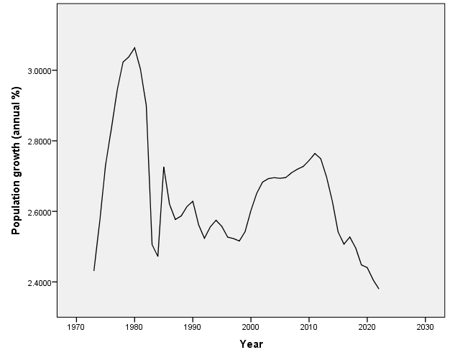
Figure 3. 1: Time plot of population growth in Nigeria.
In figure 3.1 above, population growth curve seems to be moving according to time. The variation is due to effect of fertility rate, death rate, net migration rate etc.

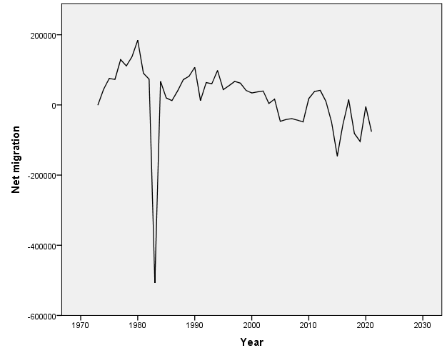
Figure 3.2: Time plot of Net Migration in Nigeria.
Figure 3.2 above illustrates the net migration plot with a shock that occurred in 1982. Further movement of the curve showed a near consistent pattern after the shock.

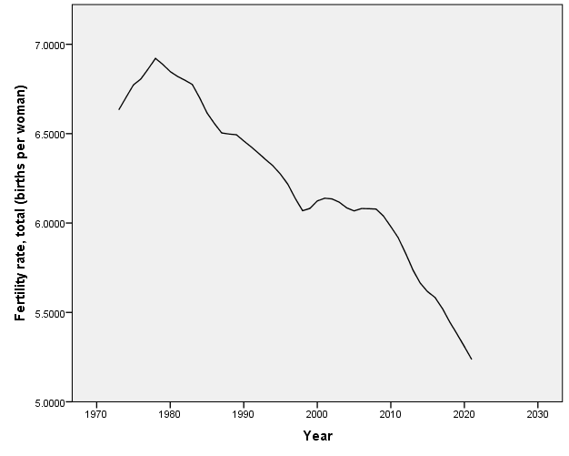
Figure 3.3: Time plot of Fertility rate in Nigeria.
In figure 3.3 above, the fertility rate also experienced a decline over the period under study. This can be explained that as more awareness on reproductive health is made available to the people, fertility rate tend to decline over time.

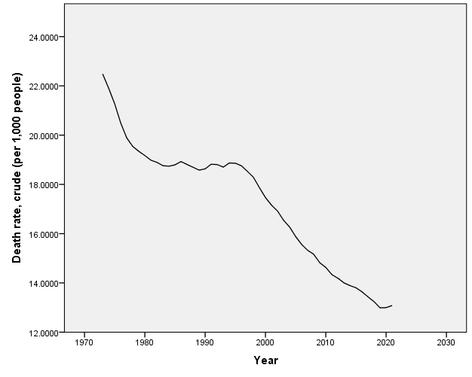
Figure 3.4: Time plot of Death rate in Nigeria.
As seen in figure 4 above, the death rate declined from year 1973 to year 2022 which implies that as more advancement is brought about by science and technology, life expectancy is increased, hence, fewer death rate is recorded.

Table 3.1: Summary of Inter-Correlations among the Predictors of Population Growth
 |  | Net migration | Fertility rate, total (births per woman) | Death rate, crude (per 1,000 people)
- Net migration |  | 1 | .350* | .387**
- Fertility rate, total (births per woman) |  | .350* | 1 | .904**
- Death rate, crude /(per 1,000 people) |  | .387** | .904** | 1
Note: $* Significant at p<0.05$. Also $** Significant at p<0.01$
Table 3.1 shows that there is a weak significant positive correlation (r(49) =.350, p<.05) between net migration and fertility rate. Furthermore, r(49) =.387, p<.05. showed a weak significant positive correlation between net migration and death rate. This suggests a slight but statistically significant trend for greater fertility rates to be associated with higher net migration, or more inflows than outflows.
The fertility rate and death rate have a very strong positive correlation (r(49) =.904, p <.05. A tight linear connection where greater death rates correspond with higher fertility rates (and vice versa) is implied by a very strong positive correlation (r(49) =.904, p <.05) between fertility rate and death rate, sharing almost 82% variance (r² ≈ 0.817) over ~51 data. In emerging nations like Nigeria, this trend is typical in the early phases of demographic change. In order to secure surviving offspring for work, security, and support in old life, couples are encouraged to have more children as "replacement fertility" due to high death rates (e.g., from infant/child mortality, inadequate healthcare). Through shorter birth intervals, resource rivalry, and maternal exhaustion, high parity also increases hazards to mothers and infants, resulting in a two-way loop.
Table 3.2: Summary of Hierarchical Multiple Regression Analysis for Variables Predicting Population
Growth.

Model |  | B | t | R² | ∆R² | P-value | Collinearity Statistics
 |  |  |  |  |  |  | Tolerance | VIF
1 | Constant | 2.640 | 122.616 |  |  | .000
 | Net migration | 7.114E-007 | 3.325 | .190 | .190 | .002 | 1.000 | 1.000
2 | Constant | 2.551 | 16.145 |  |  | .000
 | Net migration | 6.599E-007 | 2.824 |  |  | .007 | .851 | 1.176
 | Death rate, crude (per 1,000 people) | .005 | .569 | .196 | .006 | .572 | .851 | 1.176
3 | Constant | .403 | 1.784 |  |  | .081
 | Net migration | 6.577E-007 | 5.107 |  |  | .000 | .851 | 1.176
 | Death rate, crude (per 1,000 people) | -.097 | -8.712 |  |  | .000 | .177 | 5.656
 | Fertility rate, total (births per woman) | .627 | 10.318 | .761 | .565 | .000 | .182 | 5.483
- Dependent Variable: Population Growth (annual %)

The hierarchical multiple regression analysis was conducted in three steps to examine the predictors of population growth in Nigeria. Model 1 as shown in Table 3.2 considered net migration as the only predictor and is expressed as:
$$Population Growth= β_{0}+β_{1}Net Migration+ε$$ the estimated coefficients:
$$Population Growth= 2.640+7.144×{10}^{-7}Net Migration$$The model was statistically significant (R² = .190, p < .01), indicating that net migration explains 19.0% of the variation in population growth. The positive coefficient implies that an increase in net migration leads to an increase in population growth. This supports the view that migration contributes directly to population dynamics by altering population size (Todaro & Smith, 2020). Similarly, the Model 2 introduced death rate alongside net migration:
$$Population Growth(PG)= β_{0}+β_{1}Net Migration+β_{2}Death Rate+ε$$ Substituting the coefficients:
$$Population Growth= 2.551+6.559×{10}^{-7}Net Migration+0.005Death Rate$$
The model showed a slight increase in explanatory power (R² = .196, ΔR² = .006), but this increment was not statistically significant (p > .05). While net migration remained significant (p < .01), death rate was not a significant predictor (p > .05), suggesting that mortality does not independently explain population growth when migration is controlled for. This implies that the effect of mortality may be conditional on other demographic factors (United Nations, 2022).
Additionally, Model 3 incorporated fertility rate, giving the full model:
$$Population Growth= β_{0}+β_{1}Net Migration+β_{2}Death Rate+β_{3}Fertility Rate+ε \\ Substituting the coefficients: \\ PGrowth= 0.403+6.577 ×{10}^{-7}Net Migration-0.097Death Rate+0.627Fertility$$
This model showed a substantial improvement in explanatory power (R² = .761, ΔR² = .565, p < .001), indicating that 76.1% of the variation in population growth is explained by the combined predictors. Fertility rate emerged as the strongest and most significant positive predictor (p < .001), while death rate became a significant negative predictor (p < .001), and net migration remained positively significant. This result is consistent with demographic transition theory, which identifies fertility as the primary driver of population growth in developing economies, with mortality exerting an inverse effect (Bongaarts and Hogson, 2020; United Nations, 2022).
5.0 Conclusion
The demographic landscape of Nigeria has undergone substantial changes over the years. According to the National Population Commission (NPC) report (2019), the country's population reached an estimated 200 million, making it the seventh most populous country globally. Such rapid population growth presents both opportunities and challenges, impacting resource allocation, infrastructure development, and overall societal well-being. Understanding the factors that contribute to population growth is essential for effective policymaking and sustainable development. The hierarchical structure of the models demonstrates that although net migration has a consistent positive influence on population growth, the inclusion of fertility rate significantly enhances the model, highlighting its dominant role. The negative effect of death rate in the final model further confirms that reductions in mortality contribute to population expansion when fertility levels remain high.
6.0 Recommendations
Policymakers should give priority to expanding family planning initiatives, such as free contraception access and education campaigns aimed at rural and northern areas where total fertility rate surpasses six children, in order to counteract the predominant role that fertility plays in Nigeria's population expansion.

• Accelerate Fertility Decline: To lower total fertility rate by 2035, include reproductive health into primary school curriculum and provide subsidies for modern contraceptives.
• Leverage Mortality Gains: To further reduce mortality rates, maintain healthcare investments (immunization, maternity care), but combine them with fertility limits to prevent excessive growth.
• Manage Migration Impacts: To reduce unforeseen demographic surges, create labor export agreements with Gulf nations and ECOWAS while putting returnee reintegration programs into place.

• Harvest Demographic Dividend: Prior to the emergence of aging challenges, invest fertility and mortality savings in youth skills training (15–35 cohort, ~60% population) for economic output.
• Data-Driven Monitoring: To assess the impact of policies and dynamically modify thresholds, conduct yearly NPC surveys that track hierarchical model predictors.
By taking these evidence-based actions, Nigeria may move toward Stage 3 of the demographic transition, stabilizing growth at 250–270 million while reaping the economic rewards of a balanced age distribution.

7.0 References
Abbani, A. Y. (2021). Nigeria’s demographic transition and implications on the attainment of sustainable development goals. Global Journal of Social Sciences, 20(1), 1-10.
Bongaarts, J. (2009). Human population growth and the demographic transition. Philosophical Transactions of the Royal Society B: Biological Sciences, 364(1532), 2985-2990.
Bongaarts, J., & Hodgson, D. (2022). Fertility trends in the developing world, 1950–2020. In Fertility Transition in the Developing World (pp. 1-14). Cham: Springer International Publishing.

Ene, E. E., Nyiputen, I. R., & Ekpe, A. N. (2021). Determinants of population growth in Nigeria. International Journal of Innovation Research and Advanced Studies, 8(3), 31-35.

Korgbeelo, C. (2025). Determinants of Population Growth Rate: Empirical Evidence from Nigeria. BW Academic Journal.
Mofoluwawo, E. O., Wahab, E. I., & Ogunniyi, O. A. (2025). The Rising Migration in Nigeria: Causes, Effects and Pathways to Sustainable National Development. Ijagun Journal of Social and Management Sciences, 9(1), 88-94.
Pontianus, V. J., & Oruonye, E. D. (2021). The Nigerian population: A treasure for national development or an unsurmountable national challenge. International Journal of Science and Research Archive, 2(1), 136-142.
National Population Census Report, 2006.
National demographic Health Reports of 2013 and 2014
National Demographic Health Survey 1980-2018
Todaro, M. P., & Smith, S. C. (2020). Economic Development (13th ed.). Pearson.
United Nations Chidren and Education Fund Report 2012
United Nations Online Report. (2022). Report on the three largest economies in the world. Retrieved from [URL]
World Development Indicators (2019). www.worldbank.org

