DEMENTIA PREDICTION USING MEMORY BASED LEARNING APPROACH

Abstract-Dementia, neurocognitive disorder, manifests as a significant decline in cognitive abilities beyond typical aging processes. Dementia is the currently seventh leading cause of death and one of the major causes of disability and dependency among older people globally. Dementia results from a variety of diseases and injuries that affect the brain. Alzheimer disease is the most common form of dementia and may contribute to 60–70% of cases. Since there is no cure for dementia currently but early diagnosis can help their family to care tare of them more carefully. Our study focuses on helping the diagnosis process easier. The core idea is to create a system using machine learning algorithm like random forest classifier to train the model and implement the application using Html, Flask.
Keywords- Dementia; Aging; machine learning; Early diagnosis; Alzheimer disease; HTML; Flask

I.INTRODUCTION
Nowadays, the healthcare sector is undergoing a significant transformation with the integration of advanced technologies for disease prediction and management. Among the myriad diseases prevalent worldwide, dementia emerges as a critical concern due to its profound impact on individuals and society. Currently, more than 55 million people are affected by dementia globally, with over 60% residing in low- and middle-income countries. Annually, there are nearly 10 million new cases reported. Leveraging the transformative potential of machine learning, particularly memory-based learning approaches, offers a promising avenue for addressing this multifaceted challenge. This paper aims to focus on the integration of memory-based learning techniques, presenting a novel and efficient approach for dementia prediction. Through an exploration of various machine learning algorithms and optimization strategies, we seek to demonstrate the efficacy of our proposed methodology in accurately forecasting dementia status.
In this paper, we delve into the prediction of dementia using machine learning techniques. Section 2 provides an overview of current techniques available for dementia prediction in today's world. The subsequent sections detail the model training, testing, evaluation, and deployment processes. Section 4 outlines the machine learning algorithms and modules utilized in the deployment of the application. Finally, conclusions are drawn in Section 5, summarizing the findings and discussing potential avenues for future research and development in this field.

II.LITERACTURE SURVEY
This paper delves into the realm of predicting dementia onset using memory-based machine learning algorithms, aiming to address the pressing need for early detection and intervention in cognitive decline. Recent studies have focused on leveraging longitudinal data, including cognitive assessments, neuroimaging biomarkers, and genetic information, to develop more accurate and personalized prediction models for dementia risk stratification.
Novel approaches, such as deep learning architectures and federated learning techniques, are emerging as promising avenues for handling large-scale, heterogeneous datasets and capturing complex relationships between diverse risk factors and dementia outcomes. Moreover, advancements in data-driven methodologies, such as transfer learning and domain adaptation, are being explored to enhance model generalization across different populations and healthcare settings, paving the way for more robust and reliable prediction tools.
Despite these advancements, challenges persist in data privacy, model interpretability, and clinical translation, highlighting the importance of interdisciplinary collaboration between data scientists, clinicians, and policymakers to overcome barriers and facilitate the adoption of predictive models in real-world healthcare settings.
In summary, this literature review sheds light on the evolving landscape of dementia prediction using memory-based machine learning algorithms, offering valuable insights into future research directions and clinical applications for improving early detection and management of cognitive disorders.

III.PROPOSED APPROACH
The proposed approach to develop a dementia prediction we followed a systematic approach combining data preprocessing, model training, and performance evaluation. Initially, we imported necessary libraries and loaded the dataset containing demographic and clinical features of subjects. Following data preprocessing steps, including handling missing values and encoding categorical variables, we prepared the data for modeling.
For exploratory data analysis, we visualized the distribution of target classes (demented and nondemented) and the independent features. These visualizations provided insights
into class imbalances, severity of dementia in the dataset.

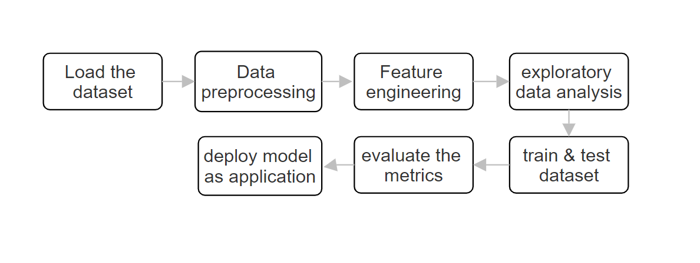
Fig 1. Flow of the system
A.Numpy:
A fundamental package for scientific computing with Python, providing support for large, multi-dimensional arrays and matrices. pandas: A powerful data manipulation and analysis library, offering data structures and operations for manipulating numerical tables and time-series data. numpy provided essential functionalities for model training and evaluation.
We utilized numpy arrays to represent features and target variables, enabling seamless integration with machine learning algorithms from libraries like scikit-learn. Numpy's array operations allowed us to split the data into training and testing sets with ease, ensuring consistency and reproducibility in our experiments.

B. Pandas:
Pandas is a popular open-source Python library used for data manipulation and analysis. It provides powerful and flexible data structures, such as DataFrame and Series, that allow users to efficiently handle structured data, including tabular and time series data. Pandas is widely used in various domains, including data science, finance, research, and academia.
Pandas is leveraged for data ingestion, serving as the conduit through which the dataset, encapsulating demographic and clinical features of subjects, is ingested from an external CSV file. This operation is executed seamlessly through the employment of the pd.read_csv() function, facilitating the instantiation of a Pandas DataFrame, a quintessential entity for structured data representation and manipulation.
C. Matplotlib:
A comprehensive library for creating static, interactive, and animated visualizations in Python, enabling data exploration and presentation.
Matplotlib, a prominent visualization library in Python, is employed to generate informative visualizations throughout the data analysis and model evaluation stages. Matplotlib is utilized to create informative visualizations that aid in exploring the dataset's characteristics. For example it used for visualization of dependent and independent features, ROC curves and confusion matrix.
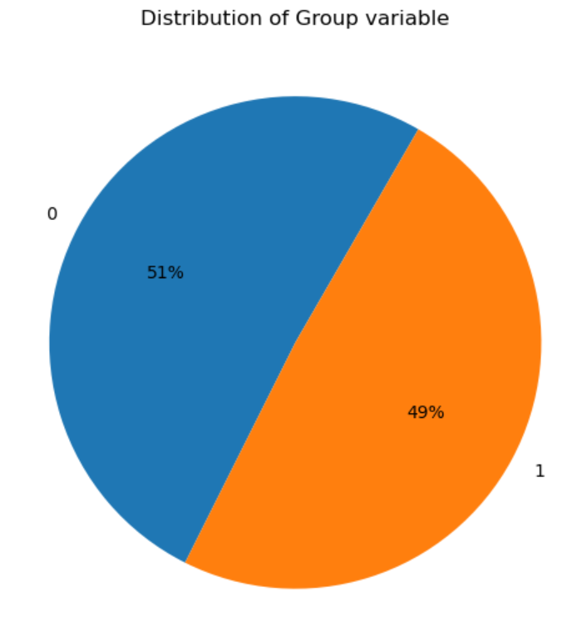
Fig 2. Pie chart created using matplotlib, shows number of demented and non - demented cases.

D. Seaborn:
Seaborn is a Python data visualization library built on top of Matplotlib that provides a high-level interface for creating attractive and informative statistical graphics. It is specifically designed for visualizing statistical relationships in data and is widely used in data analysis, exploration, and presentation.

Seaborn is utilized primarily for exploratory data analysis (EDA) and visualizing the distribution of data. Specifically, Seaborn is used to generate informative visualizations that aid in understanding the characteristics of the dataset and in gaining insights into the distribution of target variables.

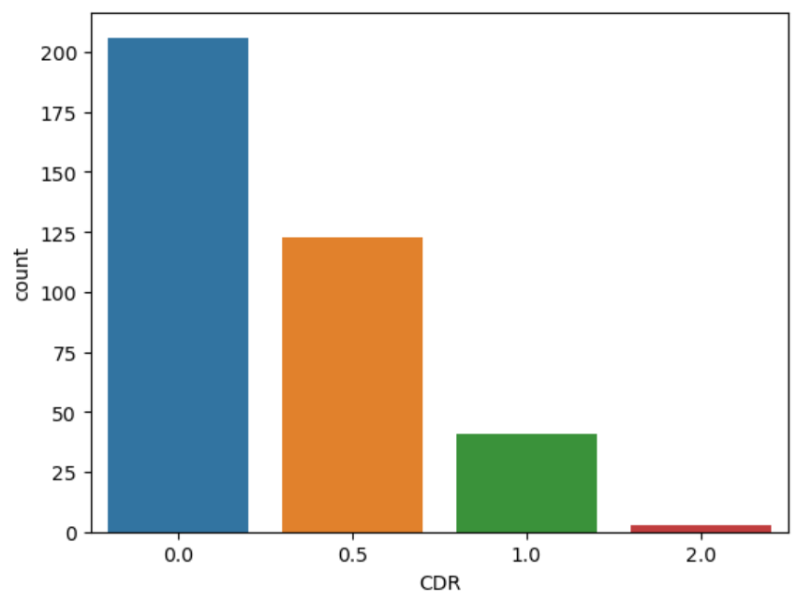
Fig 3. Bar graph created using seaborn shows the
Number of persons in each range of CDR

IV.IMPLEMENTATION AND RESULTS

- Data Preprocessing:
The first of the approach is to load the dataset. The module utilizes efficient querying techniques to navigate through the vast OASIS dataset, retrieving relevant records based on predefined criteria. After that data preprocessing begins, cleanse the data to handle missing values, outliers, and inconsistencies. Standardize and normalize features to ensure uniformity and facilitate model convergence. Standardize and normalize features to ensure uniformity and facilitate model convergence. This step involves scaling numerical features to have zero mean and unit variance or scaling features to a specific range, such as [0, 1].

B)Feature Engineering:
Extract relevant features from the dataset, such as cognitive test scores, age, education level, family history of dementia, etc. Perform dimensionality reduction techniques feature selection methods to mitigate the curse of dimensionality and enhance model performance. These techniques help enhance model efficiency by reducing the number of features while preserving essential information. Feature engineering is a crucial step in shaping the input variables for the subsequent modeling phase, ensuring that the model is trained on relevant and informative features.

C)Model Train And Evaluate:

1)Dataset Splitting:
Split the preprocessed dataset into training, validation, and testing sets. The training set is used to train the model, the validation set is used to optimize hyperparameters and prevent overfitting, and the testing set is used to evaluate the model's performance.

2)Model Training:
Train the memory-based learning model, such as a machine learning classifier or a deep learning model, on the training data. Adjust hyperparameters through techniques like cross-validation to optimize model performance and generalization ability.

3)Model Evaluation:
Assess the trained model's performance using evaluation metrics tailored to dementia prediction, such as accuracy, sensitivity, specificity, precision, recall, and F1-score. Conduct cross-validation to estimate the model's generalization ability and stability across different subsets of the data. Analyze the model's performance on the testing set to validate its effectiveness in real-world scenarios.

D) Deploy Application:
Upon successful training and evaluation, the model is ready for deployment in clinical or research settings. It is integrated into existing healthcare systems or decision support tools to aid clinicians in identifying individuals at risk of dementia. Continuous monitoring and periodic updates are implemented to ensure the model remains relevant and effective as new data becomes available over time. This deployment phase ensures the practical applicability of the developed model, fostering its utility in real-world scenarios and contributing to advancements in dementia prediction and patient care.
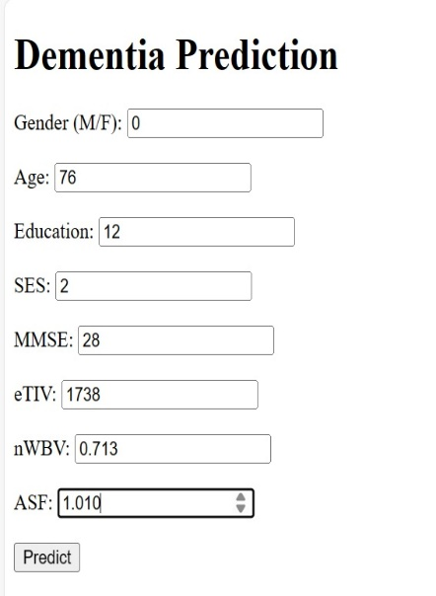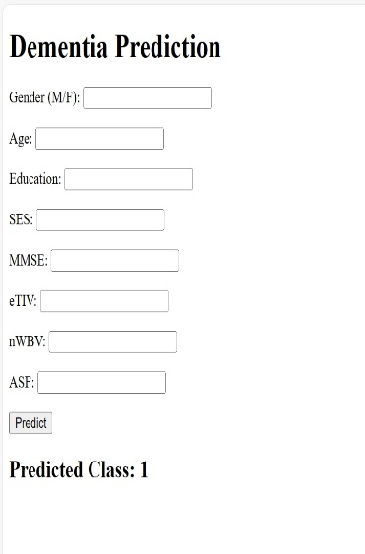

V. CONCLUSION
In conclusion, our project outlines a comprehensive approach to dementia prediction, integrating data preprocessing, feature engineering, model training, evaluation, and deployment. By gathering diverse datasets encompassing demographic, medical, lifestyle, cognitive, and genetic information, we ensure a holistic representation of factors influencing dementia risk. Through meticulous data cleansing, standardization, and normalization, we enhance data quality and facilitate model convergence. Feature engineering techniques, including extraction and dimensionality reduction, enable us to identify relevant predictors and mitigate dimensionality challenges.
Subsequent model training and evaluation phases involve rigorous dataset splitting, hyperparameter tuning, and performance assessment using tailored evaluation metrics. By leveraging memory-based learning models and cross-validation techniques, we optimize model performance and ensure robustness against overfitting.
The deployment of our trained model in clinical and research settings marks a crucial step towards real-world application. Integrating the model into existing healthcare systems empowers clinicians with a powerful tool for identifying individuals at risk of dementia and informing personalized intervention strategies.
Overall, our project represents a significant advancement in the field of dementia prediction, offering a systematic and data-driven approach to early detection and intervention, ultimately contributing to improved patient outcomes and enhanced healthcare delivery.

VI. REFERENCES
1. Alzheimer’s Association. (2020). 2020 Alzheimer's disease facts and figures. Alzheimer's & Dementia, 16(3), 391-460.
2. Livingston, G., Huntley, J., Sommerlad, A., Ames, D., Ballard, C., Banerjee, S., ... & Mukadam, N. (2020). Dementia prevention, intervention, and care: 2020 report of the Lancet Commission. The Lancet, 396(10248), 413-446.
3. Cui, Z., Zhong, S., Xu, P., He, Y., Gong, G., & Poldrack, R. A. (2021). Machine learning for neuroimaging with scikit-learn. NeuroImage, 220, 117149.
4. Vieira, S., Pinaya, W. H., Mechelli, A., & Using Deep Learning to Investigate the Neuroimaging Correlates of Psychiatric and Neurological Disorders: Methods and Applications. (2017). NeuroImage: Clinical, 17, 879-888.
5. Sarraf, S., & Tofighi, G. (2016). Deep learning-based pipeline to recognize Alzheimer's disease using fMRI data. In Healthcare Innovation Point-Of-Care Technologies Conference (HI-POCT), IEEE (pp. 105-108).
6. Marquand, A. F., Kia, S. M., Zabihi, M., Wolfers, T., Buitelaar, J. K., & Beckmann, C. F. (2019). Conceptualizing mental disorders as deviations from normative functioning. Molecular Psychiatry, 24(10), 1415-1424.
7. Rathore, S., Habes, M., Iftikhar, M. A., Shacklett, A., & Davatzikos, C. (2017). A review on neuroimaging-based classification studies and associated feature extraction methods for Alzheimer's disease and its prodromal stages. NeuroImage, 155, 530-548.
8. Prince, M., Bryce, R., Albanese, E., Wimo, A., Ribeiro, W., & Ferri, C. P. (2013). The global prevalence of dementia: A systematic review and metaanalysis. Alzheimer's & Dementia, 9(1), 63-75.e2.
9. Dubey, H., Parmar, V., Khan, A. A., & Jain, S. (2021). An efficient convolutional neural network for Alzheimer’s disease prediction using neuroimaging data. SN Computer Science, 2(4), 1-13.
10. Li, H., & Liao, X. (2020). A deep learning-based multi-model ensemble method for early diagnosis of Alzheimer’s disease. Scientific Reports, 10(1), 1-14.

