Effects of Essential Oils in Swiss Albino Mice

Md. Golam Haider *¹
, Eti Begum¹, Md. Taimur Islam¹, Abu Naser Md. Aminoor Rahman²
¹Department of Pathobiology, Faculty of Veterinary Medicine and Animal Science, Gazipur Agricultural University, Gazipur 1706, Bangladesh.
²Department of Gynecology, Obstetrics and Reproductive Health, Gazipur Agricultural University, Gazipur 1706, Bangladesh.
*Corresponding Author: ghaider@gau.edu.bd; Phone +8801712642948

Abstract
The present study was untaken to use essential oils in Swiss albino mice in the department of Pathobiology. Essential oils (Eos) are concentrated liquids of complex mixtures of volatile compounds. Essential oils are a good source of several bioactive compounds, which have antioxidative and antimicrobial properties. The experiment was carried out on Swiss Albino mice (Mus musculus). Twenty-Five (25) mice of 7 days old were bought from the Animal Resource Center, ICDDR, B. The collected mice had neither any developmental disorders, detectable genital diseases nor other diseases that may cause any problem in the experiment or affect the result of the experiment. Twenty-five (25) mice at 21 days old were randomly used for the experiment and the mice were divided into five groups and each group will consists of five mice. Groups I, II, III & IV received orally Pulmo Gold 1ml/5L water, Activo Powder -100mg/kg feed, Reference liquid-5ml/1L water and Respocare liquid-5ml/1L doses of the essential oils, respectively. Group-V (control group) will be supplied with normal foods and ad libitum water. In case of control group (group-V), the body weight gaining rate is lower than the other treated groups. The highest number of microorganisms are found in control group and 4 samples are contaminated with microbes out of 5 samples incased of kidneys and intestine. On the other hands 5 samples are contaminated incased of liver. The lowest number of organisms are found in group II (Activo Powder) and 1 sample of kidney, liver and intestine are associated with microorganisms.

Keywords: Essential oils, Effects, Internal organs, Mice

Introduction
Essential oils (Eos) are concentrated liquids of complex mixtures of volatile compounds and can be extracted from different parts of plants, for example, leaves, peels, barks, flowers, buds, seeds, and so on. Essential oils are a good source of several bioactive compounds, which have antioxidative and antimicrobial properties (Rao et al., 2019). In addition, some essential oils have been used as medicine. Furthermore, the uses of essential oils have received increasing attention as the natural additives for the shelf-life extension of food products, due to the risk in using synthetic preservatives. (Tongnuanchan et al., 2014). The essential oils have been recognised for antimicrobial properties for centuries and, with growing demand from changes in legislation, consumer trends and increasing isolation of antibiotic resistant pathogens, alternatives to chemical-based bactericides need to be found (Fisher et al., 2008).
EOs are concentrated natural products with strong smells that are produced by aromatic plants as secondary metabolites. These oils are present as variable mixtures of primarily terpenoids, especially monoterpenes (C10) and sesquiterpenes (C15), although diterpenes (C20) may also be present. A variety of other molecules also occur, such as acids, alcohols, aldehydes, aliphatic hydrocarbons, acyclic esters or lactones; rare nitrogen- and sulphur-containing compounds; coumarins; and homologues of phenylpropanoids. Eos are extracted from various aromatic plants that are generally found in temperate or warm countries, where they often represent an important part of the traditional pharmacopoeia. These plants may be known for their antioxidant effects as well as their antiseptic and medicinal properties and fragrance are often used in the preservation of foods and asanalgesics, sedatives, anti-inflammatories, spasmolytics and local anaesthetics. Eos contain a wide series of secondary metabolites that can inhibit or slow the growth of bacteria, yeasts and moulds. The EOs and their components have a variety of targets, particularly the membrane and cytoplasm, and in certain situations, they completely alter the morphology of the cells (Nazzaro et al., 2013).
The most recent studies reveal that essential oils drugs are vigorously used in Poultry industry in all over the world because these kinds of drugs are affected on body weight gain and reduce microorganisms in different organs. Emergence of antibiotic resistant bacteria has created the necessity of replacement of antibiotic with other products like prebiotics, organic acid botanicals, and herbal essential oils. Essential oils are important aromatic components of herbs and spices, that are used as natural alternatives for replacing antibiotic growth promoters (AGPs) in poultry feed as these possess antimicrobial, antifungal, antiparasitic, and antiviral properties. Besides, other beneficial effects of essential oils are including appetite stimulation, improvement of enzyme secretion related to food digestion, and immune response activation. Some essential oils appear to exhibit particular medicinal properties that have been claimed to cure one or another organ dysfunction or systemic disorder (Silva et al., 2003; Hajhashemi et al., 2003; Perry et al., 2003).
Recently, use of essential oils in broiler chickens has drawn attentions and are generally used as blend with a carrier oil or combination with other plant oils in the feed to enhance the productive performance of birds. (Krishan et al., 2014). Essential oils are perceived as growth promoters in poultry diets (Zhang et al., 2014).
That’s why the experiment will be performed on Swiss Albino mice as a poultry model to observe the beneficial effects of essential oils drugs. The researches at cells and tissues level are also very much limited to clear the concepts about beneficial effects of essential oils drugs on various vital organs of the body. So, this experiment will be conducted to investigate the beneficial effects on tissues and microbial load in vital organs of essential oils drugs induced Swiss Albino mice and the results will be very much helpful for the pathologists as well as researchers also to understand, diagnosis and clarify these results as evidence of beneficial effects of essential oils. Thus, the present piece of work will be praiseworthy if it will provide the details about beneficial effects of essential oils drugs on body weight gain, microbial load and histopathological changes of vital organs. Therefore, the specific objectives are investigation the beneficial effects of essential oils on the body weight gain & microbial load in different organs, and the gross and histopathological lesions of Swiss albino mice occurs due to ingestion of essential oils
Materials and methods

The experiment was conducted in the laboratory of the Department of Pathobiology, Gazipur Agricultural University, Gazipur-1706, during November 2023 to June, 2024.
Ethical approval
The ethical approval of this study was received from the Local Ethics Committee for Animal Experiments of Gazipur Agricultural University, Gazipur-1706| (FVMAS/AREC/2023/47).

Experimental animals
The experiment was carried out on Swiss Albino mice (Mus musculus). Twenty-Five (25) mice of 7 days old were bought from the Animal Resource Center, ICDDR, B. The collected mice had neither any developmental disorders, detectable genital diseases nor other diseases that may cause any problem in the experiment or affect the result of the experiment.

Rearing and care
The mice were adapted at Pathobiology Laboratory, FVMAS, GAU for the period of 14 days before being used for the experiment (Figure 1). The mice were housed in compartmentalized rectangular cages wrapped with wire mesh. The cages were kept in well ventilated room at 28±2 ºC and a relative humidity of 70-80% with natural day and light. The mice were cared in proper hygienic conditions, with experimental & normal feeding ad libitum. Standard mouse-pellets (collected from ICDDR, B) was used as normal feed (1). During the experimental period, uniformity of the management practices was maintained as much as possible.

Experimental design
Twenty-five (25) mice at 21 days old were randomly used for the experiment and the mice were divided into five groups and each group will consists of five mice which will be marked as group-I, group-II, group- III, group-IV and group-V. The group-V will be treated as control group and other groups will be treated as sample groups. Groups I, II, III & IV received orally Pulmo Gold® 1ml/5L water, Activo Powder® -100mg/kg feed, Reference liquid®-5ml/1L water and Respocare liquid®-5ml/1L doses of the essential oils respectively. Group-V (control group) will be supplied with normal foods and ad libitum water.

Experimental procedure
Groups I, II, III & IV received orally Pulmo Gold® 1ml/5L water, Activo Powder® -100mg/kg feed, Reference liquid®-5ml/1L water and Respocare liquid®-5ml/1L doses of the essential oils will be administered orally once daily for 45 days to sample groups, respectively. Group-V (control group) will be supplied with normal foods and ad libitum water.

Sample collection
After administration of essential oils drugs for 45 days, different important organs (Intestine, liver, kidney) will be collected from the mice of both control and sample groups to investigate the beneficial effects of essential oils drugs. The whole experiment will be conducted in the central laboratory, Faculty of Veterinary Medicine and Animal Science, Gazipur Agricultural University, Gazipur-1706.

Sample preservation
Immediately after killing, commercially available cotton tipped swabs were used after sterilization by autoclaving for the collection of swabs of different organs for bacteriological study. The vital organs were collected as soon as possible with the help of scalpel and scissors avoiding any destruction of the organs. The specimens then were collected and fixed in the 10% formalin solution.

Gross and Histological study
The gross lesions were recorded during postmortem. Histopathology was done in the Department of Pathobiology, GAU, Gazipur. The gross study was done by visual observation. Detail histological study was completed using low and high-power light microscopy.

Statistical analyses
During the study period we were regularly collecting the data of daily feed intake measure and weakly body weight measure of the mice. After study period we were collect their gross anatomical data.

Photomicrography
Photomicrography was taken using photomicrographic camera (ZEISS AxioCam ERc5s) facilities facilitated by Department of Gynecology, Obstetrics and Reproductive Health, GAU.

Data Interpretation
Finally, at the end of and histopathological study, all the data were compiled, compared and analyzed for constructive interpretation.
Statistical analysis was performed using SPSS (IBM@ Version 21.0, USA). All results are represented as the Means ± S.E. For the comparison, one-way analysis of variance (ANOVA) was carried. Differences were considered to be statistically significant when the p value was less the 0.05.
Results
Beneficial Effects of Essential Oils on body weight gain
Essential oils are plant component which possess antimicrobial activity and increase the body weight gradually. The following graph (Figure 2) represented the beneficial effect of different essential oils drugs on body weight gain. In case of control group (group-V), the body weight gaining rate is lower than the other treated groups. And, the group-II and group-IV showed the higher body weight gaining rate. Analysis of variance of the results revealed that the differences in the changes of body weight gaining rate among the different groups (both control and treated) was significant (p<0.05).

Effect of Essential oils drugs on microbial load in different organs:
Essential oils have different components and possess several activities such as antibacterial, antifungal, antiparasitic, antioxidant, anti-inflammatory and can affect gut functions by stimulating digestive secretions which reduces the adherence of pathogens. The effect of essential oils drugs on microbial load of mice in different organs are presented in the Table 1. The highest number of microorganisms are found in control group and 4 samples are contaminated with microbes out of 5 samples incased of kidneys and intestine. On the other hands 5 samples are contaminated incased of liver. The lowest number of organisms are found in group II (Activo Powder®) and 1 sample of kidney, liver and intestine are associated with microorganisms.

Colony Characters
Isolated organisms form round, white dew drop like colonies on nutrient agar (Fig.04).

Morphology
Both gram positive and gram-negative microorganisms were presented in gram stain mixed with pink and purple color.

Motility
Organisms were found motile when examined under microscope with hanging drop slide preparation.

Effect of Essential oils drugs on microbial load of intestine
The effects of essential oils drugs on microbiological load of intestine of mice are presented in the Figure 3(i- v). Organisms form round, white dew drop like colonies on nutrient agar. The lowest number of organisms were found in group II and group III which were 21x10³,000 CFU/ ml and 3.52x10⁶ CFU/ml but the highest number of microorganisms were showing in the control group V that was 5.85x10⁹ CFU/ ml.

Effect of Essential oils drugs on microbial load of liver
The effects of essential oils drugs on microbiological load on kidneys of mice are presented in the Figure 4(i- v). Organisms form round, white dew drop like colonies on nutrient agar. The highest number of microorganisms were found in the control group V which was 6.87x10⁸ CFU/ ml in comparison to others treated groups.

Effect of Essential oils drugs on microbial load of kidneys
The effects of essential oils drugs on microbiological load on kidneys of mice are presented in the Figure 5(i- v). Organisms form round, white dew drop like colonies on nutrient agar. The highest number of microorganisms were showing in the control group V that was 6x10⁸ CFU/ ml in comparison to others treated groups.

Effect of essential oils drugs on intestine
Gross anatomical change
The gross anatomical effects of essential oils drugs on intestine of mice are presented in the Figure 6(i-v). Intestine of all treated groups were showed no morphological changes but slight hemorrhage with thin wall of intestine showing in control group.

Histopathological changes
In my study, there is no significant change found in all treated groups but in case of group I, group II & group III were showing lymphocyte infiltration (Figure 7, 8 and 9) and haemorrhage and lymphocyte infiltration found in group IV (Figure 10). In case of control group (GV C) hemorrhage & desquamation of villus were found (Figure 11).
Effect of essential oils drugs on liver
Gross anatomical change
The gross anatomical effects of essential oils drugs on liver of mice are presented in the Figure 12 (i-v). Liver of all treated groups (GI, GII, GIII & GIV) were showed no morphological changes but swelling was formed on the liver of control group (GV) and congestion were also found in control group (Plate 16).

Histopathological changes
In this study, in case of all treated groups, there were no significant change. But the histology of liver of group I was showing macrophage, lymphocyte and RBC infiltration in the sinusoid lymphocyte infiltration (Figure 13). There were found lymphocytic infiltration in the sinusoid in case of group G II and G III (Figure 14 and 15). In case of group IV lymphocyte and neutrophil infiltration were found in the sinusoid (Figure 16). The histology of liver of control group (GVC) was showing cell necrosis, lymphocyte infiltration and congestion in the sinusoid (Figure 17).
Effect of essential oils drugs on kidneys

Gross anatomical change
The gross anatomical effects of essential oils drugs on kidneys of mice are presented in the Figure 18(i-v). Kidneys of G I, G II and G III groups were showed no morphological changes but slight hemorrhage with congestion of kidneys showing in G IV group. Control (G V) group of kidneys were showing congestion and fragile.

Histopathological changes:
Histopathologically, kidneys of mice of G I, G II and G III were showing normal structure. (Figures 19, 20 and 21), star mark indicates haemorrhage and arrows indicate lymphocyte infiltration were observed in mice of IV group (Figure 22). Histopathological analysis of kidney showed thickening of the lining of the collecting tubules with change in cell structure and also revealed some glomerulus structure in raptured condition (star mark) (Figure 23).

Discussion

Essential oils are very commonly used for alternative to antibiotic growth promoters in poultry industry. It’s have antioxidant, antimicrobial and immunomodulator activities (Karadas et al., 2014; Rahimi et al., 2011). There are some promising results on the use of EOs and other natural products as performance enhancers. Typical performance parameters for poultry rearing are body weight, growth, feed intake, feed conversion ratio and egg production (Cabuk et al. (2014; Khattak et al., 2014; Rao et al., 2019).
Microbiological loads are in different treatment groups of different essential oils were found lowest in the intestine, liver and kidneys. The highest number of microorganisms were found in the control group V which was 6.87x10⁸ CFU/ ml in comparison to others treated groups. Essential oils have different components and possess antimicrobial activity is not due to a single mechanism, but to several sites of action at the cellular level. Then, different modes of action are involved in the antimicrobial activity of essential oils (Djilani et al., 2012). The findings of the study were supported by the other authors (Fisher and Phillips, 2008; Nazzaro et al., 2013; Langeveld et al., 2014 and Rao et al., 2019).

Gross and histopathological changes of different organs after ingestion of essential oils drugs
Gross and Histopathological changes in intestine
The gross anatomical effects of essential oils drugs on intestine of mice. Intestine of all treated groups were showed no morphological changes but slight hemorrhage with thin wall of intestine showing in control group. In this study, there is no significant change found in all treated groups but in case of group I, group II & group III were showing lymphocyte infiltration and haemorrhage and lymphocyte infiltration found in group IV. In case of control group hemorrhage & desquamation of villus were found.
Gross and Histopathological changes in liver
The gross anatomical effects of essential oils drugs on liver of mice. Liver of all treated groups were showed no morphological changes but swelling was formed on the liver of control group and congestion were also found in control group. In this study, in case of all treated groups, there were no significant change. But the histology of liver of group I was showing macrophage, lymphocyte and RBC infiltration in the sinusoid lymphocyte infiltration. There were found lymphocytic infiltration in the sinusoid in case of group G II and G III. In case of group IV lymphocyte and neutrophil infiltration were found in the sinusoid. The histology of liver of control group was showing cell necrosis, lymphocyte infiltration and congestion in the sinusoid.
Gross and Histopathological changes in kidneys
The gross anatomical effects of essential oils drugs on kidneys of mice. Kidneys of G I, G II and G III groups were showed no morphological changes but slight hemorrhage with congestion of kidneys showing in G IV group. Control group of kidneys were showing congestion and fragile.
Histopathologically, kidneys of mice of G I, G II and G III were showing normal. Haemorrhage and lymphocyte infiltration were observed in mice of IV group. Histopathological analysis of kidney showed thickening of the lining of the collecting tubules with change in cell structure and also revealed some glomerulus structure in raptured condition. No macroscopic changes were seen in the histopathology analysis of kidneys and livers. For skin irritation test shaved rabbit skin was treated with 10% ointment formulation. Ointment of L. angustifolia oil did not affect mice skin. Generally, this toxicity study demonstrated that L. angustifolia and Ethiopian C. citratus essential oil is nontoxic (Lulekal et al., 2019; Mekonnen et al., 2019). Histopathologically, thickened intestinal mucosa lining; tubular degeneration and proteinuria in the kidneys; vascular congestion, focal necrosis and hydropic degeneration of hepatocytes in the liver, were encountered (Nakavuma et al., 2016).

Table 1. Cultural prevalence of microorganisms of collected samples in different organs.

Sl. No. | Organs & site of swabs | Total swabs (Each group contain 5 ml  samples) | Microorganisms found in different group (Cultural Prevalence %)
Sl. No. | Organs & site of swabs | Total swabs (Each group contain 5 ml  samples) | Group I | Group II | Group III | Group IV | Group V(Control)
01. | Intestine | 25 | 2 (40%) | 1 (20%) | 2 (40%) | 3 (60%) | 4 (80%)
02. | Kidneys | 25 | 2 (40%) | 1(20%) | 2(40%) | 2(40%) | 4(80%)
03. | Liver | 25 | 2(40%) | 1(20%) | 1(20%) | 3 (60%) | 5 (100%)

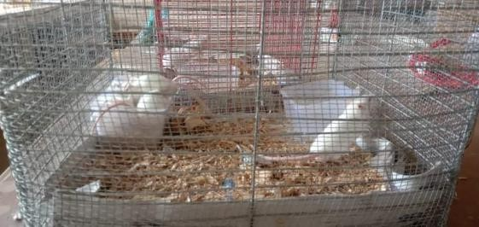
Figure 1. Rearing of experimental mice

Body Weight
40
35
30
25
20
15
10
5
0
Group I
Group II Group III Group IV
Group V(Control)
20 30 40
Age (Days)
60
65
Body Weight(g)
50
Figure 2: Beneficial Effects of essential oils in body weight gain

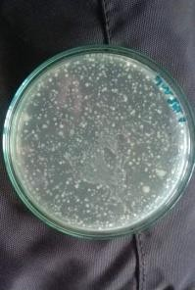
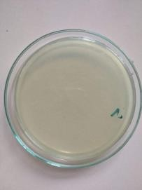
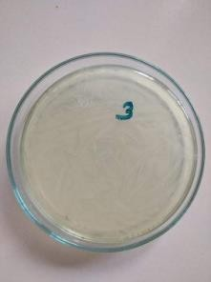
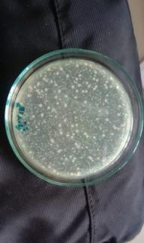
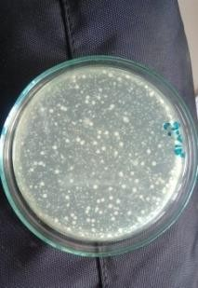
i
ii
iii
iv
v
GI
GII
G III
G IV
GV C
Figure 3(i-v). Microbial load on Intestine of mice in different groups

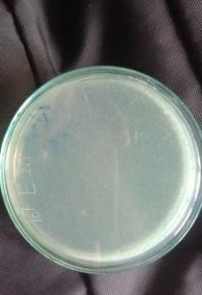
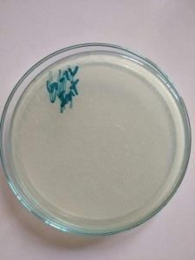
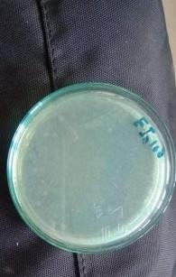
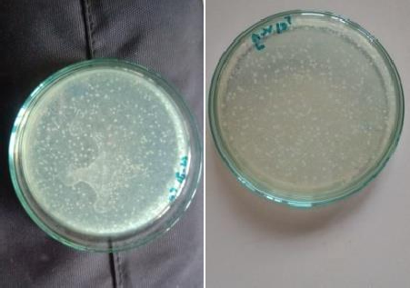
i
ii
iii
iv
v
G I
G II
G III
G IV
GV C
Figure 4 (i-v). Microbial load on liver of mice in different groups

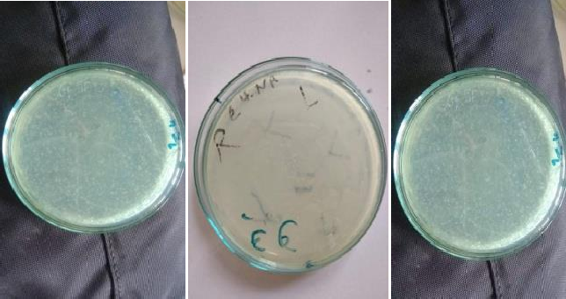
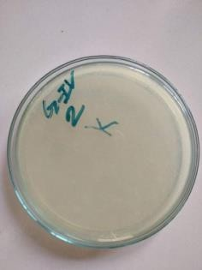
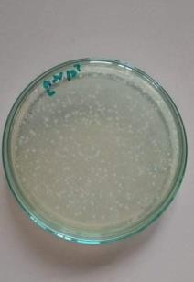
i
ii
iii
iv
v
G I
G II
G III
G IV
GV C
Figure 5 (i-v). Microbial load on Kidneys of mice in different groups

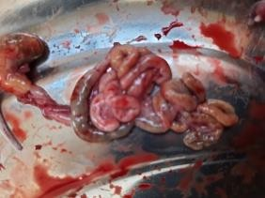
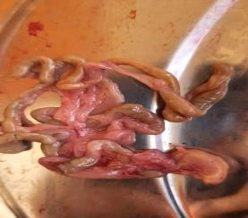
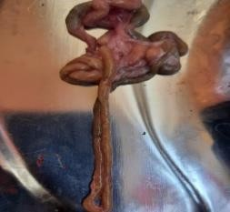
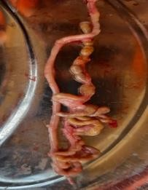
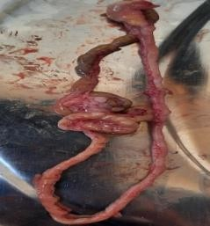
v
GV C
iii
iv
i
ii
G I
G II
G III
G IV
Figure 6(i-v). Intestine of mice. No morphological changes in all treated
groups but slight haemorrhage and congestion showing in control group

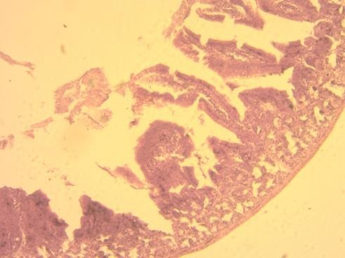
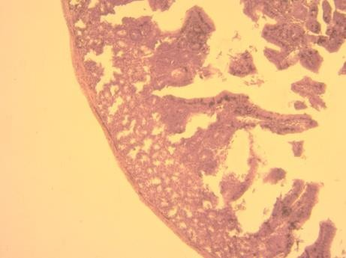
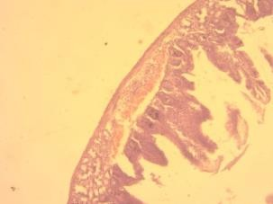
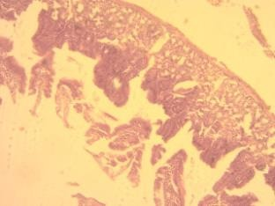
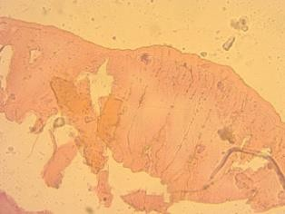

G I
Figure 7. The mucosa of intestine group
showing lymphocyte infiltration, H & E
Stain (10X).

G II
Figure 8. Histology of intestine Group II.
Arrows showing lymphocyte infiltration,
H & E stain(10X)

G IV
Figure 10. Histology of intestine Group IV.
Arrows showing haemorrhage and lymphocyte infiltration, H & E stain (10X)

G III
GV C
Figure 11. Histology of intestine Group V
(Control). Arrows showing haemorrhage and desquamation of villus, H & E stain (10X).

Figure 9. Histology of liver (Group- III), arrow shows no infiltration in the intestine, H&E stain (40X).

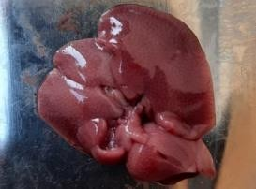
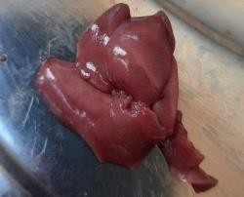
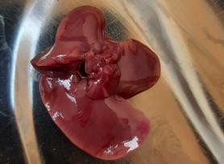
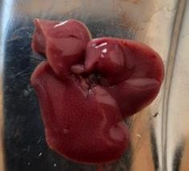
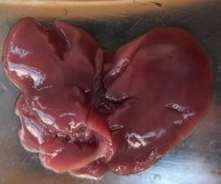
i
G I
ii
G II
iii
G III
iv
G IV
v
GV C
Figure 12 (i-v). Liver of mice. All treated groups were normal but swelling and congestion found on the liver of control group (GVC).

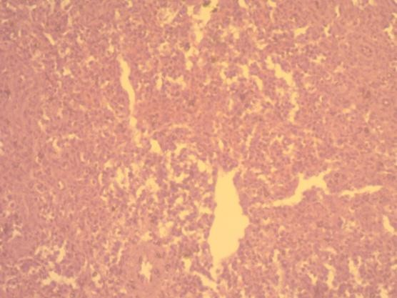

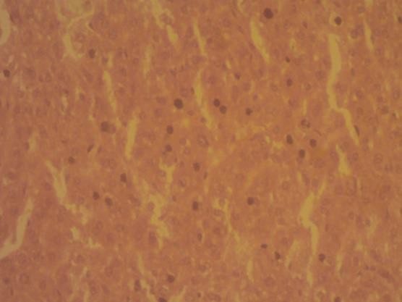
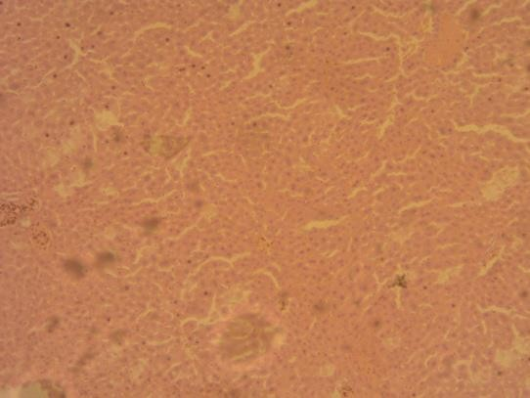
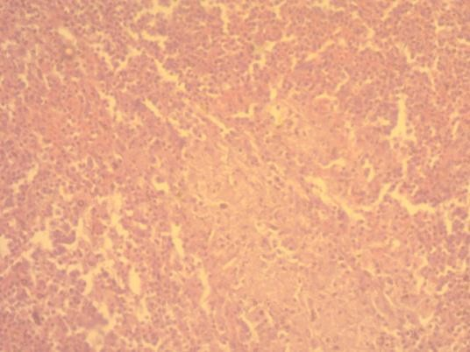
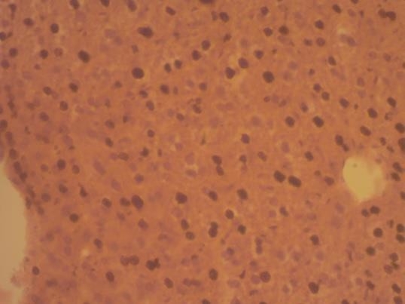
Figure 14. Histology of liver (Group-C), arrow shows lymphocyte infiltration in the sinusoid, H&E stain (40X).

G II
G I
Figure 13. Histology of liver (Group-I), macrophage, lymphocyte and RBC infiltration in the sinusoid, H&E stain (40X).

G IV
G III
Figure 15. Histology of liver (Group- IV), arrow shows lymphocyte infiltration, H&E stain (40X).

G V C
Figure 17. Control group was showing cell necrosis, lymphocyte infiltration and congestion in the sinusoid of liver, H&E stain (40X).

Figure 16. Histology of liver (Group- IV), arrow shows lymphocyte and neutrophil infiltration in the sinusoid, H&E stain (40X).

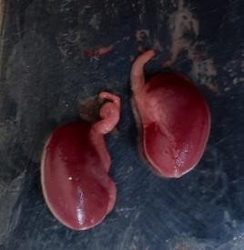
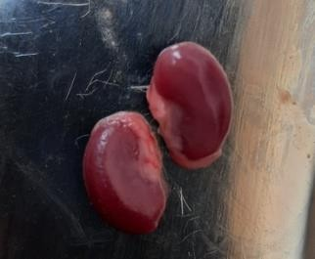
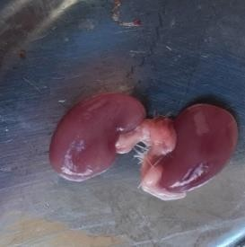
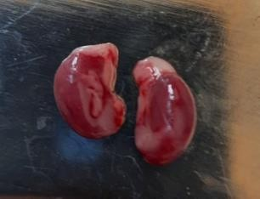
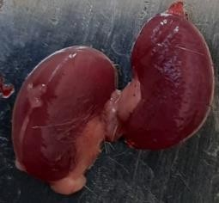
i
ii
GI
GII
iii
GIII
iv
G IV
v
GV C
Figure 18(i-v). All treated groups were showed no morphological changes except G IV showed slight hemorrhage with congestion of kidneys and control (GV) group was showing congestion and fragile.

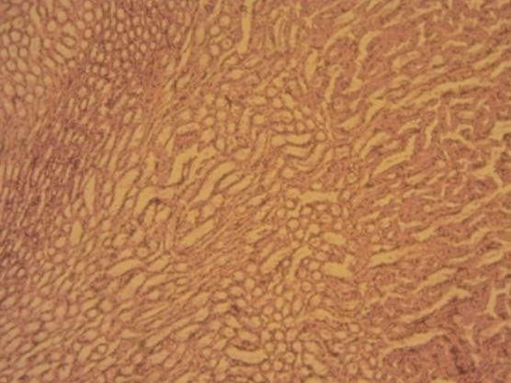
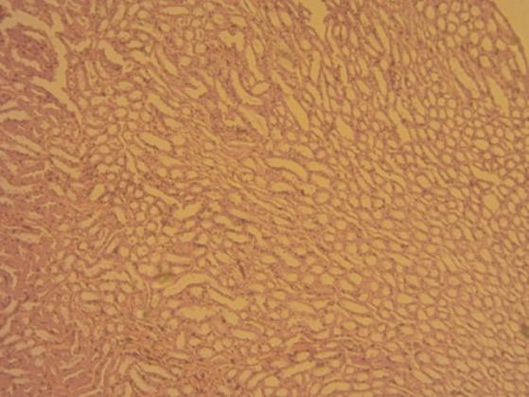
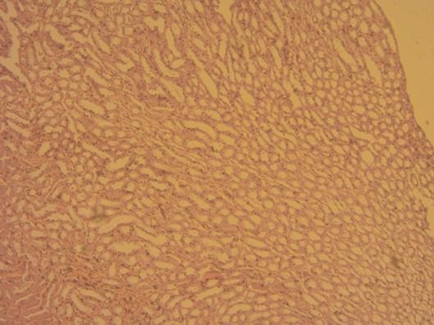
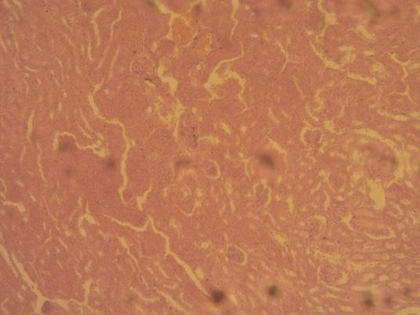
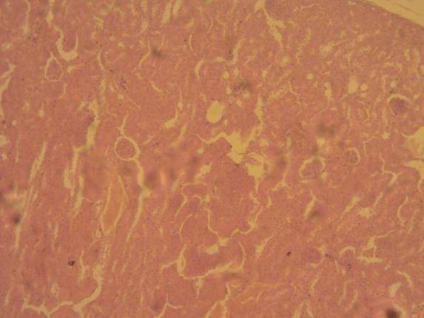
G I
Figure 19. Histology of kidney of groupI showing normal structure, H&E stain (10X).

Figure 20. Histology ofkidney of group II showing normal structure, H & E stain (10X).

GII
Figure 21. Group III showing normal structure of kidney, H & E stain (10X).

G III
Figure 22. Histology of kidney. star mark indicate haemorrhage and arrows indicate lymphocyte infiltration, H & E stain ( 10X).

GI V
G V C
Figure 23. Histology of kidney. Star mark indicate glomerulus structure in raptured condition, (Control group V), H & E stain
(10X).

References

Bakkali F, Averbeck S, Averbeck D, Idaomar M (2008). Biological effects of essential oils–a review. Food and Chemi. Toxicol. 46: 446-475.
Costa CA, Bidinotto LT, Takahira RK, Salvadori DM, Barbisan LF, Costa M (2011). Cholesterol reduction and lack of genotoxic or toxic effects in mice after repeated 21-day oral intake of lemongrass (Cymbopogon citratus) essential oil. Food and Chemi. Toxicol. 49: 2268-2272.
Dahham SS, Hassan LEA, Ahamed MBK, Majid ASA, Majid AMSA, Zulkepli NN (2016). In vivo toxicity and antitumor activity of essential oils extract from agarwood (Aquilaria crassna). BMC Complement. and Alternat. Med. 16: 1-11.
Djilani A,Dicko A (2012). The therapeutic benefits of essential oils. In Book. Chapter 7. Nutrition, Well-being and Health Pp. 155-179.
Ezzat Abd El-Hack M, Alagawany M, Ragab Farag M, Tiwari R, Karthik K, Dhama K, Adel M (2016). Beneficial impacts of thymol essential oil on health and production of animals, fish and poultry: a review. J. Essent. Oil Res. 28: 365-382.
Fisher K, Phillips C (2008). Potential antimicrobial uses of essential oils in food. Trends in food Sci. and Technol. 19: 156-164.
Gopi M, Karthik K, Manjunathachar HV, Tamilmahan P, Kesavan M, Dashprakash M, Purushothaman MR (2014). Essential oils as a feed additive in poultry nutrition. Adv. Anim. Vet. Sci. 2: 1-7.
Hajhashemi V, Ghannadi A, Sharif B (2003). Anti-inflammatory and analgesic properties of the leaf extracts and essential oil of Lavandula angustifolia Mill. J. Ethnopharmacol. 89: 67-71.
Hansen JM, Go YM. Jones DP (2006). Nuclear and mitochondrial compartmentation of oxidative stress and redox signaling. Annu. Rev. Pharmacol. Toxicol. 46: 215-234.
Jang IS, Ko YH, Yang HY, Ha JS, Kim JY, Kim JY, Lee CY (2004). Influence of essential oil components on growth performance and the functional activity of the pancreas and small intestine in broiler chickens. Asian-Austral. J. Ani. Sci. 17(3), 394-400.
Krishan G, Narang A (2014). Use of essential oils in poultry nutrition: A new approach. J. Adv. Vet. and Ani. Res. 1:156-162.
Langeveld WT, Veldhuizen EJ, Burt SA (2014). Synergy between essential oil components and antibiotics: a review. Critical Reviews in Microbiol. 40: 76-94.
Lulekal E, Tesfaye, S, Gebrechristos S, Dires K, Zenebe T, Zegeye N, Mekonnen A. (2019). Phytochemical analysis and evaluation of skin irritation, acute and sub-acute toxicity of Cymbopogon citratus essential oil in mice and rabbits. Toxicol. Reports, 6: 1289-1294.
Mekonnen A, Tesfaye S, Christos SG, Dires K, Zenebe T, Zegeye N, Lulekal E (2019). Evaluation of skin irritation and acute and subacute oral toxicity of Lavandula angustifolia essential oils in rabbit and mice. J. Toxicol. 2019: 1-8
Nakavuma JL, Matasyoh JC, Wagara IN, Kalema J, Alinaitwe L (2016). Toxicity studies on anti-fungal essential oils extracted from selected aromatic plants from Mabira and Kakamega forests, East Africa. European J. Medi. Plants, 14: 1-14
Nazzaro F, Fratianni F, De Martino L, Coppola R, De Feo V (2013). Effect of essential oils on pathogenic bacteria. Pharmaceuticals, 6: 1451-1474.
Perry NS, Bollen C, Perry EK, Ballard C (2003). Salvia for dementia therapy: review of pharmacological activity and pilot tolerability clinical trial. Pharmacol. Biochemist. and Behavior. 75: 651-659.
Rao J, Chen B, McClements DJ (2019). "Improving the Efficacy of Essential Oils as Antimicrobials in Foods: Mechanisms of Action. Annual Review of Food Sci. and Technol. 10: 365–387.
Schwartz J, Shklar G, Trickler D (1993). Vitamin C enhances the development of carcinomas in the hamster buccal pouch experimental model. Oral Surgery, Oral Medicine, Oral Pathol. 76: 718-722.
Silva J, Abebe W, Sousa SM, Duarte VG, Machado MIL, Matos FJA (2003). Analgesic and anti-inflammatory effects of essential oils of Eucalyptus. J. Ethnopharmacol. 89: 277-283.
Tongnuanchan P, Benjakul S (2014). Essential oils: extraction, bioactivities, and their uses for food preservation. J. food sci. 79: 1231-1249.
Zhai H, Liu H, Wang S, Wu J, Kluenter AM (2018). Potential of essential oils for poultry and pigs. Ani. Nutri. 4: 179-186.
Zheng S, Yang H, Zhang S, Wang X, Yu L, Lu J, Li J (1997). Initial study on naturally occurring products from traditional Chinese herbs and vegetables for chemoprevention. J. Cellular Biochemist. 67: 106-112.

