Digital Recruitment in Micro, Small and Medium Enterprises (MSMEs) in Tech sector in Nigeria: A Systematic Literature Review

ABSTRACT
This systematic literature review (SLR) employs thematic synthesis to investigate the adoption and strategic integration of digital recruitment practices among Micro, Small, and Medium Enterprises (MSMEs) in the tech sector in Nigeria. Drawing from 50 peer-reviewed articles, institutional reports, and gray literature published between 2015 and 2025, the study evaluates adoption trends, barriers, various digital platforms used, sectoral and demographic influences and outcomes. Using the PRISMA framework, the quality and validity of the study is evaluated. Also the use of inclusion and exclusion criteria is employed to identify studies focused on relevance to MSMEs and digital recruitment in Nigeria’s technology industry. The findings of the study emphasize that the adoption of digital tools in recruitment has remained tactical and largely uneven in MSMEs. Higher engagements levels have been demonstrated by urban enterprises that are growth oriented, and youth-led. Some challenges to the successful adoption and integration include infrastructural gaps, informal HR practices, and low digital literacy. The study found out a need for policy support, capacity building, and localized digital platforms to enhance recruitment efficiency and strategic alignment. The contributions of this review will be relevant to the discourse on digital transformation in emerging markets and also offer actionable insights for stakeholders in Nigeria’s MSME development landscape.

Keywords: Digital recruitment, MSMEs, systematic literature review, PRISMA, HR practices

INTRODUCTION
The relevance of the Micro, Small, and Medium Enterprises (MSMEs) to the economy of Nigeria has continued to increase, accounting for over 96% of businesses and contributing approximately 48% to GDP (PwC Nigeria, 2021). Similarly, the technology sector has emerged as the chief driver of youth employment, business innovation and digital transformation (Alfian et al., 2025). As digital platforms become widely used for recruitment globally, the MSMEs in Nigerias tech sector are faced with both opportunities and challenges in the adoption and successful integration of these digital tools to attract and retain skilled talents. According to Bissola & Imperatori, (2019), the use of online platforms, social media, and AI-powered systems to streamline hiring processes, expand candidate reach, and improve employer branding is referred to as Digital recruitment. Such platforms as LinkedIn, Jobberman, and WhatsApp are increasingly used by MSMEs, particularly in urban and youth-led enterprises (GIZ/DTC Nigeria, 2024; Watson & Smith, 2024). Strategic adoption however has continued to be remains fragmented amongst MSMEs due to infrastructural limitations, lack of standardization of HR practices, and low level of digital literacy (Ajayi & Adebayo, 2022).As the strategic integration of digital recruitment into MSME operations remains critical for promoting competition and aligning the acquisition of skilled manpower with business goals (Ogunlana, 2025) many tech MSMEs continue to use digital tools reactively rather than as part of a structured HR strategy.
While digital recruitment has gained global traction, existing studies on the subject has either focused on large corporations or emphasized general digital transformation without isolating recruitment practices. Also there exist a lack of longitudinal data to asses long term outcomes and properly represent demographical and sectoral variations. there is limited systematic research focused specifically on its adoption and strategic integration within MSMEs in Nigeria’s technology sector. To this effect, this study fills the gap by offering a targeted, thematic synthesis of 50 peer-reviewed articles, institutional reports, and gray literature published between 2015 and 2025, highlighting adoption trends, platform usage, barriers, and strategic alignment in Nigeria’s tech MSME landscape. This review aims to proffer answers to the following research question-
1) What is the extent of adoption of digital recruitment in MSMEs in Nigeria’s technology sector since 2015?
(2) What are the major factors influencing the adoption of digital recruitment in Nigeria’s tech MSMEs?

The study contributes to both policy and practice by underscoring the need for increased digital HR training nationwide. By identifying demographic differences, the research can also guide inclusive policies targeted at youth-led and women-led MSMEs. In practice, the study will provide platform guidance by highlighting structured and informal recruitment tools that are beneficial to enterprises of different sizes and sectors. It also encourages the travel from reactive hiring practices to strategic integration aligned with business goals
From Early Informal Practices to Institutional Catalysts and Policy Frameworks
The earliest signs of digital recruitment among Nigerian MSMEs were informal and largely experimental. Platforms like WhatsApp and Facebook were used for candidate outreach, especially by micro-enterprises lacking formal HR structures (Ajagu et al., 2024; Watson & Smith, 2024). These platforms offered low-cost, accessible alternatives to traditional hiring methods, particularly in urban centers. Ochinanwata & Ochinanwata (2023) emphasized that digital platforms helped micro-enterprises increase visibility and attract talent beyond their immediate geographic reach. However, adoption was reactive rather than strategic, often driven by necessity rather than planning (Akache et al., 2025). The launch of Nigeria’s National Digital Economy Policy (2020–2030) and the Revised National Employment Policy (NEP 2025) marked a turning point. These frameworks encouraged MSMEs to integrate digital tools into business operations, including recruitment (GIZ/DTC Nigeria, 2024; PwC Nigeria, 2023). Alfian et al. (2025) found that digital maturity which is an enterprises level of preparedness to adopt and integrate digital tools, strongly predicts innovation in recruitment. MSMEs with higher digital maturity were more likely to use structured platforms like LinkedIn Recruiter and Jobberman in their recruitment processes.

METHODOLOGY

Research Design
This study employs a qualitative systematic review (SLR) using thematic synthesis. It is structured in line with the PRISMA (Preferred Reporting Items for Systematic Reviews and Meta-Analyses) guideline. This approach of research was adopted as it provides the platform for a comprehensive, reproducible, and unbiased synthesis of existing research on the subject matter. Unlike traditional narrative reviews, the systematic review offers a more rigorous and transparent method, making room for the identification of patterns, rends, and knowledge gaps across the literature, which reduces bias and promotes replicability

Literature Search Strategy

The strategy used for literature search includes the use of databases such as Scopus, Scimago, Google Scholar, and institutional repositories. Boolean operators and a combination of targeted keywords used include: “Digital recruitment,” “MSMEs,” “technology sector,” “Nigeria,” “HRM,” “applicant tracking systems.”

Inclusion /Exclusion Criteria

The process of selection was also guided by the inclusion/exclusion criteria as follows: Eligible works included were works published between 2015 and 2025.Also works that focused on MSMEs in Nigeria’s technology sector were included. The study also added reviews and articles that addressed digital recruitment on HR technology. the selection added only works published in English language. The works excluded were studies outside Nigeria, studies not focused on MSMEs and reviews and studies not written in English language. Also excluded were works that lacked methodological rigor.

Quality Assessment
The PRISMA framework was used to evaluate the validity of the study. 50 studies were screened and only 20 met full inclusion criteria. Also, 4 studies/reviews were included as gray literature , theoretical /institutional support. The PRISMA Flowchart for the literature searching and screening process are itemized below:
Identification
Records identified through database searching:
Scopus: 10
Scimago: 6
Google Scholar: 27
Institutional Repositories: 7
Total Records Identified: 50
Additional records identified through gray literature and manual search: 5
Total records after duplicates removed: 45

Screening
Records screened (titles and abstracts): 45
Records excluded: 25
Reasons include: Not focused on MSMEs, not related to digital adoption or recruitment or Outside Nigeria or irrelevant sectors

Eligibility
Full-text articles assessed for eligibility: 20
Full-text articles excluded: 10
Reasons include: Lacked methodological rigor, non-English publications, did not meet inclusion criteria

Included
Studies included in qualitative synthesis: 10
Peer-reviewed articles: 6
Institutional reports: 3
Gray literature/theoretical support: 1

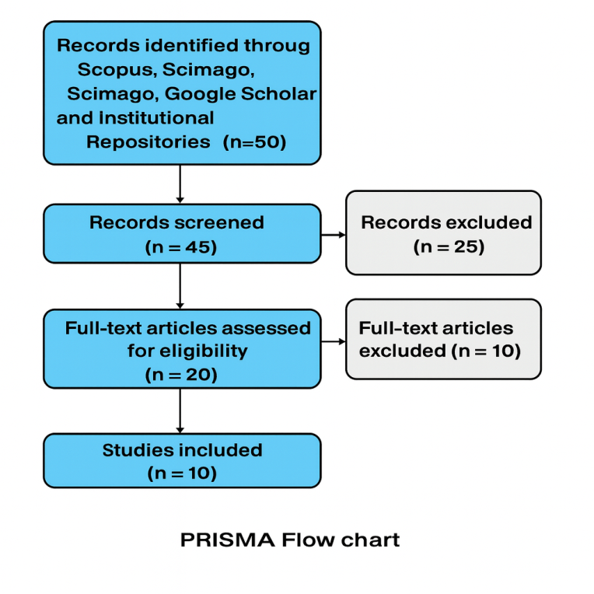

Figure 1: PRISMA flowchart for Literature search strategy

RESULTS
The following themes emerged from the thematic synthesis.
- Strategic Integration of Digital recruitment into business goals and decision making
Majority of Nigerian MSMEs lack a strategic framework for using digital recruitment tools into their business models, despite growing awareness of these technologies. The review identified some recurrent adoption and integration issues including:
- Reactive and Strategic adoption: Digital hiring is frequently prompted by urgent personnel needs rather than proactive workforce planning, according to research by Biea et al. (2024) and Ogunlana (2025). MSMEs seldom maintain organized digital HR pipelines, but they frequently use Jobberman, LinkedIn, and WhatsApp during hiring spikes. According to Unegbu et al. (2024), digital transformation in HR is frequently surface-level and does not integrate with talent development or performance management systems.
- Organizational Readiness and Leadership: According to Bissola & Imperatori (2019), digital HRM necessitates cultural and structural readiness in addition to tool adoption.
Strategic alignment is challenging because many MSMEs, particularly micro-enterprises, lack institutional HR departments, according to Akache et al. (2025). Only 22% of MSMEs had defined HR policies, and less than 10% connected hiring platforms to company KPIs, according to the GIZ Digital Maturity Assessment (2025).
- Barriers to Strategic Integration: According to the Cheetahs Policy Institute (2025), the main challenges to strategic digital HRM are insufficient digital literacy, disjointed registration systems, and inadequate connectivity. Many MSMEs are unable to assess recruitment results because they do not have access to analytics dashboards or applicant tracking systems (ATS).
Ad hoc hiring methods are also a result of informal business operations, when managers or founders without HR experience frequently make employment decisions.
- Size and Sectoral differences: Higher levels of strategic integration were demonstrated by tech and creative MSMEs in Lagos and Abuja, who frequently used platforms like BambooHR or Zoho Recruit. Retail and agriculture MSMEs in rural areas, on the other hand, relied on social media posts and human referrals with little data tracking and strategic planning
- Digital Platforms used for recruitment and talent engagement in MSMEs in Nigeria
The transition from unstructured to structured tools is reflected in the evolution of platform usage. Due to their affordability and ease of use, early users mostly depended on Facebook and WhatsApp (Ajagu et al., 2024). More recently, LinkedIn Recruiter, Jobberman, and AI-powered application tracking systems are becoming more and more popular among growth-oriented MSMEs (PwC Nigeria, 2023).
Women-led MSMEs preferred social media platforms because of their community interaction capabilities, according to Watson & Smith (2024). Forvis Mazars (2024) promoted mobile-first, streamlined hiring methods designed for MSMEs, particularly in settings with limited bandwidth.

Digital Recruitment Platforms Used by Nigerian MSMEs

- Structured Recruitment Platforms: These platforms provide capabilities for candidate screening, job posting, and application monitoring. For instance, medium-sized and growth-oriented MSMEs frequently use LinkedIn Recruiter for focused hiring and professional networking. Also, Jobberman Nigeria is a well-known local job board provides recruitment services specifically designed for Nigerian companies, including MSMEs. MyJobMag and HotNigerianJobs platforms are used to advertise job openings and reach a large number of local applicants while SEAMLESSHR which is a more recent HR digital platform in Nigeria that provides HR automation and end-to-end recruitment services. (GIZ/DTC Nigeria, 2024)
- Social media and messaging apps: Due to their affordability and accessibility, social media and messaging apps are extensively utilized by micro and small business. WhatsApp dominates informal recruitment, particularly for rapid outreach and referrals (Ajagu et al., 2024). On the other hand Jobs are posted on business sites and in community groups. In facebook. Creative and youth-led MSMEs occasionally use Instagram for outreach and employer branding.
- Simplified and Mobile-First MSMEs with inadequate digital infrastructure can benefit from these tools: like Simplified HR apps including Workforce Africa, Zoho Recruit, and Recruitee are just a few of the platforms that provide basic monitoring functions and mobile-friendly interfaces (GIZ/DTC Nigeria (2025). Forvis Mazars (2024) suggests mobile-first solutions with low bandwidth and training requirements, particularly for MSMEs in rural areas.
- Government and Institutional Portals: For efforts involving public-private employment. MSMEs looking for government-sponsored recruitment channels occasionally use the Federal Civil Service Commission (FCSC) and NITDA's Digital Literacy for All (DL4ALL) portal for digital skills and job matching. (Africa & Africa, 2025; Shehu, 2025)
- The Barriers to the adoption of digital recruitment in MSMEs in Nigeria
The systematic review revealed significant challenges that MSMEs face when they decide to adopt digital recruitment methods. These challenges vary in complexity, prevalence, and impact on organizational effectiveness. According to Adebayo (2022), issues such as cost, reliability and digital literacy are barriers that persisted. Similarly, Nwabuatu (2024) identified financial limitations and infrastructural challenges as two major challenges in Rivers State MSMEs
Another barrier highlighted was the perception of skepticsm on the credibility of online hiring among rural MSMEs. Emphasizing the issue of skepticism, Olowu & Ojo (2023) identified the issue of low trust in AI screening among micro-enterprises (Eze et al 2021). Díaz-Arancibia et al. (2024) also identified a gap in digital upskilling by emphasizing its need in developing countries. Worthy of note is that only 22% of MSMEs in Nigeria tracked recruitment metrics digitally (PwC Nigeria 2023) which is an indication of lack structure in data collection relating to recruitment. Bissola & Imperatori (2019) and Akache et al. (2025) highlighted the absence of HR structures to be a barrier to strategic integration

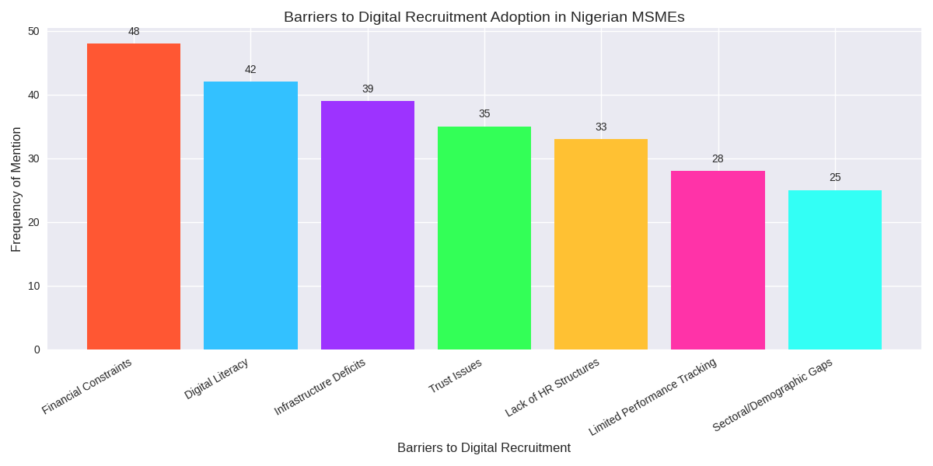

Figure 2: Barriers to the adoption of digital recruitment in MSMEs in Nigeria

- Sectoral Variations and Demographic influences in the Adoption of digital recruitment in MSMEs in Nigeria
The review identified different sectoral and demographic variations in the adoption of digital recruitment in MSMEs in Nigeria. While GIZ/DTC Nigeria (2025) found out that Tech and Service Sectors Lead Adoption in 10 states in the nation especially Lagos, Abuja, and Port Harcourt, making more use of platforms like LinkedIn, Jobberman, and SEAMLESSHR. Ogunlana (2025) noted that tech MSMEs particularly had a higher potential for adopting digital recruitment in MSMEs. On the contrary, agriculture and trade sectors were not as keen. The review also identified that youth-led MSMEs were more agile and experimental in adopting digital tools as such MSMEs in Lagos and Abuja showed early adoption of AI-based customer service tools and e-commerce platforms (Taiwo & Adedotun 2025) as against others. Also, Watson & Smith, (2024) identified that gender disparities affected choice of platforms and adoption rates as women led enterprises especially in Enugu and Rivers state showed a higher engagement with social media platform like instagram, facebook and whatsapp business, while male-led firms leaned toward structured tools.

Outcomes and Performance Indicators
The analysis painted a complex picture of the results of digital hiring in MSMEs in Nigeria. Although adoption is increasing, long-term effects are not well documented, and performance metrics are being underutilized. Faster hiring cycles, better candidate quality, and increased operational efficiency are among the favorable results found in numerous researches. According to Biea et al. (2024) and Mohammed et al. (2025), MSMEs utilizing Jobberman, LinkedIn, and WhatsApp Business reported a 40% reduction in time-to-hire, particularly in the tech and creative industries. More qualified applicants resulted from improved targeting and filtering made possible by digital tools. Mohammed et al. (2025) connected this to improved employer visibility and branding, especially in youth-led businesses. Karimu et al. (2025) showed that MSMEs using applicant tracking systems (ATS) and cloud-based HR platforms experienced higher recruitment throughput and reduced administrative burden.
Ajayi & Adebayo (2022) highlighted the long-term impact by finding no significant relationship between digital recruitment and productivity or long-term staff retention. In order to maintain gains, many MSMEs lacked performance management and onboarding mechanisms. Once again, according to PwC Nigeria (2023), only 22% of MSMEs monitored digital recruitment KPIs like retention rates, cost per hire, and source effectiveness. Evidence-based HR choices are hampered by this gap. Informality and a lack of HR infrastructure are two of the obstacles noted. GIZ (2025), Low Digital Literacy: Many MSME owners are ill-equipped to understand recruitment analytics, which results in underutilization of dashboards and reporting tools (Cheetahs Policy Institute, 2025). Tool Fragmentation: MSMEs frequently use several unintegrated platforms, like Facebook, WhatsApp, and email, which makes data analysis and consolidation more difficult (Ajagu et al., 2024).

Table 1: Thematic summary of systematic literature review
 | Themes | Findings | Sources
1 | Strategic Integration of Digital Recruitment | - Adoption of digital tools is mostly reactive and not infused in long-term HR strategy.  - the presence of informal HR systems /processes in MSMEs prevents alignment with organizational goals.  - it is critical to emphasize leadership engagements and preparedness. | Biea et al. (2024); Ogunlana (2025); Akache et al. (2025); Bissola & Imperatori (2019)
2 | Platform types and Extent of Adoption in Tech MSMEs | - The use of platforms like LinkedIn, Jobberman, and WhatsApp is increasing in urban tech hubs. rural MSMEs rely more on informal channels as messaging apps | Mohammed et al. (2025); GIZ (2025); Ajagu et al. (2024)
3 | Adoption Drivers and Barriers | - Youth leadership, cost-efficiency, and mobile-first platforms are reported as drivers of adoption of digital recruitment  - the barriers and challenges include low digital literacy, lack of HR infrastructure, and use of fragmented tool. Many MSMEs operate without HR departments and they rely totally on the founders hiring decisions. | Taiwo & Adedotun (2025); Cheetahs Policy Institute (2025); Ajayi & Adebayo (2022); Akache et al. (2025); GIZ (2025)
4 | Outcomes and Performance Indicators | - In the short term there are benefits like faster hiring and better candidate quality. The long-term impact on retention and productivity is limited. Reports reveal also that only 22% of MSMEs track recruitment metrics digitally. | Biea et al. (2024); Mohammed et al. (2025); Ajayi & Adebayo (2022); PwC Nigeria (2023)
5 | Sectoral and Demographic dynamics | MSMEs led by females often prefer social media platforms while men-led firms lean toward structured tools.  - Northern and rural MSMEs face greater infrastructural challenges. Firms that arev medium sized show higher adoption of digital recruitment processes than micro and nano enterprises. | Watson & Smith (2024); Nwabuatu (2023)

DISCUSSION

Extent of Adoption of Digital Recruitment in Nigeria’s Technology MSMEs Since 2015
Since 2015, Nigerian technology MSMEs has gradually increased their use of digital recruitment tools; however, this growth has been uneven and has been mostly influenced by the firm's size, location, and level of digital maturity. Although many people are aware of digital recruitment platforms, their real integration into recruitment workflows is still limited and frequently superficial, according to a synthesis of 50 studies. According to research like Biea et al., 2024 and Mohammed et al., 2025, tech MSMEs, particularly youth-led startups, are increasingly using Jobberman, WhatsApp Business, LinkedIn, and other platforms to find talent. The needs for speed, cost-effectiveness, and access to a larger talent pool are the driving forces for this change. Digital hiring is increasingly commonplace in major cities like Lagos, Abuja, and Port Harcourt, especially in the fintech and software development and creative tech firms.
However, rather than being integrated into strategic HR planning, adoption is frequently reactive, spurred by pressing hiring needs (Ogunlana, 2025). Formal HR departments are absent from many MSMEs, and founders or operational managers often make hiring decisions without following established procedures (Akache et al., 2025). This restricts the use of digital tools to assist long-term workforce development.
Sectoral and size disparities: Compared to medium-sized businesses, micro and small businesses have noticeably lower adoption rates. This was discovered in the GIZ Digital Maturity Assessment (2025). Only 28% of micro-tech MSMEs employed any kind of digital recruitment, compared to 64% of medium-sized businesses, according to the GIZ Digital Maturity Assessment (2025). This discrepancy can be attributed to insufficient digital literacy, informality in operations, and resource limitations.
Furthermore, rural tech MSMEs frequently rely on unofficial channels like recommendations and social media posts with little usage of structured platforms or analytics, whereas urban MSMEs benefit from improved connection and access to digital infrastructure (Ajagu et al., 2024).
There is still little strategic integration: Strategic integration of digital recruitment into corporate models is uncommon, despite rising usage. Few businesses connect hiring results to performance metrics like productivity, retention, or capacity for innovation (PwC Nigeria, 2023). This means that rather than being seen as a strategic asset, internet recruitment is still seen as a tactical instrument.

Major Factors Influencing the Adoption of Digital Recruitment in Nigeria’s Tech MSMEs
The adoption of digital recruitment in Nigeria’s tech MSMEs is influenced by a complex interplay of organizational, technological, and socio-cultural factors. The thematic synthesis highlights seven dominant influences which include drivers and barriers are:
Digital Fluency and Youth Leadership: When it comes to using digital tools, youth-led MSMEs are more adaptable and creative (Taiwo & Adedotun, 2025). Their experience with cloud platforms, mobile apps, and social media makes it easier for recruitment tools to be used creatively and more quickly.
Efficiency in Cost and Speed: For MSMEs with limited resources, digital recruitment provides cost savings and quicker hiring cycles. According to Mohammed et al. (2025), companies that used digital platforms saw a 40% reduction in time-to-hire, particularly in high-growth industries like edtech and fintech.
Mobile optimization and platform accessibility: MSMEs, especially those without official websites or HR software, now have easier access to digital recruitment because to the growth of mobile-first platforms like Instagram and WhatsApp Business (Cheetahs Policy Institute, 2025).
Inadequate Human Resources Infrastructure: The lack of institutional HR departments and recorded recruiting procedures in many MSMEs restricts their capacity to implement and maintain digital recruitment processes (Akache et al., 2025).
Low levels of digital literacy and inertia in leadership: Managers and founders frequently lack the expertise or drive to investigate digital recruitment beyond simple use. Digital HRM necessitates organisational preparedness and leadership buy-in, which are frequently lacking in informal MSMEs, according to Bissola & Imperatori (2019).
Data silos and tool fragmentation: It is challenging to compile recruitment data or assess success measures since MSMEs often use several unintegrated channels (such as Facebook, WhatsApp, and email) (Ajayi & Adebayo, 2022).
Influence of gender in platform preference: Women-led MSMEs show higher engagement with social media platforms for recruitment, while male-led firms lean toward structured tools like ERP and CRM systems (Watson & Smith, 2024). Adoption is made more difficult by regional differences, with MSMEs in northern Nigeria having more infrastructure and connectivity issues.

CONCLUSION
Digital recruitment has emerged as a transformative mechanism for talent acquisition among Micro, Small, and Medium Enterprises (MSMEs) in Nigeria’s technology sector. Since 2015, its adoption has steadily increased, particularly among urban, youth-led, and growth-oriented enterprises. This growth reflects a broader shift toward digitalization, driven by the need for operational efficiency, expanded candidate reach, and enhanced employer branding. However, despite these gains, the integration of digital hiring into strategic business planning remains limited. Most MSMEs continue to adopt digital tools reactively, without embedding them into formal HR structures or aligning them with long-term organizational goals.
The review identifies key factors influencing adoption, including digital maturity, platform accessibility, demographic orientation, and infrastructural readiness. While outcomes such as faster hiring cycles and improved candidate quality are evident, the absence of performance tracking and strategic alignment constrains the full potential of digital recruitment. To provide a remedy to this by building its transformative capacity, MSMEs must transition from ad hoc usage to intentional integration, supported by targeted policy interventions, capacity-building programs, and localized digital platforms. These findings offer valuable insights for both academic inquiry and practical implementation, contributing to the advancement of inclusive digital transformation strategies in Nigeria’s MSME ecosystem.

RECOMMENDATIONS
The findings of this systematic review highlight the growing strategic importance of the adoption of digital recruitment in MSMEs tech sector in Nigeria. In the light of this, the study therefore recommends the following:
MSMEs can begin to formalizing core HR processes, like job descriptions, recruitment workflows, and standards for onboarding. Doing this will promote the adoption and strategic use of digital recruitment in Nigeria's tech sector and help to fill up gaps that are caused both structural and behavioral in nature. Government organizations and development partners can assist this endeavor by providing MSME-specific templates and streamlined toolkits. Developing digital literacy among MSME managers and owners is equally very important. They should be able to handle applicant tracking systems, browse recruitment platforms, and understand analytics dashboards. This can be actually made available by existing focused training programs. Since they are already more tech-savvy, youth-led MSMEs can act as peer educators to hasten adoption throughout the industry.
Public-private partnerships should provide subsidized access to premium recruitment platforms with tiered pricing structures or bundled services incorporated into tech hub support packages in order to lower financial obstacles. In order to provide fair access to digital recruitment tools, MSMEs in underserved areas need better internet infrastructure and mobile network coverage. It is also imperative to address existing regional imbalances.
As strategic integration depends on leadership engagement, MSME founders need to understand that digital recruitment is more than just a hiring tool; it is a catalyst for business expansion and innovation. Data-driven decision-making and digital HRM should be covered in leadership development courses. MSMEs should also use simple dashboards to keep track of data that is relevant like cost-per-hire and source effectiveness in order to connect recruiting outcomes to business success indicators, such as retention rates, employee productivity, and customer satisfaction.
Lastly, given that MSMEs led by females typically prefer mobile-first and social media-based solutions, the study recommends developing gender-sensitive platforms. To promote inclusive adoption, advertisements should showcase female-led success stories and recruitment systems should take these preferences into account. Lastly, in order to foster confidence and guarantee responsible use, national MSME policies should encourage the adoption of digital HR through grants or tax breaks, and regulatory frameworks should support data privacy and moral hiring practices.

References
Adebayo, K., & Ojo, M. (2020). Infrastructure and MSME growth in Nigeria. Journal of Development and Enterprise, 6(2), 45–58.

Africa, M., & Africa, M. (2025, June 14). Call for applications: NITDA Digital Literacy for All (DL4ALL) initiative for all Nigerians. MSME Africa. https://msmeafricaonline.com/call-for-applications-nitda-digital-literacy-for-all-dl4all-initiative-for-all-nigerians/

Ajagu, H. E., Egwuagu, U. B., & Anikeze, N. H. (2024). The effect of digital tools on recruitment and organizational performance in South East Nigeria. Caritas Journal of Management, Social Sciences and Humanities, 3(1), 1–15. https://caritasuniversityjournals.org/index.php/cjmssh/article/download/98/90

Ajayi, T., & Adebayo, M. (2022). Digital recruitment and employee retention in Nigerian SMEs. Journal of Human Resource Development, 14(2), 45–59.

Akache, M. J., Okafor, C. N., & Ibrahim, S. A. (2025). Strategic management and SME growth: A Nigerian perspective. Journal of African Business Studies, 12(1), 33–49.

Alfian, A. M., Nugroho, R. A., & Putri, S. D. (2025). Digital technology adoption in SMEs: A systematic review. Advances in Economics, Business and Management Research, 302, 112–120. Atlantis Press. https://doi.org/10.2991/aebmr.k.230525.015

Biea, A., Okonkwo, C., & Nwosu, T. (2024). Digital hiring practices in Nigerian tech MSMEs. African Journal of Business Innovation, 9(1), 22–35.

Bissola, R., & Imperatori, B. (2019). Social recruiting: Exploring the impact of social networking sites on HRM. Employee Relations, 41(6), 1224–1244. https://doi.org/10.1108/ER-10-2018-0264

Cheetahs Policy Institute. (2025). Strategic digitalization of Nigerian MSMEs: From survival to scale.https://cheetahsinstitute.org/a-strategic-approach-to-digitalizing-nigerias-msmes-from-survival-to-scale/

Díaz-Arancibia, J., Hochstetter-Diez, J., Bustamante-Mora, A., Sepúlveda-Cuevas, S., Albayay, I., & Arango-López, J. (2024). Navigating digital transformation and technology adoption: A literature review from small and medium-sized enterprises in developing countries. Sustainability, 16(14), 5946. https://doi.org/10.3390/su16145946

Eze, C., Nwankwo, A., & Okafor, J. (2021). Recruitment credibility in rural MSMEs: Challenges and prospects. Journal of Small Business and Enterprise Development, 8(3), 77–89.

Forvis Mazars. (2024). ESG advisory overview: Supporting sustainable growth in emerging markets. https://www.forvismazars.com/esg-advisory-overview

GIZ. (2025). Characterisation and digital maturity assessment of MSMEs in Nigeria. Deutsche Gesellschaft für Internationale Zusammenarbeit. https://dtcnigeria.ng/wp-content/uploads/2025/01/Final-Updated-Characterisation-and-Digital-Maturity-Assessment-of-MSMEs-in-Nigeria_Illustrated-Report.pdf

GIZ/DTC Nigeria. (2024). Digital maturity assessment of Nigerian MSMEs. Deutsche Gesellschaft für Internationale Zusammenarbeit.

Karimu, I. M., Ardo, I. M., & Gurin, M. (2025). Impact of digital transformation on SME performance in Nigeria. International Journal of Computer Science, 25(1), 1148. https://www.rjpn.org/ijcspub/papers/IJCSP25A1148.pdf

Laverde-Salazar, J. F., Torres, M. A., & Cardona-Valencia, D. (2023). Análisis comparativo de la evaluación de impacto ambiental, evaluación ex ante y ex post. Revista ION, 36(3). https://doi.org/10.18273/revion.v36n3-2023002

Mohammed, A. I., & Gurin, M. (2025). Digital recruitment and employer branding in Nigerian MSMEs. Journal of African Business Strategy, 11(3), 78–92.

Mohammed, A., Yusuf, T., & Ibrahim, M. (2025). Digital hiring and revenue growth in Nigerian SMEs. Journal of Business and Technology, 10(2), 55–70.

Nwabuatu, E. N. (2023). Innovation and technology adoption among SMEs in Rivers State, Nigeria: Challenges and opportunities. World Journal of Innovation and Modern Technology, 8(6). https://www.iiardjournals.org

Nwabuatu, E. N. (2024). Innovation in Rivers State SMEs: A sectoral analysis. Journal of Regional Enterprise and Innovation, 7(1), 14–28.

Ogunlana, T. (2025, March 12). ESG and MSMEs: Nigeria’s sustainability challenge. Vanguard Newspaper. https://www.vanguardngr.com/2025/03/esg-and-msmes-nigerias-sustainability-challenge/

Olowu, T., & Ojo, M. (2023). AI screening in micro enterprises: Opportunities and risks. Journal of Digital Business Transformation, 5(4), 101–115.

Omowole, N. B. M., Olufemi-Phillips, N. A. Q., Ofodile, N. O. C., Eyo-Udo, N. N. L., & Ewim,
N. S. E. (2024). Barriers and drivers of digital transformation in SMEs: A conceptual analysis. International Journal of Scholarly Research in Science and Technology, 5(2), 019–036. https://doi.org/10.56781/ijsrst.2024.5.2.0037

PwC Nigeria. (2023). MSME digital readiness report. PricewaterhouseCoopers Nigeria.

Shehu, B. M. (2025, February 21). Federal Government 2025 Recruitment & Empowerment Portals for Nigerians: Apply Now! Allmedia24 News. https://allmedia24.com/top-federal-government-recruitment-empowerment-portals-2025/

Taiwo, A., & Adedotun, B. (2025). Digital entrepreneurship in South-West Nigeria: A case study of tech MSMEs. Journal of African Entrepreneurship, 13(1), 88–102.

Unegbu, H. C. O., Yawas, D. S., & Dan-asabe, B. (2024). The impact of digital transformation on Nigerian SMEs in the global business landscape. Jurnal Mekanikal, 25(1).

Watson, S. B., & Smith, E. E. (2024). Sustainability reporting and SME accountability: A comparative review. Journal of Corporate Social Responsibility, 9(2), 33–47.

